Secretariat provided by the United Nations Environment Programme (UNEP)

Doc.: AEWA/StC Inf.4.4
09 November 2006
Original: English

FORTH MEETING OF THE STANDING COMMITTEE
20 -21 November 2005, Bonn, Germany

FACT SHEET

I. Meeting Venue
The meeting will take place at the UN CAMPUS also known as Langer Eugen in Bonn, Germany.
(Please see the attached maps).

EC card and credit card machine are on the ground floor in the building.
The meeting room is located on the 27 floors Room 2705 and will be signposted.

Address:

UN CAMPUS BONN - Langer EUGEN
UNEP/AEWA Secretariat
African-Eurasian Waterbird Agreement
Hermann - Ehlers - Strasse 10
53113 Bonn
Germany

How to get to the venue:
By Bus:
From Main Station direction Regierungsviertel (No 63, 66 )
Stop (Haltestelle) Heussallee / Museumsmeile
How to reach the Secretariat by phone:
During official office hours you could reach the AEWA by telephone: +49 228 815-2413. After office hours you could make contact with:
Mr Bert Lenten Tel: +49 175-56 27 311 (mobile phone)
Mr Sergey Dereliev Tel: +49 151 174 176 05 (mobile phone)

II. Opening
The meeting will be opened at 09.30 h on Monday, 20 November 2006.

III. Transport
Bonn is well connected to the rail network with a main line central train station (Bonn Hauptbahnhof). It is located approximately twenty minutes journey time south of Cologne and two hours north-west of Frankfurt/Main. There is an international airport serving Cologne/Bonn. The taxi fare from the airport to the city centre is approximately EUR 35, 00, but there is also a bus service (no 670) to the city centre (opposite the main railway station (Hauptbahnhof)) costing EUR 5, 00.

Delegates arriving at Frankfurt International Airport may wish to take the train to Bonn. There is high-speed train service (ICE) between the airport and Cologne. Travel time is approximately 40 minutes. Departure is from the long-distance train station (Fernbahnhof) in the airport complex. The direction is Cologne. The station stop for Bonn is the town of Siegburg. Taxis are available for approximately 30 EUR from Siegburg to the Bonn city centre and Bad Godesberg.

Normal train service between Frankfurt International Airport and Bonn is also available (from the long-distance train station (Fernbahnhof) in the airport). Travel time is approximately 1 hour 45 minutes. This trip along the Rhine River is one of the most scenic train trips in Germany and brings you directly into the city centre of Bonn and Bonn-Bad Godesberg.

IV. Hotel accommodation
The Secretariat has arranged block reservations for all Standing Committee members in the Hotel EDEN. The hotel is situated in city centre of Bonn-BAD GODESBERG, close (0.3km) to the railway station (Bad Godesberg Bahnhof).

The Hotel offers the United Nations a special rate which is about 75,00 EURO per night and room.
Non-sponsored delegates will be responsible for paying for their hotel accommodation and other expenses.

Address:

Hotel EDEN
Kurpark 5a
53177 Bonn-Bad Godesberg
Tel: +49 (0) 228-95727-0
Fax: +49 (0) 228-362494
Internet: www.eden-godesberg.de
E-Mail: rezeption@eden-godesberg.de

V. Daily Subsistence Allowance (sponsored delegates)
Those delegates sponsored to attend the Standing Committee meeting can collect DSAs from the Secretariat between 14.00-17.00 hours on the first day of the meeting.

VI. Travel
Those delegates sponsored to attend the Standing Committee meeting should approach the Secretariat regarding air ticket confirmations no later than the first day of the meeting.

VII. Weather
The meeting is being held from 20-21 November, which is winter time in Bonn. The weather in Bonn at this time is cold and sometimes it rains. So do not forget to bring your raincoat, and a pullover or other warm clothes.

VIII. Currency
Germany’s currency is the Euro. Credit cards are accepted in the hotel, in most shops and in most restaurants in Bonn.

IX. Visas
An official letter of invitation has been sent to each of the participants. This can be used with your visa application to apply for a German visa. Visas can be obtained from your nearest German embassy or consulate. Please contact the Secretariat immediately if you have difficulty obtaining a visa.

X. Communications
The hotel has a modern communication system (national and international). The participants are responsible for paying their private telephone calls and faxes. The hotel fixes the prices.

XI. Working language of the meeting
The meeting’s working languages will be English and French. Interpretation for these languages and German will be provided.

XII. Identification badges
All delegates will receive an identification badge. You are requested to wear this badge during all official functions to gain access to the venue.

XIII. Documents
Documents can be downloaded on the Secretariat’s Webpage before the meeting in English and French. Delegates are kindly reminded to please bring meeting documentation with them.

XIV. Time zone
Germany is in the Central European Time zone.

MAP of BONN
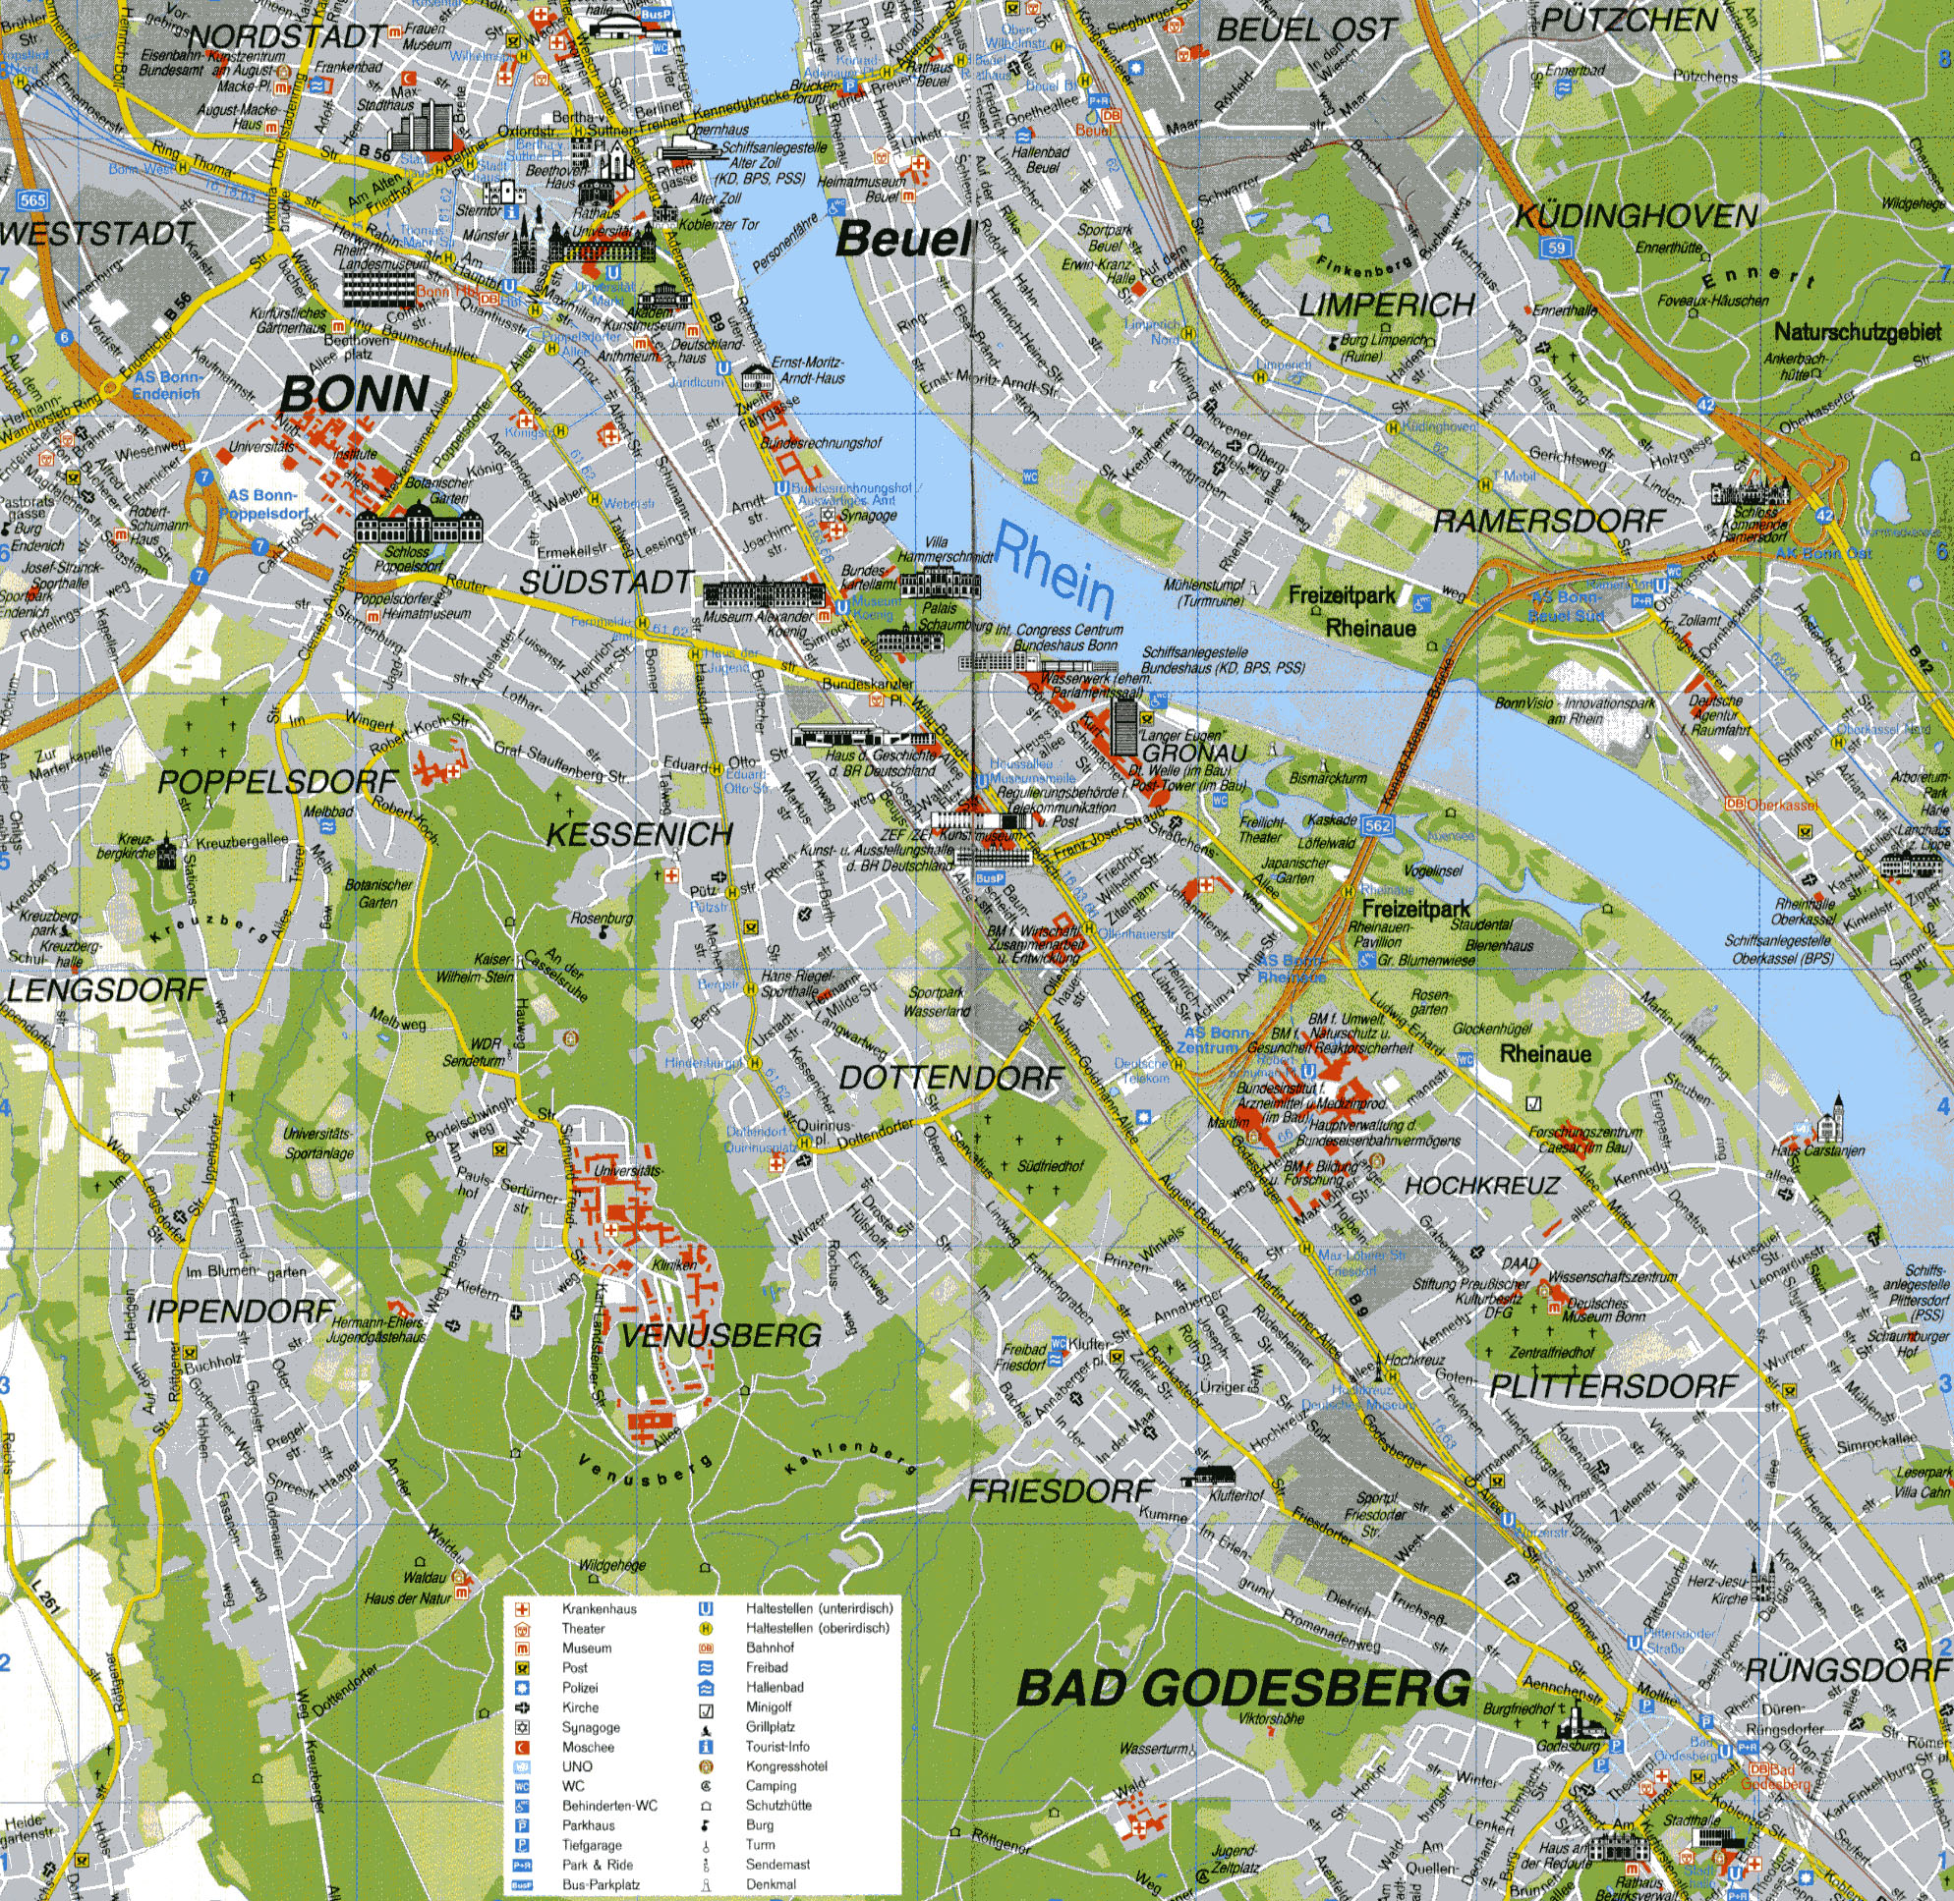
Meeting Venue:
UN Campus (Langer Eugen
Main Station Bonn

Map of Bonn - Gronau for UN CAMPUS (Langer EUGEN LE)

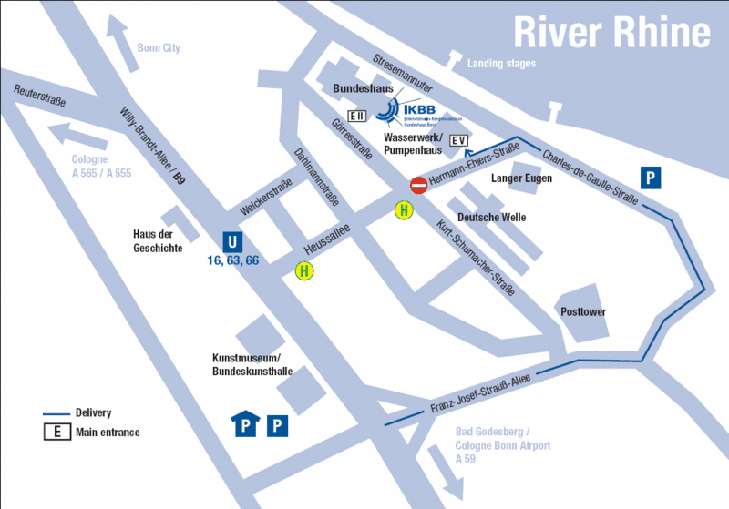
Meeting Venue:
UN Campus (Langer Eugen

Map of Bad Godesberg

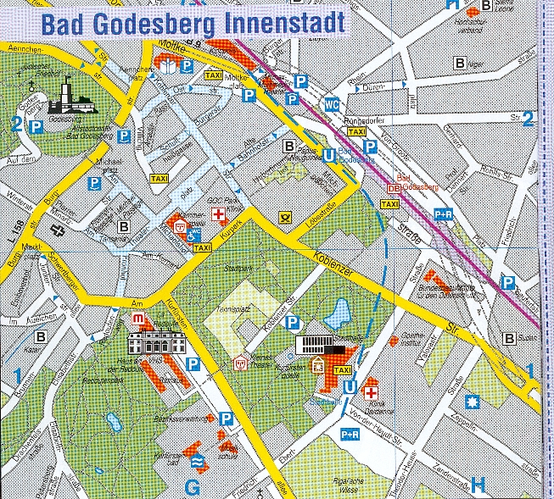
HOTEL EDEN

