CRITERIA FOR PRIORITIZING AEWA POPULATIONS FOR ACTION AND MANAGEMENT PLANNING AND FOR THE REVISION AND RETIREMENT OF ACTION PLANS AS WELL AS GUIDANCE ON THE DEFINITION OF PRINCIPAL RANGE STATES IN ACTION PLANS

Introduction

Species action and management planning under AEWA is a dynamic process. Much experience has been gained by the AEWA governing bodies, the range states and various other stakeholders involved during the 20 years lifespan of the Agreement. As species action and management planning under AEWA continues to develop, so does the continued need for clear criteria and guidance to steer the various stages of the planning and implementation process.

Three such areas in need of criteria and guidance were identified in particular during this triennium:

- the prioritization of species for action and management planning under AEWA;
- the assessment of AEWA International Single Species Action Plans for revision and retirement; and
- the definition of Principal Range States in Action Plans for species with a wide geographical range.

The AEWA Technical Committee approved the following guidance and criteria at its 12th Meeting on 3-6 March 2015 in Bonn, Germany. The criteria for the selection of species to be prioritized for management planning may still be subject to minor adjustments prior to the Meeting of the Parties depending on a prioritization exercise to be carried out by the Technical Committee in the coming months. The Standing Committee will be duly notified in the event of an adjustment to the current text.

Action Requested from the Standing Committee

The Standing Committee is invited to approve the meeting document for submission to the 6th Session of the Meeting of AEWA Parties in November 2015, where Parties will be invited to adopt the suggested process for the revision and retirement of Action Plans and to take note of the other criteria and guidance prepared by the Technical Committee.

- CRITERIA FOR PRIORITIZING AEWA POPULATIONS FOR ACTION AND MANAGEMENT PLANNING

Background

In 2008 the first edition of the AEWA Review of the Stage of Preparation and Implementation of International Single Species Action Plans (ISSAPs) was compiled and submitted to the 4th Session of the Meeting of the Parties to AEWA. This review, amongst other things, suggested a priority list of populations for which ISSAPs should be elaborated; this priority list was endorsed by MOP4 through Resolution 4.4.

At MOP5 the Secretariat presented a summary of the current state of ISSAP and International Single Species Management Plan production and coordination (document AEWA/MOP 5.24). MOP5 also adopted amendments to AEWA Table 1 which meant that it was necessary to revise the priority list endorsed by MOP4. Following this necessity, MOP5 requested the Technical Committee through Resolution 5.8 to revise the priority list for ISSAPs at its first meeting after each Meeting of the Parties in the light of approved changes to Table 1. The Technical Committee subsequently adopted the following criteria at its 11th Meeting in August 2012 and these were used for the prioritization of species for action planning between MOP5 and MOP6. These generic criteria will be applied by the Technical Committee for the future prioritization of species populations following each Meeting of the Parties.

In addition, following the development and successful implementation of the AEWA International Management Plan for the Pink-footed Goose, which was adopted at MOP5 in 2012, there is a need for the Technical Committee to prioritize populations for further management planning. Management of waterbird populations is required under paragraph 4.3.4 of the AEWA Action Plan whereby Parties shall cooperate with a view to developing action plans for populations which cause significant damage, in particular to crops and fisheries.

In addition, target 2.5 of the AEWA Strategic Plan 2009-2017 states that adaptive harvest management of quarry populations should be ensured at international scale and to achieve this target, international harvest management plans should be developed and implemented for at least two quarry populations. Generic criteria to be applied by the Technical Committee for the prioritization of species populations for management planning following each Meeting of the Parties are also listed below.

A1. Prioritization Criteria for International Single Species Action Plans

Objective: AEWA International Single Species Action Plans are recovery plans for species/populations listed in Column A with priority given to the most threatened species listed in Category 1, Categories 2 and 3 marked with an asterisk, and Category 4 on Column A of Table 1 of the AEWA Action Plan with the aim to restore them to a favourable conservation status.

As agreed at the Technical Committee’s 11th Meeting, the following criteria are applied for the selection and prioritization of populations for action planning (to be applied consecutively):

- IUCN Red List status – in descending order: Critically Endangered (CR), Endangered (EN), Vulnerable (VU), Near-threatened (NT) and Least Concern (LC);

- Population size estimate – in descending order from lowest to highest estimate. The estimates are to be taken from the latest Conservation Status Review (CSR). Where the population size estimate has been given by a range (e.g. 1-10,000) the geometrical mean has been used for the ranking (i.e. 5,000). Populations with exact size estimates (e.g. 5,000) have been ranked higher than populations whose size estimates are presented by a range and the geometrical mean is equal to the size of the populations with an exact estimate (e.g. 5,000 as an exact population estimate is ranked higher than 5,000 as a geometrical mean of the estimate from 1-10,000).

When two or more populations have the same population estimate, those belonging to less numerous species within the Agreement area have been ranked higher.

- Population trend estimate – in descending order: Declining, Fluctuating, Unknown, Stable and Increasing, and with estimates taken from the latest CSR.

- Vulnerability to climate change - classified as high, moderate or low, according to the report on the effects of climate change on migratory waterbirds within the African-Eurasian flyways presented to MOP4 (AEWA/MOP 4.27).

A2. Prioritization Criteria for International Single Species Management Plans

Objective: AEWA also provides for the regulation of human taking of species/populations listed under the Agreement. AEWA Management Plans therefore have the objective to restore or to maintain species/populations for which human interaction exists in a favourable conservation status. Management Plans can be developed for species/populations listed in Columns B or C of Table 1 of the AEWA Action Plan.

There are two types of management plans under the Agreement – those with a recovery objective and those that aim to manage populations causing significant damage to agriculture or fisheries whilst maintaining a favourable conservation status.

- Management plans with a recovery objective

This category applies to species/populations listed in Column B Category 2c (showing significant long-term decline) and 2d (showing large fluctuations in population size or trend) of which taking occurs and which may or may not cause damages.

This group of species/populations will be prioritized for management planning according to the following two criteria, to be applied consecutively:

- Population size estimate – in descending order from lowest to highest estimate. The estimates are to be taken from the latest Conservation Status Review (CSR). Where the population size estimate has been given by a range (e.g. 1-10,000) the geometrical mean has been used for the ranking (i.e. 5,000). Populations with exact size estimates (e.g. 5,000) have been ranked higher than populations whose size estimates are presented by a range and the geometrical mean is equal to the size of the populations with an exact estimate (e.g. 5,000 as an exact population estimate is ranked higher than 5,000 as a geometrical mean of the estimate from 1-10,000).

When two or more populations have the same population estimate, those belonging to less numerous species within the Agreement area have been ranked higher.

- Population trend estimate – in descending order: Declining, Fluctuating, Unknown. The estimates are to be taken from the latest CSR.

- Management plans that aim to manage populations causing significant damage to agriculture or fisheries whilst maintaining a favourable conservation status

This category applies to species/populations listed on Columns B or C which are causing significant damage.

This group of species/populations will be prioritized for management planning according to the following two criteria, to be applied consecutively:

- Population trend estimate - in descending order from highest to lowest: Increasing, Stable and Unknown. The estimates are to be taken from the latest CSR.

- Population size estimate – in descending order from highest to lowest estimate. The estimates are to be taken from the latest Conservation Status Review (CSR). Where the population size estimate has been given by a range (e.g. 1-10,000) the geometrical mean has been used for the ranking (i.e. 5,000). Populations with exact size estimates (e.g. 5,000) have been ranked higher than populations whose size estimates are presented by a range and the geometrical mean is equal to the size of the populations with an exact estimate (e.g. 5,000 as an exact population estimate is ranked higher than 5,000 as a geometrical mean of the estimate from 1-10,000).

- PROCESS FOR THE ASSESSMENT OF AEWA INTERNATIONAL SINGLE SPECIES
ACTION PLANS FOR REVISION AND RETIREMENT

Background

Thus far the action planning process under AEWA does not foresee a set procedure for the assessment of Action Plans for revision and/or retirement from implementation by Parties. The changed status of species populations and/or the successful implementation of Action Plans may, however, warrant the revision and/or retirement of selected Plans. There is also a need for the Technical Committee to re-assess the prioritization of species populations for which Action Plans exist that are not actively being implemented. Should such species/populations still rank high on the priority list for action planning when re-evaluated, a revision of the Action Plan should be considered. If the re-assessment determines that the species/population is no longer a priority, the Technical Committee could consider recommending the retirement of the Plan in question.

It is therefore proposed to adopt a decision-making process on the basis of which the AEWA Technical Committee can assess the status of Action Plans and potentially recommend to the AEWA Meeting of the Parties to retire them. Retired plans will be removed from the list of Action Plans to be implemented by Parties under the Agreement and the species/populations will be reverted back to the list of species/populations reviewed for action planning.

The following table provides an overview of AEWA International Single Species Action Plans which are currently not being actively implemented as reported by the Range States through their national reports OR as assessed by the AEWA Review of the Stage of Preparation and Implementation of International Single Species Action and Management Plans, OR for which no mechanism for coordinated international implementation has been established. These plans are NOT being proposed for retirement at present, but are all in need of re-assessment by the Technical Committee either to be revised or to be retired.

Species | MOP6-proposed  Table 1 listing | Adopted | Revision  foreseen | IUCN  status | NOTE
Maccoa Duck (Oxyura maccoa) | A1c | MOP4 in 2008 | 2018 | NT | AEWA ISSAP
White-headed Duck (Oxyura leucocephala) | A1b | MOP3 in 2005 | 2015 | EN | joint AEWA/CMS/EU ISSAP
Corncrake (Crex crex) | C1 | MOP3 in 2005 | 2015 | LC | joint AEWA/CMS/EU ISSAP
Ferruginous Duck (Aythya nyroca) | 3 pops – A1a1c  A1a 3c  A1a3c | MOP3 in 2005 | 2015 | NT | joint AEWA/CMS ISSAP
Great Snipe (Gallinago media) | A2A4 | MOP2 in 2002 | 2005 | NT | joint AEWA/Bern Convention ISSAP
Black-winged Pratincole (Glareola nordmanni) | A4 | MOP2 in 2002 | 2005 | NT | joint AEWA/Bern Convention ISSAP

Suggested decision-making process for the assessment of ISSAPs for revision or retirement:

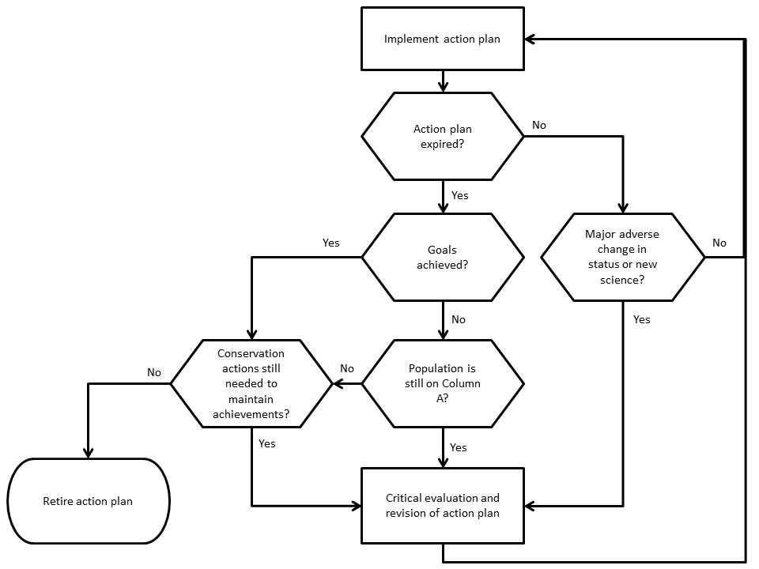

Process for the Revision or Retirement of ISSAPs

The revision or retirement of Action Plans based on the decision-making process above shall be proposed to the AEWA Meeting of the Parties by the AEWA Technical Committee in close collaboration with the AEWA Secretariat, as appropriate. On the basis of such a proposal, the Meeting of the Parties will be requested to take a decision on whether the suggested plan(s) shall be revised/retired or not.

In the case of joint Action Plans with other international intergovernmental organizations (Convention on Migratory Species, Bern Convention, European Commission), the UNEP/AEWA Secretariat will consult with the respective organizations following the recommendation of the Technical Committee and will subsequently inform them of the revision/retirement of the joint Action Plans within the AEWA process. Following a decision of the MOP to revise/retire an Action Plan, the Secretariat will also publish the information on the AEWA website and indicate any plans which have been retired.

The AEWA Technical Committee will continue to monitor the status of the species for which Action Plans have been retired within the framework of the CSR and the prioritization of AEWA species for action and management planning. Should such species populations once again become prioritized for an Action Plan - for example on the basis of new information or a change in conservation status – the Secretariat will arrange for the retired Action Plan to be revised and submitted to the MOP for adoption and subsequent implementation.

- GUIDANCE ON DEFINING THE ACTION PLAN SPATIAL SCOPE FOR SPECIES WITH A WIDE GEOGRAPHICAL RANGE
Background

Various approaches are used in the existing AEWA Action Plans to determine the geographic scope and the Principal Range States which carry the major responsibility for the implementation of the respective plans. For Action Plans covering species populations with a wide geographic distribution, relatively high numbers and/or different sub-species, a more differentiated approach may be necessary in order to limit the scope of the plan so that urgent activities for implementation remain focused on the most important Range States.

The categorization suggested below has been introduced in the draft AEWA International Single Species Action Plan for the Eurasian Curlew, which covers the sub-species Numenius a. arquata, N. a. orientalis and N. a. suschkini and is expected to be adopted at MOP6 in November 2015.

Defining the ISSAP spatial scope for species with a large geographic range

The following categories are proposed for defining the geographical scope and determining the subsequent Principal Range States for species with large global coverage:

- Principal Range States: Range States that regularly support a set percentage (between 1 and 5% of the biogeographic population) breeding and/or non-breeding numbers of the species/subspecies and ideally not exceeding 20 countries;

- Survey Range States: Range States for which there is currently insufficient data available to assess their significance for the species;

- Consultation Range States: Range States which host breeding and/or non-breeding numbers below the set percentage threshold (between 1 and 5% of the biogeographic population). Following consultation, these Range States may choose to be considered as a Principal Range State in the context of ISSAP implementation.

