REPORT ON THE DEVELOPMENT OF WATERBIRD MONITORING
ALONG THE AFRICAN-EURASIAN FLYWAYS

Compiled by Wetlands International and the UNEP/AEWA Secretariat

Executive Summary

This paper presents an overview of the progress that has been made by the African-Eurasian Waterbird Monitoring Partnership since MOP5 in response to operative paragraph 1 of Resolution 5.22. The report describes the achievements made in the field of network and capacity development, the technical improvements and outputs from the International Waterbird Census (IWC). However, it also highlights that funding for all these activities is largely based on short-term project funding (except data management that is funded by Wetlands International) with no long-term sustainability and addressing this issue requires urgent measures. To this end the paper proposes five actions:

- Create a Waterbird Monitoring Fund under AEWA and invite voluntary contributions from donor Parties to support low-income Parties in monitoring the internationally important sites on their territory.

- Suggest Contracting Parties and other stakeholders to incorporate waterbird monitoring into the twinning schemes they were encouraged to establish under Resolution 5.20 or other flyway-related collaborative programmes.

- Invite the flyway coordinator to identify funding needs and through the UNEP/AEWA Secretariat inform Contracting Parties and other stakeholders about gaps to be filled on an annual basis.

- Invite the organisations participating in the Waterbird Monitoring Partnership to jointly establish a Waterbird Partnership Fund to raise funds for waterbird monitoring and other AEWA-related activities primarily from the private and corporate sector.

- Invite Contracting Parties, non-governmental organisations and other organisations to use the World Migratory Bird Day events as fundraising opportunities.

Background

As described in document AEWA/MOP5 42 Rev.1 (Strategic Development of the Waterbird Monitoring in the African-Eurasian Flyways), waterbird monitoring is an essential tool for the implementation of the Agreement in many respects, however, the capacity at site, national and international level is insufficient for adequate monitoring of waterbird populations in the Agreement area. As the 6th edition of the AEWA Conservation Status Report (CSR6) again shows, only about 1/3 of the status assessment of the AEWA populations are based on monitoring activities.
Recognising that inadequate funding represents a major impediment to the future development of waterbird monitoring activities across the flyway, which are needed for mobilising and curating information needed for the compilation of the AEWA Conservation Status Reports, the Meeting of the Parties has adopted Resolution 5.22 on establishing a long-term basic structural funding regime for the international waterbird census in the African-Eurasian region.

Paragraph 1 of this resolution "Invites the Technical Committee to work with the Waterbird Monitoring Partnership to make progress towards the monitoring-related targets of the AEWA Strategic Plan 2009-2017 and to report to MOP6 and, if required, to propose this issue to be revisited at MOP6 with the aim to secure a long-term, sustainable solution for international waterbird monitoring". This report outlines the progress made since the 5th Session of the Meeting of the Parties to AEWA (MOP5) and assesses the long-term adequacy and sustainability of the current arrangements.

Organisational development

The Strategic Working Group of the African-Eurasian Waterbird Monitoring Partnership, established in 2011, continued to meet biannually and has slightly expanded its membership. The Strategic Working Group includes organisations with long-term strategic interest in the development of waterbird monitoring at regional, sub-regional or flyway scale.

It is chaired by Dr Johan Mooij as representative of the Member Delegates of Wetlands International and includes the UNEP/AEWA Secretariat, BirdLife International, the British Trust for Ornithology (BTO), the European Bird Census Council, the Federation of Associations for Hunting and Conservation of the European Union (FACE), the French Hunting and Wildlife Agency (ONCFS), the Dutch Centre for Field Ornithology (SOVON), Tour du Valat Fondation (TdV), the Wildfowl and Wetlands Trust (representing the WI/IUCN SSC Species Specialist Groups) and Wetlands International. Regional meetings of the national International Waterbird Census (IWC) coordinators from Africa and the Western Palearctic elected their representatives for the Strategic Working Group in 2012 and 2013 respectively.

A regularly updated website, quarterly newsletters and a waterbird forum facilitate the exchange of information amongst the national coordinators and wider group of stakeholders including AEWA and Ramsar
National Focal Points.

Five major projects, of which four were co-funded by the MAVA Foundation (the first four in the list below), have contributed to strengthening the national waterbird monitoring schemes:

- The Conserving Migratory Birds in West Africa together with the Wadden Sea Flyway Initiative, coordinated by SOVON, BirdLife International and the Africa Office of Wetlands International supported seven coastal countries from Mauritania to Sierra Leone;
- The Mediterranean Waterbird Monitoring Project, coordinated by Tour du Valat and ONCFS, supported the five countries of North Africa;
- The Adriatic Flyway Initiative, led by EuroNatur, has supported Albania and countries of the former Yugoslavia;
- The Strengthening of the International Waterbird Census in the African-Eurasian Flyway project, coordinated by Wetlands International, has supported another 30 countries; and finally;
- The Technical Support Unit of the AEWA African Initiative (ONCFS/TdV) has organised a data management workshop for the Francophone countries in Africa and supported counts in Senegal, Sudan & Egypt.

As the result of such support, countries’ participation and willingness to report their observations has increased substantially (Figures 1 and 2). However, support to counts and national capacity building activities in low-income countries was very irregular. The majority of the support was available to West Africa and the Mediterranean and more limited support could be provided to Eastern Europe, Central Asia and East Africa.

Flyway level coordination was supported, apart from the MAVA project (2012-2013), by voluntary contributions from the Swiss Federal Office for the Environment (2012-2014), the UK Department for Environment, Food and Rural Affairs (2013) the French Ministry of Ecology, Sustainable Development and Energy (MEDDE), Sustainable Development and Energy (2014) and the EU LIFE+ NGO Operational Grant (2014). However, at the time of writing, funding for the coordination position was still not available for 2015.

Ongoing data acquisition and curating was funded by Wetlands International, which ensured timely production of annual count total reports and was fundamental in rebuilding the trust of the network of coordinators.

Technical improvements

With the support of the MAVA Foundation, an existing online data gathering portal (www.observado.org), was modified to cater for the needs of national schemes that cannot afford to develop their own online database. Also, a new global online IWC database was developed that allows national coordinators to directly upload, download and share their data. The aim of these activities is to accelerate data flow in the future.

Impact

As the result of reorganising the scheme coordination, embracing the partnership approach and the technical improvements, it was possible to reduce the time-lag between the last year of the trend period used for trend analysis in the AEWA Conservation Status Report from five years in CSR5 to only three - in the case of West African populations even to one year - in CSR6.

Annual IWC count totals have been produced every year since 2011. Population size and trend estimates are produced for the AEWA Conservation Status and the Waterbird Population Estimates are now published in a searchable online database (wpe.wetlands.org) and the online database also allows for consultation with the expert networks. These latest developments contributed to meeting the indicator of Target 3.1 of the AEWA Strategic Plan 2009-2017.

Since 2011, 18 data request were served, which resulted in 12 scientific articles or reports (see full list in Appendix). These reports addressed issues such as range shifts caused by climate change, the effectiveness of protected area networks and indicators.

The number of populations whose status could be analysed based on monitoring data has increased by 75% (the AEWA Strategic Plan 2009-2017 target 3.1. indicator was a 50% increase) and now 36% of the AEWA populations is assessed based on regular monitoring data, although this was not only the result of the improvement in the IWC, but also the data mobilisation for the Art. 12 reporting under the EU Birds Directive and the European Red List of Birds projects, which also played an important role in the improvements.

Funding and its sustainability

With the exception of the special counts and the support to counts in low-income countries, the financial targets set out in document AEWA/MOP 5.42 were largely met. In total, an estimated 427 thousand Euro was raised for various components in 2014. In the case of capacity development, available funding to the five projects mentioned above has even exceeded the minimum estimates.

However, apart from the funding from Wetlands International to data management, all funding is project-based and short- or maximum medium-term without any guarantee of long-term sustainability. This is particularly problematic in the case of count support in low-income countries and flyway level coordination.

In the case of the former, this results in irregular and insufficient coverage of key sites, which leads to highly fluctuating and uncertain population size and trend estimates at flyway level. In the case of the latter, this hinders ongoing coordination between various stakeholders (e.g. national coordinators, expert groups, organisations leading on capacity building, donors, UNEP/AEWA Secretariat and Technical Committee), and systematic work on the implementation work plan of the partnership although the experience of the last three years has shown the value of these activities. The failure to develop the guidelines requested in Paragraphs
2-4 of Resolution 5.2 is a clear example for strategic tasks that could not be implemented, due to the absence of funding for flyway level coordination.

It is clear from the above that the current funding regime does not provide the long-term predictable structural funding necessary to fulfil the needs of AEWA, neither at international nor at national level in low-income countries. However, the experience of the last three to four years demonstrates what can be achieved with a programmatic approach and sufficient capacity if the necessary funding is available. To maintain the achievements so far, the amounts estimated as part of the JNCC funded IWC review and presented in AEWA/MOP 5.42 (see the second column in the table attached to this paper) would be necessary including the 80,000 Euro for supporting counts of critical sites in low income countries and a further 65,000 Euro for the flyway level coordination.

So far, amongst the capacity building projects, only the Adriatic Flyway 3 Project, was approved for continuation until the end of February 2018. The Wadden Sea Flyway Initiative phase two is planned to run from 2015 to 2018, but confirmation is still pending. It is already known that the application of the Wetlands International European Association to the EU LIFE+ NGO Operational Grant scheme, which included a significant proportion of the funding for flyway level coordination, was not successful and at the time of writing this report, no funding had been pledged for the flyway-level coordination or for counts in low-income countries in 2015.

Document AEWA/MOP 5.42 has explored five different options. The options “business as usual” and “incorporating the costs of the IWC into products” are clearly not to be pursued because past experience shows that they do not work. Based on the discussions at MOP5 and the understanding that the financial situation of both the UNEP/AEWA Secretariat (and other MEA Secretariats) as well as Contracting Parties, make it unlikely that the option of a) incorporating the costs of the IWC into the AEWA core budget or b) contributing proportionately to a dedicated budget line of the AEWA Trust Fund, will be accepted at the next MOP. However, a multipronged approach that combines a range of options suited for different audiences could produce results.

Recommendations

The following options could still improve the predictability of funding for IWC counts in low-income countries and for flyway level coordination:

- Create a Waterbird Monitoring Fund under AEWA and invite voluntary contributions from donor Parties to support low-income Parties in monitoring the internationally important sites on their territory. A proportion of the contributions could be reserved for the coaching activities to be provided by the flyway level coordinator to make sure that the counts are carried out according to the best practices for waterbird monitoring and the results are useful for flyway level population size and trend analyses (This option builds on the fourth option in document AEWA/MOP 5.42). This fund would work under the UNEP- managed AEWA Trust Fund.

- Suggest Contracting Parties and other stakeholders to incorporate waterbird monitoring into the twinning schemes they were encouraged to establish under Resolution 5.20 or other flyway-related collaborative programmes. Good examples for such arrangements exist e.g. under the Wadden Sea Flyway Initiative between the Wadden Sea and Banc d'Arguin or between France, Sudan and Egypt.

- Invite the flyway coordinator to identify funding needs and through the UNEP/AEWA Secretariat inform Contracting Parties and other stakeholders about gaps to be filled on an annual basis.

- Invite the organisations participating in the Waterbird Monitoring Partnership to jointly establish a Waterbird Partnership Fund to raise funds for waterbird monitoring and other AEWA-related activities.

- Invite Contracting Parties, non-governmental organisations and other organisations to use the World Migratory Bird Day events as fundraising opportunities and to contribute to the Waterbird Monitoring Fund or to the Waterbird Partnership Fund. Also, invite the Secretariat and the Partnership to provide guidelines to the Contracting Parties in this respect.
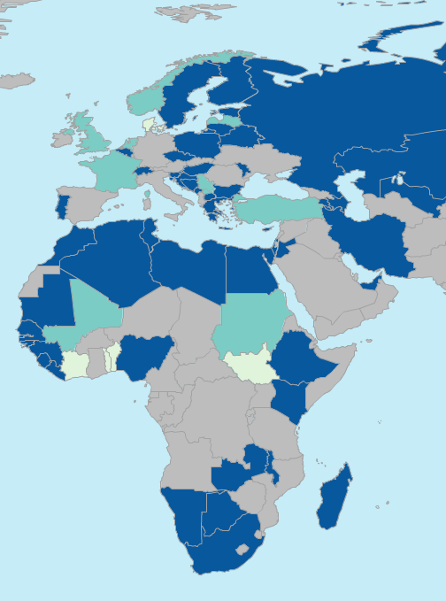
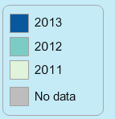
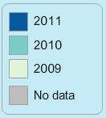
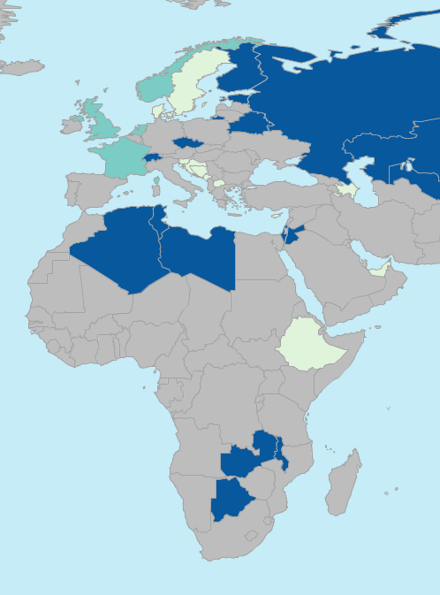

Figure 1. Data availability in 2011 and 2013

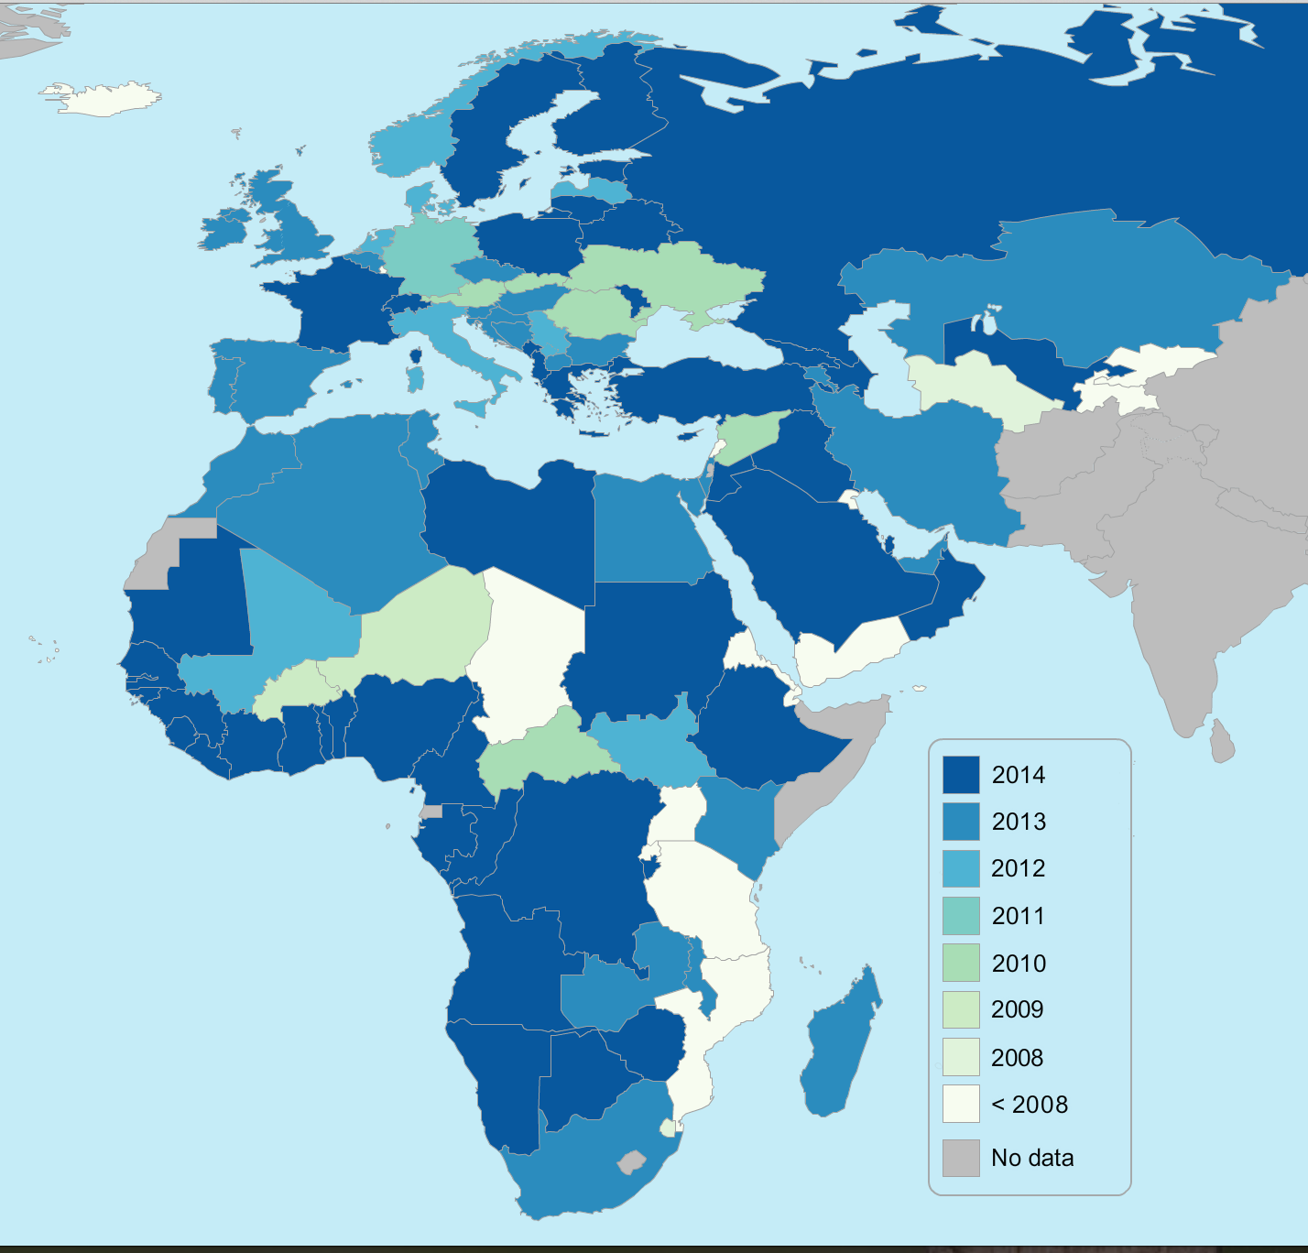

Figure 2. Latest data available in 2014
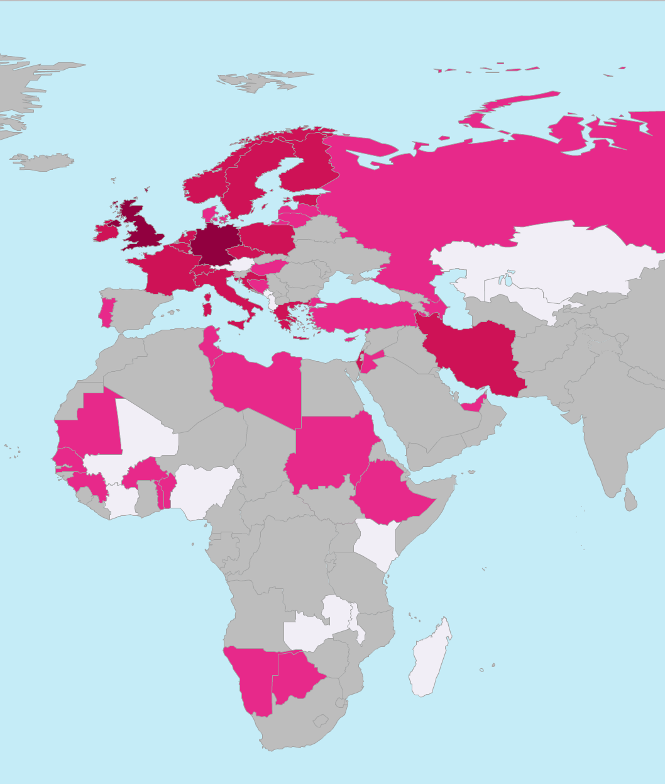  2011 | 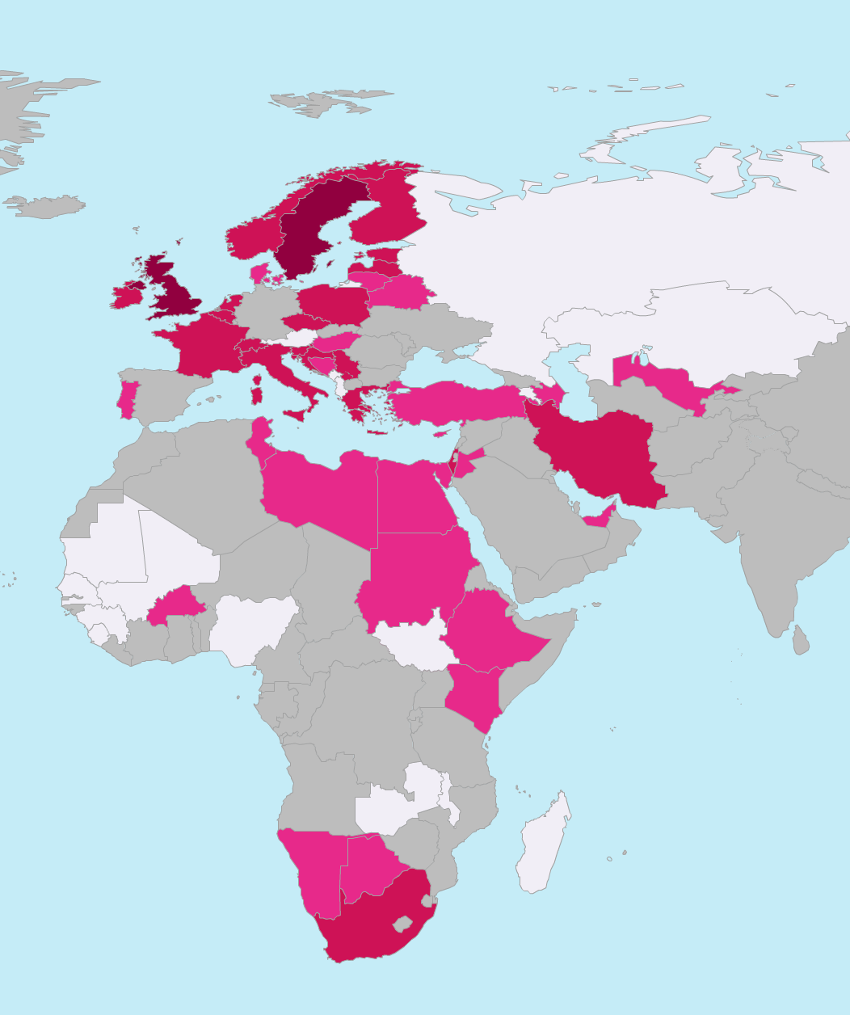  2012
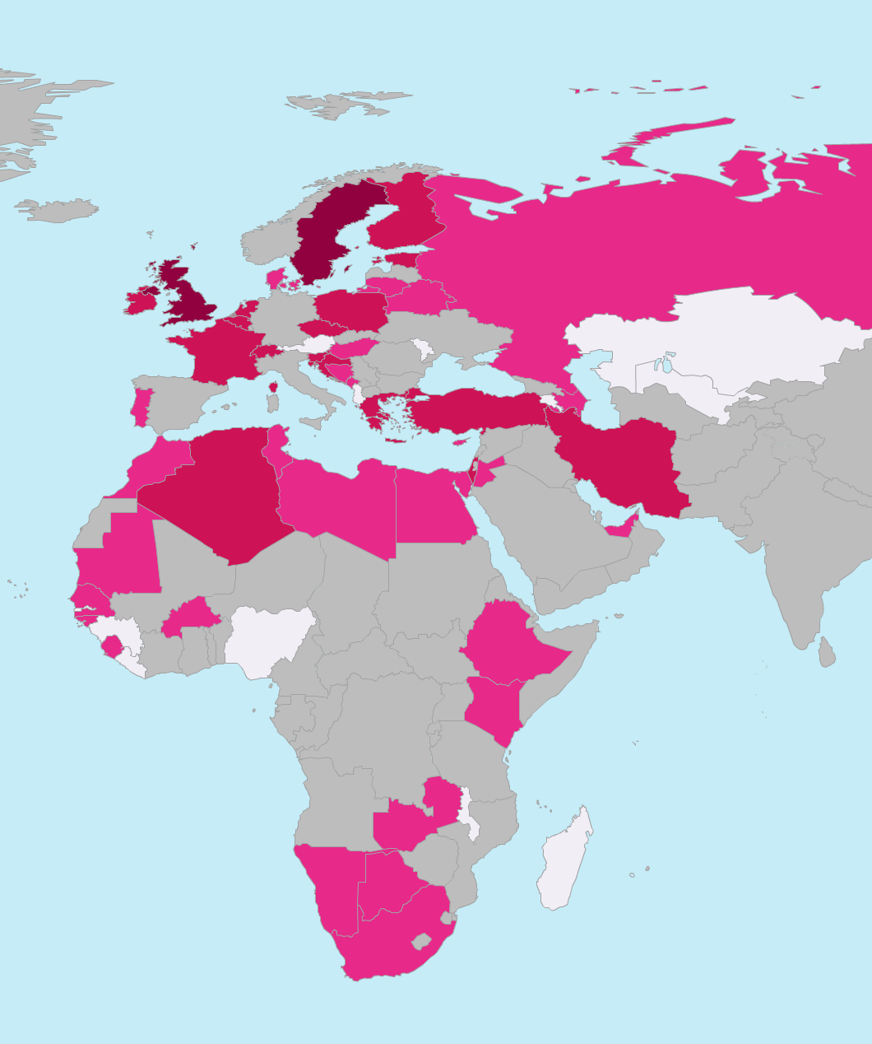  2013 | 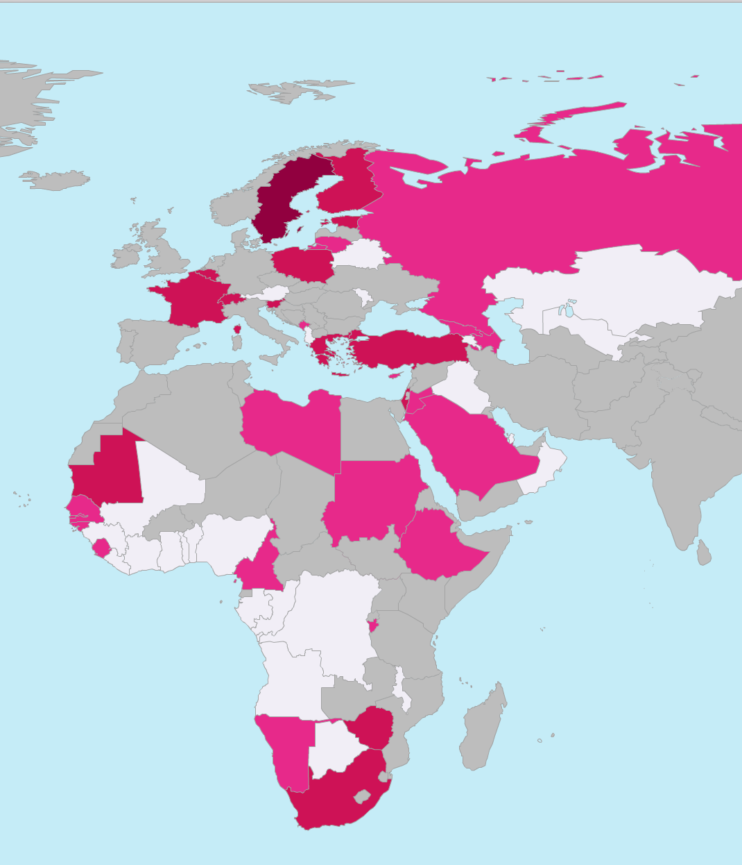  2014

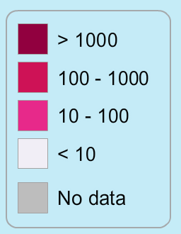

Figure 3. Number of site visits per country

Financial overview based on estimates in document AEWA/MOP 5.42

Component | Total estimated  (all costs  x1,000 €) | Realised in 2014  (all costs  x1,000 €) | Comments
Annually recurring activities
Global coordination and data management | 100 | 100 | Association of the Members of Wetlands International
Basic regional coordination | 65 | 54 | Supported by the EU LIFE+ NGO Operational Grant, voluntary contributions of Switzerland and France in 2014. Funding for 2015 is not yet secured.
IWC coordinators’ meeting (one meeting per region per year, three regions) | 30 | n.a. | Not applicable in 2014, but it was funded by the MAVA Foundation. However, both the Pan-African Ornithological Congress and the European Bird Census Council Conferences will be in 2016 and this means that c. 50-60 thousand Euro will be needed to support the participation of national coordinators at these events
Capacity development in countries with insufficient coverage of key sites | min. 40 | c. 200 | Wadden Sea Flyway Initiative addresses countries along the East Atlantic Flyway in Africa. Focus countries are: Mauritania, Senegal, Cabo Verde, Guinea Bissau, Guinea and Sierra Leone. Currently this work is supported by the Netherlands and Germany.  Tour du Valat/ONCFS Mediterranean Waterbird Monitoring project focuses on North Africa: Morocco, Algeria, Tunisia, Libya and Egypt. EuroNatur focuses on supporting Bosnia-Herzegovina, Serbia, Montenegro, Macedonia and Albania. Plan of Action for Africa: ONCFS and Tour du Valat are still in the process of defining their priorities, but it is likely to be the Sahelian zone building on their earlier work in Sudan, South Sudan, Chad, Mali and Senegal.
Small grants for general IWC counts in developing countries | min. 80 | c. 64 | No funding is available yet other than in the above- mentioned capacity building projects. In the case of West Africa, this was €12k in 2013 and €43k (+€36k to support assistance by European counters) in 2013. It was c. €11k in North Africa. The MAVA project has also contributed some €10k to counts as part of training counts. This sum does not include costs at ONCFS (Sudan and South Sudan) and EuroNatur.
Goose and swan counts | min. 22 | 0
Seaduck counts coordination | min. 16 | 9 | EU LIFE+ NGO Operational Grant and AEWA
Total of annual costs | min. 353 | 427
Triannual costs
Seaduck counts | 85 | 0 | Coordinated counts are planned for 2016/17 in the Baltic Sea
Tidal wetland counts in Africa and the Middle East | 70 | 0 | The CMB/WFI contributed to this in West Africa
AEWA Conservation Status Report | 55 | 71 | AEWA and Switzerland
CSN Tool update | 50 | 0
Waterbird Population Estimates | min. 30 | 0
Policy relevant indicators | n.a. |  | Indices for wintering waterbirds in the EU were developed under the EU LIFE+ NGO operational grant
Special analyses | n.a. | 16 | Pan-European and European Union level trend analyses contributed to the European Red List of Birds project
Total periodic costs | 290 | 87

Keys:
min.: indicates a minimum cost estimate, but projects with enhanced content may actually cost more.
n.a.: indicates that the activity responds to needs to be defined bilaterally and it is not possible to estimate the costs here.

Appendix: List of publications that used the IWC data and IWC data requests

2015
1. Nagy, Szabolcs, Langendoen, Tom & Flink, Stephan: A Pilot Wintering Waterbird Indicator for the European Union. Wetlands International European Association, Ede.
http://www.wetlands.org/WatchRead/Currentpublications/tabid/56/mod/1570/articleType/ArticleView/articleId/3711/Default.aspx

2. Pavón-Jordán, Diego, Fox, Anthony D., Clausen, Preben, Dagys, Mindaugas, Deceuninck, Bernard, Devos, Koen, Hearn, Richard D., Holt, Chas A., Hornman, Menno, Keller, Verena, Langendoen, Tom, Ławicki, Łukasz, Lorentsen, Svein H., Luigujõe, Leho, Meissner, Włodzimierz, Musil, Petr, Nilsson, Leif, Paquet, Jean-Yves, Stipniece, Antra, Stroud, David A., Wahl, Johannes, Zenatello, Marco, Lehikoinen, Aleksi 2015. Climate-driven changes in winter abundance of a migratory waterbird in relation to EU protected areas. Diversity and Distributions, 1472-4642
http://dx.doi.org/10.1111/ddi.12300

2014
1. Kleijn, D., Cherkaoui, I., Goedhart, P. W., Hout, J., & Lammertsma, D. (2014). Waterbirds increase more rapidly in Ramsar-designated wetlands than in unprotected wetlands. Journal of Applied Ecology, 51(2), 289-298.
http://onlinelibrary.wiley.com/doi/10.1111/1365-2664.12193/abstract

2. Nagy, Szabolcs, Flink, Stephan & Langendoen, Tom 2014. Waterbird trends 1988-2012: Results of trend analyses of data from the International Waterbird Census in the African-Eurasian Flyway. Wetlands International, Ede.
http://www.wetlands.org/Portals/0/TRIM%20Report%202014_10_05.pdf

3. van Roomen, M., van Winden, E. & T. Langendoen 2014. The assessment of trends and population sizes of a selection of waterbird species and populations from the coastal East Atlantic Flyway for Conservation Status Report 6 of the African Eurasian Waterbird Agreement. Wadden Sea Flyway Initiative, Wetlands International & Birdlife International, Nijmegen.
http://www.wetlands.org/Portals/0/EAF_selection%20of%20species2014_2.doc.pdf

2013
1. Aunins, A., Nilsson, L., Hario, M., Garthe, S., Dagys, M., Pedersen, K. I., & Skov, H. (2013). Abundance of waterbirds in the wintering season. HELCOM Core Indicator of Biodiversity.
http://www.helcom.fi/Core%20Indicators/HELCOM-CoreIndicator_Abundance_of_waterbirds_in_the_wintering_season.pdf

2. Lehikoinen, Aleksi, Jaatinen, Kim, Vähätalo, Anssi V., Clausen, Preben, Crowe, Olivia, Deceuninck, Bernard, Hearn, Richard, Holt, Chas A., Hornman, Menno, Keller, Verena, Nilsson, Leif, Langendoen, Tom, Tománková, Irena, Wahl, Johannes, Fox, Anthony D. 2013. Rapid climate driven shifts in wintering distributions of three common waterbird species. Global Change Biology 19: 1365-2486
http://dx.doi.org/10.1111/gcb.12200

3. Dalby, Lars; Söderquist, Pär; Christensen, Thomas K.; Clausen, Preben; Einarsson, Árni; Elmberg, Johan; Fox, Anthony D.; Holmqvist, Niklas; Langendoen, Tom; Lehikoinen, Aleksi; Lindström, Åke; Lorentsen, Svein-Håkon; Nilsson, Leif; Pöysä, Hannu; Rintala, Jukka; Sigfússon, Arnór Þ.; Svenning, Jens-Christian. 2013. The status of the Nordic populations of the Mallard (Anas platyrhynchos) in a changing world. Ornis Fennica 90: 2-15
http://pure.au.dk/portal/files/54026900/Dalbyetal2013.pdf

2012
1. Harebottle, Doug M. 2012. Assessing the Conservation Value of Wetlands and Waterbirds with a Focus on the Winter Rainfall Region of South Africa. Ph.D. Thesis. University of Cape Town: South Africa.
http://adu.org.za/pdf/Harebottle_DM_PhD_thesis_UCT_May2012.pdf

2. Dalby, Lars, Fox, Anthony D., Petersen, Ib K., Delany, Simon, Svenning, Jens-Christian. 2012. Temperature does not dictate the wintering distributions of European dabbling duck species. Ibis 155:80-88
http://onlinelibrary.wiley.com/doi/10.1111/j.1474-919X.2012.01257.x/abstract;jsessionid=F7605ED4D36AEB1F26CB7FE39430DC31.d03t01

3. van Roomen M., Hornman M., Flink S., Langendoen T., van Winden E., Nagy S. & van Turnhout C. 2012. Flyway-trends for waterbird species important in Lakes IJsselmeer and Markermeer. Sovon-rapport 2012/22, Sovon Dutch Centre for Field Ornithology, Nijmegen - the Netherlands.
http://www.wetlands.org/Portals/0/Rap_2012-22_FlywaytrendsTotaalLR.pdf

Data requests:

2015
1. Goose Specialist Group: Update of population estimates for Bean Geese wintering in Europe
http://www.wetlands.org/Portals/0/Rap_2012-22_FlywaytrendsTotaalLR.pdf

2014
1. Society for the Protection of Prespa. Conservation of pelicans in Greece and SE Europe.
2. Cormorant Specialist Group (EU project CorMan): Pan-European roost count Great Cormorant, January 2013.
3. Division of Biology & Conservation Ecology, School of Science & the Environment, Manchester Metropolitan University: The Conservation and Management of Selected Huntable Bird Species in Europe
http://www.wetlands.org/Portals/0/Rap_2012-22_FlywaytrendsTotaalLR.pdf

2013
1. ONCFS. PhD thesis: Influence of post-harvest agricultural practices on rice field use by wintering ducks
Wetlands International Foundation: Iraqi Marshlands World Heritage comparative analysis
http://www.wetlands.org/Portals/0/Rap_2012-22_FlywaytrendsTotaalLR.pdf

2012
1. Ligue pour la Protection des Oiseaux. Trend analysis of non-breeding birds in France.
2. Alterra Wageningen UR. Econet-flyways - analysis on flyway patterns
3. Wildfowl & Wetlands Trust: Understanding trends and distribution changes in wintering Red-breasted Goose
4. Sovon: Naar een effectief en internationaal verantwoord beheer van de in Nederland overwinterende populatie Kolganzen (Anser albifrons)
5. Centre d'Etudes Biologiques de Chizé UPR : Distribution and decline of Common and Brown Scoters in the Western Palaearctic region.
6. ONCFS: Redaction of a monograph on Teal (Anas crecca)

2011
1. NOWAC initiative: Long-term trends in ecosystem effects on food quality and abundance, and the consequences for population trends in migratory waterbirds.
2. CIRAD ESUR Animal et Gestion intégrée des risques : GRIPAVI - geographical and seasonal variations in avian influenza prevalence
3. IMARES PhD thesis: Trends of wintering Scaup in North-west Europe
4. CNRS: Influence of global changes on wader communities
5. University Lille: Spatio-temporal evolution of the migration of sea ducks in European coasts.
6. Doñana Biological Reserve Station: Long distance dispersal of aquatic organisms by waterbirds
7. Centre for Ecological Research and Forestry Applications (CREAF): Shorebird populations trends

http://www.wetlands.org/AfricanEurasianWaterbirdCensus/tabid/2788/Default.aspx

