RESOLUTION 4.8

FINANCIAL AND ADMINISTRATIVE MATTERS

Recalling Article V, Paragraph 2 (a) and (b), of the Agreement, which states that Parties shall contribute to the budget of the Agreement in accordance with the United Nations scale of assessment,

Acknowledging with appreciation the financial and other support provided by the Government of the Federal Republic of Germany for hosting the Agreement Secretariat, which is co-located with the Secretariat of the Convention on the Conservation of Migratory Species of Wild Animals in Bonn,

Furthermore acknowledging with appreciation that the Government of Germany has provided a Junior Professional Information Officer as of 1 October 2005 to 30 September 2008 to strengthen the capacity of the Agreement Secretariat,

Aware that the 4th Conservation Status report shows that more than 40 percent of the populations covered by AEWA are in decline and that some are even on the brink of extinction,

Further aware that more needs to be done to significantly reduce the current rate of biodiversity loss in accordance with the 2010 target,

Recognizing the importance of all Parties being able to participate in the implementation of the Agreement and related activities,

Appreciating the additional support given by various Parties and intergovernmental and non-governmental organisations on a voluntary basis to implement the Agreement,

Furthermore appreciating the support of the Global Environment Facility for the development and implementation of the Wings over Wetlands UNEP-GEF African-Eurasian Flyways project,

Recognizing the need to provide sufficient resources to enable the Secretariat to implement the AEWA Strategic Plan 2009-2017 and to serve all Parties in the Agreement area,

Aware that many Parties, particularly developing countries or countries with economies in transition, may not have the financial means to send representatives to meetings of bodies established under the Agreement,

Noting the considerable number of Contracting and non-Contracting Parties as well as organisations attending the fourth session of the Meeting of the Parties, and the resulting additional expenditures to Parties thus incurred, and

Further noting that the 5th session of the Meeting of the Parties should take place preferably after the 11th session of the Conference of the Parties to the Ramsar Convention on Wetlands to enable synergies and make savings.

The Meeting of the Parties:

- Decides that the 5th Meeting of the Parties shall take place in 2012;

- Confirms that Parties shall contribute to the budget adopted at the scale agreed upon by the Meeting of the Parties in accordance with Article V, Paragraph 2 (a) and (b), of the Agreement;

- Adopts the budget for 2009-2012 attached as Appendix I to the present Resolution;

- Agrees with the scale of contributions for Parties to the Agreement as listed in Appendix II to the present Resolution, and to the application of that scale pro rata to new Parties;

- Agrees that the minimum contribution shall not be less than 2000 Euros per annum and that exceptionally for the period 2009-2012 the maximum contribution shall be restricted to 20 percent of the total budget;

- Instructs the Secretariat, using the financial regulations and rules of the United Nations; the staff regulations and rules of the United Nations and other administrative policies or procedures; promulgated by the Secretary-General of the United Nations, to develop a series of budget scenarios based on the AEWA Strategic Plan 2009-2012 for further consideration by Parties at the fifth Meeting of Parties in 2012;

- Requests Parties, in particular those that are required to pay the minimum contribution, to consider paying for the whole quadriennium in one installment;

- Further requests Parties to pay their contributions promptly as far as possible but in any case not later than the end of June of the year to which they relate;

- Agrees to set the threshold of eligibility for funding of delegates to attend AEWA meetings at 0.200 on the UN Scale of Assessment and, as a general rule, to exclude countries from the European Union and European countries with strong economies, as listed in Appendix IV attached hereto and/ or countries that have payments in arrears of more than 3 years;

- Takes note of Resolution 4.10 of the Meeting of the Parties on the international implementation tasks for the period 2009-2012 and its related appendices;

- Urges all Parties to make voluntary contributions to the Trust Fund to support requests from developing countries and countries with economies in transition to participate in and implement the Agreement throughout the quadriennium;

- Further urges Contracting Parties and other partners to provide additional contributions to secure urgent implementation of the Agreement, in particular implementation of the GEF “Wings over Wetlands” project, implementation of the Strategic Plan 2009-2017 and implementation of the Communication Strategy;

- Invites States not Party to the Agreement, governmental, intergovernmental and non-governmental organisations and other sources to consider contributing to the implementation of the Agreement on a voluntary basis;

- Approves as of 1st of January 2009, and taking into account the UN Rules and Regulations, to:

- upgrade the post of Associate Technical Officer from P-2 to P-3; and

- change the status of the post of Associate Programme Officer from limited duration (L-2) to
fixed term (P-2);

- Invites Contracting Parties as well as the United Nations Environment Programme to consider the feasibility of providing gratis personnel and/or junior professional officers, in accordance with the United Nations rules and regulations, to strengthen the capacity of the Agreement Secretariat;

- Requests the Executive Director of the United Nations Environment Programme to extend the duration of the Trust Fund to 31 December 2012; and

- Approves the terms of reference for the administration of the Agreement budget as set out in Appendix III to the present Resolution for the period 2009-2012.

Appendix I

BUDGET ESTIMATES 2009-2012

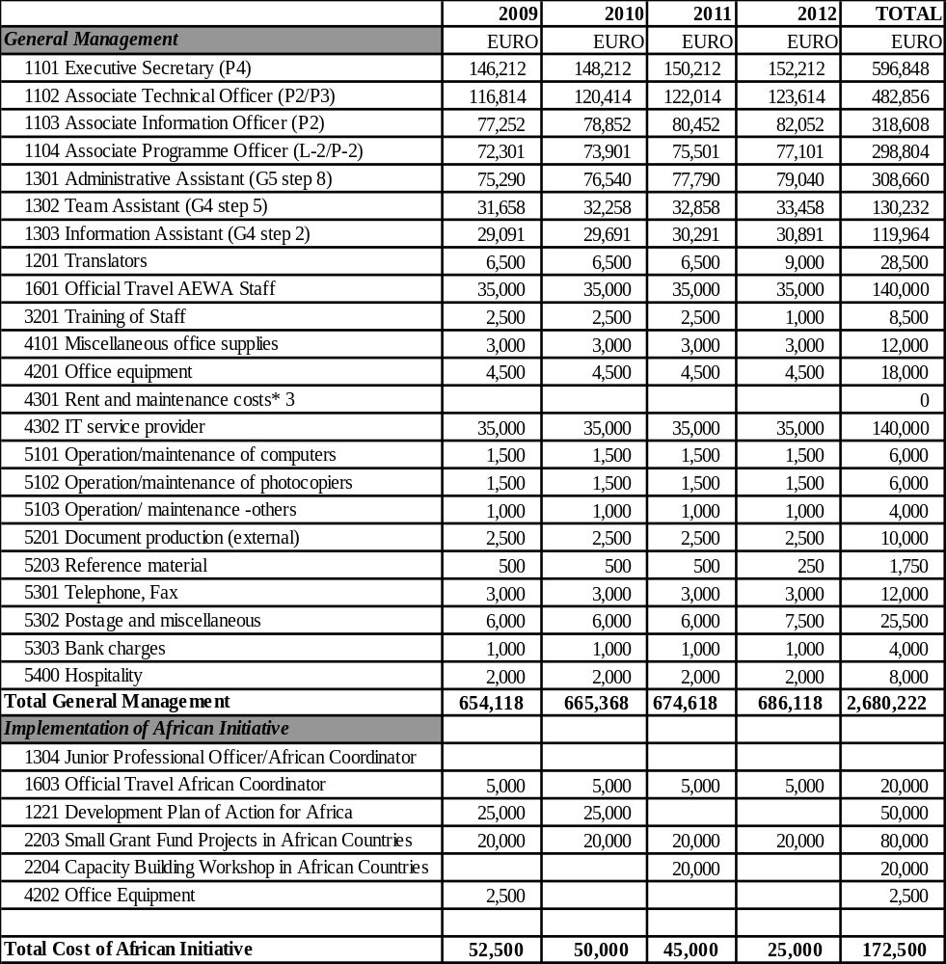

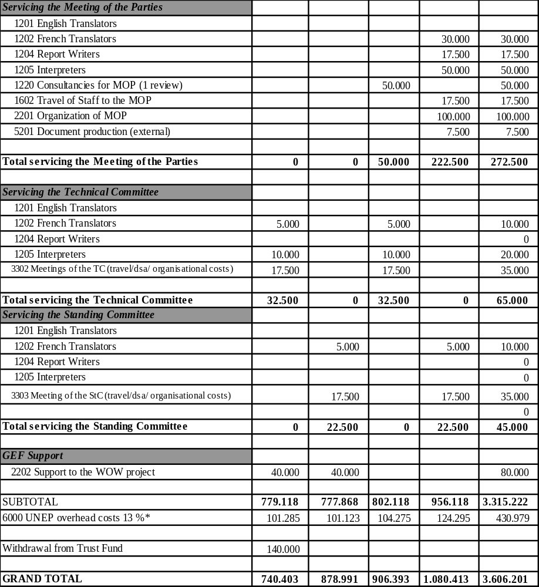

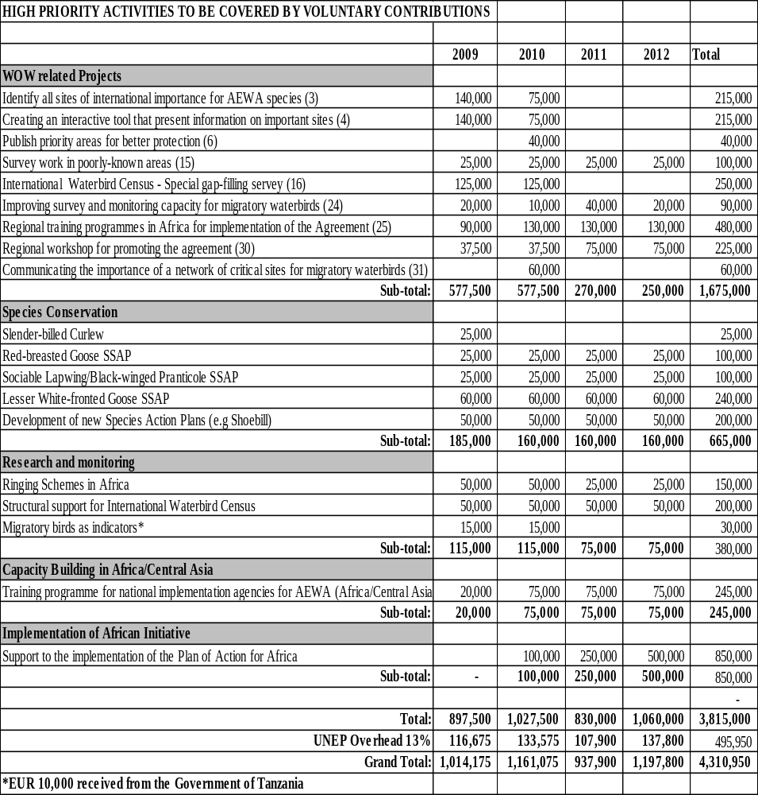

Appendix II

AEWA ANNUAL CONTRIBUTIONS FOR THE YEARS 2009-2012
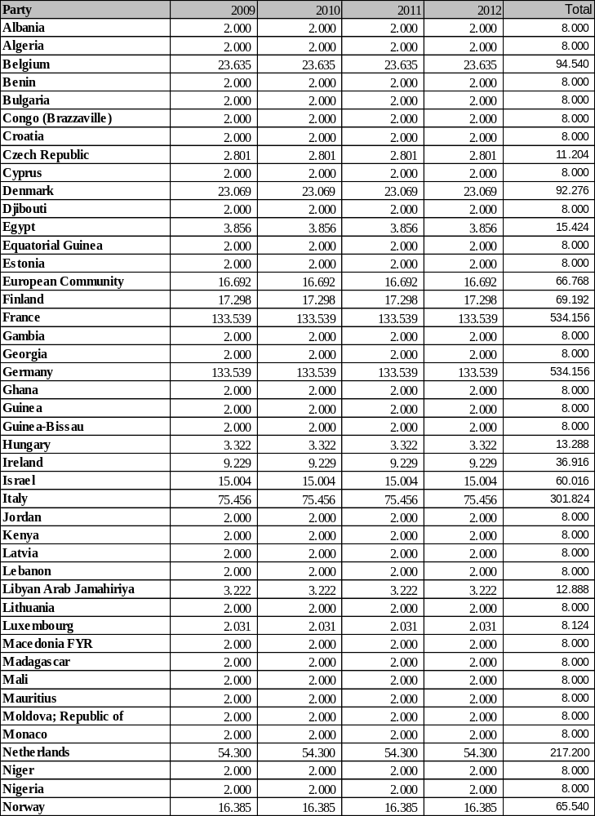
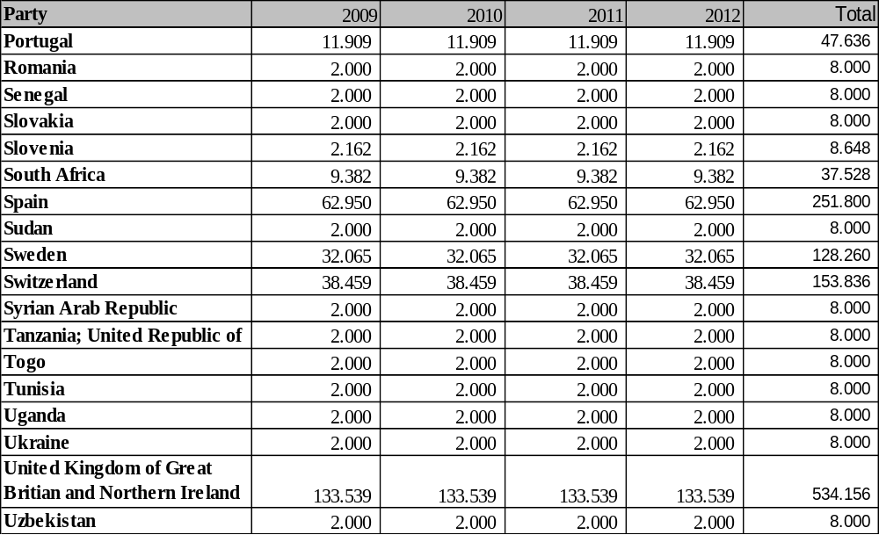
Appendix III

TERMS OF REFERENCE FOR THE ADMINISTRATION OF THE TRUST FUND FOR THE AGREEMENT ON THE CONSERVATION OF AFRICAN-EURASIAN MIGRATORY WATERBIRDS

- The terms of reference for the Trust Fund of the Agreement on the Conservation of African-Eurasian Migratory Waterbirds (AEWA) shall refer to the financial years beginning 1 January 2009 and ending 31 December 2012.

- The Trust Fund shall be administered by the Executive Director of the United Nations Environment Programme (UNEP) subject to the approval of the Governing Council of UNEP and the consent of the Secretary-General of the United Nations.

- The administration of the Trust Fund shall be governed by the financial regulations and rules of the United Nations, the staff regulations and rules of the United Nations and other administrative policies or procedures, promulgated by the Secretary-General of the United Nations.

- In accordance with United Nations rules, UNEP shall deduct from the income an administrative charge equal to 13 per cent of the expenditure charged to the AEWA Trust Fund in respect of activities financed under AEWA.

- The financial resources of the Trust Fund for 2009-2012 shall be derived from:

- Contributions made by Parties by reference to appendix II of Resolution 4.8, including contributions from any new Party; and

- Further contributions from Parties and contributions from States not Parties to the Agreement, other governmental, intergovernmental and non-governmental organisations and other sources.

- All contributions to the Trust Fund shall be paid in fully convertible Euros. For contributions from States that become Parties after the beginning of the financial period, the initial contribution (from the first day of the third month after deposit of the instrument of ratification, acceptance or accession until the end of the financial period) shall be determined pro rata based on the contribution of other States Parties on the same level of the United Nations scale of assessments, as it applies from time to time. However, if the contribution of a new Party determined on this basis would be more than 20 per cent of the budget, the contribution of that Party shall be 20 per cent of the budget for the financial year of joining (or pro rata for a part year). The contribution of each Party as laid down in appendix II of Resolution 4.8 shall be fixed until the next ordinary session of the Meeting of the Parties. Contributions of new Parties shall flow into the Trust Fund of the Agreement. Contributions shall be paid in annual installments. The contributions shall be due on 1 January 2009, 2010, 2011 and 2012.
Contributions shall be paid into the following account:

UNEP Euro Account
Account No. 6161603755
J.P. Morgan AG
Gruneburgweg 2
60322 Frankfurt / Main
Germany
Bank code number 501 108 00
SWIFT No. CHASDEFX
IBAN: DE 565011080061616 03755

- For the convenience of the Parties, for each of the years of the financial period the Executive Director of UNEP shall as soon as possible notify the Parties to the Agreement of their assessed contributions.

- Contributions received into the Trust Fund that are not immediately required to finance activities shall be invested at the discretion of the United Nations, and any income shall be credited to the Trust Fund.

- The Trust Fund shall be subject to audit by the United Nations Board of Auditors.

- The budget estimates covering income and expenditures for each of the four calendar years constituting the financial period to which they relate, prepared in Euros, shall be submitted to the Meeting of the Parties to the Agreement.

- The estimates of each of the calendar years covered by the financial period shall be divided into sections and objects of expenditure, shall be specified according to budget lines, shall include references to the programmes of work to which they relate, and shall be accompanied by such information as may be required by or on behalf of the contributors, and such further information as the Executive Director of UNEP may deem useful and advisable. In particular, estimates shall also be prepared for each programme of work for each of the calendar years, with expenditure itemized for each programme so as to correspond to the sections, objects of expenditure, and budget lines described in the first sentence of this paragraph.

- In addition to the budget estimates for the financial period described in the preceding paragraphs, the Secretariat of the Agreement, in consultation with the Standing Committee of the Agreement and the Executive Director of UNEP, shall prepare a medium-term plan as envisaged in chapter III of the Legislative and Financial Texts Regarding the United Nations Environment Programme and Environment Fund. The medium-term plan will cover the years 2009-2015, inclusive, and shall incorporate the budget for the financial period 2009-2012.

- The proposed budget and medium-term plan, including all the necessary information, shall be dispatched by the Secretariat to all Parties at least 90 days before the date fixed for the opening of the Meeting of the Parties.

- The budget and medium-term plan shall be adopted by unanimous vote of the Parties present and voting at the Meeting of the Parties.

- In the event that the Executive Director of UNEP anticipates that there might be a shortfall in resources over the financial period as a whole, the Executive Director shall consult with the Secretariat, which shall seek the advice of the Standing Committee as to its priorities for expenditure.

- Commitments against the resources of the Trust Fund may be made only if they are covered by the necessary income of the Agreement. No commitments shall be made in advance of the receipt of contributions.

- Upon the request of the Secretariat of the Agreement, after seeking the advice of the Standing Committee, the Executive Director of UNEP should, to the extent consistent with the financial regulations and rules of the United Nations, make transfers from one budget line to another. At the end of the first, second or third calendar year of the financial period, the Executive Director of UNEP may proceed to transfer any uncommitted balance of appropriations to the second, third or fourth calendar year respectively, provided that it does not exceed the total budget approved by the Parties, unless this is specifically sanctioned in writing by the Standing Committee.

- At the end of each calendar year of the financial period, the Executive Director of UNEP shall submit to the Parties, through the Agreement Secretariat, the accounts for the year. The Executive Director shall also submit, as soon as practicable, the audited accounts for the financial period. These shall include full details of actual expenditure compared to the original provisions for each budget line.

- Those financial reports required to be submitted to the Executive Director of UNEP shall be transmitted simultaneously by the Secretariat of the Agreement to the members of the Standing Committee.

- The Secretariat of the Agreement shall provide the Standing Committee with an estimate of proposed expenditures over the coming year simultaneously with, or as soon as possible after, distribution of the accounts and reports referred to in the preceding paragraphs.

- The present terms of reference shall be effective from 1 January 2009 to 31 December 2012.

Appendix IV

ELIGIBILITY FOR SPONSORSHIP FOR AEWA MEETINGS

N° | Party | Proposed rules  UN Scale in %  2009*
1 | Albania | 0.006
2 | Algeria | 0.085
3 | Belgium | 1.1020
4 | Benin | 0.001
5 | Bulgaria | 0.020
6 | Congo | 0.001
7 | Croatia | 0.050
8 | Cyprus | 0,044
9 | Czech Republic | 0.281
10 | Denmark | 0.739
11 | Djibouti | 0.001
12 | Egypt | 0.088
13 | Estonia | 0,016
14 | European Community | 2.500
15 | Equatorial Guinea | 0.002
16 | Finland | 0.564
17 | France | 6.310
18 | Gambia | 0.001
19 | Georgia | 0.003
20 | Germany | 8.577
21 | Ghana | 0.004
22 | Guinea | 0.001
23 | Guinea Bissau | 0.001
24 | Hungary | 0.244
25 | Ireland | 0.445
26 | Israel | 0.419
27 | Italy | 5.079
28 | Jordan | 0.012
29 | Kenya | 0.010
30 | Latvia | 0.018
31 | Lebanon | 0.034
32 | Libyan Arab Jamahiriya | 0.062
33 | Lithuania | 0.031
34 | Luxembourg | 0.085
35 | Macedonia; FYR | 0.005
36 | Madagascar | 0.002
37 | Mali | 0.002
38 | Mauritius | 0.011
39 | Moldova; Republic of | 0.001
40 | Monaco | 0.003
41 | Netherlands | 1.873
42 | Niger | 0.001
43 | Nigeria | 0.048
44 | Norway | 0,782
45 | Portugal | 0.527
46 | Romania | 0.070
47 | Senegal | 0.004
48 | Slovakia | 0.063
49 | Slovenia | 0.096
50 | South Africa | 0.292
51 | Spain | 2.968
52 | Sudan | 0.010
53 | Sweden | 1,0701
54 | Switzerland | 1.216
55 | Syrian Arab Republic | 0.016
56 | Tanzania; United Republic of | 0.006
57 | Togo | 0.001
58 | Tunisia | 0.031
59 | Uganda | 0.003
60 | Ukraine | 0.045
61 | United Kingdom of Great Britain and Northern Ireland | 6.642
62 | Uzbekistan | 0.008
 | Parties which are considered eligible for financial support to attend relevant AEWA-sponsored meetings.
 | Parties which are considered non-eligible for financial support to attend relevant AEWA-sponsored meetings.
* | UN Scale of Assessment 2007 -2009 as adopted by the General Assembly (doc. A/REs/61/237) on 13-2-2007.

The calendar year 1 January to 31 December is the accounting and financial year, but the official closure date is 31 March of the following year. Thus, on 31 March the accounts of the previous year have to be closed, and it is only then that the Executive Director can submit the accounts of the previous calendar year.

