DRAFT INTERNATIONAL SINGLE SPECIES ACTION PLAN FOR THE CONSERVATION OF THE SOCIABLE LAPWING

Introduction

The present International Single Species Action Plan for the Conservation of the Sociable Lapwing (Vanellus gregarius) is a revision of the AEWA ISSAP adopted by MOP2 in 2002. The revision was initiated in 2009 by the AEWA Secretariat in conjunction with the Royal Society for the Protection of Birds (BirdLife UK) in the framework of a Sociable Lapwing conservation project funded by the UK’s Darwin Initiative and co-funded by Swarovski Optik through the BirdLife’s Preventing Extinctions Programme.

This revised Action Plan is a joint CMS-AEWA SSAP due to the inclusion of the other species’ flyway leading to the Indian sub-continent. The Plan has been compiled by a team led by Robert Sheldon of RSBP. Drafts of the plan went through rigorous consultations with experts from the species’ range states and international organisations, the AEWA Technical Committee, the CMS Scientific Council followed by official consultation with governmental officials in the range states. In November 2011 the SSAP was adopted by the CMS COP10. The draft plan was endorsed for submission to MOP5 by the Technical Committee at its 10th meeting in September 2011 and the Standing Committee at its 7th meeting in November 2011.

The Action Plan follows the revised format for Single Species Action Plans approved by MOP4 in September 2008.

Action requested from the Meeting of the Parties

The Meeting of the Parties is invited to review this draft SSAP and adopt it for further implementation.

DRAFT INTERNATIONAL SINGLE SPECIES ACTION PLAN FOR THE CONSERVATION OF THE SOCIABLE LAPWING

Vanellus gregarius

Convention on the Conservation of Migratory Species of Wild Animals (CMS)

Agreement on the Conservation of African-Eurasian Migratory Waterbirds (AEWA)

Prepared by
The Royal Society for the Protection of Birds (RSPB)

Co-funded by
The UK Government’s Darwin Initiative and Swarovski Optik through Birdlife International’s Preventing Extinctions Programme



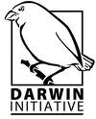


Compiled by: Rob Sheldon¹, Maxim Koshkin², Johannes Kamp¹, Sergey Dereliev³, Paul Donald¹ & Sharif Jbour⁴
1 RSPB, The Lodge, Sandy, Bedfordshire, SG19 2DL, UK
2 ACBK, 40, Orbita-1, off. 203, 050043 Almaty, Republic of Kazakhstan
3 UNEP/AEWA Secretariat, African-Eurasian Waterbird Agreement, UN Campus, Hermann-Ehlers-Str. 10, 53113 Bonn, Germany
4 Birdlife Middle East, Building No. 2, Salameh Al Maa’yta Street, Kahlda, Amman- Jordan, PO Box 2295, Amman 11953, Jordan
E-mail: robert.sheldon@rspb.org.uk; sdereliev@unep.de

Milestones in the production of the Plan:
Stakeholder workshop: 30th March – 1st April 2009, Almaty, Kazakhstan
First draft: June 2009, presented to experts
Stakeholder workshop: 18th – 20th March 2011, Palmyra, Syrian Arab Republic
Second draft: August 2011, presented to the Range States, the CMS Scientific Council and the AEWA Technical Committee
Final draft: October 2011, adopted by the 10th CMS Conference of the Parties in November 2011 and by the AEWA Standing Committee in 2011 for presentation to the 5th Session of the Meeting of the Parties to AEWA in May 2012, La Rochelle, France

Review
This International Single Species Action Plan is supersedes the AEWA International Single Species Action Plan for the Sociable Lapwing approved by MOP2 in 2002. The plan should be reviewed and updated every 10 years (next revision in 2022)

Geographical scope
This Single Species Action Plan shall be implemented in the following countries: Eritrea, Ethiopia, India, Iraq, Kazakhstan, Oman, Pakistan, The Russian Federation, Saudi Arabia, Sudan, the Syrian Arab Republic, Turkey and Uzbekistan.

Credits
We would like to thank the following people for providing data, support and assistance to the preparation of this action plan: May Abidou, Ahmad Aidek, Nabegh Asswad, Özge Balkiz, Michael Brombacher, Will Cresswell, Aidar Darbayev, Akram Darwich, Gadzhibek Dzhamirzoyev, Omar Fadel, Elisrag Fadlalla, Akarsu Ferdi, Vitaly Gromov, Reema Hamdan, Samir Hani, Ibrahim Al Hasani, Ibrahim Hashim, Adam Hassan, Süreyya Isfendiyaroglu, Ibrahim Khader, Guido Keijl, Anna Korotkova, Marina Koshkina, Yasin Köycü, Jolanta Kremer, Anmol Kumar, Jim Lawrence, Dhananjai Mohan, Vladimir Morozov, David Murdoch, Paul Ndang’ang’a, Osama Al Nouri, Andreas Pittl, Richard Porter, Asad Rahmani, Mohammad Al Salameh, Mudhafar Salim, Ali Salman, Mohammed Shobrak, Shri Yogendra Pal Singh, Sergey Sklyarenko, Jose Tavares, Ruslan Urazaliyev, Geoff Welch

Recommended citation: Sheldon, R.D., Koshkin, M.A., Kamp, J., Dereliev, S., Donald, P.F., & Jbour, S. (Compilers). 2012. International Single Species Action Plan for the Conservation of the Sociable Lapwing Vanellus gregarius. CMS Technical Series No. XX, AEWA Technical Series No. XX. Bonn, Germany.

Picture on the front cover:

Drawing on the inner cover:

CONTENTS

FOREWORD 1
EXECUTIVE SUMMARY 1
1. BIOLOGICAL ASSESSMENT 1
1.1. Taxonomy and biogeographic populations 1
1.2. Distribution throughout the annual cycle 1
1.3. Habitat requirements 1
1.3.1. Breeding habitat selection and use 1
1.3.2. Habitat selection and use at stopover sites 1
1.3.3. Winter habitat selection and use 1
1.4. Survival and productivity 1
1.4.1. Nest survival and causes of nest loss 1
1.4.2. Chick survival 1
1.5. Population size and trend 1
2. THREATS 1
2.1. Overview of Species Threat Status 1
2.2. Description of key threats 1
2.3 Problem tree analysis 1
3. POLICIES AND LEGISLATION RELEVANT FOR MANAGEMENT 1
3.1. International conservation and legal status of the species 1
3.2. National policies, legislation and ongoing activities 1
4. FRAMEWORK FOR ACTION 1
5. REFERENCES 1
6. ANNEX 1 1

FOREWORD

EXECUTIVE SUMMARY

Sociable Lapwing – a species under threat

The Sociable Lapwing (Vanellus gregarius) is globally threatened, being recognized as Critically Endangered by IUCN. It is listed in Column A of the action plan under the African-Eurasian Migratory Waterbird Agreement (AEWA) and in Annex I of the Bonn Convention.

The Sociable Lapwing is a migratory species. It breeds in the central steppes of Kazakhstan with small numbers in Russia. The majority of the population migrate through south-west Russia, into Turkey and through a number of countries in the Middle East, before spending the winter in north-east African and the Arabian Peninsula. A small number of birds migrate south-east into Pakistan and north-west India.

On the breeding grounds, the species is strongly associated with domestic grazing animals. This association is due to the short sward that is the preferred nesting habitat. Breeding attempts on ploughed fields have been infrequently recorded, and then with poor breeding success. Habitat selection during migration is poorly understood but there does appear to be a link to tilled land and short grazed steppe for feeding, with wetlands used for resting. Similar habitat preferences are reported from the wintering areas.

The Sociable Lapwing occurs in 13 principal range states that comprise the geographical scope of this single species action plan. The key threat for the species has been identified as hunting on the eastern migration route. The development of legislation and enforcement of hunting regulations are the key threat that this Action Plan has to tackle. The loss and degradation of habitat across the breeding grounds, migration routes and wintering areas are an important but secondary threat to the species. The future importance of habitat loss and degradation should not be underestimated.

Action plan goal

Restore the Sociable Lapwing to favourable conservation status and remove it from the threatened categories of the IUCN Red List, CMS Annex I and Column A of the AEWA Table 1.

Action plan objective

The objective of this Single Species Action Plan is to reverse the recent negative population trend leading to a population size of 8,000 – 10,000 breeding pairs by 2022.

Results required to deliver the Goal and Objective

Result 1. Baseline annual survival rate identified and increased by 2022
Result 2. Reproductive success is maximized through maintained nest survival rates higher than 35 per cent (5 year rolling mean) and overall productivity higher than 0.75 fledged chicks per female (5 year rolling mean).
Result 3. All key sites along the flyways are protected and adequately managed
Result 4. All identified knowledge gaps are filled by 2022
Result 5. International cooperation is maximized through the full engagement of all principal range states in the framework of the Single Species Action Plan and AEWA

1. BIOLOGICAL ASSESSMENT

1.1. Taxonomy and biogeographic populations

Phylum: Chordata
Class: Aves
Order: Charadriiformes
Family: Charadriidae
Tribus: Vanellinae
Species: Vanellus gregarius (Pallas 1771)

Synonyms: Sociable Plover
Charadrius gregarius (Pallas 1771)
Chaetusia gregaria (Agassiz 1846)
Tringa keptuschka (Lepekhin 1774)
Tringa fasciata (Gmelin 1774)
Vanellus pallidus (Heuglin 1856) (nomen nudum)
Chettusia wagleri (Gray 1871)
Chettusia gregaria (Hartert 1920)

Monotypic species. No studies have been conducted on the level of genetic variation across the distribution range, and there is no scientific evidence for distinct subpopulations. However, there are two distinct wintering areas (Figure 1). Birds wintering in NE Africa and on the Indian subcontinent, respectively, have been assumed to originate from different populations in the West and East of the breeding range (assuming that an implicit migratory divide exists). However, recent satellite tagging work (Figures 2 & 3) suggests that there is exchange between populations across the breeding range; therefore the existence of migratory divide seems unlikely.

1.2. Distribution throughout the annual cycle

In January, birds are on their wintering grounds in Sudan, Oman and NW India. Single birds and small flocks are regularly observed in Israel, Saudi Arabia, the United Arab Emirates and Iran.
In February, most birds stay in the wintering areas as mentioned above until mid-month and depart thereafter. They reach Iraq, the Syrian Arab Republic and probably N Pakistan towards the end of the month.
In March, the last birds leave the wintering sites. In the Syrian Arab Republic and Turkey, important concentrations build up at stopover sites between 01–20 March, peaking around 10 March. In Iraq and Pakistan, birds pass through until the end of the month, with first birds observed in Kazakhstan in the last ten days.
In April, the first birds arrive on the breeding grounds in the first days of the month, while passage in Azerbaijan and Uzbekistan peaks and small numbers reach S Russia and W Kazakhstan. Around mid-April, good numbers arrive in the southern breeding areas in Kazakhstan, starting incubation around the 20th of the month. By late April, birds are present throughout the breeding range.
In May, new birds arrive on the breeding grounds until the middle of the month, while significant numbers are already incubating in Kazakhstan. The first chicks hatch around 20 May in Central Kazakhstan.
In June, many birds are still on nests in Russia and Kazakhstan, while most of the successful breeding pairs guard chicks. Throughout the month, flocks of moulting males gather at the breeding grounds. First chicks fledge towards the end of the month.
In July, fledged chicks and moulting adults gather in post-breeding flocks in the breeding areas, with first dispersal movements observed around mid-month. Around 20 July strong migration starts with medium to large flocks passing through Central Kazakhstan.
In August, most birds leave the breeding grounds; movements through Kazakhstan are slow and protracted, with first birds observed in Uzbekistan and at key Russian stopover sites (such as Manych lowlands).
In September, large numbers gather during the first two weeks at Manych in SW Russia, with significant passage observed in the Caucasus region. Birds arrive at key stopover sites in Turkey and Uzbekistan during the second half of the month. The last birds depart from the breeding grounds, some are observed in S Kazakhstan and Uzbekistan.
In October, some birds are still in SW Russia, while large concentrations build up in Turkey, where the birds stop over until around 15 October. A few birds arrive at the wintering sites in India and Sudan in the last days of the month, and there is significant passage in Pakistan.
In November, the wintering areas are occupied during the whole month, with most of the records from the Indian Subcontinent gathered in this period.
In December, birds are rather mobile at their wintering grounds in Sudan, Oman and NW India. Single birds and small flocks appear in Israel, Saudi Arabia, the United Arab Emirates and Iran.

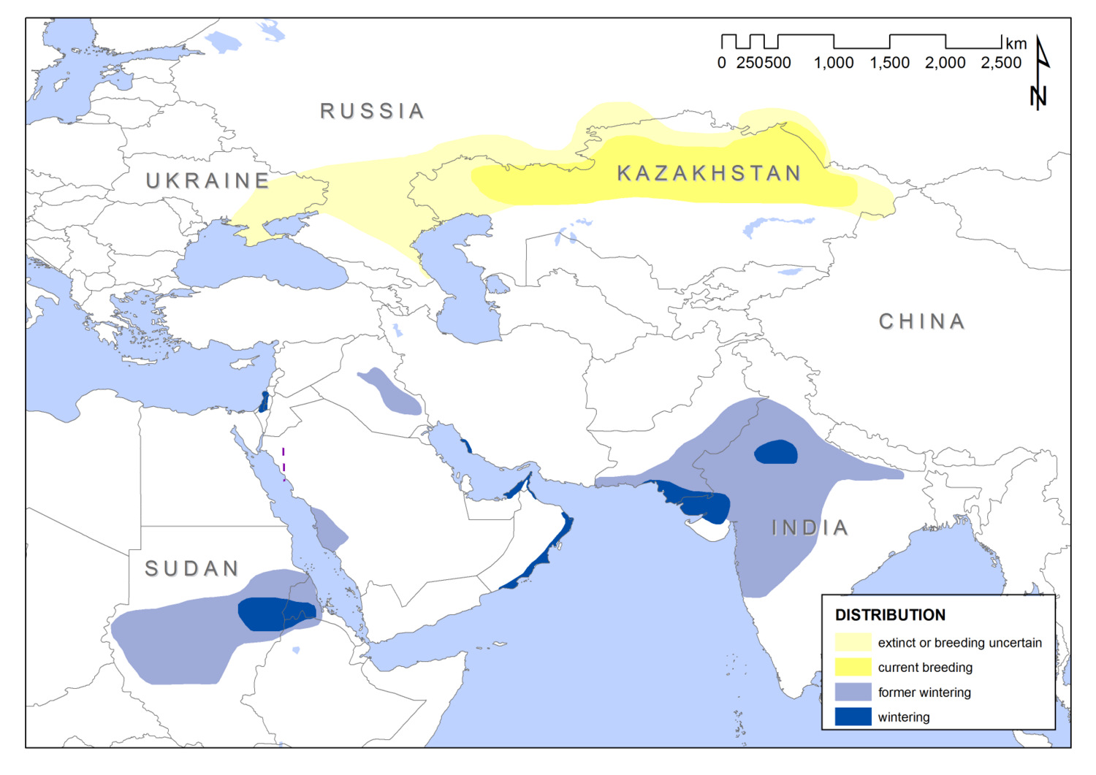
Figure 1. Current and historic breeding and winter distribution of the Sociable Lapwing, based on more than 1,800 records collected from various sources (RSPB unpublished data).

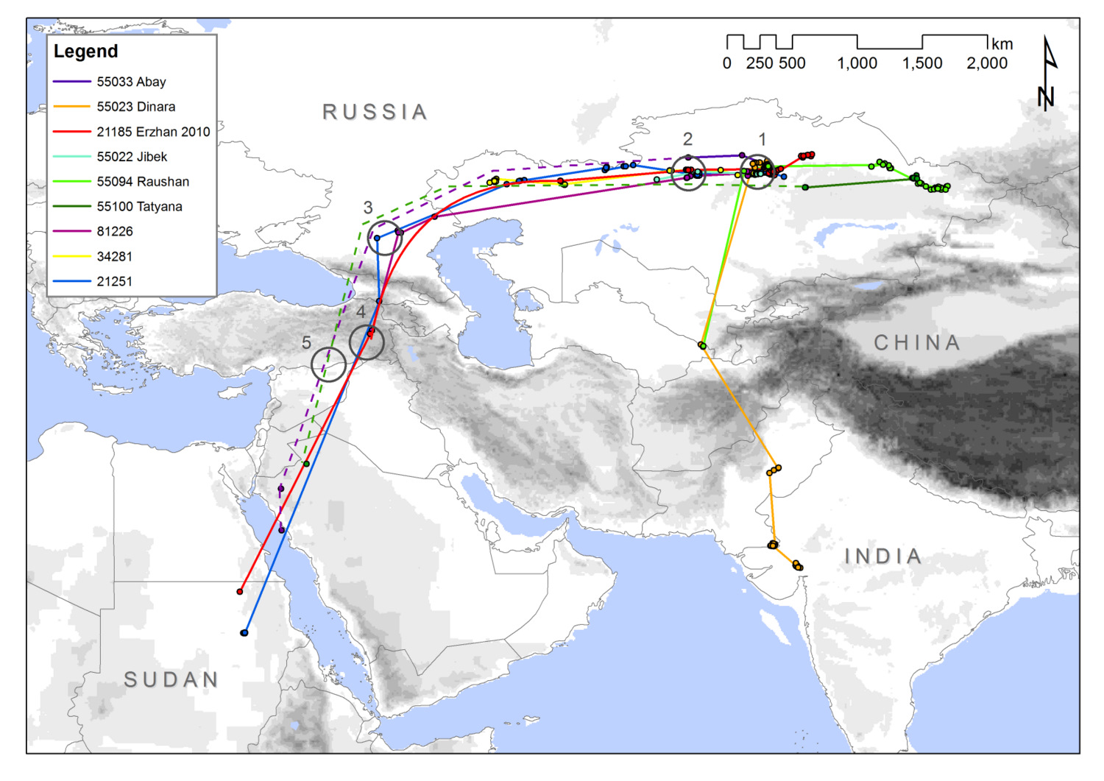

Figure 2. Main autumn migration routes of nine Sociable Lapwings fitted with satellite tags in 2007, 2008 and 2010. Dashed lines connect locations along a known flyway, but are hypothetical.
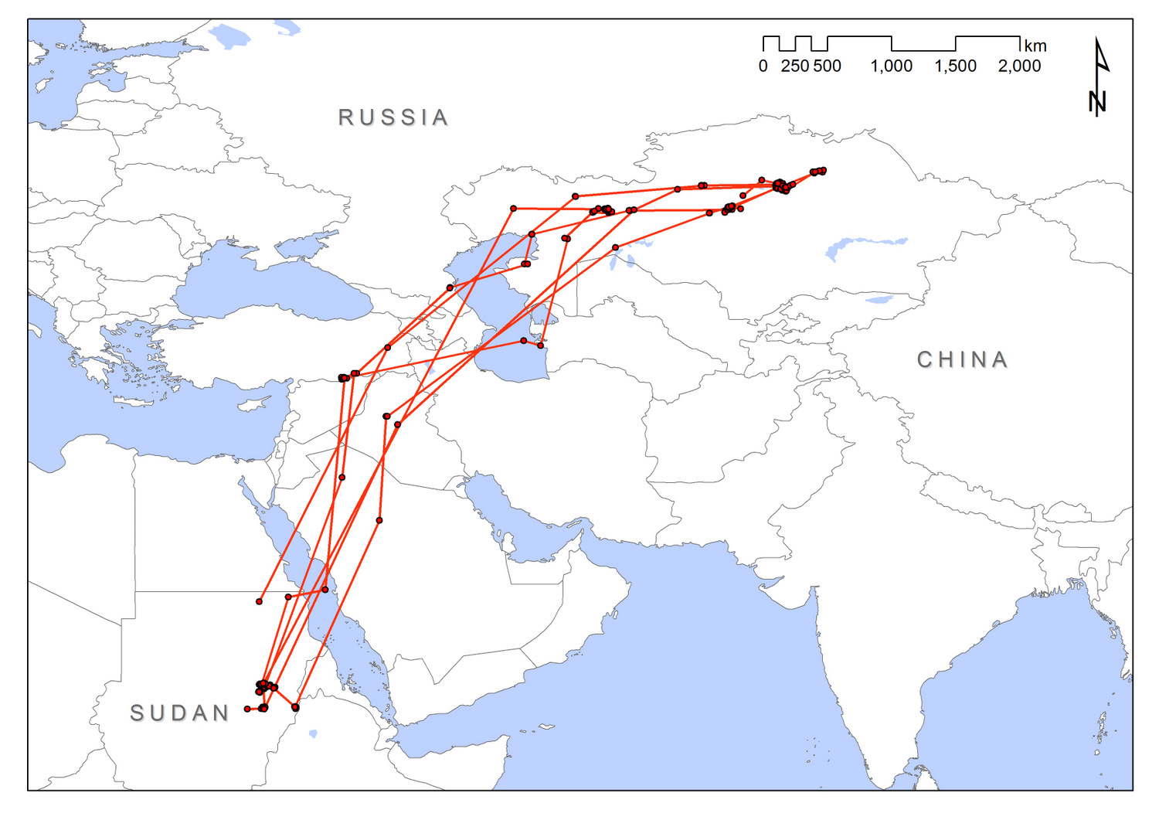
Stopover sites are marked by circles: 1) Tengiz-Korgalzhyn region, Kazakhstan 2) Torghay lowlands, Kazakhstan 3) Manych depression, Russia 4) Muş Plain,Turkey 5) Ceylanpınar IBA, Turkey and Northern Syrian Arab Republican steppes.

Figure 3. Movements of a single male Sociable Lapwing, fitted with a satellite tag in Korgalzhyn region, Central Kazakhstan in June 2007 and subsequently tracked up to January 2011. This bird seems to cross the Northern Caspian Sea in autumn, and the Southern part of the Caspian Sea in spring.

1.3. Habitat requirements

1.3.1. Breeding habitat selection and use
A detailed study on habitat selection and use in Kazakhstan has been conducted recently (Kamp et al. 2009). Across the breeding range, Sociable Lapwings are strongly associated with domestic livestock (especially cattle, sheep and goats), as large grazers create suitable habitat conditions. Grazing intensity and density of Sociable Lapwing nests are strongly correlated in Central Kazakhstan. Current grazing patterns are very much influenced by the fact that livestock is concentrated within a radius of 4–5 (max. 10) km around human settlements, thus most Sociable Lapwing colonies are found within this radius. A small number of birds were also recorded on recently burnt feather grass (Stipa) steppe and fallow or abandoned cereal fields.

Habitat is selected more often in the vicinity of wetlands and especially along rivers. This might be due to the fact that the birds migrate along rivers and thus discover suitable breeding habitat by rivers first, but also by the need for adults and chicks to drink and bathe on hot days.

On a smaller scale (colony level), vegetation height (very short, strongly grazed swards preferred), the cover of bare soil (optimum around 50 per cent) and a high cover of animal dung (around 10 per cent) are the most influential factors in habitat selection. The pronounced preference for strongly grazed areas may be driven mainly by vegetation height. Nests are often placed in dung piles. A possible camouflaging or insulating effect of the dung has been suggested, but food availability (dung beetles, Diptera) might also be higher where dung is abundant.

Formerly occupied habitats, such as ungrazed steppe and sparsely vegetated saltpans (‘solonchaks’), seem to be virtually vacated now, possibly due to an absence of large grazing animals after the collapse of the nomadic pre-Soviet and later semi-nomadic Soviet livestock breeding system in 1991, which left vast expanses of steppe virtually ungrazed.

Co-evolution with wild ungulates has been suggested repeatedly, but it seems unlikely that these animals were able to create the preferred short swards at least during the last 50 years judging from their migration phenology, numbers and foraging behaviour (Bekenov 1998).

Breeding attempts on ploughed fields have been infrequently recorded (mostly in Russia and N Kazakhstan), and then with poor breeding success.

1.3.2. Habitat selection and use at stopover sites
In recent years, larger flocks of birds stopping over in Central Kazakhstan (up to 470 in July 2009) have been observed on sown wheat fields (J. Kamp, M. Koshkin pers. obs.). At the Russian stopover sites N of the Caucasus, the birds feed on grazed steppe and ploughed and tilled fields, but depart to freshwater and salt lakes to rest and roost (Field et al. 2007, Koshkin et al. 2010).

In Turkey, most birds were observed on arable fields with 10–12 cm high wheat seedlings or on ploughed fields without vegetation (some following ploughing tractors and feeding on invertebrates brought to the surface). Some birds also used extensively grazed steppe and lentil fields (Biricik et al. 2009). In some years, fallow cereal fields are used by large numbers of birds (Bozdogan et al. 2007).

In the Northern Syrian Arab Republic, mostly heavily grazed steppe areas with very sparse vegetation are visited (Hofland & Keijl 2008), rarely also semi-desert habitat and stony wadis (S. Jbour pers. comm.). Sociable Lapwings were frequently observed near seasonal pools (fedahs) with lush vegetation (partly grazed) after frequent rains during survey work in the Syrian Arab Republic in spring 2010 (H. Hmidan pers. comm.)

Smaller stopover sites in Russia and Kazakhstan were also found in pristine, mostly ungrazed steppe habitat.
Little is know of the stop-over sites en route for the birds that winter in the Indian sub-continent. Data collected from the recent satellite tracking suggest that the Indus Valley and surrounding areas with agricultural habitats and a mosaic of wetlands could be important.

1.3.3. Winter habitat selection and use
Most information on winter habitat selection is anecdotal or old. In Africa, in the second half of the 19th century, birds wintered mainly on burnt savannah and steppe, harvested cultivation (e.g. Sorghum) and cattle pastures (Heuglin 1871). Surveys in Sudan in January 2009 suggest that habitat use has not changed much since then. Flocks were discovered on rain-fed cultivated land, stubble fields, moderately grazed to severely overgrazed pastures and at road margins. Insects, but also seeds and watermelon pieces (falling from passing lorries) have been identified as food sources (I.M. Hashim and M.S. Fadlalla pers. comm.).

The current wintering areas in Sudan as revealed by satellite telemetry and field surveys coincide with areas of the highest livestock densities in Africa (Wint & Robinson 2007) suggesting a high importance of grazed habitat for the species also in the wintering areas.

In India, mostly arable land (ploughed, fallow, or with young cereal plants) is used, but birds are also observed wintering at wetlands (A. Rahmani pers. comm.).

1.4. Survival and productivity

1.4.1. Nest survival and causes of nest loss

Like most waders, Sociable Lapwings lay on average 4 (mean of 3.8 ± 0.1) eggs in a shallow scrape on the ground and tend to nest in small colonies (range of 1-8 nests) (Watson et al. 2006).

There are few robust estimates of nest survival from large enough sample sizes to allow comparison with current studies of Sociable Lapwing nesting biology. Gordienko (1991) reports a nest loss of 44% (from 26 nests) during the 1980s in Naurzum Reserve, Kazakhstan.

More recently, in 2004, Watson et al (2006) report an overall Mayfield nest survival rate of 19.3 per cent from 58 nests in a study area centred on the settlement of Korgalzhyn, central Kazakhstan (50° 35’ N, 70° 01’ E). Percentage survival estimates reported by Gordienko (1991) and Watson et al. (2004) are not directly comparable. However, Gordienko (1991) found that 44 per cent of nests with eggs (n = 26) failed. Watson et als equivalent rate is 61 per cent failure of nests found with eggs before hatch (n = 56); the difference in frequencies between the two studies is not significant (χ² = 2.4, P = 0.12). Thus, there appears to have been little change in nest survival between the 1980s and the present.

Monitoring of nest survival has continued in the Korgalzhyn study area of Watson et al between 2005 – 2008, with 564 nests monitored. Of these, 283 (50 per cent) successfully hatched and 281 failed for various reasons. Using Mayfield estimates daily survival equals 0.9604 which equates to an overall survival rate of 32 per cent. Survival rate varies from year to year. Combining data sets from 2004 through to 2008, two years show low nest survival and three years high survival. Data from another study area in NE Kazakhstan (Pavlodar province) collected in 2007 shows low nest survival (Mayfield estimate of 17.5 per cent) which was similar to that recorded in Korgalzhyn in the same year. One hypothesis currently being investigated is that nest survival rates fluctuate in a cycle with vole numbers, in years of high vole numbers, nest survival rates are higher than in years when vole numbers are low since predators have an abundant alternative source of food.

Causes of nest loss vary from year to year but the two main causes of loss are predation by mammals and trampling by domestic livestock. Of 641 nests in the Korgalzhyn area (2004-2008), 141 (22 per cent) were predated, and 84 (13 per cent) trampled. Predation (48 per cent) rather than trampling (13 per cent) was also the main cause of nest loss in the Pavlodar area in 2007 (Figure 4).

Evidence from nest cameras suggests that nocturnal mammalian predators such as Red Fox (Vulpes vulpes), Long-eared Hedgehog (Hemiechinus auritus) and Steppe Polecat (Siberian Ferret) (Mustela eversmanni) are the key predators. Single cases of sousliks (Spermophilus major and Citellus fulvus) predating nests were also recorded on camera. The previous AEWA Sociable Lapwing International Single Species Action Plan (Tomkovich & Lebedeva 2004) noted that rooks and/or domestic cats and dogs were key predators contributing to the decline in breeding numbers. However, no instances of predation by rooks or cats/dogs were recorded on digital cameras, and in five years of intensive fieldwork, no nest loss could be attributed to these potential nest predators.

It is unlikely that the magnitude of the recent population decline can be wholly explained by low nest survival. However, attempts to manipulate grazing management (particularly sheep) in some key colonies may contribute to enhancing nest survival that may be beneficial at the population level.

0%
10%
20%
30%
40%
50%
60%
70%
80%
90%
100%
KO_2004
KO_2005
KO_2006
KO_2007
KO_2008
PA_2007
unknown
successful
weather
deserted
trampled
predated
Figure 4 Annual variation in reasons for nest failure in two study areas (Korgalzhyn, ‘KO’ and Pavlodar ‘PA’) in Central and Northern Kazakhstan 2004–2008 after data from Watson et al. (2006) and R. Sheldon, J. Kamp and M. Koshkin (unpublished data).

1.4.2. Chick survival

No historical data exist on chick survival from hatching through to fledging. Between 2005 and 2009 an intensive programme of colour-ringing chicks has enabled individuals to be followed through to fledging in Central Kazakhstan (Sheldon, Kamp & Koshkin unpublished data). Including data from Watson et al (2006) productivity can be estimated for the period 2004-2008. Comparing Sociable Lapwing productivity estimates with those of Northern Lapwing suggests that fledging rates are sufficient to maintain population stability in three years out of five (Figure 5). Thus, low productivity is unlikely to be the key mechanism underlying the recent population decline in Sociable Lapwing.

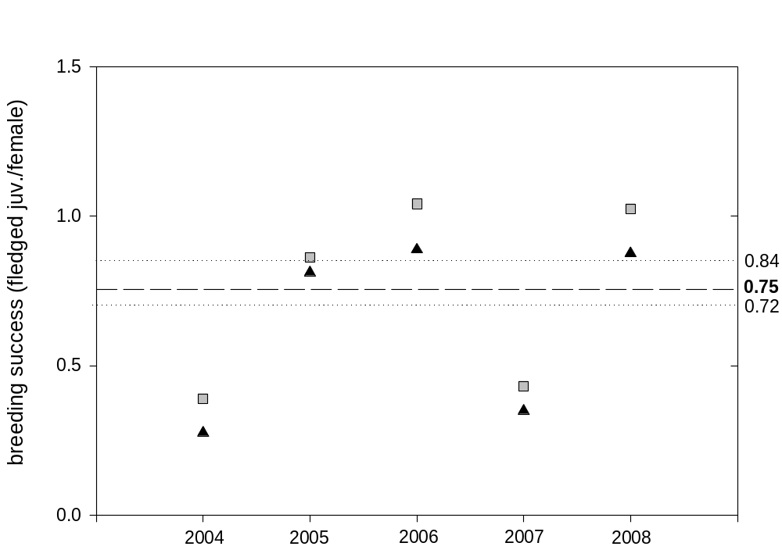

Figure 5. Minimum and maximum number of colour-ringed fledged chicks per breeding attempt and year (squares – assuming re-nesting, triangles – assuming no re-nesting), from a study population in Central Kazakhstan (R.D. Sheldon, J. Kamp, M.A. Koshkin unpublished data). The dashed line indicates the five year mean of r = 0.75 assuming re-nesting, the dotted lines mark alternative levels of productivity needed to maintain population stability in Northern Lapwing after Peach et al. (1994) and Catchpole et al. (1999).

1.5. Population size and trend

Table 1 Population size and trend by country

Country | Breeding numbers  (ind) | Quality | Year of the estimate | Breeding population trend in the last 10 years | Quality | Maximum single counts, migrating/wintering birds in the last 10 years (ind) | Quality | Year of the estimate
Kazakhstan | 3000 -10800 | 3 | 2006 | Stable or increasing | 2 | 2100 | 1 | 2009
Russia | 100-120 | 3 | 2011 | Decreasing | 3 | 1090 | 1 | 2009
Turkey | - | - | - | - | - | 3200 | 1 | 2007
Syrian Arab Republic | - | - | - | - | - | 2000 | 1 | 2007
Iraq | - | - | - | - | - | 20 | 1 | 2004
Sudan | - | - | - | - | - | 38 | 1 | 2009
Eritrea |  |  |  |  |  | Unknown
Ethiopia |  |  |  |  |  | Unknown
Oman | - | - | - | - | - | 90 | 1 | 2010
Saudi Arabia |  |  |  |  |  | Unknown¹
India | - | - | - | - | - | 90 | 1 | 2011
Pakistan |  |  |  |  |  | Unknown¹
Uzbekistan |  |  |  |  |  | 200 | 1
Overall | 3200-11200 | 3 | 2006 | Stable or increasing | 2

¹ = satellite tagged birds tracked to these countries but no follow up surveys undertaken to date.

Quality:
1 = Good (observed) = based on reliable or representative quantitative data derived from comprehensive measurements
2 = Good (estimated) = based on reliable or representative quantitative data derived from sampling or interpolation
3 = Medium (estimated) = based on incomplete quantitative data derived from sampling or interpolation.
4 = Medium (inferred) = based on incomplete or poor quantitative data derived from indirect evidence.

2. THREATS

2.1. Overview of Species Threat Status

In the first AEWA Sociable Lapwing International Single Species Action Plan (Tomkovich & Lebedeva 2004), the following threats of high importance were listed:
- Reduced grazing by domestic livestock leading to decreased habitat availability;
- Predation by corvids;
- Trampling by sheep and cattle.

Grazing pressure has significantly increased since the year 2000, and large areas of apparently suitable habitat are unoccupied each year, thus reduced habitat availability is no longer considered a threat in Kazakhstan (Kamp et al. 2009). However, in Russia grazing pressure has not been increasing throughout the same period. On the contrary, it has been decreasing especially in western and northern parts of the steppe zone of Russia (Orenburg, Chelyabinsk, Kurgan and Omsk Regions). As a result the former traditional breeding areas of Sociable Lapwing in those regions are largely unsuitable.

Predation by corvids has been ruled out as a major threat according to results of recent research on the breeding grounds (1.4.1, 1.4.2).

Trampling by livestock (especially sheep) is considered an ongoing threat, however with minor effects on overall breeding success (1.4.1). However, future changes in livestock management could have a significant impact on breeding populations in the future, particularly through reducing breeding success.

Since the Tomkovich & Lebedeva (2004), hunting at stopover sites on the migration routes has been identified as a key threat to the species. Of particular concern is hunting during the return migration when birds are returning to breed. Based on our current knowledge, hunting should be treated as the key threat to Sociable Lapwing.

2.2. Description of key threats

List of critical and important threats

(a) Direct threats, causing reduced hatching success and high mortality of chicks and adults

1. Hunting

Stopover/wintering sites Importance: Critical.

Large-scale hunting at stopover sites currently appears to be the most important threat influencing the species’ survival. There is evidence from known stopover sites in the north-eastern Syrian Arab Republic and some areas in Iraq from 2008 and 2009 that Sociable Lapwings are widely hunted by local hunters and visiting falconers from the Gulf States (Hofland & Keijl 2008; A. Aidek, S. Jbour, M. Salim and O. Al-Sheikly pers. comm). The hunting has been reported on spring migration when Sociable Lapwings congregate in large numbers; this is of particular concern as these are birds returning to breed in central Asia.

The reasons that Sociable Lapwing are targeted are unclear, but it seems that hunting pressure is a combination of subsistence hunting from locals, to sport for visiting hunters. The species is considered to be quite an easy prey for falcons, probably replacing other bird species traditionally hunted (but now much depleted) such as Macqueen’s (Asian Houbara) Bustard Chlamydotis macqueenii and sandgrouse Pterocles spp. Subsistence hunting of migratory waterfowl could be important in Pakistan, but there is no data to substantiate this.
2. Nest trampling by livestock

Breeding areas Importance: Medium

Clutch trampling can reduce nest survival significantly in some years (section 1.4.1). Most trampling incidents are likely to be caused by sheep and goats due to the way dense flocks are driven at high speeds often in close proximity to breeding colonies. Horses and cattle seem to be of minor threat as these move mostly in loose herds and appear to avoid stepping on nests (J Kamp pers. obs.).

3. Predation of eggs and chicks

Breeding areas Importance: Low
Predation varies from year to year but does not appear to be a limiting factor in either nest or chick survival. Evidence collected from nest cameras suggests that nocturnal mammals are key predators, rather than domestic dogs or cats, and that corvids are not as important as previously thought.

(b) Indirect threats causing habitat loss and low reproductive success

1. Reduced habitat availability for the species

Breeding areas Importance: High

A strong link between livestock grazing intensity and Sociable Lapwing nest density has been shown recently (Kamp et al. 2009), and livestock numbers are thus considered a proxy for the amount of habitat available for Sociable Lapwings. Animal stocks collapsed after the break-up of the Soviet Union in 1991, but numbers of all herded animals are strongly increasing again in Kazakhstan since the year 2000 (Kazakhstan State Statistics Agency 2009). Habitat modelling has shown that the amount of suitable habitat available for Sociable Lapwings is currently much greater than the area currently occupied (Kamp et al. 2009, Murzakhanov et al. 2008). This is caused by current low livestock mobility and concentration effects around villages, leading to increased grazing intensity compared to Soviet times (Milner-Gulland et al. 2006). High stock densities around villages were made possible by large-scale abandonment of arable fields and seed grass land surrounding human habitation in Soviet times after 1991.

The current situation is thus rather beneficial for the Sociable Lapwing in Kazakhstan and reduced habitat availability is not considered to be problematic in the short term (5–10 years). However, there is recent evidence for a likely decrease in available habitat within the next decade: Livestock numbers in some regions of Kazakhstan are stagnating or even decreasing due to improving living standard. Furthermore, mitigation measures to avoid overgrazing around settlements are being introduced in Kazakhstan leading to higher stock mobility and less grazing pressure. Kamp et al. (submitted) modeled a 30% decline for Sociable Lapwing until 2020 based on quantitative targets to reduce grazing pressure in Korgalzhyn region, Central Kazakhstan.

Stopover/wintering sites Importance: Medium

Whilst there appear to be few immediate threats to stopover and wintering sites, there are potential changes that may impact on habitat availability in the future. Continued expansion of urban and agricultural areas in Kazakhstan and Russia may reduce habitat suitability for birds congregating in post-breeding flocks and in the early stages of migration. However, the mobility of Sociable Lapwings suggests that this is not an immediate threat. Indeed, some areas managed intensively for agriculture, for example, arable fields around Manych wetlands in south-west Russia, appear to be well used by both foraging and roosting Sociable Lapwings (Sheldon pers. obs).

Increased spread of tree planting on the Asian wintering grounds, India and Pakistan, is a potential threat due to the species’ preference for open habitats in which to forage and roost. For example, there has been significant effort on raising plantations in the northern Pakistan, particularly Gilgit Baltistan Province, since the mid-1980’s.

Future land use change linked to irrigation schemes could see substantial changes in habitat suitability. However, it is unclear whether some of these changes could be detrimental or indeed beneficial. There is some observational evidence from Turkey, that Sociable Lapwings utilize irrigated crops for feeding, and locations of satellite tagged birds in Saudi Arabia are in areas of irrigated wheat crops.

There is the potential threat of increased disturbance from oil and gas exploration across the Sociable Lapwing range. It is likely that there will be increased exploration in the Middle East and parts of Sudan, as well as north-western part of India.

2. Degradation of habitat

Stopover/wintering sites Importance: Medium

The key threat leading to habitat degradation is a combination of changing rainfall patterns and the subsequent grazing conditions. Notably, in the Syrian Arab Republic steppes some areas where significant numbers of birds were recorded in 2007 appear to have been degraded through intensive grazing and drought conditions, and few birds were located there in 2010 (H. Hmidan pers. comm.). Similarly, on the wintering grounds in Sudan, substantial changes in vegetation cover have been observed between survey years (2008 and 2009) (I. M. Hashim pers. comm.). The impact that this maybe having on Sociable Lapwings is unclear, but could result in birds returning to the breeding grounds in poor condition, this needs further research.

The number of irrigation projects has increased in countries such as Turkey, India and Pakistan and this may lead to a change in habitat quality. Conversely, irrigation could be a potential benefit and this needs further monitoring and research.

(c) Knowledge limitations

Breeding areas

1. Low return rate of colour-ringed birds. High
Potentially hunting pressure leads to loss of colour-ringed birds or colour-ringed birds might return to other areas – movements within the breeding range are not fully understood.
2. Future trends in land use and their implications for habitat availability are poorly understood. High
Possible scenarios on land use change have been developed recently and linked to Sociable Lapwing population development, but only for a restricted area.
3. The generality of the results on breeding biology and species’ survival based on data collected in a relatively small study area in Central Kazakhstan is not clear. Medium
4. The limits of the species’ distribution are not clear and large knowledge gaps on numbers and distribution still exist. Medium

Stopover/wintering sites

1. The current hunting pressure has not been quantified reliably, future trends in hunting pressure are not clear. Critical
2. Locations of potential further wintering and stopover sites are unknown, especially on the eastern flyway. Critical
3. The migration strategy is not fully understood especially regarding differences in spring and autumn migration. High
4. Knowledge on movements within the wintering areas is poor. High
5. Knowledge of the species’ ecology during migration and wintering is poor. Medium
6. The species has not been identified as high priority conservation species in all range states. Critical

Demographic parameters are insufficiently known to undertake PVA (High)

1. Robust population estimate is missing
2. Estimates of annual survival of adults and juveniles are currently lacking due to a low number of re-sightings of marked individuals
3. Generation length is not known
4. The existence and size of a non-breeding population is unknown.

2.3 Problem tree analysis
Recent rapid decline of Sociable Lapwing population

Increased mortality of young and adults
Reduced breeding productivity

Decreased survival of nests
Predation of nests and chicks
Habitat loss & degradation on flyway
Hunting on stop over sites
Habitat loss & degradation in wintering areas
Reduced habitat availability

Increase in livestock numbers
Change in livestock management
Sport hunting
Subsistence hunting
Drought
Irrigation
Overgrazing
Development (industrial)
Plantations
Predator abundance

Hunting laws not enforced
Lack of legislation
Agricultural intensification
Climate change
Agricultural intensification
Land-use change

Level 1: Mechanism through which the threats operate
Level 2: Specific threats
Level 3: Immediate causes of threats
Level 4: Root causes of threats

3. POLICIES AND LEGISLATION RELEVANT FOR MANAGEMENT

3.1. International conservation and legal status of the species

Table 2 (page 22) shows the international conservation designations and legal status of the Sociable Lapwing under both the European and global instruments and mechanisms

Table 3 (page 23) summarises the applicability of European and intergovernmental instruments to the principal range states (need a definition in section 1) for Sociable Lapwing as of October 2011.

3.2. National policies, legislation and ongoing activities

Kazakhstan - The species is listed in the Red Data book of Kazakhstan and hunting of the species is prohibited.

Russia – The species is listed on Category 1 –endangered species, in the Red Data book of Russia, and is also listed in a number of regional Red Data books. The Sociable Lapwing is also listed in the Russia-India Agreement on Migratory Birds.

India – The species is protected through Schedule IV of the Wildlife (Protection) Act, 1972, and thus hunting and trapping are illegal.

Pakistan – There is no national legislation that covers Sociable Lapwing in Pakistan, but the species is protected in some provincial legislation.

Turkey – The species is protected from hunting through national legislation. The terrestrial hunting law gives the power to the Central Hunting Committee (MAK) to determine game species lists and bag sizes, and the MAK has put the sociable lapwing on the protected list.

Syrian Arab Republic – The species is protected from hunting through national legislation (although this is rarely enforced).

Iraq – The species is not currently protected through national legislation, but it is hoped to be included in future legislation.

Uzbekistan – The species is listed in the Red Data Book of the Republic of Uzbekistan on category 2(VU:R) - vulnerable, naturally rare, migratory species.

Oman - No information

Saudi Arabia – the species is protected through national Hunting Law of 1978 (amended in 2000). The hunting of migratory species was banned in 2006.

Eritrea – The species is protected by national wildlife law that limits hunting, but Sociable Lapwing is not specifically mentioned.

Ethiopia – The species is not covered by national legislation due to poor knowledge of its occurrence and distribution.

Sudan – The species is not currently protected through national legislation although there are plans to add to Schedule 1 of the Wildlife Act.

Ongoing conservation activities are focussed on two areas at present:
- Monitoring and research activities
Much of the ongoing monitoring and research activity is summarised in section 1 of this Action Plan. This work has largely been funded through two significant grants from the UK Government’s Darwin Initiative. From 2006-2009, the project, ‘conserving a flagship steppe species: the critically endangered Sociable Lapwing,’ focussed on the breeding grounds of Kazakhstan with low level work in some range states.

Between 2009 -2011, the project, ‘tracking the Sociable Lapwing: conservation beyond the breeding grounds,’ concentrated efforts on the migration routes and wintering grounds.

Monitoring and research work is continuing through support of Birdlife International’s Preventing Extinctions Programme. Swarovski Optik and RSPB have been Species Champions for the Sociable Lapwing since 2008 and will continue until at least 2013. Regular monitoring has been undertaken in Kazakhstan, Russia, Turkey, the Syrian Arab Republic, Iraq, Sudan and India since 2006. Some work has been undertaken in Eritrea. Much of this work is ongoing with support from Swarovski Optik and is being expanded to other countries within the species’ range

- Awareness raising
Through the above mentioned Darwin Projects a large amount of public awareness raising has been undertaken and is ongoing. One key tool is the use of the Amazing Journey web-site that is tracking satellite tagged birds from Kazakhstan to the wintering grounds. This interactive web-site encourages bird-watchers and the general public to submit their own records of Sociable Lapwing. This web-site is supported through Swarovski Optik and it’s management and upkeep are ongoing.

Publicity material has been produced in local languages in Turkey, the Syrian Arab Republic, Iraq and India, and more is planned as part of ongoing activities.

Table 2. Summary of the International conservation and legal status of Sociable Lapwing.

Global Status¹ | AEWA² | Bonn Convention³ | CITES | Bern Convention⁴ | EU Birds Directive⁵
Critically Endangered | A1a, 1b &1c | I | Not listed | II | I

Source
¹Birdlife International (2004). Threatened Birds of the World 2004. CD-ROM, Cambridge, UK
²(insert web-link)
³Migratory species that have been categorized as being in danger of extinction throughout all or a significant proportion of their range. For more details see the Convention text (insert web-link)
⁴Give special attention to the protection of areas that are of importance (Article 4) and ensure the special protection of the species (Article 6). For more details see the Convention text (insert web-link)
⁵The species shall be subject to special conservation measures concerning their habitat in order to ensure their survival and reproduction in their area of distribution. For more details see the Directive text (insert web-link)

Table 3. Summary of applicability of major international conservation instruments to principal range states for Sociable Lapwing

Principal range state for Sociable Lapwing | Member state bound by EU Directives and policies | Beneficiary of EU European Neighbourhood Policy | Party to AEWA | Party to CMS | Party to Bern | Party to CBD | Party to Ramsar
Eritrea | No | No | No | Yes | N/a | Yes | No
Ethiopia | No | No | Yes | Yes | N/a | Yes | No
India | No | No | N/a | Yes | N/a | Yes | Yes
Iraq | No | No | No | No | N/a | Yes | Yes
Kazakhstan | No | No | No | Yes | N/a | Yes | Yes
Oman | No | No | No |  | N/a | Yes | No
Pakistan | No | No | N/a | Yes | N/a | Yes | Yes
Russian Federation | No | Strategic partnership | No | No | Yes | Yes | Yes
Saudi Arabia | No | No | No | Yes | N/a | Yes | No
Sudan | No | No | Yes |  | N/a | Yes | Yes
Syrian Arab Republic | No | Yes | Yes | Yes | N/a | No | Yes
Turkey | Candidate | No | No | No | Yes | Yes | Yes
Uzbekistan | No | No | Yes | Yes | N/a | Yes | Yes

4. FRAMEWORK FOR ACTION

This section identifies and defines the overall conservation Goal, and the Objectives, the Results and the Actions of the Plan.

Goal
Restore the Sociable Lapwing to favourable conservation status and remove it from the threatened categories of the IUCN Red List, CMS Appendices I and II and Column A of the AEWA Table 1.

Objective
The objective of this Single Species Action Plan is to reverse the recent negative population trend leading to a population size of 8,000-10,000 breeding pairs by 2022.

Results

Result | Indicator | Means of verification
1. Baseline annual survival rate identified and increased by 2022 | Annual adult survival rate estimated through analysis of existing data.  Ongoing colour-ringing and re-sighting undertaken annually until 2022 and subsequently re-analysed. | Scientific papers published by 2013 and 2022.  Annual written reports from ongoing colour-ringing activities in Kazakhstan.  Annual written reports from survey teams across the migratory routes and wintering grounds.
2. Reproductive success is maximised through maintained nest survival rates higher than 35per cent (5 year rolling mean) and overall productivity higher than 0.75 fledged chicks per female (5 year rolling mean). | Five-year rolling mean of nest survival is >35 per cent  Five-year rolling mean of chick survival is >0.75 fledged chicks per female | Scientific paper published in 2013.  Annual written reports from ongoing monitoring in Kazakhstan
3. All key sites along the flyways are protected and adequately managed | National hunting or conservation legislation is in place across all range states and includes protection for Sociable Lapwing  All key sites identified and management plans written  Important Bird Area network managed favourably for Sociable Lapwing | Ratified hunting and conservation legislation within principal range states  All range principal range states are members of AEWA and/or CMS  National Species Action Plans identify key sites and conservation actions
4. All identified knowledge gaps are filled by 2022 | Knowledge gaps filled by 2022 | Papers published in peer-reviewed journals.  Annual monitoring and expedition reports
5. International co-operation is maximised through the full engagement of all principal range states in the framework of the Single Species Action Plan and AEWA | The AEWA Sociable Lapwing International Working Group is active and includes all principal range states  National Action Plans based on this plan are established and implemented | Progress reports by the AEWA Secretariat  National Action Plans published and on the SLIWG web-site  AEWA SLIWG to meet in 2015 and 2020

Table 4. Results and actions

Priority scale: Time scale:
- Essential Immediate: to commence within the next year
- High ` Short: to commence within the next 3 years
- Medium Medium: to commence within the next 5 years
- Low Long: to commence within the next 10 years
Ongoing: an action that is currently being implemented and should continue
Completed: an action that was completed during preparation of the action plan

Result | Action | Priority | Timescale | Organizations responsible
1. Baseline annual survival rate identified and increased by 2022 | Action 1.1  Analyse data from colour-ring project in Kazakhstan  Applicable to: KZ | Essential | Immediate | RSPB and ACBK
 | Action 1.2  Minimize the loss of Sociable Lapwings by hunting along the flyways through creation/efficient enforcement of legislation  Applicable to: SY, IQ, TU, PK | Essential | Immediate | Government institutions in charge of nature conservation and hunting
2. Reproductive success is maximized through maintained nest survival rates higher than 35 per cent (5- year rolling mean) and mean chick survival higher than 0.75 fledged chicks per female (5- year rolling mean). | Action 2.1  To reduce the number of nest trampling incidents during breeding season through improved livestock management  Applicable to: KZ, (RU) | High | Short | Government institutions in charge of nature conservation and livestock
 | Action 2.2  Additional key breeding sites are identified across the breeding range  Applicable to: KZ (RU) | High | Medium | ACBK
3. All key sites along the flyways are protected and adequately managed | Action 3.1  Protect and manage known key staging areas  Applicable to: All range states | High | Medium/long | Government institutions in charge of nature conservation
 | Action 3.2  Ensure that Sociable Lapwing habitat requirements are included in relevant governmental land-use policies in breeding and wintering areas  Applicable to: KZ, RU, IN, SD, SA, ER, ET, OM, PK | High | Medium/long | Government institutions in charge of nature conservation
 | Action 3.3  Assess the effectiveness of the existing protected area network across the range states  Applicable to: All range states | High | Medium | RSPB
 | Action 3.4  Ensure that Sociable Lapwing is declared a priority conservation species in the relevant legislation of all the range states for enhanced protection  Applicable to: All range states | Medium | Medium | Government institutions in charge of nature conservation.
4. All identified knowledge gaps are filled by 2022 | Action 4.1  Identify additional staging areas and stop-over sites on the western flyway  Applicable to: KZ, RU, TU, SY, IQ | High | Short/medium | Government institutions in charge of nature conservation.  National & International conservation NGOs
 | Action 4.2  Identify the route and key staging areas on the eastern flyway  Applicable to: KZ, IN, PK | High | Short/medium | Government institutions in charge of nature conservation.  National & International conservation NGOs
 | Action 4.3  Evaluate the extent of hunting pressure in the Syrian Arab Republic, Iraq & Turkey  Applicable to: SY, IQ | Essential | Immediate | Government institutions in charge of nature conservation and hunting  National & International conservation NGOs
 | Action 4.4  Identify further wintering sites in Sudan and elsewhere in north-east Africa, the Middle East and India  Applicable to: SU, ER, ET, IN | High | Short/medium | Government institutions in charge of nature conservation.  National & International conservation NGOs
 | Action 4.5  Further research on the demographic parameters  Applicable to: all range states | Medium | Medium | Government institutions in charge of nature conservation.  National & International conservation NGOs
 | Action 4.6  Research on the migration strategy through satellite tracking and colour ringing birds on the breeding grounds  Applicable to: KZ | Essential | Immediate | Government institutions in charge of nature conservation.  ACBK
 | Action 4.7  Identification of new breeding areas through satellite tracking of birds caught on the wintering grounds  Applicable to: SU, IN | Medium | Medium | Government institutions in charge of nature conservation.  National & International conservation NGOs
 | Action 4.8  Conduct co-ordinated counts of breeding areas in Kazakhstan and Russia to improve the world population estimate  Applicable to: KZ, RU | High | Short | Government institutions in charge of nature conservation.  National & International conservation NGOs
 | Action 4.9  Determine the effects of possible land-use changes on breeding numbers and distribution  Applicable to: KZ, RU | Medium | Medium | Government institutions in charge of nature conservation.  National & International conservation NGOs
 | Action 4.10  Determine the effects of possible land-use changes in the wintering grounds  Applicable to: SU, IN, ET, ET, SA, PK, OM | Low | Long | Government institutions in charge of nature conservation.  National & International conservation NGOs
 | Action 4.11  Identify the current climate space of Sociable Lapwing in Kazakhstan and Russia to predict the potential impacts of climate change on future distribution  Applicable to: KZ, RU | Low | Long | Government institutions in charge of nature conservation.  National & International conservation NGOs
 | Action 4.12  Identify the ecological requirements on the stop-over sites and wintering grounds  Applicable to: All range states |  |  | Government institutions in charge of nature conservation.  National & International conservation NGOs
5. International cooperation is maximized through the full engagement of all principal range states in the framework of the Single Species Action Plan and AEWA | Action 5.1  Accession to AEWA of all principal range states  Applicable to: IQ, KZ, RU, TU, ER, OM | High | Short | Government institutions in charge of nature conservation.  AEWA Secretariat
 | Action 5.2  Maintain the active work of the AEWA Sociable Lapwing International Working Group to coordinate the implementation of the Single Species Action Plan  Applicable to: all range states | Essential | Immediate | Government institutions in charge of nature conservation.  AEWA Secretariat

5. REFERENCES

Bekenov AB, Grachev YuA, Milner-Gulland EJ (1998). The ecology and management of the Saiga antelope in Kazakhstan. Mammal Review 28: 1–52.

Biricik M, Deniz H, Mungan R, Akarsu F, Ataol M, Balkiz Ö (2009). Sociable Lawping (Vanellus gregarius) 2008 field report. Unpublished report, Doga Dernegi, Ankara.

Bozdogan M, Balkiz Ö, Tavares J (2007). Survey of Sociable Lapwing (Vanellus gegarius) in Southeastern Anatolia during early spring 2007. Unpublished report, Doga Dernegi, Ankara.

Catchpole EA, Morgan BJT, Freeman SN & Peach WJ 1999. Modelling the survival of British Lapwings Vanellus vanellus using ring-recovery data and weather covariates. Bird Study 46: S5–S13.

Field R, Gordon JJ, Koshkin M, Field KM, Gordon O, Kucheryavaya N, Fedosov V, Malovichko L (2007). The Chagraiskoje Reservoir area of Stavropol Region, SW Russia, harbours significant numbers of migrating Sociable Lapwings Vanellus gregarius. Wader Study Group Bull. 112: 60-64.

Gordienko NS (1991). [Biology and population numbers of Sociable Lapwing in the Kostanay steppes.] Ornitologiya 25:54–61. (In Russian.)

von Heuglin MT (1871). [Avifauna of Northeast-Africa.] Cassel, Germany. [In German.]

Hofland R, Keijll G. (2009). Syrian Arab Republic Sociable Lapwing survey 18 February – 5 March 2007. WIWO-report No. 85, Utrecht.

Kamp J, Sheldon RD, Koshkin MA, Donald PF, Biedermann R (2009). Post-Soviet steppe management causes pronounced synanthropy in the Sociable Lapwing Vanellus gregarius. Ibis 151: 452–463.

Kamp J, Urazaliev R, Donald PF, Hoelzel, N (submitted). Post-Soviet agricultural change predicts future declines after recent recovery in Eurasian steppe bird populations.

Kazakhstan State Statistics Agency (2009). Agriculture. Available at http://www.stat.kz [accessed 15 July 2009].

Koshkin MA, Fedosov V, Gordon J, Gordon O, Kurbanbagamaev M, Malovichko L, Pleshanov, M, Sheldon RD (2010). Sociable Lapwing survey in the Manych lowlands, SW Russia in autumn 2009. Unpublished report, RSPB, ACBK, Stavropol university.

Millner-Gulland EJ, Kerven C, Behnke R, Wright IA, Smailov A (2006). A mult-agent system model of pastoralist behaviour in Kazakhstan Ecological Complexity 3: 23–36.

Murzakhanov EB, Bazdyrev AV, Smelantsev IO (2008): Numbers and distribution of the Sociable Lapwing in the Omsk district, Novosibirsk district and Altaiskii Krai, Russian Federation. Unpublished report, NGO ‘Ecocenter Strizh’, Tomsk. 10pp.

Peach WJ Thompson PS, Coulson JC (1994). Annual and long-term variation in the survival rates of British Lapwings Vanellus vanellus. Journal of Animal Ecology 63:60–70.

Terraube J, Arroya BE, Mougeot F, Madders M, Watson J, Bragin EA (2009). Breeding biology of the pallid harrier Circus macrourus in north-central Kazakhstan: implications for the conservation of a Near Threatened species: Oryx 43: 104–112.

Watson M, Wilson JM, Koshkin M, Sherbakov B, Karpov F, Gavrilov A, Schielzeth H, Brombacher M, Collar NJ, Cresswell W (2006). Nest survival and productivity of the critically endangered Sociable Lapwing Vanellus gregarius. Ibis 148: 489–502.

Wint GRW, Robinson TP (2007). Gridded livestock of the world 2007. Rome: FAO. Online-database: http://ergodd.zoo.ox.ac.uk/agaagdat/index.htm

6. ANNEX 1

List of all IBAs that have Sociable Lapwing as a qualifying feature.

IBA name | Code | Latitude | Longitude
Corbett Tiger Reserve | IN102 | 29.58 | 78.91
Dihaila Jheel and other wetlands | IN141 | 25.69 | 78.16
Flamingo city | IN085 | 24 | 69.86
Keoladeo National Park and Ajan Bande | IN064 | 27.15 | 77.51
Kurra Jheel | IN118 | 27.01 | 79.1
Naliya Grassland (Lala Bustard Wildlife Sanctuary) | IN091 | 23.5 | 68.75
Okhla Bird Sanctuary | IN057 | 28.55 | 77.3
Valmiki Tiger Reserve and Saraiyaman Lake | IN301 | 27.3 | 84.14
Mongol Daguur | MN066 | 49.71 | 115.25
Ogii Lake | MN042 | 47.76 | 102.7
Handrop Shandoor National Park | PK006 | 36.08 | 72.53
Indus Waterfowl Refuge | PK015 | 31.83 | 70.9
Kinjhar (Kalri) Wildlife Sanctuary | PK048 | 24.93 | 68.05
Kirthar National Park (including Hub Dam) | PK046 | 25.75 | 67.5
Lal Sohanra National Park | PK028 | 29.36 | 71.95
Manchar Lake | PK045 | 26.41 | 67.65
Pugri Lake | PK040 | 27.3 | 68.05
Taunsa Barrage Wildlife Sanctuary | PK026 | 30.7 | 70.83
Ucchali Wetland Complex | PK024 | 32.55 | 72.01
Aktubek | KZ057 | 50.21 | 69.5
Amangeldy | KZ052 | 50.56 | 69.85
Amankaragay Forest | KZ034 | 52.43 | 63.95
Chingiztau Mountains | KZ109 | 48.41 | 79.66
Ertis Ormany (Shaldai Forest) | KZ105 | 51.83 | 78.83
Irgiz-Turgay Lakes | KZ042 | 48.66 | 62.13
Korgalzhyn State Nature Reserve | KZ051 | 50.41 | 69.23
Koybagar-Tyuntyugur Lake System | KZ033 | 52.65 | 65.63
Kulykol-Taldykol Lake System | KZ036 | 51.39 | 61.9
Kumdykol-Zharlykol Lake System | KZ056 | 50.58 | 70.88
Lower reaches of the Emba River | KZ010 | 46.98 | 53.56
Naurzum State Nature Reserve | KZ040 | 51.51 | 64.28
Sarykopa Lake System | KZ041 | 50.21 | 64.13
Semey Ormany (Semipalatinsk Forest) | KZ107 | 50.68 | 79.96
Shoshkaly Lake System | KZ027 | 53.66 | 64.93
Tounsor Hollow Lakes | KZ037 | 51.26 | 62.38
Ulytau Mountains | KZ062 | 48.4 | 66.68
Vicinity of Korgalzhyn village | KZ054 | 50.58 | 70.05
Zharsor-Urkash Salt Lakes | KZ038 | 51.34 | 62.75
Zhumay-Mayshukyr Lake System | KZ053 | 50.71 | 69.88
Zhusandala | KZ095 | 44.45 | 74.95
Birsuat |  | 52.16 | 60.35
Blagoveschenskaya (Kulunda lake and vicinity) |  | 53 | 79.66
Uzkaya Steppe |  | 51.51 | 80.26
Bulunkul and Yashilkul lakes and mountains | TJ014 | 37.83 | 73
Gizilagach State Reserve | AZ048 | 39.08 | 49.05
Bulukhta area | RU247 | 49.33 | 46.16
Kulaksay lowland | RU216 | 50.73 | 55.83
Lysyi Liman lake and valley of Vostochniy Manych river | RU272 | 45.8 | 44.08
Stepnovski saltmarshes | RU311 | 50 | 45.75
Mouth of Samur river | RU173 | 41.86 | 48.5
Anzali Mordab complex | IR016 | 37.41 | 49.46
Miankaleh Peninsula and Gorgan Bay | IR023 | 36.83 | 53.75
Haur Al Suwayqiyah | IQ020 | 32.7 | 45.91
Samara dam | IQ008 | 34.25 | 43.83
Hula valley | IL002 | 33.08 | 35.61
Jezre'el, Harod and Bet She'an valleys | IL008 | 32.58 | 35.33
Western Negev | IL015 | 31.16 | 34.66
Zevulun valley | IL004 | 32.88 | 35.1
Aqaba | JO017 | 29.42 | 35.07
Mafraq - Irbid plain | JO003 | 32.49 | 36.04
Shaumari | JO010 | 31.75 | 36.68
Masirah island | OM017 | 20.41 | 58.78
Sun Farms, Sohar | OM005 | 24.31 | 56.75
Al-Ha'ir | SA014 | 24.38 | 46.82
Dawmat al-Jandl wetland | SA002 | 29.81 | 39.88
Buhayrat al-Assad | SY007 | 36 | 38.11
Golan Heights | SY024 | 33 | 35.75
Tadmur desert and mountains | SY018 | 34.5 | 38.3
Tual al-'Abba | SY003 | 36.41 | 39.33
Digdaga - Hamraniyah | AE002 | 25.66 | 55.91
Dzheiran Ecocentre | UZ017 | 39.6 | 64.65
Krasnoarmeiskiye waste lands | RU425 | 43 | 47.4
Salt lakes "Manych" | RU420 | 44.43 | 46.35
Southern part of Chograiski reservoir | RU288 | 45.46 | 44.43
Agri plain | TR124 | 39.66 | 43
Bulanik and Malazgirt plains | TR085 | 39.18 | 42.15
Ceylanpinar | TR213 | 36.93 | 39.81
Igdir Plain | TR132 | 39.86 | 44.51

Distribution of IBAs that have Sociable Lapwing as a qualifying feature

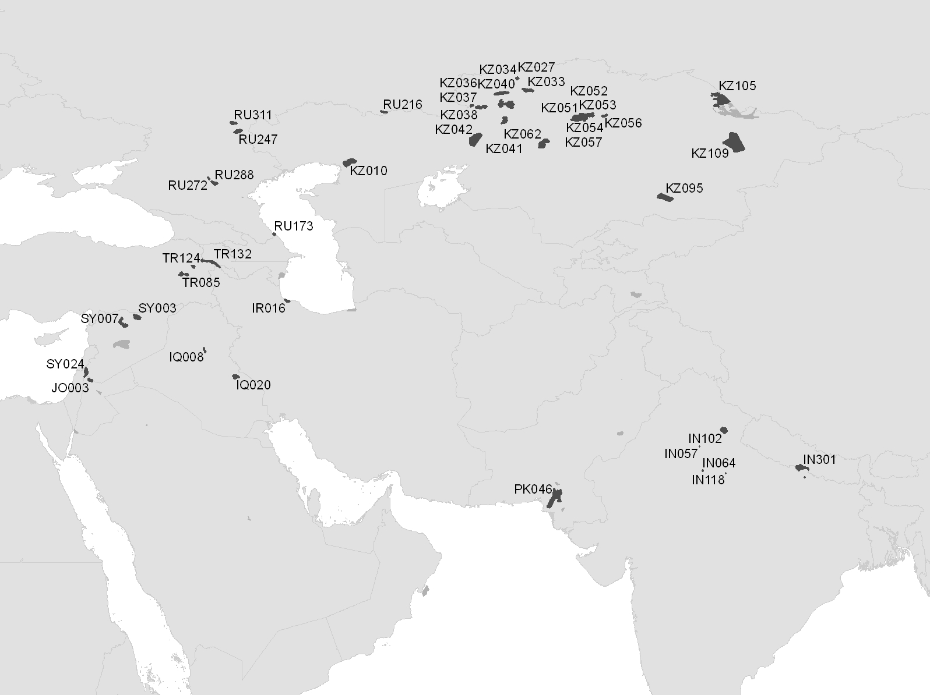

To be added before publication completed

