 | Agreement on the Conservation of  African-Eurasian Migratory Waterbirds | Doc: AEWA/MOP 4.9  Agenda item: 11 b.  Original: English  Date: 22 August 2008
4th Session of the Meeting of the Parties
15 – 19 September 2008, Antananarivo, Madagascar
“Flyway Conservation at Work – Review of the Past, Vision for the Future"

HUNTING AND TRADE LEGISLATION IN COUNTRIES RELATING TO THE SPECIES LISTED IN ANNEX 2 TO AEWA

Introduction

According to Paragraph 7.4 of the AEWA Action Plan, the Agreement Secretariat, in coordination with the Technical Committee and the Parties, shall prepare a series of international reviews necessary for the implementation of the Action Plan, including, inter alia, a review on pertinent hunting and trade legislation in each country relating to the species listed in Annex 2 to the Agreement.

The draft Review on hunting and trade legislation in countries relating to the species listed in Annex 2 to the African-Eurasian Migratory Waterbird Agreement (AEWA) was prepared by the AEWA Secretariat in 2007. The final version was approved by the Technical Committee at its 8th meeting in March 2008 and endorsed by the Standing Committee at its 5th meeting in June 2008 for submission to MOP4. Conclusions and recommendations from the review served as a basis for draft Resolution 4.3.

Action requested from the Meeting of the Parties

The Meeting of the Parties is invited to note the Review on hunting and trade legislation in countries relating to the species listed in Annex 2 to the African-Eurasian Migratory Waterbird Agreement (AEWA) and to adopt draft Resolution 4.3.

Review on hunting and trade legislation
in countries relating to the species listed in Annex 2 to the
African-Eurasian Migratory Waterbird Agreement (AEWA)

Final draft 2007

Prepared by
UNEP/AEWA Secretariat
This document has been prepared by the UNEP/AEWA Secretariat:

Author: Catherine Lehmann, Programme Officer

Special thanks to Bert Lenten (Executive Secretary), Sergey Dereliev (Technical Officer) and the members of the Technical Committee to AEWA for reviewing this paper, to Johannes Müller (Intern/Consultant) for helping ensure the quality and completeness of the data by keeping up communication with focal points, for compiling and analyzing received information and for taking part in this project, to Ricardas Patiejunas (Consultant) for developing the statistical datasheet, and to Jolanta Kremer (Team Assistant) for proofreading the text.

This review would not have been possible without the cooperation of our contacts throughout the AEWA area who provided information on the hunting and trade legislation in their country. Thanks to all of the following people who helped by completing questionnaires, by providing other relevant information or by sharing their expertise:

Elvana Ramaj and Dr. Zamir Dedej, Albania
Hikmat Alizada, Azerbaijan
Wouter Faveyts, Belgium
Pacal Gbethoho, Benin
Valeri Georgiev, Bulgaria
Yemboado Namoando, Burkina Faso
Damien Nindorera, Burundi
Kathryn Dickson, Canada
Mahamat Hassane Idriss, Chad
Ikonga Jerome Mokoko, Congo (Republic)
Tano Sombo and Kouassi Remy Kouadio, Côte d’Ivoire
Ivana Jelenić and Ana Kobašlić, Croatia
Nicolaos Kassinis, Cyprus
Jiri Pykal, Czech Republic
Houssein Abdillahi Rayaleh, Djibouti
Andres Kuresoo, Estonia
Belete Geda, Ethiopia
Matti Osara, Finland
François Lamarque, Annie Charlez, Jean-Yves Mondain-Monval, Patrice Blanchet and Dr. Patrick Triplet, France
Alagie Manjang, Gambia
Irine Lomashvili, Georgia
Doris Henn, Germany
Charles C. Amankwah, Ghana
Namory Keita, Guinea
Zoltan Czirak, Hungary
Ohad Hatzofe, Israel
Alessandro Adreotti, Italy
Alfred Owino Ochieng, Kenya
Vilnis Bernards, Latvia
Lara Samaha and Rasha Kanj, Lebanon
Khaled S. Etayeb and Abdulmula A. Hamza, Libya
Michael Fasel, Liechtenstein
Laura Janulaitienė, Lithuania
Sandra Cellina, Luxembourg
Branko Micevski and Aleksandar Nastov, Macedonia
Zarasoa, Madagascar
Alfousseini Semega, Mali
Dr. Rajendraprasad Sookhareea, Mauritius
Stela Drucioc and Andrei Munteanu, Moldova
Patrick Van Klaveren and R. Bermond, Monaco
Hayat Mesbah and Mohamed, Morocco
Jan van Spaandonk, Netherlands (the)
John Hyelakuma Mshelbwala, Nigeria
Øystein Storkersen, Norway
Claudia Faanco, Portugal
Anna Belousova, Russian Federation
Peter Pilinský, Slovakia
Andrej Bibič, Slovenia
Dr. Abdullahi M. Issa, Somalia
Dr. R. van der Westhuizen, South Africa
Barbara Soto-Largo, Spain
Khamis Adieing Ding, Sudan
Peter Örn, Sweden
Rolf Anderegg, Switzerland
Dr. Akram Eissa Darwish, Syria
Koukou Trevé Tengue, Togo
Trabelssi Lassaad and Gwayel Jamel, Tunisia
Serhan Çagirandkaya, Turkey
Prof. Eldar A. Rustamov, Turkmenistan
Christine Rumble, United Kingdom
Peter J. Mundy, Zimbabwe
Dr. John Harradine, British Association for Shooting and Conservation (BASC)
Niels Kanstrup, President of the Migratory Birds Commission, International Council for Game and Wildlife Conservation (CIC)
Rachelle Adam, Environmental Law Expert
Jelena Kralj, Vice-Chair of the AEWA Technical Committee
Dr. Yves Lecocq, Angus Middleton and Cy Griffin, Federation of Associations for Hunting and Conservation of the E.U. (FACE)
Guy-Noël Olivier, Oiseaux Migrateurs du Paléarctique (OMPO)
Content

Foreword 7
Preface 9
A. Executive Summary (including Recommendations) 10
B. Report 20
I. Introduction 20
1. AEWA and hunting & trade 20
a) Legally binding documents 20
b) The Conservation Guidelines 21
c) AEWA Resolutions 21
d) AEWA projects 22
2. Aim 22
3. Objectives 22
4. Methodology 22
5. Regional division of countries 25
6. Structure of this review 26
II. Other international treaties / supranational organisations addressing the issues of hunting and/ or trade 27
1. The Convention on the Conservation of Migratory Species of Wild Animals (CMS) 30
2. The Convention on International Trade in Endangered Species of Wild Fauna and Flora (CITES) 31
a) Introduction to CITES 31
b) AEWA and CITES 32
aa) Which countries are Parties to CITES? 33
bb) Is CITES given force of law by countries? 33
cc) Status of “AEWA waterbird populations” under CITES 33
dd) Trade in waterbirds in the AEWA region 34
ee) Illegal trade 37
ff) Measures against illegal trade 37
gg) Efficiency of measures against illegal trade 38
hh) Monitoring of trade (import/ export and domestic trade) 39
aaa) Established systems of monitoring domestic and international trade in the AEWA area 40
bbb) The share of hunting for trade purposes compared to all hunting activities on waterbirds 44
3. The Convention on the Conservation of European Wildlife and Natural Habitats (Bern Convention) 47
a) Introduction to the Bern Convention 47
b) Status of AEWA populations under the Bern Convention 48
4. EU Directive 79/409/EEC (”Birds Directive”) 50
a) Introduction to the Birds Directive 50
b) AEWA and the Birds Directive 50
c) The Birds Directive and hunting & trade 51
d) Implementation of the AEWA requirements on hunting and trade by the Birds Directive 52
5. Convention on Biological Diversity and its Addis Ababa Principles and Guidelines for the sustainable use of biodiversity 54
6. The Ramsar Convention 54
7. The World Trade Organization (WTO) & TRIPS 55
8. Asia-Pacific Migratory Waterbird Conservation Strategy and North American Waterfowl Management Plan 56
9. Conservation of Arctic Flora and Fauna (CAFF) 56
10. Convention for the Protection of the Mediterranean Sea against Pollution (Barcelona Convention) 57
III. Current situation and developments in individual countries 58
1. Strict protection for species listed in Table 1 Column A 58
a) Populations listed in Column A 60
b) Strict protection from hunting 60
c) Are there plans to provide strict protection from hunting to Column A populations in the future? 61
d) Strict protection from trade 62
e) Are there plans to provide strict protection against trade in the future? 63
f) Strict protection from both hunting and trade 65
g) Exception: Hunting as a long-established cultural practice 65
aa) Do countries allow hunting of Column A asterisk populations as a long-established cultural practice? 67
bb) Sustainability 67
h) Regional differences concerning strict protection from hunting of and trade in Column A populations 69
i) Exemptions for reasons explicitely listed in Paragraph 2.1.3 of the AEWA Action Plan 76
aa) Exemptions according to Paragraph 2.1.3 sentence 1 a-e) Action Plan granted 76
bb) No other satisfactory solution 78
cc) Precise as to content 78
dd) Limited in space and time 78
ee) Measures taken to prevent these excemptions operating to the detriment of the species listed in Table 1 79
ff) Information of the Agreement Secretariat 79
j) Look-alike Species 80
2. Regulation of hunting and trade for species listed in Table 1 Column B 82
a) Populations listed in Column B 84
b) Strict protection from hunting 84
c) Hunting regulations 85
aa) Hunting seasons 85
aaa) Is hunting prohibited during the stages of reproduction and rearing? 85
bbb) Is hunting prohibited during the stages of return to the breeding grounds? 87
bb) Hunting methods 91
aaa) Modes of taking 91
bbb) Restrictions on poisoned baits for hunting of waterbirds (Paragraph 4.1.5 AEWA Action Plan) 94
(1) Is the use of poisoned baits prohibited? 94
(2) Where do countries stand with reducing or eliminating the use of poisoned baits? 96
(3) How do countries rate the quality of their own measures taken to enforce the legal ban on poisoned baits? 97
cc) Bag limits 100
aaa) Does legislation establish bag limits? 100
bbb) Enforcement 101
dd) Any other measures established to regulate hunting? 103
d) Prohibition of trade 105
e) Exemptions for reasons explicitely listed in Paragraph 2.1.3 of the AEWA Action Plan 106
3. Regulation of hunting and trade for species listed in Table 1 Column C 107
a) Overview of populations listed in Column C 107
b) Hunting restrictions 108
aa) Prohibition of hunting of Column C populations 108
bb) Regulation of hunting of Column C populations 108
c) Trade restrictions 109
4. International cooperation 110
5. Harvest data collection 112
a) System for harvest data collection established? 114
b) Characteristica of the harvest data collection systems (where established) 115
c) Use of collected harvest data on the national level 116
d) Use of collected harvest data on the international level 116
e) Reasons mentioned why data are not used for assessing the annual harvest of species listed in Table 1 118
f) What would help to improve the use of harvest data? 119
g) Are collected harvest data used as a basis to regulate trade in waterbirds? 120
6. Illegal hunting 121
a) Does illegal hunting take place? 121
b) Law enforcement 122
aa) Enforcement measures 122
bb) Quality of the measures 123
7. Restocking 125
8. Non-native species 126
9. Hunters 129
a) Is it mandatory for hunters to organise themselves in clubs or associations? 131
b) Are hunters encouraged to organise themselves? 131
c) Are hunters organised in clubs or associations? 132
d) Participation of hunters clubs and organisations in activities which aim for ensuring sustainability 136
e) Proficiency test 138
aa) Do hunters have to undertake a proficiency test? 138
bb) If not, does the government promote the requirement of a proficiency test ? 139
cc) If yes, does proficiency test include bird identification? 139
dd) Other components of the proficiency test 140
ee) Other requirements for obtaining a hunting license than a proficiency test 140
f) Funding system 142
IV. References 143
Annex 1: Status of populations listed on Table 1 of the AEWA Action Plan under CITES 144
Annex 2: Status of populations listed on Table 1 of the AEWA Action Plan under the Bern Convention 155

Foreword

By Bert Lenten, Executive Secretary

This review on hunting and trade legislation offers a first ever opportunity to assess where the Contracting Parties to the Agreement stand on the level of enforcement of regulations with respect to hunting and trade of migratory waterbirds. Concluded in 1995 and being in force since 1999, the Agreement is relatively young and has just entered the phase of implementation; the focus of its efforts during the first years having been to promote the Agreement and to recruit more Parties. Many countries have joined the Agreement during the last few years, which should be taken into account when developing policies on the basis of the data and results provided by this international review (see table below).

Being the first of its kind, this review provides a situation analysis, draws conclusions and provides recommendations defining activities that might be needed on the international level in order to bring forward the implementation of the Agreement’s requirements on hunting and trade legislation in the short and middle-term future. This document will moreover help to measure the Agreement’s success, on the basis of an update review, due to be drawn up in a few years time.

Having the relevant legislation in place provides governmental authorities the necessary empowerment and mandate for tackling issues like poaching, illegal trade, etc. However, it should not be forgotten that the success of legislation depends, on the one hand, on accurate and updated scientific and technical data as a prerequisite, and on the other hand on sound enforcement measures in the follow-up. Both of these aspects were therefore subject to the survey on hunting and trade legislation; the main focus of this document, however, is on hunting and trade legislation.

The remarkably high number, especially of Non-Parties, participating in this survey has confirmed that good contacts and working relationships are already established between the Agreement and Range State governments, and that a strong interest in the international conservation work done by AEWA exists in many Non-Party Range States. Many of these countries have already informed the Secretariat that they have started the process of joining the Agreement or have expressed a strong interest in doing so. The Secretariat continuously works towards assisting these processes and futher strengthening contacts to Non-Party Range State governments.

AEWA Contracting Parties (as of 1 January 2008) sorted by their date of accession

AFRICA

MOROCCO | 19/11/1997
CONGO (BRAZZAVILLE) | 01/11/1999
EGYPT | 01/11/1999
GAMBIA | 01/11/1999
GUINEA | 01/11/1999
NIGER | 01/11/1999
SENEGAL | 01/11/1999
SUDAN | 01/11/1999
TANZANIA | 01/11/1999
TOGO | 01/11/1999
EQUATORIAL GUINEA | 01/12/1999
BENIN | 01/01/2000
MALI | 01/01/2000
SOUTH AFRICA | 01/01/2000
UGANDA | 01/12/2000
MAURITIUS | 01/01/2001
KENYA | 01/06/2001
DJIBOUTI | 01/05/2004
NIGERIA | 01/07/2004
LIBYAN ARAB JAMAHIRIYA | 01/06/2005
GHANA | 01/10/2005
TUNISIA | 01/10/2005
ALGERIA | 01/10/2006
GUINEA-BISSAU | 01/11/2006
MADAGASCAR | 01/01/2007
EUROPEAN UNION

GREECE | 14/05/1998
ROMANIA | 01/10/1999
GERMANY | 01/11/1999
NETHERLANDS | 01/11/1999
SPAIN | 01/11/1999
SWEDEN | 01/11/1999
UNITED KINGDOM | 01/11/1999
DENMARK | 01/01/2000
FINLAND | 01/01/2000
BULGARIA | 01/02/2000
SLOVAKIA | 01/07/2001
HUNGARY | 01/03/2003
IRELAND | 01/08/2003
SLOVENIA | 01/10/2003
FRANCE | 01/12/2003
LUXEMBOURG | 01/12/2003
PORTUGAL | 01/03/2004
LITHUANIA | 01/11/2004
EUROPEAN COMMUNITY | 01/10/2005
BELGIUM | 01/06/2006
CZECH REPUBLIC | 01/09/2006
ITALY | 01/09/2006
LATVIA | 01/01/2006
EURASIA

JORDAN | 01/11/1999
MONACO | 01/11/1999
SWITZERLAND | 01/11/1999
MACEDONIA FYR | 01/02/2000
CROATIA | 01/09/2000
MOLDOVA | 01/04/2001
GEORGIA | 01/08/2001
ALBANIA | 01/09/2001
ISRAEL | 01/11/2002
LEBANON | 01/12/2002
UKRAINE | 01/01/2003
SYRIA | 01/08/2003
UZBEKISTAN | 01/04/2004

Preface

According to Paragraph 7.4 of the AEWA Action Plan the Agreement Secretariat, in coordination with the Technical Committee and the Parties, shall prepare a series of international reviews necessary for the implementation of the Action Plan, including, inter alia, a review on pertinent hunting and trade legislation in each country relating to the species listed in Annex 2 to the Agreement.

The production of the international reviews for the forthcoming Meeting of the Parties (MOP4) in September 2008 was given high priority by the Third Meeting of the Parties (MOP3) in October 2005, Dakar, Senegal. Following this up the AEWA Secretariat has elaborated the present draft of the “Review on hunting and trade legislation”, which is planned to be submitted to MOP4.

A. Executive Summary (including Recommendations)

I. Introduction

The Agreement on the Conservation of African-Eurasian Migratory Waterbirds (AEWA) specifies actions for sustainable hunting of and trade in migratory waterbirds in its legally binding Action Plan, which result in a number of requirements on hunting and trade legislation in the countries that are Party to AEWA.

This report starts with a review of international treaties and supranational organizations addressing the issues of hunting of and/ or trade in migratory waterbirds and in the context of AEWA (chapter B II). Further on it analyses the legal situation regarding hunting of and trade in migratory waterbirds in the single countries (chapter B III). Moreoever it provides a set of conclusions and recommendations concerning actions to be taken by the Parties and respective bodies of the Agreement.

For the review of international treaties and supranational organisations, the legal texts (and annexes) as well as relevant documents have been reviewed in detail and in comparison with AEWA requirements. The analysis of the situation in individual countries is primarily based on a questionnaire (and submitted legal reference texts) received from 74 % of the Focal Points in countries that are Party to AEWA and additional 27 % of the Non-Parties. The Compilor has moreover used openly accessible information sources such as legal and scientific databases and official websites. Information was analyzed in the light of AEWA requirements on hunting and trade legislation provided by the Agreement text and its Action Plan, and in the context of additional guiding documents such as the AEWA Conservation Guidelines, the text and guidance document of the Birds Directive as well as historical considerations, when needed. Results are presented following a regional scheme which allows a comparison of the situation in the different sub-regions (Africa/ European Union/ Eurasia (all countries outside Africa and not being member states of the EU)).

II. Other international treaties/ supranational organisations addressing the issues of hunting and/ or trade

This part of the review has resulted in recommendations in three cases:

1. The Convention of International Trade in Endangered Species of Wild Fauna and Flora (CITES)

CITES regulates import and export of endangered species of animals and plants including 8 % of all AEWA populations (and 18 % of its Column A populations). In consequence, 92 % of the AEWA populations are not covered by the framework of CITES, neither is the issue of domestic trade. Most AEWA Range States are Parties to CITES and have implemented its requirements in their national legislation. However, the implementation of CITES provides only very limited coverage of AEWA provisions on trade.

International trade is monitored in a large share of countries through the mechanisms provided by CITES, and recent data show that international trade also affects waterbird populations covered by AEWA. Domestic trade is not well monitored throughout the entire AEWA area, although more AEWA Parties have an established system for the monitoring of domestic trade than Non-Parties. The importance of hunting for trade purposes, or in more general terms, the socio-economic impact of waterbird hunting, is thus not well known in many countries. However, most countries that were actually able to provide information on this question responded that hunting for trade was either not existent or relatively unpopular.

The highest peak for illegal trade is reached in African countries, which could be a result of the different socio-economic importance of trade in waterbirds in these countries, but also of a lack of effective enforcement mechanisms. The enforcement of measures against illegal trade also needs to be improved in parts of Eurasia, while measures are reported to be successful in all EU countries.

Recommendations:
1. The Technical Committee reviews the list of AEWA Column A populations that are not covered by CITES and gives advice to the Meeting of the Parties which of these populations – from an AEWA point of view – would profit from being included in Appendix 1 of CITES. Parties to AEWA and CITES may decide to propose these populations for inclusion in Appendix 1 at the following CITES COP.
2. The Meeting of the Parties encourages those countries that have not yet joined AEWA and/ or CITES to do so.
3. The Meeting of the Parties directs the Secretariat, funds permitting, to provide training and technical assistance to the Parties in order to improve the enforcement of measures against illegal trade.
4. The Technical Committee examines whether there is need for establishing a comprehensive monitoring system for domestic trade in the AEWA area and, provided there is need, gives guidance to the Meeting of the Parties on how to implement such a system.
5. The Secretariat, funds permitting, provides for the implementation of International Implementation Priority No. 10 and 13 “Evaluation of waterbird harvests in the Agreement area” and “Evaluation of socio-economic impacts of waterbird hunting”.
6. The Secretariat, in close coordination with the Technical Committee, updates the Conservation Guidelines on regulating trade in migratory waterbirds according to the findings and updated information provided in this review.

2. The Convention of the Conservation of European Wildlife and Natural Habitats (Bern Convention)

The Bern Convention’s specific actions on hunting and trade are relevant to 30 % of the populations covered by AEWA. The level of protection the Bern Convention gives to single species, however, does not always correspond to the status of bird populations under AEWA (part of the populations is ranked higher, part lower). An explanation for that might be that AEWA provides a system for single bird populations while the Bern Convention Appendices list bird species.

Recommendation:
AEWA seeks cooperation with the Bern Convention in order to align with the level of protection of common species regarding hunting and trade.

3. The EU Directive 79/409/EEC (Birds Directive)

The coverage between the Birds Directive’s and AEWA restrictions on hunting and trade is high, although some issues are regulated in a stricter and more defined way in the Birds Directive. An analysis of the Annexes II and III of the Birds Directive in the light of AEWA requirements, however, shows that hunting in the Column A population Brent Goose Branta bernicla hrota (Svalbard/Denmark and UK), which according to AEWA should be strictly protected, is theoretically allowed under the Birds Directive in case of Denmark and Germany. Trade in the Column A populations a) the Greater White-fronted Goose Anser albifrons albifrons and b) the Golden Plover Pluvialis apricaria is to be prohibited under AEWA, but possible under the Birds Directive, provided member states make a provision for a restriction. Similar discrepancies should especially be avoided in case of future amendments to the Annexes of the Birds Directive, which may be made in view of the recent accessions of Bulgaria and Romania to the EU. In case of Bulgaria and Romania this might become relevant for the species Netta rufina and Bucephala clangula clangula, which are both to be found in Annex II/2 of the Birds Directive, but in Column A of AEWA Table 1.

Recommendations:
- The European Community and AEWA work together towards harmonising the AEWA Table 1 and the Annexes II/2 and III/2 of the Birds Directive.
- The European Community takes into account AEWA provisions for future amendments to the Annexes of the Birds Directive.

III. Current situation and developments in individual countries

1. Strict protection for species listed in Table 1 Column A

a) Legal ban on hunting and trade

Parties with populations listed in Column A of Table 1 shall prohibit the taking of birds and eggs […] as well as the trade of birds, any parts or derivatives of such birds and their eggs (Para. 2.1.1 (a) and (c) Action Plan).

Strict protection from hunting and trade for Column A populations is provided in 67 % of the Parties and in 25 % of the Non-Parties. Actually more countries have established a strict ban on hunting of Column A populations than on trade.

The overall situation looks better in the case of Parties than in Non-Party Range States. Taking into account that AEWA is a relatively young Agreement and the fact that half of the countries lacking the required legislation have joined the Agreement in 2001 and later, it can be concluded that the implementation of AEWA is well underway.

From a regional perspective the situation is most positive in EU countries (nearly 100 % compliance). A higher percentage of African countries have a ban on both hunting and trade than in the case of Eurasia; however, 25 % of African Parties still do not provide strict protection from hunting nor from trade to any Column A population. In Eurasia deficits tend to be related to trade legislation, while in case of hunting a strict ban concerning Column A populations exists in the large majority of the Parties.

The reasons, why legislations are insufficient, range from few or many legislative gaps concerning single Column A species or their eggs, over protection from hunting and trade being geographically limited to certain protected areas, to a complete lack of relevant prohibitions. The following factors might explain some of the gaps:

- Column A of Table 1 lists populations belonging to three different categories, the last category including populations which are “least concern”-species according to the IUCN Red List, but accorded the same strict protection as endangered populations under AEWA. Hunting prohibitions and game lists in the individual countries, however, seem often to be based on the IUCN or national Red Lists criteria.
- Differently from the IUCN Red List as well as national Red Lists and legislations, the AEWA Action Plan and its Table 1 work on the level of waterbird populations and not waterbird species. To be in line with AEWA the Parties therefore have to follow the requirements of the Action Plan set for the specific population that actually occurs in their own territory, in case of different populations (and with different conservation status) occuring in one and the same country the government would, in principle, have to ensure the stricter level of protection for all birds (whichever population they belong to).

Recommendations:
- Parties are urged to accord strict protection from hunting and trade to all populations listed in Column A.
- The Technical Committee advises on a more adequate implementation of the Action Plan’s population approach in the national legislation and, if needed, provides guidance on its consequences for Parties. Such guidance may e.g. clarify the question how to deal with different populations of the same species in a country.
- The Secretariat, funds permitting, provides training and technical assistance to the Parties on the implementation of the AEWA Action Plan, including its restrictions on hunting and trade.

b) Exemptions from strict protection

aa) Hunting as a long-established cultural practice

For populations belonging to Column A marked with an asterisk hunting (not trade!) may continue on a sustainable use basis, provided this represents a long-established cultural practice (Para. 2.1.1 s. 3 Action Plan).

A relatively large share of countries makes use of this exception. However, according to the Action Plan, such exception is only possible if relevant international species action plans for these species are in place. The latter is not the case; moreover, the survey has shown that sustainability is not taken into account at all in part of the countries, and some countries allow trade in these birds although trade is not subject to such exceptions according to the Action Plan. Finally, some countries make use of this exception although hunting the relevant species does not represent any tradition.

Recommendations:
- The Technical Committee provides a definition of “long-established cultural practice”, which is given legal force by integrating it into Paragraph 2.1. of the AEWA Action Plan or adopted by Resolution at the Meeting of the Parties or integrated in the Conservation Guidelines on sustainable harvest of migratory waterbirds.
- The Technical Committee reviews the conservation status of populations listed in Column A and marked with an asterisk and provides advice to the Meeting of the Parties for which of these populations either an amendment to Paragraph 2.1.1 sentence 3 of the Action Plan or a preliminary ban on hunting may be recommendable (for the reason that the sustainability is not provided for in the framework of an international single species action plan yet). Moreover it gives advice to which of these populations priority should be given for establishing a single species action plan in the near future. Such single species action plan should provide measures for adaptive management, thus dealing with the sustainable taking of birds from these populations.
- In the medium-term and in implementation of Paragraph 2.2.1 of the Action Plan the Secretariat, funds permitting, provides for the development of single species action plans (including measures for adaptive management) for all populations marked with an asterisk.

bb) Exemptions listed in Paragraph 2.1.3 of the AEWA Action Plan

Parties may grant exemptions from the restrictions on hunting and trade of Column A populations for the purposes laid down in Paragraph 2.1.3 (a) – (e), provided there is no other satisfactory solution. Such exemptions have to be precise as to content, limited in space and time and shall not operate to the detriment of the species listed in Table 1. Finally, Parties shall inform the Secretariat of any exemption granted.

In 59 % of all Range States legislation provides for exemptions. 14 % of the Range States (7 % of the Parties), however, grant exemptions that are not explicitely mentioned under Paragraph 2.1.3 of the Action Plan. These might be regarded an “overriding public interest” pursuant to Paragraph 2.1.3 (b). The latter is, however, difficult to assess due to a lack of definition of this indefinite legal term. Measures taken, for example, in the context of Avian Influenza (and for the reason of public interest) show that exemptions potentially have an important impact on migratory waterbirds and why the Action Plan should be as clear as possible in this question. Clarification might be reached through an amendment of the wording of this exemption or by providing a definition. Art. 9 of the Birds Directive, for example, foresees similar derogations from its general (hunting) provisions, but instead of “overriding public interests” suggests the more defined interests of “public health and safety”.

Granted exemptions in most countries are required to be precise as to content and limited in space and time. Measures to prevent exemptions operating to the detriment of the species are, however, often not taken. The Secretariat has also not received any information from the Parties regarding exemptions granted in the individual countries yet.

Recommendations:
- The Technical Committee reviews the exemptions listed in Paragraph 2.1.3 a-e) of the AEWA Action Plan and advises on whether the indefinite legal term “other overriding public interests” should be amended or defined.
- The Technical Committee provides guidance concerning measures that should be taken in order to prevent exemptions operating to the detriment of species listed in Table 1.
- In accordance with Paragraph 2.1.3 sentence 3 the Parties inform the Secretariat about exemptions granted in their country.
- The Parties are urged to provide for the full implementation of Paragraph 2.1.3.

c) Look-alike species

Parties shall prepare and implement national single species action plans for the populations listed in Column A of Table 1. When appropriate, the problem of accidental killing of birds by hunters as a result of incorrect identification of the species should be considered. (Para. 2.2.2 Action Plan)

In 21 % of all countries legal restrictions concerning look-alike species are in place, while 71 % lack such regulations. Countries use different approaches: 1.) prohibition of hunting of those species which look similar to an endangered species even if the conservation status would theoretically allow hunting of this species (preventive approach), 2) punishing hunters who have shot an endangered species (repressive approach), 3) set aggregate bag limits for look-alike species (regulative approach). For all approaches, which do not consistently forbid hunting of look-alike species, hunters’ bird identification skills play a key role in whether endangered birds are shot or not. The question remains whether even excellent bird identification skills suffice to avoid making this kind of mistake.

Recommendation:
The Technical Committee provides guidance to the Parties how to deal with look-alike species with regard to hunting on a species-by-species basis.

2. Regulation of hunting and trade for populations listed in Table 1 Column B

Hunting of and trade in waterbirds belonging to populations listed in Column B are in principle allowed. However, the Action Plan provides a set of requirements on hunting and trade in order to ensure a sustainable use of these populations.

- Strict protection

28 % of the Parties and 38 % of the Non-Parties currently have a strict ban on hunting that also includes all Column B populations. This goes beyond the level of protection that is stipulated by the AEWA Action Plan.

- Hunting seasons

Parties shall prohibit the taking of birds belonging to the populations listed in Column B during their various stages of reproduction and rearing and during their return to their breeding grounds if the taking has an unfavourable impact on the conservation status of the population concerned (Para. 2.1.2 (a) Action Plan).

Hunting during the stages of reproduction and rearing is prohibited in all EU countries, and in most countries in Africa (85 % +7 % partly) and Eurasia (88 % + 12 % partly).

A ban on hunting during the stages of return to the breeding grounds, commonly called the “pre-nuptial migration”, is provided by 95 % of the EU countries (+ 5 % partly), 81 % of the Eurasian countries (+ 19 % partly) and only 57 % of the African countries (+ 9 % partly). However, in this context it is to be pointed out that the ban on hunting during the pre-nuptial migration, according to the Action Plan, is only needed “if the taking has an unfavourable impact on the conservation status of the population concerned”. Such an assessment, however, presumes a level of existing harvest data and knowledge on the impact of hunting on the single populations that is evidently not in place in many countries. It might therefore be necessary to reword this provision in the Action Plan in order to provide a clear regulation, which does not depend on scientific assessments that can hardly be made. Moreover, it might be needed to review the pre-nuptial and reproduction periods in countries especially outside the EU (where this has already been done under the Birds Directive’s framework) in order to secure a complete system of protection during those periods, in which the survival of wild birds is particularly under threat.

Recommendations:
- The Technical Committee reviews Paragraph 2.1.2 (a) of the AEWA Action Plan and its passage “if the taking has an unfavourable impact on the conservation status of the population concerned”, elaborates the impact of this qualified term on Parties implementing it, and provides advice to the Meeting of the Parties whether the paragraph should be amended (e.g. in harmonisation with the Birds Directive).
- The Technical Committee reviews the prenuptial migration and reproduction of each huntable species covered by the Agreement and, if needed, provides further guidance on the implementation of Paragraph 2.1.2 (a) AEWA Action Plan.

- Hunting methods

Parties shall regulate the modes of taking (Para. 2.1.2 (b) Action Plan).

The Action Plan does not provide any definition or list of prohibited or allowed modes or methods of hunting. Moreoever, Paragraph 2.1.2 refers to Column B populations only, thus lacking a reference to Column C populations. Taking into account that prohibited hunting methods are often non-selective (compare e.g Annex IV of the Birds Directive and the Bern Convention), and that hunting of birds belonging to Column C populations is supposed to be sustainable, such regulations should also refer to all Column C populations.

Member states of the EU are bound by the Birds Directive. Consequently, hunting methods and modes for hunting migratory waterbirds – provided hunting waterbirds is allowed - are regulated in all national legislations (in compliance with Appendix IV to the Birds Directive). In Africa, however, 17 % of the countries have no established regulations on methods for hunting waterbirds although hunting is in principle allowed by the legislation. An additional 22 % prohibit hunting (any hunting/ waterbirds/ Column B populations), which is why hunting methods are either not regulated or do not apply. All other countries have legal restrictions on hunting methods, which, however differ in quality. Hunting methods are regulated in basically all Eurasian countries that allow hunting of waterbirds (with one exception). Some countries which, in addition to AEWA, are bound by the Bern Convention made clear that hunting methods are regulated in accordance with its Appendix IV.

Recommendations:
- The Technical Committee elaborates a definition or enumeration of examples for the term “hunting modes” used in Paragraph 2.1.2 (b) of the Action Plan. Annex IV of the Birds Directive or the Bern Convention might be used as a model. This will provide elaborate guidance to Parties and help to harmonise the restrictions on hunting methods especially in all those countries that are not covered by the Birds Directive or the Bern Convention. The elaborated definition/ enumerative list might be incorporated in the text of the Action Plan in order to provide it with legal force; however Parties may also wish to provide such guidance by Resolution or by completing the Conservation Guidelines on sustainable harvest of migratory waterbirds.
- The Technical Committee reviews Paragraphs 2.1.2 and 4.1 of the Action Plan and, if needed, provides advice to the Meeting of the Parties on how to amend the text in the way that provisions on “hunting modes”, but also on limitations on hunting seasons as well as limits on taking, clearly refer to Column B and C populations.

d) Restrictions on poisoned baits

Parties shall develop and implement measures to reduce, and as far as possible eliminate, the use of poisoned baits (Para. 4.1.5 Action Plan).

The large majority of Parties has legally banned the use of poisoned baits, even though the share of countries having done so is much higher in Europe (100 %) and Eurasia (89 %) than in Africa (50 %). Problems appear to be rather related to the enforcement of such measures in certain regions, and more efforts are needed on this level. In Europe all the countries that provided information, had at least reduced the use of poisoned baits and the share of countries having eliminated them is quite high (65 %). In Africa and Eurasia, however, the problem of poisoned baits still exists to a greater extent. Although eliminated or reduced in some of the countries there are still others in which their use has not been reduced at all. Some (African) countries do not have any enforcement measures in place or, if existing, then their quality is often rated “moderate” or even “low”. Although the share of Non-Parties that have a legal ban on the use of poisoned baits is relatively low compared to Parties, more of these countries have informed that the use of poisoned baits has been eliminated (or the problem has never been relevant).

Recommendations:
- All Parties that have not yet established any measures for reducing or eliminating the use of poisoned baits shall provide such measures by 2011.
- The Meeting of the Parties directs the Secretariat, funds permitting, to provide training and technical assistance to the Parties in order to improve the enforcement of the legal ban on poisoned baits.

e) Bag limits

Parties shall establish limits on taking, where appropriate, and provide adequate controls to ensure that these limits are observed (Para. 2.1.2 (c)).

Actually nearly half of the Parties that principally allow hunting do not have established bag limits. However, bag limits are not a constraint according to the Action Plan but to be established “where appropriate”, which pays respect to the diversity of existing hunting regulations in the different countries, but also bears the risk that conservation is not being ensured along the whole of a species’ flyway. When existing, controls are often considered to be insufficient. The enforcement obviously needs to be improved.

Recommendations:
The Technical Committee reviews Paragraph 2.1.2 (c) and its term “where appropriate” in order to provide Parties with elaborate guidance on the question whether bag limits are to be established in the respective countries.

- Prohibition of trade

Trade in birds belonging to Column B populations and their eggs as well as any parts of such birds and their eggs shall be prohibited when the bird or egg was taken in contravention of the restriction on hunting laid down in the Action Plan (Para. 2.1.2 (d) Action Plan).

The wording of this provision differs from the corresponding provision for Column A populations in Paragraph 2.1.1 (c), which provides for a ban on trade in “[…] parts and derivatives of such birds”.

While trade prohibitions are in place in 90 % (+10 % partly) of the EU countries, this is the case in 67 % (+ 11 % partly) of the Eurasian Parties and in only 31 % (+ 13 % partly) of the African Parties.

Recommendations:
- The Meeting of the Parties decides to amend Paragraph 2.1.2 (d) of the Action Plan as follows:
  - prohibit the possession or utilisation of, and trade in, birds and eggs of the populations which have been taken in contravention of any prohibition laid down pursuant to the provisions of this paragraph, as well as the possession or utilisation of, and trade in, any readily recognisable parts or derivatives of such birds and their eggs.
- The Parties are urged to prohibit trade in all birds of populations, which have been taken in contravention of AEWA provisions concerning the taking of birds (which presumes hunting restrictions are in line with AEWA).

- Regulation of hunting and trade for populations listed in Table 1 Column C

Parties shall ensure that any use of migratory waterbirds is based on an assessment of the best available knowledge of their ecology and is sustainable for the species as well as for the ecological systems that support them (Art. III Para. 2 (b) Agreement text).

Not all Column C populations are subject to hunting and trade regulations in all countries in the AEWA area. The Action Plan does not provide any specific provisions for these populations that are not of major concern from a conservation perspective. However, any use of such birds shall be sustainable and amendments to the Action Plan in order to provide clear references to Column C populations in existing provisions might be useful.

Recommendation:
The Technical Committee reviews Paragraphs 2.1.2 and 4.1 of the Action Plan and, if needed, provides advice to the Meeting of the Parties on how to amend the text in the way that provisions on hunting modes, on limitations on hunting during breeding and pre-nuptial seasons, as well as limits on taking clearly refer to Column B and C populations.

4. International cooperation

Parties shall cooperate to ensure that their hunting legislation implements the principle of sustainable use as envisaged in this Action Plan, taking into account the full geographical range of the waterbird populations concerned and their life history characteristics (Para. 4.1.1 Action Plan).

Countries, when asked if they cooperate with other AEWA Range States towards the implementation of the principle of sustainable use in their hunting legislation, in 47 % of the cases informed that no cooperation was taking place.

From its quite general wording it is not clear what kind of cooperation Paragraph 4.1.1 actually aims for. The question is whether its implementation would be reached through the implementation of all other specific actions on hunting required by the Action Plan, or if additional cooperative effors are expected from the Parties. The structure and wording of the provision support the first option. However, there might be a need to clarify the meaning of Paragraph 4.1.1, and depending on the outcome, to further elaborate the requirements on hunting pronounced in the Action Plan in order to enhance cooperation between AEWA Parties and ensure adequate implementation of the principle of sustainable use.

Recommendation:
- The Technical Committee provides guidance to the Parties on how to implement Paragraph 4.1.1 and, if needed, advises on amendments to be made to the Action Plan in order to provide Parties with more specific requirements with respect to the “principle of sustainable use”.
- The Secretariat, funds permitting, provides training and technical assistance to the Parties on the implementation of the AEWA Action Plan, including its restrictions on hunting and trade and especially focusing on the implementation of the principle of sustainable use in the national legislation.

5. Harvest data collection

Parties shall cooperate with a view to developing a reliable and harmonised system for the collection of harvest data in order to assess the annual harvest of populations listed in Table 1. They shall provide the Agreement secretariat with estimates of the total annual take for each population, when available. (Para. 4.1.3 Action Plan)

The numbers of migratory waterbirds harvested within the AEWA area are not completely known and, even where data exist, these are only partially used for the assessment of the annual harvest of and trade in migratory waterbirds. Harvest data, however, are vitally important and needed to consider the sustainability of hunting harvests; to introduce protection measures where they are needed to conserve threatened or vulnerable species; to asses the socio-economic importance of waterbird hunting and to contribute to an assessment of trade in migratory waterbirds.

The lack of data collection and evaluation concerns both the national and the international level. On the national level data are either not collected at all, or not collected in a standardised way in different countries or even different regions of one country. The latter makes the potential use of data for the whole of a flyway very difficult. Consequently both the establishment of a harvest data collection system in each country, as well as the harmonisation of all existing systems throughout the AEWA area are needed. However, there is still no international tool in place that would allow for the management and smooth exchange of existing harvest data throughout the AEWA area. A database is currently being established by the European Commission and FACE for the EU member states (ARTEMIS), a project which directly contributes to the implementation of Paragraph 4.1.3 s. 1 within the EU member states. For the rest of the AEWA area a system will need to be established.

The Secretariat has not received any estimates of the total annual take of birds so far.

Recommendations:
1. Parties are stimulated to develop/ improve a harvest data management system on the national level.
2. Parties are urged to submit existing data on the total annual take for each population to the Secretariat. The Secretariat will publish these data and make them available for all AEWA Range States.
3. The Technical Committee reviews the ARTEMIS project and gives advice on steps to be taken in order to establish an international system for the management of harvest data for the countries in the AEWA area that are not covered by ARTEMIS.
4. The Secretariat, funds permitting, provides for the implementation of International Implementation Priority No. 10 “Evaluation of waterbird harvests in the Agreement area”.

6. Illegal hunting

Parties shall develop and implement measures to reduce, and as far as possible eliminate, illegal taking (Para. 4.1.4 Action Plan).

Measures against illegal hunting are principally in place in the large majority of countries. However, taking into account that illegal hunting still exists in a big share of countries (although the intensity varies a lot between the different countries) and that enforcement measures were rated as being of moderate or even low quality in many of these, it is clear that improvement needs to be made on the level of enforcement.

Recommendation:
- The Meeting of the Parties urges the Parties to improve the combat against illegal hunting or to implement additional measures to further reduce illegal hunting in species covered by the Agreement.
- The Meeting of the Parties directs the Secretariat, funds permitting, to provide assistance to the Parties in order to improve the enforcement of AEWA, including measures against illegal taking.

7. Restocking

Restocking waterbirds (especially the Mallard Anas platyrhynchos) for hunting purposes is a common practice in many countries of the AEWA region and, in principle, accepted by AEWA. Accordingly it is allowed in 37 % of all countries and in additional 20 % under certain limitations (restrictions on species, areas etc.), although not all countries make use of this option. In certain countries restocking may only take place with special permit from the responsible national authority and in the frame of (or even for the purpose of) conservation management planning (specifying e.g. species and number of released birds). In a number of countries (captive-bred) Mallards are released for hunting puposes, whereby the level of related controls differes from country to country. In e.g. France restocking is followed by a sanitary follow-up due to Avian Influenza while in Italy, for example, no strict controls related to restocking programmes exist. Portugal undertakes stocking programmes in hunting areas, but veterinary controls are reported to be insufficient due to the fact that the impact of restocking is not assessed.

Recommendation:
The Technical Committee provides advice on whether provisions concerning the control of restocking should be included in the Action Plan.

8. Non-native species

Parties shall prohibit the deliberate introduction of non-native waterbird species into the environment and take all appropriate measures to prevent the unintentional release of such species if this introduction or release would prejudice the conservation status of wild flora and fauna […] (Art. III para. 2 (g) Agreement text). According to Para. 2.5 of the Action Plan Parties shall, if they consider it necessary, prohibit the introduction of non-native species […].

The Agreement text clearly states that Parties shall prohibit the deliberate introduction of non-native waterbird species into the environment and take all appropriate measures to prevent the unintentional release of such species if this introduction or release would prejudice the conservation status of wild flora and fauna. In the AEWA Action Plan, however, the corresponding paragraph contains the qualified term “if they consider it necessary”. Not all AEWA Parties have legislation in place concerning “non-native species”. An amendment to the Action Plan might be needed to bring it in line with the stricter Agreement text.

Recommendations:
- The Parties are urged to prohibit the deliberate introduction of non-native waterbird species into the environment and to take all appropriate measures to prevent the unintentional release of such species in accordance with the recommendations of the international review on the status of introduced non-native species.
- The Technical Committee reviews Paragraph 2.5 of the AEWA Action Plan and especially provides advice on whether its qualified term “if they consider it necessary” should be deleted from the text.

9. Hunters

Parties shall, where appropriate, encourage hunters, at local, national and international levels, to form clubs or organisations to coordinate their activities and to help ensure sustainability. Moreover they shall, where appropriate, promote the requirement of a proficiency test for hunters, including among other things, bird identification. (Paragraph 4.1.7 and 4.1.8 Action Plan)

Organisation of hunters:
In approximately a third of the Parties the membership of hunters to clubs or associations is neither mandatory nor encouraged by the government on a voluntary basis. Actually, big gaps exist in Africa, but also in countries of the Eurasian region.

Contributions of hunters to waterbird management:
Hunting clubs make valuable contributions to the overall waterbird management; they can help providing bag statistics, ensure good training of hunters etc. Governments should therefore put more emphasis on this issue, although this is already the case in a relatively large share of countries.

Proficiency test:
A proficiency test is not in place in all countries, and also bird identification as one test component (which is explicitely required by AEWA) is missing in certain countries. International minimum standards for setting up such a test would help to harmonise the requirements throughout the AEWA area.

Funding system:
44 % of all countries have linked the revenues e.g. from hunting license fees to the sustainable management of wild birds. Concerns expressed, however, include the fact that such revenues do not sufficiently cover the expenses related to species conservation management.

Recommendations:
- Parties are urged to promote the membership of hunters to organisations and to establish or enhance cooperation with hunting organisations in order to involve hunters in activities linked to waterbird management (data collection, training of hunters, habitat management etc.).
- The Technical Committee, in close cooperation with international hunting organizations (FACE, CIC) is requested to provide minimum standard requirements for a proficiency test.
- National and international hunting organisations are urged to focus on membership development.
- Parties are recommended to develop ways of linking regular governmental income (e.g. from hunting license systems) to the migratory waterbird management in order to ensure the budget for the implementation and enforcement of AEWA.

B. Report

I. Introduction

1. AEWA and hunting & trade

The Agreement on the Conservation of African-Eurasian Migratory Waterbirds (AEWA) was concluded under the auspices of the Convention on the Conservation of Migratory Species of Wild Animals (CMS) on 16 June 1995 in The Hague, the Netherlands and entered into force on 1 November 1999. Since then the Agreement is an independent international treaty. It covers 235 species of birds ecologically dependent on wetlands for at least part of their annual cycle in Europe, parts of Asia and Canada, the Middle East and Africa. The Agreement provides for coordinated and concerted action to be taken by the Range States throughout the migration system of waterbirds to which it applies. Of the 119 Range States (118 countries and the European Community) currently 59 countries have become a Contracting Party to AEWA. Parties to the Agreement are called upon to engage in a wide range of conservation actions which are described in a comprehensive Action Plan. This detailed plan, which is annexed to the Agreement text and legally binding, addresses key issues including the management of human activities such as unsustainable hunting of and trade in migratory waterbirds.

The African-Eurasian Migratory Waterbird Agreement has a very practical approach to the issue of hunting and trade, which is regarded as a legitimate and traditional use of the natural resources, provided it is practiced in a sustainable way. The trade in waterbirds generally leads to concerns about adverse impacts on ecosystems from trapping activities and the spread of exotic species and diseases. Conversely, domestic trade seems important to some local economies, there being examples where markets are trading many thousands of birds each year. For many centuries rural communities, particularly in remote areas, have been using waterbirds in a sustainable way. The improvement of techniques and equipment as well as the increase of human populations, however, are the reasons why waterbird populations, and especially colonial breeders, have become more vulnerable. Hunting and trade thus need to be regulated.

However, it is recognised that hunters make important contributions to the management of waterbirds and other wildlife and habitats. The Agreement Secretariat therefore closely cooperates with hunters’ organisations, which are also regularly represented at the Agreement’s meetings. The International Council for Game and Wildlife Conservation (CIC) has a regular seat in the Technical Committee as one of 3 international Non-Governmental Organisations in accordance with Article VII paragraph 1c) of the Agreement. In addition, the “Federation of Assciations for Hunting and Conservation of the E.U” (FACE) regularly attends AEWA meetings as observer.

a) Legally binding documents

The Agreement text

The Agreement text refers to fundamental principles and general conservation measures, highlighting in particular the need to take measures to conserve migratory waterbirds, giving special attention to endangered species as well as to those with an unfavourable conservation status. It asks Parties to observe the precautionary principle when taking such measures. Conservation aspects specified more in detail include inter alia: sustainable use; investigating potential problems posed by human activities and potential remedial measures; prohibition of the deliberate introduction on non-native waterbird species.

According to Article III paragraph 2 of the Agreement, Parties shall accord the same strict protection for endangered migratory waterbird species as is provided under Article III paragraphs 4 and 5 of the Bonn Convention on the Conservation of Migratory Species (CMS). Appendix I of the Bonn Convention lists species in danger of extinction and for which taking, for any purpose, is prohibited.

The Action Plan and its Table 1

Moreover, the Agreement text refers to a detailed legally binding Action Plan, which is annexed to it and which specifies actions that the Parties shall undertake in relation to priority species and issues, consistent with the general conservation measures specified in Article III. These actions are described under different headings, of which two are of relevance with respect to hunting and trade: “Species conservation” with its paragraph on legal measures (paragraph 2.1 of the Action Plan) and “Management of human activities” (paragraph 4.1 of the Action Plan).

The Action Plan is regularly reviewed at meetings of the Technical Committee and is subject to suggestions from Contracting Parties and experts. Subsequently, it is reviewed at sessions of the Meeting of the Parties. The populations of migratory waterbirds to which the Action Plan is applicable, are listed in its Table 1. Table 1 contains an exhaustive overview of all populations of species covered by AEWA classifying them in different columns (A, B and C) and categories according to their conservation status, and subsequently listing them for different levels of protection under the Action Plan. Column A populations are subject to absolute strict protection from hunting and trade. In general terms, Parties shall prohibit the taking of these birds and their eggs as well as the trade in birds or eggs, or any recognisable parts or derivatives of such birds and their eggs. Column A contains populations of all migratory waterbird species that are listed in Appendix I (= endangered species) of the Bonn Convention. Moreover, Column A contains species that are listed as threatened in Threatened Birds of the World as well as populations with population sizes ranging from less than around 10,000 individuals, but also up to between 25,000 and 100,000 individuals, provided one of the additional specified criteria applies (e.g. significant long-term decline).

b) The Conservation Guidelines

In order to assist the Parties in the implementation of their obligations under the Agreement, the Agreement Secretariat has coordinated the development of a series of Conservation Guidelines. The Guidelines which were prepared in coordination with the Technical Committee and with the assistance of experts from Range States, were adopted at MOP1. Between MOP sessions they are regularly reviewed. Two of the Conservation Guidelines are the ‘Guidelines on sustainable harvest of migratory waterbirds’ and the ‘Guidelines on regulating trade in migratory waterbirds’.

In addition, the Secretariat will soon publish the ‘Guidelines on National Legislation’, which provide additional guidance regarding the implementation of AEWA by its Parties in terms of law, including relevant obligations concerning hunting and trade legislation.

c) AEWA Resolutions

A number of relevant resolutions have been adopted at the different Meetings of the Parties, being
- Resolution 1.14 on phasing out lead shot
- Resolution 2.2 on phasing out lead shot on hunting in wetlands
- Resolution 3.19 on implementing the Addis Ababa principles and guidelines for the sustainable use of biodiversity

d) AEWA projects

Moreover, at each MOP the Parties adopt by Resolution the ‘International Implementation Priorities’, a catalogue of projects which are given priority for the triennium following a MOP, and which contain activites under different headlines, inter alia, the management of human acitivities.

Projects concerning sustainable hunting which have already been realised under the Agreement’s framework include:

- 4 regional workshops on sustainable hunting, namely in Romania (2001), Senegal (2004), and - in the framework of the BirdLife’s LIFE project on Sustainable Hunting of Migratory Birds in the Mediterranean Third Countries - in Tunisia (2006) and Jordan (2007)
- Update review of the use of non-toxic shot for waterbird hunting (in process)
- The production of information material:
  - Special Newsletter on lead poisoning in waterbirds (2002)
  - Technical Series No. 3: Non-toxic shot - A path towards sustainable use of the waterbird resource
  - Several articles published and disseminated by the AEWA Secretariat.

The International Implementation Priorities 2006-2008, moreover, contain following relevant projects which have not been realised so far due to lacking financial resources:

- Evaluation of waterbird harvests in the Agreement area
- Evaluation of socio-economic impacts of waterbird hunting

2. Aim

This report aims to review the hunting and trade legislation in countries relating to the species listed in Annex 2 to the African-Eurasian Migratory Waterbird Agreement (Paragraph 7.4 (d) of the AEWA Action Plan).

3. Objectives

a) Review the requirements on hunting and trade legislation set by AEWA
b) Provide an analysis on the current legislative situation in the countries covered by AEWA in the light of AEWA requirements on hunting and trade (including other relevant international treaties/ organisations)
b) Draw conclusions
c) Make recommendations.

4. Methodology

Data collection

The main tool for collecting the needed information from the different countries has been a questionnaire on hunting and trade legislation exclusively developed for the purpose of this survey and in close cooperation with the AEWA Technical Committee. This questionnaire has been distributed in English and French language to all governmental focal points throughout the region. Despite its efforts (regular reminders in a time frame of approximately 7 months) the Secretariat could not reach a full coverage of the AEWA region through the submitted questionnaires. The countries deducted which have submitted insufficient information or not in time, this leaves 74 % (43 of 58 countries) and notably 27 % of the Non-Parties that are reflected in this report.

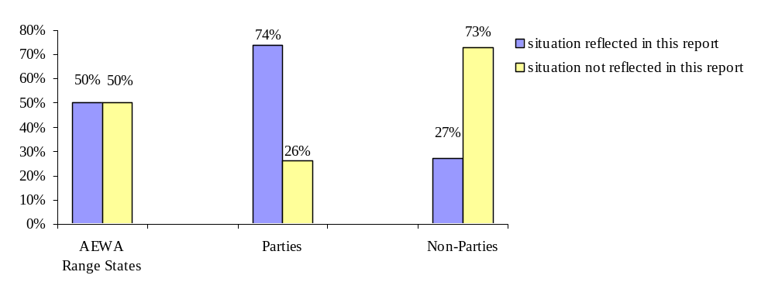
Graph 1: The review on hunting and trade legislation reflects the situation of 59 of 118 AEWA Range States (50 %), which can be split into 43 Parties (74 %) and 16 Non-Parties (27 %).

The received questionnaires have all been examined on the level of completeness and consistency and with help of the respective legislation, when provided by the national focal points or accessible through official legal databases (e.g. ECOLEX, FAOLEX) and in one of the following languages: English, French, German, Dutch, Bulgarian, and Russian. Missing, inconsistent or unclear answers have been discussed with the national focal points and, whenever possible, accordingly amended or supplemented with additional details. In addition, provided detailed information (e.g. national species lists) has been double checked with the AEWA Table 1 and additional information sources such as the BirdLife International database, official websites etc. Gaps and inconsistencies that could obviously not be solved have been kept out of consideration. In these cases the answers flow into the statistics as “no information”.
The AEWA Secretariat has done its utmost to reach a high level of quality of the information received through the questionnaires; however the responsibility for delivered information remains with the respective national focal point.

The work on the questionnaire and the compilation of the information needed to produce this international review on hunting and trade legislation implied detailed work with Table 1 of Annex 3, which reflects all populations of bird species covered by the Agreement dividing them into three groups of different conservation status. Filling out the questionnaire especially presupposed knowledge about a) the species occurring in a country, b) their status according to Table 1, and c) pertinent legislation on hunting and trade including its enforcement.

For the analysis of other international treaties and supranational organisations, the legal texts (and Annexes) and relevant documents and/ or Resolutions have been reviewed in detail and in comparison with AEWA requirements.

Analysis

Naturally, preparing and analysing the questionnaires presumed an additional step, which included intensive work with the Agreement text and Action Plan and other existing non-binding documents, namely the examination of the question of what the national legislation should cover in order to meet the requirements under AEWA regarding national hunting and trade legislation.

The Agreement text and the Action Plan as well as the relevant Conservation Guidelines are consequently referred to in the different chapters of this review in order to present the information received through the survey on hunting and trade legislation in the light of the AEWA provisions and guiding documents.

This review reflects the situation in spring / summer 2007 and is to be read on the assumption that the legal situation in a country is a constant process. Accordingly, the Secretariat has been informed by several countries that hunting and/ or trade legislation is currently being developed or amended: Armenia, Congo (-Brazzaville), Côte d’Ivoire, Kenya, Lebanon, Lybia, Morocco, Nigeria, Somalia, Sudan, Syria, Mauritius.

Finally, it should be noted that the issue of “lead shot” is subject to another international review and is therefore not been covered by this paper.

Difficulties faced

The Action Plan - although concrete in its actions - often uses qualified terms (e.g. “where appropriate”; “if they [Parties] consider it necessary”) or lacks explanatory definitions, concrete enumerations or additional guidance which would help to ensure that Contracting Parties implement the Action Plan in their countries as intended by this international treaty. More concrete (but not binding!) guidance is provided in the AEWA Conservation Guidelines (see Introduction). However, in addition to the Guidelines and in awareness of their limits there is aneed to go back into the history of AEWA and to take into account the drafters’ intentions that lead to the final text of the Agreement and its Action Plan. Actually, the hunting issue appeared to be a controverse point of discussion at the negotiating meeting in 1995. In order to reach a consensus, all provisions of the Action Plan were brought into line with EU legislation, namely the Birds Directive. This suggests that the Directive may be considered to be an ’interpretation aid’ when it comes to common legal or technical terms; this has been chosen as a basis for the elaboration of this review. However, future amendments to the Action Plan or additional documents might also aim for (individual) clarification and more concrete guidance concerning objectives expressed and terms used in the context of the Agreement’s international framework.

The Action Plan and this review use the terminology of “hunting legislation” and “trade legislation”. However, depending on the legislative system of an individual country relevant legal requirements in this context might also be found in other legislative documents concerned with wildlife conservation such as “Biodiversity Acts” etc. These documents have, of course, been taken into account despite the terminology used in the mandate (Paragraph 7.4 (d) Action Plan).

The work with Table 1 has shown that its usability could be improved, for example, by adding definitions for geographical terms used in the range descriptions or by concretising existing ones in order to enable clear determination of geographical ranges of single populations. Moreover, geographical terms used for the single populations listed may eventually need to be reviewed as inconsistencies between the information received from single countries and Table 1 have been remarked. The table, in addition, appears to have gaps, the filling of which should be an important task for the near future. Finally, it is considered recommendable to establish an international catalogue for the Agreement’s range which allows queries on the populations occurring in each Range State of AEWA.

5. Regional division of countries

In order to present results for certain regions across the AEWA Range, the following scheme has been used. (The European Community as a Contracting Party is left out of this overview.)

Countries marked in bold letters have returned the questionnaire and/ or provided sufficient information on the issue in a timely manner and are reflected in this report.

Region 1 – African countries (referred to as “Africa”)

Contracting Parties (16):
Algeria, Benin, Congo (-Brazzaville), Djibouti, Egypt, Equatorial Guinea, the Gambia, Ghana, Guinea, Guinea-Bissau, Kenya, the Libyan Arab Jamahiriya, Madagascar, Mali, Mauritius, Niger, Nigeria, Senegal, South Africa, Sudan, Togo, Tunisia, Uganda, the United Republic of Tanzania.

Non-Contracting States / Signatory States (8):
Angola, Botswana, Burkina Faso, Burundi, Cameroon, Central African Republic, Cape Verde, Chad, Comoros, Côte d’Ivoire, Democratic Republic of the Congo (Congo-Kinshasa), Eritrea, Ethiopia, Gabon, Lesotho, Liberia, Malawi, Mauritania, Morocco, Mozambique, Namibia, Rwanda, Sao Tome and Principe, Seychelles, Sierra Leone, Somalia, Swaziland, Zambia, Zimbabwe.

Region 2 – European Union member states (referred to as “EU”)

Contracting Parties (18):
Belgium, Bulgaria, the Czech Republic, Denmark (including Faroes), Finland, France, Germany, Hungary, Ireland, Italy, Latvia, Lithuania, Luxembourg, the Netherlands, Portugal, Romania, Slovakia, Slovenia, Spain, Sweden, the United Kingdom of Great Britain and Northern Ireland.

Non-Contracting States / Signatory States (2):
Austria, Cyprus, Estonia, Greece, Malta, Poland.

Region 3 – Non-EU European and Asian countries including Canada (referred to as “Eurasia”)

Contracting Parties (9):
Albania, Croatia, Georgia, Israel, Jordan, Lebanon, Republic of Moldova, The Former Yugoslav Republic of Macedonia, Monaco, Switzerland, the Syrian Arab Republic, Ukraine, Uzbekistan.

Non-Contracting States / Signatory States (6):
Andorra, Armenia, Azerbaijan, Bahrain, Belarus, Bosnia and Herzegovina, Canada, Greenland, Iceland, Iran (Islamic Republic of), Iraq, Kazakhstan, Kuwait, Liechtenstein, Montenegro, Norway, Oman, Qatar, the
Russian Federation, San Marino, Saudi Arabia, Serbia, Turkey, Turkmenistan, the United Arab Emirates, Yemen.

Whenever this document refers to the “countries”, the different regions (“Africa”, “EU” and “Eurasia”) or to “Parties” and “Non-Parties” exclusively those countries are implied which have provided their answers to the Secretariat according to the above overview. When Parties and Non-Parties as well as the different regions are compared one should keep in mind that the different groups do not consist of the same amount of countries. In the case of EU countries (Region 2) the participation of Non-Parties was extremely low (two countries) which is why the review does not provide any comparison between this group and the European Parties (18 countries) as such a comparison would be of no significance.

The European Community representing a regional economic integration organisation and not a state, did not participate in the survey, which was designed for state goverments. However, through the legal analysis of the Birds Directive this review also reflects the situation in the EU.

6. Structure of this review

The outcomes of the survey are mainly presented in chapter IV and V, and with the following structure:

- Relevant (legal) background documentation (Agreement text, Action Plan, Conservation Guidelines)
- Results of the survey
- Conclusions
- Recommendations

Recommendations resulting from lessons learned through the elaboration of this review:

- The Technical Committee reviews the geographical terms used in Table 1 of the AEWA Action Plan.

- The Secretariat, funds permitting, provides a catalogue on the Agreement website which enables queries on all populations occurring in each Range State of AEWA.

II. Other international treaties / supranational organisations addressing the issues of hunting and/ or trade

There are several other international legal instruments concerned with the issues of hunting and/ or trade that are relevant to AEWA Parties and Range States and therefore need to be considered in this context. The following table gives an overview of the membership of AEWA Range States to the most important international treaties in this context:

 | CMS |  | CITES | Bern Convention | CBD | Ramsar
Africa
AEWA Parties
Algeria | √ |  | √ |  | √ | √
Benin | √ |  | √ |  | √ | √
Congo (Rep) | √ |  | √ |  | √ | √
Djibouti | √ |  | √ |  | √ | √
Egypt | √ |  | √ |  | √ | √
Equatorial Guinea |  |  | √ |  | √ | √
Gambia | √ |  | √ |  | √ | √
Ghana | √ |  | √ |  | √ | √
Guinea | √ |  | √ |  | √ | √
Guinea-Bissau | √ |  | √ |  | √ | √
Kenya | √ |  | √ |  | √ | √
Libya | √ |  | √ |  | √ | √
Madagascar | √ |  | √ |  | √ | √
Mali | √ |  | √ |  | √ | √
Mauritius | √ |  | √ |  | √ | √
Niger | √ |  | √ |  | √ | √
Nigeria | √ |  | √ |  | √ | √
Senegal | √ |  | √ | √ | √ | √
South Africa | √ |  | √ |  | √ | √
Sudan |  |  | √ |  | √ | √
Togo | √ |  | √ |  |  | √
Tanzania | √ |  | √ |  | √ | √
Tunisia | √ |  | √ | √ | √ | √
Uganda | √ |  | √ |  | √ | √
Non-Parties
Angola | √ |  |  |  | √
Botswana |  |  | √ |  | √ | √
Burkina Faso | √ |  | √ | √ | √ | √
Burundi |  |  | √ |  | √ | √
Cameroon | √ |  | √ |  | √ | √
Cape Verde | √ |  | √ |  | √ | √
Central African Republic | S |  | √ |  | √ | √
Chad | √ |  | √ |  | √ | √
Comoros |  |  | √ |  | √ | √
Congo (DR) | √ |  | √ |  | √ | √
Côte d’Ivoire | √ |  | √ |  | √ | √
Eritrea | √ |  | √ |  | √
Ethiopia |  |  | √ |  | √
Gabon |  |  | √ |  | √ | √
Lesotho |  |  | √ |  | √ | √
Liberia | √ |  | √ |  | √ | √
Malawi |  |  | √ |  | √ | √
Mauritania | √ |  | √ |  | √ | √
Morocco | √ |  | √ | √ | √ | √
Mozambique |  |  | √ |  | √ | √
Namibia |  |  | √ |  | √ | √
Rwanda | √ |  | √ |  | √ | √
Sao Tome and Principe | √ |  | √ |  | √ | √
Seychelles | √ |  | √ |  | √ | √
Sierra Leone |  |  | √ |  | √ | √
Somalia | √ |  | √
Swaziland |  |  | √ |  | √
Zambia |  |  | √ |  | √ | √
Zimbabwe |  |  | √ |  | √
European Union
AEWA Parties
Belgium |  | √ | √ | √ | √ | √
Bulgaria |  | √ | √ | √ | √ | √
Czech Republic |  | √ | √ | √ | √ | √
Denmark |  | √ | √ | √ | √ | √
European Community |  | √ |  | √ | √
Finland |  | √ | √ | √ | √ | √
France |  | √ | √ | √ | √ | √
Germany |  | √ | √ | √ | √ | √
Hungary |  | √ | √ | √ | √ | √
Ireland |  | √ | √ | √ | √ | √
Italy |  | √ | √ | √ | √ | √
Latvia |  | √ | √ | √ | √ | √
Lithuania |  | √ | √ | √ | √ | √
Luxembourg |  | √ | √ | √ | √ | √
Netherlands |  | √ | √ | √ | √ | √
Portugal |  | √ | √ | √ | √ | √
Romania |  | √ | √ | √ | √ | √
Slovakia |  | √ | √ | √ | √ | √
Slovenia |  | √ | √ | √ | √ | √
Spain |  | √ | √ | √ | √ | √
Sweden |  | √ | √ | √ | √ | √
UK |  | √ | √ | √ | √ | √
Non-Parties
Austria |  | √ | √ | √ | √ | √
Cyprus |  | √ | √ | √ | √ | √
Estonia |  |  | √ | √ | √ | √
Greece |  | √ | √ | √ | √ | √
Malta |  | √ | √ | √ | √ | √
Poland |  | √ | √ | √ | √ | √
Eurasia (outside EU)
AEWA Parties
Albania |  | √ | √ | √ | √ | √
Croatia |  | √ | √ | √ | √ | √
Georgia |  | √ | √ |  | √ | √
Israel |  | √ | √ |  | √ | √
Jordan |  | √ | √ |  | √ | √
Lebanon |  |  |  |  | √ | √
Moldova (Republic of) |  | √ | √ | √ | √ | √
Macedonia (FYROM) |  | √ | √ | √ | √ | √
Monaco |  | √ | √ | √ | √ | √
Switzerland |  | √ | √ | √ | √ | √
Syrian Arab Republic |  | √ | √ |  | √ | √
Ukraine |  | √ | √ | √ | √ | √
Uzbekistan |  | √ | √ |  | √ | √
Non-Parties
Andorra |  |  |  | √
Armenia |  |  |  | S | √ | √
Azerbaijan |  |  | √ | √ | √ | √
Bahrain |  |  |  |  |  | √
Belarus |  | √ | √ |  | √ | √
Bosnia and Herzegovina |  |  |  |  | √ | √
Canada |  |  | √ |  | √ | √
Greenland
Iceland |  |  | √ | √ | √ | √
Iran (Islamic Republic of) |  |  | √ |  | √ | √
Iraq
Kazakhstan |  | √ | √ |  | √ | √
Kuwait |  |  | √ |  | √
Liechtenstein |  | √ | √ | √ | √ | √
Montenegro |  |  | √ |  | √ | √
Norway |  | √ | √ | √ | √ | √
Oman |  |  |  |  | √
Qatar |  |  | √ |  | √
Russian Federation |  |  | √ |  | √ | √
San Marino |  |  | √ |  | √
Saudi Arabia |  | √ | √ |  | √
Serbia |  |  | √ |  | √ | √
Turkey |  |  | √ | √ | √ | √
Turkmenistan |  |  |  |  | √
United Arab Emirates |  |  | √ |  | √
Yemen |  | √ | √ |  | √

1. The Convention on the Conservation of Migratory Species of Wild Animals (CMS)

CMS, also known as the Bonn Convention, was concluded in 1979 and is administered by UNEP. It aims to conserve terrestrial, marine and avian migratory species throughout their range. Particular focus is on coordinated species conservation and management, conservation and restoration of habitat, control of factors impeding migration, cooperative research and monitoring, and public education and exchange of information among Parties. Its implementation is assured through especially developed Agreements, Memoranda of Understanding and Action Plans.

CMS is not immediately involved in the issue of hunting and trade of migratory waterbirds, neither does it provide for specific means for hunting and trade regulation in its original text. The implementation of conservation measures for migratory waterbirds included in Appendix II of CMS, and with respect to the countries along the African-Eurasian flyway, is explicitely provided by AEWA. According to Article V of the Convention Agreements such as AEWA should cover the whole of the range of the migratory species concerned and shall deal with all aspects of the conservation and management. The AEWA Action Plan thus provides for specific conservation measures, inter alia, with respect to the hunting and trade.

The Convention text, however, requests Parties to provide for immediate protection of a specified number of endangered migratory species, which are listed in Appendix I of the Convention (Article II 3b) CMS) and, in particular, to prohibit the taking of these species, exceptions being allowed under very limited conditions only, specified in the Convention text (Article III 5 CMS). AEWA, which in its Article III refers to Article III 4 and 5 CMS, asking Parties to provide the same strict protection for endangered migratory waterbirds as CMS, has consequently included all waterbird species of its geographical scope that are listed in Appendix I to CMS in its Column A.

Finally, it is noteworthy that CMS has also pleaded for more precaution and restriction in international as well as domestic wildlife trade as a part of its proposals to combat Avian Flu.

2. The Convention on International Trade in Endangered Species of Wild Fauna and Flora (CITES)

Part of the survey on hunting and trade legislation dealt with CITES and related questions, which are therefore analysed in this chapter.

This chapter addresses following issues:

- Introduction to CITES
- AEWA and CITES
aa) Which countries are Parties to CITES?
bb) Is CITES given force of law by countries?
cc) Status of “AEWA waterbird populations” under CITES
dd) Trade in waterbirds in the AEWA region
ee) Illegal trade
ff) Measures against illegal trade
gg) Efficiency of measures against illegal trade
hh) Monitoring of trade (import/ export and domestic trade)
aaa) Established systems of monitoring domestic and international trade in the AEWA area
bbb) Share of hunting for trade purposes compared to all hunting activities on waterbirds

a) Introduction to CITES

CITES, also known as the “Washington Convention”, is a legally binding international treaty focusing on specimen conservation through trade regulation (in contrast to habitat conservation). The aim of CITES is to ensure that international trade in specimens of wild animals and plants does not threaten their survival and it accords varying degrees of protection to more than 33,000 species of animals and plants, including 19 species of migratory waterbirds (44 populations) covered by AEWA.
CITES provides a framework that encourages states to implement a system of specimen management, prohibition of trade in violation of CITES (including penalties for this) and laws providing for the confiscation of specimens. More specifically, CITES subjects selected specimens to certain controls, requiring authorisation of import, export and introduction of these species through a licensing system. The Convention does not prohibit trade if concerned populations are well-managed. The species covered by CITES are listed in three Appendices, according to the degree of protection they need:
CITES Appendix I
Appendix I lists species that are the most endangered (threatened with extinction) among CITES-listed animals and plants. CITES prohibits international trade in specimens of these species except when the purpose of the import is not commercial, for instance for scientific research. Additionally Article VII of the Convention provides for exemptions to this prohibition and these requirements.

CITES Appendix II
Appendix II lists species that are not necessarily threatened with extinction now, but that may become so unless trade is closely controlled. It also includes so-called "look-alike species", i.e. species of which the specimens in trade look like those of species listed for conservation reasons. International trade in specimens of Appendix-II species may be authorised by the granting of an export permit or re-export certificate. No import permit is necessary for these species under CITES (although a permit is needed in some countries that have taken stricter measures than CITES requires). Permits or certificates should only be granted if the relevant authorities are satisfied that certain conditions are met, above all that trade will not be detrimental to the survival of the species in the wild.

CITES Appendix III
Appendix III is a list of species included at the request of a Party that already regulates trade in the species and that needs the cooperation of other countries to prevent unsustainable or illegal exploitation. International trade in specimens of species listed in this Appendix is allowed only on presentation of the appropriate permits or certificates.

The CITES Appendices are regularly updated at the CITES Conferences of the Parties, which take place once every two years (Art. XI 2 CITES). Any Party may propose an amendment to Appendix I or II for consideration at the next meeting (Art. XV 1a) CITES). Moreover, any Party may at any time submit to the Secretariat a list of species which it identifies as being subject to regulation within its jurisdiction for inclusion in Appendix III (compare Art. XVI 1, II 3 CITES).

b) AEWA and CITES

The AEWA Action Plan requires strict protection from trade for all birds of populations listed in Column A of Table 1 as well as their eggs or any readily recognisable parts or derivatives of such birds (Paragraph 2.1.1 (c)). Birds of populations listed in Column B of Table 1 shall only be traded if they have not been taken in contravention of any prohibition (on hunting) laid down pursuant to Paragraph 2.1 of the Action Plan. For birds of populations listed in Column C of Table 1 the Action Plan does not provide detailed provisions on hunting and trade. Hunting and trade, however, when taking place, should be sustainable (see Article III e (b) Agreement text). The term of “trade” is not defined in the AEWA Action Plan, but also not restricted. The common understanding is in fact that trade could be international trade (import and export), but also – which is of much higher practical relevance for most migratory waterbirds and not covered by CITES – domestic trade. The AEWA Conservation Guidelines on regulating trade in migratory waterbirds define trade as the exchange of goods for money or other goods, either between people in different countries (international trade) or amongst people within a nation (domestic trade). Food, pets, hunting trophies, zoo specimens or traditional medicines can be traded, and trade can involve a low level of commercialisation (e.g. rural market trade) or be very commercial (e.g. international trade in rare species). Trade can involve live or dead intact birds, or parts of birds, such as skins and feathers, or eggs or young.

CITES is of particular importance for the objectives of AEWA since it regulates the international trade in certain endangered species covered by AEWA. However, it is important to realise that the CITES regulations do not (fully) imply the implementation of the more general AEWA requirements related to controlling trade of specimens for two main reasons: 1) CITES actually covers only a relatively small part of all AEWA waterbird populations (44 populations of 19 species); 2) CITES deals exclusively with international and not – as in the case of AEWA – also with domestic trade.

In September 2002 the CITES and the CMS Secretariats, “realising that activities under CITES concern migratory species and issues that also are covered by CMS or Agreements concluded under its auspices”, signed a Memorandum of Understanding in which it was agreed to reach institutional cooperation and policy compatibility, inter alia, by liaising on how to complement each other in promoting their Conventions’ shared goals […] through their instruments’ respective competences on international wildlife trade […]. The Parties to CITES, moreover, through Resolution 13.3 (COP 13, Santiago, 2002) directed the CITES Standing Committee to keep under regular review the Memorandum of Understanding with CMS and to extend invitations to CMS and its related Agreements to participate in meetings pertaining to species and issues of common concern.

aa) Which countries are Parties to CITES?

Most AEWA Parties and Non-Parties (except Andorra, Angola, Armenia, Bahrain, Bosnia and Herzegovina, Lebanon, Oman, Turkmenistan and Greenland) are Party to CITES. Unlike AEWA, CITES does not have a provision that allows regional economic integration organiation like the EC to become a Contracting Party. However, CITES has been implemented in the EU by Council Regulation 338/97/EG and Commission Regulation 1808/2001 (with amendments).

bb) Is CITES given force of law by countries?

81 % (+ 5% partly) of the countries indicated in the questionnaire that the provisions of the CITES Convention are given force of law by their national legislation, with only slight differences between AEWA Parties (84 % yes + 2 % partly) and Non-Parties (75 % yes + 13 % partly) as well as between regional groups. Most notable, all EU member states which answered this question replied “yes”.

cc) Status of “AEWA waterbird populations” under CITES

Actually CITES covers only 8 % of the 507 migratory waterbird populations (235 species) that are listed under AEWA (43 populations of 19 species).

Most of them are Column A populations, of which 18 % are covered by CITES. However for only 3 % the level of protection is actually as strict under CITES as under AEWA:
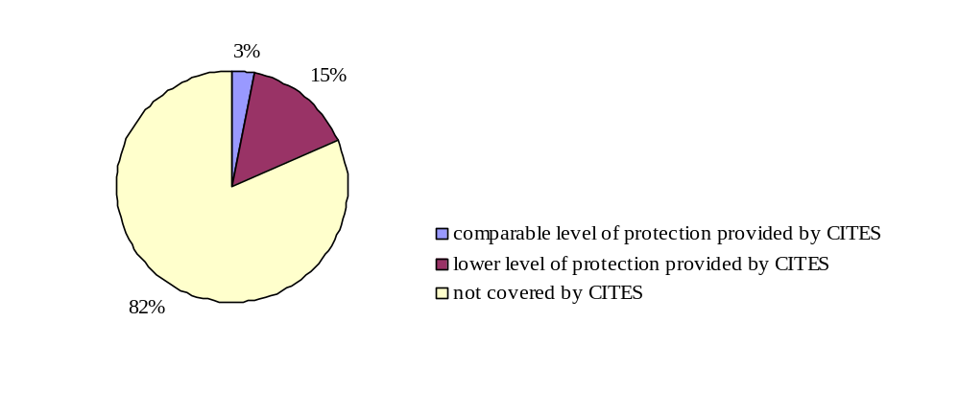
Graph 2: 6 populations listed under Column A of AEWA Table 1 are covered by CITES Appendix I (3 %); 29 populations listed under Column A of AEWA Table 1 are covered by CITES Appendix II (15 %); 158 populations listed under Column A of AEWA Table 1 are not covered by CITES at all (82 %).

In case of Column B only 8 populations (less than 1 % of all Column B populations) are covered by CITES Appendix II, while 149 populations are not covered by CITES at all. None of the 157 Column C populations is covered by CITES.

dd) Trade in waterbirds in the AEWA region

As pointed out in the AEWA ‘Conservation Guidelines on regulating trade in migratory waterbirds’ accurate figures for the volume of trade in waterbirds are lacking, owing to the absence of comprehensive reporting requirements. The best available information is actually collected under CITES. Recent CITES data provide some insights into the waterbird species subject to international trade, and also the types of trade taking place (see updated table below). When compared with the trade in cage birds (e.g. parrots and songbirds), only small numbers of migratory waterbirds are subject to international trade in the AEWA area. Much more significant, both from a species-conservation and a socio-economic viewpoint, is trade in domestic markets. Some studies have reported that hundreds of thousands of waterbirds are traded in this way.
CITES trade figures for the AEWA region for species listed in the AEWA Action Plan (data supplied by The World Conservation Monitoring Centre)

Column A
Species | CITES  App. | 2004 | Source of birds | Type of specimen | Reason for trade | 2005 | Source of birds | Type of specimen | Reason for trade
Geronticus eremita | I | 40 | 40 captive-bred | 39 live birds; 1 eggs | 20 zoo; 11 personal; 4 breeding in captivitiy or artificial propagation; 5 (re-) introduction | 18 | 6 captive-bred; 12 wild taken | 6 live bird; 12 specimen | 6 zoo; 12 scientific
Grus leucogeranus | I | 2 | unknown | 2 live birds | 2 scientific | none
Pelecanus crispus | I | 6 | 4 captive-bred; 2 wild taken | 4 live bird; 2 bodies | 1 zoo; 3 breeding in captivity or artificial propagation; 2 scientific | 2 | 2 captive-bred | 2 live bird | 2 zoo
Numenius tenuirostris | I | none |  |  |  | none
Spheniscus demersus* | II | 46 | 27 captive-bred; 5 captive-born; 14 confiscated or seized specimens | 45 live birds; 1 skull | 19 Circuses and traveling exhibition; 17 commercial trade; 9 zoo; 1 personal | 89 | 53 captive-bred; 36 captive-born | 86 live bird; 1 trophy, 2 skulls | 74 zoo; 13 commercial trade; 2 personal
Platalea leucorodia | II | 37 | 12 captive-bred; 6 captive-born; 19 wild taken | 29 live birds; 1 body; 7 specimen | 20 commercial trade; 7 breeding in captivity or artificial propagation; 1 private; 2 zoo; 7 scientific | 140 | 24 scientific; 20 commercial trade; 2 private; 93 educational; 1 breeding in captivity or artificial propagation | 21 live birds; 93 feathers; 1 body; 25 specimens | 116 pre-Convention specimen;
Ciconia nigra | II | 8 | 3 captive-bred; 1 captive-born; 3 wild taken; 1 unknown | 8 live birds | 1 (re-) introduction; 7 zoo | 2 | 2 captive-bred | 2 live birds | 2 zoo
Phoenicopterus ruber roseus* | II | 15 | 12 captive-bred; 3 unknown | 15 live birds | 15 zoo | 3 | 3 unknown | 3 live birds | 3 zoo
Phoenicopterus minor* | II | 837 | 75 captive-bred; 761 wild taken; 1 unknown | 59 specimens; 774 live birds; 1 body; 2 skeletons; 1 skull; | 59 scientific; 2 personal; 774 commercial trade; 2 educational | 668; 45 g; 14 ml | 1 captive-born; 627 + 45 g + 14 ml wild-taken; 40 captive-bred | 41 + 45 g + 14 ml specimens; 627 live birds | 41 + 45 g + 14 ml scientific; 627 commercial trade
Baleaniceps rex | II | 5 | 5 wild taken | 5 live birds | 5 zoo | 16 | 15 wild taken; 1 “pre-Convention specimen” | 15 live birds; 1 feathers | 15 zoo; 1 commercial trade
Branta ruficollis | II | 44 | 44 captive-bred | 44 live birds | 3 zoo; 41 commercial trade | 83 | 83 captive-bred | 82 live birds; 1 feathers | 83 commercial trade
Oxyura leucocephala | II | 27 | 27 captive-bred | 27 live birds | 8 zoo; 5 breeding in captivity or artificial propagation; 14 commercial trade | 12 | 12 captive-bred | 12 live birds | 12 commercial trade
Balearica pavonina | II | 388 | 27 captive-bred; 357 wild taken; 4 captive-born | 385 live birds; 3 skins | 384 commercial trade; 4 unknown | 91 | 63 captive-bred; 28 wild taken | 90 live birds; 1 trophies | 55 commercial trade; 4 scientific; 4 zoo; 28 breeeding in captivity or artificial propagation
Balearica regulorum | II | 31 | 30 captive-bred; 1 wild taken | 22 feathers; 1 body; 8 live birds | 5 zoo; 26 commercial trade | 167 | 119 captive-bred; 48 wild taken | 2 bodies; 1 trophy; 1 skull; 163 live birds | 3 zoo; 3 personal; 161 commercial trade
Grus virgo* | II | 84 | 3 captive-bred; 81 wild taken | 84 live birds | 1 zoo; 83 commercial trade | 43 | 38 captive-bred; 1 wild taken; 4 unknown | 1 skull; 42 live birds | 20 breeding in captivity or artificial propagation; 6 zoo; 1 personal; 12 commercial trade; 4 unknown
Grus paradisea | II | 10 | 7 captive-bred; 1 wild taken; 2 captive-born | 7 live birds; 2 bodies; 1 skull | 5 zoo; 2 breeding in captivity or artificial propagation; 2 personal; 1 commercial trade | 283 | 13 captive-bred; 270 wild taken | 270 specimens; 1 egg; 12 live birds | 12 breeding in captivity or articifial propagation; 270 scientific; 1 personal
Grus carunculatus | II | 3 | 1 captive-bred; 1 wild taken; 1 unknown | 3 live birds | 2 zoo; 1 commercial trade | none
Grus grus* | II | 18 | 18 wild taken | 18 live birds | 18 commercial trade | 90 | 72 wild taken; 18 captive-bred | 90 live birds | 78 commercial trade; 12 breeding in captivity or artificial propagation
Column B
Sarkidiornis melanotos | II | 17 | 4 confiscated or seized specimens; 12 wild taken; 1 captive-bred | 10 trophies; 1 small leather products; 4 feathers; 2 unspecified | 6 educational; 10 hunting trophies; 1 commercial trade | 16 | 6 captive-bred; 10 wild taken | 5 feathers; 5 trophies; 6 life birds | 2 scientific; 3 educational; 2 commercial trade; 4 zoo; 5 hunting trophies

ee) Illegal trade

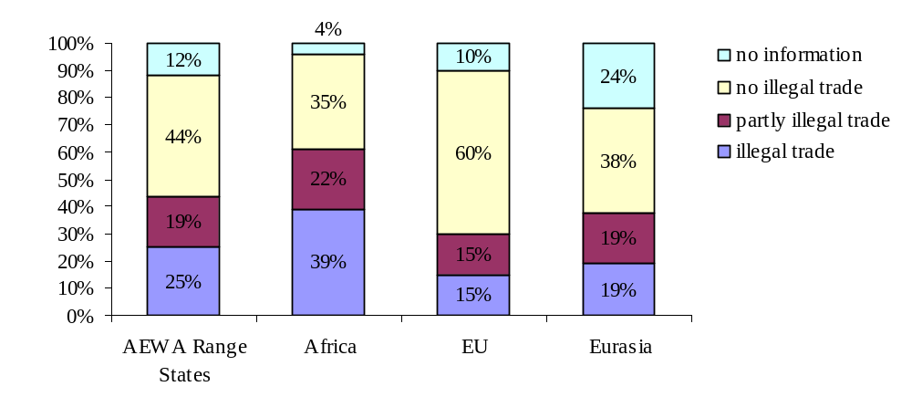
Graph 3: Illegal trade taking place in the AEWA region (question 75).

The survey has shown that illegal trade in waterbirds exists in at least 25 % of the countries (in additional 19 % partly). Regional differences are vast: In Africa, illegal trade is particularly common (39 % + 22% partly), while the rate is relatively low in Eurasia (19 % + 19 % partly) and the EU (15 % + 15 % partly), where it tends to be rather known as a small-scale activity. In parts of Belgium e.g. the keeping of ornamental birds, including many waterbird species (especially waders), is reported as being a popular pastime among a small but dedicated group of people, and there have been records of birds being taken from the wild and afterwards being ‘whitewashed’ as bred in captivity. In Eurasia, the rate of AEWA Contracting Parties with illegal trade in waterbirds is 11 % (+ 22% partly), while it is far higher (29 % + 14 % partly) among Non-Parties.

ff) Measures against illegal trade

Good enforcement is the key to the effective regulation of trade in waterbirds. Fines, penalties and, for sustained illegal activities, convictions must be imposed to deter persistent offenders.

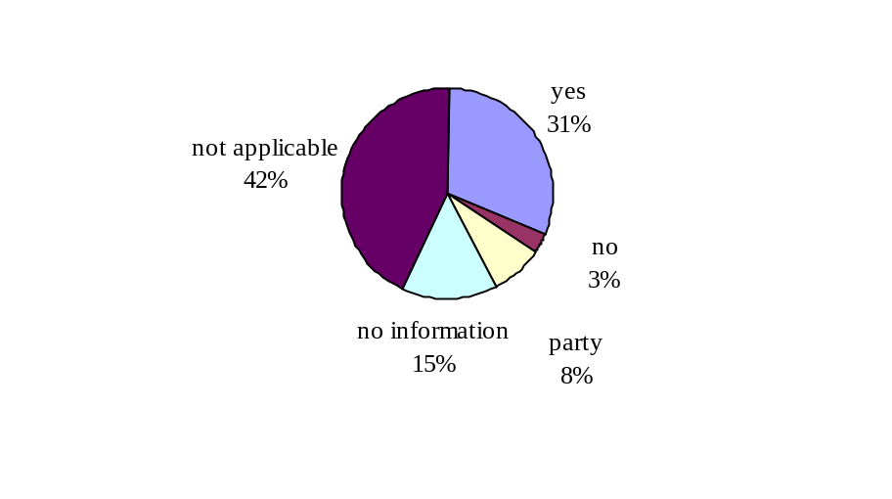
Graph 4: Measures to reduce or eliminate illegal trade in waterbirds in the AEWA area (question 76)

In view of the numbers shown for existing illegal trade, the large majority of the affected countries has measures in place to fight illegal trade (31 % of all + 8 % partly). A large share (57 %) of countries did not reply to this question because it was not applicable or information was lacking, but only 3 % replied “no” (Luxembourg and Tunisia).

Unfortunately, not much detailed information was provided about which kind of measures countries use against illegal trade. Mentioned were surveys and awareness-raising activities. Some countries referred to the implementation of CITES as a means to combat illegal trade, which suggests that measures in these countries primarily concentrate on the export and import of endangered species covered by CITES and may neglect domestic trade as well as part of the AEWA species. Croatia explicitly informed that especially measures against domestic trade need to be improved e.g. through awareness-raising activities. As pointed out by the UK comprehensive monitoring and measuring of illegal trade remains a challenge, which from the governmental point of view is difficult to tackle.

gg) Efficiency of measures against illegal trade

Range States/ Parties/ Non-Parties
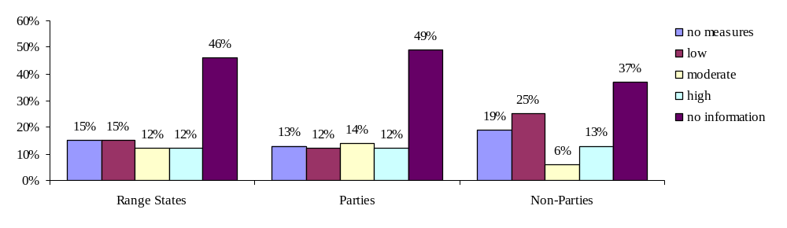Graph 5: Quality of measures against illegal trade in all Range States/ Parties/ Non-Parties (question 77).

Africa, the EU and Eurasia
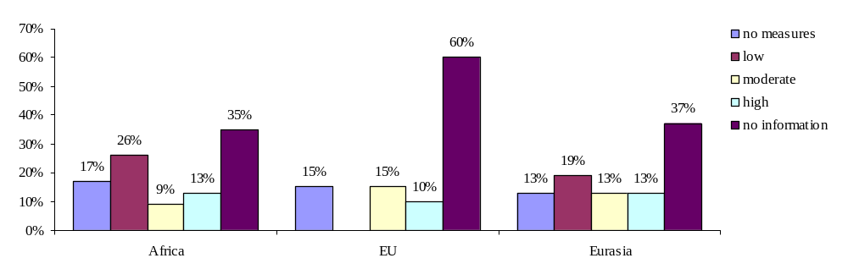

Graph 6: Quality of measures against illegal trade in Africa, EU and Eurasia (question 77).

As a consequence of the previous answers, this question was either not applicable to most countries (no cases of illegal trade and therefore no measures needed; only Tunisia has illegal trade, but no measures in place).
However, the 31 % (+8 partly) of countries concerned by this question have estimated the efficiency of their national measures as low (15 %), medium (12 %) and high (12 %). It has to be noted that on the level of Non-Parties of all regions as well as in the group of all African countries, more than half of the concerned countries estimated the efficiency of national measures to be “low”. Particularly evidently, all African Non-Parties concerned replied “low”. Efficiency also appears to be low in some Eurasian countries. However, it is higher amongst Eurasian Non-Parties (29 % of all answers: “high”) than among Eurasian Parties (no answer “high”). In contrast, not a single concerned EU country replied that the quality was “low”.

hh) Monitoring of trade (import/ export and domestic trade)

Conservation Guidelines on regulating trade in migratory waterbirds, Step 4:

[…] Data on trade in migratory waterbirds could be substantially improved if all countries with known trade […] were to introduce […] comprehensive monitoring.

The monitoring and regulation of domestic trade in migratory waterbirds is likely to be substantially more difficult and resource intensive than is the case with international trade. Individual traders may work with many hundreds of contacts in dispersed rural villages who trap, or arrange for the trapping of, wild birds. It is therefore not surprising that there is currently little monitoring or control of domestic trade in wild birds, legal or otherwise, in many countries.

In those countries where capture of migratory waterbirds is serving a significant domestic market, there should, where possible, be more detailed assessments of the impact of harvests for domestic trade on wild bird populations. Ideally, an annual capture quota should be developed to cover species harvested for domestic use or export. Quotas should be allocated and monitored to keep harvests within established limits. To be effective, capture and export regulatory systems should be linked to ensure that permitted trapping levels do not exceed established harvest quotas.

High standards of animal welfare should be a fundamental component of all bird trade. This is also a conservation measure, since trade-associated mortality (through poor welfare) is likely to increase the number of birds removed from the wild to meet demand. As a result, this mortality may itself be considered a factor contributing to the decline of wild bird populations. Trade-associated mortality has been linked to inadequate provision of food and water, exposure to extreme temperatures, lack of adequate ventilation, disease, aggression and other causes. Ensuring acceptable levels of care is the responsibility of the trappers, the traders and all other persons involved.

Overall, where domestic trade appears significant for migratory waterbirds, regulatory procedures may be modelled on, and integrated with, those developed for CITES, and implemented through domestic legislation, as far as the resources and infrastructures of individual AEWA Range States will permit.

aaa) Established systems of monitoring domestic and international trade in the AEWA area

Monitoring of domestic trade is a major tool for ensuring observation of national trade restrictions. In contrast, monitoring of imports and exports is mainly oriented at fulfilling the obligations of CITES, to which most surveyed countries are a Party.

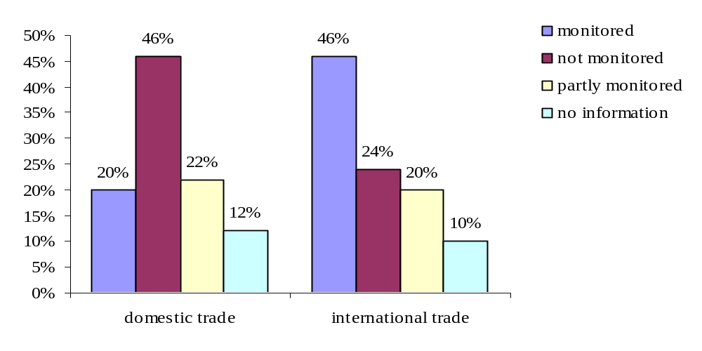
Graph 7: Do countries have established systems of comprehensive monitoring of domestic and international trade in wild birds covered by AEWA? (questions 80 and 81).

20 % of all countries monitor domestic trade in AEWA species, and an additional 22 % have a limited system in place, with restrictions on the range of species (mainly) or territory covered. For example, in France and Morocco public places, where trade takes place (e.g. supermarkets, groceries, public market places etc.), are controlled by the so-called hunting police.
In contrast, 46 % currently do not have any such system in place. Reasons mentioned are on one hand the lack of financial resources to establish such a system and, on the other hand, the fact that there is no “legal trade” or supposedly no domestic trade taking place, which would require monitoring.

Since the Conservation Guidelines on regulating trade in migratory waterbirds were drafted the situation concerning monitoring of import and export of birds seems to have improved. The Guidelines state: “Few countries in the AEWA area currently monitor all imports and exports of birds, including species not listed by CITES (only Denmark and the U.K.)”. The results obtained through the survey on hunting and trade legislation suggest that meanwhile many more countries monitor imports and exports of wild birds including all AEWA species (46 %), particularly in Africa and the European Union (see graphs 10 and 12). In additional 20 % of the countries import and export are monitored with restrictions, mainly on the species covered.

AEWA Parties and Non-Parties: domestic and international trade
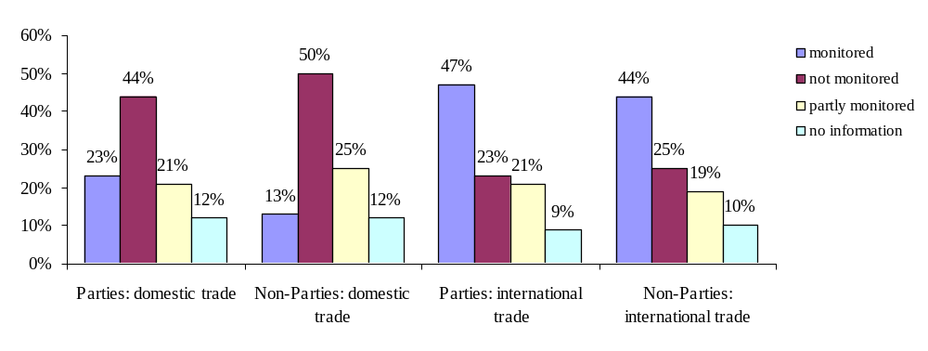
Graph 8: Established systems of comprehensive monitoring of domestic and international trade in wild birds covered by AEWA in Parties/ Non-Parties (questions 80 and 81).

On the level of import and export monitoring, there is almost no difference between AEWA Parties and Non-Parties. This most probably results from the fact that both AEWA Parties and Non-Parties are Parties to CITES. When it comes to monitoring of domestic trade the difference between AEWA Parties and Non-Parties is more significant. Only 13 % of Non-Parties have a comprehensive monitoring scheme in place (however, further 25 % have established a limited system). For Parties, this ratio is at 23 % (limited system: additional 21 %).

Africa: domestic trade
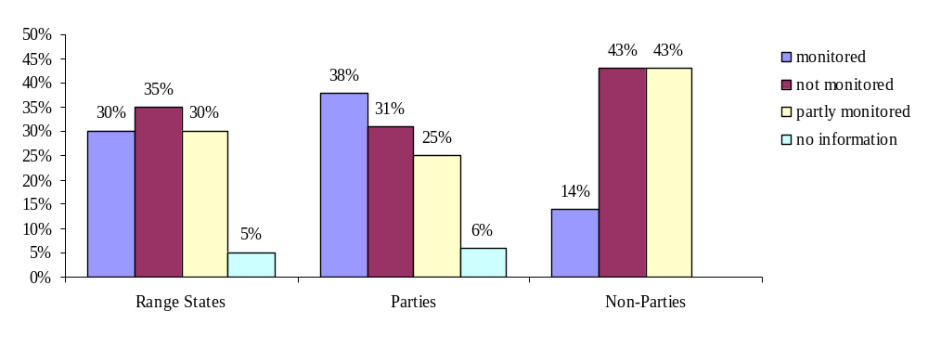

Graph 9: Established systems of comprehensive monitoring of domestic trade in wild birds covered by AEWA in Africa (questions 81).

Africa: international trade
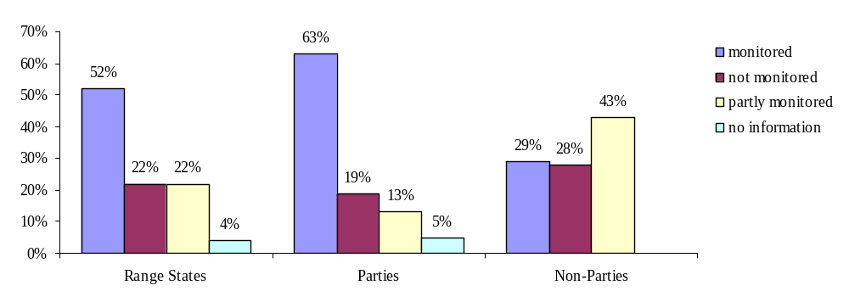
Graph 10: Established systems of comprehensive monitoring of international trade in wild birds covered by AEWA in Africa (questions 80).

According to the answers provided in the survey the African region has the highest share of established monitoring schemes for both domestic trade and imports/exports, 30 % of countries having established a comprehensive monitoring system and another 30 % disposing of such a system limited to certain species or a part of their territory.
It is striking that while 38 % of Parties in Africa have a comprehensive domestic trade monitoring system in place, this is true for only 14 % of Non-Parties of the continent. This is similar when it comes to monitoring of imports and exports: While 63 % of Parties have a complete system in place (+13 % partly), just 29 % (+43 % partly) of Non-Parties do so.

EU: domestic trade
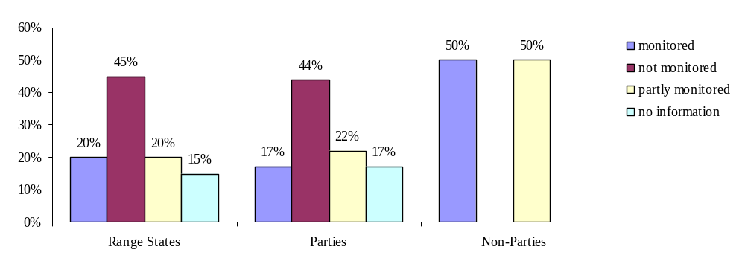
Graph 11: Established systems of comprehensive monitoring of domestic trade in wild birds covered by AEWA in the EU (questions 81).

EU: international trade
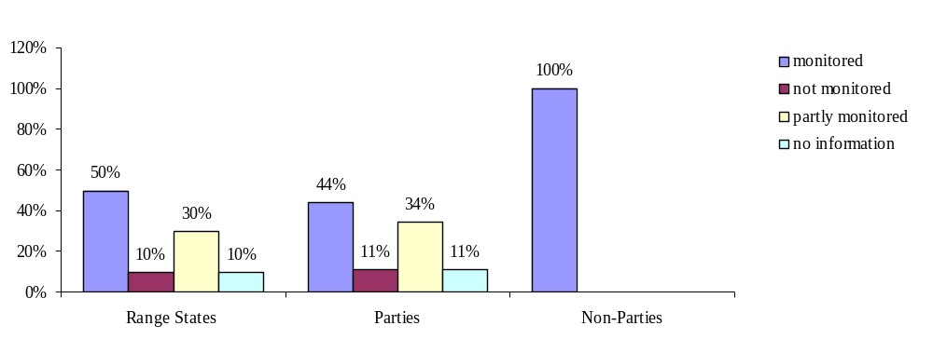
Graph 12: Established systems of comprehensive monitoring of international trade in wild birds covered by AEWA in the EU (questions 80).

50 % (+30 % partly) of the EU countries monitor import and export of wild birds, while only 20 % (+20 % partly) have a system in place to monitor domestic trade in wild birds.

Eurasia: domestic trade
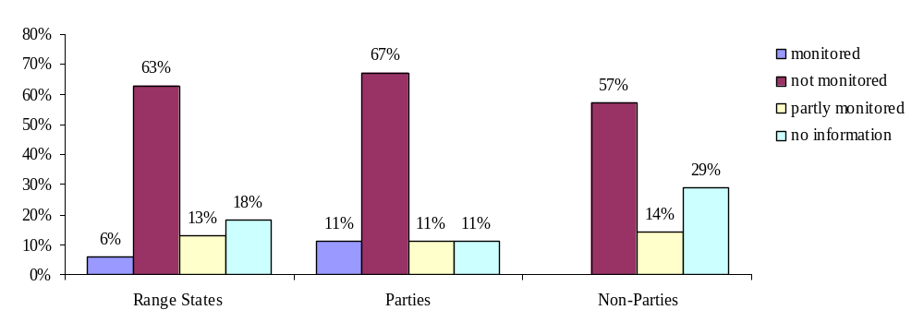

Graph 13: Established systems of comprehensive monitoring of domestic trade in wild birds covered by AEWA in Eurasia (questions 81).

Eurasia: international trade
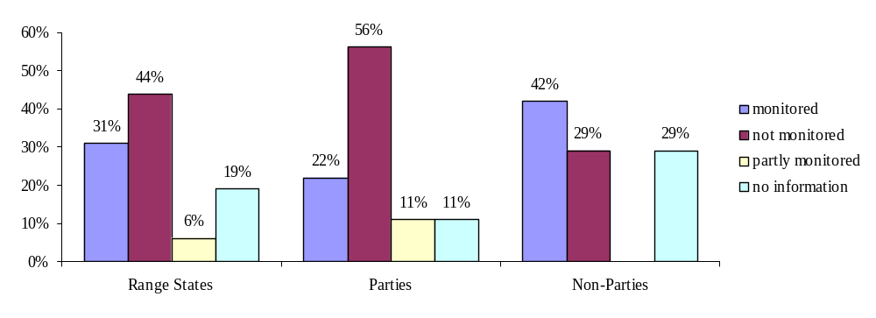
Graph 14: Established systems of comprehensive monitoring of international trade in wild birds covered by AEWA in Eurasia (questions 80).

In Eurasia, monitoring is less widespread than in the EU. Only 31 % of the countries (+6 % partly) monitor international trade in wild birds (only 22 % of Parties). Israel is the only country which indicated that it has a comprehensive monitoring system in place. Furthermore, the Russian Federation (Non-Party) monitors domestic trade for 5-10 % of its AEWA species, and the former Yugoslav Republic of Macedonia has another limited system in place. Accordingly, although some countries did not provide information on this question, a striking 63 % of Eurasian countries explicitly replied that they do not dispose of a domestic trade monitoring system.

bbb) The share of hunting for trade purposes compared to all hunting activities on waterbirds

Through the questionnaire on hunting and trade legislation, Focal Points were, moreoever, asked to provide a figure about the share of hunting for trade purposes compared to all hunting activities in their country.
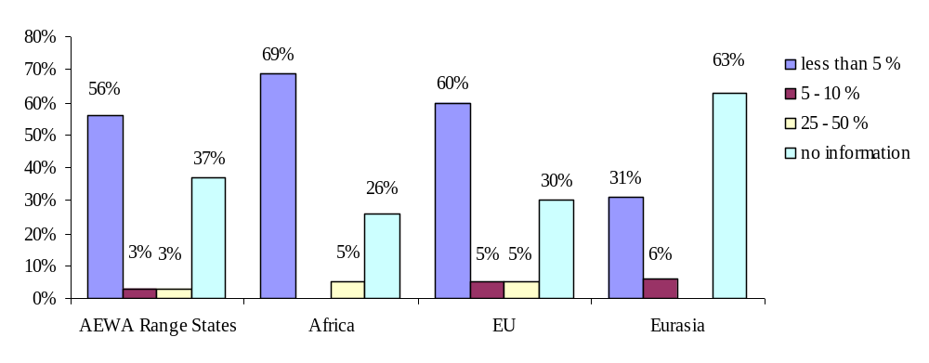
Graph 15: Percentage of hunting for trade purposes compared to all hunting activities on waterbirds (question 78).

Actually a large share of countries (37 % of all countries) has not been able to provide such information, often due to a lack of monitoring or any data. The lack of information is most significant in Eurasian countries of which 63 % were not able to provide an answer to this question. However, the large majority of replying countries estimated that the percentage of hunting for trade purposes (compared to all hunting of waterfowl) is less than 5 % (often even 0 %). The only exemptions are Italy, Turkmenistan (both estimated 5-10 %), Czech Republic and Mali (both 25-50 %).

The International Implementation Priorities 2006-2008 (adopted by Resolution 3.11 at MOP3, Dakar, Senegal, October 2005) include two relevant projects which will help to enhance the knowledge, inter alia, on hunting for trade purposes and its socio-economic impacts. Unfortunately, funds for realising these two projects have not been secured so far.

AEWA International Implementation Priorities 2006-2008 (adopted by Resolution 3.11):

IIP No 10: Evaluation of waterbird harvests in the Agreement area

Waterbirds are harvested widely throughout the Agreement area for sport, trade and subsistence (including by indigenous people) and thus have importance for local economies. However, little is known of the scale of such harvesting, particularly in Africa and South-west Asia, nor of the impacts that such harvesting has on waterbird populations. The effects of wounding of waterbirds by hunters remain little known and would be a valuable subject for study. It is therefore proposed to examine the location, scale (by species), methods and impacts of waterbird harvesting throughout the Agreement area, but with a particular focus on poorly known regions. The project will identify areas, methods or species where harvesting may be unsustainable and require intervention, and will feed into the development of future monitoring programmes. The taking of live waterbirds for collections and zoos should be included in this work.

IIP No 13: Evaluation of socio-economic impacts of waterbird hunting

Sport, market and subsistence hunting of waterbirds have the potential to contribute substantially to sustainable rural development throughout the Agreement area. Yet very little is known of the socio-economic impacts of such forms of hunting in different regions and its potential contribution to species and habitat conservation. This project will build on implementation priority number 10 above, and will research the socio-economic benefits of different types of waterbird hunting in different parts of the Agreement area (e.g. subsistence hunting in arctic/sub-arctic areas (including by indigenous populations), tourist or market hunting in Africa, and sport hunting in Europe). Significant work has been undertaken on this subject in North America, and should provide a useful background to the study. The results of the case studies will be presented to a workshop and published to advise future sustainable rural development initiatives.

Conclusions:

CITES

Most countries referred to in this review are Party to CITES and have given it the force of law in their national legislation, and by doing so provided for a system of specimen management, prohibition of trade in violation of CITES (including penalties for this) and laws providing for the confiscation of specimens.

However, 82 % of the AEWA populations listed in Column A of Table 1, are not covered by CITES. On the level of protection from trade, AEWA, compared to CITES, has an added value for 92 % of its populations and for the whole issue of domestic trade. The implementation of restrictions on trade as pronounced in the AEWA Action Plan, in addition to implementing CITES, is therefore very important for the overall conservation of waterbird species.

Illegal trade

Illegal trade is most dominant in African countries. This might be explained with the different socio-economic importance of trade in waterbirds for local people compared to European countries, for example. However, the lack of (effective) enforcement that was ranked “low” in many African countries, especially Non-Parties, might be another reason for that. Also in some of the Eurasian countries, measures against illegal trade are in need of improvement while all European countries have at least moderate, often even highly effective measures in place, a statement that convinces, taking into account the relatively low rate of illegal trade known in this region.

Monitoring of trade

A comprehensive monitoring system for international trade is provided in a large share of countries through the implementation of CITES. In contrast, domestic trade is not well monitored, but a system is in place in a larger share of countries that are Party to AEWA, than in Non-Parties. For both monitoring of import and export as well as monitoring of domestic trade, the largest share of systems in place is reported to be established in African countries. Research projects on the issue of waterbird harvest for sport, trade and subsistence purposes and its importance for local economies are already included in the International Implementation Priorities. However, funds for realising these projects are lacking so far.

The share of countries that lack information on “hunting for trade purposes” is accordingly high. As a contrast, most countries that were able to provide information on this question responded that hunting for trade is either not existent or relatively unpopular (less than 5 % of all hunting).

Recommendations ‘CITES’, ‘Illegal trade’ and ‘Monitoring of trade’:

1. The Technical Committee reviews the list of AEWA Column A populations that are not covered by CITES and gives advice to the Meeting of the Parties which of these populations – from an AEWA point of view – would profit from being included in Appendix 1 of CITES. Parties to AEWA and CITES may decide to propose these populations for inclusion in Appendix 1 at the following CITES COP.

2. The Meeting of the Parties encourages those countries that have not yet joined AEWA and/ or CITES, to do so.

3. The Meeting of the Parties directs the Secretariat, funds permitting, to provide training and technical assistance to the Parties in order to improve the enforcement of measures against illegal trade.

4. The Technical Committee examines whether there is need for establishing a comprehensive monitoring system for domestic trade in the AEWA area and, provided there is need, gives guidance to the Meeting of the Parties on how to implement such a system.

5. The Secretariat, funds permitting, provides for the implementation of International Implementation Priority No. 10 and 13 “Evaluation of waterbird harvests in the Agreement area” and “Evaluation of socio-economic impacts of waterbird hunting”.

6. The Secretariat, in close coordination with the Technical Committee, updates the Conservation Guidelines on regulating trade in migratory waterbirds according to the findings and update information provided in this review.

3. The Convention on the Conservation of European Wildlife and Natural Habitats (Bern Convention)

This chapter addresses following issues:

- Introduction to the Bern Convention
b) Status of AEWA populations under the Bern Convention

a) Introduction to the Bern Convention

The Bern Convention, which was initiated by the Council of Europe, an independent, intergovernmental organisation with several humanitarian, democratic, and cultural aims including environmental protection, entered into force in 1982. The Bern Convention is open to all 47 member states (including all 27 EU states) of the Council of Europe as well as to Pan-European and African non-member states and the “European Economic Community”. So far, it has been ratified by 39 member states, the European Community and four non-member states. To implement the Bern Convention in Europe, the European Community adopted Council Directive 79/409/EEC on the Conservation of Wild Birds (the EC Birds Directive) in 1979, and Council Directive 92/43/EEC on the Conservation of Natural Habitats and of Wild Fauna and Flora (the EC Habitats Directive) in 1992.

The Convention aims to protect rare and endangered animal and plant species and natural habitats. It lists protected species, contains provisions for protecting natural habitats, regulates the methods used to exploit certain species, and asks states to regulate trading in animals, particularly rare species. Special attention is given to endangered and vulnerable species, including endangered and vulnerable migratory species specified in appendices.

The Bern Convention firmly prohibits all forms of deliberate capture and keeping and deliberate killing of wild species specified in its Appendix II, the deliberate destruction or taking of eggs from the wild or keeping these eggs even if empty, as well as trade in any of the highly endangered species listed in Appendix II. The latter concerns dead and live animals as well as derivatives (see Article 6 of the Bern Convention). Contracting Parties have issued recommendations that firmly stand against illegal taking of or trading in birds. Remarkably the Bern Convention regulates the “internal trade” of species listed in its Appendix II, which complements the regulations of the CITES Convention that exclusively cover international trade (export / import).

Furthermore, the Convention requests Contracting Parties to take legislative and administrative measures to ensure the protection of the wild species specified in its Annex III. According to Art 7 of the Convention these measures shall include closed seasons and/ or other procedures regulating the exploitation; the temporary or local prohibition of exploitation in order to restore population levels and the regulation of sale of live and dead birds.

With regard to poaching, resolutions propose educational efforts besides wardening in protected areas as well as the prosecution of illegal action (taking, trade, possession, sale etc.) concerning protected species. Convention regulations on the methods of exploitation of listed species thus also include hunting previsions.

In addition, the Bern Convention covers the introduction and reintroduction of species in a certain region. Under the aegis of the Bern Convention, a European Strategy for coping with the issue of Alien Invasive Species, especially through the prevention of the introduction of such species, has been adopted.

Bern Convention:

Appendix II
Article 6
Each Contracting Party shall take appropriate and necessary legislative and administrative measures to ensure the special protection of the wild fauna species specified in Appendix II. The following will in particular be prohibited for these species:
- all forms of deliberate capture and keeping and deliberate killing;
- the deliberate damage to or destruction of breeding or resting sites;
- the deliberate disturbance of wild fauna, particularly during the period of breeding, rearing and hibernation, insofar as disturbance would be significant in relation to the objectives of this Convention;
- the deliberate destruction or taking of eggs from the wild or keeping these eggs even if empty;
- the possession of and internal trade in these animals, alive or dead, including stuffed animals and any readily recognisable part or derivative thereof, where this would contribute to the effectiveness of the provisions of this article.
Appendix III
Article 7
- Each Contracting Party shall take appropriate and necessary legislative and administrative measures to ensure the protection of the wild fauna species specified in Appendix III.
- Any exploitation of wild fauna specified in Appendix III shall be regulated in order to keep the populations out of danger, taking into account the requirements of Article 2.
- Measures to be taken shall include:
  - closed seasons and/or other procedures regulating the exploitation;
  - the temporary or local prohibition of exploitation, as appropriate, in order to restore satisfactory population levels;
  - the regulation as appropriate of sale, keeping for sale, transport for sale or offering for sale of live and dead wild animals.

b) Status of AEWA populations under the Bern Convention

AEWA Column A populations:

- 49 populations covered by Appendix II of the Bern Convention (comparable level of protection)
- 20 populations covered by Appendix III of the Bern Convention (less strict)
- 124 populations not covered by the Bern Convention (outside its range)

AEWA Column B populations:

- 31 populations covered by Appendix II of the Bern Convention (Bern more strict)
- 38 populations covered by Appendix III of the Bern Convention (comparable level of protection)
- 1 population not covered by the Bern Convention (inside its range)
- 87 populations not covered by the Bern Convention (outside its range)

AEWA Column C populations:

- 15 populations covered by Appendix II of the Bern Convention (Bern more strict)
- 51 populations covered by Appendix III of the Bern Convention (comparable level of protection)
- 4 populations not covered by the Bern Convention (inside its range)
- 87 populations not covered by the Bern Convention (outside its range)

Conclusion:

The Bern Convention is relevant for 30 % of the populations covered by AEWA, namely 36 % of all Column A populations, 45 % of all Column B populations and 45 % of all Column C populations. The level of protection under the Bern Convention does not always match with the status of bird populations under AEWA (part of the populations is ranked higher, part lower). An explanation for that might be that AEWA provides a system for single bird populations while the Bern Convention Appendices list bird species.

Recommendation “Bern Convention”:

AEWA seeks cooperation with the Bern Convention in order to align with the level of protection of common species regarding hunting and trade.

4. EU Directive 79/409/EEC (”Birds Directive”)

This chapter addresses following issues:

- Introduction to the Birds Directive
- AEWA and the Birds Directive
- The Birds Directive and hunting & trade
d) Implementation of the AEWA requirements on hunting and trade by the Birds Directive

a) Introduction to the Birds Directive

The European Union, supranational organisation of 27 European countries, has increasingly focused on environmental regulation, as far as transboundary issues are concerned. One instrument for this kind of regulation is the adoption of EU Directives. These legal instruments are addressed at EU member states, providing a binding framework for implementation as national legislation. They are also a means for union-wide nature protection. To address the issue of wild birds’ protection, the Birds Directive was adopted by EU bodies in 1979. In contrast to the more general Habitats Directive, it particularly addresses bird protection. Its annexes feature a list of bird species that are particularly threatened and need special conservation schemes (such as Species Action Plans). To achieve this, on the one hand, it regulates conservation of listed habitats through Special Protection Areas, a network of protected sites in EU member states. On the other hand, it provides detailed and extensive requirements on bird protection, addressing issues such as hunting in and trade of wild birds.

So far, the Birds Directive has been quite successful in reducing the loss of wetlands as well as of endangered bird populations. The main organisations representing European hunters and bird conservationists, namely FACE and BirdLife International, have signed an agreement affirming their commitment to the Birds Directive objectives in the framework of the European Commission’s “Sustainable Hunting Initiative”.

The Ornis Committee (composed of member state representatives) takes decisions to implement the directive.

Beyond the Birds Directive, the European Community’s Habitats Directive (Council Directive 92/43/EEC on the Conservation of natural habitats and of wild fauna and flora), adopted in 1993, aims to protect about 220 habitats and 1,000 species listed according to defined protection criteria.

b) AEWA and the Birds Directive

The European Community, independently from the individual member states, is a Contracting Party to AEWA. As an international treaty AEWA is legally to be placed between primary law (treaty on European Union) and secondary law (namely e.g. the Birds Directive) of the European Union. This means the EC could only conclude AEWA under the condition that AEWA complied with the treaty on European Union (reverse of Art. 300 V EU: “When the Council envisages concluding an agreement which calls for amendments to this Treaty, the amendments must first be adopted in accordance with the procedure laid down in Art. 48 of the Treaty on European Union)”. However, “Agreements concluded under the conditions set out in this Article [300 EU] shall be binding on the institutions of the Community and on Member states” (Art. 300 VII EU), in other words all secondary law of the EU (as well as national legislation of its member states) must comply with the concluded Agreement.

c) The Birds Directive and hunting & trade

The Birds Directive relates to the conservation of all species of naturally occurring birds in the wild state in the European territory of the EU Member States (not to Greenland; compare Article 1). It shall apply to birds, their eggs, nests and habitats.

Member States are requested to prohibit, for all bird species referred to in Article 1, in particular deliberate killing or capture by any method, […], taking their eggs in the wild and keeping these eggs even if empty, […], keeping birds of species the hunting and capture of which is prohibited (compare Article 5). Member States, moreover, shall prohibit, for all bird species referred to in Article 1, the sale, transport for sale, keeping for sale and the offering for sale of live or dead birds and of any readily recognisable parts or derivatives of such birds (compare Article 6).

Annex I species (species in danger of extinction, species vulnerable to specific changes in their habitat, species considered rare etc.) must be subject to special conservation measures concerning their habitat in order to ensure their survival and reproduction. Special Protection Areas must be designated by EU member states for these species.

Hunting of birds is thus, in principle, prohibited for all bird species occurring in the European territory. However, Annex II/1 and II/2 provide a list of 82 species and sub-species that may be hunted either in the whole geographical sea and land area where the Directive applies (II/1) or within the territory of the Member States in respect of which bird species are indicated (II/2). Hunting shall comply with the principles of wise use and ecologically balanced control of the species of birds concerned. Hunting shall, in particular, not be practiced during the period of reproduction or during return to the rearing grounds (compare Article 7). There are also rules defining which hunting methods are permitted (Annex IV provides a list of (e.g. non-selective) hunting methods and modes of transport which are banned).

Trade, although in principle prohibited according to Artice 6 1), is allowed for those species listed in Annex III/1 (throughout the whole territory) and III/2 (within the territory of Member States making provision for certain restrictions), provided that the birds have been legally killed or captured or otherwise legally acquired, and after consultation with the European Commission.

However, it is important to note that the Birds Directive fully recognises hunting as a form of sustainable use if it does not threaten endangered species. For this kind of hunting, the Directive lists some ecological principles and legal requirements (“hunting management”). In support of these aims, a programme of scientific, conservation and awareness raising measures has been developed.

EU member states, moreover, have the particular duty to safeguard the habitats of migratory birds. According to Article 4, paragraph 2, member states are supposed to impose special conservation measures also for regularly occurring migratory species not listed in Annex I. Furthermore, article 7 particularly emphasises migratory species when it comes to guaranteeing the sustainability of hunting. In particular, migratory species that are subject to hunting regulations should not be hunted during their periods of reproduction or during return to their rearing grounds.

AEWA Column A populations

Listed on the Birds Directive Annex II/2
Eurasian Golden Plover Pluvialis apricaria apricaria, Britain, Ireland, Denmark, Germany and Baltic (breeding)
Black-tailed Godwit Limosa limosa islandica, Iceland/Western Europe
Eurasian Curlew Numenius arquata suschkini, South-east Europe and South-west Asia (breeding)
Greater White-fronted Goose Anser albifrons albifrons, Western Siberia/Central Europe
Greater White-fronted Goose Anser albifrons flavirostris, Greenland/Ireland and UK
Brent Goose Branta bernicla hrota, Svalbard/Denmark and UK
Brent Goose Branta bernicla hrota, Canada and Greenland/Ireland
Red-crested Pochard Netta rufina, Black Sea and East Mediterranean
Common Goldeneye Bucephala clangula clangula, Western Siberia and North-east Europe/Black Sea
Goosander Mergus merganser merganser, North-east Europe/Black Sea
Listed on the Birds Directive Annex III/2
Greater White-fronted Goose Anser albifrons albifrons, Western Siberia/Central Europe
Eurasian Golden Plover Pluvialis apricaria apricaria, Britain, Ireland, Denmark, Germany and Baltic (breeding)

d) Implementation of the AEWA requirements on hunting and trade by the Birds Directive
As mentioned in the introduction, the Birds Directive was actually taken as model for designing the Agreement text and Action Plan with the result of a high coverage between EU and AEWA restrictions, although some issues are regulated in a stricter and more defined way in the Birds Directive (e.g. the Birds Directive provides a list of prohibited methods of hunting what is not the case for AEWA).

An analysis of the Annexes II and III of the Birds Directive in the light of AEWA requirements, however, leads to following results:

- According to its Annex II/2 the Birds Directive allows hunting of the Brent Goose Branta bernicla in Denmark and Germany. This formally concerns following Column A population, for which AEWA requires a strict ban on hunting:

  - Brent Goose, Branta bernicla hrota, Svalbard/Denmark and UK

- According to its Annex III/2 the Birds Directive allows trade (provided Member States make provision for certain restrictions and provided the birds have been legally killed or captured or otherwise legally acquired) in a) the Greater White-fronted Goose Anser albifrons albifrons and b) the Golden Plover Pluvialis apricaria. This formally concerns following Column A populations, for which AEWA allows hunting as a long-established cultural practice, but not trade (!):

- Greater White-fronted Goose, Anser albifrons albifrons, Western Siberia, Central Europe
- Golden Plover, Pluvialis apricaria apricaria, Britain, Ireland, Denmark, Germany and Baltic (breeding)

These are slight discrepancies between the Birds Directive’s Annexes II and III and the AEWA Action Plan and its Table 1, which should in the long term and in the context of the membership of the European Community to AEWA be harmonised.

Moreover, for future amendments to the Annexes of the Birds Directive, especially in view of the recent accessions of Bulgaria and Romania to the EU, AEWA restrictions will have to be taken into account. In the case of Bulgaria and Romania this might become relevant for the species Netta rufina and Bucephala clangula clangula, which are both to be found on Annex II/2 of the Birds Directive, but in Column A of AEWA Table 1.

However, in addition to the European Community itself, of course, also most of its member states are Contracting Parties to AEWA and may therefore, in accordance with Article 14 of the Birds Directive, chose to introduce stricter protective measures than those provided for under the Directive (in the very few cases for which this actually applies). The listing of species in Annex II and III of the Birds Directive does not oblige a Member State to allow for it to be hunted (and/ or traded). It is merely an option of which the Member States may or may not avail themselves.

Recommendations “Birds Directive”:

- The European Community and AEWA work together towards harmonising the AEWA Table 1 and the Annexes II/2 and III/2 of the Birds Directive.

- The European Community takes into account AEWA provisions for future amendments to the Annexes of the Birds Directive.

5. Convention on Biological Diversity and its Addis Ababa Principles and Guidelines for the sustainable use of biodiversity

In 1992, the Convention on Biological Diversity (CBD), the first global agreement on the conservation and sustainable use of biological diversity, was concluded as part of the three Rio conventions and since then 190 countries have become Contracting Parties to the Convention.

CBD has three main goals: The conservation of biodiversity, sustainable use of the components of biodiversity, and the sharing benefits arising from the commercial and other utilisation of genetic resources in a fair and equitable way. CBD is comprehensive in its goals, and deals with an issue so vital to humanity's future, that it stands as a landmark in international law. It recognises - for the first time - that the conservation of biological diversity is "a common concern of humankind" and is an integral part of the development process. Among others, it links traditional conservation efforts to the economic goal of sustainably using biological resources. Importantly, CBD is legally binding; countries that join it are obliged to implement its provisions.

CBD decisions and resolutions set out a policy of regulation and sustainable use of biodiversity. Through its fourteen “Addis Ababa Principles and Guidelines on the Sustainable Use of Biodiversity”, CBD provides practical principles and operational guidelines which promote sustainability and sustainable use in this field in order to reduce the current rate of biodiversity loss.The principles address the possible threats posed to certain species by extensive hunting and the consequent risks to sustained livelihood. Principle 10 expresses that international and national policies guiding trade should consider the real value of natural systems against man-made replacement.

While CBD does not feature any specific instruments concerning trade or hunting issues, it is clear that hunting as well as trade are supposed to be regulated in the context of sustainability and conservation of natural resources.
In addition, there is a close relationship between many of CBD’s provisions and the provisions of the multilateral trade agreements of the World Trade Organization (WTO). For example, CBD contracting parties have underlined the relationship between the Biosafety Protocol and the provisions of the WTO Agreements on Technical Barriers to Trade (TBT) and Application of Sanitary and Phytosanitary Measures (SPS).

Sure enough, there are collaborative efforts and synergies developed between CBD and other international organisations such as the Ramsar Convention which specifically concern waterbird conservation.

6. The Ramsar Convention

The Convention on Wetlands of International Importance, signed in Ramsar, Iran, in 1971 (and therefore commonly known as the Ramsar Convention), is an intergovernmental treaty which provides the framework for national action and international co-operation for the conservation and wise use of wetlands and their resources, especially as a habitat for waterbirds. It is the only global environmental convention which specifically aims to conserve one type of ecosystem. There are presently 155 Contracting Parties to the Ramsar Convention, with over 1,600 wetland sites included in the Ramsar List of Wetlands of International Importance.
The Ramsar Convention urges its Contracting Parties to conserve wetlands and their species, and to use them sustainably (“wise use”). Naturally, this might also include hunting regulation (and bans) for certain areas. In this context, the Convention acknowledges the necessity to secure the livelihoods of people whose income depend on wetlands.

For specific conservation areas in a country, states are urged to introduce a special legal status that allows for the control of hunting in these regions.

Recommendation 9 (Promotion of Hunting Research and Education) addresses the conditions of hunting in internationally important wetlands. Firstly, this recommendation urges research organisations to obtain data on the breeding success, productivity and general mortality of the main species involved, and to carry out special studies on the effect of hunting on wildfowl populations. Secondly, it urges international and national hunters’ organisations to encourage sportsmanlike methods in hunting, and stop actions which obviously lead to mass destruction or loss of waterfowl; intensify educational measures to improve hunters’ knowledge of different species of waterfowl; and make hunters aware of their responsibilities for conservation and wise use of waterfowl resources through proper hunting practices. To achieve these aims, wetlands management plans are supposed to be developed.

The Ramsar Convention also encourages international cooperation in the regulation of trade in species derived from wetlands. It promotes monitoring of international trade in order to track back trade objects’ origins, thus verifying their legal and sustainable harvesting (especially concerning particularly endangered species). One possibility to connect trade regulation and conservation efforts is to direct resources gained from trade control back to wetland conservation agencies.

Sometimes these provisions might overlap with provisions already expressed through CITES. However, Ramsar requirements are to be seen as a specialised supplement for water-dependant species. Besides, there are some Ramsar Parties that are not Party to CITES.

Finally, the Ramsar Convention also seeks to raise awareness of the role of Invasive Alien Species.

Recognising the complementary approaches of Ramsar and AEWA and the opportunities for synergies the AEWA and Ramsar Secretariats together with CMS signed a Joint Work Plan 2003-2005 addressing cooperation on existing areas of work so as to enhance their implementation.

Regional Initiative: Mediterranean Wetlands Initiative

An inititative under Ramsar that particularly concerns the AEWA range is the Mediterranean Wetlands Initiative (MedWet). MedWet fosters cooperation for wetland conservation and “wise use” of wetlands in the Mediterranean region, with participation of twenty-five Mediterranean countries, specialised wetland centers and international environmental organisations that regularly meet to discuss, identify key issues and take positive action to protect wetlands, for man and for biodiversity. It has become a formal part of the Ramsar Convention in 1999 (including an official coordination unit). The initiative also features a couple of networks which address specific issues or regions.

The initiative aims at empowering regional stakeholders to successfully implement the conservation goals of the Ramsar Convention. It also encourages the promotion of sustainable hunting practices, including the phasing out of lead shot, through its Mediterranean Wetlands Strategy (see General objective 5 of the Strategy).

MedWet naturally also concerns waterbird conservation, one of its non-governmental partners being the BirdLife International conservation partnership.

7. The World Trade Organization (WTO) & TRIPS

The World Trade Organisation is among the most important organisations worldwide when it comes to international trade questions. Its mission is to extend free trade and to provide a consensus-based platform for trade negotiation. Its dispute settlement bodies are often referred to in order to resolve conflicts that arise when environmental regulation intervenes in international trade arrangements.

The World Trade Organisation addresses the issue of biodiversity in many ways, though often indirectly. In a widely-observed WTO decision (“the shrimp-turtle case”), its Appellate body decided that, in general, a country may prohibit imports of products / animals if their production contradicts local environmental regulations, in particular when they concern protection of biodiversity.

Also, the WTO apparently is still in the process of adjusting the relationship between its Agreement on Trade-Related Aspects of Intellectual Property Rights (TRIPS) and the Convention on Biological Diversity (which, through its Article 15 and others, calls for the creation of access and benefit sharing arrangements with respect to the commercial use of genetic resources and traditional knowledge).

In addition, WTO has also organised workshops etc. in order to address the issue of invasive alien species which is also relevant to AEWA because this phenomenon is considered the second most important cause for habitat decline worldwide. There is no definitive approach to the issue yet, but it might in future be addressable through the WTO Agreement on Sanitary and Phytosanitary Measures.

8. Asia-Pacific Migratory Waterbird Conservation Strategy and North American Waterfowl Management Plan

These two regional waterbird conservation strategies are close to AEWA in their objectives, but are only partly of geographical relevance for the AEWA range.
The United States of America, Canada and Mexico have adopted the North American Waterfowl Management Plan. It is a non-regulatory strategy that aims to conserve wetland habitats through public-private partnerships. The plan provides for the conservation not only of waterbirds, but of all kinds of water-dependant species.

Another American international agreement on waterbirds is the “North American Colonial Waterbird Conservation Plan”. The objective of this initiative is to specifically advance the conservation of colonial-nesting waterbirds and their habitats through partnerships.

Concerning the Australasian waterbird flyway, regional strategies (“Asia-Pacific Migratory Waterbird Conservation Strategy”) have been adopted for certain time frames (lately 2001 – 2005), which also advocates the international harmonisation of legislation concerning monitoring and management of harvesting and trade in bird and bird products.

9. Conservation of Arctic Flora and Fauna (CAFF)

CAFF is a working group under the Arctic Council, concerned with the conservation of flora and fauna in the arctic region. The member states of the Arctic Council being Canada, USA (Alaska), Greenland, Iceland, Norway, Sweden, Finland and the Russian Federation work together in addressing the conservation of Arctic biodiversity, communicating the findings to the governments and residents of the Arctic and helping to promote practices which ensure sustainability of the Arctic’s living resources.

Seabirds as part of the Arctic marine ecosystems are important to many indigenous peoples for food and as an economic resource. Moreover, they are top predators that act as indicators of the health of the marine ecosystems. Sharing common seabird populations and threats the arctic countries have recognised their joint and equal responsibility for the conservation of seabirds in the Arctic. The CAFF Seabird Expert Group (CBird) is involved in a number of projects, focused on research and monitoring population effects from climate change, fisheries interactions, and harvest as well as education and outreach. Murres, Eiders, and Ivory Gull have been recognized by CAFF and the Cbird Group as needing special attention in multiple countries because of dramatic long-term population declines, of which some have been the result of human actions, such as fishery interactions (“by-catch”), over-harvest, and oil spills. The purpose of these conservation strategies is to increase monitoring of population trends, and where possible reduce the human impact on these species.

10. Convention for the Protection of the Mediterranean Sea against Pollution (Barcelona Convention)

The Barcelona Convention of 1976, amended in 1995, and the Protocols drawn up in line with this Convention aim to reduce pollution in the Mediterranean Sea and protect and improve the marine environment in the area, thereby contributing to its sustainable development.

The RAC/SPA Action Plan for the conservation of bird species listed in Annex II of the Protocol concerning specially protected areas (SPAs) and biological diversity in the Mediterrean concerns several species that are also listed in the AEWA Action Plan (see box). The Regional Activity Centre for Specially Protected Areas (RAC/SPA).

RAC/SPA, based in Tunis, as part of a host agreement signed in 1991 between Tunisia and the UNEP, was established by the Contracting Parties to the Barcelona Convention in order to help the Mediterranean countries to implement the Protocol on Specially Protected Areas and Biological Diversity in the Mediterranean (that came into force in December 1999). Direct persecution (such as illegal hunting and the use of poison) as well as the Introduction of and predation by alien species are among the threats the Action Plan aims to identify and control on the national level.

AEWA bird species (in bold) listed in the Protocol’s Annex II list of endangered or threatened species:

Cory’s Shearwater Calonectris diomedea
Mediterranean Shearwater Puffinus yelkouan
European Storm-petrel Hydrobates pelagicus
European Shag Phalacrocorax aristotelis
Pygmy Cormorant Phalacrocorax pygmeus
White Pelican Pelecanus onocrotalus
Dalmatian Pelican Pelecanus crispus
Greater Flamingo Phoenicopterus ruber

Osprey Pandion haliaetus
Eleonora’s Falcon Falco eleonorae
Slender-billed Curlew Numenius tenuirostris
Audouin’s Gull Larus audouinii
Lesser Crested Tern Sterna bengalensis
Sandwich Tern Sterna sandvicensis
Little Tern Sterna albifrons

III. Current situation and developments in individual countries

1. Strict protection for species listed in Table 1 Column A

According to Art. 2.1.1 AEWA Action Plan, Parties with populations listed in Column A of Table 1 shall provide strict protection to these populations. They shall in particular prohibit the taking of birds and eggs of those populations occurring in their territory. Moreover, they shall prohibit the trade of birds, any parts or derivatives of such birds as well as their eggs, which have been taken in contravention of the prohibitions on the taking of birds, what in case of Column A potentially comprises all listed populations.

Strict protection from hunting and trade is, in principle, to be accorded to all birds of populations listed under Column A and throughout the whole territory of any country that is Party to AEWA. However, the AEWA Action Plan provides for exceptions for those populations listed In Column A that are marked with an asterisk and for which hunting (not trade!) may continue on a sustainable use basis where hunting of these populations represents a long-established cultural practice. Moreover, the Action Plan provides a list of special purposes for which Parties may grant exemptions from the restrictions on hunting and trade of Column A populations (Paragraph 2.1.3 Action Plan).

This chapter addresses following issues:

      - Populations listed in Column A
      - Strict protection from hunting
      - Are there plans to provide strict protection from hunting to Column A populations in the future?
      - Strict protection from trade
      - Are there plans to provide strict protection against trade in the future?
      - Strict protection from both hunting and trade
      - Exception: Hunting as a long-established cultural practice
      - Regional differences
      - Exemptions according to Paragraph 2.1.3 of the Action Plan
      - Restrictions on “look-alike species”

Agreement text:

ARTICLE II
Fundamental Principles

1. Parties shall take co-ordinated measures to maintain migratory waterbird species in a favourable conservation status or to restore them to such a status. To this end, they shall apply within the limits of their national jurisdiction the measures prescribed in Article III, together with the specific actions determined in the Action Plan provided for in Article IV, of this Agreement.

2. In implementing the measures prescribed in paragraph 1 above, Parties should take into account the precautionary principle.

ARTICLE III
General Conservation Measures

1. The Parties shall take measures to conserve migratory waterbirds, giving special attention to endangered species as well as to those with an unfavourable conservation status.
[…]

AEWA Action Plan:

2.1 Legal measures
2.1.1 Parties with populations listed in column A of Table 1 shall provide protection to those populations listed in accordance with Article III, paragraph 2(a), of this Agreement. Such Parties shall in particular and subject to paragraph 2.1.3 below:

(a) prohibit the taking of birds and eggs of those populations occurring in their territory;
[…]

(c) prohibit the possession or utilization of, and trade in, birds or eggs of those populations which have been taken in contravention of the prohibitions laid down pursuant to subparagraph (a) above, as well as the possession or utilization of, and trade in, any readily recognizable parts or derivatives of such birds and their eggs.
[…]

a) Populations listed in Column A

Populations of this column occur in all countries that have responded to the questionnaire except in Burundi and Monaco.

b) Strict protection from hunting

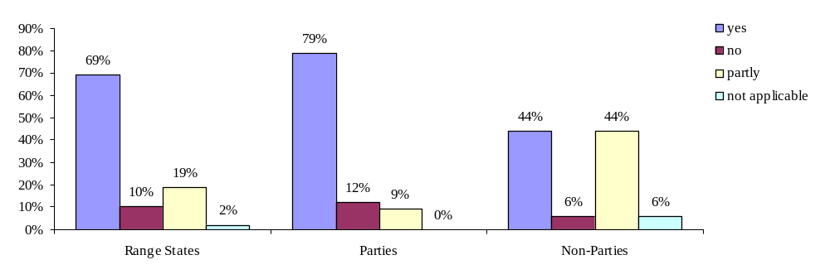
Graph 16: Strict protection from hunting in AEWA Range States/ Parties/ Non-Parties (question 7).

69 % of all countries, which have responded to the questionnaire, have a legal ban on hunting for all Column A populations, while 10 % do not provide strict protection for any Column A population. 19 % provide strict protection, but do not cover all populations or prohibit hunting only spacial-wise. For 2 % the question was not regarded applicable.

The results vary significantly between Parties and Non-Parties, which can be seen as a success indicator for the Agreement: 79 % of the Parties prohibit hunting of all Column A populations while among the Non-Parties only 44 % provide the same strict level of protection. No strict protection from hunting for any population is provided by 12 % of the Parties, while 6 % of the Non-Parties do not have a ban on hunting in place for any Column A population.

c) Are there plans to provide strict protection from hunting to Column A populations in the future?

AEWA Range States:

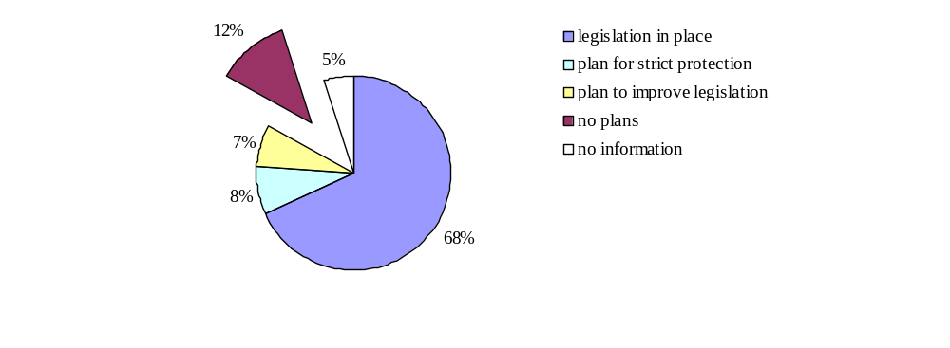
Graph 17: Plans for a future ban on hunting of Column A populations in AEWA Range States (question 10).

Plans to at least improve the situation exist in 7 % of the countries, while an additional 8 % informed about plans to provide strict protection from hunting to all Column A populations. 12 %, however, have expressed that plans about future amendments to their current (and in terms of AEWA insufficient) legislation do not exist. For the remaining 73 % the question was either not applicable (68 %: because the legislation is already in place) or no information was provided (5 %).

Parties:

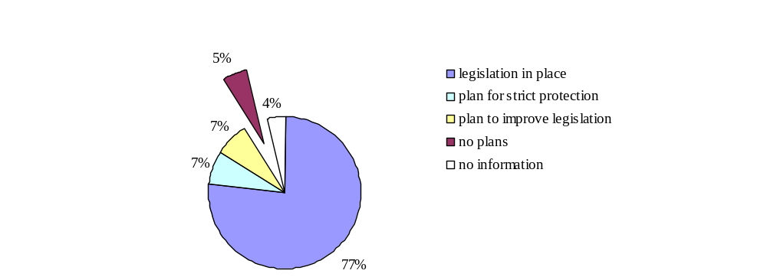

Graph 18: Plans for a future ban on hunting of Column A populations in Parties (question 10).

Non-Parties:
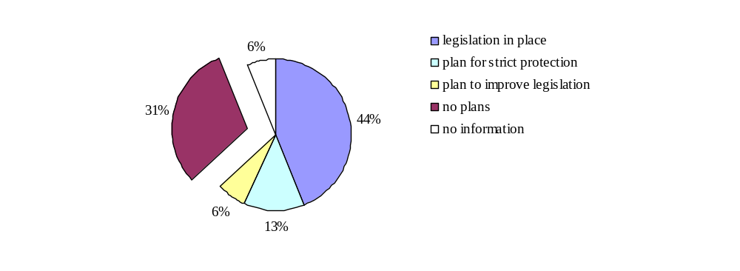
Graph 19: Plans for a future ban on hunting of Column A populations in Non-Parties (question 10).

A separate look at the Parties, however, leads to more positive results: 7 % of the Parties (in addition to the 77 % that already have the legislation in place) plan to provide strict protection to all Column A populations; additional 7 % have plans to improve their current legislation. Another 5 %, however, have no plans for future amendments. In contrast, although only 44 % of the Non-Parties have legislation in place which provides strict protection to all Column A populations there is a large share of 31 % of Non-Parties in which plans to at least improve the legislation are non-existant..

d) Strict protection from trade

According to Paragraph 2.1.1 (c) of the Action Plan Parties shall “prohibit […] trade in birds or eggs of those populations which have been taken in contravention of the prohibitions laid down pursuant to [the prohibition on taking of birds and eggs] as well as […] in any readily recognisable parts or derivatives of such birds and their eggs.

Implementation of this requirement implies the evidentiary problems relating to:

(1) Distinguishing items that have been “taken in contravention of the prohibitions”.

In case of Column A populations taking is ideally to be strictly forbidden for all concerned populations (and their eggs), so that any taking of such birds (or eggs) would be “in contravention of the prohibitions related to the taking of birds”, thus any trade in Column A populations (or parts, derivatives or eggs) is also to be strictly prohibited.

(2) Defining and identifying “readily recognisable parts or derivatives”.

The Conservation Guidelines on regulating trade in migratory waterbirds describe “readily recognisable parts or derivatives” as follows: Trade can involve live or dead intact birds, or parts of birds, such as skins and feathers, or eggs or young.
The terminology has, moreover, been thoroughly debated under CITES (using the same terminology).

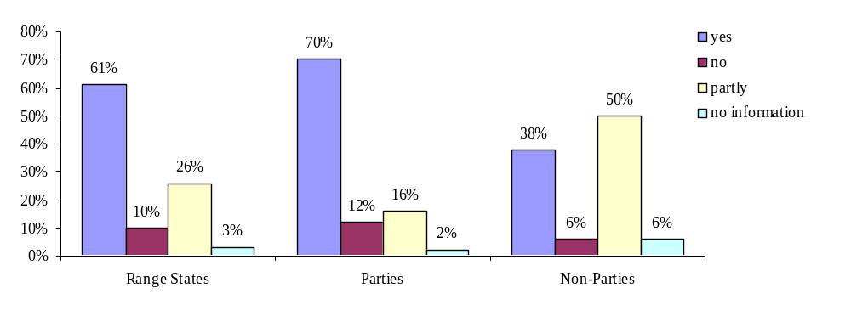
Graph 20: Strict protection from trade in AEWA Range States/ Parties/ Non-Parties (question 11).

According to the results received from the questionnaire trade is strictly prohibited for all Column A species in only 61 % of all countries; 10 % do not provide strict protection to any Column A species and 26 % fulfill only part of the requirements. No information was provided by 3 %.

A separate look at Parties and Non-Parties leads to significant results: While 70 % of the Parties provide strict protection to all relevant populations, only 38 % of the Non-Parties have legislation in place that covers all populations. However, 50 % of the Non-Parties provide at least strict protection on a partial basis (species-wise and/ or spacial-wise).

e) Are there plans to provide strict protection against trade in the future?

Range States:
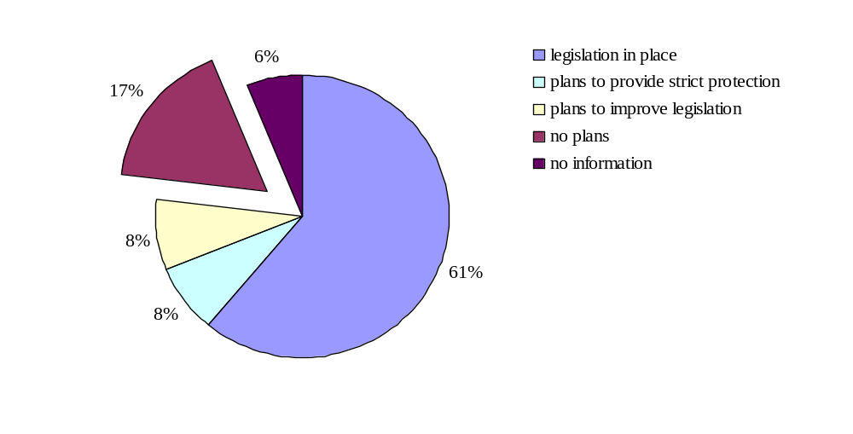
Graph 21: Plans for a future ban on trade in Column A populations in AEWA Range States (question 12).

Parties:
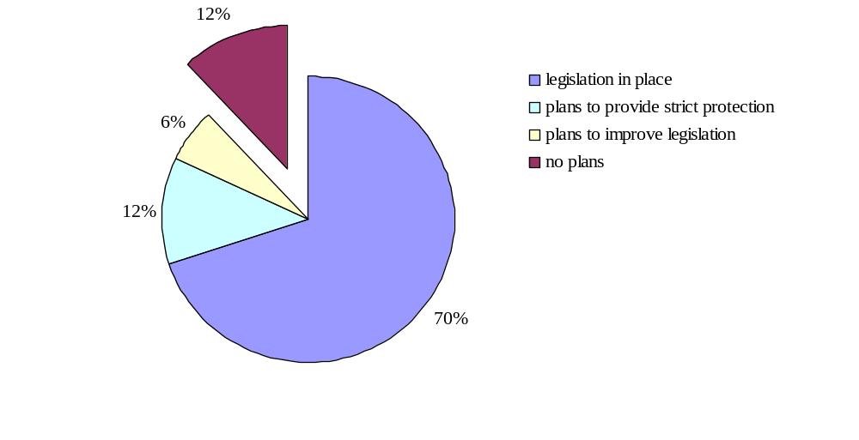
Graph 22: Plans for a future ban on trade in Column A populations in AEWA Range States (question 12).

Non-Parties:
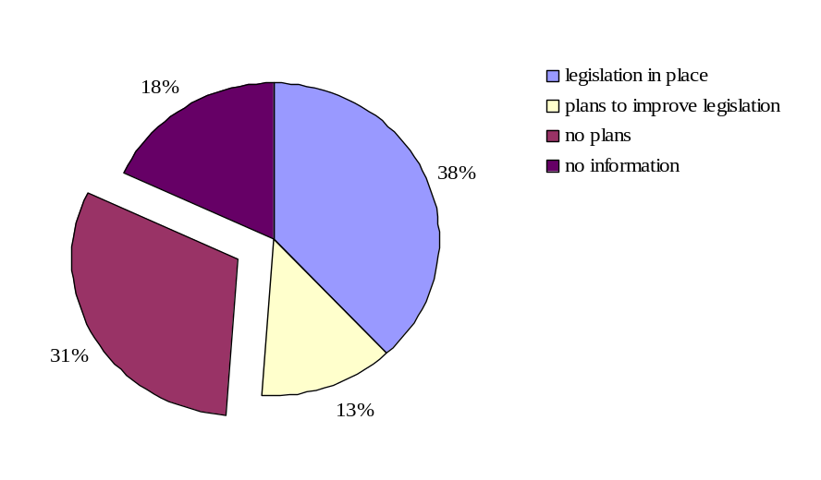
Graph 23: Plans for a future ban on trade in Column A populations in AEWA Range States (question 12)

In the case of Parties a relatively large share of countries plan to bring their trade legislation in line with AEWA in the near future, while among Non-Parties not many countries signaled having plans for amendments.

f) Strict protection from both hunting and trade

This graph reflects the situation in the AEWA area concerning strict protection from both hunting and trade:
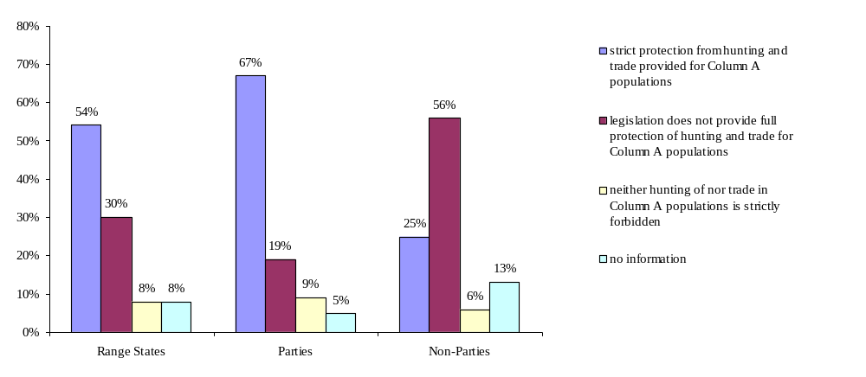
Graph 24: Strict protection of Column A populations provided for both hunting and trade in Range States/ Parties/ Non-Parties.

An analysis of the situation in the countries including both strict protection from hunting and trade leads to following results: Strict protection from both hunting and trade exists in 54 % of all countries, in 67 % of the Parties and in 25 % of the Non-Parties.

g) Exception: Hunting as a long-established cultural practice

AEWA gives specific attention to traditional and subsistence users of migratory waterbirds, to ensure that they are not inappropriately burdened by the species protection and general limitations on the use of such species.

According to Paragraph 2.1.1 sentence 3 of the Action Plan “by way of exception for those populations listed in Categories 2 and 3 in Column A only and which are marked by an asterisk, hunting may continue on a sustainable-use basis where hunting of such populations is a long-established cultural practice. This sustainable use shall be conducted within the framework of special provisions of a species action plan at the appropriate international level.”

Neither the Action Plan nor the Conservation Guidelines on sustainable harvest of migratory waterbirds or any other AEWA reference document provide for a definition of “long-established cultural practice”. The information provided on this issue in the frame of the survey on hunting and trade legislation is therefore based on the term as understood by the respective national Focal Points and/ or defined in the respective national legislation.
Agreement text:

ARTICLE III
General Conservation Measures

1. The Parties shall take measures to conserve migratory waterbirds, giving special attention to endangered species as well as to those with an unfavourable conservation status.

2. To this end, the Parties shall:
(a) accord the same strict protection for endangered migratory waterbird species in the Agreement Area as is provided for under Article III, paragraphs 4 and 5, of the Convention [on migratory species];

Convention text:

ARTICLE III

5. Parties that are Range States of a migratory species listed in Appendix I shall prohibit the taking of animals belonging to such species. Exceptions may be made to this prohibition only if:

a) the taking is for scientific purposes;
b) the taking is for the purpose of enhancing the propagation or survival of the affected species;
c) the taking is to accommodate the needs of traditional subsistence users of such species; or
d) extraordinary circumstances so require; provided that such exceptions are precise as to content and limited in space and time. Such taking should not operate to the disadvantage of the species.

AEWA Action Plan:

2.1 Legal measures
2.1.1
[…]
By way of exception for those populations listed in Categories 2 and 3 in Column A only and which are marked by an asterisk, hunting may continue on a sustainable use basis where hunting of such populations is a long-established cultural practice. This sustainable use shall be conducted within the framework of special provisions of a species action plan at the appropriate international level.

2.2 Single Species Action Plans

2.2.1 Parties shall cooperate with a view to developing and implementing international single species action plans for populations listed in Category 1 of Column A of Table 1 as a priority and for those populations listed with an asterisk in Column A of Table 1. The Agreement secretariat shall coordinate the development, harmonization and implementation of such plans.

aa) Do countries allow hunting of Column A asterisk populations as a long-established cultural practice?
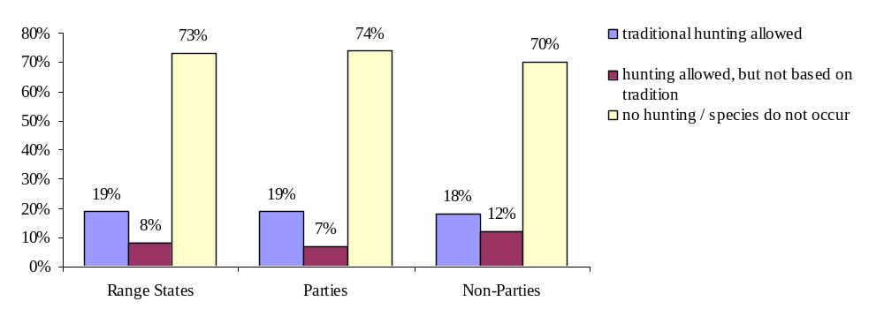
Graph 25: Hunting of asterisk populations as a long-established cultural practice in AEWA Range States/ Parties/ Non-Parties (question 13).

19 % of all countries allow hunting as a long-established cultural practice in at least one of the Column A populations marked with an asterisk; additional 8 % allow hunting in at least one of these populations, but have signaled that this does not represent any cultural practice. Differences between Parties and Non-Parties are only very slight.

Countries that allow hunting as a long-established cultural practice, according to the information received, are Canada (any Anatidae for sport hunting and any species by Aboriginal people), Chad, Czech Republic (Anser albifrons albifrons), France (Limosa limosa arctica), Hungary (Anser albifrons albifrons), Latvia (Anser albifrons albifrons), Mali (no information about species), the Russian Federation (no information about species), Slovakia (Anser albifrons albifrons), Sudan (no information about species), UK (Anser albifrons flavirostris: legislation allows hunting in Wales, but there is a voluntary ban; Pluvialis apricaria apricaria). Legal hunting of asterisk populations without traditional motivation exists in: Croatia (Anser albifrons), Gambia, Togo, Ethiopia, Zimbabwe (no information about species).

bb) Sustainability

Countries allowing hunting in Column A populations marked with an asterisk as a long-established cultural practice are expected to ensure that this is done on a sustainable use basis and in the framework of special provisions of a species action plan at the appropriate international level.

50 % of the countries, in which hunting of Column A populations marked with an asterisk is allowed as a long-established cultural practice have confirmed that this is done on a sustainable use basis; additional 20 % suggest that sustainability is “partly” provided for. 30 %, however, have answered this question with a clear “no”.
None of the responding countries has informed that hunting of the relevant population is managed in the framework of a species action plan.

Innternational Single Species Action Plans, in the framework of which the countries could participate, have not been established for any of the asterisk species so far, although required according to Paragraph 2.2 of the AEWA Action Plan. An International Species Action Plan for the Anser albifrons flavirostris is currently being drafte. However, this Action Plan will be a conservation management plan and not cover hunting management activities.

Among the restrictions actually established by countries on the national level to ensure a sustainable use of asterisk populations are hunting seasons, shooting hours, restriction on hunting days, bag and possession limits, patrolling, awareness programmes and limitations on hunting methods and equipment.

Trade in these species (not permitted under AEWA) is allowed by 40 % of the same countries, namely Canada (only among Aboriginal people and in any species), Mali, Russian Federation, Sudan, UK (Pluvialis apricaria apricaria may be sold dead from September to February).

Conclusions:

Although the Action Plan, in principle, allows countries to continue with their hunting traditions in case of the few Column A populations that are marked with an asterisk, it at the same time requests for preconditions to ensure that these populations are used on a sustainable basis and without threatening the populations. These preconditions, namely the existence and implementation of relevant international species action plans, have not been provided yet. Consequently – to be in line with AEWA – hunting of asterisk populations should not take place as long as these action plans are not established and their implementation not provided for in all countries involved.

However, a relatively large share of countries makes use of this exception despite the fact that international single species action plans do not exist. Moreover, sustainability is not taken into account at all in parts of the countries, and some countries allow trade in these birds although trade is not covered by the exception made by the Action Plan and is to be strictly prohibited. Finally, some countries also make use of this exception although hunting the relevant species does not represent any tradition.

Recommendations “Hunting as a long-established cultural practice”:

- The Technical Committee provides a definition of “long-established cultural practice”, which is given legal force by integrating it into Paragraph 2.1. of the AEWA Action Plan or adopted by Resolution at the Meeting of the Parties or integrated in the Conservation Guidelines on sustainable harvest of migratory waterbirds.

- The Technical Committee reviews the conservation status of populations listed in Column A and marked with an asterisk and provides advice to the Meeting of the Parties for which of these populations either an amendment to Paragraph 2.1.1 sentence 3 of the Action Plan or a preliminary ban on hunting may be recommendable (for the reason that the sustainability is not provided for in the framework of an international single species action plan yet). Moreover it gives advice to which of these populations priority should be given for establishing a single species action plan in the near future. Such single species action plans should provide measures for adaptive management, thus dealing with the sustainable taking of birds from these populations.

- In the medium-term and in implementation of Paragraph 2.2.1 of the Action Plan, the Secretariat, funds permitting, provides for the development of single species action plans (including measures for adaptive management) for all populations marked with an asterisk.

h) Regional differences concerning strict protection from hunting of and trade in Column A populations

A look into the results obtained in the single regions leads to significant differences which are worth being considered more closely:

Region 1: African Parties and Non-Parties

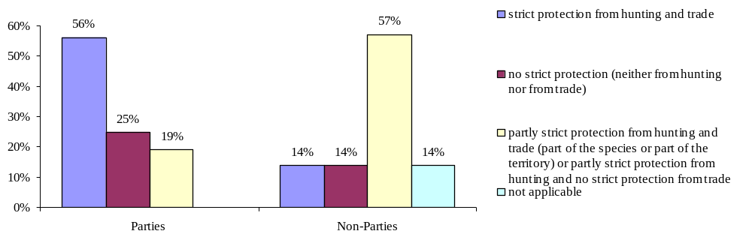
Graph 26: Strict protection from hunting and trade in African Parties and Non-Parties (questions 7 and 11).

56 % of the African countries that are Party to AEWA have a legal ban on both hunting and trade for populations listed in Column A. In 25 % of the African Parties, however, neither hunting nor trade is prohibited for any population listed in Column A; when considering trade only this is even the case in 31 % of these countries. In 19 % of the African Parties in case of hunting (and in 13 % of these also in case of trade), countries’ legislation does not entirely fulfill the Agreement’s obligations for different reasons (see box).
Reasons why African Parties provide only partly strict protection to Column A populations

Hunting:
None of the Parties included in the 19 % have an exhaustive coverage of all relevant Column A populations (a third of this group covers only less than 5 %; another third cover only 25-50 %; the last third covers only 50-75 % of all occurring populations); some Parties of the same group have signaled that hunting, however, is prohibited on part of their territory (a third of this group prohibits hunting on less than 5 % of the territory, another third on 50-75 % of the territory).

Trade:
Only a third of the Parties included in the 19 % have sufficient trade regulations in place; the other two thirds have insufficient legislation on trade (e.g. for the reason that only less than 5 % of the relevant populations are protected from trade while the collection of any eggs is prohibited).

From the African Non-Parties only 14 % have reported that hunting as well as trade in the Column A populations is prohibited according to their legislation. Another 14 % do not provide for any protection from hunting and trade; 14 % have declared the question not applicable. 57 %, however, provide partial protection from hunting and trade for Column A populations (see box).

Reasons why African Non-Parties only partly provide strict protection to Column A populations

Hunting:
In 25 % of the Non-Parties that provide partial strict protection, hunting is only prohibited for 25-50 % of the relevant populations; another 25 % protect more than 75 % of the relevant populations; 25 % have informed that strict protection from hunting is provided for, but only in less than 5 % of the territory and not covering the collection of wild birds’ eggs; the remaining 25 % have not provided details on the deficits.

Trade:
The same countries do not provide the required strict protection for Column A populations from trade. 25 % protect more than 75 % of the relevant populations; 25 % protect only 25-50 % of the populations; another 25 % prohibit trade in less than 5 % of the populations and in less than 5 % of the territory. 25 % accord full protection to birds of the relevant populations, but there are no restrictions on the trade in their eggs.

Plans for new legislation?
African Parties:
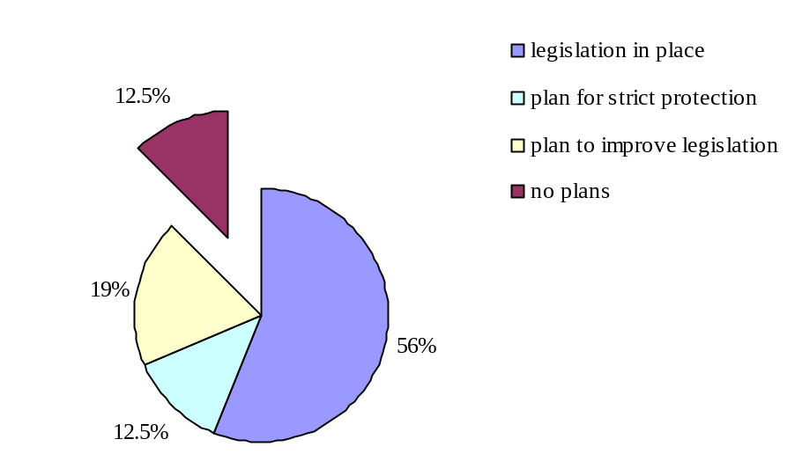

Graph 27: Plans for a future ban on hunting of and trade in Column A populations in African Parties (questions 10 and 12).

Half of the African Parties without any established legislation concerning hunting and trade of the Column A populations have signaled that there are plans to introduce strict prohibitions of hunting and trade. The other half, however, does not foresee any change in the current situation. All Parties in Africa, which have insufficient legislation in place already, have plans to at least improve the situation for Column A populations.

African Non-Parties:
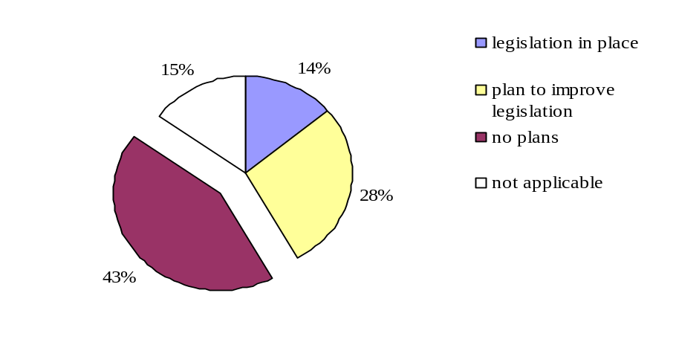
Graph 28: Plans for a future ban on hunting and trade of Column A populations in African Non-Parties (questions 10 and 12).

More than half of the African Non-Parties that provide only partial or not even strict protection to any Column A population have signaled that no plans exist to change the current legal situation. However, in 28 % of these countries there are plans to at least improve the legal situation.

Conclusion Africa:

The level of protection of Column A populations in African countries is lower than it is the case for the whole Agreement area. However, Parties have a higher degree of compliance with AEWA than Non-Parties.

Region 2: EU

EU Parties:

Strict protection from hunting and trade
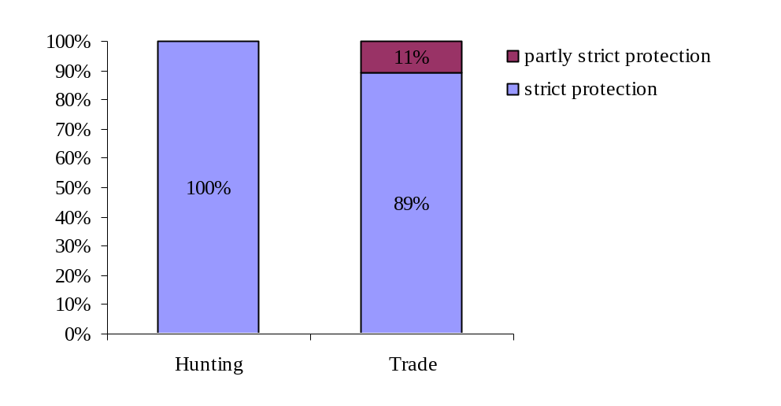
Graph 29: Strict protection from hunting and trade in European Parties (questions 7 and 11).

All EU member states – Parties as well as Non-Parties - have a legal ban on hunting of populations listed in Column A of Table 1. Hunting of asterisk populations as a long-established cultural practice, however, takes place in 25 % of the EU countries (Czech Republic, Hungary, Latvia, Slovakia and UK).

Deficits only exist in two countries (=11 %) and regarding trade in Column A populations: Italy does not have legislation in place to prohibit the trade in eggs. The UK (in line with the Birds Directive, but not conform with AEWA) allows trade in Pluvialis apricaria apricaria (Column A and marked with an asterisk), which may be sold (dead) from 1 September 28 February.
.
EU Non-Party:

Cyprus provides strict protection from hunting and trade; Estonia, however, prohibits trade for CITES species only, which amount to 10-25 % of occurring AEWA species; all others may be traded.

Plans for new legislation?

Italy plans to include a legal ban on trade in eggs; UK and Estonia have not signaled any plans.

Conclusion EU:

The overall picture in Europe is very good. To be fully in line with AEWA, the UK would need to formally prohibit trade in Pluvialis apricaria apricaria. Estonia, once joining the Agreement, would be advised to provide for prohibition against trade for all Column A populations.

Region 3: Eurasia

Eurasian Parties:

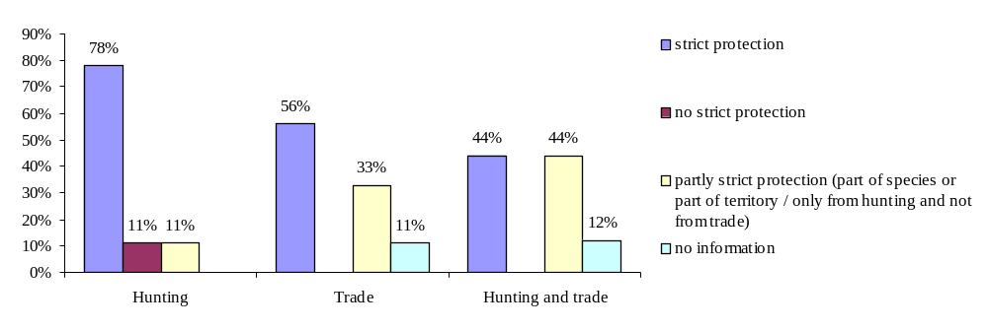
Graph 30: Strict protection from hunting and trade in Eurasian Parties (questions 7 and 11).

Hunting is strictly prohibited by 78 % of the Parties while strict protection from trade is provided for in only 56 % of the Parties. Only 44 % of the Eurasian Parties provide strict protection for all Column A populations from both hunting and trade.
Reasons why Eurasian Parties provide no or only partial strict protection to Column A populations

Hunting:
Lebanon (11%: no strict protection from hunting) has legislation in place; however, Ministrial decrees needed to implement the provisions of the legislation are still outstanding, but planned for. The FYR Macedonia (11%) prohibits hunting for only part of the relevant populations.

Trade:
44 % of the Parties provide strict protection from trade for only part of the populations (e.g. Albania protects only the eggs of birds; Georgia prohibits trade for only 25-50 % of the populations).

Plans for new legislation?

Plans to at least improve the situation among those Parties that do not fulfill the requirements already exist in two of four countries: In the FYR Macedonia plans exist to improve hunting and trade legislation; in Albania legislation to implement CITES has been drafted and is planned to enter into force in 2008.

Eurasian Non-Parties:

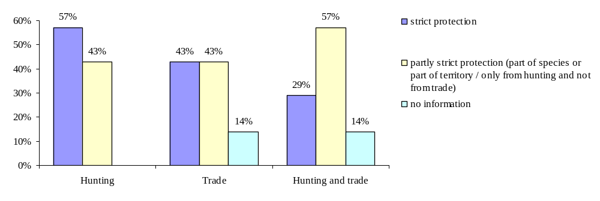
Graph 31: Strict protection from hunting and trade in Eurasian Non-Parties (question 7 and 11).

29 % of the Non-Parties provide strict protection from both hunting and trade. The figures change significantly when hunting and trade are looked at individually: hunting of Column A populations is prohibited in 57 % of the Non-Parties, while a ban on trade exists in only 42 % of the Non-Parties.
43 % of the Non-Parties provide strict protection from hunting to only part of the Column A populations. A partial protection from trade is provided by 43 % of the Non-Parties.

Reasons why Eurasian Non-Parties provide only partly strict protection to Column A populations

29 % provide strict protection from hunting to only to 25-50 % of occurring Column A populations, of which 14,5 % have a ban on hunting on 50-75 % of the territory; in case of 14,5 % no detailed information is available.

In 14,5 % eggs are not included; in 29 % trade is only prohibited for 25-50 % of the populations.

Plans for new legislation?

Plans for new legislation exist in one of three countries (Russian Federation) for hunting as well as for trade.

Conclusion Eurasia:

In case of Eurasia AEWA requirements on hunting and trade concerning Column A populations have been implemented by 44 % of the Parties which is far below the average of all AEWA Parties (67 %) and also lower than this is the case for African Parties (56 %). However, the deficits clearly lay in trade legislation, while a hunting ban on Column A populations is in place in 78 % of the Eurasian Parties, which is a less successful result than achieved in the EU, but still a good figure compared to African Parties. Also it has to be pointed out that none of the Eurasian countries has no legal prohibitions of hunting and/ or trade of Column A populations in place as this is still the case in 25 % of the African Parties. All in all, better results were achieved by Eurasian Parties than by Non-Parties which suggests that AEWA has already been implemented in the region.

Conclusions “Strict protection from hunting and trade”:

Parties are more successful than Non-Parties

Legislation in countries that are Party to AEWA proves to have a higher degree of compliance with AEWA requirements for Column A populations than in Non-Parties. Taking into account that AEWA is a relatively young agreement the figures for AEWA Parties suggest that the implementation of AEWA regarding strict protection to Column A populations is well-underway in many countries. Nevertheless approximately a third of the Parties still does not provide the full strict protection from hunting and/ or trade to all Column A populations as required by the Action Plan. Half of the countries that still have insufficient legislation became Contracting Parties in 2000 or earlier; the other countries joined in 2001or later, few of them quite recently, which might explain the gaps in the current legislation.

The level of implementation differs between the regions

The highest level of implementation regarding the restrictions on both hunting and trade of bird populations listed in Column A under AEWA is provided by EU countries, which are, of course, at the same time bound by the Birds Directive (and the Bern Convention).
A higher percentage of African countries has a ban on both hunting and trade than is the case in Eurasia; however, still 25 % of African Parties provide neither strict protection from hunting nor from trade to any Column A population.
In Eurasia deficits tend to be related to trade legislation, while in the case of hunting a strict ban concerning Column A populations exists in the large majority of the Parties.

Existing legislation still has gaps in many countries

The reasons, why legislations are insufficient, range from few or many legislative gaps concerning single Column A species or their eggs, over protection from hunting and trade being geographically limited to certain protected areas, to a complete lack of relevant prohibitions.

Possible explanation for the gaps in the legislation:

- Column A of Table 1 lists populations belonging to three different categories: 1(a) endangered populations (listed in Appendix 1 of CMS); 1(b) threatened populations (listed in Threatened Birds of the World, BirdLife International 2000); 1(c) Populations which number less than around 10,000 individuals. The last group of populations includes populations which are categorised as “least concern” species according to the IUCN Red List. However, under AEWA they are accorded the same strict protection as endangered populations.

Hunting prohibitions and game lists in the individual countries often seem to be based on the IUCN or national Red Lists criteria, which might explain gaps in the legislation of Non-Parties or Parties which have not made additional efforts yet in order to provide full implementation of AEWA.

- Differently from the IUCN Red List as well as national Red Lists and legislations, the AEWA Action Plan and its Table 1 is based on the level of waterbird populations and not waterbird species. As a consequence, different populations of one and the same species can have a different classification in the AEWA table. To be in line with AEWA the Parties therefore have to follow the requirements of the Action Plan set for the specific population that actually occurs in their own territory. Countries in which only one population occurs will have to provide the level of protection that is requested by AEWA for this special population. However, it might happen that birds of different populations (and with a different conservation status) occur in one and the same country. In this case the government would, in principle, have to ensure the stricter level of protection for all birds (whichever population they belong to). Latter has not been regulated under AEWA explicitely, but can be concluded from the AEWA policy, e.g. on look-alike species (argumentum a fortiori/ a minore ad maius).

Deficits are more important regarding trade than regarding hunting

All in all, the figures suggest that the situation is slightly better regarding hunting than regarding trade in Column A populations.
In the case of Europe (more precisely in the UK) one reason for that lays in the fact that AEWA actually provides stricter protection from trade in Pluvialis apricaria apricaria than the Birds Directive does, a discrepancy which needs to be clarified (see Recommendations “Birds Directive”).
In case of Africa and Eurasia, where the gaps in the trade legislation are more significant, one factor might be seen in relation to CITES: Many countries have implemented CITES or are in the process of doing so. However, CITES does not cover all AEWA populations and requirements (see chapter IV. 2.). Many “AEWA Non-Parties” are Party to CITES. In force since 1974, CITES is also much more established among its Parties than this is the case for AEWA, what explains the probably higher success rate of countries having followed up their obligations towards CITES, while in the light of AEWA trade legislation still has deficits in many of its (African and Eurasian) Parties. Moreover, domestic trade is not well monitored and knowledge is lacking about waterbird harvest for trade purposes and its importance for the human population of a country.

Recommendations “Strict protection from hunting and trade”:

- Parties are urged to accord strict protection from hunting and trade to all populations listed in Column A.

- The Technical Committee advises on a more adequate implementation of the Action Plan’s population approach in the national legislation and, if needed, provides guidance on its consequences for Parties. Such guidance may e.g. clarify the question how to deal with different populations of the same species in a country.

- The Secretariat, funds permitting, provides training and technical assistance to the Parties on the implementation of the AEWA Action Plan, including its restrictions on hunting and trade.

i) Exemptions for reasons explicitely listed in Paragraph 2.1.3 of the AEWA Action Plan

AEWA Action Plan
2.1 Legal measures
[…]
2.1.3 Parties may grant exemptions to the prohibitions laid down in paragraphs 2.1.1 and 2.1.2, irrespective of the provisions of Article III, paragraph 5, of the Convention, where there is no other satisfactory solution, for the following purposes:

(a) to prevent serious damage to crops, water and fisheries;
(b) in the interests of air safety or other overriding public interests;
(c) for the purpose of research and education, of re-establishment and for the breeding necessary for these purposes;
(d) to permit under strictly supervised conditions, on a selective basis and to a limited extent, the taking and keeping or other judicious use of certain birds in small numbers; and
(e) for the purpose of enhancing the propagation or survival of the populations concerned.

Such exemptions shall be precise as to content and limited in space and time and shall not operate to the detriment of the populations listed in Table 1. Parties shall as soon as possible inform the Agreement secretariat of any exemptions granted pursuant to this provision. Although hunting of Column A populations is strictly prohibited it may still be practiced as a tool to control damage caused by certain species.

Parties may grant exemptions to the prohibitions laid down in paragraphs 2.1.1 and 2.1.2 […] where there is no other satisfactory solution. Such exemptions allow for some flexibility in the application of law. The possibilities for use of these exemptions are, however, constrained. As a general rule exemptions should always be justified in relation to the overall objectives of the Agreement. In addition, exemptions specifically have to comply with the precise conditions decribed in Paragraph 2.1.3 of the Action Plan.

aa) Exemptions according to Paragraph 2.1.3 sentence 1 a-e) Action Plan granted

All in all 59 % of all countries’ legislations grant certain exemptions from hunting and trade restrictions for bird species listed in Table Column A, while 34 % do not provide any such flexible provision for particular problems or situations that exist or may arise. 2 % have not provided any information on this issue; for 5 % the question was not considered applicable.

The following overview shows the exemptions enumerated in Art. 2.1.3 sentence 1, a-e) of the Action Plan with the percentage of countries making use of each exemption; in addition countries were asked to inform if exemptions different from the listed ones were granted (“other reasons”):

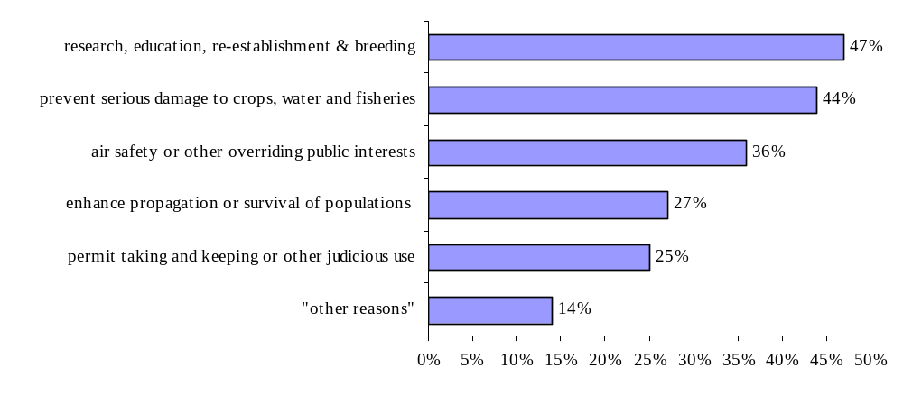
Graph 32: Exemptions from hunting and trade prohibitions concerning Column A populations granted by countries’ legislation in the AEWA area (the percentages reflect the number of countries granting each exemption in the national legislation).

In principle the Action Plan’s list of exemptions that may be granted is enumerative, in other words the exemptions listed are not meant to provide examples, but to be exclusive. However, 14 % of all countries (7 % of the Parties!) grant exemptions that are not explicitely mentioned in Paragraph 2.1.3 a-e) of the AEWA Action Plan.

Such exemptions granted by Parties include:
- measures taken in the context of Avian Influenza (control and diagnostic/ veterinary monitoring);
- the prevention of serious damage to cattle and woods;
- reasons of protection of fauna and flora;
- in case of immediate danger to a person, domestic or farmed animal, property;
- permits for game management;
- prevention of animal diseases;
- ''some other acceptable purpose''.

Non-Parties, in addition to some of the examples given below, provide exemptions from hunting restrictions
- to prevent disturbance at human settlements;
- to VIPs, e.g. coming from the Gulf region to practice falconry, or any other high-level governmental representatives.

In principle the examples listed in Paragraph 2.1.3 are quite concrete. The only exemption which is potentially an open window for allowing exemptions that are not explicitely mentioned in this paragraph is the case of “air safety and other overriding public interests”.
Neither the AEWA Action Plan nor the Conservation Guidelines or any other AEWA document provides a definition of this indefinite legal term. From its wording the derogation would theoretically allow for any exemption linked to any aspect that is given importance by the public (which can differ a lot in different cultural and political contexts). However, from a systematic and teleological (ratio legis) point of view, namely taking into account the other exemptions named in Paragraph 2.1.3 and the wider context of the Action Plan, latter is certainly not in the intention of the drafters of the Action Plan. Considering that “the interest of air safety” is a given example for an overriding interest it is more probable that exclusively public interests linked to “safety” are intended to be covered.
In the Birds Directive, which served as a kind of model for the Agreement text (and its Action Plan), and which provides a similar provision, the corresponding derogation is named “public health and safety”. Taking this into account in more historic approach of interpreting the provision would eventually provide for a larger field of application, namely explicitely allowing for exemptions when it comes to health issues. However, “public health” might also be seen as one aspect of “safety” anyway.

In concreto concerning the list of exemptions granted by Parties and Non-Parties this means that e.g. the exemption “in case of immediate danger to a person” might be covered by the Action Plan as an “overriding public interest” due to its safety aspect. Other exemptions like “the prevention of serious damage to cattle and woods”, however, might rather not be in line with AEWA. Exceptions from hunting prohibitions granted to “VIPs” certainly do not fall under the legal term of “overriding public interests” and would need to be reviewed for the future in view of Paragraph 2.1.3 of the Action Plan by the respective government. A case which could certainly be regarded as a “borderline-case” and which might have much impact on the Table 1 populations is the case of Avian Influenza and the decision whether the control and diagnostic of the virus – provided there is not a research purpose anyway - could be seen as an “overriding public interest”. However, the recent outbreak of Avian Influenza and its scientific follow-up have also shown that in the large majority of cases of Avian Influenza, migratory waterbirds were not the vector for the virus, a fact which was not well-known at that time (and probably still not) and which could have lead countries to misinterpret the discussed exemption.

After all, it might be seen as necessary to define or concretise the term of “other overriding public interest” in order to provide a binding and clear basis for exemptions granted by Parties and to ensure that it is exclusively used in the way intended by the drafters of the Action Plan and the international community.

bb) No other satisfactory solution

Parties may grant exemptions to the prohibitions laid down in paragraphs 2.1.1 and 2.1.2 […] where there is no other satisfactory solution.

Only 3 % (+11 % partly) of all responding countries (in the case of Parties: 2 % + 9 % partly) have informed that there would have been alternatives to exemptions granted. None of these countries are members to the EU.

In addition, according to Paragraph 2.1.3 sentence 2 of the Action Plan, such exemptions shall be precise as to content, limited in space and time, and shall not operate to the detriment of the populations listed in Table 1. Moreover, Parties shall as soon as possible inform the Agreement Secretariat of any exemptions granted pursuant to this provision.

cc) Precise as to content

7 % of all countries (5 % of the (exclusively African) Parties) informed that exemptions granted are not precise as to content.

dd) Limited in space and time

In 3 % of all countries (none of the Parties!) exemptions are granted without limitation in space and time.

ee) Measures taken to prevent these excemptions operating to the detriment of the species listed in Table 1

25 % of all countries and even 28 % of the Parties have informed that measures preventing exemptions operating to the detriment of the species listed in Table 1 are not taken. The share of countries that does not comply with this condition is surprisingly high compared to the other conditions, and it comprises countries from all regions.

ff) Information of the Agreement Secretariat

Parties, according to Paragraph 2.1.3 sentence 3 of the Action Plan, shall as soon as possible inform the Agreement Secretariat of any exemption granted pursuant to the same provision. The Secretariat, however, has not received any information up to now. It is therefore difficult to assess if, and how frequently, exemptions are actually granted. Moreover, due to the lack of information the Agreement bodies are prevented from providing advice to single countries concerning exemptions granted, which might in single cases lead to misleading decisions.

Conclusions:

    - 7 % of the Parties grant exemptions that are not explicetly mentioned under Paragraph 2.1.3 of the Action Plan, but might be regarded an “overriding public interest” pursuant to Paragraph 2.1.3 (b). The Action Plan, however, lacks a definition of the indefinite legal term “other overriding public interests”, which in single cases makes it difficult to assess whether granted exemptions could be seen as covered by the Action Plan or not. The measures taken e.g. in the context of Avian Influenza prove that this question has the potential to have an important impact on migratory waterbirds. Art. 9 of the Birds Directive foresees similar derogations from its general (hunting) provisions, but instead of “overriding public interests” suggests the interests of “public health and safety”. It might be advisible to amend Paragraph 2.1.3 (b) accordingly or to provide another definition or more concrete formulation to this exemption.

    - The only condition, under which Parties may grant exemptions to the restrictions on hunting laid down in the Action Plan, and which is not observed by the large majority of Parties, is the condition on ‘measures to be taken to prevent that exemptions operate to the detriment of the species’. However, in single cases deficits also concern the other conditions to Paragraph 2.1.3 sentence 2 of the Action Plan.

    - Moreover, the Secretariat has not received any information from the Parties regarding exemptions granted in the individual countries yet.

Recommendations:

- The Technical Committee reviews the exemptions listed in Paragraph 2.1.3 a-e) of the AEWA Action Plan and advises on whether the indefinite legal term “other overriding public interests” should be amended or defined.

- The Technical Committee provides guidance concerning measures that should be taken in order to prevent exemptions operating to the detriment of species listed in Table 1.

- In accordance with Paragraph 2.1.3 sentence 3 the Parties inform the Secretariat about exemptions granted in their country.

- The Parties are urged to provide for the full implementation of Paragraph 2.1.3.

j) Look-alike Species

AEWA Action

2.2 Single Species Action Plans

[…]

2.2.2 Parties shall prepare and implement national single species action plans for the populations listed in Column A of Table 1 with a view to improving their overall conservation status. This action plan shall include special provisions for those populations marked with an asterisk. When appropriate, the problem of accidental killing of birds by hunters as a result of incorrect identification of the species should be considered.

AEWA Conservation Guidelines on sustainable harvest of migratory waterbirds:
Any international harvest framework should be based on clear and unambiguous objectives for harvest management, these being related to the conservation status of particular waterbird populations. The harvest framework should, among others, address policies to be adopted to protect endangered ‘look-alike’ species.

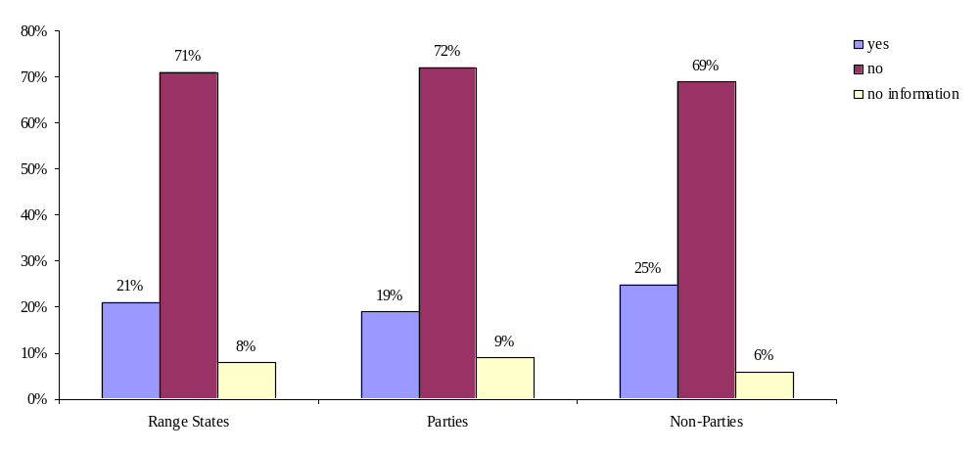
Graph 33: Restrictions concerning look-alike species in AEWA Range Staes/ Parties/ Non-Parties (question 62).

Through the questionnaire Focal Points were asked if their legislation contains restrictions concerning “look-alike species”. 21 % of all countries responded “yes”, while 71 % answered “no”. In all regions the percentage of Non-Parties that have restrictions concerning “look-alike species” is slightly higher than in case of Parties.

Countries have communicated different approaches to protecting endangered ‘look-alike species’: one approach is to prohibit hunting of those species which look similar to an endangered species even if the conservation status would theoretically allow hunting of this species. This preventive solution, if successfully implemented, ensures a high level of protection as it takes away the risk that a species is mistaken for another not endangered species by a hunter. Another solution (suggested by Lithuania, for example) is to solve the problem on the level of enforcement by punishing hunters who have shot an endangered species, an approach which leaves a higher risk that endangered species get killed, as hunting the look-alike species is principally allowed. Canada tackles the problem by setting aggregate bag limits for look-alike species. For all options which do not consequently forbid hunting of look-alike species, hunters’ bird-identification skills play a major role for the question whether endangered birds get shot or not. The question is whether this is enough, taking into account that distinguishing certain species (e.g. Lesser White-fronted Goose and White-fronted Goose) is extremely difficult, and even more from the distance that usually seperates hunters and game. Moreover, the time in which hunters have to decide whether they shoot or not is very limited and bears a risk that a bird is wrongly identified.

Recommendation:

The Technical Committee provides guidance to the Parties how to deal with look-alike species with regard to hunting on a species-by-species basis.

2. Regulation of hunting and trade for species listed in Table 1 Column B

AEWA, in principle, allows for the hunting of waterbird populations listed in Column B or C of Table 1 as it is considered to constitute acceptable exploitation due to the population level, geographical distribution and reproductive rate of the populations listed under these columns.

According to Article III of the Agreement text “Parties shall ensure that any use of migratory waterbirds is based on an assessment of the best available knowledge of their ecology and is sustainable for the species as well as for the ecological system that supports them”. The Action Plan in its Paragraph 4.1 on hunting, moreover, stipulates that “Parties shall cooperate to ensure that their hunting legislation implements the principle of sustainable use as envisaged in the Action Plan, taking into account the full geographical range of the waterbird populations concerned and their life history characteristics”. Paragraphs 2.1.2 and 4.1 of the Action Plan, moreover, provide specific actions concerning the regulation of hunting (addressing issues like hunting seasons, bag limits and hunting methods).

According to the AEWA Guidelines on sustainable harvest of migratory waterbirds components of the nation’s hunting regulations would include when, where and how hunting can take place, and might include the maximum permissible take for each waterbird population.

Trade, according to Paragraph 2.1.2 (d) of the Action Plan, shall be prohibited for birds belonging to Column B populations (their eggs, parts or derivatives of such birds) when taken in contravention of any prohibition laid down pursuant to the provisions of the same paragraph (regulations on hunting!).

This chapter addresses following issues:

- Populations listed in Column B
- Strict protection from hunting
- Hunting regulations
aa) Hunting seasons; stages of reproduction and rearing; stages of return to the breeding grounds
bb) Hunting methods
aaa) Modes of hunting
bbb) Restrictions on poisoned baits
cc) Bag limits
dd) Other measures to regulate hunting
- Prohibition of trade
- Exemptions according to Paragraph 2.1.3 of the Action Plan

Agreement text:

ARTICLE III
General Conservation Measures

1. The Parties shall take measures to conserve migratory waterbirds, giving special attention to endangered species as well as to those with an unfavourable conservation status.

2. To this end, the Parties shall:
[…]
(b) ensure that any use of migratory waterbirds is based on an assessment of the best available knowledge of their ecology and is sustainable for the species as well as for the ecological systems that support them;

AEWA Action Plan:

2.1 Legal measures

[…]

2.1.2 Parties with populations listed in Table 1 shall regulate the taking of birds and eggs of all populations listed in column B of Table 1. The object of such legal measures shall be to maintain or contribute to the restoration of those populations to a favourable conservation status and to ensure, on the basis of the best available knowledge of population dynamics, that any taking or other use is sustainable. Such legal measures, subject to paragraph 2.1.3 below, shall in particular:

(a) prohibit the taking of birds belonging to the populations concerned during their various stages of reproduction and rearing and during their return to their breeding grounds if the taking has an unfavourable impact on the conservation status of the population concerned;

(b) regulate the modes of taking;

(c) establish limits on taking, where appropriate, and provide adequate controls to ensure that these limits are observed;

[…]

4.1 Hunting

4.1.1 Parties shall cooperate to ensure that their hunting legislation implements the principle of sustainable use as envisaged in this Action Plan, taking into account the full geographical range of the waterbird populations concerned and their life history characteristics.

    - Parties shall endeavour to phase out the use of lead shot for hunting in wetlands by the year 2000

    - Parties shall develop and implement measures to reduce, and as far as possible eliminate, the use of poisoned baits.

a) Populations listed in Column B

Populations listed in Column B occur in all countries referred to in this review.

b) Strict protection from hunting

All countries:
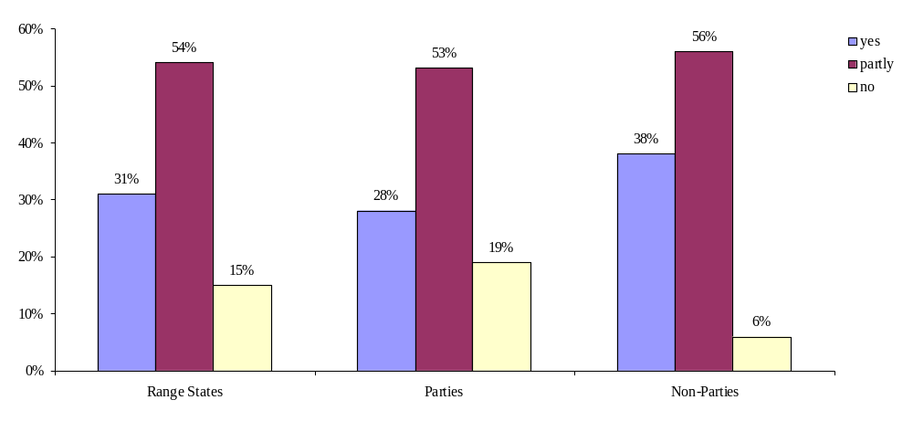
Graph 34: Strict protection from hunting provided to Column B populations in AEWA Range States/ Parties/ Non-Parties (question 21).

Africa, the EU and Eurasia:
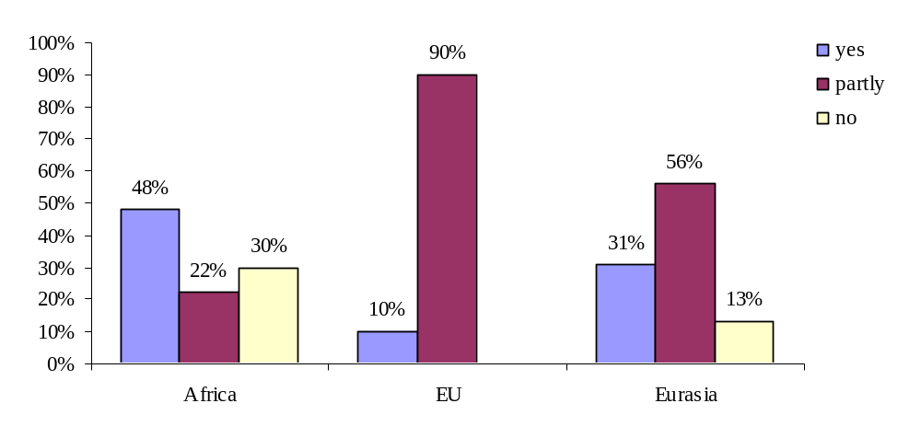
Graph 35: Strict protection from hunting provided to Column B populations in Africa, the EU and Eurasia (question 21).

31 % of all countries (28 % of the Parties and a considerable 38 % of the Non-Parties) currently have a strict ban on hunting that also includes all Column B populations. This goes beyond the level of protection that is stipulated by the AEWA Action Plan. On the regional level all EU countries have a ban on hunting for at least part of the populations (with a large majority having a ban on hunting for more than 75 % of the populations). In Africa and Eurasia the differences between the countries are more important: While in both regions quite a large share of countries prohibits hunting of all Column B populations, there are still countries where hunting of Column B populations is, in principle, allowed.

c) Hunting regulations

aa) Hunting seasons

According to Paragraph 2.1.2 of the AEWA Action Plan “Parties […] shall regulate the taking of birds and eggs of all populations listed in Column B of Table 1”, and “in particular prohibit the taking of birds belonging to the populations concerned during their various stages of reproduction and rearing and during their return to their breeding grounds if the taking has an unfavourable impact on the conservation status of the population concerned.”

The AEWA Conservation Guidelines recommend Range States to decide on the timing of the hunting season and when hunting is to be permitted within a 24-hour period. Restricting hunting hours may be useful in leaving birds undisturbed for at least a part of the day, or where there might be safety or identification problems in poor visibility. Management control over hunting hours may be achieved through legislation or voluntarily through national or local hunting groups.

The large majority of countries that have returned the questionnaire do not generally prohibit the hunting of waterbirds. In contrast, hunting of waterbirds is regulated in most countries. The definition of hunting seasons, either on an annual basis through decrees or through persistent legislation, is a widespread component of such hunting regulation.
There is no significant difference between Parties and Non-Parties of AEWA concerning the length and time period of hunting seasons. At regional level, harmonisation of hunting seasons has been established, most prominently through the European Union’s Birds Directive.

In the European Union, the hunting of waterbirds does not start before around 15 August, sometimes as late as November. One exeption is Finland, where hunting of the male Common Eider Somateria mollissima is open from 1 June on. End dates of hunting seasons are sometimes as early as October, mainly however in January or even in February.
Hunting of the Eurasian Woodcock Scolopax rusticola is permitted in March and April in Hungary and Slovakia.

In Africa, opening dates of hunting seasons vary from October to January; closing dates from February to May. A noteworthy exemption is Kenya, where hunting is open from July till September, which does not correspond to any other replying country’s hunting period.

In the Eurasian region, opening dates of waterbird hunting are between August and November, while closing varies from October (for particular species) to March.

aaa) Is hunting prohibited during the stages of reproduction and rearing?

The term “stages of reproduction and rearing” covers not only the breeding season, but also the occupation of the breeding areas as well as the period of dependence of young birds after leaving the nest.

All countries:
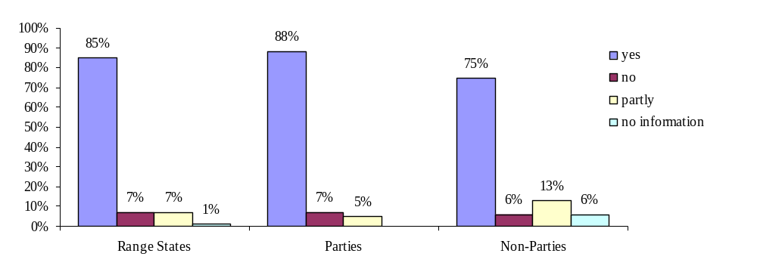
Graph 36: Prohibition of hunting during the stages of reproduction and rearing in Range States, Parties and Non-Parties (question 22).

Africa:
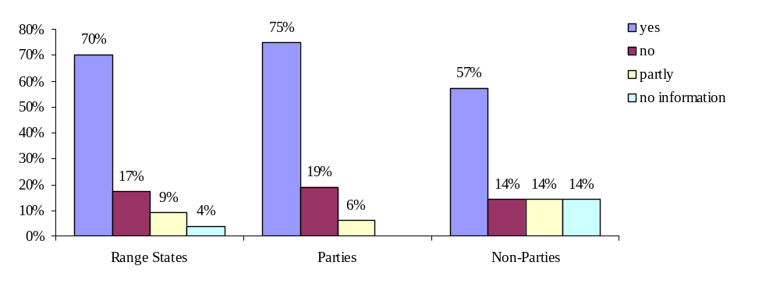
Graph 37: Prohibition of hunting during the stages of reproduction and rearing in Africa (question 22).

EU and Eurasia:
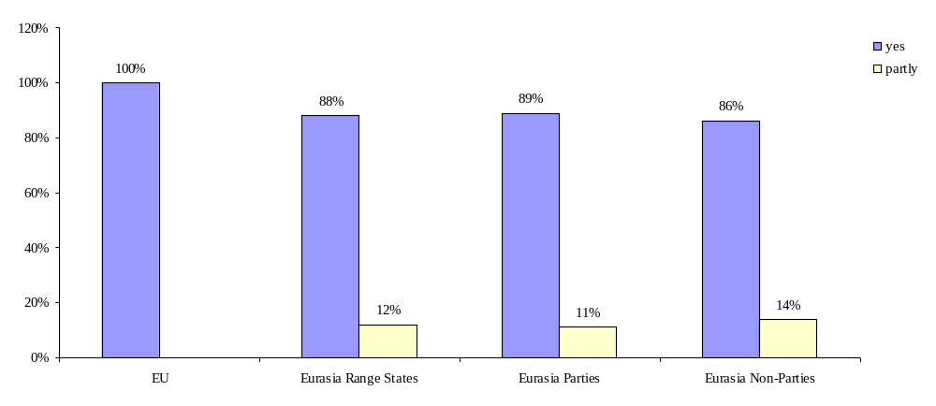
Graph 38: Prohibition of hunting during the stages of reproduction and rearing in the EU and Eurasia (question 22).

85 % of the countries (88 % of the Parties) have confirmed that their hunting seasons take place outside the waterbirds’ stages of reproduction and rearing. 7 % of the countries/ Parties (+7/ 5 % partly), however still allow hunting of waterbirds during these periods. It is significant that all EU countries have placed their hunting seasons outside these stages. In Africa and Eurasia, however, strict protection is not consequently ensured during the stages of reproduction and rearing.

bbb) Is hunting prohibited during the stages of return to the breeding grounds?

Return to the breeding areas is an annual displacement, in one of more stages, of birds from their wintering areas back to nesting grounds. The wintering period ends with departure from the wintering areas where migrant birds have been more or less stationary since the end of the post-nuptial migration. The return to the breeding areas is commonly called ‘pre-nuptial migration’ or ‘spring migration’. The start, end and length of the migration season in a particular country are determined by a number of biological, geographical and methodological factors.

AEWA Action Plan:

Parties […] shall in particular:

(a) prohibit the taking of birds belonging to the populations concerned during their various stages of reproduction and rearing and during their return to their breeding grounds if the taking has an unfavourable impact on the conservation status of the population concerned;

The above provision of the AEWA Action Plan that is related to the issue of hunting seasons contains a qualified term. Its implementation is therefore difficult to analyse as it requests Parties to prohibit the taking of birds (belonging to the populations listed in column B of Table 1 (not C!)) during the various stages of reproduction and rearing and during their return to their breeding grounds if the taking has an unfavourable impact on the conservation status of the population concerned. This qualified term, which from the conservational point of view is assumed to refer to the stage of return to breeding grounds only (although this can neither be clearly concluded from the English nor from the French wording), presumes a comprehensive, internationally harmonised and well-managed harvest data system in all countries, as well as sufficient knowledge on the impact of hunting on each population concerned. Both are actually not the case in most countries of the AEWA region. Morever, even if enough data were available, verifying these would represent a challenging and highly scientific task. There might therefore be a need to review the qualification in this paragraph in order to avoid that its applicability for countries depends on factors that are not well known.

Through the questionnaire countries were asked to inform if hunting of Column B populations is prohibited during the return to the breeding ground. The answers received enabled a first assessment of the current situation, leaving apart the qualified term:

All countries:
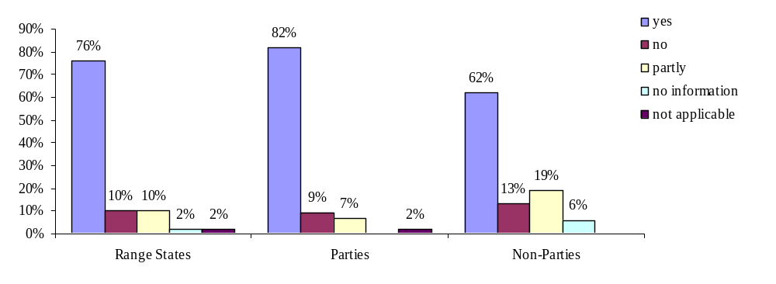
Graph 39: Prohibition of hunting during the stages of return to the breeding grounds in AEWA Range States/ Parties/ Non-Parties (question 23).

Africa:
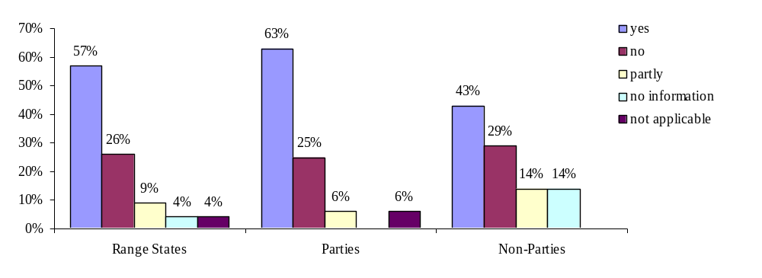
Graph 40: Prohibition of hunting during the stages of return to the breeding grounds in Africa (question 23).
EU and Eurasia:
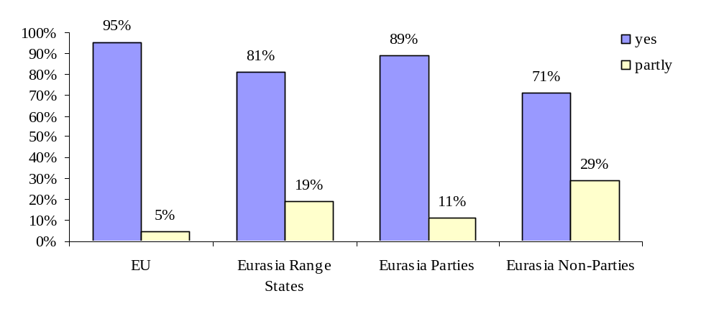
Graph 41: Prohibition of hunting during the stages of return to the breeding grounds in the EU and Eurasia (question 23).

The graphs show that the requirement of strict protection during the stages of return to the breeding grounds is slightly less well implemented throughout the AEWA area than this is the case for the stages of reproduction and rearing.

Conclusions:

Although harmonisation of hunting seasons has progressed, further regional cooperation in this field appears useful both in Africa and Eurasia. Such efforts successfully work in the European Union, whose territory does not cover distances as vast as, for instance, those on the African continent. For large-scale harmonisation, the very different migration times and places should lead to a flexible framework of regulation in such regions.

Particular attention should be paid to Kenya, where hunting seasons significantly differ from those in other countries.

The provisions of the AEWA Action Plan and of the Birds Directive are very similar; however the Birds Directive is stricter as it prohibits hunting of all huntable species during the various stages of reproduction and rearing/ return to the rearing grounds without any exception or condition apart from the general derogations foreseen in Article 9 of the Birds Directive. Moreover, in the framework of the Birds Directive the pre-nuptial and reproduction periods have been determined for each huntable species, paying account to prior EU Court decisions that state that Article 7(4) sentence 3 is designed to secure a complete system of protection in the periods during which the survival of wild birds is particularly under threat, thus protection against hunting activities cannot be confined to the majority of birds of a given species, as determined by average reproductive cycles and migratory movements.

In many African and Eurasian countries information on the different stages of reproduction and the return to the breeding grounds may be less elaborated and comprehensive than it is the case under the legal framework of the European Commission. To ensure a strong and successful implementation of the Agreement, however, it is very important to provide all countries with clear and precise regulations allowing them to fulfill their obligations towards the Agreement and at the same time enabling the bodies of the Agreement to measure its successful implementation.

Recommendations:

- The Technical Committee reviews Paragraph 2.1.2 (a) of the AEWA Action Plan and its passage “if the taking has an unfavourable impact on the conservation status of the population concerned”, elaborates the impact of this qualified term on Parties implementing it, and provides advice to the Meeting of the Parties whether the paragraph should be amended (e.g. in harmonisation with the Birds Directive).

- The Technical Committee reviews the prenuptial migration and reproduction of each huntable species covered by the Agreement and, if needed, provides further guidance on the implementation of Paragraph 2.1.2 (a) AEWA Action Plan.

bb) Hunting methods

AEWA Action Plan:

2.1 Legal measures

[…]
2.1.2 Parties with populations listed in Table 1 shall regulate the taking of birds and eggs of all populations listed in column B of Table 1. The object of such legal measures shall be to maintain or contribute to the restoration of those populations to a favourable conservation status and to ensure, on the basis of the best available knowledge of population dynamics, that any taking or other use is sustainable. Such legal measures, subject to paragraph 2.1.3 below, shall in particular:
[…]
(b) regulate the modes of taking;
[…]
4.1 Hunting

4.1.1 Parties shall cooperate to ensure that their hunting legislation implements the principle of sustainable use as envisaged in this Action Plan, taking into account the full geographical range of the waterbird populations concerned and their life history characteristics.
[…]
    - Parties shall endeavour to phase out the use of lead shot for hunting in wetlands by the year 2000

    - Parties shall develop and implement measures to reduce, and as far as possible eliminate, the use of poisoned baits.

aaa) Modes of taking

According to Paragrah 2.1.2 of the AEWA Action Plan “Parties with populations listed in Table 1 shall regulate the taking of birds and eggs of all populations listed in Column B of Table 1 […] Such legal measures shall in particular […] regulate the modes of taking”. “The object of legal measures shall be to maintain or contribute to the restoration of those populations to a favourable conservation status and to ensure, on the basis of the best available knowledge of population dynamics, that any taking or other use is sustainable.”

Differently from the Birds Directive or the Bern Convention the AEWA Action Plan does not provide any definition or list of prohibited hunting modes or methods, or of such allowed. Only specifications on hunting modes are the explicit regulations on lead shot and on poisoned baits in Paragraph 4.1.4 and 4.1.5 of the Action Plan. Differently from Paragraph 2.1.2 of the Action Plan these two regulations do not refer to Column B species only, but apply to all waterbird species. However, against its restrictive wording Paragraph 2.1.2 should not be understood in the way that hunting methods do not need to be regulated concerning Column C species. Especially for non-selective hunting methods that are excluded in many countries the status of single huntable species has no relevance. Also Paragraph 4.1.1 requests that “Parties shall cooperate to ensure that their hunting legislation implements the principle of sustainable use as envisaged in this Action Plan…”. This provision together with the provisions on lead shot and poisoned baits laid down in the same paragraph make clear that hunting methods are to be regulated for any huntable species listed in Table 1. The fact that the need for regulations of hunting modes has been pointed out in Paragraph 2.1.1 may lay in the reason that Column B populations, more evidently than Column C populations, need to be especially focused on in order to avoid serious population decreases, and are therefore more in the centre of the Action Plan.

For the reasons outlined this chapter refers to all huntable species whichever their status may be according to Table 1.

The AEWA Conservation Guidelines on sustainable harvest of migratory waterbirds – although pointing out that “hunting regulations would include when, where and how hunting can take place” - do not provide further guidance on the question which hunting modes or methods exactly should be prohibited or what the criteria for such decision should be.

In this context it is useful to consult equivalent provisions of other international instruments, namely the Bern Convention and the Birds Directive:
According to the Bern Convention Parties shall prohibit the use of all indiscriminate means of capture and killing and the use of all means capable of causing local disappearance of, or serious disturbance to, populations of a species. Similar to this, but more precisely, the Birds Directive asks Member States to prohibit the use of all means, arrangements or methods used for the large-scale or non-selective capture or killing of birds or capable of causing the local disappearance of a species. Both instruments provide an enumerative list of "Prohibited methods and means of capture and killing and modes of transport" in their respective Annexes IV, which are in fact almost identical:

Appendix IV of the Birds Directive/ Bern Convention:

Snares (with the exception of Lagopus noth of latitude 58 °)
Limes
Hooks
Live birds used as decoys which are blind or mutilated
Tape recorders
Electrical devices capable of killing and stunning (Bern Convention) / electrocuting devices (Birds Directive)
Artificial light sources
Mirrors (Bern Convention: and other dazzling devices)
Devices for illuminating targets
Sighting devices for night shooting comprising an electronic image magnifier or image converter
Explosives
Nets
Traps
Poison and (Bern Convention) poisoned or anaesthetic bait
Semi-automatic or automatic weapons with a magazine capable of holding more than two rounds of ammunition
Aircraft
Motor vehicles (Bern Convention: motor vehicles in motion)
Birds Directive: Boats driven at a speed exceeding five kilometers per hour. On the open sea, Member States may, for safety reasons, authorise the use of motorboats with a maximum speed of 18 kilometres per hour. Member States shall inform the Commission of any authorisations granted.

EU
Member states of the EU are bound by the Birds Directive. Consequently, hunting methods and modes for hunting migratory waterbirds – provided hunting waterbirds is allowed - are regulated in all national legislations (in compliance with Appendix IV to the Birds Directive).

Africa
17 % of the countries have no regulations on methods for hunting waterbirds in place although hunting is in principle allowed by the legislation. An additional 22 % prohibit hunting (any hunting/ waterbirds/ Column B populations), which is why hunting methods are either not regulated or do not apply. Côte d’Ivoire has informed that hunting, which is currently totally banned, is planned to be reopened in 2008 and hunting methods will then be regulated.
All other countries have legal restrictions on hunting methods, which do, however, differ in quality. There is no significant difference between Parties and Non-Parties.

Eurasia
Hunting methods are regulated in basically all countries that allow hunting of waterbirds; only Moldova informed that hunting (part of Column C populations) is allowed, but methods are not regulated. Some countries that, in addition to AEWA, are bound by the Bern Convention made clear that hunting methods are regulated in accordance with its Appendix IV (e.g. Albania and Switzerland).

Recommendations:

- The Technical Committee elaborates a definition or enumeration of examples for the term “hunting modes” used in Paragraph 2.1.2 (b) of the Action Plan. Annex IV of the Birds Directive or the Bern Convention might be used as a model. This will provide elaborate guidance to Parties and help to harmonise the restrictions on hunting methods especially in all those countries that are not covered by the Birds Directive or the Bern Convention. The elaborated definition/ enumerative list might be incorporated in the text of the Action Plan in order to provide it with legal force; however Parties may also wish to provide such guidance by Resolution or by completing the Conservation Guidelines on sustainable harvest of migratory waterbirds.

- The Technical Committee reviews Paragraphs 2.1.2 and 4.1 of the Action Plan and, if needed, provides advice to the Meeting of the Parties on how to amend the text in the way that provisions on “hunting modes”, but also on limitations on hunting seasons as well as limits on taking, clearly refer to Column B and C populations.

bbb) Restrictions on poisoned baits for hunting of waterbirds (Paragraph 4.1.5 AEWA Action Plan)

According to Paragraph 4.1.5 of the AEWA Action Plan “Parties shall develop and implement measures to reduce, and as far as possible eliminate, the use of poisoned baits”.

The Action Plan does not explicitely request a legal prohibition of poisoned baits, but – more generally – the development and implementation of any measures which help reducing (and possibly eliminating) the use of poisoned baits.

(1) Is the use of poisoned baits prohibited?

All countries:
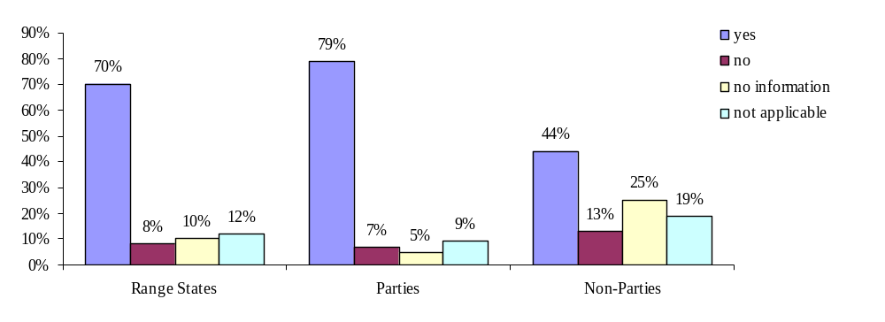
Graph 42: Prohibition of the use of poisoned baits for hunting of waterbirds in AEWA Range States, Parties and Non-Parties.

However, the graph shows that in 70 % of the countries’ hunting legislation prohibits the use of poisoned baits for hunting of (migratory water-) birds, while only 8 % of the countries do not have such legislation in place. The option “not applicable”, representing 12 % of the countries, in this context covers those countries in which poisoned baits are reported not to be used or even to be unknown as a hunting method.

The picture is different when Parties and Non-Parties are looked at separately. While a significant 79 % of the Parties explicitely prohibit the use of poisoned baits, this is only the case for 44 % of the Non-Parties (this figure might be higher in reality taking into account that information is lacking for 25 % of the Non-Parties).

Africa:
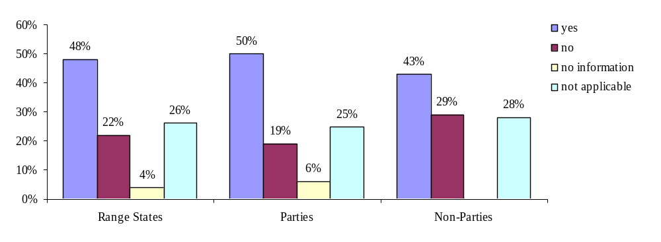
Graph 43: Prohibition of the use of poisoned baits for hunting of waterbirds in Africa.

EU and Eurasia:
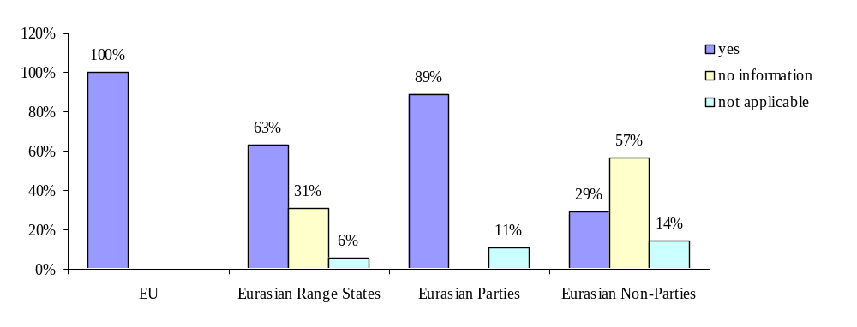
Graph 44: Prohibition of the use of poisoned baits for hunting of waterbirds in the EU and Eurasia.

A separate look at the different regions shows that relevant legislation is in place in significant 100 % of the EU countries, while among African countries only 48 % have a ban on poisoned baits. However, it has to be taken into account that additional 26 % of the African countries state that the issue of poisoned baits does not apply, mostly for the reason that these are not used or even unknown as a hunting method. 21 % of the African countries do not have relevant legislation in place although poisoned baits are used in these countries. In individual cases poisoned baits are even used by responsible authorities to control exotic pest birds like the crow (Mauritius) or for crop protection (Quelea quelea, South Africa). All in all, the situation is slightly more positive in case of African Parties than among Non-Parties.
For Eurasia the survey showed that legislation is in place in 89 % of the countries that are Party to AEWA. The information received from Non-Parties does not allow for clear conclusions: 29 % of these countries informed having legislation in place; for 57 %, however, information on the issue is missing.

(2) Where do countries stand with reducing or eliminating the use of poisoned baits?
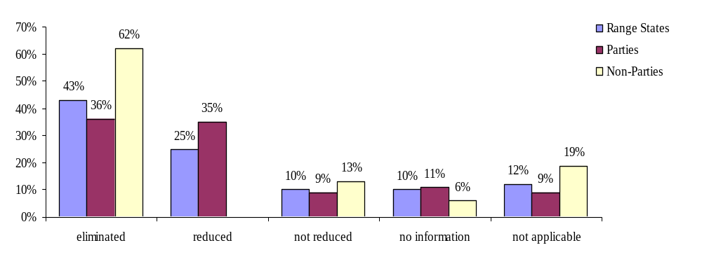
Graph 45: Use of poisoned baits in AEWA Range States, Parties and Non-Parties.

Africa, EU and Eurasia:
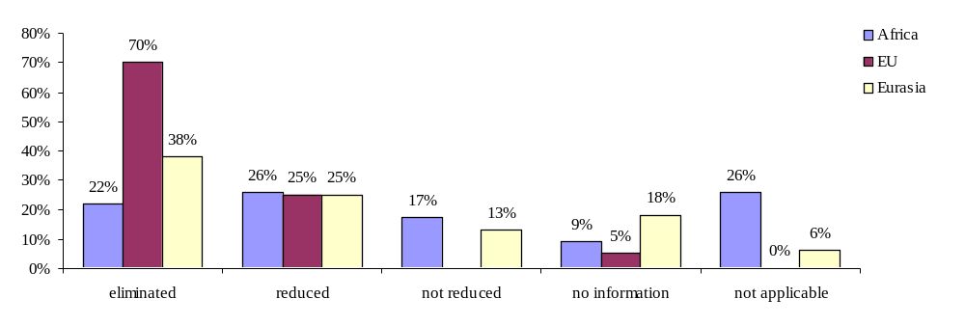
Graph 46: Use of poisoned baits in Africa, the EU and Eurasia.

Poisoned baits are still used in many countries, but on the other hand measures to eliminate them have already lead to positive results. The differences between the regions are quite prominent. Among the EU member states there is no country in which the legal ban has not contributed to an improved situation. 70 % of the EU countries have succefully eliminated the use of poisoned baits; an additional 25 % of the European countries have been able to reduce the use of poisoned baits, although there are still records of illegal use, e.g. in France cases of Anatidae poisoned by Chloralose have been recorded.
In Africa the share of countries having eliminated the use of poisoned baits amounts to only 22 %, while 17 % of the countries have not been able to reduce the use of poisoned baits at all. Interestingly, these are basically the same countries that have also informed of not having any established measures (and one country only low-quality measures) against the use of poisoned baits. Improvement, however, has been achieved in 26 % of the countries.
In Eurasia more than a third of the countries have eliminated the use of poisoned baits successfully. However, 13 % of the countries have not reduced the use of poisoned baits although the legislation is in place (Lebanon and the FYR Macedonia). In the case of Lebanon the implementation is pending because the implementation decree has not been decided yet; the FYR Macedonia has only low-quality measures in place, which need to be improved. In Canada poisoned baits are not being used at all (not applicable).

Remarkably, all in all Non-Parties seem to be more successful in eliminating the use of poisoned baits than Parties to AEWA.

Enforcement measures taken in countries include preventive initiatives ranging from education and public & media campaigns to controls and dissuasions, as well as repressive/ persecutive measures including (high) fines, seizures and destruction of equipment, confiscation of the hunting license and even imprisonment (e.g. for a month in Lebanon (legislation not implemented yet), or up to six months in the UK). In Spain hunting permits can be withdrawn for a hunting area if poisoning is proven, even if no single person has been found guilty.

Although very successful in many single countries, the enforcement of the required ban on poisoned baits, does, however, still generally need to be improved throughout the whole area.

(3) How do countries rate the quality of their own measures taken to enforce the legal ban on poisoned baits?

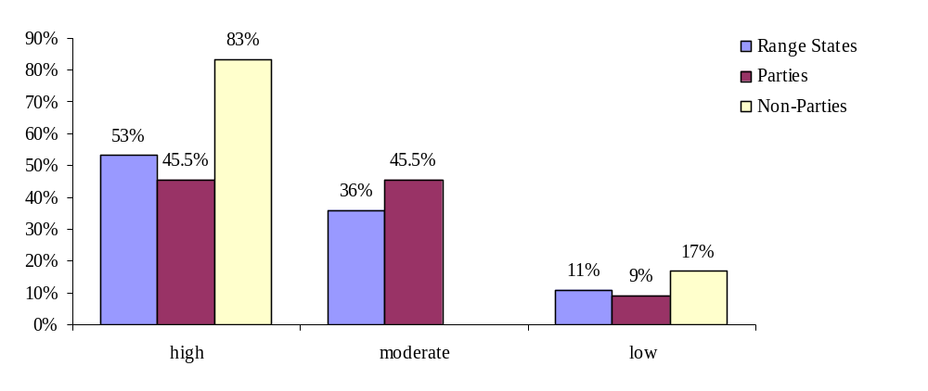
Graph 47: Effectiveness of measures taken against the use of poisoned baits in AEWA Range States, Parties and Non-Parties.

Africa, EU and Eurasia
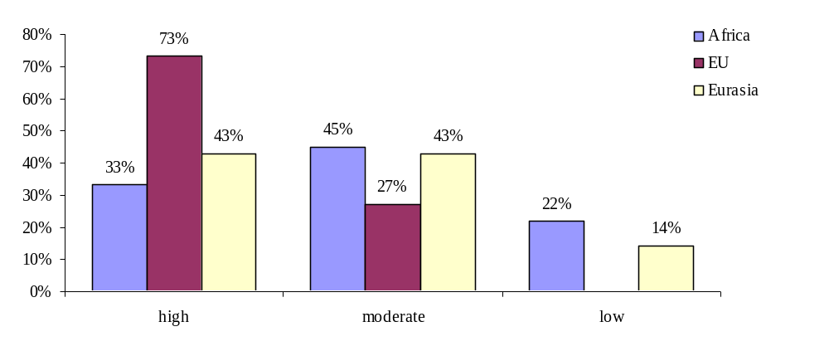
Graph 48: Effectiveness of measures taken against the use of poisoned baits in Africa, the EU and Eurasia.

In Africa measures against poisoned baits were rated high (33 %), moderate (45 %) or low (22 %). Concerns expressed range from the lack of human resources to monitor hunting activities (Kenya), to the general problem of dangerous chemicals being used for agricultural purposes. Techniques used include the use of layers of some plants (Sudan).

The quality of the measures taken by EU countries to reduce or eliminate the use of poisoned baits - although in some countries considered as being “moderate” - was in most cases rated being “high”.

In Eurasia, the measures - when existing - are generally considered being of moderate or high quality, in one case “low” (FYR Macedonia). Concerns expressed include difficulties faced when it comes to the collection of fines (Albania), the low quality of controls (Georgia) and the lacking capacities to organise public campaigns (FYRM).

Plans to eliminate the use of poisoned baits exist in Chad and Nigeria.

Conclusions:

Legal ban
All in all, the large majority of Parties has legally banned the use of poisoned baits, even though the share of countries having done so is much higher in Europe (100 %) and Eurasia (89 %) than in Africa (50 %), where many countries still have to implement the requirements regarding poisoned baits.

Enforcement
Problems appear rather to be related to the level of enforcement in certain regions, and more efforts are needed on this level. In Europe none of the countries that came back with information, has not at least reduced the use of poisoned baits and the share of countries having eliminated them is quite high (65 %). In Africa and Eurasia, however, the problem of poisoned baits is still more present than in EU countries. Although eliminated or reduced in some of the countries there are still others in which their use has not been reduced at all. Some (African) countries do not have any enforcement measures in place or, when existing, then their quality is often rated “moderate” or even “low”.

Although the share of Non-Parties that have a legal ban on the use of poisoned baits is relatively low compared to Parties, more of these countries have informed that the use of poisoned baits has been eliminated (or the problem has never been relevant).

Recommendations:

- All Parties that have not yet established any measures for reducing or eliminating the use of poisoned baits yet shall provide such measures by 2011.

- The Meeting of the Parties directs the Secretariat, funds permitting, to provide training and technical assistance to the Parties in order to improve the enforcement of the legal ban on poisoned baits.

cc) Bag limits

AEWA Action Plan:

  - Legal measures
[…]
2.1.2 Parties with populations listed in Table 1 shall regulate the taking of birds and eggs of all populations listed in column B of Table 1. The object of such legal measures shall be to maintain or contribute to the restoration of those populations to a favourable conservation status and to ensure, on the basis of the best available knowledge of population dynamics, that any taking or other use is sustainable. Such legal measures, subject to paragraph 2.1.3 below, shall in particular:
[…]
(c) establish limits on taking, where appropriate, and provide adequate controls to ensure that these limits are observed; […]

AEWA Conservation Guidelines on sustainable harvest of migratory waterbirds, Step 5

[Bag limits] necessitate good information on population status and trends and on the numbers and activities of hunters. The setting of national regulations is a question of realism and balance. If too liberal, hunters may be tempted to compromise hunting standards in order to take the maximum number of birds permissible, and if too strict, violations may occur because the hunters view the regulations as too restrictive.

aaa) Does legislation establish bag limits?

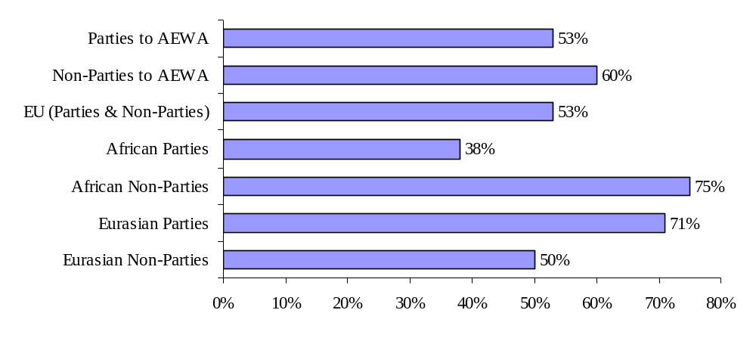
Graph 49: Share of countries, in which hunting of Column B species is (at least partly) allowed, and in which bag limits are established by legislation.

The Action Plan requests Parties to establish limits on taking, where approporiate […]. The question when bag limits on a certain species are considered to be “appropriate” is neither concretised in the Action Plan nor in any other AEWA background document. The management of hunting including the establishment of bag limits is in fact in the scope of evaluation of the Parties who will decide in the context of the respective pertinent hunting legislation and conservation management if bag limits are needed and - if they are - determine them.

Statutory bag limits for (at least part of) Column B (and C) populations actually exist in all three regions, all in all in around half of the countries, in which hunting is not prohibited. Usually, bag limits are established for individual game birds providing the bag limit for a day/ hunting season/ year. Some countries, however, have bag limits for groups of waterbirds (e.g. waders, ducks, geese) regardless of the individual population status or even of that for the whole group of “game birds”. Usually bag limits are reviewed prior to the hunting season, ideally according to the previous year’s estimated population size and/ or harvest data, and newly decided upon each year in a Ministry decree or on a regional level. However, bag limits are often also established by means of a longer-term (statutory) management plan for species or hunting grounds. Bag limits can vary depending on the type of hunting permit issued or, for example, be linked to the concession of the hunting guide. In France bag limits are not established by legislation, but by hunting associations on a voluntary basis (so-called “ethic bag limits”) and validated by the responsible authority on the national or regional level. In the UK shooting controls, whilst legally established, are effectively self-regulated; hunting bag limits do not exist. In Guinea, bag limits are to be negotiated with the authority in charge of the respective game.

bbb) Enforcement

How do countries rate the quality of their own controls on bag limits?

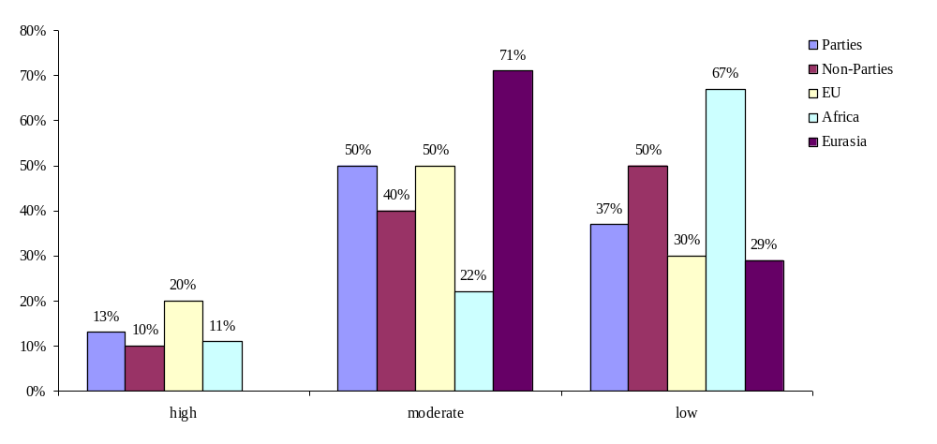

Graph 50: Quality of controls on bag limits in Parties/ Non-Parties, the EU, Africa and Eurasia.

Enforcement measures concerning bag limits, when existing, are most often rated being of moderate quality (which corresponds to regular area-wide controls) or, most prominently in Africa, of low quality (irregular and/ or not area-wide). High-standard control systems, ensuring that limits are fully observed concerning all species and throughout the whole territory, exist in 13 % of the Parties and 10 % of the Non-Party Range States according to the information received.

Measures include controls and patrolling undertaken by the responsible authorities’ officers and rangers or through statutory reporting requirements for hunters/ hunting clubs; national harvest surveys; banding (ringing) programs.
Concerns expressed in this respect especially reflect a lack of financial and human resources in some countries.

Conclusions:

Actually nearly half of the Parties that principally allow hunting do not have established bag limits. However, bag limits are not a constraint according to the Action Plan but to be established “where appropriate”, which pays respect to the diversity of existing hunting regulations in the different countries, but also bears the rusk that conservation is not being ensured along the whole a a species’ flyway. When existing, controls are often considered being insufficient. The enforcement obviously needs to be improved.

Recommendations:

- The Technical Committee reviews Paragraph 2.1.2 (c) and its term “where appropriate” in order to provide Parties with elaborate guidance on the question whether bag limits are to be established in the respective countries.

dd) Any other measures established to regulate hunting?

AEWA Conservation Guidelines on sustainable harvest of migratory waterbirds:

[…]
Establishing refuges for waterbirds
All Range States are likely to want to manage hunting, and to minimise disturbance in important conservation areas, e.g. internationally important wetlands. Refuges, where appropriate, should be:
- free from all activities that cause disturbance, not just those related to hunting;
- of sufficient size to be effective, usually calculated according to the sensitivity of the most vulnerable species;
- sufficiently diverse to include all habitat components required by the full range of waterbirds present;
- protected by buffer zones where hunting activity is managed, to increase the effectiveness of the refuge area;
- created where endangered species are difficult to distinguish from quarry species, and may therefore be at risk from accidental hunting mortality.
Local hunting clubs should be encouraged to play an active role in the implementation of a network of refuges.
[…]
Minimising disturbance
Assessment of hunting disturbance must distinguish between short-term effects and long-term impacts on population size and health, and should be made in relation to disturbance caused by all factors at each site. Disturbance may cause the displacement of birds, the disruption of daily activities and the break-up of family units. Where nutrient reserves are lost at critical times, disturbance may also affect rates of reproduction and survival. An assessment of disturbance levels can be obtained by counting the number of shots heard from a fixed point over a fixed period of time per day. This can be an efficient way of monitoring the relative degree of disturbance to particular areas.

Management authorities and hunting clubs can establish disturbance-free areas and reduce the intensity of hunting where this is judged to be too high. Further measures can include reducing season lengths, hunter numbers and density, bag sizes etc. These aspects should be incorporated within a plan for disturbance management, both on and around the site. Hunting plans are best developed and agreed locally with all interested parties.

Further measures to limit disturbance may be desirable during times of stress, e.g. when the birds are breeding, moulting or on migration, during prolonged periods of severe weather or during incidents of pollution (see Guidelines No.2: Guidelines on identifying and tackling emergency situations for migratory waterbirds). Under such circumstances, the governing agency or hunting groups themselves may call for restraint on hunting disturbance.
[…]
Good habitat management
Hunting organisations and individual hunters already carry out major and important wetland creation and improvement projects. Hunters can be engaged in habitat conservation and management and the control of predators, including alien species. Several hunting organisations have developed ‘habitat stamp’ schemes using designs by famous artists, with sales producing substantial amounts of revenue for habitat conservation projects. Such efforts should be recognised and encouraged.

Conversely, the management of wetlands to ‘improve’ harvesting opportunities may include undesirable activities for the ecosystem as a whole, e.g. disruption of the hydrological regime, destruction of wetland vegetation or removal of fish as competitors of waterbirds. Such habitat degradation should be avoided. Care should be taken not to damage or degrade existing wildlife habitats, including surrounding and nearby lands. The involvement of conservation groups and habitat specialists is recommended to obtain maximum benefit from any wetland enhancement projects.

49 % of the countries informed that additional measures (different from hunting seasons, bag limits, the regulation of hunting methods or a total ban on hunting, trade/ collection of eggs) were provided in their legislation. Explicitely mentioned were:

Africa
Parties | Non-Parties
  - Protected areas
  - Prompt reporting on hunting bags: information is required on date, location, type of hunting, i.e static, driven or walked-up, number of guns, number of shots fired; duration of hunting (approximate, in hours); number of waterbirds counted before the shooting (Kenya)
  - Hunters are accompanied by guides for more control (Sudan)
  - Controls (during hunting seasons)
  - Penalties
EU
Parties | Non-Parties
  - Protected areas/ refuges
  - High quality controls of hunting seasons

Eurasia
Parties | Non-Parties
- Protected areas  - Specific hunting rules for specific sites (hunting time (hours) limits, limits in use of boats, limited number of hunting days), territories with bird hunting prohibitions (Latvia)  - statutory management planning: Implementation of the plans is controlled by state hunting inspectors, and reporting of hunting clubs on implementation of these plans, including on hunting levels, to Slovenian Forest Service (SFS) is a statutory requirement. Reports from Hunting Clubs are collected yearly by the Hunting Association of Slovenia (all Clubs are members of the Association) and special hunting reserves (managed by the Slovenian Forest Service) and submitted to the SFS (Slovenia)  - The Hunting permit also specifies the particular hunting territory (Georgia) | - control for time constraints, type of hunting, norms, species list; the control is low (Russia)

d) Prohibition of trade

AEWA Action Plan

2.1.2 Parties with populations listed in Table 1 shall regulate the taking of birds and eggs of all populations listed in column B of Table 1. The object of such legal measures shall be to maintain or contribute to the restoration of those populations to a favourable conservation status and to ensure, on the basis of the best available knowledge of population dynamics, that any taking or other use is sustainable. Such legal measures, subject to paragraph 2.1.3 below, shall in particular:

[…]
- prohibit the possession or utilisation of, and trade in, birds and eggs of the populations which have been taken in contravention of any prohibition laid down pursuant to the provisions of this paragraph, as well as the possession or utilisation of, and trade in, any parts of such birds and their eggs.

In the case of Column B populations trade in birds and eggs shall be prohibited when the bird or egg was taken in contravention of the restrictions on hunting laid down pursuant to the Action Plan. This means AEWA allows trade in birds which have been taken in accordance with regulations that aim for maintaining or contributing to the restoration of Column B populations to a favourable conservation status, such as e.g. hunting seasons, bag limits etc.

Differently from Paragraph 2.1.1 (c) which concerns trade in Column A populations Paragraph 2.1.2 (d) does not mention “readily recognisable parts or derivatives of such birds”, but only “any parts of such birds”. The Parties may wish to amend the Action Plan and add “derivatives” in the wording of Paragraph 2.1.2 (d).

Is trade in Column B populations prohibited?

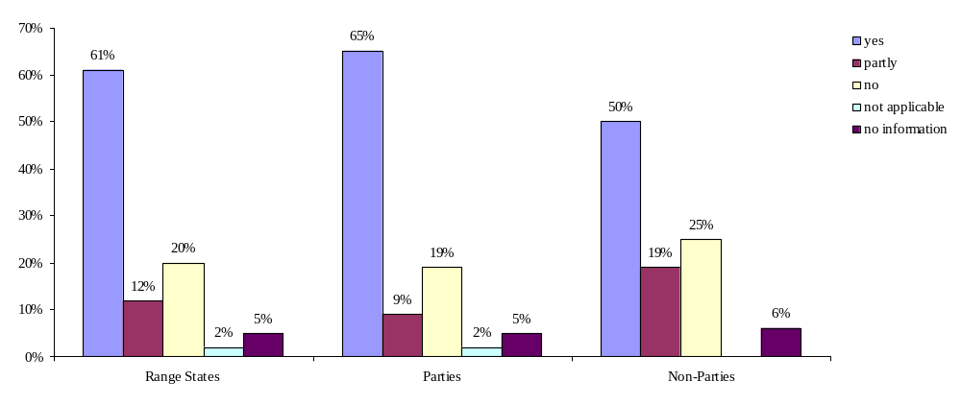
Graph 51: Is trade prohibited for Column B populations taken against hunting regulations in Range States/ Parties/ Non-Parties? (question 30)

Asked if trade in birds that were taken against hunting regulations is prohibited, 65 % of the Parties informed that this was the case (+9 % partly), while 19 % made clear that trade in birds from Column B populations is not prohibited. The option “partly” was in most cases chosen because the prohibition did not refer to all Column B populations or did not include all possible “items” of trade, being (living) birds as well as parts of such birds and their eggs.
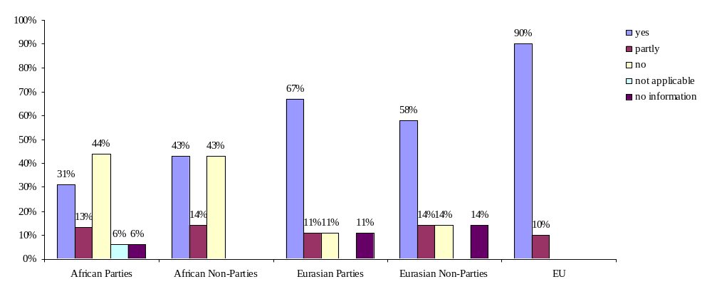
Graph 52: Is trade prohibited for Column B populations taken against hunting regulations in Africa, Eurasia and the EU? (question 30)

Figures differ quite prominently between the regions. While trade prohibitions are in place in 90 % (+10 % partly) of the EU countries, this is the case in 67 % (+ 11 % partly) of the Eurasian Parties and in only 31 % (+ 13 % partly) of the African Parties.

All in all, half of the countries that do not prohibit trade in Column B populations have plans to do so in future, whilst another half has no such plans.

Recommendations:

- The Meeting of the Parties decides to amend Paragraph 2.1.2 (d) of the Action Plan as follows:

  - prohibit the possession or utilisation of, and trade in, birds and eggs of the populations which have been taken in contravention of any prohibition laid down pursuant to the provisions of this paragraph, as well as the possession or utilisation of, and trade in, any readily recognisable parts or derivatives of such birds and their eggs.

- The Parties are urged to prohibit trade in all birds of populations, which have been taken in contravention of AEWA provisions concerning the taking of birds (which presumes hunting restrictions are in line with AEWA).

e) Exemptions for reasons explicitely listed in Paragraph 2.1.3 of the AEWA Action Plan

Focal Points were asked to inform about exemptions from hunting and trade restrictions granted by their legislation concerning Column B populations. The answers received were only slightly different from the ones received concerning Column A populations (please compare III. 13 i)). It is however worth mentioning that all in all exemptions are granted in five more countries than this is the case for Column A populations.

3. Regulation of hunting and trade for species listed in Table 1 Column C

Agreement text:

ARTICLE III
General Conservation Measures
1. The Parties shall take measures to conserve migratory waterbirds, giving special attention to endangered species as well as to those with an unfavourable conservation status.
2. To this end, the Parties shall:
[…]
(b) ensure that any use of migratory waterbirds is based on an assessment of the best available knowledge of their ecology and is sustainable for the species as well as for the ecological systems that support them;
[…]

AEWA Action Plan:

4.1.1 Parties shall cooperate to ensure that their hunting legislation implements the principle of sustainable use as envisaged in this Action Plan, taking into account the full geographical range of the waterbird populations concerned and their life history characteristics.

a) Overview of populations listed in Column C

Populations listed in this column occur in all countries referred to in this review.

b) Hunting restrictions

aa) Prohibition of hunting of Column C populations
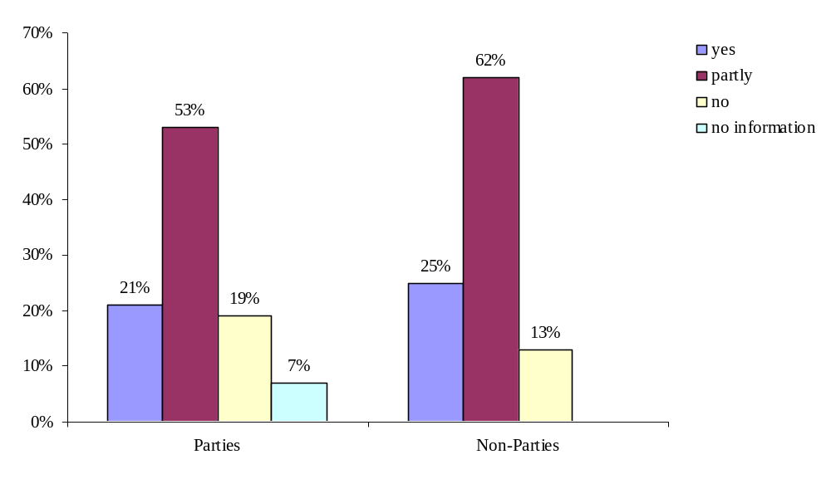
Graph 53: Prohibition of hunting in AEWA Parties and Non-Parties (question 38).

Hunting Column C populations – although not required by AEWA – is prohibited in 21 % (+ 53 % partly) of the Parties and 25 % (+ 62 % partly) of the Non-Parties.

bb) Regulation of hunting of Column C populations
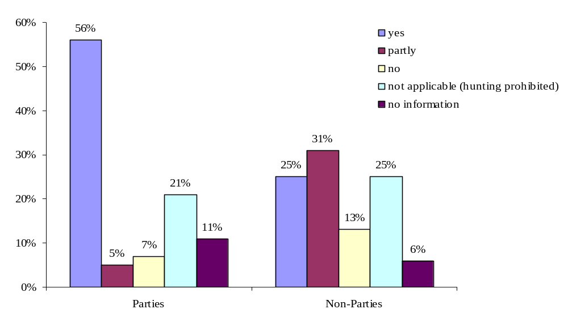
Graph 54: Regulation of hunting in AEWA Parties and Non-Parties (question 39).

Most of the countries in which hunting of Column C populations is (partly) allowed have restrictions on hunting in place. However, still this is not the case in few (exclusively African) countries (7 % of the Parties and 13 % of the Non-Parties).

c) Trade restrictions
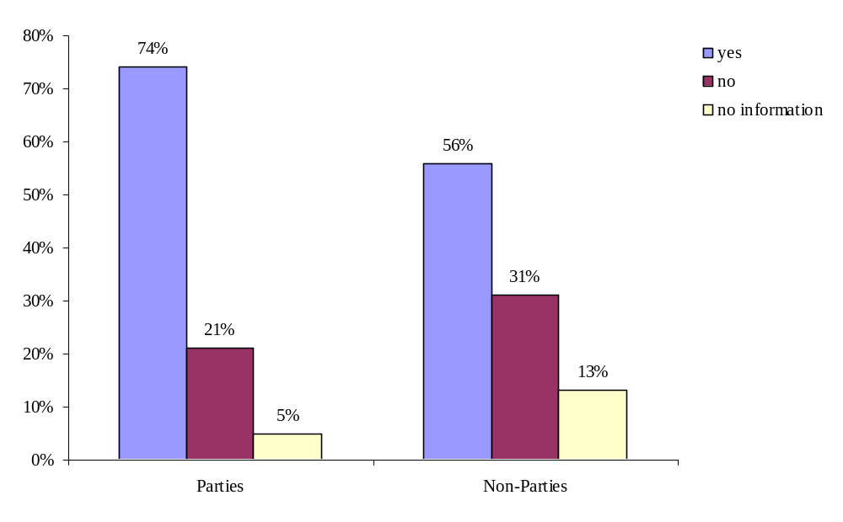
Graph 55: Regulation of trade in AEWA Parties and Non-Parties (question 40).

Trade in Column C populations is regulated in 74 % of the Parties and 56 % of the Non-Parties, while 21 % of the Parties and 31 % of the Non-Parties have no such regulations in place at all.

Conclusions:

Not all Column C populations are subject to hunting and trade restrictions in all countries in the AEWA area. The Action Plan does not provide any specific provisions for these populations, which are not of major concern from a conservation perspective, such as this is done in case of Column A and B populations. However, any use of such birds shall be sustainable.

Recommendation:

The Technical Committee reviews Paragraphs 2.1.2 and 4.1 of the Action Plan and, if needed, provides advice to the Meeting of the Parties on how to amend the text in the way that provisions on hunting modes, on limitations on hunting during breeding and pre-nuptial seasons, as well as limits on taking clearly refer to Column B and C populations.

4. International cooperation

AEWA Action Plan:

4.1.1 Parties shall cooperate to ensure that their hunting legislation implements the principle of sustainable use as envisaged in this Action Plan, taking into account the full geographical range of the waterbird populations concerned and their life history characteristics.

According to the AEWA Action Plan Parties shall cooperate to ensure that their hunting legislation implements the principle of sustainable use as envisaged in the Action Plan.

This leads to two questions:
- What kind of international cooperation does this provision aim for and
- When is this realised?

What kind of international cooperation is aimed for?

In principle international cooperation towards an “AEWA-proof” hunting legislation in individual countries is ensured by the Agreement itself, which provides the political platform for cooperation and also specific actions through its Action Plan to be implemented by Parties in the respective countries.

Following the above argumentation the aim of Paragraph 4.1.1 to implement the principle of sustainable use as envisaged in the Action Plan would be reached as soon as Parties have implemented all specific requirements on hunting legislation that can be found in the Action Plan, namely in the Paragraphs 2.1. and 4.1.

Such specific requirements, like e.g. a ban on hunting for all Column A populations, are evidently based on an approach which takes into account the full geographic range of the waterbird populations and, as far as data allow for this, also their life history characteristics. Moreover, they provide Parties with an elaborated “check-list” towards the implementation of the principle of sustainable hunting.

However, the question remains whether Paragraph 4.1.1 aims for additional cooperative efforts going further than the implementation of all (other) specific requirements on hunting mentioned in the Action Plan by the individual countries.

The structure of provision 4.1 on Hunting suggests that the general requirement of 4.1.1 is being translated into more concrete actions following it in Paragraphs 4.1.2 – 4.1.8, thus by implementing these Parties also fulfill Paragraph 4.1.1. The wording “as envisaged in this Action Plan”, which puts international cooperation in the limits of the provisions of the Action Plan, supports this interpretation.

When is international cooperation realised?

As analysed in different chapters of the present document the Action Plan, however, tends to be general and result-oriented in the description of its actions (e.g. Parties shall regulate the modes of taking; Parties shall promote the requirement of a proficiency test, including among other things bird identification).

To implement the principle of sustainable use as envisaged by the AEWA Action Plan in individual countries all stakeholders concerned with the development of related legislation actually need very good and precise knowledge about 1) the AEWA requirements regarding hunting (principle of sustainable use), 2) how to translate these requirements into national legal provisions, taking into account the international context of AEWA, 3) how to implement and enforce such legislation in order to ensure its effectiveness.

Thus with respect to Paragraph 4.1.1 requirements on hunting pronounced in the Action Plan might need to be further elaborated in order to provide Parties with more specific guidance on the overall requirement of implementing the principle of sustainable use (e.g. a list of prohibited hunting modes, a minimum standard for a proficiency test etc.).

Countries were asked to rate the quality of the international cooperation taking place with other AEWA Parties/ Range States towards the implementation of the principle of sustainable use in hunting legislation. In case of Parties 47 % informed that no (additional effort of) cooperation is taking place on the issue of sustainable hunting. Among those which actually rated the quality of international cooperation on the issue, the quality was rated high (12 %), moderate (21 %) and low (12 %). The examples of cooperation provided by countries often referred to bilateral or regional initiatives with neighbour countries.

The gaps in the countries’ legislation identified in the course of this review and the above responses provided by Focal Points show that there might be need to strengthen the capacities on the governmental level and to enhance cooperation between AEWA Parties with respect to hunting legislation. Latter could be reached through further elaboration of the Action Plan.

Recommendation:

- The Technical Committee provides guidance to the Parties on how to implement Paragraph 4.1.1 and, if needed, advises on amendments to be made to the Action Plan in order to provide Parties with more specific requirements with respect to the “principle of sustainable use”.

- The Secretariat, funds permitting, provides training and technical assistance to the Parties on the implementation of the AEWA Action Plan, including its restrictions on hunting and trade and especially focusing on the implementation of the principle of sustainable use in the national legislation.

5. Harvest data collection

AEWA Action Plan:

4.1.3 Parties shall cooperate with a view to developing a reliable and harmonised system for the collection of harvest data in order to assess the annual harvest of populations listed in Table 1. They shall provide the Agreement secretariat with estimates of the total annual take for each population, when available.

AEWA Conservation Guidelines on sustainable harvest of migratory waterbirds:

In order to ensure a sustainable exploitation of waterbirds and the maintainance of populations in a favourable conservation status international cooperation is needed, as is a ‘harvest framework’ within which Range States may operate.

Essential to the regular review of harvest frameworks is information on the size and composition of hunting harvests. This information should be collected, where possible, by individual Range States, and made available centrally for international analysis.

An annual survey by means of questionnaires to hunters should be a high priority for implementation in each Range State. This is useful in providing standardised information on both hunting success and hunter effort. Such questionnaires may form an integral part of a licensing system for hunters, and should at least include the date of the hunt, location and, for each species, the number taken or shot but not collected.

Of secondary importance is a ‘Parts Survey’ which provides a sample of wings, tails or other parts of the birds shot during the hunting season. These parts are identified to species, sex and age, providing valuable data on the composition of the waterbird harvest. Such data can be used to assess the degree of hunting ‘pressure’ on the different sexes and age-components, information of great value in assessing harvesting impact on particular populations. These data also complement and extend the information gained from hunter questionnaire surveys.

Ideally, parts should be collected from hunters throughout the hunting season, and may be deposited at, or mailed to, regional collection points. An alternative approach is to rely on a small number of purposely-trained hunters who examine and report on the bags themselves. Training, regular experience and identification materials are needed for operating a Parts Survey successfully.

To achieve compatibility in methods and reporting for both harvest and parts surveys, it is best to adopt minimum, internationally agreed standards for recording in the AEWA area. Also, it is vital that a summary of the information gained is reported back to the contributors, if interest and support are to be maintained. This can be done both nationally and internationally. Ringing recoveries are also valuable in assessing harvest rates, and hunters should be encouraged to report any rings that are found.

AEWA Conservation Guidelines on sustainable harvest of migratory waterbirds:

If overall management of waterbird harvests is to work, harvest frameworks should be adopted at the national and local level. This may be achieved through legislation or through a voluntary approach, using a national hunting organisation and/or local network of hunting clubs. The use of hunting clubs is relatively inexpensive, can be effective and long-lasting, and provides a strong motive for involvement and a sense of ownership in the overall process. Alternatively, Range States may chose to adopt a more enforceable, legislative approach.

Whichever method a Range State selects to manage hunting activity, training of relevant personnel (i.e. employees or voluntary groups of hunters) is essential, to help with the enforcement of harvest regulations. Checks on hunters and observations of hunting in progress can be undertaken, with penalties (fines, bans, seizure of equipment etc.) introduced to discourage bad practice.

At the level of domestic trade, only incomplete records are available for the number of migratory waterbirds harvested for trade. This information is necessary to:
- determine accurately whether such trade is sustainable or not, this being a key requirement for the protection of threatened and vulnerable populations;
- assess the scale and significance of trade in waterbirds;
- evaluate the impact of trade and its socio-economic importance;
- provide information for the setting of quotas or other control measures (see below).

The information on harvesting for trade must be coupled with monitoring the status of waterbirds (see Guidelines No.9: Guidelines for a waterbird monitoring protocol). There is little point in setting trade quotas if it is not known how many birds there are in the population that can be harvested in a sustainable way. In fact, the regulation of trade should move from being a reactive to being a proactive planning process. Currently trade continues until there is some evidence of severe depletion. Instead, trade should be regulated on the basis of recent population performance, with the precautionary principle being invoked where there is doubt about whether particular levels of harvests can be sustained.

Both the monitoring of populations and the monitoring of harvests are likely to be expensive, and each AEWA Range State must adopt procedures according to its capabilities. International guidance and a framework would clearly be important in the adoption of common standards to allow international syntheses and comparisons (see Guidelines No.9: Guidelines for a waterbird monitoring protocol). Revenues may be generated from the operation of both international and national trade regulations (e.g. export taxes, permit fees and dealers’ authorisation certificates). It would seem beneficial for a portion of these revenues to be allocated to assessment and monitoring studies, including work at the local level.

a) System for harvest data collection established?
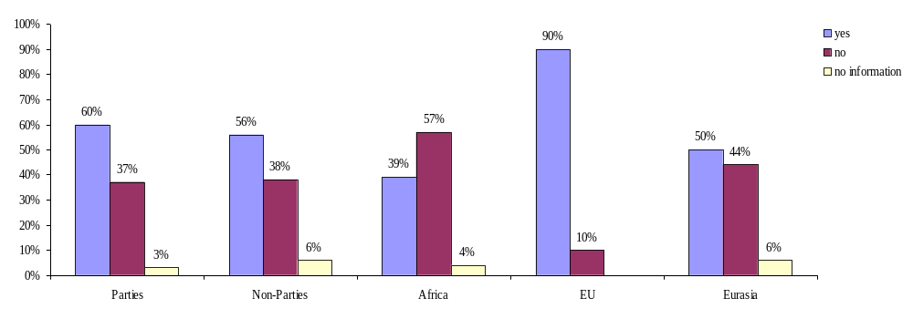
Graph 56: Is there a system for the collection of harvest data in AEWA Parties/ Non-Parties/ Africa, the EU and Eurasia? (question 45)

A system for the collection of harvest data is established in 60 % of the Parties (and 56 % of the Non-Parties). Apparently the largest coverage in this respect is provided in the EU countries (90 %) while only 50 % of the Eurasian countries and 39 % of the African countries systematically collect harvest data.

Reasons mentioned why a harvested data collection system is not in place:

Africa
Parties | Non-Parties
- No official decision yet (Ghana)  - Hunting is neither organised nor controlled ; there is need for organizing hunters and establishing a system of data collection (Guinea)  - Lack of enough trained personnel to monitor the harvesting system (Kenya)  - No hunting of migratory waterbirds (Mauritius)  - Harvest of data will begin as soon as the new legislation comes into force (Nigeria)  - Harvest data are not directly collected, but can be obtained from the numbers of licences issued annually. However, these licences do not show the species names. Support would be needed for capacity building, field equipment (field guides, binoculars, GPS, computers) (Sudan)  - Lacking information about hunting and trade activities among the population; hunting activities are neither monitored nor studied (Togo)  - Only very little hunting of waterbirds (Tunisia) | - Hunting is prohibited (Burundi, Côte d’Ivoire)  - Lack of financial and human resources and equipment (Chad)
EU
Parties | Non-Parties
- Establishment of direct links to game management (Hungary)
- Data collection is not compulsory for local and regional authorities. It would be necessary to consider the delivery of harvest data an essential requirement for allowing hunting (Italy)
- Data is currently collected on a voluntary basis and is organised by shooters’ representative organisations. Environment policy is devolved to each country (i.e. England, Wales, Scotland and Northern Ireland) and it would be for each country’s Government to decide whether to implement such a scheme. There may thus be differences in the way each scheme could be implemented which would not assist information exchange at the UK level. There is no guarantee that compulsory reporting would be accurate (UK)
Eurasia
Parties | Non-Parties
- There is legal requirement or mechanism to make reports. Existing voluntary data are unreliable due to lack of trust of and cooperation with the hunters (Israel)  - Harvest data are not collected as the hunting law is not enforced yet and hunting is still prohibited. Some hunting practices occur illegally and are recorded and reported to relevant institutions. Once the hunting law will be enforced, necessary technical and financial support will be needed to establish an efficient monitoring system and a precise system of data collection in addition to the execution of capacity building and training programmes to the control officers in the relevant public administrations (Labanon)  - Need for technical assistance (equipment) and training for specialists (Moldova) | - Hunting of species listed in Table 1 is prohibited (Azerbaijan)  - Specific harvest data collection is not necessary because there is trust in gamekeepers, who adhere to shooting plans. Some few sample controls are conducted though (Liechtenstein)

b) Characteristica of the harvest data collection systems (where established)
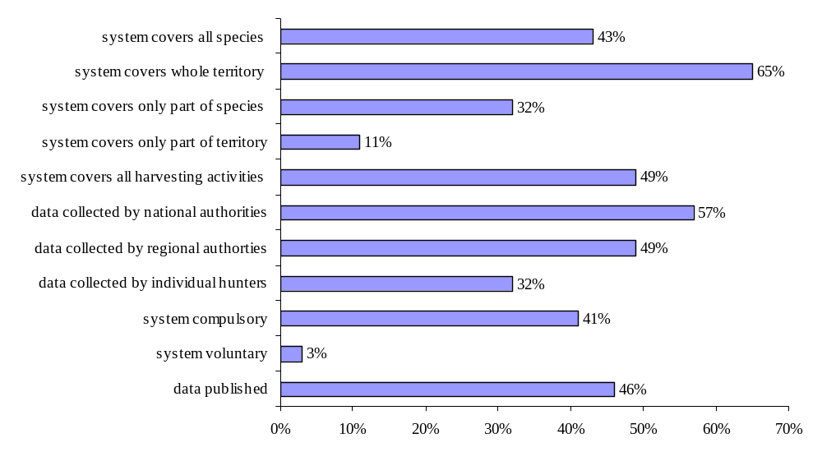
Graph 57: How are harvest data collection systems organised in the AEWA Range States (percentages relate exclusively to those countries that have such a system in place)? (question 46)

The harvest data collection systems and their quality are apparently of different types in the respective countries. Not all provide a full coverage of species and/ or territory, neither do they all cover all existing harvesting activities. Data happen to refer to single species, but in other cases are simply collected for the whole group of waterbirds. Data can be collected by national or regional authorities while some countries involve the single hunters in the collection of data; e.g. in Cyprus the harvest is assessed by field check stations, mainly by means of telephone surveys with 1 % of all hunters, while e.g. in Kenya all hunters have to provide detailed information on date, location and type of hunting (static, driven or walked-up), number of guns, number of shots fired; duration of hunting. Only few countries informed that their harvest data collection system was voluntary; most of the systems are actually compulsory. However, less than half of the countries publish the collected data.

c) Use of collected harvest data on the national level

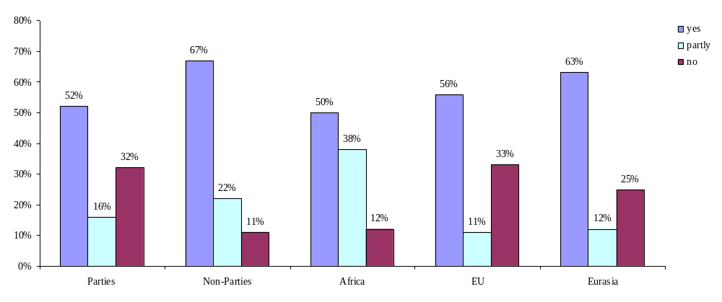
Graph 58: Are collected harvest data used on the national level in Parties/ Non-Parties, Africa, the EU and Eurasia (percentages relate exclusively to those countries that collect harvest data)? (question 47)

d) Use of collected harvest data on the international level

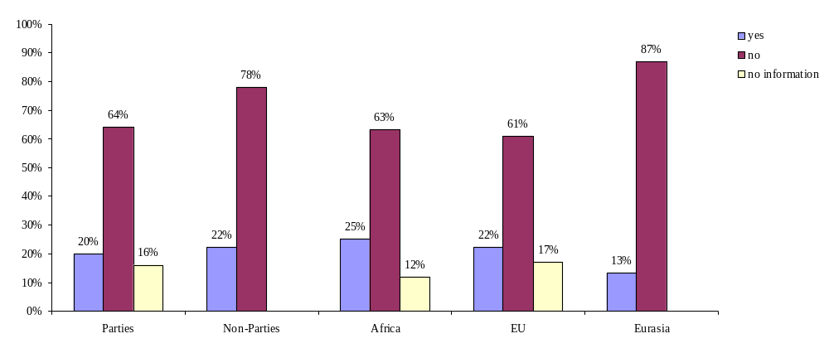
Graph 59: Are collected harvest data used on the international level in Parties/ Non-Parties, Africa, the EU and Eurasia (percentages relate exclusively to those countries that collect harvest data)? (question 47)

While around half of the countries in which harvest data are collected make use of these data on the national level, this is the case in less than 25 % of the countries when it comes to the international level. Countries, which responded that data were used on the international level actually referred to the annual winter census, to bilateral cooperation (Spain/France) or to data being included in international species action plans or submitted to the Ornis Committee. The results confirm that an international harvest framework – as it is required by the AEWA Action Plan and Guidelines on sustainable harvest of migratory waterbirds – needs to be established.

ARTEMIS: the European Hunting Bag Data Collection Programme
Artemis, the new and ambitious European Hunting Bag Data Collection Programme was launched in Athens in 2006, under the European Commission’s Sustainable Hunting Initiative. It is expected that ARTEMIS will considerably improve knowledge of, and communication on bag data in Europe. The first objectives of the Artemis data bank, as decided in the ARTEMIS Workshop held on 23 March 2007 in Brussels, are:
- Produce a comprehensive inventory of existing methodologies and systems.
- Collect comparable data that can be utilized for identifying trends in havest levels, and possibly for detecting trends in the populations for species poorly covered by conventional systems.
- Although it was initially envisaged that ARTEMIS would cover only hunted bird species, there are a number of advantages to extending the project to other “game” species.
- National systems for collecting bag statistics should be preserved, but an option for adopting a stardised scheme should be made possible.
The Federation of Associations for Hunting and Conservation of the EU (FACE) will undertake the technical coordination of the Artemis data bank, in collaboration with national focal points and assisted by a Steering Group. At a later stage a Scientific Committee will be set up.
Artemis aims to contribute to the delivery of the Countdown 2010 Target for biodiversity conservation. The first bag data have already been submitted, but it will probably take several years before the Artemis data bank will be fully operational for formulating conclusions and concrete wildlife management recommendations.
For the time being another workshop is envisaged in order to decide on how to present the bag data received so far.

e) Reasons mentioned why data are not used for assessing the annual harvest of species listed in Table 1

Africa
Parties | Non-Parties
National level
- Hunt of birds is neglectable in Congo due to the richness in mammals.  - Lack of capacity to collect sufficient data (Gambia)  - Harvest data collection system not yet fully implemented, also lack of capacity and funds (South Africa)  - There is nearly no official demand for hunting birds, although there is evidence in the field that hunting of birds takes place (Togo) | - Lack of capacity to collect and evaluate data (Chad)  - Data are used partly to assess the status of the species in question (Ethiopia)
International level
- Lack of an international harvest data collection system (Benin)  - Lack of data on the national level makes effective international cooperation impossible (Gambia)  - Monitoring and reporting by the hunting fraternity is poor (Kenya)  - Lack of funding (South Africa) | - Lack of an international harvest data collection system (Morocco)
EU
Parties | Non-Parties
National level
- The current legislation does not allow any direct link between hunting and the population sizes. No provisional limit is foreseen at the national or regional level (Italy)  - No data exists to assess the extent of national harvest (UK) | - The Central Hunting Management Database was established in 2006 and is still not fully functional. Information is being collected from scientific and expert studies and expert opinion of hunting specialists (Cyprus)
International level
- Only few countries evaluate such data (France)  - There is no link between hunting bags and the number of birds shot and no uniform regulation for the production of such data in Italy, where data are collected on the regional level  - The information is published. However, counts are more important (Switzerland)  - No data exist to assess the extent of national harvest and no international process exists to contribute to (UK) | - Central Hunting Management Database was established in 2006 and still is not fully functional, up till now all information was collected from scientific and expert studies and expert opinion of hunting specialists. The non-use on the international level is a consequence of the non-use on the national level (Croatia)  - There must be contact between countries at least along the same flyway to compare population trends and harvest records (Cyprus)
Eurasia
Parties | Non-Parties
National level
- No data on harvest (Israel)
- Since the hunting law is not enforced yet, there is no harvest data at the present to be used (Lebanon)
- Data are not submitted to the AEWA Focal Points (FYR Macedonia)
- Hunting of waterbird species is not so popular in Slovakia
International level
- Lack of cooperation and communication programmes with other countries, especially neighboring countries (Albania)  - The scientists are using the harvest data for their purpose (Lithuania) | - There are no contacts and there is no demand for these data. A network of specialists should be created to be used for exchange (Moldova)  - No effective cooperation (Russia)

f) What would help to improve the use of harvest data?

Africa
Parties | Non-Parties
- Introduce a more efficient system and a database on the national level (Benin)  - Coordinated monitoring systems (Kenya)  - Funds to finance a development programme and central database of hunted species (South Africa) | - Capacity building (technical and equipment) (Burkina Faso)  - Regular data collection (Chad)  - International help (Ethiopia)  - An international harvest data system (Morocco)
EU
Parties | Non-Parties
- Harvest data are regularly published in hunting journals, but only in the Czech language. Publishing such data in English and making them available to the international community (e.g. through Ministry website) might help (Czech Republic)  - The European Commission is currently elaborating a harvest data collection system for the EU member states (France)  - Modify national legislation (Italy)  - Compile and analyse data on the international level (Norway)  - Enhanced cooperation between hunters and stakeholders (Spain)  - Harvest data would need to be collected by standardised methods and by a larger number of shooters to ensure accuracy, consistency and confidence in the data (UK) | - Establish comparable annual harvest assessment program in all countries which show the trends of species harvest along the flyways (Cyprus)
Eurasia
Parties | Non-Parties
- Enhance international cooperation in order to exchange views and make a better use of the collected data (Albania)  - The (national) database is not complete yet, so problems are not yet identified (Croatia)  - Establish a reliable reporting mechanism (Israel)  - Canalise information to the AEWA Focal Points and organize meetings with the relevant stakeholders ( hunting ground managers and representatives form the Ministry) to clarify AEWA requirements (Macedonia)  - Regional/ international training on collecting and using annual harvest data should be organised by the AEWA Secretariat (Moldova) | - Improve quality of bag statistics (Estonia)  - Develop legislation, standards and procedures, issue enough means for hunting control and collect harvest data (Russian Federation)  - Establish an official procedure for the comprehensive collection and effective use of data (Turkmenistan)

g) Are collected harvest data used as a basis to regulate trade in waterbirds?

Of the 21 countries that came back to this question four countries informed that trade was regulated on the basis of the harvest data, while ten countries said this was not the case. The remaining countries indicated that trade was either not permitted (3) or not practiced (3) or the question was not applicable (32).

Conclusions:

The survey has confirmed that the numbers of migratory waterbirds harvested within the AEWA area are not completely known and, even when data exist, these are only partially used for the assessment of the annual harvest of and trade in migratory waterbirds. Harvest data, however, are vitally important and needed to:
- consider the sustainability of hunting harvests;
- introduce protection measures where they are needed to conserve threatened or vulnerable species
- asses the socio-economic importance of waterbird hunting
- contribute to an assessment of trade in migratory waterbirds.

The lack of data collection and evalutation concerns both the national and the international level. On the national level data are either not collected at all, or not collected in a standardised way in different countries or even different regions of one country. The latter makes the potential use of data for the whole of a flyway very difficult. In consequence both the establishment of a harvest data collection system in each country, as well as the harmonisation of all existing systems throughout the AEWA area are needed. However, there is still no international tool in place that would allow for the management and smooth exchange of existing harvest data throughout the AEWA area. A database is currently being established by the European Commission for the EU member states (ARTEMIS), a project which directly contributes to the implementation of Paragraph 4.1.3 sentence 1 within the EU member states. For the rest of the AEWA area a system will need to be established.

According to Art. 4.1.3 of the AEWA Action Plan Parties shall provide the Agreement Secretariat with estimates of the total annual take for each population, when available. This has not happened so far.

Recommendations:

1. Parties are stimulated to develop/ improve a harvest data management system on the national level.

2. Parties are urged to submit existing data on the total annual take for each population to the Secretariat. The Secretariat will publish these data and make them available for all AEWA Range States.

3. The Technical Committee reviews the ARTEMIS project and gives advice on steps to be taken in order to establish an international system for the management of harvest data for the countries in the AEWA area that are not covered by ARTEMIS.

4. The Secretariat, funds permitting, provides for the implementation of International Implementation Priority No. 10 “Evaluation of waterbird harvests in the Agreement area”.

6. Illegal hunting

AEWA Action Plan:

4.1.4 Parties shall develop and implement measures to reduce, and as far as possible eliminate, illegal taking.

a) Does illegal hunting take place?
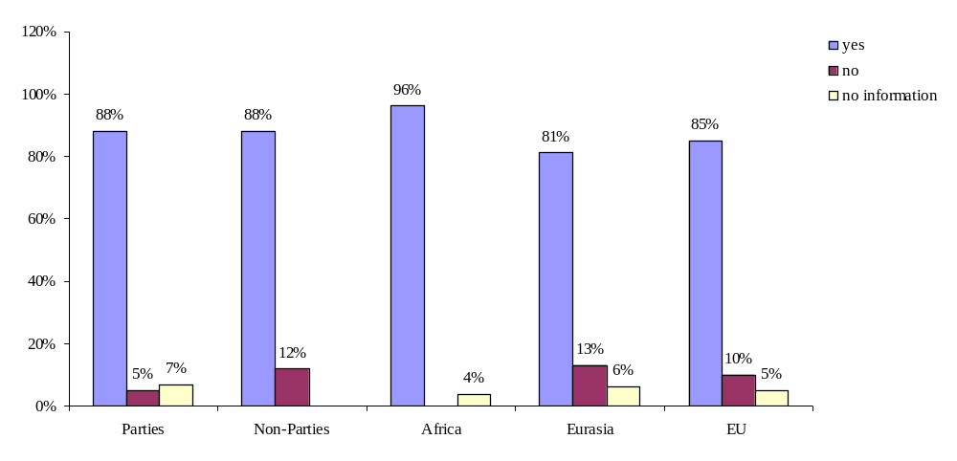
Graph 60: Illegal hunting taking place in Parties/ Non-Parties and in Africa, Eurasia and the EU (question 59).

The graphs show that throughout the whole Agreement area illegal hunting still is an issue in the large majority of the countries. The comments provided in the questionnaires, however, tend to confirm that in European countries poaching of waterbirds is rather a small-scale activity (also due to good enforcement) while, for example, single African countries report back about intensive and wide-spread poaching taking place within their territory.

b) Law enforcement

aa) Enforcement measures

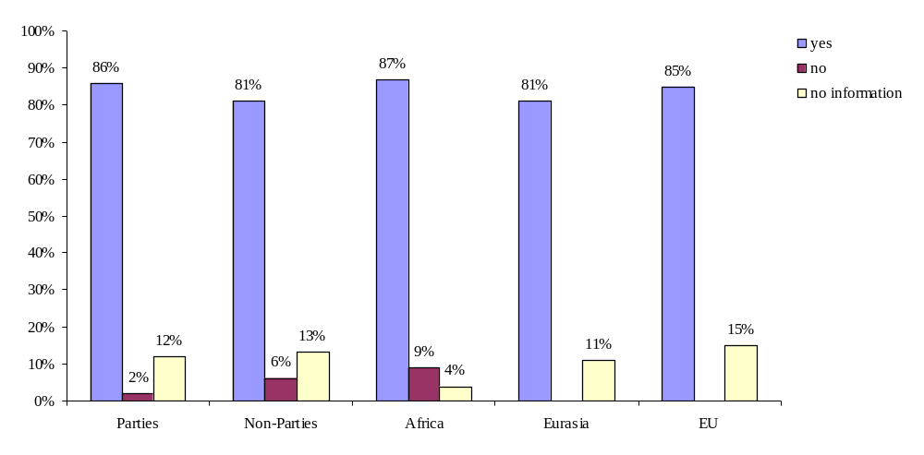
Graph 61: Measures taken against illegal hunting in Parties/ Non-Parties and in Africa, Eurasia and the EU (question 60).

Measures to combat illegal hunting formally exist in all countries in which poaching of waterbirds takes place except in Congo (“no measures are needed in case of birds, because illegal hunting concerns birds only very little”) and Zimbabwe. Such measures include fines, seizure of equipment, controls, penalties, a “poaching hotline”, enforcement inspectors, rangers system, responsibility given to hunters, social control, local environmental offices with networks of people who watch for illegal hunting, “environmental police”, awareness raising activities, involvement of communities and training of scouts, patrolling, surveillance, hunting license systems.

However, in many countries the problem lays with the lack of implementation of such enforcement measures:

bb) Quality of the measures
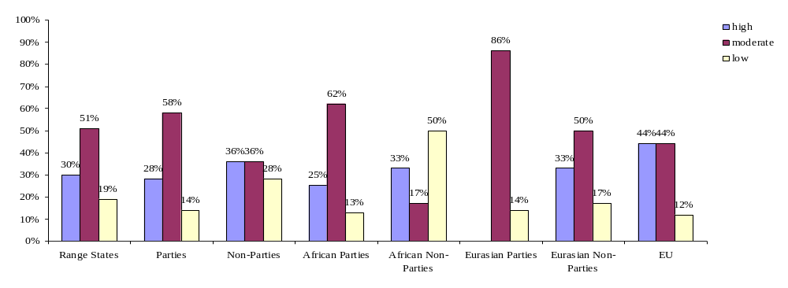
Graph 62: How is the quality of enforcement measures against illegal hunting rated in the AEWA area?

Measures against illegal hunting were rated being of moderate quality in most countries (which stands for illegal hunting having been reduced, but not eliminated), but still 14 % of the Parties have informed that measures were to be rated low (illegal hunting has not been reduced), while 28 % signaled having eliminated hunting with high-quality measures.

Reasons mentioned for illegal hunting taking place:

Africa
Parties | Non-Parties
- Legislation not known among people  - Illegal hunting takes place in remote areas that are not accessible to authorities | - Aiming for the protection and restoration of its species Côte d’Ivoire banned hunting in 1974. This was, however, not accepted by the rural population and the different stakeholders of the hunting sector. Enforcement measures, moreoever, were not taken and the posts of the large majority of staff involved in hunting issues were allocated to new fields of work. All this led to an immense increase of illegal hunting activities, thus conservation efforts completely failed. Therefore in 1994 hunting was reopened and regulated. However, birds of Table 1 – under the regulations adopted since 1994 - are still considered as not huntable, although it is now planned to reintroduce hunting for certain Column B species in 2008 including legal restrictions on hunting.
Eurasia
Parties | Non-Parties
- Penalties not adequate
- Measures are in place, but not sufficient
- Lack of financial means

Conclusions:

A legal ban on hunting potentially leads to poaching activities and therefore always needs to be accompanied and followed up by strong enforcement measures that ensure the effectiveness of the legal prohibition in place. The experiences made in Côte d’Ivoire, for example, (see box) show that a prohibition, if neither enforced nor put in the respective socio-economic and socio-cultural context, can easily have the opposite effect, thus create an immense market for illegal activities instead of bringing the wished improvement for the species.

According to the answers in the questionnaire measures against illegal hunting are principally in place in the large majority of countries. However, taking into account that illegal hunting still exists in a big share of countries (although the intensity varies a lot between the different countries) and that enforcement measures were rated being of moderate or even low quality in many of these it is clear that improvement needs to be made on the level of enforcement.

The following measures can be considered for building and strengthening capacities for enforcement:

- Coordinated technical and financial assistance to formulate effective laws and regulations and to develop and maintain institutions, programmes and action plans for enforcement, monitoring and evaluation of national laws implementing AEWA;
- Development of specific guidelines with reference to AEWA for law enforcement officers to conduct operations, investigations and inspections, and procedures for reporting and processing information nationally and internationally;
- Formulation of programmes for coordinating compliance and enforcement actions including compliance promotion, with other states;
- Organise workshops/ training programmes to provide opportunities for sharing information and experiences, using regional centres for cost-effective and long-term training programmes

Recommendation:

- The Meeting of the Parties urges the Parties to improve the combat against illegal hunting or to implement additional measures to further reduce illegal hunting in species covered by the Agreement.

- The Meeting of the Parties directs the Secretariat, funds permitting, to provide assistance to the Parties in order to improve the enforcement of AEWA, including measures against illegal taking.

7. Restocking

AEWA Conservation Guidelines on sustainable harvest of migratory waterbirds:
The release of farm-reared birds may reduce the harvest of wild birds, increase hunter satisfaction and boost local hunting economies. However, such birds may be prone to disease and relatively tame, and may offer poor sport. Habitat protection and improvement are probably a better way of increasing waterbird harvests and should be part of any stocking programme.

Is restocking waterbirds allowed in the AEWA area?

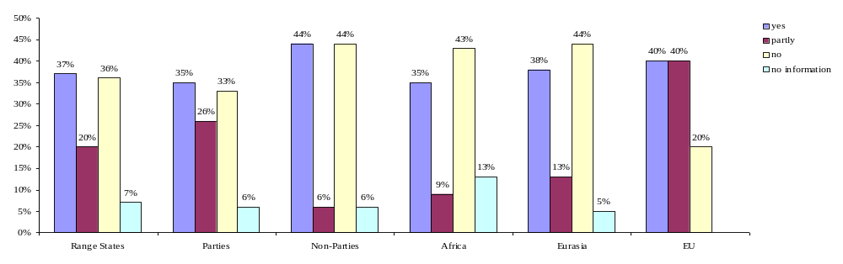
Graph 63: Is restocking allowed in AEWA Range States/ Parties/ Non-Parties and in Africa, Eurasia and the EU? (question 63)

Restocking is in principle allowed in 37 % of all countries and in additional in 20 % under certain limitations (restrictions on species, areas etc.), although not all countries make use of this option. In certain countries restocking may only take place with a special permit from the responsible national authority and in the frame of (or even for the purpose of) conservation management planning (specifying e.g. species and number of released birds). In a number of countries (captive-bred) Mallards (Anas platyrhynchos) are released for hunting puposes, whereby the level of related controls differes from country to country. In France, for example, restocking is followed by a sanitary follow-up due to Avian Influenza while in Italy no strict controls related to restocking programmes exist. Portugal undertakes stocking programmes in hunting areas, but veterinary controls are reported to be insufficient due to the fact that the impact of restocking is not assessed. Also Moldova reports about farms where hunting species are bred and restocked in nature.

Conclusions:

Restocking waterbirds (especially the Mallard) for hunting purposes is a common practice in many countries of the AEWA region and, in principle, accepted by AEWA.

Recommendation:

The Technical Committee provides advice on whether provisions concerning the control of restocking should be included in the Action Plan.

8. Non-native species
Agreement text:

Article III

1. The Parties shall take measures to conserve migratory waterbirds, giving special attention to endangered species as well as to those with an unfavourable conservation status.

2. To this end, the Parties shall:

(g) prohibit the deliberate introduction of non-native waterbird species into the environment and take all appropriate measures to prevent the unintentional release of such species if this introduction or release would prejudice the conservation status of wild flora and fauna; when non-native waterbird species have already been introduced, the Parties shall take all appropriate measures to prevent these species from becoming a potential threat to indigenous species.

AEWA Action Plan:

Introductions

Parties shall, if they consider it necessary, prohibit the introduction on non-native species of animals and plants which may be detrimental to the populations listed in Table 1.
Parties shall, if they consider it necessary, require the taking of appropriate precautions to avoid the accidental escape of captive birds belonging to non-native species.
Parties shall take measures to the extent feasible and appropriate, including taking, to ensure that when non-native species or hybrids thereof have already been introduced into their territory, those species or their hybrids do not pose a potential hazard to the populations listed in Table 1.

AEWA Guidelines on avoidance of introductions of non-native waterbird species:

A policy usually promoted with regard to intentional introductions of non-native species is to allow it only after an appropriate risk assessment procedure has proven the species to be low risk. However, with regard to waterbirds, our ability to predict impacts of non-native waterbirds on native biodiversity is very limited. Hence, considering the precautionary principle the wisest policy is to prohibit any intentional releases on non-native waterbirds.

AEWA Conservation Guidelines on sustainable harvest of migratory waterbirds:

The introduction of exotic species outside their native range inevitably causes alterations to the structure of native waterbird communities. It can cause genetic erosion, and may threaten the survival of some waterbird populations. It is now regarded as poor practice and should be actively discouraged.

The issue of introduction of non-native species has not been treated in a comprehensive way for the reason that this is focused on by another international review produced in the framework of the Agreement and its Action Plan (compare paragraph 7.4 (g) Action Plan). However, one question of the survey aimed for specifically finding out if the issue of non-native species is regulated in the countries’ legislations:

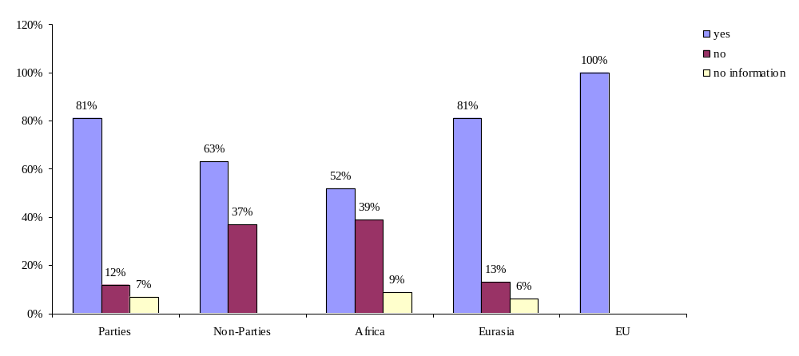
Graph 64: Does the legislation restrict the introduction of non-native species in Parties/ Non-Parties and in Africa, Eurasia and the EU? (question 64)

Asked whether there are restrictions concerning the introduction on non-native species in the countries’ legislation 81 % of the Parties responded “yes”, while 12 % informed that restrictions are not to be found in the pertinent legislation. In the case of Non-Parties, restrictions are found in the legislation of 63 % and not existent in 37 %. Significantly, all EU countries have legal restrictions on non-native species, while in Eurasia 81% of all countries (89 % of the Parties) and in Africa only 52 % of all countries (56 % of the Parties) have attached importance to the issue by regulating it in the pertinent legislation.

Conclusions:

The Agreement text (as well as the Guidelines on avoidance of introductions of non-native waterbird species) clearly state that Parties shall prohibit the deliberate introduction of non-native waterbird species into the environment and take all appropriate measures to prevent the unintentional release of such species if this introduction or release would prejudice the conservation status of wild flora and fauna. Not all AEWA Parties have legislation in place concerning “non-native species” though. In the AEWA Action Plan the corresponding paragraph contains the qualified term “if they consider it necessary”, which leaves it to the Parties discretion to take action or not. It might be wished for reasons of clarity to brfing in line the Action Plan with the stricter Agreement text by amending the wording of Paragraph 2.5 of the Action Plan in accordance with Article III 2 (g).

Recommendations:

- The Parties are urged to prohibit the deliberate introduction of non-native waterbird species into the environment and to take all appropriate measures to prevent the unintentional release of such species in accordance with the recommendations of the international review on the status of introduced non-native species.

- The Technical Committee reviews Paragraph 2.5 of the AEWA Action Plan and especially provides advice on whether its qualified term “if they consider it necessary” should be deleted from the text.

9. Hunters

It is recognised that hunters clubs and organisations can make important contributions to the management of waterbirds. According to the Action Plan “Parties shall encourage hunters, at local, national and international levels, to form clubs or organisations to coordinate their activities and to help ensure sustainability”.

This chapter addresses the following issues:

- Is it mandatory for hunters to organise themselves in clubs or associations?
- Are hunters organised in clubs or associations (at local, national and international level)
- If not mandatory, are hunters encouraged to organise themselves?
- Participation of hunters clubs and organisations in acitivties which aim for ensuring sustainability
- Proficiency test
- Funding system

AEWA Action Plan:

    - Where appropriate, Parties shall encourage hunters, at local, national and international levels, to form clubs or organisations to coordinate their activities and to help ensure sustainability.
    - Parties shall, where appropriate, promote the requirement of a proficiency test for hunters, including among other things, bird identification.

AEWA Conservation Guidelines on sustainable harvest of migratory waterbirds:

[…] the management of harvest data may be achieved through a voluntary approach, using a national hunting organisation and/or local network of hunting clubs. Moreover, hunting organisations and individual hunters already carry out major and important wetland creation and improvement projects. Hunters can be engaged in habitat conservation and management and the control of predators, including alien species. Several hunting organisations have developed ‘habitat stamp’ schemes using designs by famous artists, with sales producing substantial amounts of revenue for habitat conservation projects. Such efforts should be recognised and encouraged.

All hunting organisations can contribute to maintaining high hunting standards. Hunting clubs should endeavour to ensure that individual hunters are proficient and well-trained. A licensing system for hunters can be helful for monitoring hunter numbers and to provide revenue for the administration of harvest management. Acquiring a licence can be made dependent on the passing of a proficiency test, attending a training course and (or supplying hunting statistics at the end of the season. All of these improve the overall quality of hunting activity within a particular Range State. Those who fail to adhere to regulations can be prevented from obtaining a hunting license.

Bird Identification
The ability of hunters to identify waterbirds is an important component of harvest management. Hunters should be able to recognise both the common and rare species encountered, with special attention given to endangered species (including “look-alike species”). Identification skills can be tested and a minimum level of proficiency expected. Training materials may help, such as general field guides and videos for birdwatchers and hunters. Firearm safety, responsible hunting practices, wildlife conservation, hunter ethics and shooting skills are amongst topics commonly included. Courses can include practical demonstrations, shooting practice, films and lectures. Where possible, encouraging contact between experienced and inexperienced hunters is a good way of improving standards.

Training must be extended to the tourists who hunt in some countries and to their guides and agents. Guides may be offered official registration with a national hunting organisation to signify that they can provide safe and responsible services to others. There can also be formal licensing agreements between hunting organisations and guides.

Codes of practice, such as the one proposed as part of the harvest framework (see Step 2), will help to ensure that high standards are maintained amongst resident and visiting hunters.

Good habitat management
Hunting organisations and individual hunters already carry out major and important wetland creation and improvement projects. Hunters can be engaged in habitat conservation and management and the control of predators, including alien species. Several hunting organisations have developed ‘habitat stamp’ schemes using designs by famous artists, with sales producing substantial amounts of revenue for habitat conservation projects. Such efforts should be recognised and encouraged.
[…]

a) Is it mandatory for hunters to organise themselves in clubs or associations?

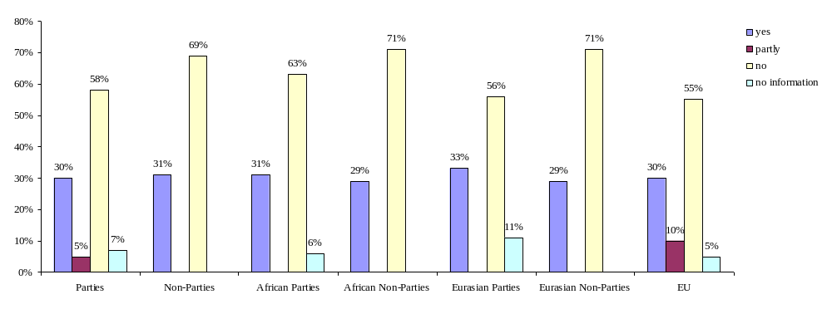
Graph 65: Statutory obligation for hunters to join a hunting club or association in the AEWA area (question 66).

In 30 % of the Parties the membership in a hunting organisation is a legal obligation; 58 % have no such regulation in their legislation. No significant difference exists between the different regions or between Parties and Non-Parties: the percentage figures for the different regions as well as respectively for Parties and Non-Parties obliging hunters to join in organisations vary from 29 % to 33 %. (Countries that currently have a total ban on hunting are included in the group of countries having replied “no”.)

Following explanations were provided for crossing the option “partly”: legal requirement only refers to a certain region of the country and does not include waterbird hunters (Belgium); there are legal regulations on this issue although the participation of hunters is not mandatory (Hungary).

b) Are hunters encouraged to organise themselves?

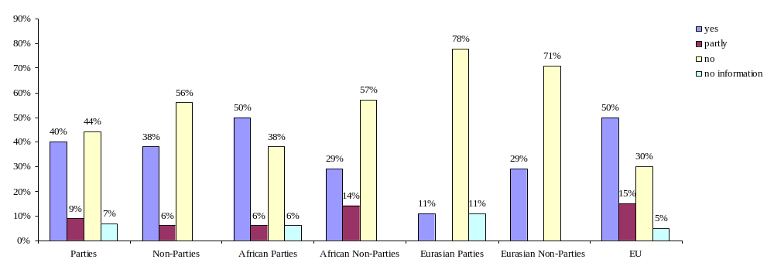
Graph 66: Are hunters encouraged on a voluntary basis to join hunters clubs or associations in the AEWA area?

Hunters can also be encouraged to join hunters organisations on a voluntary basis, e.g. by governmental initiatives or by the hunters organisations themselves. In the survey 40 % of the Parties (+ 9 % partly) informed that hunters in their countries are encouraged in another way than by legal obligation to organise themselves, while 44 % signaled that hunters are not encouraged. No significant differences exist between Parties and Non-Parties. On a regional level the highest initiative in this respect is taken by EU countries (50 % responded yes + 15 % partly), while the ratio is quite low among the African countries (50 % + 6 % partly of the Parties) and even lower among Eurasian countries (11 % of the Parties and 29 % Non-Parties responded yes). (Countries that currently have a total ban are included in the group of countries having replied “no”).

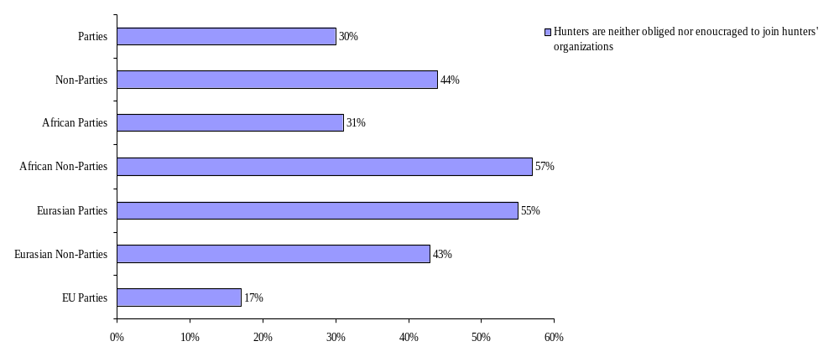
Graph 67: Share of countries in the AEWA area, in which hunters are neither legally obliged nor encouraged on a voluntary basis to join hunters’ organisations.

30 % of the Parties have neither a legal obligation in place nor are hunters encouraged in another way to organise themselves and form clubs or organisations. The figures suggest that the situation is more favourable among Parties than among Non-Parties. However, taking into account that part of the Parties have not provided any information on this issue (compare graphs 68 and 69), the situation might in reality probably be the same or very similar for Parties and Non-Parties. The regional differences are quite significant: while hunters are not encouraged or legally obliged to organise themselves in 17 % of the EU Parties, this is the case in 31 % of the African and in even 55 % of the Eurasian Parties.

c) Are hunters organised in clubs or associations?

The reality, compared to the efforts undertaken by the governments to enhance organisational structures among hunters, all in all, looks slightly more positive, which might be the result of successful membership development undertaken by hunters organisations.

Parties:

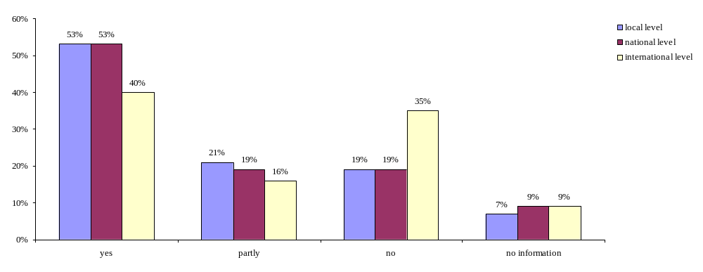
Graph 68: Hunters being organised on the local/ national/ international level in countries that are Party to AEWA (question 65).

Non-Parties:
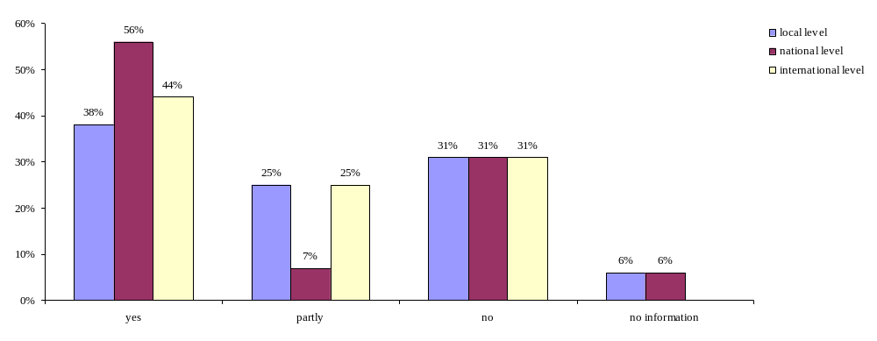
Graph 69: Hunters being organised on the local/ national/ international level in countries that are not Party to AEWA (question 65).

Actually, organisational structures for hunters (at least partly) exist in more than 70 % of the Parties on the local and national level; in 56 % of the Parties hunters are also involved internationally. In case of Non-Parties the overall situation is quite comparable.
Africa:
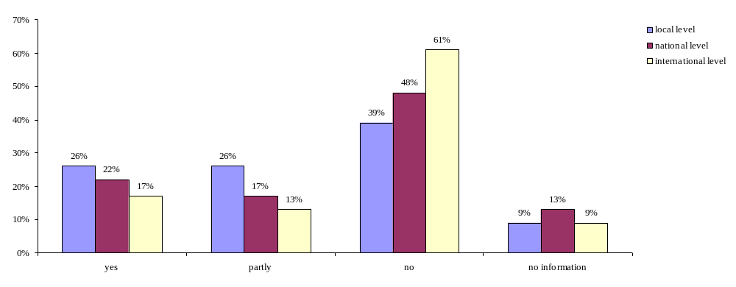
Graph 70: Hunters being organised on the local/ national/ international level in Africa (question 65).

Eurasia:

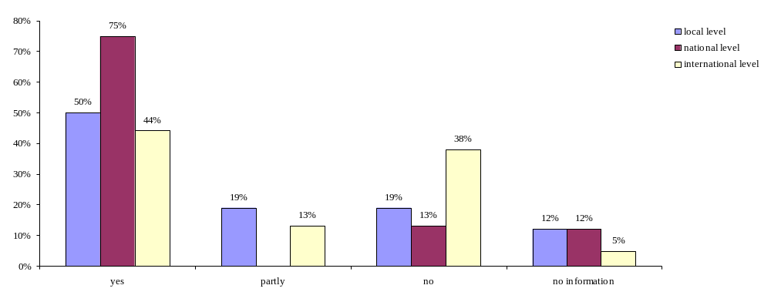

Graph 71: Hunters being organised on the local/ national/ international level in Eurasia (question 65).

EU:
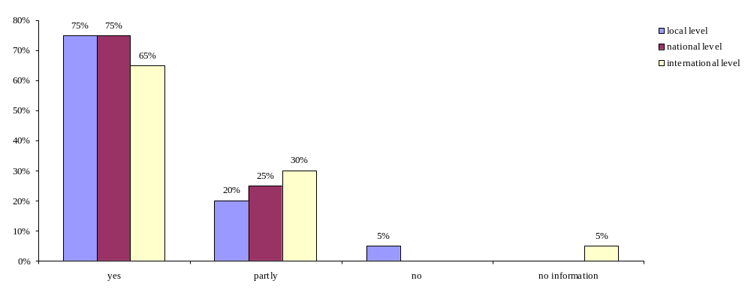
Graph 72: Hunters being organised on the local/ national/ international level in the EU (question 65).

Looking into the different regions it is evident that in a remarkably high amount of European countries (around 95 % or even more) hunters are (at least partly) organised on local, national as well as international level, while the ratio is less positive for Eurasian (not exceeding 80 %) and even lower for the African region (not exceeding 58 %).

Member states to the International Council for Game and Wildlife Conservation (CIC):

Member states to the Federation of Associations for Hunting and Conservation of the EU (FACE):

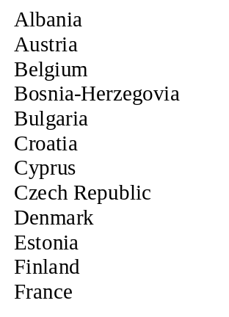
Liechtenstein
Luxembourg
Greece
Hungary
Italy
Morocco
Norway

Poland
Portugal
Slovakia
Slovenia
Spain

Austria
Cyprus
Czech Republic
Finland
Germany

Switzerland
The Netherlands
Tunisia
Turkey

Germany
Greece
Hungary
Ireland
Italy
Latvia
Lithuania
Luxembourg
Malta
Moldova
Montenegro
Netherlands (the)
Norway
Poland
Portugal
Romania
Serbia
Slovakia
Slovenia
Spain
Switzerland
Sweden
Turkey
UK

- Participation of hunters clubs and organisations in activities which aim for ensuring sustainability

Parties and Non-Parties:
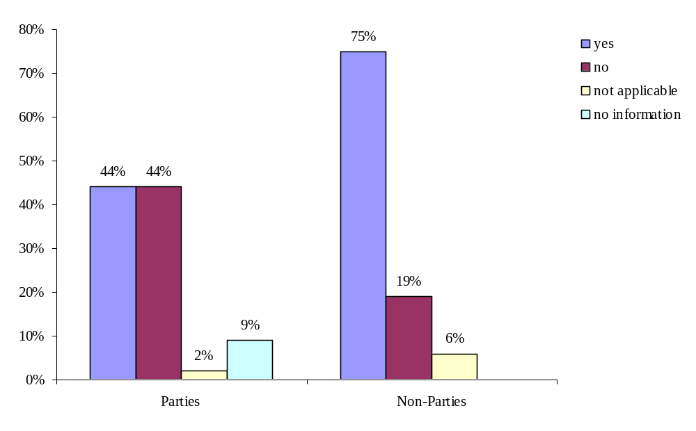
Graph 73: Do governments of Parties/ Non-Parties involve hunters’ clubs and organisations in activities which aim for ensuring sustainability of migratory waterbird populations? (question 68)

Hunters clubs and organisations are involved by the government in activities which aim for ensuring sustainability of migratory waterbird populations in 44 % of the Parties and 75 % of the Non-Parties.

Africa, Eurasia and EU:

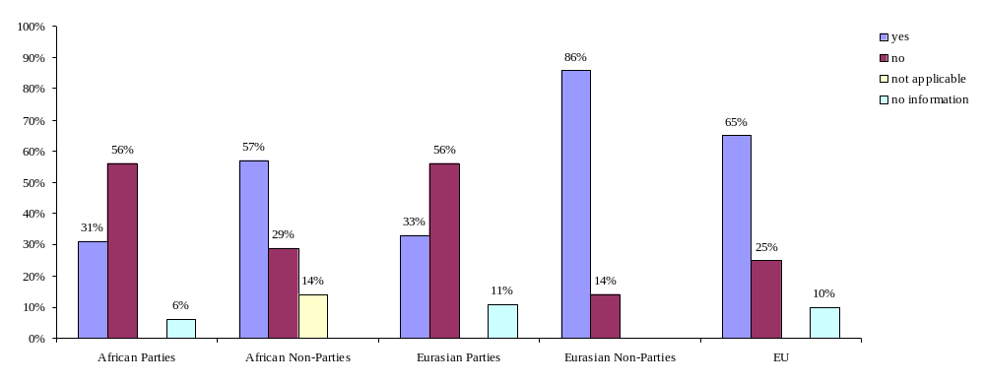
Graph 74: Involvement of hunters’ clubs and organisations in activities which aim for ensuring sustainability of migratory waterbirds in the Africa, Eurasia and the EU (question 68).

In all regions a higher percentage of Non-Parties’ governments involve hunters than it is the case for Parties. The highest percentage is reached among Eurasian Non-Parties of which 86 % involve hunters actively in migratory waterbird management.

Examples given for hunters being involved in governmental migratory waterbird management:

Africa
Parties | Non-Parties
- The bird shooting fraternity to play a role, and contribute to the success of tissue sample collection for analysis under the avian influenza surveillance programme in Kenya, in liaison with the Veterinary Department KWS;
The bird shooting fraternity to contribute towards management of problem waterbirds in rice schemes when called upon to undertake shooting exercise;
They work and cooperate with field research officers in different regions on all issues pertaining to bird shooting and monitoring of waterbird populations;
Help with awareness-creation among the local people on the dangers of illegal hunting and sale especially of duck carcasses;
Help with the general monitoring of wildlife populations and report any relevant information useful for wildlife conservation (Kenya)
- discussion meetings (Congo)
EU
Parties | Non-Parties
- involved in governmental decisions: give advice on technical and juridical decisions (France)
Eurasia
Parties | Non-Parties
- participation in Biodiversity International Days, other local activities on biodiversity conservation provided for students (Moldova) | - hunters have opportunity to comment on proposals (Canada)  - hearing part, monitoring, surveys etc. (Norway)

e) Proficiency test

aa) Do hunters have to undertake a proficiency test?

All countries:
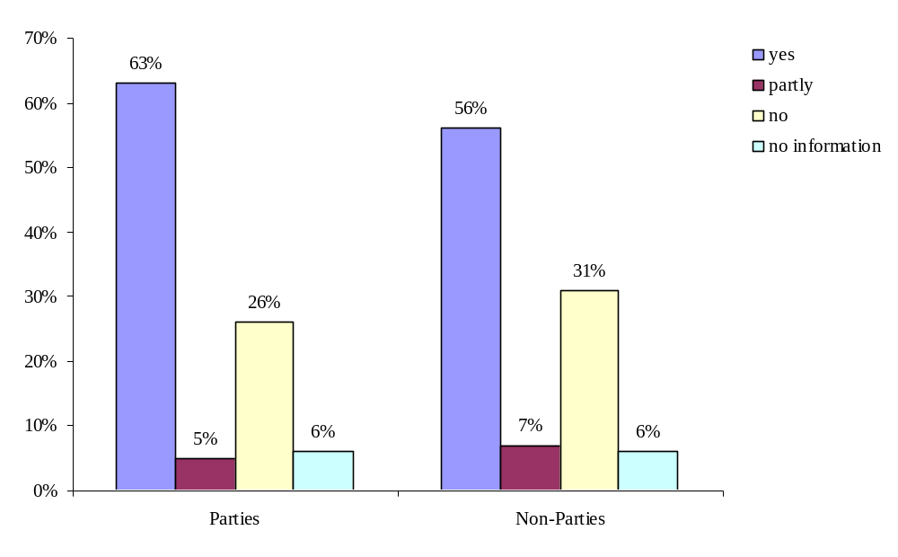
Graph 75: Proficiency test obligatory in Parties/ Non-Parties (question 69).

A proficiency test is obligatory in 63 % (+ 5 % partly) of the Parties and in 56 % (+7 % partly) of the Non-Parties. The option “partly” was chosen by countries for the reason that the issue of proficiency test is treated differently in different regions of the countries (Spain) and because enquiries are made about the person’s character before any firing/hunting licence is issued (Mauritius).

Africa, Eurasia and the EU:
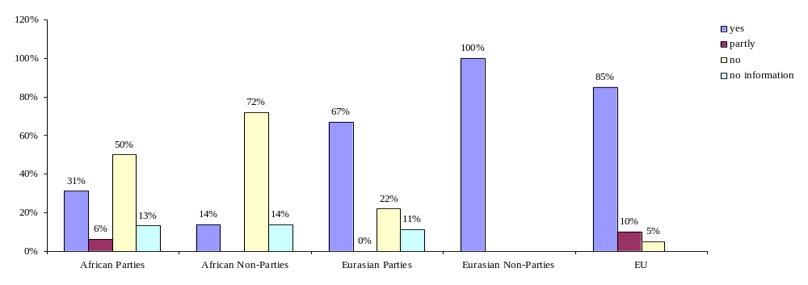
Graph 76: Proficiency test obligatory in Africa, Eurasia and the EU (question 69).

The regional comparison shows clearly that while the requirement of a proficiency test is widespread in the EU and Eurasia, there are quite prominent gaps in Africa.

bb) If not, does the government promote the requirement of a proficiency test ?

Parties:
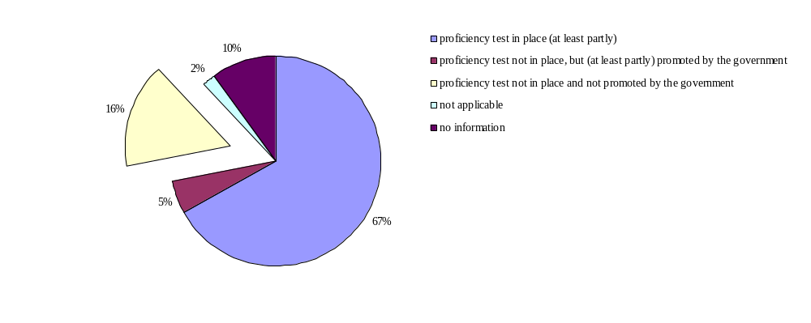
Graph 77: If there is no proficiency test for hunters, do the respective Parties promote the need for such a proficiency test? (question 70).

16 % of the Parties have no proficiency test in place and also do not promote the requirement of such a test.

cc) If yes, does proficiency test include bird identification?

Parties:
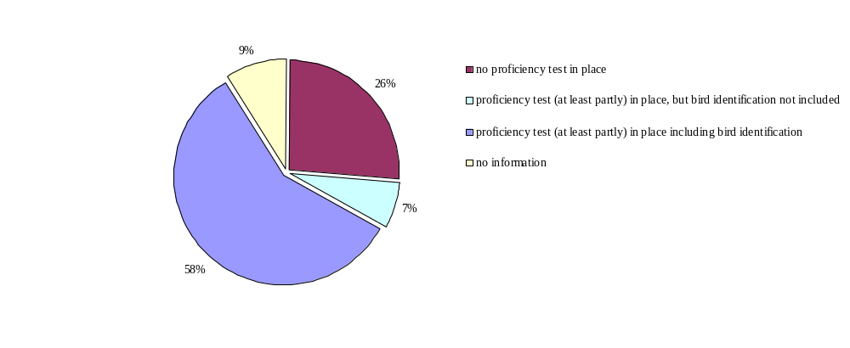
Graph 78: Proficiency test including bird identification in Parties (question 71).

Non-Parties:

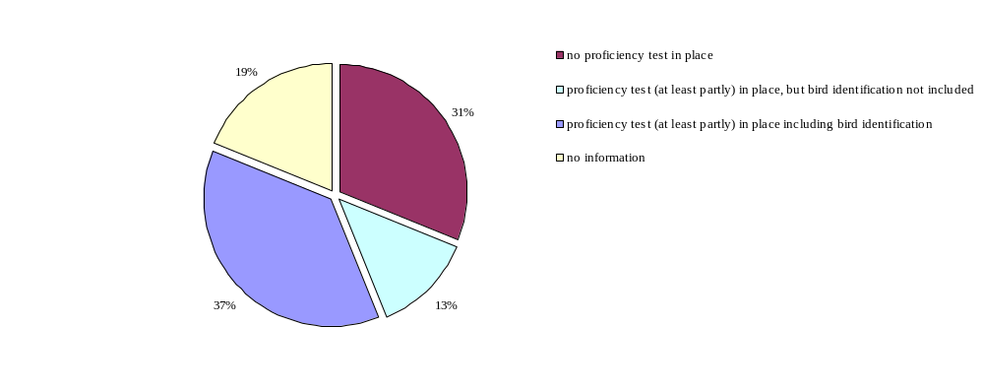
Graph 79: Proficiency test including bird identification in Non-Parties (question 71).

Most countries, which have a proficiency test in place, include bird identification as one component. However, in 7 % of the Parties and 13 % of the Non-Parties bird identification does not play a role although a proficiency test is required for hunters.

dd) Other components of the proficiency test

Proficiency tests may consist of practical and theoretical parts. There is a multitude of components, which differ significantly between countries.

Most common elements include knowledge of the relevant legislation and regulation (18 countries), on weapons and munitions (16), on hunting methods and procedures (10). Zoology is another important area, including the identification of huntable and protected species (10), biology (9) and general zoology (7). Further common elements are shooting tests (7) and knowledge on game management (6), safety and security (5), cynology (5) as well as hunting ethics (4). Ecology or nature conservation is a test component in only 6 of the replying countries.
There is a wide array of further components existing in several states, shown in the box below. It might be noteworthy that only one country (Kenya) has indicated that the use of the reporting system is a test element.
Further examples of proficiency test components (indicated by 1-3 countries only):
administration, animal diseases, aptitude/psychophysical order, ballistics, care for game, first aid, game meat hygiene / handling of quarry, hunting art, hunting gazette, hunting history and / tradition, knowledge of species’ protection status, management of hunting ground, national language, orientation in nature, practical test (e.g. repairing a vehicle), prophylaxis, protection of agricultural crops, taking of blood

ee) Other requirements for obtaining a hunting license than a proficiency test

Most countries replying to the questionnaire require other/ more elements in order to assign a hunting license, most notably in Eurasia. However, in Africa, only 26 % of the countries indicated that they have additional requirements for obtaining a hunting license.

Training courses are a requirement for obtaining a hunting license in 24 % of the Range States. To emphasise a promising example, in addition to a training course, Slovenian legislation requires junior hunters to be accompanied by seniors.
Hunting statistics must be supplied at the end of each hunting season in 17 % countries to keep a hunting license.
Other requirements, which may not particularly improve the quality of hunting activities, include general requirements like a gun license or formal requirements (such as an age limit or an annual fee). Two countries require coverage by hunting insurance; several others require an adequate health condition. Albania has linked the membership to the association with the issuance of a hunting permit.
One requirement, which seems promising in order to advance responsible waterbird hunting, is blamelessness (e.g. to be proven by a certificate of good conduct in the Netherlands).

Conclusions:

Organisation of hunters
In approximately a third of the Parties the membership of hunters to clubs or associations is neither mandatory nor encouraged by the government on a voluntary basis. Actually, big gaps exist in Africa, but also in countries of the Eurasian region.

Contributions of hunters to waterbird management
Hunting clubs make valuable contributions to the overall waterbird management, they can help by providing bag statistics, ensure good training of hunters etc. Governments should therefore put more emphasis on this issue, although this is already the case in a relatively large share of countries.

Proficiency test
A proficiency test is not in place in all countries, and also bird identification as one test component (which is explicitely required by AEWA) is missing in single countries. International minimum standards for how such a test should be structured would help to harmonise the requirements throughout the AEWA area.

Recommendations:

- Parties are urged to promote the membership of hunters to organisations and to establish or enhance cooperation with hunting organisations in order to involve hunters in activities linked to waterbird management (data collection, training of hunters, habitat management etc.).

- The Technical Committee, in close cooperation with international hunting organisations (FACE, CIC) is requested to provide minimum standard requirements for a proficiency test.

- National and international hunting organisations are urged to focus on membership development.

f) Funding system

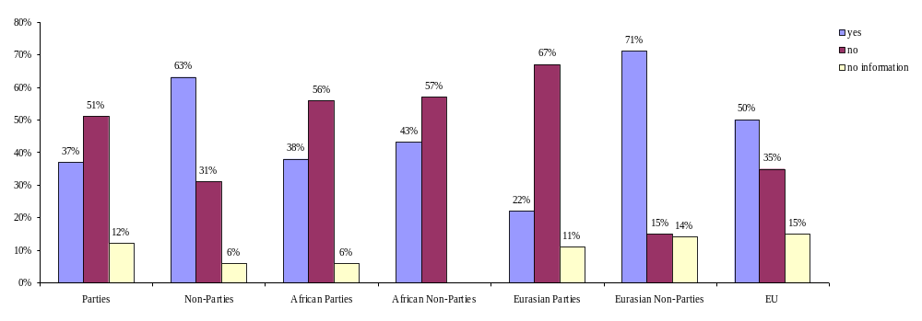
Graph 80: Revenues from hunting linked to the sustainable management of wild birds (question 74).

44 % of all countries have linked the revenues e.g. from hunting license fees to the sustainable management of wild birds. The figures do not differ significantly between the different regions. However, in all regions a higher percentage of Non-Parties have such a funding system in place compared to Parties: 38 % of African Parties compared to 43 % of African Non-Parties and 71 % of Eurasian Non-Parties compared to 22 % of Eurasian Parties. Concerns expressed, however, include the fact that such revenues do not sufficiently cover the expenses related to species conservation management.

Recommendations:

    - Parties are recommended to develop ways of linking regular governmental income (e.g. from hunting license systems) to the migratory waterbird management in order to ensure the budget for the implementation and enforcement of AEWA.

IV. References

1. Bibliographical references:

- Manual on Compliance with and Enforcement of Multilateral Envrionmental Agreements, UNEP 2006

- Conservation Guidelines on sustainable harvest of migratory waterbirds, AEWA
- Conservation Guidelines on regulating trade in migratory waterbirds, AEWA

Available at http://www.unep-aewa.org/publications/conservation_guidelines.htm

- Guidance document on hunting under Council Directive 79/409/EEC on the conservation of wild birds, August 2004

Available at http://www.unece.org/env/pp/compliance/C2007-18/Communication/SupportingDocumentation2006.12.04/EUKommissionenGuidance_birdsdirect_en.pdf

2. Institutional websites and databases:

- http://www.unep-aewa.org
- http://www.cms.int
- http://www.coe.int/t/e/cultural_co-operation/environment/nature_and_biological_diversity/Nature_protection/
- http://ec.europa.eu/environment/nature/nature_conservation/eu_nature_legislation/birds_directive/index_en.htm
- http://www.cbd.int/default.shtml
- http://www.ramsar.org/
- http://www.medwet.org/medwetnew/en/index.asp
- http://www.arcticportal.org/en/caff/
- http://www.cites.org/
- http://www.cic-wildlife.org
- http://www.face-europe.org
- http://www.unep-wcmc.org/citestrade/trade.cfm
- http://www.ecolex.org/index.php
- http://www.faolex.fao.org/faolex/index.htm

Annex 1: Status of populations listed on Table 1 of the AEWA Action Plan under CITES

Column A populations

Listed on CITES Appendix 1
THRESKIORNITHIDAE
Northern Bald Ibis Geronticus eremita, Morocco
Northern Bald Ibis Geronticus eremita, South-west Asia
GRUIDAE
Siberian Crane Grus leucogeranus, Iran (wintering)
PELECANIDAE
Dalmatian Pelican Pelecanus crispus, Black Sea and Mediterranean (wintering)
Dalmatian Pelican Pelecanus crispus, South-west Asia and South Asia (wintering)
SCOLOPACIDAE
Slender-billed Curlew Numenius tenuirostris, Central Siberia/Mediterranean and South-west Asia

Listed on CITES Appendix 2
SPHENISCIDAE
African Penguin Spheniscus demersus, Southern Africa
THRESKIORNITHIDAE
Eurasian Spoonbill Platalea leucorodia leucorodia, West Europe/West Mediterranean and West Africa
Eurasian Spoonbill Platalea leucorodia leucorodia, Central and South-eastern Europe/Mediterranean and Tropical Africa
Eurasian Spoonbill Platalea leucorodia archeri, Red Sea and Somalia
Eurasian Spoonbill Platalea leucorodia balsaci, Coastal West Africa (Mauritania)
Eurasian Spoonbill Platalea leucorodia major, Western Asia/South-west and South Asia
CICONIIDAE
Black Stork Ciconia nigra, Southern Africa
Black Stork Ciconia nigra, South-west Europe/West Africa
Black Stork Ciconia nigra, Central and Eastern Europe/Sub-Saharan Africa
PHOENICOPTERIDAE
Greater Flamingo Phoenicopterus ruber roseus, West Africa
Greater Flamingo Phoenicopterus ruber roseus, Eastern Africa
Greater Flamingo Phoenicopterus ruber roseus, Southern Africa (to Madagascar)
Lesser Flamingo Phoenicopterus minor, West Africa
Lesser Flamingo Phoenicopterus minor, Southern Africa (to Madagascar)
BALAENICIPITIDAE
Shoebill Baleaniceps rex, Central Tropical Africa
ANATIDAE
Ted-breasted Goose Branta ruficollis, Northern Siberia/Black Sea and Caspian
White-headed Duck Oxyura leucocephala, West Mediterranean (Spain and Morocco)
White-headed Duck Oxyura leucocephala, Algeria and Tunisia
White-headed Duck Oxyura leucocephala, East Mediterranean, Turkey and South-west Asia
GRUIDAE
Black Crowned Crane Balearica pavonina pavonina, West Africa (Senegal to Chad)
Black Crowned Crane Balearica pavonina ceciliae, Eastern Africa (Sudan to Uganda)
Grey Crowned Crane Balearica regulorum regulorum, Southern Africa (Northern to Angola and Southern Zimbabwe)
Grey Crowned Crane Balearica regulorum gibbericeps, Eastern Africa (Kenya to Mozambique)
Demoiselle Crane Grus virgo, Black Sea (Ukraine)/North-east Africa
Demoiselle Crane Grus virgo, Turkey (breeding)
Blue Crane Grus paradisea, Extreme Southern Africa
Wattled Crane Grus carunculatus, Central and Southern Africa
Common Crane Grus grus, Eastern Europe/Turkey, Middle East and North-eastern Africa
Common Crane Grus grus, Turkey and Georgia (breeding)

Not covered by CITES
GAVIIDAE
Great Northern Diver Gavia immer, Europe (wintering)
White-billed Diver Gavia adamsii, Northern Europe (wintering)
PODICIPEDIDAE
Great Crested Grebe Podiceps cristatus cristatus, Caspian & South-west Asia (wintering)
Red-necked Grebe Podiceps grisegena grisegena, Caspian (wintering)
Great Crested Grebe Podiceps cristatus infuscatus, Eastern Africa (Ethiopia to Northern Zambia)
Great Crested Grebe Podiceps cristatus infuscatus, Southern Africa
Slavonian Grebe Podiceps auritus auritus, North-west Europe (large-billed)
Slavonian Grebe Podiceps auritus auritus, Caspian and South Asia (wintering)
Black-necked Grebe Podiceps nigricollis gurneyi, Southern Africa
PELECANIDAE
Great White Pelican Pelecanus onocrotalus, Southern Africa
Great White Pelican Pelecanus onocrotalus, Europe and Western Asia (breeding)
SULIDAE
Cape Gannet Sula (Morus) capensis, Southern Africa
PHALACROCORACIDAE
Crowned Cormorant Phalacrocorax coronatus, Coastal South-west Africa
Bank Cormorant Phalacrocorax neglectus, Coastal South-west Africa
Great Cormorant Phalacrocorax carbo lucidus, Coastal Southern Africa
Socotra Cormorant Phalacrocorax nigrogularis, Gulf and Arabian Sea
ARDEIDAE
Black Heron Egretta ardesiaca, Sub-Saharan Africa
Slaty Egret Egretta vinaceigula, South-central Africa
Western Reef Egret Egretta gularis schistacea, South-west Asia and South Asia
Mascarene Reef Egret Egretta dimorpha, Coastal Eastern Africa
Purple Heron Ardea purpurea purpurea, West Europe and West Mediterranean/West Africa
Great Egret Casmerodius albus albus, Western, Central and South-eastern Europe/Black Sea and Mediterranean
Cattle Egret Bubulcus ibis ibis, East Mediterranean and South-west Asia
Squacco Heron Ardeola ralloides ralloides, Medit., Black Sea and Northern Africa/Sub-Saharan Africa
Madagascar Pond-Heron Ardeola idea, Madagascar and Aldabra/Central and Eastern Africa
Great Bittern Botaurus stellaris stellaris, Europe (breeding)
Great Bittern Botaurus stellaris stellaris, South-west Asia (wintering)
Great Bittern Botaurus stellaris capensis, Southern Africa
CICONIIDAE
White Stork Ciconia ciconia ciconia, Southern Africa
White Stork Ciconia ciconia ciconia, Iberia and North-west Africa/Sub-Saharan Africa
White Stork Ciconia ciconia ciconia, Western Asia/South-west Asia
RALLIDAE
Streaky-breasted Flufftail Sarothrura boehmi, Central Africa
White-winged Flufftail Sarothrura ayresi, Ethiopia and Southern Africa
Corncrake Crex crex, Europe and Western Asia/Sub-Saharan Africa
Baillon’s Crake Porzana pusilla intermedia, Europe (breeding)
Striped Crane Aenigmatolimnas marginalis, Sub-Saharan Africa
Red-knobbed Coot Fulica cristata, Spain and Morocco
DROMADIDAE
Crab Plover Dromas ardeola, North-west Indian Ocean, Red Sea and Gulf
HAEMATOPODIDAE
African Black Oystercatcher Haematopus moquini, Coastal Southern Africa
THRESKIORNITHIDAE
Glossy Ibis Plegadis falcinellus falcinellus, Black Sea and Mediterranean/West Africa
Sacred Ibis Threskiornis aethiopicus aethiopicus, Iraq and Iran
African Spoonbill Platalea alba, Sub-Saharan Africa
ANATIDAE
White-backed Duck Thalassornis leuconotus leuconotus, West Africa
White-backed Duck Thalassornis leuconotus leuconotus, Eastern and Southern Africa
Maccoa Duck Oxyura maccoa, Eastern Africa
Maccoa Duck Oxyura maccoa, Southern Africa
Whooper Swan Cygnus cygnus, Iceland/UK and Ireland
Whooper Swan Cygnus cygnus, Northern Europe and Western Siberia/Black Sea and Eastern Mediterranean
Whooper Swan Cygnus cygnus, West and Central Siberia/Caspian
Bewick’s Swan Cygnus columbianus bewickii, Western Siberia and North-eastern Europe/North-west Europe
Bewick’s Swan Cygnus columbianus bewickii, Northern Siberia/Caspian
Greater White-fronted Goose Anser albifrons albifrons, Western Siberia/Central Europe
Greater White-fronted Goose Anser albifrons albifrons, Northern Siberia/Caspian and Iraq
Greater White-fronted Goose Anser albifrons flavirostris, Greenland/Ireland and UK
Lesser White-fronted Goose Anser erythropus, Northern Europe and Western Siberia/Black Sea and Caspian
Barnacle Goose Branta leucopsis, Svalbard/South-west Scotland
Brent Goose Branta bernicla hrota, Svalbard/Denmark and UK
Brent Goose Branta bernicla hrota, Canada and Greenland/Ireland
Egyptian Goose Alopochen aegyptiacus, West Africa
Ruddy Shelduck Tadorna ferruginea, North-west Africa
Ruddy Shelduck Tadorna ferruginea, East Mediterranean and Black Sea/North-east Africa
Common Shelduck Tadorna tadorna, Black Sea and Mediterranean
African Pygmy-goose Nettapus auritus, West Africa
Cape Teal Anas capensis, Eastern Africa (Rift Valley)
Cape Teal Anas capensis, Lake Chad basin
Red-billed Duck Anas erythrorhyncha, Madagascar
Hottentot Teal Anas hottentota, Lake Chad Basin
Marbled Teal Marmoronetta angustirostris, West Mediterranean/West Mediterranean and West Africa
Marbled Teal Marmoronetta angustirostris, East Mediterranean
Marbled Teal Marmoronetta angustirostris, South-west Asia
Red-crested Pochard Netta rufina, Black Sea and East Mediterranean
Ferruginous Pochard Aythya nyroca, West Mediterranean/North and West Africa
Ferruginous Pochard Aythya nyroca, Eastern Europe/Estern Mediterranean and Sahelian Africa
Ferruginous Pochard Aythya nyroca, Western Asia/South-west Asia and North-east Africa
Steller’s Eider Polysticta stelleri, Western Siberia/North-east Europe
Velvet Scoter Melanitta fusca fusca, Black Sea and Caspian
Common Goldeneye Bucephala clangula clangula, Western Siberia and North-east Europe/Black Sea
Common Goldeneye Bucephala clangula clangula, Western Siberia/Caspian
Smew Mergellus albellus, North-west and Central Europe (wintering)
Smew Mergellus albellus, Western Siberia/South-west Asia
Red-breasted Merganser Mergus serrator serrator, Western Siberia/South-west and Central Asia
Goosander Mergus merganser merganser, North-east Europe/Black Sea
Goosander Mergus merganser merganser, Western Siberia/Caspian
LARIDAE
White-eyed Gull Larus leucophthalmus, Red Sea and nearby coasts
Audouin’s Gull Larus audouinii, Mediterranean/North and West coasts of Africa
Armenian Gull Larus armenicus, Armenia, Eastern Turkey and North-west Iran
Great Black-backed Gull Larus ichthyaetus, Black Sea and Caspian/South-west Asia
Slender-billed Gull Larus genei, West Africa (breeding)
Gull-billed Tern Sterna nilotica nilotica, Western Europe/West Africa
Gull-billed Tern Sterna nilotica nilotica, Black Sea and East Mediterranean/Eastern Africa
Gull-billed Tern Sterna nilotica nilotica, West and Central Asia/South-west Asia
Caspian Tern Sterna caspia caspia, Southern Africa (breeding)
Caspian Tern Sterna caspia caspia, Europe (breeding)
Caspian Tern Sterna caspia caspia, Caspian (breeding)
Lesser Crested Tern Sterna bengalensis par, Red Sea/Eastern Africa
Lesser Crested Tern Sterna bengalensis emigrata, South Mediterranean/North-western and West Africa coasts
Great Crested Tern Sterna bergii bergii, Southern Africa (Angola – Mozambique)
Great Crested Tern Sterna bergii enigma, Madagascar & Mozambique/Southern Africa
Great Crested Tern Sterna bergii thalassina, Eastern Africa and Seychelles
Great Crested Tern Sterna bergii velox, Red Sea and North-east Africa
Sandwich Tern Sterna sandvicensis sandvicensis, Black Sea and Mediterranean (breeding)
Roseate Tern Sterna dougallii dougallii, Southern Africa
Roseate Tern Sterna dougallii dougallii, East Africa
Roseate Tern Sterna dougallii dougallii, Europe (breeding)
Roseate Tern Sterna dougallii arideensis, Madagascar, Seychelles and Mascarenes
Roseate Tern Sterna dougallii bangsi, North Arabian Sea (Oman)
Antarctic Tern Sterna vittata vittata, P. Edward, Marion, Crozet and Kerguelen/South Africa
Antarctic Tern Sterna vittata tristanensis, Tristan da Cunha and Gough/South Africa
Little Tern Sterna albifrons albifrons, Eastern Atlantic (breeding)
Little Tern Sterna albifrons albifrons, Black Sea and East Mediterranean (breeding)
Little Tern Sterna albifrons albifrons, Caspian (breeding)
Little Tern Sterna albifrons guineae, West Africa (breeding)
Damara Tern Sterna balaenarum, Namibia and South Africa/Atlantic coast to Ghana
Whiskered Tern Chlidonias hybridus hybridus, Western Europe and North-west Africa (breeding)
Whiskered Tern Chlidonias hybridus sclateri, Eastern Africa (Kenya and Tanzania)
Whiskered Tern Chlidonias hybridus sclateri, Southern Africa (Malawi and Zambia to South Africa
RYNCHOPIDAE
African Skimmer Rynchops flavirostris, Coastal West Africa and Central Africa
African Skimmer Rynchops flavirostris, Eastern and Southern Africa
RECURVIROSTRIDAE
Black-winged Stilt Himantopus himantopus himantopus, Southern Africa (‘meridionalis’)
Pied Avocet Recurvirostra avosetta, Southern Africa
Pied Avocet Recurvirostra avosetta, South-east Europe, Black Sea and Turkey (breeding)
Pied Avocet Recurvirostra avosetta, West and South-west Asia/Eastern Africa
BURHINIDAE
Senegal Thick-knee Burhinus senegalensis senegalensis, West Africa
Senegal Thick-knee Burhinus senegalensis inornatus, North-east and Eastern Africa
GLAREOLIDAE
Egyptian Plover Pluvianus aegyptius aegyptius, Eastern Africa
Collared Pratincole Glareola pratincola pratincola, Western Europe and North-western Africa/West Africa
Collared Pratincole Glareola pratincola pratincola, Black Sea and Eastern Mediterranean/Eastern Sahel zone
Black-winged Pratincole Glareola nordmanni, South-eastern Europe and Western Asia/Southern Africa
Madagascar Pratincole Glareola ocularis, Madagascar/East Africa
Rock Pratincole Glareola nuchalis liberiae, West Africa
Grey Pratincole Glareola cinerea cinerea, South-eastern West Africa and Central Africa
CHARARIIDAE
Eurasian Golden Plover Pluvialis apricaria apricaria, Britain, Ireland, Denmark, Germany and Baltic (breeding)
Chestnut-banded Plover Charadrius pallidus pallidus, Southern Africa
Chestnut-banded Plover Charadrius pallidus venustus, Eastern Africa
Kentish Plover Charadrius alexandrinus alexandrinus, West Europe and West Mediterranean/West Africa
Kentish Plover Charadrius alexandrinus alexandrinus, Black Sea and East Mediterranean/Eastern Sahel
White-fronted Plover Charadrius marginatus mechowi, Southern and Eastern Africa
White-fronted Plover Charadrius marginatus mechowi, West to West-central Africa
Greater Sandplover Charadrius leschenaultii columbinus, Turkey and South-western Asia/East Mediterranean and Red Sea
Caspian Plover Charadrius asiaticus, South-eastern Europe and West Asia/East and South-central Africa
Eurasian Dotterel Eudromias morinellus, Europe/North-west Africa
Senegal Lapwing Vanellus lugubris, Southern West Africa
Senegal Lapwing Vanellus lugubris, Central and Eastern Africa
Black-winged Lapwing Vanellus melanopterus minor, Southern Africa
Crowned Lapwing Vanellus coronatus coronatus, Central Africa
Brown-chested Lapwing Vanellus superciliosus, West and Central Africa
Sociable Plover Vanellus gregarius, South-east Europe and Western Asia/North-east Africa
Sociable Plover Vanellus gregarius, Central Asian Republics/North-west India
White-tailed Plover Vanellus leucurus, South-west Asia and North-east Africa
SCOLOPACIDAE
Black-tailed Godwit Limosa limosa islandica, Iceland/Western Europe
Whimbrel Numenius phaeopus alboaxillaris, South-west Asia/Eastern Africa
Eurasian Curlew Numenius arquata orientalis, Western Siberia/South-west Asia, East and South Africa
Eurasian Curlew Numenius arquata suschkini, South-east Europe and South-west Asia (breeding)
Great Knot Calidris tenuirostris, Eastern Siberia/South-west Asia and West-southern Asia
Dunlin Calidris alpina schinzii, Britain and Ireland/South-western Europe and North-western Africa
Dunlin Calidris alpina schinzii, Baltic/Sout-western Europe and North-western Africa
Dunlin Calidris alpina arctica, North-eastern Greenland/West Africa
Broad-billed Sandpiper Limicola falcinellus falcinellus, Northern Europe/South-western Asia and Africa

Column B populations

Listed on CITES Appendix 2
SPHENISCIDAE
African Penguin Spheniscus demersus, Southern Africa
PHOENICOPTERIDAE
Greater Flamingo Phoenicopterus ruber roseus, West Mediterranean
Greater Flamingo Phoenicopterus ruber roseus, East Mediterranean, South-west and South Asia
Lesser Flamingo Phoenicopterus minor, Eastern Africa
ANATIDAE
Comb Duck Sarkidiornis melanotos melnanotos, West Africa
GRUIDAE
Demoiselle Crane Grus virgo, Kalmykia/North-east Africa
Common Crane Grus grus, North-west Europe/Iberia and Morocco
Common Crane Grus grus, North-east and Central Europe/North Africa
Common Crane Grus grus, Western Siberia/South Asia

Not covered by CITES
GAVIIDAE
Red-throated Diver Gavia stellata, North-west Europe (breeding)
Red-throated Diver, Gavia stellata, Caspian, Black Sea & East Mediterranean (wintering)
Black-throated Diver Gavia arctica arctica, Northern Europe and Western Siberia/Europe
PODICIPEDIDAE
Red-necked Grebe Podiceps grisegena grisegena, North-west Europe (wintering)
Red-necked Grebe Podiceps grisegena grisegena, Black Sea and Mediterranean (wintering)
Slavonian Grebe Podiceps auritus auritus, North-east Europe (small-billed)
Black-necked Grebe Podiceps nigrollis nigrollis, Western Asia/South-west and South Asia
PELECANIDAE
Great White Pelican Pelecanus onocrotalus, West Africa
Pink-backed Pelican Pelecanus rufescens, Tropical Africa and South-west Arabia
SULIDAE
Cape Gannet Sula (Morus) capensis, Southern Africa
PHALACROCORACIDAE
Pygmy Cormorant Phalacrocorax pygmeus, Black Sea and Mediterranean
Pygmy Cormorant Phalacrocorax pygmeus, South-west Asia
Great Cormorant Phalacrocorax carbo lucidus, Coastal West Africa
Socotra Cormorant Phalacrocorax nigrogularis, Gulf and Arabian Sea
Cape Cormorant Phalacrocorax capensis, Coastal Southern Africa
ARDEIDAE
Little Egret Egretta garzetta garzetta, Western Asia/South-western Asia, North-eastern and Eastern Africa
Western Reef Egret Egretta gularis gularis, West Africa
Western Reef Egret Egretta gularis schistacea, North-east Africa and Red Sea
Purple Heron Ardea purpurea purpurea, Tropical Africa
Purple Heron Ardea purpurea purpurea, East Europe and South-west Asia/Sub-Saharan Africa
Great Egret Casmerodius albus albus, Western Asia/South-west Asia
Intermediate Egret Mesophoyx intermedia brachyrhyncha, Sub-Saharan Africa
Squacco Heron Ardeola ralloides ralloides, West and South-west Asia/Sub-Saharan Africa
Rufous-bellied Heron Ardeola rufiventris, Tropical Eastern and Southern Africa
Black-crowned Night-Heron Nycticorax nycticorax nycticorax, Sub-Saharan Africa and Madagascar
Black-crowned Night-Heron Nycticorax nycticorax nycticorax, Europe and North-west Africa/Mediterranean and Africa
Black-crowned Night-Heron Nycticorax nycticorax nycticorax, Western Asia/South-western Asia and North-eastern Africa
Little Bittern Ixobrychus minutus minutus, Europe and North Africa/Sub-Saharan Africa
Little Bittern Ixobrychus minutus minutus, West and South-west Asia/Sub-Saharan Africa
Little Bittern Ixobrychus minutus payesii, Sub-Saharan Africa
Dwarf Bittern Ixobrychus sturmii, Sub-Saharan Africa
CICONIIDAE
Yellow-billed Stork Mycteria ibis, Sub-Saharan Africa (excluding Madagascar)
Abdim’s Stork Ciconia abdimii, Sub-Saharan Africa and South-western Arabia
Wooly-necked Stork Ciconia episcopus microscelis, Sub-Saharan Africa
THRESKIORNITHIDAE
Glossy Ibis Plegadis falcinellus falcinellus, South-west Asia/Eastern Africa
ANATIDAE
Mute Swan Cygnus olor, Black Sea
Mute Swan Cygnus olor, West and Central Asia/Caspian
Whooper Swan Cygnus cygnus, North-west Mainland Europe
Pink-footed Goose Anser brachyrhnchus, East Greenland and Iceland/UK
Pink-footed Goose Anser brachyrhnchus, Svalbard/North-west Europe
Bean Goose Anser fabalis fabalis, North-east Europe/North-west Europe
Greylag Goose Anser anser anser, Iceland/UK and Ireland
Greylag Goose Anser anser anser, Central Europe/North Africa
Greylag Goose Anser anser rubrirostris, Black Sea and Turkey
Barnacle Goose Branta leucopsis, East Greenland/Scotland and Ireland
Brent Goose Branta bernicla bernicla, Western Siberia/Western Europe
Ruddy Shelduck Tadorna ferruginea, Western Asia and Caspian/Iran and Iraq
South African Shelduck Tadorna cana, Southern Africa
Common Shelduck Tadorna tadorna, North-west Europe
Common Shelduck Tadorna tadorna, Western Asia/Caspian and Middle East
Spur-winged Goose Plectropterus gambensis niger, Southern Africa
Gadwall Anas strepera strepera, North-western Europe
Gadwall Anas strepera strepera, North-eastern Europe/Black Sea and Mediterranean
Eurasian Wigeon Anas penelope, West Siberia and North-eastern Europe/Black Sea and Mediterranean
Eurasian Wigeon Anas penelope, West Siberia/South-western Asia and North-eastern Africa
Mallard Anas platyrhynchos platyrhynchos, Eastern Europe/Black Sea and East Mediterranean
Northern Shoveler Anas clypeata, North-western and Central Europe (wintering)
Northern Shoveler Anas clypeata, West Siberia, North-eastern and Eastern Europe/Southern Europe and West Africa
Northern Shoveler Anas clypeata, West Siberia, South-western Asia, North-eastern and Eastern Africa
Northern Pintail Anas acuta, North-western Europe
Northern Pintail Anas acuta, Western Siberia, North-eastern Europe/Southern Europe and West Africa
Garganey Anas querquedula, Western Siberia and Europe/West Africa
Common Teal Anas crecca crecca, Western Siberia/South-western Asia and North-eastern Africa
Hottentot Teal Anas hottentota, Eastern Africa (south to North Zambia)
Hottentot Teal Anas hottentota, Southern Africa (north to South Zambia)
Red-crested Pochard Netta rufina, South-west and Central Europe/West Mediterranean
Common Pochard Aythya ferina, Western Siberia/South-west Asia
Common Eider Somateria mollissima borelalis, Svalbard and Franz Joseph (breeding)
Steller’s Eider Polysticta stelleri, Western Siberia/North-east Europe
Common Scoter Melanitta nigra nigra, West Siberia and Northern Europe/Western Europe and North-western Africa
Velvet Scoter Melanitta fusca fusca, Western Siberia and Northern Europe/North-western Europe
Common Goldeneye Bucephala clangula clangula, North-east Europe/Adriatic
Smew Mergellus albellus, North-east Europe/Black Sea and East Mediterranean
Red-breasted Merganser Mergus serrator serrator, North-east Europe/Black Sea and Mediterranean
RALLIDAE
Corncrake Crex crex, Europe and Western Asia/Sub-Saharan Africa
Little Crake Porzana parva parva, Western Eurasia/Africa
Spotted Crake Porzana porzana, Europe/Africa
RECURVIROSTRIDAE
Black-winged Stilt Himantopus himantopus himantopus, South-western Europe and North-west Africa/West Africa
Black-winged Stilt Himantopus himantopus himantopus, Central Europe and Eastern Mediterranean/North-Central Africa
Black-winged Stilt Himantopus himantopus himantopus, Western, Central and South-western Asia/South-western Asia and North-eastern Africa
Pied Avocet Recurvirostra avosetta, Eastern Africa
Pied Avocet Recurvirostra avosetta, Western Europe and North-west Africa (breeding)
GLAREOLIDAE
Egyptian Plover Pluvianus aegyptius aegyptius, Western Africa
Collared Pratincole Glareola pratincola pratincola, South-western Asia/South-western Asia and North-eastern Africa
Rock Pratincole Glareola nuchalis nuchalis, Eastern and Central Africa
CHARARIIDAE
Eurasian Golden Plover Pluvialis apricaria altifrons, Northern Siberia/Caspian and Asia Minor
Pacific Golden Plover Pluvialis fulva, North-central Siberia/South and South-western Asia, North-eastern Africa
Grey Plover Pluvialis squatarola, Central and Eastern Siberia/South-western Asia, Eastern and Southern Africa
Common Ringed Plover Charadrius hiaticula hiaticula, Northern Europe/Europe and North Africa
Common Ringed Plover Charadrius hiaticula psammodroma, Canada, Greenland and Iceland/West and South Africa
Kittlitz’s Plover Charadrius pecuarius pecuarius, West Africa
Charadrius forbesi, Western and Central Africa
Kentish Plover Charadrius alexandrinus alexandrinus, South-western and Central Asia/South-western Asia and North-eastern Africa
Mongolian Plover Charadrius mongolus pamirensis, West-central Asia/South-western Asia and Eastern Africa
Greater Sandplover Charadrius leschenaultii crassirostris, Caspian and South-western Asia/Arabia and North-eastern Africa
Greater Sandplover Charadrius leschenaultii leschenaultii, Central Asia/Eastern and Southern Africa
Eurasian Dotterel Eudromias morinellus, Asia/Middle East
Northern Lapwing Vanellus vanellus, Europe/Europe and North Africa
Spur-winged Plover Vanellus spinosus, Black Sea and Mediterranean (breeding)
White-headed Lapwing Vanellus albiceps, West and Central Africa
Wattled Lapwing Vanellus senegallus senegallus, West Africa
Wattled Lapwing Vanellus senegallus solitaneus, South-west Africa
Wattled Lapwing Vanellus senegallus lateralis, Eastern and South-east Africa
Crowned Lapwing Vanellus coronatus xerophilus, South-west Africa
White-tailed Plover Vanellus leucurus, Central Asian Republics/South Asia
SCOLOPACIDAE
Great Snipe Gallinago media, Scandinavia/probably West Africa
Great Snipe Gallinago media, Western Siberia and North-eastern Europe/South-east Africa
Common Snipe Gallinago gallinago gallinago, Europe/South and West Europe and North-west Africa
Jack Snipe Lymnocryptes minimus, Northern Europe/Southern and Western Europe and West Africa
Jack Snipe Lymnocryptes minimus, Western Siberia/South-western Asia and North-eastern Africa
Black-tailed Godwit Limosa limosa limosa, Western Europe/North-west and West Africa
Black-tailed Godwit Limosa limosa limosa, Eastern Europe/Central and Eastern Africa
Black-tailed Godwit Limosa limosa limosa, West-central Asia/South-western Asia and Eastern Africa
Bar-tailed Godwit Limosa lapponica lapponica, Northern Europe/Western Europe
Bar-tailed Godwit Limosa lapponica taymyrensis, Western Siberia/West and South-west Africa
Spotted Redshank Tringa erythropus, Western Siberia/South-west Asia, North-eastern and Eastern Africa
Common Redshank Tringa totanus totanus, North-western Europe/West Europe, North-western and West Africa
Common Redshank Tringa totanus totanus, Central and east Europe/East Mediterranean and Africa
Common Redshank Tringa totanus britannica , Britain and Ireland/Britain, Ireland, France
Marsh Sandpiper Tringa stagnatilis, Eastern Europe/West and Central Africa
Marsh Sandpiper Tringa stagnatilis, Western Asia/South-western Asia, Eastern and Southern Africa
Wood Sandpiper Tringa glareola, North-west Europe/West Africa
Ruddy Turnstone Areniaria interpres interpres, North-eastern Canada and Greenland/West Europe and North-western Africa
Ruddy Turnstone Areniaria interpres interpres, Northern Europe/West Africa
Red Knot Calidris canutus canutus, Northern Siberia/West and Southern Africa
Red Knot Calidris canutus islandica, North-eastern Canada and Greenland/Western Europe
Little Stint Calidris minuta, Northern Europe/Southern Europe, North and West Africa
Temminck’s Stint Calidris temminckii, Fennoscandia/North and West Africa
Purple Sandpiper Calidris maritima maritima, North and West Europe (excluding Iceland) (wintering)
Ruff Philomachus pugnax, Northern Europe and Western Siberia/West Africa
Ruff Philomachus pugnax, Northern Siberia/South-western Asia, East and South Africa
LARIDAE
Sooty Gull Larus hemprichii, Red Sea, Gulf, Arabia and Eastern Africa
Common Gull Larus canus canus, North-western and Central Europe/Atlantic coast and Mediterranean
Common Gull Larus canus heinei, North-eastern Europe and Western Siberia/Black Sea and Caspian
Kelp Gull Larus dominicanus vetula, Coastal Southern Africa
Lesser Black-backed Gull Larus fuscus fuscus, North-eastern Europe/Black Sea, South-western Asia and Eastern Africa
Grey-headed Gull Larus cirrocephalus poiocephalus, West Africa
Grey-headed Gull Larus cirrocephalus poiocephalus, Coastal Southern Africa (excluding Madagascar)
Hartlaub’s Gull Larus hartlaubii, Coastal South-west Africa
Slender-billed Gull Larus genei, Black Sea and Mediterranean (breeding)
Slender-billed Gull Larus genei, West, South-west and South Asia (breeding)
Mediterranean Gull Larus melanocephalus, West Europe, Mediterranean and North-west Africa
Little Gull Larus minutus, Central and Eastern Europe/South-western Europe and West Mediterranean
Little Gull Larus minutus, West Asia/East Mediterranean, Black Sea and Caspian
Caspian Tern Sterna caspia caspia, West Africa (breeding)
Royal Tern Sterna maxima albidorsalis, West Africa (breeding)
Lesser Crested Tern Sterna bengalensis bengalensis, Gulf/Southern Asia
Sandwich Tern Sterna sandvicensis sandvicensis, Western Europe/West Africa
Sandwich Tern Sterna sandvicensis sandvicensis, West and Central Asia/South-west and South Asia
Saunders’s Tern Sterna saundersi, Western South Asia, Red Sea, Gulf and Eastern Africa
White-cheeked Tern Sterna repressa, Western South Asia, Red Sea, Gulf and Eastern Africa
Whiskered Tern Chlidonias hybridus hybridus, Caspian (breeding)
Black Tern Chlidonias niger niger, Europe and Western Asia/Atlantic coast of Africa
Column C populations

not covered by CITES
GAVIIDAE
Black-throated Diver Gavia arctica suschkini, Central Siberia/Caspian
PODICIPEDIDAE
Little Grebe Tachybaptus ruficollis ruficollis, Europe & North-west Africa
Great Crested Grebe Podiceps cristatus cristatus, North-west & Western Europe
Great Crested Grebe Podiceps cristatus cristatus, Black Sea & Mediterranean (wintering)
Black-necked Grebe Podiceps nigricollis nigricollis, Europe/South & West Europe & North Africa
PELECANIDAE
Great White Pelican Pelecanus onocrotalus, Eastern Africa
PHALACROCORACIDAE
Great Cormorant Phalacrocorax carbo carbo North-west Europe
Great Cormorant Phalacrocorax carbo sinensis Northern & Central Europe
Great Cormorant Phalacrocorax carbo sinensis Black Sea & Mediterranean
Great Cormorant Phalacrocorax carbo sinensis West & South-west Asia
Great Cormorant Phalacrocorax carbo lucidus Central & Eastern Africa
ARDEIDAE
Little Egret Egretta garzetta garzetta Sub-Saharan Africa
Little Egret Egretta garzetta garzetta Europe, Black Sea & Mediterranean/W & C Africa
Grey Heron Ardea cinerea cinerea Sub-Saharan Africa
Grey Heron Ardea cinerea cinerea Europe & North Africa (bre)
Grey Heron Ardea cinerea cinerea West & South-west Asia (bre)
Black-headed Heron Ardea melanocephala Sub-Saharan Africa
Great Egret Casmerodius albus melanorhynchos Sub-Saharan Africa & Madagascar
Cattle Egret Bubulcus ibis ibis Southern Africa
Cattle Egret Bubulcus ibis ibis Tropical Africa
Cattle Egret Bubulcus ibis ibis South-west Europe & North-west Africa
Squacco Heron Ardeola ralloides paludivaga Sub-Saharan Africa & Madagascar
CICONIIDAE
African Openbill Anastomus lamelligerus lamelligerus Sub-Saharan Africa
White Stork Ciconia ciconia ciconia Central & Eastern Europe/Sub-Saharan Africa
Marabou Stork Leptoptilos crumeniferus Sub-Saharan Africa
THRESKIORNITHIDAE
Glossy Ibis Plegadis falcinellus falcinellus Sub-Saharan Africa (bre)
Sacred Ibis Threskiornis aethiopicus aethiopicus Sub-Saharan Africa
ANATIDAE
Fulvous Whistling-Duck Dendrocygna bicolor West Africa (Senegal to Chad)
Fulvous Whistling-Duck Dendrocygna bicolor Eastern & Southern Africa
White-faced Whistling-Duck Dendrocygna viduata West Africa (Senegal to Chad)
White-faced Whistling-Duck Dendrocygna viduata Eastern & Southern Africa
Mute Swan Cygnus olor North-west Mainland & Central Europe
Bean Goose Anser fabalis rossicus West & Central Siberia/NE & SW Europe
Bean Goose Anser fabalis johanseni West & Central Siberia/Turkmenistan to W China
Greater White-fronted Goose Anser albifrons albifrons NW Siberia & NE Europe/North-west Europe
Greater White-fronted Goose Anser albifrons albifrons Western Siberia/Black Sea & Turkey
Greylag Goose Anser anser anser NW Europe/South-west Europe
Greylag Goose Anser anser rubrirostris Western Siberia/Caspian & Iraq
Barnacle Goose Branta leucopsis Russia/Germany & Netherlands
Egyptian Goose Alopochen aegyptiacus Eastern & Southern Africa
Spur-winged Goose Plectropterus gambensis gambensis West Africa
Spur-winged Goose Plectropterus gambensis gambensis Eastern Africa (Sudan to Zambia)
Comb Duck Sarkidiornis melanotos melanotos Southern & Eastern Africa
African Pygmy-Goose Nettapus auritus Southern & Eastern Africa
Cape Teal Anas capensis Southern Africa (N to Angola & Zambia)
Gadwall Anas strepera strepera Western Siberia/SW Asia & NE Africa
Eurasian Wigeon Anas penelope Western Siberia & NE Europe/NW Europe
Mallard Anas platyrhynchos platyrhynchos North-west Europe
Mallard Anas platyrhynchos platyrhynchos Northern Europe/West Mediterranean
Mallard Anas platyrhynchos platyrhynchos Western Siberia/South-west Asia
Yellow-billed Duck Anas undulata undulata Southern Africa
Red-billed Duck Anas erythrorhyncha Southern Africa
Red-billed Duck Anas erythrorhyncha Eastern Africa
Northern Pintail Anas acuta Western Siberia/SW Asia & Eastern Africa
Garganey Anas querquedula Western Siberia/SW Asia, NE & Eastern Africa
Common Teal Anas crecca crecca North-west Europe
Common Teal Anas crecca crecca W Siberia & NE Europe/Black Sea & Mediterranean
Red-crested Pochard Netta rufina Western & Central Asia/South-west Asia
Southern Pochard Netta erythrophthalma brunnea Southern & Eastern Africa
Common Pochard Aythya ferina North-east Europe/North-west Europe
Common Pochard Aythya ferina Central & NE Europe/Black Sea & Mediterranean
Tufted Duck Aythya fuligula North-west Europe (win)
Tufted Duck Aythya fuligula Central Europe, Black Sea & Mediterranean (win)
Tufted Duck Aythya fuligula Western Siberia/SW Asia & NE Africa
Greater Scaup Aythya marila marila Northern Europe/Western Europe
Greater Scaup Aythya marila marila Western Siberia/Black Sea & Caspian
Common Eider Somateria mollissima mollissima Baltic, Denmark & Netherlands
Common Eider Somateria mollissima mollissima Norway & Russia
King Eider Somateria spectabilis East Greenland, NE Europe & Western Siberia
Long-tailed Duck Clangula hyemalis Iceland & Greenland
Long-tailed Duck Clangula hyemalis Western Siberia/North Europe
Common Goldeneye Bucephala clangula clangula North-west & Central Europe (win)
Red-breasted Merganser Mergus serrator serrator North-west & Central Europe (win)
Goosander Mergus merganser merganser North-west & Central Europe (win)
RALLIDAE
Buff-spotted Flufftail Sarothrura elegans elegans NE, Eastern & Southern Africa
Buff-spotted Flufftail Sarothrura elegans reichenovi S West Africa to Central Africa
Water Rail Rallus aquaticus aquaticus Europe & North Africa
Water Rail Rallus aquaticus korejewi Western Siberia/South-west Asia
African Rail Rallus caerulescens Southern & Eastern Africa
African Crake Crecopsis egregia Sub-Saharan Africa
Black Crake Amaurornis flavirostris Sub-Saharan Africa
Allen’s Gallinule Porphyrio alleni Sub-Saharan Africa
Common Moorhen Gallinula chloropus chloropus Europe & North Africa
Common Moorhen Gallinula chloropus chloropus West & South-west Asia
Lesser Moorhen Gallinula angulata Sub-Saharan Africa
Red-knobbed Coot Fulica cristata Sub-Saharan Africa
Common Coot Fulica atra atra North-west Europe (win)
Common Coot Fulica atra atra Black Sea & Mediterranean (win)
Common Coot Fulica atra atra South-west Asia (win)
HAEMATOPODIDAE
Eurasian Oystercatcher Haematopus ostralegus ostralegus Europe/South & West Europe & NW Africa
Eurasian Oystercatcher Haematopus ostralegus longipes SE Eur & W Asia/SW Asia & NE Africa
RECURVIROSTRIDAE
Black-winged Stilt Himantopus himantopus himantopus Sub-Saharan Africa (excluding south)
CHARADRIIDAE
Eurasian Golden Plover Pluvialis apricaria altifrons Iceland & Faroes/East Atlantic coast
Eurasian Golden Plover Pluvialis apricaria altifrons Northern Europe/Western Europe & NW Africa
Grey Plover Pluvialis squatarola W Siberia & Canada/W Europe & W Africa
Common Ringed Plover Charadrius hiaticula tundrae NE Europe & Siberia/SW Asia, E & S Africa
Little Ringed Plover Charadrius dubius curonicus Europe & North-west Africa/West Africa
Little Ringed Plover Charadrius dubius curonicus West & South-west Asia/Eastern Africa
Kittlitz’s Plover Charadrius pecuarius pecuarius Southern & Eastern Africa
Three-banded Plover Charadrius tricollaris tricollaris Southern & Eastern Africa
Northern Lapwing Vanellus vanellus Western Asia/South-west Asia
Crowned Lapwing Vanellus coronatus coronatus Eastern & Southern Africa
SCOLOPACIDAE
Eurasian Woodstock Scolopax rusticola Europe/South & West Europe & North Africa
Eurasian Woodstock Scolopax rusticola Western Siberia/South-west Asia (Caspian)
Pintail Snipe Gallinago stenura Northern Siberia/South Asia & Eastern Africa
Common Snipe Gallinago gallinago gallinago Western Siberia/South-west Asia & Africa
Common Snipe Gallinago gallinago faeroeensis Iceland, Faroes & Northern Scotland/Ireland
Bar-tailed Godwit Limosa lapponica menzbieri Central Siberia/South & SW Asia & Eastern Africa
Whimbrel Numenius phaeopus phaeopus Northern Europe/West Africa
Whimbrel Numenius phaeopus phaeopus West Siberia/Southern & Eastern Africa
Whimbrel Numenius phaeopus islandicus Iceland, Faroes & Scotland/West Africa
Eurasian Curlew Numenius arquata arquata Europe/Europe, North & West Africa
Spotted Redshank Tringa erythropus N Europe/Southern Europe, North & West Africa
Common Redshank Tringa totanus ussuriensis Western Asia/SW Asia, NE & Eastern Africa
Common Redshank Tringa totanus robusta Iceland & Faroes/Western Europe
Common Greenshank Tringa nebularia Northern Europe/SW Europe, NW & West Africa
Common Greenshank Tringa nebularia Western Siberia/SW Asia, E & S Africa
Green Sandpiper Tringa ochropus Northern Europe/S & W Europe, West Africa
Green Sandpiper Tringa ochropus Western Siberia/SW Asia, NE & Eastern Africa
Wood Sandpiper Tringa glareola NE Europe & W Siberia/Eastern & Southern Africa
Terek Sandpiper Tringa cinerea NE Europe & W Siberia/SW Asia, E & S Africa
Common Sandpiper Tringa hypoleucos West & Central Europe/West Africa
Common Sandpiper Tringa hypoleucos E Europe & W Siberia/Central, E & S Africa
Ruddy Turnstone Arenaria interpres interpres West & Central Siberia/SW Asia, E & S Africa
Sanderling Calidris alba East Atlantic Europe, West & Southern Africa (win)
Sanderling Calidris alba South-west Asia, Eastern & Southern Africa (win)
Little Stint Calidris minuta Western Siberia/SW Asia, E & S Africa
Temminck’s Stint Calidris temminckii NE Europe & W Siberia/SW Asia & Eastern Africa
Dunlin Calidris alpina alpina NE Europe & NW Siberia/W Europe & NW Africa
Dunlin Calidris alpina centralis Central Siberia/SW Asia & NE Africa
Dunlin Calidris alpina schinzii Iceland & Greenland/NW and West Africa
Curlew Sandpiper Calidris ferruginea Western Siberia/West Africa
Curlew Sandpiper Calidris ferruginea Central Siberia/SW Asia, E & S Africa
Red-necked Phalarope Phalaropus lobatus Western Eurasia/Arabian Sea
Grey Phalarope Phalaropus fulicaria Canada & Greenland/Atlantic coast of Africa
LARIDAE
Great Black-backed Gull Larus marinus North & West Europe
Glaucous Gull Larus hyperboreus hyperboreus Svalbard & N Russia (bre)
Glaucous Gull Larus hyperboreus leuceretes Canada, Greenland & Iceland (bre)
Iceland Gull Larus glaucoides glaucoides Greenland/Iceland & North-west Europe
Herring Gull Larus argentatus argentatus North & North-west Europe
Herring Gull Larus argentatus argenteus Iceland & Western Europe
Heuglin’s Gull Larus heuglini NE Europe & W Siberia/SW Asia & NE Africa
Heuglin’s Gull Larus (heuglini) barabensis South-west Siberia/South-west Asia
Yellow-legged Gull Larus cachinnans cachinnans Black Sea & Western Asia/SW Asia, NE Africa
Yellow-legged Gull Larus cachinnans michahellis Mediterranean, Iberia & Morocco
Lesser Black-backed Gull Larus fuscus graellsii Western Europe/Mediterranean & West Africa
Grey-headed Gull Larus cirrocephalus poiocephalus Central & Eastern Africa
Common Black-backed Gull Larus ridibundus W Europe/W Europe, W Mediterranean, West Africa
Common Black-backed Gull Larus ridibundus East Europe/Black Sea & East Mediterranean
Common Black-backed Gull Larus ridibundus West Asia/SW Asia & NE Africa
Sabine’s Gull Xema sabini sabini Canada & Greenland/SE Atlantic
Common Tern Sterna hirundo hirundo Southern & Western Europe (bre)
Common Tern Sterna hirundo hirundo Northern & Eastern Europe (bre)
Common Tern Sterna hirundo hirundo Western Asia (bre)
Arctic Tern Sterna paradisaea Western Eurasia (bre)
Whishered Tern Chlidonias hybridus hybridus Black Sea & East Mediterranean (bre)
White-winged Tern Chlidonias leucopterus Eastern Europe & Western Asia/Africa

Annex 2: Status of populations listed on Table 1 of the AEWA Action Plan under the Bern Convention

AEWA Column A populations

Listed on Bern Convention Appendix II
GAVIIDAE
Great Northern Diver Gavia immer Europe (wintering)
White-billed Diver Gavia adamsii, Northern Europe (wintering)
PODICIPEDIDAE
Slavonian Grebe Podiceps auritus auritus, North-west Europe (large-billed)
PELECANIDAE
Great White Pelican Pelecanus onocrotalus, Europe and Western Asia (breeding)
Dalmatian Pelican Pelecanus crispus, Black Sea and Mediterranean (wintering)
ARDEIDAE
Purple Heron Ardea purpurea purpurea, West Europe and West Mediterranean/West Africa
Great Egret Casmerodius albus albus, Western, Central and South-eastern Europe/Black Sea and Mediterranean
Cattle Egret Bubulcus ibis ibis, East Mediterranean and South-west Asia
Squacco Heron Ardeola ralloides ralloides, Medit., Black Sea and Northern Africa/Sub-Saharan Africa
Great Bittern Botaurus stellaris stellaris, Europe (breeding)
CICONIIDAE
Black Stork Ciconia nigra, South-west Europe/West Africa
Black Stork Ciconia nigra, Central and Eastern Europe/Sub-Saharan Africa
White Stork Ciconia ciconia ciconia, Iberia and North-west Africa/Sub-Saharan Africa
THRESKIORNITHIDAE
Glossy Ibis Plegadis falcinellus falcinellus, Black Sea and Mediterranean/West Africa
Eurasian Spoonbill Platalea leucorodia leucorodia, West Europe/West Mediterranean and West Africa
Eurasian Spoonbill Platalea leucorodia leucorodia, Central and South-eastern Europe/Mediterranean and Tropical Africa
ANATIDAE
Lesser White-fronted Goose Anser erythropus, Northern Europe and Western Siberia/Black Sea and Caspian
Barnacle Goose Branta leucopsis, Svalbard/South-west Scotland
Whooper Swan Cygnus cygnus, Iceland/UK and Ireland
Whooper Swan Cygnus cygnus, Northern Europe and Western Siberia/Black Sea and Eastern Mediterranean
Bewick’s Swan Cygnus columbianus bewickii, Western Siberia and North-eastern Europe/North-west Europe
Marbled Teal Marmoronetta angustirostris, West Mediterranean/West Mediterranean and West Africa
Marbled Teal Marmoronetta angustirostris, East Mediterranean
Smew Mergellus albellus, North-west and Central Europe (wintering)
White-headed Duck Oxyura leucocephala, West Mediterranean (Spain and Morocco)
White-headed Duck Oxyura leucocephala, East Mediterranean, Turkey and South-west Asia
Common Shelduck Tadorna tadorna, Black Sea and Mediterranean
Ruddy Shelduck Tadorna ferruginea, East Mediterranean and Black Sea/North-east Africa
GRUIDAE
Demoiselle Crane Grus virgo, Black Sea (Ukraine)/North-east Africa
RALLIDAE
Corncrake Crex crex, Europe and Western Asia/Sub-Saharan Africa
Baillon’s Crake Porzana pusilla intermedia, Europe (breeding)
Red-knobbed Coot Fulica cristata, Spain and Morocco
GLAREOLIDAE
Collared Pratincole Glareola pratincola pratincola, Western Europe and North-western Africa/West Africa
Collared Pratincole Glareola pratincola pratincola, Black Sea and Eastern Mediterranean/Eastern Sahel zone
Black-winged Pratincole Glareola nordmanni, South-eastern Europe and Western Asia and North-eastern
CHARADRIIDAE
Kentish Plover Charadrius alexandrinus alexandrinus, West Europe and West Mediterranean/West Africa
Kentish Plover Charadrius alexandrinus alexandrinus, Black Sea and East Mediterranean/Eastern Sahel
Greater Sandplover Charadrius leschenaultii columbinus, Turkey and South-western Asia/East Mediterranean and Red Sea
SCOLOPACIDAE
Dunlin Calidris alpina schinzii, Britain and Ireland/South-western Europe and North-western Africa
Dunlin Calidris alpina schinzii, Baltic/Sout-western Europe and North-western Africa
Slender-billed Curlew Numenius tenuirostris, Central Siberia/Mediterranean and South-west Asia
Broad-billed Sandpiper Limicola falcinellus falcinellus, Northern Europe/South-western Asia and Africa
RECURVIROSTRIDAE
Pied Avocet Recurvirostra avosetta, South-east Europe, Black Sea and Turkey (breeding)
LARIDAE
Audouin’s Gull Larus audouinii, Mediterranean/North and West coasts of Africa
Sandwich Tern Sterna sandvicensis sandvicensis, Black Sea and Mediterranean (breeding)
Roseate Tern Sterna dougallii dougallii, Europe (breeding)
Little Tern Sterna albifrons albifrons, Eastern Atlantic (breeding)
Little Tern Sterna albifrons albifrons, Black Sea and East Mediterranean (breeding)
Whiskered Tern Chlidonias hybridus hybridus, Western Europe and North-west Africa (breeding)

Listed on Bern Convention Appendix III (all species not included in Appendix II except 3 species from B/C)
ANATIDAE
Greater White-fronted Goose Anser albifrons albifrons, Western Siberia/Central Europe
Greater White-fronted Goose Anser albifrons flavirostris, Greenland/Ireland and UK
Brent Goose Branta bernicla hrota, Svalbard/Denmark and UK
Brent Goose Branta bernicla hrota, Canada and Greenland/Ireland
Red-crested Pochard Netta rufina, Black Sea and East Mediterranean
Ferruginous Pochard Aythya nyroca, West Mediterranean/North and West Africa
Ferruginous Pochard Aythya nyroca, Eastern Europe/Estern Mediterranean and Sahelian Africa
Velvet Scoter Melanitta fusca fusca, Black Sea and Caspian
Common Goldeneye Bucephala clangula clangula, Western Siberia and North-east Europe/Black Sea
Goosander Mergus merganser merganser, North-east Europe/Black Sea
CHARARIIDAE
Eurasian Golden Plover Pluvialis apricaria apricaria, Britain, Ireland, Denmark, Germany and Baltic (breeding)
Caspian Plover Charadrius asiaticus, South-eastern Europe and West Asia/East and South-central Africa
Sociable Plover Vanellus gregarius, South-east Europe and Western Asia/North-east Africa
SCOLOPACIDAE
Black-tailed Godwit Limosa limosa islandica, Iceland/Western Europe
Eurasian Curlew Numenius arquata suschkini, South-east Europe and South-west Asia (breeding)
LARIDAE
Great Black-backed Gull Larus ichthyaetus, Black Sea and Caspian/South-west Asia
Gull-billed Tern Sterna nilotica nilotica, Western Europe/West Africa
Gull-billed Tern Sterna nilotica nilotica, Black Sea and East Mediterranean/Eastern Africa
Caspian Tern Sterna caspia caspia, Europe (breeding)
Lesser Crested Tern Sterna bengalensis emigrata, South Mediterranean/North-western and West Africa coasts
AEWA Column B populations

Listed on Bern Convention Appendix II
GAVIIDAE
Red-throated Diver Gavia stellata, North-west Europe (breeding)
Red-throated Diver, Gavia stellata, Caspian, Black Sea & East Mediterranean (wintering)
Black-throated Diver Gavia arctica arctica, Northern Europe and Western Siberia/Europe
PODICIPEDIDAE
Red-necked Grebe Podiceps grisegena grisegena, North-west Europe (wintering)
Red-necked Grebe Podiceps grisegena grisegena, Black Sea and Mediterranean (wintering)
PHALACROCORACIDAE
Pygmy Cormorant Phalacrocorax pygmeus, Black Sea and Mediterranean
ARDEIDAE
Black-crowned Night-Heron Nycticorax nycticorax nycticorax, Europe and North-west Africa/Mediterranean and Africa
Little Bittern Ixobrychus minutus minutus, Europe and North Africa/Sub-Saharan Africa
PHOENICOPTERIDAE
Greater Flamingo Phoenicopterus ruber roseus, West Mediterranean
Greater Flamingo Phoenicopterus ruber roseus, East Mediterranean, South-west and South Asia
ANATIDAE
Barnacle Goose Branta leucopsis, East Greenland/Scotland and Ireland
Whooper Swan Cygnus cygnus, North-west Mainland Europe
Smew Mergellus albellus, North-east Europe/Black Sea and East Mediterranean
Common Shelduck Tadorna tadorna, North-west Europe
GRUIDAE
Common Crane Grus grus, North-west Europe/Iberia and Morocco
RALLIDAE
Corncrake Crex crex, Europe and Western Asia/Sub-Saharan Africa
Little Crake Porzana parva parva, Western Eurasia/Africa
Spotted Crake Porzana porzana, Europe/Africa
RECURVIROSTRIDAE
Black-winged Stilt Himantopus himantopus himantopus, South-western Europe and North-west Africa/West Africa
Black-winged Stilt Himantopus himantopus himantopus, Central Europe and Eastern Mediterranean/North-Central Africa
Pied Avocet Recurvirostra avosetta, Western Europe and North-west Africa (breeding)
CHARARIIDAE
Common Ringed Plover Charadrius hiaticula hiaticula, Northern Europe/Europe and North Africa
SCOLOPACIDAE
Great Snipe Gallinago media, Scandinavia/probably West Africa
Wood Sandpiper Tringa glareola, North-west Europe/West Africa
Little Stint Calidris minuta, Northern Europe/Southern Europe, North and West Africa
Purple Sandpiper Calidris maritima maritima, North and West Europe (excluding Iceland) (wintering)
LARIDAE
Slender-billed Gull Larus genei, Black Sea and Mediterranean (breeding)
Mediterranean Gull Larus melanocephalus, West Europe, Mediterranean and North-west Africa
Little Gull Larus minutus, Central and Eastern Europe/South-western Europe and West Mediterranean
Little Gull Larus minutus, West Asia/East Mediterranean, Black Sea and Caspian
Sandwich Tern Sterna sandvicensis sandvicensis, Western Europe/West Africa
Black Tern Chlidonias niger niger, Europe and Western Asia/Atlantic coast of Africa

Listed on Bern Convention Appendix III
ANATIDAE
Mute Swan Cygnus olor, Black Sea
Pink-footed Goose Anser brachyrhnchus, East Greenland and Iceland/UK
Pink-footed Goose Anser brachyrhnchus, Svalbard/North-west Europe
Bean Goose Anser fabalis fabalis, North-east Europe/North-west Europe
Greylag Goose Anser anser anser, Iceland/UK and Ireland
Greylag Goose Anser anser anser, Central Europe/North Africa
Greylag Goose Anser anser rubrirostris, Black Sea and Turkey
Brent Goose Branta bernicla bernicla, Western Siberia/Western Europe
Gadwall Anas strepera strepera, North-western Europe
Gadwall Anas strepera strepera, North-eastern Europe/Black Sea and Mediterranean
Eurasian Wigeon Anas penelope, West Siberia and North-eastern Europe/Black Sea and Mediterranean
Mallard Anas platyrhynchos platyrhynchos, Eastern Europe/Black Sea and East Mediterranean
Northern Shoveler Anas clypeata, North-western and Central Europe (wintering)
Northern Shoveler Anas clypeata, West Siberia, North-eastern and Eastern Europe/Southern Europe and West Africa
Northern Pintail Anas acuta, North-western Europe
Northern Pintail Anas acuta, Western Siberia, North-eastern Europe/Southern Europe and West Africa
Garganey Anas querquedula, Western Siberia and Europe/West Africa
Red-crested Pochard Netta rufina, South-west and Central Europe/West Mediterranean
Common Eider Somateria mollissima borelalis, Svalbard and Franz Joseph (breeding)
Common Scoter Melanitta nigra nigra, West Siberia and Northern Europe/Western Europe and North-western Africa
Velvet Scoter Melanitta fusca fusca, Western Siberia and Northern Europe/North-western Europe
Common Goldeneye Bucephala clangula clangula, North-east Europe/Adriatic
Red-breasted Merganser Mergus serrator serrator, North-east Europe/Black Sea and Mediterranean
CHARADRIIDAE
Northern Lapwing Vanellus vanellus, Europe/Europe and North Africa
Spur-winged Plover Vanellus spinosus, Black Sea and Mediterranean (breeding)
SCOLOPACIDAE
Common Snipe Gallinago gallinago gallinago, Europe/South and West Europe and North-west Africa
Jack Snipe Lymnocryptes minimus, Northern Europe/Southern and Western Europe and West Africa
Black-tailed Godwit Limosa limosa limosa, Western Europe/North-west and West Africa
Bar-tailed Godwit Limosa lapponica lapponica, Northern Europe/Western Europe
Common Redshank Tringa totanus totanus, North-western Europe/West Europe, North-western and West Africa
Common Redshank Tringa totanus totanus, Central and east Europe/East Mediterranean and Africa
Common Redshank Tringa totanus britannica , Britain and Ireland/Britain, Ireland, France
Ruddy Turnstone Areniaria interpres interpres, North-eastern Canada and Greenland/West Europe and North-western Africa
Ruddy Turnstone Areniaria interpres interpres, Northern Europe/West Africa
Red Knot Calidris canutus islandica, North-eastern Canada and Greenland/Western Europe
Ruff Philomachus pugnax, Northern Europe and Western Siberia/West Africa
LARIDAE
Common Gull Larus canus canus, North-western and Central Europe/Atlantic coast and Mediterranean
Common Gull Larus canus heinei, North-eastern Europe and Western Siberia/Black Sea and Caspian

Not covered by Bern Convention
LARIDAE
Lesser Black-backed Gull Larus fuscus fuscus, North-eastern Europe/Black Sea, South-western Asia and Eastern Africa
AEWA Column C populations

Listed on Bern Convention Appendix II
PODICIPEDIDAE
Little Grebe Tachybaptus ruficollis ruficollis, Europe & North-west Africa
Black-necked Grebe Podiceps nigricollis nigricollis, Europe/South & West Europe & North Africa
ARDEIDAE
Little Egret Egretta garzetta garzetta Europe, Black Sea & Mediterranean/W & C Africa
Cattle Egret Bubulcus ibis ibis South-west Europe & North-west Africa
CICONIIDAE
White Stork Ciconia ciconia ciconia Central & Eastern Europe/Sub-Saharan Africa
ANATIDAE
Barnacle Goose Branta leucopsis Russia/Germany & Netherlands
CHARADRIIDAE
Little Ringed Plover Charadrius dubius curonicus Europe & North-west Africa/West Africa
SCOLOPACIDAE
Green Sandpiper Tringa ochropus Northern Europe/S & W Europe, West Africa
Common Sandpiper Tringa hypoleucos West & Central Europe/West Africa
Sanderling Calidris alba East Atlantic Europe, West & Southern Africa (win)
Dunlin Calidris alpina alpina NE Europe & NW Siberia/W Europe & NW Africa
LARIDAE
Common Tern Sterna hirundo hirundo Southern & Western Europe (bre)
Common Tern Sterna hirundo hirundo Northern & Eastern Europe (bre)
Arctic Tern Sterna paradisaea Western Eurasia (bre)
Whishered Tern Chlidonias hybridus hybridus Black Sea & East Mediterranean (bre)

Listed on Bern Convention Appendix III
PODICIPEDIDAE
Great Crested Grebe Podiceps cristatus cristatus, North-west & Western Europe
Great Crested Grebe Podiceps cristatus cristatus, Black Sea & Mediterranean (wintering)
PHALACROCORACIDAE
Great Cormorant Phalacrocorax carbo carbo North-west Europe
Great Cormorant Phalacrocorax carbo sinensis Northern & Central Europe
Great Cormorant Phalacrocorax carbo sinensis Black Sea & Mediterranean
ARDEIDAE
Grey Heron Ardea cinerea cinerea Europe & North Africa (bre)
ANATIDAE
Mute Swan Cygnus olor North-west Mainland & Central Europe
Bean Goose Anser fabalis rossicus West & Central Siberia/NE & SW Europe
Greater White-fronted Goose Anser albifrons albifrons NW Siberia & NE Europe/North-west Europe
Greater White-fronted Goose Anser albifrons albifrons Western Siberia/Black Sea & Turkey
Greylag Goose Anser anser anser NW Europe/South-west Europe
Eurasian Wigeon Anas penelope Western Siberia & NE Europe/NW Europe
Mallard Anas platyrhynchos platyrhynchos North-west Europe
Mallard Anas platyrhynchos platyrhynchos Northern Europe/West Mediterranean
Common Teal Anas crecca crecca North-west Europe
Common Teal Anas crecca crecca W Siberia & NE Europe/Black Sea & Mediterranean
Common Pochard Aythya ferina North-east Europe/North-west Europe
Common Pochard Aythya ferina Central & NE Europe/Black Sea & Mediterranean
Tufted Duck Aythya fuligula North-west Europe (win)
Tufted Duck Aythya fuligula Central Europe, Black Sea & Mediterranean (win)
Greater Scaup Aythya marila marila Northern Europe/Western Europe
Greater Scaup Aythya marila marila Western Siberia/Black Sea & Caspian
Common Eider Somateria mollissima mollissima Baltic, Denmark & Netherlands
Long-tailed Duck Clangula hyemalis Western Siberia/North Europe
Common Goldeneye Bucephala clangula clangula North-west & Central Europe (win)
Red-breasted Merganser Mergus serrator serrator North-west & Central Europe (win)
Goosander Mergus merganser merganser North-west & Central Europe (win)
RALLIDAE
Water Rail Rallus aquaticus aquaticus Europe & North Africa
Common Moorhen Gallinula chloropus chloropus Europe & North Africa
Common Coot Fulica atra atra North-west Europe (win)
Common Coot Fulica atra atra Black Sea & Mediterranean (win)
HAEMATOPODIDAE
Eurasian Oystercatcher Haematopus ostralegus ostralegus Europe/South & West Europe & NW Africa
Eurasian Oystercatcher Haematopus ostralegus longipes SE Eur & W Asia/SW Asia & NE Africa
CHARADRIIDAE
Eurasian Golden Plover Pluvialis apricaria altifrons Iceland & Faroes/East Atlantic coast
Eurasian Golden Plover Pluvialis apricaria altifrons Northern Europe/Western Europe & NW Africa
Grey Plover Pluvialis squatarola W Siberia & Canada/W Europe & W Africa
SCOLOPACIDAE
Eurasian Woodstock Scolopax rusticola Europe/South & West Europe & North Africa
Common Snipe Gallinago gallinago faeroeensis Iceland, Faroes & Northern Scotland/Ireland
Whimbrel Numenius phaeopus phaeopus Northern Europe/West Africa
Whimbrel Numenius phaeopus islandicus Iceland, Faroes & Scotland/West Africa
Eurasian Curlew Numenius arquata arquata Europe/Europe, North & West Africa
Spotted Redshank Tringa erythropus N Europe/Southern Europe, North & West Africa
Common Redshank Tringa totanus robusta Iceland & Faroes/Western Europe
Common Greenshank Tringa nebularia Northern Europe/SW Europe, NW & West Africa
Red-necked Phalarope Phalaropus lobatus Western Eurasia/Arabian Sea
LARIDAE
Glaucous Gull Larus hyperboreus hyperboreus Svalbard & N Russia (bre)
Iceland Gull Larus glaucoides glaucoides Greenland/Iceland & North-west Europe
Yellow-legged Gull Larus cachinnans cachinnans Black Sea & Western Asia/SW Asia, NE Africa
Yellow-legged Gull Larus cachinnans michahellis Mediterranean, Iberia & Morocco
Common Black-backed Gull Larus ridibundus W Europe/W Europe, W Mediterranean, West Africa
Common Black-backed Gull Larus ridibundus East Europe/Black Sea & East Mediterranean

Not covered by Bern Convention
LARIDAE
Great Black-backed Gull Larus marinus North & West Europe
Lesser Black-backed Gull Larus fuscus graellsii Western Europe/Mediterranean & West Africa
Herring Gull Larus argentatus argentatus North & North-west Europe
Herring Gull Larus argentatus argenteus Iceland & Western Europe

Signatory (the Agreement has been signed, but has not entered into force yet).
Signatory (the Agreement has been signed, but has not entered into force yet).
AEWA Conservation Guidelines on sustainable harvest of migratory waterbirds, Step 1.
As of 1 November 2007.
Compare Art. II paragraph 1 AEWA (fundamental principles).
AEWA Conservation Guidelines on regulating trade in migratory waterbirds, Introduction.
Compare AEWA Conservation Guidelines on sustainable harvest of migratory waterbirds, Introduction.
Article II AEWA.
Article III AEWA.
Compare AEWA Conservation Guidelines on regulating trade in migratory waterbirds, Introduction.
Article IV AEWA.
See Paragraph 2.1.1 Action Plan.
For details see the key classification in the introduction to Table 1 which is annexed to the Agreement text and Action Plan.
http://www.unep-aewa.org/publications/conservation_guidelines.htm
http://www.unep-aewa.org/meetings/en/mop/mop3_docs/final_resolutions_word/res3_11_iip_2006-2008.doc
http://www.ecolex.org/index.php
http://faolex.fao.org/faolex/index.htm
E.g. no reference is made to Comores.
Equatorial Guinea has not submitted its answers to the questionnaire, but has informed the Secretariat that no specific legislation on hunting or trade concerning the species listed in Table 1 of AEWA exists; however conservation is directly or indirectly regulated through legislation on environmental issues such as the national law on CITES or on water and coast.
The answers received from Somalia were not used for the statistics of this review due to difficulties of evaluating the legislation under the exceptional circumstances of the current political and legal situation in the country.
Greenland belongs to the Kingdom of Denmark.
As of 1 November 2007.
Signatory (the Agreement has been signed, but has not entered into force yet).
The membership to the EU implies that countries are legally bound to the Birds and Habitat Directives.
Signatory (the Agreement has been signed, but has not entered into force yet).
http://www.cms.int
http://www.cites.org/
Compare Introduction and AEWA Conservation Guidelines on sustainable harvest of migratory waterbirds, Introduction.
Compare AEWA Conservation Guidelines on regulating trade in migratory waterbirds, Introduction.
http://www.cites.org/common/disc/sec/CITES-CMS.pdf
Greenland belongs to the Kingdom of Denmark.
As of July 2007.
Please see Annex 1 for detailed lists of populations (The CITES appendices in fact do not list single populations, but the whole species).
Five populations can be found under Column A and B. For this synthesis with CITES appendices the Compilor has chosen to treat them as Column A populations only to avoid that they are reflected in the statistics twice.
AEWA Conservation Guidelines on regulating trade in migratory waterbirds, Introduction.
The deadline for the submission of data to the CITES database is each year on 31 October for data concerning the previous year. Comprehensive data for 2006 will be available from WCMC in Feburary 2008.
The option “partly” was most often chosen by countries in which illegal trade still exists, but on a very small (neglectable) scale.
AEWA Conservation Guidelines on the trade in migratory waterbirds, Step 3.
Luxembourg is actually not aware of illegal trade taking place; it is assumed that in single cases waterbirds are raised by private people for reasons of personal interests rather than with a commercial motivation.
Referred to CITES: Albania, Burundi, Georgia, Libya and Syria.
E.g. Hungary monitors all species except huntable ones.
E.g. Benin monitors “domestic trade” exclusively at airports; the Russian Federation controls mainly official markets for domestic and wild birds.
Albania.
Luxembourg.
Canada, Sudan.
The Conservation Guidelines were adopted at the first session of the Meeting of the Parties in October 1999.
Explicitely confirmed that CITES species only are monitored by Belgium, France, Latvia, Morocco, Portugal, Slovenia, Spain, UK, Zimbabwe.
http://www.coe.int/t/e/cultural_co-operation/environment/nature_and_biological_diversity/Nature_protection/
The EU has implemented the Bern Convention via regulation 3254/91/EWG (concerns trade).
As of 1 November 2007.
See Annex 2 for detailed lists of populations.
The Corncrake Crex crex is listed under Column A and B of the AEWA Table 1. For this systhesis with the Bern Convention’s appendices the Compilor has chosen to treat it as Column A population only.
http://ec.europa.eu/environment/nature/nature_conservation/eu_nature_legislation/birds_directive/index_en.htm
Strict protection means “no hunting” + “no trade”.
Compare Guidance document on hunting under Council Directive 79/409/EEC on the conservation of wild birds, August 2004, 2.3.5.
http://www.cbd.int/default.shtml
Adopted by the 7th meeting of the Conference of the Parties to the Convention on Biological Diversity in 2004.
http://www.ramsar.org/
http://www.medwet.org/medwetnew/en/index.asp
http://www.ramsar.org/medwet/key_medwet_strategy.htm
http://arcticportal.org/en/caff/
Platalea alba (Sub-Saharan Africa); Thalassornis leuconotus leuconotus (Eastern and Southern Africa); Anser albifrons albifrons, (Western Siberia / Central Europe); Anser albifrons flavirostris (Greenland / Ireland and UK); Pluvialis apricaria apricaria, (Britain, Ireland, Denmark, Germany and Baltic (breeding)); Limosa limosa islandica (Iceland / Western Europe).
Not included in these statistics are the Column A populations marked with an asterisk, for which hunting may continue if this represents a long-established cultural practice (see III 1g).
Burundi (no Column A populations occur according to the information received).
This does not include the cases in which Column A populations marked with an asterisk are hunted because this represents a long established cultural practice.
Congo 1999, Guinea 1999, Mali 2000, Mauritius 2001, Sudan 1999, Togo 1999, Tunisia 2005, Croatia 2005, Macedonia 2000, Lebanon 2002, Albania 2001, Georgia 2001.
Germany (strict protection of Column A populations provided by law), Mauritius (no strict protection of Column A populations provided by law) and Zimbabwe (no strict protection of Column A populations provided by law).
Chad, Guinea, Israel, Russian Federation.
Benin, Chad, Kenya, Russian Federation.
Burkina Faso, Ethiopia.
AEWA Conservation Guidelines on sustainable harvest of migratory waterbirds, Step 5
AEWA Conservation Guidelines on sustainable harvest of migratory waterbirds, Step 5.
Compare Guidance document on hunting under Council Directive 79/409/EEC on the conservaton of wild birds, August 2004, 2.5.5.
Compare Guidance document on hunting under Council Directive 79/409/EEC on the conservaton of wild birds, August 2004, 2.5.6 ff.
According to Article 7 (4), sentence 3 Birds Directive Member States “shall see […] that the species to which hunting laws apply are not hunted during the rearing season nor during the various stages of reproduction. In the case of migratory species, they shall see in particular that the species to which hunting regulations apply are not hunted during their period of reproduction or during their return to their rearing grounds.
Compare Guidance document on hunting under Council Directive 79/409/EEC on the conservaton of wild birds, August 2004, 2.5; Key concepts of Article 7(4) of Directive 79/409/EEC; Period of Reproduction and Prenuptial migration of Annex II Bird Species in the EU; September 2001.
AEWA Conservation Guidelines on sustainable harvest of migratory waterbirds, Step 5
Congo Rep., Ethiopia, Guinea and Mauritius.
Burundi, Djibouti, Gambia, Ghana and South Africa.
In some cases the legislation prohibits the use of “poison”.
Poisoned baits have never been used: Canada, Congo, Guinea, Tunisia; There is no restriction because there is no hunting: Burundi, Djibouti; “Not applicable” (no explanation): Ethiopia
Some countries also have reported that the use of poisoned baits has never been practiced for taking waterbirds; however there is a legal ban on their use.
Although the use of poisoned baits is reported to still cause a problem for raptors in Belgium, Czech Republic (around ten sea eagles Haliaeetus albicilla poisoned by Carbofuran), the Netherlands, Portugal and the UK.
Czech Republic, Israel, Spain, Portugal.
Chad, Congo Rep., Mauritius, Tunisia, Zimbabwe.
The remaining 8 % did not respond to this question.
AEWA Conservation Guidelines on sustainable harvest of migratory waterbirds, Step 1.
Compare Manual on Compliance with and Enforcement of Multilateral Environmental Agreements, UNEP 2006.
Cyprus, Gambia, Georgia, Sudan and Switzerland have noted that restocking programmes are not undertaken although legislation allows them.
Germany, Luxembourg, Morocco, Slovenia.
Croatia, Togo.
Czech Republik, Italy, France, Hungary, Russian Federation, Slovakia, UK.
This population is listed under Column A and B of the AEWA Table 1.
This population is listed under Column A and B of the AEWA Table 1.
This population is listed under Column A and B of the AEWA Table 1.
This population is listed under Column A and B of the AEWA Table 1.
This population is listed under Column A and B of the AEWA Table 1.
Populations outside the range of the Bern Convention are not reflected in this table.
This population is listed under Column A and B of the AEWA Table 1.

