INFORMATION FOR PARTICIPANTS

Contents

1. Meeting dates and venue 2
2. Contacts 3
3. COVID guidelines 3
4. Getting to Bonn 4
5. Working language, documents and WiFi 5
6. Meals 6
7. Passport and visa requirements 6
8. Accommodation 6
9. Time zone and weather 8
10. Voltage and plugs 8
11. Currency 8
12. Useful numbers 8
13. Security requirements at the UN Campus 8
14. Disclaimer 9
ANNEX 1 – Visa Information 10

1. Meeting dates and venue

The meeting will be held from Tuesday 14 March until Thursday 16 March 2023 at the UN Campus in Bonn, which is also where the UNEP/AEWA Secretariat has its premises.

The meeting will be opened at 09:00 on Tuesday 14 March and is scheduled to finish at 17:00 on Thursday
16 March 2023.

Registration will open at 08:00 on Tuesday 14 March 2023 in the Foyer of the Langer Eugen building within the UN Campus, which is where the meeting will take place.

UN Campus Bonn
Langer Eugen
27th Floor / Room 2705
Platz der Vereinten Nationen 1
53113 Bonn
Germany

All participants must present their passports/national ID cards at the UN security guardhouse at the main entrance when they first enter the UN campus.

Map showing the location of the UN Campus:

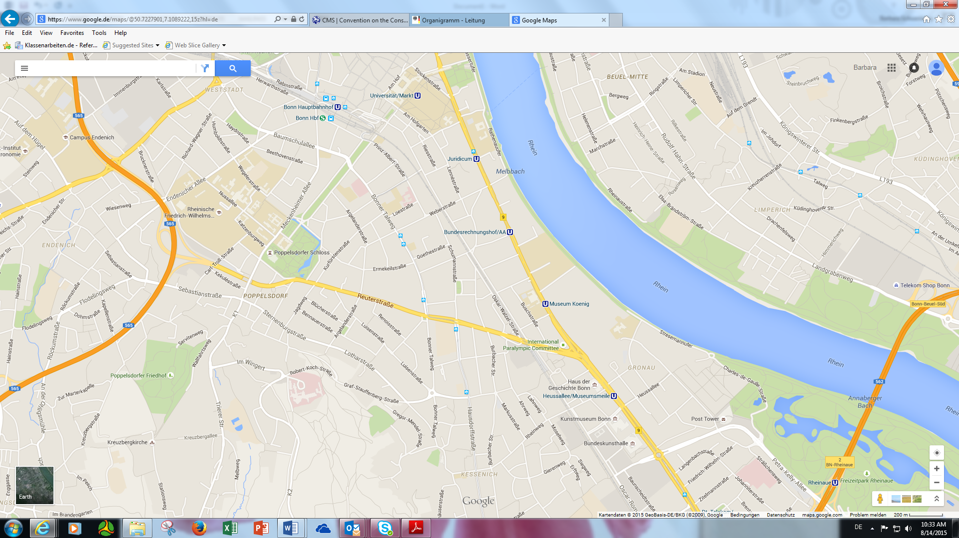
Main Entrance
To UN Campus

610/611 Bus stop
Deutsche Welle
Tram 63/16 or 66
Heussallee/Museumsmeile

How to get to the meeting venue:

By train:
From the main railway station (Bonn Hauptbahnhof) in the city centre, take an RE train (direction Koblenz) or RB train (direction Bonn-Mehlem or Ahrbrück) to the new “UN Campus” station, which is situated about 800m from the UN Campus main entrance.

By tram (U-Bahn):
From the main railway station (Bonn Hauptbahnhof) in the city centre: take tram 63 or 16 (direction Bad Godesberg) or tram 66 (direction Bad Honnef or Ramersdorf) to the stop Heussallee/Museumsmeile.

From Bad Godesberg station (Bahnhof): take tram 63/16 (direction Bonn Hauptbahnhof) to the stop Heussallee/Museumsmeile. < Tram 63/Tram 16 >.

Upon arrival at the stop Heussallee/Museumsmeile, exit the station by following the signage “UN Campus” and continue walking straight ahead for about five minutes until you get to the UN Campus Guardhouse, which is where you undergo a routine security check before entering the UN Campus, where you will see a large building with the UN logo on top, which is the Langer Eugen (LEU).

By bus:
From Bonn city centre (Hauptbahnhof) or Bad Godesberg city centre, take Bus 610 or 611 to the stop Deutsche Welle. After getting off, you will see the UN Campus Guardhouse, which is where you enter.

Tram or bus tickets can be obtained from ticket machines in the stations or on the bus or tram itself. If you are travelling in and around Bonn, please select Zone 1b, a one-way ticket (1 trip) costs 2.80 EUR and a multiple ticket (4 trips) costs 10.70 EUR.

By taxi:
The fare for a taxi ride to the UN Campus from Bonn city centre (Hauptbahnhof/ Main station) is around 15.00 EUR and from Bad Godesberg city centre about 20.00 EUR. The central phone number for Bonn taxis (where English is spoken) is +49 (0) 228 555 555.

2. Contacts
Mr Sergey Dereliev
sergey.dereliev@un.org
Tel.: +49 (0) 228 815 2415
Mobile: +49 (0) 151 - 167 890 84

Ms Jeannine Dicken
jeannine.dicken@un.org
Tel.: +49 (0) 228 815 2455
UNEP/AEWA Secretariat
UN Campus
Platz der Vereinten Nationen 1
53113 Bonn
Germany

3. COVID guidelines

Upon arrival to Germany:

Although a COVID vaccination or a negative COVID test upon arrival to Germany is currently not mandatory, we strongly recommend that you are able to show proof of full vaccincation (+booster) or a negative test (ideally both) in case of possible random checks at the airport.
Should you have to transit while traveling to Germany, please check the COVID guidelines in your country of transit!

COVID-19 ordiances in the state of Northrhine-Westphalia (NRW):

In the state of NRW it is currently mandatory to wear a medical face mask (FFP2) in all medical facilities.

There is no more requirement to isolate in case of a COVID-19 infection. Positive COVID-19 cases are recommended to wear a mask in all indoor areas.

UN Campus:

Wearing a face mask on the UN Campus is no longer mandatory.

It is recommended that anyone on Campus exhibiting respiratory symptoms (COVID-19 or otherwise) to wear a mask in all indoor areas and to follow good hygiene practices to protect others.

We recommend you carry a face mask with you at all times.

4. Getting to Bonn

Bonn is located approximately a thirty-minute car journey south of Cologne and two hours north-west of Frankfurt/Main and can be reached from three airports, Cologne/Bonn Airport, Frankfurt International Airport and Düsseldorf Airport.

Participants arriving at Cologne/Bonn Airport can reach Bonn city centre by taxi (the fare from the airport to the city centre is approximately 45.00 EUR), or by bus (SB 60), departing from the bus stop at Terminal 1 to the city centre (final stop “Hauptbahnhof”, main railway station) costing around 9.00 EUR. Please see the following map for directions to the SB 60 bus stop:

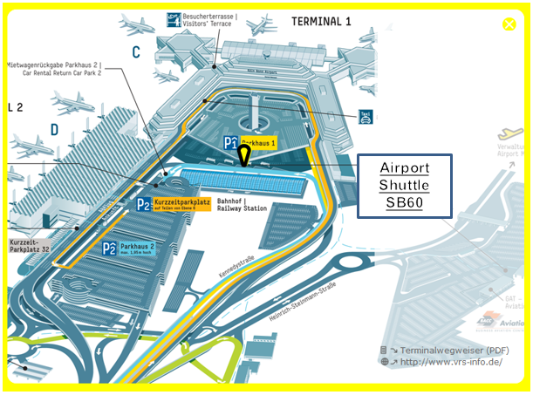

Participants arriving at Frankfurt International Airport may wish to take the train to Siegburg/Bonn. There is high-speed train service (ICE) between the airport and Siegburg/Bonn. Travel time is approximately 40 minutes and a 2nd class ticket costs around 61.00 EUR. Departure is from the long-distance train station (Fernbahnhof) in the airport complex; the direction is Cologne.

The station stop for Bonn is the town of Siegburg (Please get off at: Siegburg/Bonn). Taxis are available for approximately 30.00 EUR from Siegburg to Bonn city. You can also catch the tram 66 from Siegburg to Bonn (ticket price 5.00 EUR, please select Zone 3 on the ticket machine). The tram journey takes approx. 25 minutes.

A regular train service between Frankfurt International Airport and Bonn main railway station (Hauptbahnhof) is also available (from the long-distance train station (Fernbahnhof) in the airport). Travel time is approximately 1 hour 45 minutes and a 2nd class ticket costs about 39.00 EUR. This is a particularly scenic trip along the Rhine River and brings you directly into the city centre of Bonn.

From Düsseldorf Airport to Bonn there is a regular direct train service, which runs hourly and takes about 60 minutes. A 2nd class ticket costs approximately 16.00 EUR.

For further information about Bonn and the surrounding region, please refer to:
http://www.bonn-region.de/english.html.

5. Working language, documents and WiFi

The meeting language will be English.

Please note that documents will not be distributed during the meeting, therefore, participants are kindly requested to bring their own copies, if required. Documents will be made available online and free wireless internet will be provided throughout the meeting.

6. Meals

The AEWA Secretariat will arrange for lunch at the canteen on the 29th Floor of the Langer Eugen Building at the UN Campus. Lunch will consist of a variety of hot meals (including vegetarian and vegan options) and a salad bar.

A separate area with reserved tables will be available for TC18 delegates on all three meeting days.

All delegates are required to pay for their lunch.

Coffee, tea and snacks will be served during the coffee breaks and a supply of water will be provided throughout the meeting. These will be offered by the AEWA Secretariat.

7. Passport and visa requirements

Upon request, an official letter of invitation will be sent to participants. This can be attached to the German visa application. Visas can be obtained from your nearest German embassy or consulate. Information and addresses can be downloaded from the website of the German Foreign Office. See Annex 1 of this info sheet to find out if you need a visa for entry to Germany. Further information can be found here.

If you have any difficulties obtaining a visa, please contact the Secretariat: jeannine.dicken@un.org.

8. Accommodation

Many of you have been to Bonn on numerous occasions and already have your favourite hotels.

The following hotels are conveniently situated for getting to the UN Campus:

Intercity Hotel Bonn
Quantiusstraße 22 (very close to the Bonn Hauptbahnhof - main train station)
53115 Bonn
Tel.: +49 228 926 181-0
E-mail: reservations@bonn.intercityhotel.de
Prices start at ca. 95 EUR, including breakfast.
**The hotel provides all its guests with a free CityTicket for local transport for the duration of their stay**.
For further information please see the hotel website:
intercityhotel.com/en/hotels/all-hotels/germany/bonn/intercityhotel-bonn
_______________________________________________________________________________________

Dorint Hotel Bonn
Berliner Freiheit 2
53111 Bonn
Tel.: +49 228 72690
E-mail: info.bonn@dorint.com
Prices range between 99 EUR and 114 EUR, including breakfast. For further information please see the hotel website: https://hotel-bonn.dorint.com/en/
_______________________________________________________________________________________

Ameron Hotel Königshof
Adenauerallee 9
53111 Bonn
Tel.: +49 228 2601-0
E-mail: info@koenigshof-bonn.de
Prices range from 115 EUR for a single room including breakfast. For further information please see the hotel website: https://www.ameronhotels.com/de/hotel-koenigshof-bonn

_______________________________________________________________________________________

Bonn Marriot World Conference Hotel
Platz der Vereinten Nationen 4 (located right next to the UN Campus)
53113 Bonn
Tel.: +49 228 280 500
E-mail: info@wccbhotel.com
Prices start at 150 EUR per night including breakfast. For further information please see the hotel website:
http://wccbhotel.com/

_______________________________________________________________________________________

Motel One Bonn - Beethoven
Berliner Freiheit 36
53111 Bonn
Tel.: +49 228 9727860
Email: bonn-beethoven@motel-one.com
Prices start at 79 EUR per night excluding breakfast. Breakfast is available for 15.90 EUR. For further information please see the hotel website:
https://www.motel-one.com/en/hotels/bonn/hotel-bonn-beethoven/

_______________________________________________________________________________________

Motel One Bonn – Hauptbahnhof
Am Hauptbahnhof 12
53111 Bonn
Tel.: +49 228 763824-0
Email: bonn-hauptbahnhof@motel-one.com
Prices start at 79 EUR per night excluding breakfast. Breakfast is available for 15.90 EUR. For further information please see the hotel website:
https://www.motel-one.com/en/hotels/bonn/hotel-bonn-hauptbahnhof/

_______________________________________________________________________________________

Living Hotel Kanzler
Adenauerallee 148
53113 Bonn
Tel.: +49 228 68440
Email: kanzler@living-hotels.com
Prices start at 130 EUR per night. For further information please see the hotel website:
https://www.living-hotels.com/hotel-kanzler-bonn/

Leisure Tax
The City of Bonn charges a tax amounting to 5% of the rate for an overnight stay, which is NOT included in the overnight rate. Business travellers, however, are EXEMPT from this tax when they submit an adequate verification that they are in Bonn on business. The Secretariat will either send you an individual invitation letter in advance or issue you with one once you have pre-registered for that purpose.

9. Time zone and weather

The meeting is being held in March, which is early spring in Bonn. The weather in Bonn is usually cool
(ca. 10-12°C during the day) and can be unpredictable, so be prepared for all weather scenarios. More information on the current weather conditions in Bonn can be found here.
Germany is in the Central European Time zone. GMT +1 hour.

10. Voltage and plugs

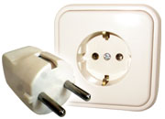
In Germany, the electrical plug/outlet and voltage operates on 220 volts, 50 Hz, with round-prong European-style plugs that fit into recessed wall sockets/ points. Many appliances with their own power adapters (such as laptop computers and digital cameras) can be plugged into either 110-120 volt or 220-240 volt sockets/points and will adapt to the voltage automatically.

11. Currency

Germany’s currency is the Euro (€). As of January 2023, the exchange rate was €0.929 for 1 USD. Credit cards are accepted in hotels and in most restaurants in Bonn, but not in all shops.

12. Useful numbers

Country dialling code: +49
City dialling code: (0)228
Railway Station Bonn: 0228 19419
Emergency: 112
Police: 110
Fire: 112
Doctors: 0228 364567 or 0228 19257
UNEP/AEWA Secretariat: 0228 815 2455/2413

13. Security requirements at the UN Campus

Please note the standard security requirements that you need to be familiar with when you visit us at the UN Campus in Bonn:

- Participants should arrive at the entrance of the building at least fifteen minutes before registration to allow enough time for eventual delays.
- Upon entering the main entrance/guardhouse of the UN Campus, all participants will be requested to show their passports/national ID cards and requested to pass through a metal detector.
- All participants will receive an identification badge to access the venue. You are requested to wear this badge at all times when you are on the UN Campus.
- No friends or family members may enter the UN Campus unless they are also participants.
- Participants may not use the facilities of other offices on the conference floor.
- Smoking is only allowed outside the building in the designated areas.
- The participants are not allowed to move freely within the building unless attended by Secretariat Staff.
- In case you lose your visitors badge, please report this to the Secretariat/Security staff.
- Participants should not leave their personal items of value unattended.

14. Disclaimer

The UNEP/AEWA Secretariat disclaims all responsibility for medical, accident and travel insurance, compensation for death or disability compensation, loss of or damage to personal property and any other loss that may be incurred during travel time or the duration of the meetings. In this context, it is strongly recommended that all meeting participants secure international medical and travel insurance for the period of travel and the duration of the meeting, prior to their departure.

ANNEX 1 – Visa Information

Delegates from the following countries require entry visas for Germany:

Afghanistan, Algeria, Angola, Armenia, Azerbaijan, Bahrain, Bangladesh, Belarus, Belize, Benin, Bhutan, Bolivia, Botswana, Burkina Faso, Burundi, Cambodia, Cameroon, Cape Verde, Central African Republic, Chad, People's Republic of China, Colombia, Comoros, Côte d'Ivoire (Ivory Coast), Cuba, Democratic People's Republic, Democratic Republic of the Congo, Djibouti, Dominica, Dominican Republic, Ecuador, Egypt, Equatorial Guinea, Eritrea, Ethiopia, Fiji, Gabon, Gambia, Georgia, Ghana, Grenada, Guinea, Guinea - Bissau, Guyana, Haiti, India, Indonesia, Iran, Iraq, Jamaica, Jordan, Kazakhstan, Kenya, Kiribati, Kosovo, Kuwait, Kyrgyzstan, Laos, Lebanon, Lesotho, Liberia, Libya, Madagascar, Malawi, Maldives, Mali, Marshall Islands, Mauritania, Micronesia, Mongolia, Montserrat, Morocco, Mozambique, Myanmar (Burma), Namibia, Nauru, Nepal, Niger, Nigeria, Oman, Pakistan, Palau, Palestinian territories, Papua New Guinea, Peru, Philippines, Qatar, Republic of the Congo, Russian Federation, Rwanda, Saint Lucia, Saint Vincent and the Grenadines, Samoa, São Tomé and Principe, Saudi Arabia, Senegal, Sierra Leone, Solomon Islands, Somalia, South Africa, South Sudan, Sri Lanka, Sudan, Suriname, Swaziland, Syria, Tajikistan, Tanzania, Thailand, Timor - Leste (East Timor), Togo, Tonga, Trinidad and Tobago, Tunisia, Turkey, Turkmenistan, Tuvalu, Uganda, Ukraine, United Arab Emirates, Uzbekistan, Vanuatu, Viet Nam, White Russia, Yemen, Zambia, and Zimbabwe.

1. Persons who do not require a visa to enter Germany may not remain on German territory for more than
90 days in any six-month period or take up gainful employment during this period.
2. Nationals of these states are not subject to the restrictions specified in (1) above.
3. Residence permits (also for stays of more than 3 months) may be applied for after entering Germany without a visa.
4. (3) also applies provided gainful employment is not taken up.
5. The visa waiver applies only to holders of biometric passports.
6. The visa waiver applies to holders of Special Administrative Region (SAR) passports.
7. The visa waiver also applies to British Nationals (Overseas).
8. The visa waiver applies only to holders of biometric passports (excluding holders of Serbian passports issued by the Serbian Coordination Directorate (in Serbian: Koordinaciona uprava)

