DELINEATION OF BIOGEOGRAPHIC POPULATIONS OF THE BEWICK´S SWAN
(CYGNUS COLUMBIANUS bewickii)

PROPOSAL TO CHANGE POPULATION DELINEATIONS

Compiled by Szabolcs Nagy, Wetlands International
With contributions from Eileen Rees, Bart Nolet and Didier Vangeluwe

Name of population(s):
Bewick’s Swan Cygnus columbianus:
- bewickii, Western Siberia & NE Europe/North-west Europe and
- bewickii, Northern Siberia/Caspian populations

Current status on AEWA Table 1:
- Category 2 of Column A
- Category 1c of Column A

What is the issue?
Scott & Rose (1996) and earlier editions of the Waterbird Population Estimates (Delany & Scott, 2002; Delany & Scott, 2006; Rose & Scott, 1997; Rose & Scott, 1994) recognised two populations in the Western Palearctic: one recognised as the bewickii, Western Siberia & NE Europe/North-west Europe population in AEWA Table 1 and another one called bewickii, Northern Siberia/Caspian. Scott & Rose (1996) stated that only small numbers were recorded around the Black Sea and in Central and Southern Europe. Therefore, they have assumed that these small numbers do not belong to any of the populations, but vagrants coming with larger flocks of Whooper Swan (Cygnus cygnus). Consequently, these areas were not included in their original population delineations (Figure 1).

Recognising the increasing number of observations and numbers in southeast Europe, the boundaries of this population were extended to include the Black Sea and Evros Delta on the Critical Site Network Tool in the mid-2000s (Figure 2).

Based on the findings of recent observations, ringing and telemetry studies, however, these populations may require revision.

Option (A): Maintaining the two existing AEWA populations but amending their boundaries to reflect the available scientific evidence concerning their breeding and non-breeding distributions.

Option (B): Merging the Western Siberia & NE Europe/North-west Europe and Northern Siberia/Caspian populations.

Option (C): Retaining the Western Siberia & NE Europe/North-west Europe and splitting the Northern Siberia/Caspian populations into a SW European and a C Asian wintering populations.

What is the evidence supporting the proposal?
Option A
Scott & Rose (1996) stated that birds breeding west of the Taymyr Peninsula winter in NW Europe. Rees (2010), however, defines the eastern border of the breeding range at the Ural mountains and this is largely supported by both ringing (Rees, 2013; Spina et al., 2022) and telemetry data (Beekman et al., 2002; Griffin et al., 2016; Nuijten & Nolet, 2020). There is no record of birds east to the Vaygach Island. Hence, the eastern limit of the population should be moved to the west and the population name should be changed to NE Europe/North-west Europe.

The breeding area of the Northern Siberia/Caspian population was unknown (Rees, 2010; Scott & Rose, 1996). Scott & Rose (1996) have speculated that birds wintering in the Caspian region breed in the easternmost extremity of the breeding range in the Taymyr Peninsula. However, telemetry studies showed that birds breeding on the Yamal Peninsula winter both in China, Centra Asia (Uzbekistan and Turkmenistan) and migrate along the Caspian and Black Seas to the Evros Delta (Vangeluwe, 2016; Vangeluwe et al., 2018) (Figure 3) and to Asia Minor as eBird (Figure 4) and IWC data (Figure 5) show. This indicates that boundaries of this population should be moved to the west to include the Yamal Peninsula. However, the sample size from the published telemetry studies is too limited and possibly unrepresentative, to firmly determine the eastern limits of the breeding range of this population, but Vangeluwe et al. (2018) defines it ranging from the Yamal to the Taymyr Penninsula. Capturing and tagging birds on the wintering or stopover sites may help to reveal the extent of the breeding range.

However, the telemetry data of Vangeluwe et al. (2018) indicates that birds winter further east in Uzbekistan and Turkmenistan than shown earlier. Therefore, the eastern border of the Central Asian population should be extended to include the Ili River valley in W China, Kyrgyzstan and along the western border of Tadjikistan. Based on eBird data, the species is accidental in India, Pakistan, Oman and Israel.

Option B
Vangeluwe et al. (2018) speculated that part of the Western Siberia & NE Europe/North-west Europe population has changed migratory route and relocated to the Black Sea and Eastern Mediterranean region. They have based this argument on the observation of birds neckbanded in NW Europe in the Evros Delta. However, this argument is contradicted by the fact that no birds tagged in NW Europe were recovered on the Yamal Peninsula. In addition, exchanges between different populations of waterfowl is fairly common, e.g. Greater White-fronted Geese equipped with satellite transmitters in NW Europe have occurred also in Hungary, the wintering range of the Pannonic population. Even Scott & Rose (1996) have reported that some exchange between the Caspian and the NW European populations of the Bewick’s Swan may take place based on recovery of ringed birds in Perm, the western side of the Ural Mountains and in Astrakhan, in the North of the Caspian. Even if there is a certain degree of exchange between the birds wintering in NW Europe and in the Evros Delta, the two biogeographic population uses largely different breeding, staging and wintering sites. Therefore, they are to be treated as separate biogeographic or flyway populations according to the existing AEWA guidelines (AEWA/MOP 3.12, AEWA/MOP 3.16, UNEP/AEWA/StC/12.11).

Option C
The migration tracks shown by Vangeluwe et al. (2018) also suggest the Bewick’s Swans migrate along the Ob River to the Turgai Lowland on the border of Russia and Kazakhstan. Here, the migration route splits. One continues further south in Central Asia to the Aral Sea and the Amurdarya and spread out towards Samarkand and the Ili River Valley, in W China. Based on the tracks, these routes seem to be separate from the one leading along the N Caspian, Black Sea and Evros Delta corridor (Figure 3). Vangeluwe (in litt.) argues that this birds together with the ones wintering around the Caspian should be treated as a separate population. However, Figures Figure 4Figure 5 show that hundreds of Bewick’s Swans winter also at other sites in the southern Caspian (Turkmenistan, Iran and Azerbaijan) and Turkey that follow still unknown migration routes. Some of these wintering sites seem to be rather frequently used considering the frequency of counts in some of these countries. Consequently, there is insufficient evidence to separate the N Caspian, Black Sea and Evros Delta corridor from the Central Asia one. Furthermore, separating these populations would result in very small 1% thresholds and would put undue emphasis on sites in the region with relatively low importance (Atkinson-Willes et al., 1982).

In conclusion, it is proposed to adopt Option A and
- change the name of the bewickii, Western Siberia & NE Europe/North-west European population to bewickii, NE Europe/North-west Europe,
- change the name of the bewickii, Northern Siberia/Caspian population to bewickii, Western Siberia/SW Europe & Central Asia and
- modify the flyway boundaries as outlined in Figure 6.

What are the implications of the proposal including any changes in status on AEWA Table 1?
The proposed changes require no changes in the classification of these populations in Table 1 of AEWA as it does not affect the population size or trend estimates.

References

Atkinson-Willes, G. L., Scott, D. A., & Prater, A. J. (1982). Criteria for selecting wetlands of international importance. Atti della Conferenza sulla conservazione delle zone umide di importanza internazionale specialmente come habitat degli uccelli acquatici., Cagliari 24–29 novembre 1980.
Beekman, J. H., Nolet, B. A., & Klaassen, M. (2002). Skipping swans: fuelling rates and wind conditions determine differential use of migratory stopover sites of Bewick's Swans Cygnus bewickii. Ardea, 90(3), 437-460.
Delany, S., & Scott, D. (2002). Waterbird Population Estimates. Third Edition. Wetlands International.
Delany, S., & Scott, D. (2006). Waterbird Population Estimates: Fourth Edition. Wetlands International.
Griffin, L., Rees, E., & Hughes, B. (2016). Satellite tracking Bewick’s Swan migration in relation to offshore and onshore wind farm sites. WWT Final Report to the Department of Energy and Climate Change. WWT, Slimbridge, 1-55.
Nuijten, R. J., & Nolet, B. A. (2020). Chains as strong as the weakest link: remote assessment of aquatic resource use on spring migration by Bewick’s Swans. Avian Conservation and Ecology, 15(2), 14.
Rees, E. (2010). Bewick's swan. Bloomsbury Publishing.
Rees, E. C. (2013). Distribution within the USSR of Bewick's Swans Cygnus columbianus bewickii marked in Britain. Wildfowl, 209-213.
Rose, P., & Scott, D. (1997). Waterfowl population estimates. Second edition. Wetlands International,.
Rose, P. M., & Scott, D. A. (1994). Waterfowl population estimates. IWRB, Slimbridge (UK).
Scott, D. A., & Rose, P. M. (1996). Atlas of Anatidae populations in Africa and western Eurasia. Wetlands International.
Spina, F., Baillie, S. R., Bairlein, F., Fiedler, W., & Thorup, K. (2022). The Eurasian African Bird Migration Atlas. EURING/CMS. https://migrationatlas.org
Vangeluwe, D. (2016). The odyssey of the Bewick Swan. https://odnature.naturalsciences.be/bebirds/en/blog_swans/post_1923
Vangeluwe, D., Rozenfeld, S., Volkov, S., Kazantzidis, S., Morosov, V., Zamyatin, D., & Kirtaev, G. (2018). Migrations of Bewick’s Swan (Cygnus bewickii): new data on tagging the migration routes, stopovers, and wintering sites. Biology Bulletin, 45(7), 706-717.

Figures

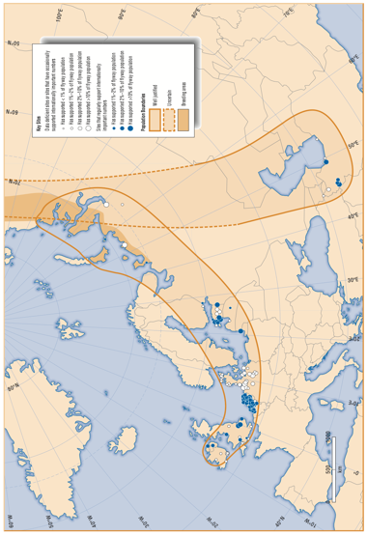

Figure 1. Population boundaries of Bewick’s Swan in the Western Palearctic based on Scott & Rose (1996).

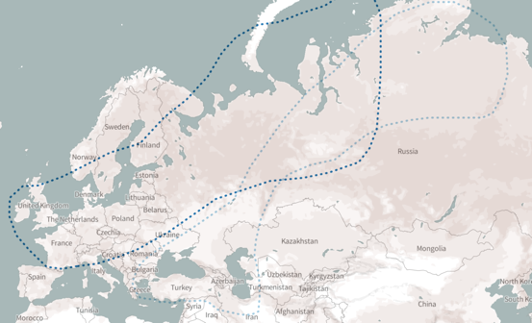

Figure 2. Population delineation according to the Critical Site Network Tool. Dark blue: Western Siberia & NE Europe/North-west Europe population, pale blue: Northern Siberia/Caspian population.
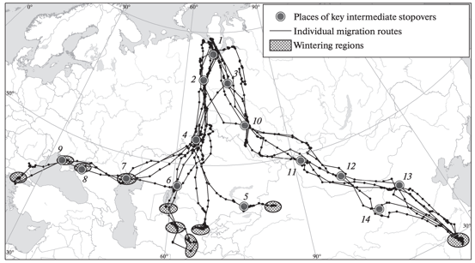

Figure 3. Individual migration routes of birds captured on the western part of the Yamal Peninsula (Vangeluwe et al., 2018)

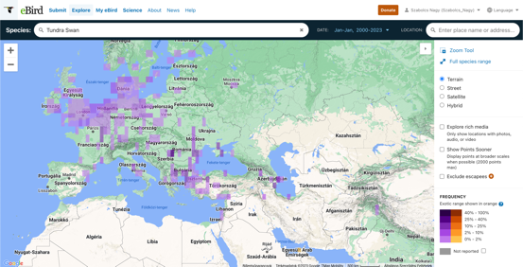

Figure 4. January Bewick’s Swan observations between 2000 and 20023 on eBird.
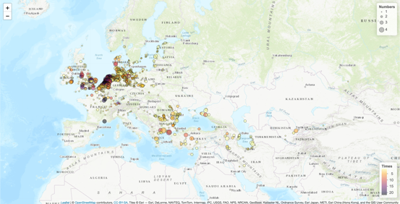

Figure 5. Bewick’s Swan counts in the International Waterbird Census since 2000. Meaning of Numbers legends: 1: 1-9, 2: 10-99, 3: 100-999, 4: ≥1,000 individuals. Times represent the number of January counts the species has been reported between 2000 and 2022.
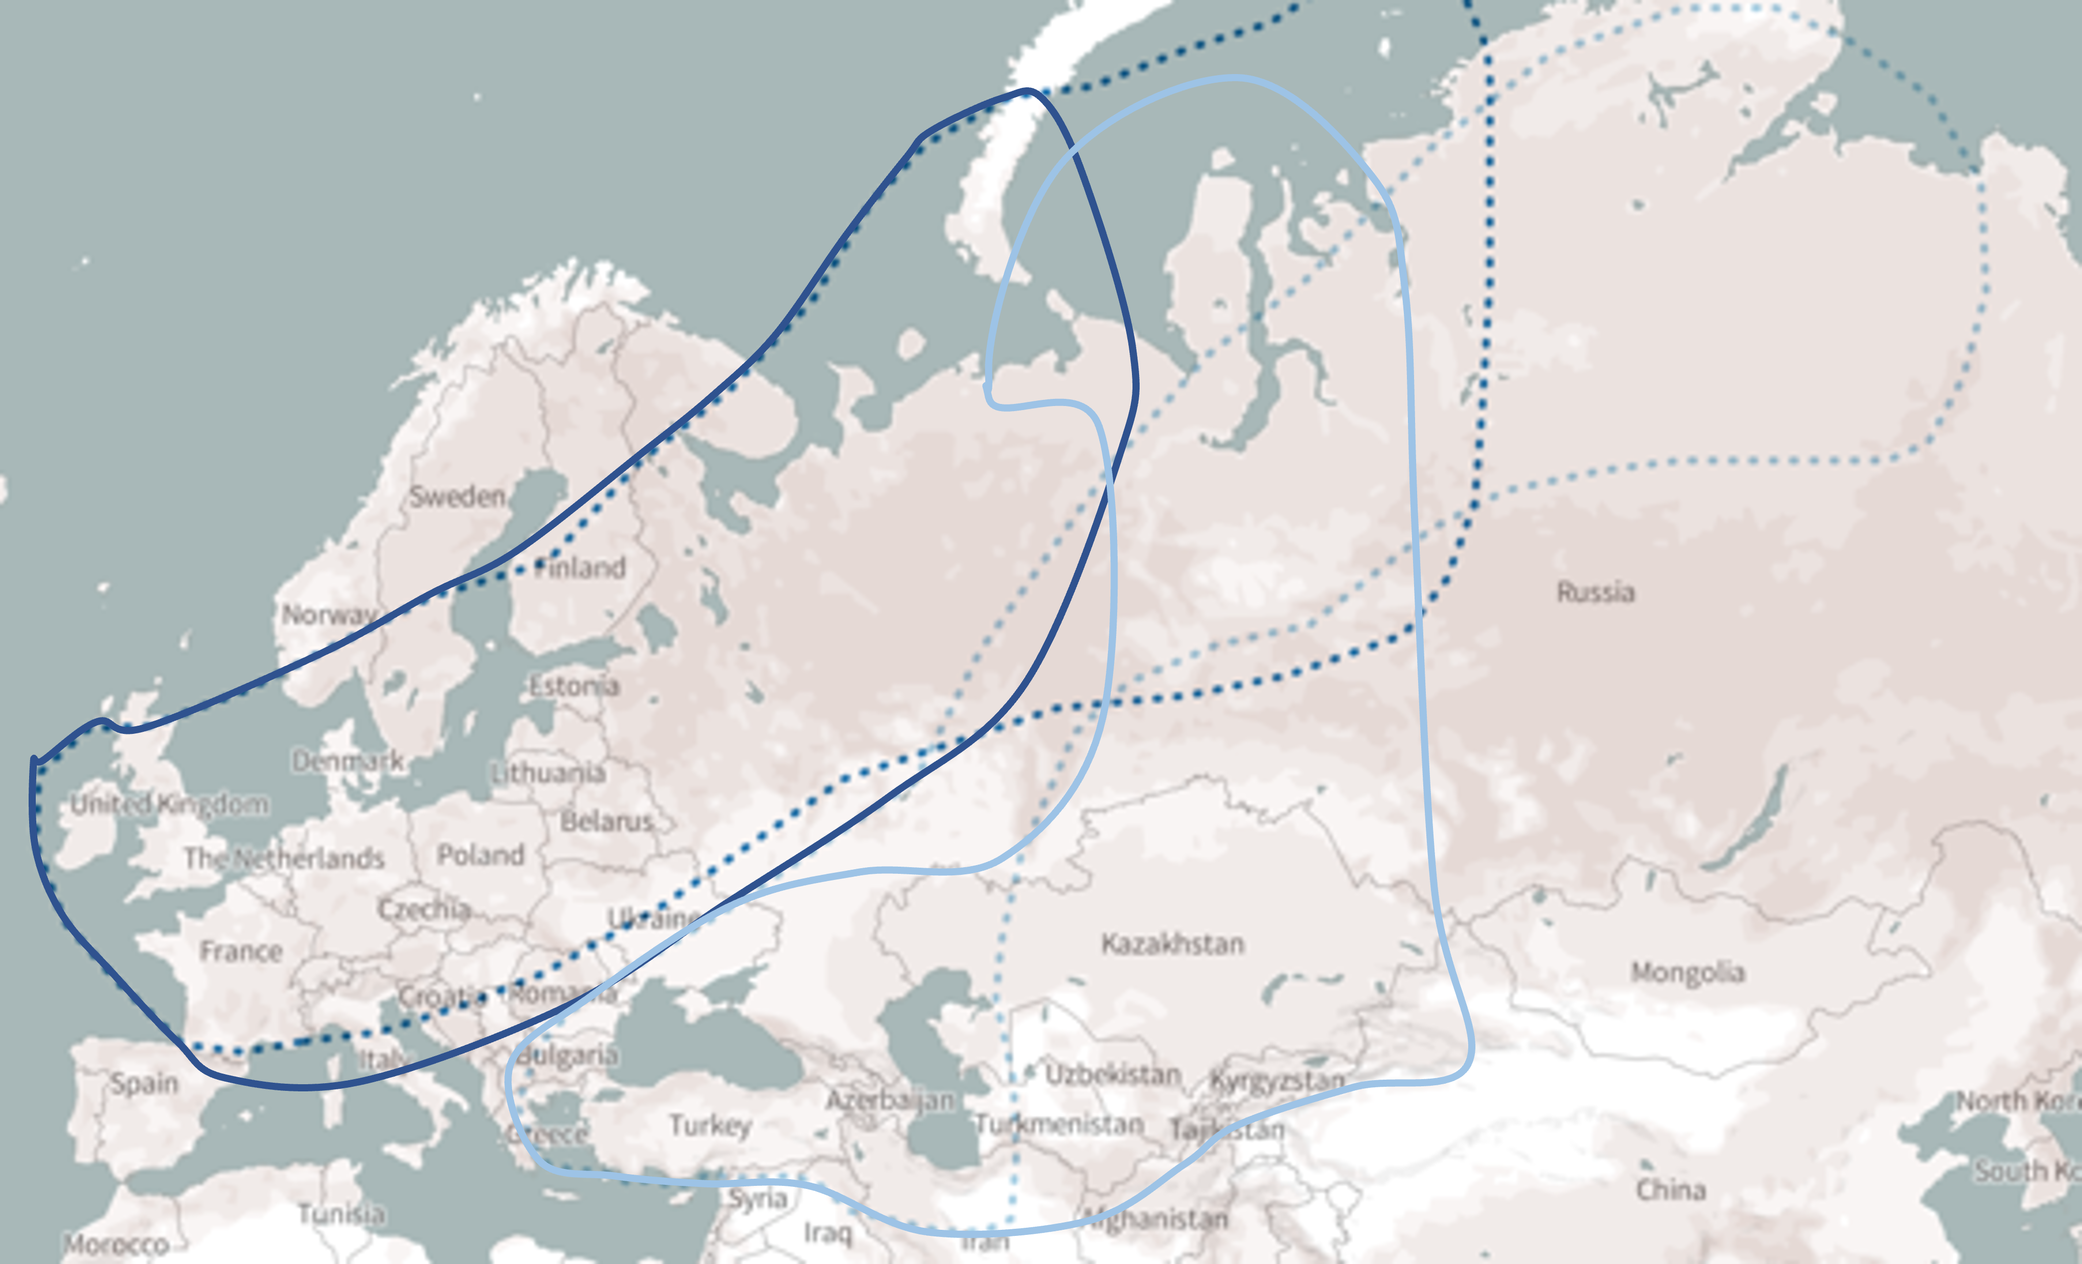

Figure 6. Proposed changes to the delineation of the Western Siberia & NE Europe/North-west Europe (dark blue lines) and the Northern Siberia/Caspian (pale blue lines) populations of Bewick’s Swan. Solid lines indicate the proposed changes to the flyway boundaries. The delineation of the breeding areas and their overlaps is based on satellite tracks kindly made available by B. Nolet (in litt. ) and the description provided by D. Vangeluwe (in litt.).

http://criticalsites.wetlands.org/en/species/22679862

