DELINEATION OF BIOGEOGRAPHIC POPULATIONS OF THE MACCOA DUCK (OXYURA MACCOA)

PROPOSAL TO CHANGE POPULATION DELINEATIONS

Compiled by Szabolcs Nagy, Wetlands International

Name of population(s):
Maccoa Duck (Oxyura maccoa), Eastern Africa

Current status on AEWA Table 1:
Categories 1b, 1c of Column A

What is the issue?
Scott & Rose (1996) defines the range of the Eastern African population including Kenya and NE Tanzania as well as W Uganda, Rwanda, Burundi and the eastern part of the Democratic Republic of Congo (DRC). They have also recognised that there might be very little mixing between these two groups of birds (Figure 1). This treatment was maintained also on the Critical Site Network (CSN) Tool. However, the population boundaries on the CSN Tool do not match the BirdLife Species range map¹.

The AEWA Single Species Action Plan for the Maccoa Duck (Berruti et al., 2007) states that species was probably only vagrant in Burundi and mentions no recent record from the DRC, only one record from Rwanda (from 1983) and two recent records from Uganda. They have also delineated the Uganda, Rwanda and the eastern part of the DRC range separate from the range in Kenya and Tanzania (Figure 2). However, they have still recognised three and not four populations of the species. This approach is inconsistent with the accepted practice of delineating biogeographic populations. Contrary to range mapping that may define multiple range fragments, the boundaries of biogeographic populations should always delineate a continuous area (see e.g. Scott & Rose, 1996).

In addition, the population delineation for the Tanzania & Kenya population presented in Berruti et al. (2007) and also replicated in the BirdLife species range map leaves out a number of important locations for the species mainly in Kenya such as around Limuru, Lake Naivasha and Lake Nakuru (see the interactive map).

As shown above there are no records from the 2000s of Maccoa Duck in the Uganda, Rwanda and the eastern part of the DRC range, the definition of the Eastern Africa population could be revised as outlined on and it should only include areas in Kenya and Tanzania as outlined on Figure 3.

What is the evidence supporting the proposal?
As mentioned above, no recent records of the Maccoa Duck are available from Burundi, Rwanda and Uganda. The current distribution of the species can be mapped based on data from the IWC, the Tanzanian Bird Atlas Project, the Kenya Bird Map, eBird, Observation.org and summarized on an interactive map².

What are the implications of the proposal including any changes in status on AEWA Table 1?
The proposed change will not affect the species listing in Table 1 of AEWA or its population size and trend estimates. It would affect only the list of range states for this population: the DRC, Burundi, Rwanda and Uganda will be no longer considered being a range state. The remaining range states will be Kenya and Tanzania.

References

Berruti, A., Baker, N., Buijs, D., Colahan, B., Davies, C., Dellegn, Y., . . . Mpofu, Z. (2007). International Single Species Action Plan for the Conservation of the Maccoa Duck (Oxyura maccoa). Agreement on the Conservation of African-Eurasian Migratory Waterbirds (AEWA) Technical Series(14).
Scott, D. A., & Rose, P. M. (1996). Atlas of Anatidae populations in Africa and western Eurasia. Wetlands International.

Figures

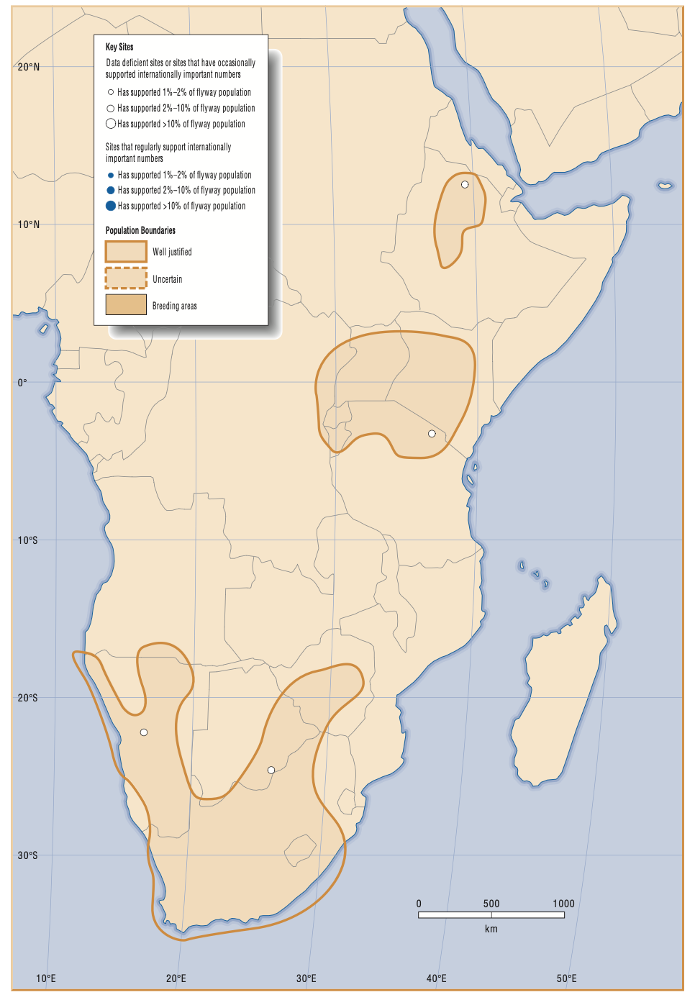

Figure 1. Delineation of the Maccoa Duck populations, including the Eastern Africa one, according to Scott & Rose (1996).

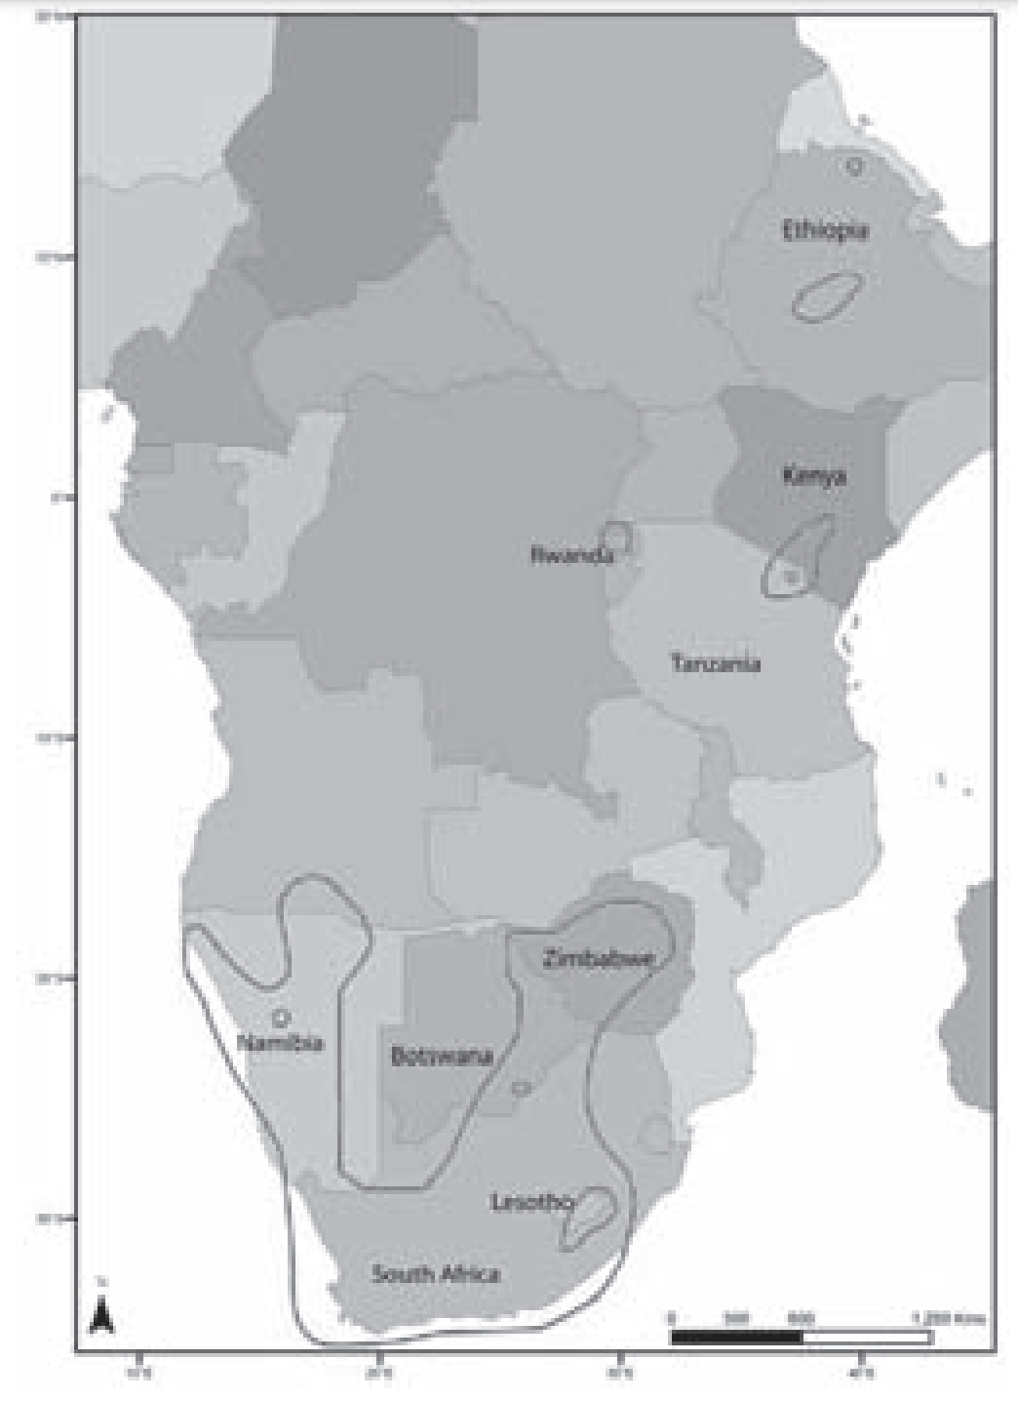

Figure 2. Delineation of Maccoa Duck populations as proposed by Berruti et al. (2007). Note that the Eastern African population has two disjunct polygons.

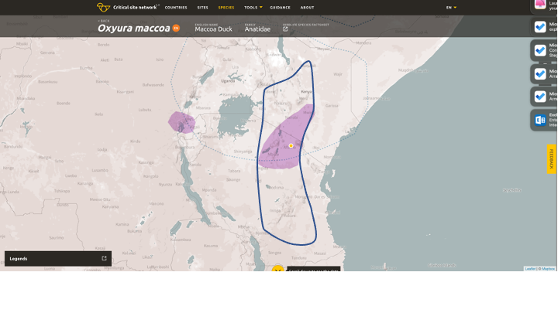
Figure 3. Proposed new delineation of the Maccoa Duck Eastern Africa population.

http://criticalsites.wetlands.org/en/species/22679820 (to see the overlap between the BirdLife range map and the population boundaries, switch on the BirdLife International species range maps layer).
https://szabolcsnagy.shinyapps.io/MaccoaDuckEAfrica/
http://tanzaniabirdatlas.net/maphtm/0078_nmap.htm
https://kenya.birdmap.africa/species/103
https://ebird.org/map/macduc1?neg=false&env.minX=20.75766370020405&env.minY=-10.136808155571023&env.maxX=48.35531995020405&env.maxY=4.329691474081787&zh=true&gp=false&ev=Z&excludeEx=&mr=1-12&bmo=1&emo=12&yr=last10
https://observation.org/species/70460/maps/?start_date=2013-01-01&interval=86400&end_date=2023-01-01&map_type=grid100k

