DELINEATION OF BIOGEOGRAPHIC POPULATIONS OF THE CASPIAN TERN
(HYDROPROGNE CASPIA)

PROPOSAL TO CHANGE POPULATION DELINEATIONS

Compiled by Szabolcs Nagy, Wetlands International

Name of population(s):

Caspian Tern (Hydroprogne caspia), Baltic (bre)

Current status on AEWA Table 1:
Category 1 of Column B

What is the issue?
In the light of distribution, ringing and telemetry data the population boundaries should be amended as shown on Figure 1.

What is the evidence supporting the proposal?
EBBA2 data (Keller et al., 2020) shows that the breeding range of the population includes now Denmark and should be extended to the western shore of Lake Vänern in Sweden. In the east, the breeding range should be extended to the eastern shore of Lake Lagoda (Figure 2).

Ringing (Spina et al., 2022; Figure 3) and telemetry (Rueda Uribe, 2021) data shows that the flyway boundary can be extended to the Atlantic coast of Europe on the west and more towards the border of Russia and Ukraine on the east.

In Africa, the eastern limit of the flyway can be extended to the line of Djbuti to Maindi on the the Indian Ocean coast of Kenya to include the Rift-valley lakes. The southern boundaries can be extended to the Upemba National Park in the Democratic Republic of Congo (Figure 3).

What are the implications of the proposal including any changes in status on AEWA Table 1?
The boundary changes will not affect the status of the population on Table 1 of AEWA only the list of Range States.

References

Keller, V., Herrando, S., Voříšek, P., Franch, M., Kipson, M., Milanesi, P., . . . Foppen, R. P. B. (2020). European Breeding mBird Atlas 2: distribution, abundance and change. European Bird Census Council & Lynx Edicions.
Rueda Uribe, C. (2021). Migratory strategy and behavioral flexibility in response to available habitat for a declining seabird, the Caspian Tern (Hydroprogne caspia).
Spina, F., Baillie, S. R., Bairlein, F., Fiedler, W., & Thorup, K. (2022). The Eurasian African Bird Migration Atlas. EURING/CMS. https://migrationatlas.org

Figures

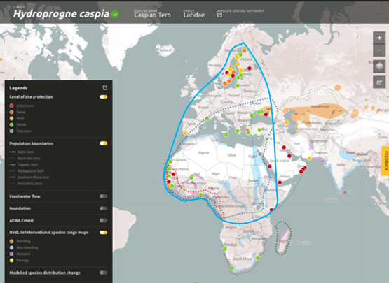

Figure 1. Existing (pale blue dotted line) and proposed (pale blue solid line) delineations of the Caspian Tern, Baltic (bre) population.

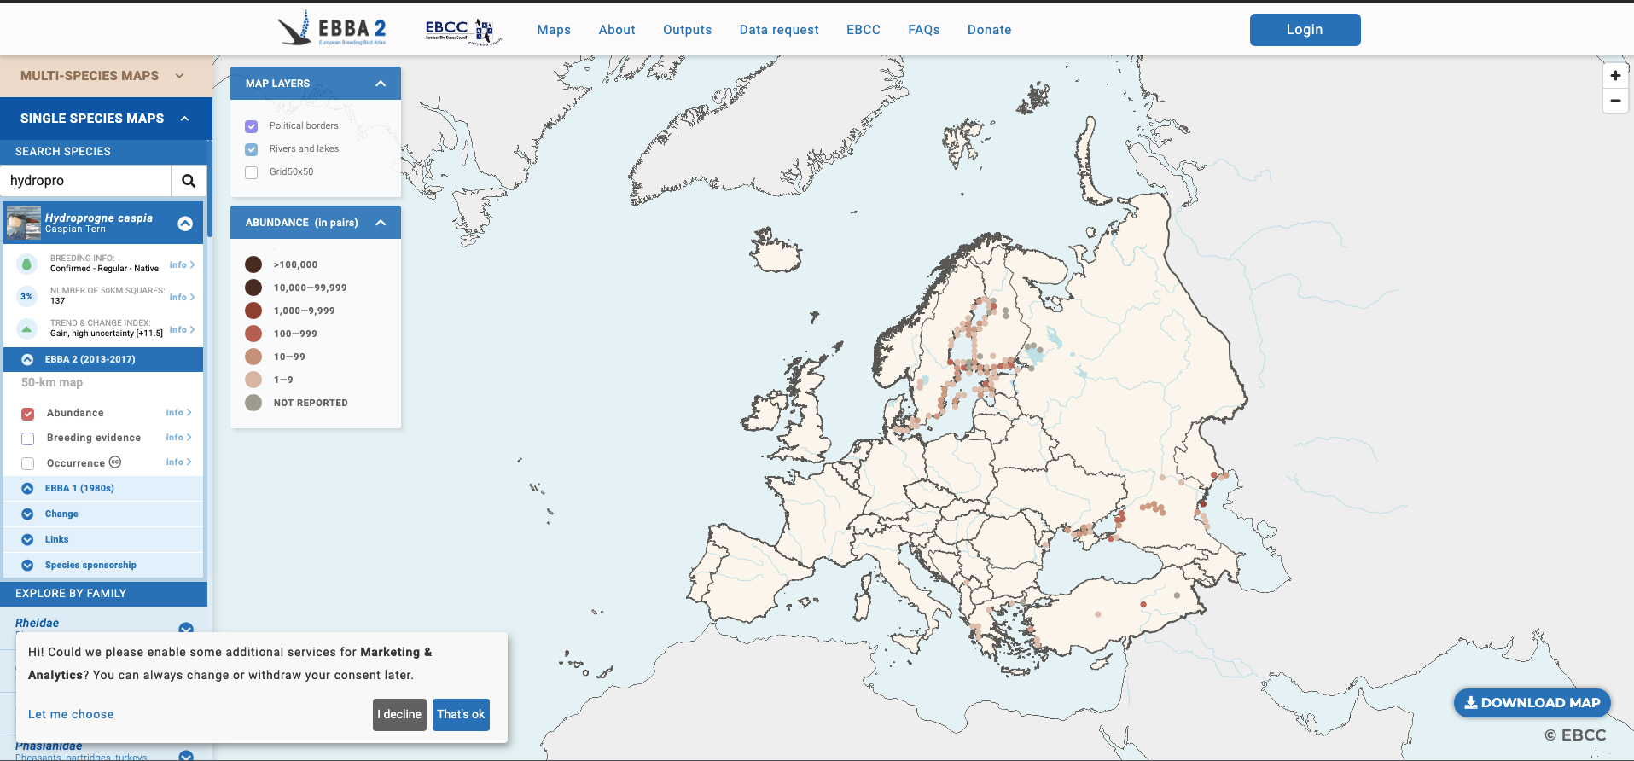

Figure 2. Breeding distribution of the Caspian Tern in Europe based on the EBBA2 data (Keller et al., 2020).
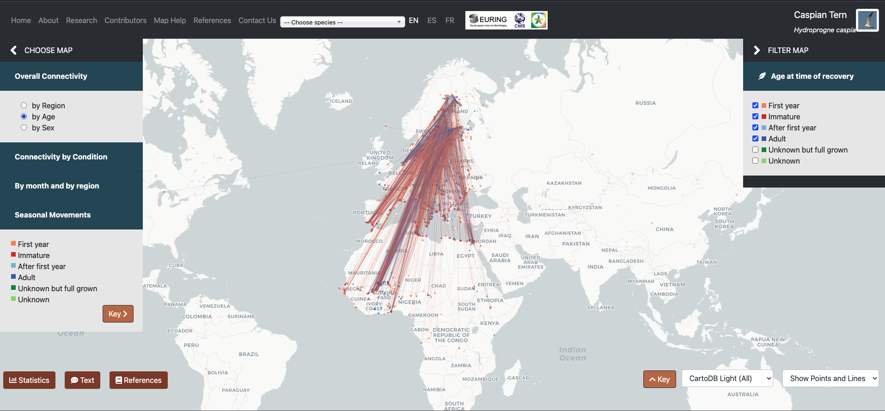

Figure 3. Ring recoveries of Caspian Tern marked in Northern Europe (Sweden and Finland) based on the Eurasian African Bird Migration Atlas (Spina et al., 2022).

https://ebba2.info/maps/species/Hydroprogne-caspia/ebba2/abundance/
https://onlinelibrary.wiley.com/doi/pdfdirect/10.1111/jav.02743

