DELINEATION OF BIOGEOGRAPHIC POPULATIONS OF THE
BAR-TAILED GODWIT
(LIMOSA LAPPONICA TAYMYRENSIS)

PROPOSAL TO CHANGE POPULATION DELINEATIONS

Compiled by Szabolcs Nagy, Wetlands International

Name of population(s):
Bar-tailed Godwit (Limosa lapponica taymyrensis):
Western Siberia/West & South-west Africa and
Central Siberia/South & SW Asia & Eastern Africa populations

Current status on AEWA Table 1:
Category 4 of Column A for both

What is the issue?
AEWA and the taxonomic reference of AEWA (del Hoyo et al., 2016) recognises two subspecies of Bar-tailed Godwit in the Agreement Area: the nominate form and the taymyrensis subspecies. Delany et al. (2009) have assumed that bird wintering in West Africa breed mainly in West Siberia east to the Taymyr Peninsula and birds wintering around Arabia and the eastern shores of Africa, breed mainly in eastern Taymyr.

Bom et al. (2022) proposed defining the taymyrensis more narrowly and described the birds wintering on the Middle East as a new subspecies (yamalensis). They have also shown that the two subspecies have also different breeding areas. Therefore, the population names in Table 1 should be changed to:
Limosa lapponica taymyrensis and
Limosa lapponica yamalensis

The respective breeding range descriptions should be changed on the Waterbird Populations Portal to:
- Central Siberia, Taymyr Peninsula and
- Western Siberia, Yamal Peninsula

The boundaries of the yamalensis population should be changed on the Critical Site Network Tool as shown on Figure 1.

What is the evidence supporting the proposal?
Bom et al. (2022) provide tracking, morphological and genetic evidence. The evidence concerning the new subspecies has been reviewed and accepted by BirdLife International (Donalds in litt.) and will be reflected in the next update in their taxonomic checklist. As the results are based on birds caught in Oman, there are some uncertainties concerning the generality of the results. However, the proposal is based on the best available evidence, and this evidence is stronger than the assumptions made in Delany et al. (2009) concerning the breeding range. In addition, 58-65% of the yamalensis Bar-tailed Godwit population winter at Barr Al Hikman (de Fouw et al., 2017) and even larger proportion uses the site during passage.

What are the implications of the proposal including any changes in status on AEWA Table 1?
The proposal leads to changing the names of the two populations in Table 1 of AEWA. It also leads to changes of the description of the breeding area of the yamalensis population in the Waterbird Population Portal and to the changing the boundaries on the Critical Site Network Tool.

References

Bom, R. A., Conklin, J. R., Verkuil, Y. I., Alves, J. A., De Fouw, J., Dekinga, A., . . . Rakhimberdiev, E. (2022). Central‐West Siberian‐breeding Bar‐tailed Godwits (Limosa lapponica) segregate in two morphologically distinct flyway populations. Ibis, 164(2), 468-485.
de Fouw, J., Thorpe, A., Bom, R. A., de Bie, S., Camphuysen, C., Etheridge, B., . . . Kelder, L. (2017). Barr Al Hikman, a major shorebird hotspot within the Asian–East African flyway: results of three winter surveys. Wader Study, 124(1), 10-25.
del Hoyo, J., Collar, N., Christie, D., Elliott, A., Fishpool, L., Boesman, P., & Kirwan, G. (2016). HBW and BirdLife International Illustrated Checklist of the Birds of the World. Volume 2.
Delany, S., Scott, D., Dodman, T., & Stroud, D. (Eds.). (2009). An Atlas of Wader Populations in Africa and Western Eurasia. Wetlands International.
Lappo, E., Tomkovich, P., Syroechkovskiy, E., & Zharikov, Y. V. (2012). Atlas of breeding waders in the Russian Arctic.

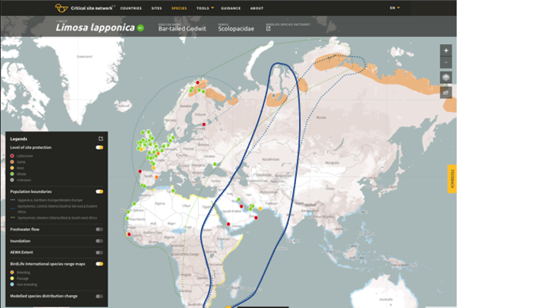
Figures

Figure 1. Existing (dotted dark blue line) and proposed (solid dark blue line) population delineations of the Bar-tailed Godwit yamalensis population.
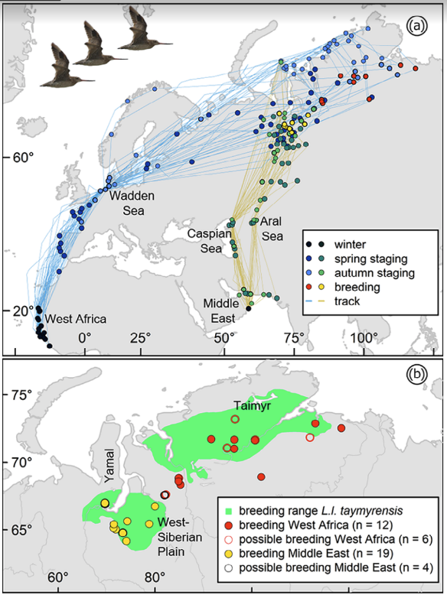

Figure 2. (a) Timing of migratory movements in Bar-tailed Godwits wintering in West Africa (blue lines and blue and red circles) and the Middle East (yellow lines and green and yellow circles). Note that autumn sites are plotted on top of spring sites. For visualization purposes, Siberian staging sites are notindicated by a separate colour, but they can be deduced from the latitude. Map is in Mercator projection. (b) Breeding sites derived from tracking data compared with the known breedingrange based on Lappo et al. (2012). From Bom et al. (2022)

https://drive.google.com/file/d/1bwZ1sbr9TDd0lcr7LtiQ7-m95LT6cjCA/view

