DELINEATION OF BIOGEOGRAPHIC POPULATIONS OF THE EUROPEAN SHAG
(GULOSUS ARISTOTELIS)

PROPOSAL TO CHANGE POPULATION DELINEATIONS

Compiled by Szabolcs Nagy, Wetlands International &
Sergey Dereliev, UNEP/AEWA Secretariat

Note for TC18
The original proposal was produced and discussed by correspondence on the TC Workspace in early 2022 (please see the discussion at the link provided in the footnote), but the TC could not conclude on the matter at its previous meeting. Therefore, the discussion was postponed for the next triennium.

Name of population:
European Shag (Gulosus aristotelis)

Current status on AEWA Table 1:
G. a. desmarestii, East Mediterranean (Croatia, Adriatic Sea) (bre) is listed in Category 1c of Column A. Other populations are not listed in Table 1 of AEWA.

What is the issue?
The European Shag and its ‘Adriatic population’ have been added to Annex 2 and Table 1 of AEWA at MOP7 in 2018. However, this motion has led to some issues to be resolved, namely:
- The name of the AEWA listed population is long and misleading because there are more (sub)population segments of European Shag in the East Mediterranean. This could be easily resolved by simplifying the name to G. a. desmarestii, Adriatic Sea.
- The definition of a new ‘population’ has created a discrepancy between the AEWA Table 1 and the population definitions in the WPE. This inconsistency needs to be resolved as Contracting Parties to the Ramsar Convention shall apply the population definitions of the WPE when applying Criterion 6 for the identification of Ramsar Sites (Ramsar Convention, 2012). Resolving this issue consistently is more complicated and different options are presented below.

What is the evidence supporting the proposal?
Since the first edition of the Waterbird Population Estimates (Rose & Scott, 1994) three populations of the European Shag has been recognised following the subspecies level taxonomy (Figure 1). This treatment followed the principles applied in the WPE (Rose & Scott, 1994): “For sedentary species it becomes more difficult to apply the definitions suggested for populations. It is often possible to demonstrate that the dynamics of almost every smaller part of a population is relatively independent of each other. This is especially true for sedentary island populations. To justify many small populations of sedentary species through this argument is often impractical for conservation management purposes and probably not always justifiable in terms of maintaining biodiversity. The alternative is to treat every sedentary species as one population which is equally unjustifiable in many cases. In the lack of any practical guidelines or principles for defining populations of sedentary species, decisions have been made according to subspecific divisions with respect to practical implementation of the 1% thresholds”. The same principle has been maintained by AEWA in case of other seabirds (AEWA Secretariat, 2005).

However, Scott & Rose (1996) have also considered the degree of geographic separation of populations when delineated sedentary Anatidae populations (e.g. in case of the East African and Ethiopian highland populations of Maccoa Duck). Identifying smaller geographically and demographically distinct populations within the aristotelis and desmarestii subspecies could follow similar principles. The resulting lower 1% thresholds for smaller populations would be beneficial to identify and protect a network of key sites for the species.

For a long time, the European Shag was considered being inappropriate for the inclusion in the agreement because it was considered non-migratory as defined by the CMS (see Table 2 in Wetlands International, 1999). At MOP7, the European Union has proposed listing two ‘populations’ that were formerly not recognised in the WPE as separate populations, namely:
- the ‘Barents Sea’, and
- the ‘East Mediterranean (Croatia, Adriatic Sea) (bre)’ populations.

MOP7 has agreed to listing only the latter. The listing of the Adriatic ‘population’ was justified based on the marking studies showing that a large part of the birds breeding in Croatia regularly winter in Slovenia and Italy. The nomination of the ‘Barents Sea’ population was opposed by Norway, Iceland and Denmark (on behalf of the Faroes) and, therefore, it was not added to Table 1.

As mentioned above, the listing of the Adriatic ‘population’ has created a discrepancy with the WPE list of populations, and it is necessary to agree on a consistent treatment of the populations of the European Shag both in the context of AEWA and in the context of the Ramsar Convention (WPE). In the context of AEWA, it is important to note that only populations that are migratory can be listed on Table 1. In this context, the applicable criterion for a migratory population is provided in Article I.1.a of the Convention on Migratory Species when “… a significant proportion of whose members cyclically and predictably cross one or more national jurisdictional boundaries”.

For the consistent treatment of the European Shag populations, it is important to systematically review the structure and migratory behaviour of the European Shag populations. All five editions of the WPE have recognised three populations following the subspecies level classification of the Handbook of the Birds of the World (del Hoyo et al., 2020), which is the same as applied in AEWA’s taxonomic reference: the HBW and BirdLife International Illustrated Checklist of the Birds of the World (del Hoyo et al., 2016):
- G. a. aristotelis: Iceland, N Scandinavia to Iberian Peninsula;
- G. a. desmarestii: C Mediterranean, E to Black Sea;
- G. a. riggenbachi: coast of Morocco.

However, this taxonomy may need revision (Orta et al., 2021). Within each of these still recognised subspecies, several more-or-less independent biogeographic units can be distinguished (Figure 2).

Within the range of the G. a. aristotelis subspecies:
- Barents Sea: this population is truly migratory (Orta et al., 2021). 5,177 pairs in Norway (Fauchald et al., 2015) and 900–1100 pairs in Russia. However, it is a matter of judgement whether the less than 20% of the population crossing from Russia to Norway represent a significant part of the whole (sub)population.
- Norwegian Sea, North Sea and Skagerrak: Galbraith et al. (1986) have differentiated three sub-populations (in N, Mid and S Norway). The latter two is treated as North Sea and Skagerrak by Fauchald et al. (2015). Ringing data suggest that the northern Norwegian birds are truly migratory, but this apparent migratory behaviour might be the result of biased chances of ring recovery in the southern areas. Even if the N Norwegian birds migrate, they do not cross any national borders and thus would not qualify for listing in Table 1 of AEWA. Fauchald et al. (2015) estimated the size of the population in the Norwegian Sea area at 9,303 pairs and in the North Sea and Skagerrak area at 13,861 pairs.
- Iceland: resident (Galbraith et al., 1986), 3,700–3,800 pairs (BirdLife International, 2021).
- Faroes: resident (Hammer et al., 2014), 1500 pairs (BirdLife International, 2021).
- North and Celtic Seas birds have shown dispersive but not cyclic movements to variable distances, mainly in the first 4-5 months after fledging, but a minority of British and Irish birds travel further across the North Sea and further south along the Atlantic coast (Galbraith et al., 1986; Grist et al., 2014; Wernham et al., 2002). 7,300–7,500 pairs in France, 4,900–5,000 pairs in the Republic of Ireland, 13,600–20,800 pairs in Great Britain (BirdLife International, 2021).
- Iberian birds are mostly sedentary. A small proportion may move further along the Atlantic coast in winter (Orta et al., 2021). 100–150 pairs in Portugal and 1,600–1,700 pairs in Spain (BirdLife International, 2021).

Within the range of the G. a. desmarestii subspecies multiple biogeographic units can be separated with limited exchange amongst these areas:
- Balearic: including the Balearic Islands and the Mediterranean coast of mainland Spain. This unit contains over 2,000–2,100 pairs (BirdLife International, 2021);
- Alboran: including the Mediterranean coast of Morocco and Algeria. C. 70 breeding pairs in Algeria. This area also hosts around 100 wintering birds from further north (Orta et al., 2021). This represents only a small proportion of the Balearic population.
- Thyrrenian: including Provence, Corsica, mainland Italy, Sardinia and some birds wintering in Tunisian waters. This population includes over 800–1,200 pairs in France, 1,500–2,100 pairs in Italy (BirdLife International, 2021) and c. 30 pairs in Tunisia (Orta et al., 2021). There is an intensive exchange of individuals between Corsica and Italy, but it appears more like dispersal than seasonal movements [Spina & Volponi].
- Libyan: small and apparently isolated unit of c. 50 pairs (Orta et al., 2021)
- Adriatic: regular post-breeding movements from Croatia to the Gulf of Trieste and the Venice Lagoon (Sponza et al., 2013). 1600–2000 pairs in Croatia, 10–24 pairs in Albania (BirdLife International, 2021). A significant part of the colour ringed individuals from Croatia were observed in Italy.
- Aegean: the Greek and majority of the Turkish birds form one population 1300–1500 pairs in the former and 880–1200 pairs in the latter (BirdLife International, 2021). Probably, there is some transboundary dispersal movement between Turkey and the Greek islands, but no evidence of cyclical migration.
- Cilician: formed by a small proportion of the Turkish birds and 20–60 pairs in Cyprus (BirdLife International, 2021). Probably, there is some dispersal movement between Turkey and Cyprus.
- Black Sea: This includes 800–1000 pairs in Ukraine, 170–250 pairs in Bulgaria, 5–15 pairs in Russia and a small proportion of the Turkish population.

Based on genetic studies, Thanou et al. (2017) has distinguished two main clades within this subspecies: a Western Mediterranean (including the Balearic, Alboran, Thyrrenian) and an Eastern Mediterranean (Libyan, Adriatic, Aegean, Cilician, Black Sea). Within the latter, an Adriatic and two Aegean genetic clusters can be distinguished. Birds from the Black Sea were not included into the analyses and their genetic distinctness is not known.

The G. a. riggenbacchi has very limited range on the Atlantic coast, in Haha, Souss and W Anti-Atlas, with breeding formerly known on Essaouira I, until 1960s, in Tarfaya and Doukkala. The breeding population is only 20–40 pairs (Orta et al., 2021).

It can be concluded from the above review, that there are two truly migratory populations of European Shag:
- the Adriatic; and
- the Barents Sea.

In addition, the following populations also regularly cross-national borders and may benefit from transboundary conservation efforts:
- North and Celtic Seas;
- Western Mediterranean;
- Eastern Mediterranean.

There are different options to resolve the issue:
- Retain the population definitions in the WPE. In this case, the MOP decision about the listing of the Adriatic ‘population’ should be reversed and it should be considered whether the whole desmarestii population would deserve listing in Table 1 of AEWA. Considering that the Adriatic subpopulation is just a small part of the whole population, it could be argued that not a significant part of the population is performing regular migratory and consequently it should be not listed in Table 1. The same argument would be valid also against the listing of the aristotelis population in Table 1.
- Both the arsitotelis and the desmarestii subspecies could be split into smaller populations such as the (a1) Icelandic, (a2) the Faroe Islands, (a3) the Barents Sea, (a4) the Norwegian Sea, (a5) the North and Celtic Seas and (a5) Iberian as well as (b1) the West Mediterranean, (b2) the Adriatic, (b3) the Aegean and (b4) the Black Sea ones. This approach would deviate to some extent from the principles applied in the WPE process and applied to seabirds earlier in AEWA. However, it would reflect more closely the structure of the population and it would allow to consider the migratory nature and potential listing on Table 1 of each of these new populations. It would certainly justify the listing of the Adriatic one and taking an informed decision on the listing of the Barents Sea one. This approach would also result in smaller 1% thresholds in the context of the Ramsar Convention. These smaller thresholds would be practically inconsequential in case of the larger populations, but could result in better site coverage of the smaller populations, especially within the range of the desmarestii subspecies where there is already a recognised need for better site protection (Velando & Freire, 2002).
- It would be possible to just split the former desmarestii population into two parts such as the Adriatic one and the rest of the desmarestii subspecies. However, this would be a rather inconsistent approach.
- Retain aristotelis as one population, but split desmarestii into a West and an East Mediterranean population (including also the Black Sea). This would be a more consistent approach than Option C and would be more in line with the principles applied in case of seabirds in AEWA. Majority of the aristotelis subspecies would be non-migratory as only the Barents Sea population performs cyclical cross-border movements, but this represents only 9% of the aristotelis subspecies. The West Mediterranean population could be also considered as being non-migratory. Within the East Mediterranean population, the Adriatic sub-population is truly migratory and it represents about one third of this population. Thus, it can be argued that a significant part of this population is migratory. In addition, no information is available on the migratory behaviour of the Black Sea population. There would be certainly exchanges between Greece and Turkey, but mostly likely not cyclical movements. The birds referred to as migratory in the Dardanelles and Bosphorus are likely to be local birds rather than indicating migratory ones from the Black Sea as the reported migration season is actually within the breeding season of Mediterranean birds and the EBBA2 data also shows that the species breeds there (Keller et al., 2020).

What are the implications of the proposal including any changes in status on AEWA Table 1?
The consequence of Option A would be reversing the decision of MOP7 and removing the European Shag from Annex 2 of AEWA and its Adriatic population from Table 1. In the context of the Ramsar Convention, the existing (outdated) 1% thresholds would be applicable.

The consequence of Option B would be retaining the Adriatic population on Table 1 but correcting its current inaccurate name. The classification of the population on Table 1 would not change. However, both the aristotelis and the desmarestii subspecies could be split into smaller biogeographic populations (see Table 1 for the proposed new biogeographic populations and their 1% thresholds). The Technical Committee should consider which new populations would qualify for listing in Table 1. However, these new biogeographic populations should replace the existing ones in the WPE with the new proposed 1% thresholds.

The consequence of Option C would be only a name change on Table 1. In the context of the Ramsar Convention, the WPE definition of the desmarestii population should be changed. However, this would represent a rather inconsistent approach to population definitions, and it is not recommended.

The consequence of Option D would be that the aristotelis subspecies should be not added to Table 1 and the 1% threshold would be calculated the same way as currently for site selection purposes. The West Mediterranean population would be not listed on Table 1, but it would have a lower 1% threshold (150 individuals). The new East Mediterranean population (without specifying Croatia and the Adria) could be listed on Table 1. The 1% threshold would be 160 individuals as the geometric mean of this population would be 16,300 individuals, which means that it should be listed in Category 2 of Column A instead of Category 1c of Column A.

References

AEWA Secretariat. (2005). Proposal for new species to be added to AEWA Annex 2. Bonn: UNEP/AEWA Secretariat
Retrieved from: https://www.unep-aewa.org/sites/default/files/document/mop3_16_new_species_0.pdf
BirdLife International. (2021). European Red List of Birds. Publications Office of the European Union.
BirdLife International, & Wetlands International. (2018). Critical Sites Network Tool 2.0
del Hoyo, J., Collar, N., Christie, D., Elliott, A., Fishpool, L., Boesman, P., & Kirwan, G. (2016). HBW and BirdLife International Illustrated Checklist of the Birds of the World. Volume 2.
del Hoyo, J. E., A., Sargatal, J., Christie, D. A., & Kirwan, G. (Eds.). (2020). Handbook of the Birds of the World Alive. Lynx Edicions.
Fauchald, P., Anker-Nilssen, T., Barrett, R., Bustnes, J. O., Bårdsen, B.-J., Christensen-Dalsgaard, S., . . . Hanssen, S. A. (2015). The status and trends of seabirds breeding in Norway and Svalbard.
Galbraith, H., Baillie, S., Furness, R., & Russell, S. (1986). Regional variations in the dispersal patterns of Shags Phalacrocorax aristotelis in northern Europe. Ornis Scandinavica, 68-74.
Grist, H., Daunt, F., Wanless, S., Nelson, E. J., Harris, M. P., Newell, M., . . . Reid, J. M. (2014). Site fidelity and individual variation in winter location in partially migratory European shags. PLoS One, 9(6), e98562.
Hammer, S., Madsen, J. J., Jensen, J.-K., Pedersen, K. T., Bloch, D., & Thorup, K. (2014). Færøsk trækfugleatlas. Fróðskapur.
Keller, V., Herrando, S., Voříšek, P., Franch, M., Kipson, M., Milanesi, P., . . . Foppen, R. P. B. (2020). European Breeding mBird Atlas 2: distribution, abundance and change. European Bird Census Council & Lynx Edicions.
Orta, J., Garcia, E. F. J., Jutglar, F., Kirwan, G. M., & Boesman, P. F. D. (2021). European Shag ( Gulosus aristotelis ), version 1.2. Cornell Lab of Ornithology.
Ramsar Convention. (2012). Strategic Framework and guidelines for the future development of the List of Wetlands of Internat ional Importance of the Convention on Wetlands (Ramsar, Iran, 1971). Gland: Secretariat of the Ramsar Convention Retrieved from https://www.ramsar.org/sites/default/files/documents/library/xi.8_annex2_framework_for_new_rsis_e_revcop13.pdf
Rose, P. M., & Scott, D. A. (1994). Waterfowl population estimates. IWRB, Slimbridge (UK).
Scott, D. A., & Rose, P. M. (1996). Atlas of Anatidae populations in Africa and western Eurasia. Wetlands International.
Sponza, S., Cosolo, M., & Kralj, J. (2013). Migration patterns of the Mediterranean Shag Phalacrocorax aristotelis desmarestii (Aves: Pelecaniformes) within the northern Adriatic Sea. Italian Journal of Zoology, 80(3), 380-391.
Thanou, E., Sponza, S., Nelson, E. J., Perry, A., Wanless, S., Daunt, F., & Cavers, S. (2017). Genetic structure in the European endemic seabird, Phalacrocorax aristotelis, shaped by a complex interaction of historical and contemporary, physical and nonphysical drivers. Molecular Ecology, 26(10), 2796-2811.
Velando, A., & Freire, J. (2002). Population modelling of European shags (Phalacrocorax aristotelis) at their southern limit: conservation implications. Biological Conservation, 107(1), 59-69.
Wernham, C., Toms, M., Marchant, J., Clark, J., Siriwardena, G., & Baillie, S. (2002). The Migration Atlas: Movements of the Birds of Britain and Ireland. London: 1-884.
Wetlands International. (1999). Report on the Conservation Status of Migratory Waterbirds in the Agreement Area. U. A. Secretariat. https://www.unep-aewa.org/sites/default/files/document/inf1_0.pdf

Tables

Table 1. The proposed new biogeographic populations of the European Shag under Option B (in red font and yellow highlight are those with true migration behaviour, in yellow highlight only are those with other transboundary movements).
Subspecies | Proposed population | Population unit | Countries (breeding) | Min. Pairs | Max. Pairs | Geomean pairs | Individuals | 1% threshold
aristotelis | Barents Sea |  | Russia | 900 | 1,100
 |  |  | Norway | 5,177 | 5,177
 |  |  | Total | 6,077 | 6,277 | 6,176 | 18,529 | 180
 | Norway |  | Norway | 23,164 | 23,164 | 23,164 | 69,492 | 700
 | Iceland |  | Iceland | 3,700 | 3,800 | 3,750 | 11,249 | 110
 | Faroes |  | Faroes | 1,500 | 1,500 | 1,500 | 4,500 | 45
 | North and Celtic Seas |  | France | 7,300 | 7,500
 |  |  | Ireland | 4,900 | 5,000
 |  |  | Great Britain | 13,600 | 20,800
 |  |  | Total | 25,800 | 33,300 | 29,311 | 87,933 | 880
 | Iberian |  | Portugal | 100 | 150
 |  |  | Spain (Atlantic coast) | 1,600 | 1,700
 |  |  | Total | 1,700 | 1,850 | 1,773 | 5,320 | 55
desmarestii | West Mediterranean | Balearic | Spain (Mediterranean coast) | 2,000 | 2,100
 |  | Alboran | Algeria | 70 | 70
 |  | Thyrrenian | France | 800 | 1,200
 |  |  | Italy | 1,500 | 2,100
 |  |  | Tunisia | 30 | 30
 |  |  | Total | 4,400 | 5,500 | 4,919 | 14,758 | 150
 | Adriatic |  | Croatia | 1,600 | 2,000
 |  |  | Albania | 10 | 24
 |  |  | Total | 1,610 | 2,024 | 1,805 | 5,416 | 55
 | East Mediterranean | Aegean | Greece | 1,300 | 1,500
 |  |  | Turkey | 880 | 1,200
 |  | Cilician | Cyprus | 20 | 60
 |  | Libyan | Libyan | 50 | 50
 |  |  | Total | 2,250 | 2,810 | 2,514 | 7,543 | 75
 | Black Sea |  | Ukraine | 800 | 1,000
 |  |  | Bulgaria | 170 | 250
 |  |  | Russia | 5 | 15
 |  |  | Total | 975 | 1,265 | 1,111 | 3,332 | 35

Figures

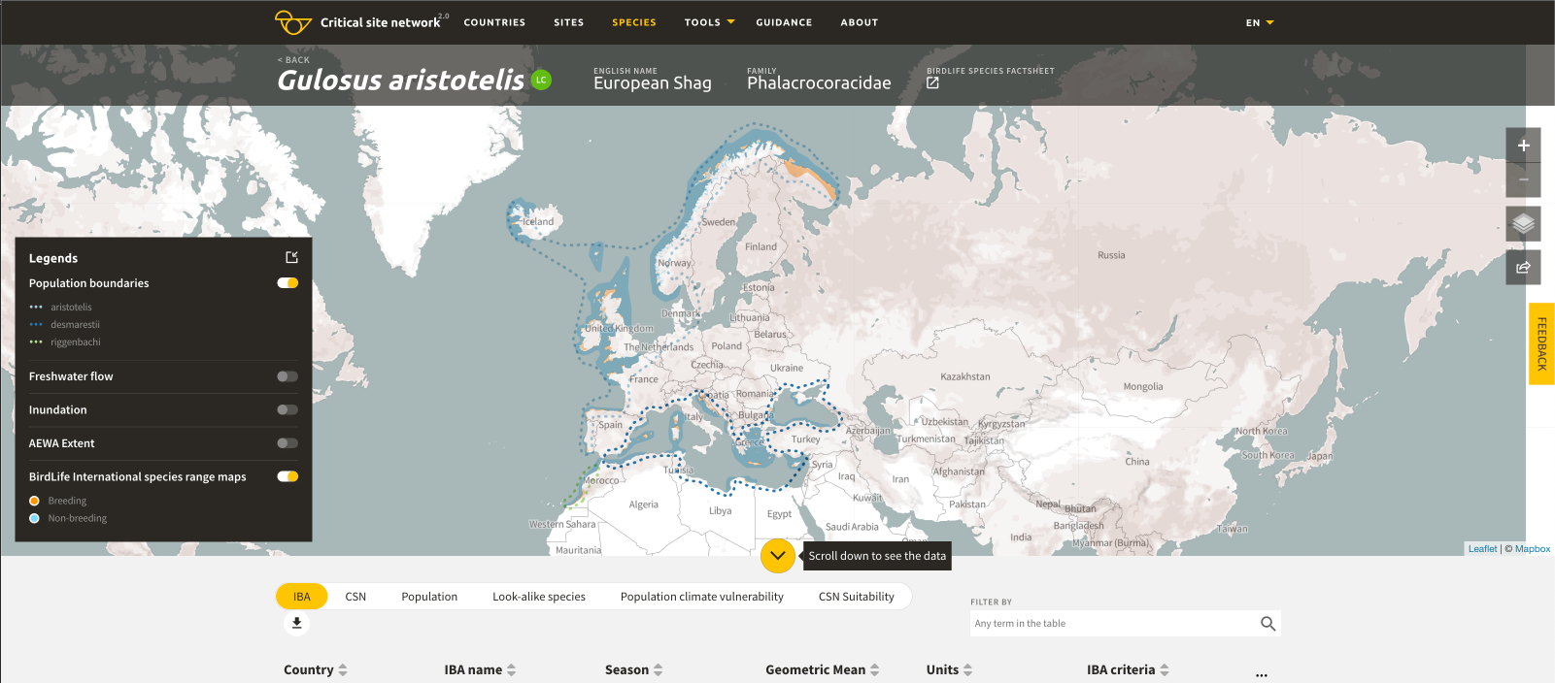

Figure 1. Population delineations for the European Shag as recognised in WPE5.
Source: CSN Tool 2.0 (BirdLife International & Wetlands International, 2018)

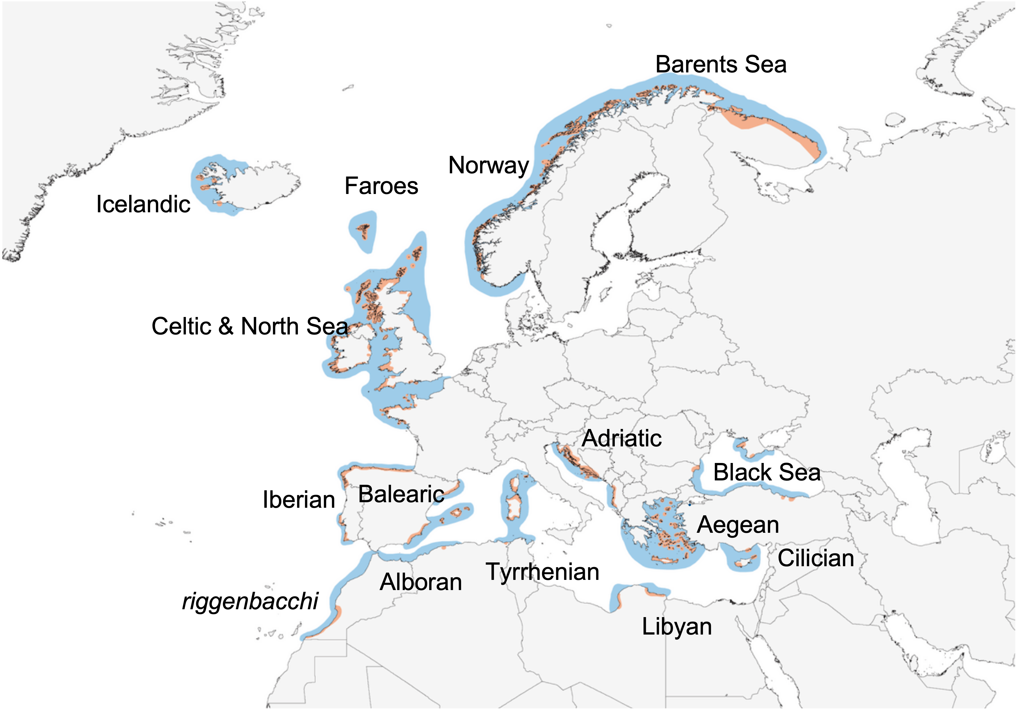

Figure 2. Distinct biogeographic units within the range of the European Shag.

https://tcworkspace.aewa.info/node/680

