DELINEATION OF BIOGEOGRAPHIC POPULATIONS OF THE GLOSSY IBIS
(PLEGADIS FALCINELLUS)

PROPOSAL TO CHANGE POPULATION DELINEATIONS

Compiled by Szabolcs Nagy & Taej Mundkur, Wetlands International

Name of population(s):
Glossy Ibis (Plegadis falcinellus), South-west Asia/Eastern Africa

Current status on AEWA Table 1:
Category 1 of Column B

What is the issue?
Apparently, there is a mismatch between the population definition presented on the CSN Tool (Figure 1) and the treatment of the population in the earlier editions of the Waterbird Population Estimates (WPE) and the first seven editions of the Conservation Status Reports (CSR). The change has possibly taken place during the preparation of flyway boundaries for the first version of the CSN Tool as these boundaries appear already on Figure 3 in Kirby et al. (2008).

Earlier WPEs and CSRs treated the South-west Asia/Eastern Africa and the S, SE Asian (non-bre) populations of Glossy Ibis separately. The definition of the South-west Asia/Eastern Africa population is based on the breeding distribution of birds, while the S, SE Asian population is based on non-breeding distribution. WPE3 and WPE4 (Delany & Scott, 2002; Delany & Scott, 2006) describe their breeding ranges as SW Asia & Caspian and C, S, SE Asia. According to Perennou et al. (1994) “Populations breeding from the North Caspian eastward winter in S and SE Asia where they mix with the resident populations. Populations breeding elsewhere in SW Asia, including the S Caspian region, appear to winter in NE Africa south to the Equator”. In CSR2, Scott (2002) states that “Birds breeding in Southwest Asia (east to the Caspian region) appear to winter mainly in the Middle East and Northeast Africa south to the equator. Populations breeding east of the Caspian appear to winter in Southern Asia, and are therefore extralimital”. However, he has included also the breeding numbers from Kazakhstan, Turkmenistan and Uzbekistan into the population estimates, which is inconsistent with the description he has provided in the same document.

Although, the change of the population boundaries was so far not well documented and has not yet presented to the AEWA Technical Committee for approval, merging the South-west Asia/Eastern Africa with the Central Asian part of the S, SE Asian (non-bre) makes practical sense as it is shown in the evidence section below. Therefore, we propose to change the name of the new population to Caspian & C Asia (bre). We also propose some minor adjustment to the boundaries as outlined on Figure 6.

What is the evidence supporting the proposal?
Analysis of ring recovery data (Santoro et al., 2019) shows that the separation between the NW and W Caspian birds (i.e. Volga Delta, Dagestan and Azerbaijan) is not as clearcut as the descriptions above suggest (Figure 3). There seems to be a considerable movement between these sites and a considerable number of birds migrate also from the N Caspian also to SW Asia. In addition, no ringing data is available from Central Asia. Hence, there is no evidence supporting the assumption that all these birds migrate to S Asia. Ringing data from other regions in the same paper shows that there is far greater variability in the migration orientation of this species.

In the meantime, the breeding distribution of Glossy Ibis has increased a lot in S, E and SE Asia both during the wintering season (Figure 4) and the breeding season (Figure 5) of the northern breeders.

Additional practical considerations include:
- Currently the S, SE Asia (non-br) population is the only one Glossy Ibis population that is defined based on the non-breeding ground. All others are based on the breeding grounds. In the range of the S, SE Asia (non-br) population there is a growing segment of resident birds both in S Asia and in SE Asia. Migrants are likely to mix with the birds breeding in S Asia, but not with the ones in SE Asia. Furthermore, there is probably very little exchange between the birds of S and SE Asia.
- Experience shows that producing population size estimates is almost impossible based on the IWC counts for this species. Perennou et al. (1994) reported total counts for the South-west Asia/Eastern Africa and the S, SE Asian (non-bre) populations at the level of 1,490 and 4,020 individuals respectively while estimated each population to be over 10,000 individuals. Monitoring a colonial breeding bird during the breeding season would make more sense both from monitoring and from the point of view of safeguarding key nesting sites.

These arguments all support redefining the populations of Glossy Ibis in Asia. This means creating a new Caspian & C Asian (bre) population from the South-west Asia/Eastern Africa and from the C Asian part of the former S, SE Asian (non-bre) populations and separating out a S Asian (bre) population and a, E, SE Asian (bre) one (Figure 6). The new delineation of the Caspian & C Asian (bre) takes into account the observations of Glossy Ibis in Socotra and Oman shown by eBird data. However, it ignores the relatively small number of movements from the Caspian towards the Black Sea and East Mediterranean.

What are the implications of the proposal including any changes in status on AEWA Table 1?
There are no implications for the listing of the population in Table 1. Already the estimates from Scott (2002) have included Kazakhstan, Turkmenistan and Uzbekistan. Updated data from these countries were also reported in CSR8.

References

Delany, S., & Scott, D. (2002). Waterbird Population Estimates. Third Edition. Wetlands International.
Delany, S., & Scott, D. (2006). Waterbird Population Estimates: Fourth Edition. Wetlands International.
Kirby, J. S., Stattersfield, A. J., Butchart, S. H., Evans, M. I., Grimmett, R. F., Jones, V. R., . . . Newton, I. (2008). Key conservation issues for migratory land-and waterbird species on the world's major flyways. Bird Conservation International, 18(1), S49.
Perennou, C., Mundkur, T., & Scott, D. A. (1994). The Asian waterfowl census 1987-91: distribution and status of Asian waterfowl. Asian Wetland Bureau.
Santoro, S., Champagnon, J., Kharitonov, S. P., Zwarts, L., Oschadleus, D. H., Mañez, M., . . . Cano-Alonso, L. S. (2019). Long-distance dispersal of the Afro-Eurasian Glossy Ibis from ring recoveries. Stork, Ibis and Spoonbill (SIS) Conservation.
Scott, D. (2002). Report on the Conservation Status of Migratory Waterbirds in the Agreement Area. 2nd edition. http://www.unep-aewa.org/sites/default/files/document/inf2_14_conservation_status_report_0.pdf
Venkatraman, C. (2009). Breeding of Glossy Ibis Plegadis falcinellus at Vedanthangal Waterbird Sanctuary, southern India. Indian Birds, 5(1), 18–19.

Figures

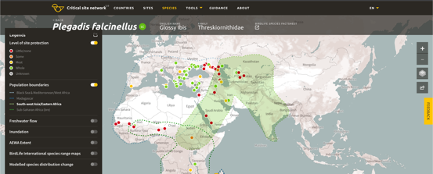

Figure 1. Delineation of the South-west Asia/Eastern Africa population of Glossy Ibis as presented on the CSN Tool.

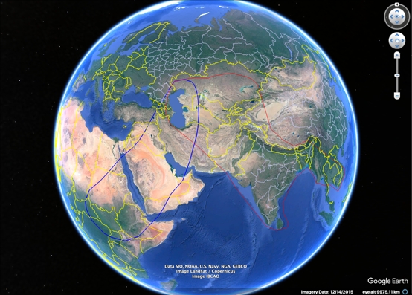

Figure 2. Delineations of the South-west Asia/Eastern Africa and the S, SE Asian (non-bre) populations of Glossy Ibis. Source: Wetlands International, unpublished shapefiles.
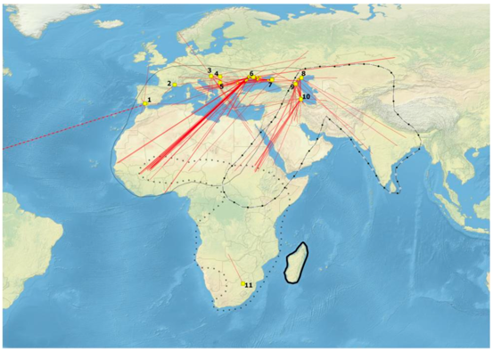

Figure 3. European ringing locations of Glossy Ibis recovered in the Eurasian-African region. The red lines show the dispersal movements from the ringing areas that are yellow squares (main ringing sites) or circles (sporadic ringing sites). The main ringing sites are numbered clockwise starting from (1) Espacio Natural de Doñana (Spain), (2) Camargue wetlands (France), (3) Kis-Balaton (Hungary), (4) Pusztaszer Landscape Protection Area (Hungary), (5) Special Nature Reserve Obedeska Bara (Serbia), (6) Dniestr River Delta (Ukraine), (7) Kuban River (Russia), (8) Volga River Delta (Russia), (9) Dagestan (Russia), (10) Kyzyl-Agach Nature Reserve (Azerbaijan), (11) Benoni (South Africa). The ringing sites (1) and (2) are still active whereas all the others are old (between 1910s and 1990s) ringing programs. One dispersal movement signalled with a dashed red line departs from Doñana wetlands to Virgin Islands (not shown for visual clarity).
Source: Santoro et al. (2019).
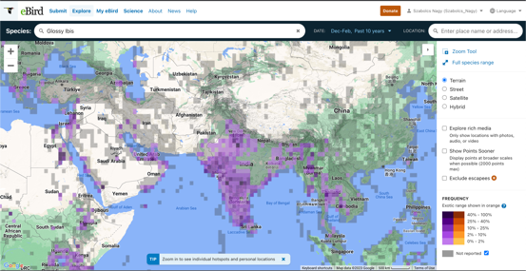

Figure 4. Winter (December – February) distribution of Glossy Ibis is Asia based on eBird data.
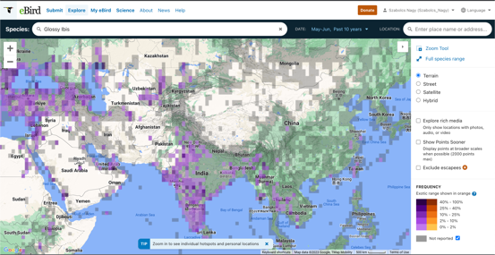

Figure 5. May - June distribution of Glossy Ibis in Asia on eBird data.

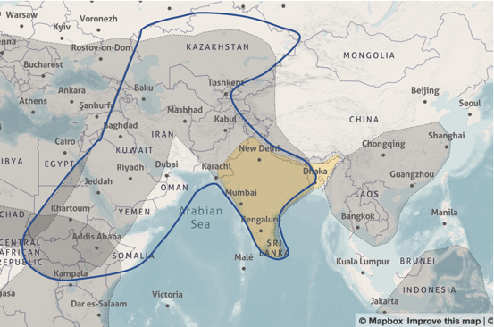
Figure 6. New delineations of the Glossy Ibis populations in Asia as presented on the Waterbird Populations Portal (dotted lines). The solid blue line represents the proposed new boundaries for the Caspian and C Asian (bre) population. The S Asian (bre) population is shown in yellow.

https://ebird.org/map/gloibi?neg=true&env.minX=&env.minY=&env.maxX=&env.maxY=&zh=false&gp=false&ev=Z&excludeEx=&mr=1-12&bmo=1&emo=12&yr=all&byr=1900&eyr=2023
https://ebird.org/map/gloibi?neg=true&env.minX=&env.minY=&env.maxX=&env.maxY=&zh=false&gp=false&ev=Z&excludeEx=&mr=12-2&bmo=12&emo=2&yr=last10
This represents the breeding season of the northerly populations. In S and SE asia, the breeding season probably starts earlier, e.g in S India laying starts in late January (Venkatraman, 2009). Venkatraman, C. (2009). Breeding of Glossy Ibis Plegadis falcinellus at Vedanthangal Waterbird Sanctuary, southern India. Indian Birds, 5(1), 18–19.
https://ebird.org/map/gloibi?neg=true&env.minX=17.32467268429701&env.minY=-3.3604438240894434&env.maxX=127.715297684297&env.maxY=47.915969610727835&zh=true&gp=false&ev=Z&excludeEx=&mr=on&bmo=5&emo=6&yr=last10&byr=2013&eyr=2023
https://wpp.wetlands.org/explore/3758/2531

