GoToMeeting User Guide for Meeting Participants
prepared by the UNEP/AEWA Secretariat

This guide has been prepared by the UNEP/AEWA Secretariat for the participants of AEWA virtual meetings and workshops, to facilitate the use of the GoToMeeting online conferencing platform.

- If you have not already done so, use the following link to download the GoToMeeting application (available for free): https://support.goto.com/meeting/help/download-now-g2m010002.

NOTE: you can also join the meeting via your web browser by clicking on the meeting link without downloading the application. However, we strongly recommend downloading the GoToMeeting application, in order to ensure a stable connection with the meeting as well as the availability of all the various functions outlined further below.
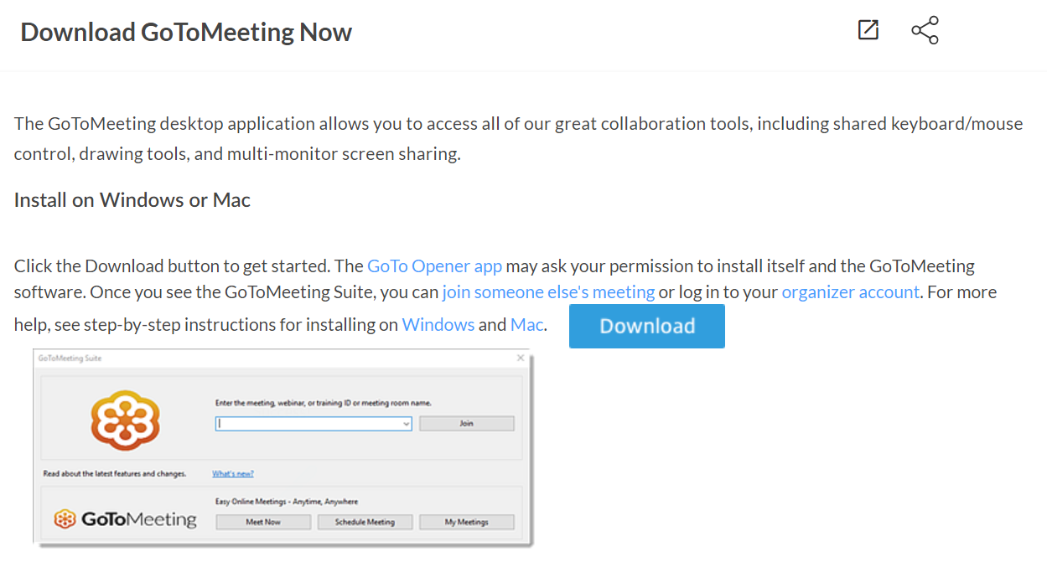
- Once the application is downloaded, install it on your device by pressing on the downloaded file to open it.
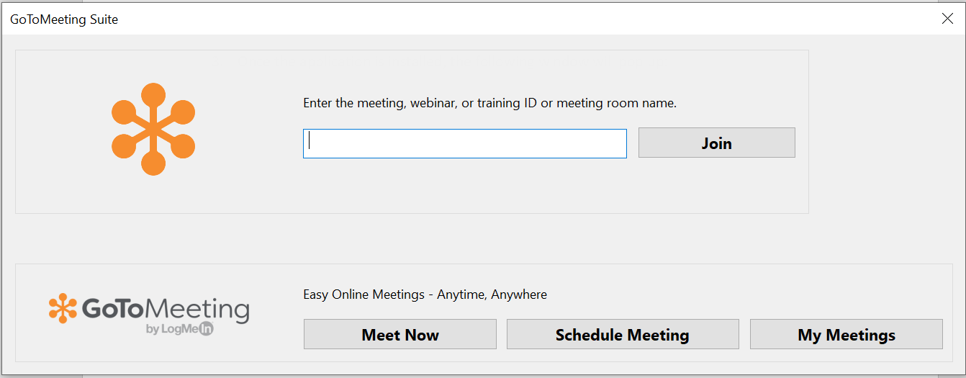
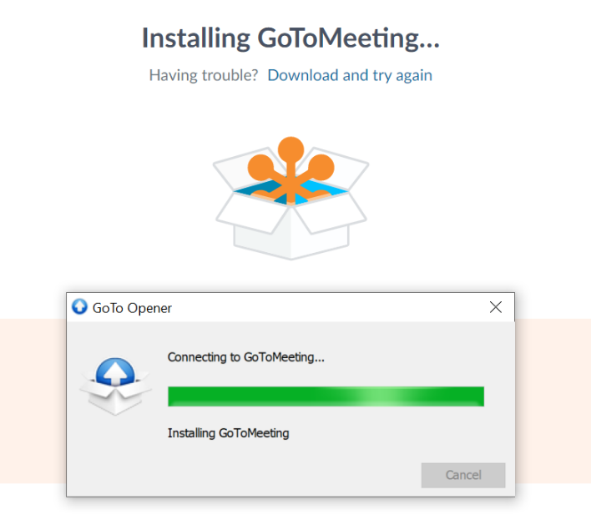
- The following window will pop up when the application is installed. The same window appears on your screen every time you open the GoToMeeting application on your device.
You can join the meeting by entering the access code indicated in the invitation or simply by clicking on the invitation link. Here is an example:
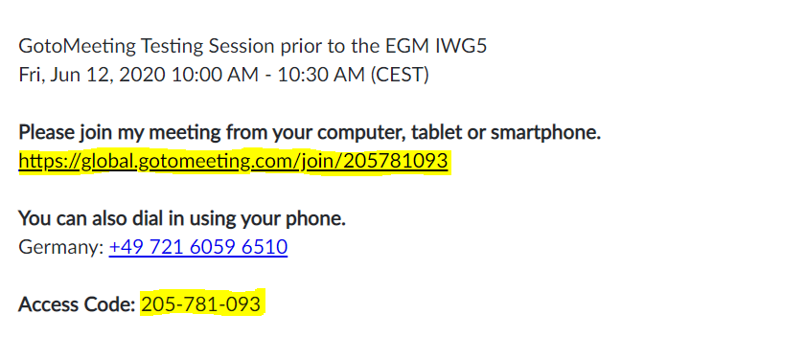

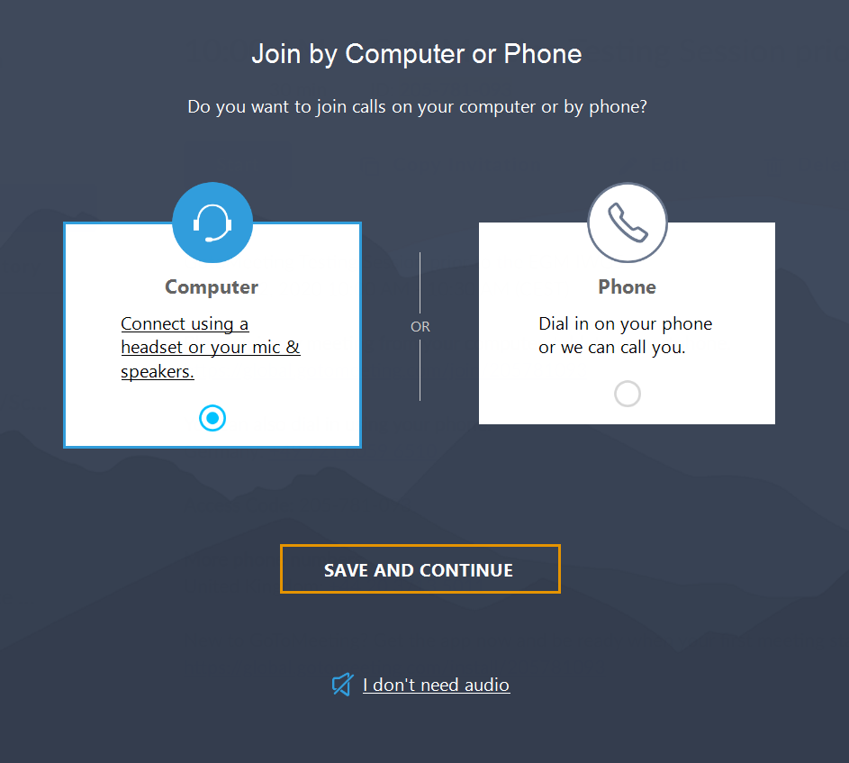
- In the following window which appears next, select the “Computer” option. Please note that you will not be able to participate in the meeting by connecting from your phone.

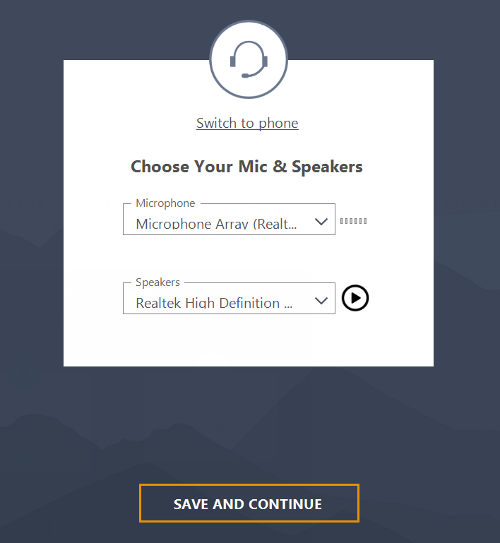
- Select the microphone and speakers that you will be using during the meeting from the drop-down lists. You can also test your speakers by pressing the button next to the drop-down menu.

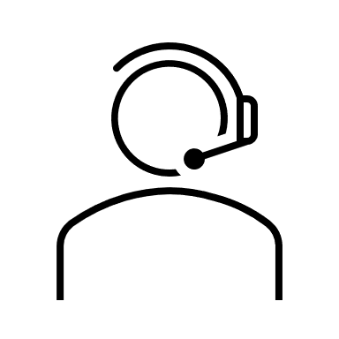
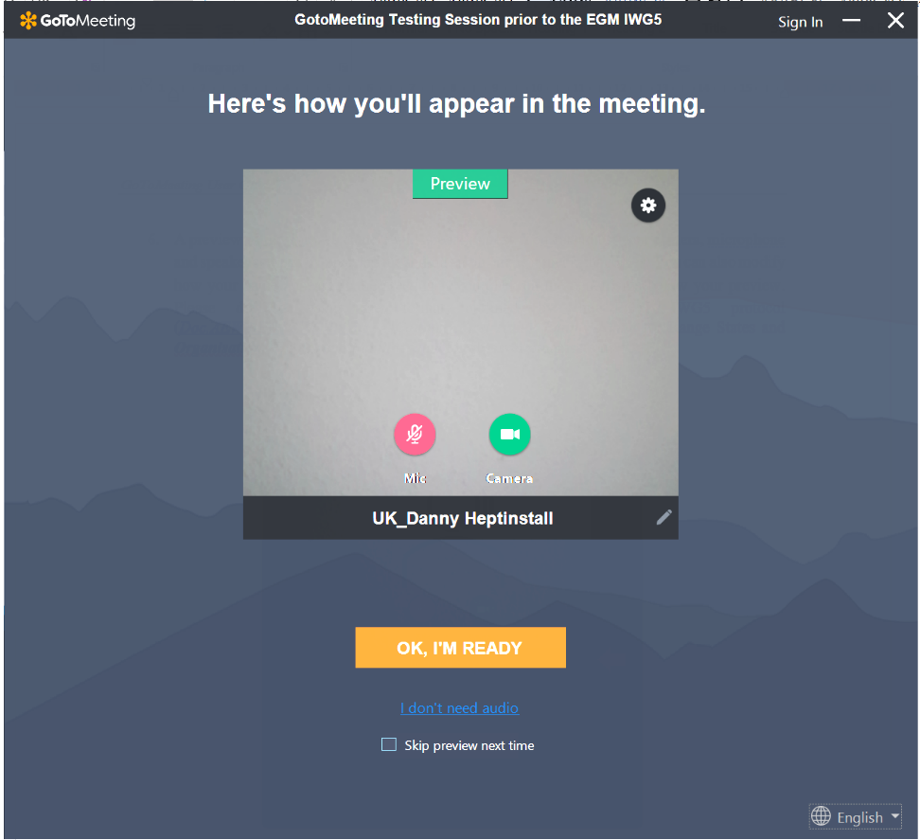
- A preview from your web camera will appear next. You can adjust your camera, microphone and speaker settings by pressing the settings icon on the upper right corner. You can also modify how your name appears in the meeting if you click on the pencil sign below your preview. Please do so by inserting and saving your First Name and your Family Name.

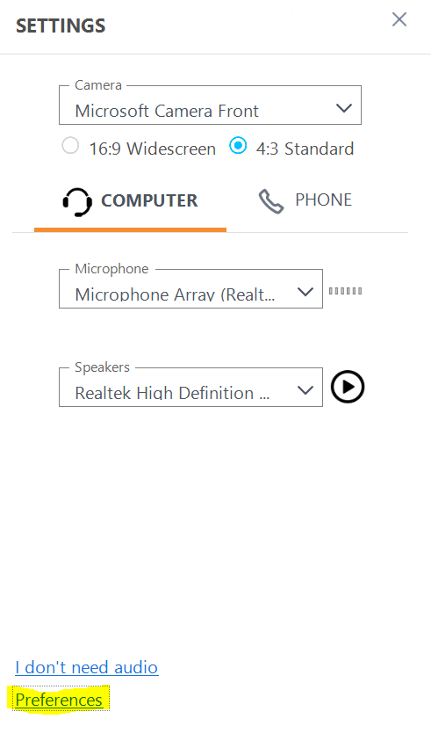
In the pop-up that appears when you click on the settings icon, you can also use the “Preferences” section below for more advanced settings:
- You will enter the call as the next step. Please see the image below for information on the screen icons:
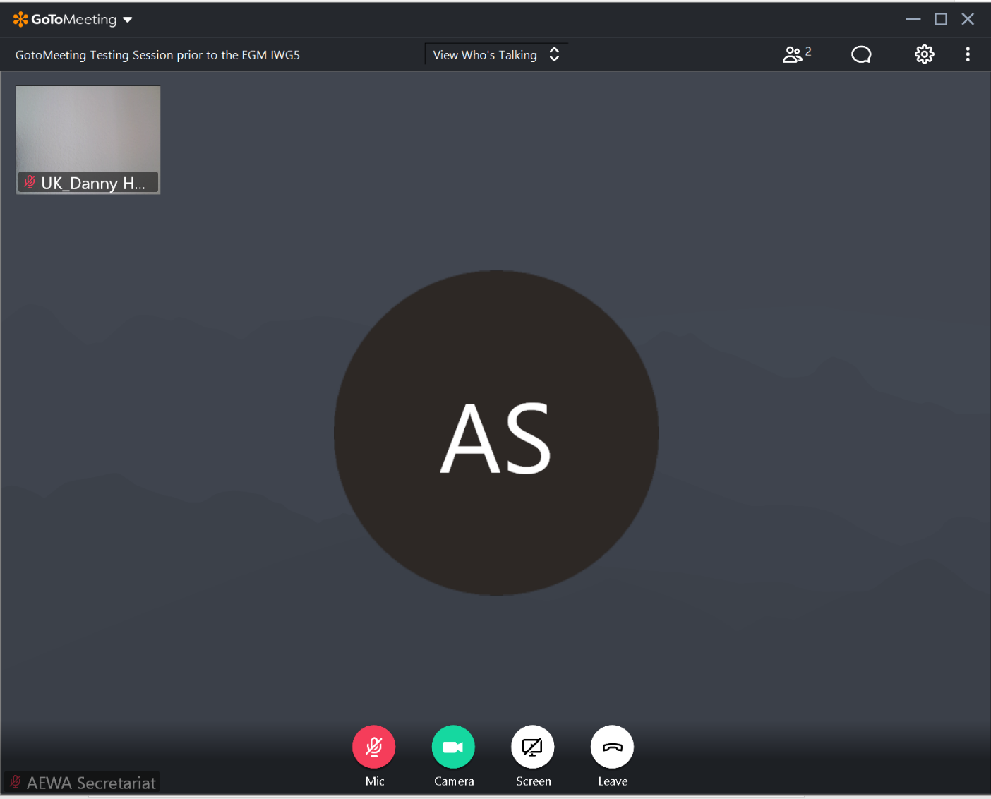

View the list of participants
Rearrange the way you see other participants
Enter the chat
(to be used for speaker queue and questions only)

Switch the web camera on and off (it is recommended to keep the camera on during the meeting)

Share your screen (for presenters)
Mute and unmute the microphone
(please keep muted unless you are speaking)
Access the settings

- You will have an opportunity to zoom in and out on the shared presentation slides if you are joining the conference call using the downloaded GoToMeeting application:
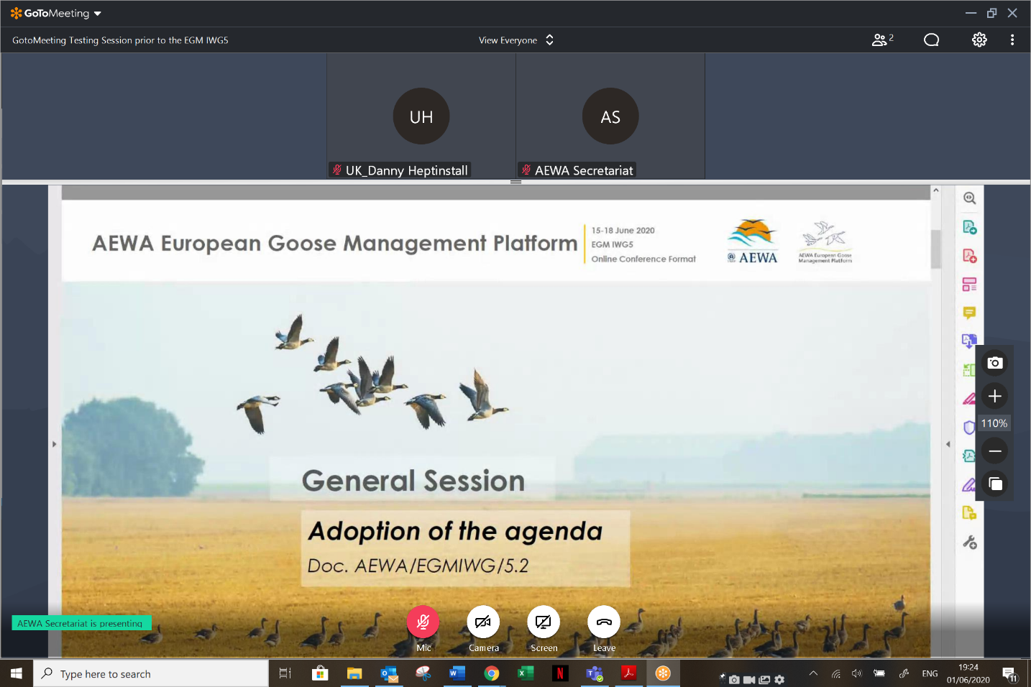
The size of the shared screen can be regulated by dragging this line up or down.

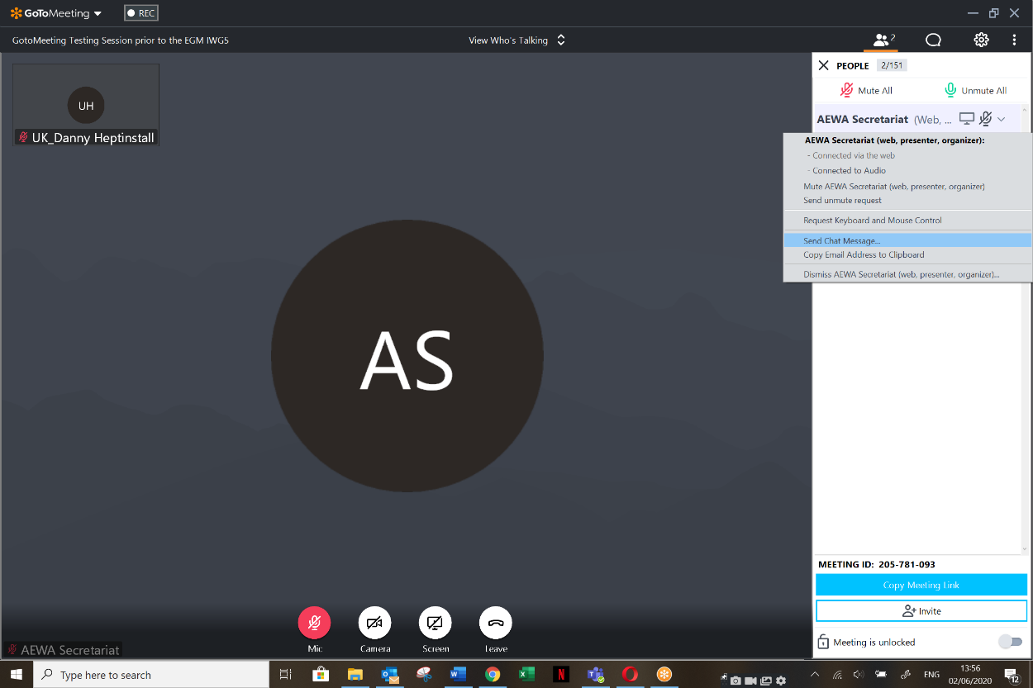
9. If you would like to contact someone from the conference call privately, this option is also available when using the downloaded application. Choose the “Send Chat Message” option after right-clicking on the name of the person in the list of participants.

