15th MEETING OF THE TECHNICAL COMMITTEE
09–11 April 2019, Bonn, Germany

DELINEATION OF BIOGEOGRAPHIC POPULATIONS OF THE GOOSANDER
(MERGUS MERGANSER)

PROPOSAL TO CHANGE POPULATION DELINEATIONS

(Compiled by Richard Hearn and James Robinson, Wildfowl & Wetlands Trust, and David Stroud,
JNCC – UK permanent observer to the Technical Committee)

Name of population(s):

Goosander Mergus merganser (North-west & Central Europe (win))

Current status on AEWA Table 1:

B1

What is the issue?

Scott & Rose (1996) in their mapping of populations of African and Western Eurasian migratory Anatidae indicated a separate status for British breeding Goosander and this led to a separate listing in the second edition of Waterbird Population Estimates.

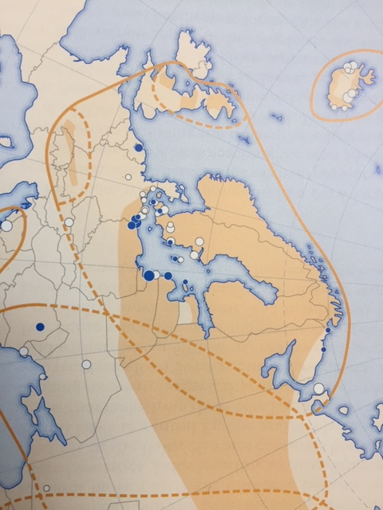

Figure 1. Population delineation of the Goosander (Mergus merganser) according to Scot & Rose (1996).

AEWA currently lists a single “North-west and Central European” population in its Action Plan. The issue has arisen as to whether there is any evidence for a separate status for British breeding Goosanders: in population
terms – can they be considered distinct from other birds breeding in NW Europe?

This paper is drawn from a previous consideration of this issue prepared by James Robinson and Richard Hearn (WWT) for the UK’s SPA and Ramsar Scientific Working Group (SPAR SWG).

Two questions were posed:

1. Should the British-breeding population of Goosanders be considered discrete from that in the rest of Northwest and central Europe, and what scientific evidence can be used to justify a change to the delimitation recommended by Wetlands International?

2. If the British population is deemed to be discrete, is there a need to treat the wintering population as one or a mixture, using different thresholds for different parts of the country, e.g. British 1% threshold for sites above the Humber-Severn line and Northwest and Central Europe 1% threshold for sites below this line, following the proposals by JNCC for other waterbirds?

What is the evidence supporting the proposal?

Subsequent review by the UK’s SPAR SWG found little evidence for Wetlands International’s original suggestion that British breeding Goosanders formed a separate group discrete from those elsewhere in NW Europe. The evidence to that end is summarised in Appendices 1 and 2.

The SPAR SWG concluded that:
“It was agreed that birds breeding in the UK can be considered migratory as a large proportion of the population regularly moves to moulting areas in Norway. In addition, there are regular influxes of continental birds into parts of the UK in winter, where they mix with UK birds. However, there is relatively little ringing information and so the degree of exchange between UK and continental birds remains uncertain.”

AEWA’s Action Plan currently does not list a separate British ‘population’ (contra Scott & Rose 1996).

What are the implications of the proposal including any changes in status on AEWA Table 1?

There is no proposal to change the current AEWA Action Plan listing for Goosander as there appears to be no evidence on which to suggest a change.

Appendix 1: Original paper to SPAR SWG (September 2004)

Treatment of Goosander populations in the UK

Background

In 1996, an atlas of Anatidae populations in Eurasia was published by Wetlands International (Scott & Rose 1996). This presented best available information on biogeographic limits for wildfowl populations and informed the second edition of Waterfowl Population Estimates (Rose & Scott 1997) which adopted the population proposed.

Although the Goosander Mergus merganser population in Britain was not considered separate from the Northwest and central Europe population in Scott & Rose (1996), it was adopted as separate by Rose & Scott (1997) [in the second edition of Waterbird Population Estimates]. Scott & Rose (1996) suggested that there is some justification for treating the British breeding population and central European population as separate populations. The decision by Rose & Scott (1997) appears to have been based on this statement. At that time, the proposed population split (as it affected the UK) was not accepted by the UK [statutory conservation agencies’] Inter-agency Ornithology Liaison Group as it was considered unsupportable on the basis of the information presented.

The proposed population was again used in the recently published third edition of Waterfowl Population Estimates (Wetlands International 2002). As an instance where UK statutory use differs from this international standard reference, it is timely that the SPA Scientific Working Group review the previous decision, especially in the light of more recently available information sources such as the BTO’s recently published Migration Atlas.

Definition of biogeographic population

The UK SPA Review uses the following definition of biogeographic population:

"A biogeographical population is a group of birds which breed in a particular location (or group of locations), interbreed freely within the group, and rarely breed or exchange individuals with other groups."

The Ramsar Convention uses the following definition (drawn directly from the definition used by Scott & Rose 1996):

biogeographical population - several types of ‘populations’ are recognized:
i. the entire population of a monotypic species;
ii. the entire population of a recognized subspecies;
iii. a discrete migratory population of a species or subspecies, i.e., a population which rarely if ever mixes with other populations of the same species or subspecies;
iv. that ‘population’ of birds from one hemisphere which spend the non-breeding season in a relatively discrete portion of another hemisphere or region. In many cases, these ‘populations’ may mix extensively with other populations on the breeding grounds, or mix with sedentary populations of the same species during the migration seasons and/or on the non-breeding grounds;
v. a regional group of sedentary, nomadic or dispersive birds with an apparently rather continuous distribution and no major gaps between breeding units sufficient to prohibit interchange of individuals during their normal nomadic wanderings and/or post-breeding dispersal.
Guidance on waterbird biogeographical populations (and, where data is available, suggested 1% thresholds for each population) is provided by Wetlands International, most recently in Rose & Scott (1997), with more detail for Anatidae populations in Africa and western Eurasia given in Scott & Rose (1996).

Mergus merganser merganser: international population estimates and 1% thresholds

The Goosander is present in temperate and boreal zones throughout almost the entire Holarctic (Scott & Rose 1996). The nominate race merganser breeds across northern Eurasia and Iceland and Britain to the Bering Sea, with around 1,000 pairs in the Alps and small numbers in southern Europe. Wetlands International (2002) currently identifies seven biogeographic populations of this race:

Population | Population estimate
NW & C Europe (non-br) | 250,000
Iceland | 900
Scotland, N England, Wales | 16,100
Central west Europe (br) | 2,670-3,400
Balkans (br) | 50-100
Black Sea (non-br) | 10,000
Caspian Sea (non-br) | 20,000

In the past, the UK statutory agencies have adopted the Northwest and Central European 1% threshold to select sites of international importance in the UK. According to Wetlands International (2002), the threshold for the Northwest and Central European population is 2,500. The threshold for Scotland, Northern England and Wales population is 160.

Given that the UK’s statutory bodies adopted the use of the Northwest and Central European threshold for site selection in the UK, any changes to this decision could have implications for the SPA suite for this species. Five-year count means presented in the most recent edition of Wildfowl & Wader Counts indicate that, if the British threshold was adopted, three WeBS sites in northern Britain would qualify as internationally important: Tay Estuary, Hirsel Lake and Lower Derwent Valley (Pollitt et al. 2003). Of these, only Hirsel Lake is not within an existing SPA boundary. The current SPA suite comprises two sites: Firth of Tay and Eden Estuary and Inner Moray Firth, both selected at Stage 1.3, i.e. within an assemblage of 20,000 birds or more (Stroud et al. 2002).

Seasonal phenology

The Wetland Bird Survey (WeBS) counts Goosanders at sites throughout the UK on priority dates throughout the year, but primarily between September and March (Pollitt et al. 2003). It is worth noting that peak numbers of Goosanders counted in the winter are almost three times higher than the estimated number of breeding birds in the UK (Gregory et al. 1997). WeBS, however, counts only around a third of the total number of wintering birds in the UK (Kershaw & Cranswick 2003).

Differences in site coverage between months mean that phenological changes through the winter cannot be reliably detected using count totals alone. Consequently, an index is calculated for each month to reflect changes in relative abundance during the season. Monthly WeBS indices for Goosander indicate that there is an increase in the numbers of birds present in Britain during the winter, numbers peaking in January and February (Fig. 1).

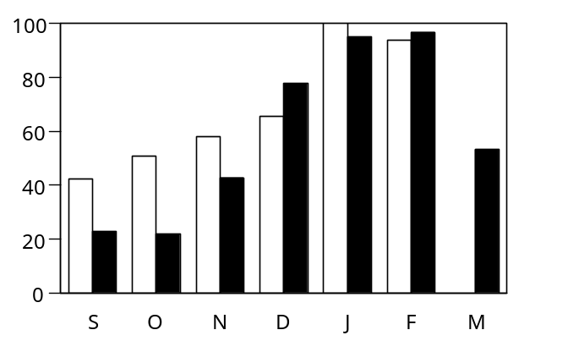
Fig. 1. Monthly indices for Goosander in Britain (white bars 1999-2000; black bars 1994-95 to 1998-99). From Pollitt et al. (2003)

Although WeBS does not currently produce regional trends, it is apparent from the tables of nationally important sites in Wildfowl & Wader Counts that peak counts at sites in northern England and Scotland generally occur much earlier in the winter, suggesting the late winter peaks at a national level are driven by increases at less important sites in the south of England or from influxes of birds from sites and habitats not counted by WeBS, e.g. rivers, to those surveyed by WeBS. It has been suggested that between 500 and 1,000 Goosanders move to the UK from the continent during the winter months (Kershaw & Hughes 1997).

Movements

The ringing of Goosanders in the UK and abroad has been limited. A total of 1,292 birds have been ringed, 160 of those being recovered subsequently (Little & Marchant 2002). There have been six recoveries of foreign-ringed birds in the UK. Unfledged ducklings and attendant females can be caught on natal rivers using mist nets stretched across the width of the waterway (e.g. Meek & Little 1977) and some breeding females have been ringed at the nest, in boxes or natural sites, during late incubation. During the breeding season, most metal ringing has occurred in Northumberland or in the Borders. Some birds marked at this time have been fitted with plastic wing-tags that allow observations of movements without the need to recover the bird in the hand. During the winter months, birds are most regularly caught in large duck-traps in the southeast of England.

British breeding birds are almost entirely resident, although males move to Norway to moult before returning to the UK for the winter (Little & Furness 1985). Like most duck species, recoveries indicate that most Goosanders (males and females) spend the winter within 150 km of their natal or breeding sites, although dispersal ranges vary markedly between individuals. Birds wing-tagged as ducklings in Northumberland, and those tagged as fully-grown adults in the Borders, spread southwards into southern Scotland and south to the English Midlands during the winter. The degree of penetration into southern England appears to have increased at the same time as the breeding range has extended south. Sightings of wing-tagged individuals suggest that some British breeding females are even site faithful. Recoveries of British-bred birds on the continent during the breeding season indicate that there is possibly some abmigration of males (i.e. permanent movement from the British population to the Northwest & Central European population). There are, however, no records of foreign-ringed Goosanders recovered as breeding birds in the UK, so the degree of mixing remains unknown.

Only one ring recovery has shown a British-bred bird penetrating as far south as the areas where the species is purely a non-breeding visitor, i.e. in Southeast England. No wing-tagged birds from Northern Britain have been observed this far south. Ringing recoveries indicate that the majority of Goosanders of both sexes in lowland England are winter visitors from the Northwest and Central European population, especially from those breeding grounds in northern Fennoscandia and western Russia. The single recovery of a foreign-ringed bird away from Southeast England (a bird ringed as a duckling in Norway and recovered in Lancashire in December) indicates that there may be a small amount of mixing of continental and British-bred birds in the winter. This mixing may be particularly marked during periods of harsh weather on the continent when many continental-bred birds may move to the UK (Chandler 1981). However, it is not known whether birds from the continent stay to breed in the UK.

Caution should be urged when interpreting the evidence from ringing and wing-tagging studies involving so few recoveries and such limited geographical scope. However, these are the best available data on which to make decisions about population delimitation at this time. An investigation of the numbers of Goosanders ringed and subsequently recovered in countries through Northwest Europe may provide further information of the magnitude of movements of birds between Britain and Northwest Europe. However, this analysis would not determine whether there is any interbreeding between birds in the British and Northwest/Central European populations.

To assess the integrity of proposed populations more directly, it will be necessary to determine the genetic structure of potentially separate groups. This should be a priority for future research on population delimitation in this species.

Issues to be resolved

- Should the British-breeding population of Goosanders be considered discrete from that in the rest of Northwest and central Europe, and what scientific evidence can be used to justify a change to the delimitation currently recommended by Wetlands International?

- If the British population is deemed to be discrete by this group, is there a need to treat the wintering population as one or a mixture, using different thresholds for different parts of the country, e.g. British 1% threshold for sites above the Humber-Severn line and Northwest and Central Europe 1% threshold for sites below this line, following the proposals by JNCC for other waterbirds?

References

Chandler, R.J. 1981. Influxes into Britain and Ireland of Red-necked Grebes and other waterbirds during winter 1978/79. British Birds 77: 479-481.
Gregory, R.D., Carter, S.P. & Baillie, S.R. 1997. Abundance, distribution, and habitat use of breeding Goosanders Mergus merganser and Red-breasted Merganser Mergus serrator on British rivers. Bird Study 44: 1-12.
Kershaw, M. & Hughes, B. 1997. Trends in the numbers of Cormorants Phalacrocorax carbo, Goosanders Mergus merganser and Red-breasted Merganser M. serrator wintering in the UK. Report to the British Trust for Ornithology.
Little, B. & Furness, R.W. 1985. Long-distance moult migration by British Goosanders Mergus merganser. Ringing & Migration 6: 77-82.
Little, B. & Marchant, J.H. 2002. Goosander Mergus merganser. In Wernham, C.V., Toms, M.P., Marchant, J.H., Clark, J.A., Siriwardena, G.M. & Baillie, S.R. (eds.) 2002. The Migration Atlas: movements of the birds of Britain and Ireland. T. & A.D. Poyser, London. Pp. 219-221.
Meek, E.R. & Little, B. 1977. Ringing studies of Goosanders in Northumberland. British birds 70: 273-283.
Pollitt, M.S., Hall, C., Holloway, S.J., Hearn, R.D., Marshall, P.E., Musgrove, A.J., Robinson, J.A. & Cranswick, P.A. 2003. The Wetland Bird Survey 2000-01: Wildfowl & Wader Counts. BTO/WWT/RSPB/JNCC, Slimbridge.
Rose, P.M. & Scott, D.A. 1997. Waterfowl Population Estimates – Second Edition. Wetlands International Publication 44, Wageningen, The Netherlands.
Scott, D.A. & Rose, P.M. 1996. Atlas of Anatidae Populations in Africa and Western Eurasia. Wetlands International Publication 41, Wageningen, The Netherlands.
Wetlands International. 2002. Waterbird Population Estimates – Third Edition. Wetlands International Global Series No. 12, Wageningen, The Netherlands.

James Robinson, WWT & David Stroud, JNCC
Appendix 2. Updated assessment of evidence for the delineation of British Goosanders (2015)

More recent editions of Waterbird Population Estimates (WPE), Wetlands International now include Britain within the Northwest and Central Europe population. In WPE5, this population is estimated to have a size of 266,000 and a 1% threshold of 2,700. Thus, no sites in the UK meet the qualifying threshold for international importance. However, the inclusion of the UK within the Northwest and Central Europe population of Goosander means that this species should be included in the 2010 SPA Review as a migratory waterbird.

Nevertheless, the evidence for this treatment remains somewhat weak and similar to that outlined in the original paper to SPAR SWG, but on balance this is still the most appropriate treatment. Although there remains a lack of ring recovery information for this species, new analyses of national and international count data provide some additional support to the inclusion of British Goosanders in the Northwest and Central Europe population.

These count data show that the trend in the UK has declined since the mid-1990s, in line with trends elsewhere in western Europe and a shift towards the north and east, where there have been large increases (Lehikoinen et al. 2013). This suggests that migratory Goosander certainly wintered in the UK, and this is further supported by the rapid increase in numbers that has occurred in recent winters when significantly colder than average weather presumably led to an increase in the number of migrant Goosander visiting the UK (Figure 1). This also suggests that migratory Goosander still winter in the UK, even if this has probably become less regular.

Figure 1. Index of Goosander trend in the UK based on WeBS data (Holt et al. 2012).

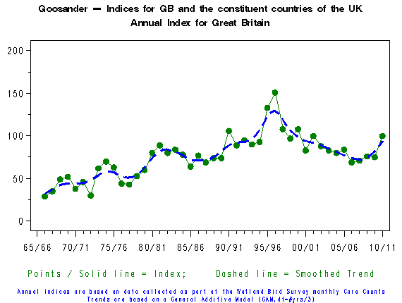

Furthermore, new national trends for England, Scotland and Wales show that the trend for England is very similar to the overall UK trend, whereas in Scotland numbers are largely stable, and in Wales Goosander is increasing. This is in line with the increasing British-breeding population being largely sedentary and that significant numbers of migratory Goosander do not winter in Scotland and Wales.

Thus, the original assertion [of Scott & Rose 1996] seems to hold true, i.e. that British-breeding Goosander, found predominantly in Scotland and Wales, disperse locally during the non-breeding season (with some moving to England) and migratory Goosander from continental Europe are found predominantly in England during winter (Little & Marchant 2002). Further, it is this English-wintering migratory component of the UK winter population that is driving the overall UK trend (a decline of 31% during 1998/99 – 2008/09; Eaton et al. 2012).

The consequences of shifting distribution

As highlighted above, a recent analysis of international count data held by the International Waterbird Census (Lehikoinen et al. 2013) found that Goosander has shifted its winter range to the north and west, with a large decrease having occurred in the Netherlands and a large increase in Finland. Although the UK was not included in that analysis because of the relatively small numbers of Goosander thought to be wintering that far west and the confounding issue of the largely sedentary British-breeding population, as outlined above, this analysis and WeBS trends support the fact that migratory Goosander still winter in the UK.

However, the population sizes of the breeding and wintering populations have recently been estimated as 3,500 pairs and 12,000 individuals, respectively (Musgrove et al. 2013), which are rather similar, suggesting that there may now not be many migratory Goosander in the UK during winter. Thus, given this shift in winter distribution and the decreasing and now apparently small number of migratory Goosander wintering in the UK, the delineation of this species may require reassessment in the future as it would seem that the British-breeding population could be moving closer to a status more comparable to outlying populations currently treated as discrete, namely the Iceland, Central west Europe and Balkans populations (Figure 2).

Figure 2. Current delineation of European Goosander populations (from Wetlands International).

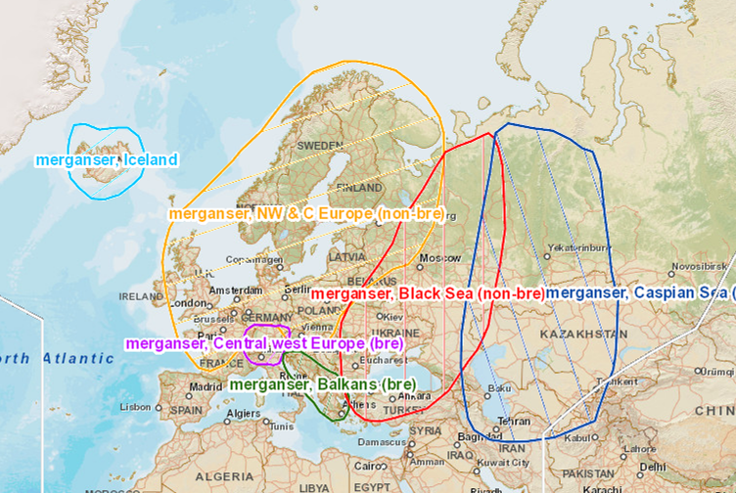

This may mean that if current trends continue, the continued treatment of the UK population as part of the Northwest and Central Europe population may be increasingly difficult to justify. It is recommended that this issue is reviewed again as part of the next UK SPA Review.

References

Eaton, M.A., R. Cuthbert, E. Dunn, P.V. Grice, C. Hall, D.B. Hayhow, R.D. Hearn, C.A. Holt, A. Knipe, J. Marchant, R. Mavor, N.J. Moran, F. Mukhida, A.J. Musgrove, D.G. Noble, S. Oppel, K. Risely, D.A. Stroud, M. Toms & S. Wotton. 2012. The state of the UK’s birds 2012. RSPB, BTO, WWT, CCW, JNCC, NE, NIEA and SNH, Sandy, Bedfordshire.

Holt, C.A., G.E. Austin, N.A. Calbrade, H.J. Mellan, R.D. Hearn, D.A. Stroud, S.R. Wotton & A.J. Musgrove. 2012. Waterbirds in the UK 2010/11: The Wetland Bird Survey. BTO/RSPB/JNCC, Thetford.

Lehikoinen, A., K. Jaatinen, A. Vähätalo, P. Clausen, O. Crowe, B. Deceuninck, R.D. Hearn, C.A. Holt, M. Hornman, V. Keller, L. Nilsson, T. Langendoen, I. Tománková, J. Wahl & A.D. Fox. 2013. Rapid climate driven shifts in wintering distributions of three common waterbird species. Global Change Biology 19: 2071-2081.

Little, B. & J.H. Marchant. 2002. Goosander. In: Wernham, C.V., M.P. Toms, J.H. Marchant, J.A. Clark, G.M. Siriwardena & S.R. Baillie. 2002. The Migration Atlas: Movements of the Birds of Britain and Ireland. T. & A.D. Poyser, London.

Musgrove, A.J., N.J. Aebischer, M.A. Eaton, R.D. Hearn, S.E. Newson, D.G. Noble, M. Parsons, K. Risely & D.A. Stroud. 2013. Population estimates of birds in Great Britain and the United Kingdom. British Birds 106: 64-100.

Richard Hearn, WWT

http://jncc.defra.gov.uk/docs/The%20status%20of%20Goosanders%20in%20the%20UK%20-%20final%20version%20for%20SPAR%20SWG%20(16Feb15).doc
Stroud, D.A., Chambers, D., Cook, S., Buxton, N., Fraser, B., Clement, P., Lewis, P., McLean, I., Baker, H. & Whitehead, S. (eds.) (2001). The UK SPA network: its scope and content. JNCC, Peterborough. Three volumes. (90 pp; 438 pp; 392 pp)
Published online at http://wpe.wetlands.org
Available at http://blx1.bto.org/webs-reporting
Using the standard calculation of three times the number of pairs to calculate population size, i.e. 3,500 x 3 = 10,500 birds

