15th MEETING OF THE TECHNICAL COMMITTEE
09–11 April 2019, Bonn, Germany

DISCUSSION PAPER ON ESTABLISHING A PROCEDURE FOR THE DEVELOPMENT, ISSUANCE AND UPDATING OF CONSERVATION AND MANAGEMENT GUIDANCE FOR AEWA POPULATIONS

Compiled by the AEWA Secretariat and Wetlands International

Background

Target 1.3 of the AEWA Strategic Plan 2019-2027 foresees that science-based conservation and management guidance should be available for all other priority populations not covered by International Species Action Plans according to Target 1.2 or International Species Management Plans according to Target 2.4. This approach was introduced by the AEWA Strategic Plan in recognition of the fact that populations listed in Table 1 Column A, Categories 1(a) and 1(b), as well as Column A populations marked with an asterisk as well as Near Threated populations in Category 4 of Column A of the AEWA Action Plan represent priorities for the development of International Species Action Plans.

In addition, however, efforts by Range States and relevant stakeholders to halt the decline and assist the recovery of a large number of populations listed in Table 1 Category 1 (c), Category 2 or Category 3 in column A or Category 2 in Column B of the AEWA Action Plan should be supported through simplified conservation and management guidance.

As foreseen in the AEWA Strategic Plan and the Plan of Action for Africa, by the end of 2019, the AEWA Technical Committee is expected to:

- conduct a rapid review of existing information to identify relevant populations for which new or improved conservation and management guidance is required for AEWA purposes and;

- agree roles, responsibilities and mechanisms for updating of guidance and preparation/dissemination of new guidance.

By AEWA MOP10, the Strategic Plan foresees that Parties shall implement actions to reduce threats to populations with unfavorable conservation status where they support more than 1% of the biogeographic population.

Establishing a procedure for the development, issuance and updating of AEWA conservation and management guidance for select populations

- Assessment and prioritisation of populations concerned

It is proposed that the assessment and prioritisation of populations for the development of AEWA conservation and management guidance be undertaken by the Technical Committee after each Session of the Meeting of the Parties in connection with the prioritisation exercise for AEWA International Species Action and Management Plans, which is already a rolling task assigned to the Committee.

The Strategic Plan foresees that the assessment and subsequent prioritisation for the development of guidance should be undertaken for those populations listed in Table 1 Category 1 (c), Category 2 or Category 3 in Column A or Category 2 in Column B of the AEWA Action Plan on the basis of population status and trend assessment (as outlined in the latest available edition of the AEWA Conservation Status Report).

A first such assessment and prioritisation has been undertaken as a basis for discussions at this meeting. All populations listed on Columns A, B and C of Table 1 were considered for the development of conservation and management guidance – not merely those populations foreseen in the Strategic Plan.

This approach was chosen to account for the following factors:

- Species/populations prioritised for action planning or management planning with recovery objective, but for which no expressions of interest or support exist to develop Plans in the near future would, in fact, benefit most from the issuance of conservation or management guidance. Amongst them, the globally threatened and near-threatened species are seen as the first priority for receiving such guidance. The remit foreseen in the Strategic Plan would have omitted the top priority species/populations from the exercise. Issued guidance would become obsolete and could be removed from the AEWA website once a Species Action or Management Plan is developed and adopted for the species in question.

- In addition to the primary priority species/populations mentioned above (globally threatened and near-threatened), priority should generally be given to populations in decline – irrespective of their listing on Table 1 (for example prioritising populations listed in Column A Categories 2 or 3 in decline over populations listed in Category 1 (c) with a stable or increasing trend).

- The guidance will be most effective if issued per species, and therefore a priority species list (with relevant populations indicated) has been created on the basis of the overall prioritisation of all relevant populations. This species list presented in Annex III shows the suggested prioritisation for the production of guidance during this triennium (2019-2021).

The prioritisation was subsequently carried out for all AEWA populations listed according to the following criteria consecutively:

For globally threatened and Near-Threatened species:
- Red List status;
- The geomean of the AEWA populations for the species.

For all other species with populations in significant long-term decline:
- The proportion of the AEWA populations in decline;
- The geomean of the AEWA populations for the species.

This methodology leads to a total of 84 species prioritized for conservation/management guidance (Annex III).

- Roles, responsibilities and mechanisms for updating of guidance and preparation/dissemination of new guidance

Following approval of the updated assessment and prioritisation at its first meeting after each MOP, the Committee will be invited to discuss possible available capacity within the Committee to produce guidance and/or the need to outsource some of the work.

In general, it is suggested that guidance for the conservation and management of prioritised species/populations be issued following approval by the Technical Committee on a rolling basis throughout the triennium. Draft guidance would be approved via the Technical Committee Workspace, as they become available.

Regarding the review of guidance issued by the Committee, it is suggested that these could also be updated on a rolling basis when and if new information regarding the species/population in question comes to light (new research, updates to the Species Fact Sheet on the BirdLife International Datazone etc.).

It is suggested that issued guidance be comprehensively reviewed by the Technical Committee members every ten years in conjunction with the overall assessment and prioritisation of species/populations.

It is further suggested that finalisation (i.e. formatting to fit agreed format) and dissemination of issued guidance following approval by the Technical Committee be handled by the AEWA Secretariat. This would include disseminating the guidance directly to the government contact points in relevant Range States, but also featuring the guidance on the species pages of the AEWA website.

- Format

As a starting point for the envisaged science-based conservation and management guidance, the AEWA Strategic Plan already indicates that some advice can be found in the Ecology and Threats sections on the Text Account tab of the relevant Species Fact Sheets in the BirdLife International Data Zone. In 2008, under the framework of the Wings Over Wetlands Project, the ecology sections were updated with information on behavior, habitat, diet, breeding sites and management information based on a literature review. Two such Fact Sheets have been attached below in Annex II as examples (Whooper Swan (Cygnus cygnus) and White-backed Duck (Thalassornis leuconotus)).

Whilst the BirdLife Fact Sheets provide a very good starting point for the envisaged AEWA Species conservation and management guidance, it is suggested to develop a specific simple format fit for AEWA purposes with updated information per population as listed under the Agreement – rather than referring Parties directly to the BirdLife Fact Sheets alone. This will allow to cater for AEWA-specific information, such as the current conservation status of various populations recognised under AEWA and the legal obligations of Contracting Parties resulting thereof.

It is suggested that the information provided in the BirdLife Fact Sheets serve as the basis for populating the AEWA guidance, in close collaboration with BirdLife International. BirdLife (as well as any other co-authors of the BirdLife Fact Sheets) would be appropriately referenced. Any new or updated information arising during the preparation of the AEWA guidance, would also be fed back to BirdLife for insertion into the Fact Sheets, as appropriate.

It is proposed that the format be two pages maximum and that the logic follow that of the revised format for AEWA International Single Species Action Plans adopted at MOP7. Maps outlining the delineation of AEWA-listed populations per species could be obtained from the Critical Site Network tool. A draft format for discussion and adoption is provided below in Annex I.

- Overview of the process with respective timelines

Steps | Timeline | Lead
Assessment and prioritisation of relevant populations for development of new AEWA conservation and management guidance | After each MOP, before 1st TC meeting in the new triennium | AEWA Secretariat on behalf of the TC
Development of guidance for prioritised species/populations | Following decision taken by TC at its 1st meeting after each MOP | TC members and AEWA Secretariat as well as other identified experts
Approval of guidance | On a rolling basis throughout the triennium via the TC workspace as new/updated guidance becomes available | TC members
Review and possible update of issued guidance | On a rolling basis as new information becomes available, but with a thorough check every 10 years | TC members and AEWA Secretariat as well as other identified experts
Dissemination and posting on AEWA website | On a rolling basis throughout the triennium via direct correspondence with relevant range states and by uploading adopted guidance on species webpage on AEWA website | AEWA Secretariat

Action expected from the AEWA Technical Committee:

The Technical Committee is invited to discuss and decide on the procedure (including prioritisation and format) for the development, issuance and updating of conservation and management guidance for AEWA populations.

In addition, the Committee is invited to discuss and decide on the first round of AEWA populations for which guidance is to be developed as a priority during this triennium.
Annex I – DRAFT Format for AEWA population conservation and management guidance

1 – Basic data

- Species covered by the guidance (all relevant populations);
- Map of whole range and list of all range states with Principal Range States (hosting breeding and/or non-breeding numbers above 1% of the biogeographic population threshold) indicated in bold;
- International legal status (as applicable, with regard to geographic range of the species/population in question): AEWA Table 1 status; CMS; CITES; Bern Convention; EU Birds Directive)

2 – Threats/Problems and Recommendations for Conservation and Management Action

Table listing identified threats and problems, the estimated impact of the threat on the species/population and corresponding recommendations for action.

Table 1. Threats/problems and Recommendations for Action

Threat/problem & description | Threat/problem level | Recommendation for Action
Description of threat/problem |  | Description of action  Applicable to: [insert range states]

3 – Biological Assessment

- Habitat;
- Description of population size and trend for each geographic population (include link to Waterbird Population Estimates portal)

4 – References

- List of most relevant literature used for the preparation the guidance
- Links to Conservation Evidence, if applicable

Annex II – Examples of Species Fact Sheets from the BirdLife International Data Zone,

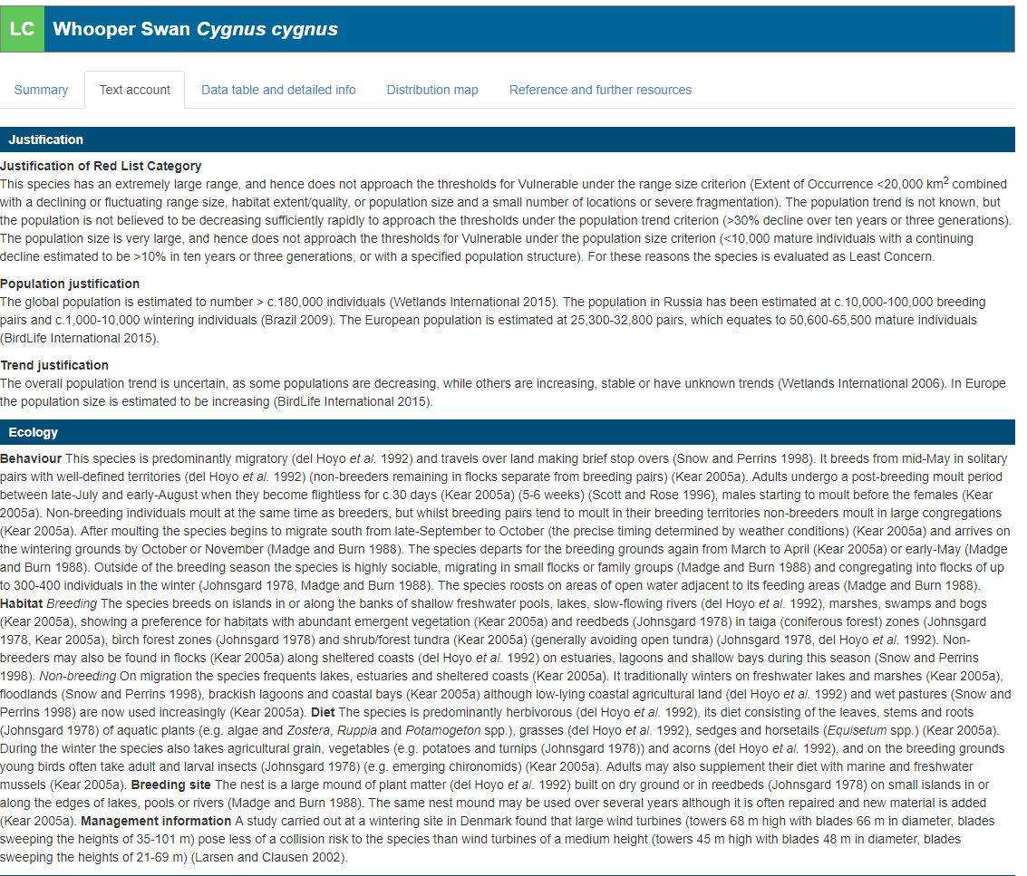
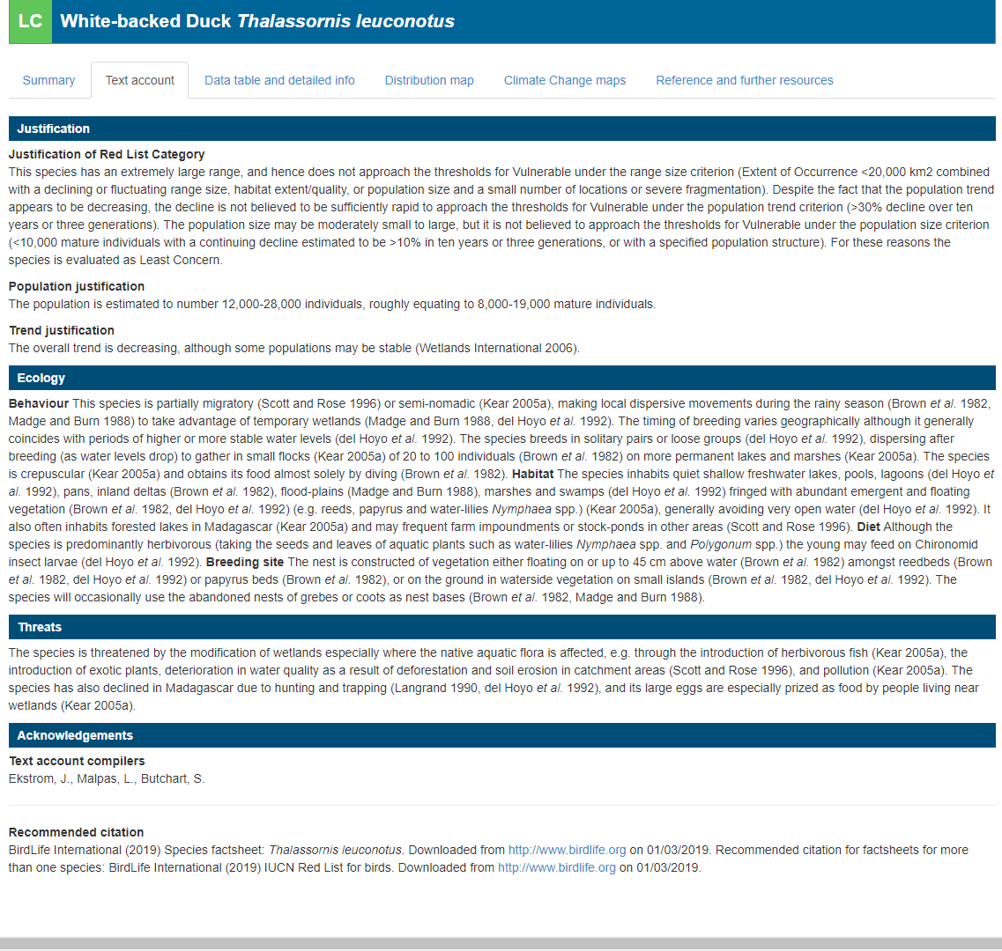
Annex III. Species prioritised for the development of conservation and management guidance

- Top priority: Globally threatened and Near-Threatened species

Nr. | Scientific Name | Common Name | Population Name | A | B | C | Red List | Pop Size | Trend
1 | Calidris tenuirostris | Great Knot | Eastern Siberia/SW Asia & W Southern Asia | 1a 1b 1c |  |  | EN | 1,500 - 2,000 | DEC?
2 | Glareola ocularis | Madagascar Pratincole | Madagascar/East Africa | 1b 1c |  |  | VU | 5,000 - 10,000 | Unknown
3 | Bugeranus carunculatus | Wattled Crane | Central & Southern Africa | 1b 1c |  |  | VU | 9,000 - 9,001 | STA?
4 | Podiceps auritus | Horned Grebe | auritus, North-west Europe (large-billed) | 1b 1c |  |  | VU | 4,600 - 5,000 | DEC/STA
 | Podiceps auritus | Horned Grebe | auritus, North-east Europe (small-billed) | 1b 2 |  |  | VU | 15,000 - 23,000 | DEC?
 | Podiceps auritus | Horned Grebe | auritus, Caspian & South Asia (win) | 1b 1c |  |  | VU | 1 - 10,000 | UNC
5 | Polysticta stelleri | Steller's Eider | Western Siberia/North-east Europe | 1a 1b |  |  | VU | 27,000 - 27,000 | STA
6 | Anthropoides paradiseus | Blue Crane | Extreme Southern Africa | 1b |  |  | VU | 25,000 - 30,000 | INC
7 | Balearica pavonina | Black Crowned-crane | pavonina, West Africa (Senegal to Chad) | 1b 1c |  |  | VU | 5,000 - 15,000 | DEC?
 | Balearica pavonina | Black Crowned-crane | ceciliae, Eastern Africa (Sudan to Uganda) | 1b 3c |  |  | VU | 28,000 - 55,000 | Unknown
8 | Marmaronetta angustirostris | Marbled Teal | East Mediterranean | 1a 1b 1c |  |  | VU | 20 - 100 | DEC
 | Marmaronetta angustirostris | Marbled Teal | West Mediterranean/West Medit. & West Africa | 1a 1b 1c |  |  | VU | 6,000 - 7,500 | DEC?
 | Marmaronetta angustirostris | Marbled Teal | South-west Asia | 1a 1b 3c |  |  | VU | 46,000 - 50,000 | INC?
9 | Phalacrocorax nigrogularis | Socotra Cormorant | Arabian Coast | 1b |  |  | VU | 270,000 - 270,000 | DEC
 | Phalacrocorax nigrogularis | Socotra Cormorant | Gulf of Aden, Socotra, Arabian Sea | 1b |  |  | VU | 60,000 - 63,000 | STA/INC
10 | Aythya ferina | Common Pochard | North-east Europe/North-west Europe | 1b |  |  | VU | 200,000 - 200,000 | DEC
 | Aythya ferina | Common Pochard | Western Siberia/South-west Asia | 1b |  |  | VU | 460,000 - 500,000 | DEC?
 | Aythya ferina | Common Pochard | Central & NE Europe/Black Sea & Mediterranean | 1b |  |  | VU | 570,000 - 630,000 | DEC?
11 | Rissa tridactyla | Black-legged Kittiwake | tridactyla, Arctic from NE Canada to Novaya Zemlya/N Atlantic | 1b |  |  | VU | 6,400,000 - 7,600,000 | DEC
12 | Fratercula arctica | Atlantic Puffin | Faeroes, S Norway & Sweden, Britain, Ireland, NW France | 1b |  |  | VU | 3,500,000 - 3,500,000 | DEC?
 | Fratercula arctica | Atlantic Puffin | Hudson bay & Maine E to S Greenland, Iceland, Bear Is, Norway to S Novaya Zemlya | 1b |  |  | VU | 12,000,000 - 15,000,000 | DEC?
 | Fratercula arctica | Atlantic Puffin | NE Canada, N Greenland, to Jan Mayen, Svalbard, N Novaya Zemlya | 1b |  |  | VU | 35,000 - 35,000 | Unknown
13 | Gavia adamsii | Yellow-billed Loon | Northern Europe (win) | 1c |  |  | NT | 1,000 - 8,000 | STA?
14 | Rynchops flavirostris | African Skimmer | Coastal West Africa & Central Africa | 1c |  |  | NT | 7,000 - 13,000 | UNC
 | Rynchops flavirostris | African Skimmer | Eastern & Southern Africa | 1c |  |  | NT | 8,000 - 12,000 | Unknown
15 | Charadrius pallidus | Chestnut-banded Plover | pallidus, Southern Africa | 2 |  |  | NT | 11,000 - 16,000 | DEC?
 | Charadrius pallidus | Chestnut-banded Plover | venustus, Eastern Africa | 1c |  |  | NT | 6,500 - 6,500 | INC?
16 | Larus leucophthalmus | White-eyed Gull | Red Sea & nearby coasts | 1a |  |  | NT | 56,000 - 62,000 | STA
17 | Larus armenicus | Armenian Gull | Armenia, Eastern Turkey & NW Iran | 3a 3c |  |  | NT | 59,000 - 85,000 | DEC
18 | Limosa lapponica | Bar-tailed Godwit | taymyrensis, Western Siberia/West & South-west Africa | 4 |  |  | NT | 500,000 - 500,000 | DEC?
 | Limosa lapponica | Bar-tailed Godwit | taymyrensis, Central Siberia/South & SW Asia & Eastern Africa | 4 |  |  | NT | 100,000 - 150,000 | INC?
 | Limosa lapponica | Bar-tailed Godwit | lapponica, Northern Europe/Western Europe | 4 |  |  | NT | 150,000 - 150,000 | INC
19 | Calidris canutus | Red Knot | canutus, Northern Siberia/West & Southern Africa | 4 |  |  | NT | 250,000 - 250,000 | DEC/STA
 | Calidris canutus | Red Knot | islandica, NE Canada & Greenland/Western Europe | 4 |  |  | NT | 500,000 - 565,000 | STA/FLU
20 | Calidris ferruginea | Curlew Sandpiper | Western Siberia/West Africa | 4 |  |  | NT | 350,000 - 450,000 | DEC
 | Calidris ferruginea | Curlew Sandpiper | Central Siberia/SW Asia, E & S Africa | 4 |  |  | NT | 400,000 - 400,000 | DEC?
21 | Haematopus ostralegus | Eurasian Oystercatcher | longipes, SE Eur & W Asia/SW Asia & NE Africa | 4 |  |  | NT | 27,000 - 50,000 | STA/FLU
 | Haematopus ostralegus | Eurasian Oystercatcher | ostralegus, Europe/South & West Europe & NW Africa | 4 |  |  | NT | 850,000 - 950,000 | STA/DEC?
22 | Somateria mollissima | Common Eider | borealis, Svalbard & Franz Joseph (bre) | 4 |  |  | NT | 60,000 - 82,500 | DEC?
 | Somateria mollissima | Common Eider | mollissima, Norway & Russia | 4 |  |  | NT | 510,000 - 525,000 | STA/INC
 | Somateria mollissima | Common Eider | mollissima, Baltic, Denmark & Netherlands | 4 |  |  | NT | 930,000 - 930,000 | STA/FLU
23 | Alca torda | Razorbill | islandica, Iceland, Faeroes, Britain, Ireland, Helgoland, NW France | 4 |  |  | NT | 1,380,000 - 1,380,000 | DEC
 | Alca torda | Razorbill | torda, E North America, Greenland, E to Baltic & White Seas | 4 |  |  | NT | 187,000 - 207,000 | INC?
24 | Vanellus vanellus | Northern Lapwing | Europe, W Asia/Europe, N Africa & SW Asia | 4 |  |  | NT | 5,500,000 - 9,500,000 | DEC

- Second priority: species with populations in significant long-term decline

Nr. | Scientific Name | Common Name | Population Name | A | B | C | Red List | Pop Size | Trend | Prop.
25 | Thalassornis leuconotus | White-backed Duck | leuconotus, West Africa | 1c |  |  | LC | 1 - 500 | DEC | 100%
 | Thalassornis leuconotus | White-backed Duck | leuconotus, Eastern & Southern Africa | 2* |  |  | LC | 10,000 - 25,000 | DEC | 100%
26 | Netta erythrophthalma | Southern Pochard | brunnea, Southern & Eastern Africa | 3c |  |  | LC | 30,000 - 70,000 | DEC? | 100%
27 | Charadrius asiaticus | Caspian Plover | SE Europe & West Asia/E & Central Southern Africa | 3c |  |  | LC | 40,000 - 55,000 | STA/DEC? | 100%
28 | Sula dactylatra | Masked Booby | melanops, W Indian Ocean | 3c |  |  | LC | 49,700 - 53,000 | Unknown | 100%
29 | Calidris falcinellus | Broad-billed Sandpiper | falcinellus, Northern Europe/SW Asia & Africa |  | 2c |  | LC | 89,000 - 132,000 | Unknown | 100%
30 | Mergus serrator | Red-breasted Merganser | Western Siberia/South-west & Central Asia | 1c |  |  | LC | 1 - 10,000 | DEC? | 100%
 | Mergus serrator | Red-breasted Merganser | North-east Europe/Black Sea & Mediterranean | 3c |  |  | LC | 22,000 - 31,000 | DEC? | 100%
 | Mergus serrator | Red-breasted Merganser | North-west & Central Europe (win) | 3c |  |  | LC | 70,000 - 105,000 | STA/DEC? | 100%
31 | Sarkidiornis melanotos | African Comb Duck | West Africa | 3c |  |  | LC | 20,000 - 40,000 | UNC | 100%
 | Sarkidiornis melanotos | African Comb Duck | Southern & Eastern Africa |  | (2c) |  | LC | 50,000 - 250,000 | STA/FLU | 100%
32 | Porphyrio alleni | Allen's Gallinule | Sub-Saharan Africa |  | (2c) |  | LC | 25,000 - 1,000,000 | DEC? | 100%
33 | Zapornia parva | Little Crake | Western Eurasia/Africa |  | 2c |  | LC | 225,000 - 310,000 | Unknown | 100%
34 | Aythya marila | Greater Scaup | marila, Western Siberia/Black Sea & Caspian |  | (2c) |  | LC | 100,000 - 200,000 | DEC? | 100%
 | Aythya marila | Greater Scaup | marila, Northern Europe/Western Europe |  | 2c |  | LC | 150,000 - 275,000 | DEC | 100%
35 | Gavia arctica | Arctic Loon | arctica, Northern Europe & Western Siberia/Europe |  | 2c |  | LC | 266,000 - 473,000 | DEC? | 100%
 | Gavia arctica | Arctic Loon | arctica, Central Siberia/Caspian | 1c |  |  | LC | 100 - 1,000 | Unknown | 100%
36 | Chlidonias niger | Black Tern | niger, Europe & Western Asia/Atlantic coast of Africa |  | 2c |  | LC | 280,000 - 580,000 | DEC? | 100%
37 | Ciconia abdimii | Abdim's Stork | Sub-Saharan Africa & SW Arabia |  | (2c) |  | LC | 300,000 - 600,000 | DEC? | 100%
38 | Phalaropus fulicarius | Red Phalarope | Canada & Greenland/Atlantic coast of Africa |  | 2c |  | LC | 1,140,000 - 2,100,000 | DEC? | 100%
39 | Mareca penelope | Eurasian Wigeon | Western Siberia/SW Asia & NE Africa |  | 2c |  | LC | 180,000 - 200,000 | DEC? | 100%
 | Mareca penelope | Eurasian Wigeon | W Siberia & NE Europe/Black Sea & Mediterranean |  | 2c |  | LC | 390,000 - 490,000 | DEC? | 100%
 | Mareca penelope | Eurasian Wigeon | Western Siberia & NE Europe/NW Europe |  | 2c |  | LC | 1,300,000 - 1,500,000 | DEC? | 100%
40 | Larus argentatus | European Herring Gull | argenteus, Iceland & Western Europe |  | 2c |  | LC | 710,000 - 790,000 | DEC | 100%
 | Larus argentatus | European Herring Gull | argentatus, North & North-west Europe |  | 2c |  | LC | 1,300,000 - 1,600,000 | DEC | 100%
41 | Uria lomvia | Thick-billed Murre | lomvia, E North America, Greenland, E to Severnaya Zemlya |  | 2c |  | LC | 7,300,000 - 8,000,000 | DEC | 100%
42 | Dendrocygna bicolor | Fulvous Whistling-duck | Eastern & Southern Africa |  | 2c |  | LC | 150,000 - 350,000 | DEC? | 90%
 | Dendrocygna bicolor | Fulvous Whistling-duck | West Africa (Senegal to Chad) |  | 1 |  | LC | 20,000 - 50,000 | UNC | 90%
43 | Vanellus coronatus | Crowned Lapwing | coronatus, Eastern & Southern Africa |  | (2c) |  | LC | 400,000 - 900,000 | DEC? | 90%
 | Vanellus coronatus | Crowned Lapwing | coronatus, Central Africa | (1c) |  |  | LC | 1 - 25,000 | Unknown | 90%
 | Vanellus coronatus | Crowned Lapwing | coronatus, South-west Africa |  | (1) |  | LC | 30,000 - 50,000 | STA? | 90%
44 | Uria aalge | Common Murre | aalge, Iceland, Faeroes, Scotland, S Norway, Baltic/NE Atlantic |  | 2c |  | LC | 6,000,000 - 8,155,000 | DEC? | 90%
 | Uria aalge | Common Murre | hyperborea, Svalbard, N Norway to Novaya Zemlya |  |  | 1 | LC | 462,000 - 481,000 | INC? | 90%
 | Uria aalge | Common Murre | albionis, Ireland, S Britain, France, Iberia, Helgoland |  |  | 1 | LC | 471,000 - 472,000 | INC | 90%
45 | Gallinago gallinago | Common Snipe | faeroeensis, Iceland, Faroes & Northern Scotland/Ireland |  |  | 1 | LC | 570,000 - 570,000 | Unknown | 90%
 | Gallinago gallinago | Common Snipe | gallinago, Western Siberia/South-west Asia & Africa |  |  | 1 | LC | 1,000,000 - 1,000,001 | Unknown | 90%
 | Gallinago gallinago | Common Snipe | gallinago, Europe/South & West Europe & NW Africa |  | 2c |  | LC | 7,400,000 - 14,500,000 | STA | 90%
46 | Tringa erythropus | Spotted Redshank | Western Siberia/SW Asia, NE & Eastern Africa |  | (1) |  | LC | 10,000 - 100,000 | STA/FLU | 80%
 | Tringa erythropus | Spotted Redshank | N Europe/Southern Europe, North & West Africa | 3c |  |  | LC | 61,500 - 162,000 | STA/DEC | 80%
47 | Sternula albifrons | Little Tern | albifrons, West Mediterranean/ W Africa (bre) | 3b 3c |  |  | LC | 21,000 - 28,000 | DEC | 80%
 | Sternula albifrons | Little Tern | albifrons, Black Sea & East Mediterranean (bre) | 3b 3c |  |  | LC | 80,000 - 117,000 | DEC | 80%
 | Sternula albifrons | Little Tern | guineae, West Africa (bre) | 1c |  |  | LC | 2,000 - 3,000 | Unknown | 80%
 | Sternula albifrons | Little Tern | albifrons, Caspian (bre) | 2 |  |  | LC | 10,000 - 25,000 | Unknown | 80%
 | Sternula albifrons | Little Tern | albifrons, Europe north of Mediterranean (bre) | 2 |  |  | LC | 19,000 - 25,000 | STA | 80%
48 | Ardea purpurea | Purple Heron | purpurea, West Europe & West Mediterranean/West Africa |  | 1 |  | LC | 32,000 - 38,000 | DEC | 80%
 | Ardea purpurea | Purple Heron | purpurea, East Europe, Black Sea & Mediterranean/Sub-Saharan Africa |  | 2c |  | LC | 61,000 - 99,000 | DEC? | 80%
 | Ardea purpurea | Purple Heron | purpurea, Tropical Africa | (3c) |  |  | LC | 75,000 - 100,000 | DEC? | 80%
 | Ardea purpurea | Purple Heron | purpurea, SW Asia (bre) | (2) |  |  | LC | 10,000 - 25,000 | UNC | 80%
49 | Eudromias morinellus | Eurasian Dotterel | Europe/North-west Africa | 3c |  |  | LC | 38,000 - 145,000 | DEC? | 70%
 | Eudromias morinellus | Eurasian Dotterel | Asia/Middle East |  | (1) |  | LC | 10,000 - 100,000 | Unknown | 70%
50 | Netta rufina | Red-crested Pochard | Western & Central Asia/South-west Asia |  | 2c |  | LC | 250,000 - 400,000 | DEC? | 70%
 | Netta rufina | Red-crested Pochard | South-west & Central Europe/West Mediterranean |  | 1 |  | LC | 50,000 - 60,000 | INC | 70%
 | Netta rufina | Red-crested Pochard | Black Sea & East Mediterranean |  | 1 |  | LC | 50,000 - 100,000 | INC? | 70%
51 | Calidris pugnax | Ruff | Northern Europe & Western Siberia/West Africa |  | 2c |  | LC | 1,000,000 - 5,000,000 | DEC? | 70%
 | Calidris pugnax | Ruff | Northern Siberia/SW Asia, E & S Africa |  |  | 1 | LC | 1,000,000 - 1,000,001 | UNC | 70%
52 | Arenaria interpres | Ruddy Turnstone | interpres, Northern Europe/West Africa | 3c |  |  | LC | 48,000 - 111,000 | DEC? | 60%
 | Arenaria interpres | Ruddy Turnstone | interpres, West & Central Siberia/SW Asia, E & S Africa |  | (2c) |  | LC | 100,000 - 100,000 | DEC? | 60%
 | Arenaria interpres | Ruddy Turnstone | interpres, NE Canada & Greenland/W Europe & NW Africa |  |  | 1 | LC | 100,000 - 200,000 | INC | 60%
53 | Tringa totanus | Common Redshank | totanus, Britain & Ireland/Britain, Ireland, France | 3c |  |  | LC | 76,500 - 76,500 | DEC | 60%
 | Tringa totanus | Common Redshank | robusta, Iceland & Faroes/Western Europe |  |  | 1 | LC | 150,000 - 420,000 | DEC? | 60%
 | Tringa totanus | Common Redshank | ussuriensis, Western Asia/SW Asia, NE & Eastern Africa |  |  | (1) | LC | 100,000 - 1,000,000 | DEC? | 60%
 | Tringa totanus | Common Redshank | totanus, Central & East Europe (breeding) |  | 2c |  | LC | 364,000 - 663,000 | DEC? | 60%
 | Tringa totanus | Common Redshank | totanus, Northern Europe (breeding) |  | 2c |  | LC | 140,000 - 220,000 | STA/FLU | 60%
54 | Larus ridibundus | Black-headed Gull | West Asia/SW Asia & NE Africa |  |  | (1) | LC | 250,000 - 250,000 | STA/FLU | 60%
 | Larus ridibundus | Black-headed Gull | East Europe/Black Sea & East Mediterranean |  |  | 1 | LC | 1,250,000 - 2,400,000 | STA/FLU | 60%
 | Larus ridibundus | Black-headed Gull | W Europe/W Europe, W Mediterranean, West Africa |  | 2c |  | LC | 2,750,000 - 3,550,000 | STA/DEC? | 60%
55 | Burhinus senegalensis | Senegal Thick-knee | North-east & Eastern Africa | (3c) |  |  | LC | 25,000 - 100,000 | DEC? | 50%
 | Burhinus senegalensis | Senegal Thick-knee | West Africa |  | 1 |  | LC | 25,000 - 100,000 | INC? | 50%
56 | Tadorna ferruginea | Ruddy Shelduck | Western Asia & Caspian/Iran & Iraq | 3c |  |  | LC | 50,000 - 70,000 | STA/FLU | 50%
 | Tadorna ferruginea | Ruddy Shelduck | North-west Africa | 1c |  |  | LC | 10,000 - 10,000 | INC? | 50%
 | Tadorna ferruginea | Ruddy Shelduck | East Mediterranean & Black Sea/North-east Africa |  | 1 |  | LC | 40,000 - 62,000 | INC | 50%
57 | Pelecanus onocrotalus | Great White Pelican | Eastern Africa |  | 2c |  | LC | 140,000 - 140,000 | DEC? | 50%
 | Pelecanus onocrotalus | Great White Pelican | Southern Africa |  | 1 |  | LC | 21,000 - 24,000 | INC? | 50%
 | Pelecanus onocrotalus | Great White Pelican | Europe & Western Asia (bre) | 1a |  |  | LC | 37,000 - 37,000 | INC | 50%
 | Pelecanus onocrotalus | Great White Pelican | West Africa |  | 1 |  | LC | 60,000 - 60,000 | INC/STA | 50%
58 | Larus genei | Slender-billed Gull | Black Sea & Mediterranean (bre) |  | 2a (2c) |  | LC | 130,000 - 200,000 | DEC | 50%
 | Larus genei | Slender-billed Gull | West Africa (bre) |  | 1 |  | LC | 24,000 - 30,000 | STA/DEC? | 50%
 | Larus genei | Slender-billed Gull | West, South-west & South Asia (bre) |  |  | 1 | LC | 150,000 - 150,000 | UNC | 50%
59 | Anser anser | Greylag Goose | anser, Iceland/UK & Ireland |  | 1 |  | LC | 93,750 - 93,750 | DEC | 50%
 | Anser anser | Greylag Goose | rubrirostris Western Siberia/Caspian & Iraq |  |  | 1 | LC | 250,000 - 250,001 | DEC | 50%
 | Anser anser | Greylag Goose | rubrirostris, Black Sea & Turkey |  | 1 |  | LC | 25,000 - 50,000 | STA? | 50%
 | Anser anser | Greylag Goose | anser, Central Europe/North Africa |  | 1 |  | LC | 59,000 - 100,000 | INC | 50%
60 | Vanellus senegallus | Wattled Lapwing | lateralis, Eastern & South-east Africa | (3c) |  |  | LC | 25,000 - 100,000 | DEC? | 40%
 | Vanellus senegallus | Wattled Lapwing | senegallus, West Africa |  | (1) |  | LC | 50,000 - 100,000 | Unknown | 40%
61 | Gelochelidon nilotica | Common Gull-billed Tern | nilotica, Black Sea & East Mediterranean/Eastern Africa | 3c |  |  | LC | 26,000 - 37,000 | DEC | 30%
 | Gelochelidon nilotica | Common Gull-billed Tern | nilotica, West & Central Asia/South-west Asia | 2 |  |  | LC | 10,000 - 25,000 | UNC | 30%
 | Gelochelidon nilotica | Common Gull-billed Tern | nilotica, Western Europe/West Africa |  | 1 |  | LC | 37,000 - 63,000 | STA/FLU | 30%
62 | Hydrocoloeus minutus | Little Gull | W Asia/E Mediterranean, Black Sea & Caspian | (3c) |  |  | LC | 25,000 - 100,000 | DEC? | 30%
 | Hydrocoloeus minutus | Little Gull | Central & E Europe/SW Europe & W Mediterranean |  | 1 |  | LC | 71,000 - 136,000 | DEC | 30%
63 | Mareca strepera | Gadwall | strepera, Western Siberia/SW Asia & NE Africa |  | (2c) |  | LC | 90,000 - 130,000 | STA/FLU | 30%
 | Mareca strepera | Gadwall | strepera, North-east Europe/Black Sea & Mediterranean |  |  | 1 | LC | 136,000 - 235,000 | STA | 30%
 | Mareca strepera | Gadwall | strepera, North-west Europe |  |  | 1 | LC | 110,000 - 138,000 | INC | 30%
64 | Anas acuta | Northern Pintail | Western Siberia/SW Asia & Eastern Africa |  | 2c |  | LC | 200,000 - 400,000 | DEC? | 30%
 | Anas acuta | Northern Pintail | North-west Europe |  | 1 |  | LC | 65,000 - 65,000 | STA/FLU | 30%
 | Anas acuta | Northern Pintail | W Siberia, NE & E Europe/S Europe & West Africa |  |  | 1 | LC | 450,000 - 750,000 | STA/FLU | 30%
65 | Anas crecca | Common Teal | crecca, Western Siberia/SW Asia & NE Africa |  | 2c |  | LC | 500,000 - 1,000,000 | STA | 30%
 | Anas crecca | Common Teal | crecca, North-west Europe |  |  | 1 | LC | 500,000 - 500,000 | INC? | 30%
 | Anas crecca | Common Teal | crecca, W Siberia & NE Europe/Black Sea & Mediterranean |  |  | 1 | LC | 1,000,000 - 1,000,000 | INC | 30%
66 | Actitis hypoleucos | Common Sandpiper | West & Central Europe/West Africa |  | 2c |  | LC | 1,000,000 - 1,600,000 | DEC/STA | 30%
 | Actitis hypoleucos | Common Sandpiper | E Europe & W Siberia/Central, E & S Africa |  |  | (1) | LC | 2,000,000 - 4,000,000 | STA | 30%
67 | Fulica atra | Common Coot | atra, South-west Asia (win) |  |  | (1) | LC | 2,000,000 - 2,000,000 | DEC? | 30%
 | Fulica atra | Common Coot | atra, North-west Europe (win) |  | 2c |  | LC | 1,200,000 - 2,000,000 | STA/DEC? | 30%
 | Fulica atra | Common Coot | atra, Black Sea & Mediterranean (win) |  |  | 1 | LC | 2,500,000 - 2,500,000 | STA/DEC? | 30%
68 | Charadrius alexandrinus | Kentish Plover | alexandrinus, Black Sea & East Mediterranean/Eastern Sahel | 3c |  |  | LC | 45,000 - 66,000 | DEC/STA | 20%
 | Charadrius alexandrinus | Kentish Plover | alexandrinus, West Europe & West Mediterranean/West Africa |  | 1 |  | LC | 56,000 - 72,000 | DEC? | 20%
 | Charadrius alexandrinus | Kentish Plover | alexandrinus, SW & Central Asia/SW Asia & NE Africa |  | (1) |  | LC | 100,000 - 150,000 | STA/FLU | 20%
69 | Aythya fuligula | Tufted Duck | Western Siberia/SW Asia & NE Africa |  | 2c |  | LC | 300,000 - 300,000 | DEC? | 20%
 | Aythya fuligula | Tufted Duck | Central Europe, Black Sea & Mediterranean (win) |  |  | 1 | LC | 400,000 - 500,000 | DEC? | 20%
 | Aythya fuligula | Tufted Duck | North-west Europe (win) |  |  | 1 | LC | 800,000 - 1,000,000 | DEC? | 20%
70 | Podiceps grisegena | Red-necked Grebe | grisegena, Caspian (win) | 2 |  |  | LC | 15,000 - 15,000 | Unknown | 10%
 | Podiceps grisegena | Red-necked Grebe | grisegena, Black Sea & Mediterranean (win) |  | 1 |  | LC | 46,000 - 88,000 | STA | 10%
 | Podiceps grisegena | Red-necked Grebe | grisegena, North-west Europe (win) |  | 1 |  | LC | 37,000 - 55,000 | INC | 10%
71 | Podiceps nigricollis | Black-necked Grebe | nigricollis, Western Asia/South-west & South Asia | 3c |  |  | LC | 20,000 - 35,000 | DEC? | 10%
 | Podiceps nigricollis | Black-necked Grebe | nigricollis, Europe/South & West Europe & North Africa |  |  | 1 | LC | 139,000 - 233,000 | DEC? | 10%
 | Podiceps nigricollis | Black-necked Grebe | gurneyi, Southern Africa | 2 |  |  | LC | 15,000 - 30,000 | INC | 10%
72 | Nycticorax nycticorax | Black-crowned Night-heron | nycticorax, W Europe, NW Africa (bre) | 3c |  |  | LC | 46,000 - 51,000 | DEC | 10%
 | Nycticorax nycticorax | Black-crowned Night-heron | nycticorax, Western Asia/SW Asia & NE Africa |  | (1) |  | LC | 25,000 - 100,000 | Unknown | 10%
 | Nycticorax nycticorax | Black-crowned Night-heron | nycticorax, C & E Europe/Black Sea & E Mediterranean (bre) |  |  | 1 | LC | 134,000 - 209,000 | STA | 10%
 | Nycticorax nycticorax | Black-crowned Night-heron | nycticorax, Sub-Saharan Africa & Madagascar |  |  | 1 | LC | 100,000 - 300,000 | STA/INC? | 10%
73 | Ardeola ralloides | Squacco Heron | ralloides, C & E Europe, Black Sea & E Mediterranean (bre) | 3c |  |  | LC | 29,000 - 52,000 | DEC | 10%
 | Ardeola ralloides | Squacco Heron | ralloides, West & South-west Asia/Sub-Saharan Africa |  | (1) |  | LC | 25,000 - 100,000 | Unknown | 10%
 | Ardeola ralloides | Squacco Heron | ralloides, SW Europe, NW Africa (bre) | 1c |  |  | LC | 9,000 - 11,000 | INC | 10%
 | Ardeola ralloides | Squacco Heron | paludivaga, Sub-Saharan Africa & Madagascar |  |  | (1) | LC | 300,000 - 600,000 | INC? | 10%
74 | Tadorna tadorna | Common Shelduck | Western Asia/Caspian & Middle East | 3c |  |  | LC | 30,000 - 50,000 | DEC? | 10%
 | Tadorna tadorna | Common Shelduck | North-west Europe |  | 2a |  | LC | 250,000 - 250,000 | STA | 10%
 | Tadorna tadorna | Common Shelduck | Black Sea & Mediterranean |  |  | 1 | LC | 260,000 - 260,000 | INC | 10%
75 | Phoenicopterus roseus | Greater Flamingo | Eastern Africa | 3a 3c |  |  | LC | 80,000 - 120,000 | DEC? | 10%
 | Phoenicopterus roseus | Greater Flamingo | South-west & South Asia |  | 2a |  | LC | 240,000 - 240,000 | DEC? | 10%
 | Phoenicopterus roseus | Greater Flamingo | West Africa | 3a |  |  | LC | 45,000 - 95,000 | STA/FLU | 10%
 | Phoenicopterus roseus | Greater Flamingo | Southern Africa (to Madagascar) |  | 2a |  | LC | 100,000 - 160,000 | INC? | 10%
 | Phoenicopterus roseus | Greater Flamingo | West Mediterranean |  | 2a |  | LC | 135,000 - 165,000 | INC | 10%
 | Phoenicopterus roseus | Greater Flamingo | East Mediterranean |  | 2a |  | LC | 158,000 - 158,000 | INC | 10%
76 | Cepphus grylle | Black Guillemot | islandicus, Iceland | 3c |  |  | LC | 21,300 - 40,500 | DEC | 10%
 | Cepphus grylle | Black Guillemot | grylle, Baltic Sea | 3c |  |  | LC | 46,000 - 46,000 | DEC | 10%
 | Cepphus grylle | Black Guillemot | faeroeensis, Faeroes |  | (1) |  | LC | 10,000 - 100,000 | Unknown | 10%
 | Cepphus grylle | Black Guillemot | mandtii, Arctic E North America to Greenland, Jan Mayen & Svalbard E through Siberia to Alaska |  |  | 1 | LC | 367,000 - 400,000 | STA? | 10%
 | Cepphus grylle | Black Guillemot | arcticus, N America, S Greenland, Britain, Ireland, Scandinavia, White Sea |  |  | 1 | LC | 720,000 - 810,000 | STA? | 10%
77 | Pluvialis apricaria | Eurasian Golden Plover | apricaria, Britain, Ireland, Denmark, Germany & Baltic (bre) |  | 2c |  | LC | 140,000 - 210,000 | DEC | 10%
 | Pluvialis apricaria | Eurasian Golden Plover | altifrons, Northern Siberia/Caspian & Asia Minor |  | (1) |  | LC | -1 - -1 | Unknown | 10%
 | Pluvialis apricaria | Eurasian Golden Plover | altifrons, Iceland & Faroes/East Atlantic coast |  |  | 1 | LC | 930,000 - 930,000 | UNC | 10%
 | Pluvialis apricaria | Eurasian Golden Plover | altifrons, Northern Europe/Western Europe & NW Africa |  |  | 1 | LC | 800,000 - 1,100,000 | INC? | 10%
78 | Calidris minuta | Little Stint | N Europe/S Europe, North & West Africa |  | (2c) |  | LC | 300,000 - 300,000 | DEC | 10%
 | Calidris minuta | Little Stint | Western Siberia/SW Asia, E & S Africa |  |  | (1) | LC | 1,000,000 - 5,000,000 | STA? | 10%
79 | Tringa ochropus | Green Sandpiper | Western Siberia/SW Asia, NE & Eastern Africa |  | (2c) |  | LC | 100,000 - 1,000,001 | DEC? | 10%
 | Tringa ochropus | Green Sandpiper | Northern Europe/S & W Europe, West Africa |  |  | 1 | LC | 1,800,000 - 3,300,000 | INC | 10%
80 | Bubulcus ibis | Cattle Egret | ibis, South-west Europe |  |  | 1 | LC | 215,000 - 253,000 | DEC? | 10%
 | Bubulcus ibis | Cattle Egret | ibis, Southern Africa |  | 2c |  | LC | 100,000 - 1,000,000 | DEC? | 10%
 | Bubulcus ibis | Cattle Egret | ibis, East Mediterranean & South-west Asia |  | 1 |  | LC | 10,000 - 100,000 | UNC | 10%
 | Bubulcus ibis | Cattle Egret | ibis, North-west Africa |  |  | 1 | LC | 100,000 - 150,000 | STA? | 10%
 | Bubulcus ibis | Cattle Egret | ibis, Tropical Africa |  |  | (1) | LC | 1,000,000 - 10,000,000 | UNC | 10%
81 | Ciconia ciconia | White Stork | ciconia, Southern Africa | 1c |  |  | LC | 20 - 30 | STA | 0%
 | Ciconia ciconia | White Stork | ciconia, Western Asia/South-west Asia | 3c |  |  | LC | 27,000 - 27,100 | Unknown | 0%
 | Ciconia ciconia | White Stork | ciconia, W Europe & North-west Africa/Sub-Saharan Africa |  | 2b |  | LC | 140,000 - 149,000 | INC | 0%
 | Ciconia ciconia | White Stork | ciconia, Central & Eastern Europe/Sub-Saharan Africa |  |  | 1 | LC | 514,000 - 561,000 | INC | 0%
82 | Podiceps cristatus | Great Crested Grebe | cristatus, Caspian & South-west Asia (win) | 3c |  |  | LC | 30,000 - 35,000 | DEC? | 0%
 | Podiceps cristatus | Great Crested Grebe | infuscatus, Eastern Africa (Ethiopia to N Zambia) | 1c |  |  | LC | 500 - 1,500 | UNC | 0%
 | Podiceps cristatus | Great Crested Grebe | cristatus, Black Sea & Mediterranean (win) |  |  | 1 | LC | 470,000 - 716,000 | STA/INC? | 0%
 | Podiceps cristatus | Great Crested Grebe | cristatus, North-west & Western Europe |  |  | 1 | LC | 513,000 - 764,000 | STA/DEC? | 0%
 | Podiceps cristatus | Great Crested Grebe | infuscatus, Southern Africa | 1c |  |  | LC | 1,500 - 5,000 | INC | 0%
83 | Larus fuscus | Lesser Black-backed Gull | fuscus, NE Europe/Black Sea, SW Asia & Eastern Africa | 3c |  |  | LC | 53,000 - 81,000 | DEC | 0%
 | Larus fuscus | Lesser Black-backed Gull | graellsii, Western Europe/Mediterranean & West Africa |  |  | 1 | LC | 560,000 - 600,000 | DEC | 0%
 | Larus fuscus | Lesser Black-backed Gull | barabensis, South-west Siberia/South-west Asia |  |  | (1) | LC | -1 - -1 | Unknown | 0%
 | Larus fuscus | Lesser Black-backed Gull | heuglini, NE Europe & W Siberia/SW Asia & NE Africa |  |  | (1) | LC | 25,000 - 1,000,000 | Unknown | 0%
 | Larus fuscus | Lesser Black-backed Gull | intermedius, S Scandinavia, Netherlands, Ebro Delta, Spain |  |  | 1 | LC | 566,000 - 699,000 | INC | 0%
84 | Calidris temminckii | Temminck's Stint | Fennoscandia/North & West Africa | 3c |  |  | LC | 24,000 - 50,000 | STA | 0%
 | Calidris temminckii | Temminck's Stint | NE Europe & W Siberia/SW Asia & Eastern Africa |  |  | 1 | LC | 1,000,000 - 2,000,000 | STA? | 0%

http://datazone.birdlife.org/species/search
Will be subject to standardised design by the AEWA Secretariat
IUCN (Red List) Threats Classification Scheme
http://datazone.birdlife.org/species/factsheet/whooper-swan-cygnus-cygnus/text
http://datazone.birdlife.org/species/factsheet/white-backed-duck-thalassornis-leuconotus/text

