15th MEETING OF THE TECHNICAL COMMITTEE
09–11 April 2019, Bonn, Germany

DELENIATION OF BIOGEOGRAPHIC POPULATIONS OF THE COMMON MURRE
(URIA AALGE)

PROPOSAL TO CHANGE POPULATION DELINEATIONS

Compiled by Szabolcs Nagy (representative of Wetlands International to the Technical Committee)

Name of population(s):

[1] Uria aalge aalge (Common Murre), Iceland, Faeroes, Scotland, S Norway, Baltic
[2] Uria aalge albionis (Common Murre), Ireland, S Britain, France, Iberia, Helgoland

Current status on AEWA Table 1:

[1] Category 2c of Column B
[2] Category 1 of Column C

What is the issue?

[1] Based on AEWA/StC/12.12/Rev.1, the 12th meeting of the Standing Committee and subsequently MOP7 has accepted the removal of the N American and Greenland segment of the U. a. aalge subspecies. However, during the revision of the flyway definitions for the CSN Tool it has emerged that the Baltic breeding birds mainly remain within the Baltic and are largely separated from the East Atlantic segment of the subspecies throughout the year. Therefore, it is proposed to define two biogeographic populations of U. a. aalge (Figure 1) noting that further subdivisions might be possible later:

[1a] Uria aalge aalge, East Atlantic: Iceland, Jan Mayen, Faeroes, Scotland, S Norway,
[1b] Uria aalge aalge, Baltic.

[2] Although this has not been reflected in the name of the population, Table 1 on page 16 of the document AEWA/StC/12.12/Rev.1 has erroneously allocated the breeding populations of France, Germany (Helgoland), Portugal and Spain to U.a. aalge instead of U. a. albionis.

What is the evidence supporting the proposal?

[1] Lyngs & Kampp (1996) showed that Baltic Guillemots are largely sedentary, and few are recovered outside the Baltic. Only some immatures venture further and have been recovered as far away as Britain and northern Norway; also, the small colony on Hallands Väderö, W Sweden, was probably founded by birds from the Baltic. Ringing data of birds breeding in Finland also confirm this (Mia Rönkä pers. com., Figure 2). According to Peterz & Blomqvist (2010) morphological differences are minimal, but ringing recoveries indicate intermittent exchange between Baltic and North Sea birds. Lyngs & Kampp (1996) shows also that birds from the North Atlantic colonies only occur occasionally in the Baltic proper.

Considering the strong natal philopatry and high breeding site fidelity as well as that specific colonies may have specific wintering areas, the East Atlantic biogeographic population might be further subdivided in the future. Colony specific geolocator data from 2013 – 2017(SEATRACK, Figure 3) indicates that Icelandic birds remain mainly around Iceland but may range as far as E Greenland and the Shetland Islands. The non-breeding range of birds from Jan Mayen seem to be much bigger and partly overlapping with the Icelandic birds. Birds from the Isle of May, UK, seem to be confined to the North Sea based on the SEATRACK data, but Harris et al. (2015) indicated some moult movements to the Barents Sea, similar to Lorentsen & May (2012) from S Norway.

[2] U. aalge breeding on Helgoland (Germany), France, Spain and Portugal belong to the U. a. albionis subspecies according to the HBW and BirdLife International Illustrated Checklist and HBW Alive, AEWA’s taxonomic references. The Supplementary Material to the European Red List for the species has treated the breeding birds in France and Germany as U. a. albionis, while the birds breeding in Spain and France were reported as U. a. ibericus. However, the latter form is not recognised by HBW and it is included into albionis. Table 1 in the document AEWA/StC/12.12/Rev.1 was compiled based on Harris & Wanless (2007) and probably followed the position of Knox (2012) who argue that U. a. hyperborea should be merged with U. a. aalge. However, this view has not been taken up by AEWA’s taxonomic reference although the species account has been updated three times since 2012. Harris & Wanless (2007) have defined the ranges of the various subspecies as follows on page 845: “Nominate aalge breeds along the coasts of North America, Greenland, Iceland, Faroes, Scotland north of 55o 38’N, southern Norway and the Baltic Sea; albionis in Ireland, Britain north to 55o 38’N, from Brittany to west Iberia and Helgoland; and hyperborea from Svalbard and northern Norway, east to Novaya Zemlya …”. This definition is consistent with the one in the HBW. Therefore, the Table 1 to document AEWA/StC/12.12/Rev.1 is updated to be consistent with AEWA’s taxonomic reference:

 | aalge | albionis | hyperborea
UK: Scotland (N, W & E) | aalge
UK: Scotland (S) |  | albionis
UK: England (Northumbria) | aalge
UK: England (minus Northumbria) |  | albionis
UK: Wales |  | albionis
UK: Northern Ireland |  | albionis
Ireland |  | albionis
France | aalge | albionis
Germany (Helgoland) | aalge | albionis
Spain | aalge | albionis
Portugal | aalge | albionis
Sweden | aalge
Denmark | aalge
Finland | aalge
Faroes | aalge
Iceland | aalge
Norway (N) |  |  | hyperborea
Norway (S) | aalge
Bear Island | aalge |  | hyperborea
Jan Mayen | aalge
Spitzbergen Svalbard | aalge |  | hyperborea
Russia (Baltic) | aalge
Russia (Arctic) |  |  | hyperborea

What are the implications of the proposal including any changes in status on AEWA Table 1?

[1a] Uria aalge aalge, E Atlantic: more than 4.7 million individuals in Iceland, the Faroes, S Norway and Scotland (Berglund & Hentati-Sundberg 2014). It is rapidly declining in Iceland, Scotland and Norway at least in the short-term (BirdLife International 2015, Fauchald 2015). Therefore, it should be classified in Category 2e of Column B. This change from Category 2c of Column B represents now legal implications because the population remains listed in the same column. It simply reflects the revised definition of the criteria for long-term and short-term declines adopted in the AEWA MOP Resolution 7.4.

[1c] Uria aalge aalge, Baltic: The population size in Sweden (58,000 individuals), Denmark (8400 individuals) and Finland (105-210 individuals) is more than 25,000 but less than 100,000 individuals (Berglund & Hentati-Sundberg 2014). As the population has increased in the long-term and stable in the short-term (BirdLife International 2015, it should be classified in Category 3 in Column A.

[2] Uria aalge albionis: the current population estimate includes birds breeding on Helgoland, France, Portugal and Spain. Hence, the correction of the definition has no consequences for the classification of the population on Table 1. It should remain in Category 1 of Column C.

Figure 1. Delineation of the proposed biogeographic populations of U. a. aalge and the delineation of the ranges of the other populations of U. aalge recognised in Table 1 of the AEWA Action Plan. (Note: the range map produced by BirdLife International is only to provide a backdrop for the flyway delineation. It will require update at a later stage to incorporate the correction proposed by experts during the consultation process).

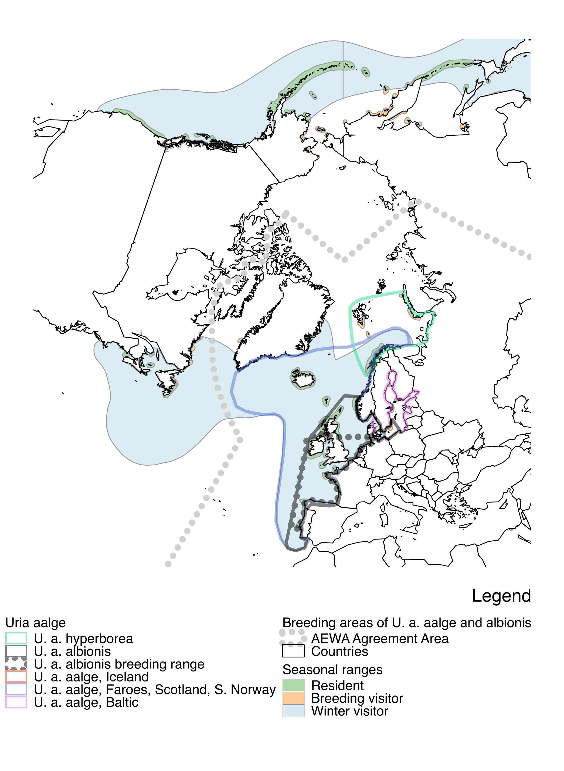

Figure 2. Ringing (blue) and recovery (red) locations of birds ringed in Finland (Source: Mia Rönkä pers. com.).

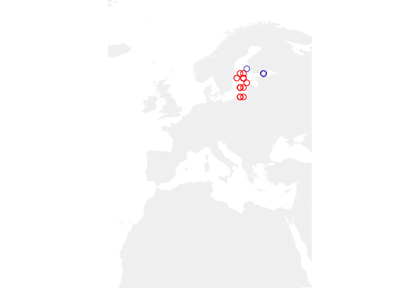

Figure 3. Non-breeding distribution of U. a. aalge breeding at colonies in the E Atlantic based on geolocator data between 2013 and 2017. Colours indicate different years. Black dots indicate the colonies where birds were captured. Sometimes it shows only single individuals. (Source: SEATRACK).

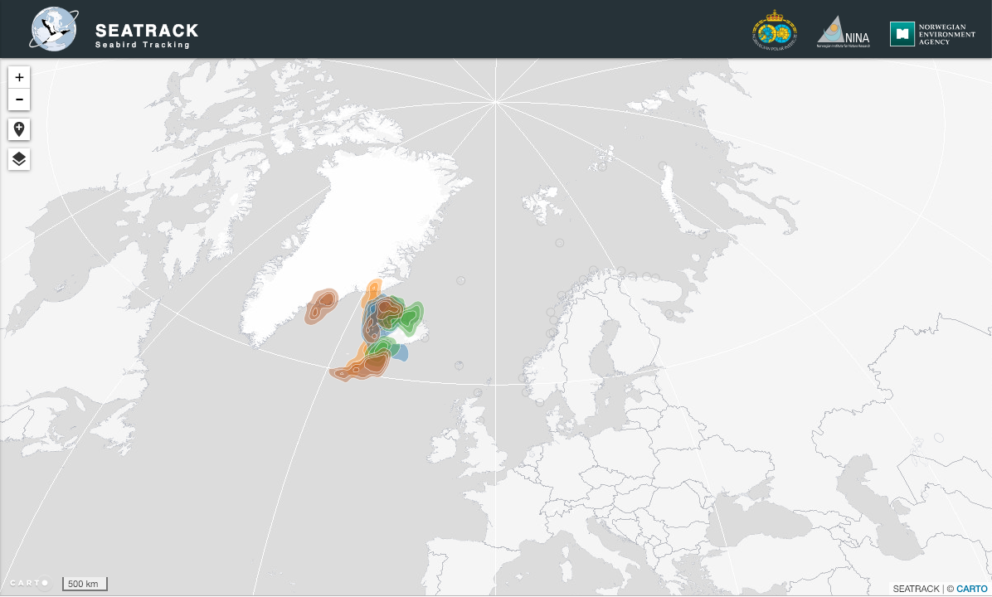

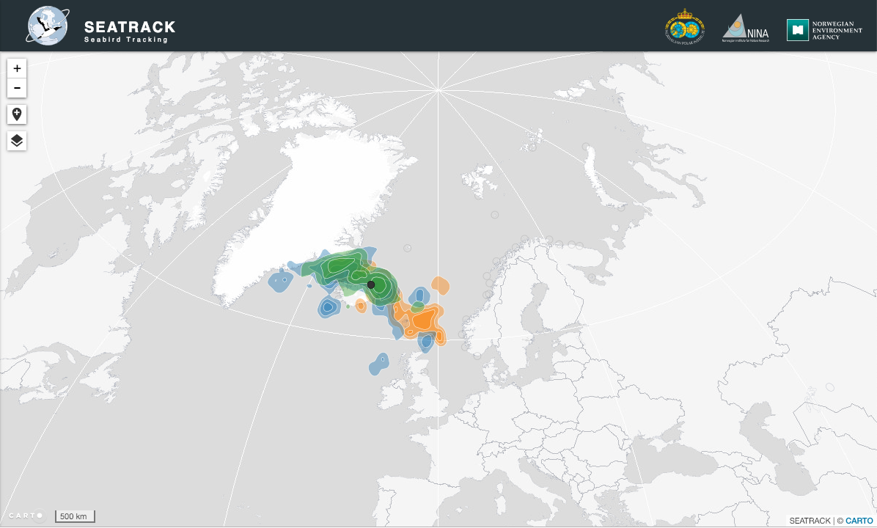
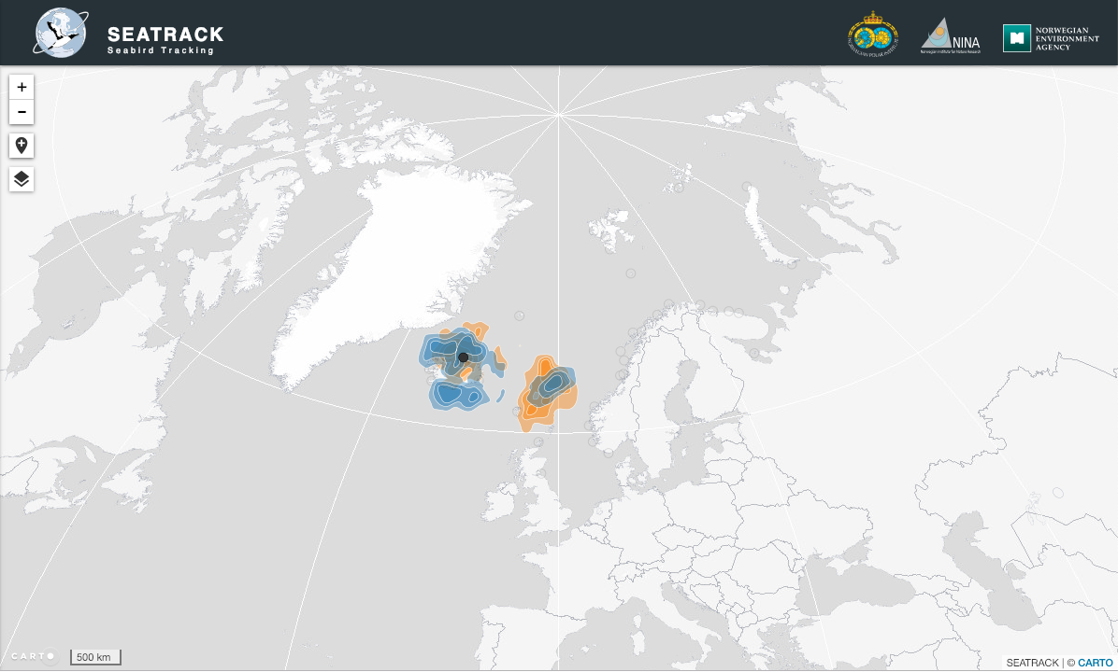

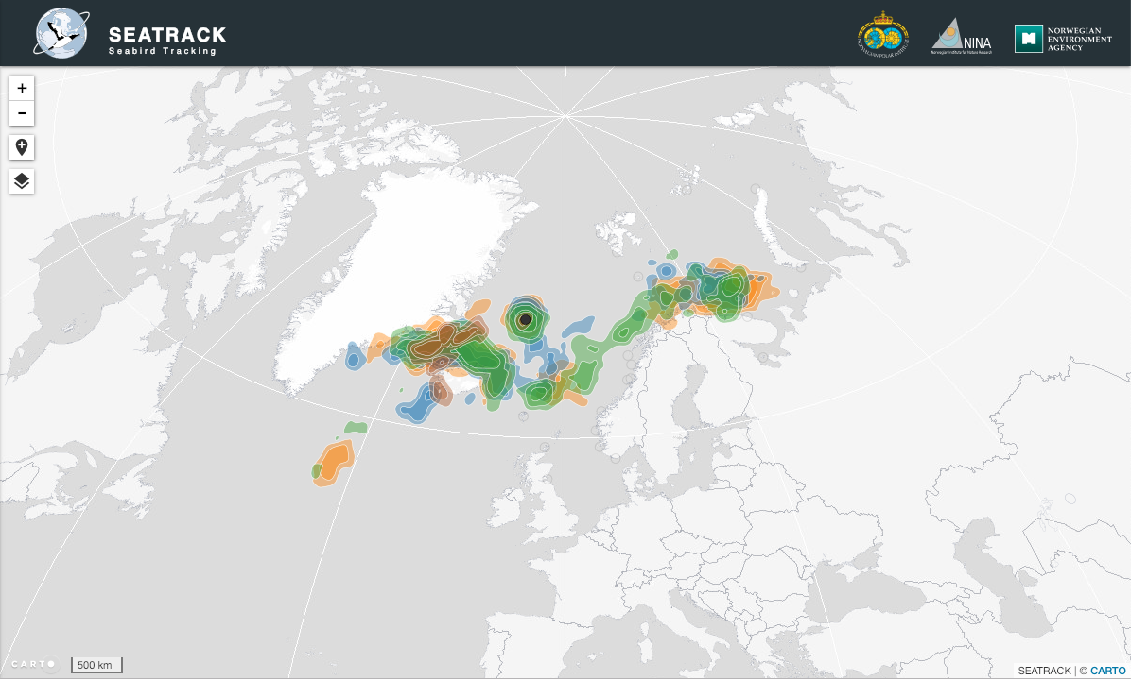

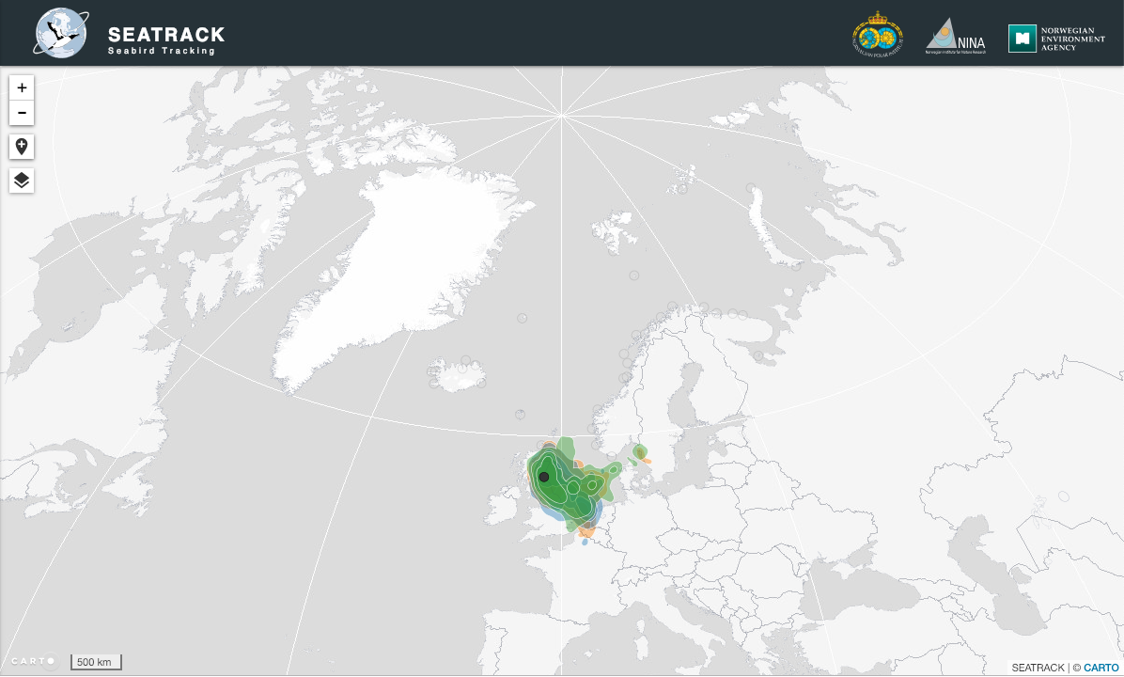

Harris, M. & Wanless, S. 2007. Common Guillemot Uria aalge. Pp. 845-849. In: The Birds of Scotland. eds. Forrester, R.W. & Andrews, I.J. Scottish Ornithologists’ Club, Aberlady.

