Regional Report for the Eastern and Southern Africa Region

Information contained in this report is collated by South Africa as a Regional Representatives from the Contracting Parties within the Eastern and Southern African regions through the consultation with the National Focal Points of about 15 Parties to AEWA, namely: Eastern Africa: Burundi, Djibouti; Ethiopia, Kenya, Rwanda, Sudan, Uganda, United Republic of Tanzania while for southern African region; Botswana, Eswatini, Madagascar, Malawi, Mauritius, South Arica and Zimbabwe.

- Each report should contain information on the following issues:
Number of Contracting Parties in the region / number of Range States in the region. New accessions since the previous StC meeting
- 80 Contracting Parties
- 38 from Africa
- 25 Range state and Contracting Parties Eastern (11) and Southern African (14) Region
- 15 Contracting Parties Eastern (8) and Southern African (7) Region
- Malawi acceded to AEWA on 01 Sep 2019

- Number of Range States (Contracting Parties and Non-Contracting Parties) that provided feedback for the report
- The following report is for six (6) Contracting Parties, that is Botswana, Ethiopia, Kenya, Uganda, Zimbabwe and South Africa
- It should be noted that it is difficult for range state who are not Parties to AEWA to provide report as they are not obliged

- Has the Regional Representative actively promoted accession to AEWA among the Range States in their region? If so, how has accession been promoted by the Regional Representative?
- With the assistance of the Secretariat, The AEWA African Initiative - For Migratory Waterbirds and People coordinator, Malawi acceded to the Agreement

This section of the regional report co covers the following four (4) question per Country: -

4. Which developments regarding the implementation of AEWA have taken place in the region since the last Meeting of the Parties?

5. Overview of special activities and/or meetings related to AEWA

6. Overview of special issues that might be of interest to the StC

7. Any other relevant information

Country name: Botswana Name of person compiling report: Ms Malebogo Somolekae
Developments regarding the implementation of AEWA

- Birdlife Botswana in partnership with a private company (Hoisting Solutions Pty (LTd) has set up a Crane Research Fund to support any initiative, research study on cranes or its habitats in Botswana.

To date a post graduate (Msc) student have been engaged to study population and distribution patterns of the wattled cranes in the Okavango Delta, starting 2019 and the study is expected to run for initially two years with a possibility of upgrading to PhD. Okavango Delta is one of the important wetland area in Africa with the largest single population of wattled crane. A comprehensive survey was last done about ten years ago and the current study will follow the same data collection methodology. The study will bring much needed data on the current population, breeding and population status.

Special activities and/or meetings related to AEWA.

- Public awareness campaign was undertaken near Lake Ngami (an important wetland area and Important Bird and Biodiversity Area (IBA) for migratory species in the region) on the 12th October 2019. The campaign was undertaken under the theme; “Protect Birds: Be the solution to plastic pollution’’, where at least 400 students from primary and secondary schools participated. Students presented songs, plays and poetry around the theme as a way of presenting the message to the general public.

WMDB celebration with students from in and around Sehitwa village, in October 12th 2019.

WMDB celebration with students from in and around Sehitwa village, in October 12th 2019.
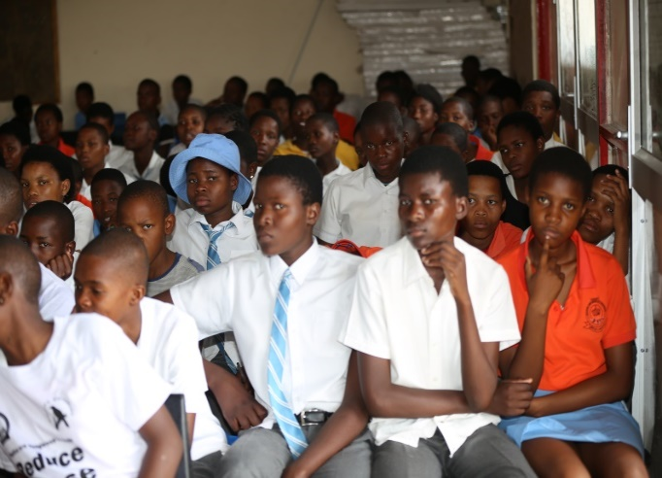

Wildlife officers from most of the regions in Botswana attended the celebration
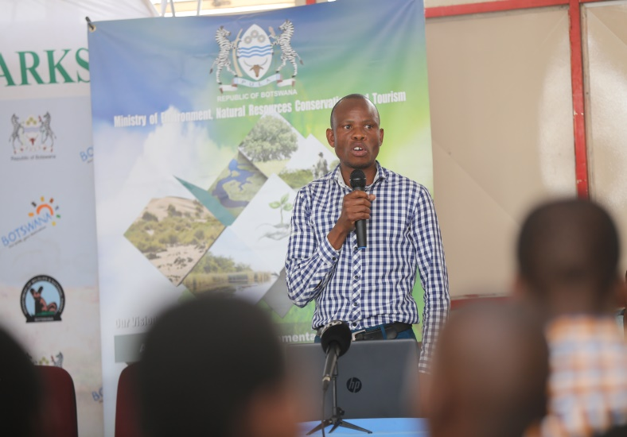
- The Director of Birdlife Botswana giving an address on the importance of waterbirds to Botswana.
- Principal Wildlife Officer giving an overview of AEWA

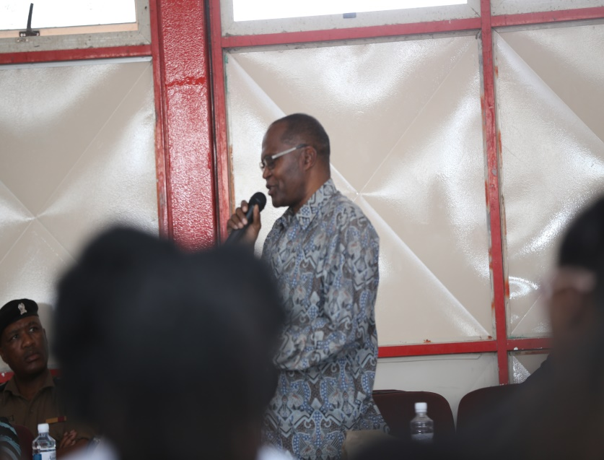

- The Acting Principal of the Botswana Wildlife Training Institute giving a key note address to the participants.
- Annual waterbirds counts were conducted to monitor the numbers and diversity of waterbirds at different waterbodies in Botswana.

Any other relevant information
- A national radio interview was done in October 2019 to disseminate information on AEWA to the general public.
- A brochure is being drafted on AEWA to communicate the role and responsibilities of AEWA to the general public.
- Plans are undergoing to the formulation of the National Working Group, for the implementation of the single species action plans, and will be done by end of December 2019. (e.g. Lesser flamingo, Slaty Egret).

Country name: Uganda Name of person compiling report: Akankwasah Barirega

Developments regarding the implementation of AEWA
- Uganda has embarked on the implementation of the Grey Crowned Crane National Action Plan
- Development of the shoebill national action plan
- Strong Law protecting endangered wildlife came into force in September 2019. The Acts protect all endangered species and provides for a life sentence for trafficking an endangered wildlife including AEWA listed species
- Uganda has concluded a national review of the Protected Areas Network to identify new areas. Key habitat has been identified for enhanced protection and AEWA species will benefit from this

Country name: Kenya Name of person compiling report: Solomon Kyalo

Developments regarding the implementation of AEWA
- Kenya participated (with representation of three; the AEWA NFP, and 2 Technical experts) in the 1st meeting of the AEWA Grey Crowned Cranes International Working Group in Entebbe, Uganda in July 2019 and shared experiences in the implementation of the AEWA GCC International Single Species Action Plan for the Conservation of the GCC.

Special activities and/or meetings related to AEWA.
- In January-February 2019, Kenya conducted a nation-wide census of the GCC, Results of the census have been published.
- In July 2019 during dry season waterfowl counts, a special attention was paid to the conservation and status of the Grey Crowned Cranes and data collected used to compare with the national census data of January /February 2019.
- There are ongoing efforts to employ use of drones as a technology to assist with monitoring of the Grey Crowned Cranes among other wetlands birds in Kenya. The efforts are a collaboration between the Government of Kenya and Germany through National Museums of Kenya and NABU respectively

Special issues of interest to StC
- Kenya continued to address issues of management of habitats for migratory water birds including sites such as the Lake Elmentaita, Lake Olbolossat and Lake Nakuru among others.
- A meeting of all GCC conservation stakeholders in the country is being planned for January 2020 to discuss and establish a better coordinated mechanism for implementation of GCC related conservation actions including finalization of the National SSAP for the conservation of GCC and implementation of the decisions of the AEWA Agreement Meeting of Parties

Country name: Ethiopia Name of person compiling report: kumara wakjira

Developments regarding the implementation of AEWA
- Inventory of waterbirds which is a long-time monitoring programme in the country was conducted in 26 wetlands by the 2019 annual count plan.

- Climate Resilient Flyway (CRF) Project initiated by AEWA and funded by the Government of Germany which is an active project since 2016 in the country implemented by the AEWA focal institution (Ethiopian Wildlife Conservation Authority and other domestic partners) in the central Rift Valley Lakes has made a lot of progress restoring degraded wetland ecosystems along the network of habitats at a landscape level which are the major stop over and feeding grounds for migratory waterbirds.

- A three-year International Single Species Action Plan for the Conservation of the Critically endangered White-winged Flufftail has been revised and produced for implementation for the coming three years from 2020-2022.

- Community conservation and research activities at Berga wetland have been carried out which benefits the wetland birds and the community in general and the critically endangered White-winged Flufftail (Sarothrura ayresii) in particular.

Country name Zimbabwe Name of person compiling report: Zivayi Matiza
- Zimbabwe participated at the 7th session of the CoP held in South Africa in December 2018
- Zimbabwe conducted water fowl census and report was compiled
- Several meetings were held between ZPWMA and Birdlife Zimbabwe on the conservation of AEWA water birds
- Zimbabwe signed a vulture action plan in early 2019 and the action plan is being implemented.
- Crane survey was conducted in Driefontein grasslands under a collaboration between ZPWMA and Birdlife Zimbabwe.

Country name: South Africa Name of person compiling report: Humbulani Mafumo

Developments regarding the implementation of AEWA

- Revision of the International Single Species Action Plan for the White-winged Flufftail

A three-year International Single Species Action Plan the Conservation of the Critically endangered White-winged Flufftail has been revised and produced for new implementation plan for the coming three years from 2020-2022. This was done at the meeting which took place in South Africa in November 2019.

- Development of the National work plan for the implementation of the Agreement on the Conservation of African-Eurasian Migratory Waterbirds (AEWA) in South Africa

South Africa embarked in a process to develop the National work plan for the implementation of the Agreement on the Conservation of African-Eurasian Migratory Waterbirds (AEWA) in South Africa. This is being consulted at a national level with relevant stakeholders and should be completed for approval by end March 2020. The work plan work plan for the implementation contains those issues that are applicable to South Africa to assist coordination and implementation at a national level.

- Development of the National work plan for the implementation of the Agreement on the Conservation of African-Eurasian Migratory Waterbirds (AEWA) in South Africa

South Africa embarked in a process to develop the National work plan for the implementation of the Agreement on the Conservation of African-Eurasian Migratory Waterbirds (AEWA) in South Africa. This is being consulted at a national level with relevant stakeholders and should be completed for approval by end March 2020. The work plan work plan for the implementation contains those issues that are applicable to South Africa to assist coordination and implementation at a national level.

- National White-winged Flufftail Working Group

South Africa through the Department of Environment, Forestry & Fisheries (DEFF) has established the National White-winged Flufftail Working Group in 2017. Its main objectives are to, coordinate actions for the conservation of the White-winged Flufftail through the implementation of the ISSAP that was developed by the AEWA Secretariat with the range States and facilitate the submission of the national report to the AEWA Secretariat amongst others. This Group met several times already and the last meeting took place in August 2019.

- The establishment of the National Wildlife Poison Prevention Working Group

The DEFF Established the National Wildlife Poisoning Prevention Working Group (NWPPWG). DEFF held the first workshop on the 2nd August 2018 with all relevant stakeholders to discuss the poisoning issues threatening the wildlife. The outcomes of the meeting indicated that there is a need for DEA to establish a national working group to deal with all poisoning issues. It was then agreed that the group should be called the National Wildlife Poisoning Prevention Working Group (NWPPWG). The Terms of Reference (ToRs) were drafted to guide the NWPPWG in implementing the National Wildlife Poisoning Prevention Strategy in agreement with the international strategy. The ToRs also cater for several sub-working groups to be established to deal with different poisoning issues. In addition to that, the sub-working group responsible for lead, the Lead Poisoning Task Team, has been established, and it will work independently however, it will report to the main working group.

- African Penguin BMP implementation
The BMP for the African penguin has been revised and submitted to authorities for official gazetting. The past BMP expired at the end of 2018. BMP revision takes place every 5 years.
The revision of this document was coordinated by the department in line of the national legislation

Furthermore, South Africa is currently drafting guidelines for the conservation translocation of African Penguins. These guidelines include translocation for establishing a new colony, as well as re-establishing extinct colonies and will lay out the options available for source penguins for the new colony. Before penguins are moved to a chosen site, it will be prepared to make it seem like an established colony. Decoys, sound recordings and mirrors will be used to give the illusion of penguins using the colony. Nest boxes will be deployed to create additional breeding habitat for the penguins. A predator proof fence will be constructed to prevent the intrusion of predators. Once the site has been prepared, penguin fledglings and/or juveniles will be released at the site. As penguins start breeding at 3 to 5 years of age it will take a few years before any return to breed.

Special activities and/or meetings related to AEWA

- 3rd Meeting of the AEWA White-winged Flufftail International Working Group:

South Africa through the National Department of Environment Forestry and Fisheries (DEFF) recently hosted and funded the 3rd Meeting of the AEWA White-winged Flufftail International Working Group: which took place from 5-8 November 2019 in Dullstroom Mpumalanga. This meeting allowed the range states (Ethiopia and South Africa) to take stock of the current situation of the species and strengthen efforts in curbing the extinction of this species. Meeting report will be developed by the Secretariat in conjunction with BirdLife South Africa and the Department of Environment Forest and Fisheries.

- Convening the AEWA 1st Benguela Coastal Seabirds International Working Group meeting

South Africa received an invitation form the Secretariat regarding to convene the 1st AEWA Benguela Coastal Seabirds International Working Group meeting. In This case South Africa through the DEFF is in the process to plan this meeting which will take place before the end of March 2019. Several preparatory meeting has taken place via skype for example. Through this process, South Africa received some funding for this meeting

- Grey Crowned Crane Single Species Action Plan
In this case, South Africa nominated representative to the AEWA Grey Crowned-crane International Working Group and participated as well in the 1st Meeting of the AEWA Grey Crowned-crane International Working Group which took place in Uganda from 24 -26 July 2019

Special issues that might be of interest to the StC
- Emergency situations (draught related) which affected the Lesser Flamingos at Kamfer’s Dam
In 2018/19 the Lesser Flamingos bred for the second consecutive year since 2011 at Kamfers Dam, Kimberley, South Africa, after no breeding was recorded from 2011 to 2016 at this pan. Unfortunately the combination of prolonged drought and a very limited effluent flow into the dam, lowered the water level of the dam. These critical conditions were exacerbated by prolonged temperatures exceeding 35 degrees while the area suffered from an extended heat wave in late January 2019, turning the 2018 breeding event into a crisis situation at Kamfers Dam. The receding water levels and high temperatures exposed the breeding colony to increased predation. As conditions worsened, members of a local volunteer group, assisted by staff from Kimberley animal welfare, rescued 1 934 flamingo chicks ultimately distributing these birds to rehabilitation facilities all around the country with a view to raise and release them back to the wild. BirdLife South Africa became actively involved, not with the rescue, but with monitoring both the birds and the conditions on the dam, to safeguard and minimize further set-backs to the still ongoing breeding event.

- 2019 World Migratory Birds Day (WMBD) celebration
South Africa through DEFF issues a statement in celebration of the 2019 WMBD in May 2019. The statement received good coverage nationally

- Plastics Colloquium
The Minister of Environment, Forestry and Fisheries has called the Plastics Colloquium to consider the effectiveness of recent or current initiatives to address the challenge of plastic pollution in South Africa. The lessons from the Colloquium will assist in directing possible projects, programmes and policies that South Africa could take to address the plastic pollution problem at national level. This took place from 21 & 22 November 2019. This is also in in line with the theme for 2019 WMBD

Any other relevant information

- Ongoing Research in relation to waterbirds

- Camera traps, breeding record and other findings compiled by Robin Colyn, KEM-JV Fellow of Conservation
BirdLife South Africa BirdLife South Africa has been conducting camera trap studies for White-winged Flufftail across core highland wetland sites within South Africa for the past five consecutive summer seasons (2015-2019). The first reliable, non-invasive and accurate method of surveying for White-winged Flufftail and other elusive wetland rallids was developed (Colyn et al. 2017; Colyn et al. 2019a). This method was employed to understand the habitat use, activity patterns and site occupancy of White-winged Flufftail in 2016-2017 (Colyn et al. 2019a). Further refinement of this method in 2017-2018 allowed for a significant increase in detection probability and subsequent collection of data related to the species. This refinement also yielded the first undisputed evidence of the species breeding in South Africa during the 2017-2018 season (Colyn et al. 2019b). These breeding events have subsequently been recorded again during the 2018-2019 season.

- Acoustics and vocalisation of species compiled by Robin Colyn, KEM-JV Fellow of Conservation,
BirdLife South Africa The further refinement of the survey method designed by BirdLife South Africa (dubbed the BirdLife South Africa Rallidae Survey Method) allowed for the inclusion of acoustic recorders into the survey design. By synchronising passive acoustic monitoring with a specifically designed camera placement grid, allowed for the assessment of the vocalisation status of White-winged Flufftail. Over the past two seasons, BirdLife South Africa successfully recorded the first robust and undisputed datasets of White-winged Flufftail vocalisations (Colyn et al. 2019b). These findings refute the belief that the call was a soft “ooping” or the postulation that the species was largely silent and lacked auditory cues.

- Genetics compiled by Dr Hanneline Smit-Robinson, Head of Conservation, BirdLife South Africa The sequencing of nine Toll-like receptor (TLR) genes described a low genetic variation in the innate immune regions of the White-winged Flufftail, similar to that observed in other bird species that have undergone population bottlenecks. The low TLR diversity indicates that the White-winged Flufftail is likely to be negatively influenced by changes in the environment. Any stochastic events, such as potential exposure to new diseases, could have hazardous impacts on the species’ survival and it is of critical importance to protect pristine habitat for the species (Dalton et al. 2016). The migratory connection, if any, has been poorly understood between the Ethiopian and South African White-winged Flufftail populations. Analyses of mitochondrial and nuclear gene regions of White-winged Flufftail samples from South African and Ethiopian birds, confirms that the populations are not different species or subspecies (Dalton et al. 2017). The genetic results could support the hypothesis of one migrating population with two seasonally occupied ranges and does not exclude the possibility of additional breeding and non-breeding sites.

- Niche modelling (African distribution) compiled by Robin Colyn, KEM-JV Fellow of Conservation, BirdLife South Africa BirdLife South Africa has been leading ecological niche modelling studies on White-winged Flufftail over the past two years. The study aims to model the distribution of viable sites for the species across its’ global range. Remote sensing analyses aim to further quantify the state and availability of wetland habitat within these biogeographically suitable areas (Colyn et al. 2019d). Better understanding of the distribution and state of core sites across the global range from Ethiopia to South Africa will allow for more efficient direction of conservation efforts and surveys.

- Habitat Management Guidelines (South Africa) compiled by Dr Melissa Howes-Whitecross, acting Terrestrial Bird Conservation Programme Manager, BirdLife South Africa As directed by the International Single Species Action Plan (ISSAP), BirdLife South Africa has finalised a document to synthesise the best available science to inform the management of suitable habitat for the species. In August 2019 the ‘Best practice guidelines for the management of White-winged Flufftail habitat’ was finalised and will be released at the 3rd AEWA WwF IWG meeting. This document will be used in conjunction with stewardship initiatives to inform landowners on how to best manage their wetlands for White-winged Flufftails in South Africa.

- Improvement penguin populations: BirdLife South Africa is working to improve penguin populations by investigating re-establishing extinct colonies and establishing additional new colonies in suitable areas. This is in alignment with activities on the BMP. The aim of trying to establish new colonies of penguins is to move penguins closer to areas where there is evidence of abundant prey species, and where they can also be protected from predators. The need for assisted colony development is due to the African Penguin’s favoured prey, sardine and anchovy, having shifted in distribution from the west coast, where many of the penguin colonies are, to the southern coast. This leaves the population highly vulnerable to any catastrophic event, e.g. an oil spill or disease outbreak. The establishment of new colonies will create resilience in the penguin population by bridging the gap between the west and east populations. In South Africa, the penguin population is concentrated in just two regions - the west coast and Algoa Bay.

