NOTE: document AEWA/StC Inf. 23.8 is the full report presented at MOP8

REPORT ON THE CONSERVATION STATUS OF MIGRATORY
WATERBIRDS IN THE AGREEMENT AREA

Eighth Edition

Introduction

Article IV of the Agreement introduces the AEWA Action Plan (Annex 3 to the Agreement). Paragraph 7.4 of the AEWA Action Plan requires the Agreement Secretariat, in coordination with the Technical Committee and the Parties, to prepare a series of seven international reviews on the implementation of the Action Plan. These reviews shall be prepared at different frequencies, as per paragraph 7.5, and shall be submitted to the Meeting for the Parties (MOP) for consideration.

Amongst these seven international reviews is the Report on the Conservation Status of Migratory Waterbirds in the Agreement Area (aka Conservation Status Report - CSR). This review has been produced regularly and submitted to each session of the MOP so far.

In accordance with paragraph 7.5, which determines the frequency of each international review, this report shall be produced for each session of the MOP. The 8th edition of the Report on the Conservation Status of Migratory Waterbirds in the Agreement Area (CSR8), as per item 7.4 (a) of the Agreement’s Action Plan, is scheduled for submission to the 8th Session of the Meeting of the Parties (MOP8) to AEWA.

Thanks to the generous support from the Governments of Germany, Switzerland, the United Kingdom, Norway and Croatia, the Secretariat was able to contract Wetlands International in August 2020 to produce CSR8. To ensure that the best available knowledge is used, the AEWA Contracting Parties were invited to review the draft status assessments produced (revised population sizes and trends) in November 2020, which, after incorporation of feedback received, formed the basis for producing the draft which was submitted to the 15th meeting of the AEWA Technical Committee that took place on 25-29 January 2021. The Technical Committee approved the draft CSR8 with some minor additions that were reflected after the meeting. At its 16th meeting on 4-6 May 2021, the Standing Committee reviewed and approved CSR8 for submission to MOP8.

Action Requested from the Meeting of the Parties

The Meeting of the Parties is invited to take note of the 8th edition of the Report on the Conservation Status of Migratory Waterbirds in the Agreement Area (CSR8) and take its conclusions and recommendations into account in the decision-making process.

Report on the Conservation Status of Migratory Waterbirds in the Agreement Area

Eighth Edition

2021

Report prepared by Wetlands International

Szabolcs Nagy & Tom Langendoen

With contributions from

Anna Staneva and Claire Rutherford (BirdLife International), Andrea Angel and Ross Wanless (Global Seabird Group of BirdLife International), Tim Dodman (Wetlands International), Eva Silarova and Jana Škorpilová (Pan-European Common Bird Monitoring Scheme Central Coordination Unit), Mikhail Kalyakin, Anton Morkovin and Olga Voltzit (Birds Russia), Sergey Sklyarenko and Ruslan Urazaliyev (Association for the Conservation of Biodiversity of Kazakhstan), Roman Kashkarov and Anna Ten (Uzbekistan Society for the Protection of Birds), Eldar Rustamov (Turkmenistan)

Financially supported by

the German Federal Ministry for the Environment and Nuclear Safety
the Swiss Federal Office for the Environment
the UK Department for Environment, Food & Rural Affairs
the Norwegian Environmental Agency
the Croatian Ministry of Economy and Sustainable Development
Table of Contents

Executive Summary 4
Acknowledgements 6
Introductions 8
Part 1. Taxonomic and geographic patterns of migratory waterbird populations included in the Agreement 10
Part 2. Population sizes 12
Part 3. Population trends 16
Part 4. Species of global conservation concern 28
Part 5. Strategic plan indicators 33
P1. At least 75% of AEWA populations with known trends show a stable or increasing trend 33
P2. At least 55% of ‘priority’ populations (as established in 2018) show a stable or increasing trend 33
P3. At least 60% of populations with unfavourable conservation status in 2018 show a stable or increasing trend. 35
P4. Percentage of harvested AEWA populations with known trends that show a stable or increasing trend 36
P5. At least 70% of AEWA populations highly dependent on site networks with known trends show a stable or increasing trend 36
P6. At least 70% of dispersed AEWA populations with known trends show a stable or increasing trend 37
Annex 1. Size and trend estimates for AEWA populations 38
Annex 2: AEWA populations with only “Best guess” population estimates by flyway groups 39
Annex 3. AEWA populations with “No idea” and “Poor” trend quality by flyway groups 44
Annex 4: AEWA populations in rapid short-term decline by flyway group 49
Annex 5. AEWA populations in long-term decline by flyway group 54
Annex 6. List of national PECBMS coordinators 62
Annex 7. List of current national IWC coordinators 63

Executive Summary
This is the eighth edition of the AEWA Conservation Status Report (CSR8). It is also the first CSR prepared to monitor progress under the Strategic Plan 2019-2027.

AEWA is the oldest and the only legally binding multi-species CMS instrument for birds, providing a framework for the conservation and sustainable use of almost half a billion waterbirds across a third of the world (326–430 million individuals based on the latest estimates) of 560 populations of 255 water- and seabird species in Africa and Eurasia. The implementation of AEWA contributes to the delivery of the Sustainable Development Goals and to the realisation of the targets of the Post-2020 Global Biodiversity Framework.

Knowledge on the status of waterbird populations has improved, but important gaps remain particularly in the eastern part of the Agreement Area where there are fewer Parties. Compared to CSR7, population size estimates have marginally improved. Now, the population estimates are based on surveys for over two-third of all AEWA populations and the short-term (10-years) population trend estimates are based on adequate population monitoring also for two-third of the AEWA populations. Overall, this means that the conservation status of 54% of the AEWA populations can be assessed based on monitoring, which is about 12 percentage points lower than the target set in the AEWA Strategic Plan 2019–2027. To achieve this target, a more systematic approach to waterbird monitoring is needed both at national level and in the provision of technical and financial assistance complementing the successful example of the Wadden Sea Flyway Initiative also in other parts of the Agreement Area. Besides the further development and maintenance of the International Waterbird Census, development of adequate breeding birds monitoring schemes is needed also in Africa, Central and Southwest Asia as well as in Russia, which received inadequate attention so far.

The number of decreasing populations, both in the short- and in the long-term, is 40% higher than the number of increasing populations and this proportion has not changed substantially over the last 15 years. The proportion of decreasing AEWA populations is higher in the eastern part of the Agreement Area where there are fewer AEWA Parties, notably in Central and Southwest Asia as well as in Eastern and Southern Africa. AEWA should step up the recruitment of new Contracting Parties in these flyways and intensify the provision of technical assistance to implement the Agreement through the Plan of Action for Africa and institute a similar mechanism for Central and Southwest Asia.

The proportion of AEWA ‘priority’ populations with stable or increasing trends remains unchanged, but the target of at least 55% set for the purpose level indicator P2 of the AEWA Strategic Plan 2019–2027 has not been achieved yet. Less than 70% of the ‘priority’ populations are subject of international action plans and an even smaller proportion of the plans are coordinated by an AEWA International Working Group and implemented comprehensively. To achieve the target set in the AEWA Strategic Plan, gaps in action planning and implementation of the plans should be filled particularly by the Principal Range States of these populations.

The proportion of populations with unfavourable conservation status in 2018 that show a stable or increasing trend has slightly increased, but the target of 60% set for the purpose level indicator P3 of the AEWA Strategic Plan 2019–2027 has not been achieved yet.

Accelerating the production of conservation and management guidance and their national implementation for the 204 (over 36% of all AEWA populations) foreseen in the AEWA Strategic Plan 2019–2027 is urgently needed.

Three out of the six purpose level indicators of the AEWA Strategic Plan 2019–2027 show negative change compared to the 2018 baseline.
These are:
- P1. At least 75% of AEWA populations with known trends show a stable or increasing trend;
- P5. At least 70% of AEWA populations highly dependent on networks of sites in any season with known trends, show a stable or increasing trend;
- P6. At least 70% of dispersed AEWA populations in any season with known trends show a stable or increasing trend.

The three indicators are closely connected because the majority of the AEWA populations are dispersed mainly in the breeding or in the non-breeding season, but a significant proportion of their populations concentrate on sites in the other season. Therefore, most of them depend both on site conservation and sympathetic habitat management on a sufficiently large scale to result in population level positive impact.

These indicators highlight the importance of protecting key sites and implementing the habitat conservation actions of the AEWA Strategic Plan 2019-2027 and the related provisions of the AEWA Action Plan. Unless a comprehensive and coherent AEWA Flyway Site Network is created and managed in close collaboration with other treaties and habitats for dispersed species are managed sustainably, it is unlikely that the status of these species will improve.

Although many AEWA populations are important quarry species, the information needed for their sustainable use and management is largely inadequate. In the absence of information from Range States about which species are being harvested in their territories, it has not been possible yet to establish the baseline and target purpose level indicator P4. (Percentage of harvested AEWA populations with known trends that show a stable or increasing trend). This basic information gap should be urgently filled in 2022 as a first step towards ensuring that AEWA waterbird populations are sustainably used and managed across their flyways (Objective 2 of the AEWA Strategic Plan 2019–2027).

Acknowledgements
The 8th edition of the Report on the Conservation Status of Migratory Waterbirds in the Agreement Area is the result of a collaborative effort of Wetlands International, BirdLife International and the EBCC. Several sources that were specifically produced for this or earlier editions of the CSR are available on the website of Wetlands International.

Updated population estimates were greatly assisted by the population and trend data provided by the EU Member States in the frame of their reporting under Article 12 of the EU Birds Directive for the period of 2013–2018 and, in the case of European countries outside of the EU, by BirdLife partner organisations in the frame of the European Red List of Birds Project funded by the European Commission (in preparation). We are grateful to Anna Staneva and Claire Rutherford of BirdLife International for making these data available to us.

We have also used for the status assessment the AEWA national reports on population status and we are grateful to the national focal points and experts who contributed to these reports.

We are grateful to the national coordinators of the Pan-European Common Bird Monitoring Scheme (PECMBS) of the European Bird Census Council which has provided breeding trend data on some abundant waterbird species and, for the first time, this data was analysed by populations (Annex 6). We thank Eva Silarova and Jana Škorpilová for facilitating this assessment.

In some cases, results of the 2nd Southern African Bird Atlas Project (SABAP2) coordinated by the Animal Demography Unit of the University of Cape Town were used to estimate trends of Southern African waterbird populations.

Population size and trend estimates were greatly improved by the enhanced survey efforts supported through the Mediterranean Waterbirds Project in North Africa, the Wadden Sea Flyway Initiative along the Atlantic seaboard of Africa and the Adriatic Flyway Project in the north-east Adriatic. Grants from the Swedish Environmental Protection Agency and from the Norwegian Environment Agency have contributed greatly to support counts and mobilize data in Eastern Africa as well as in the Black Sea and Caspian regions respectively. The activities of the Technical Support Unit for the Plan of Action for Africa have also contributed to collecting new data and mobilizing or improving existing data.

The African-Eurasian Waterbird Census, as the flyway level implementation of the International Waterbird Census, is one of the most important monitoring schemes contributing data to this and the above-mentioned assessments. The results of the IWC trend analyses are available through the IWC Online portal. Our special gratitude goes to the c. 20,000 observers who collected data from more than 17,000 sites in the AEWA region and the national IWC coordinators (Annex 7). We are also grateful to the members of the Strategic Working Group of the African-Eurasian Waterbird Monitoring Partnership who provided useful strategic guidance on the development of waterbird monitoring in the flyway.

We are grateful for the financial support towards data management provided by the Association of Members of Wetlands International and for the flyway level coordination of the African-Eurasian Waterbird Census by the Swiss Federal Office for the Environment, the Norwegian Environment Agency as well as by the EU LIFE+ NGO Operational Grant. Collection of the data would not have been possible without the funding provided for waterbird monitoring nationally and regionally by a wide range of governmental and non-governmental organisations.

The IWC trend analysis, the production of population size and trend estimates based on this analysis and the collection and review of other sources and the production of CSR8 was possible thanks to the generous support of the Governments of Germany, Switzerland, the United Kingdom, Norway, and Croatia.

The text and the status assessments were greatly improved by comments made by Neil Baker, Robin Colin, Tony Fox, Richard Hearn, Alfonso Hernandes Rios, Menno Hornman, Alistair McInnes, Jesper Madsen, Kerryn Morrison, Eileen Rees, Marc van Roomen and Paul Rose.

Introductions
Article IV of the Agreement text introduces the AEWA Action Plan, which is attached as Annex 3 to the Agreement. Paragraph 7.4 of the AEWA Action Plan requires the Agreement Secretariat, in coordination with the Technical Committee and the Parties, to prepare a series of seven international reviews on the implementation of the Action Plan. These reviews shall be prepared at different frequencies, as per paragraph 7.5, and shall be submitted to the Meeting for the Parties (MOP) for consideration.

Amongst these seven international reviews is the Report on the conservation status of migratory waterbirds in the Agreement area (aka Conservation Status Report - CSR). This review has been regularly produced and submitted to each session of MOP so far. The last four editions follow an enhanced format with increased analytical content.

Wetlands International was contracted by the UNEP/AEWA Secretariat in August 2020 to produce the 8th edition of the Conservation Status Report. This edition used the reports produced by Andrea Angel and Ross Wanless, on behalf of the Global Seabird Group of BirdLife International, on the status of ‘tropical’ seabirds and the status update produced by Tim Dodman for the CSR6, the report on the Status of coastal waterbird populations in the East Atlantic Flyway produced by Marc van Roomen et al. (2017). With support from Germany and the EU NGO Grant, Wetlands International has contracted Birds Russia, the Association for the Conservation of Biodiversity of Kazakhstan, the Uzbekistan Society for the Protection of Birds and Eldar Rustamov (Turkmenistan) to produce national population size estimates for selected breeding AEWA populations in their respective countries. The Rubicon Foundation led the assessment of the status of other populations.

Executive summary: This section includes the key conclusions of the report concerning the available knowledge about the status of waterbird populations and the geographic areas that deserve special attention because of the high number or proportion of declining populations. It also contains a summary of the key policy relevant recommendations.

Part 1: summarises the taxonomic and geographic patterns of waterbird populations included into the Agreement.
Part 2: summarises the information concerning population size estimates and their taxonomic and geographic patterns.
Part 3: summarises the information concerning population trends, their patterns by taxonomic groups and geographic areas.
Part 4: summarises the Red List status information for the species listed on Annex 2 of the Agreement.
Part 5: reports the current status of the AEWA Strategic Plan 2019-2027 indicators against the 2018 baseline.
Annex 1: contains the table documenting the population sizes and trends of waterbird populations included into the agreement. The same information is also available on the Waterbird Population Estimates Portal. Instructions on how to access the data and additional background documents can be found here.

Annex 2: AEWA populations with only “Best guess” population estimates by flyway groups

Annex 3: AEWA populations with “No idea” and “Poor” trend quality by flyway groups

Annex 4: AEWA populations in rapid short-term decline by flyway group

Annex 5: AEWA populations in long-term decline by flyway group

Annex 6: List of national PECBMS coordinators

Annex 7: List of current national IWC coordinators

Figure 1. Audit trail of population size and trend data used in CSR8. Assessments are documented in the CSR8 entries of the WPE Portal. Original analyses or further references are available in the data sources.

Part 1. Taxonomic and geographic patterns of migratory waterbird populations included in the Agreement
Just over half of all AEWA populations belong to only three families
With the changes approved by the AEWA Standing Committee intersessionally, as mandated by MOP7, the Agreement includes 560 populations of 255 species. This means that the total number of AEWA populations has increased by 4 populations compared to the Table 1 adopted by MOP7.

The 560 populations belong to 27 waterbird families of 11 orders: Ducks, Geese, Swans (Anatidae), Grebes (Podicipedidae), Flamingos (Phoenicopteridae), Tropicbirds (Phaethontidae), Rails, Gallinules, Coots (Rallidae), Cranes (Gruidae), Loons (Gaviidae), Penguins (Spheniscidae), Storks (Ciconiidae), Ibises, Spoonbills (Therskiornithidae), Herons (Ardeidae), Shoebill (Balaenicipitidae), Pelicans (Pelicanidae), Frigatebirds (Fregatidae), Gannets, Boobies (Sulidae), Cormorants (Phalacrocoracidae), Thick-knees (Burhinidae), Egyptian Plover (Pluvianidae), Oystercatchers (Haematopodidae), Avocets, Stilts (Recurvirostridae), Plovers (Charadriidae), Sandpipers, Snipes, Phalaropes (Scolopacidae), Crab-plover (Dromadidae), Coursers, Pratincoles (Glareolidae), Gulls, Terns, Skimmers (Laridae), Skuas (Stercorariidae) and Auks (Alcidae). The largest families are the Ducks, Geese, Swans (Anatidae): 132 populations (23%), Gulls, Terns, Skimmers (Laridae, 90 populations, 16%) and Sandpipers, Snipes, Phalaropes (Scolopacidae, 71 populations, 13%). Together, these three families represent just over half of the AEWA populations (Figure 2).

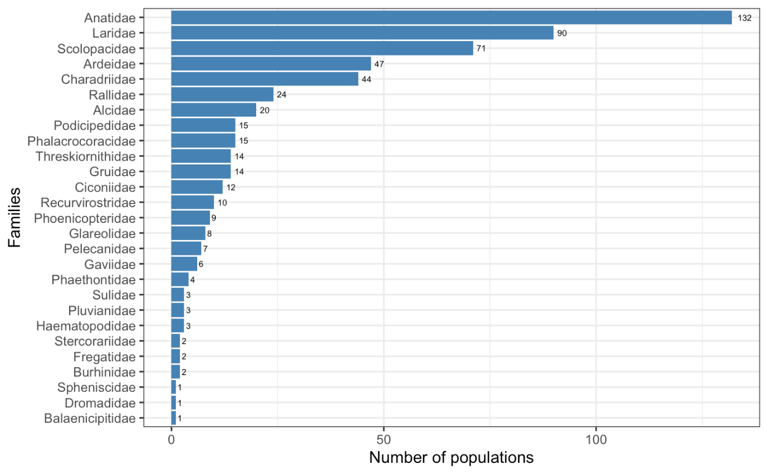

Figure 2. Number of AEWA populations per family.

70% of all AEWA populations breed in the Palearctic and
61% of all AEWA populations occur (also) in Sub-Saharan Africa
The AEWA populations are classified into multi-species flyway groups following the approach introduced in the 5th edition of the AEWA Conservation Status Report. This distinguishes amongst populations that remain in a single terrestrial ecoregion throughout their annual cycle, such as the Nearctic, the Western Palearctic or the Afrotropic, and populations that migrate from the Palearctic or Nearctic to the Afrotropical or the Indomalayan ecoregions.

393 populations (70% of all AEWA populations) breed in the Palearctic ecoregion. Nearly half of them (187 populations) migrate to the Afrotropical ecoregion. 161 populations (29%) are Intra-African migrants (Figure 3).

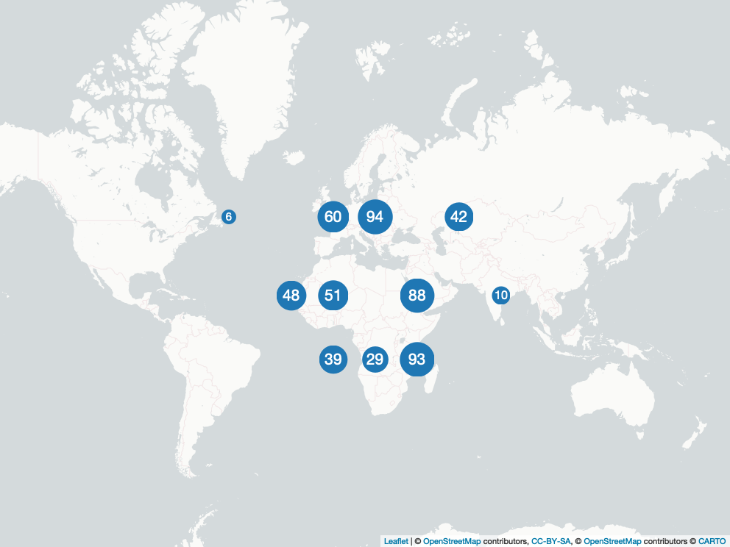

Figure 3. Number of AEWA populations by flyway groups. Upper row, from left to right: Nearctic and Western Palearctic flyways: Atlantic, Black Sea and Mediterranean, Central and Southwest Asian. Middle row from left to right: intercontinental flyways: East Atlantic, Sahelian, West Asia – East African, Central Asian. Bottom row, from left to right: Afrotropical flyways: Western and Central African, Sub-Saharan, Eastern and Southern African.

Part 2. Population sizes
More than two-thirds of the population size estimates are based on monitoring
As in earlier editions of the CSR, the quality of population size estimates was assessed. The quality assessments (Table 1) are equivalent to the method categories in the EU Birds Directive Article 12 and the AEWA population status reporting.

Table 1. Population size estimate quality categories

Category | Description
No estimate | No population estimate is available at all
Best guess | The population estimate is based on very little survey data
Expert opinion | The population estimate is based on incomplete survey data and expert knowledge was used to account for missing data
Census based | The population estimate is based on almost complete survey or statistically robust estimates

The population size estimate of 108 populations (19%) is based on full census or statistically robust estimates. For another 50% of all AEWA populations, the estimate is based on incomplete survey data (expert opinion). For 31% of the populations, the estimate is based on very incomplete surveys (see Annex 2) and for only 1% of the populations there is no estimate (Figure 4). This represents marginal improvement compared to the CSR7 (15%, 51%, 32% and 2%, respectively).
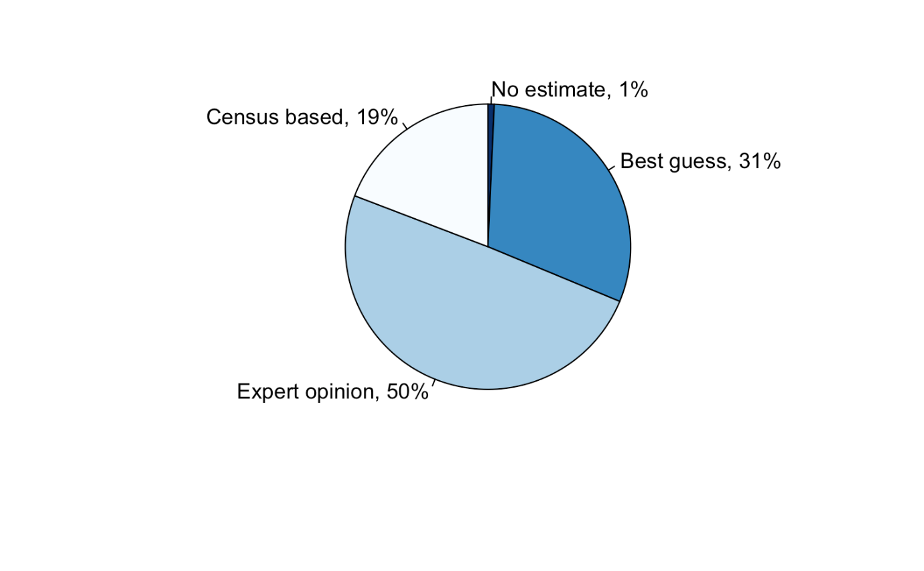
Figure 4. Quality of population size estimates.
More systematic surveys and reporting are needed in the Asian and African parts of the Agreement Area
Most of the population size estimates are based on complete or somewhat incomplete surveys (expert opinion) in the Nearctic, in the Atlantic as well as in the Black Sea and Mediterranean flyways in the Western Palearctic but also in the East Atlantic and Sahelian flyways (Figure 5). Most population estimates are based on very limited surveys (best guess) in Central and Southwest Asian, the West
Asia – East African and Central Asian flyways and all three Intra-African flyways. Producing high quality population size estimates seems to be particularly challenging for populations that belong to the Sub-Saharan African flyway group. This is related to both capacity and security issues. The proportion of populations with estimates based on very incomplete surveys is also relatively large in the Atlantic flyway group in the Western Palearctic. This is because of the challenges of monitoring certain high Arctic populations.

Populations still with only best guess estimate are listed in Annex 2.

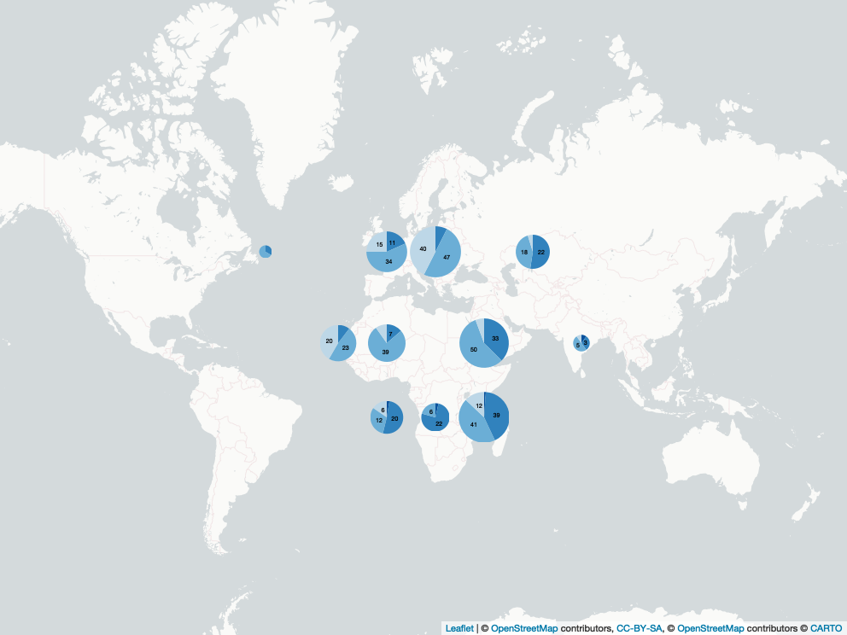

Figure 5. Quality of population size estimates by flyway groups. Flyway groups as on Figure 3. Colour codes from darkest to lightest blue: no estimate, best guess, expert opinion and census based.
Cryptic and dryland species are still poorly monitored
As in CSR7, families with a higher-than-average proportion of only best guess population size estimates includes the Ibises, Spoonbills (Threskiornithidae), the Avocets, Stilts (Recurvirostridae), the Herons (Ardeidae), the Skuas (Stercorariidae), the Coursers, Pratincoles (Glareolidae), the Loons (Gaviidae), the Plovers (Charadriidae), the Rails, Gallinules, Coots (Rallidae), the Egyptian Plover (Pluvianidae), the Thick-knees (Burhinidae) and the Shoebill (Balaenaciptidae). A common characteristic of these groups is that they include large numbers of species with cryptic behaviour and/or are associated with habitats not covered well by traditional multispecies surveys, especially in Africa. This underlines the importance of designing and setting up adequate monitoring schemes for all AEWA populations.

On the other hand, the Gannets, Boobies (Sulidae), the Flamingos (Phoenicopteridae), the Cranes (Gruidae), the Cormorants (Phalacrocoracidae), the Auks (Alcidae), the Penguins (Spheniscidae), the Crab-plover (Dromadidae) and especially the geese and swans amongst the Anatidae have a higher proportion of populations whose estimates are based on complete census (Figure 6).

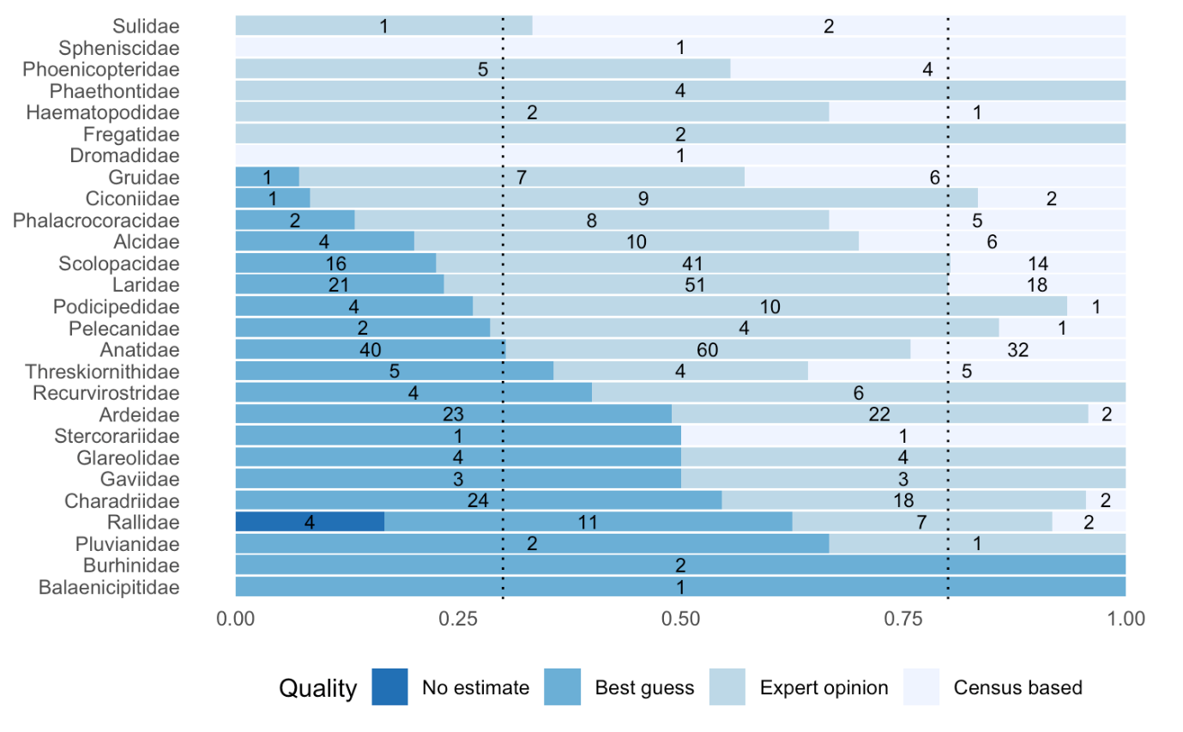

Figure 6. Quality of population estimates by family. The dotted line to the left indicates the overall proportion of populations with best guess estimates. The dotted line to the right indicates the overall proportion of populations with expert opinion estimates.
More than half of the AEWA populations have fewer than 100,000 individuals
More than half of the AEWA populations are relatively small and have fewer than 100,000 individuals (Figure 7). 149 populations fall in the class of 25,000 – 100,000 individuals and would qualify under Category 1 of Column B or in Category 3 of Column A depending on other factors of vulnerability. 54 populations are in the size class 10,000 – 25,000 individuals and 96 in the class of <10,000 individuals. This means that these populations would qualify for Categories 2 and 1c of Column A, respectively. However, another 259 populations, nearly half of all AEWA populations, are larger than 100,000 individuals and 62 (11%) even exceed 1 million individuals.
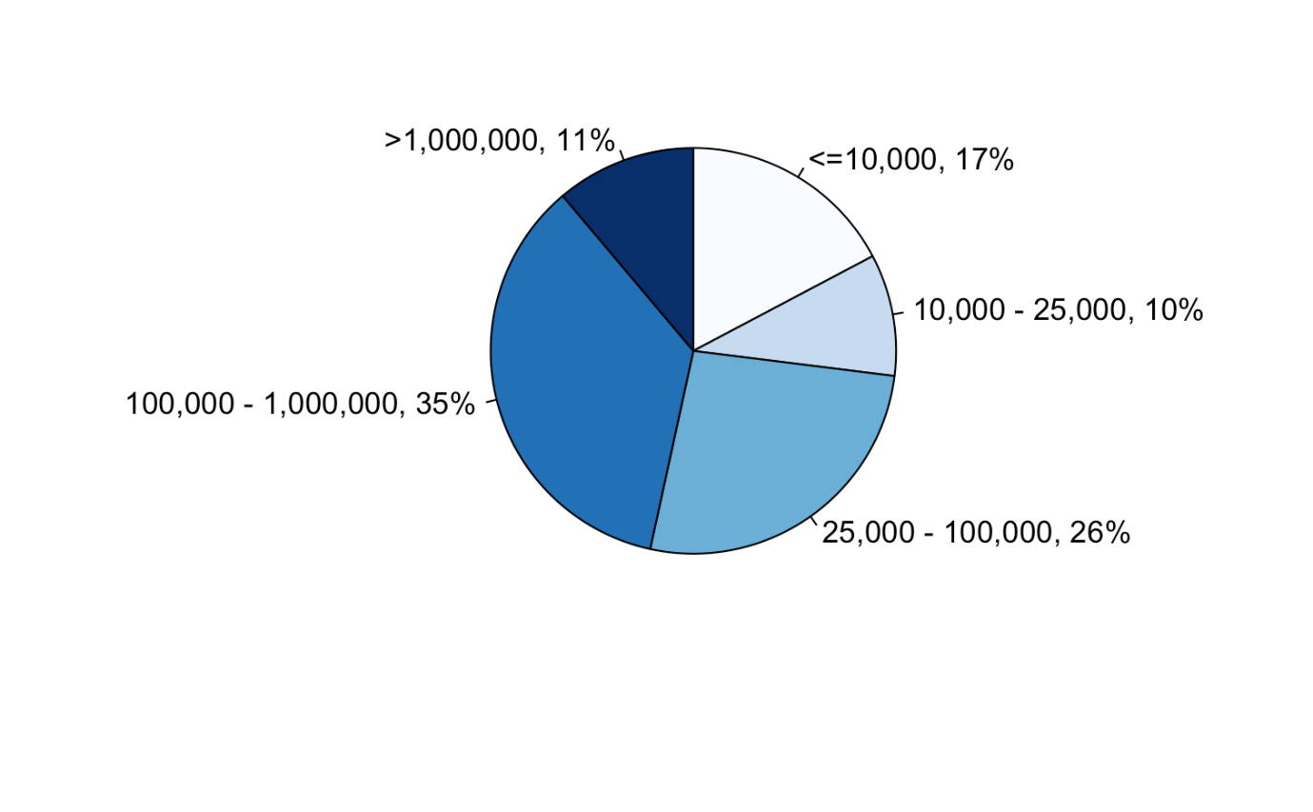
Figure 7. AEWA populations by size classes (in individuals).

Only four populations have no population size estimates (Table 2), which is less than half of the number of populations with no estimates in CSR7. These are all somewhat cryptic rail or crake species (Rallidae). Three of these are African populations. The Buff-spotted Flufftail (Sarothrura elegans) is widely distributed in Central, Eastern and Southern Africa. Its range overlaps that of the African Rail (Rallus caerulescens), the other African rail species with no estimates at all.

Table 2. AEWA populations with no population size estimates

Species | Population
Sarothrura elegans | elegans, NE, Eastern & Southern Africa
Sarothrura elegans | reichenovi, S West Africa to Central Africa
Rallus aquaticus | korejewi, Western Siberia/South-west Asia
Rallus caerulescens | Southern & Eastern Africa

Part 3. Population trends
Trends were assessed for two time periods: (a) the most recent available 10 years (short-term) and (b) the long-term (3-generations). The quality of short-term trend estimates was assessed following the scoring system developed by the International Wader Study Group. The categories are defined in Table 3.

Table 3. Trend quality categories

Category | Description
No idea: | No monitoring at international scale in either breeding or wintering periods. Trends are unknown (no data) or uncertain (trend direction cannot be established).
Poor: | Some international monitoring in either breeding or wintering periods although inadequate in quality or scope. Trends assumed through partial information.
Reasonable: | International monitoring in either breeding or wintering periods that is adequate in quality or scope to track direction of population changes.
Good: | International monitoring in either breeding or wintering periods that is adequate in quality or scope to track direction of population changes with defined statistical precision.

The trend quality was good for 115 populations (20%), reasonable for 285 populations (51%), poor for 115 populations (21%) and no idea for 46 populations (8%) (see Annex 3). This means that the short-term (10-year) trend can be established for almost three-quarter of the populations based on international monitoring (Figure 8). This is a significant improvement compared to CSR7 (9%, 39%, 38% and 14% respectively).
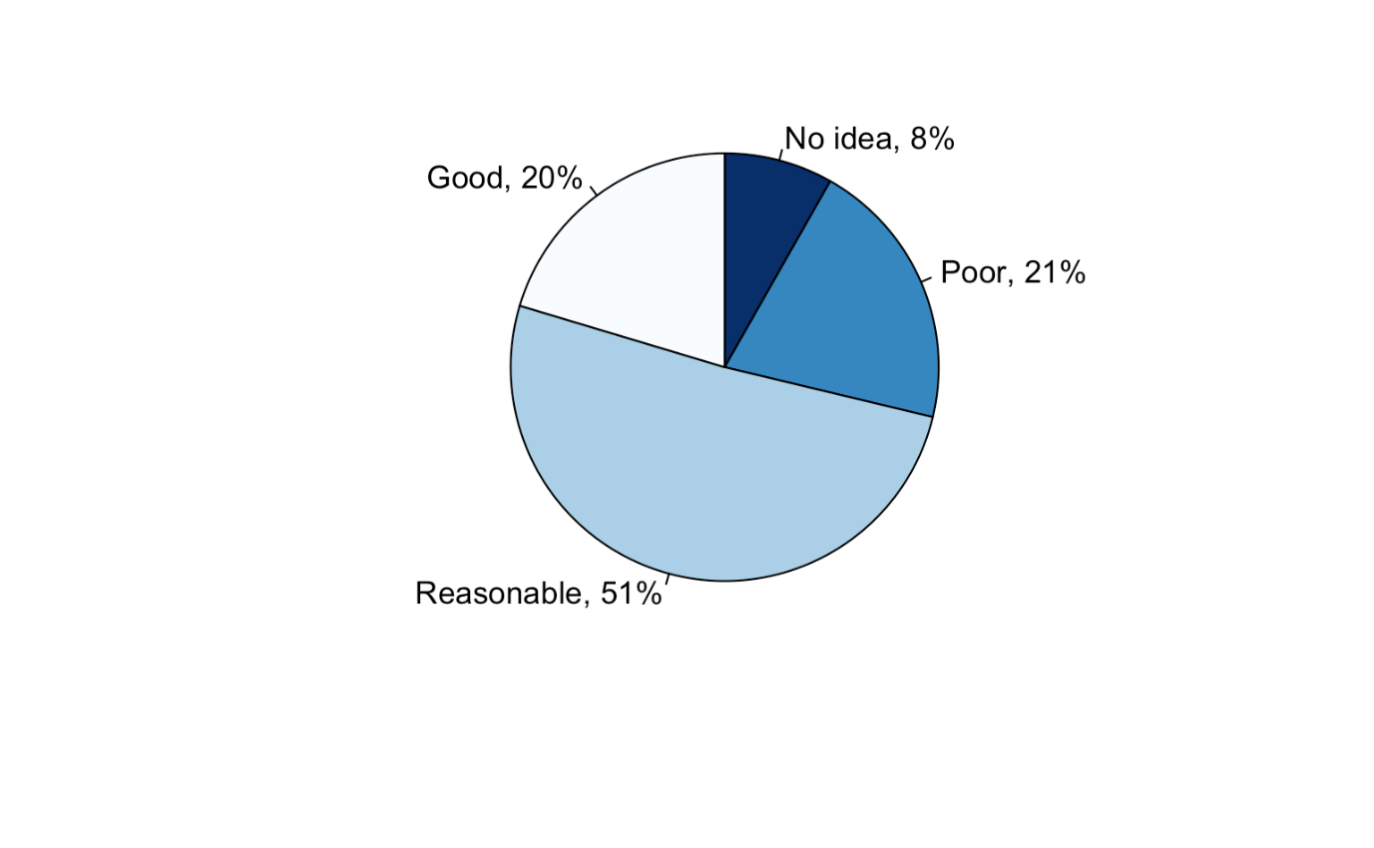
Figure 8. Short-term trend estimates quality of AEWA populations.
Development of systematic monitoring of AEWA populations remains a pressing issue in Africa and Asia
As with population size estimates, the best population trend estimates are available from the Black Sea and Mediterranean as well as from the East Atlantic flyways, followed by the Atlantic flyway of the Western Palearctic (Figure 9). The highest proportions of populations with no trend information are in the three Intra-African flyways, in the Central Asian, the West Asia – East African and in the Central and Southwest Asian flyways. Within Africa, the share of populations with reasonable trend estimates is higher in Eastern and Southern Africa than in Western and Central African and Sub-Saharan African flyways.

Populations with “No idea” and “Poor” trend quality are listed in Annex 3.

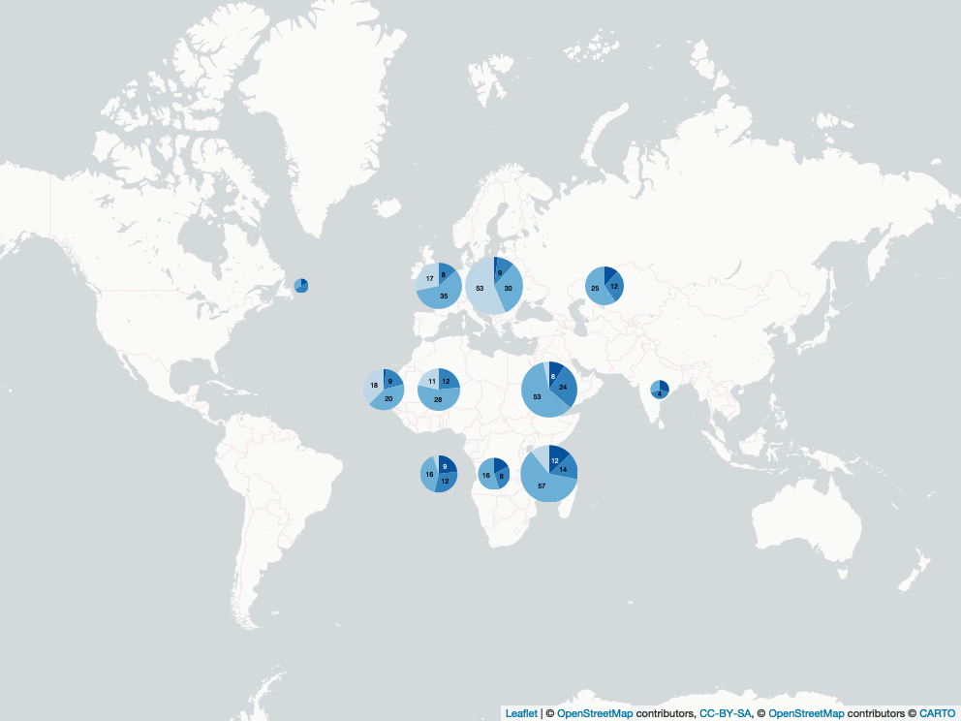

Figure 9. Trend estimates quality by flyway group. Flyway groups as on Figure 3. Colour codes from darkest to lightest blue: no idea, poor, reasonable and good (see Table 3).
Waterbird monitoring is also needed in the breeding season
Families with above average numbers of “Poor” or “No idea” quality population trends include the Shoebill (Balaenicipitade), the Thick-knees (Burhinidae), the Tropicbirds (Phaethontidae), the Egyptian Plover (Pluvianidae), the Loons (Gaviidae), the Coursers, Pratincoles (Glareolidae), the Rails, Gallinules, Coots (Rallidae), the Frigatebirds (Fregatidae), the Skuas (Stercorariidae), the Herons (Ardeidae), the Gulls, Terns, Skimmers (Laridae), the Auks (Alcidae), the Gannets, Boobies (Sulidae), the Cranes (Gruidae) and the Plovers (Charadriidae). These are mostly families of seabirds often breeding on remote islands, nomadic or cryptic species that are not well monitored by generic monitoring schemes such as the International Waterbird Census.

On the other hand, families that can be well monitored in the framework of generic schemes, such as sandpipers (Scolopacidae), ducks, geese and swans (Anatidae), storks (Ciconiidae), grebes (Podicipedidae), etc. have mostly “Reasonable” or “Good” quality trend estimates (Figure 10).

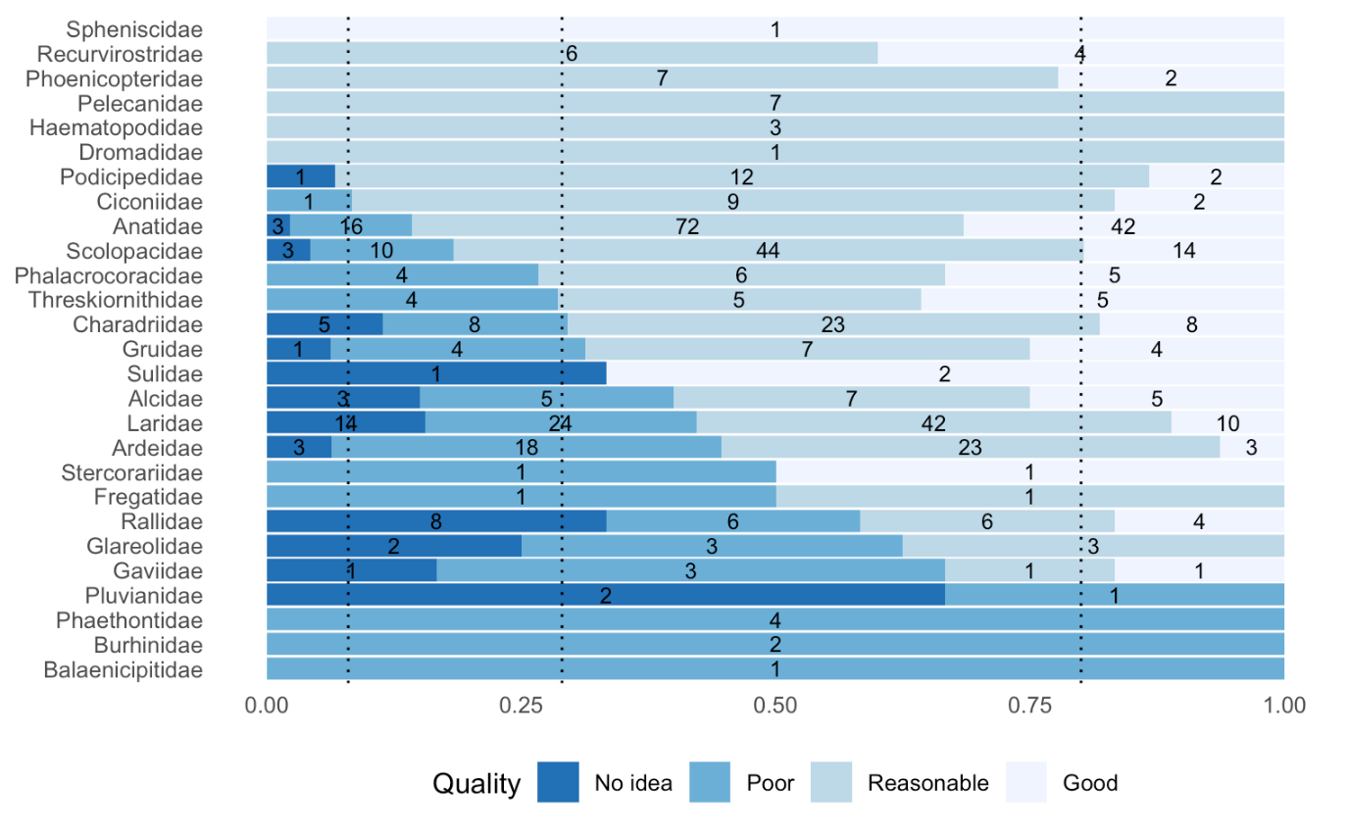

Figure 10. Trend estimates quality by family. Dotted lines from left to right represent the overall proportion of populations with trend qualities no idea, poor and reasonable.

40% more AEWA populations are decreasing than increasing
The short-term trend is known for 480 populations (86% of all AEWA populations). 197 populations (41% of all populations with known trends) are decreasing, 141 populations (29%) are stable or fluctuating and 142 populations (30%) are increasing (Figure 11). This means that both the proportion of populations that decrease and the proportion of populations that increase has slightly increased compared to CSR7, while the proportion of stable populations has decreased. While in CSR7, 36% more populations have declined than increased, this ratio has increased to 40% now. It is almost back to the level in 1999 (42%, i.e. CSR1) and to the level in 2008 (41%, i.e. at the start of the AEWA Strategic Plan 2008-2018).
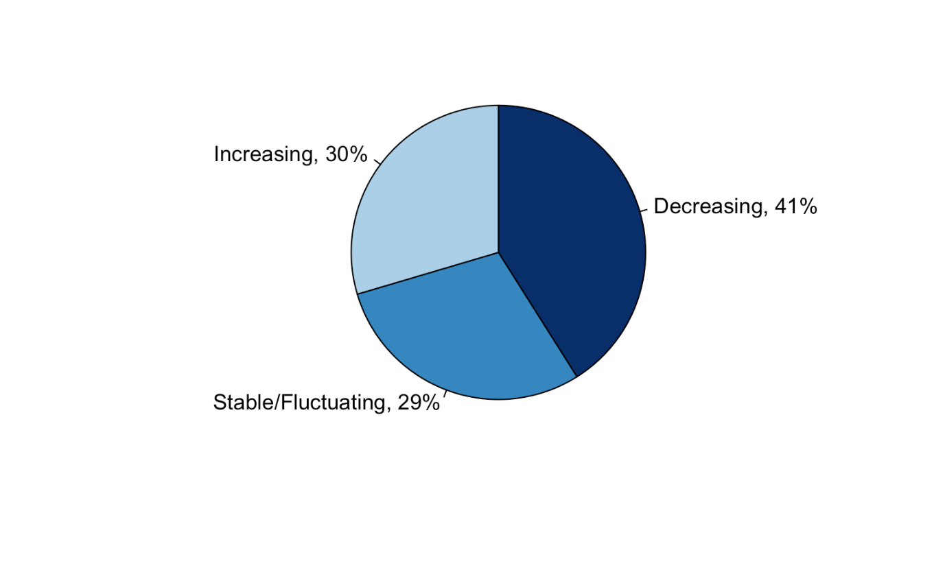
Figure 11. Short-term population trend direction of AEWA populations.

Populations in the eastern part of the Agreement Area are faring worse than in the western part
The highest proportion of populations with decreasing trend in the short-term can be found in the Central and Southwest Asian, Eastern and Southern African and Sub-Saharan African flyways (Figure 12).

The highest proportion of populations with increasing short-term trend can be found in Western and Central African, in the Nearctic, Central Asian flyways and in the Atlantic part of the Palearctic followed by the Black Sea and Mediterranean, Sahelian and East Atlantic flyways.

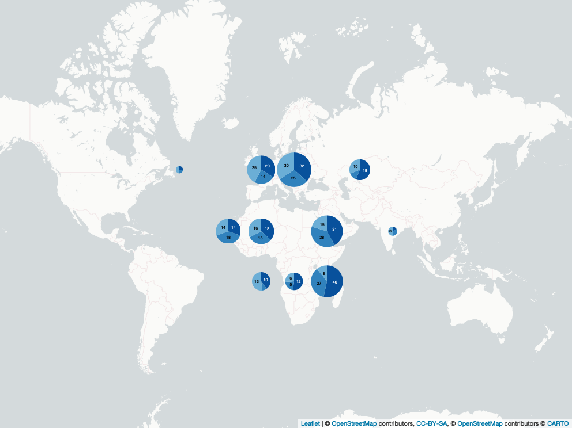

Figure 12. Short-term trend direction by flyway groups. Flyway groups as in Figure 3. Colour codes from darkest to lightest blue: decreasing, stable/fluctuating and increasing.

More than half of the populations of pratincoles, rails, sandpipers, plovers, storks, ibises and spoonbills are decreasing in the short-term
Waterbird families where all AEWA populations with a known trend are decreasing in the short-term include the Shoebill (Balaenicipitidae), the Coursers, Pratincoles (Glareolidae) and Penguins (Spheniscidae). These are typically small families. More than half of the AEWA populations are decreasing amongst the Loons (Gaviidae), the Cranes (Gruidae), the Rails, Gallinules, Coots (Rallidae), the Sandpipers, Snipes, Phalaropes (Scolopacidae) and the Ibises, Spoonbills (Threskiornithidae). The families with above average proportion of decreasing populations also include the Thick-knees (Burhinidae), the Storks (Ciconidae), the Grebes (Podicipedidae), the Gannets (Sulidae), the Plovers (Charadriidae) and the Pelicans (Pelecanidae).

Above average proportion of increasing populations can be found amongst the Egyptian Plover (Pluvianidae), the Auks (Alcidae), the Avocets, Stilts (Recurvirostridae), Gannets, Boobies (Sulidae), the Flamingos (Phoenicopteridae), the Thick-knees (Burhinidae), the Pelicans (Pelecanidae), the Storks (Ciconidae), Ibises, Spoonbills (Threskiornithidae), the Ducks, Geese, Swans (Anatidae), the Herons (Ardeidae) and the Cormorants (Phalacrocaricidae) (Figure 13).

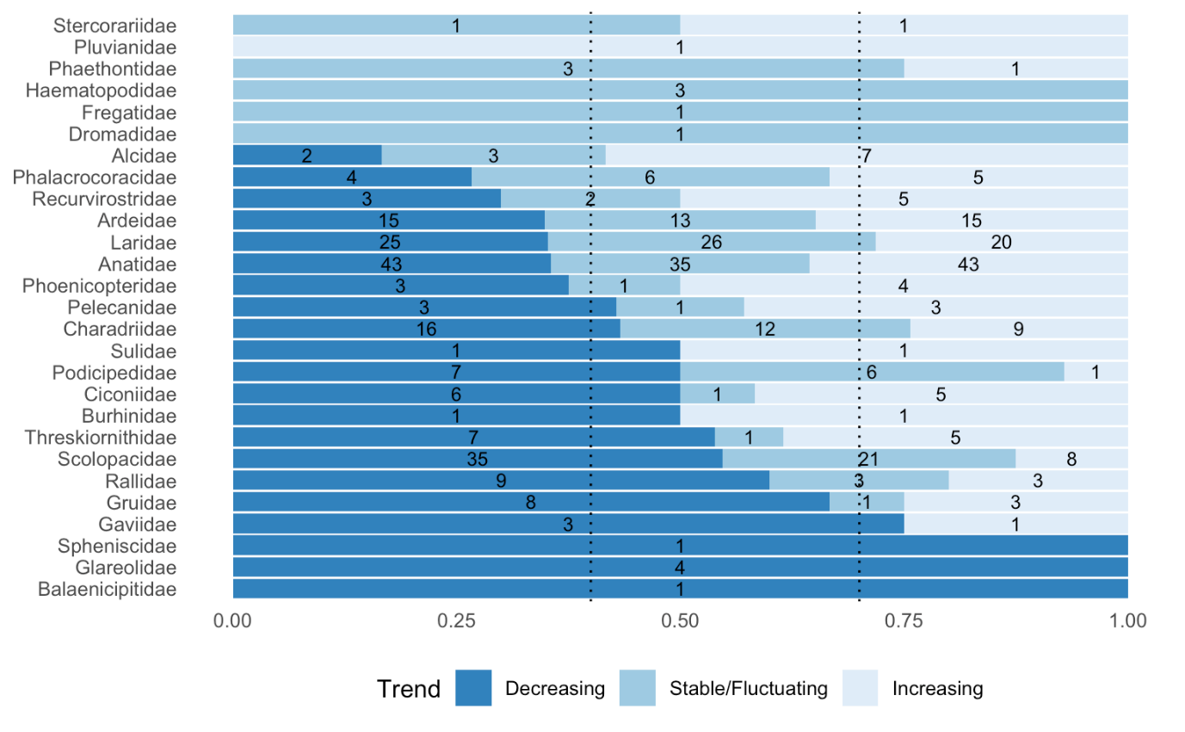

Figure 13. Short-term trend direction of AEWA populations by family. Dotted lines from left to right represent the overall proportion of populations with decreasing and stable/fluctuating short-term trends.

One in every five AEWA populations is in rapid short-term decline

At MOP7, the AEWA Parties agreed to introduce a new category to classify populations in rapid short-term decline in Categories 3e and 2e of Column A and B, respectively. Populations are considered to be in rapid short-term decline if the population growth rate over the last 10 years indicates that the population declines at a rate equivalent to 30% over three generations.

In total, 115 populations (20% of all AEWA populations) are in rapid short-term decline (see Annex 4). Almost half of these populations are larger than 100,000 individuals and, therefore, would qualify under the criterion for Category 2e of Column B. 25 populations (22% of the 115 populations) are in the size class of 25,000 – 100,000 individuals and would qualify for listing in Category 3e of Column A. 15 populations (13%) in the size class of 10,000 – 25,000 individuals and 19 populations (16%) are smaller than 10,000 individuals (Figure 14). These would be classified in Categories 2 and 1c of Column A irrespective of their population trend. The proportions of populations in rapid short-term decline is slightly higher in the 10,000 – 25,000, 25,000 – 100,000 and in the 100,000 – 1,000,000 individuals size classes, slightly smaller in the >1,000,000 individuals size class and the same in the <=10,000 individuals size class than the proportions of all AEWA populations in these classes (see Figure 7 for comparison).

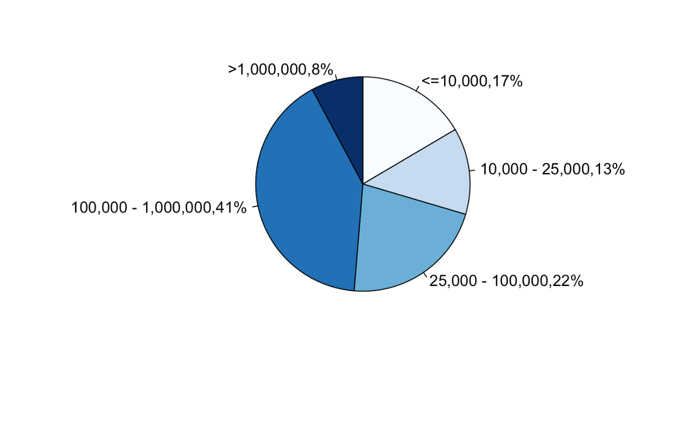
Figure 14. Populations in rapid short-term decline by size classes.

The highest proportion of populations in rapid short-term decline is amongst the Cranes and the Avocets, Stilts
Above average proportion of the populations of the Avocets, Stilts (Recurvirostridae), the Cranes (Gruidae), the Loons (Gaviidae), the Flamingos (Phoenicopteridae), the Gannets, Boobies (Sulidae), the Pelicans (Pelicanidae), the Ibises, Spoonbills (Therskiornithidae), the Sandpipers, Snipes, Phalaropes (Scolopacidae) and the Duck, Geese, Swans (Anatidae) are in rapid short-term decline.

The highest number of populations in rapid short-term decline belong to the Ducks, Geese, Swans (Anatidae), Sandpipers, Snipes, Phalaropes (Scolopacidae) as well as gulls and terns (Laridae) (Figure 15).

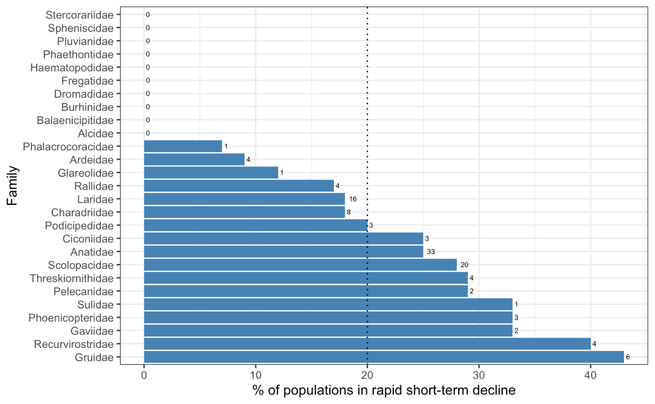

Figure 15. Proportion of populations in rapid short-term decline by family. Numbers indicate the number of populations in rapid short-term decline. The dotted line indicates the overall average proportion of populations in rapid short-term decline

The highest proportion of AEWA populations in rapid short-term decline are in the Sub-Saharan African, Central and Southwest Asian and in the Eastern and Southern African flyways
The largest number of populations in rapid short-term decline can be found in the Eastern and Southern African flyway (27 populations) followed by 17 populations in the Atlantic flyway and 14 populations in the Central and Southwest Asian flyway in the Western Palearctic and 12 populations in the West Asia – East African flyway. 10 populations are in rapid short-term decline in each of the Sub-Saharan African, Sahelian and Black Sea and Mediterranean flyways. 8 populations are in rapid short-term decline in the East Atlantic flyway, 6 populations in the Western and Central African one and only 1 in the Central Asian flyways. No populations are in rapid short-term decline in the Nearctic (Figure 16).

AEWA populations in rapid short-term decline are listed in Annex 4 for each flyway group.

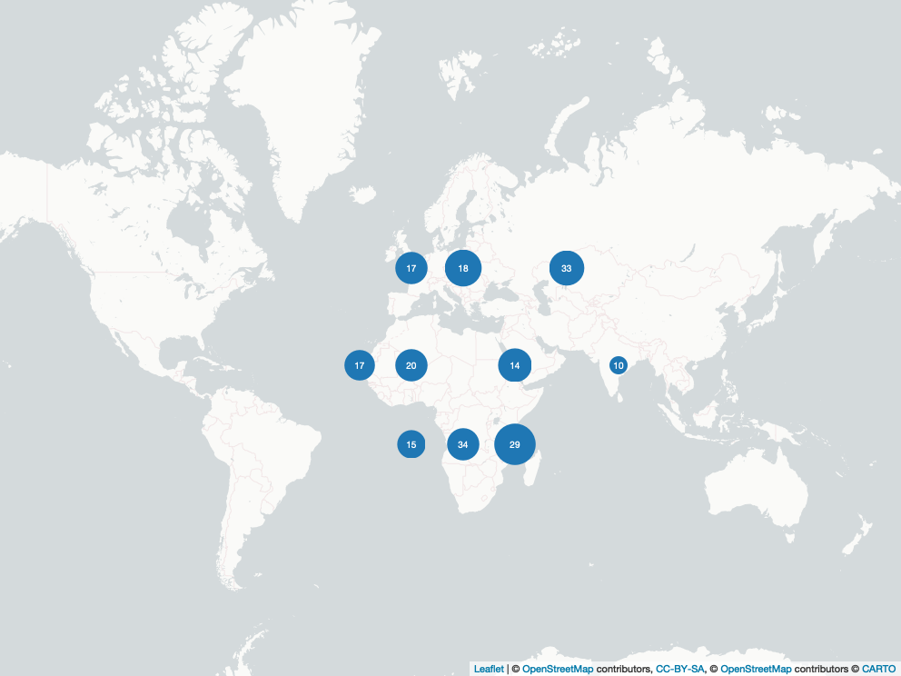

Figure 16. Proportion of populations in rapid short-term decline by flyway groups. Flyway groups as in Figure 3. Numbers indicate the proportions of all populations in the flyway group. The size of the circles indicates the number of populations in rapid short-term decline (see text above).

Almost half of the AEWA populations are in long-term decline
Long-term decline exceeding 10% over 10 years or three generations, whichever one is the longer, qualifies AEWA populations for listing in Categories 3c and 2c of Columns A and B, respectively. The mean generation length of species listed on Annex 2 of AEWA is 7.33 years, which means that the average length of the three-generations-periods is 22 years.

There is information on the long-term trend direction for 495 populations (88% of all AEWA populations). 167 populations (34% of the populations with known long-term trend) have been increasing, 113 (23%) have been stable/fluctuating and 215 (43%) have been declining (see Annex 5) (Figure 17). This means that 29% more populations have been declining than increasing in the long-term. This ratio between the decreasing and increasing long-term trends is somewhat more positive than the short-term trends.

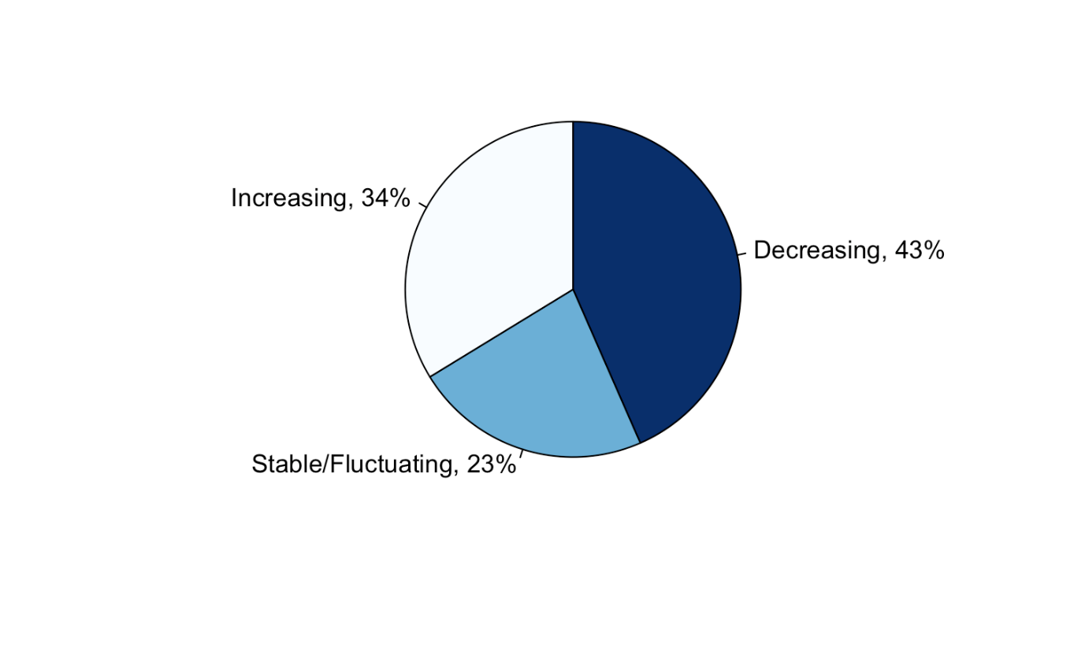
Figure 17. AEWA populations by their long-term trend.

The highest proportion of populations in long-term decline are also in the eastern part of the Agreement Area
The highest proportion of AEWA populations have increased in the Nearctic region, the Western and Central African Flyway and in the Atlantic Flyway of the Western Palearctic. They are followed by the Black Sea and Mediterranean, the East Atlantic, the Sahelian and the Central Asian flyways.

The proportion of populations in long-term decline is highest in Central and Southwest Asian, Southern and Eastern African, Sub-Saharan Africa and in the West Asia – East African flyway (Figure 18).

This geographic pattern is similar to the short-term trend (Figure 11). AEWA populations in long-term decline are listed in Annex 5.

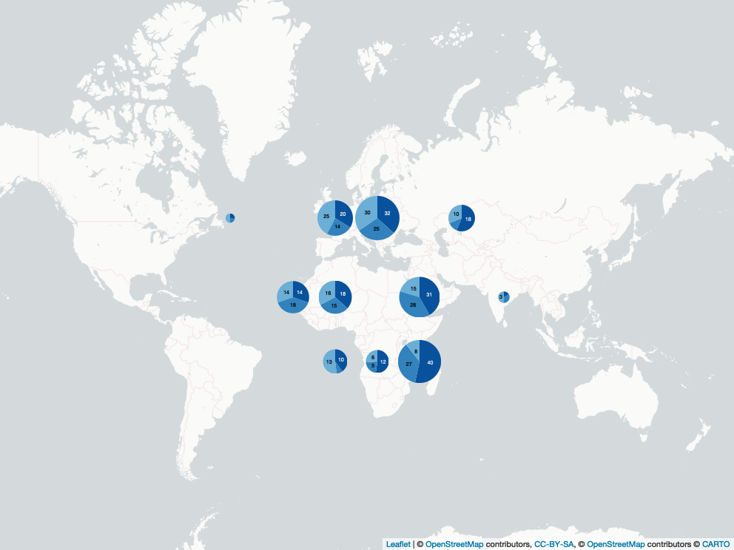

Figure 18. Long-term population trends by flyways. Flyway groups as in Figure 3. Colour codes from darkest to lightest blue: decreasing, stable/fluctuating and increasing.

The status of the Shoebill, the Penguins, the Cranes, the Coursers, Pratincoles, the Loons, the Rails, Gallinules, Coots and the Sandpipers, Snipes, Phalaropes has been deteriorating more than other groups
Apart from the two families, the Shoebill (Balaenicipitidae) and the Penguins (Spheniscidae) each with only a single population listed in Table 1, more than half of the populations of the Rails, Gallinules, Coots (Rallidae), the Coursers, Pratincoles (Glareolidae), the Oystercatchers (Haematopodidae), the Cranes (Gruidae), the Loons (Gaviidae) and Sandpipers, Snipes, Phalaropes (Scolopacidae) have been decreasing in the long-term. Higher-than-average proportion of populations have declined also amongst the Thick-knees (Burhinidae), the Frigatebirds (Fregatidae), the Egyptian Plover (Pluvianidae), the Gannets, Boobies (Sulidae), the Grebes (Podicipedidae) and Ducks, Geese, Swans (Anatidae) (Figure 19).

Higher-than-average proportion of populations have been increasing in the long-term amongst the Crab-plover (Dromadidae), Avocets, Stilts (Recurvirostridae), the Pelicans (Pelecanidae), the Flamingos (Phoenicopteridae), the Ibises, Spoonbills (Threskiornithidae), the Thick-knees (Burhinidae), the Gannets, Boobies (Sulidae), the Skuas (Stercorariidae), the Egyptian Plover (Pluvianidae), the Auks (Alcidae), the Storks (Ciconidae), the Cormorants (Phalacrocoracidae), the Loons (Gaviidae), the Herons (Ardeidae), the Ducks, Geese, Swans (Anatidae) and the Cranes (Gruidae).

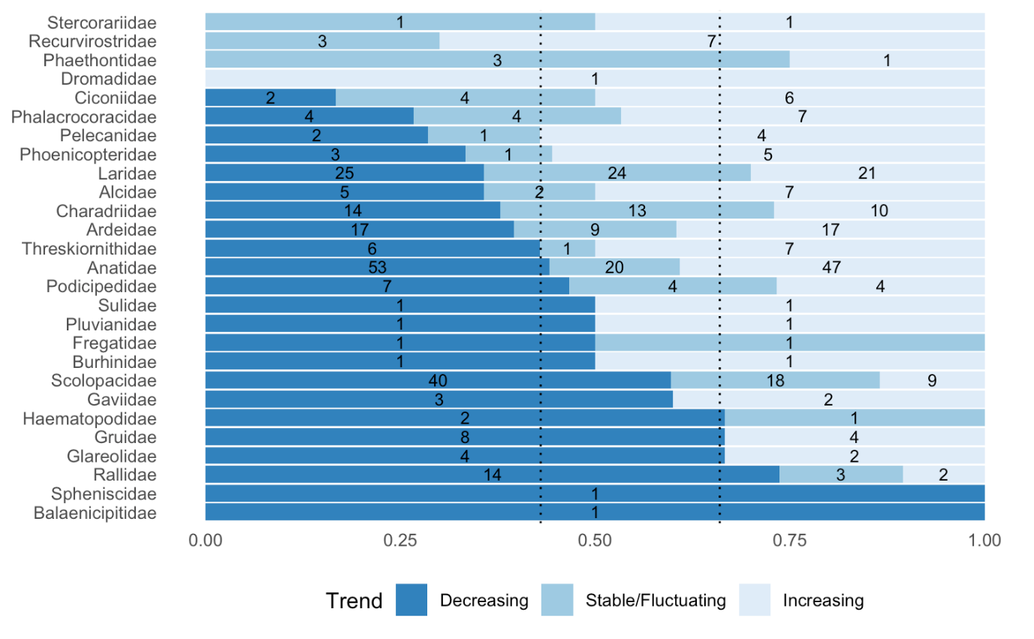

Figure 19. Long-term trend direction by family. Dotted lines from left to right represent the overall proportion of populations with decreasing and stable/fluctuating long-term trends.

Part 4. Species of global conservation concern

Based on the 2020 IUCN Red List update, 203 Least Concern, 19 Near Threatened, 20 Vulnerable, nine Endangered and four Critically Endangered species are listed in Annex 2 of AEWA. Hence, 33 (13%) of the AEWA species are considered globally threatened (the last three of these categories) and 52 species (20%) are of global conservation concern (globally threatened and Near Threatened) (Figure 20, Tables 4 and 5).

Since CSR7, the number of globally threatened species has increased by two. One of the newly recognised globally threatened species is the Black-legged Kittiwake (Rissa tridactyla) that was Least Concern before. The other one is the Audouin’s Gull (Larus audouinii). This species was recognised as Near Threatened in 2004 and downgraded to Least Concern in 2015 following a strong population increase. It has been upgraded to Vulnerable in 2020 following large declines at its main breeding site in Spain.

One Critically Endangered species, the Northern Bald Ibis (Geronticus eremita), was downgraded to Endangered. It is subject of an AEWA International Single Species Action Plan with an AEWA International Working Group.

Two Near Threatened species, the African Oystercatcher (Haematopus moquini) and White-eyed Gull (Larus leucophthalmus), were downgraded to Least Concern. Hence, the overall number of Threatened and Near Threatened species listed on Annex 2 of AEWA has not changed compared to CSR7.

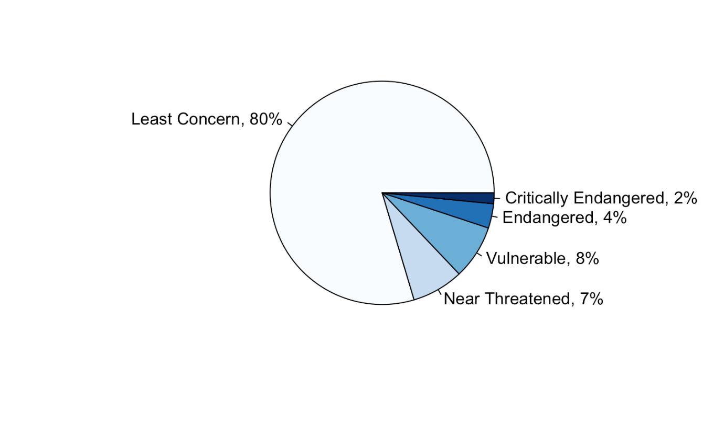
Figure 20. Global Red List status of species listed in Annex 2 of AEWA.

Table 4. Globally Threatened species listed on Annex 2 of AEWA as of January 2021

Critically Endangered
English name | Scientific name | Action Plan | Year
Slender-billed Curlew | Numenius tenuirostris | CMS/ Bern/ EU | 1994
White-winged Flufftail | Sarothrura ayresi | CMS/AEWA | 2008
Siberian Crane | Leucogeranus leucogeranus | CMS | 2010
Sociable Lapwing | Vanellus gregarius | CMS/AEWA | 2012

Endangered
English name | Scientific name | Action Plan | Year
Madagascar Pond-heron | Ardeola idae | CMS/AEWA | 2008
Grey Crowned Crane | Balearica regulorum | AEWA | 2015
African Penguin | Spheniscus demersus | AEWA* | 2015
Northern Bald Ibis | Geronticus eremita | AEWA | 2015
Cape Gannet | Morus capensis | AEWA* | 2015
Cape Cormorant | Phalacrocorax capensis | AEWA* | 2015
Bank Cormorant | Phalacrocorax neglectus | AEWA* | 2015
White-headed Duck | Oxyura leucocephala | CMS/AEWA/EU | 2018
Great Knot | Calidris tenuirostris | –

*: AEWA International Multi-species Action Plan for the Conservation of Benguela Current Upwelling System Coastal Seabirds

Vulnerable
English name | Scientific name | Action Plan | Year
Audouin's Gull | Larus audouinii | Bern/EU | 1996
Steller's Eider | Polysticta stelleri | EU | 1997
Marbled Teal | Marmaronetta angustirostris | EU | 2008
Lesser White-fronted Goose | Anser erythropus | AEWA | 2008
Maccoa Duck | Oxyura maccoa | AEWA | 2008
Red-breasted Goose | Branta ruficollis | AEWA/EU | 2012
Slaty Egret | Egretta vinaceigula | AEWA | 2012
Shoebill | Balaeniceps rex | AEWA | 2013
Long-tailed Duck | Clangula hyemalis | AEWA | 2015
Damara Tern | Sternula balaenarum | AEWA* | 2015
Velvet Scoter | Melanitta fusca | AEWA/EU | 2018
Black-legged Kittiwake | Rissa tridactyla | CAFF | 2020
Common Pochard | Aythya ferina | –
Horned Grebe | Podiceps auritus | –
Black Crowned Crane | Balearica pavonina | –
Wattled Crane | Bugeranus carunculatus | –
Blue Crane | Anthropoides paradiseus | –
Socotra Cormorant | Phalacrocorax nigrogularis | –
Madagascar Pratincole | Glareola ocularis | –
Atlantic Puffin | Fratercula arctica | –

Table 5. Globally Near Threatened species listed on Annex 2 of AEWA as of January 2021

English name | Scientific name | Action Plan | Year
Black-winged Pratincole | Glareola nordmanni | AEWA/Bern | 2004
Great Snipe | Gallinago media | AEWA/Bern/EU | 2004
Ferruginous Duck | Aythya nyroca | CMS/AEWA | 2005
Lesser Flamingo | Phoeniconaias minor | CMS/AEWA | 2008
Black-tailed Godwit | Limosa limosa | AEWA/EU, EU° | 2008
Crowned Cormorant | Microcarbo coronatus | AEWA* | 2015
Eurasian Curlew | Numenius arquata | AEWA, EU° | 2015
Dalmatian Pelican | Pelecanus crispus | CMS/AEWA/EU/EAAFP | 2018
Eurasian Oystercatcher | Haematopus ostralegus | EU° | 2018
Northern Lapwing | Vanellus vanellus | EU° | 2018
Common Eider | Somateria mollissima | (AEWA) | (2021)
Yellow-billed Loon | Gavia adamsii | –
Chestnut-banded Plover | Charadrius pallidus | –
Bar-tailed Godwit | Limosa lapponica | –
Red Knot | Calidris canutus | –
Curlew Sandpiper | Calidris ferruginea | –
African Skimmer | Rynchops flavirostris | –
Armenian Gull | Larus armenicus | –
Razorbill | Alca torda | –

°: EU International Multi-Species Action Plan for the Conservation of Breeding Waders in Wet Grassland Habitats in Europe
The proportion of populations that belong to a species of global conservation concern is highest in Eastern and Southern Africa
The proportion of populations that belong to a species of global conservation concern is by far the highest in Eastern and Southern Africa, followed by Central and Southwest Asia and the Atlantic and Black Sea – Mediterranean flyways in the Western Palearctic. Importantly, apart from AEWA, no other international treaty exists in the first two flyways mentioned above to facilitate the recovery of these waterbird populations. Contrary to other flyways, most of the species associated with Eastern and Southern Africa are restricted to that region and do not occur elsewhere. Tables 4 and 5 show that the largest number of globally threatened species without an action plan (such as the Wattled Crane, Blue Crane and Madagascar Pratincole) are also associated with this region (Figure 21).

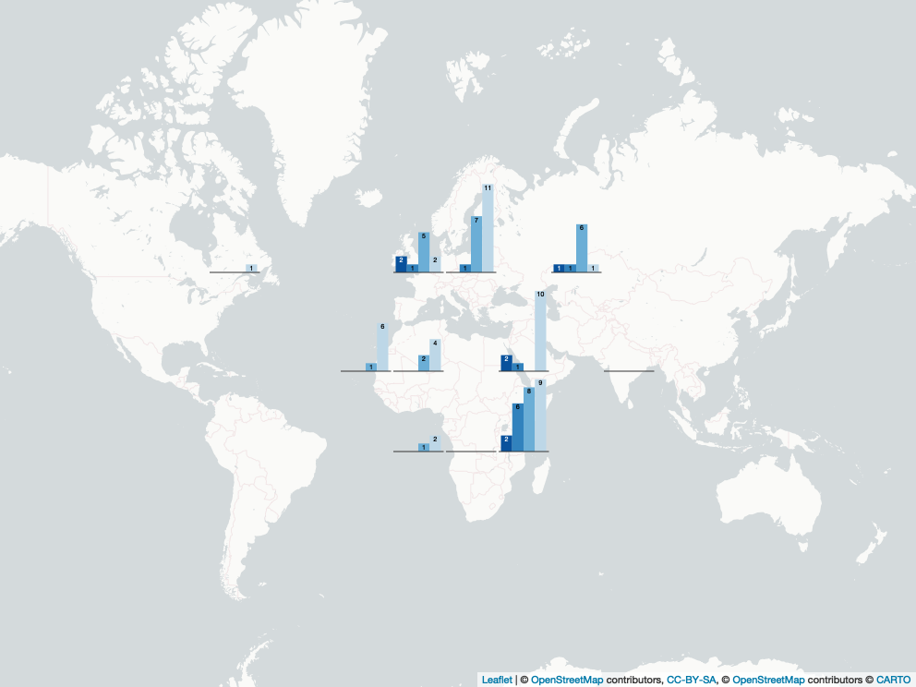

Figure 21. Number of populations of species of global conservation concern by flyway. Flyway groups as in Figure 3. Colour codes from darkest to lightest blue: Critically Endangered, Endangered, Vulnerable and Near Threatened.

Part 5. Strategic plan indicators
The AEWA Strategic Plan 2019-2027 contains 5 purpose level indicators:
P1. At least 75% of AEWA populations with known trends show a stable or increasing trend.
P2. At least 55% of ‘priority’ populations (as established in 2018) show a stable or increasing trend.
P3. At least 60% of populations with unfavourable conservation status in 2018 show a stable or increasing trend.
P4. Percentage of harvested AEWA populations with known trends that show a stable or increasing trend.
P5. At least 70% of AEWA populations highly dependent on site networks with known trends show a stable or increasing trend.
P6. At least 70% of dispersed AEWA populations with known trends show a stable or increasing trend.

P1. At least 75% of AEWA populations with known trends show a stable or increasing trend

☹️ | As Figure 10 shows 60% of the 480 AEWA populations with known short-term trend show a stable or increasing trend. The baseline calculated based on CSR7 was 65%  (N = 432 populations). The target is not met, and the indicator shows a negative change.

P2. At least 55% of ‘priority’ populations (as established in 2018) show a stable or increasing trend

According to the AEWA Strategic Plan for 2019–2027, ‘priority’ populations are those listed in Table 1 of the AEWA Action Plan and classified as Globally Threatened species (i.e. Critically Endangered, Endangered and Vulnerable) or Near Threatened species on the IUCN Red List of Threatened Species as reported in the most recent summary by BirdLife International, as well as those listed in Table 1, Column A, Categories 2 and 3 that are marked with an asterisk. A baseline was established in 2018. In total, the pool consisted of 98 populations including two additional populations, the Mediterranean/N & W coasts of Africa population of Audouin’s Gull (Larus audouinii) and the Europe & Western Asia (bre) of Great White Pelican (Pelecanus onocrotalus) which were also included because they are listed on Appendix 1 of the CMS. From these 98 populations, 18 populations were excluded because of unknown or uncertain trends and the baseline of 45% of the populations increasing or stable was established based on 80 populations. Based on the data for CSR8, 86 populations fulfil the selection criteria (i.e. has other than uncertain or unknown short-term trend) and 45% of the populations are stable or increasing (Figure 22). Hence, no improvement, but also no negative change.
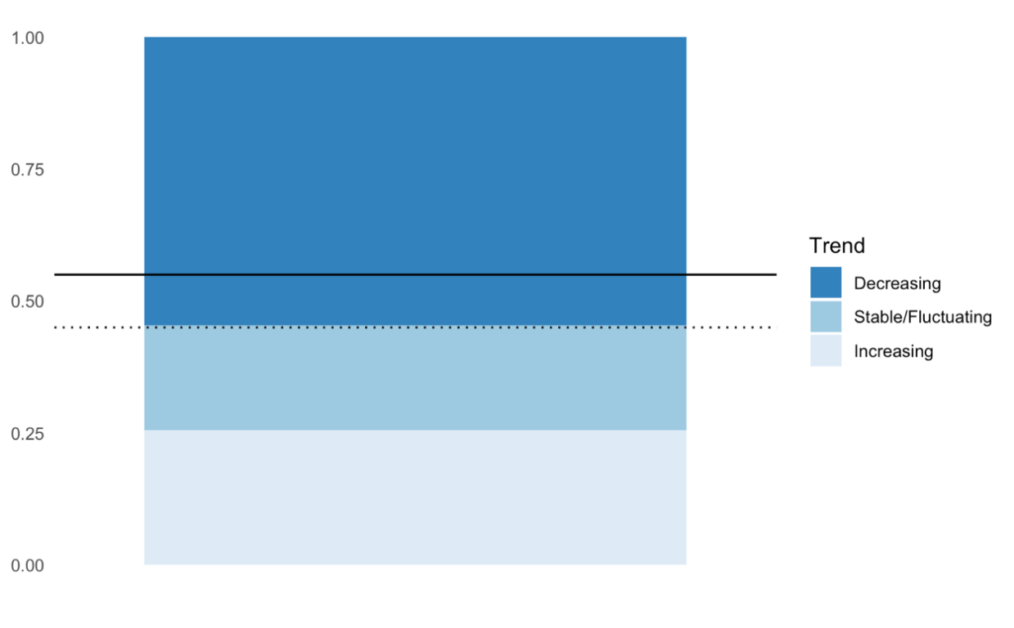
Figure 22. Proportion of priority populations increasing, stable/fluctuating and decreasing. The dotted line represents the baseline and the solid one the target.

P3. At least 60% of populations with unfavourable conservation status in 2018 show a stable or increasing trend.

According to the AEWA Strategic Plan for 2019–2027, populations with unfavourable conservation status include those listed in Column A, Categories 1(c), 2 & 3 and Column B, Category 2, in Table 1 of the AEWA Action Plan. The baseline was 51% based on 155 populations with known trend (out of 204 population that meets the criteria above). Based on the data for CSR8, 169 populations fulfil the selection criteria (i.e. has other than uncertain or unknown short-term trend) and 53% of the populations are stable or increasing (Figure 23). This represents a slight improvement, but the target is not reached yet.

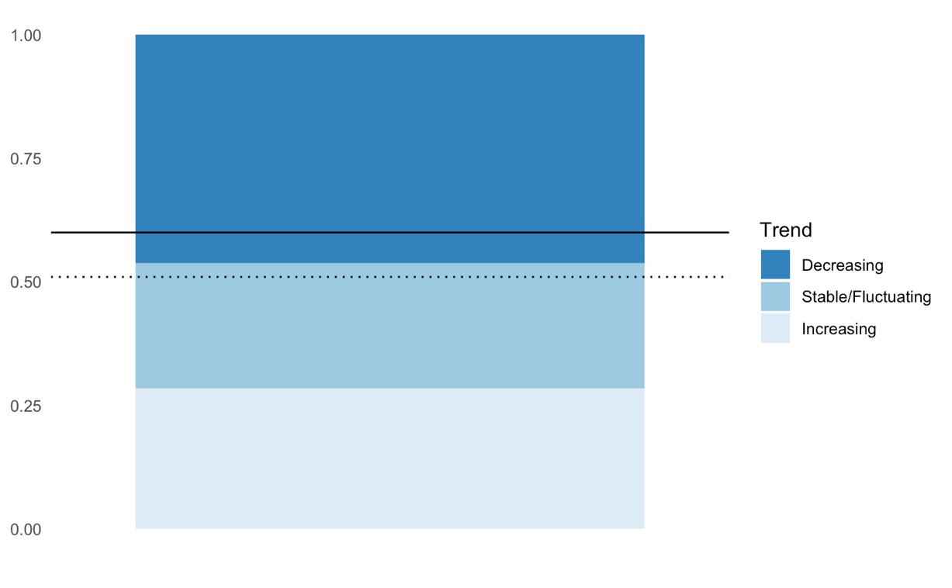
289
Figure 23. Proportion of priority populations increasing, stable/fluctuating and decreasing. The dotted line represents the baseline and the solid one the target.

P4. Percentage of harvested AEWA populations with known trends that show a stable or increasing trend

According to the AEWA Strategic Plan for 2019–2027, a harvested population is a population that is legally harvested in at least one country within its range. The target threshold for this indicator is to be defined on the basis of the most up-to-date information available after the baseline has been identified. Current baseline: to be identified once the list of harvested populations has been determined based on information to be collated from Parties in 2022. The 2018 baseline will be then also calculated retrospectively.

P5. At least 70% of AEWA populations highly dependent on-site networks with known trends show a stable or increasing trend

️ | According to the AEWA Strategic Plan for 2019–2027, populations highly dependent on-site networks are those for which 25% or more of the population occurs at relatively few key sites during at least one season of its annual cycle. The 2018 baseline was 63% based on 355 populations with known trend (out 429 populations that meet the criteria above). Based on the data for CSR8, 380 populations fulfil the selection criteria (i.e. has other than uncertain or unknown short-term trend) and 59% of the populations are stable or increasing (Figure 24). Hence, the indicator suggests some deterioration instead of progress towards the target.  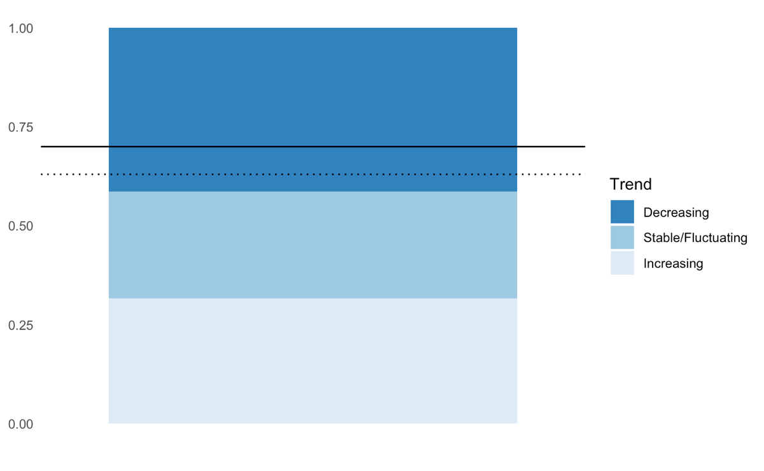  289  Figure 24. Proportion of priority populations increasing, stable/fluctuating and decreasing. The dotted line represents the baseline and the solid one the target.

P6. At least 70% of dispersed AEWA populations with known trends show a stable or increasing trend

️ | According to the AEWA Strategic Plan for 2019–2027, a dispersed population is one where at least 75% of the population is ‘dispersed’ during at least one season of its annual cycle, with relatively small numbers occurring at multiple sites. The 2018 baseline was 63% based on 320 populations with known trend (out of 416 populations that meet the criteria above). Based on the data for CSR8, 365 populations fulfil the selection criteria (i.e. has other than uncertain or unknown short-term trend) and 58% of the populations are stable or increasing (Figure 25). Hence, the indicator suggests some deterioration instead of progress towards the target.  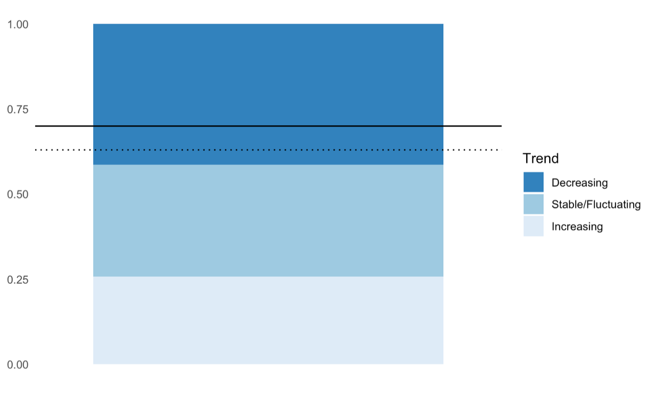  289  Figure 25. Proportion of priority populations increasing, stable/fluctuating and decreasing. The dotted line represents the baseline and the solid one the target.

Annex 1. Size and trend estimates for AEWA populations

The updated population size and trend estimates are provided as a separate attachment to this document (as PDF and Excel files) but can be also accessed on the WPE Portal under CSR8.

Detailed justification to the population size and trend estimates is provided for each population and available on the Waterbird Population Estimates (WPE) Portal. Information for the draft CSR8 can be looked up by selecting the publication “CSR8” and the conservation framework “AEWA” before hitting the search button or using this link:

http://wpe.wetlands.org/search?form%5Bspecies%5D=&form%5Bpopulation%5D=&form%5Bpublication%5D=11&form%5Bprotection%5D%5B1%5D=1

On the WPE portal, the trend assessment refers to the short-term (10-year) trend. However, further information is provided in the notes concerning the long-term (3 generations and beyond) trends, which is the criterion for listing populations under categories A3(c) and B2(c).

Several background documents are accessible on the website of Wetlands International and the results of the IWC trend analysis (Nagy & Langendoen, 2020) is available on the IWC Online Portal.

Annex 2: AEWA populations with only “Best guess” population estimates by flyway groups

English name | Scientific name | Population name
Afrotropic - Eastern and Southern African flyway
White-faced Whistling-duck | Dendrocygna viduata | Eastern & Southern Africa
Fulvous Whistling-duck | Dendrocygna bicolor | Eastern & Southern Africa
White-backed Duck | Thalassornis leuconotus | leuconotus, Eastern & Southern Africa
Egyptian Goose | Alopochen aegyptiaca | Eastern & Southern Africa
Spur-winged Goose | Plectropterus gambensis | gambensis, Eastern Africa (Sudan to Zambia)
Spur-winged Goose | Plectropterus gambensis | niger, Southern Africa
African Comb Duck | Sarkidiornis melanotos | Southern & Eastern Africa
African Pygmy-goose | Nettapus auritus | Southern & Eastern Africa
Southern Pochard | Netta erythrophthalma | brunnea, Southern & Eastern Africa
Spotted Teal | Spatula hottentota | Eastern Africa (south to N Zambia)
Spotted Teal | Spatula hottentota | Southern Africa (north to S Zambia)
Yellow-billed Duck | Anas undulata | undulata, Southern Africa
Cape Teal | Anas capensis | Southern Africa (N to Angola & Zambia)
Red-billed Teal | Anas erythrorhyncha | Madagascar
Red-billed Teal | Anas erythrorhyncha | Southern Africa
Great Crested Grebe | Podiceps cristatus | infuscatus, Southern Africa
Great Crested Grebe | Podiceps cristatus | infuscatus, Eastern Africa (Ethiopia to N Zambia)
Red-knobbed Coot | Fulica cristata | Sub-Saharan Africa
Eurasian Bittern | Botaurus stellaris | capensis, Southern Africa
Rufous-bellied Heron | Ardeola rufiventris | Central, Eastern & Southern Africa
Cattle Egret | Bubulcus ibis | ibis, Southern Africa
Shoebill | Balaeniceps rex | Central Tropical Africa
Great White Pelican | Pelecanus onocrotalus | Eastern Africa
Great Cormorant | Phalacrocorax carbo | lucidus, Central & Eastern Africa
Senegal Thick-knee | Burhinus senegalensis | North-east & Eastern Africa
Egyptian Plover | Pluvianus aegyptius | Eastern Africa
Pied Avocet | Recurvirostra avosetta | Eastern Africa
Kittlitz's Plover | Charadrius pecuarius | Southern & Eastern Africa
African Three-banded Plover | Charadrius tricollaris | Southern & Eastern Africa
Senegal Lapwing | Vanellus lugubris | Central & Eastern Africa
Black-winged Lapwing | Vanellus melanopterus | minor, Southern Africa
Crowned Lapwing | Vanellus coronatus | coronatus, Eastern & Southern Africa
Crowned Lapwing | Vanellus coronatus | coronatus, Central Africa
Crowned Lapwing | Vanellus coronatus | coronatus, South-west Africa
Wattled Lapwing | Vanellus senegallus | lateralis, Eastern & South-east Africa
Rock Pratincole | Glareola nuchalis | nuchalis, Eastern & Central Africa
African Skimmer | Rynchops flavirostris | Eastern & Southern Africa
Grey-headed Gull | Larus cirrocephalus | Central, Eastern and Southern Africa
Whiskered Tern | Chlidonias hybrida | delalandii, Southern Africa (Malawi & Zambia to South Africa)
Afrotropic - Sub-Saharan African flyway
African Crake | Crex egregia | Sub-Saharan Africa
Black Crake | Zapornia flavirostra | Sub-Saharan Africa
Striped Crake | Amaurornis marginalis | Sub-Saharan Africa
Allen's Gallinule | Porphyrio alleni | Sub-Saharan Africa
Lesser Moorhen | Paragallinula angulata | Sub-Saharan Africa
African Woollyneck | Ciconia microscelis | Sub-Saharan Africa
African Spoonbill | Platalea alba | Sub-Saharan Africa
African Sacred Ibis | Threskiornis aethiopicus | Sub-Saharan Africa
Glossy Ibis | Plegadis falcinellus | Sub-Saharan Africa (bre)
Common Little Bittern | Ixobrychus minutus | payesii, Sub-Saharan Africa
Dwarf Bittern | Ixobrychus sturmii | Sub-Saharan Africa
Black-crowned Night-heron | Nycticorax nycticorax | nycticorax, Sub-Saharan Africa & Madagascar
Cattle Egret | Bubulcus ibis | ibis, Tropical Africa
Grey Heron | Ardea cinerea | cinerea, Sub-Saharan Africa
Black-headed Heron | Ardea melanocephala | Sub-Saharan Africa
Purple Heron | Ardea purpurea | purpurea, Tropical Africa
Great White Egret | Ardea alba | melanorhynchos, Sub-Saharan Africa & Madagascar
Yellow-billed Egret | Ardea brachyrhyncha | Sub-Saharan Africa
Black Heron | Egretta ardesiaca | Sub-Saharan Africa
Pink-backed Pelican | Pelecanus rufescens | Tropical Africa & SW Arabia
Black-winged Stilt | Himantopus himantopus | himantopus, Sub-Saharan Africa (excluding south)
White-fronted Plover | Charadrius marginatus | mechowi, Inland East & Central Africa
Afrotropic - Western and Central African flyway
Fulvous Whistling-duck | Dendrocygna bicolor | West Africa (Senegal to Chad)
White-backed Duck | Thalassornis leuconotus | leuconotus, West Africa
Egyptian Goose | Alopochen aegyptiaca | West Africa
African Pygmy-goose | Nettapus auritus | West Africa
Spotted Teal | Spatula hottentota | Lake Chad Basin
Cape Teal | Anas capensis | Lake Chad basin
Streaky-breasted Flufftail | Sarothrura boehmi | Central Africa
Western Reef-egret | Egretta gularis | gularis, West Africa
Senegal Thick-knee | Burhinus senegalensis | West Africa
Egyptian Plover | Pluvianus aegyptius | Lower Congo Basin
Kittlitz's Plover | Charadrius pecuarius | West Africa
Forbes's Plover | Charadrius forbesi | Western & Central Africa
White-fronted Plover | Charadrius marginatus | hesperius, West Africa
White-headed Lapwing | Vanellus albiceps | West & Central Africa
Senegal Lapwing | Vanellus lugubris | Southern West Africa
Wattled Lapwing | Vanellus senegallus | senegallus, West Africa
Brown-chested Lapwing | Vanellus superciliosus | West & Central Africa
Rock Pratincole | Glareola nuchalis | liberiae, West Africa
Grey Pratincole | Glareola cinerea | SE West Africa & Central Africa
African Skimmer | Rynchops flavirostris | Coastal West Africa & Central Africa
Central Asian Flyway
Western Reef-egret | Egretta gularis | schistacea, South-west Asia & South Asia
Pintail Snipe | Gallinago stenura | Northern Siberia/South Asia & Eastern Africa
Lesser Black-backed Gull | Larus fuscus | barabensis, South-west Siberia/South-west Asia
East Atlantic Flyway
Common Redshank | Tringa totanus | totanus, Northern Europe (breeding)
Sabine's Gull | Xema sabini | sabini, Canada & Greenland/SE Atlantic
Black Tern | Chlidonias niger | niger, Europe & Western Asia/Atlantic coast of Africa
Arctic Tern | Sterna paradisaea | Western Eurasia (bre)
Long-tailed Jaeger | Stercorarius longicaudus | longicaudus, N Europe & W Siberia/S Atlantic
Nearctic
Glaucous Gull | Larus hyperboreus | leuceretes, Canada, Greenland & Iceland (bre)
Little Auk | Alle alle | alle, West Atlantic (bre)
Sahelian Flyway
Baillon's Crake | Zapornia pusilla | intermedia, Europe (bre)
Demoiselle Crane | Anthropoides virgo | Black Sea (Ukraine)/North-east Africa
Black-winged Stilt | Himantopus himantopus | himantopus, Central Europe & E Mediterranean/N-Central Africa
Black-tailed Godwit | Limosa limosa | limosa, Eastern Europe/Central & Eastern Africa
Ruff | Calidris pugnax | Northern Europe & Western Siberia/West Africa
Great Snipe | Gallinago media | Scandinavia/probably West Africa
Caspian Tern | Hydroprogne caspia | Black Sea (bre)
West Asia – East African Flyway
Ferruginous Duck | Aythya nyroca | Western Asia/SW Asia & NE Africa
Garganey | Spatula querquedula | Western Siberia/SW Asia, NE & Eastern Africa
Northern Shoveler | Spatula clypeata | W Siberia/SW Asia, NE & Eastern Africa
Mallard | Anas platyrhynchos | platyrhynchos, Western Siberia/South-west Asia
Northern Pintail | Anas acuta | Western Siberia/SW Asia & Eastern Africa
Common Teal | Anas crecca | crecca, Western Siberia/SW Asia & NE Africa
Corncrake | Crex crex | Europe & Western Asia/Sub-Saharan Africa
Eurasian Spoonbill | Platalea leucorodia | archeri, Red Sea & Somalia
Eurasian Bittern | Botaurus stellaris | stellaris, South-west Asia (win)
Common Little Bittern | Ixobrychus minutus | minutus, West & South-west Asia/Sub-Saharan Africa
Squacco Heron | Ardeola ralloides | ralloides, West & South-west Asia/Sub-Saharan Africa
Cattle Egret | Bubulcus ibis | ibis, East Mediterranean & South-west Asia
Grey Heron | Ardea cinerea | cinerea, West & South-west Asia (bre)
Purple Heron | Ardea purpurea | purpurea, SW Asia (bre)
Little Egret | Egretta garzetta | garzetta, Western Asia/SW Asia, NE & Eastern Africa
Black-winged Stilt | Himantopus himantopus | himantopus, W, C & SW Asia/SW Asia & NE Africa
Grey Plover | Pluvialis squatarola | squatarola, C & E Siberia/SW Asia, Eastern & Southern Africa
Pacific Golden Plover | Pluvialis fulva | North-central Siberia/South & SW Asia, NE Africa
Kentish Plover | Charadrius alexandrinus | alexandrinus, SW & Central Asia/SW Asia & NE Africa
Greater Sandplover | Charadrius leschenaultii | leschenaultii, Central Asia/Eastern & Southern Africa
Caspian Plover | Charadrius asiaticus | SE Europe & West Asia/E & Central Southern Africa
White-tailed Lapwing | Vanellus leucurus | C & SW Asia/NE Africa, SW & S Asia
Eurasian Curlew | Numenius arquata | suschkini, South-east Europe & South-west Asia (bre)
Ruddy Turnstone | Arenaria interpres | interpres, West & Central Siberia/SW Asia, E & S Africa
Ruff | Calidris pugnax | Northern Siberia/SW Asia, E & S Africa
Little Stint | Calidris minuta | Western Siberia/SW Asia, E & S Africa
Common Greenshank | Tringa nebularia | Western Siberia/SW Asia, E & S Africa
Collared Pratincole | Glareola pratincola | pratincola, SW Asia/SW Asia & NE Africa
Black-headed Gull | Larus ridibundus | West Asia/SW Asia & NE Africa
Lesser Black-backed Gull | Larus fuscus | heuglini, NE Europe & W Siberia/SW Asia & NE Africa
Caspian Tern | Hydroprogne caspia | Caspian (bre)
White-winged Tern | Chlidonias leucopterus | Eastern Europe & Western Asia/Africa
Common Tern | Sterna hirundo | hirundo, Western Asia (bre)
Western Palearctic - Atlantic
Long-tailed Duck | Clangula hyemalis | Iceland & Greenland (bre)
Common Goldeneye | Bucephala clangula | clangula, North-west & Central Europe (win)
Red-throated Loon | Gavia stellata | North-west Europe (win)
Iceland Gull | Larus glaucoides | glaucoides, Greenland/Iceland & North-west Europe
Black Guillemot | Cepphus grylle | faeroeensis, Faeroes
Black Guillemot | Cepphus grylle | islandicus, Iceland
Little Auk | Alle alle | alle, East Atlantic (bre)
Western Palearctic - Black Sea and Mediterranean
Common Goldeneye | Bucephala clangula | clangula, North-east Europe/Adriatic
Marbled Teal | Marmaronetta angustirostris | East Mediterranean
Western Water Rail | Rallus aquaticus | aquaticus, Europe & North Africa
Red-throated Loon | Gavia stellata | Caspian, Black Sea & East Mediterranean (win)
Greater Sandplover | Charadrius leschenaultii | columbinus, Turkey & SW Asia/E. Mediterranean & Red Sea
Spur-winged Lapwing | Vanellus spinosus | Black Sea & Mediterranean (bre)
Slender-billed Curlew | Numenius tenuirostris | Central Siberia/Mediterranean & SW Asia
Eurasian Woodcock | Scolopax rusticola | Europe/South & West Europe & North Africa
Jack Snipe | Lymnocryptes minimus | Northern Europe/S & W Europe & West Africa
Little Gull | Hydrocoloeus minutus | W Asia/E Mediterranean, Black Sea & Caspian
Slender-billed Gull | Larus genei | Black Sea & Mediterranean (bre)
Western Palearctic - C and SW Asia
Mute Swan | Cygnus olor | West & Central Asia/Caspian
Bean Goose | Anser fabalis | johanseni, West & Central Siberia/Turkmenistan to W China
Greater White-fronted Goose | Anser albifrons | albifrons, Northern Siberia/Caspian & Iraq
Common Goldeneye | Bucephala clangula | clangula, Western Siberia/Caspian
Smew | Mergellus albellus | Western Siberia/South-west Asia
Goosander | Mergus merganser | merganser, Western Siberia/Caspian
Red-breasted Merganser | Mergus serrator | Western Siberia/South-west & Central Asia
Red-crested Pochard | Netta rufina | Western & Central Asia/South-west Asia
Greater Scaup | Aythya marila | marila, Western Siberia/Black Sea & Caspian
Red-necked Grebe | Podiceps grisegena | grisegena, Caspian (win)
Horned Grebe | Podiceps auritus | auritus, Caspian & South Asia (win)
Common Moorhen | Gallinula chloropus | chloropus, West & South-west Asia
Arctic Loon | Gavia arctica | arctica, Central Siberia/Caspian
African Sacred Ibis | Threskiornis aethiopicus | Iraq & Iran
Great White Egret | Ardea alba | alba, Western Asia/South-west Asia
Great Cormorant | Phalacrocorax carbo | sinensis, West & South-west Asia
Eurasian Woodcock | Scolopax rusticola | Western Siberia/South-west Asia (Caspian)
Jack Snipe | Lymnocryptes minimus | Western Siberia/SW Asia & NE Africa
Red-necked Phalarope | Phalaropus lobatus | Western Eurasia/Arabian Sea
Slender-billed Gull | Larus genei | West, South-west & South Asia (bre)
Little Tern | Sternula albifrons | albifrons, Caspian (bre)
Common Gull-billed Tern | Gelochelidon nilotica | nilotica, West & Central Asia/South-west Asia

Annex 3. AEWA populations with “No idea” and “Poor” trend quality by flyway groups
Population names in bold indicate populations with “No idea” trend quality. All others have “Poor” trend quality.

English name | Scientific name | Population name
Afrotropic - Eastern and Southern African Flyway
Fulvous Whistling-duck | Dendrocygna bicolor | Eastern & Southern Africa
Spur-winged Goose | Plectropterus gambensis | gambensis, Eastern Africa (Sudan to Zambia)
Red-billed Teal | Anas erythrorhyncha | Madagascar
Red-tailed Tropicbird | Phaethon rubricauda | rubricauda, Indian Ocean
White-tailed Tropicbird | Phaethon lepturus | lepturus, W Indian Ocean
Buff-spotted Flufftail | Sarothrura elegans | elegans, NE, Eastern & Southern Africa
White-winged Flufftail | Sarothrura ayresi | Southern Africa
Black Crowned Crane | Balearica pavonina | ceciliae, Eastern Africa (Sudan to Uganda)
Slaty Egret | Egretta vinaceigula | Central Southern Africa
Western Reef-egret | Egretta gularis | dimorpha, Coastal Eastern Africa
Shoebill | Balaeniceps rex | Central Tropical Africa
Great Frigatebird | Fregata minor | aldabrensis, W Indian Ocean
Senegal Thick-knee | Burhinus senegalensis | North-east & Eastern Africa
Egyptian Plover | Pluvianus aegyptius | Eastern Africa
Senegal Lapwing | Vanellus lugubris | Central & Eastern Africa
Crowned Lapwing | Vanellus coronatus | coronatus, Central Africa
Madagascar Pratincole | Glareola ocularis | Madagascar/East Africa
Rock Pratincole | Glareola nuchalis | nuchalis, Eastern & Central Africa
African Skimmer | Rynchops flavirostris | Eastern & Southern Africa
Roseate Tern | Sterna dougallii | dougallii, East Africa
Roseate Tern | Sterna dougallii | dougallii, Southern Africa and Madagascar
Roseate Tern | Sterna dougallii | gracilis, Seychelles & Mascarenes
Antarctic Tern | Sterna vittata | vittata, P.Edward, Marion, Crozet & Kerguelen/South Africa
Antarctic Tern | Sterna vittata | tristanensis, Tristan da Cunha & Gough/South Africa
Greater Crested Tern | Thalasseus bergii | bergii, Madagascar & Mozambique/Southern Africa
Greater Crested Tern | Thalasseus bergii | thalassinus, Eastern Africa & Seychelles
Afrotropic - Sub-Saharan African Flyway
African Rail | Rallus caerulescens | Southern & Eastern Africa
African Crake | Crex egregia | Sub-Saharan Africa
Black Crake | Zapornia flavirostra | Sub-Saharan Africa
Striped Crake | Amaurornis marginalis | Sub-Saharan Africa
Allen's Gallinule | Porphyrio alleni | Sub-Saharan Africa
Abdim's Stork | Ciconia abdimii | Sub-Saharan Africa & SW Arabia
Common Little Bittern | Ixobrychus minutus | payesii, Sub-Saharan Africa
Dwarf Bittern | Ixobrychus sturmii | Sub-Saharan Africa
Black-crowned Night-heron | Nycticorax nycticorax | nycticorax, Sub-Saharan Africa & Madagascar
Squacco Heron | Ardeola ralloides | paludivaga, Sub-Saharan Africa & Madagascar
Grey Heron | Ardea cinerea | cinerea, Sub-Saharan Africa
Purple Heron | Ardea purpurea | purpurea, Tropical Africa
White-fronted Plover | Charadrius marginatus | mechowi, Inland East & Central Africa
Afrotropic - Western and Central African Flyway
Fulvous Whistling-duck | Dendrocygna bicolor | West Africa (Senegal to Chad)
White-backed Duck | Thalassornis leuconotus | leuconotus, West Africa
Spur-winged Goose | Plectropterus gambensis | gambensis, West Africa
African Comb Duck | Sarkidiornis melanotos | West Africa
Spotted Teal | Spatula hottentota | Lake Chad Basin
Cape Teal | Anas capensis | Lake Chad basin
Red-billed Tropicbird | Phaethon aethereus | aetherus, South Atlantic
Buff-spotted Flufftail | Sarothrura elegans | reichenovi, S West Africa to Central Africa
Streaky-breasted Flufftail | Sarothrura boehmi | Central Africa
Black Crowned Crane | Balearica pavonina | pavonina, West Africa (Senegal to Chad)
Senegal Thick-knee | Burhinus senegalensis | West Africa
Egyptian Plover | Pluvianus aegyptius | Lower Congo Basin
Egyptian Plover | Pluvianus aegyptius | West Africa
Forbes's Plover | Charadrius forbesi | Western & Central Africa
White-fronted Plover | Charadrius marginatus | hesperius, West Africa
Senegal Lapwing | Vanellus lugubris | Southern West Africa
Brown-chested Lapwing | Vanellus superciliosus | West & Central Africa
Rock Pratincole | Glareola nuchalis | liberiae, West Africa
African Skimmer | Rynchops flavirostris | Coastal West Africa & Central Africa
Bridled Tern | Onychoprion anaethetus | melanopterus, W Africa
Little Tern | Sternula albifrons | guineae, West Africa (bre)
Central Asian Flyway
Western Water Rail | Rallus aquaticus | korejewi, Western Siberia/South-west Asia
Common Crane | Grus grus | grus, Western Siberia/South Asia
Eurasian Spoonbill | Platalea leucorodia | leucorodia, Western Asia/South-west & South Asia
Whimbrel | Numenius phaeopus | rogachevae, C Siberia (bre)
Pintail Snipe | Gallinago stenura | Northern Siberia/South Asia & Eastern Africa
Lesser Black-backed Gull | Larus fuscus | barabensis, South-west Siberia/South-west Asia
Lesser Crested Tern | Thalasseus bengalensis | bengalensis, Gulf/Southern Asia
East Atlantic Flyway
Common Little Bittern | Ixobrychus minutus | minutus, W Europe, NW Africa/Subsaharan Africa
Squacco Heron | Ardeola ralloides | ralloides, SW Europe, NW Africa (bre)
Whimbrel | Numenius phaeopus | islandicus, Iceland, Faroes & Scotland/West Africa
Dunlin | Calidris alpina | arctica, NE Greenland/West Africa
Red Phalarope | Phalaropus fulicarius | Canada & Greenland/Atlantic coast of Africa
Sabine's Gull | Xema sabini | sabini, Canada & Greenland/SE Atlantic
Lesser Black-backed Gull | Larus fuscus | graellsii, Western Europe/Mediterranean & West Africa
Black Tern | Chlidonias niger | niger, Europe & Western Asia/Atlantic coast of Africa
Arctic Tern | Sterna paradisaea | Western Eurasia (bre)
Long-tailed Jaeger | Stercorarius longicaudus | longicaudus, N Europe & W Siberia/S Atlantic
Nearctic
Glaucous Gull | Larus hyperboreus | leuceretes, Canada, Greenland & Iceland (bre)
Black Guillemot | Cepphus grylle | mandtii, E Canadian Arctic & W Greenland (bre)
Black Guillemot | Cepphus grylle | arcticus, NE America and S Greenland (bre)
Little Auk | Alle alle | alle, West Atlantic (bre)
Sahelian Flyway
Ferruginous Duck | Aythya nyroca | Eastern Europe/E Mediterranean & Sahelian Africa
Garganey | Spatula querquedula | Western Siberia & Europe/West Africa
Spotted Crake | Porzana porzana | Europe/Africa
Little Crake | Zapornia parva | Western Eurasia/Africa
Baillon's Crake | Zapornia pusilla | intermedia, Europe (bre)
Demoiselle Crane | Anthropoides virgo | Black Sea (Ukraine)/North-east Africa
Common Little Bittern | Ixobrychus minutus | minutus, C & E Europe, Black Sea & E Mediterranean/Sub-saharan Africa
Black-crowned Night-heron | Nycticorax nycticorax | nycticorax, C & E Europe/Black Sea & E Mediterranean (bre)
Squacco Heron | Ardeola ralloides | ralloides, C & E Europe, Black Sea & E Mediterranean (bre)
Grey Heron | Ardea cinerea | cinerea, Central & Eastern Europe
Little Egret | Egretta garzetta | garzetta, Central & E Europe, Black Sea, E Mediterranean
Caspian Tern | Hydroprogne caspia | Black Sea (bre)
West Asia – East African Flyway
Ferruginous Duck | Aythya nyroca | Western Asia/SW Asia & NE Africa
Red-billed Tropicbird | Phaethon aethereus | indicus, Persian Gulf, Gulf of Aden, Red Sea
Eurasian Spoonbill | Platalea leucorodia | archeri, Red Sea & Somalia
Glossy Ibis | Plegadis falcinellus | South-west Asia/Eastern Africa
Eurasian Bittern | Botaurus stellaris | stellaris, South-west Asia (win)
Common Little Bittern | Ixobrychus minutus | minutus, West & South-west Asia/Sub-Saharan Africa
Black-crowned Night-heron | Nycticorax nycticorax | nycticorax, Western Asia/SW Asia & NE Africa
Squacco Heron | Ardeola ralloides | ralloides, West & South-west Asia/Sub-Saharan Africa
Cattle Egret | Bubulcus ibis | ibis, East Mediterranean & South-west Asia
Western Reef-egret | Egretta gularis | schistacea, North-east Africa & Red Sea
Masked Booby | Sula dactylatra | melanops, W Indian Ocean
Little Ringed Plover | Charadrius dubius | curonicus, West & South-west Asia/Eastern Africa
Greater Sandplover | Charadrius leschenaultii | leschenaultii, Central Asia/Eastern & Southern Africa
Caspian Plover | Charadrius asiaticus | SE Europe & West Asia/E & Central Southern Africa
Whimbrel | Numenius phaeopus | alboaxilliaris, N of Caspian/Eastern Africa
Eurasian Curlew | Numenius arquata | suschkini, South-east Europe & South-west Asia (bre)
Terek Sandpiper | Xenus cinereus | NE Europe & W Siberia/SW Asia, E & S Africa
Collared Pratincole | Glareola pratincola | pratincola, SW Asia/SW Asia & NE Africa
Black-winged Pratincole | Glareola nordmanni | SE Europe & Western Asia/Southern Africa
Brown Noddy | Anous stolidus | plumbeigularis, Red Sea & Gulf of Aden
Lesser Noddy | Anous tenuirostris | tenuirostris, Indian OceanIslands to E Africa
White-eyed Gull | Larus leucophthalmus | Red Sea & nearby coasts
Lesser Black-backed Gull | Larus fuscus | heuglini, NE Europe & W Siberia/SW Asia & NE Africa
Sooty Tern | Onychoprion fuscatus | nubilosus, Red Sea, Gulf of Aden, E to Pacific
Bridled Tern | Onychoprion anaethetus | antarcticus, Red Sea, E Africa, Persian Gulf, Arabian Sea to W India
Bridled Tern | Onychoprion anaethetus | antarcticus, W Indian Ocean
Little Tern | Sternula albifrons | albifrons, Black Sea & East Mediterranean (bre)
Saunders's Tern | Sternula saundersi | W South Asia, Red Sea, Gulf & Eastern Africa
Common Tern | Sterna hirundo | hirundo, Western Asia (bre)
White-cheeked Tern | Sterna repressa | W South Asia, Red Sea, Gulf & Eastern Africa
Lesser Crested Tern | Thalasseus bengalensis | bengalensis, Red Sea/Eastern Africa
Greater Crested Tern | Thalasseus bergii | velox, Red Sea & North-east Africa
Western Palearctic – Atlantic Flyway
King Eider | Somateria spectabilis | East Greenland, NE Europe & Western Siberia
Arctic Loon | Gavia arctica | arctica, Northern Europe & Western Siberia/Europe
Yellow-billed Loon | Gavia adamsii | Northern Europe (win)
European Herring Gull | Larus argentatus | argenteus, Iceland & Western Europe
Iceland Gull | Larus glaucoides | glaucoides, Greenland/Iceland & North-west Europe
Glaucous Gull | Larus hyperboreus | hyperboreus, Svalbard & N Russia (bre)
Black Guillemot | Cepphus grylle | faeroeensis, Faeroes
Black Guillemot | Cepphus grylle | arcticus, British Isles and N Europe
Black Guillemot | Cepphus grylle | mandtii, E Greenland to E Laptev Sea (bre)
Little Auk | Alle alle | polaris, Franz Josef Land & Severnaya Zemlya (bre)
Little Auk | Alle alle | alle, East Atlantic (bre)
Western Palearctic - Black Sea and Mediterranean
Velvet Scoter | Melanitta fusca | Black Sea & Caspian
Western Water Rail | Rallus aquaticus | aquaticus, Europe & North Africa
Red-throated Loon | Gavia stellata | Caspian, Black Sea & East Mediterranean (win)
European Shag | Gulosus aristotelis | desmarestii, Adriatic
Greater Sandplover | Charadrius leschenaultii | columbinus, Turkey & SW Asia/E. Mediterranean & Red Sea
Spur-winged Lapwing | Vanellus spinosus | Black Sea & Mediterranean (bre)
Slender-billed Curlew | Numenius tenuirostris | Central Siberia/Mediterranean & SW Asia
Jack Snipe | Lymnocryptes minimus | Northern Europe/S & W Europe & West Africa
Western Palearctic – Central and Southwest Asian Flyway
Whooper Swan | Cygnus cygnus | West & Central Siberia/Caspian
Bean Goose | Anser fabalis | johanseni, West & Central Siberia/Turkmenistan to W China
Greater White-fronted Goose | Anser albifrons | albifrons, Northern Siberia/Caspian & Iraq
Lesser White-fronted Goose | Anser erythropus | NE Europe & W Siberia/Black Sea & Caspian
Red-necked Grebe | Podiceps grisegena | grisegena, Caspian (win)
Arctic Loon | Gavia arctica | arctica, Central Siberia/Caspian
African Sacred Ibis | Threskiornis aethiopicus | Iraq & Iran
Great Cormorant | Phalacrocorax carbo | sinensis, West & South-west Asia
Socotra Cormorant | Phalacrocorax nigrogularis | Gulf of Aden, Socotra, Arabian Sea
Socotra Cormorant | Phalacrocorax nigrogularis | Arabian Coast
Eurasian Dotterel | Eudromias morinellus | Asia/Middle East
Eurasian Woodcock | Scolopax rusticola | Western Siberia/South-west Asia (Caspian)
Jack Snipe | Lymnocryptes minimus | Western Siberia/SW Asia & NE Africa
Red-necked Phalarope | Phalaropus lobatus | Western Eurasia/Arabian Sea
Little Tern | Sternula albifrons | albifrons, Caspian (bre)
Common Gull-billed Tern | Gelochelidon nilotica | nilotica, West & Central Asia/South-west Asia
Roseate Tern | Sterna dougallii | gracilis, North Arabian Sea (Oman)

Annex 4: AEWA populations in rapid short-term decline by flyway group

English Name | Scientific name | Population name | Size class
Afrotropic - Eastern and Southern African Flyway
Maccoa Duck | Oxyura maccoa | Southern Africa | <=10,000
Maccoa Duck | Oxyura maccoa | Eastern Africa | <=10,000
Great Crested Grebe | Podiceps cristatus | infuscatus, Eastern Africa (Ethiopia to N Zambia) | <=10,000
White-winged Flufftail | Sarothrura ayresi | Ethiopia | <=10,000
Grey Crowned Crane | Balearica regulorum | regulorum, Southern Africa (N to Angola & S Zimbabwe) | <=10,000
Madagascar Pond-heron | Ardeola idae | Madagascar & Aldabra/Central & Eastern Africa | <=10,000
Damara Tern | Sternula balaenarum | Namibia & South Africa/Atlantic coast to Ghana | <=10,000
Caspian Tern | Hydroprogne caspia | Southern Africa (bre) | <=10,000
White-backed Duck | Thalassornis leuconotus | leuconotus, Eastern & Southern Africa | 10,000 - 25,000
Grey Crowned Crane | Balearica regulorum | gibbericeps, Eastern Africa (Kenya to Mozambique) | 10,000 - 25,000
Great White Pelican | Pelecanus onocrotalus | Southern Africa | 10,000 - 25,000
Pied Avocet | Recurvirostra avosetta | Southern Africa | 10,000 - 25,000
Black-winged Stilt | Himantopus himantopus | himantopus, Southern Africa | 10,000 - 25,000
Chestnut-banded Plover | Charadrius pallidus | pallidus, Southern Africa | 10,000 - 25,000
Hartlaub's Gull | Larus hartlaubii | Coastal South-west Africa | 10,000 - 25,000
Greater Crested Tern | Thalasseus bergii | bergii, Southern Africa (Angola - Mozambique) | 10,000 - 25,000
South African Shelduck | Tadorna cana | Southern Africa | 25,000 - 100,000
Spotted Teal | Spatula hottentota | Southern Africa (north to S Zambia) | 25,000 - 100,000
Cape Teal | Anas capensis | Southern Africa (N to Angola & Zambia) | 25,000 - 100,000
Greater Flamingo | Phoenicopterus roseus | Eastern Africa | 25,000 - 100,000
Kelp Gull | Larus dominicanus | vetula, Coastal Southern Africa | 25,000 - 100,000
African Comb Duck | Sarkidiornis melanotos | Southern & Eastern Africa | 100,000 - 1,000,000
Red-billed Teal | Anas erythrorhyncha | Southern Africa | 100,000 - 1,000,000
Cape Gannet | Morus capensis | Southern Africa | 100,000 - 1,000,000
Cape Cormorant | Phalacrocorax capensis | Coastal Southern Africa | 100,000 - 1,000,000
Kittlitz's Plover | Charadrius pecuarius | Southern & Eastern Africa | 100,000 - 1,000,000
Lesser Flamingo | Phoeniconaias minor | Eastern Africa | >1,000,000
Afrotropic - Sub-Saharan African Flyway
African Spoonbill | Platalea alba | Sub-Saharan Africa | 25,000 - 100,000
Glossy Ibis | Plegadis falcinellus | Sub-Saharan Africa (bre) | 25,000 - 100,000
Lesser Moorhen | Paragallinula angulata | Sub-Saharan Africa | 100,000 - 1,000,000
Yellow-billed Stork | Mycteria ibis | Sub-Saharan Africa (excluding Madagascar) | 100,000 - 1,000,000
African Openbill | Anastomus lamelligerus | lamelligerus, Sub-Saharan Africa | 100,000 - 1,000,000
Abdim's Stork | Ciconia abdimii | Sub-Saharan Africa & SW Arabia | 100,000 - 1,000,000
African Sacred Ibis | Threskiornis aethiopicus | Sub-Saharan Africa | 100,000 - 1,000,000
Great White Egret | Ardea alba | melanorhynchos, Sub-Saharan Africa & Madagascar | 100,000 - 1,000,000
Black-winged Stilt | Himantopus himantopus | himantopus, Sub-Saharan Africa (excluding south) | 100,000 - 1,000,000
Cattle Egret | Bubulcus ibis | ibis, Tropical Africa | >1,000,000
Afrotropic - Western and Central African Flyway
African Pygmy-goose | Nettapus auritus | West Africa | <=10,000
Black Crowned Crane | Balearica pavonina | pavonina, West Africa (Senegal to Chad) | <=10,000
White-headed Lapwing | Vanellus albiceps | West & Central Africa | 25,000 - 100,000
Wattled Lapwing | Vanellus senegallus | senegallus, West Africa | 25,000 - 100,000
White-faced Whistling-duck | Dendrocygna viduata | West Africa (Senegal to Chad) | 100,000 - 1,000,000
Royal Tern | Thalasseus maximus | albidorsalis, West Africa (bre) | 100,000 - 1,000,000
Central Asian Flyway
Greater Flamingo | Phoenicopterus roseus | South-west & South Asia | 100,000 - 1,000,000
East Atlantic Flyway
Common Little Bittern | Ixobrychus minutus | minutus, W Europe, NW Africa/Subsaharan Africa | 10,000 - 25,000
Collared Pratincole | Glareola pratincola | pratincola, Western Europe & NW Africa/West Africa | 10,000 - 25,000
Black-tailed Godwit | Limosa limosa | limosa, Western Europe/NW & West Africa | 25,000 - 100,000
Audouin's Gull | Larus audouinii | Mediterranean/N & W coasts of Africa | 25,000 - 100,000
Black-winged Stilt | Himantopus himantopus | himantopus, SW Europe & North-west Africa/West Africa | 100,000 - 1,000,000
Grey Plover | Pluvialis squatarola | squatarola, W Siberia/W Europe & W Africa | 100,000 - 1,000,000
Red Knot | Calidris canutus | canutus, Northern Siberia/West & Southern Africa | 100,000 - 1,000,000
Lesser Black-backed Gull | Larus fuscus | graellsii, Western Europe/Mediterranean & West Africa | 100,000 - 1,000,000
Sahelian Flyway
Demoiselle Crane | Anthropoides virgo | Black Sea (Ukraine)/North-east Africa | <=10,000
Demoiselle Crane | Anthropoides virgo | Kalmykia/North-east Africa | 10,000 - 25,000
Black-tailed Godwit | Limosa limosa | limosa, Eastern Europe/Central & Eastern Africa | 25,000 - 100,000
Temminck's Stint | Calidris temminckii | Fennoscandia/North & West Africa | 25,000 - 100,000
Spotted Redshank | Tringa erythropus | N Europe/Southern Europe, North & West Africa | 25,000 - 100,000
Northern Pintail | Anas acuta | W Siberia, NE & E Europe/S Europe & West Africa | 100,000 - 1,000,000
Curlew Sandpiper | Calidris ferruginea | Western Siberia/West Africa | 100,000 - 1,000,000
Little Stint | Calidris minuta | N Europe/S Europe, North & West Africa | 100,000 - 1,000,000
Common Redshank | Tringa totanus | totanus, Central & East Europe (breeding) | 100,000 - 1,000,000
Common Coot | Fulica atra | atra, Black Sea & Mediterranean (win) | >1,000,000
West Asia – East African Flyway
Northern Bald Ibis | Geronticus eremita | South-west Asia | <=10,000
Greater Sandplover | Charadrius leschenaultii | leschenaultii, Central Asia/Eastern & Southern Africa | 25,000 - 100,000
Broad-billed Sandpiper | Calidris falcinellus | falcinellus, Northern Europe/SW Asia & Africa | 25,000 - 100,000
Tufted Duck | Aythya fuligula | Western Siberia/SW Asia & NE Africa | 100,000 - 1,000,000
Garganey | Spatula querquedula | Western Siberia/SW Asia, NE & Eastern Africa | 100,000 - 1,000,000
Curlew Sandpiper | Calidris ferruginea | Central Siberia/SW Asia, E & S Africa | 100,000 - 1,000,000
Temminck's Stint | Calidris temminckii | NE Europe & W Siberia/SW Asia & Eastern Africa | 100,000 - 1,000,000
Sanderling | Calidris alba | alba, South-west Asia, Eastern & Southern Africa (win) | 100,000 - 1,000,000
Spotted Redshank | Tringa erythropus | Western Siberia/SW Asia, NE & Eastern Africa | 100,000 - 1,000,000
Marsh Sandpiper | Tringa stagnatilis | Western Asia/SW Asia, Eastern & Southern Africa | 100,000 - 1,000,000
Ruff | Calidris pugnax | Northern Siberia/SW Asia, E & S Africa | >1,000,000
Little Stint | Calidris minuta | Western Siberia/SW Asia, E & S Africa | >1,000,000
Western Palearctic – Atlantic Flyway
Dunlin | Calidris alpina | schinzii, Baltic/SW Europe & NW Africa | <=10,000
Tundra Swan | Cygnus columbianus | bewickii, Western Siberia & NE Europe/North-west Europe | 10,000 - 25,000
Purple Sandpiper | Calidris maritima | NE Canada & N Greenland (breeding) | 10,000 - 25,000
Brent Goose | Branta bernicla | hrota, Canada & Greenland/Ireland | 25,000 - 100,000
Greylag Goose | Anser anser | anser, Iceland/UK & Ireland | 25,000 - 100,000
Dunlin | Calidris alpina | schinzii, Britain & Ireland/SW Europe & NW Africa | 25,000 - 100,000
Common Redshank | Tringa totanus | totanus, Britain & Ireland/Britain, Ireland, France | 25,000 - 100,000
King Eider | Somateria spectabilis | East Greenland, NE Europe & Western Siberia | 100,000 - 1,000,000
Common Eider | Somateria mollissima | mollissima, Norway & Russia | 100,000 - 1,000,000
Common Eider | Somateria mollissima | Baltic, North & Celtic Seas | 100,000 - 1,000,000
Common Pochard | Aythya ferina | North-east Europe/North-west Europe | 100,000 - 1,000,000
Red-throated Loon | Gavia stellata | North-west Europe (win) | 100,000 - 1,000,000
Little Gull | Hydrocoloeus minutus | Central & E Europe/SW Europe & W Mediterranean | 100,000 - 1,000,000
European Herring Gull | Larus argentatus | argenteus, Iceland & Western Europe | 100,000 - 1,000,000
European Herring Gull | Larus argentatus | argentatus, North & North-west Europe | 100,000 - 1,000,000
Eurasian Golden Plover | Pluvialis apricaria | altifrons, Iceland & Faroes/East Atlantic coast | >1,000,000
Northern Lapwing | Vanellus vanellus | Europe, W Asia/Europe, N Africa & SW Asia | >1,000,000
Western Palearctic - Black Sea and Mediterranean Flyway
White-headed Duck | Oxyura leucocephala | Algeria & Tunisia | <=10,000
Velvet Scoter | Melanitta fusca | Black Sea & Caspian | <=10,000
Marbled Teal | Marmaronetta angustirostris | East Mediterranean | <=10,000
Red-throated Loon | Gavia stellata | Caspian, Black Sea & East Mediterranean (win) | <=10,000
Red-crested Pochard | Netta rufina | Black Sea & East Mediterranean | 25,000 - 100,000
Common Goldeneye | Bucephala clangula | clangula, North-east Europe/Adriatic | 100,000 - 1,000,000
Little Gull | Hydrocoloeus minutus | W Asia/E Mediterranean, Black Sea & Caspian | 100,000 - 1,000,000
Slender-billed Gull | Larus genei | Black Sea & Mediterranean (bre) | 100,000 - 1,000,000
Mediterranean Gull | Larus melanocephalus | W Europe, Mediterranean & NW Africa | 100,000 - 1,000,000
Mew Gull | Larus canus | heinei, NE Europe & Western Siberia/Black Sea & Caspian | >1,000,000
Western Palearctic – Central and Southwest Asian Flyway
Red-breasted Merganser | Mergus serrator | Western Siberia/South-west & Central Asia | <=10,000
Siberian Crane | Leucogeranus leucogeranus | Iran (win) | <=10,000
White-headed Duck | Oxyura leucocephala | East Mediterranean, Turkey & South-west Asia | 10,000 - 25,000
Dalmatian Pelican | Pelecanus crispus | South-west Asia & South Asia (win) | 10,000 - 25,000
Common Goldeneye | Bucephala clangula | clangula, Western Siberia/Caspian | 25,000 - 100,000
Common Shelduck | Tadorna tadorna | Western Asia/Caspian & Middle East | 25,000 - 100,000
Great Crested Grebe | Podiceps cristatus | cristatus, Caspian & South-west Asia (win) | 25,000 - 100,000
Horned Grebe | Podiceps auritus | auritus, Caspian & South Asia (win) | 25,000 - 100,000
Greylag Goose | Anser anser | rubrirostris Western Siberia/Caspian & Iraq | 100,000 - 1,000,000
Red-crested Pochard | Netta rufina | Western & Central Asia/South-west Asia | 100,000 - 1,000,000
Common Pochard | Aythya ferina | Western Siberia/South-west Asia | 100,000 - 1,000,000
Greater Scaup | Aythya marila | marila, Western Siberia/Black Sea & Caspian | 100,000 - 1,000,000
Slender-billed Gull | Larus genei | West, South-west & South Asia (bre) | 100,000 - 1,000,000
Common Coot | Fulica atra | atra, South-west Asia (win) | >1,000,000

Annex 5. AEWA populations in long-term decline by flyway group

English name | Scientific name | Population name | Size class
Afrotropic - Eastern and Southern African Flyway
Maccoa Duck | Oxyura maccoa | Southern Africa | <=10,000
Maccoa Duck | Oxyura maccoa | Eastern Africa | <=10,000
White-winged Flufftail | Sarothrura ayresi | Southern Africa | <=10,000
White-winged Flufftail | Sarothrura ayresi | Ethiopia | <=10,000
Grey Crowned Crane | Balearica regulorum | regulorum, Southern Africa (N to Angola & S Zimbabwe) | <=10,000
Wattled Crane | Bugeranus carunculatus | Central & Southern Africa | <=10,000
Eurasian Bittern | Botaurus stellaris | capensis, Southern Africa | <=10,000
Madagascar Pond-heron | Ardeola idae | Madagascar & Aldabra/Central & Eastern Africa | <=10,000
Slaty Egret | Egretta vinaceigula | Central Southern Africa | <=10,000
Shoebill | Balaeniceps rex | Central Tropical Africa | <=10,000
Bank Cormorant | Phalacrocorax neglectus | Coastal South-west Africa | <=10,000
Egyptian Plover | Pluvianus aegyptius | Eastern Africa | <=10,000
Madagascar Pratincole | Glareola ocularis | Madagascar/East Africa | <=10,000
Damara Tern | Sternula balaenarum | Namibia & South Africa/Atlantic coast to Ghana | <=10,000
Roseate Tern | Sterna dougallii | gracilis, Seychelles & Mascarenes | <=10,000
Antarctic Tern | Sterna vittata | sanctipauli | <=10,000
White-backed Duck | Thalassornis leuconotus | leuconotus, Eastern & Southern Africa | 10,000 - 25,000
Red-billed Teal | Anas erythrorhyncha | Madagascar | 10,000 - 25,000
Grey Crowned Crane | Balearica regulorum | gibbericeps, Eastern Africa (Kenya to Mozambique) | 10,000 - 25,000
Great White Pelican | Pelecanus onocrotalus | Southern Africa | 10,000 - 25,000
Great Frigatebird | Fregata minor | aldabrensis, W Indian Ocean | 10,000 - 25,000
Hartlaub's Gull | Larus hartlaubii | Coastal South-west Africa | 10,000 - 25,000
South African Shelduck | Tadorna cana | Southern Africa | 25,000 - 100,000
Southern Pochard | Netta erythrophthalma | brunnea, Southern & Eastern Africa | 25,000 - 100,000
Spotted Teal | Spatula hottentota | Southern Africa (north to S Zambia) | 25,000 - 100,000
Greater Flamingo | Phoenicopterus roseus | Eastern Africa | 25,000 - 100,000
Black Crowned Crane | Balearica pavonina | ceciliae, Eastern Africa (Sudan to Uganda) | 25,000 - 100,000
African Penguin | Spheniscus demersus | Southern Africa | 25,000 - 100,000
Senegal Thick-knee | Burhinus senegalensis | North-east & Eastern Africa | 25,000 - 100,000
Wattled Lapwing | Vanellus senegallus | lateralis, Eastern & South-east Africa | 25,000 - 100,000
African Comb Duck | Sarkidiornis melanotos | Southern & Eastern Africa | 100,000 - 1,000,000
Red-billed Teal | Anas erythrorhyncha | Southern Africa | 100,000 - 1,000,000
Red-knobbed Coot | Fulica cristata | Sub-Saharan Africa | 100,000 - 1,000,000
Cattle Egret | Bubulcus ibis | ibis, Southern Africa | 100,000 - 1,000,000
Cape Gannet | Morus capensis | Southern Africa | 100,000 - 1,000,000
Cape Cormorant | Phalacrocorax capensis | Coastal Southern Africa | 100,000 - 1,000,000
Kittlitz's Plover | Charadrius pecuarius | Southern & Eastern Africa | 100,000 - 1,000,000
Crowned Lapwing | Vanellus coronatus | coronatus, Eastern & Southern Africa | 100,000 - 1,000,000
Lesser Flamingo | Phoeniconaias minor | Eastern Africa | >1,000,000
Afrotropic - Sub-Saharan African Flyway
Striped Crake | Amaurornis marginalis | Sub-Saharan Africa | <=10,000
African Spoonbill | Platalea alba | Sub-Saharan Africa | 25,000 - 100,000
Glossy Ibis | Plegadis falcinellus | Sub-Saharan Africa (bre) | 25,000 - 100,000
Purple Heron | Ardea purpurea | purpurea, Tropical Africa | 25,000 - 100,000
Allen's Gallinule | Porphyrio alleni | Sub-Saharan Africa | 100,000 - 1,000,000
Lesser Moorhen | Paragallinula angulata | Sub-Saharan Africa | 100,000 - 1,000,000
Abdim's Stork | Ciconia abdimii | Sub-Saharan Africa & SW Arabia | 100,000 - 1,000,000
Black-headed Heron | Ardea melanocephala | Sub-Saharan Africa | 100,000 - 1,000,000
Little Egret | Egretta garzetta | garzetta, Sub-Saharan Africa | 100,000 - 1,000,000
Cattle Egret | Bubulcus ibis | ibis, Tropical Africa | >1,000,000
Afrotropic - Western and Central African Flyway
White-backed Duck | Thalassornis leuconotus | leuconotus, West Africa | <=10,000
African Pygmy-goose | Nettapus auritus | West Africa | <=10,000
Spotted Teal | Spatula hottentota | Lake Chad Basin | <=10,000
Cape Teal | Anas capensis | Lake Chad basin | <=10,000
Streaky-breasted Flufftail | Sarothrura boehmi | Central Africa | <=10,000
Black Crowned Crane | Balearica pavonina | pavonina, West Africa (Senegal to Chad) | <=10,000
Eurasian Spoonbill | Platalea leucorodia | balsaci, Coastal West Africa (Mauritania) | <=10,000
Western Reef-egret | Egretta gularis | gularis, West Africa | 10,000 - 25,000
African Comb Duck | Sarkidiornis melanotos | West Africa | 25,000 - 100,000
Rock Pratincole | Glareola nuchalis | liberiae, West Africa | 100,000 - 1,000,000
Central Asian Flyway
Eurasian Spoonbill | Platalea leucorodia | leucorodia, Western Asia/South-west & South Asia | 25,000 - 100,000
Sandwich Tern | Thalasseus sandvicensis | sandvicensis, West & Central Asia/South-west & South Asia | 25,000 - 100,000
Greater Flamingo | Phoenicopterus roseus | South-west & South Asia | 100,000 - 1,000,000
East Atlantic Flyway
Common Little Bittern | Ixobrychus minutus | minutus, W Europe, NW Africa/Subsaharan Africa | 10,000 - 25,000
Little Tern | Sternula albifrons | albifrons, West Mediterranean/ W Africa (bre) | 10,000 - 25,000
Black-crowned Night-heron | Nycticorax nycticorax | nycticorax, W Europe, NW Africa (bre) | 25,000 - 100,000
Kentish Plover | Charadrius alexandrinus | alexandrinus, West Europe & West Mediterranean/West Africa | 25,000 - 100,000
Black-tailed Godwit | Limosa limosa | limosa, Western Europe/NW & West Africa | 25,000 - 100,000
Ruddy Turnstone | Arenaria interpres | interpres, Northern Europe/West Africa | 25,000 - 100,000
Eurasian Oystercatcher | Haematopus ostralegus | ostralegus, Europe/South & West Europe & NW Africa | 100,000 - 1,000,000
Common Ringed Plover | Charadrius hiaticula | psammodromus, Canada, Greenland & Iceland/W & S Africa | 100,000 - 1,000,000
Eurasian Curlew | Numenius arquata | arquata, Europe/Europe, North & West Africa | 100,000 - 1,000,000
Bar-tailed Godwit | Limosa lapponica | taymyrensis, Western Siberia/West & South-west Africa | 100,000 - 1,000,000
Red Knot | Calidris canutus | canutus, Northern Siberia/West & Southern Africa | 100,000 - 1,000,000
Common Redshank | Tringa totanus | totanus, Northern Europe (breeding) | 100,000 - 1,000,000
Black Tern | Chlidonias niger | niger, Europe & Western Asia/Atlantic coast of Africa | 100,000 - 1,000,000
Red Phalarope | Phalaropus fulicarius | Canada & Greenland/Atlantic coast of Africa | >1,000,000
Black-legged Kittiwake | Rissa tridactyla | tridactyla, Arctic from NE Canada to Novaya Zemlya/N Atlantic | >1,000,000
Nearctic
Thick-billed Murre | Uria lomvia | lomvia, W Atlantic (bre) | >1,000,000
Sahelian Flyway
Marbled Teal | Marmaronetta angustirostris | West Mediterranean/West Medit. & West Africa | <=10,000
Baillon's Crake | Zapornia pusilla | intermedia, Europe (bre) | <=10,000
Demoiselle Crane | Anthropoides virgo | Black Sea (Ukraine)/North-east Africa | <=10,000
Caspian Tern | Hydroprogne caspia | Black Sea (bre) | <=10,000
Caspian Tern | Hydroprogne caspia | Baltic (bre) | <=10,000
Demoiselle Crane | Anthropoides virgo | Kalmykia/North-east Africa | 10,000 - 25,000
Collared Pratincole | Glareola pratincola | pratincola, Black Sea & E Mediterranean/Eastern Sahel zone | 10,000 - 25,000
Squacco Heron | Ardeola ralloides | ralloides, C & E Europe, Black Sea & E Mediterranean (bre) | 25,000 - 100,000
Kentish Plover | Charadrius alexandrinus | alexandrinus, Black Sea & East Mediterranean/Eastern Sahel | 25,000 - 100,000
Black-tailed Godwit | Limosa limosa | limosa, Eastern Europe/Central & Eastern Africa | 25,000 - 100,000
Temminck's Stint | Calidris temminckii | Fennoscandia/North & West Africa | 25,000 - 100,000
Spotted Redshank | Tringa erythropus | N Europe/Southern Europe, North & West Africa | 25,000 - 100,000
Marsh Sandpiper | Tringa stagnatilis | Eastern Europe/West & Central Africa | 25,000 - 100,000
Eurasian Wigeon | Mareca penelope | W Siberia & NE Europe/Black Sea & Mediterranean | 100,000 - 1,000,000
Spotted Crake | Porzana porzana | Europe/Africa | 100,000 - 1,000,000
Little Crake | Zapornia parva | Western Eurasia/Africa | 100,000 - 1,000,000
Eurasian Bittern | Botaurus stellaris | stellaris, C & E Europe, Black Sea & E Mediterranean (bre) | 100,000 - 1,000,000
Curlew Sandpiper | Calidris ferruginea | Western Siberia/West Africa | 100,000 - 1,000,000
Little Stint | Calidris minuta | N Europe/S Europe, North & West Africa | 100,000 - 1,000,000
Common Redshank | Tringa totanus | totanus, Central & East Europe (breeding) | 100,000 - 1,000,000
Common Moorhen | Gallinula chloropus | chloropus, Europe & North Africa | >1,000,000
Common Coot | Fulica atra | atra, Black Sea & Mediterranean (win) | >1,000,000
Ruff | Calidris pugnax | Northern Europe & Western Siberia/West Africa | >1,000,000
Common Snipe | Gallinago gallinago | gallinago, Europe/South & West Europe & NW Africa | >1,000,000
Common Sandpiper | Actitis hypoleucos | West & Central Europe/West Africa | >1,000,000
West Asia – East African Flyway
Eurasian Spoonbill | Platalea leucorodia | archeri, Red Sea & Somalia | <=10,000
Northern Bald Ibis | Geronticus eremita | South-west Asia | <=10,000
Sociable Lapwing | Vanellus gregarius | Central Asia/S, SW Asia, NE Africa | <=10,000
Whimbrel | Numenius phaeopus | alboaxilliaris, N of Caspian/Eastern Africa | <=10,000
Eurasian Curlew | Numenius arquata | suschkini, South-east Europe & South-west Asia (bre) | <=10,000
Great Knot | Calidris tenuirostris | Eastern Siberia/SW Asia & W Southern Asia | <=10,000
White Stork | Ciconia ciconia | ciconia, Western Asia/South-west Asia | 10,000 - 25,000
Purple Heron | Ardea purpurea | purpurea, SW Asia (bre) | 10,000 - 25,000
Caspian Plover | Charadrius asiaticus | SE Europe & West Asia/E & Central Southern Africa | 10,000 - 25,000
Common Gull-billed Tern | Gelochelidon nilotica | nilotica, Black Sea & East Mediterranean/Eastern Africa | 10,000 - 25,000
Little Egret | Egretta garzetta | garzetta, Western Asia/SW Asia, NE & Eastern Africa | 25,000 - 100,000
Eurasian Oystercatcher | Haematopus ostralegus | longipes, SE Eur & W Asia/SW Asia & NE Africa | 25,000 - 100,000
Grey Plover | Pluvialis squatarola | squatarola, C & E Siberia/SW Asia, Eastern & Southern Africa | 25,000 - 100,000
Pacific Golden Plover | Pluvialis fulva | North-central Siberia/South & SW Asia, NE Africa | 25,000 - 100,000
Ruddy Turnstone | Arenaria interpres | interpres, West & Central Siberia/SW Asia, E & S Africa | 25,000 - 100,000
Broad-billed Sandpiper | Calidris falcinellus | falcinellus, Northern Europe/SW Asia & Africa | 25,000 - 100,000
Collared Pratincole | Glareola pratincola | pratincola, SW Asia/SW Asia & NE Africa | 25,000 - 100,000
Sooty Gull | Larus hemprichii | Red Sea, Gulf, Arabia & Eastern Africa | 25,000 - 100,000
Lesser Black-backed Gull | Larus fuscus | fuscus, NE Europe/Black Sea, SW Asia & Eastern Africa | 25,000 - 100,000
Little Tern | Sternula albifrons | albifrons, Black Sea & East Mediterranean (bre) | 25,000 - 100,000
Tufted Duck | Aythya fuligula | Western Siberia/SW Asia & NE Africa | 100,000 - 1,000,000
Garganey | Spatula querquedula | Western Siberia/SW Asia, NE & Eastern Africa | 100,000 - 1,000,000
Northern Shoveler | Spatula clypeata | W Siberia/SW Asia, NE & Eastern Africa | 100,000 - 1,000,000
Gadwall | Mareca strepera | strepera, Western Siberia/SW Asia & NE Africa | 100,000 - 1,000,000
Eurasian Wigeon | Mareca penelope | Western Siberia/SW Asia & NE Africa | 100,000 - 1,000,000
Mallard | Anas platyrhynchos | platyrhynchos, Western Siberia/South-west Asia | 100,000 - 1,000,000
Northern Pintail | Anas acuta | Western Siberia/SW Asia & Eastern Africa | 100,000 - 1,000,000
Grey Heron | Ardea cinerea | cinerea, West & South-west Asia (bre) | 100,000 - 1,000,000
Black-tailed Godwit | Limosa limosa | limosa, West-central Asia/SW Asia & Eastern Africa | 100,000 - 1,000,000
Curlew Sandpiper | Calidris ferruginea | Central Siberia/SW Asia, E & S Africa | 100,000 - 1,000,000
Temminck's Stint | Calidris temminckii | NE Europe & W Siberia/SW Asia & Eastern Africa | 100,000 - 1,000,000
Great Snipe | Gallinago media | Western Siberia & NE Europe/South-east Africa | 100,000 - 1,000,000
Common Redshank | Tringa totanus | ussuriensis, Western Asia/SW Asia, NE & Eastern Africa | 100,000 - 1,000,000
Marsh Sandpiper | Tringa stagnatilis | Western Asia/SW Asia, Eastern & Southern Africa | 100,000 - 1,000,000
Ruff | Calidris pugnax | Northern Siberia/SW Asia, E & S Africa | >1,000,000
Little Stint | Calidris minuta | Western Siberia/SW Asia, E & S Africa | >1,000,000
Common Snipe | Gallinago gallinago | gallinago, Western Siberia/South-west Asia & Africa | >1,000,000
Common Greenshank | Tringa nebularia | Western Siberia/SW Asia, E & S Africa | >1,000,000
Wood Sandpiper | Tringa glareola | NE Europe & W Siberia/Eastern & Southern Africa | >1,000,000
White-winged Tern | Chlidonias leucopterus | Eastern Europe & Western Asia/Africa | >1,000,000
Western Palearctic – Atlantic Flyway
Yellow-billed Loon | Gavia adamsii | Northern Europe (win) | <=10,000
Dunlin | Calidris alpina | schinzii, Baltic/SW Europe & NW Africa | <=10,000
Tundra Swan | Cygnus columbianus | bewickii, Western Siberia & NE Europe/North-west Europe | 10,000 - 25,000
Greater White-fronted Goose | Anser albifrons | flavirostris, Greenland/Ireland & UK | 10,000 - 25,000
Purple Sandpiper | Calidris maritima | NE Canada & N Greenland (breeding) | 10,000 - 25,000
Bean Goose | Anser fabalis | fabalis, North-east Europe/North-west Europe | 25,000 - 100,000
Red-necked Grebe | Podiceps grisegena | grisegena, North-west Europe (win) | 25,000 - 100,000
Common Redshank | Tringa totanus | totanus, Britain & Ireland/Britain, Ireland, France | 25,000 - 100,000
Great Black-backed Gull | Larus marinus | North & West Europe | 25,000 - 100,000
Black Guillemot | Cepphus grylle | grylle, Baltic Sea | 25,000 - 100,000
Black Guillemot | Cepphus grylle | islandicus, Iceland | 25,000 - 100,000
Common Eider | Somateria mollissima | mollissima, Norway & Russia | 100,000 - 1,000,000
Common Eider | Somateria mollissima | Baltic, North & Celtic Seas | 100,000 - 1,000,000
Velvet Scoter | Melanitta fusca | Western Siberia & Northern Europe/NW Europe | 100,000 - 1,000,000
Red-breasted Merganser | Mergus serrator | North-west & Central Europe (win) | 100,000 - 1,000,000
Common Pochard | Aythya ferina | North-east Europe/North-west Europe | 100,000 - 1,000,000
Tufted Duck | Aythya fuligula | North-west Europe (win) | 100,000 - 1,000,000
Arctic Loon | Gavia arctica | arctica, Northern Europe & Western Siberia/Europe | 100,000 - 1,000,000
Red Knot | Calidris canutus | islandica, NE Canada & Greenland/Western Europe | 100,000 - 1,000,000
Little Gull | Hydrocoloeus minutus | Central & E Europe/SW Europe & W Mediterranean | 100,000 - 1,000,000
European Herring Gull | Larus argentatus | argenteus, Iceland & Western Europe | 100,000 - 1,000,000
European Herring Gull | Larus argentatus | argentatus, North & North-west Europe | 100,000 - 1,000,000
Common Murre | Uria aalge | hyperborea, Svalbard, N Norway to Novaya Zemlya | 100,000 - 1,000,000
Long-tailed Duck | Clangula hyemalis | Western Siberia/North Europe (bre) | >1,000,000
Common Goldeneye | Bucephala clangula | clangula, North-west & Central Europe (win) | >1,000,000
Eurasian Wigeon | Mareca penelope | Western Siberia & NE Europe/NW Europe | >1,000,000
Common Coot | Fulica atra | atra, North-west Europe (win) | >1,000,000
Northern Lapwing | Vanellus vanellus | Europe, W Asia/Europe, N Africa & SW Asia | >1,000,000
Common Snipe | Gallinago gallinago | faeroeensis, Iceland, Faroes & Northern Scotland/Ireland | >1,000,000
Black-headed Gull | Larus ridibundus | W Europe/W Europe, W Mediterranean, West Africa | >1,000,000
Mew Gull | Larus canus | canus, NW & C Europe/Atlantic coast & Mediterranean | >1,000,000
Thick-billed Murre | Uria lomvia | lomvia, E Atlantic (bre) | >1,000,000
Western Palearctic - Black Sea and Mediterranean Flyway
Lesser White-fronted Goose | Anser erythropus | Fennoscandia | <=10,000
Velvet Scoter | Melanitta fusca | Black Sea & Caspian | <=10,000
Marbled Teal | Marmaronetta angustirostris | East Mediterranean | <=10,000
Red-throated Loon | Gavia stellata | Caspian, Black Sea & East Mediterranean (win) | <=10,000
Greater Sandplover | Charadrius leschenaultii | columbinus, Turkey & SW Asia/E. Mediterranean & Red Sea | <=10,000
Slender-billed Curlew | Numenius tenuirostris | Central Siberia/Mediterranean & SW Asia | <=10,000
Greylag Goose | Anser anser | rubrirostris, Black Sea & Turkey | 25,000 - 100,000
Red-breasted Merganser | Mergus serrator | North-east Europe/Black Sea & Mediterranean | 25,000 - 100,000
Red-necked Grebe | Podiceps grisegena | grisegena, Black Sea & Mediterranean (win) | 25,000 - 100,000
Horned Grebe | Podiceps auritus | auritus, North-east Europe (small-billed) | 25,000 - 100,000
Eurasian Dotterel | Eudromias morinellus | Europe/North-west Africa | 25,000 - 100,000
Common Goldeneye | Bucephala clangula | clangula, North-east Europe/Adriatic | 100,000 - 1,000,000
Black-necked Grebe | Podiceps nigricollis | nigricollis, Europe/South & West Europe & North Africa | 100,000 - 1,000,000
Little Gull | Hydrocoloeus minutus | W Asia/E Mediterranean, Black Sea & Caspian | 100,000 - 1,000,000
Mallard | Anas platyrhynchos | platyrhynchos, Northern Europe/West Mediterranean | >1,000,000
Eurasian Woodcock | Scolopax rusticola | Europe/South & West Europe & North Africa | >1,000,000
Mew Gull | Larus canus | heinei, NE Europe & Western Siberia/Black Sea & Caspian | >1,000,000
Western Palearctic – Central and Southwest Asian Flyway
Bean Goose | Anser fabalis | johanseni, West & Central Siberia/Turkmenistan to W China | <=10,000
Red-breasted Merganser | Mergus serrator | Western Siberia/South-west & Central Asia | <=10,000
Siberian Crane | Leucogeranus leucogeranus | Iran (win) | <=10,000
Roseate Tern | Sterna dougallii | gracilis, North Arabian Sea (Oman) | <=10,000
White-headed Duck | Oxyura leucocephala | East Mediterranean, Turkey & South-west Asia | 10,000 - 25,000
Dalmatian Pelican | Pelecanus crispus | South-west Asia & South Asia (win) | 10,000 - 25,000
Lesser White-fronted Goose | Anser erythropus | NE Europe & W Siberia/Black Sea & Caspian | 25,000 - 100,000
Common Goldeneye | Bucephala clangula | clangula, Western Siberia/Caspian | 25,000 - 100,000
Common Shelduck | Tadorna tadorna | Western Asia/Caspian & Middle East | 25,000 - 100,000
Ruddy Shelduck | Tadorna ferruginea | Western Asia & Caspian/Iran & Iraq | 25,000 - 100,000
Great Crested Grebe | Podiceps cristatus | cristatus, Caspian & South-west Asia (win) | 25,000 - 100,000
Horned Grebe | Podiceps auritus | auritus, Caspian & South Asia (win) | 25,000 - 100,000
Great White Egret | Ardea alba | alba, Western Asia/South-west Asia | 25,000 - 100,000
Pygmy Cormorant | Microcarbo pygmaeus | South-west Asia | 25,000 - 100,000
Eurasian Dotterel | Eudromias morinellus | Asia/Middle East | 25,000 - 100,000
Greylag Goose | Anser anser | rubrirostris Western Siberia/Caspian & Iraq | 100,000 - 1,000,000
Red-crested Pochard | Netta rufina | Western & Central Asia/South-west Asia | 100,000 - 1,000,000
Common Pochard | Aythya ferina | Western Siberia/South-west Asia | 100,000 - 1,000,000
Greater Scaup | Aythya marila | marila, Western Siberia/Black Sea & Caspian | 100,000 - 1,000,000
Black-necked Grebe | Podiceps nigricollis | nigricollis, Western Asia/South-west & South Asia | 100,000 - 1,000,000
Socotra Cormorant | Phalacrocorax nigrogularis | Arabian Coast | 100,000 - 1,000,000
Slender-billed Gull | Larus genei | West, South-west & South Asia (bre) | 100,000 - 1,000,000
Common Coot | Fulica atra | atra, South-west Asia (win) | >1,000,000

Annex 6. List of national PECBMS coordinators
Norbert Teufelbauer, Benjamin Seaman – BirdLife Austria, Austria
Antoine Derouaux – Aves – Natagora, Belgium (Wallonia)
Iordan Hristov – Bulgarian Society for the Protection of Birds (BSPB), Bulgaria
Christina Ieronymidou – BirdLife Cyprus, Cyprus
Jiří Reif – Institute for Environmental Studies, Charles University in Prague, Faculty of Science, Czech Republic
Daniel Palm Eskildsen – DOF/BirdLife Denmark
Aleksi Lehikoinen – Zoological Museum, Finnish Museum of Natural History, Finland
Benoit Fontaine, Frédéric Jiguet – Centre d'Écologie et des Sciences de la Conservation (UMR 7204) - Muséum national d'Histoire naturelle, France
Sven Trautmann – Dachverband Deutscher Avifaunisten, Germany
Danae Portolou – Hellenic Ornithological Society (HOS), Greece
Lesley Lewis – BirdWatch Ireland and the National Parks and Wildlife Service, Ireland
Ainars Aunins – Latvian Ornithological Society, Latvia
Petras Kurlavičius – Lithuanian Ornithological Society, Lithuania
Cindy Redel – Centrale Ornithologique, natur&ëmwelt a.s.b.l. (BirdLife Luxembourg), Luxembourg
Chris van Turnhout – Sovon (Dutch Centre for Field Ornithology), The Netherlands
Ingar Jostein Øien, John Atle Kålås, – BirdLife Norway and Norwegian Institute for Nature Research, Norway
Tomasz Chodkiewicz – OTOP/BirdLife Poland (The Polish Society for the Protection of Birds), Poland
Hany Alonso – SPEA – Sociedade Portuguesa para o Estudo das Aves, Portugal
Zoltán Benkő – Romanian Ornithological Society, in cooperation with the Association for Bird and Nature Protection „Milvus Group“, Romania
Jozef Ridzoň – Slovak Ornithological Society/BirdLife Slovakia
Primož Kmecl – DOPPS-BirdLife Slovenia, Slovenia
Blas Molina – SEO/BirdLife, Spain
Åke Lindström – Dept. of Biology, Lund University, Sweden
Hans Schmid, Nicolas Strebel – Swiss Ornithological Institute, Switzerland
David Noble – British Trust for Ornithology, United Kingdom

Annex 7. List of current national IWC coordinators
Taulant Bino (Albania, Albanian Ornithological Society); Nadjiba Bendjedda & Samir Sayoud (Algeria, Direction Generale des Forets); Miguel Xavier (Angola, Instituto Nacional Da Biodiversidade e Áreas De Conservação (INBAC)); Mamikon Ghasabyan (Armenia, Armenian Society for the Protection of Birds); Norbert Teufelbauer & Johannes Laber (Austria, Birdlife Austria); Enam Ul Haque & Samiul Mohsanin (Bangladesh, Bangladesh Bird Club);Viktor Natykanets (Belarus, Scientific Practical Centre for Biological Resources of National Academy of Sciences of Belarus); Koen Devos (Belgium, Research Institute for Nature and Forest (INBO)); Jean- Yves Paquet (Belgium, La Centrale Ornithologique Aves (AVES)); Hughes Akpona & Melkior Kouchade (Benin, Direction Générale des Forêts et des Resources Naturelles (DGFRN)); Toussaint Loubegnon (Benin, Université de Kétou); Goran Topić (Bosnia-Herzegovina, Naše ptice); Stephanie Tyler (Botswana, BirdLife Botswana); Idrissa Ouedraogo (Burkina Faso, NATURAMA); Valeri Georgiev (Bulgaria, Ministry of Environment and Water); Eric Niyongabo & Arsène Manirambona (Burundi, Association Burundaise pour la Protection de la Nature); Gordon Ajonina (Cameroon, Cameroon Wildlife Conservation Society); Tommy Melo (Cabo Verde, Biosfera I); Jonas Nekema (Central African Republic, Service des Inventaires et Aménagement de la Faune, Ministère des Eaux et Forêts); Hugh Doulton & Amelaid Houmadi (Comoros, Dahari); Jérôme Mokoko Ikonga (Republic of the Congo, WCS-Congo); Salimata Kone & Damo Edmond Kouadio (Côte D’Ivoire, Direction de la Faune et des Ressources Cynégétiques, Ministère des Eaux et Forêts); Pierre Mavuemba (Democratic Republic Of Congo, Institut Supérieur de Navigation et de Pêche); Tibor Mikuska & Adrian Tomik (Croatia, Croatian Society for Bird and Nature Protection); Christina Ieronymidou (Cyprus, BirdLife Cyprus); Zuzana Musilová (Czechia, Faculty of Environmental Sciences, Czech University of Life Sciences); Preben Clausen (Denmark, Aarhus University); Houssein Kassim Mohamed (Djibouti, Association Djibouti Nature); Wed Abdou (Egypt, Egyptian Environmental Affairs Agency, Nature Conservation Sector); Ghebrehiwet Medhanie & Russom Tewlde Teklay (Eritrea, Eritrea Institute of Technology); Leho Luigujoe (Estonia, Estonian University of Life Sciences); Aleksi Lehikoinen (Finland, Finnish Museum of Natural History); Markku Mikkola-Roos (Finland, Finnish Environment Institute (SYKE)); Mihret Ewnetu (Ethiopia, Ethiopian Wildlife Conservation Authority); Clémence Gaudard, Lucie Schmaltz & Caroline Moussy (France, Ligue pour la Protection des Oiseaux); Alphonsine Koumba Mfoubou (Gabon, Service des Inventaires et de la Protection de la Faune, Ministère des Eaux et Forêts); Abdoulie Sawo (Gambia, Department of Parks and Wildlife Management); Jimsher Mamuchadze (Georgia, Environmental Association PSOVI); Johannes Wahl & Nikolas Prior (Germany, Dachverband Deutscher Avifaunisten (DDA)); Charles Amankwah (Ghana, Wildlife Division of the Forestry Commission of Ghana); Yaa Ntiamoa-Baidu & Jones Quartey (Ghana, Centre for African Wetlands); Danae Portolou (Greece, Hellenic Ornithological Society (HOS)); Namory Keita (Guinea, Direction Nationale des Eaux et Forêts); Joãozinho Sá (Guinea Bissau, ODZH/Wetlands International Guinee- Bissau Office); Sándor Faragó (Hungary, University of West-Hungary); P. Sathiyaselvam (India, Bombay Natural History Society);Dhruv Verma (India, Wetlands International); Niamh Fitzgerald & Lesley Lewis (Ireland, Birdwatch Ireland); Marco Zenatello (Italy, Istituto Superiore per la Protezione e la Ricerca Ambientale (ISPRA)); Ilhan (Ireene) Madindou (Kenya, National Museum of Kenya); Colin Jackson (Kenya, A Rocha Kenya); Antra Stipniece (Latvia, University of Latvia, Institute of Biology); Michael Garbo (Liberia, Society for Conservation of Nature of Liberia (SCNL); Khaled Salem Etayeb (Libya, Libyan Society of Birds); Laimonas Sniauksta (Lithuania, Lithuanian Ornithological Society (LOD)); Elisabeth Kirsch (Luxembourg, Centrale Ornithologique Luxembourg, natur&ëmwelt a.s.b.l); Rivo Rabarisoa (Madagascar, Asity Madagascar); Samuel Lenard Chihana (Malawi, Wildlife and Environmental Society of Malawi (WESM)); Bouba Fofana (Mali, Wetlands International Mali); John J. Borg (Malta, BirdLife Malta); Sidi Mohamed Ould Lehlou (Mauritania, Directeur of the Direction des Aires Protégées et du Littoral); Amadou Kidé (Mauritania, Parc National Banc d’Arguin); Daf Ould Sehla Ould Daf & Zeine Abidine (Mauritania, Parc National du Diawling); Seewajee Pandoo (Mauritius, National Parks and Conservation Service); Emilien Dautrey & Thomas Ferrari (Mayotte, GEPOMAY); Vitalie Ajder (Moldova, Societatea Pentru Protecția Păsărilor și a Naturii); Andrej Vizi (Montenegro, Natural History Museum of Montenegro); Mohamed Dakki (Morocco, GREPOM); Holger Kolberg (Namibia, Ministry of Environment & Tourism & Namibian Bird Club); Hem Sagar Baral (Nepal, Himalayan Nature); Abdou Malam Issa (Niger, Service de l’Aménagement de la Faune et de l’Apiculture); Joseph Onoja & Mohammed Garba Boyi (Nigeria, Nigerian Conservation Foundation (NCF)); Danka Uzunova (North Macedonia, Macedonian Ecological Society); Menno Hornman (Netherlands, SOVON); Svein-Håkon Lorentsen (Norway, Norwegian Institute for Nature Research (NINA)); Altaf Hussain & Ali Mehrban (Pakistan, Zoological Survey of Pakistan); Wlodzimierz Meissner (Poland, University of Gdansk); Vitor Encarnação (Portugal, Instituto da Conservação da Natureza e das Florestas (ICNF)); Cristi Domsa (Romania, Romanian Ornithological Society (SOR)); Alexander Solokha (Russian Federation, State Information-Analytical Center of Game Animals and Habitats); Claudien Nsabagasani (Rwanda, Birding and Educational Tours LTD); Antonio Meyer (São Tomé and Príncipe, Direcção das Florestas); Ibrahima Gueye & Aminata Sall Diop (Senegal, Ministère de l’environnement et du développement durable); Marko Šćiban (Serbia, Bird Protection and Study Society of Serbia (BPSSS)); April Burt (Seychelles, Seychelles Island Foundation); Papanie Bai Sesay (Sierra Leone, Conservation Society of Sierra Leone); Michal Baláž & Jozef Ridzon (Slovakia, Slovak Ornithological Society (SOS)); Luka Božič (Slovenia, Društvo Za Opazovanje In Proučevanje Ptic Slovenije (DOPPS)); Michael Brooks (South Africa, Animal Demography Unit of the University of Cape Town); Minasona Lero Peter (South Sudan, Ministry of Environment, Wildlife Conservation and Tourism); Blas Molina (Spain, SEO/BirdLife); Udaya Sirivardana & Deepal Warakagoda (Sri Lanka, Ceylon Bird Club); Ibrahim M Hashim (Sudan, Sudanese Wildlife Society); Ara Monadjim & Muzi Subiya (Swaziland, University of Swaziland); Fredrik Haas (Sweden, University of Lund); Nicolas Strebel (Switzerland, Vogelwarte); Ally Nkwabi (Tanzania, Tanzania Wildlife Research Institute (TAWRI)); Jasson John (Tanzania, University of Dar es Salaam); Maurice Agbeti (Togo, Direction de la Faune et de la Chasse); Hichem Azafzaf (Tunisia, Les Amis des Oiseaux (AAO)); Kiraz Erciyas Yavuz (Turkey, Ondokuz Mayis University); Achilles Byaruhanga & Judith Mirembe (Uganda, Nature Uganda); Vasiliy Kostiushyn (Ukraine, Institute of Zoology of the National Academy of Sciences of Ukraine); Teresa Frost (United Kingdom, British Trust for Ornithology (BTO)); Chris Wood (Zambia, BirdWatch Zambia); Ian Riddell (Zimbabwe, BirdLife Zimbabwe).

Populations of Globally Threatened and Near Threatened species or populations listed in Column A, Categories 2 and 3 and marked with an asterisk.
https://www.wetlands.org/publications/1304/
https://nature-art12.eionet.europa.eu/article12/summary
http://www.ebcc.info/pecbm.html
http://www.medwaterbirds.net/
http://www.waddensea-secretariat.org/management/projects/wadden-sea-flyway-initiative-wsfi
http://www.euronatur.org/Adriatic-Flyway.937.0.html
http://iwc.wetlands.org
https://europe.wetlands.org/our-network/waterbird-monitoring-partnership/
Its seven previous editions are available on the AEWA web site under Meeting of the Parties: http://www.unep-aewa.org/en/meetings/meetings-of-parties
See International Wader Studies No. 15 (URL: http://www.waderstudygroup.org/pubs/iws15.php).
This figure excludes populations with unknown and uncertain trends.
https://www.cms.int/slender-billed-curlew/en/documents/action-plans
https://www.unep-aewa.org/en/publication/international-single-species-action-plan-conservation-white-winged-flufftail-ts-no-38cms
https://www.cms.int/siberian-crane/en/documents/action-plans
https://www.unep-aewa.org/en/publication/international-single-species-action-plan-conservation-sociable-lapwing-ts-no-47
https://www.unep-aewa.org/en/publication/international-single-species-action-plan-conservation-madagascar-pond-heron-ts-no-39
https://www.unep-aewa.org/en/publication/international-single-species-action-plan-conservation-grey-crowned-crane-ts-no-59
https://www.unep-aewa.org/sites/default/files/publication/unep_aewa_ts55_rev_issap_nbi.pdf
https://www.unep-aewa.org/sites/default/files/document/aewa_mop7_24_draft_rev_cms_aewa_eu_issap_whd_en_1.pdf
https://www.unep-aewa.org/en/publication/international-multi-species-action-plan-conservation-benguela-current-upwelling-system
https://ec.europa.eu/environment/nature/conservation/wildbirds/action_plans/docs/laurus_audouinii.pdf
https://ec.europa.eu/environment/nature/conservation/wildbirds/action_plans/docs/polysticta_stelleri.pdf
https://ec.europa.eu/environment/nature/conservation/wildbirds/action_plans/docs/marmaronetta_angustirostris.pdf
https://www.unep-aewa.org/en/publication/international-single-species-action-plan-conservation-lesser-white-fronted-goose-western
https://www.unep-aewa.org/en/publication/international-single-species-action-plan-conservation-maccoa-duck-ts-no-14
https://www.unep-aewa.org/en/publication/international-single-species-action-plan-conservation-red-breasted-goose-ts-no-46
https://www.unep-aewa.org/en/publication/international-single-species-action-plan-conservation-slaty-egret-ts-no-43
https://www.unep-aewa.org/en/publication/international-single-species-action-plan-conservation-shoebill-ts-no-51
https://www.unep-aewa.org/en/publication/international-single-species-action-plan-conservation-long-tailed-duck-ts-no57
https://www.unep-aewa.org/en/publication/international-single-species-action-plan-conservation-velvet-scoter-w-siberia-n-europenw
https://caff.is/strategies-series/526-international-black-legged-kittiwake-conservation-strategy-and-action-plan
https://www.unep-aewa.org/sites/default/files/publication/ts4_bw_pratincole_0.pdf
https://www.unep-aewa.org/en/publication/international-single-species-action-plan-conservation-great-snipe-ts-no-5
https://www.unep-aewa.org/en/publication/international-single-species-action-plan-conservation-ferruginous-duck-ts-no-7
https://www.unep-aewa.org/en/publication/international-single-species-action-plan-conservation-lesser-flamingo-ts-no-34cms-no-18
https://www.unep-aewa.org/en/publication/international-single-species-action-plan-conservation-black-tailed-godwit-ts-no-37
https://www.unep-aewa.org/en/publication/international-single-species-action-plan-conservation-eurasian-curlew-ts-no-58
https://www.unep-aewa.org/sites/default/files/document/aewa_mop7_25cms_aewa_eu_issap_dp_en.pdf
To be submitted to MOP8 for approval.
https://www.unep-aewa.org/en/document/eu-international-multi-species-action-plan-conservation-breeding-waders-wet-grassland
http://wpe.wetlands.org/
https://www.wetlands.org/publications/1304/
http://iwc.wetlands.org/index.php/aewatrends8

