**SECRETARIAT PLAN OF WORK 2023-2025[1]**



 





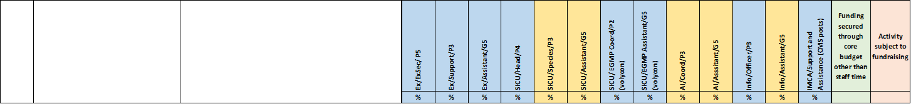

1. Version approved by the Standing Committee on 31 March 2023.