REPORT ON THE JOINT CMS/AEWA INFORMATION MANAGEMENT, COMMUNICATION AND AWARENESS-RAISING (IMCA) UNIT

Prepared by the UNEP/AEWA Secretariat

Introduction

The following report provides a summary of the main activities carried out for the UNEP/AEWA Secretariat by the Joint CMS/AEWA Information Management, Communication and Awareness-raising (IMCA) Unit during the period between January to December 2022. Document AEWA/MOP 8.18 provides a detailed overview of the Unit’s activity and management for the period prior to January 2022.

Management and Composition of the Joint Unit

The following organigram shows the current composition of the Unit as a result of its reshaping since the beginning of the year 2022, with the appointment of the CMS P3 Public Information Officer as the Coordinator of the Unit on 16 February 2022.

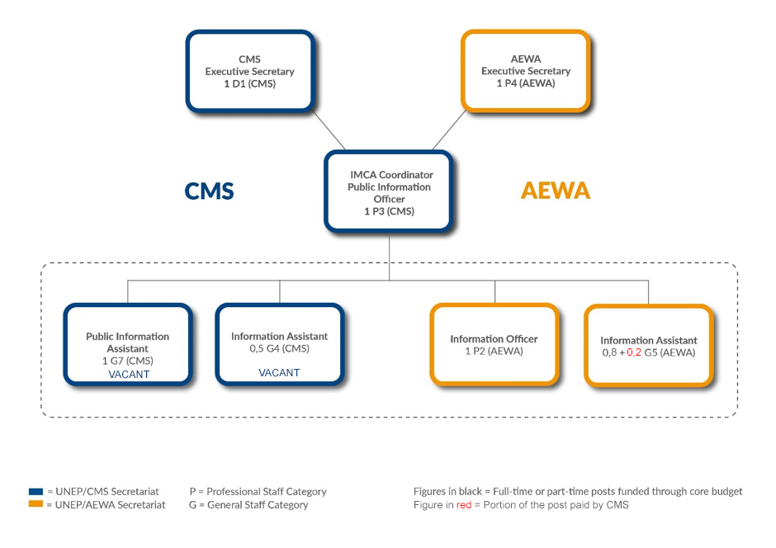
Figure 1: Organigram of the Joint Information Management, Communications and Awareness-raising (IMCA) Unit of the UNEP/CMS and UNEP/AEWA Secretariats (as of 26 May 2023)

The following notable changes in the Unit occurred in 2022:

- The CMS Public Information Officer (P3) as the Coordinator of the Unit on 16 February 2022.
- The CMS Senior Public Information Assistant (G7) went on continuous certified sick leave from 11 July 2022 to February 2023 (the time of her retirement).
- An Individual Contractor for website was recruited in October 2022 to focus on the technological upgrade of the AEWA websites for the Single Species Action Plans.

Time and Task Monitoring Tool
A time and task tracking tool (toggl.com) has been in use since 2016 to monitor and report on the work the IMCA Staff and Consultants for each Secretariat. The online tool allows each member of the team to log their work according to pre-defined projects and activities per client (i.e. CMS, AEWA or JOINT). The tool can also produce overview reports that will support the management of the Unit and will help ensure that the 1/3 – 2/3 arrangement is fulfilled.
Time Monitoring Report for January – December 2022

Below is a report produced by Toggl, which shows the working hours logged by four IMCA Unit Staff Members as well as the Individual Contractor for website.
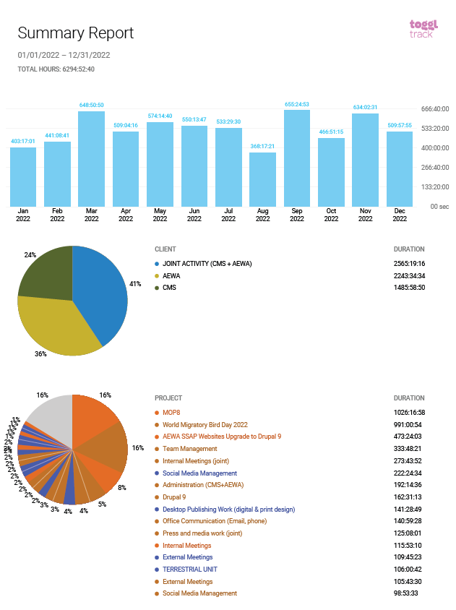
Figure 2: Time Tracking per Client Report for IMCA Team for Period of January - December 2022

Figure 3: Time Tracking per Project Report for IMCA Team for Period of January - December 2022. Projects in orange are AEWA-related, in blue CMS-related and in brown Joint CMS-AEWA-related.

Overview of IMCA Activities in 2022 relevant to AEWA

2022 being a MOP year for AEWA, most of the communications and information management activities of the unit focused on the preparation in the run-up to the MOP (including support provided for the pre-MOP8 meetings), the in-session period and the related follow-up activities.
Immediately after MOP8, an individual contractor was recruited to conduct the necessary upgrade of all the AEWA Single Species Action Plan websites from Drupal 7 to Drupal 9.

MOP8 Communications and Information Management

IMCA developed a communication plan with targets contributing to the following three goals of the AEWA global communication strategy (MOP6):

- Demonstrate ‘How Flyway Conservation Works’ and the Effectiveness of AEWA, as an Instrument for Conserving Migratory Waterbirds along the African-Eurasian Flyway
- Convey Reasons Why Waterbirds Matter
- Draw Attention to Threats to Waterbirds

Meetings of the Parties (MOPs) to AEWA offer a special opportunity for communication around the topics of waterbird and flyway conservation. As such the 8th session of the MOP in September 2022 allowed to bring greater focus on the achievements and challenges of the past as well as the issues relevant the next triennium. The AEWA MOP was one of the international biodiversity-related meetings prior to the adoption of the Montreal-Kunming Global Biodiversity Framework and it allowed communication on the relevance of AEWA to the implementation of the future GBF and the Sustainable Development Goals.

The MOP8 communication plan followed four objectives:

- OBJECTIVE 1: To raise awareness amongst all AEWA constituents on the importance of strengthening AEWA in view of the implementation of waterbirds conservation along the flyway and achieving the AEWA Strategic Plan (2019-2027)

- OBJECTIVE 2: To showcase that implementing AEWA contributes to the SDGs and the Post-2020 Global Biodiversity Framework.

- OBJECTIVE 3: To raise-awareness about the success stories on the conservation of species under AEWA, as well as on the plight of those that are in rapid decline

- OBJECTIVE 4: To expand the outreach of AEWA’s communication network, to diversify the channels of communications, to enhance collaboration with potential communications partners

With key messages, identified target audiences and engaged partners, IMCA implemented the plan with the following highlights:

A newsroom platform was specifically developed for the MOP featuring twelve website Articles on the topics of the Conservation Status Report 8, climate change, ongoing conservation actions and scientific studies, four daily coverage of the meeting, two press releases and media advisories and a newsletter. These contents were also disseminated through various AEWA communications channels such as the social media channels and the newsletter platform.

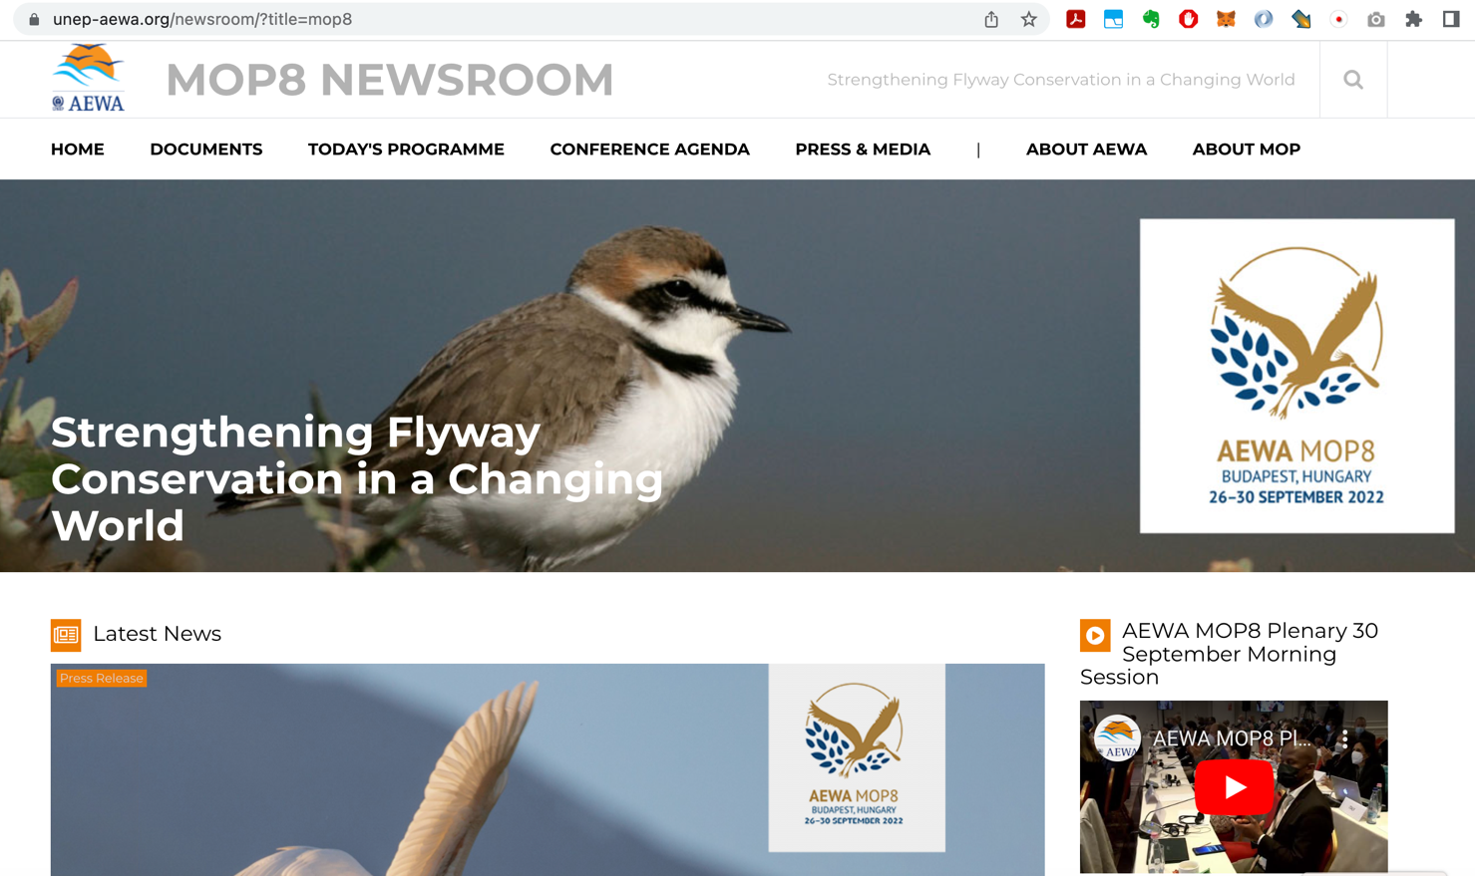

Partner Engagement

With the timely engagement of the partners, IMCA garnered strong support from NGOs coordinating the Single Species Action Plans of AEWA such as Birdlife South Africa and UN entities such as UNEP and the CBD. All CMS social media channel were also used to amplify the AEWA MOP8 messages through the various channels.
In particular, UNEP’s Executive Office, media and social media support was made possible through early collaboration. Inger Andersen, the Executive Director of UNEP also provided a statement for the opening of the MOP that was shared through the UNEP platforms, including the website and all their social media accounts, with more than 1 million followers.

Partner NGOs coordinating the AEWA SSAPs provided content for the website on ongoing conservation issues related to the coordination of the SSAPs. The CIC also provided audio-visual support during the meeting with a team of photographers and videographers visually covering the meeting.

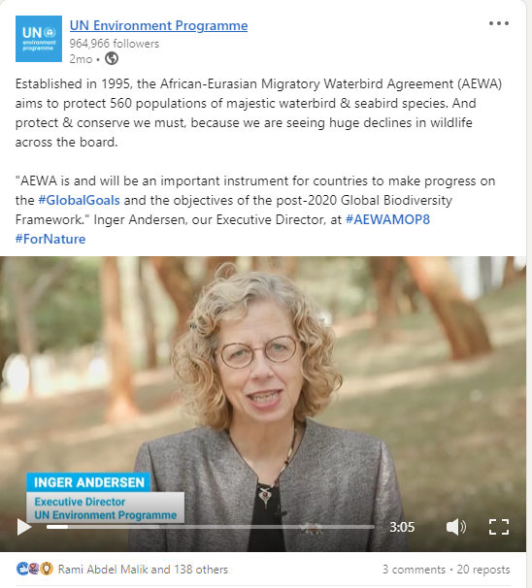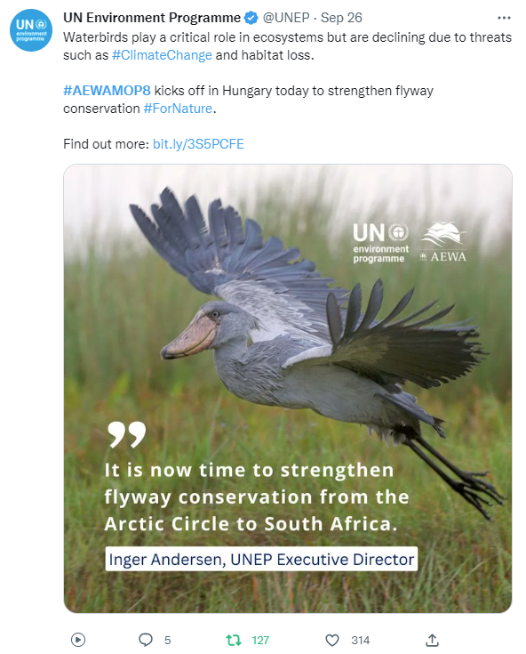

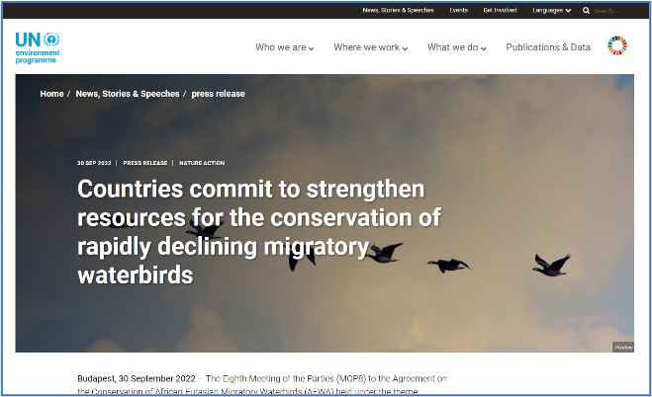

Communications Impact:

- 25 Articles in the press
- 40K page views in September/ October 2022
- 95 social media messages from AEWA’s accounts (Twitter and Facebook)
- +750 Tweets using #AEWAMOP8

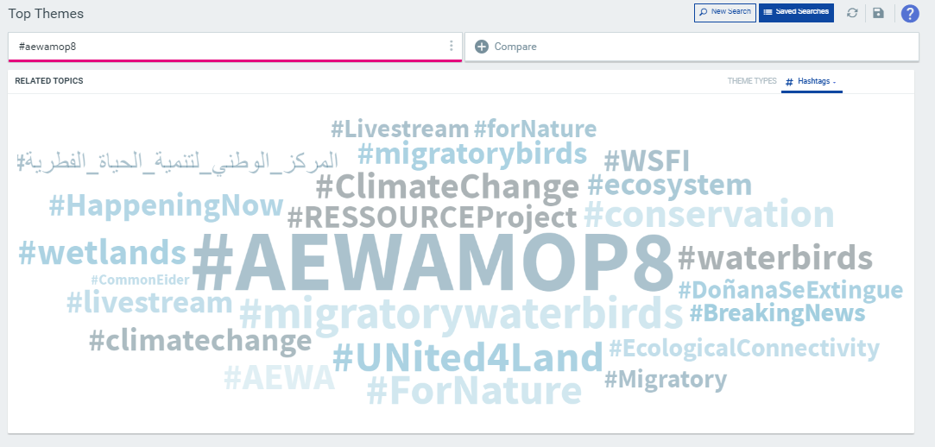
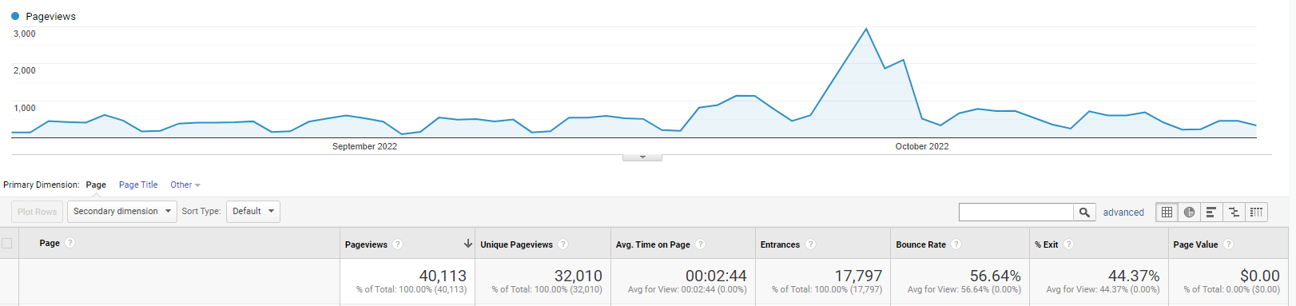

Press Coverage

25 press articles highlighted the meeting in the international and national media. The BBC World Service News Summary mentioned the MOP and a live interview on the main Hungarian TV channel of the AEWA Executive Secretary brough the MOP’s issues to the prime-time audience in the host country.

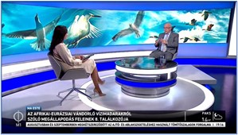
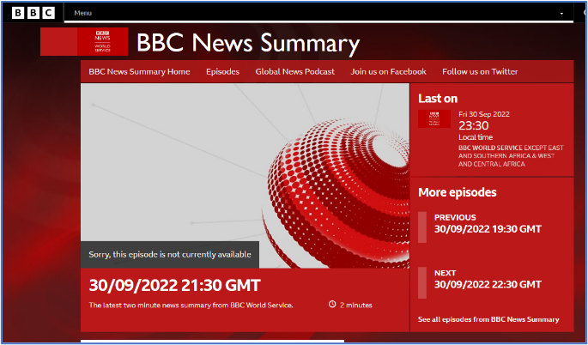

Overview of Joint Activities (CMS/AEWA) relevant to AEWA

The largest activity under the joint CMS/AEWA section was related to the organization of the World Migratory Bird Day Campaign. Another notable common project this year in the upgrade of CMS Family websites recorded under “Drupal 9” project.

IMCA Time Balance in 2022

For the period 1 January – 31 December 2022, the overall ratio of time allocation of work carried out by the Joint Communications Unit is balanced with 52 % CMS and 48 % AEWA - with the Joint Activities factored in at a 1/3 AEWA and 2/3 CMS ratio.
The Joint Communications Unit has worked a total of

- 185 days on CMS related tasks
- 280 days on AEWA-related tasks and
- 369 days on Joint CMS/AEWA tasks

From October to November 2022, the salary of the individual contractor for website was paid from the voluntary contribution by the UK government for the upgrade of the SSAP websites. CMS has also paid its contribution from December 2022 to April 2023.
The time the Executive Secretaries of CMS and AEWA also spend on IMCA-related issues are not captured in Toggl.

IMCA staff have spent a total of 835 man-days (434 for CMS (52%) and 400 for AEWA (48%)).
The optimal ratio in 2022 for the CMS portion should have been 559 (67%) and AEWA’s part 275 (33%), with 125 man-days in favour of AEWA.

Overall IMCA Time Balance (2017 – 2022)

As captured in the IMCA Toggl Reports, there has been an imbalance of the time the Unit has spent in favour of CMS since the IMCA Unit began with the time and task tracking in 2017.

The total imbalance for the period from 2017 to 2021 amounted to an accumulated 107 man-days in favour of CMS. However, with shift of the unit’s focus to the AEWA MOP, the imbalance has also shifted towards AEWA with a total of 20 man-days in favour of AEWA as of 31 December 2022.

Staff contribution of the CMS and AEWA Secretariats to the IMCA Unit

The tables below show the contributions of both the CMS and AEWA Secretariats to the Unit in 2022.

In 2021, the share of the CMS contribution stood at ca. 60,5 %, while AEWA’s share was at 39,5%. The balanced of the year was leaning towards more AEWA contribution with a calculated monetary difference to the optimum of ca. 25,108 EUR in favour of AEWA (meaning CMS would need to theoretically pay this amount to AEWA in order to reach the optimal balance), using the CMS standard salary costs approved at CMS COP13 for 2022 (UNEP/CMS/COP13/Doc.13.2/Rev.1).

 |  |  | YEAR: 2022
Secretariat | Position | % Time / Months | Cost (€)
CMS | Public Information Officer (P3) | 100%/10.5 | 118,886
CMS | Senior Information Assistant (G7) | 100%/12 | 92,416
CMS | Secretary (G4) / Information Assistant (G5) (CMS Contr.) | 20% / 12 | 14,498
CMS | Website Individual Contractor | 100% / 1 | 4,000
 |  | TOTAL (CMS): | 229,800
Secretariat | Position | % Time / Months | Cost (€)
AEWA | Information Officer (P2) | 100%/12 | 105,429
AEWA | Information Assistant (G5) | 80% / 12 | 57,991
 |  | TOTAL (AEWA): | 163,420
 |  | TOTAL (CMS + AEWA) | 393,220
 |  | CMS Share (%) | 60,5
 |  | AEWA Share (%) | 39,5
 |  | OPTIMAL:
 |  | CMS (2/3) | 237,898
 |  | AEWA (1/3) | 155,321
 |  | 2022 Balance
 |  | CMS | -8,098
 |  | AEWA | 8,098

However, taking the contributions of all the years since the start of IMCA into account (2014 – 2022), a calculated monetary difference to the optimum balance of ca. 127,179 EUR exists, meaning that CMS would need to pay this amount to AEWA in order to reach the agreed equilibrium or allocate more CMS staff time to AEWA tasks.

 | CMS | AEWA | TOTAL
2022 | 229,800 | 163,420 | 393,220
Optimal (2/3 CMS + 1/3 AEWA): | 237,898 | 155,321
Difference (+ Overpaid / - Underpaid): | -8,098 | 8,098
2021 | 245,110 | 160,216 | 405,326
Optimal (2/3 CMS + 1/3 AEWA): | 270,217 | 135,108
Difference (+ Overpaid / - Underpaid): | -25,108 | 25,108
2020 | 362,809 | 167,636 | 530,445
Optimal (2/3 CMS + 1/3 AEWA): | 353,630 | 176,815
Difference (+ Overpaid / - Underpaid): | 9,179 | -9,179
2019 | 280,707 | 164,349 | 445,056
Optimal (2/3 CMS + 1/3 AEWA): | 296,704 | 148,352
Difference (+ Overpaid / - Underpaid): | -15,997 | 15,997
2018 | 277,279 | 164,881 | 442,160
Optimal (2/3 CMS + 1/3 AEWA): | 294,773 | 147,387
Difference (+ Overpaid / - Underpaid): | -17,494 | 17,494
2017 | 279,895 | 157,892 | 437,787
Optimal (2/3 CMS + 1/3 AEWA): | 291,858 | 145,929
Difference (+ Overpaid / - Underpaid): | -11,963 | 11,963
2016 | 274,544 | 158,479 | 433,023
Optimal (2/3 CMS + 1/3 AEWA): | 288,682 | 144,341
Difference (+ Overpaid / - Underpaid): | -14,138 | 14,138
2015 | 204,088 | 138,488 | 342,576
Optimal (2/3 CMS + 1/3 AEWA): | 228,384 | 114,192
Difference (+ Overpaid / - Underpaid): | -24,296 | 24,296
2014 | 215,785 | 136,789 | 352,574
Optimal (2/3 CMS + 1/3 AEWA): | 235,049 | 117,525
Difference (+ Overpaid / - Underpaid): | -19,264 | 19,264
TOTAL TO OPTIMUM (2014 - 2022): | -127,179 | 127,179

