**Overview of the tasks to be implemented by the Secretariat in 2022**

Following a correspondence from the Government of the Netherlands sent to the Chair of the Standing Committee, dated 17th January 2022, the Chair has requested the UNEP/AEWA Secretariat to present at the 20th Meeting of the Standing Committee an overview of all Secretariat tasks to be implemented in 2022.

A general overview of all tasks the Secretariat will be undertaking in 2022 is provided in Annex I. The overview is split into the four main sections corresponding to the four units of the Secretariat. However, as the overview also shows in its last column many tasks are cross-cutting and work is shared between different units involved. The current staffing situation of the Secretariat is described in Annex II. In addition, Annex III contains a list of all tasks specifically related to the preparations of the 8th Session of the Meeting of the Parties scheduled to take place on 26 – 30 September 2022 in Budapest, Hungary. The MOP8 preparations will be in the focus of the Secretariat work throughout the spring and summer period 2022 and prioritized above any other tasks.

The European Goose Management Platform (EGMP) has its own Programme of work decided by the European Goose Management International Working Group, which can be downloaded at [aewa_egm_iwg_6_17_budget_and_cpow.pdf](https://egmp.aewa.info/sites/default/files/meeting_files/documents/aewa_egm_iwg_6_17_budget_and_cpow.pdf)

In accordance with the UNEP staff performance evaluation cycles, the individual work plans of Secretariat staff members are annually decided in the course of March, starting from 1 April each year. The list of activities provided in Annex I will therefore still undergo changes and additions, depending on the activities agreed for the new working cycle.

1. **Overview of Secretariat’s tasks for 2022**

EX = Executive Management Unit; SICU = Science, Implementation and Compliance Unit;

AI = African Initiative Unit; IMCA = Joint CMS and AEWA Information Management, Communications and Awareness-Raising Unit















**II. Organisation and Staffing of the Secretariat**

1. Organisation of the Secretariat

The Secretariat is organised into four units which cover four broad areas of work: 1. General Management; 2. Science, Implementation and Compliance; African Initiative; and Information Management, Communications and Awareness-Raising. The individual staff members and units work closely as a team, interacting with each other daily on cross-cutting issues. It should be noted that the AEWA Information Unit is part of the joint Information Management, Communication and Awareness-raising Unit (IMCA) co-funded by AEWA and CMS.

Without the extension of the part-time positions through voluntary contributions, the availability of staff funded entirely through voluntary contributions and the support of interns, the Secretariat would be in a position where it could deliver even less services against all its mandates.

In 2019, 2020 and 2021 the Secretariat applied for a UNEP Junior Professional Officer (JPO) position to support the work of the Technical Committee. Unfortunately, in all years the applications were unsuccessful. We have applied again in 2022 as this position is key in stepping up the Secretariat’s facilitative role for the work of the Technical Committee.

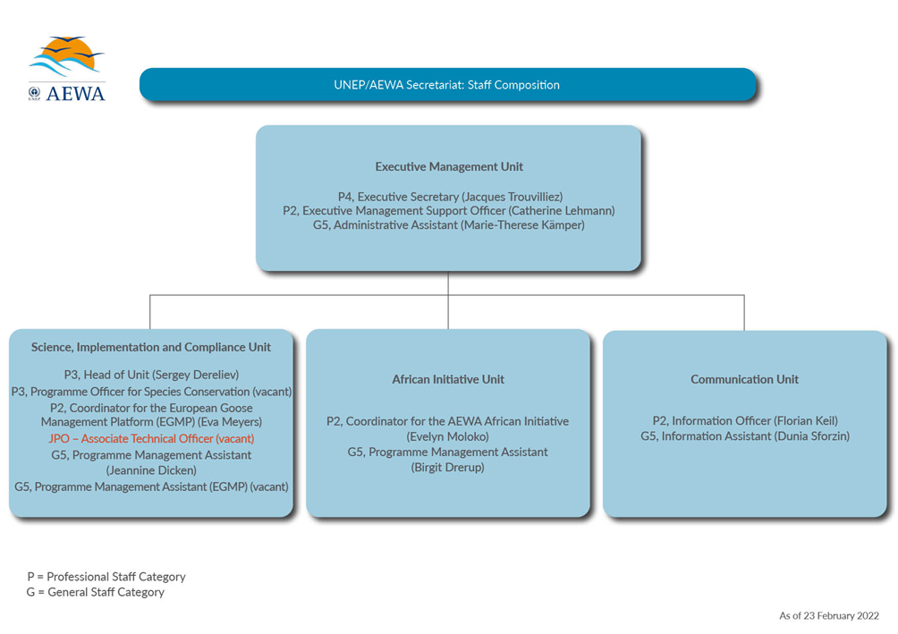

2. Staffing situation

The Secretariat currently comprises nine staff members: five Professional Staff members (P staff), four General Staff members (G staff) and, in addition, one P staff for the EGMP programme which is funded independently from the core budget. One P3 position has been vacant since 11 March 2021 due to a lack of funding. The core budget covers 7.1 full-time equivalent positions (FTEs), while voluntary contributions and savings have allowed the addition of 1.3 full-time equivalent positions and the EGMP programme.

*Staff partly funded by the core budget*

The positions of the African Initiative (AI) Coordinator (P-2) and the AI Programme Management Assistant (G-5) were partly funded (50 per cent) through the AEWA core budget 2019-2021 and in 2022. The Secretariat was able to maintain the P-2 position at 100 per cent and the G-5 position at 80 per cent thanks to voluntary contributions received from Germany, the United Kingdom, Luxemburg, Switzerland and the European Commission.

The savings and voluntary contributions have also allowed to keep the part-time SICU Programme Management Assistant (80 %) at 100 % and the part-time Information Assistant (50 %) at 80 %.

*Staff fully dependent on voluntary contributions (Fixed-term project posts)*

Associate Programme Officer (P-2) and Programme Management Assistant (G-5) for the AEWA European Goose Management Platform

The AEWA European Goose Management Platform (EGMP) is currently managed by one full-time P2 project post. The P2 position is financially secured until December 2022. The assistance was provided through a consultancy until 31 January 2022. It is planned to recruit an assistant at the G5 level in spring 2022.

**III. Overview of Secretariat tasks in preparation of the 8th Session of the Meeting of the Parties to AEWA, Budapest, Hungary, 26-30 September 2022**

| **Task** |
| --- |
| **Overall planning** |
| Host Government Agreement |
| Preparatory visits in Budapest |
| Fundraising |
| Venue and equipment arrangements |
| Security & COVID-related hygiene measures |
| Catering |
| Hotel arrangements |
| Mid and post-conference excursions |
| Shipment of equipment and information materials |
| Procurement of general equipment and materials for staff |
| **Additional human support** |
| Translators |
| Interpretation |
| Report writer |
| CMS staff |
| IT support |
| **Participants** |
| Invitations, online registration & follow up with participants, including badge production, name plates |
| Travel and visa arrangements for staff, contractors and funded delegates, including support towards non-funded delegates |
| DSA arrangements |
| Collection of credentials |
| Vaccinations |
| **Information management/ publicity** |
| Website |
| MOP8 “identity” & publicity (logo, theme, banners etc.) |
| Information/ Press-related tasks, including brochures, press releases, press conference etc. |
| Prepare daily journals |
| Social Media |
| Give aways |
| **Meeting-related preparation** |
| EU coordination |
| African coordination |
| Chair and Vice-Chair arrangements and meeting preparation |
| Host for MOP9 |
| Side events & poster exhibition arrangements with organizers, including side event brochure |
| Reception |
| Opening and closing ceremonies |
| Document production and publication in English and French |
| Presentations and information slides |
| AEWA Conservation Award |
| Champions Night |
| Standing Committee meeting arrangements |
| Briefing and providing documents to contractors and other support staff |
| Hospitality |