DISCUSSION PAPER ON THE INTEGRATION OF LENGTH OF AEWA MEMBERSHIP
INTO THE ANALYSIS OF NATIONAL REPORTS TO MOP8

Compiled by UNEP-WCMC

Introduction
The information submitted in the National Reports to AEWA is analysed and synthesised for every MOP to give a clear overview of the level of implementation of the Agreement by Parties and to contribute to measuring progress towards the fulfilment of indicators of the AEWA Strategic and Action Plans. At MOP7 (December 2018, Durban, South Africa), Resolution 7.1 on the Adoption and implementation of the AEWA Strategic Plan and Plan of Action for Africa for the period of 2019-2027 was adopted, in which operative paragraph 8(i) requests that reporting on progress should “consider the progress in light of the variable time since Parties have acceded to the Agreement”. For targets of the Strategic Plan that involve actions that might require longer time-frames to implement, newer Parties may have been less likely to have met these targets and could potentially affect the overall picture of progress; therefore disaggregating the responses of newer and more established Parties may provide additional insights into the overall implementation. UNEP-WCMC were asked by the Secretariat to consider this issue and propose a potential approach that would factor in the length of time that countries were party to AEWA in the context of the National Report Analysis to MOP8.

Effect of length of membership of the Parties on the analysis of National Reports to MOP7
In order to evaluate whether length of membership was likely to influence the outcome of the assessment against long-term targets, the National Reports to MOP7 were considered and questions 34 (on phasing out the use of lead shot), 16 (on a regulatory framework for re-establishments) and 19 (on legislation prohibiting introductions) were taken as case studies.
In total, 53 National Reports were received by the cut-off date and included in the analysis of National Reports on the implementation of AEWA for the period 2015-2017, representing 71% of the 75 AEWA Contracting Parties expected to report. The breakdown of submission compared to length of time as a member of AEWA (in 5-year brackets) is presented in Table 1. The proportion of Parties that did not submit National Reports in each 5-year bracket increased with shorter memberships; however, it should also be noted that the number of Parties in each 5-year bracket was variable, with fewer Parties with memberships of 10 years or less.

Table 1. Number of Parties that submitted National Reports on the implementation of AEWA for the period 2015-2017 by the cut-off date for inclusion in the analysis of National Reports to MOP7, per bracket of five years.

Length of membership | Number of Parties that submitted | Number of Parties that did not submit | Percentage of non-submission
16-20 years | 26 | 7 | 21%
11-15 years | 19 | 6 | 24%
6-10 years | 4 | 2 | 33%
0-5 years | 4 | 7 | 64%
Case Study 1: Question 34. Has your country phased out the use of lead shot for hunting in wetlands? (AEWA Action Plan, paragraph 4.1.4)
Bearing in mind the overall reporting rates according to the groupings presented in Table 1, we use question 34 to consider the effects of the length of membership. A total of 23 Parties (31% of Contracting Parties) reported that lead shot has been fully phased out in their country, while 13 Parties confirmed that lead shot had not yet been phased out (Figure 1.1).
b)
a)

Figure 1.1. Number of Parties reporting on the phasing out of the use of lead shot for hunting in wetlands: a) Overall - all responses combined, b) Disaggregated - responses broken down by length of membership, in brackets of 5 years.

Overall achievement of Target 2.1 of the Strategic Plan 2009-2018, which aims for all Parties to have phased out the use of lead shot for hunting in wetlands in their country, is 31%. The percentage of progress towards achievement of Target 2.1 by length of membership under different scenarios is presented in Figure 1.2 below.

Figure 1.2. Progress towards achievement of Target 2.1 of the Strategic Plan as reported by Parties to MOP7, overall and disaggregated by length of membership under different scenarios. Scenario 1: disaggregated in brackets of 0-5 years, 6-10 years and >10 years; Scenario 2: disaggregated in brackets of 0-10 years and >10 years; and Scenario 3: disaggregated in brackets of 0-5 years and >5 years.
A comparison of the scenarios in Figure 1.2 finds that, due to the differences in number of Parties and proportion of reporting in the brackets, disaggregating the countries that have been members for 5 years or less (Scenarios 1 and 3) inflates the reporting value of these individual Parties: with 11 Parties in this bracket and only 4 having reported, each Party that reports represents 25% of the progress of that bracket. Conversely, the progress in the Parties that have been members >5 years is broadly unaffected by removing these Parties compared to the overall progress (Scenario 3 – 34% versus 31% respectively), meaning that the overall value of disaggregating should be questioned. In a disaggregation by length of membership at 10 years (Scenario 2), the 0-10 years bracket contains 17 Parties, which reduces the inflation in the reporting value of individual Parties in this bracket; however, discrepancies in number of Parties and proportion of reporting between the brackets remain. In effect, the assumption that the newer Parties skew the results may not be justified. This pattern is similar for the two other questions (16 and 19) below.
Case Study 2: Question 16. Is there a regulatory framework for re-establishments of species, including waterbirds, in your country? (AEWA Action Plan, paragraph 2.4)
b)
a)

Figure 2.1. Number of Parties reporting a regulatory framework for the re-establishment of species: a) Overall - all responses combined, b) Disaggregated - responses broken down by length of membership, in brackets of 5 years.
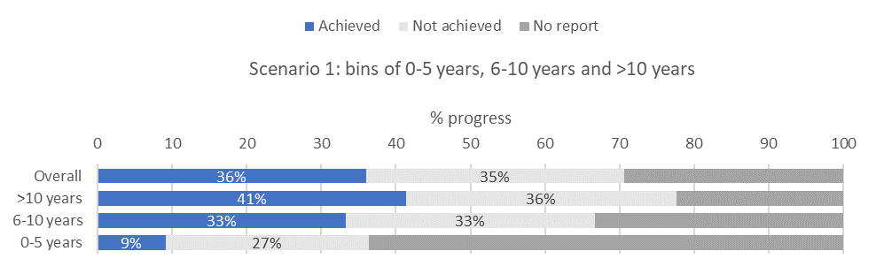
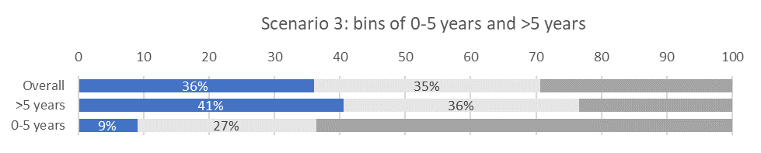
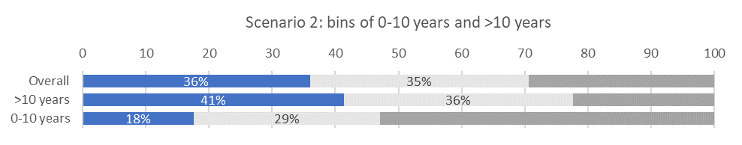
Figure 2.2. Progress towards achievement of this component of paragraph 2.4 of the AEWA Action Plan as reported by Parties to MOP7, overall and disaggregated by length of membership under different scenarios. Scenario 1: disaggregated in brackets of 0-5 years, 6-10 years and >10 years; Scenario 2: disaggregated in brackets of 0-10 years and >10 years; and Scenario 3: disaggregated in brackets of 0-5 years and >5 years.
Case Study 3: Question 19. Does your country have legislation in place, which prohibits the introduction into the environment of non-native species of animals and plants which may be detrimental to migratory waterbirds? (AEWA Action Plan, paragraph 2.5.1)
b)
a)

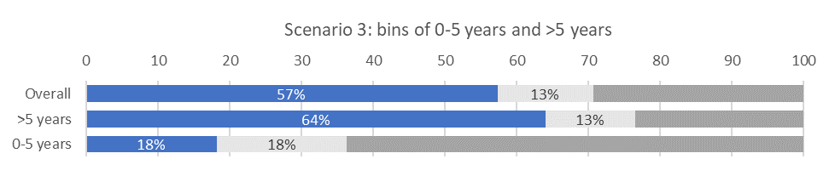
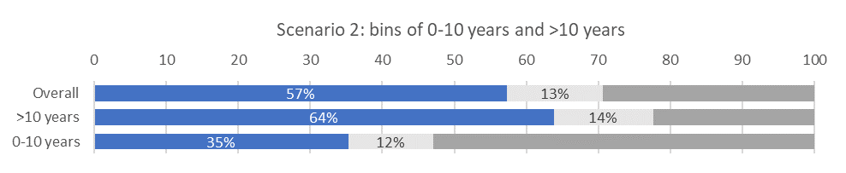
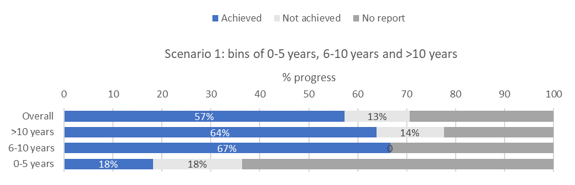
Figure 3.1. Number of Parties reporting legislation prohibiting the introduction of non-native species: a) Overall - all responses combined, b) Disaggregated - responses broken down by length of membership, in brackets of 5 years.

Figure 3.2. Progress towards achievement of Target 1.5 of the Strategic Plan as reported by Parties to MOP7, overall and disaggregated by length of membership under different scenarios. Scenario 1: disaggregated in brackets of 0-5 years, 6-10 years and >10 years; Scenario 2: disaggregated in brackets of 0-10 years and >10 years; and Scenario 3: disaggregated in brackets of 0-5 years and >5 years.

Length of membership of the Parties to AEWA for the analysis of National Reports to MOP8
Table 2. Number of Parties due to provide National Reports to MOP8 in 2021 per length of membership, in brackets of five years. Full details by Contracting Party in Annex I.
Length of membership | Number of Parties
21+ years | 23
16-20 years | 25
11-15 years | 14
6-10 years | 11
*0-5 years | 6
*Parties with less than 1 full year of membership (Armenia and Turkmenistan) are not expected to report and have been excluded.
Proposed approach for including length of membership in the analysis of National Reports to MOP8
While there are issues of non-submission across all lengths of membership (Table 1), there is the highest proportion of non-submission for those Parties that have joined within the last 5 years based on reporting rates to MOP7. In addition, there is a comparatively small number of Parties in this bracket (Table 2). On this basis, it is suggested that a separation between Parties that have joined within the most recent 10 years and those that have been Party to AEWA for >10 years may provide the most valuable disaggregation. To provide context on the reporting rates and overall levels of implementation, there may be value in providing a high-level summary of overall reporting rates in the Introduction based on this assessment.
However, based on this analysis, with submission challenges and implementation challenges seen across the various lengths of membership, there may be limited value in the inclusion of this additional break-down of results throughout the report, and it may confuse the picture on the overall implementation by providing too much data. If the Technical Committee does see the value in having this addition information, the suggested approach would be to include the length of membership into the analysis of National Reports to MOP8 as per Scenario 2, presenting progress bars towards achievement of the Strategic Target representing Parties overall and Parties with memberships longer or shorter than 10 years, for a small selection of relevant, priority questions.
A potential subset of questions is provided in Annex II.

Annex I.
Length of time as a Contracting Party to AEWA, by the date of submission of the National Reports to MOP8 (8th April 2021). *Parties with less than 1 full year of membership (Armenia and Turkmenistan) are not expected to report.
10 year cutoff
5 year cutoff
Contracting Party | Number of Parties | Date of Accession | No. full years
Egypt | 1 | 01/01/1999 | 22
Republic of the Congo, Gambia, Germany, Guinea, Jordan, Monaco, Netherlands, Niger, Senegal, Spain, Sudan, Sweden, Switzerland, Togo, United Kingdom of Great Britain and Northern Ireland, United Republic of Tanzania | 16 | 01/11/1999 | 21
Benin, Denmark, Finland, Mali | 4 | 01/01/2000 | 21
Bulgaria, North Macedonia | 2 | 01/02/2000 | 21
Croatia | 1 | 01/09/2000 | 20
Romania | 1 | 01/10/2000 | 20
Uganda | 1 | 01/12/2000 | 20
Mauritius | 1 | 01/01/2001 | 20
Republic of Moldova | 1 | 01/04/2001 | 20
Kenya | 1 | 01/06/2001 | 19
Slovakia | 1 | 01/07/2001 | 19
Georgia | 1 | 01/08/2001 | 19
Albania | 1 | 01/09/2001 | 19
South Africa | 1 | 01/04/2002 | 19
Israel | 1 | 01/11/2002 | 18
Lebanon | 1 | 01/12/2002 | 18
Equatorial Guinea, Ukraine | 2 | 01/01/2003 | 18
Hungary | 1 | 01/03/2003 | 18
Ireland, Syrian Arab Republic | 2 | 01/08/2003 | 17
Slovenia | 1 | 01/10/2003 | 17
France, Luxembourg | 2 | 01/12/2003 | 17
Djibouti, Portugal | 2 | 01/03/2004 | 17
Uzbekistan | 1 | 01/04/2004 | 17
Nigeria | 1 | 01/07/2004 | 16
Lithuania | 1 | 01/11/2004 | 16
Libya | 1 | 01/06/2005 | 15
Tunisia | 1 | 01/07/2005 | 15
Ghana | 1 | 01/10/2005 | 15
Latvia | 1 | 01/01/2006 | 15
Belgium | 1 | 01/06/2006 | 14
Czech Republic | 1 | 23/06/2006 | 14
Italy | 1 | 01/09/2006 | 14
Algeria | 1 | 01/10/2006 | 14
Guinea-Bissau | 1 | 01/11/2006 | 14
Madagascar | 1 | 01/01/2007 | 14
Cyprus, Norway | 2 | 01/09/2008 | 12
Estonia | 1 | 01/11/2008 | 12
Ethiopia | 1 | 01/02/2010 | 11
Chad, Montenegro | 2 | 01/11/2011 | 9
Zimbabwe | 1 | 01/06/2012 | 8
Gabon, Morocco | 2 | 01/12/2012 | 8
Eswatini | 1 | 01/01/2013 | 8
Côte d'Ivoire, Iceland | 2 | 01/06/2013 | 7
Burkina Faso | 1 | 01/10/2013 | 7
Rwanda | 1 | 01/09/2014 | 6
Burundi | 1 | 01/10/2014 | 6
Mauritania | 1 | 01/05/2015 | 5
Belarus | 1 | 01/04/2016 | 5
Botswana | 1 | 01/11/2017 | 3
Central African Republic | 1 | 01/01/2019 | 2
Serbia | 1 | 01/03/2019 | 2
Malawi | 1 | 01/09/2019 | 1
Armenia | 1 | 01/07/2020 | 0*
Turkmenistan | 1 | 01/01/2021 | 0*

Annex II.
Questions relating to Actions of the Strategic Plan and Action Plan that require longer time-frames to implement and may merit disaggregated analysis (criteria – (1) the mandate is included in the AEWA Annex 3 (Action Plan) and (2) it is uniformly applicable across Parties).
21. Is there a regulatory framework for re-establishments of species, including waterbirds, in your country (AEWA Action Plan, paragraph 2.4)?
24. Does your country have legislation in place, which prohibits the introduction into the environment of non-native species of animals and plants which may be detrimental to migratory waterbirds? (AEWA Action Plan, paragraph 2.5.1)
25. Does your country impose legislative requirements on zoos, private collections, etc. in order to avoid the accidental escape of captive animals belonging to non-native species which may be detrimental to migratory waterbirds? (AEWA Action Plan, paragraph 2.5.2)
39. Has your country identified the network of all sites of international and national importance for the migratory waterbird species/populations listed on Table 1? (AEWA Action Plan, paragraph 3.1.2; AEWA Strategic Plan 2019-2027, Action 3.1(a))
42. Which sites that were identified as important, either internationally or nationally, for Table 1 migratory waterbird species/populations have been designated as protected areas under the national legislation and have management plans that are being implemented, including with the aim to increase resilience to the effects of climate change? (AEWA Action Plan, paragraph 3.2.1, AEWA Strategic Plan 2019-2027, Target 3.3)
49. Does the legislation of your country implement the principle of sustainable use of waterbirds, as envisaged in the AEWA Action Plan, taking into account the full geographical range of the waterbird populations concerned and their life history characteristics? (AEWA Action Plan, paragraph 4.1.1; AEWA Strategic Plan 2019-2027, Target 2.2)
51. Has your country phased out the use of lead shot for hunting in wetlands? (AEWA Action Plan, paragraph 4.1.4; AEWA Strategic Plan 2019-2027, Action 2.2(d))
52. Are there measures in your country to reduce/eliminate illegal taking? (AEWA Action Plan, paragraph 4.1.6; AEWA Strategic Plan 2019-2027, Action 2.2(e))
60. Does your country have legislation in place, which provides for Strategic Environmental Assessment/Environmental Impact Assessment (SEA/EIA) of activities potentially negatively affecting natural habitats or wildlife? (AEWA Action Plan, paragraph 4.3.1; AEWA Strategic Plan 2019-2027, Target 3.5)
72. Does your country have waterbird monitoring schemes for the AEWA species in place? (AEWA Strategic Plan 2019-2027, Actions 1.4(a) and 1.4(b))

