DELINEATION OF BIGEOGRAPHIC POPULATIONS OF THE COMMON EIDER
(SOMATERIA MOLLISSIMA)

Introduction

As part of the AEWA Technical Committee work plan for the inter-sessional period 2019-2021, which was approved by the 7th Session of the Meeting of the Parties in December 2018 (Resolution 7.11), the Committee was tasked with considering evidence supporting the delineation of population boundaries for select species, including the Common Eider (Somateria mollissima), and to make any recommendations, as appropriate, to the AEWA Standing Committee for interim approval so that any changes can be taken into account in work to develop proposals for MOP8 (CSR8 and proposed changes to Table 1 of AEWA’s Action Plan).

The Technical Committee subsequently recommended the merger of the UK/Ireland population of the Common Eider with the Baltic, Denmark and Netherlands population to form the Baltic, North & Celtic Seas population based on the evidence submitted which was adopted by the Standing Committee at its 15th Meeting in December 2019 (document StC 15.7).

During the AEWA international action-planning process for the Common Eider in 2020 a new population delineation issue emerged, which was subsequently reviewed and approved by the Technical Committee at its 16th meeting in January 2021:

- Proposal to slightly modify the population delineation of the Baltic, North & Celtic Seas Common Eider population (Somateria m. mollissima) adopted at the 15th Meeting of the AEWA Standing Committee to also include the Orkney Island Common Eiders as part of said population (revised pro-forma attached as
Annex I, with the clarifying amendments to the population delineation previously approved by TC15 and adopted by StC15 highlighted in yellow). The proposed inclusion would have no impact on the listing of the population as Category 4 on Column A Table 1 of the Action Plan.

Action Requested from the Standing Committee

The Standing Committee is requested to review the revised delineation of the Common Eider population outlined above as recommended by the Technical Committee and to approve it for further use.
Annex I

DELINEATION OF BIGEOGRAPHIC POPULATIONS OF THE COMMON EIDER
(SOMATERIA MOLLISSIMA)

PROPOSAL TO CHANGE POPULATION DELINEATIONS

(Compiled by Danny Heptinstall, UK Permanent Observer to the Technical Committee)

Name of population(s):

Common Eider Somateria mollissima mollissima (Baltic, Denmark & Netherlands)

Current status on AEWA Table 1:

A4

What is the issue?

Scott & Rose (1996) in their mapping of populations of African and Western Eurasian migratory Anatidae indicated populations of European Eider within three races as follows:

S. m. borealis (islandica)
- Greenland
- Iceland
- Svalbard and Franz Joseph Land

S. m. faroeensis
- Faroe Islands
- Shetland and Orkney Islands

S. m. mollissima
- Britain [and Ireland] excluding Orkney and Shetland
- Baltic, Denmark and Netherlands
- Norway and Russia
- White Sea

Some of these populations are sedentary. Those listed by AEWA are given in bold and underlined.

The issue is whether there is actually good evidence to separate ‘British [and Irish]’ Eiders from those in the ‘Baltic, Denmark and Netherlands’ population (as proposed by Scott & Rose 1996) and followed by AEWA subsequently.

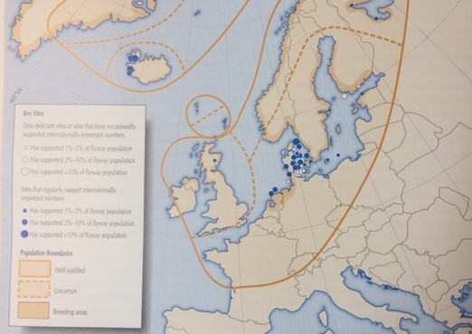

Figure 1. Delineation of European Common Eider populations by Scott & Rose (1996).

What is the evidence supporting the proposal?

The UK’s SPA and Ramsar Scientific Working Group have previously reviewed population delineation of European Eiders and have found little evidence for Wetlands International’ original suggestion that British and Irish birds form a separate group discrete from those elsewhere in NW Europe.

The evidence to that end is summarised in Appendix 1 (based on unpublished SWG papers).

Definitions of the term ‘biogeographical population’ adopted by the Ramsar Convention and followed by AEWA are given in Appendix 2.

The evidence of inter-change with continental Europe suggests that British and Irish Eiders do not fall within any of these definitions. In particular, they are not:

iii. a discrete migratory population of a species or subspecies, i.e., a population which rarely if ever mixes with other populations of the same species or subspecies;
nor are they
v. a regional group of sedentary, nomadic or dispersive birds with an apparently rather continuous distribution and no major gaps between breeding units sufficient to prohibit interchange of individuals during their normal nomadic wanderings and/or post-breeding dispersal.

Accordingly, the UK SPAR SWG concluded that:

“The Northwest European Eider population (i.e. the sum of the three Somateria m. mollissima populations in this region, ) should, until more information becomes available, be used as the relevant biogeographical population for the UK, and this population be considered migratory. (Stroud et al. 2016)
Based on such (lack of) evidence for clear separation of populations, UK practice has been to treat British and Irish Eider as part of a combined British/Irish population with the Baltic/Denmark/Netherlands population (Stroud et al. 2016; http://jncc.defra.gov.uk/pdf/UKSPA3_EiderSomateriam.mollissima(non-breeding).pdf).

Subsequently, the UK SPAR SWG clarified the status of eiders in Orkney. It concluded that while genetic evidence is lacking to definitively determine whether eider in Orkney are faeroeensis, until such information becomes available the UK will treat them as belonging to mollissima on the basis of limited interchange with Shetland birds (latter were determined by genetic and morphological analysis to be faeroeensis; Furness et al, 2010).

What are the implications of the proposal including any changes in status on AEWA Table 1?

Currently Baltic, Denmark and Netherlands Eider population of the nominate race is listed as A4 by the AEWA Action Plan (i.e. “Species, which are listed as Near Threatened on the IUCN Red List of Threatened species, as reported in the most recent summary by BirdLife International, but do not fulfil the conditions in respect of Category 1, 2 or 3, as described above, and which are pertinent for international action.”)

Change to the delineation of this population by merging it with the Britain and Ireland population would thus not result in change of status (or obligations) in the Range States to the Baltic, Denmark and Netherlands population, but for the Britain and Ireland population, as a newly “listed”, will require the UK and Ireland to comply with provisions for Column A category 4 listed populations with respect to the Common Eider. At the same time, the population size and 1% threshold for a larger defined population would increase. However, the estimate in WPE 5 is out-dated and should be revised based on the latest data. Frost et al. (2019) has estimated 77,000 individuals for Great Britain and a further 470 is estimated for the Republic of Ireland (Crowe & Holt, 2013). This results in a combined population estimate of 1,007,470 wintering birds for the North Sea & Baltic population without the birds of the Norway & Russia population.

Population | Population size | 1% threshold
Baltic, Denmark & Netherlands (CSR7) | 930,000 | 9,800
Britain and Ireland (WPE 5) | 57,800 - 57,900 | 580
Combined North Sea & Baltic population | 1,007,470 | 10,000

As any such change has a bearing on selection thresholds used by other Parties, it would be appropriate for the TC to consult with those Parties to ensure that any proposal is soundly based.

References

Furness, R.W., Mable, B., Savory, F., Griffiths, K., Baillie, S.R. and Heubeck, M. (2010) Subspecies status of Common Eiders Somateria mollissima in Shetland based on morphology and DNA. Bird Study, 57: 3, 330 — 335. URL: http://dx.doi.org/10.1080/00063657.2010.481708

Scott, D.A. & Rose, P.M. 1996. Atlas of Anatidae Populations in Africa and Western Eurasia. Wetlands International Publication 41, Wageningen, The Netherlands.

Stroud, D.A., Bainbridge, I.P., Maddock, A., Anthony, S., Baker, H., Buxton, N., Chambers, D., Enlander, I., Hearn, R.D., Jennings, K.R, Mavor, R., Whitehead, S. & Wilson, J.D. - on behalf of the UK SPA & Ramsar Scientific Working Group (eds.) 2016. The status of UK SPAs in the 2000s: the third network review. 1,108 pp. JNCC, Peterborough. http://jncc.defra.gov.uk/page-7309
Appendix 1. Treatment of Somateria m. mollissima

Five populations of S. m. mollissima are identified by Rose & Scott (1996):
- Britain and Ireland (population 73,000 individuals and 1% threshold of 750);
- Baltic, Denmark and the Netherlands (population 850,000-1,200,000 and 1% threshold of 10,300);
- Norway & NW Russia (population 300,000-550,000 and 1% threshold of 4,250);
- White Sea (population 20,000-30,000 and 1% threshold of 250); and
- Black Sea (population 5,400 and 1% threshold of 55).

Birds occurring in Britain and Ireland are separated from those occurring elsewhere in NW Europe on the basis of “little mixing”.

The BTO Migration Atlas (Wernham et al. 2002) indicates that there have been recoveries in Denmark and the Baltic of Eiders ringed in Britain, although the overall picture is that there are few long-distance movements for the species.

Known movements relate almost entirely to abmigration into the Baltic population consisting almost exclusively of males. With the females being philopatric it is the males that leave their natal breeding grounds. Some birds ringed in the breeding season at Forvie (mostly males) were recovered abroad presumably reflecting the movement of British/Irish males to the Baltic/Denmark where they remain to breed with Baltic/ Danish females. There have also been five males (probably British) ringed in winter at Forvie and found breeding in the Baltic. Also, three females ringed at Forvie in winter were found in continental Europe implying some winter visitors in this population.

The second UK SPA Review (Stroud et al. 2001) considered Eiders in Britain to be non-migratory in the breeding season but migratory in the non-breeding season (thus there is only a SPA suite identified in the non-breeding season). Analyses in the BTO Migration Atlas (Baillie 2002) however suggest the reverse to be the case and the species is categorised as a short-distance migrant in the breeding season but sedentary in the non-breeding season.

This categorisation may be a product of the definitions used in the Atlas which needs careful interpretation.

Expert opinion from Denmark (S. Pihl pers. comm.) is that Continental Eiders (probably mainly from Norway and the Wadden Sea) can be found wintering in UK and as such may potentially interbreed with UK breeding birds. Some Eider breeding colonies, however, seem to be discrete in their choice of winter quarters, so exchange patterns are probably site-specific to an extent. Certainly, the simple national totals from WeBS show a marked increase in numbers in the first half of the winter (Figure 1), although these data are not corrected for survey coverage, and of course an element of the apparent 'decline' in summer will reflect movement to British breeding colonies (and reduced count coverage then). It is possible that a more detailed analysis of these data would show more marked mid-winter increases in eastern Britain, reflecting known exchange patterns across the North Sea (Baillie 2002).

In previous centuries it seems possible that Continental Eiders wintered in UK waters in larger numbers (S. Pihl pers comm.). It can be anticipated that with the continuing amelioration of winter climate, numbers of Continental Eiders wintering in UK will probably decrease further. Thus, current range and distribution is probably quite dynamic, as with some wintering waders.

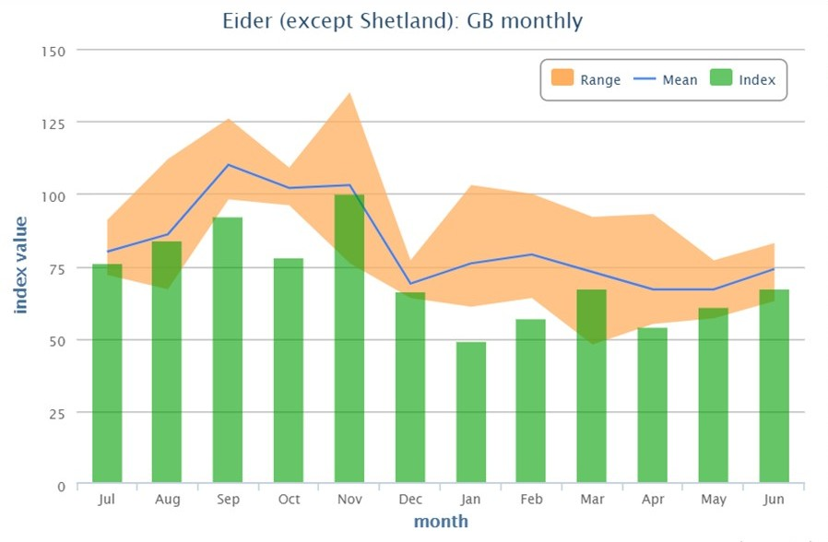

Figure 1. Monthly British totals of Common Eiders counted by the UK Wetland Bird Survey (uncorrected for coverage). Source: https://app.bto.org/webs-reporting/

References

Baillie, S. 2002. Common Eider (Eider) Somateria mollissima. Pp. 214-216. In: Wernham, C.V., Toms, M.P., Marchant, J.H., Clark, J.A., Siriwardena, G.M. & Baillie, S.R. 2002. The Migration Atlas: Movements of the Birds of Britain and Ireland. London, T. & A.D. Poyser.

Crowe, O. & Holt, C. (2013) Estimates of waterbird numbers wintering in Ireland, 2006/07 – 2010/11. Irish Birds 9:4

Frost, T, Austin, G. Hearn, R., McAvoy, Robinson, A., Stroud, D., Woodward, I. & Wotton, S. (2019) Population estimates of wintering waterbirds in Great Britain. British Birds 112: 130-145.

Stroud, D.A., Chambers, D., Cook, S., Buxton, N., Fraser, B., Clement, P., Lewis, P., McLean, I., Baker, H. & Whitehead, S. (eds.) 2001. The UK SPA network: its scope and content. JNCC, Peterborough. Three volumes. (90 pp; 438 pp; 392 pp.)

Wernham, C.V., Toms, M.P., Marchant, J.H., Clark, J.A., Siriwardena, G.M. & Baillie, S.R. 2002. The Migration Atlas: Movements of the Birds of Britain and Ireland. London, T. & A.D. Poyser.
Appendix 2. Definition of the term biogeographical population

AEWA uses the following definition (drawn directly from the definition used by Scott & Rose 1996):

biogeographical population - several types of ‘populations’ are recognized:
i. the entire population of a monotypic species;
ii. the entire population of a recognized subspecies;
iii. a discrete migratory population of a species or subspecies, i.e., a population which rarely if ever mixes with other populations of the same species or subspecies;
iv. that ‘population’ of birds from one hemisphere which spend the non-breeding season in a relatively discrete portion of another hemisphere or region. In many cases, these ‘populations’ may mix extensively with other populations on the breeding grounds, or mix with sedentary populations of the same species during the migration seasons and/or on the non-breeding grounds;
v. a regional group of sedentary, nomadic or dispersive birds with an apparently rather continuous distribution and no major gaps between breeding units sufficient to prohibit interchange of individuals during their normal nomadic wanderings and/or post-breeding dispersal.

UK/Ireland (excluding Shetland and Orkney, later revised by UK SPAR SWG to exclude only Shetland because Orkney birds judged to be mollissima); Norway/Russia; and the Baltic, Denmark and the Netherlands
However, the subsequent UK practice has been to combine British/Irish population with the Baltic/Denmark/Netherlands population retaining a separate Norway/Russia population
https://www.unep-aewa.org/sites/default/files/document/mop3_12_guidance_biographical_population_waterbird_0.pdf

