REPORT ON THE JOINT CMS/AEWA INFORMATION MANAGEMENT, COMMUNICATION AND AWARENESS-RAISING UNIT

Introduction

The following report provides a summary of the main activities carried out for the UNEP/AEWA Secretariat by the Joint CMS/AEWA Information Management, Communication and Awareness-raising (IMCA) Unit during the period between January 2017 and June 2018. The report also provides an update on the latest management and institutional developments relating to the Joint Unit, since its establishment in January 2014 as a pilot in joint services between the UNEP/CMS and UNEP/AEWA Secretariats.

Institutional Arrangements

The institutional arrangements for the Joint IMCA Unit have evolved significantly since its initial creation in January 2014.

Through Resolution 6.22, the AEWA Meeting of the Parties requested the UNEP/AEWA and UNEP/CMS Secretariats to develop a proposal within three months after MOP6 detailing implementation arrangements for the Joint IMCA Unit including staff time and budget sharing ratios, management structure, monitoring and evaluation indicators, among others, to be approved by the Standing Committee.

Considering the importance of this issue, the Committee granted the UNEP/AEWA Secretariat additional time to prepare a detailed proposal in consultation with the UNEP/CMS Secretariat.

During this period, a method to monitor staff time allocation within the IMCA Unit was tested and assessed and the draft proposal on the future management modalities was discussed extensively with the UNEP/CMS Secretariat.

The proposal for the IMCA Unit as requested by Resolution 6.22. was circulated on 27 September and approved by the members of the AEWA Standing Committee on 24 October 2016.
Management of the Joint Unit

The IMCA Unit is jointly managed by the CMS Executive Secretary and the AEWA Executive Secretary, while the IMCA Coordinator (the AEWA Information Officer) has the responsibility for the day-to-day management of the team. Over the course of the past four years since the establishment of the Unit in January 2014, much progress has been made in terms of transforming the Unit into an effective shared team that serves a wide range of communication, information management and outreach needs of both the UNEP/CMS and UNEP/AEWA Secretariats. This has been achieved through a re-organization and specialization process that focused on establishing “core communications and information management capacity” within the team, in the areas of 1. Website and Knowledge Management, 2. Screen and Print Design, 3. Writing & Editorial Service, 4. Press and Media (incl. social media) and 5. Campaigns and Outreach.

Team Composition

The organigram below describes the current composition of the IMCA Unit showing the regular staff and consultant positions contributed by UNEP/CMS and UNEP/AEWA Secretariats to the Joint Unit:
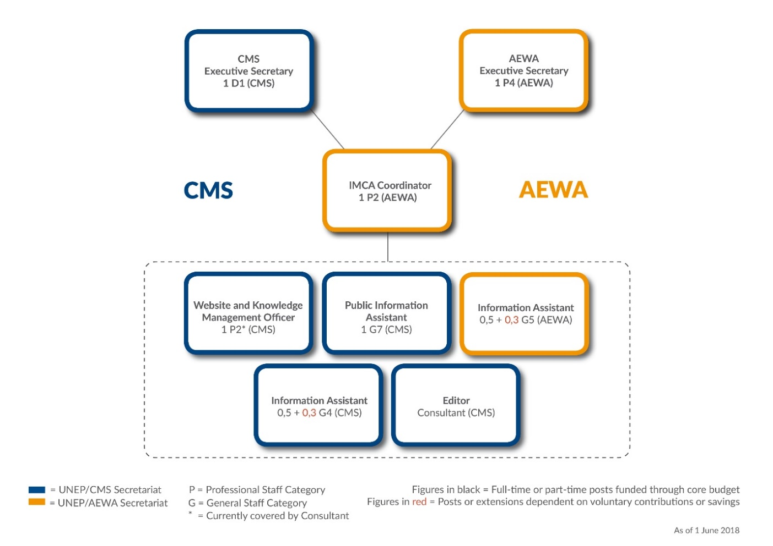

Figure 1: Organigram of the Joint Information Management, Communications and Awareness-raising (IMCA) Unit of the UNEP/CMS and UNEP/AEWA Secretariats (as of June 2018)

Management Improvements

The IMCA Coordinator has, over the past four years, established a number of management tools and procedures, which have significantly improved the operation of the Unit. These include:

- A Communications Pipeline – A permanently up-to-date table of upcoming CMS and AEWA events and activities which require communications support from the IMCA Unit. The pipeline has evolved into a useful planning and management tool for the Unit, as it defines the specific communication activities being planned (website news, press releases, social media, videos etc.) and the IMCA staff involved in each activity.

- Regular Editorial Meetings – The IMCA Unit holds weekly editorial meetings to coordinate and plan its work. The regular meetings are led by the IMCA Coordinator and used to discuss and review the latest Communications Pipeline.

- Time and Task Monitoring Tool – A time and task tracking tool has been established to be able to monitor and report on the actual work being conducted by the IMCA Unit for each Secretariat. The online tool allows each member of the team to log their work according to pre-defined projects and activities per client (i.e. CMS, AEWA or JOINT). The tool can also produce overview reports that will aid the general management of the Unit and will help ensure that the 1/3 – 2/3 arrangement is fulfilled.

Example Time Monitoring Report (January – December 2017)

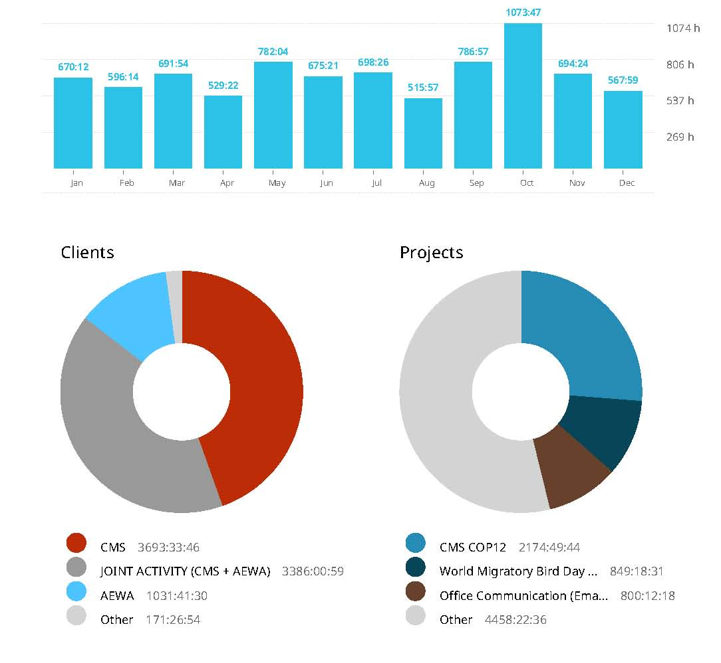
Below is a report produced by the time monitoring tool being used by the IMCA Unit (www.toggl.com). It shows all the hours logged by five of the IMCA Unit team members grouped by clients (AEWA, CMS and JOINT) over a period of one full year (January – December 2017). The time tracking is being done according to the main activities listed in an annual Programme of Work (PoW) for the IMCA Unit approved by both the CMS and AEWA Executive Secretary (see below).

Figure 2: Example Time Tracking per Client Report for IMCA Team for Period of January - December 2017 (Copyright: Toggl.com)

IMCA Unit Programme of Work

As outlined in the implementation arrangements, the work of the Unit is guided by an agreed Programme of Work (PoW) and all IMCA team members are required to use a web-based Time and Task Monitoring Tool (Toggl) to record the actual work being conducted by the IMCA Unit for each respective Secretariat.

The first annual Programme of Work for the Unit was agreed by the two Executive Secretaries for 2017, which was a CMS COP year. The resulting time balance in 2017 is in favour of CMS, as a result of the higher workload for the CMS COP12 in October 2017. In 2018, which is an AEWA MOP year, it is expected that the balance should be in favour of AEWA as estimated by the 2018 Programme of Work.

Communication Strategy

At the AEWA MOP6 in November 2015, AEWA Parties adopted a new Communication Strategy for the Agreement through AEWA Resolution 6.10 and which was also acknowledged in AEWA Resolution 6.18.

The overall aim of the strategy is to guide the communication work of all the relevant AEWA stakeholders to support the implementation of the Agreement. As such, the strategy is an important (high level) document for the Secretariat and the IMCA Unit in terms of providing a strategic framework for ongoing communication efforts.

The strategy is used by both the AEWA Executive Secretary and the IMCA Coordinator (the AEWA Information Officer) to give strategic direction to the work of the IMCA Unit as it relates to AEWA and the Secretariats communication and awareness-raising efforts. Over the past year, since its adoption, the new Communication Strategy has proven to be a useful tool and reference document, as it clearly defines AEWA’s communication objectives, niche and target audiences, etc.

The AEWA Communication Strategy is available on the AEWA Website at: http://www.unep-aewa.org/en/cepa

The Secretariat has also prepared a short “Report on the Implementation of the AEWA Communication Strategy” for 13th Meeting of the AEWA Standing Committee (See: Document AEWA / StC 13.10)

Summary Report of IMCA Unit Activities

Below is a summary of the main communication and information management-related activities carried out by the IMCA Unit for the UNEP/AEWA Secretariat between January 2016 and June 2018.

Information Management

The IMCA Unit technically manages and maintains all external websites and online tools of the UNEP/AEWA Secretariat. This includes the management of the official AEWA website, the AEWA Technical Committee Workspace and a number of AEWA Single Species Action Plan Working Group websites. In addition, the IMCA Unit is in charge of the technical management of the Online National Reporting System (ORS), the Online Meeting Registration System and Contacts Database, all of which are used by the UNEP/AEWA Secretariat. The website analytics in place for the official AEWA website show 68,500 unique users and over 287,000 pages viewed in the period from January 2017 to June 2018.

While the development, hosting and technical maintenance of some of the tools continues to be done in cooperation with external web developers to a limited extent, the in-house website management capacity within the IMCA Unit has increased significantly with the hiring of a CMS Website and Knowledge Management Consultant, which is also clearly benefitting the UNEP/AEWA Secretariat.

The IMCA Website Consultant is able to tackle many of the technical issues which previously required the expertise and support of external developers and fulfils many important day-to-day functions in the area of knowledge and website management for both the UNEP/AEWA and UNEP/CMS Secretariats (and the wider CMS Family), from bug fixing, to helpdesk and training of staff, establishment of web publishing norms and work flows, to web design, data management and usability improvements.

Online National Reporting – Improvements to the AEWA Reporting Format

Over the course of this reporting period, the IMCA Unit worked closely with the AEWA Science, Implementation and Compliance Unit (SICU) and UNEP-WCMC to help set-up AEWA’s MOP7 National Report in the Online Reporting System (ORS). Improvements were made to the online presentation of the report through a customized “species per country” option that was previously not available in the AEWA report. The reporting process and technical (IT) support service for AEWA National Respondents on issues relating to the use of the Online Reporting System is also being managed by the IMCA Unit for reporting to AEWA MOP7.

Online National Reporting System (ORS) – AEWA’s Pioneering Role

The IMCA Unit continues to work closely with the IT and Species Units at UNEP-WCMC to optimize the use of the Online Reporting System (ORS). Thanks to a UNEP DELC / EU ACP funded project, the original ORS which was used for reporting to both AEWA MOP5 and MOP6, has been significantly improved by UNEP-WCMC in close cooperation with the IMCA Unit in terms of its usability and interoperability. The active participation in the further development process of the ORS by the IMCA Unit is a direct continuation of the pioneering role that the UNEP/AEWA Secretariat has played in the development of the first version of the ORS. Meanwhile, the early vision of creating a single, highly sophisticated online national reporting tool for use by multiple Multilateral Environment Agreements (MEAs) has become a reality, with several MEAs using the ORS for their national reporting processes. Users of the ORS include AEWA, CMS, EUROBATS, Bern Convention, CITES, RAMSAR, PLANT TREATY, and a number of other MEAs have expressed their interest.

For more information on the ORS please see: http://www.ors.ngo/

Communication-Related Activities

In addition to managing the various AEWA-related websites and online tools, the IMCA Unit also manages the regular production of website news announcements, the AEWA Electronic Newsletter and the Agreements social media channels (Both Twitter and Facebook). The IMCA Unit also coordinates the production of press releases, media advisories, op-eds and the production of audio-visual products for AEWA. Work on a number of thematic pages began in late 2017 and has intensified in 2018. These are being developed under the guidance of the AEWA Executive Secretary on the topics of 1.) Climate Change 2.) Lead Poisoning and 3.) Renewable Energy as they relate to migratory waterbirds.

The IMCA Unit also provides in-house design services for the UNEP/AEWA Secretariat with regard to both print and digital products. Thanks to the design and desktop publishing skills within the Unit, the UNEP/AEWA Secretariat does not have to go through time-consuming administrative procedures to hire external designers for design work needed for basic layouts and publications. For example, design work conducted by the IMCA Unit has resulted in the creation, cropping and arrangement of customized graphics and images used to enhance the presentation of both AEWA website and social media content.

For a more detailed summary of communication-related activities carried out by the IMCA Unit for the UNEP/AEWA Secretariat since January 2016, please see the “Report on the Implementation of the AEWA Communication Strategy” for 13th Meeting of the AEWA Standing Committee (See: Document AEWA / StC 13.10)

Campaigns and Events: World Migratory Bird Day

The IMCA Unit is charged with managing the public outreach and awareness-raising activities of the UNEP/AEWA Secretariat. These include yearly events such as participation in the UN Day Celebrations in Bonn and other public events conducted by the AEWA Secretariat throughout the year. However, the primary outreach campaign for AEWA (and CMS) being led by the IMCA Unit continues to be World Migratory Bird Day.

For a more detailed summary of the main developments relating to the campaign since January 2016 please see the “Report on the Implementation of the AEWA Communication Strategy” for 13th Meeting of the AEWA Standing Committee (See: Document AEWA / StC 13.10)

Cooperation with other Partners

In addition to coordinating the day-to-day information management, communications and outreach activities of the UNEP/AEWA Secretariat, the IMCA Unit has actively contributed to enhancing cooperation between AEWA and other external partners and organizations in 2016:

UNEP Information and Knowledge Management (IKM) Initiative

AEWA is one of the 43 international and regionally binding environment treaties actively contributing to the MEA Information and Knowledge Management (IKM) Initiative facilitated by UNEP. The flagship product of the initiative is www.InforMEA.org, a sophisticated information portal which harvests COP and MOP decisions and resolutions, news, events, national focal point contacts, national reports and implementation plans from all participating MEA Secretariats and organizes this information around a set of agreed terms. The UNEP/AEWA Secretariat benefitted greatly from this initiative, both with regards to exchange of knowledge with other MEA Secretariats and in terms of financial support from the project to improve the interoperability and overall management of the AEWA website. The UNEP/AEWA Secretariat (and wider CMS Family) is represented at the IKM Steering Committee by the IMCA Coordinator. Among other things, he is chair of the IKM working group on outreach and communication as well actively promoting enhanced cooperation between MEAs with regard to national reporting and the use of the ORS as a common reporting tool for MEAs. For more information on the IKM Initiative please see:

- InforMEA Website: https://www.informea.org/en
- InforMEA Video:
https://www.youtube.com/watch?list=PLq-dwpj8XoR-ThtlFSCzd2wxo0Y7NrcJ1&v=bKmNindEWFg

UN Bonn Communications Group (UNCG)

The UNEP/AEWA Secretariat (and wider CMS Family) is represented at the UN Bonn Communications Group (UNCG) by the IMCA Coordinator. UNCG brings together all Communications Focal Points at the UN Campus to coordinate and exchange on outreach and communications efforts of UN Bonn Entities. Participation in the UNCG and events such as UN Day in Bonn, the Deutsche Welle Global Media Forum and other UN Bonn related outreach events help maintain and improve recognition of AEWA as one of the UN entities operating from Bonn, Germany. Participation in UN Bonn related events such as UN Day are also important for acknowledging both the Host City (Bonn) and Host Country (Germany) of the UNEP/AEWA Secretariat. For more information, please visit: www.unbonn.org.

