**REPORT OF THE SECRETARIAT ON FINANCE AND**

**ADMINISTRATIVE ISSUES IN 2013 – 2015 AND 2016 - 2018**

*Prepared by the UNEP/AEWA Secretariat*

**Introduction**

Budget period 2013 – 2015

The Secretariat reported on financial and administrative matters at the 12th Meeting of the Standing Committee (January 2017, Paris, France). The Standing Committee Document 12.17 reported on staffing issues and income and expenditures for the period 01 January 2016 – 31 December 2016, as well as the expenditures for the 2013-2015 triennium.

Due to pending reversals, the two attached expenditure reports (2013-2015 and 2016) were only interim versions. The Meeting took note of the report and expected to receive the final expenditure reports once all the necessary reversals would have been carried out.

The final report for the triennium 2013-2015 has been annexed to this document (see Annex 1). The final report for 2016 is part of the report for the budget period 2016-2018 (see below).

Budget period 2016 – 2018

At the 6th Session of the Meeting of the Parties to AEWA, the core budget for 2016-2018 was adopted through Resolution 6.18. The present document aims at reporting on staffing issues and on income and expenditure for the period 1 January 2016 –31 May 2018.

**Action Requested from the Standing Committee**

The Standing Committee is requested to review and approve the information provided in the report.

**A. Budget period 2013 – 2015**

**1. Expenditures 1 January 2013 – 31 December 2015**

Annex 1 shows the budget implementation of the 2013-2015 triennium as at 31 December 2017. The triennial budget shows a positive ending balance of EUR 226,066 before Programme Support Costs, corresponding to an implementation rate of 91.70 %.

The reversals that have been carried out retrospectively in the course of 2017 have especially reduced the balance in the budget line 1106 for the African Initiative Coordinator and the over-expenditure on the MOP organization, compared to the report presented at StC12. However, the positive ending balance does not fully compensate the withdrawal from the trust fund decided by MOP6 (370 000 EUR) despite the effort of the Secretariat to reduce as much as possible the operational costs.

**2. Trust Fund balance**

The Trust Fund balance for assessed contributions as at 31 December 2015 amounted to USD 687,372 (which is inclusive of the Operating Reserve of a constant level of at least 15 % of the estimated annual expenditure or EUR 150,000, whichever is higher).

**B. Budget period 2016 – 2018**

1. **Staffing (1 January 2016 – 31 May 2018)**

Staff funded by the core budget

There have been no major changes to the team during the period covered by the report.

**African Initiative Unit**

The positions of the African Initiative Coordinator (P-2) and the Programme Management Assistant (G-5) were partly funded (50 %) through the AEWA core budget 2016-2018 since 01 January 2016. The Secretariat was able to maintain the P-2 position at 100 % and the G-5 position at 80 % in 2016, 2017 and first half of 2018, and expects to be able to do so until the end of 2018, thanks to contributions from the Federal Office for the Env

ironment in Switzerland and the European Commission.

For a full report on the Implementation of the African Initiative and the Plan of Action for Africa, please see document StC13.8.

Staff fully dependent on voluntary contributions

**Associate Programme Officer (P-2) for Single Species Action Plan Support and the coordination of implementation of the Lesser White-fronted Goose International Single Species Action Plan**

The position of the Associate Programme Officer for Single Species Action Plan Support and the coordination of implementation of the Lesser White-fronted Goose International Single Species Action Plan has been secured until February 2020. The Secretariat is grateful to the Norwegian Environment Agency for its continuing support of this important position.

**Associate Programme Officer (P-2) and Programme Management Assistant (G-5) for the AEWA European Goose Management Platform**

Thanks to funding received from the Governments of Norway, Finland, Denmark and France towards the implementation of the AEWA European Goose Management Platform (EGMP), the Secretariat has been able to recruit staff on two project posts: one full-time P-2 Associate Programme Officer in July 2017 and one full-time G-5 Programme Management Assistant in November 2017. The possibility to maintain these posts is dependent on the annual voluntary contributions by the range states to the EGMP.

Interns

The UNEP/AEWA Secretariat participates in the CMS Family Internship Programme. In the framework of this programme, 14 interns supported the work of the Secretariat in the period under consideration (March 2016 – June 2018), which is an average of six interns per year. With one exception all of them have been supporting the work of the IMCA team.

Staff reclassification

All the three AEWA G-4 posts were reclassified in 2016, in accordance with AEWA Resolution 6.18 and the three staff members were successfully upgraded to G5 level in 2017.

At the CMS COP11 (Quito, November 2014), CMS Parties requested UNEP and the UNEP/CMS Secretariat through Resolution 11.1 “*to undertake a review of the grading of the Secretariat’s posts, in line with the functions of the Secretariat, […] to enable decisions on the grading of the posts to be taken by Parties at COP12*”. In response to this mandate, the UNEP/CMS Secretariat contracted a Consultant to assess the need for reclassification for all CMS posts.

By correspondence of 29 September 2016, the AEWA Standing Committee provided the Secretariat with the mandate to commission a similar reclassification assessment alongside the one undertaken by the CMS Secretariat. The report delivered by the independent Consultant will be used, as requested by the   
12th Meeting of the Standing Committee, to provide the 7th Session of the Meeting of the Parties (MOP7) to AEWA with a valid independent assessment of all Secretariat posts. The Consultant reviewed all positions except the three AEWA G-4 posts, which had already been reclassified (*cf. supra*), as well as the post of the Executive Secretary, which had already been classified by UNON at P-5 level in 2012, but maintained at P-4 level by MOP5 due to financial constraints.

The 12th Meeting of the Standing Committee requested the Secretariat to initiate the adjustment of those job titles and job descriptions of the P-staff positions with the Human Resources Unit at the United Nations Office at Nairobi (UNON), that had been assessed at being at a lower level than the ones they are performing on. This is not an upgrade and those positions will retain their current grading, but their titles and job descriptions will, at least, correctly reflect the actual duties and responsibilities undertaken.

Organisation of the Secretariat

The individual staff members and units work closely as a team, interacting with each other on cross-cutting issues on a daily basis; they are divided into four major areas of work (as described in Annex 7 – Organisational Structure and Annex 8 - Staff Composition of the UNEP/AEWA Secretariat).

Each staff member has an annual work plan, which is approved and/or revised annually as well as on a mid-term basis by his/her direct supervisor. All the work plans are examined by the Executive Secretary, in order to ensure synergies between the units and to avoid a duplication of efforts. The Secretariat nonetheless faces a number of challenges in the delivery of its mandate and is rather stretched. This is due to the ever-increasing range of services to be delivered: without the extension of the part-time positions through voluntary contributions, the availability of staff funded through voluntary contributions and the support of interns, the Secretariat would not have been in a position to deliver all services requested during the course of the period covered by the report.

As at 01 June 2018, the core budget covers 7.25 full-time equivalent positions (FTEs), while voluntary contributions have allowed the addition of 4.15 full-time equivalent positions. The Secretariat currently comprises twelve staff members (see Annex II): seven Professional Staff members   
(P staff) and five General Staff members (G staff).

**2. Core Budget (AWL) – Overview of income and expenditure**

Income

**Annex 2** summarizes the status of collection of annual assessed contributions from Parties as at 31 May 2018. The assessed contributions 2016-2018 approved by MOP6 amount to EUR 2,768,778. The overview shows a generally healthy income situation. Unpaid pledges amount to a total of EUR 519,360, split up as follows: EUR 312,547 for 2017 and previous years, and EUR 206,813 for 2018. It should be noted that the deadline for the annual contribution is 30 June and has not been reached at the time of writing. Advanced payments for future years amount to EUR 138,179. The UNEP/AEWA Secretariat regularly reminds Parties of outstanding contributions for the current and previous years.

Expenditures (2016 - 2018)

**Annex 3** provides an interim report of 2016 - 2018 budget implementation as at 31 May 2018. The budget for 2016 includes an authorised withdrawal from the trust fund of EUR 71,564 for the small grant fund projects in African countries as well as the classification exercise for the AEWA positions.

The staff salaries under General Management showing overspendings on certain lines, partly due to a change in percentages of staff working hours, are compensated by other staff lines. Overexpenditures in the operative costs in 2016, e.g. for telephone and fax and office operations are due to the high work peak caused by MOP6 in November 2015.

It should be noted that the AEWA budget has benefited from a favourable EUR/ USD exchange rate in the years of 2016 and 2017. Overall, the budget shows a positive end-year balance, before Programme Support Costs, of EUR 104,175 in 2016 and EUR 9,036 in 2017, and a healthy balance of EUR 621,552 for the running year 2018 after five months of implementation.

Trust Fund balance

According to the currently available preliminary statement of financial performance, the Trust Fund balance for assessed contributions as at 31 December 2017 is expected to amount to USD 677,006 (which is inclusive of the Operating Reserve of a constant level of at least 15 % of the estimated annual expenditure or EUR 150,000, whichever is higher). The Secretariat, however, wishes to point out that due to ongoing reversals and corrective actions, the final figure might still slightly differ.

**3. Voluntary Contributions (AVL) - Overview of collections 2016-2018**

In addition to the annual contributions paid by Parties towards the AEWA core budget (AWL), the Secretariat also received voluntary contributions from different governments and organisations that were earmarked for certain activities. These voluntary contributions are managed in the separate Trust Fund (AVL). Annexes 4, 5 and 6 summarize the voluntary contributions to the AVL Trust fund in 2016, 2017 and 2018 respectively.

The pledged voluntary contributions received amounted to **EUR 595,072** (EUR 205,555 + USD 431,359 equivalent to EUR 389,517[1]) in 2016 (Annex 4), **EUR 556,697** in 2016 (EUR 313,250 + USD 260,435, equivalent to EUR 232,047[2] + GBP 10,000 equivalent to EUR 11,400) in 2017 and **EUR 161,998** in 2018 (EUR 145,000 + GBP 6,700 equivalent to EUR 7,645 + Skr 100,000 equivalent to EUR 9,353.

The voluntary contributions received in 2016-2018 were earmarked for the coordination and implementation of the Lesser White-fronted Goose ISSAP, the European Goose Management Platform, the African Initiative, the Strategic Plan 2019-2027 process, the production of the 7th edition of the Conservation Status report and other MOP7 documents, funded delegates attending MOP7, the organisation of MOP7, the planning workshop for the Velvet Scoter ISSAP and the 1st Meeting of the Eurasian Curlew International Working Group. The Secretariat would like to thank all governments and organisations that have provided contributions to AEWA.

**ANNEX 1: IMPLEMENTATION OF THE APPROVED AEWA BUDGET 2013 - 2015**

**Final Report as at 31 December 2017 (in EUR)**





*Covered by a pledge from the Government of Norway **Covered by the Government of Germany ***From the 13% overhead, UNEP is covering the costs of one professional and four general service staff members of the CMS Administrative and Fund Management Unit, which supports the UNEP/AEWA Secretariat

**ANNEX 2: GENERAL TRUST FUND FOR ANNUAL CONTRIBUTION TO THE AGREEMENT ON THE CONSERVATION OF AFRICAN - EURASIAN MIGRATORY WATERBIRDS (AWL)**

**Status of Contributions as at 31 May 2018 (in EUR)**

| **COUNTRIES** | **Unpaid Pledges for 2017 & Prior Years** | **Advanced Payments for Future Years** | **Pledges for 2018** | **Collections in 2018 for 2017 & Prior Years** | **Collections in 2018 for 2018** | **Collections During 2018 for Future Years** | **Unpaid Pledges for 2017 & Prior Years** | **Unpaid Pledges for 2018** | **Advanced Payments for 2019 (Future Years)** | **Total Outstanding as of 2018** |
| --- | --- | --- | --- | --- | --- | --- | --- | --- | --- | --- |
|  | **EUR** | **EUR** | **EUR** | **EUR** | **EUR** | **EUR** | **EUR** | **EUR** | **EUR** | **EUR** |
| Albania | 0 | 0 | 2,000 |  | 2,000 |  | 0 | 0 | 0 | 0 |
| Algeria | 2,000 | 0 | 2,000 |  |  |  | 2,000 | 2,000 | 0 | 4,000 |
| Belarus | 0 | 0 | 2,000 |  |  |  | 0 | 2,000 | 0 | 2,000 |
| Belgium | 0 | 0 | 23,494 |  |  |  | 0 | 23,494 | 0 | 23,494 |
| Benin | 9,991 | 0 | 2,000 |  |  |  | 9,991 | 2,000 | 0 | 11,991 |
| Botswana | 333 | 0 | 2,000 |  |  |  | 333 | 2,000 | 0 | 2,333 |
| Bulgaria | 0 | 0 | 2,000 |  | 2,000 |  | 0 | 0 | 0 | 0 |
| Burkina Faso | 5,870 | 0 | 2,000 |  |  |  | 5,870 | 2,000 | 0 | 7,870 |
| Burundi | 6,500 | 0 | 2,000 |  |  |  | 6,500 | 2,000 | 0 | 8,500 |
| Chad | 12,333 | 0 | 2,000 |  |  |  | 12,333 | 2,000 | 0 | 14,333 |
| Congo | 18,362 | 0 | 2,000 |  |  |  | 18,362 | 2,000 | 0 | 20,362 |
| Cote d'Ivoire | 0 | 5,394 | 2,000 |  |  |  | 0 | 0 | 3,394 | 0 |
| Croatia | 0 | 0 | 2,000 |  | 2,000 |  | 0 | 0 | 0 | 0 |
| Cyprus | 0 | 2,000 | 2,000 |  |  |  | 0 | 0 | 0 | 0 |
| Czech Republic | 0 | 2,784 | 2,784 |  |  |  | 0 | 0 | 0 | 0 |
| Denmark | 0 | 0 | 22,932 |  |  |  | 0 | 22,932 | 0 | 22,932 |
| Djibouti | 18,470 | 0 | 2,000 |  |  |  | 18,470 | 2,000 | 0 | 20,470 |
| Egypt | 0 | 3,833 | 3,833 |  |  |  | 0 | 0 | 0 | 0 |
| Equatorial Guinea | 4,000 | 0 | 2,000 |  |  |  | 4,000 | 2,000 | 0 | 6,000 |
| Estonia | 0 | 0 | 2,000 |  | 2,000 |  | 0 | 0 | 0 | 0 |
| Ethiopia | 6,000 | 0 | 2,000 |  |  |  | 6,000 | 2,000 | 0 | 8,000 |
| European Commission | 0 | 0 | 16,593 |  |  |  | 0 | 16,593 | 0 | 16,593 |
| Finland | 0 | 0 | 17,195 |  | 17,195 |  | 0 | 0 | 0 | 0 |
| France | 0 | 132,745 | 132,745 |  |  | 132,745 | 0 | 0 | 132,745 | 0 |
| Gabon | 10,167 | 0 | 2,000 |  |  |  | 10,167 | 2,000 | 0 | 12,167 |
| Gambia | 4,000 | 0 | 2,000 |  |  |  | 4,000 | 2,000 | 0 | 6,000 |
| Georgia | 0 | 0 | 2,000 |  | 2,000 |  | 0 | 0 | 0 | 0 |
| Germany, F.R. | 0 | 0 | 132,745 |  | 132,745 |  | 0 | 0 | 0 | 0 |
| Ghana | 0 | 2,000 | 2,000 |  |  |  | 0 | 0 | 0 | 0 |
| Guinea | 4,000 | 0 | 2,000 |  |  |  | 4,000 | 2,000 | 0 | 6,000 |
| Guinea - Bissau | 18,300 | 0 | 2,000 |  |  |  | 18,300 | 2,000 | 0 | 20,300 |
| Hungary | 0 | 0 | 3,302 |  | 3,302 |  | 0 | 0 | 0 | 0 |
| Iceland | 0 | 0 | 2,000 |  |  |  | 0 | 2,000 | 0 | 2,000 |
| Ireland | 0 | 0 | 9,174 |  |  |  | 0 | 9,174 | 0 | 9,174 |
| Israel | 0 | 0 | 14,915 |  |  |  | 0 | 14,915 | 0 | 14,915 |
| Italy | 0 | 0 | 75,007 |  | 75,007 |  | 0 | 0 | 0 | 0 |
| Jordan | 4,000 | 0 | 2,000 |  |  |  | 4,000 | 2,000 | 0 | 6,000 |
| Kenya | 4,000 | 0 | 2,000 |  |  |  | 4,000 | 2,000 | 0 | 6,000 |
| Latvia | 0 | 0 | 2,000 |  | 2,000 |  | 0 | 0 | 0 | 0 |
| Lebanon | 3,052 | 0 | 2,000 | 2,000 |  |  | 1,052 | 2,000 | 0 | 3,052 |
| Libya | 39,025 | 0 | 3,203 |  |  |  | 39,025 | 3,203 | 0 | 42,228 |
| Lithuania | 0 | 2,000 | 2,000 |  |  |  | 0 | 0 | 0 | 0 |
| Luxembourg | 0 | 2,000 | 2,000 |  |  |  | 0 | 0 | 0 | 0 |
| Macedonia | 16,000 | 0 | 2,000 |  |  |  | 16,000 | 2,000 | 0 | 18,000 |
| Madagascar | 0 | 1,210 | 2,000 |  |  |  | 0 | 790 | 0 | 790 |
| Mali | 9,999 | 0 | 2,000 |  |  |  | 9,999 | 2,000 | 0 | 11,999 |
| Mauritania | 5,333 | 0 | 2,000 |  |  |  | 5,333 | 2,000 | 0 | 7,333 |
| Mauritius | 0 | 0 | 2,000 |  | 2,000 |  | 0 | 0 | 0 | 0 |
| Moldova | 0 | 0 | 2,000 |  |  |  | 0 | 2,000 | 0 | 2,000 |
| Monaco | 0 | 0 | 2,000 |  | 2,000 |  | 0 | 0 | 0 | 0 |
| Montenegro | 0 | 0 | 2,000 |  | 2,000 |  | 0 | 0 | 0 | 0 |
| Morocco | 0 | 0 | 2,000 |  |  |  | 0 | 2,000 | 0 | 2,000 |
| Netherlands | 0 | 0 | 53,977 |  | 53,977 |  | 0 | 0 | 0 | 0 |
| Niger | 18,704 | 0 | 2,000 |  |  |  | 18,704 | 2,000 | 0 | 20,704 |
| Nigeria | 4,000 | 0 | 2,000 |  |  |  | 4,000 | 2,000 | 0 | 6,000 |
| Norway | 0 | 0 | 16,288 |  | 16,288 |  | 0 | 0 | 0 | 0 |
| Portugal | 11,838 | 0 | 11,838 |  |  |  | 11,838 | 11,838 | 0 | 23,676 |
| Romania | 0 | 0 | 2,000 |  | 2,000 |  | 0 | 0 | 0 | 0 |
| Rwanda | 0.00 | 2,000 | 2,000 |  |  |  | 0.00 | 0 | 0 | 0 |
| Senegal | 14,000 | 0 | 2,000 |  |  |  | 14,000 | 2,000 | 0 | 16,000 |
| Slovakia | 0 | 2,000 | 2,000 |  |  |  | 0 | 0 | 0 | 0 |
| Slovenia | 0 | 4,149 | 2,149 |  |  |  | 0 | 0 | 2,000 | 0 |
| South Africa | 0 | 9,326 | 9,326 |  |  |  | 0 | 0 | 0 | 0 |
| Spain | 0 | 100 | 62,576 |  | 62,476 |  | 0 | 0 | 0 | 0 |
| Sudan | 15,174 | 0 | 2,000 |  |  |  | 15,174 | 2,000 | 0 | 17,174 |
| Swaziland | 4,000 | 0 | 2,000 |  |  |  | 4,000 | 2,000 | 0 | 6,000 |
| Sweden | 0 | 0 | 31,874 |  |  |  | 0 | 31,874 | 0 | 31,874 |
| Switzerland | 0 | 0 | 38,230 |  | 38,230 |  | 0 | 0 | 0 | 0 |
| Syria | 13,885 | 0 | 2,000 |  |  |  | 13,885 | 2,000 | 0 | 15,885 |
| Togo | 2,000 | 0 | 2,000 |  |  |  | 2,000 | 2,000 | 0 | 4,000 |
| Tunisia | 15,600 | 0 | 2,000 |  |  |  | 15,600 | 2,000 | 0 | 17,600 |
| U.K. | 0 | 0 | 132,745 |  | 132,745 |  | 0 | 0 | 0 | 0 |
| Uganda | 0 | 2,040 | 2,000 |  |  |  | 0 | 0 | 40 | 0 |
| Ukraine | 0 | 0 | 2,000 |  |  |  | 0 | 2,000 | 0 | 2,000 |
| United Rep. of Tanzania | 8,000 | 0 | 2,000 |  |  |  | 8,000 | 2,000 | 0 | 10,000 |
| Uzbekistan | 3,610 | 0 | 2,000 |  |  |  | 3,610 | 2,000 | 0 | 5,610 |
| Zimbabwe | 2,000 | 0 | 2,000 |  |  |  | 2,000 | 2,000 | 0 | 4,000 |
| **Total** | **314,547** | **173,581** | **926,925** | **2,000** | **551,965** | **132,745** | **312,547** | **206,813** | **138,179** | **519,360** |

**ANNEX 3: IMPLEMENTATION OF THE APPROVED AEWA BUDGET 2016-2018**

**Report as at 31 May 2018 (in EUR)**





**ANNEX 4: GENERAL TRUST FUND FOR VOLUNTARY CONTRIBUTIONS TO THE AGREEMENT ON THE CONSERVATION OF AFRICAN - EURASIAN MIGRATORY WATERBIRDS (AVL)**

**Status of contributions as at 31 December 2016**



**ANNEX 5: GENERAL TRUST FUND FOR VOLUNTARY CONTRIBUTIONS TO THE AGREEMENT ON THE CONSERVATION OF AFRICAN - EURASIAN MIGRATORY WATERBIRDS (AVL)**

**Status of contributions as at 31 December 2017**



**ANNEX 6: GENERAL TRUST FUND FOR VOLUNTARY CONTRIBUTIONS TO THE AGREEMENT ON THE CONSERVATION OF AFRICAN - EURASIAN MIGRATORY WATERBIRDS (AVL)**

**Status of contributions as at 31 May 2018**



**ANNEX 7 – UNEP/AEWA Secretariat Organisational structure**

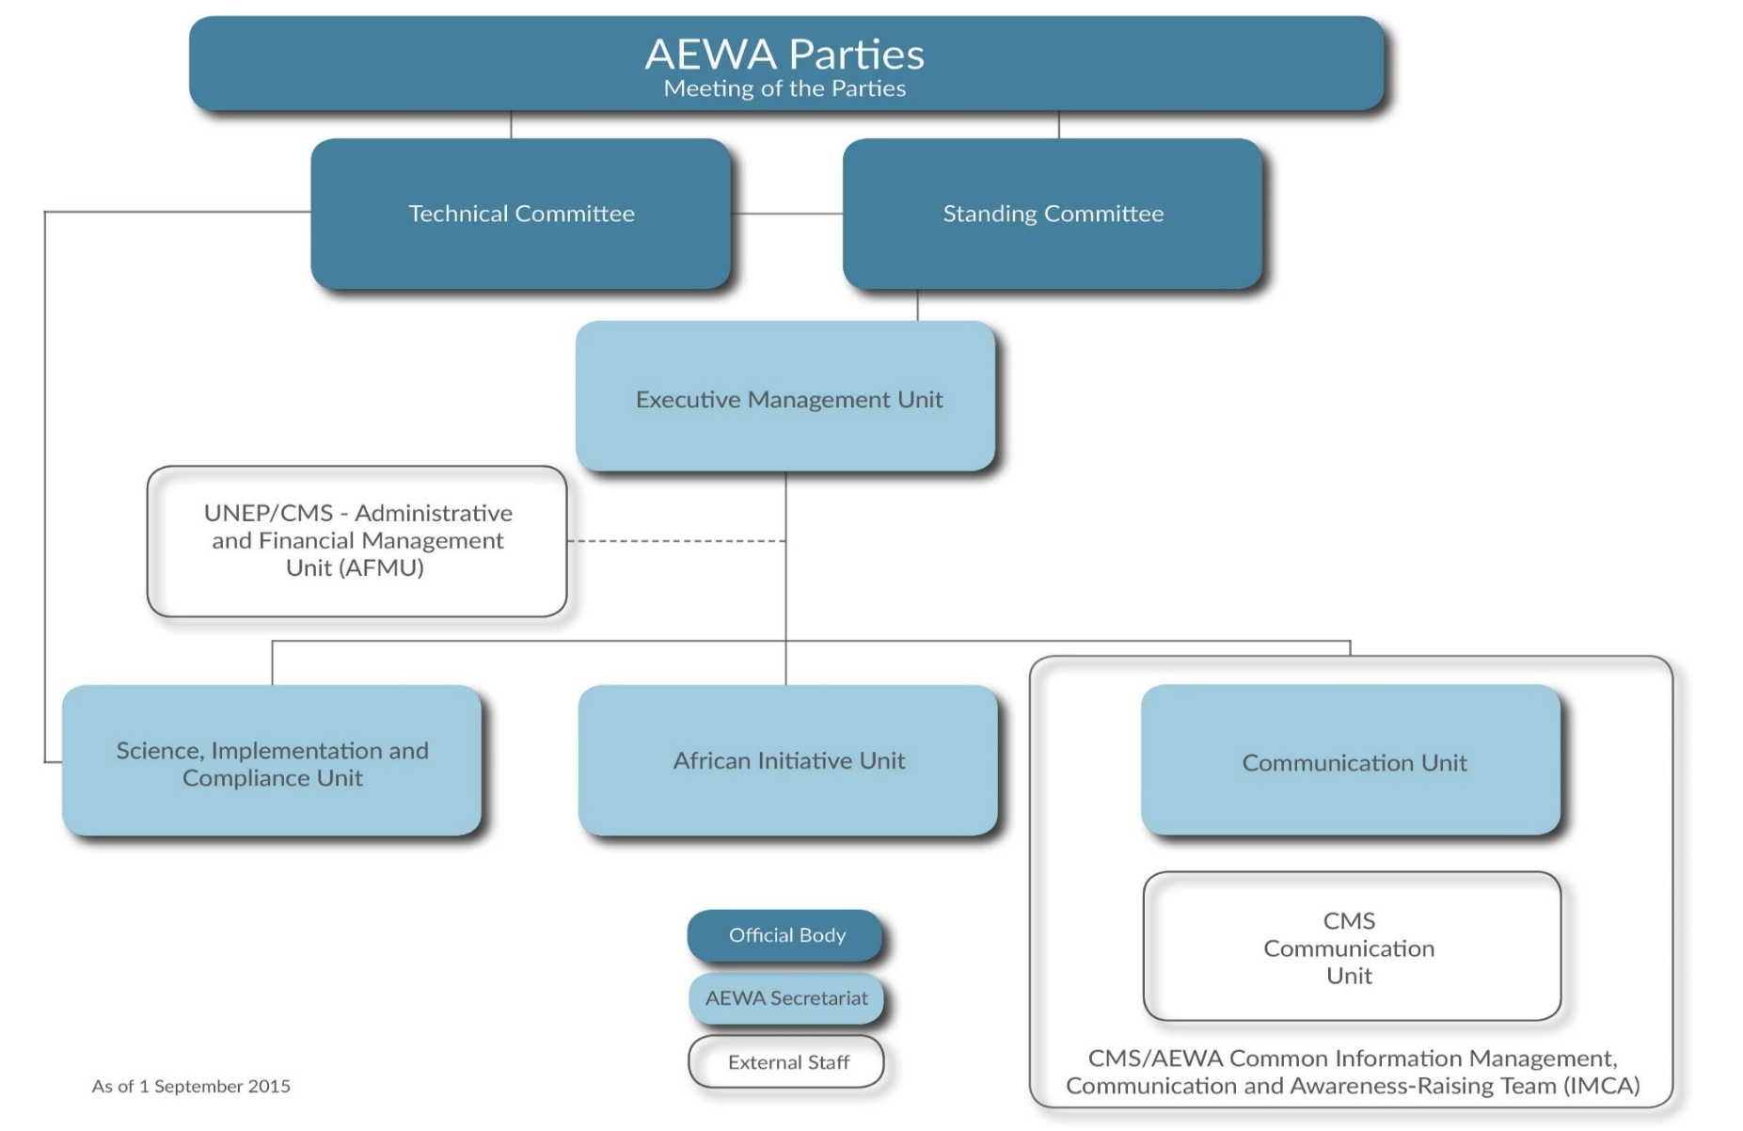

**ANNEX 8 – UNEP/AEWA Secretariat Staff Composition**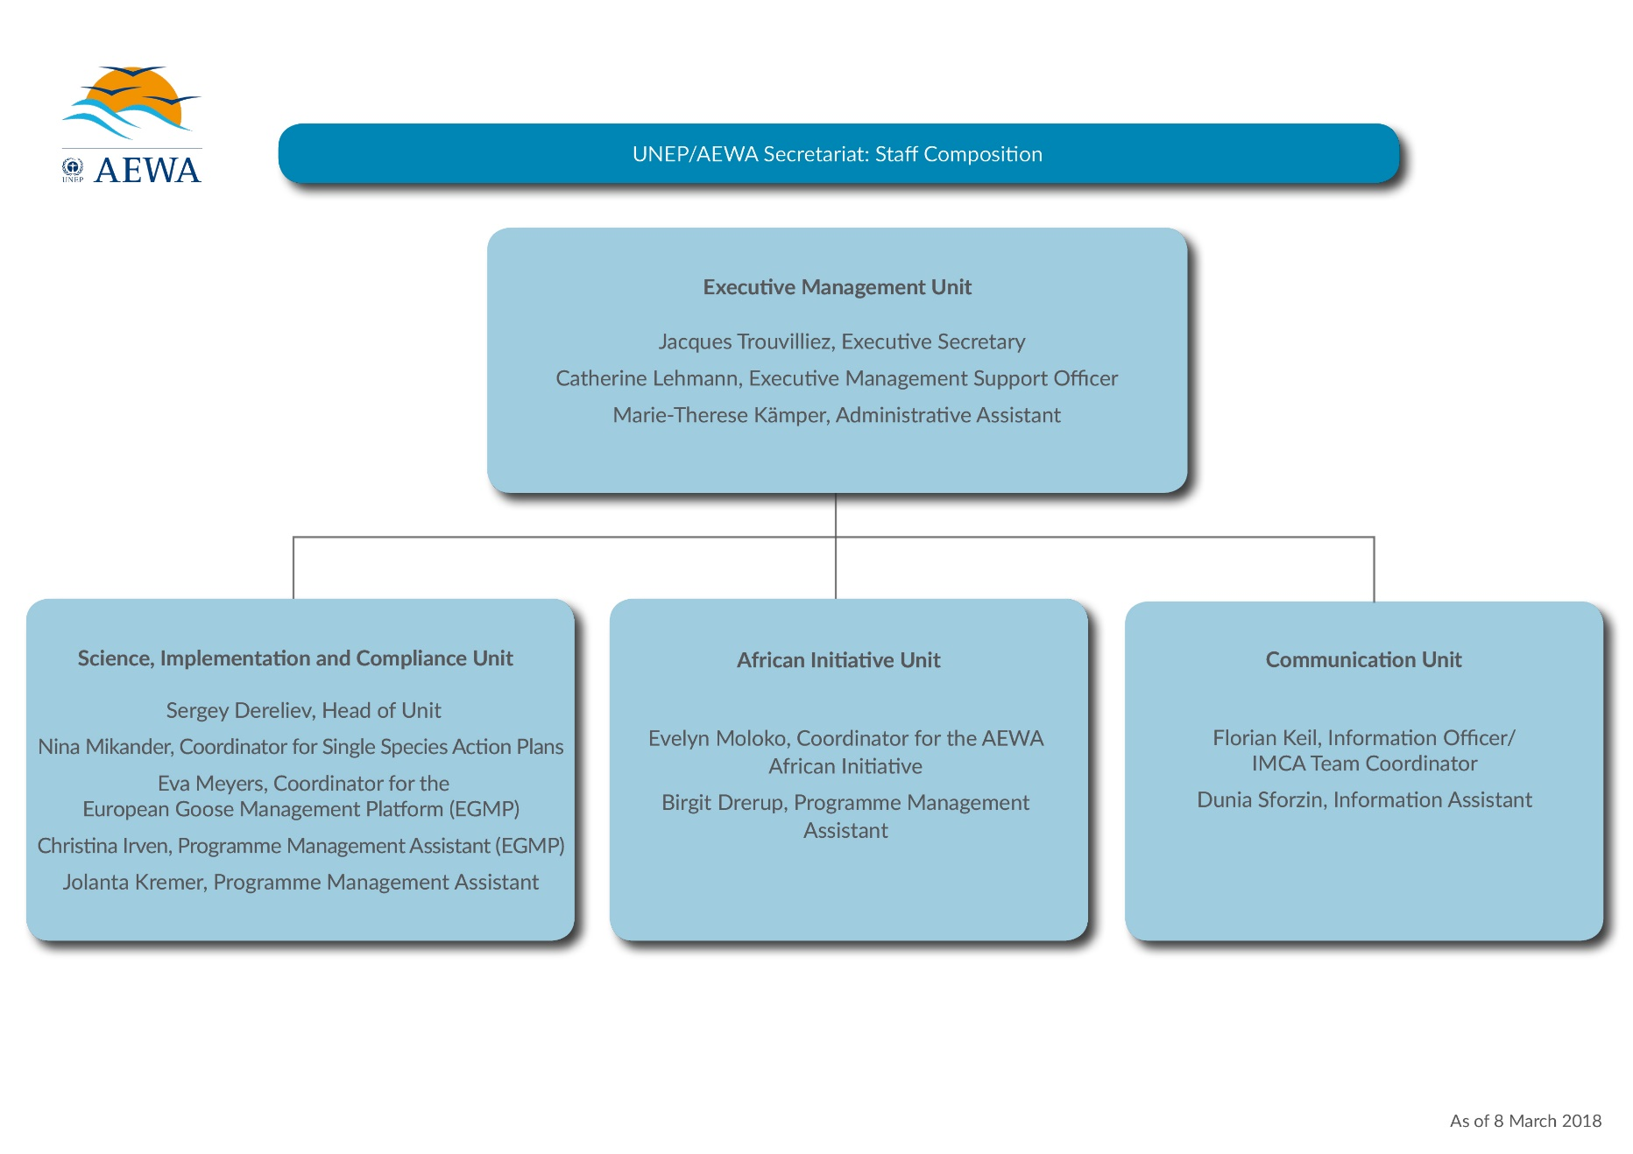

1. Exchange rate 0,903.
2. Exchange rate 0,891.