REPORT OF THE 2nd MEETING OF THE AEWA NORTHERN BALD IBIS
INTERNATIONAL WORKING GROUP

25–27 September 2017, Agadir, Morocco

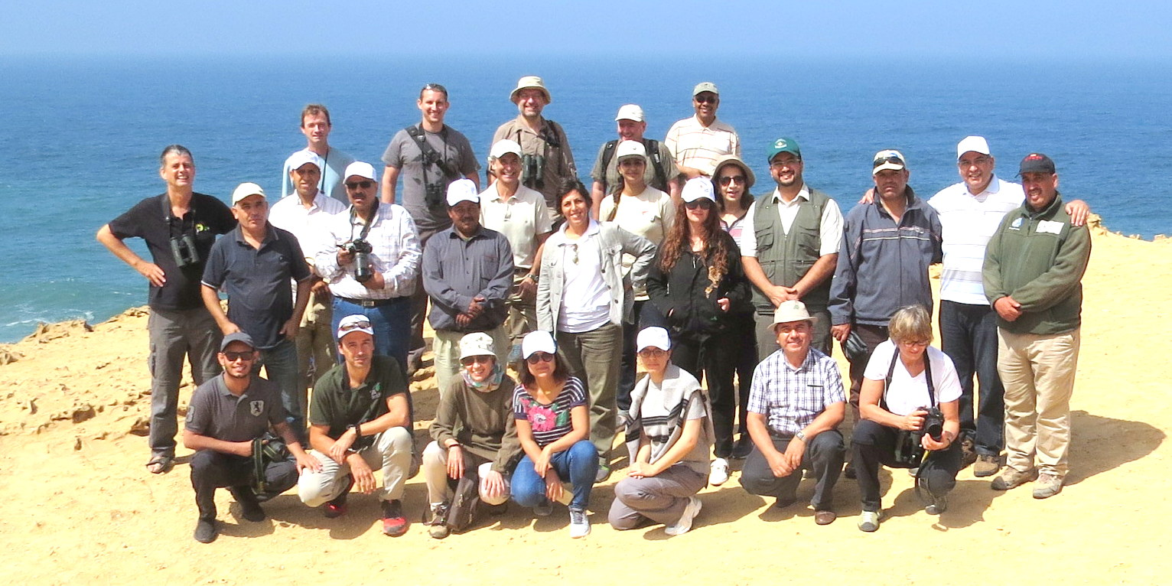

The 2nd Meeting of the AEWA Northern Bald Ibis International Working Group was hosted and
co-sponsored by the High Commission for Water and Forests and the Fight against Desertification (HCEFLCD) and organised by the Souss-Massa National Park.

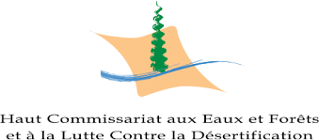
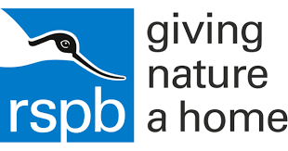
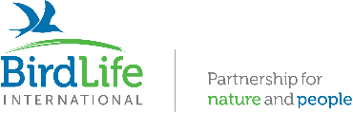
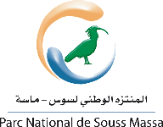

Table of Contents

- Overview and Acknowledgements 2
- Summary of Decisions and Action Points Agreed by the Meeting 2
- Notes on Plenary Discussions 4

APPENDIX 1 - Agenda 22
APPENDIX 2 - Revised Terms of Reference for the AEWA Northern Bald Ibis International Working 25
APPENDIX 3 - List of participants 27
APPENDIX 4 - Implementation Plan for 2017-2020 31
APPENDIX 5 - Photo record of meeting 61

      - Overview & Acknowledgements

Following the inauguration meeting of the International Working Group (IWG) for Northern Bald Ibis in Jazan, Saudi Arabia, November 2012, this was the second IWG meeting, which aimed to review the progress since then and plan out the implementation of the revised International Single Species Action Plan for the species that was adopted by AEWA MOP6 in November 2015.

This second IWG meeting elaborated three-year country-wise implementation plans with reference to the ISSAP, and these plans are presented in this report in Appendix 4 as key outputs. The progress on these will be reviewed at the next meeting in 2020.

The meeting was held in Agadir, Morocco, and was generously supported by the High Commission for Water and Forests and the Fight against Desertification of the Kingdom of Morocco with further travel costs covered by the Royal Society for the Protection of Birds, BirdLife International and several participating attendees. We are particularly grateful to Souss-Massa National Park (SMNP) and the Moroccan Government for making arrangements and their support on the ground.

      - Summary of Decisions and Action Points Agreed by the Meeting

Agenda item | Decision | Action/Remarks
Confirmation of observers and status of participants | Agreed the following:  National delegations are the majority of participants; includes GREPOM, BirdLife in Morocco - an NGO invited by the Government as part of the Moroccan delegation.  Coordination group: UNEP/AEWA Secretariat and BirdLife International. This includes the three BirdLife coordinators: Chris Bowden (overall; RSPB, BirdLife in UK), Jorge Orueta (Western Population; SEO, BirdLife in Spain) and Sharif Jbour (Eastern Population; BirdLife Secretariat Middle East Office, sent apologies - unable to attend).  Observers: Divided into permanent observer – International Advisory Group on Northern Bald Ibis (IAGNBI)/ Christiane Boehm; and one-off observers – Breeding Centre for Endangered Arabian Wildlife (BCEAW), Sharjah, UAE/Simon Matthews, Critical Ecosystem Partnership Fund (CEPF)/Awatef Abiadh.  Individual experts (one-off): Amina Fellous (Algeria); Miguel Quevedo (Jerez Zoo, Spain); Ali Aghnaj (Morocco)). | N/A
Chair of IWG | Morocco nominated and accepted as new chair, represented by Mohamed Endichi | Note the chair term is three years or until the next IWG meeting.
Revision of IWG Terms of Reference | Algeria added as range state. Other pertinent amendments made following the 2015 revised Species Action Plan. | Revised ToR included here (see Appendix 2)
National reporting: format, practices and timelines | Revised the agreed reporting period to be reduced from 6 years to 3 years (ideally).  This 3-year frequency to be backed up by convening IWG meeting every 3 years.  Reporting template will follow format and structure of Implementation Plan (although this was not the case for this meeting).  Deadline for report completion by Range States will be 3 months before the next meeting.  Sponsorship to attend future meetings will be limited to those who provide reports by the agreed deadlines. | Plan for next meeting and reporting review in 2020.  Template for future reporting will be modified to follow Implementation Plan format (template to be agreed in the course of 2018).  Reporting requests to be circulated well in advance, i.e. in 2019.
Next IWG meeting |  | Ethiopia offered to host in 2020 which will be confirmed by 2019 or alternative agreed.

      - Notes on Plenary Discussions

These notes clarify and supplement the decisions and actions (above) and the presentations which are not summarised here.

Day 1 - Monday 25 September 2017

3.1. Welcome and Introduction

Outgoing Chair Mohammed Shobrak of Saudi Arabia opened the meeting.

Thanks to hosts: High Commission for Water and Forests and the Fight against Desertification and Souss-Massa National Park.

Hand over to the meeting host, Morocco, represented by Mr. Mohamed Endichi, Director of the Fight against Desertification and the Protection of Nature, for welcome and vote of thanks.

Chair’s introduction:
- Stressed importance of coordination between Range States, following first meeting in Saudi Arabia and adoption of revised Species Action Plan at AEWA MOP.
- Crucial element is public awareness and relationship to local development and the needs of the local population, in relation to income generation through (e.g.) sustainable fishing, tourism, crafts. Discovery of the new colonies in Morocco is great news.
- Express our gratitude to all who have contributed to the work including these discoveries, especially sponsors for their contribution and interest, SMNP staff, national and international experts, local population and authorities.
- Introduced and opened the meeting, and stressed its importance, and wishes all participants a fruitful and pleasant stay in Agadir.

3.2. Adoption of the agenda

Chair handed over to Sergey Dereliev, UNEP/AEWA Secretariat, to speak:
- Welcome and thanks, and especially to the High Commission and SMNP, which testifies to the Moroccan Government’s determination and commitment to the conservation of the ibis.
- Introduced Chris Bowden (RSPB) as the IWG coordinator, who added his own personal thanks and welcome.
- One addition to the agenda: report of the Coordinator since the IWG first meeting in Jazan, Saudi Arabia, and introduction to the IWG for benefit of new members.
- No other suggestions or objections, amended agenda adopted.
- Each participant introduced him/herself briefly.

3.3. Confirmation of observers (see Table 1 on page 2).

3.4. Appointment of a new Chair Country for the Working Group
Outgoing chair:
- Mohammed Shobrak (Saudi Arabia) thanked all for their support in his time as chair and introduced and thanked Morocco for agreeing to be nominated for the role of the new Chair Country.
- Mohammed Shobrak (Saudi Arabia) commented on the increasing awareness of the ibis locally in Morocco, as shown by the airport staff at Agadir knowing the significance of the ibis: a welcome sign of increasing national awareness, but more seriously an important theme to expand on in the future.
- Proposed Morocco, represented by Mohamed Endichi, (Morocco) as new chair, approved by all.

Sergey Dereliev added his thanks to Mohammed Shobrak (Saudi Arabia) for his work as Chair since the meeting in Jazan.

Incoming Chair:
- Introduced himself.
- Thanked his predecessor, UNEP/AEWA Secretariat and coordinator and work done to maintain conservation efforts.
- Many would like to attend these meetings and the presence of many colleagues shows our commitment.
- Assured participants that all efforts will be made to ensure that conclusions are acted on, working with UNEP/AEWA Secretariat to do our part.

3.5. Presentation: The context of the IWG, and Coordinator’s report
(additional to tabled agenda)
Chris Bowden (RSPB)

Points in addition to or reinforcing presentation:
- Northern Bald Ibis has importance far beyond species conservation – a flagship for its range states, and for the inhabitants where it lives.
- Huge investment made by Governments in Turkey and Morocco, release programmes in Europe, and Bald Ibis present in zoos worldwide. Need to coordinate these independent programmes.
- Reviewed the IAGNBI meetings; much profile given to reintroductions and has tended to be driven by projects.
- First ever agreed Species Action Plan emerged from a meeting in Madrid adopted by AEWA in 2005. However, recognition that more Government involvement was needed.
- IWG was created in 2012 with its first meeting in Jazan, Saudi Arabia.
- Action Plan was reviewed in 2015, leading to development and adoption of a revised Action Plan. 69% of high priority actions have been implemented. (see the revised NBI ISSAP, among input papers for this meeting).
- IWG is now working on producing and releasing its own website.
- Chris Bowden (RSPB) has stepped down as chair of IAGNBI; role now shared between Christiane Boehm (Austria) and Cathy King (Spain) and IAGNBI contributes to IWG as an external expert group with special attention to reintroductions.
- IWG Coordination is there to service national delegations: open to all ideas and queries.

Further comments from Sergey Dereliev (UNEP/AEWA):
- Approach of International Species Working Groups is relevant to all Action Plans under AEWA, which has >20 SAPs. Common approach, single and multi-species (latter including one on goose management, with annual meetings talking about annual hunting quotas; recovery plans are not annual, more typically 3+ years).
- IAGNBI existed before IWG and continues to be appreciated and highly valued. Other Working Groups didn’t have such a predecessor, but IAGNBI continues in its more focused role on reintroductions, while IWG is more holistic and Government-led.
- Coordination was outsourced to BirdLife International as UNEP/AEWA Secretariat capacity is limited, with RSPB leading on behalf of BirdLife International and 2 regional co-coordinators: they and the UNEP/AEWA Secretariat are there to serve Governments (e.g. seeking funding and supporting national and regional processes).
- In principle, coordination could also be outsourced to Governments.

3.66. Working Group Terms of Reference – revision
Chair, UNEP/AEWA Secretariat

Sergey Dereliev (UNEP/AEWA): Revision to ToR follows updated action plan (originally ToR adopted at Jazan). Document NBIIWG 2.2 presents draft revised version. Changes as follows:
- Goals and purpose: as per new 2015 action plan with indicators assigned.
- New countries forming Working Group as Range States (which hold wild pops, or where recent extinctions have occurred with strong potential for reintroduction): add Algeria.

Q. Christiane Boehm (IAGNBI): Why was Spain not included, when birds are visiting Morocco from reintroduction project there?
A. Sergey Dereliev (UNEP/AEWA): In new Action Plan, status of reintroduction projects is not clarified and we they need be reviewed and a decision taken on their relevance and future association with the International Species Action Plan. Current AEWA Action Plan does not involve any reintroduction actions in Europe. List of countries (and thus IWG members) follows the Range States as per the Action Plan. Chris Bowden (RSPB): IAGNBI becomes focus for Austria and Spain and it is important that relations between IWG and IAGNBI are strong and good to keep the momentum. Country membership should be kept under review, especially Spain noting the close proximity of the released birds and clear potential for interaction of released birds with the wild population. Coordinator of IWG is a member and permanent observer of IAGNBI, and vice versa – for now, this is a technical separation, and work in progress.

Q. Mengistu Wondafrash (Ethiopia): What is the status of Eritrea and Yemen?
A. Sergey Dereliev (UNEP/AEWA): They are full members, unable to be present on this occasion (Syria also absent but presenting via Skype). With limited resources, priority is given to countries where action is planned and possible. Chair confirmed that they will be informed of any decisions taken here.

No other questions or comments (and none received by email); revised ToR therefore adopted.

3.7. National reporting: format, practices and timelines
Chair, Chris Bowden (RSPB), UNEP/AEWA Secretariat
There are two kinds of reporting:
- Standard 6-yearly review of all AEWA Species Action Plans was done in 2015 and the result was included in the meeting input documents.
- Specific reporting ahead of IWG meeting (more frequent, i.e. < 6 years, ideally 3 years).

The IWG reporting:
- In principle should use a template following format and structure of Implementation Plan, although this was not the case for this meeting. Such a template will be prepared for the next meeting.
- Deadline for completion by Range States will be 3 months before meeting, based on Implementation Plan (developed at this meeting): thus making it as detailed and focused as possible.
- Sponsorship to attend meetings limited to those who provide reports. For this meeting 5/7 countries reported, a good rate of return.

The Chair noted the need for standardised format to ensure relevant content, and Sergey Dereliev (UNEP/AEWA) confirmed that a proposed format would be developed to be agreed and adopted by correspondence next year.

3.8. NBI species status – general overview
Chris Bowden (RSPB)

Points in addition to or reinforcing presentation:
- Very early decline suggested by increasingly inaccurate hieroglyphics suggesting not based on live birds (3000 years ago).
- Cliffs often described as ‘inaccessible’ but in fact easily disturbed, and this is one the main threats.
- Mohammed Shobrak (Saudi Arabia) – regarding hunting in Saudi Arabia, noted that visible satellite transmitters can make them targets to inquisitive hunters, and this included the notorious hunted bird in Saudi which the hunter said was targeted because of the transmitter. Compare with stories that satellite tagged vultures crossing borders were a form of spying.
- Genetic. Christiane Boehm (Austria) reported the captive population has strong genetic variability, but that work is continuing; museum samples from Eastern birds being analysed. Study may need some support from IWG to obtain blood samples which are far easier to analyse for DNA than swabs and feathers.

3.9. Country reports (points in addition to or reinforcing presentations)

3.9.1 Saudi Arabia – Mohammed Shobrak (Saudi Arabia)
3 rangers able to follow up records along whole Red Sea coast.
Q. Mohammed Ribi (Morocco): are all actions done by State or under support of International NGOs?
A. SWA is Government organisation but also BirdLife Affiliate. Agents in charge report to Royal (Govt) Council expert, who responds (e.g. on protection of coastal areas) after taking technical advice as necessary. Implementing in field is challenging.

Q. Miguel Quevedo (Spain): can you identify blackspots for electrocution and collision, and mitigate?
A. Small-scale studies carried out; wires can be buried in sensitive spots. A key area for migratory species (including Bald Ibis when there was a population) has been identified on coast S of Jeddah. Electrocution and collision are becoming crucial issues for this and other species: much to be done.

3.9.2 Turkey – Taner Hatipoglu

- Actions were tabulated against 2005 action plan.
- Seeking a suitable site for second breeding centre, but site not yet identified.
- New building has been added at Birecik, but needs more staff/capacity.
- Remarkable increase in population: 242 after breeding in 2017; typically around 50 juveniles produced in recent years.
- Doga Dernegi (DD; BirdLife in Turkey) led on education and awareness work: schools, farmers, using direct communications, brochures, stickers etc.
- Semi wild pop began in 1977 with 26 but added and then mixed with wild birds. (7 additional tiny captive populations in Turkish zoos).

Q. Sergey Dereliev (UNEP/AEWA): again we have reports of mortality from collision and electrocution (compare with Saudi).
A. Windy conditions contributed to mass mortality through collisions in 2016. Birds fly past/over town to reach feeding area to S; in windy weather, some were blown into wires passing over the river. Wires hard to see. Make more visible? Private companies which now control electricity transmission hard to force to change practices. Some such mortality elsewhere, but only 2-3 birds per year and this is the blackspot.

Q. Ali Aghnaj (Morocco): when will a new semi-wild population be created?
A. Haven’t yet found a suitable site; problem is land availability. A suitable area with cliffs was submerged when a dam was built.

Q. Mohammed Ribi (Morocco): what is the main strategic objective for Turkey?
A. Establish a migratory population. But this is challenging right now because of the political situation. Currently better to strengthen semi-wild populations, to ensure they are sustainable so that future options are open.
Comment from Mohammed Ribi (Morocco): This cannot be done unless all E population range states remain coordinated: must have suitable conditions along flyway. (Agreed)

Q. Christiane Boehm (IAGNBI): what is the purpose of captive populations (i.e. in Turkish zoos)? There are currently too few birds in each (need 6-8, not 2) to be viable.
A. Mainly to learn how to keep ibis in captivity. Birecik husbandry is evidently successful and can be copied.

Q. Mohammed Shobrak (Saudi Arabia): in correspondence, Gianluca Serra has proposed the possibility of establishing a breeding population in Saudi Arabia or Iraq – could Saudi help with surveys towards this? And could there be any additional populations that we could search for?
A (Chris Bowden (RSPB)). We can ask for more information from G. Serra? This could lead to and guide a recommendation to survey for more possible breeding areas.

Q. Amina Fellous Djardini (Algeria): can we capitalise on recent work (workshop and guidelines) on reducing electrocution risks with IUCN, experience from Spain etc?
A (Jorge Orueta (Spain)): much info exists from Spain on this, to convince electricity companies to make electric lines safer, and prosecute negligent companies.
(More discussion to follow on this in work planning sessions: much guidance available through CMS including AEWA, also covering Sensitivity Mapping in relation to impacts of energy generation and transmission infrastructure)

3.9.3 Ethiopia – Mengistu Wondafrash

Q. Chris Bowden (RSPB): was the report and publication on wintering birds (habitat and foraging) refered to in the presentation something new or already done earlier?
A. Yes, this is report and resulting papers by Serra et al. from past 2 years. Also a joint report between Govt and EWNHS on policy aspects.

Q. Ali Aghnaj (Morocco): are ideas for habitat restoration based on mapping of habitat use of ibises? We would need to do a distribution study to target this.
A. just explaining habitat restoration in general terms (to wider native biodiversity), not specific to ibis for which we do not know enough about key habitat features.

Short discussion on wintering sites ensued:
- Mengistu Wondafrash (Ethiopia): we still wonder if there could be another wintering area; clearly there was another site, as when 13 birds were known to be migrating we could only account for 4 and so were missing 9 birds.
- Chris Bowden (RSPB): 4 adults were coming to one site; 1 to another site further S; we were not seeing juveniles or subadults in Ethiopia. Were they staying in Arabia? Although one made it to Djibouti and 2 untagged birds were in Ethiopia in 2013 and so these could not have come from a known population. In December 2015, we wanted to tag the last bird but were too late arriving to do so: bird had gone. Did juveniles need adults to show them the best wintering areas, or maybe just remained in Arabia? Unclear but a topic for discussion.
3.9.4 Morocco - Mohammed El Bekkay

Some major developments:
- 2017 breeding season summary: 122 pairs bred (another record), post-breeding total 589 birds. Some additional birds occur outside park e.g. N of Tamri and S of Souss-Massa, so the true total is certainly higher.
- New colonies discovered and published.
- Same wardens (in most cases) since 1995 have now been recruited and status formalised with Government funds.

Other updates:
- Cliff ‘cleaning’ to enhance colony space has not been done.
- A range of awareness-raising activities carried out with universities and colleges.
- Presentation stressed importance of local community involvement.

Q. Mengistu Wondafrash (Ethiopia): what are predators of adult bald ibis especially when nesting (in Ethiopia, they react strongly to raptors overflying)?
A. Predation is rare. Raptor predation is unusual, although ibis avoid sharing ledge with falcons. There can also be competition for sites with Great Cormorant. Ravens are occasional predators.

Q. Nafissa Mahieddine (Algeria): What was the cause of the downward spike in breeding pairs in 2012?
A. A very cold period led Tamri birds not to breed at all (Souss Massa in more sheltered and warmer spots did much better).

Q. Mohammed Shobrak (Saudi Arabia): what form of monitoring of foraging and breeding is carried out?
A. Standardised protocol of monitoring and reporting on ibis at breeding and feeding area.

Q. Jorge Orueta (Spain): breeding figure of 122 pairs refers to those with eggs; were there additional non-laying pairs?
A. Yes, 15 pairs (note this proportion is quite normal). Possibly lacking space to nest, or just inexperienced. Survey of dispersal activity is very important as we are not accounting for all birds after breeding e.g. there have been records in Middle Atlas and S as far as Cap Blanc, Mauritania; also 50 birds on garbage at Laayoune. Need to develop a strong monitoring/dispersal survey.

Q. Khadija Bourass (Morocco): any other development threats?
A. A power station was planned around 2008-2010 N of Agadir, but Parliament and other elected representatives decided against it because of impact on ibis-related tourism, and it was moved/proposed for a site 250 km to the North.

Also, since then, desalination plants are being planned: one in Souss-Massa (within north of Park, and very close to the major roost site for the species outside the breeding season), plus another proposal at Cap Rhir (Tamri area and frequented by the birds, but well away from main colony).
Comments on this. Mohamed Dakki (Morocco): was asked to provide advice regarding a desalination plant at Tamri, which he did – expressing serious concerns; Government also did the same regarding the power station, and that project has stopped. The desalination plant(s) may go ahead however. There has been an impact study, and National Commission evaluated; 20 ha project footprint, but plant covering only 1 ha for the plant, but would still require power lines and other infrastructure. Powerlines to be placed underground. Noted that no ibis has yet been reported killed by powerlines in SMNP.

Protection of Tamri colony: a new Protected Area has been proposed for many years but not yet achieved. Mohamed Dakki (Morocco) expressed caution over treatment of the latest new sites as ‘colonies’; they are tiny, isolated sites (c. 30km north of the main Tamri colony) and potentially vulnerable to disturbance (and questions were raised on the wisdom of publishing). Declaring as Ramsar sites could be the most efficient way to protect, since this has regularly used to stop damaging projects.

3.9.5 Algeria – Nafissa Mahieddine

Presentation mainly concerned suggested reintroduction project in NW Algeria close to Moroccan border at Tlemcen National Park.

Q. Christiane Boehm (IAGNBI): How was site selected?
A. Species did occur there, a bird breeding station is present, site is well protected (Tlemcen NP) and habitat considered suitable. But this is a long-term plan, and the Government is not rushing into it.

Q. Mohammed Shobrak (Saudi Arabia): Has there been any study on the causes of decline in Algeria?
A. None known, and now very difficult to do this as so much time has passed.

Q. Sergey Dereliev (UNEP/AEWA): starting a reintroduction programme is a major undertaking. It will be important to consider AEWA guidelines on translocation of migratory waterbirds, among others. Have you used any guidelines?
A. No but at present the idea is at a very early stage, a ‘reflection’ of possibilities.

Amina Fellous Djardini (Algeria) then showed photos of an alternative region further south, Parc Culturel de l’Atlas Saharien, which covers a strip of the southern fringe of the Atlas Mountains in Algeria extending E from the Moroccan border and covering 63,930 km². This is the site of the last colony in Algeria, in a landscape looking similar to that in Syria although greener. A highly important site, with cultural values (prehistoric rock engraving) as well as biodiversity ones.

3.9.6 Syria - Nabegh Ghazal Asswad (presentation via Skype)

Comment: Mohammed Shobrak (Saudi Arabia): congratulations to Syrian Society for Conservation of Wildlife for hard work in a very difficult situation (sentiment widely shared). The Eastern population is effectively restricted to the Turkish birds, so we must find another solution to reinforce it, although still some hope that we may find birds in Ethiopia to lead us to further discoveries, but otherwise reintroduction is the only option.

3.10. Northern Bald Ibis on the IUCN Red List
Roger Safford on behalf of the BirdLife International Red List team

The presentation discussed the potential downlisting of Northern Bald Ibis from Critically Endangered to Endangered on the IUCN Red List: criteria and implications.
- Background to the IUCN Red List and the Categories and Criteria.
- Applying the IUCN Red List Categories and Criteria to Northern Bald Ibis.
- Implications for conservation designations and legal status.
- Summary and next steps.

Questions and discussion – joined on skype by Ian Burfield (Global Science Coordinator) and James Westrip (Red List Research Assistant) of BirdLife International

3.10.1. How do the IUCN Red List (RL) criteria take into account the social structure of some species’ populations, like NBI, where the majority of the population congregates in one or a few places at certain times of year (breeding cliffs, post-breeding congregation), and is therefore at much higher risk of being affected by threats than more dispersed species?

The population unit for Red List assessments is mature individuals, rather than e.g. number of colonies or post-breeding flocks. However, the RL criteria do take account of such phenomena, under Criterion D, whereby species with a restricted area of occupancy (typically <20 km²) or number of locations (typically ≤5) with a plausible future threat that could rapidly drive the species to CR or EX can be listed as VU under D2. In this case, however, we’re proposing that the species qualifies at a higher level as EN under D1 anyway.

3.10.2. How do criteria factor in the degradation of habitat, even though the species is increasing now?
This was taken into account under Criterion B: deterioration in quality can be looked at in the present, but the species would not meet the other sub-conditions for listing as CR under Criterion B (even if Extent of Occurrence and Area of Occupancy did meet the relevant thresholds), as there are no extreme fluctuations, it is found at ≥ 2 locations, and it is not severely fragmented.
The question also raised the matter of future threats from this - can this be used to say there will be a future continuing decline?
A. This depends on the ‘data uncertainty’ fields that IUCN provide. For a future decline we can only either 'project' or 'suspect' it - the full definitions of these terms can be found in the IUCN guidelines; but for a species to be listed under criterion C2 based on a future decline, this would have to be 'projected', when the current situation is, in effect, a 'suspected' future continuing decline.
3.10.3. What about the risks to >500 birds concentrated in one site (Souss Massa NP) in winter?

See answer to 1 above

3.10.4. Could we assess the extinction risk/RL status of the eastern and western populations separately, to draw attention to their very different statuses?

BirdLife only assesses the status of the world’s 11,000 birds at species level (and the same is true for virtually every other taxon on the Red List too). However, regional Red List assessments are possible, following IUCN guidelines, and the regional status of the NBI has in fact been assessed in that way, for the ‘Arabian Red List’ (https://portals.iucn.org/library/node/46661), where it emerged as CR. This difference should be mentioned and the source cited in the species’ global factsheet when it is updated in 2018.

3.10.5. How can we consider downlisting the species when its historical range has contracted by >90%?

Although declines in range (either area of occupancy or extent of occurrence) are one of the ways in which population reductions may be inferred under Criterion A, they cannot override direct observation or indices of abundance, where these exist. In the case of NBI, the detailed population monitoring from Morocco clearly shows that the species’ population has increased in recent decades, rather than declined. Furthermore, the timescale relevant to these assessments of extinction risk is limited to 10 years or 3 generations, whichever is longer, which in the case of the NBI means 3 x 8 = c. 24 years.

3.10.6. What about the risk of sudden events and catastrophes? For example, under climate change, the increasing frequency of storms is more likely to cause a sudden collapse of one of the nesting cliffs; and the species did undergo a catastrophe just before the 24-year window mentioned above.
This is again partly covered by the answer to 1 above. The catastrophe mentioned above was a mass die-off of c. 40 birds (not all mature individuals) in 1996, when they died of an unknown cause (possibly a virus or some toxin – although all tests have been negative). This took place within the 3-generation limit (24 years). However, this would still not qualify the species for CR, because (a) over the 3-generation time period 1993-2017 the population has increased and so does not trigger criterion A; and (b) this event was a one-off Reduction rather than a Continuing Decline, and so it does not meet the conditions for criterion C. Nonetheless, this was a terrible occurrence and measures have hopefully been taken to avoid it happening again.
At the time of the presentation, it had been thought by those in Cambridge that the deaths took place earlier in the 1990s, thus more than 3 generations ago. However, with the correction to the date (1996), the above answer is correct and indicates that CR criteria are not triggered even though the event took place within the 3-generation timespan.
3.10.7. If a catastrophe did happen, would BirdLife/IUCN be able to immediately uplist the species to CR again, or would it have to wait e.g. 5 years first?

Yes, rapid uplisting is possible. The Red List guidelines are very clear on this. Whilst downlisting a species involves waiting 5 years, to ensure that the species’ status really has improved, there is no need to wait before uplisting it to a higher category if something dramatic happens. This should happen without delay, and the fact that BirdLife updates the global Red List for birds annually means that such emergency uplisting can happen swiftly. A caveat could also be added to the Red List rationale if/when we downlist this species to EN in 2018, acknowledging that any such catastrophe may lead to it being uplisted to CR in future.

3.11. Review of the day and plans for day 2 – Chris Bowden and Sergey Dereliev

The coordinator gave brief conclusions on the status of the NBI populations and the progress of implementation of the ISSAP. He thanked the delegations for their excellent updates, and drew attention to particular highlights:
- Saudi Arabia – impressive efforts continuing, considering the recent lack of known ibis sites and records: hunters’ workshops, powerline workshops, all necessary to create conditions for any future reintroduction.
- Turkey – excellent progress of semi-wild population, up from 48 to 242, more infrastructure and support. Looking ahead to prospects of establishing a second population, despite the current difficulty of releases.
- Ethiopia - despite limited options, best possible job done; keen to continue to look for other sites or check sites known to have held birds in the past.
- Morocco – the most tangible progress in the last year has been twofold: an increase in total population, and the recent discovery of new colonies. National Action Plan (‘PANIC’) continuing development and engagement. However, worrying continuation of threats e.g. desalination plant. Achieving improved protection status of Tamri is a big target. Increasing engagement of GREPOM is very positive. Some interesting records outside core range – we need to understand their significance (e.g. 50 birds at Laayoune).
- Algeria – good to hear of plans for reintroductions, to be discussed further in workshop sessions.
- Syria – great to hear from Nabegh Ghazal Asswad at SSCW: we salute the dedication of the Syrian ibis conservationists in such extremely difficult circumstances and the apparent possibility for future awareness work in the short term is heartening.
- Red List – valuable discussion, and unusual (and fortunate) to have such an opportunity to talk through the criteria with Red List assessors. There is still time to continue discussions via the Red List forum in 2018.

Sergey Dereliev (UNEP/AEWA) presented the plan for day 2 of the Meeting:
- Good opportunity to plan with so many stakeholders present.
- 3 break-out groups as follows:
- Morocco: facilitators Ali Aghnaj (Morocco) and Jorge Orueta (Spain).
- Algeria: facilitators Chris Bowden (RSPB) and Christiane Boehm (IAGNBI).
- E population: present Range States - Turkey, Saudi Arabia, Ethiopia: facilitators Roger Safford (BirdLife) and Sergey Dereliev (UNEP/AEWA), also Simon Matthews (United Arab Emirates) attending.
- Each to have rapporteur to feed back to plenary with highest priority activities.
- Each breakout group develops draft Implementation Plan for consultation in Range States before plan is finalised: we are not developing a final plan here.
- Responsibility: specify an individual wherever possible, rather than an institution.
- Timing (preferable expressed as a deadline): planning horizon for this exercise is three years, 2017-2020.
- Priority levels for actions– begin with existing levels as in the ISSAP, and modify as necessary.

The Chair thanked participants for such a productive day, with good agenda and high-quality presentations. Today was the update on status quo (mise à niveau), tomorrow we plan future activities.

Day 2 – 26th September 2017

Debriefing from break-out groups which worked independently throughout most of day 2

3.12. Morocco (group feedback presented by Jorge Orueta)

Responsibility for actions
Sergey Dereliev (UNEP/AEWA): in next draft, institutions are requested to assign individuals to take responsibility for each activity wherever possible.

Powerlines
Sergey Dereliev (UNEP/AEWA): recommends reconsidering low priority. Even if little or no mortality has been identified, mortality could be occurring, as it is hard to detect (note raptor mortality demonstrated in one short section of powerline in S Morocco recently); depends on intensity of monitoring. Bald Ibis is vulnerable to powerlines, as has been proven in other Range States (e.g. Turkey) and Spain.

Genetic work
Christiane Boehm (IAGNBI): Is this really low priority? More samples needed from E and W populations to confirm level of distinction. Mohammed El Bekkay - Have planned action to catch or tag birds; can take samples then. Needs fundraising.

Miguel Quevedo (Spain): Doñana Biological Station (Andalucia Govt) have much equipment and may be able to help with captures if needed, including training staff to capture and handle birds.

Seeking new or reoccupied colonies
Amina Fellous Djardini (Algeria) recommends maintaining research and surveillance of former colonies as high priority; may be reoccupied as population increases.

Chris Bowden (RSPB) – agrees that search of old colonies should continue, but should look in all suitable habitats, as expanding population might take to completely new sites.

Mohammed El Bekkay (Morocco) – the group discussed a regular tour of old sites, leading to a study of reasons for loss of old colonies. Discuss further in PANIC, with possibility of working with other partners such as universities.

Ali Aghnaj (Morocco): this would be a major, multi-disciplinary study.

Mohammed Ribi (Morocco): agrees, and suggests difficult to plan in next 3 years.

Chris Bowden (RSPB) – good to see high priority given to tagging juveniles, and training on correct and safe handling of the birds.

3.13. Algeria (group feedback presented by Chris Bowden (RSPB)

Noted that it would be useful to have a better understanding of Algerian Government structures and roles, perhaps via organograms.

Preparing for reintroduction
Mohammed Shobrak (Saudi Arabia): the proposed schedule seems very fast and time will be needed to consider all aspects of feasibility, including:
- diagnosing cause of decline;
- preparation and protection of the reintroduction site, and identifying resource needs;
- following IUCN (and AEWA) criteria and guidelines for reintroductions, in all stages (before, during and after start-up).

Chris Bowden (RSPB): food availability and pesticide risk need to be considered as part of site assessment.

Christiane Boehm (IAGNBI): it is very difficult to diagnose causes of decline of a long-extinct population. However, hunting likely to have been a problem, now banned but still occurs.

Amina Fellous Djardini (Algeria): bird is sacred in some areas and no major change in local activities is known; reasons for decline likely to be complex and related to migration. Main sites under consideration are protected (National Park, Cultural Park).

Need for Government commitment
Mohammed Ribi (Morocco): Need to think in terms of two stages: feasibility assessment and action. Feasibility studies do not often recommend doing nothing, but in this case need to be cautious. Strongly recommends to proponents of reintroduction in Algeria to ensure commitment from Government at a high level, not only scientists and conservationists, before starting: political support crucial to sustainability. The supporting arguments with the most traction may be in terms of strategic national interest, and international obligations of the Government of Algeria.

Nafissa Mahieddine (Algeria): Feasibility study and preparing captive population are happening at the same time. Algeria already has a national strategy identifying actions for the 23 most threatened species including Bald Ibis, so it is already a high-priority plan of which the authorities are aware.

Amina Fellous Djardini (Algeria): has been under consideration since 2000.

Mohammed Shobrak (Saudi Arabia): supports point made by Mohammed Ribi, that risks would be greatly reduced by Government support. Lesson from Syria: international organisations supported for several years, but when this funding stopped, the programme there stalled.

Amina Fellous Djardini (Algeria): agreed – need support of fauna and flora office and Prime Minister.

Nafissa: Mahieddine (Algeria): Barbary Deer (rare N African subspecies of Red Deer) reintroductions have taken place, providing national lessons for any Bald Ibis reintroduction although appreciate this is quite different.

3.14. Eastern population – Ethiopia, Turkey and KSA (group feedback presented by Sergey Dereliev (UNEP/AEWA))

Overall, a manageable number of activities mainly in Turkey, with Government leadership role able to ensure most of them.

Disease and veterinary support

Mohammed Shobrak (Saudi Arabia): can Spain provide veterinary support, especially regarding medication etc, to Turkey to reduce disease problems?

Miguel Quevedo (Spain): yes, ready to help. Birecik population must be monitored closely, especially with respect to Avian Influenza. If it is identified, quarantine and/or vaccination would be needed immediately, but note that the virus changes and vaccines must be the latest ones. Also should consider West Nile Virus and other emerging diseases.

Powerlines
Taner Hatipoglu (Turkey): interested in mitigation measures on powerlines used in Spain near aviaries.

Miguel Quevedo (Spain): such measures have been used with success and are easily placed; agreed to discuss further separately.

Establishment of a second colony
Amina Fellous Djardini (Algeira): are there no suitable areas for a second colony already protected?

Taner Hatipoglu (Turkey): There was one, but it is now flooded by a dam, and more searches are needed.
Chris Bowden (RSPB): Notes clear parallels between needs in Algeria and Turkey, which are both discussing establishment of new populations in sites where ibis are long extinct. Can we coordinate since timing and requirements seem to be similar? Both countries can use same support and advice via IWG coordinator and IAGNBI.

National plans
Mohammed Ribi (Morocco): do Turkey or Syria have national Action Plans (like the Moroccan ‘PANIC’)? Could a regional action plan for the E population be a good idea, especially because this is fundamentally a migratory population?

Taner Hatipoglu (Turkey): no national Action Plan, but has been discussed. However, it would only involve one Ministry (Forestry and Water Affairs), so might not add much value to the ISSAP as applied to Turkey.

3.15. Comments on cross-cutting actions

2.2.2 Reduced visibility of tags
This may not be crucial in E population in next 3 years because releases are unlikely in this period.

Roger Safford (BirdLife): satellite tag technology is making the tags ever smaller, so if needed, less visible tags are now available (Mohammed Shobrak (Saudi Arabia) added that smaller tags have proven useful for ducks). Advice available from San Diego and elsewhere including BirdLife (and RSPB, SEO) via IWG.

The point may be relevant to the Moroccan plan: again, seek advice through IWG.

Mengistu Wondafrash (Ethiopia): beware of any visible rings, tags etc; these may be seen as valuable and attract attention of hunters or poachers.

4.3.1 Managing juveniles after splitting from migrating flock.
Chris Bowden (RSPB): in developing methodology for releases, trials with experimental flocks could inform improved release process. Austrian project was going to trial.

Christiane Boehm (IAGNBI): sedentary colony of 40-50 birds; idea was to separate and take one group to another location but not yet carried out. Intention was simply to split an over-large sedentary flock into two, not particularly related to migration.

Mohammed Shobrak (Saudi Arabia): problem of young leaving adults (possibly not capable yet of doing full migration: Christiane Boehm (IAGNBI)); how can we use utilise Austrian experience, and start releases of young to join migrating adults. No longer possible for E population.
For IWG purposes, the topic was held over until such approaches are possible and needed.

4.4.1 PVA for both populations
Not possible for E population, but could be possible for W population.

Christiane Boehm (IAGNBI): would help us to determine how best to maintain genetic variability, which is needed for a healthy population using simulation models e.g. Vortex. However, population is increasing, suggesting a priori that this is not a major issue (genetic problems could prevent increases or cause decreases).

4.5.1 Study of use of stopover and migratory sites
Interest had been expressed in looking at Arabian stopover sites, which could be done retrospectively (Chris Bowden (RSPB)); this need not be a field activity. Mohammed Shobrak (Saudi Arabia): need precise UTM coordinates and remote analyse. But this is a fairly low priority, not currently holding back conservation measures.

4.7 Study of feeding microhabitat
Morocco thought this low priority; microhabitats and foraging needs in Turkey believed to be well enough understood.

Simon Matthews (United Arab Emirates): satellite tagging may allow this kind of analysis quite easily; field-based survey probably beyond scope of next 3 years.

Mohammed El Bekkay (Morocco): recall the plan to revisit old breeding sites, but not undertake this as a detailed study/research. This may become more relevant when more sites identified, after 2020. Could change the intention last word to ‘mapped’ rather than ‘understood’. Morocco group to follow up in PANIC.

3.16. Next steps to complete the implementation plan

- We now have an implementation plan, subject to elaboration: much momentum is evident!
- Each facilitator to tidy up notes on the actions, send (within 2 weeks: mid-October) to each group to check and consult nationally with feedback, then return to IWG Coordinator by end of December. Chris Bowden to consolidate after that and circulate (this action was completed and the final Implementation Plan is presented in this report in Appendix 4). Country delegations to report at next meeting in 2020 against this.

- Mohammed Shobrak (Saudi Arabia): always seek to maximise use of expertise including IAGNBI. Coordination of support through Chris Bowden (RSPB), Sharif Jbour (BirdLife), Jorge Orueta (Spain) as appropriate.

- AEWA aiming to launch website including intranet: an online workspace where all info is archived and requests can be placed for support or expertise offered.

3.17. Fundraising
Brief comments were provided by Roger Safford, BirdLife International.
Preventing Extinctions Programme (PEP)
PEP is BirdLife International’s Species Programme. As such, it is a Programme of Work, not a fund (as is, for example, the Critical Ecosystem Partnership Fund), and it does not have funds to allocate at will: all must be raised, for which capacity is limited. However, part of the work of the programme is to raise funds for BirdLife Partner NGOs’ priority projects, and this has included Northern Bald Ibis: much of the NGO contribution to the progress of the ISSAP has been and continues to be funded by contributions through PEP, in particular from the Prince Albert II of Monaco Foundation.

Fundraising opportunities
BirdLife can continue to attempt to fundraise through the PEP. The most appropriate fundraising targets for PEP or any other institutional funder (such as a trust, foundation, NGO or foreign Government agency) would be one-off costs, for example to diagnose or ‘unblock’ a problem, test a proposed management solution (with a view to replication if successful), obtain key scientific information to inform better conservation management, or (in some case) obtain equipment that will significantly increase effectiveness.

Fundraising constraints
A clear lesson is that funders will not continue to support ongoing running costs (recurring costs) of a programme as they consider it is not their long-term role to do so. Thus, the Prince Albert II of Monaco Foundation has funded three projects including, until recently, the salaries of the ibis wardens in Morocco, but they made clear that they will not fund a fourth project and expect the salaries to be paid through national sources. The decision of the Moroccan Government to cover the salaries of the wardens is particularly welcome and well-timed, not only as a commitment to ibis conservation and to those who have devoted themselves to this cause, but also demonstrating the appreciation of the funding situation.

3.18. Other business

Red Listing – expression of concern
Ali Aghnaj (Morocco) suggested that Range State delegations should agree next steps and formulate a view on the potential downlisting of Bald Ibis from Critically Endangered to Endangered. It was agreed as follows:
- To use public consultation between now and summer 2018 to communicate Range States view about the possible downlisting to BirdLife International. Some views have been shared at this meeting and will be set out in the meeting report (detailed notes were taken), but participants are encouraged to restate these in the online Red List forum.
- Delegations from Morocco, Algeria, Ethiopia, Turkey and Saudi Arabia (all Range States present) agreed on expressing concern over reduced national and international interest that could result from downlisting, potentially leading to negative impact on the conservation of Bald Ibis.
- Saudi Arabia also pointed out the concern that downlisting could lead to a reduced focus on the Eastern Population which clearly is on the very brink of extinction in the wild, if not already extinct; it will be important to recognise regional differences in status if this population can be saved.
- Chris Bowden (RSPB) is mandated on behalf of the IWG to express this to IUCN.

3.19. Next meeting – Sergey Dereliev (UNEP/AEWA)

In line with implementation planning, next meeting should be in 2020, and a suggestion was to hold it back-to-back with the Pan-African Ornithological Congress (PAOC), which Ethiopia has proposed to host. If the PAOC hosting is not confirmed, IWG and UNEP/AEWA Secretariat will seek other offers.

On behalf of the Chairman, the UNEP/UNEP/AEWA Secretariat and Ali Aghnaj, Sergey Dereliev (UNEP/AEWA) thanked the participants for their excellent efforts, contributions and commitments, with particular reference to the workshop facilitators, IWG coordinators and the Government of Morocco.

The meeting was then closed.

APPENDIX 1 - MEETING AGENDA

Dates: Monday the 25th of September until Wednesday the 27th of September 2017

Venue: Agadir, Morocco

Host: High Commission for Water and Forests and the Fight against Desertification (HCEFLCD)

Organiser: The Souss-Massa National Park

Chair: Saudi Arabia and a new chair country (to be elected)

Meeting Documents:

The following working documents will be made available to you for review in advance of the meeting (non-exclusive):

- Preliminary annotated agenda
- Draft revised Terms of Reference for the Working Group

The following information documents will be made available to you in due course (non-exclusive):

- Provisional list of participants
- Report of the 1st NBI IWG meeting

Main Objectives:

- Elect a new Chair country for the Working Group;
- Revise the Terms of Reference for the Working Group;
- Clarify Working Group’s reporting practices;
- Clarify Working Group’s operational budget matters;
- Receive reports from the Range States on the status of the species, the pressures and threats and the implementation of the Northern Bald Ibis International Single Species Action Plan (NBI ISSAP);
- Develop and agree on a work plan on the basis of the NBI ISSAP;
- Discuss funding opportunities for urgent conservation actions in line with the agreed work plan;
- Discuss the potential downlisting of NBI from Critically Endangered to Endangered on the IUCN Red List – criteria and implications.

Meeting languages: Meeting documents will be provided in English and the meeting language will also be English.

MONDAY THE 25th OF SEPTEMBER
Time | Item | Document | Remarks | [Lead]
08:00 | Arrival and registration | -- |  | Host
09:00 | Welcome and Introduction | -- |  | Chair,  Host
09:15 | Adoption of the agenda | NBI IWG 2.1 |  | Chair
09:20 | Introduction of attendees | -- | Tour du table | Chair
09:50 | Confirmation of observers | -- | Presentation, discussion and confirmation of observer organizations. | Chair
09:55 | Appointment of a new Chair Country for the Working Group | -- | Presentation, discussion and election of a chair | Chair
10:00 | Working Group Terms of Reference – revision | NBI IWG 2.2 | Presentation, discussion and adoption | Chair, AEWA
10:20 | National reporting | NBI IWG Inf. 2.4 | Clarify reporting format, practices and timelines | Chair, CB, AEWA
10:45 | NBI species status – general overview | -- | Presentation on the status of the species as background to country reports | CB
11:15 | Coffee Break
11:45 | Saudi Arabia – country report | -- | Presentation | [KSA]
12:10 | Turkey – country report | -- | Presentation | [TUR]
12:35 | Ethiopia – country report | -- | Presentation | [ETH]
13:00 | Lunch Break
14:00 | Morocco – country report | -- | Presentation | [MOR]
14:25 | Algeria – country report | -- | Presentation | [ALG]
14:50 | Syria – country report | -- | Presentation | [SYR]
15:00 | Potential downlisting of NBI from Critically Endangered to Endangered on the IUCN Red List – criteria and implications | _ | Presentation and discussion | RS
15:30 | Brief conclusion on the status of the NBI populations and the progress of implementation of the ISSAP | -- |  | Chair, CB
15:45 | Coffee Break
16:15 | Work Plan development – identification of priority activities, timeframes and responsibilities | NBI IWG Inf. 2.2 | Facilitated break-out group sessions | Facilitators
17:45 | End of day 1; summary and announcements
TUESDAY THE 26th OF SEPTEMBER
Time | Item | Document | Remarks | [Lead]
09:00 | Introduction to Day 2 | -- |  | Chair, CB
09:10 | Work Plan development – identification of priority activities, timeframes and responsibilities (cont.) | NBI IWG Inf. 2.2 | Facilitated break-out group sessions | Facilitators
11:00 | Coffee Break
11:30 | Work Plan development – identification of priority activities, timeframes and responsibilities (cont.) | NBI IWG Inf. 2.2 | Facilitated break-out group sessions | Facilitators
13:00 | Lunch Break
14:00 | Work Plan development – identification of priority activities, timeframes and responsibilities (cont.) | NBI IWG Inf. 2.2 | Facilitated break-out group sessions | Facilitators
16:00 | Coffee Break
16:30 | Feedback to plenary from break-out groups | -- | Reports and discussion; approval of the work plan | Rapporteurs
17:15 | Funding for implementing the work plan | -- | Discussion (CEPF, PEP, etc.) | CB, JO, SJ, RS
18:00 | Date and venue of the next meeting | -- | Discussion | Chair
18:15 | Summary and closure of the meeting | -- |  | Chair

WEDNESDAY THE 27nd OF SEPTEMBER
Time | Item | Document | Remarks | [Lead]
tbc | Field trip to NBI site(s) [exact location tbc]

APPENDIX 2
REVISED TERMS OF REFERENCE FOR THE AEWA NORTHERN BALD IBIS INTERNATIONAL WORKING GROUP (NBI IWG)

Goals (as defined in the International Single Species Action Plan for the Northern Bald Ibis)
- Restore the Northern Bald Ibis to a favourable conservation status (downlist the species from the globally threatened categories on the IUCN Red List and from Column A, Category 1 of the AEWA Table 1);
- Increase population size and breeding range in the wild by 2025 (establish two new colonies (of five or more pairs each) away from current breeding sites in Morocco or other former sites, and Moroccan population continuing to increase to 700 individuals).

Role
The role of the AEWA Northern Bald Ibis International Working Group will be to:
- coordinate and catalyse the implementation of the International Northern Bald Ibis Single Species Action Plan (SSAP);
- stimulate and support Range States in the implementation of the SSAP; and
- monitor and report on the implementation and the effectiveness of the SSAP.

Scope
The AEWA Northern Bald Ibis International Working Group will:
- set priorities for action and implement them;
- coordinate the overall international implementation;
- raise funds for implementation;
- assist Range States in producing national action plans;
- ensure regular and thorough monitoring of the species populations;
- stimulate and support scientific research in the species necessary for conservation;
- promote the protection of the network of critical sites for the species;
- facilitate internal and external communication and exchange of scientific, technical, legal and other required information, including with other specialists and interested parties;
- assist with information in determination of the red list status and population size and trends of the species;
- regularly monitor the effectiveness of implementation of the SSAP and take appropriate action according to the findings of this monitoring;
- regularly report on the implementation of the SSAP to the AEWA Meeting of the Parties through the National Focal Points; and
- update the international SSAP in 2025 or as required.

Membership
The AEWA Northern Bald Ibis International Working Group will comprise (1) designated representatives of national state authorities in charge of the implementation of AEWA and (2) representatives of national expert and conservation organisations as invited to the national delegations by the state authorities from all major Range States.

Countries forming the working group: Algeria, Eritrea, Ethiopia, Morocco, Saudi Arabia, Syria, Turkey, and Yemen.

The Chair of the AEWA Northern Bald Ibis International Working Group may invite and admit international expert and conservation organisations as well as individual experts as observers to the Working Group, as necessary. Observer organization confirmed by the Range States at the first meeting of the Working Group is the International Advisory Group on the Northern Bald Ibis (IAGNBI).

Officers
A Chair (country) of the AEWA Northern Bald Ibis International Working Group will be elected amongst its members.

A part-time Coordinator will be nominated by BirdLife International from within the BirdLife Partnership, with a medium term objective to establish this role at BirdLife International. The Coordinator will be in charge of the day-to-day operations of the Working Group and shall act in close cooperation with the Chair and the UNEP/AEWA Secretariat.

The designated representatives of national state authorities will act as National Focal Points for the SSAP and will be the main contact persons for the Chair and the Coordinator.

Meetings
The AEWA Northern Bald Ibis International Working Group should aim to hold face-to-face meetings once every three years. Other face-to-face meetings may be arranged as circumstances allow (e.g. back-to-back meetings with other international fora). Between meetings, business will be conducted electronically via Working Group’s website and list server.

Reporting
A thorough report on the implementation of the SSAP will be produced according to a standard format with contributions from all Range States and submitted for inclusion into the general International Review on the Stage of Preparation and Implementation of Single Species Action Plans to the AEWA Meeting of the Parties. Reports shall also be prepared by each Range State to a format agreed by the Working Group and presented at each face-to-face meeting of the Working Group. These National Reports shall be submitted to the Coordinator at the latest three months prior to the date of the next Meeting of the Working Group. Financial support for meeting attendance and for the implementation of the SSAP for eligible range states (according to AEWA MOP decisions) will be also determined by the timely submission of national reports. Other reports will be produced as required by the AEWA Technical Committee or the UNEP/AEWA Secretariat.

Financing
The operations of the AEWA Northern Bald Ibis International Working Group, including the coordinator post, as necessary, are to be financed primarily by its members and, if applicable, by its observers; the UNEP/AEWA Secretariat cannot commit regular financial support and may only provide such if possible. Funding for SSAP activities of the Working Group or its members is to be sought from various sources.

APPENDIX 3 – LIST OF PARTICIPANTS
NATIONAL DELEGATIONS
ALGERIA | MOROCCO
Ms Nafissa MAHIEDDINE (NGR)  Wildlife Protection Bureau  Directorate General of Forests  BP 232  Chemin Doudou Mokhtar  Ben Aknoun  Algiers  Algeria  Tel.: +213 779 59 36 11  E-Mail: nafissamahieddine@yahoo.fr | Mr Mohamed ENDICHI (NGR)  Director  Directorate of the Combat against Desertification and of Nature Protection  High Commission for Water and Forests and the Combat against Desertification (HCEFLCD)  3, Rue Haroun Arrachid, Agdal  Rabat  Morocco  Tel.: +212 537 673 932  Fax: +212 537 672 628  E-Mail: endichi@eauxetforets.gov.ma
ETHIOPIA
Mr Asgedom KAHSAY GEBRETENSAE (NGR)  Directorate Director  Ethiopian Wildlife Conservation Authority  P.O. Box 386  Mexico Square  Addis Ababa  Ethiopia  Tel.: +251 551 4389  E-mail: kahsaygt@hotmail.com | Mr Zouhair AMHAOUCH (NGR)  Head of Division of the Parks and Natural Reserves  High Commission for Water and Forests and the Combat against Desertification (HCEFLCD)  3, Rue Haroun Errachid, Agdal  Rabat  Morocco  Tel.: +212 661 047 483  E-mail: zouhairamhaouch@yahoo.fr
Mr Mengistu WONDAFRASH (NE)  Chief Executive Officer  Ethiopian Wildlife and Natural History Society  (EWNHS)  P.O. Box 13303  Addis Ababa  Ethiopia  Tel.: +251 116 632 774  E-mail: m.wondfrash@ewnhs.org.et | Ms Hayat MESBAH (NGR)  Head of Service of Conservation Wild Flora and Fauna  High Commission for Water and Forests and the Combat against Desertification (HCEFLCD)  3, Rue Haroun Errachid, Agdal  Rabat  Morocco  Tel.: 212 661 90 44 19  E-mail: mesbah_ef@yahoo.fr
Mr Mohamed NOAMAN (NGR)
Service of Conservation Wild Flora and Fauna
High Commission for Water and Forests and the Combat against Desertification (HCEFLCD)
3, Rue Haroun Errachid, Agdal
Rabat Morocco

Tel.: +212 673 587 629
E-mail: noaman_md@yahoo.fr

Mr Mohammed EL BEKKAY (Meeting  Coordinator)  Director  Parc National de Souss Massa  Agadir  Morocco  Tel.: +212 (0) 528 33 38 80 / +212 (0) 661 91 10 41  E-mail: el_bekkay@yahoo.fr | Ms Khadija BOURASS  Executive Director  GREPOM  Réssidence OUM HANI 3  Avenue Ouali Al Had Sidi Mohaed  Salé  Morocco  Tel.: +212 613 633 387  E-mail: Bourass_khadija@yahoo.fr
Ms Latifa SIKLI (NGR)  Veterinarian Service of Conservation Wild Flora and Fauna  High Commission for Water and Forests and the Combat against Desertification (HCEFLCD)  3, Rue Haroun Errachid, Agdal  Rabat Morocco  Tel.: +212 677 692 035  E-mail: laty.sk@gmail.com | Ms Widade OUBROU (NE)  Ecological Monitoring and Scientific Research Office  Head Office  Parc National de Souss Massa  Agadir  Morocco  Tel.: +212 528 333 880  E-mail: oubrouwidade@gmail.com
Mr Mohammed RIBI (NGR)  Chief of Staff of the High Commissioner  High Commission for Water and Forests and the Combat against Desertification (HCEFLCD)  3, Rue Haroun Errachid, Agdal  Rabat Morocco  Tel.: +212 661 962 821  E-mail: mohammed_ribi@yahoo.fr | Ms Afaf OCHFY  Ecotourism and Partnership, Eco-development Office  Parc National de Souss Massa  Agadir  Morocco  Tel.: +212 528 333 880  E-mail: afafochfy@gmail.com
 | SAUDI ARABIA
Mr Mohamed DAKKI  President  GREPOM  Institut Scientifique  Avenue Ibn Batouta  10090 Rabat Morocco  Tel.: +212 661 391 281  E-mail: dakkiisr@gmail.com | Mr Jaber HARESSI (NGR)  Saudi Wildlife Authority  P.O. Box 61681  Riyadh 11575  Saudi Arabia  Tel.: +966 1144 18700  E-mail: jaber12009@hotmail.com
Professor Mohamed SHOBRAK (NE)
Dean of Academic Research, Taif University
Bird Adviser, Saudi Wildlife Authority
Research and Monitoring, Biology Department Science College
P.O. Box 888
21974 Taif
Saudi Arabia

Tel.: +966 127 24 44 39
E-mail: shobrak@saudibirds.org

TURKEY

Mr Özcan YAMAN (NGR)  Ministry of Forestry and Water Affairs  General Directorate of Nature Conservation  Gazi Mahallesi  Alparslan Türkeş Cd. No:71  06560 Yenimahalle  Ankara  Turkey  E-Mail: ozcanyuksek@yahoo.com | Mr Taner HATIPOGLU (NE)  Ministry of Forestry and Water Affairs  General Directorate of Nature Conservation Gazi Mahallesi  Alparslan Türkeş Cd. No:71  06560 Yenimahalle  Ankara  Turkey  E-mail: thatipoglu@yahoo.com
OBSERVERS
Ms Christiane BOEHM  Co-chair Chair International Advisory Group  of the Northern Bald Ibis (IAGNBI)  Alpenzoo Innsbruck-Tirol  Weiherburggasse 37 a  6020 Innsbruck  Austria  E-mail: c.boehm@alpenzoo.at | Mr Simon James MATTHEWS  Operations Manager  Sharjah Environment and Protected Areas Authority  Wasit Wetland Center  Sharjah  United Arab Emirates  Tel.: +971 (0) 56 900 1414  E-mail: simon.matthews@bceaw.ae
Ms Awatef ABIADH
Program Officer North Arica /
Regional Implementation Team
Ligue pour la Protection des Oiseaux
Fonderies Royales CS 90263
17305 Rochefort CEDEX
France

Tél : +33 (0)5 46 83 60 82
E-mail: awatef.abiadh@lpo.fr

INVITED EXPERTS
Ms Amina FELLOUS DJARDINI  National Agency for Conservation of Nature  1605 ALgiers  Algeria  Tel.: +213 (0) 552 701 445  E-mail: fellousa2000@yahoo.fr | Mr Miguel A. QUEVEDO  Veterinarian  Zoobotánico Jerez  Cádiz  Spain  E-mail: maquevedo@colvet.es
Mr Ali AGHNAJ
Independent expert
App 2. Imm 220
Rue Rabat, Q. El Alaouiyine
Témara, 12000
Morocco

Tel.: +212 661 190 340
E-mail: aaghnaj@gmail.com
OTHER PARTICIPANTS

Mr Chris BOWDEN  Coordinator of the AEWA Northern Bald Ibis  International Working Group  c/o International Species Recovery  RSPB, The Lodge, Sandy  Beds SG19 2DL  United Kingdom  Tel.: +44 779 317 0662 / +91 990 177 4697  E-mail: chris.bowden@rspb.org.uk | Mr Sergey DERELIEV  UNEP/UNEP/AEWA Secretariat  UN Campus  Platz der Vereinten Nationen 1  531113 Bonn  Germany  Tel.: +49 228 815 2455  E-mail: sergey.dereliev@unep-aewa.org
Mr Roger SAFFORD  BirdLife International  The David Attenborough Building  Pembroke Street  Cambridge CB2 3QZ  United Kingdom  Tel.: +44 1223 747 576  E-mail: roger.safford@birdlife.org | Mr Jorge FERNÁNDEZ ORUETA  NBI IWG Regional Coordinator Western Population  SEO BirdLife,  Melquíades Biencinto, 34  28053, Madrid  Spain  Tel.: +34 914 340 910 / +34 664 543 940  E-mail: jorueta@seo.org

APPENDIX 4 – IMPLEMENTATION PLAN FOR 2017-2020

SSAP action | Means of implementation (activities) |  |  | Responsible for implementation (others to be involved) | Funding needs / source | Priority | Timeline / deadline |  | Comments
Result 1.1. Chick mortality on nest is minimised
1.1.1. Prevent human disturbance and incidental nest destruction by predators such as ravens through close monitoring  MOR, SYR, TUR | TUR – no activities needed  SYR – N/A  MOR - To maintain surveillance on breeding sites  Recruit wardens for the new colonies  Acquire monitoring material for additional wardens (motorbikes, binoculars, telescopes..etc.)  Raise awareness among local users at breeding |  |  | DREFLCD – SO  DREFLCD – SO  GREPOM  DREFLCD – SO  GREPOM | 120000.00  HCEFLCD  30000.00  HCEFLCD  50000,00  HCEFLCD / BirdLife / CEPF  10000.00  HCEFLCD - GREPOM | Essential  Essential  Essential  Essential | Ongoing  Durant all the planning period  2018-2019  Breeding season  2017  2018-2020  During the breeding season |  | This action mainly concerns disturbance that leads to predation. Not a major issue in Turkey.  Not needed because breeding station is secure. Not much problem with raptors. Occasional predation by martens when not deterred by dogs. 3-4 pairs outside nesting station on cliffs around town, not protected, but still low predation risk.  Actions may be required at short notice to react to new situations  [may require only low level monitoring but detailed initial monitoring needed to determine any requirements is priority]
1.1.2. Collect discarded/lost fishing lines and nets around colonies  MOR |  |  |  |  |  |  |  |  | MOR - Included in the daily task of the wardens  [note agreed this can be removed as separate activity for future documents]
1.1.3. Increase awareness amongst fishermen  MOR | MOR - Cf . 1.1.1.4
1.1.4. Provide (safe) nesting material around colonies  MOR, SYR | SYR – N/A |  |  |  |  |  |  |  | MOR - Not needed at the moment for Morocco population [keep listed for future consideration only]
1.1.5. Improve nesting ledges if Syrian population increases  SYR | SYR – N/A
Result 1.2. Food availability is increased
1.2.1. Maintain the reservoir in proximity of the colony SYR | SYR – N/A
1.2.2. Establish food availability monitoring and alarm system for cases of drought  MOR, SYR | SYR – N/A  MOR - Cf 4.7 |  |  |  |  |  |  |  | To be discussed at PANIC meeting for MOR.  [for potential trials of supplementary feeding, but kept here mainly just for future consideration]
Result 1.3. Improved access to water
1.3.1. Maintain supply of fresh water at waterholes close to colonies  MOR | MOR - To maintain fresh water supply by the colonies  To establish watering points at new sites |  |  | PNSM  DREFLCD-SO | ---  ---- | Medium  Medium | During all the planning period  Starting 2018 |  | Part of wardens routine  If the IBIS reuse these sites
1.3.2. Establish emergency water ponds for cases of drought  SYR | SYR – N/A
Result 1.4. Catastrophic impact of diseases prevented
1.4.1. Maintain regular monitoring and hygiene protocol  TUR | TUR  1. Establish a protocol for regular communication between the Ministry of Forest and Water Affairs and the Ministry of Agriculture to exchange alerts for any avian disease outbreaks in the area in domestic and wild birds.  2.To implement the protocol at local level in Birecik.  3.Introduce and enhanced hygiene protocol for staff in contact with the birds – uniforms and shoes to be used only in the station and washed there + disinfected; establish safe change area for staff.  4.Reduce opportunities for contact between NBI and wild birds at the feeding station by netting the feeding pots. |  |  | 1.MFWA (Taner Hatipoglu) + MA (person to be nominated)  2.MFWA (Taner Hatipoglu & Reshad tbc) + MA (to name person)  3.MFWA (Reshad tbc)  4.MFWA (Taner Hatipoglu) | 1.N/A  2.N/A  3.Costs covered by MFWA  4.Costs covered by MFWA | 1.High  2.High  3.High  4.High | 1.End 2017  2.Jan 2018 onwards  3.End June 2018  4.End 2017 |  | Disease is major risk to Turkish population, all being at one colony at high density. Particularly avian influenza.  Continue existing hygiene and monitoring protocols, e.g. high standards for food preparation. Following are considerations for additional measures.  Various measures to be considered when outbreaks suspected, e.g. put shading over cage, various levels of ‘lock-down’. Good experience in zoos and other captive breeding centres, with examples provided by WWT and Sharjah.  Reduce access for other birds (mainly migrant waterbirds rather than local landbirds) to ibis food which could bring AI. Hygiene for people in contact with birds in captivity –  two visits per day year round. May need measures to reduce risk of transmission through personnel: disinfectant, use mask and gloves when preparing food; boards across walkways where staff must change shoes. (Staff don’t currently have uniforms – introduce work-only clothes.)  Screening: samples taken annually for salmonella etc. and other disease monitoring, but this has limited value as deaths often sudden. More important is rapid reaction when find a sick bird (again, AI is the priority).  Risks from visitors low despite c.30,000 per year as they are kept >150m away from the birds. (maintain this!)  A quarantine or isolation area is being introduced for sick birds.
1.4.2. Create new semi-wild population away from Birecik  TUR | TUR  1.Identify suitable locations and undertake a feasibility study in order to choose the most appropriate one.  2.Decide on the objectives of the project and prepare detailed plan & resource need assessment  3.Apply for funding to the Ministry of Development |  |  | 1.MFWA (Reshad tbc & Taner Hatipoglu) + University of Ankara (to name person)  2.MFWA (Taner Hatipoglu, Reshad tbc, Regional Director in Sanliurfa)  3.MFWA (Director General & Deputy Minister) | 1.Cost covered by MFWA  2.Costs covered by MFWA  3.N/A | 1.High  2.High  3.High | 1.End 2018  2.End June 2019  3.July 2019 |  | Criteria for feasibility assessment discussed at IAGNABI 2016, but refer also to the AEWA Guidelines on Conservation Translocation. Consider requesting external expert support for the feasibility study; possible joint activity with Algeria (see action 3.7)  Results of the application expected Mar-Apr 2020
1.4.3. Establish disease emergency response system  MOR, TUR | TUR  1.Design a disease emergency response system for Avian Influenza.  2.Roll out and implement the response system.  MOR - Update protocol for health scanning of NBI populations  Establish partnerships for the implementation of the protocol  Implement protocol when necessary |  |  | 1.MFWA (Taner Hatipoglu & Rashed tbc) + MA (person to name)  2.MFWA (Taner Hatipoglu & Rashed tbc) + MA (person add name)  DREFLCD-SO  ONSSA  DREFLCD-SO  DREFLCD-SO | 1.N/A  2.N/A  ----  ----  5000.00 | 1.High  2.High  Medium  Medium  Medium | 1.End June 2018  2.July 2018 onwards  2018  2018  2019-2020 |  | Protocol exists for daily operation of the centre with hygiene and monitoring included – continue this. But no measures specifically about disease response. Therefore, disease outbreak protocols to be developed and rehearsed regularly. Response is dependent on where outbreak occurs (inside cages or outside cages and at what distance) eg. Covering roofs, quarantine, closing access to facilities, etc.. Check EAZA guidelines (?); Ministry of Agriculture also has guidelines. Use both.  Activities link to Action 1.4.1., activity 3
1.4.5. Enforce protocols for carcass and waste removal from domestic bird farms in case of outbreaks  MOR | MOR – Coordinate with competent services and local authorities when needed |  |  | DREFLCD-SO  ONSSA | ------ | As needed | 2017-2020
1.4.6. Apply stringent health control and screening of captive birds prior to conservation translocation  ALL | TUR – no activities envisaged  SYR – N/A  MOR - NA  ALG Check sanitary protocol required by Ministry of Agriculture, Rural Development and fisheries. |  |  | ALG - General Direction of Forests (DGF) |  |  | 2018 (prior to arrival!) |  | Translocation in Turkey unlikely by 2020  ALG - Administrative process to be followed.  Also check IAGNBI guidelines on sanitary protocol
Result 1.5. Reduced intra-specific competition for nesting sites
1.5.1. Enlarge and improve nesting ledges  MOR |  | MOR - To study technical feasibility of edges management in the colonies  To implement management interventions selected  To monitor the impact of the implemented management | DREFLCD-SO / GREPOM  SEO-BL / GREPOM /  DREFLCD-SO  DREFLCD-SO |  | ----  4000.00  ---- | High  High  High | 2018  2018  2018-2020
1.5.2. Test and establish artificial ledges  MOR |  |  |  |  |  |  |  | MOR - Not during the 3 year period  Explore the possibility of implementing this activity during the feasibility assessment activity 1.5.1.1
Result 1.6. Human disturbance is minimised
1.6.1. Maintain and improve wardening in the colonies  MOR, SYR | MOR - Cf 1.1.1.1, 1.1.1.2 & 1.1.1.4  SYR – N/A |  |  | SYR - SSCW |  |  |  |  | SYR: Wardening for monitoring possible NBI might be possible if carefully planned at the moment. Don’t rule out.
1.6.2. Increase awareness amongst local people and visitors  MOR, SYR | MOR - Design and implement an awareness plan in Tamri region  To keep the awareness system towards local population and visitors in the colonies at PNSM  SYR – N/A |  |  | DREFLCD-SO / GREPOM  PNSM / GREPOM | 20000.00  3000.00 | Medium  Medium | 2018-2020  During all planning period |  | Opérationnaliser les propositions du PAG du SIBE de Tamri
1.6.3. Provide alternative water sources for pastoralists  SYR | SYR – N/A
1.6.4. Manage access by pastoralists to existing water sources  SYR | SYR – N/A
1.6.5. Designate all colonies as protected  MOR, SYR, TUR | SYR – N/A  TUR – no activities needed  MOR - To launch the process to create a formally protected area in Tamri |  |  | DREFLCD-SO  HCEFLCD | ---- | Essential | 2019-2020 |  | Current Birecik colony is protected and well safeguarded from human disturbance, and any new colony would be likewise, as a precondition to its establishment. Continue this. No additional measures needed.  Conditioned by the promulgation of implementing decree on the new law on Protected areas (but need to advance)
1.6.6. Develop and implement management plans for the protected areas  MOR, SYR, TUR | SYR – N/A  TUR - Carry on with the implementation of the management plan for Birecik  MOR - To update SMNP management plan  To implement the management at Tamri SIBE |  |  | Min FWA (Regional Director & Regional Engineer)  DREFLCD-SO  HCEFLCD  DREFLCD-SO  HCEFLCD | Costs covered by MFWA  100000.00  300000.00 | Essential  Essential  Essential | Ongoing  2019-2020  2019-2020 |  | Conditioned by the promulgation of implementing decree on the new law on Protected areas
Result 1.7. Predation is minimised
1.7.1. Monitor predation levels  MOR, SYR | SYR – N/A |  |  |  |  | MOR - Low
1.7.2. Undertake predation control measures when necessary  MOR, SYR | SYR – N/A |  |  |  |  | MOR - Low
Result 1.8. Problematic buildings on cliffs are removed and new ones prevented
1.8.1. Strengthen enforcement of legislation, also through the involvement of other authorities than NP  MOR | MOR - Monitoring and control of constructions |  |  | DREFLCD-SO | Operating costs | Medium | During all planning period
Result 1.9. Impact of collapse of breeding cliffs is minimised
1.9.1. Evaluate possibility of improving current roosting sites as potential new breeding sites  MOR |  |  |  |  |  |  |  |  | MOR - Not relevant during the 3 year planning period
Result 2.1. Impact of locust treatment is prevented
2.1.1. Continue work with locust control unit to avoid toxic treatment within Souss Massa NP  MOR | MOR - Maintain the coordination and collaboration with the authorities responsible of anti-locust fight |  |  | DREFLCD-SO | ------ | Medium | During all planning period
Result 2.2. Illegal killing and trapping is minimised
2.2.1. Raise awareness among hunter/falconers on satellite tagging and NBI conservation  KSA | 1.Run at least one event, such as a workshop, a year focused on the areas (1) between Jeddah and Jizan and (2) north KSA. |  |  | 1.SWA (to name person) | 1.Costs to be covered by SWA | 1.High | 1.Once a year from 2018 to 2020 |  | Two workshops with falconers in other parts of the country took place in 2017.  Falconry clubs established to bring the practice under an umbrella with rules and licensing; build on/expand this.  Hunters more difficult, as no opportunity for an umbrella body. Age average 18-25 years, many university students. Main options seem to be enforcement and publicising prosecutions and bans i.e. extensive public awareness programmes using both traditional and social media; both approaches merit expansion. National reputation affected by illegal hunting is a serious concern,  Efforts to control hunting also assisted by protection of coastal areas (20km inland). Warden camps to deter hunting to be developed further – but this is enforcement and broadbrush – being site-specific, may not currently benefit NBI in absence of known sites.
2.2.2. Reduce visibility of satellite tags by finding alternative means of attachment  ALL | E POP – N/A  1.MOR, funding permitting, to use in their satellite tagging newer, smaller and less-visible tags. |  |  | 1.High Commission (seek advice through the NBI IWG and IAGNBI networks) | 1.To be estimated (depends on the brand/technology and number of tags used) | 1.High  MOR - Low | 1.As necessary |  | May not be of significance in E POP in next 3 years as releases are unlikely in this period.  May be relevant to MOR where catching and tagging is planned. Warning was expressed also regarding colour rings that may attract the attention of hunters.  Note that advances in technology may soon make small transmitters more viable (and affordable) to help resolve this. Needs clarification here by expert input.[check above and replicate for other regions]
2.2.3. Raise awareness among hunters/trappers and/or general public on NBI in key areas, where needed  ALL | SYR – N/A  TUR – N/A  KSA – No activities envisaged  ETH – N/A  ALG – 1. Exhibition of NBI at animal parks (see 3.7.1)  2. Hunters questionnaires & sensitisation (after initial site selection)  3. Organization of awareness workshops  4. Use of social media to raise awareness and promote vigilance for NBI |  |  | ALG - DGF, Animal parks  2. DGF, NGOs, National Federation of Hunters Assocs  3. DGF  4.Bird Observers FB pages ‘To save wildlife in Algeria’ | ALG- Ministry of Agriculture, Rural Development and fisheries | ALG - High  MOR - Low | ALG - 2018  2019,20  Ongoing |  | Currently no key areas known in KSA  Great efforts are made in terms of awareness, not specifically for the bald ibis but for all wild animals including birds
Result 2.3. Risk of electrocution and collision with power lines is minimised
2.3.1. Identify critical and dangerous power lines around known key sites  ALL | SYR – N/A  TUR – No activities needed  KSA – No activities envisaged  YEM – N/A  ETH – No activities needed  ALG - (After initial site selection) |  |  |  |  | MOR - Low | 2019 |  | Dangerous powerlines already identified in Birecik area therefore this action is not required in Turkey.  No key sites known currently in KSA.  ETH generally considered safe regarding power lines (no dangerous power lines in the known site).
2.3.2. Retrofit design or put dangerous sections of power lines underground  ALL | SYR – N/A  KSA – N/A  YEM – N/A  ETH – N/A  TUR  1.Provide advice and examples technical solutions to MFWA  2.Approach the utility company at Birecik with proposal for solutions to securing pylons and wires  3.In case of negative response, approach the Ministry of Energy  ALG - (After initial site selection) |  |  | 1.UNEP/AEWA Secretariat (Sergey Dereliev) + Energy Task Force members  2.MFWA (Deputy Director General)  3.MFWA (Deputy Director General) | 1.N/A  2.N/A  3.N/A | 1.Essential  2.Essential  3.Essential  MOR - Low | 1.End 2017  2.End June 2018  3.Within 3 months after negative response  2019 |  | In Birecik additional collision risk at night or sandstorms. Need to increase visibility – range of options exist in various countries, e.g. plastic streamers or balls etc; mitigation measures need to be suited to species, problem and location.  CMS/AEWA guidelines on avoiding/mitigating power line impact on birds to be used.  In KSA no key sites – general improvement of the grid (in line with wider obligations not specific to NBI) but beyond scope of a single species plan.
2.3.3. Take NBI into account in SEA/EIA procedures for new power lines (possible re-routing) around key areas  ALL | SYR – N/A  TUR – No activities envisaged  KSA – N/A  YEM – N/A  ETH – N/A  ALG - (After initial site selection)  MOR - Take NBI into account in SEA/EIA procedures for new power lines (possible re-routing) around key areas  [Ensure this factor considered in all developments in Agadir and Tamri regions] |  |  | HCEFLCD  DREFLCD-SO | ---- | Medium | 2019  During all Planning period |  | Nothing new needed in the next 3 years in TUR.  MOR – this point will be considered in more detail at PANIC.
2.3.4. Introduce bird safe standards into national regulations  ALL | SYR – N/A  TUR – No activities envisaged  KSA – N/A  YEM – N/A  ETH – N/A  ALG - Approach Electricity Society regarding safe design of pylons  MOR- Take NBI into account in SEA/EIA procedures for new power lines (possible re-routing) around key areas |  |  | DGF letter to Minister of Energy  HCEFLCD  DREFLCD-SO | Minister of Energy  ---- | Medium  Medium | 2017  2018 & During all Planning period |  | Much bigger subject than NBI - beyond scope of a SSAP although should be highlighted where possible with reference to this SSAP.  This is not a priority, as there are very few cases of electrocution reported in ALG  MOR – this point will be considered in more detail at PANIC.
Result 2.4. Establishment of windfarms close to key sites is avoided
2.4.1. Exclude NBI key areas from renewable energy development  ALL | SYR – N/A  KSA – N/A  YEM – N/A  ETH – N/A  TUR  1.Routinely monitor for potential renewable energy projects that might be planned for the NBI protected area.  ALG - (After initial site selection)  MOR – N/A |  |  | 1.MFWA (Taner Hatipoglu) | 1.N/A | 1.Ongoing | 1.High |  | No projects known in the ETH site.  No detail or key areas in KSA.  In TUR solar farms are planned but should be kept out of the protected area used by the NBI under existing rules. Need to monitor in case of change to rules or priorities: routine/ongoing work.
2.4.2. Take NBI into account in SEA/EIA procedures for windfarms (possible re-location) around key areas  ALL | SYR – N/A  KSA – N/A  YEM – N/A  ETH – N/A  TUR  1.Routinely monitor for potential wind farm projects in the vicinity of Birecik.  ALG - (After initial site selection)  MOR – N/A |  |  | 1.MFWA (Taner Hatipoglu) | 1.N/A | 1.Ongoing | 1.High |  | Currently no windfarm projects are known for the Birecik area.
Result 2.5. Survival chance of dispersing juveniles is increased
2.5.1. Identify feeding and roosting sites outside Souss-Massa/Tamri and assess their status  MOR | MOR - Continue with survey to identify sites  Training Moroccan experts on capture, and tagging NBI  Tagging with GPS transmitter  To gather information from fishermen and other resource-people |  |  | HCEFLCD  DREFLCD-SO  GREPOM  HCEFLCD  DREFLCD-SO  GREPOM  HCEFLCD  DREFLCD-SO  GREPOM  DREFLCD-SO  GREPOM | 5000.00  10000.00  40000.00  ----- | Essential  Essential  Essential  Essential | 2017-2020  2018  2018-2020  2017-2020
2.5.2. Put conservation measures in place as necessary  MOR | MOR - To define actions tailored to each site  To implement the defined actions |  |  | HCEFLCD  DREFLCD-SO  GREPOM  HCEFLCD  DREFLCD-SO  GREPOM | ----  To be defined accordingly | Medium  Medium | 2017-2020  2017-2020
Result 2.6. Decline in area of feeding habitat is minimised
2.6.1. Monitor and control sand extraction activities; enforce existing legislation  TUR | TUR - No activities needed |  |  |  |  |  |  |  | Sand extraction is forbidden in the protected area, which extend along river from Syrian border to N of Birecik. Nothing additional needed at this stage.
2.6.2. Promote NBI-friendly crop pattern, e.g. by subsidising  MOR, TUR | TUR – No activities needed |  |  |  |  | MOR - Low |  |  | NBI feed along the valley, often in agricultural land – especially aubergine & parsley fields, pistachio groves. No problem so subsidising for other crops not necessary; also, no change in crops foreseen.
2.6.3. Promotion of low-input crops  MOR, TUR | TUR – No activities envisaged |  |  |  |  | MOR - Low |  |  | Some pesticide use, but farmer relations are good and they inform NBI team of planned use; in general not seen as a big issue.
2.6.4. Promote eco-friendly source of income  MOR, TUR | TUR – No activities envisaged  MOR - Identification of new projects to implement with local population  Implementation of the projects identified |  |  | DREFLCD-SO  GREPOM  DREFLCD-SO  GREPOM | -----  200000,00 | Medium  Medium | 2017  2017-2020
2.6.5. Promote NBI-based tourism for direct benefit to local community  MOR, TUR | TUR – No activities envisaged  MOR - To develop a tourism product on NBI  To organise and promote marketing around that tourism product |  |  | DREFLCD-SO  DREFLCD-SO  Communal organisations Tourism sector partners | 5000,00  ----- | High  Medium | 2018  2018-2020 |  | Limited scope for extension of this in Turkey but could expand exhibits in new visitor centre. Nearly all visitors to Birecik breeding centre visit very briefly, and their visits bring limited benefit to local community (only a small shop).
Result 2.7. Habitat loss/degradation due to infrastructure/ urban development is minimised
2.7.1. NBI areas taken into account in physical planning and SEA/EIA procedures  ALL | TUR – Not activities needed  ETH – No activities envisaged  MOR - Take NBI into account in all major physical planning / development and in SEA/EIA procedures for key areas for Bald Ibis |  |  | HCEFLCD  DREFLCD-SO | ---- | Essential | During all Planning period |  | No major development pressures in Birecik site (TUR) which is protected and has management plan.  Minimal development in the ETH site.
Result 2.8. Desertification of habitat in key areas is prevented or mitigated
2.8.1. Regulate agriculture activities in key areas  KSA | KSA - N/A |  |  |  |  |  |  |  | Currently no known sites in KSA.
2.8.2. Regulate grazing in key areas (through promotion of sustainable practices with local communities)  ETH, MOR, SYR, YEM | SYR – N/A  YEM – N/A  ETH – No activities needed |  |  |  |  | MOR - Low |  |  | No pressure or change in threat from grazing (not much grazing at all) or other factors at the ETH known site. Ibises don’t need long grass or bushland, and they use highly modified habitats. Traditional land management systems are compatible with ibis survival.  No evidence of negative impact of grazing on Bald Ibis Population in Morocco
2.8.3. Support provision of alternative sources of energy (gas, solar, etc.) and improve energy use efficiency  SYR, MOR | SYR – N/A |  |  |  |  | MOR - Low
2.8.4. Enforce environmental regulations on charcoal production  YEM | YEM - N/A
2.8.5. Identify degraded habitats in key areas and restore them  ALL | TUR – No activities needed  KSA – No activities envisaged  ETH – No activities needed |  |  |  |  | MOR - Low |  |  | TUR No habitat limitation at present around Birecik, and core Protected Area (179 ha) is safe from degrading factors. Birecik PA is part of a larger preservation area, extending along the Euphrates (thus mainly wetland, and known to be important for birds) 30 km towards Syrian border, which has management plan to prevent degradation.  KSA No key areas known at present.  ETH Quality of habitat is fine for ibises; long-established land use system, apparently sustainable.
Result 3.1. Eastern population increased 5-fold
3.1.1. Develop project for further reinforcement of the Syrian popn. and implement it  SYR, TUR | SYR – N/A  TUR – N/A |  |  | SYR - SSCW |  |  |  |  | No extant population is confirmed in SYR.  SYR. Monitoring and observing opportunities for birds might still be carefully planned despite difficulties. Don’t rule out
Result 3.2. Semi-wild population in Birecik is maintained at a minimum of 150 birds
3.2.1. Continue the conservation programme in Birecik  TUR | TUR - Ongoing. |  |  |  |  |  |  |  | Continue, but consider implications of population increase, which puts this site at/beyond carrying capacity: now >250 birds, probably as many as can be sustained.  Planning to pass any future ‘excess’ beyond 250 birds to Turkish zoos (two already received, a third planned) or new site.  Sharjah has an interest in keeping a captive flock, which would spread the risk, so surplus birds could be possibly exported to UAE. Turkish delegation suggested to visit Sharjah.
Result 3.3. A wild migratory population is established in Birecik
3.3.1. Further releases from Birecik  TUR | TUR - No activities envisaged in period |  |  |  |  |  |  |  | Not likely in the next three years.
Result 3.4. Semi-wild population established at a second site in Turkey (ideally in area compatible with 3.5)
3.4.1. Identify potential areas and undertake feasibility studies and risk assessments  TUR | TUR - Covered by activity 1.4.2
Result 3.5. A wild population is established away from Birecik
3.5.1. Identify potential areas for reintroduction and undertake feasibility studies and risk assessments  TUR | TUR - No activities envisaged. (see comment) |  |  |  |  |  |  |  | No implementation expected in the next three years.  Studies only should begin and ToRs developed.
3.5.2. Implement reintroduction upon positive conclusions from feasibility studies and risk assessments  TUR | TUR - No activities envisaged. |  |  |  |  |  |  |  | No implementation expected in the next three years.
Result 3.6. Sites away from Souss-Massa/Tamri are re-colonised/colonised
3.6.1. Monitor and assess potential/feasibility of roosting/former colony sites which are visited by birds  MOR |  |  |  |  |  | MOR - Low
3.6.2. Improve conditions in the most favourably assessed sites to attract breeders  MOR |  |  |  |  |  | MOR - Low
Result 3.7. A population is re-established in Algeria
3.7.1. Identify potential areas for reintroduction, including possible wintering areas and undertake feasibility studies and risk assessments  ALG | ALG –  Summarise bibliography  Define 2-3 potential areas/sites for feasibility studies  Prepare questionnaires for local population  Site prospection  As part of site selection process, assess:  1) food availability (each of 4 seasons),  2) pesticide (locust control) risk |  |  | Forest administration (DGF) & Agence Nature Conservation (ANN)  [With inputs from Cultural Park of Atlas Sahara (Culture Ministry)  University (all Algeria)  MEE (Ministry Env)  RNOOA (NGO of observers)  University (AlBayadh, Tiaret,Laghouat...)  National Plant Protection Institute (INPV) | Applying to:  Ministry of Agriculture  Ministry of Culture  Ministry of Environment (MEE)  Ministry of Education and Scientific Research  (MERS) | High | 2017  2017-18  2018 |  | Write to AEWA informing intention of reintroduction  Consult AEWA reintroduction guidelines & IAGNBI release guidelines (2016 update in report).
3.7.2. Implement reintroduction upon positive conclusions of the feasibility studies and risk assessments  ALG | ALG Visit to Proyecto Eremita/Jerez Zoo for demonstration and training of keeper , manager(s), vet.  Agree exhibit and project aviary design based on:  Spanish visit, EEP best practice manual & behavioural guide.  Aviary construction of exhibition aviary at animal parks and at hunting centres  Developing and submitting proposal for larger project  Transfer of selected birds to zoo  Familiarising with husbandry techniques |  |  | Forest administration (DGF)  DGF  Ministry of Agriculture  Ministry of Culture  DGF/Hunting Centers/animal parks  DGF  DGF  DGF | (?)  DGF/Ministry of Agriculture  DGF/Ministry of Agriculture  International eg IUCN, UNDP?  EEP Zoos  EEP Zoos | High  High  High  High  High  High | April 2018  2018  2018  2018  Sep 2018  2018,19,20 |  | First contact through formal letter to Andalusia Govt. & NBI EEP & Jerez Zoo. (2017-Jan-2018)  Hunting centre: centre specialized in animal breeding  after the construction of the aviaries and training
Result 4.1. Use of dispersal sites and suitability for colonisation as breeding sites is identified
4.1.1. Assess suitability of nesting and feeding areas
MOR
Result 4.2. Potential for re-colonisation of former breeding sites is identified
4.2.1. Assess suitability of nesting and feeding areas  MOR | MOR - Assess suitability of new discovered nesting and their surround feeding areas |  |  | HCEFLCD  DREFLCD-SO  GREPOM | 2000.00 | Medium | 2018-2020
Result 4.3. A method of managing juveniles after split up from migrating flock is developed
4.3.1. Undertake trial with experimental flock  ALL | TUR - No activities envisaged. |  |  |  |  | MOR - Low |  |  | Method to be developed by projects handling captive or experimental flocks. The topic is held over until such approaches are possible and needed.  IAGNBI to lead any approach
Result 4.4. Population viability assessment for both Western and Eastern populations is available
4.4.1. Run and publish population viability assessment  ALL | TUR - No activities envisaged. |  |  |  |  | MOR - Medium |  |  | No extant E POP at present.  For the W POP was not considered a priority as it is increasing.
Result 4.5. Use of stop-over and wintering sites by birds is determined
4.5.1. Undertake field surveys  ALL | E POP – N/A |  |  |  |  | MOR - Low |  |  | E POP – No extant population is known at present.  MOR – more info on wintering sites could lead to finding new sites? Good to compile information at least or consider more effort. PANIC topic..
Result 4.6. Actual sites identified through satellite tracking have been verified on the grounds, delineated and mapped
4.6.1. Undertake field work and mapping  (TUR) | E POP – N/A |  |  |  |  |  |  |  | E POP – No extant population is known at present and no releases are planned in the next three years.
Result 4.7. Feeding micro-habitat selection in breeding, stop-over and wintering areas understood
4.7.1. Undertake studies  ALL | TUR - No activities envisaged. |  |  |  |  | MOR - Low |  |  | Believed to be well enough understood in TUR.  This may become more relevant for MOR when more sites identified, after 2020.  More feasible if change the intention: last word to change to ‘mapped’ rather than ‘understood’.  MOR to follow up in PANIC.
Result 4.8. Genetic make-up and levels of inbreeding/outbreeding have been determined in Syrian and Turkish populations
4.8.1. Collect samples at any possible occasion  ALL E Pop RSs | TUR – No activities envisaged.  ALL other RSs – N/A |  |  |  |  |  |  |  | Difficult to get permits for export of samples, but scope to work with existing collected material. Used to collect blood for sexing, but now use feathers with local University (Harran). DNA less easily extracted than from blood samples, but good enough. Have 200 samples in Middle East Technical University (METU) – seek ways to have these analysed.
4.8.2. Undertake genetic analysis and publish results  ALL E Pop RSs | E POP - 1.Facilitate a link between Univ of Ankara / Middle East Tech University and a western research group specialising in NBI genetics. |  |  | 1.MFWA (Taner Hatipoglu) & NBI IWG Coordinator (Chris Bowden) | 1.N/A | 1.High | End 2018 |  | Already attempted by Taner Hatipoglu with University of Trier.
Result 4.9. Juvenile dispersal in Moroccan population is mapped
4.9.1. Satellite telemetry study  MOR | MOR - Cf. Result 2.5. |  |  |  |  |  |  |  | To discuss further at PANIC
4.9.2. Ground verification MOR | MOR - Cf. Result 2.5. |  |  |  |  |  |  |  | To discuss further at PANIC
Result 4.10. Potential risk of power line collision and electrocution is understood
4.10.1. Undertake assessment of risks thru monitoring  ALL | E POP – No activities envisaged. |  |  |  |  | MOR - Low |  |  | Risks in TUR quite clear, no extant population in the other RSs of the E POP.
Result 4.11. Reasons for extinction of former colonies are understood and documented
4.11.1. Design and undertake study  MOR |  |  |  |  |  | MOR - Low
Complementary Actions
CA1. Develop NBI IWG educational & public awareness materials to adapt in each country | 1.Conceptualise the scope of the materials  2.Produce multilingual versions plus provide electronic files for adaptation to RSs |  |  | 1.NBI IWG coordinator (Chris Bowden)  2.NBI IWG coordinator (Chris Bowden) | 1.N/A  2.10,000-20,000 EUR | 1.Medium  2.Medium | 1.End 2018  2.Mid 2019 |  | Can use advice and support from Sharjah.
CA2. Maintain annual monitoring of NBI sites in ETH | 1.Clarify the list of sites to be monitored  2.Organise annual visits to each site |  |  | 1.EWCA (Mihret Ewnetu) & EWNHS (Yilma Dellelegn)  2.EWCA (Mihret Ewnetu) & EWNHS (Yilma Dellelegn) | 1.N/A  2.1,500+ EUR annually (EWCA) | 1.High  2.High | 1.End 2017  2.Jan 2018 onwards |  | Monitoring of the known and other potential sites may lead to confirmation of extant migrating birds.

APPENDIX 5

PHOTOS FROM THE 2nd MEETING OF THE AEWA NORTHERN BALD IBIS INTERNATIONAL WORKING GROUP

25 – 27 September 2017, Agadir, Morocco

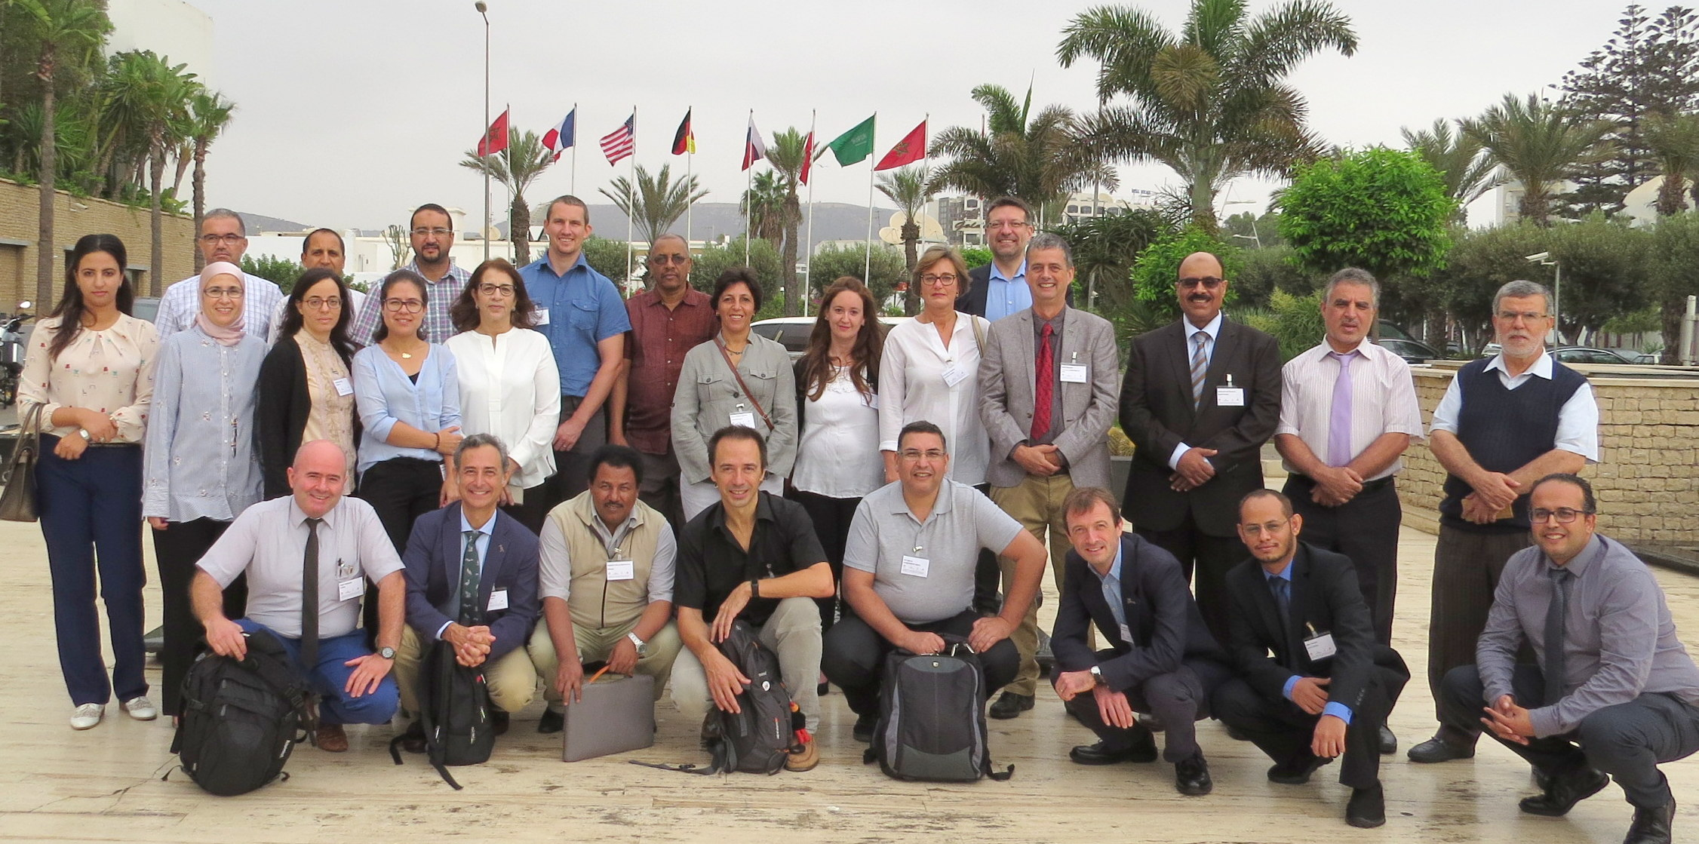

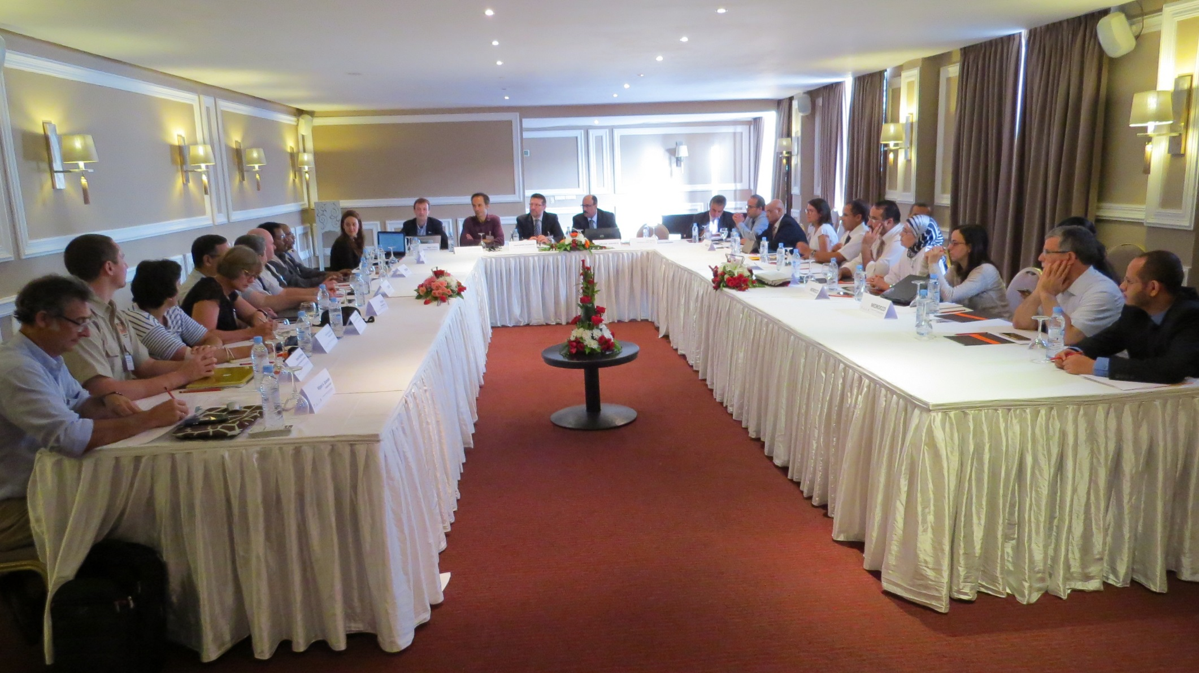

Opening session – Day 1

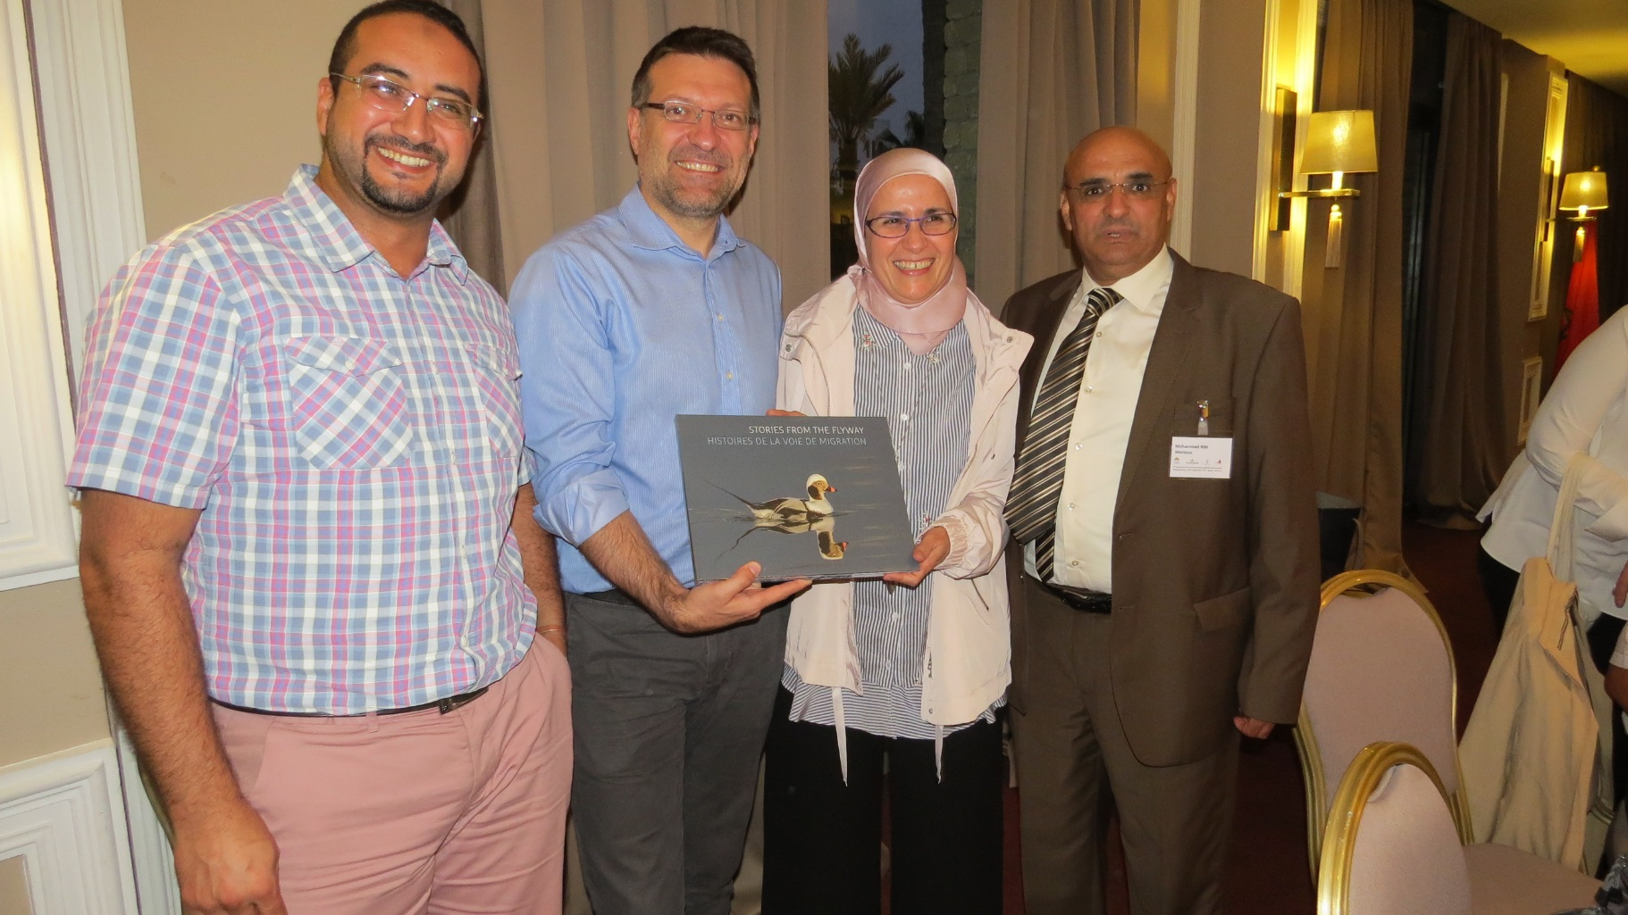

Presentation of the book produced by the UNEP/AEWA Secretariat to mark the 20th Anniversary of AEWA, Stories from the Flyway
to the Souss-Massa National Park team with thanks for the wonderful hospitality received

(Left to right – Mohammed El Bekkay, Sergey Dereliev, Widade Oubrou, Mohammed Ribi)

Mohamed Shobrak
(Saudi Arabia)

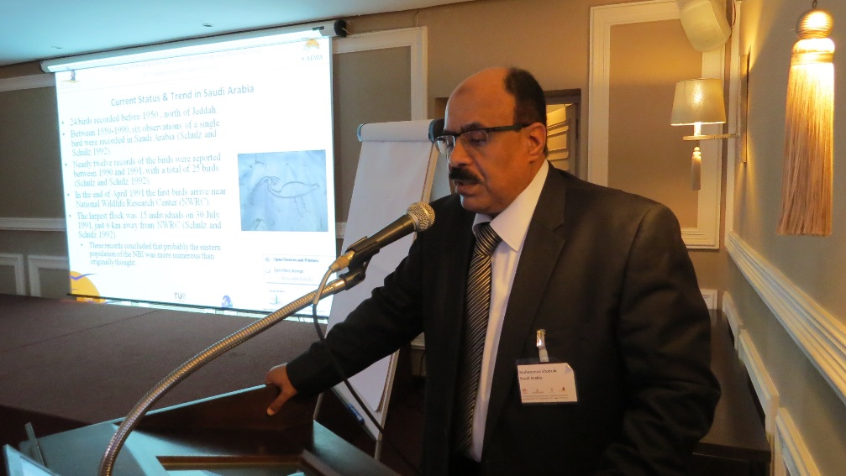

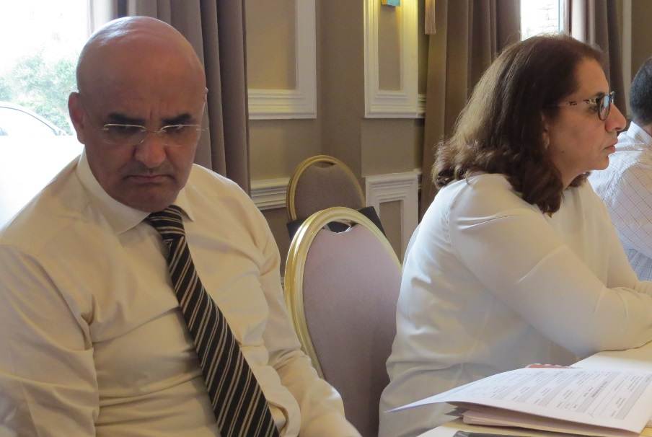

Mohammed Ribi & Hayat Mesbah
(Morocco)

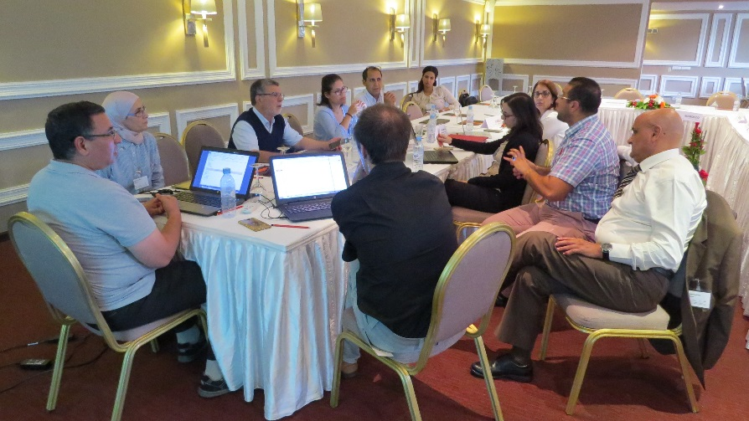
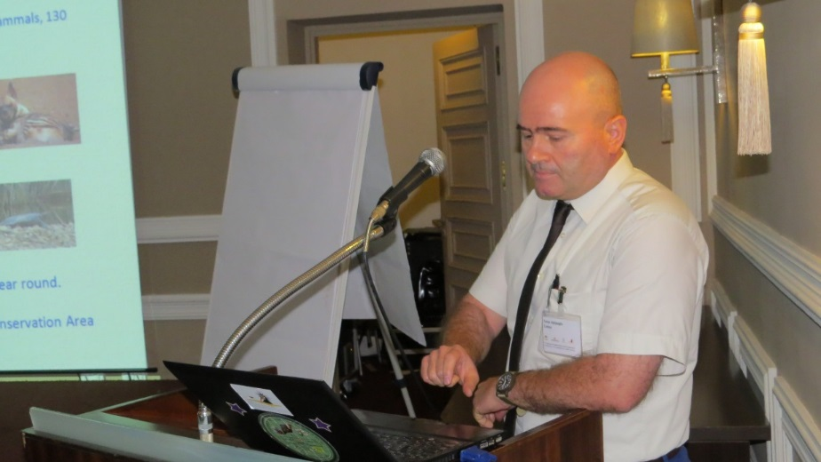

Taner Hatipoglu (Turkey) Morocco working group

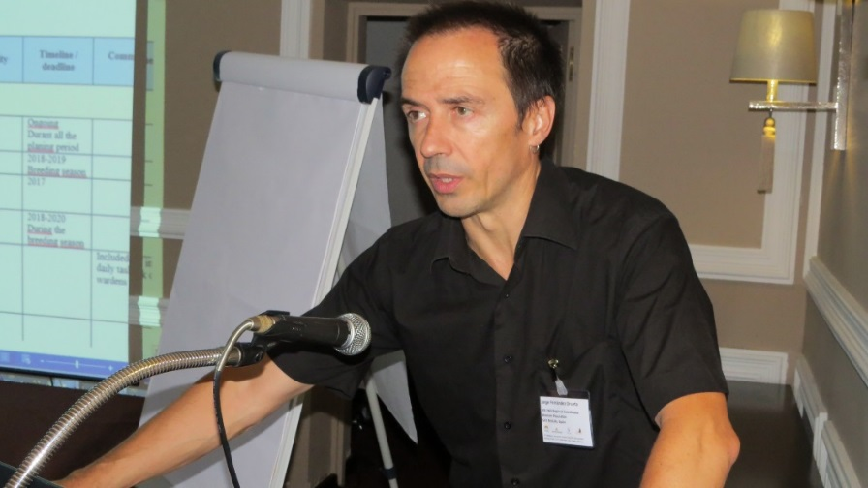
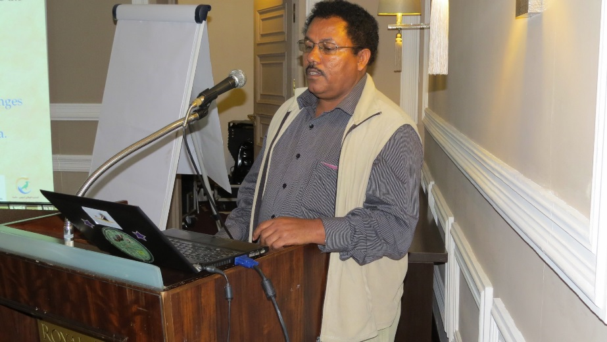

Asgedom Kahsay GebretenSae (Ethiopia) Jorge Orueta (SEO/Birdlife)

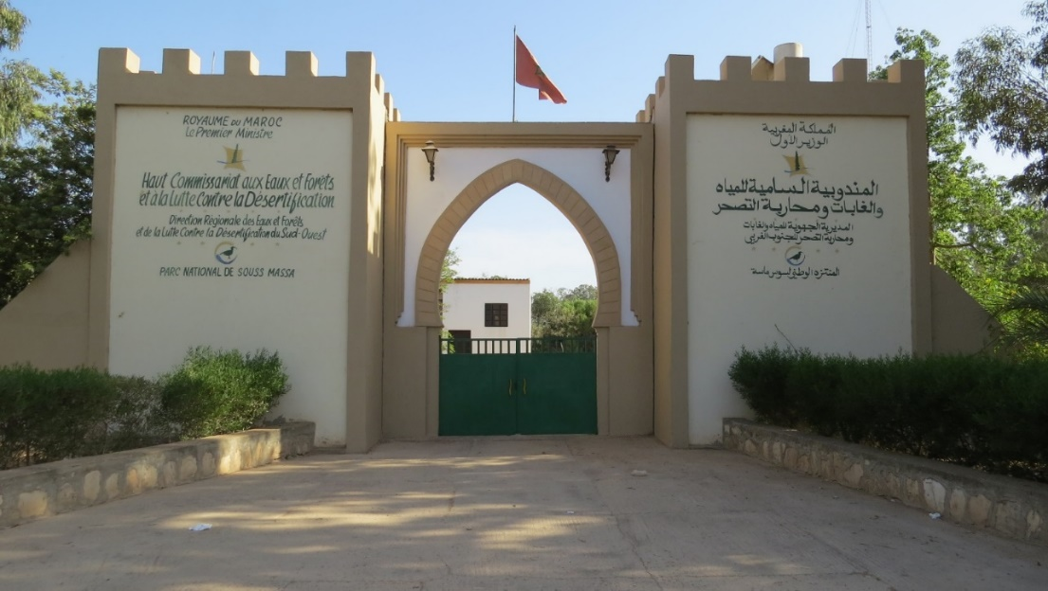

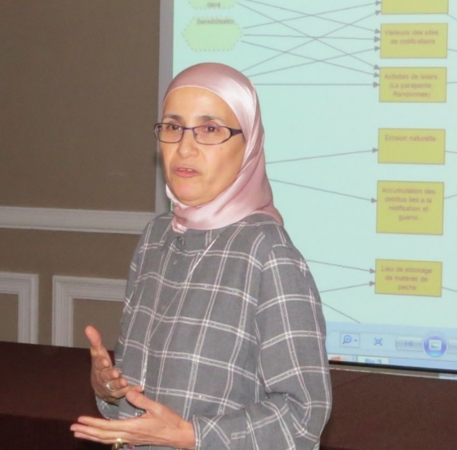

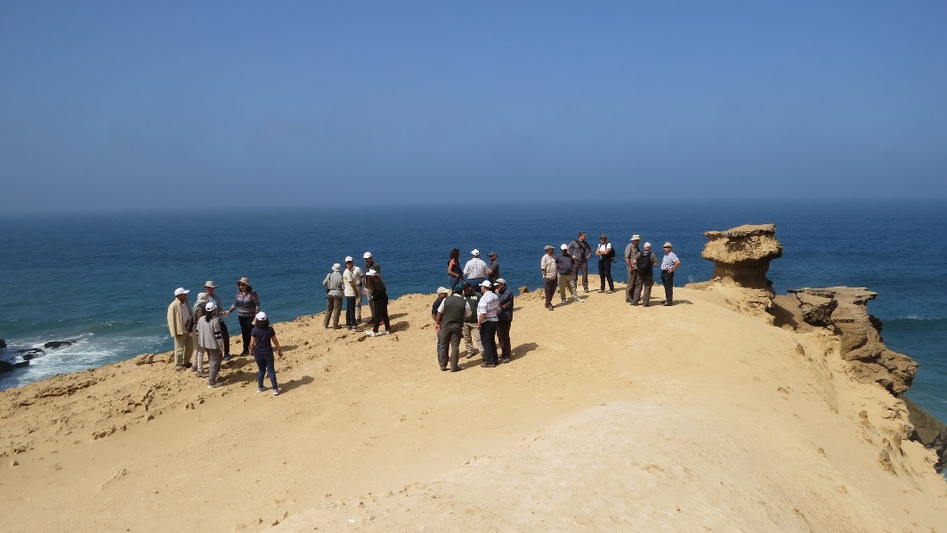

Souss-Massa National Park
excursion with presentation by Widade Oubrou (Morocco)

Photos from the field trip to Souss-Massa National Park kindly organised by Mohamed El Bekkay and his team
(Ibis wardens Mohamed El Gadrouri & Abdullah Essamar showed us a large flock of ibis feeding close to the park boundary)

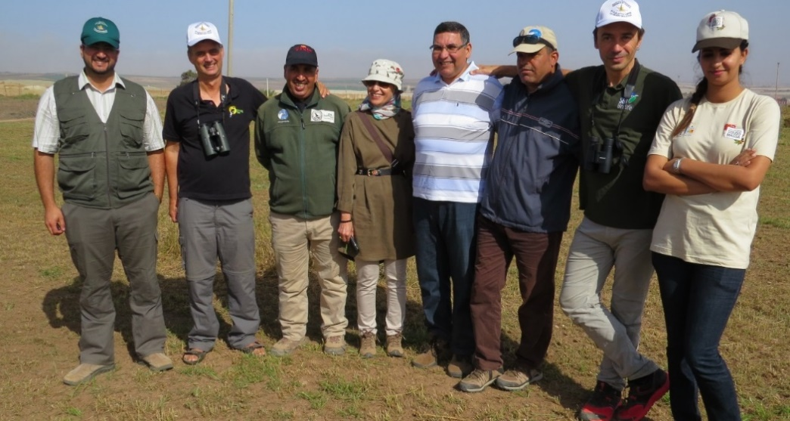
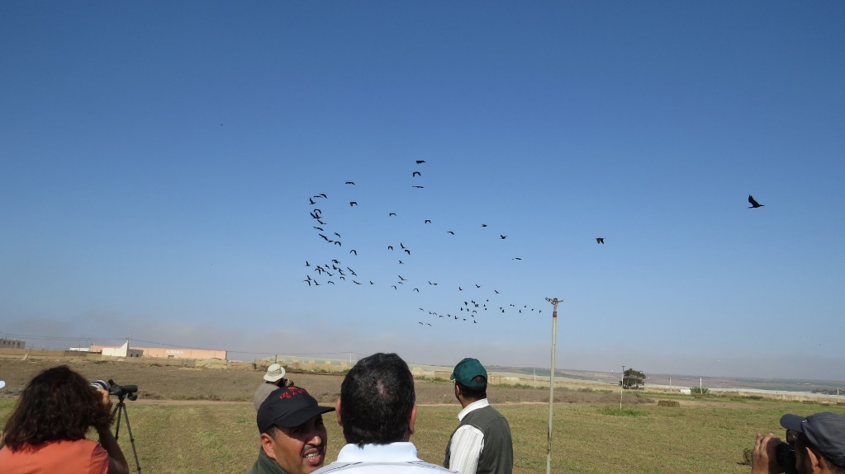

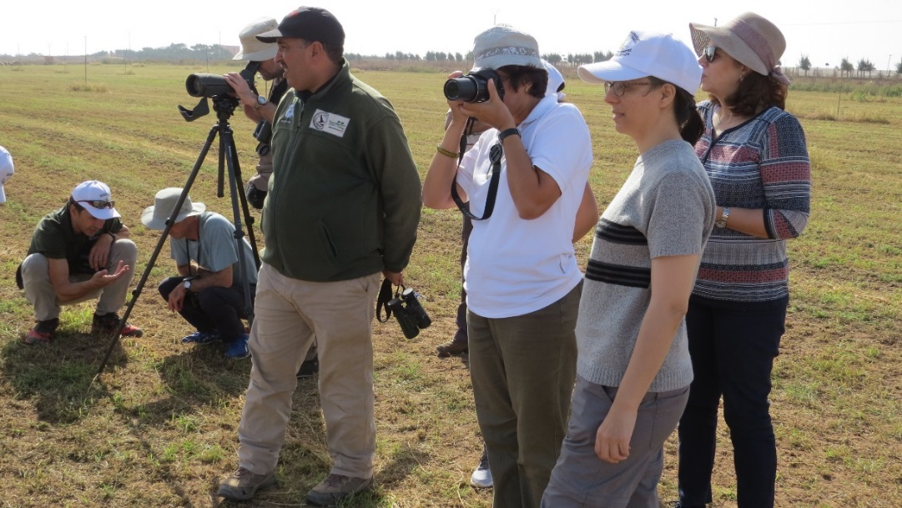
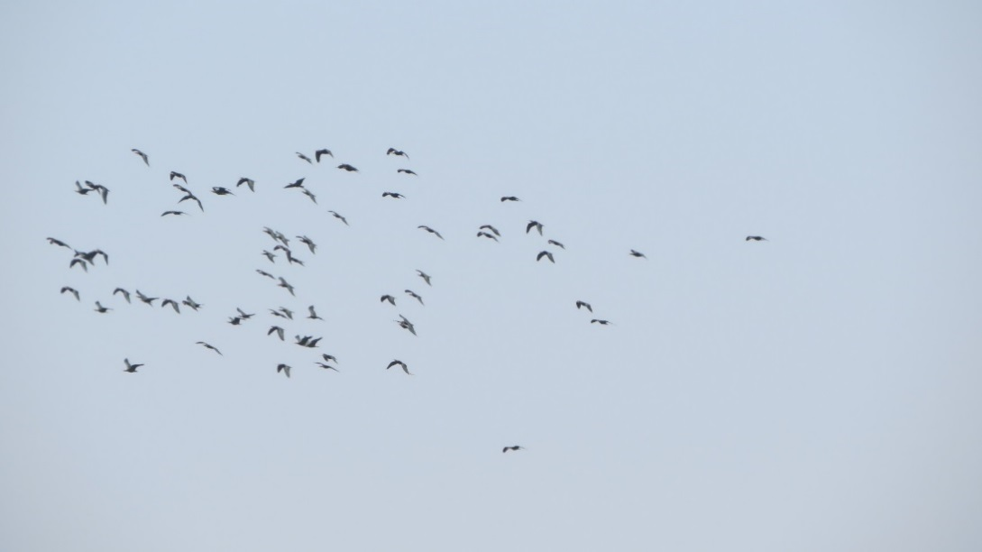

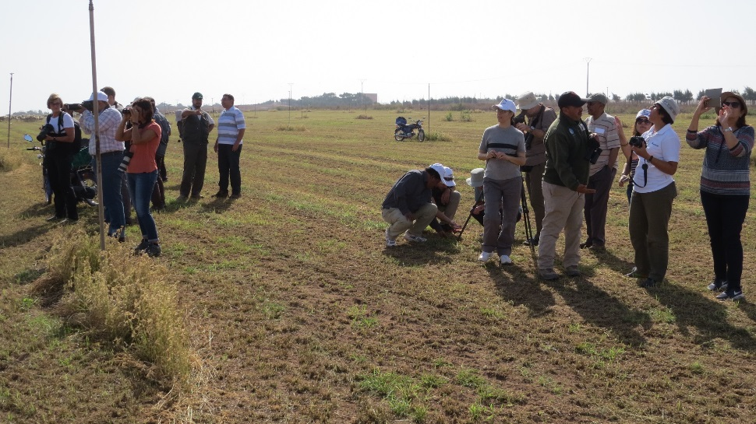
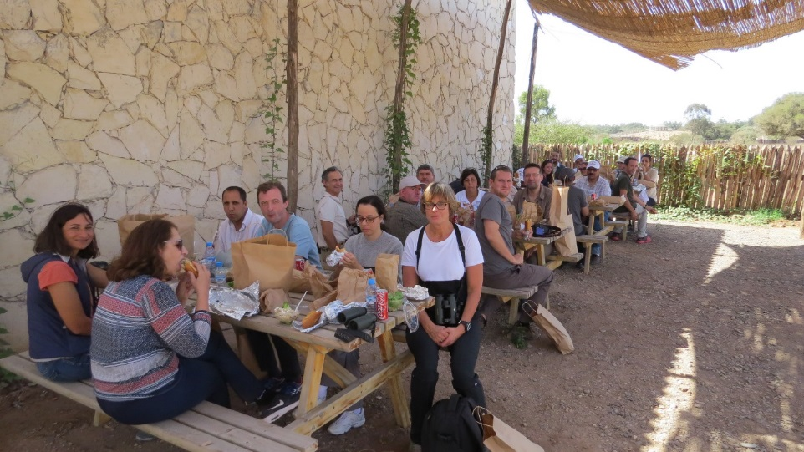

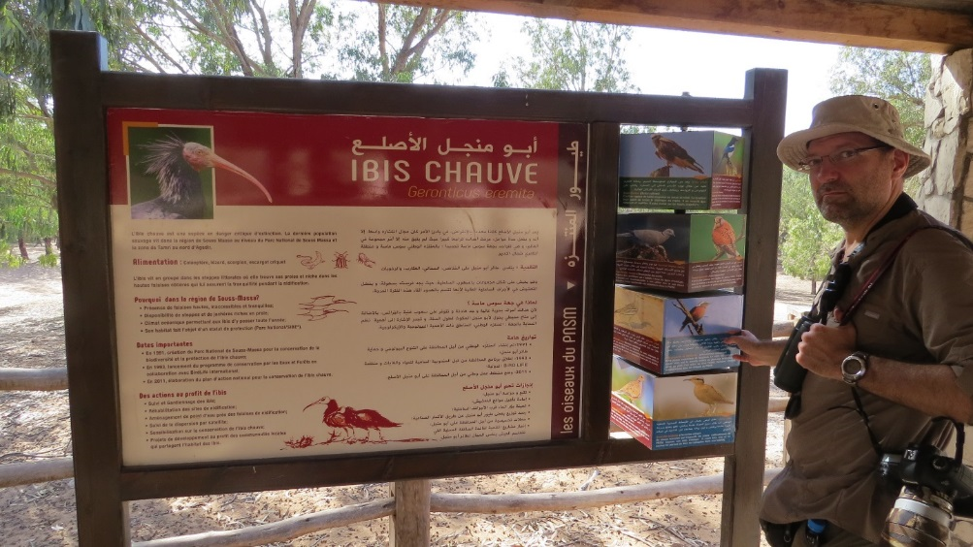

This implementation plan was developed during the 2nd meeting of the AEWA Northern Bald Ibis International Group meeting on 25-27 September 2017 on the basis of the AEWA International Single Species Action Plan for the Conservation of the Northern Bald Ibis (November 2015) and was endorsed by the IWG members by correspondence on Dec 31 2017.
Visit was paid to the sites and, under the current circumstances, it does not seem urgent to establish permanent surveillance. Subject to some initial intensive monitoring, It may be enough with some surveys to identify the potential conflict with local users, as well as to investigate the local knowledge about the colony, raise awareness and evaluate. [visit report available from PNSM].
SIBE: Site d'intérêt biologique et écologique: site of biological an ecological interest, not an official conservation tool but committed to be protected.

