DISCUSSION PAPER ON THE INTEGRATION OF LENGTH OF AEWA MEMBERSHIP
INTO THE ANALYSIS OF NATIONAL REPORTS TO MOP8
Compiled by UNEP-WCMC

Introduction
The information submitted in the National Reports to AEWA is analysed and synthesised for every MOP to give a clear overview of the level of implementation of the Agreement by Parties and to contribute to measuring progress towards the fulfilment of indicators of the AEWA Strategic and Action Plans. At MOP7 (December 2018, Durban, South Africa), Resolution 7.1 on the Adoption and implementation of the AEWA Strategic Plan and Plan of Action for Africa for the period of 2019-2027 was adopted, in which operative paragraph 8(i) requests that reporting on progress should “consider the progress in light of the variable time since Parties have acceded to the Agreement”. For targets of the Strategic Plan that involve actions that might require longer timeframes to implement, newer Parties may have been less likely to have met these targets and could potentially affect the overall picture of progress. On this basis, it was assumed that disaggregating the responses of newer and more established Parties may provide additional insights into the overall implementation.
For the 16th meeting of the Technical Committee (January 2021, virtual conference), UNEP-WCMC were asked by the Secretariat to consider this issue, explore the value in disaggregating and propose a potential approach that would factor in the length of time that countries were party to AEWA in the context of the National Report Analysis to MOP8. UNEP-WCMC prepared an analysis showing the effect of disaggregating responses by the length of time Parties have acceded to the Agreement using three questions analysed previously as part of the National Reports to MOP7 as case studies. See Annex I for an extract of this analysis and explanatory case studies. Case studies 1-3 were presented to the Technical Committee alongside a proposed way forward. Case studies 4 and 5 have been added to this document at the request of the Technical Committee.
Based on the analysis, with submission challenges and implementation challenges seen across the various lengths of membership, UNEP-WCMC advised the Technical Committee that there may be limited value in the inclusion of this additional break-down of results throughout the report.
Discussion at the 16th session of the Technical Committee
The Technical Committee, at its 16th session in January 2021, was invited to discuss whether the integration of the length of time as an AEWA Contracting Party would provide valuable additional information given the variable reporting rates and, if so, to decide whether the proposed approach for groupings (Scenario 2 – memberships ≤10 and >10 years) would be appropriate to apply in the analysis for a subset of relevant National Report questions.

The Technical Committee agreed that overall, the case studies 1-3 indicated that there did not seem to be a causal relationship between length of time that countries were party to AEWA and implementation, and therefore that disaggregation to factor in the length of membership would not add value to the Analysis of National Reports to MOP8. The Technical Committee therefore recommended that length of time should not be provided as an additional level of detail in the Analysis of National Reports in future.
The Technical Committee requested two additional case studies to further test the hypothesis that length of membership influenced the level of implementation. The addition of the two case studies 4 and 5 does not change the overall conclusion, however, with implementation challenges still seen across all lengths of membership.
The Technical Committee suggested, however, that the lack of a clear causal link was an important finding in and of itself as it indicated that there may be some implementation challenges that some Parties face irrespective of length of time of membership (rather than only the newer Parties facing implementation challenges as they work to get relevant provisions in place). The Technical Committee discussed that a firmer understanding of root causes for this may be beneficial to further enhance implementation of key AEWA provisions, and that consideration should be given as to whether any specific metrics for causal analyses needed to be collected through future revisions of the national reporting template. Understanding causes of implementation challenges better could also aid in prioritization of funding, capacity building and technical support.
Annex I: Case Studies exploring the relationship between length of AEWA membership and implementation
Extract of analysis presented to the 16th Technical Committee (document UNEP/AEWA/TC16.47 Corr.1).
Case studies 1-3 were presented to the Technical Committee alongside a proposed way forward. Case studies 4 and 5 have been added to this document at the request of the Technical Committee.
Case Study | National Report questions from MOP7 National Report questionnaire
1 | Q34. Has your country phased out the use of lead shot for hunting in wetlands? (AEWA Action Plan, paragraph 4.1.4)
2 | Q16. Is there a regulatory framework for re-establishments of species, including waterbirds, in your country? (AEWA Action Plan, paragraph 2.4)
3 | Q19. Does your country have legislation in place, which prohibits the introduction into the environment of non-native species of animals and plants which may be detrimental to migratory waterbirds? (AEWA Action Plan, paragraph 2.5.1)
4 | Q25. Does your country impose legislative requirements on zoos, private collections, etc. in order to avoid the accidental escape of captive animals belonging to non-native species which may be detrimental to migratory waterbirds? (AEWA Action Plan, paragraph 2.5.2)
5 | Q39. Has your country identified the network of all sites of international and national importance for the migratory waterbird species/populations listed on Table 1? (AEWA Action Plan, paragraph 3.1.2; AEWA Strategic Plan 2019-2027, Action 3.1(a))
Three scenarios were used in the case studies to explore the impact of the length of time as an AEWA Contracting Party on implementation: scenario 1: splitting Parties into groups of 0-5, 6-10 and >10 years of membership, scenario 2: groups of <10 and >10 years of membership, and scenario 3: groups of <5 and >5 years of membership.
From the initial analysis of case studies 1-3, scenario 2 (splitting Parties into groups of <10 and >10 years of membership) was considered to provide the most valuable disaggregation, in order to mitigate the combined effects of a comparatively small number of Parties and high proportion of non-submission in those Parties that have joined within the last 5 years based on reporting rates to MOP7. However, as submission and implementation challenges were seen across the various lengths of membership, it was concluded that there was limited value in including the additional break-down of results throughout the report and that it may instead confuse the picture on the overall implementation by providing too much data. It was suggested that disaggregation as per scenario 2 could be provided as a high-level summary of overall reporting rates to provide context on the reporting rates and overall levels of implementation, and if desired, for a small selection of relevant, priority questions.

Case Study 1: Question 34. Has your country phased out the use of lead shot for hunting in wetlands? (AEWA Action Plan, paragraph 4.1.4)
A total of 23 Parties (31% of Contracting Parties) reported that lead shot has been fully phased out in their country, while 13 Parties confirmed that lead shot had not yet been phased out (Figure 1.1).
b)
a)

Figure 1.1. Number of Parties reporting on the phasing out of the use of lead shot for hunting in wetlands: a) Overall - all responses combined, b) Disaggregated - responses broken down by length of membership, in brackets of 5 years.

Overall achievement of Target 2.1 of the Strategic Plan 2009-2018, which aims for all Parties to have phased out the use of lead shot for hunting in wetlands in their country, is 31%. The percentage of progress towards achievement of Target 2.1 by length of membership under different aggregation scenarios is presented in Figure 1.2 below.

Figure 1.2. Progress towards achievement of Target 2.1 of the Strategic Plan as reported by Parties to MOP7, overall and disaggregated by length of membership under different scenarios. Scenario 1: disaggregated in brackets of 0-5 years, 6-10 years and >10 years; Scenario 2: disaggregated in brackets of 0-10 years and >10 years; and Scenario 3: disaggregated in brackets of 0-5 years and >5 years.
A comparison of the different scenarios finds that, due to the differences in number of Parties and proportion of reporting in each scenario, disaggregating the countries that have been members for 5 years or less (Scenarios 1 and 3) inflates the reporting value of these individual Parties: with 11 Parties in this grouping and only 4 having reported, each Party that reports represents 25% of the progress of that group. Conversely, the progress in the Parties that have been members >5 years is broadly unaffected by removing these Parties compared to the overall progress across all Parties (for example in this case study, Scenario 3 shows that implementation by Parties that have been members >5 years is 34%, compared to 31% across all Parties). In a disaggregation by length of membership at 10 years (Scenario 2), the 0-10 years bracket contains 17 Parties, which reduces the inflation in the reporting value of individual Parties in this bracket; however, the discrepancies in number of Parties and proportion of reporting between the 0-10 years and >10 years brackets remain. In effect, the assumption that the newer Parties skew the results may not be justified. This pattern is similar for the other questions provided, including the additional case studies 4-5.

Case Study 2: Question 16. Is there a regulatory framework for re-establishments of species, including waterbirds, in your country? (AEWA Action Plan, paragraph 2.4)
b)
a)

Figure 2.1. Number of Parties reporting a regulatory framework for the re-establishment of species: a) Overall - all responses combined, b) Disaggregated - responses broken down by length of membership, in brackets of 5 years.
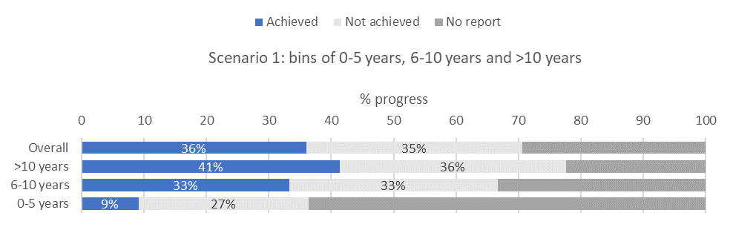
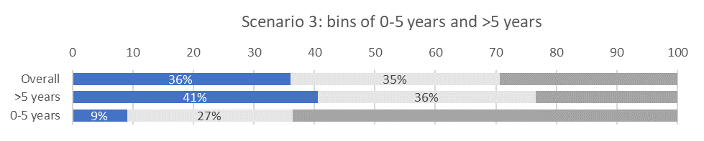
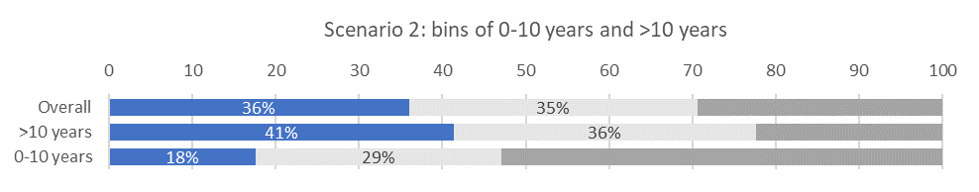
Figure 2.2. Progress towards achievement of this component of paragraph 2.4 of the AEWA Action Plan as reported by Parties to MOP7, overall and disaggregated by length of membership under different scenarios. Scenario 1: disaggregated in brackets of 0-5 years, 6-10 years and >10 years; Scenario 2: disaggregated in brackets of 0-10 years and >10 years; and Scenario 3: disaggregated in brackets of 0-5 years and >5 years.

Case Study 3: Question 19. Does your country have legislation in place, which prohibits the introduction into the environment of non-native species of animals and plants which may be detrimental to migratory waterbirds? (AEWA Action Plan, paragraph 2.5.1)
b)
a)

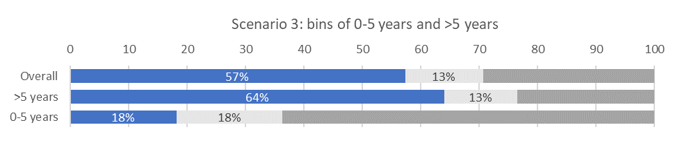
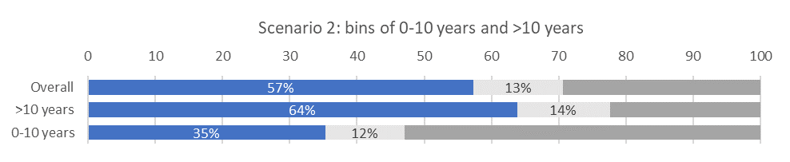
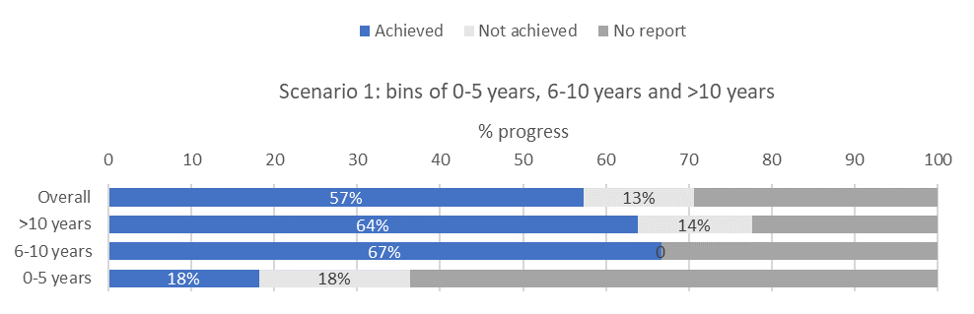
Figure 3.1. Number of Parties reporting legislation prohibiting the introduction of non-native species: a) Overall - all responses combined, b) Disaggregated - responses broken down by length of membership, in brackets of 5 years.
Figure 3.2. Progress towards achievement of Target 1.5 of the Strategic Plan as reported by Parties to MOP7, overall and disaggregated by length of membership under different scenarios. Scenario 1: disaggregated in brackets of 0-5 years, 6-10 years and >10 years; Scenario 2: disaggregated in brackets of 0-10 years and >10 years; and Scenario 3: disaggregated in brackets of 0-5 years and >5 years.

Case Study 4: Question 25. Has your country identified the network of all sites of international and national importance for the migratory waterbird species/populations listed on Table 1? (AEWA Action Plan, paragraph 3.1.2)
b)
a)

Figure 4.1. Number of Parties reporting having identified the network of all sites of international and national importance for the migratory waterbird species/populations listed on Table 1: a) Overall - all responses combined, b) Disaggregated - responses broken down by length of membership, in brackets of 5 years.

Figure 4.2. Progress towards achievement of this component of paragraph 3.1.2 of the AEWA Action Plan as reported by Parties to MOP7, overall and disaggregated by length of membership under different scenarios. Scenario 1: disaggregated in brackets of 0-5 years, 6-10 years and >10 years; Scenario 2: disaggregated in brackets of 0-10 years and >10 years; and Scenario 3: disaggregated in brackets of 0-5 years and >5 years.

Case Study 5: Question 39. Does your country have legislation in place, which provides for Strategic Environmental Assessment/Environmental Impact Assessment (SEA/EIA) of activities potentially negatively affecting natural habitats or wildlife? (AEWA Action Plan, paragraph 4.3.1)
a)
b)

Figure 5.1. Number of Parties reporting legislation providing for SEA/EIA of activities potentially negatively affecting natural habitats or wildlife: a) Overall - all responses combined, b) Disaggregated - responses broken down by length of membership, in brackets of 5 years.

Figure 5.2. Progress towards achievement of this component of paragraph 4.3.1 of the AEWA Action Plan as reported by Parties to MOP7, overall and disaggregated by length of membership under different scenarios. Scenario 1: disaggregated in brackets of 0-5 years, 6-10 years and >10 years; Scenario 2: disaggregated in brackets of 0-10 years and >10 years; and Scenario 3: disaggregated in brackets of 0-5 years and >5 years.

