**PARTICIPANTS INFORMATION SHEET**

**CONTACT DETAILS / ORGANIZATION TEAM**

|  |  |
| --- | --- |
| **UNEP/AEWA Secretariat (Germany):**  **Ms Catherine Lehmann**  Executive Management Support Officer  E-mail: [catherine.lehmann@un.org](mailto:catherine.lehmann@un.org) | **Ms Marie Therese Kaemper**  Administrative Assistant  E-mail: [marie-therese.kaemper@un.org](mailto:marie-therese.kaemper@un.org) |
| The 8th Session of the Meeting of the Parties to AEWA (MOP8) will open on **Tuesday, 27 September at 09.00** (registration will be open at 7.30) and close on **Friday, 30 September at around 18.00**. A detailed meeting schedule is attached to this information sheet. | |
| **MEETING VENUE & SCHEDULE**  The meeting venue is the **Corinthia Hotel Budapest**, address: Erzsébet Körút 43-49, Budapest H-1073 (<https://www.corinthia.com/budapest/>). The hotel is located in the city centre and easy to reach by public transport.  **Monday, 26 September 2022:**  **16.00 – 19.00: First EU Coordination Meeting.** This first coordination meeting will **not** take place at the Corinthia Hotel, but at the **Ministry of Technology and Industry**, **address: Fő u. 44-50, Budapest.** Please ensure to **carry your passport** which will be checked at the entrance. Coordination meetings on subsequent days will take place at the Corinthia Hotel. Participants are required to wear a face mask during the meeting. For your own safety and that of others, please also perform a rapid antigen self-test before attending the meeting, if possible. Registration starts from 15.00.  **16.00 – 19.00: First African Regional Coordination Meeting.** This first African Coordination Meeting will **not** take place at the Corinthia Hotel, but at the **Ministry of Agriculture, address: Apáczai Csere János utca 9., Budapest 1052.** Please ensure to **carry your passport** which will be checked at the entrance. Coordination meetings on subsequent days will take place at the Corinthia Hotel. Participants are required to wear a face mask during the meeting. For your own safety and that of others, please also perform a rapid antigen self-test before attending the meeting, if possible. Registration starts from 15.00.  **From 19.30:** A **reception for all delegates** will take place at: **EXTRA, address: Klauzál utca 15, 1072 Budapest**. An invitation will be sent to all registered participants by email.    **Tuesday, 27 September 2022 (Day 1):** **Official opening of MOP8** at **Corinthia Hotel Budapest** **at 9.00**, plenary sessions and sessions of the two working groups (technical & administration and finance).  **Wednesday, 28 September 2022 (Day 2):** Sessions of the two working groups.  **Thursday, 29 September 2022 (Day 3):** All delegates will be invited to attend a full day of side-events organized by partners while the Secretariat will prepare the revised meeting documents and draft resolutions for adoption, based on the discussions and deliberations of the MOP on Days 1 and 2.  **Friday, 30 September 2022 (Day 4):** The MOP8 plenary will be reconvened for final discussions and adoption of resolutions.  **REGISTRATION FOR MOP8**  The following options for registration for MOP8 will be available:  **Monday, 26 September, 15.00 – 18.00:**   * Participants of the first **EU** **coordination meeting** will be able to register at:   Ministry of Technology and Industry, Budapest, Fő u. 44-50, 1011 Budapest   * Participants of the **African** **coordination meeting** will be able to register at:   Ministry of Agriculture, Apáczai Csere János utca 9., Budapest 1052   * All **other** participants can register at:   Corinthia Hotel Budapest, Erzsébet Körút 43-49, 1073 Budapest  **From Tuesday, 27 September, 7.30:**   * Corinthia Hotel Budapest, Erzsébet Körút 43-49, 1073 Budapest   **DAILY SUBSISTENCE ALLOWANCE (DSA)**  Sponsored delegates will receive a sum to cover their costs of accommodation, meals, travel to and from airports, visas, vaccines and any other incidental costs (calculated according to the UN regulations for daily subsistence allowance - DSA).  The DSA will be provided to you when you register on site in the form of a cash card, charged with the appropriate amount. After you have received the card, it will take between half a day and a day to activate the card for use. The cash cards are embossed with a number but no name. They can be used in the same way as regular credit cards, e.g., for getting cash at ATMs or paying at hotels, restaurants or shops.  Please make sure that you have sufficient cash (Hungarian forinth or HUF) with you for buying local transport tickets or any other items you will need on the day of your arrival and the day after.  **WORKING LANGUAGES AND MEETING DOCUMENTS**  The meeting will be conducted in English and French. Simultaneous interpretation will be available during the plenary and official working group sessions. Meeting documents are available at:  [8th Session of the Meeting of the Parties (MOP8) to AEWA | AEWA (unep-aewa.org)](https://www.unep-aewa.org/en/meeting/8th-session-meeting-parties-mop8-aewa) | |

**VISA REQUIREMENTS**

Participants are responsible for making their own arrangements for obtaining their entry visa for Hungary and/or transit visa if applicable. Requirements for entry into Hungary differ from country to country and are subject to change. More information is available at:

<https://konzinfo.mfa.gov.hu/en/embassies#hungarian-embassies-abroad>

<https://konzinfo.mfa.gov.hu/en/list-third-countries-where-schengen-state-issues-visas-behalf-hungary>

Nationals of countries requiring a visa to enter Hungary must obtain their visa ahead of their departure as visas are not issued on arrival in Hungary. Please apply for your visa as early as possible and no later than a minimum of 6-8 weeks before your departure, at the nearest Hungarian Embassy (in countries without a Hungarian Embassy: at the nearest Embassy of a country issuing visas on behalf of Hungary), as visa processing times can be long. For most participants, the type of visa required for entry to Hungary will be a short-stay Schengen visas for 90 days and less (C visa).

Participants who have requested a visa letter with their online pre-registration will be provided with an **official letter from the government of Hungary,** as well as a **formal note (note verbale) from the UNEP/AEWA Secretariat** to support their visa application.

**Contacts within the UNEP/AEWA Secretariat for support with respect to visa applications:**

Ms Birgit Drerup Ms Tine Lindberg-Roncari

Programme Management Assistant (African Unit) Meeting Services Assistant

E-mail : [birgit.drerup@un.org](mailto:birgit.drerup@un.org) E-mail : [tine.lindberg-roncari1@un.org](mailto:tine.lindberg-roncari1@un.org)

Ms Shanay Huseynova

Programme Management Assistant (EGMP)

E-mail : [shanay.huseynova@un.org](mailto:shanay.huseynova@un.org)

**HOTELS**

**Important note:** Both participants sponsored by the UNEP/AEWA Secretariat and self-sponsored participants are required to make their own hotel booking! Participants are advised to book accommodation at their earliest convenience.

The host government recommends the following hotels:

3 Star Hotels

* [**Medos Hotel**](https://medoshotel.hu/en/main-page/)
* [**City Hotel Unio**](http://www.uniohotel.hu/)
* [**Easy Star Hotel**](https://www.booking.com/hotel/hu/central-dominik-pension.html?aid=7942854&label=Easy-Star-Hotel)
* [**Silver Hotel Budapest City Center**](http://www.silverhotel-budapestcitycenter.com/index.htm)
* [**Benczur Hotel**](http://www.benczurhotelbudapest.com/index.htm?lbl=ggl-en-rsp&gclid=Cj0KCQjw0oyYBhDGARIsAMZEuMtKC25gU9EKnRSZhjp32aPGdUJotK_SiqtiSJDZlynh_xZ-Oq1BzJ4aAhurEALw_wcB)

4 Star Hotels

* [**Eurostars Ambassador**](https://www.eurostarshotels.co.uk/eurostars-ambassador.html)
* [**Courtyard by Marriott**](https://www.marriott.com/en-us/hotels/budcy-courtyard-budapest-city-center/overview/?scid=bb1a189a-fec3-4d19-a255-54ba596febe2&y_source=1_MzU0MDY0Mi03MTUtbG9jYXRpb24ud2Vic2l0ZQ%3D%3D)
* [**Hotel Nemzeti Budapest**](https://all.accor.com/hotel/1686/index.en.shtml?utm_campaign=seo+maps&utm_medium=seo+maps&utm_source=google+Maps)
* [**Novotel Centrum**](https://novotel-budapest-centrum.h-rez.com/index_it.htm)
* [**Danubius Hotel Hungaria City Center**](https://www.danubiushotels.com/en/our-hotels-budapest/hotel-hungaria-city-center)

5 Star Hotels

* [**Anantara New York Palace**](https://www.nh-hotels.com/hotel/anantara-new-york-palace-budapest-hotel?campid=8435708&gclid=Cj0KCQjw0oyYBhDGARIsAMZEuMsLGRW7yJIr_qgodO-FfOiQZkofTJsqmwGriaRvzPIUWf7tAVNaucMaAlFUEALw_wcB&gclsrc=aw.ds)
* [**Corinthia Grand Hotel**](https://www.corinthia.com/budapest/)

Another way to find and book your accommodation in Budapest is by using a hotel booking platform such as <https://www.booking.com> or <https://www.tripadvisor.com>. Search results can be filtered by a range of criteria (e.g., budget per night, free cancellation, reservation without credit card etc.).

**TRANSFER FROM AND TO THE AIRPORT**

**Shuttle service to/from Budapest International Airport**

**For funded delegates only,** the host government will offer a free shuttle from Budapest International Airport to delegates’ accommodation (hotel or other). The funded delegates will be welcomed at the airport upon arrival. There will also be a free shuttle for funded delegates taking them to the airport on their day of departure.

If there are any changes in your flight (cancelled, delayed or missed), please inform Ms Éva Fejes from the Hungarian Ministry of Agriculture either by e-mail (eva.fejes@am.gov.hu), or by phone (+36 30 904 0033), preferably by using WhatsApp.

**Taxi:** If you would like to use a taxi, it is recommended to order taxis from official taxi companies, as their fares within Budapest are fixed and they charge using taximeters based on distance and time.

Főtaxi: +36 1 222 2222; <https://fotaxi.hu/en/>

City taxi: +36 1 211 1118; <https://www.citytaxi.hu/index.php?lang=en>

Taxi 4: +36 1 444 4444; <https://www.taxi4.hu/en/>

**TO CORINTHIA HOTEL BY PUBLIC TRANSPORT**

**Tram:**

Tram No. 4 or 6: This tram stops almost in front of Corinthia Budapest. If you take one of these trams, please get off at “Király utca / Erzsébet körút” stop.

**Metro:**

Take Metro Line 1 (the yellow line) and get off at the “Oktogon”. From there take the tram 4 or 6 towards Móricz Zsigmond körtér or walk 650m.

Or

Take Metro Line 2 (the red line) and get off at the “Blaha Lujza tér”. From there take the tram 4 or 6 towards Széll Kálmán tér or walk 1000m.

Public transport tickets can be purchased from ticket vending machines at stations and bus stops, or with the BudapestGo application

(<https://bkk.hu/en/tickets-and-passes/budapestgo/?gclid=CjwKCAjw-8qVBhANEiwAfjXLrjIV2NrJJHhkgW414WnugjwtSVBjR7tQuBes3mM5xrwlO27Q_KWlaBoC3OEQAvD_BwE>)

Public transportation is free for EU citizens over the age of 65.

**MEALS**

A free Lunch will kindly be offered for free by the host government at the meeting venue for all meeting participants on the three days of the meeting (Tuesday, Wednesday, Friday). Participants are requested to make their own arrangements for breakfast and dinner, as well as for lunches on the days before and after the meeting, as applicable.

**SIDE EVENTS**

On Thursday, 29 September 2022, all delegates will be invited to attend a full day of side events at Corinthia Hotel, organized by partners. Please see the [dedicated brochure on side events](https://www.unep-aewa.org/manage/sites/default/files/uploads/mop8_side_event_brochure_w_foreword.pdf) for further information or contact the Secretariat at [eva.meyers@un.org](mailto:eva.meyers@un.orgo) or [shanay.huseynova@un.org](mailto:shanay.huseynova@un.org)

**CURRENCY AND CREDIT CARDS**

**Currency**

The official Hungarian currency is the forint (HUF). The current exchange rate (July 2022) is about HUF 395 to EUR 1.

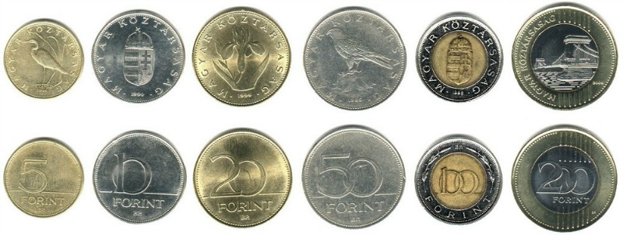 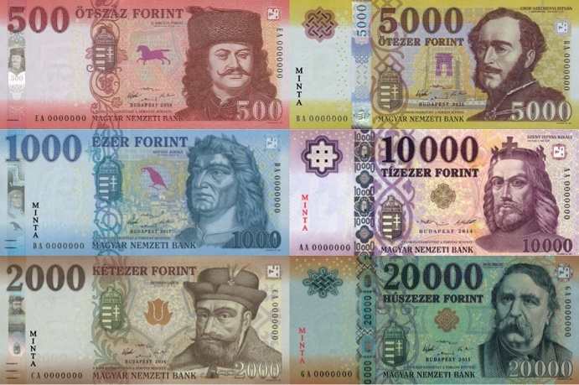

**Currency exchange**

We strongly advise that you only exchange currency at official exchange agencies or banks. Don’t exchange money on the streets with random strangers who pretend to offer you better exchange rates.

Many shops accept euros, but at a less favourable exchange rate compared to banks or exchange agencies. Most shops in Hungary are obliged to accept debit/credit cards.

**Credit and debit cards**

Visa, Mastercard and Maestro are widely accepted in Hungary, with American Express being somewhat less widespread.

**INTERNET**

**Wi-Fi:** High speed Wi-Fi will be provided at the venue.Outside, fast and reliable Wi-Fi is usually available in almost all hotels, restaurants, cafes, bars and shopping centres.

**Emergency telephone numbers**

The meeting venue has provisions for first aid and medical care. If you need emergency services these are the telephone numbers:

General emergency service: 112

Police:107

Ambulance:104

Fire service:105

**HEALTH**

First aid and emergency medical care are free for foreigners; in other cases, you need to pay for the treatment, unless you have travel insurance which covers healthcare. For your own safety, it is of utmost importance that you have sufficient health insurance cover.

At the time of writing (14 September 2022) there are no COVID-19-relaled restrictions to enter Hungary, but some airlines may have measures to limit the propagation of COVID-19 and the situation evolves rapidly. It is highly recommended to have the full vaccination status for your own safety and to ensure a smooth entry into Hungary and the meeting venue.

Wearing a face mask will be obligatory when indoors/in the venue except when eating or drinking or when taking the floor. Participants will also be expected to perform a rapid antigen self-test every morning before joining the meeting. Masks and self-test kits will be distributed free of charge to participants upon registration. For further details please consult the Secretariat’s dedicated COVID-19 guidelines.

**WEATHER**

September is the first month of autumn, with average daytime temperatures of around 17 degrees Celsius, while at night it can feel rather cool. Weather forecasts can be found on <https://weather.com/>

**ELECTRICAL VOLTAGE AND ADAPTERS**

Standard voltage is 230 Volts, AC 50Hz. Primary sockets require European plugs with two round pins. If you are coming from a country with a different standard, we recommend that you pack a universal travel adapter.

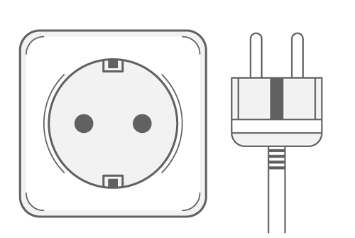

**BUSINESS HOURS**

Most stores in Hungary are open from 10 am to 6 pm Monday to Friday, and from 10 am to 1 or 2 pm on Saturdays. Large malls often extend their opening hours to 9 pm. Many malls are open on Sundays as well, with somewhat shorter opening hours. There will be no public holidays in Hungary during the period of MOP8.

**EATING AND DRINKING**

In Hungary tap water is considered safe to drink. Pork is an ingredient in many Hungarian meat dishes, but you will always find alternatives (poultry, beef, fish, vegetarian or vegan dishes) in restaurants.

**GENERAL INFORMATION ABOUT BUDAPEST AND HUNGARY**

You can find more information on the following websites:

<https://visithungary.com/>

<https://spiceofeurope>.com

**TIME ZONE**

During the period of MOP8, Central European Summer Time (CEST, Daylight Saving Time) is in effect in Hungary. This is one hour ahead of Central European Time (CET) and 2 hours ahead of Coordinated Universal Time (UTC).

***We look forward to meeting you in Budapest!***

**Annex 1**

**MOP8 schedule**

