AEWA Species Management Guidance for the
Garganey

Spatula querquedula

Agreement on the Conservation of
African-Eurasian Migratory Waterbirds (AEWA)

AEWA Species Management Guidance for the
Garganey

Spatula querquedula

May 2022

Produced by the AEWA Technical Committee
Compiled by Paul Buckley

This guidance has been produced to facilitate the implementation of the
AEWA Strategic Plan 2019-2027 (Objective 1, Target 1.3)

Prepared with funding from the Department for Environment, Food and Rural Affairs, United Kingdom
Contents
SUMMARY AND FUTURE PRIORITIES 4
1.BASIC DATA 4
2.THREATS/PROBLEMS AND RECOMMENDATIONS FOR CONSERVATION ACTION 6
3.BIOLOGICAL ASSESSMENT 8
4.REFERENCES 9

SUMMARY AND FUTURE PRIORITIES

Garganey is a widespread and fairly common species and is classified as of Least Concern globally on the IUCN Red List, although there is evidence of declines in some populations. Targeted conservation efforts for this species are therefore limited, other than perhaps on the edges of its range where it is classified as rare and treated as a priority. There is a clear northerly shift in its European breeding distribution over the last three decades, and this is also believed to have occurred across its range in Russia (Keller et al 2020). Its migratory nature renders it vulnerable to a wider range of threats than some more sedentary species, including wetland losses to agriculture and water infrastructure developments in the wintering range. It is heavily hunted, and more effort is needed to ensure that numbers harvested are understood and kept within sustainable limits. Conservation efforts should target a suite of waterbird species and focus primarily on maintaining its wetland habitat. Priority actions should include:

- Protection and management of key wetlands with nationally or internationally important populations of this species, including in its wintering range. Ensure that hydrological conditions re maintained, invasive plants and animals are controlled, and that disturbance is managed in the most important breeding and stopover sites.
- Better management of hunting, including monitoring of numbers harvested, setting of limits or quotas where necessary and ensuring that regulatory agencies have the skills and resources to monitor and enforce levels and practices.
- Development of National Management Plans to help focus and prioritise management and conservation work. Garganey is most likely to be included in Plans covering a suite of wetland species or in a concise single species plan if it is of recognized national importance.

- BASIC DATA

Species name: Garganey (Spatula querquedula)

Range states within AEWA region (Wetlands International 2021) (those Principal Range States in Bold have significant breeding populations or non-breeding >1%)
Western Siberia & Europe / West Africa population
Breeding: Albania, Austria, Belarus, Belgium, Bosnia and Herzegovina, Bulgaria, Croatia, Denmark, Estonia, Finland, France, Germany, Greece, Hungary, Iceland, Ireland, Italy, Latvia, Liechtenstein, Lithuania, Luxembourg, Moldova, Montenegro, Morocco, Netherlands, North Macedonia, Norway, Poland, Portugal, Romania, Russia, Serbia, Slovakia, Slovenia, Spain, Sweden, Switzerland, Turkey, Ukraine, United Kingdom, .
Main wintering areas: Benin, Burundi, Cameroon, Central African Republic, Chad, Cote d’Ivoire, Democratic Republic of the Congo, Gabon, Gambia, Ghana, Guinea, Guinea-Bissau, Liberia, Mali, Mauritania, Niger, Nigeria, Rwanda, Senegal, Sierra Leone, Sudan, Togo, Zambia.
Passage or scarce wintering: Algeria, Botswana, Cabo Verde, Cyprus, Egypt, Libya, Malawi, Malta,
Tunisia.
Western Siberia/ SW Asia, NE & E Africa population
Breeding: Armenia, Azerbaijan, Georgia, Iran, Kazakhstan, Russia, Turkey, Turkmenistan, Uzbekistan.
Main wintering areas: Democratic Republic of the Congo, Djibouti, Eritrea, Ethiopia, Kenya, Somalia, South Sudan, Sudan, Tanzania, Uganda, Zambia.
Passage or scarce wintering: Bahrain, Cyprus, Egypt, Iraq, Israel, Jordan, Kuwait, Lebanon, Oman, Qatar, Saudi Arabia, Syria, United Arab Emirates, Yemen, Zimbabwe.

Range map downloaded from the Critical Site Network Tool (http://criticalsites.wetlands.org)

International legal status
Global IUCN Status: Least Concern (last reviewed 2016).
AEWA Table 1: Western Siberia & Europe/West Africa Column C 1
Western Siberia/SW Asia, NE & Eastern Africa Column C 1
CMS: Appendix II
Bern Convention: Appendix III

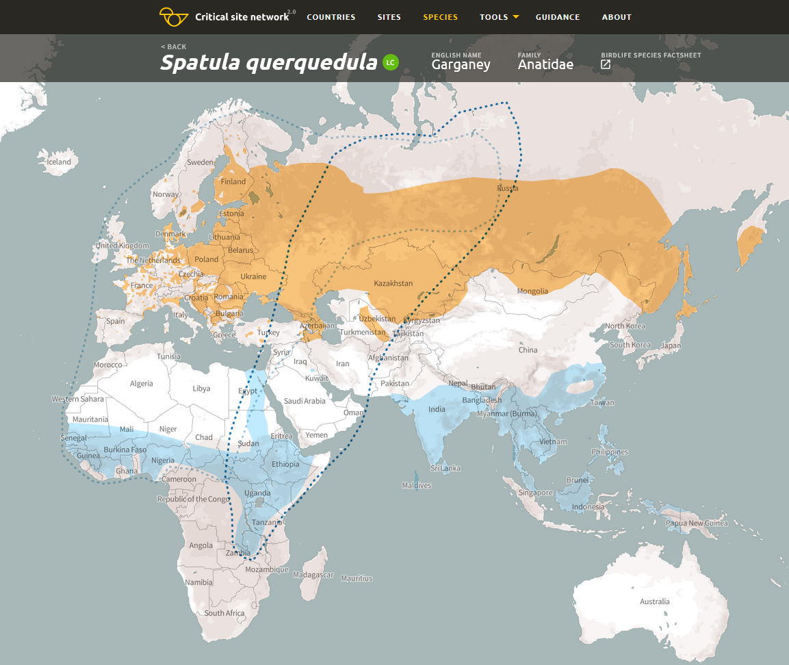
Range map of the Garganey (Spatula querquedula). Light blue dotted line – population boundaries of the Western Siberia & Europe / West Africa population; Dark blue dotted line - population boundaries of the Western Siberia/ SW Asia, NE & E Africa population. Orange polygons – breeding range; Blue polygons – non-breeding range.

- THREATS/PROBLEMS AND RECOMMENDATIONS FOR CONSERVATION ACTION

Table 1. Threats/problems and Recommendations for Action

*Information in Table 1 adapted from BirdLife International threats assessment: Garganey (Spatula querquedula) - BirdLife species factsheet. Amended threat codes are highlighted in Red. These scores/ratings are for the species as a whole, while for individual populations and nationally a higher level may apply.

Threat/problem & description  (IUCN Threat Code) | Threat/problem level | Recommendation for Action
Biological resource use – Hunting & trapping terrestrial animals - Intentional use (species is the target) (5.1.1) Evidence of over-harvesting in Eastern Europe due to quotas over sustainable limits, poor monitoring and low capacity of regulators. Estimates of >500,000 a year shot in Europe (Hirschfeld and Heyd 2005, Kear 2005). In Africa limited data, probably much subsistence hunting and impact unknown and may not be a threat, but apparent increasing commercialisation e.g. in Mali is a concern (Zwarts et al 2012).  Biological resource use - Hunting & trapping terrestrial animals - Unintentional effects (species is not the target) (5.1.2) (Hirschfeld and Heyd 2005) | Medium Impact 6  Low Impact 4 | Population monitoring at key wetlands should be improved, and accurate bag numbers recorded in countries where the species is hunted to improve prospects for sustainability (esp. Eastern Europe). In Africa, seek to better understand numbers harvested/impact and introduce targeted enforcement and awareness raising actions at key sites – these are likely to target a suite of species – alongside livelihoods initiatives (Madsen et al 2015).  Implement phasing out of lead ammunition for hunting in wetlands as required by AEWA Text
Climate change & severe weather – droughts (11.2)  Impacts unclear but population in Europe appears to be moving north and decreasing in Southern Europe (Poysa and Vaananen 2014). Natural variation in Sahel wetlands makes any long-term trends hard to assess (Keller et al 2020, Schricke 2002).  Climate and water level fluctuation may be an increasing threat in both breeding and non-breeding range. | Low Impact 4 | Habitat management measures to prevent or minimize the drying of and reduced water levels in key wetlands.  Monitor overall trends in distribution including those that may be linked to climate change.
Human intrusions & disturbance – work and other activities (6.3) A range of activities including wetland and meadow management at breeding sites in Europe, heavy disturbance by people and livestock in stop-over and wintering areas (Schricke 2002, Kear 2005, Keller et al 2020) | Low Impact 4 | Prevent disturbance especially during the breeding season. Avoid damaging wetland/meadow management during breeding season (All countries). Evidence also that migratory stop-over sites are important for resting so preventing disturbance is important here also.
Invasive and other problematic species, genes & diseases. Invasive non-native alien species (8.1.1). Threats vary include American Mink in Europe (Brzezinski et al 2020), a variety of invasive plants in many areas in breeding range.  Invasive and other problematic species, genes & diseases. Viral/prion induced diseases (8.5.1) – Avian influenza  Invasive and other problematic species, genes & diseases. Viral/prion induced diseases (8.5.1) – West Nile Virus  Invasive and other problematic species, genes & diseases. Problematic species of unknown origin (8.4.2) - Clostridium botulinum | Low Impact 4  Low Impact 5  Low Impact 5  Low Impact 5 | Control of introduced predators (e.g. American mink). (Europe and elsewhere). Control of invasive plants where they clog up wetlands and reduce available habitat.  Monitoring of all relevant disease appearance and spread. Biosecurity to reduce spread in human modified systems and actions in natural wetlands to minimize access and shooting, and interaction with domestic birds and livestock. Habitat management to encourage predators of mosquitos.
Natural system modifications - Abstraction of surface water (7.2)  Natural system modifications – Large and small dams (7.2.11)  Natural system modifications – other ecosystem modifications (7.3)  These hydrological impacts encompass a wide range of activity from large scale dams and irrigation projects with international funding through to local rural projects implemented by communities (Schricke 2002, Zwarts et al 2012). Projected impact of the Fomi dam on the Inner Niger Delta is one example that is quite significant. | Medium Impact 7  Medium Impact 7  Low Impact 4 | Action tailored to specific countries and issues, and best detailed in national plans of action. If there is significant further infrastructure development in Wast Africa, this is probably the key threat to the non-breeding populations of this species. Key areas of breeding and non-breeding habitat for this species should be identified and protected (most likely justified by a suite of species).  Habitat enhancement through wetland restoration, especially in the EU as part of the EU Biodiversity Policy. Prevent habitat deterioration through the drainage and reclamation of wetlands.  Increase their protected status esp. in non-breeding range. Hydrological management to maintain water levels in protected and other wetlands. (All countries)  Better EIA and mitigation measures in infrastructure developments inc. dams, river diversions, irrigation (esp. West Africa)

- BIOLOGICAL ASSESSMENT

Habitat
Breeding: In the breeding season this species frequents small, shallow ponds and lakes with abundant floating, emergent and fringing vegetation (Johnsgard 1978, de Hoyo. 1992) (that is not too tall or dense, such as bulrush - Typha spp.) (Cramp and Simmons 1977, Green 1998), in grass dominated environments, like swampy meadows, flooded fields, shallow freshwater marshes (Johnsgard 1978, de Hoyo. 1992, Schricke 2001).

Non-breeding: During this season the species shows a preference for large freshwater or occasionally brackish lakes, again with abundant floating, emergent and fringing vegetation (Kear 2005b), also shallow flood plains, shallow dams, pans and sewage ponds (Hockey et al. 2005). The species also frequents coastal saltmarshes and lagoons on passage (de Hoyo. 1992) and may spend the day resting on marine inshore waters when migrating (Madge and Burn 1988). In its critical Sahel wintering grounds, the species favours very large, complex wetlands with considerable movements according to food supply and levels of disturbance. Garganey will often spend the day in open water areas and then fly 10-15kms to feeding grounds at night (Zwarts et al 2012).

Population
This species has an extremely large range, and hence does not approach the thresholds for Vulnerable under the range size criterion (extent of occurrence <20,000 km² combined with a declining or fluctuating range size, habitat extent/quality, or population size and a small number of locations or severe fragmentation).

The global population is estimated to number c.2,600,000-2,800,000 individuals (Wetlands International 2015). The European population is estimated at 681,000 to 920,000 mature individuals with a declining trend (BirdLife International 2021b). Wintering populations in West Africa are difficult to estimate but estimated at between 1 and 1.8 million (UNEP-AEWA 2021). A coordinated count of 1.3m was made in 2000 (Zwarts et al 2012). The Inner Niger Delta is the most important area, but populations fluctuate greatly according to local and regional conditions. The SW Asian/North-east African population is smaller c 100-200,000 individuals. The population size is large, and hence does not approach the thresholds for Vulnerable under the population size criterion (<10,000 mature individuals with a continuing decline estimated to be >10% in ten years or three generations, or with a specified population structure).

The overall population trend is thought to be decreasing. As of 2017, the Western Siberia & Europe / West Africa population is identified as Decreasing or Stable while the Western Siberia/ SW Asia, NE & E Africa population is thought to be Decreasing (UNEP-AEWA 2021, Wetlands International 2018). The major threat in Sahelian Africa is considered to be wetland loss to agriculture and water management infrastructure. No counts or assessment have been possible in Lake Chad and Inner Niger Delta for several years due to security concerns (SWM project in litt.). Studies in Finland show breeding numbers linked most notably to spring temperatures in northern Europe and to water levels and habitat conditions in Sahelian Africa (Poysa and Vaananen 2014). There is a clearly northerly shift in distribution over the past three decades illustrated through the maps of the first and second European Breeding Bird Atlases, although the conservation implications of this are not clear. This is also reported in an increase in the population in Northern Russia but steep declines in Southern European countries such as Italy (Keller et al 2020). The European population is estimated to be decreasing by less than 25% in 3 generations (19.5 years) (BirdLife International 2015), and therefore the species is evaluated as Least Concern.

- REFERENCES

Balmaki, B.; Barati, A. 2006. Harvesting status of migratory waterfowl in northern Iran: a case study from Gilan Province. In: Boere, G.; Galbraith, C., Stroud, D. (ed.), Waterbirds around the world, pp. 868-869. The Stationary Office, Edinburgh, UK.
BirdLife International 2021b European Red List of Birds. Luxembourg: Publications Office of the European Union. BirdLife-European-Red-List-of-Birds-2021.pdf
BirdLife International and Handbook of the Birds of the World 2020 Bird species distribution maps of the world. Version 2020.1. Available at http://datazone.birdlife.org/species/requestdis.
BirdLife International 2022 Species factsheet: Spatula querquedula. Downloaded from http://www.birdlife.org
Bregnballe, T.; Noer, H.; Christensen, T.K.; Clausen, P.; Asferg, T.; Fox, A.D.; Delany, S. 2006. Sustainable hunting of migratory waterbirds: the Danish approach. In: G. Boere, C. Galbraith and D. Stroud (eds), Waterbirds around the world, pp. 854-860. The Stationery Office, Edinburgh, U.K.
Brzezinski et al 2020 The expansion wave of an invasive predator leaves declining waterbird populations behind. Wiley Online Library Diversity and Distributions. 2020;26:138–150.
Cramp, S.; Simmons, K. E. L. 1977. Handbook of the birds of Europe, the Middle East and Africa. The birds of the western Palearctic, vol. I: ostriches to ducks. Oxford University Press, Oxford.
del Hoyo, J.; Elliot, A.; Sargatal, J. 1992. Handbook of the Birds of the World, vol. 1: Ostrich to Ducks. Lynx Edicions, Barcelona, Spain.
Deniau, C.P, Mathevet, R., Gautier, D., Besnard, A., Cornu, G. and Le Bel, S. 2022. Flyways to hell? An empirical assessment of Palearctic migratory waterbird harvest practices in key wetlands of Sahel-sub-Saharan Africa. Biological Conservation 265 https://doi.org/10.1016/j.biocon.2021.109419
Gaidet, N., Dodman, T., Caron, A., Balanca, G., Desvaux, S., Goutard, F., Cattoli, G., Lamarque, F., Hagemeijer, W. and Monicat, F. 2007. Avian Influenza Viruses in Water Birds, Africa. Emerging Infectious Diseases 13(4): 626-629.
Green, A. J. 1998. Habitat selection by the Marbled Teal Marmaronetta angustirostris, Ferruginous Duck Aythya nyroca and other ducks in the Göksu Delta, Turkey in late summer. Revue d'Ecologie (La Terre et la Vie) 53: 225-243.
Guillemain, M. et al 2004 Fuelling rates of garganey (Anas querquedula) staging in the Camargue, southern France, during spring migration J Ornithol 145: 152–158 DOI 10.1007/s10336-004-0026-9
Hirschfeld, A. & A. Heyd 2005: Mortality of migratory birds caused by hunting in Europe: bag statistics and proposals for the conservation of birds and animal welfare. Ber. Vogelschutz 42: 47-74
Hockey, P.A.R., Dean, W.R.J. and Ryan, P.G. 2005. Roberts birds of southern Africa. Trustees of the John Voelcker Bird Book Fund, Cape Town, South Africa.
Johnsgard, P.A. 1978. Ducks, geese and swans of the World. University of Nebraska Press, Lincoln and London.
Kear, J. 2005. Ducks, geese and swans volume 2: species accounts (Cairina to Mergus). Oxford University Press, Oxford, U.K.
Keller,V., Herrando,S.,Vorisek,P., et al 2020 European Breeding Bird Atlas 2: Distribution, Abundance and Change. European Bird Census Council & Lnyx Edicions, Barcelona.
Madsen, J., Bunnefeld, N., Nagy, S., Griffin, C., Defos du Rau, P., Mondain-Monval, J.Y., Hearn, R., Czajkowski, A., Grauer, A., Merkel, F.R., Williams, J.H., Alhainen, M., Guillemain, M., Middleton, A., Christensen, T.K. & Noe, O. 2015. Guidelines on Sustainable Harvest of Migratory Waterbirds. AEWA Conservation Guidelines No. 5, AEWA Technical Series No. 62. Bonn, Germany.
Melville, D.S.; Shortridge, K.F. 2006. Migratory waterbirds and avian influenza in the East Asian-Australasian Flyway with particular reference to the 2003-2004 H5N1 outbreak. In: G. Boere, C. Galbraith and D. Stroud (eds), Waterbirds around the world, pp. 432-438. The Stationery Office, Edinburgh, U.K.
Opermanis, O., Mednis, A. and Bauga, I. 2001. Duck nests and predators: interaction, specialisation and possible management. Wildlife Biology 7(2): 87-96.
Polet, G. 2000. Waterfowl and flood extent in the Hadejia-Nguru wetlands of north-east Nigeria. Bird Conservation International 10(3): 203-209.
Poysa, H. and Vaananen, V-M. 2014 Drivers of breeding numbers in a long-distance migrant, the Garganey (Anas querquedula): effects of climate and hunting pressure J Ornithol (2014) 155:679–687
Schricke, V. 2002. Elements for a garganey (Anas querquedula) management plan. Game and Wildlife Science 18(1): 9-41.
Scott, D. A.; Rose, P. M. 1996. Atlas of Anatidae populations in Africa and western Eurasia. Wetlands International, Wageningen, Netherlands.
SWM programme: Le Projet RESSOURCE dans les zones humides sahéliennes - SWM Programme (swm-programme.info) »
Treca, B. 1981. Diet of the garganey (Anas querquedula) in the Senegal delta. L'Oiseau et la Revue Française d'Ornithologie 51(1): 33-58.
Triplett, P. and Yesou, P. 2000. Controlling the flood in the Senegal Delta: do waterfowl populations adapt to their new environment? Ostrich 71(1-2): 106-111.
UNEP-AEWA 2021 Report on the conservation status of migratory waterbirds in the agreement area - 8th Edition https://www.unep-aewa.org/en/document/report-conservation-status-migratory-waterbirds-agreement-area-8th-edition
Vaananen, V. M. 2001. Hunting disturbance and the timing of autumn migration in Anas species. Wildlife Biology 7(1): 3-9.
Wetlands International. 2018. Waterbird Population Estimates. Available at: Admin <i>Spatula querquedula</i> (Garganey) - Western Siberia & Europe/West Africa (wetlands.org)
Admin <i>Spatula querquedula</i> (Garganey) - Western Siberia/SW Asia, NE & Eastern Africa (wetlands.org)
Admin Search (wetlands.org)

Wetlands International 2021. Critical Sites Network Critical Sites Network Tool 2.0 (wetlands.org)
Zwarts, L., Bijlsma, R. G., Van der Kamp, J., & Wymenga, E. 2012. Living on the edge: wetlands and birds in a changing Sahel.

IUCN (Red List) Threats Classification Scheme

