AEWA Species Management Guidance for the
African Comb Duck

Sarkidiornis melanotos

Agreement on the Conservation of
African-Eurasian Migratory Waterbirds (AEWA)

AEWA Species Management Guidance for the
African Comb Duck

Sarkidiornis melanotos

May 2022

Produced by the AEWA Technical Committee
Compiled by Paul Buckley

This guidance has been produced to facilitate the implementation of the
AEWA Strategic Plan 2019-2027 (Objective 1, Target 1.3)

Prepared with funding from the Department for Environment, Food and Rural Affairs, United Kingdom
Contents
SUMMARY AND FUTURE PRIORITIES 4
1. BASIC DATA 4
2.THREATS/PROBLEMS AND RECOMMENDATIONS FOR CONSERVATION ACTION 5
3.BIOLOGICAL ASSESSMENT 6
4.REFERENCES 7

SUMMARY AND FUTURE PRIORITIES

African Comb Duck is a widespread and fairly common species across much of tropical Africa and also in parts of Asia. It is currently classified as Least Concern on the IUCN Red List. There is some evidence of a decline in numbers however, especially in West Africa. It inhabits a fairly wide range of habitats but there is a strong association with areas of close proximity to both wetland and forested habitats, which it uses for nesting, and so efforts for its conservation would also benefit a wider suite of species. It could be vulnerable to increasing aridity due to climate change and there is already evidence of a retreat from the southern end of its range. It is hunted and efforts should be made to monitor and manage this practice. Priority actions should include:

- Protect and manage key wetlands with nationally or internationally important populations of this species. Strive to ensure that areas of forest and woodland around the wetland are protected.
- Increase knowledge of the population size, trend and distribution by improved surveys, especially in large riverine systems which are not well covered by existing monitoring programmes.
- Improve monitoring of hunting and ensure that regulatory agencies have the skills and resources to monitor and enforce levels of hunting.
- Develop concise National Action Plans or include within relevant habitat or multi-species plans, especially where populations are considered vulnerable.

- BASIC DATA

Species name: African Comb Duck (Sarkidiornis melanotos)

Range states within AEWA region (Wetlands International 2021) (Principal Range States in Bold have significant breeding populations or non-breeding numbers of >1%)
West Africa population: Benin, Burkina Faso, Cameroon, Central African Republic, Chad, Cote d’Ivoire, Equatorial Guinea, Gambia, Ghana, Guinea, Guinea-Bissau, Liberia, Mali, Mauritania, Niger, Nigeria, Senegal, Sierra Leone, Sudan, Togo.
Southern & Eastern Africa population: Angola, Botswana, Burundi, Cameroon, Central African Republic, Democratic Republic of Congo, Eritrea, Eswatini, Ethiopia, Gabon, Kenya, Lesotho, Malawi, Mozambique, Namibia, Rwanda, Somalia, South Africa, South Sudan, Sudan, Tanzania, Uganda, Zambia, Zimbabwe.
(This species also occurs in a number of Asian countries outside of the AEWA region and in Madagascar, but the population is not listed in AEWA’s Annex 3).

Range map downloaded from the Critical Site Network Tool (http://criticalsites.wetlands.org)

International legal status
Global IUCN Status: Least Concern (last reviewed 2016).
AEWA Table 1: West African population A 3c
Southern & Eastern African population B 2c
CMS: Annex II
CITES: Annex II

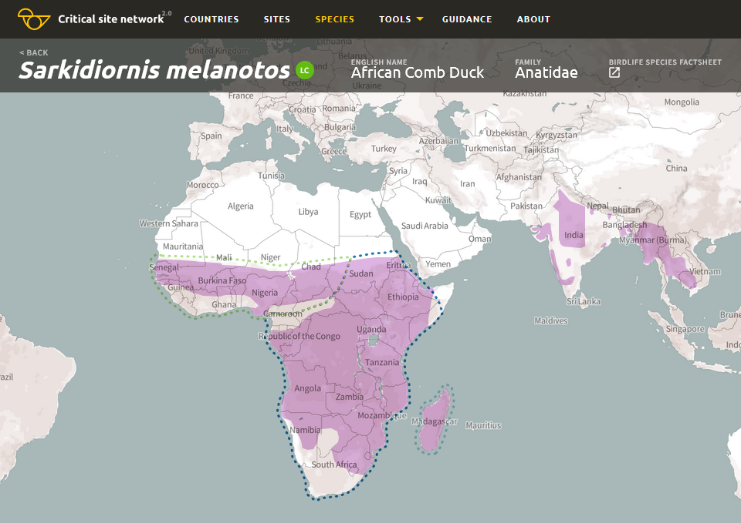

Range map of the African Comb Duck (Sarkidiornis melanotos). Light green dotted line – population boundaries of the West Africa population; Dark blue dotted line - population boundaries of the Eastern and Southern Africa population.

- THREATS/PROBLEMS AND RECOMMENDATIONS FOR CONSERVATION ACTION

Table 1. Threats/problems and Recommendations for Action

*Information in Table 1 adapted from BirdLife International threats assessment: African Comb Duck (Sarkidiornis melanotos) - BirdLife species factsheet. These scores/ratings are for the species as a whole, while for individual populations or Range States a higher level may apply.

Threat/problem & description  (IUCN threat code) | Threat/problem level | Recommendation for Action
Biological resource use – Intentional use (species being assessed is the target) (5.1.1) Hunted both legally and also through poaching (shooting, trapping or poisoning) for food, and this may be reducing populations in some areas. Some exploitation for pet trade  Biological resource use – logging and wood harvesting (5.3) | Low impact 5  Low impact 5 | Monitor hunting levels and seek to restrict to sustainable levels where over-exploited (Madsen et al 2015). (All countries). Address poaching through legislation, enforcement and awareness raising although most likely for a suite species rather than this one alone.  Improve data on population size and trends across range to underpin management.  Influence forestry policy to give greater protection for and restoration of riverine woodlands. Implement riverine and wet forest and woodland conservation projects (All countries)
Invasive and other problematic species, genes & diseases – Avian influenza (Gaidet et al 2007). Potential for other diseases (8.1). | Low Impact 4 | Disease outbreak monitoring, control and containment (All countries)
Natural system modifications – Large dams (7.2). Likely to be impacted by a range of infrastructure and irrigation projects large and small although no clear assessment. For example, reclamation of wetlands for sorghum in Southern Chad (Defos du Rau in. litt.) Species declined following damming of Senegal River (Triplett and Yesou 2000) and the impact of the Fomi dam on the Inner Niger Delta could be quite significant | Medium Impact 6 | This would need to be addressed by improved legislation for sustainable land use, policy and enforcement for infrastructure and irrigation projects including better EIA and mitigation measures (All countries)
Pollution - Herbicides and pesticides, affecting species accidentally in farmed areas, and deliberately through poisoning of waterbirds in rice fields (e.g. by carbofuran) (del Hoyo et al 1992. | Low Impact 5 | Elimination of harmful poisons through legislation and enforcement and raising awareness of their danger to wildlife and people. Encourage sustainable agriculture with lower use of pesticides. (All countries)

- BIOLOGICAL ASSESSMENT

Habitat
This species inhabits grassy ponds or lakes in savanna, open woodlands along large rivers and lakes (Johnsgard 1978), swamps (del Hoyo et al. 1992), marshes, floodplains, river deltas (Brown et al. 1982, Kear 2005a), flooded forest, pastures and rice-paddies (Kear 2005a) and occasionally sandbars and mudflats (Johnsgard 1978). There is a strong association with relatively well watered habitats and nesting occurs in holes in trees close to wetlands. They are locally migratory and can travel considerable distances for example recorded moving from Zimbabwe to Chad. They can occur in considerable concentrations for example the recent concentrations reported in Southern Chad.

Population
Latest population estimates (UNEP-AEWA 2021) suggest a population of between 20,000-40,000 individuals in West Africa, and 50,000-250,000 individuals in Southern and Eastern Africa. These estimates are significantly higher than maxima counted during IWC, but maybe still too low as some very large concentrations (estimated at up to 70,000 have been recorded from Southern Chad between 2017 and 2020 (SWM in litt.). There is significant uncertainty around both population size and trends. The population appears to fluctuate, although the Southern and Eastern population may be declining (UNEP-AEWA 2021). More detailed information from Southern Africa is also inconclusive with evidence of a decreased reporting rate between the periods of the first and second Southern African Bird Atlases, and an apparent decline in the most southerly part of its range. However, Atlas reports have increased since 2016 (SABAP 2 2021). This emphasises the need for increased monitoring of wetlands in Africa, especially those in more remote areas.

Despite the fact that the population trend is reported to be decreasing (UNEP-AEWA 2021, BirdLife International 2022), there is much uncertainty, and any decline is not believed to be sufficiently rapid to approach the thresholds for Vulnerable under the population trend criterion (>30% decline over ten years or three generations). The population size is large, and hence does not approach the thresholds for Vulnerable under the population size criterion (<10,000 mature individuals with a continuing decline estimated to be >10% in ten years or three generations, or with a specified population structure). For these reasons the species is evaluated as Least Concern.

- REFERENCES

BirdLife International and Handbook of the Birds of the World 2020. Bird species distribution maps of the world. Version 2020.1. Available at http://datazone.birdlife.org/species/requestdis.
BirdLife International 2022. Species factsheet: Sarkidiornis melanotos. Downloaded from http://www.birdlife.org
Brown, L.H., Urban, E.K. and Newman, K. 1982. The Birds of Africa, Volume I. Academic Press, London.
del Hoyo, J.; Elliot, A.; Sargatal, J. 1992. Handbook of the Birds of the World, vol. 1: Ostrich to Ducks. Lynx Edicions, Barcelona, Spain.
Gaidet, N., Dodman, T., Caron, A., Balanca, G., Desvaux, S., Goutard, F., Cattoli, G., Lamarque, F., Hagemeijer, W. and Monicat, F. 2007. Avian Influenza Viruses in Water Birds, Africa. Emerging Infectious Diseases 13(4): 626-629.
Hockey, P.A.R., Dean, W.R.J. and Ryan, P.G. 2005. Roberts birds of southern Africa. Trustees of the John Voelcker Bird Book Fund, Cape Town, South Africa.
Johnsgard, P.A. 1978. Ducks, geese and swans of the World. University of Nebraska Press, Lincoln and London.
Kear, J. 2005. Ducks, geese and swans volume 1: general chapters; species accounts (Anhima to Salvadorina). Oxford University Press, Oxford, U.K.
Madge, S.; Burn, H. 1988. Wildfowl. Christopher Helm, London.
Madsen, J., Bunnefeld, N., Nagy, S., Griffin, C., Defos du Rau, P., Mondain-Monval, J.Y., Hearn, R., Czajkowski, A., Grauer, A., Merkel, F.R., Williams, J.H., Alhainen, M., Guillemain, M., Middleton, A., Christensen, T.K. & Noe, O. 2015. Guidelines on Sustainable Harvest of Migratory Waterbirds. AEWA Conservation Guidelines No. 5, AEWA Technical Series No. 62. Bonn, Germany.
Southern African Bird Atlas Project: SABAP2: Duck, Knob-billed (birdmap.africa)
SWM programme: Le Projet RESSOURCE dans les zones humides sahéliennes - SWM Programme (swm-programme.info) »

Triplett, P. and Yesou, P. 2000. Controlling the flood in the Senegal Delta: do waterfowl populations adapt to their new environment? Ostrich 71(1-2): 106-111.
UNEP-AEWA 2021 Report on the conservation status of migratory waterbirds in the agreement area - 8th Edition https://www.unep-aewa.org/en/document/report-conservation-status-migratory-waterbirds-agreement-area-8th-editionWetlands International: Waterbird population estimates:
Admin <i>Sarkidiornis melanotos</i> (African Comb Duck) - West Africa (wetlands.org)
Admin <i>Sarkidiornis melanotos</i> (African Comb Duck) - Southern & Eastern Africa (wetlands.org)
Admin Search (wetlands.org)

Wetlands International 2021. Critical Sites Network Tool 2.0 (wetlands.org)

IUCN (Red List) Threats Classification Scheme

