AEWA Species Conservation Guidance for the
African Skimmer

Rynchops flavirostris

Agreement on the Conservation of
African-Eurasian Migratory Waterbirds (AEWA)

AEWA Species Conservation Guidance for the
African Skimmer

Rynchops flavirostris

May 2022

Produced by the AEWA Technical Committee
Compiled by Paul Buckley

This guidance has been produced to facilitate the implementation of the
AEWA Strategic Plan 2019-2027 (Objective 1, Target 1.3)

Prepared with funding from the Department for Environment, Food and Rural Affairs, United Kingdom
Contents
SUMMARY AND FUTURE PRIORITIES 4
1. BASIC DATA 4
2. THREATS/PROBLEMS AND RECOMMENDATIONS FOR CONSERVATION ACTION 5
3. BIOLOGICAL ASSESSMENT 7
4. REFERENCES 8

SUMMARY AND FUTURE PRIORITIES

The African Skimmer is classified as Least Concern on the IUCN Red List, having recently been downgraded from Near Threatened. The Waterbird Population Estimates have shown consistent reported declines since the mid-1980s (Wetlands International 2021), although data is poor and therefore trends are uncertain. African Skimmer is highly dependent on exposed sandbars on large rivers for breeding and this means that its population is largely confined to those places. It is threatened largely by the loss or inundation of these sandbars through natural or man-made influences, as well as through various forms of disturbance and exploitation. The species has not been the focus of much conservation work to date and further measures may be needed. These include:

- Coordinated census and monitoring (especially at breeding sites) would help to give a better understanding of the status of both populations, as this itinerant species is not effectively monitored by standard look-see waterbird counts.
- Breeding and regular non-breeding sites need better formal protection and management and key targeted actions ranging from law enforcement through to community livelihood initiatives
- Major developments on rivers, especially dams and irrigation projects, need more rigorous EIA with comprehensive mitigation and river management interventions for species such as African Skimmer if they go ahead.
- This and other species would benefit from active and better controlled management of inland lake and river fisheries within its breeding range.
- This species would benefit from the development of concise National Action Plans as well as establishing an informal network of those interested in its conservation to exchange information, advice and ideas.

1. BASIC DATA

Species name: African Skimmer (Rynchops flavirostris)

Range states (Wetlands International 2021) (Principal Range states known to have key breeding populations or >1% of non-breeding birds in Bold)
Coastal West Africa and Central Africa population: Angola, Burkina Faso, Cameroon, Central African Republic, Chad, Congo Republic of, Cote d’Ivoire, Democratic Republic of Congo, Equatorial Guinea, Gabon, Gambia, Ghana, Guinea, Guinea-Bissau, Liberia, Mali, Mauritania, Namibia, Niger, Nigeria, Senegal, Sierra Leone.
Eastern and Southern Africa population: Botswana, Burundi, Egypt, Ethiopia, Kenya, Malawi, Mozambique, Rwanda, South Sudan, Sudan, Tanzania, Uganda, Zambia, Zimbabwe.

Range map downloaded from the Critical Site Network Tool (http://criticalsites.wetlands.org)

International legal status
Global Status Least Concern (Criteria C1 2a(ii)) (last reviewed 2021 and downgraded from NT).
AEWA Table 1: Column A 1c (all populations)
CMS: Annex II

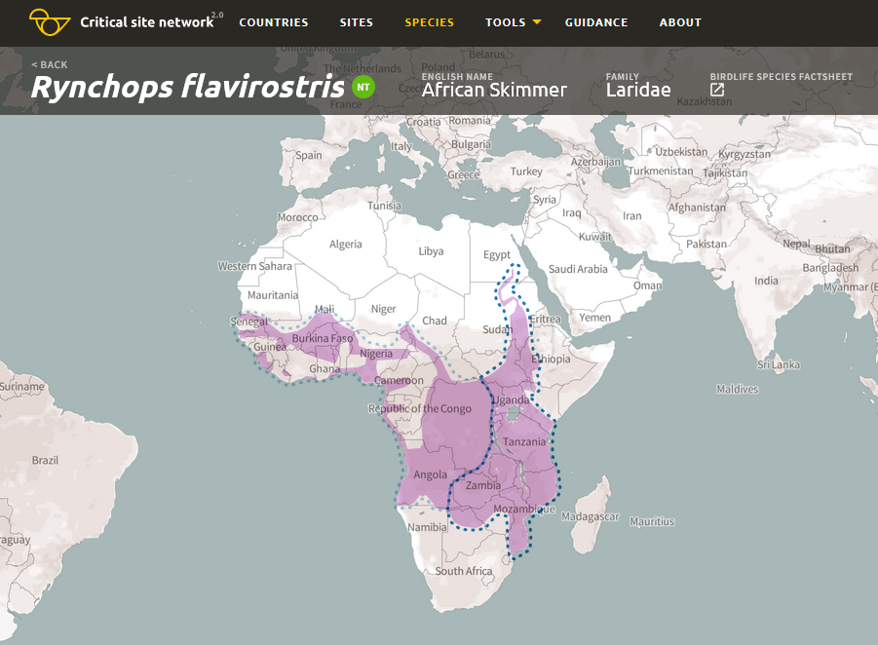

Range map of the African Skimmer (Rynchops flavirostris). Light blue dotted line – population boundaries of the Coastal West Africa and Central Africa population; Dark blue dotted line - population boundaries of the Eastern and Southern Africa population.

2. THREATS/PROBLEMS AND RECOMMENDATIONS FOR CONSERVATION ACTION

Table 1. Threats/problems and Recommendations for Conservation and Management Action

* Information in Table 1 adapted from BirdLife International threat assessment: African Skimmer (Rynchops flavirostris) - BirdLife species factsheet. Amended threat codes are highlighted in Red. These scores/ratings are for the species as a whole, while for individual populations and nationally a higher level may apply.

Threat/problem & description  (IUCN Threat Code) | Threat/problem level | Recommendation for Action
Biological resource use – Hunting & trapping terrestrial animals - Intentional use (species is the target) (5.1.1) Collection of eggs and young (including for bait) could be an important factor locally in Southern and Western Africa (Tyler 2004).  Biological resource use – Hunting & trapping terrestrial animals - Unintentional effects (species being assessed is not the target) (5.1.2) Evidence from several areas of overfishing and harvesting of fry (e.g. Namibia RDB 2015) but links not proven. | Low 5  Unknown | Better knowledge of and mapping of breeding populations and monitoring of population trends through coordinated census will better enable many of the subsequent actions  Better legal protection of and enforcement over threats to breeding colonies at national level. This should include protection of sites and of individuals. Awareness raising and community livelihood projects (All countries where evidence of impact)  Promote sustainable fishing at policy level and among communities along key rivers and lakes to protect the birds and their food source (All countries)
Human intrusions & disturbance – recreation activities (6.1) Physical disturbance by recreation boats and effects of their wash on breeding colonies – direct and through absence of birds causing egg mortality and predation (Tyler 2004)  Human intrusions & disturbance – work and communities (6.3) Damage and disturbance by people and livestock. Local sand extraction from sand bars is widespread in West Africa and could be damaging (R. Hearn pers. comm.) | Unknown  Medium 7 | Boat speed controls and zonation, awareness raising (Botswana and other areas with tourism/heavy boat traffic)  Awareness raising and protection of breeding islands, focused community livelihoods projects (All countries)
Invasive and other problematic species, genes & diseases Invasive non-native/alien species/diseases - Unspecified species (8.1.1). Introduced predatory fish may impact upon small prey fish for this species (Tyler and Stone 2000) | Unknown | Increased control of predatory alien fish. Better biosecurity policy to prevent their further spread (All countries)
Natural system modifications – dams and water management use – all types (7.2). Major impact at affected sites where dams and irrigation schemes do not identify or mitigate impacts (e.g. in Namibia RDB 2015) | Medium 7 | Identify major rivers which should be protected from damaging developments. Better EIA and mitigation of impacts on breeding areas (All countries)
Pollution – Herbicides and pesticides (9.3.3) Suggestion of toxic build-up from organo-chlorine pesticides as well as other chemical run-off polluting rivers and affecting fish (Coppinger 1998)  Pollution – soil erosion and sedimentation (9.3.2) Widespread poor agricultural management leading to decline in river quality and raised water levels flooding breeding sand bars | Unknown  Medium 7 | Remove most harmful pesticides and legislate and encourage better use (All countries)  Sustainable land management initiatives targeted to reduce erosion and protect breeding islands (All countries)
Climate Change – droughts, storms and flooding (11.2, 11.4) Unknown but mirrored by impacts due to man-induced changes to river hydrology. Breeding birds vulnerable to shifts to more extreme events where sandbars are flooded/ accessible to predation. | Unknown | Monitoring and adaptation through habitat management if possible.

3. BIOLOGICAL ASSESSMENT

Habitat
This species requires expanses of calm water for feeding (Urban et al. 1986). Breeding It breeds along broad rivers on large, dry sandbars that are largely free from vegetation (Urban et al. 1986). It sometimes breeds on sandy lake shores, and very occasionally on sandy seashores (Urban et al. 1986). Non-breeding During the non-breeding season it is more commonly found at lakes (Urban et al. 1986) and frequents coastal lagoons, saltpans, open marshes and estuaries (Urban et al. 1986, del Hoyo et al. 1996). It is less common along coasts (del Hoyo et al. 1996). Vagrant birds may use swamps and artificial habitats such as sewage ponds and dams (Urban et al. 1986).

Populations
The African Skimmer is an intra-African migrant and disperses widely after the breeding season. Its range includes major rivers and lakes south of the Sahara, Senegal east to Sudan and south-western Ethiopia south to extreme northern Namibia (Cunene River), northern Botswana, the basin of the Zambezi River and southern Mozambique (Urban et al. 1986, Zusi 1996). It occurs as a non-breeding visitor north-west to the Gambia River and on stretches of the Nile River. The largest breeding colonies rarely support more than 50 pairs but reaches of the Zambezi supported an estimated 1 428 birds in 1986/7 (Coppinger et al. 1988). The largest non-breeding flocks may be over 1,000 as recorded in Kenya and Tanzania (Britton 1980)
There are an estimated 7,000-13,000 in West and Central Africa and 8,000-12,000 in East Africa and South Africa giving a total of 15,000-25,000 individuals, roughly equivalent to 10,000-17,000 mature individuals, although these estimates are from 2001 (UNEP-AEWA 2021, BirdLife International 2022). There is no clear information on trends although the population is suspected to be in decline owing to wetland habitat degradation, over-exploitation of fishing stocks and human disturbance.
More detailed analysis is available for some countries from national atlas and can be used to target additional research and conservation action. For example: Reported from 27% of atlas squares in Zambia, 17% of atlas squares in Malawi, 16% of atlas squares in Tanzania, 12% of atlas squares in Kenya, 9% of atlas squares in Uganda, 3% of atlas squares in Ethiopia. Information from Namibia and Botswana suggests continuing declines, as does the reporting through the Southern African Bird Atlas project (Tyler 2004, SABAP2).

4. REFERENCES

BirdLife International and Handbook of the Birds of the World 2020. Bird species distribution maps of the world. Version 2020.1. Available at http://datazone.birdlife.org/species/requestdis.
BirdLife International 2022 Species factsheet: Rynchops flavirostris. Downloaded from http://www.birdlife.org
Britton PL (ed) 1980. Birds of East Africa. East African Natural History Society, Nairobi
Coppinger, M. P.; Williams, G. D.; Maclean, G. L. 1988. Distribution and breeding biology of the African Skimmer on the upper and middle Zambezi River. Ostrich 59: 85-96.
del Hoyo, J., Elliott, A., and Sargatal, J. 1996. Handbook of the Birds of the World, vol. 3: Hoatzin to Auks. Lynx Edicions, Barcelona, Spain.
Ginn, P. J.; McIlleron, W. G.; Milstein, P. le S. 1989. The complete book of southern African birds. Struik Winchester, Cape Town.
Hancock, P. 2008. African Skimmer. In: Hancock, P. (ed.), The status of globally and nationally threatened birds in Botswana, 2008., pp. 21-22. BirdLife Botswana.
Namibia Red Data Book 2015. African_Skimmer.pdf (the-eis.com)
SABAP2: Skimmer, African (birdmap.africa)
Tanzania Bird Atlas. http://tanzaniabirdatlas.net
Tyler SJ. 2004. The breeding and population status of the African Skimmer Rynchops flavirostris in Botswana. Ostrich 75(4): 329-332.
Tyler, S. J.; Stone, J. R. 2000. African Skimmers Rynchops flavirostris in Botswana. Babbler 37: 33-38.
UNEP-AEWA 2021 Report on the conservation status of migratory waterbirds in the agreement area - 8th Edition https://www.unep-aewa.org/en/document/report-conservation-status-migratory-waterbirds-agreement-area-8th-edition
Urban, E.K., Fry, C.H. and Keith, S. 1986. The Birds of Africa, Volume II. Academic Press, London.
Wetlands International Waterbirds Populations Estimates: iwc.wetlands.org/index.php/aewatrends8
Admin <i>Rynchops flavirostris</i> (African Skimmer) - Coastal West Africa & Central Africa (wetlands.org)
Admin <i>Rynchops flavirostris</i> (African Skimmer) - Eastern & Southern Africa (wetlands.org)
Wetlands International 2021. Critical Sites Network Tool 2.0 (wetlands.org)
Zusi, R. L. 1996. Rynchopidae (Skimmers). In: del Hoyo, J.; Elliott, A.; Sargatal, J. (ed.), Handbook of the birds of the world, pp. 668-677. Lynx Edicions, Barcelona, Spain.

IUCN (Red List) Threats Classification Scheme

