AEWA Species Conservation Guidance for the
Black Crowned Crane

Balearica pavonina

Agreement on the Conservation of
African-Eurasian Migratory Waterbirds (AEWA)

AEWA Species Conservation Guidance for the
Black Crowned Crane

Balearica pavonina

May 2022

Produced by the AEWA Technical Committee
Compiled by Paul Buckley

This guidance has been produced to facilitate the implementation of the
AEWA Strategic Plan 2019-2027 (Objective 1, Target 1.3)

Prepared with funding from the Department for Environment, Food and Rural Affairs, United Kingdom
Contents
SUMMARY AND FUTURE PRIORITIES 4
1. BASIC DATA 4
2. THREATS/PROBLEMS AND RECOMMENDATIONS FOR CONSERVATION ACTION 5
3. BIOLOGICAL ASSESSMENT 7
4. REFERENCES 8

SUMMARY AND FUTURE PRIORITIES

The Black Crowned Crane is classified as Vulnerable on the IUCN Red List and its population appears to have declined significantly, possibly by up to 30-49% since 1975. The two sub-species are distributed across the Sahel region of Africa from Senegal to Ethiopia and including several countries where security has limited the ability to conduct conservation work in recent years. Consequently, this is one of the least known cranes with huge gaps in knowledge concerning population trends, and key threats and necessary conservation actions. An earlier outline Action Plan was completed (Williams et al 2003) and the section on this species in the ICF Crane Conservation Strategy (Mirande and Harris 2019) gives an excellent summary of the current situation. Priority actions will include:

- Seeking a better understanding of the distribution and population size of the species wherever possible, especially in the key range states where information is currently most limited
- Through this, gaining a greater understanding of the key threats, and the possible conservation solutions to be implemented, focused on the most important breeding and flocking sites and engaging conservation authorities and local communities
- Implementing local conservation projects where security allows, for example in Senegal and in parts of Ethiopia and Chad, especially where local communities can be helped to benefit from more sustainable land use which protects important areas for this species
- Strengthen measures to prevent illegal international trade in this CITES Annex 1 species
- Harnessing national and international efforts to influence decisions on major infrastructure projects such as dams, drainage and irrigation projects and oil and gas developments
- Supporting and enabling conservation practitioners implementing projects designed to benefit this species.

1.BASIC DATA

Species name: Black Crowned Crane (Balearica pavonina)

Principal Range States (Wetlands International 2021) (those hosting breeding and/or non-breeding numbers above 1% of the biogeographic population threshold) indicated in bold (note great uncertainty over numbers and/or breeding status. This species may occur in small numbers or formerly occurred in some other adjacent states);
B.p.pavonina, West Africa (Senegal to Chad) population: Cameroon, Chad, Central African Republic, Gambia, Guinea, Guinea-Bissau, Mali, Mauritania, Niger, Nigeria, Senegal, Togo.
B.p.ceceliae, Eastern Africa (Sudan to Uganda) population: Chad, Ethiopia, Kenya, South Sudan, Sudan, Uganda.

Range map downloaded from the Critical Site Network Tool (http://criticalsites.wetlands.org)

International legal status
Global IUCN Status: Vulnerable (Criteria A4bcd) (last reviewed 2016).
AEWA Table 1: West African population (sub-species pavonina) /population A 1b, 1c
AEWA Table 1: East African population (sub-species ceceliae) /population A 1b, 1c
CITES: Annex I (since 2019).
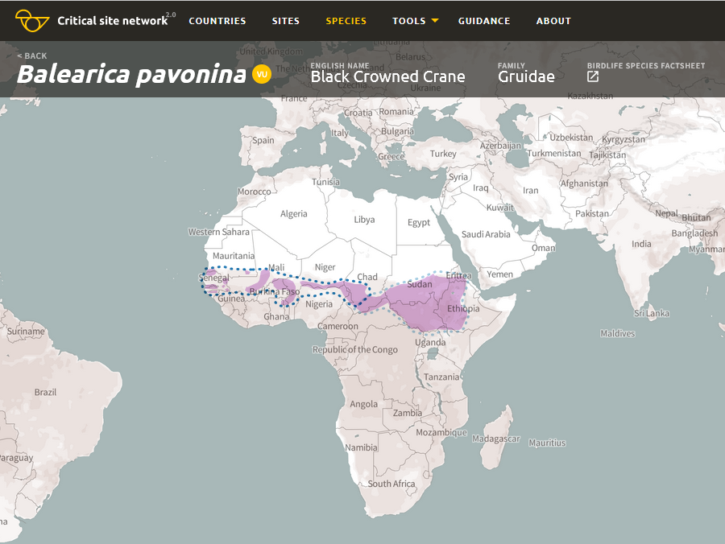

Range map of the Black Crowned Crane (Balearica pavonina). Dark blue dotted line – population boundaries of the West Africa (Senegal to Chad) population; Light blue dotted line - population boundaries of the Eastern Africa (Sudan to Uganda) population.

2. THREATS/PROBLEMS AND RECOMMENDATIONS FOR CONSERVATION ACTION

Table 1. Threats/problems and Recommendations for Action

* Information in Table 1 adapted from BirdLife International threats assessment: Black Crowned Crane (Balearica pavonina) - BirdLife species factsheet. Amended Threat codes are highlighted in in Red, based on discussions with species experts and newer information (esp. Mirande and Harris 2019). These scores/ratings are for the species as a whole while for individual populations and nationally a higher level may apply.

Threat/problem & description (IUCN threat code) | Threat/problem level | Recommendation for Action
Agriculture & aquaculture - Annual & perennial non-timber crops - Agro-industry farming (2.1.3) Small- and large-scale irrigation, drainage of wetlands and intensification of agriculture, probably occurring in much of range esp. cited in Chad and Sudan (P. Defos Du Rau pers. Comm.).  Agriculture & aquaculture - Small-holder grazing, ranching or farming (2.3.2) Habitat conversion, overgrazing and fire. | Medium 7  Medium 7 | Identification and protection of critical sites through better knowledge of breeding population and distribution. Strengthen land use policy, EIA and mitigation of impacts. Influence national policy on land use planning, habitat and species protection and sustainable agriculture (All countries)  Awareness raising, engagement and livelihoods projects involving local communities and decision makers (All countries)
Biological resource use – Intentional use (species being assessed is the target) (5.1.1) ] Main issues are probably capture for illegal bird trade and especially the practice of domestication – widely kept in W. Africa (Mirande and Harris 2019).Eggs and chicks may be taken and killed for food, adults for traditional healing. | Medium 7 | Implement laws and enforcement. Improving monitoring of capture and trade. Awareness raising with Government and communities. (All countries)
Climate change & severe weather – Droughts (11.2) Unclear impacts and CSN tool suggests limited likely impact (Wetlands International 2021). Potential direct impacts on species habitat suitability (see Hole et al 2009) and indirect impacts through people forced to migrate and/or pressure new areas of land | Low 5 | Adaptation in and around Protected Areas through programmes to promote sustainable land use and alternative livelihoods. Awareness raising and collaboration with migrant communities to safeguard key sites and reduce disturbance. (All countries)
Energy production & mining – Oil and Gas drilling (3.1) – actual or potential threat around wetlands in parts of the range. | Low 5 | Identification and protection of critical sites, better EIA and mitigation of impacts. Influence government energy and conservation policy (All countries)
Human intrusions & disturbance - war and civil unrest (6.2) Widespread across the range – can cause both direct persecution and inhibits ability to implement conservation programmes (Mirande and Harris 2019).  Work and other activities (6.3) - disturbance by livestock and people at breeding sites. | Unknown  Medium 7 | Mitigation where possible (Conflict zones). Any conservation work possible may be best implemented by supporting local NGOs/CBOs  Locally, disturbance by livestock and people at breeding sites could be reduced by community-based conservation programmes.
Natural system modifications – Dams (7.2) Both small local water supply dams and large-scale infrastructure projects.  Natural system modifications-  Increase in fire frequency/intensity (7.1.1) Fire widely used for agriculture and unintentional fire may increase due to droughts (Mirande and Harris 2019). | Low 5  Unknown | Identification and protection of critical sites, better EIA and mitigation of impacts. Influence government policy  Awareness raising, fire prevention measures in and around wetlands and other protected areas (All countries)
Pollution - Herbicides and pesticides (9.3.3)  Pollution - Industrial & military effluents (9.2) | Low 5  Low 5 | Awareness raising and enforcement of regulations. Promotion of sustainable land use projects and programmes (All countries)  Unknown

3. BIOLOGICAL ASSESSMENT

Habitat
Breeding: This species is found in wet and dry open habitats, but prefers freshwater marshes, wet grasslands, and the peripheries of water-bodies (Meine and Archibald 1996). In South Sudan it is especially found in areas with water up to one meter in depth, and knee-high to hip-high vegetation dominated by Cyperus, Eleocharis, Scirpus, Setaria, Cynodon and various leguminous and rosaceous plants (Johnsgard 1983). It always remains near wetlands, but is rarely associated with deep, open water (Urban et al. 1986). It often prefers to forage on dry ground with short grass (Johnsgard 1983) and, particularly in West Africa, it will sometimes forage and nest in upland areas (del Hoyo et al. 1996), rice fields, wet crop fields and even abandoned fields (Meine and Archibald 1996). It prefers to roost in large trees but will use small trees or shallow water when necessary (Johnsgard 1983). Non-breeding: During the non-breeding season it congregates in larger permanent wetlands, and often forages near herds of domestic livestock (del Hoyo et al. 1996, Meine and Archibald 1996) or even in rubbish dumps (Johnsgard 1983). At the end of the dry season birds may be congregated into whatever wetland remains, and occasionally very large flocks have been reported congregating. Possible further drying of the species range as a result of climate change is a concern.

Population
The West African population (sub-species pavonina) was estimated to number 5 – 15,000 individuals in 2010, and the East African population (sub-species ceciliae) is less well-known, though estimated at 28,000-55,000 individuals in 2005 (UNEP-AEWA 2021). This gives a total population estimate of 33,000-70,000 individuals.

The western sub-species (B. p. pavonina) is estimated to have declined from 15,000-20,000 individuals in 1985 to 15,000 individuals in 2004 (Beilfuss et al. 2007). Although the eastern sub-species may have undergone a more substantial decline (50,000-70,000 individuals in 1985 to 28,000-55,000 individuals in 2004), the accuracy of initial and current counts are questionable hence a trend based on these data is not advisable (Beilfuss et al. 2007, T. Dodman in litt. 2009). Therefore, based on data from B. p. pavonina populations alone, the species is estimated to have declined between 0-25% from 1985-2004. Given the uncertainty around these estimates, BirdLife provisionally estimate a worst-case decline of 30-49% over 45 years (three generations), though the true figure may be higher depending on the status of B. p. ceciliae (BirdLife International 2022).

This species is classified as Vulnerable on the IUCN Red List as recent surveys have shown a rapid population decline which is predicted to continue into the future, primarily due to habitat loss and trapping for domestication or illegal international trade. However, trend data for the eastern sub-population is poorly known. Should the worst-case scenario for B. p. ceciliae prove to be accurate, this species may warrant further up-listing in the future.

4. REFERENCES

Anon. 2013. A victory in the fight against illegal trade of crowned cranes. ICF Bugle 39 2013.
Aynalem, S.; Helm, M.; Guinness, F.; Cabot, D. 2014. Survey of Wattled and Black Crowned Crane breeding sites in Boyo and other wetlands, Ethiopia. In: Mabhachi, O. (ed.), African Cranes, Wetlands and Communities Newsletter 13, pp. 24.
Beilfuss, R.; Dodman, T.; Urban, E. K. 2007. The status of cranes in Africa in 2005. Ostrich 78(2): 175-184.
BirdLife International and Handbook of the Birds of the World 2020 Bird species distribution maps of the world. Version 2020.1. Available at http://datazone.birdlife.org/species/requestdis.
BirdLife International 2022 Species factsheet: Balearica pavonina. Downloaded from http://www.birdlife.org
BirdLife International and Durham University 2021 Species climate change impacts factsheet: pavonina. Downloaded from http://www.birdlife.org.
del Hoyo, J., Elliott, A., and Sargatal, J. 1996. Handbook of the Birds of the World, vol. 3: Hoatzin to Auks. Lynx Edicions, Barcelona, Spain.
Dodman, T.; Diop, M. S.; Ndiaye, I.; Sá, J.; Abidine, E. Z.; Fall, M. 2014. Black Crowned Crane surveys in West Africa. In: Mabhachi, O. (ed.), African Cranes, Wetlands and Communities Newsletter 13, pp. 5-11.
Hole, D.G., S.G. Willis, D.J. Pain, L.D. Fishpool, S.H.M. Butchart, Y.C. Collingham, C. Rahbek and B. Huntley 2009. Projected impacts of climate change on a continent-wide protected area network. Ecology Letters 12: 420-431.
Johnsgard, P. A. 1983. Cranes of the world. Croom Helm, London.
Kone, B.; Fofana, B.; Beilfuss, R.; Dodman, T. 2007. The impact of capture, domestication and trade on black-crowned cranes in the Inner Niger Delta, Mali. Ostrich 78(2): 195-203.
Meine, C. D. and Archibald, G. W. 1996. The cranes - status survey and conservation action plan. International Union for Conservation of Nature and Natural Resources, Gland, Switzerland, and Cambridge, U.K.
Mirande CM, Harris JT, editors. 2019. Crane Conservation Strategy. Baraboo, Wisconsin, USA: International Crane Foundation. 454 pp.
Morrison, K. 2009. Trade in Grey (Balearica regulorum) and Black Crowned (Balearica pavonina) Cranes. Report to CITES Animals Committee meeting 20 – 24 April 2009.
UNEP-AEWA 2021. Report on the conservation status of migratory waterbirds in the agreement area - 8th Edition https://www.unep-aewa.org/en/document/report-conservation-status-migratory-waterbirds-agreement-area-8th-editionUNEP-WCMC. 2005. CITES trade database.
Urban, E.K., Fry, C.H. and Keith, S. 1986. The Birds of Africa, Volume II. Academic Press, London.
Wetlands International 2021. "Waterbird Population Estimates". Retrieved from wpe.wetlands.org
iwc.wetlands.org/index.php/aewatrends8
Admin <i>Balearica pavonina</i> (Black Crowned Crane) - pavonina, West Africa (Senegal to Chad) (wetlands.org)
Admin <i>Balearica pavonina</i> (Black Crowned Crane) - ceciliae, Eastern Africa (Sudan to Uganda) (wetlands.org)
Wetlands International 2021. Critical Sites Network Tool 2.0 (wetlands.org)
Williams, E.T.C., Beilfuss, R.D. & Dodman, T. 2003. Status survey and conservation action plan for the Black Crowned Crane Balearica pavonina. Wetlands International, Dakar.
Zellelew, S.A. et al 2020. Distribution and population estimates of four crane species in Ethiopia: a global crane hotspot facing increasing threats Scopus 40(2): 1–17, July 2020.

IUCN (Red List) Threats Classification Scheme

