COMPLEMENTARY GUIDELINES ON CLIMATE CHANGE ADAPTATION MEASURES
FOR WATERBIRDS

Compiled by Szabolcs Nagy

Introduction
The Climate Resilient Flyway project coordinated by Wetlands International was launched at AEWA MOP6 in 2015. The project was funded by the International Climate Initiative of the German Federal Government and co-funded by the AEWA Secretariat through a grant provided by the Government of Luxembourg. One of the products of this project is the “Complementary guidelines on climate change adaptation measures for waterbirds” which builds on the existing AEWA MOP-approved guidelines on the topic (Conservation Guidelines No. 12 - AEWA guidelines on climate change adaptation for waterbirds; and AEWA guidance framework for climate change adaptation – Resolution 6.6) and provides a very useful additional practical guidance on planning climate change adaptation measures.
These new guidelines were compiled by Szabolcs Nagy as part of the Wetlands International’s project team, and they were used in the training organised in December 2021 in the framework of the project for Anglophone African Contracting Parties to AEWA. Following that training, the document was further developed, and a case study was added to the Annex to demonstrate the use of the various tools and the entire workflow of the planning process.
The final draft of the document was submitted to the Technical Committee for their review and consideration for approval as formal AEWA Conservation Guidelines. The Technical Committee unanimously agreed that this represents a very valuable addition to the AEWA body of guidance and that it is a quality product that can be recommended for adoption by MOP. It was forwarded to the Standing Committee which approved it by correspondence for submission to MOP8.

Action Requested from the Meeting of the Parties
The Meeting of the Parties is requested to review the draft document and consider it for adoption as formal AEWA Conservation Guidelines (see also Draft Resolution 8.8).

Table of Contents
1 Table of Contents 2
2 Executive summary 3
3 Background 4
3.1 Scope of the present guidance document 5
4 Understanding the impacts of climate change on waterbirds 7
4.1 Climate change 7
4.2 Impacts on water flow and freshwater wetlands 8
4.3 Sea-level rise 9
Stage 1: Update yourself on the impact of climate change in your country 10
5 Identifying species vulnerable to climate change 11
5.1 Climate change vulnerability assessment (CCVA) 11
6 Prioritizing key sites for climate change adaptation 13
6.1 Assessing the exposure of sites to climate change 13
6.2 Adaptation strategies within a site network 14
6.2.1 Site network for a single species 14
6.2.2 Site network for a suite of species 15
6.3 Site management strategies to increase the resistance of qualifying species 17
6.4 The landscape approach 18
6.5 Habitat management in the wider landscape 19
7 Integrating the needs of waterbirds into national climate change policies 20
7.1 Policy frameworks for climate change mitigation and adaptation 20
7.1.1 United Nations Framework Convention on Climate Change 20
7.1.2 United Nations Convention to Combat Desertification 21
7.1.3 EU Green Deal & Fit for 55 21
7.2 Nature-based solutions 22
7.3 Assessing the potential contribution of key sites to climate change mitigation and adaptation 23
7.4 Minimising the impact of renewable energy on AEWA species 23
8 References 25
Appendix I Study the available climate models 29
Appendix II Freshwater flow and inundation changes on the CSN Tool 2.0 32
Appendix III Identify the key sites or regions for AEWA populations 37
Appendix IV Projected range changes for a species 34
Appendix V Appendix 3. Projected changes in the suitability of a Critical Site for its qualifying species 39
Appendix VI Impact of climate change on site suitability 40

Executive summary

Climate change is already affecting waterbird species listed in Annex 2 of AEWA and modelling studies predict further changes. Climate change is a phenomenon that requires co-ordinated measures from the Parties of AEWA and has been addressed by a series of AEWA resolutions and it is the subject of the AEWA Conservation Guidelines No. 12 published in 2008. This document aims to complement that conservation guideline document and the Updated advice on climate change adaptation measures for waterbirds adopted by AEWA Resolution 6.6 in 2015.

This guidance document focuses on providing practical guidance to AEWA Parties on the use of the new information sources on the impacts of climate change, the Critical Site Network Tool 2.0 developed as part of the Climate Resilient Flyway project supported by the German International Climate Initiative to support the on the ground implementation of AEWA Resolution 6.6 at national and at site level. Therefore, it leads the reader through a stepwise process organised in five stages:
- Review the impact of climate change on biodiversity in your country;
- Assess the vulnerability of AEWA species to climate change in your country;
- Assess the vulnerability of Critical Sites to climate change in your country;
- Identify climate change adaptation measures to support AEWA populations at their key sites or in the wider landscape;
- Integrate the needs of waterbirds into national climate change mitigation and adaptation policies.

Application of the tools developed under Climate Resilient Flyway project are illustrated on the example of the Verloerenvlei Estuary, South Africa, in a series of annexes at the end of the document.

Climate change is already affecting many waterbird species negatively. As successful adaptation depends on strengthening waterbird populations at the areas that are still suitable for them now, no-regret conservation actions should be taken as soon as possible even based on incomplete knowledge. This document primarily aims to help countries Parties with limited resources to understand the impacts of climate change on their waterbird populations and key sites and start planning and implementing climate change adaptation measures in a pro-active manner integrating the adaptation of climate change adaptation for waterbirds into broader national climate change adaptation and mitigation policies.

Background

Climate change is already affecting the waterbird species listed on AEWA (Amano et al., 2020; Brommer et al., 2012; Maclean et al., 2008) and modelling studies predict further changes depending on the climate change scenarios applied (BirdLife International & Durham University, 2009; BirdLife International & Wetlands International, 2018; Breiner et al., 2021; Huntley et al., 2007; Nagy et al., 2021).

Although climate change is not explicitly mentioned in the AEWA Agreement text, the obligations to address climate change arise from Article II of the Agreement which states that “Parties shall take co-ordinated measures to maintain migratory waterbird species in a favourable conservation status or to restore them to such a status” and Article III which requires Parties to “… investigate problems that are posed or are likely to be posed by human activities and endeavour to implement remedial measures, including habitat rehabilitation and restoration, and compensatory measures for loss of habitat”.

AEWA Resolution 3.17 (AEWA, 2005) has instructed the Technical Committee to assess the current evidence of the effects of climate change and to develop Conservation Guidelines on possible adaptation measures. In response to this, a BTO Research Report (Maclean et al., 2007a) was presented to MOP4 which has reviewed the available knowledge on climate change and its impacts on waterbirds in the Agreement area. This report has also presented the results of a trait-based sensitivity assessment of AEWA species and populations. In AEWA Resolution 4.14 (AEWA, 2008), the MOP has called on Range States to take actions and requested the Technical Committee to assess whether existing international networks of sites are sufficient for the protection of migratory waterbirds. In addition, it has adopted the AEWA Conservation Guidelines No. 12 on measures needed to help waterbirds to adapt to climate change (Maclean & Rehfisch, 2008).

AEWA Conservation Guidelines No. 12 recommends a simple five-step process to implement climate change adaptation measures:
- Identify Parties to be involved in implementing species-based, sites-based, regional, national and international measures to help waterbirds to adapt to climate change
- Identify species and populations most at risk from climate change and identify priority measures
- Prepare priority list of key sites most at risk from climate change and identify priority adaptation measures
- Prepare priority list of key national, regional, and international measures for helping waterbirds adapt to climate change
- Implement climate change adaptation management measures.

AEWA MOP5 in 2012 adopted Resolution 5.13 on Climate change adaptation measures for waterbirds in 2012 (AEWA, 2012a). Appendix I of the resolution sets out an AEWA guidance framework for climate change adaptation. This framework has been updated by Resolution 6.6 on Updated advice on climate change adaptation measures for waterbirds in 2015 (AEWA, 2015b). The main elements of this guidance framework are summarised in Figure 1. Appendix I of the framework provides links to other guidance documents produced by the Ramsar Convention on Wetlands, the Convention on Migratory Species, and others.

Figure 1. AEWA framework for climate change adaptation for waterbirds as adopted by Resolution 6.6.
Between 2015 and 2021, Wetlands International and its partners implemented the Climate Resilient Flyway project supported by the German International Climate Initiative. This project has focused on helping the practical implementation of the AEWA guidance on climate change adaptation by influencing national policies and carrying out site actions at demonstration sites in Mali and Ethiopia, assessing the climate change exposure of migratory waterbirds and their key sites across the agreement area and making this information accessible to Contracting Parties through the Critical Site Network Tool 2.0.

Scope of the present guidance document

This guidance document complements the existing AEWA Conservation Guidelines No. 12 and the updated guidance framework (2015) by focusing on (1) how the Critical Site Network Tool 2.0 can be used to identify species and (2) sites most at risk from climate change, (3) designing climate change adaptation measures for individual sites taking account of their context at the site-network scale, and for the site network as a whole, plus (4) integrating the needs of waterbirds into national climate change adaptation policies. To assist planning climate change adaptation for AEWA populations, each main section ends with a couple of steps organised in five stages:
- Review the impact of climate change on biodiversity in your country;
- Assess the vulnerability of AEWA species to climate change in your country;
- Assess the vulnerability of Critical Sites to climate change in your country;
- Identify climate change adaptation measures to support AEWA populations at their key sites or in the wider landscape;
- Integrate the needs of waterbirds into national climate change mitigation and adaptation policies.

Each of these stages are illustrated with practical examples from the Verlorenvlei Estuary, South Africa, in a series of appendices at the end of the document. These examples were developed at the AEWA training workshop on climate change adaptation on 13–16 December 2021 by Bronwyn Maree and Mashua Tebogo (with input from Giselle Murison). The Verlorenvlei estuary was used to illustrate the potential impacts of climate change as set out in Section 6.1; however, some of the possible climate change impacts are more relevant to Verlorenvlei than others, and participants in the AEWA training workshop did not have the necessary background material, or knowledge of the system to develop accurate or complete assessments of the estuary. Therefore, the example of Verlorenvlei should be taken more as a means of illustrating the scope of the model, rather than purporting facts about this Critical Site. For this to be an accurate assessment of the Verlorenvlei estuary, a wide range of experts would need to be consulted (e.g.: Estuary Advisory Forum). This disclaimer applies to the information provided in Appendices VII-IX.

Understanding the impacts of climate change on waterbirds

Waterbirds and their habitats are expected to be affected by a number of changes driven by climate change:
- Changes in temperature throughout the year;
- Changes in seasonality;
- Changes in rainfall and drought;
- Changes in timing and duration of inundation of inland wetlands;
- Sea-level rise.

Many of these changes will affect waterbirds indirectly through the availability of their habitats, morphology, genetics, behaviour including their phenology, their interspecific interactions such as their predator-prey relationship, competition, distribution and abundance. In case of migratory waterbirds, another important consideration is how these changes affect the connectivity of sites between the breeding and non-breeding areas. Maclean et al. (2007a) have already provided an overview of the current and future effects of climate change in the Agreement area based on the information that was available at that time. The key elements of that description are still valid, but more up-to-date reviews are available in Cox (2010) and Pearce-Higgins & Green (2014). Therefore, these descriptions are not repeated here, but we highlight additional information sources that Parties, and other stakeholders may want to consult.

Climate change

The future impact of climate change is studied through climate change scenarios. The future climate is projected based on various general circulation models (GCMs) which are driven by several future projections of greenhouse gas (GHG) concentrations (Representative Concentration Pathways, RCPs) based on projected global socio-economic changes called Shared Socio-economic Pathways (SSPs). Using different SSPs and RCPs allows assessing the consequences of different development scenarios, while the different GCMs represent different understandings of how a certain level of climate forcing translates into climatic changes in different parts of the World. For example, these different scenarios can be used to compare the consequences of keeping the increase of global temperature at around 1.5°C or allowing a larger increase.

Besides the global climate change models there are ongoing efforts to downscale these global models into regional climate change models under the framework of the Coordinated Regional Climate Downscaling Experiment (CORDEX).

New global datasets available on climatic parameters:
- WorldClim 2 (Fick & Hijmans, 2017): spatially interpolated monthly climate data for global land areas at very high spatial resolution (1 km²) including monthly temperature (minimum, maximum and average), precipitation, solar radiation, vapour pressure, wind speed aggregated across. The historical period covers 1970–2000. The predictions are averages for four 20-years periods of 2021–2040, 2041–2060, 2061–2080 and 2081-2100 based on nine GCMs and for four SSPs. In addition, 19 bioclimatic variables are also available. Bioclimatic variables are aggregations of the WorldClim values that might be biologically more meaningful.
- CMCC-BioClimInd (Noce et al., 2020): this global dataset provides a set of 35 bioclimatic variables at 0.5° resolution (the same as the scale of the future predictions of WorldClim 2) for a historical period (1960–1999) and an ensemble of 11 simulations under two RCPs.

The synthesis of the latest scientific knowledge is summarised in the IPCC’s Sixth Assessment Report. The report of Working Group I on the physical science bases of climate change is also supported by an interactive atlas. For how to use the IPCC’s interactive atlas to understand the impact of climate change in your context, see Appendix I.

Impacts on water flow and freshwater wetlands

Climate change will affect wetlands not only because of changes in local temperature and precipitation but through more complex interactions between water extraction and land use upstream. Global water models (Telteu et al., 2021) try to capture these complex interactions, but are unable to assess how this may affect the inundation of areas which is highly relevant in the context of waterbird habitats. The Critical Site Network Tool 2.0 (CSN2.0) makes available the summarised results of the modelling of the projected changes in the rivers and lakes under RCP6 using two GCMs (Anand, 2018; Nagy et al., 2021). For how to look up changes in freshwater flow and inundation length in the CSN2.0 tool, see Appendix II.

Based on this modelling work, we can expect longer inundation (flooding) periods in most of Northern and Western Europe, in West Siberia and in Eastern Africa, while the inundation periods are projected to become shorter in the Mediterranean, Asia Minor, Western and Southern Africa (Figure 2).
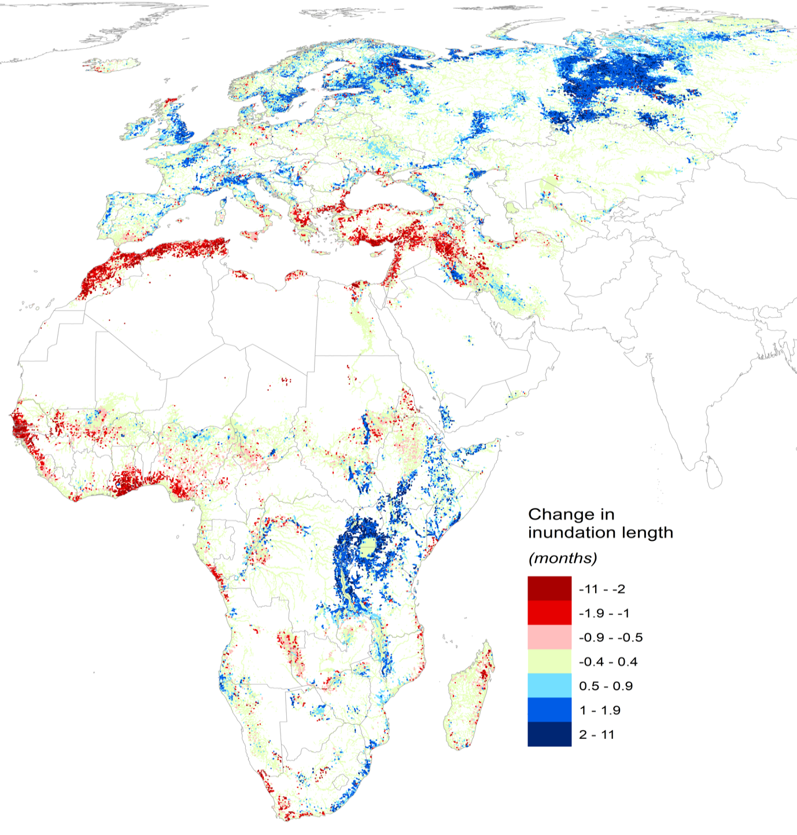
Figure 2. Modelled change in average inundation duration length in wetlands between baseline and the year 2050. The results shown are predicted inundation changes for two climate model results (HadGEM2-ES and IPSL-CM5A-LR) using the Representative Concentration Pathway RCP 6.0, averaged at the original 500m resolution. The inundation changes visualized in this map are the average predicted inundation duration change within a 5km radius of all wetland pixels (ie. only pixels experiencing some inundation and excluding dryland pixels.) Source: (Anand, 2018).

Sea-level rise

The global mean sea level (GMSL) is rising at an accelerating rate. Currently, the main driver of this is the melt of the glaciers. In the future, however, thermal expansion will become the main factor (Oppenheimer et al., 2019).

The Global Intertidal Change Tool shows the change already happening in distribution of tidal flats between 1984 and 2014 based on satellite images.

The NASA’s Sea Level Projection Tool provides access to spatially explicit future projections of the magnitude of sea-level rise under different climate change scenarios for various decades in the future.

The Climate Central’s Coastal Risk Screening Tool helps visualising the areas that are under flood risk from sea level rise and flooding. The flooded areas might be overestimated in areas where no information was available on sea defence and water management infrastructure (e.g. in the Netherlands or the Senegal Delta). It is also important to note that this tool is designed to assess flood risk to properties. However, it can also inform screening where conditions might be suitable for the development of new intertidal habitats in the future.

Stage 1: Update yourself on the impact of climate change in your country at your site(s)
1. Study available climate models. How will temperature, precipitation, and evapotranspiration in your country under different climate change scenarios? The simplest way to do this is to use the IPCC’s Interactive Atlas (9Appendix I), but you can use WorldClim 2.0 or CMCC-BioClimInd if you have GIS or R programming ability in your team.

2. Study the hydrological models. The simplest way is through the Critical Site Network Tool (9Appendix II).

Identifying species vulnerable to climate change

The first step in the process of developing targeted climate change adaptation measures is assessing the vulnerability of species to climate change. Foden et al. (2019) provides a review and guidance on this matter and it is summarised below.

In this context, the vulnerability means an overall measure of concern. This is determined by the species’ exposure (i.e. extrinsic pressures that affect it as the consequence of climate change, e.g. heath stress, loss of habitat), its sensitivity (i.e. intrinsic factors that moderate and/or exacerbate the impact of pressures such as specialised habitat requirements, environmental tolerances, dependence on environmental triggers, dependence on interspecific interactions, rarity, sensitive life history, high exposure to other pressures) and its adaptive capacity (i.e. the capability to adjust to climate change including the variability and extremes of climate, to respond to the consequences such as phenotypic plasticity, dispersal ability and evolvability).

Climate change vulnerability assessment (CCVA)

The CCVA is a systematic assessment that tries to answer the following questions:
- What impacts are climate changes already having?
- What is likely to happen in the future?
- Which species, habitats and regions are most at risk from climate change?

The main steps of a CCVA are summarised in Figure 3. For further details see Foden et al. (2019) and additional guidance in Pacifici et al. (2015).

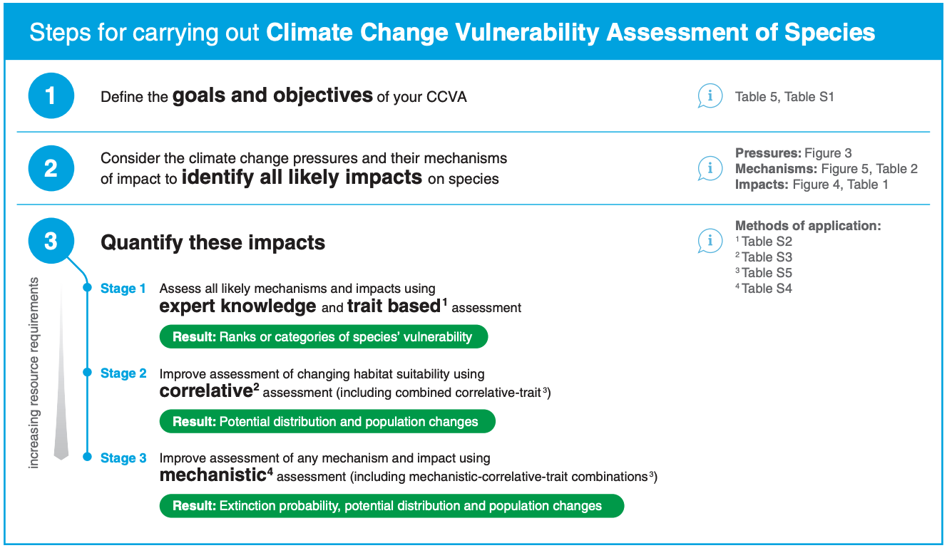
Figure 3. The main steps in a CCVA process. Source: Foden et al. (2019).
In the context of AEWA, a simple trait-based assessment was produced by Maclean et al. (2007b) taking into account only population size, range extent and fragmentation, habitat association and food specialisation. Although these are all important traits, other traits might be also important to consider (Foden et al., 2019). For further details on trait-based ecology see de Bello et al. (2021).

Nagy et al. (2021) has produced a correlative assessment for most AEWA species using five bioclimatic variables (Bio 1: annual mean temperature, Bio 2: mean diurnal range, Bio 12: annual precipitation, Bio 14: precipitation of the driest month, Bio 15: precipitation seasonality), three hydrological parameters (extent of permanently and seasonally inundated areas, spatial variability of inundation), terrain roughness and extent of urbanised areas. The results of these species distribution models (SDMs) are available on the Critical Site Network Tool 2.0 and further guidance on how to extract and use this information is provided in Appendix III. Species distribution modelling in the context of climate change adaptation has a subject of many publications, but for a practical introduction to species distribution modelling in the context of climate change see Guisan & Zimmerman (2017).

A complementary species vulnerability assessment is being produced for seabirds in Northwest Europe by the London Zoological Society.

Stage 2: Assess the vulnerability of AEWA species to climate change in your country or at your site
1. Carry out a quick screening of the climate change exposure of AEWA populations in your country. As a minimum, use the vulnerability scores from Maclean et al. (2007b) to assess sensitivity and the projected species/population distribution changes from the Critical Sites Network 2.0 (see 9Appendix III), but you may embark on your own trait-based and correlative assessment if capacity and funding is available. If you have many AEWA populations, it is suggested to focus on the ones listed in Categories 1 and 4 of Column A (Annex 3 to the Agreement) and on the populations your country is supporting a substantial part of (>5%) in either season.

2. Produce a ranked list of vulnerable AEWA populations in your country or at your site.

Prioritizing key sites for climate change adaptation

The distribution of AEWA species is already changing in response to the changing climatic conditions both in Europe (Amano et al., 2020; Johnston et al., 2013; Lehikoinen et al., 2013; Maclean et al., 2008) and Africa (Smith et al., 2017a, 2017b; Underhill & Brooks, 2016; Underhill et al., 2016a, 2016b). Because of changing distribution of waterbirds, the importance of key sites is also changing (Gaget et al., 2020; Johnston et al., 2013; Pavón‐Jordán et al., 2015) and it is recognised that management of such sites also must adapt to the impacts of climate change (AEWA, 2012b, 2015b; ALTERRA et al., 2014; Gross et al., 2016; Stein et al., 2014).

However, site managers can adapt to climate change by either trying to prevent change or accept change (Tanner-McAllister et al., 2017). The former may include managing change and building resistance, applying soft or hard engineering solutions while the latter may include modifying existing systems that fit better the new climatic environment, manage change by building resilience or by doing nothing (and accepting loss).

Changing environment conditions represent a paradigm shift for protected area managers. Managing for change and not “just” for persistence will become increasingly important (Gross et al., 2016; Stein et al., 2014). As well-managed protected areas will have an increasingly important role in facilitating the adaptation of species to changing climatic conditions, it will be even more important than before to manage sites in the context of regional site networks and landscapes (Franks et al., 2016; Hole et al., 2011; Hole et al., 2009).

Because of the gradually changing environmental conditions, the management objectives of the sites will need to be regularly adapted (Figure 4).

Figure 4. A proposed process of managing sites as part of a site network in the context of climate change

Assessing the exposure of sites to climate change
Understanding how a site is likely to be exposed to climate change should be the first step towards taking decisions concerning its future management.
- It starts with clarifying what the key conservation features of the site are (e.g. why is it identified as a key site, i.e. why it is protected?).
- How will be these features affected by climate change? This includes identifying and prioritizing the change in the physical (e.g. sea-level rise) and biological (e.g. food availability) conditions in relation to the key conservation features of the site, its consequences and the subsequent ecological outcome for the conservation features.

In its simplest form, this can be based on simple logical deductions as shown on Figure 5. If the future suitability of a site is also modelled for the key species, it might be possible to extract from the models what parameters are likely to drive the reduction of suitability locally (see some examples in Figure 18).

Figure 5. Assessing the impact of climate change using the example of sea-level rise. Based on Franks et al. (2016).

The Critical Site Network Tool 2.0 can be used not only to identify how Critical Sites are projected to be affected by hydrological changes (Appendix II), but it is also possible to see how their suitability is projected to change for their qualifying species (Appendix V).

If you have modelled data for a site, you can also use the response plots of the climate model to identify the factors that might be the most influential. See an example using the data presented on the Critical Site Network Tool 2.0 in Appendix VI.

Adaptation strategies within a site network

A site network for a single species

In the context of a single species, it is important to consider how the importance of sites will change for the species with climate change over time. In case of a business-as-usual scenario, it is assumed that GHG emission continue to increase, and the mean temperature also continue to rise. This means that the suitability of sites is also going to change over time (Figure 6):
- Sites along the trailing edge of the range are likely to become climatically less suitable in the future. However, birds respond directly to habitat and food availability and less so to temperature or precipitation. Hence, there is some room to maintain suitable feeding and habitat conditions with appropriate management and protected areas represent good buffers against the impact of climate change (Lehikoinen et al., 2019; Lehikoinen et al., 2021; Santangeli et al., 2017; Virkkala et al., 2014; Virkkala & Rajasärkkä, 2012; Virkkala et al., 2018). Investing into the management of these sites is particularly important if models indicate that the species or population is likely to suffer a range contraction as the result of climate change.
- Sites in the current range that is projected to remain suitable represent the strongest foundations for the future conservation of the species or population. These need to be identified and protected. Ideally, these sites should even act as source populations to colonise areas that become suitable with climate change.
- Sites along the leading edge of the species range might become suitable. Dispersal of waterbirds can be relatively easily accommodated if a sufficiently large and heterogenous network of protected areas is maintained and the management of these sites is responsive to the need of colonising species (Gaget et al., 2020; Pavón‐Jordán et al., 2015).

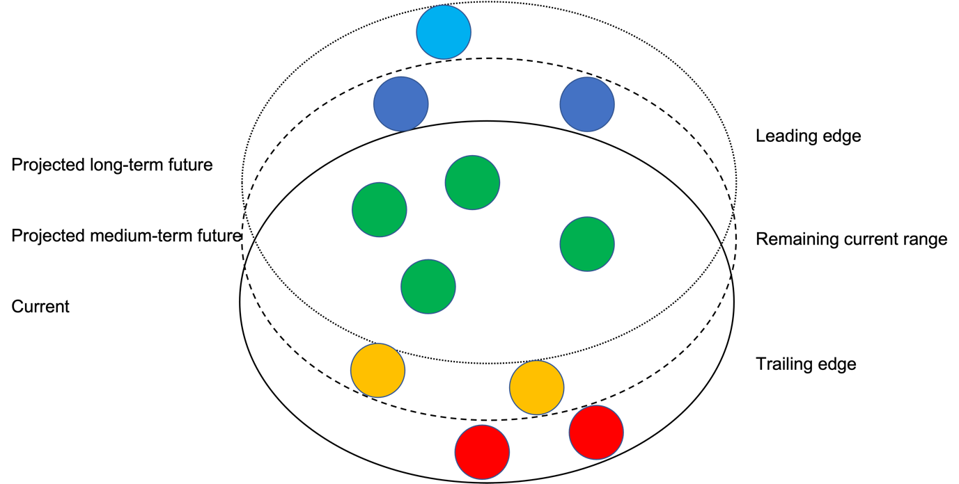
Figure 6. Schematic illustration of the distribution of a single species and the projected changes in the suitability of its key sites (Based on Figure 7.4 in Pearce-Higgins & Green, 2014with modifications).
Key sites identified for a single species can be looked up for any species on the Critical Site Network Tool 2.0 (Appendix 3).

A site network for a suite of species

As shown earlier, species already respond to climate change by changing their distribution depending on their own environmental tolerances. This means that certain species will “emigrate” from some of the sites where they currently occur as they become unsuitable and can “colonise” certain new sites that become suitable. Species that remain at the site can be called “persistent” species.

Based on the proportion of projected number of emigrants compared to the number of projected colonists, Hole et al. (2011) proposed a set of climate change adaptation strategies for sites which are summarised in Figure 7:
- Sites where the proportion of both emigrating and colonising species are low and the proportion of persistent species is high require management for resilience focusing on the persistent species.
- At sites with a high proportion of emigrant species the management should focus on increasing resistance and quickly boosting the populations of species that are likely to emigrate in the future.
- Sites where both the proportion of emigrating and colonising species are high are characterised by high (species) turnover. At such sites the site management should both boost the populations of emigrants and facilitate the transformation of habitats to support projected colonists.
- Sites where the proportion of projected emigrants is relatively low while the number of potential colonists is relatively high are projected to have an increasing value for conservation in the future. At these sites management should focus on maintaining viable populations of persistent species while facilitate the transformation of habitats to support projected colonists.
- At sites with intermediate proportions of emigrating, colonising and persistent species, the goal of site management can encompass management for resistance, resilience and/or for facilitation.

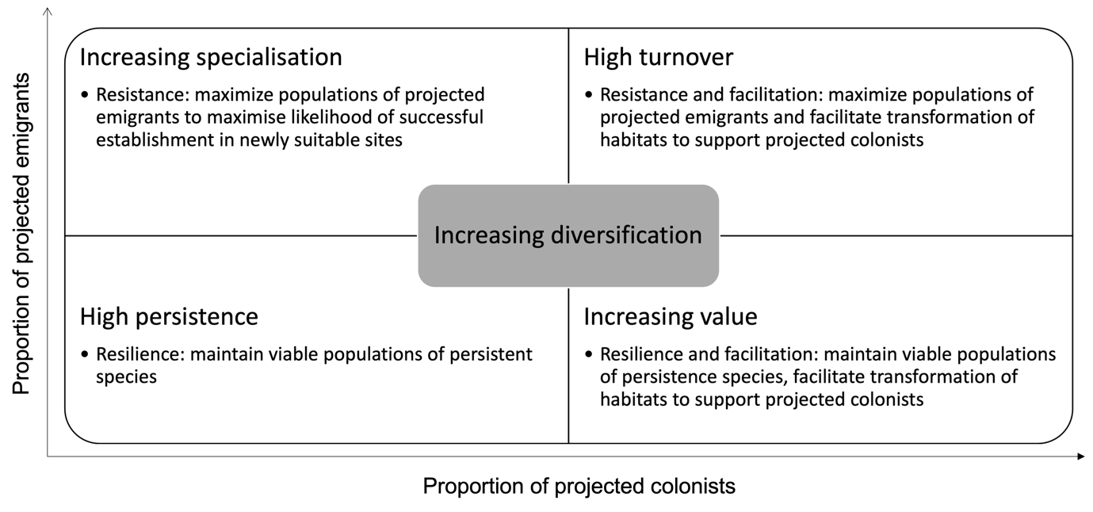
Figure 7. Climate changed adaptation categories based on proportion of projected emigrant and colonist species. (Source: Hole et al., 2011).
Habitat restoration for persistent species is desirable at sites that fall into the high persistence CCAS category, and restoration for projected emigrants is high priority at sites classified as increasing specialisation. Habitat restoration and creation is also a high priority at sites with high turnover or with increasing value. At these sites, the management need to balance the restoration of habitats for emigrants (in case of the former) or persistent species (in case of the latter) with the need of creating new habitats suitable for projected colonists.

Managing disturbance regimes (e.g. fire, flood and grazing) is high priority at sites in the increasing specialisation, high turnover and increasing value categories. In case of the former, it is important to inhibit habitat succession if that benefits the emigrants while in the latter two case it requires balancing the requirements of emigrants or persistent species with the requirements of colonists.
Increasing the extent of sites is high priority at sites in the high turnover and increasing value CCAS categories because more space is needed to accommodate potentially conflicting habitat management needs.

Breiner et al. (2021) have applied the above framework to Critical Sites for waterbirds identified in the AEWA Agreement Area (Figure 8). Their results suggests that most Critical Sites in Africa and the arid zones of Southwest Asia fall into the increasing specialisation CCAS category because species distribution in these arid regions is more influenced by precipitation than by temperature (Amano et al., 2020; Nagy et al., 2021). In the meantime, while most Critical Sites in the European Union fall into the high persistence (mostly in Northwest Europe) or increasing value (mainly in Fennoscandia and the Baltic) categories. This is primarily driven by the shift of the wintering areas further northeast as winters are getting milder. High turnover and increasing value are also characteristic for sites in Eastern Europe and Central Asia indicating a substantial redistribution of bird populations there also mainly in winter.

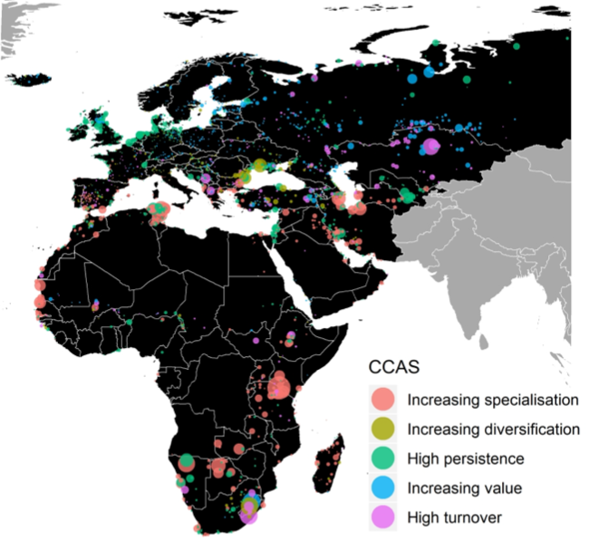
Figure 8. Climate Change Adaptation Strategy (CCAS) categories for existing Critical Sites for waterbirds (red: ‘increasing specialisation’; olive: ‘increasing diversification’; green: ‘high persistence’; blue: ‘increasing value’; purple: ‘high turnover’; see Fig. S 11 for details). Larger circles represent higher site importance, calculated by summing for each site the product for each species of (1) its IUCN Red List category (Least Concern = 1; Near Threatened = 2; Vulnerable = 3; Endangered = 4; Critically Endangered = 5), (2) the proportion of its flyway population supported by the site, (3) the proportional change in its modelled range size, and (4) the proportional change in its habitat suitability at the site.

Site management strategies to increase the resistance of qualifying species

Climate change adaptation measures at sites will be most challenging in case of species or populations that are projected to suffer large contraction of their current range and have little or no scope of expanding their current range. Amongst the AEWA species, this is the case for most Afrotropical species and for many of the Arctic breeding wader species in the breeding season (Nagy et al., 2021). In case of these species management that increases the resistance of key sites to the impact of climate change are particularly important. Pearce-Higgins & Green (2014) distinguish two broad categories of management that aims to increase resistance: counteracting and compensatory management.

Counteracting management aims at reversing the change in external conditions that have negative impacts on the demographic rates of a species that cause the population decline because of climate change. Examples of counteracting management include blocking drainage channels to improve food supply for Eurasian Golden Plover and thus maintain its chick survival, creating alternative breeding sites for Black-tailed Godwit to counteract increasing flood risk at the Ouse Washes in the UK. Other typical examples of counteracting management are addressing water shortages by restoration of natural flow or water retention capacity or control of invasive species (Pearce-Higgins & Green, 2014).

Compensatory management accepts that climate change may have negative impact on the species, but it compensates for this through other management action that cancels out the negative influence of the change. It may even affect other demographic rate than what is causing the decline of the species. Examples include predator control improving breeding success of Golden Plover or closing fisheries in the vicinity of Kittiwake colonies (Pearce-Higgins & Green, 2014).

Most wetlands sites are also part of a larger hydrological system and can be managed only as part of that system. For example, the water supply of Lake Abijatta, Ethiopia, comes from the neighbouring Lake Ziway. Water extraction for irrigation in that catchment reduces the water supply to Lake Abijatta. A valid climate change adaptation strategy can be reducing the water extraction for irrigation by promoting more water efficient irrigation methods, promoting the cultivation of crops that require less water, increasing the water retention capacity of the catchment through afforestation. Likewise, the water supply of the Inner Niger Delta, one of the largest Ramsar sites in Africa, crucially depends on the management of the Niger River and its tributaries upstream. Therefore, most wetlands need to be managed using the landscape approach rather than as a separated site.

The landscape approach

The landscape approach represents a conceptual framework whereby stakeholders in a landscape aim to reconcile competing social, economic and environmental objectives. A landscape approach aims to ensure a full range of local level needs are met, while also considering goals of stakeholders, such as national governments or the international community. The 4 returns framework for landscape restoration combines methodologies developed by leading organisations working on landscape management and restoration.

The 4 Returns Framework connects ecology, community values, spirit and culture, and long-term economic sustainability at the landscape level. The approach allows people from across the spectrum — government, business and communities — to co-create and deliver a common vision for a resilient landscape. Together, a diverse community can start imagining how a landscape can become sustainable, liveable and financially attractive to as many people as possible. It is a conceptual and practical framework that aims to help stakeholders achieve 4 returns, by following five processes (the 5 elements), within a multifunctional landscape (the 3 zones). This transformative approach takes place over a realistic time period (minimum 20 years). The process recognises the importance of: inclusive governance and the role of laws and policies; of finance to fund the transition to landscape restoration; and the importance of markets, to ensure the long-term security of sustainable enterprises (Dudley et al., 2021). For further details see the reference and a case study for its application to the Verlorenvlei Estuary in Appendix VIII.

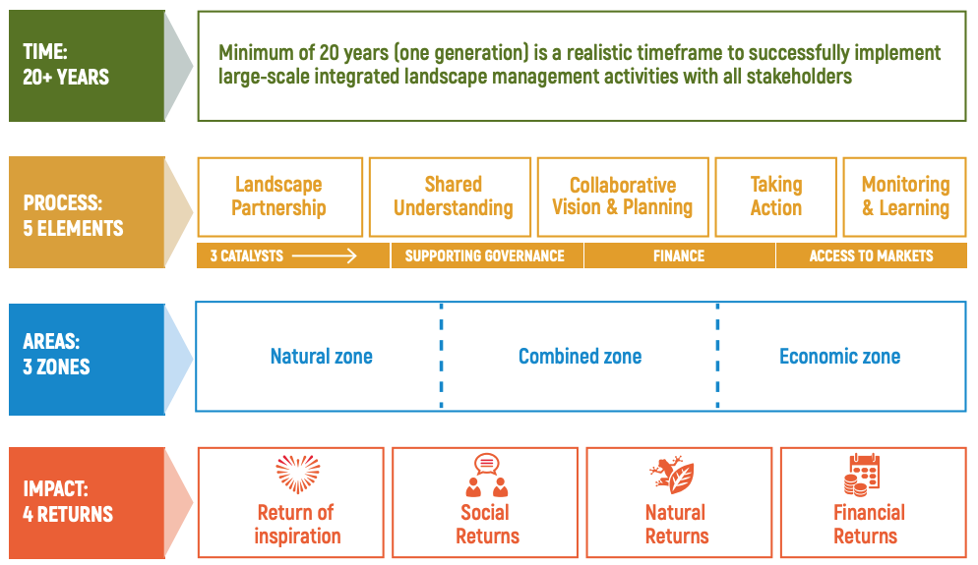
Figure 9. Components of the 4 returns framework for landscape restoration. Based on Dudley et al. (2021).

Habitat management in the wider landscape

Creating and managing additional habitats to act as stepping stones or corridors between larger protected areas is an important element of various CCAS (Hole et al., 2011). However, this might be less crucial for many AEWA species as these are capable of migrating over large distances and there is little evidence that habitat fragmentation has limited the response of birds to climate change (Pearce-Higgins & Green, 2014). However, many waterbird species are dispersed breeders and only a small proportion of their populations are covered by key sites meeting criteria of international importance (Nagy et al., 2021). However, these species are also exposed to the impacts of climate change. Very often climate change would exacerbate the impact of already existing threats such as agriculture intensification, land use changes or drainage. In most cases mitigating other existing threats can contribute strongly to counteract or compensate the impact of climate change. In some other cases, bird conservation considerations can be integrated into more general nature-based solutions deployed for other societal benefits (e.g. carbon sequestration, flood protection, coastal defence, see more details in Chapter 7.2).

Stage 3: Identify climate change adaptation measures to support AEWA populations at their key sites or in the wider landscape
1. Identify the key sites or regions for each of the AEWA populations, but in particular for the priority ones, in your country (9Appendix IV).

2. Based on monitoring data and models, assess the on-going and projected changes in the distribution and site use of waterbird populations. Are any sites becoming more or less important (e.g. see Step 9 in Appendix III)? How is and likely to change the role of the sites in the site network?

3. In consultation with site managers, assess the potential impacts of climate change at each site or landscape. Information from the SDMs can inform such reviews (Appendix VI).

4. In consultation with site managers and other stakeholders identify alternative strategies to counteract or compensate the impacts of climate change at the site or at landscape or regional level (Appendix VII).

5. Assess the consequences of these alternative strategies in the context of the coherence and comprehensiveness of the site network for the AEWA species both at national and at population level.

Integrating the needs of waterbirds into national climate change policies

Climate change presents a wide range of challenges not only for waterbirds but also for human populations. This includes effects on the human health through direct effects caused by heat waves, air pollution and weather disasters and indirect effects mediated by climate such as diseases, crop yields and marine productivity and its diffuse effects can lead to impoverishment, displacement, or conflicts over water resources. Increased frequency of draught, floods, sea-level rise threaten the life and livelihood of billions of people.

Responses to climate change include both mitigation and adaptation measures. Mitigation measures focus on reducing GHG emission. This includes replacing fossil fuel with renewable energy sources including wind, hydro- and solar power, biofuel, etc. Some of these represent direct threats to AEWA species or to their habitats and the issue has been addressed in AEWA Resolution 6.11 and in van der Winden et al. (2015) .

Another approach to mitigation focuses on increasing carbon sequestration which aims to capture and store carbon in carbon sinks such as forests (by protecting existing forests, promoting afforestation, reforestation and proforestation), protection of other carbon rich habitats such as inland (such as peatlands) and coastal (sea grass, mudflats, salt marshes, mangroves) wetlands, preventing permafrost leak. These efforts can be well linked with the conservation of habitats for waterbirds (see Chapters 7.2 and 7.3).

Climate change adaptation aims to reduce the risk to the society. Adaptation can include structural and physical adaptation through engineering, technology or ecosystem-based approaches, social adaptation, and institutional adaptation. Some forms of structural and physical adaptation may represent risks to waterbird habitats (e.g. water diversion, land grab, engineered flood protection), while ecosystem-based adaptation may offer new opportunities for their conservation.

Policy frameworks for climate change mitigation and adaptation

National climate change policies are primarily driven by the United Nations Framework Convention on Climate Change (UNFCCC) with contributions from the United Nations Convention to Combat Desertification in Those Countries Experiencing Serious Drought and/or Desertification, Particularly in Africa (UNCCD).

United Nations Framework Convention on Climate Change

The UNFCCC has entered into force in 1994. It aims to stabilise GHG concentrations in the atmosphere at level that would prevent dangerous anthropogenic interference with the climate systems. It also states that such levels should be achieved within a timeframe sufficient to allow ecosystems to adapt naturally to climate change, to ensure that food production is not threatened and to enable sustainable economic development.

Under the Paris Agreement each country must outline its post-2020 climate mitigation actions in the Nationally Determined Contributions (NDCs). Countries were requested to submit their NDCs by 2020 and every five years thereafter. Each successive NDC shall represent enhanced ambitions.

Under the Cancun Adaptation Framework, developing countries formulate and implement National Adaptation Plans (NAPs). These identify medium- and long-term adaptation needs and implementing strategies and programmes to address those needs.

AEWA species are mainly associated with inland wetlands (including peatlands), coastal, intertidal and neritic marine habitats as well as with grasslands. Peatlands, mangroves and other wetlands are also important carbon sinks and thus they contribute to climate change mitigation. In addition, wetlands also play an important role in the ecosystem-based adaptation to climate change. Conserving and restoring wetlands can positively contribute to countries NDCs and it can also attract funding from carbon offsetting schemes.

United Nations Convention to Combat Desertification

The UNCCD came into force in 1994 and it is the sole international treaty linking environment and development to sustainable land management. Its objective is to combat desertification and mitigate the effects of drought through integrated strategies that focus on improved productivity of land and the rehabilitation, conservation and sustainable management of land and water resources. General obligations of parties include adopting integrated approached to address the physical, biological and socio-economic aspects of desertification and draught and to promote cooperation in the field of environmental protection and the conservation of land and water resources as they relate to desertification and drought.

It works through national, subregional and regional action programmes. Four out of the five regional annexes concern the AEWA Agreement Area: I. Africa, II. Asia, IV. Northern Mediterranean and V. Central and Eastern Europe (CEE). National action programmes have been developed already for most African, Asian and Eastern European countries.

Potential synergies with the AEWA objectives relate to water resource management in the context of sustainable irrigation and drought preparedness and how wetlands can be integrated into this. A major initiative is the Great Green Wall launched in 2007. It stretches 8,000 km in 20 countries of the Sahel from Dakar, Senegal, to Djibouti. The intervention areas already selected in 11 countries cover 156 million hectares. Another, even broader initiative of the Land Degradation Neutrality (LDN) aims that land degradation is avoided and reduced and partial degradation is compensated. This process is supported through LDN target setting and the LDN Fund which is an impact investment fund to support the restoration of degraded land applying the landscape approach.

EU Green Deal & Fit for 55

The European Green Deal for the European Union aims to transform the EU into a fair and prosperous society and to protect and enhance the EU’s natural capital and it is the EU’s strategy to implement the sustainable development goals. Its headline policies include reducing the EU’s GHG emission towards 55% of the 1990 levels (Fit for 55). The new EU Biodiversity Strategy includes ambitious targets for nature restoration focusing especially on carbon reach ecosystems such as forests, peatlands and other wetlands. It is expected that after the adoption of the EU Natura Restoration legislation, each Member States will have to produce a National Nature Restoration Plan which will identify priorities and resourcing. This offers some new opportunities for integrating the requirements of AEWA species also into these ecosystem restoration projects.

The African Union’s Climate Change and Resilient Development Strategy and Action Plan 2020 - 2030
The overall objective of the Africa Climate Change Strategy, is to achieve the Agenda 2063 Vision by building the resilience of the African continent to the negative impacts of climate change and attain SDG 13 by taking urgent action to combat climate change and its impacts.

The strategy acknowledges that climate change is projected to decrease biodiversity and wetland regions leading to loss of soil and trees and the possible proliferation of zoonoses. A degraded ecosystem often results in a substantial increase in vulnerability as a result of the loss of critical ecosystem services. Further, climate change is already modifying the frequency and intensity of many weather-related hazards as well as steadily increasing vulnerability and eroding the resilience.

The Strategy calls upon the AU Commission and REC Secretariats to develop implementation plans, projects, budgets and mobilize resources to ensure the objectives and results of this Strategy are attained, mainstreaming climate change into other initiatives and programmes and partnerships development, coordination and harmonization.

Nature-based solutions

The increasing need for climate change mitigation, climate change adaptation and other societal challenges combined with the biodiversity crisis provided a strong impetus to the emergence of the concept of nature-based solutions (NbS). IUCN (Cohen-Shacham et al., 2016) defines NbS as: “Actions to protect, sustainably manage and restore natural or modified ecosystems that address societal challenges effectively and adaptively, simultaneously providing human well-being and biodiversity benefits”.

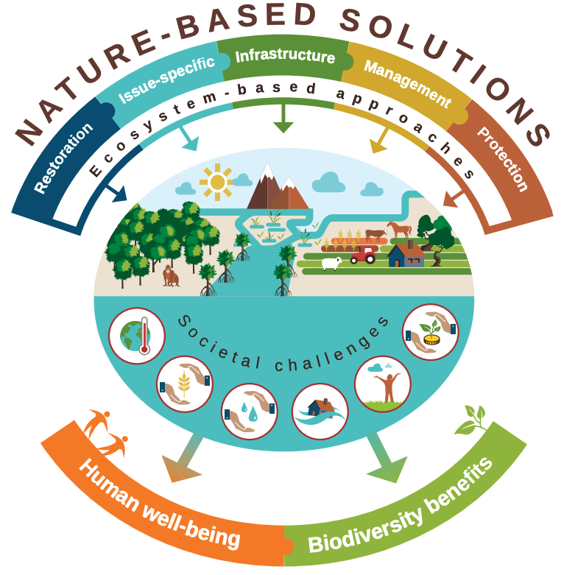
Figure 10. Nature-based solutions as an umbrella concept for various approaches such as ecosystem restoration (e.g. ecological restoration, ecological engineering), issue-specific approaches (e.g. ecosystem-based adaptation, ecosystem-based mitigation), infrastructure (e.g. green infrastructure), ecosystem-based management (e.g. integrated coastal zone management, Integrated water resources management) and ecosystem protection (area-based conservation including protected areas) to address societal challenges (such as climate change, food security, water security, disaster risk management, human health and conservation) for human well-being and biodiversity.
There are many different NbS approaches depending on their focuses. They include ecosystem-based mitigation (EbM, e.g. REDD+), ecosystem-based adaptation (EbA), climate adaptation services (CAS), ecosystem-based disaster risk reduction (Eco-DRR), green infrastructure (GI), eco-engineering (including building with nature, BwN). As the IUCN Standard for NbS (IUCN, 2020) requires that they result in net benefit for biodiversity, such approaches may offer potential benefits also for AEWA species. In the context of the conservation of AEWA species, there are clear synergies with various forms of natural climate buffers (NCB,) that contribute to carbon sequestration (carbon sinks), protection against coastal erosion, sea-level rise (bio-builders) and flood protection (living coasts against sea water as well as natural “sponges” and blue-green spaces against inland water).

Assessing the potential contribution of key sites to climate change mitigation and adaptation

Key sites for AEWA species form part of a site network not only for waterbirds but also act as nodes of the green infrastructure supporting biodiversity conservation, climate change mitigation and adaptation and providing multitudes of other ecosystem services.

The Toolkit for Ecosystem Service Site-based Assessment (TESSA) provides a framework to assess the ecosystem service delivery from individual sites (e.g. Important Bird and Biodiversity Areas, Key Biodiversity Areas, Critical Sites, or any other site) and how the provision of these services may change under alternative land-use decisions or interventions . It is freely available.

Minimising the impact of renewable energy on AEWA species

The need to reduce GHG emission represents a strong business case for the development of renewable energy such as bioenergy, geothermal energy, hydropower, wave and tidal energy, solar and wind energy. However, some of these may present some risks to AEWA species (e.g. additive mortality caused by wind farms) and their habitats (e.g. in particular bioenergy). The impacts of these technologies on migratory species and guidelines on their sustainable deployment are presented in the publications resulting from a joint assignment commissioned by the Convention on Migratory Species (CMS), AEWA and the BirdLife International UNDP/GEF Migratory Soaring Birds project (van der Winden et al., 2015; van der Winden et al., 2014) and was adopted by AEWA Resolution 6.5 (AEWA, 2015a). The resolution calls upon Contracting Parties to utilise these guidelines both at the strategic and project level.

Under the same UNDP/GEF project, BirdLife International has developed a Soaring Bird Sensitivity Mapping Tool that can help screening wind energy projects for soaring birds in the Mediterranean.

Besides the CMS, AEWA and BirdLife International guidelines, the European Commission has developed a series of guidelines concerning the Natura 2000 network and renewable energy covering wind energy, solar, geothermal and ocean energy and a manual to assist wildlife sensitivity mapping. Besides these specific guidelines, there are also generic guidelines what EU Member States are expected to follow in the context of managing Natura 2000 sites and when planning new developments.

Stage 4: Integrate the needs of waterbirds into national climate change mitigation and adaptation policies
1. What are the provisions of your country’s NDC, NAPs for climate change adaptation and to combat desertification and drought?

2. When will be these plans revised and how can you engage with the revision process?

3. Identify climate change adaptation and mitigation measures that could be beneficial or harmful to AEWA species, especially the priority ones.

4. Identify the areas that are sensitive to potentially harmful mitigation or adaptation measures.

5. Identify the ecosystem services provided by each key site/regions, especially in relation to climate change mitigation and adaptation including carbon sequestration, renewable energy, water and food security, flood protection (Appendix IX).

6. Identify opportunities to integrate the requirements of AEWA species into nature-based solutions inside and outside of current key sites and regions.

7. If there is little experience with the landscape approach in your country, identify a site/landscape to demonstrate it.

8. Develop plans for upscaling the landscape approach to other landscapes. Identify key stakeholders and training needs, secure resources.

9. Develop steps to integrate of the requirements of AEWA species into national plans.

References
AEWA. (2005). Resolution 3.17: Climate change and migratory waterbirds. Bonn: UNEP/AEWA Secretariat Retrieved from https://www.unep-aewa.org/sites/default/files/document/res3_17_climate_change_0.pdf
AEWA. (2008). Resolution 4.14: The effects of climate change on migratory waterbirds. Bonn: UNEP/AEWA Secretariat Retrieved from https://www.unep-aewa.org/sites/default/files/document/res4_14_climate_change_final_0.pdf
AEWA. (2012a). Climate Change Adaptation Measures of Waterbirds. Bonn: UNEP/AEWA Secretariat Retrieved from https://www.unep-aewa.org/sites/default/files/document/res_5_13_climate_change_0.pdf
AEWA. (2012b). Resolution 5.13: Climate Change Adaptation Measures of Waterbirds. Bonn: UNEP/AEWA Secretariat Retrieved from https://www.unep-aewa.org/sites/default/files/document/res_5_13_climate_change_0.pdf
AEWA. (2015a). Resolution 6.5: Revision and adoption Conservation Guidelines. Bonn: UNEP/AEWA Secretariat Retrieved from https://www.unep-aewa.org/sites/default/files/document/aewa_mop6_res5_cons_guidelines_en.pdf
AEWA. (2015b). Resolution 6.6. Updated advice on climate change adaptation measures for waterbirds. Bonn: UNEP/AEWA Secretariat Retrieved from https://www.unep-aewa.org/sites/default/files/document/aewa_mop6_res6_climatechange_en.pdf
AEWA. (2018). AEWA Strategic Plan 2019-2027. Bonn: AEWA Secretariat Retrieved from https://www.unep-aewa.org/sites/default/files/document/aewa_tc15_inf_3_aewa_sp_2019-2027_en.pdf
AEWA. (2019). Agreement Text and Annexes: As amended at the 7th Session of the Meeting of the Parties to AEWA 4 - 8 December 2018, Durban, South Africa. Bonn: UNEP/AEWA Secretariat Retrieved from https://www.unep-aewa.org/sites/default/files/basic_page_documents/agreement_text_english_final.pdf
AEWA Technical Committee. (2019). Preliminary proposal for an inventory framework of internationally and nationally important sites. Doc AEWA/TC 15.17. Bonn: UNEP/AEWA Secretariat, Retrieved from https://www.unep-aewa.org/sites/default/files/document/aewa_tc15_17_preliminary_proposal_inventory_framework_internationally_and_nationally_important_sites_en.pdf
ALTERRA, Directorate-General for Environment (European Commission), & EUROSITE. (2014). Guidelines on climate change and Natura 2000: Dealing with the impact of climate change, on the management of the Natura 2000 network of areas of high biodiversity value (Technical Report 2013-68, Issue. E. Union. https://op.europa.eu/en/publication-detail/-/publication/59c03f44-f672-4f61-bbf7-5422479cf6bb
Amano, T., Székely, T., Wauchope, H. S., Sandel, B., Nagy, S., Mundkur, T., . . . Sutherland, W. J. (2020). Responses of global waterbird populations to climate change vary with latitude. Nature Climate Change, 1-6.
Anand, M. (2018). The future of flood-prone areas in Africa and Europe: predicting changing inundation patterns under climate change.
BirdLife International, & Durham University. (2009). Projecting the impacts of climate change. http://datazone.birdlife.org/species/climatechangemaps
BirdLife International, & Wetlands International. (2018). Critical Sites Network Tool 2.0
Breiner, F. T. A., MiraButchart, Stuart H.M., Flörke, MartinaFluet-Chouinard, EtienneGuisan, AntoineHilarides, LammertJones, Victoria R. Kalyakin, Mikhail Lehner, Bernhard, van Leeuwen, M., Pearce-Higgins, J. W., Voltzit, O., & Nagy, S. (2021). Setting priorities for climate change adaptation of Critical Sites in the Africa-Eurasian waterbird flyways. Global Change Biology. https://doi.org/https://doi.org/10.1111/gcb.15961
Brommer, J. E., Lehikoinen, A., & Valkama, J. (2012). The breeding ranges of Central European and Arctic bird species move poleward. PLoS One, 7(9), e43648. https://doi.org/10.1371/journal.pone.0043648
Cohen-Shacham, E., Walters, G., Janzen, C., & Maginnis, S. (2016). Nature-based solutions to address global societal challenges (IUCN: Gland, Switzerland, Issue. https://portals.iucn.org/library/sites/library/files/documents/2016-036.pdf
Cox, G. W. (2010). Bird migration and global change. Island Press.
de Bello, F., Carmona, C. P., Dias, A. T., Götzenberger, L., Moretti, M., & Berg, M. P. (2021). Handbook of trait-based ecology: from theory to R tools. Cambridge University Press.
Dudley, N., Baker, C., Chatterton, P., Ferwerda, W., Gutierrez, V., & Madgwick, J. (2021). The 4 returns framework for landscape restoration. UN Decade on Ecosystem Restoration Report. Commonland, Wetlands International, WWF Landscape Finance Lab, IUCN Commission on Ecosystem Management.
Fick, S. E., & Hijmans, R. J. (2017). WorldClim 2: new 1‐km spatial resolution climate surfaces for global land areas. International journal of climatology, 37(12), 4302-4315.
Foden, W. B., Young, B. E., Akçakaya, H. R., Garcia, R. A., Hoffmann, A. A., Stein, B. A., . . . Huntley, B. (2019). Climate change vulnerability assessment of species. WIREs Climate Change, 10(1), e551. https://doi.org/https://doi.org/10.1002/wcc.551
Franks, S. E., Pearce-Higgins, J. W., Ausden, M., & Massimino, D. (2016). Increasing the Resilience of the UK’s Special Protection Areas to Climate Change – overview and key messages (Natural England Commissioned Reports, Issue.
Gaget, E., Pavón‐Jordán, D., Johnston, A., Lehikoinen, A., Hochachka, W. M., Sandercock, B. K., . . . Bino, T. (2020). Benefits of protected areas for nonbreeding waterbirds adjusting their distributions under climate warming. Conservation Biology.
Gross, J. E., Watson, J., Welling, L., & Woodley, S. (2016). Adapting to climate change. Best Practice Protected Area Guidelines Series(24).
Guisan, A., Thuiller, W., & Zimmermann, N. E. (2017). Habitat suitability and distribution models: with applications in R. Cambridge University Press.
Hole, D. G., Huntley, B., Arinaitwe, J., Butchart, S. H., Collingham, Y. C., Fishpool, L. D., . . . Willis, S. G. (2011). Toward a management framework for networks of protected areas in the face of climate change. Conservation Biology, 25(2), 305-315.
Hole, D. G., Willis, S. G., Pain, D. J., Fishpool, L. D., Butchart, S. H., Collingham, Y. C., . . . Huntley, B. (2009). Projected impacts of climate change on a continent‐wide protected area network. Ecology letters, 12(5), 420-431.
Huntley, B., Green, R. E., Collingham, Y. C., & Willis, S. G. (2007). A climatic atlas of European breeding birds. Durham University, The RSPB & Lynx Edicions.
IUCN. (2020). Global Standard for Nature‐based Solutions. A user‐friendly framework for the verification, design and scaling up of NbS. In. Gland, Switzerland: IUCN.
Johnston, A., Ausden, M., Dodd, A. M., Bradbury, R. B., Chamberlain, D. E., Jiguet, F., . . . Ockendon, N. (2013). Observed and predicted effects of climate change on species abundance in protected areas. Nature Climate Change, 3(12), 1055-1061.
Lehikoinen, A., Jaatinen, K., Vähätalo, A. V., Clausen, P., Crowe, O., Deceuninck, B., . . . Keller, V. (2013). Rapid climate driven shifts in wintering distributions of three common waterbird species. Global change biology, 19(7), 2071-2081.
Lehikoinen, P., Santangeli, A., Jaatinen, K., Rajasärkkä, A., & Lehikoinen, A. (2019). Protected areas act as a buffer against detrimental effects of climate change—Evidence from large‐scale, long‐term abundance data. Global change biology, 25(1), 304-313.
Lehikoinen, P., Tiusanen, M., Santangeli, A., Rajasärkkä, A., Jaatinen, K., Valkama, J., . . . Lehikoinen, A. (2021). Increasing protected area coverage mitigates climate-driven community changes. Biological Conservation, 253, 108892.
Maclean, I., Austin, G. E., Rehfisch, M. M., Blew, J., Crowe, O., Delany, S., . . . Laursen, K. (2008). Climate change causes rapid changes in the distribution and site abundance of birds in winter. Global Change Biology, 14(11), 2489-2500.
Maclean, I., & Rehfisch, M. (2008). Guidelines on the measures needed to help waterbirds adapt to climate change. AEWA Secretariat.
Maclean, I. M. D., Rehfisch, M. M., Delany, S., & Robinson, R. A. (2007a). The Effects of Climate Change on Migratory Waterbirds within the African-Eurasian Flyways (BTO Research Report No. 486, Issue. https://www.unep-aewa.org/sites/default/files/document/mop4_27_climate_change_report_0.pdf
Maclean, I. M. D., Rehfisch, M. M., Delany, S., & Robinson, R. A. (2007b). The Effects of Climate Change on Migratory Waterbirds within the African-Eurasian Flyways (BTO Research Report, Issue. https://www.unep-aewa.org/sites/default/files/document/mop4_27_climate_change_report_0.pdf
Nagy, S., Breiner, F. T., Anand, M., Butchart, S. H., Flörke, M., Fluet-Chouinard, E., . . . Kalyakin, M. (2021). Climate change exposure of waterbird species in the African-Eurasian flyways. Bird Conservation International, 1-26.
Noce, S., Caporaso, L., & Santini, M. (2020). A new global dataset of bioclimatic indicators. Scientific data, 7(1), 1-12.
Oppenheimer, M., Glavovic, B., Hinkel, J., van de Wal, R., Magnan, A. K., Abd-Elgawad, A., . . . Ghosh, T. (2019). Sea level rise and implications for low lying islands, coasts and communities.
Pacifici, M., Foden, W. B., Visconti, P., Watson, J. E., Butchart, S. H., Kovacs, K. M., . . . Akçakaya, H. R. (2015). Assessing species vulnerability to climate change. Nature Climate Change, 5(3), 215-224.
Pavón‐Jordán, D., Fox, A. D., Clausen, P., Dagys, M., Deceuninck, B., Devos, K., . . . Keller, V. (2015). Climate‐driven changes in winter abundance of a migratory waterbird in relation to EU protected areas. Diversity and Distributions, 21(5), 571-582.
Pearce-Higgins, J. W., & Green, R. E. (2014). Birds and climate change: impacts and conservation responses.
Pearce-Higgins, J. W., Green, R. E., & Green, R. (2014). Birds and climate change: impacts and conservation responses.
Santangeli, A., Rajasärkkä, A., & Lehikoinen, A. (2017). Effects of high latitude protected areas on bird communities under rapid climate change. Global change biology, 23(6), 2241-2249.
Smith, C. C., Underhill, L. G., & Brooks, M. (2017a). Bird distribution dynamics 11-the storks of South Africa, Lesotho and Swaziland. Biodiversity Observations, 8, 17: 11-33.
Smith, C. C., Underhill, L. G., & Brooks, M. (2017b). Bird distribution dynamics 13-the grebes of South African, Lesotho and Swaziland. Biodiversity Observations, 8, 21: 21-14.
Stein, B. A., Glick, P., Edelson, N., & Staudt, A. (2014). Climate-smart conservation: putting adaption principles into practice (0615997317). https://www.nwf.org/~/media/PDFs/Global-Warming/2014/Climate-Smart-Conservation-Final_06-06-2014.pdf
Tanner-McAllister, S. L., Rhodes, J., & Hockings, M. (2017). Managing for climate change on protected areas: An adaptive management decision making framework. Journal of environmental management, 204, 510-518.
Telteu, C.-E., Müller Schmied, H., Thiery, W., Leng, G., Burek, P., Liu, X., . . . Gosling, S. N. (2021). Understanding each other's models: a standard representation of global water models to support improvement, intercomparison, and communication.
Underhill, L. G., & Brooks, M. (2016). Bird distribution dynamics 2-Maccoa Duck Oxyura maccoa In South Africa, Lesotho and Swaziland. Biodiversity Observations, 1-8.
Underhill, L. G., Gómez, M. L., & Brooks, M. (2016a). Bird distribution dynamics 3-African Spoonbill Platalea alba in South Africa, Lesotho and Swaziland. Biodiversity Observations, 1-6.
Underhill, L. G., Gómez, M. L., & Brooks, M. (2016b). Bird distribution dynamics 4-Glossy Ibis Plegadis falcinellus in South Africa, Lesotho and Swaziland. Biodiversity Observations, 1-7.
van der Winden, J., van Vliet, F., Patterson, A., & Lane, B. (2015). Renewable Energy Technologies and Migratory Species: Guidelines for sustainable deployment. Bonn: UNEP/AEWA Secretariat Retrieved from https://www.unep-aewa.org/sites/default/files/document/mop6_37_draft_renewable_energy_guidelines.pdf
van der Winden, J., van Vliet, F., Rein, C., & Lane, B. (2014). Renewable Energy Technology Deployment and Migratory Species: an Overview. Abu Dhabi: International Renewable Energy Agency Retrieved from https://www.unep-aewa.org/sites/default/files/document/mop6_38_renewable_energy_review_0.pdf
Virkkala, R., Pöyry, J., Heikkinen, R. K., Lehikoinen, A., & Valkama, J. (2014). Protected areas alleviate climate change effects on northern bird species of conservation concern. Ecology and Evolution, 4(15), 2991-3003.
Virkkala, R., & Rajasärkkä, A. (2012). Preserving species populations in the boreal zone in a changing climate: contrasting trends of bird species groups in a protected area network. Nature Conservation, 3, 1.
Virkkala, R., Rajasärkkä, A., Heikkinen, R. K., Kuusela, S., Leikola, N., & Pöyry, J. (2018). Birds in boreal protected areas shift northwards in the warming climate but show different rates of population decline. Biological Conservation, 226, 271-279. https://doi.org/10.1002/ece3.3328

Appendices

Study the available climate models

There are many different data sources on climate change. Here we only present the use of the IPCC’s Interactive Atlas (https://interactive-atlas.ipcc.ch/) as it is available for everyone and it does not require GIS or R programming skills.

Regional information can be accessed through the regional information tab (marked with 1 on Figure 11).

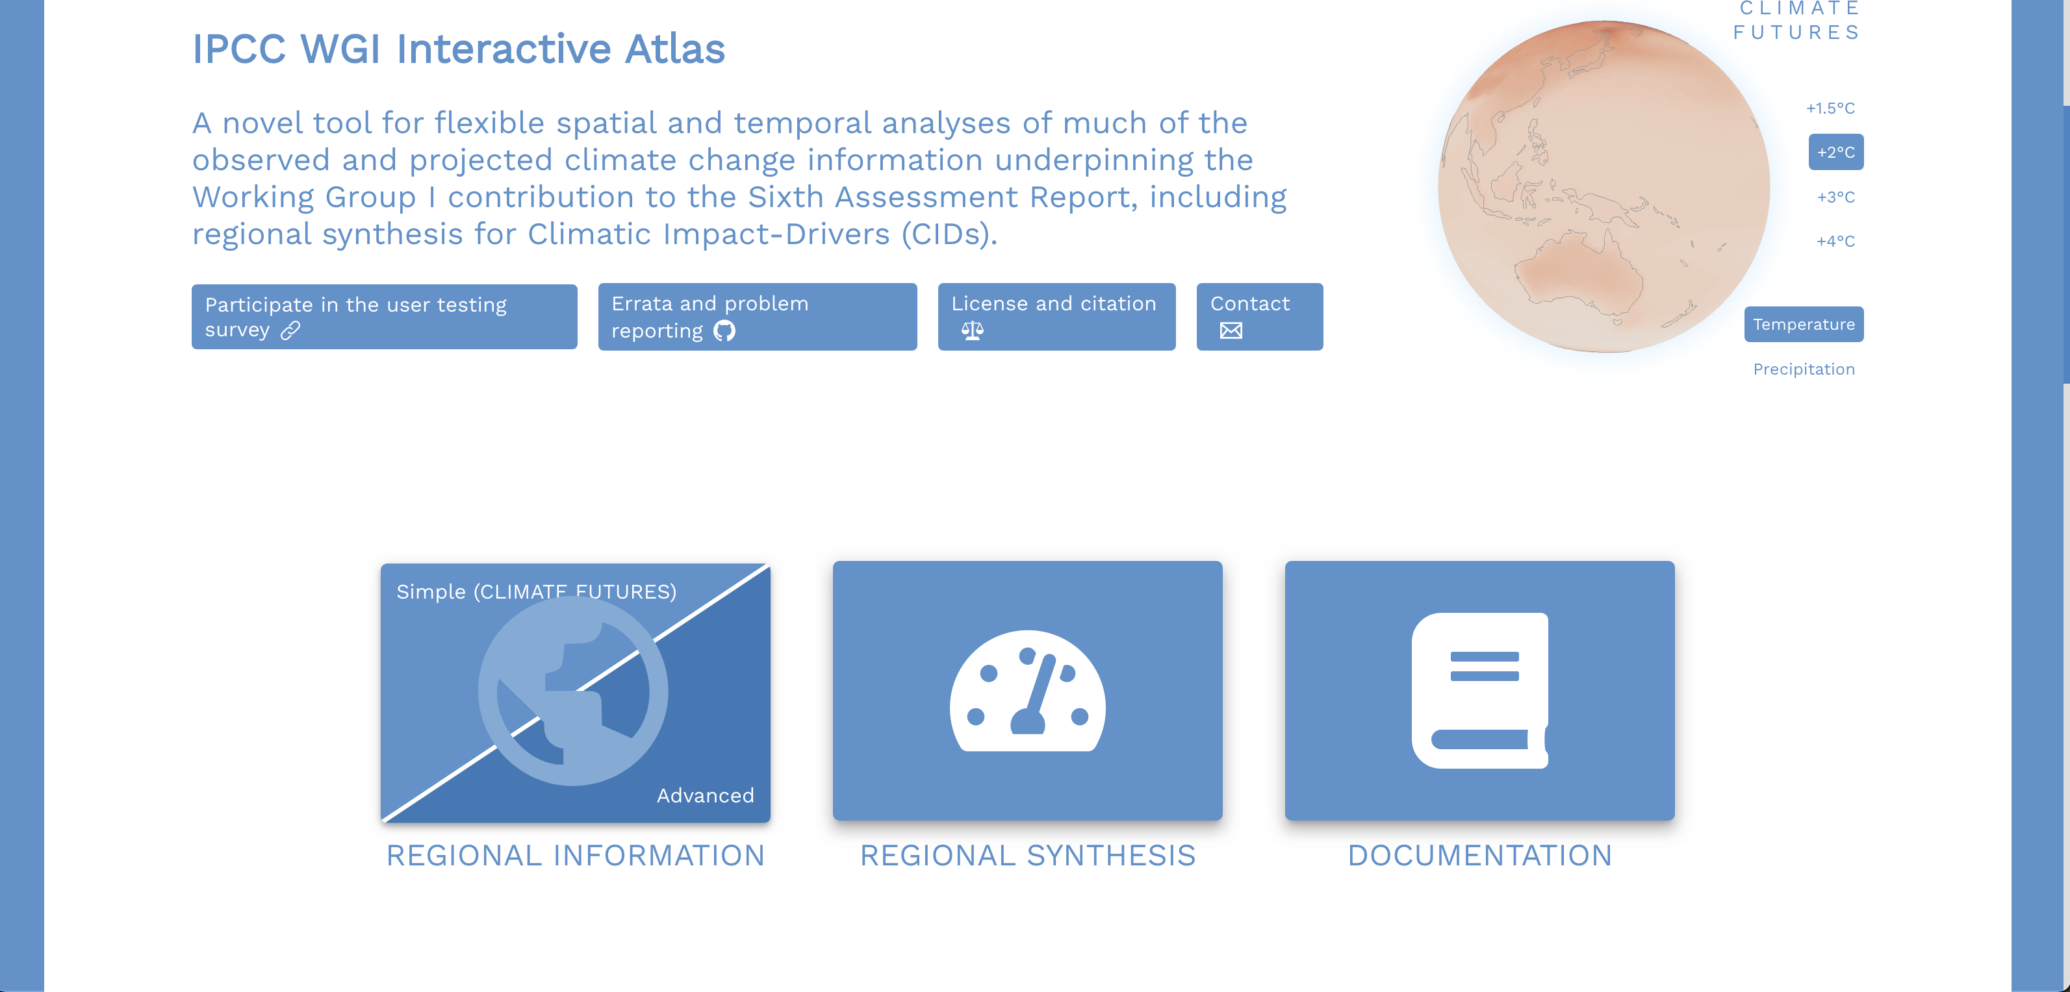
1
Figure 11. Starting page of the IPCC's Interactive Atlas.
Clicking on the Advanced option allows the investigation of the projections of many datasets (Figure 12) for several ecologically relevant climatic parameters (Figure 13) for different time periods, scenarios in comparison to various baselines (Figure 14) for the entire year or for various seasons.

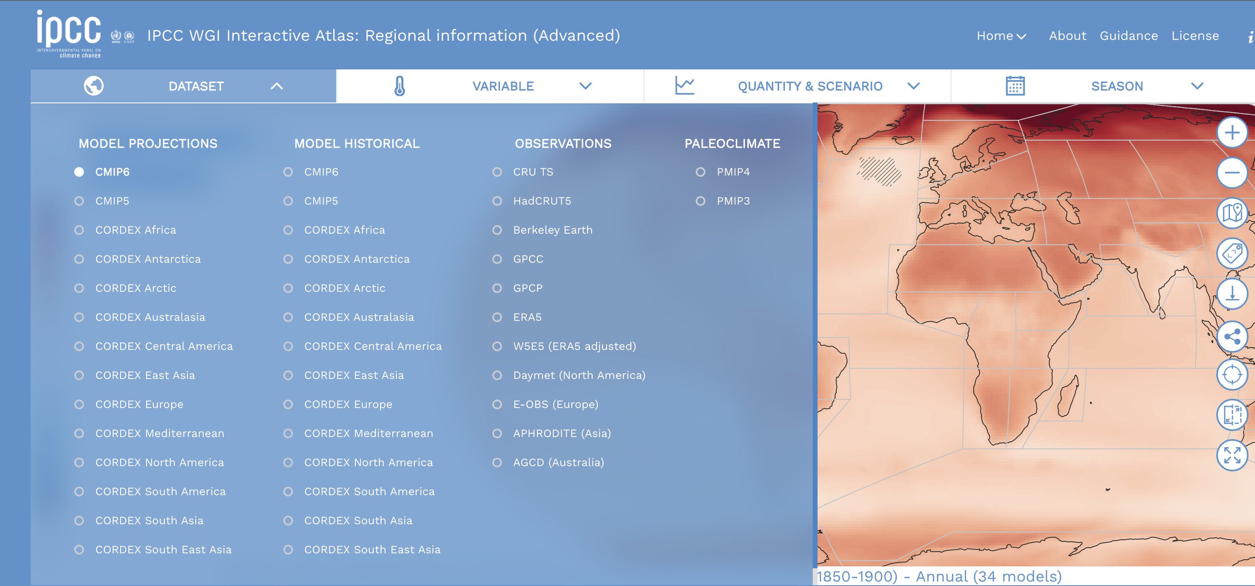
Figure 12. Datasets available through the IPCC's Interactive Atlas.
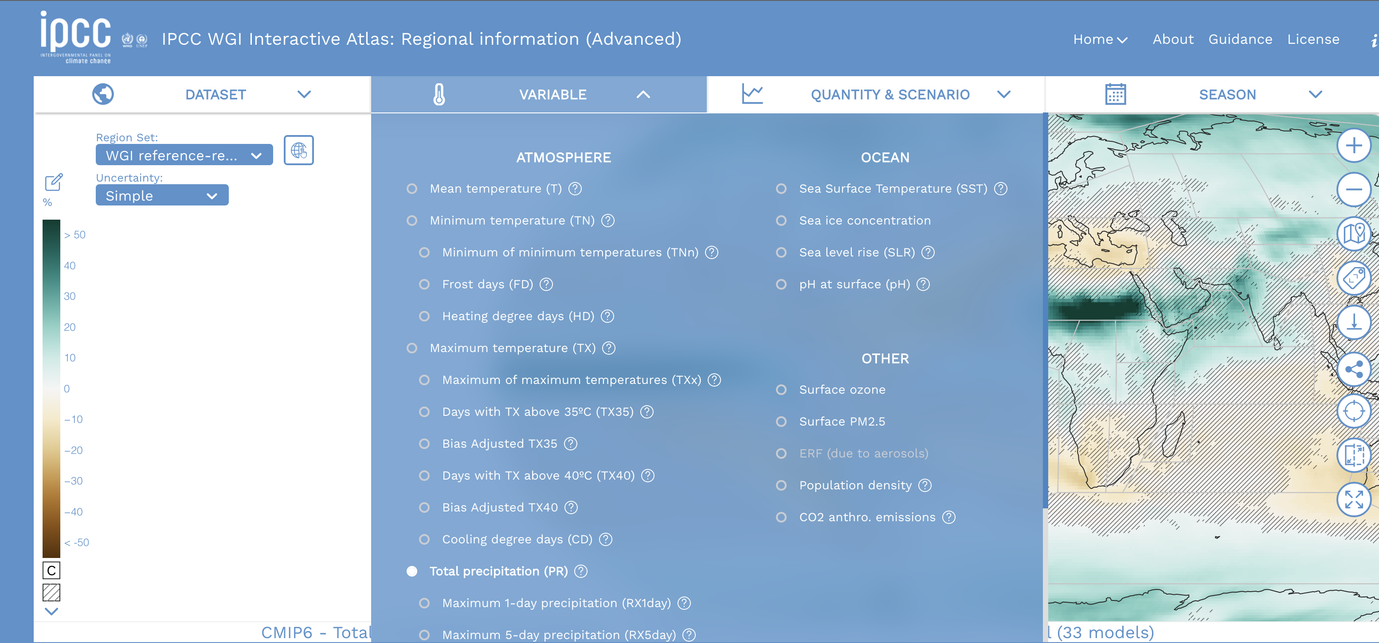
Figure 13. Climatic variables accessible through the IPCC's Interactive Atlas.
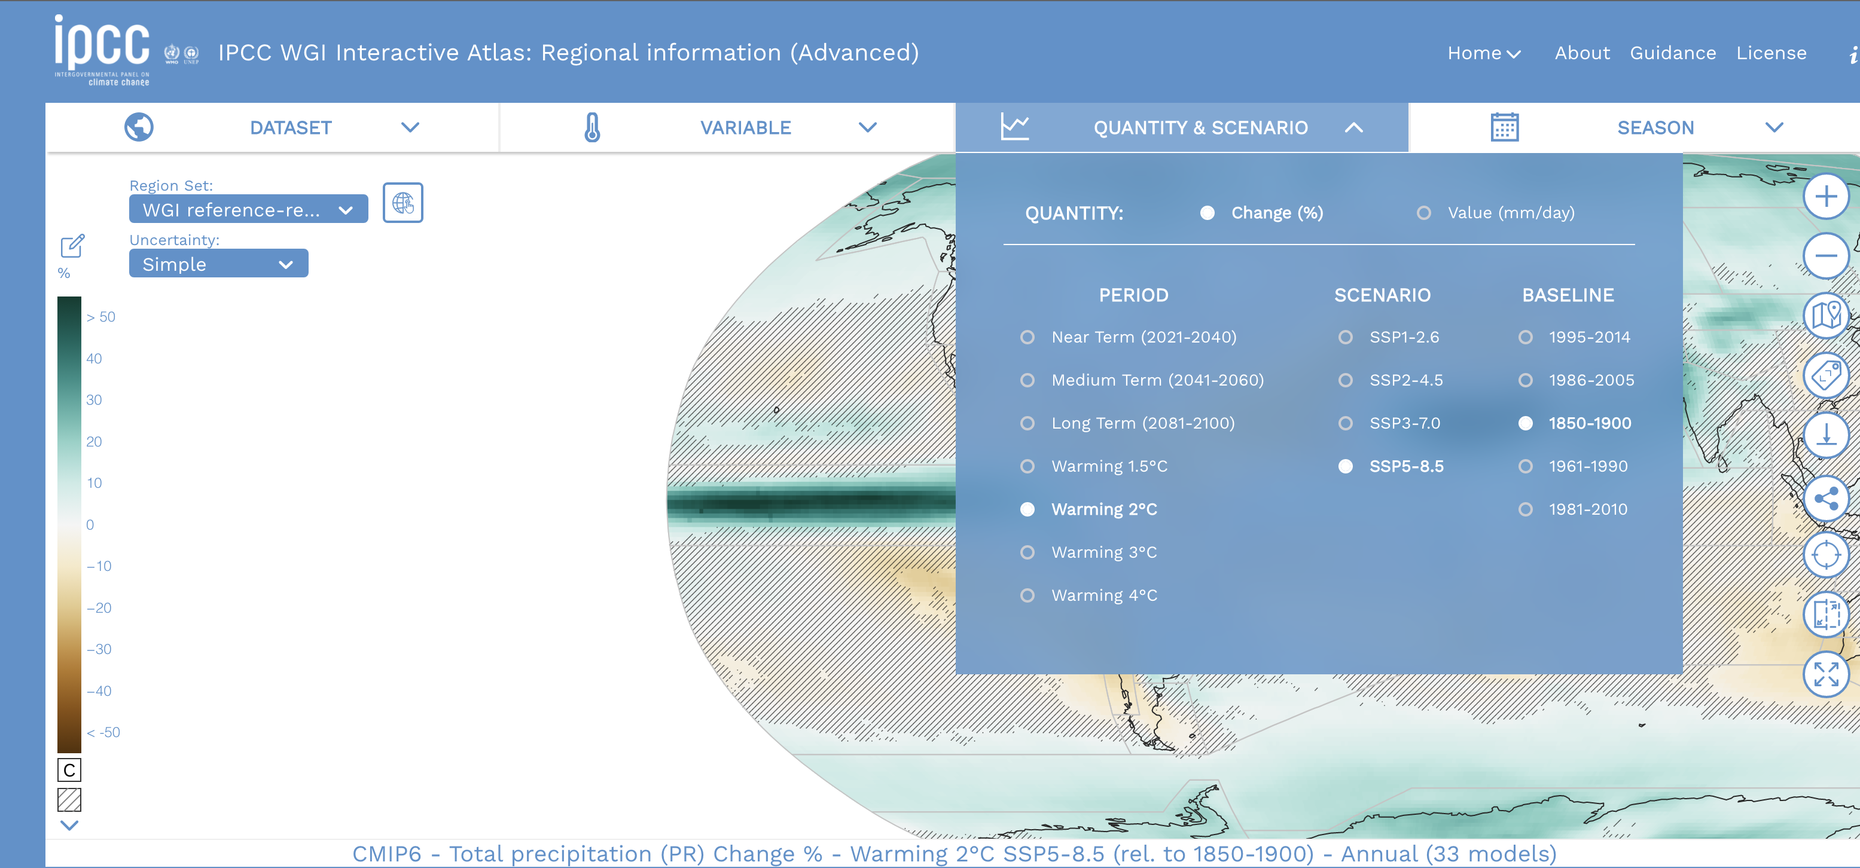
Figure 14. Time periods, scenarios and baselines that can be used in the IPCC's Interactive Atlas.
Clicking on the map opens up a panel that shows the changes of a selected variable (e.g. annual mean temperature) from the selected dataset (e.g. CMIP6) for the selected period (e.g. mid-term (2041–60)) under a selected SSP scenario (e.g. SSP2-4.5) against a selected baseline (e.g. recent years (i.e. 1995–2014)) in different forms (Figure 15). The Table Summary provides a quick overview of projected change in the selected variable.

For example, comparing various SSP scenarios for the annual mean temperature shows that the temperature is expected to increase by 0.7–0.8 °C already in the near term, i.e. in the next 20 years (Figure 16) at the Verlorenvlei estuary. However, the magnitude of temperature rise is expected to be much larger (1.6 °C and 2.4 °C by 2060 and 2100 respectively) under the business-as-usual SSP2-4.5 scenario (Figure 15). In the meantime, the annual mean precipitation may decrease by 1–1.5% (Figure 16). The increasing temperature and reduced precipitation suggests that evapotranspiration will increase in the area and the conditions might become less favourable for waterbirds. Increasing consecutive dry days suggest that drought periods will also increase. The predicted sea level rise ranges from 0.1, 0.2, 0.5 meters under the conservation oriented SSP1-2.6 scenario in the near, medium and long-term, but can increase to 0.1, 0.3 and 0.6 metres under the business-as-usual SSP2-4.5 scenario, which suggests that coastal habitats will be affected by sea-level rise severely over the long-term.

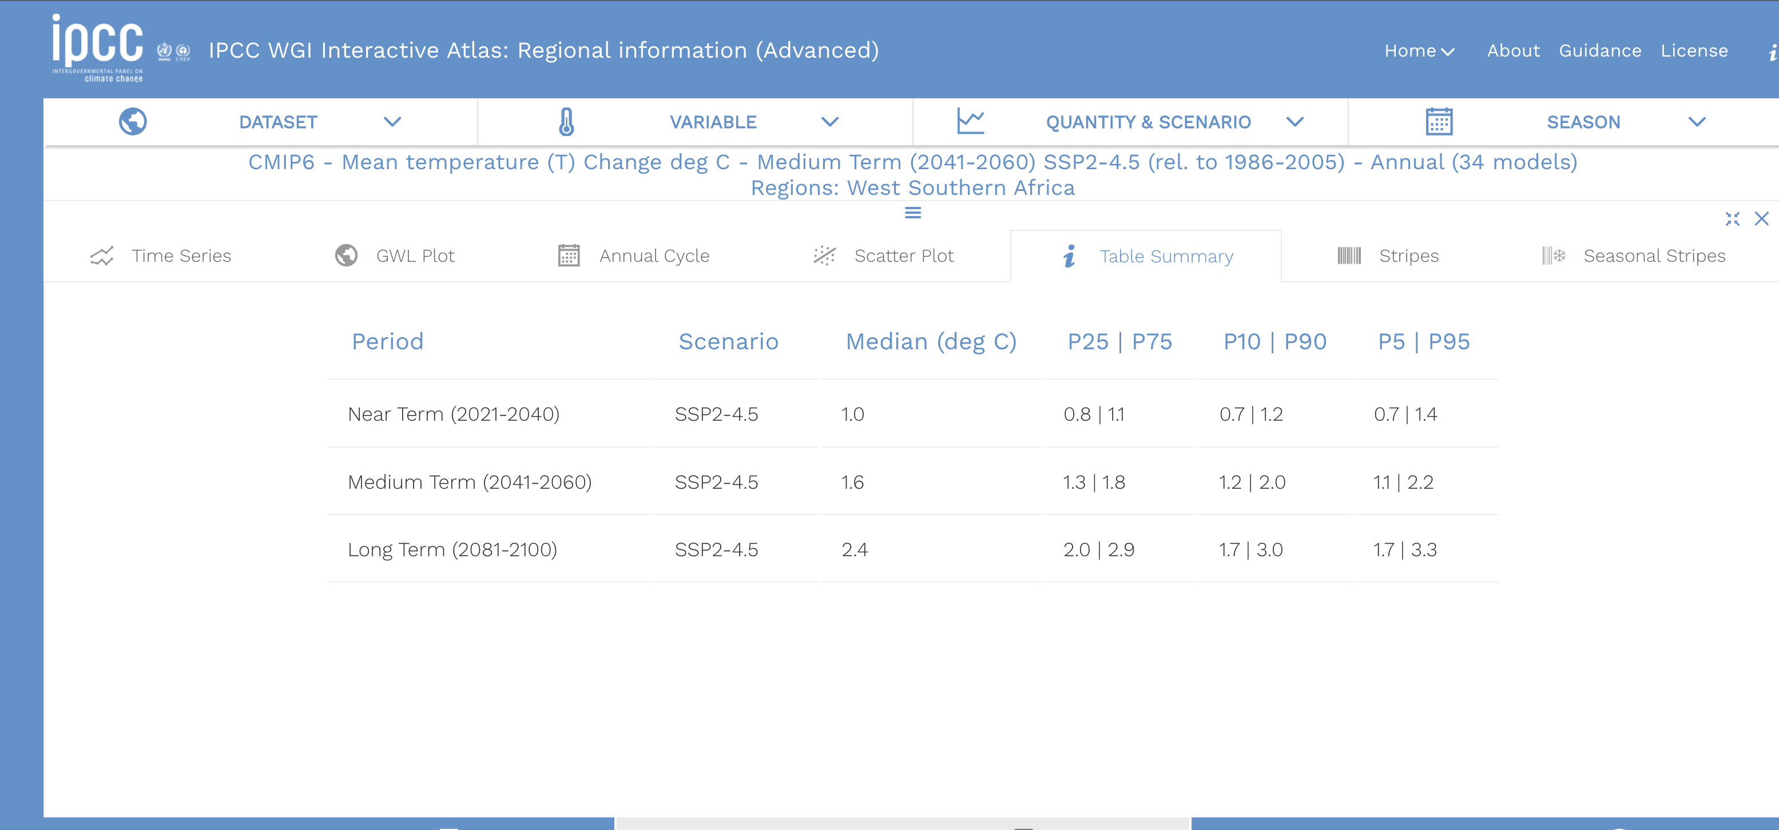
Figure 15. Panel showing the changes in the climatic value.

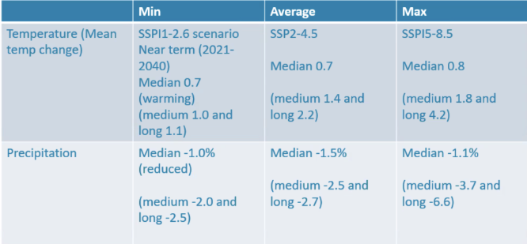
Figure 16 Comparison of the short-term impacts of various climate change scenarios at the Verlorenvlei estuary.

Freshwater flow and inundation changes on the CSN Tool 2.0

Definitions
Freshwater flow: this represents how much water flows in the wetland in a year at present.
Inundation: this represents the average number of months per year an area is inundated at present.

Steps
- Start in any of the Countries or Species menus in CSN 2.0 (http://criticalsites.wetlands.org).
- Select a country or species (Figure 17).
- To look up the current freshwater flow, turn on the Freshwater flow switch. On the Legends panel in the left side of the screen. The Average annual freshwater flow (present) switch will be switched on by default.
- To look up projected changes in freshwater flow, turn on the % change in annual freshwater flow (2050) switch.
- To see which Important Bird and Key Biodiversity Areas or Critical Sites are projected to receive less water in the future select the IBA or Critical Sites tabs, respectively, at the bottom of the page and then make sure that the switch for Level of site protection is turned on.
1
3
5
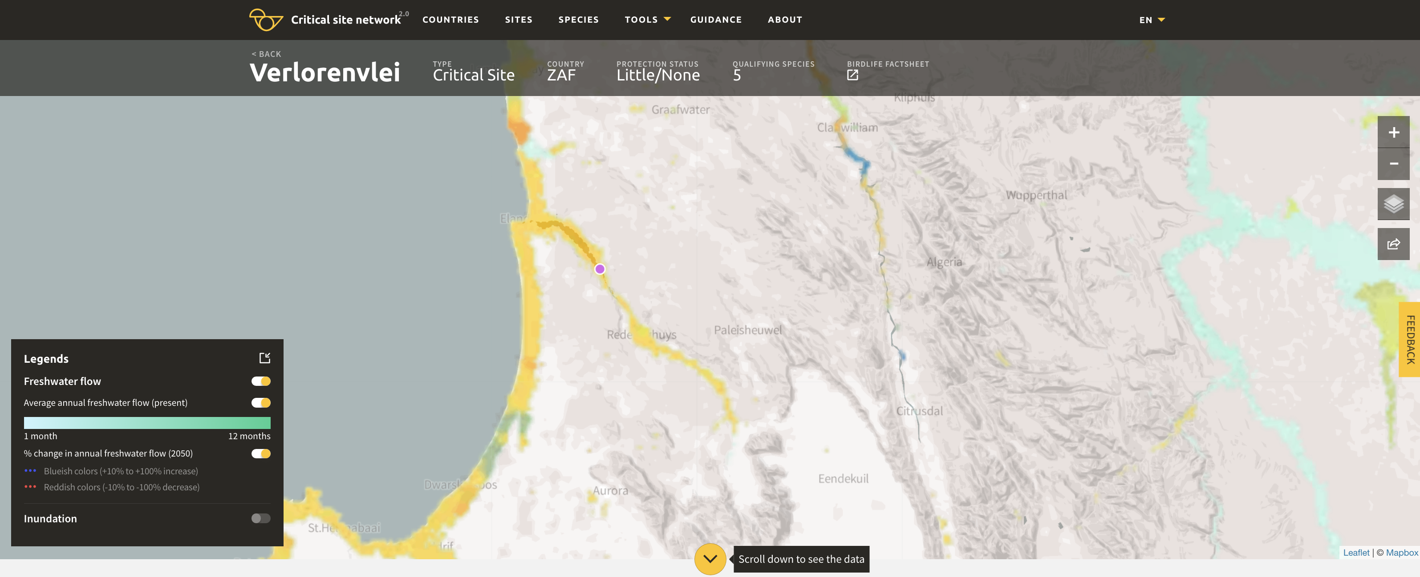
Figure 17. This picture illustrates that the Verlorenvlei is projected to have less water. (Red numbers illustrate steps mentioned in the description).
- To look up the current inundation duration, select the Average number of months inundated per year (present) switch (Figure 18).
- To look up projected changes, turn on the Change in inundation duration (2050) switch (Figure 18).
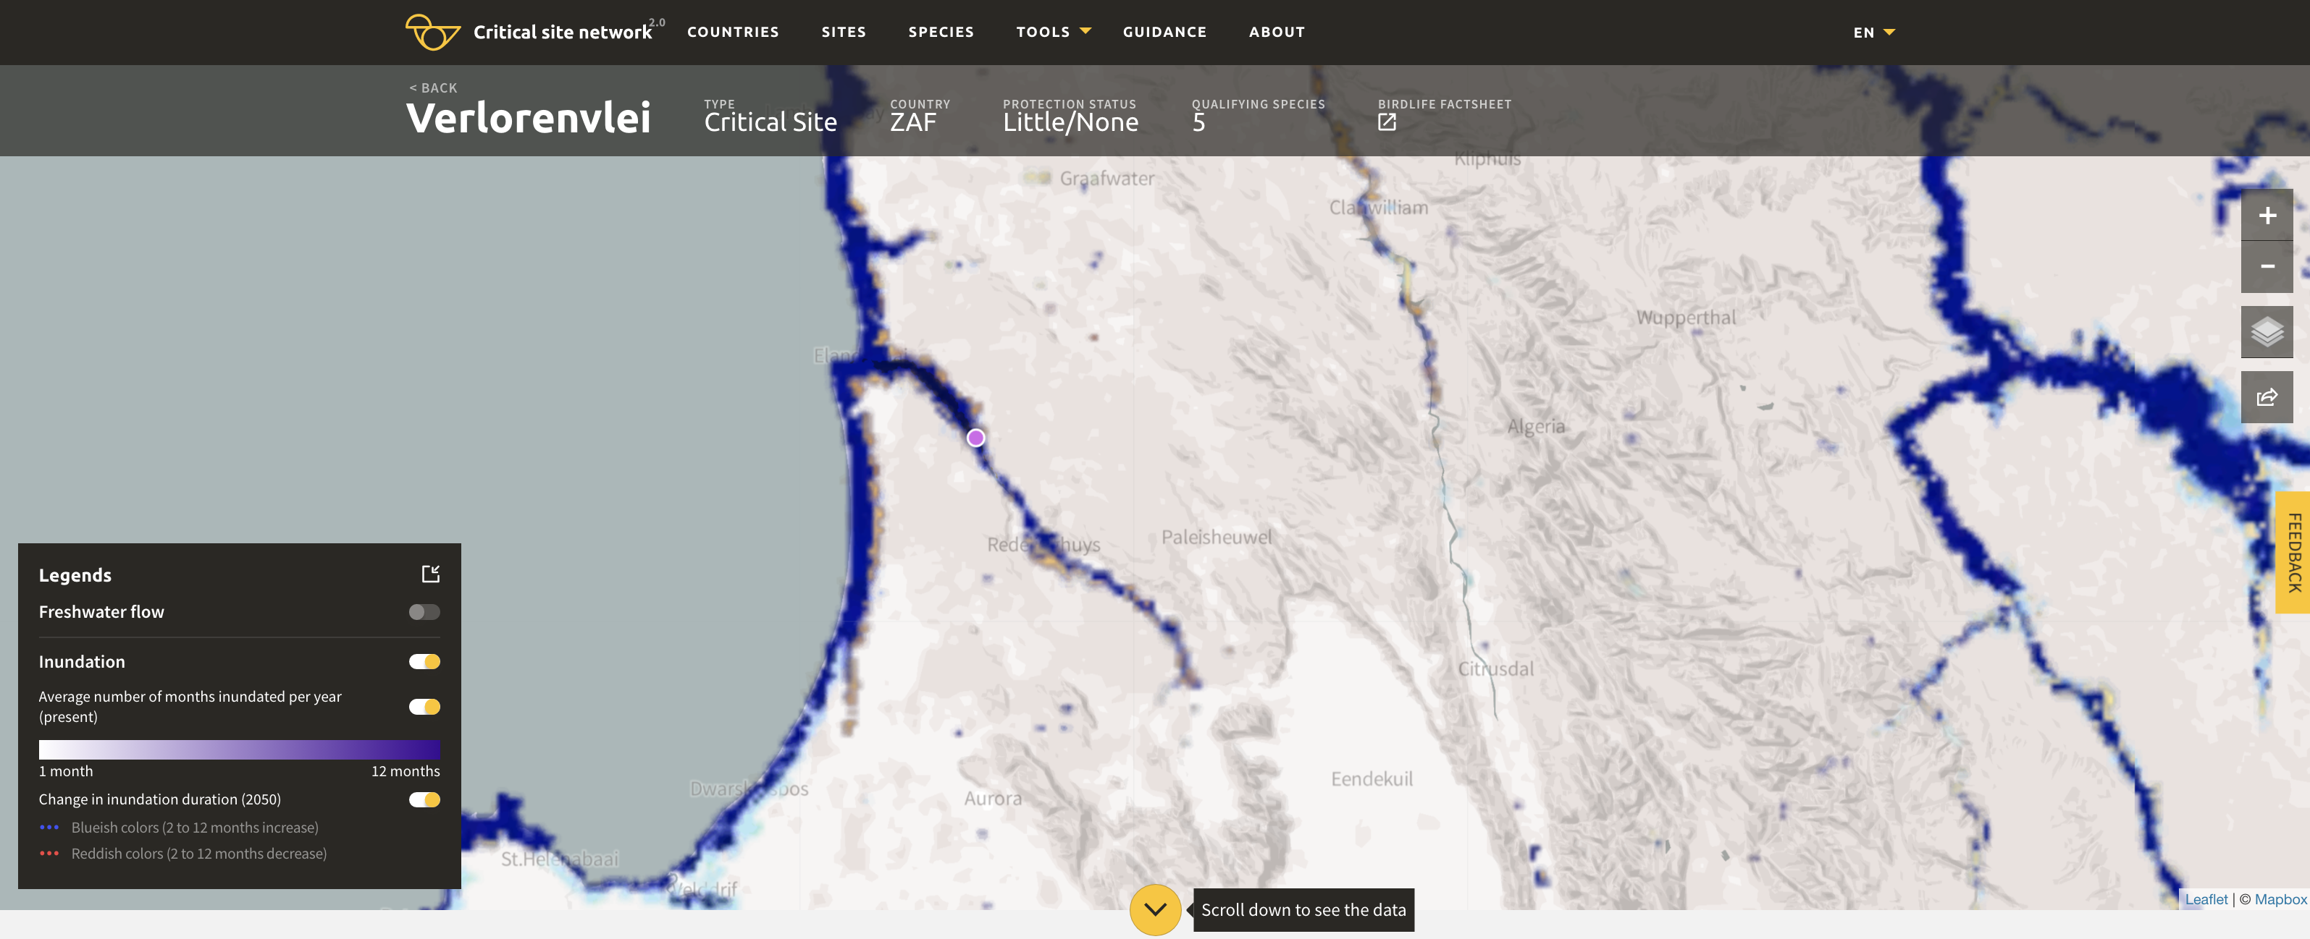
6
7
Figure 18. The Verlorenvlei is projected to have reduced inundations. (Red numbers illustrate steps mentioned in the description)

Caveats
The model predictions are influenced by several factors including the modelling assumptions concerning the climate forcing scenarios (RCMs), the global circulation model (GCM), the shared socio-economic pathways (SSPs), but also the assumptions concerning water extraction, dam management, etc. In addition, the inundation model depends on the remote sensing-based mapping of inundation extent. However, remote sensing might be not able to detect wetlands under the canopy or may misclassify cloud shadow as wetlands. Moreover, the modelling is not able to fully capture the effects of the water management infrastructure on inundation. The flood extent might be overestimated in countries with large floodplains with dikes (e.g. the Netherlands, Hungary). Therefore, the results of this modelling should be used only as indications of exposure but not as predictions.

Projected range changes for a waterbird species

Steps
- Select a species either from the Species or from the Countries > Species menus in the CSN 2.0 (http://criticalsites.wetlands.org) if you carry out a flyway or country-level assessment.
- To investigate the projected range changes of the individual species, click on the black arrow in the yellow circle at the end of the row to go to the species page.
- Turn on the Modelled species distribution change in the Legend panel on the left (Figure 19).
- Turn on the Season and either Present Suitability, Future Suitability or Gains/Losses.
- (You can compare the modelled present suitability with the mapped range of the species if you also turn on the BirdLife International Species range maps. Also note that only the distribution of the species within the AEWA range was modelled).

4
3
5

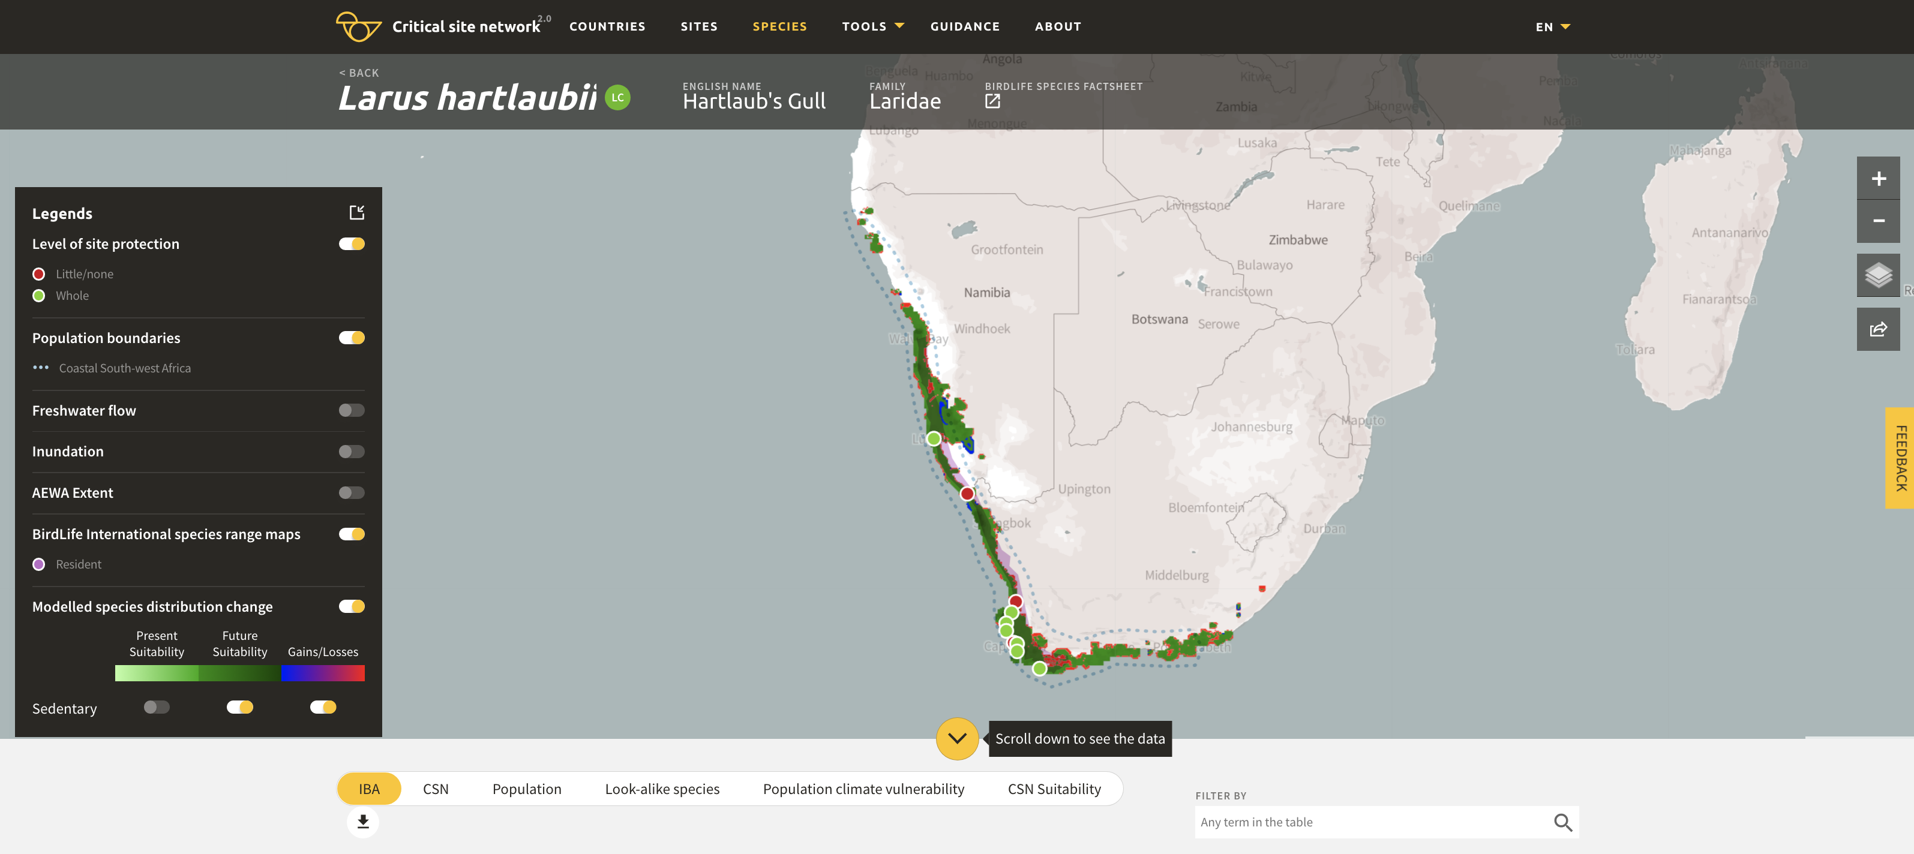
Figure 19. Mapped and modelled distribution of Hartlaub’s Gull (Larus hartlaubii) on the Critical Site Network Tool 2.0. Purple: mapped distribution of the species. Green: future modelled suitability. Darker shades represent more suitable areas. Red highlights areas that are projected to become climatically unsuitable by 2050. Blue highlight areas that are currently not suitable but projected to become climatically suitable by 2050. The dots represent Critical Sites identified for the species. Note the pattern of range change. Contrary to Palearctic species, Afrotropic waterbird species are predicted to suffer range fragmentation (driven by precipitation) rather than range shift.
- To see more details about how the range and the suitability of Critical Sites is projected to change, click on the Population climate vulnerability tab (Figure 20).
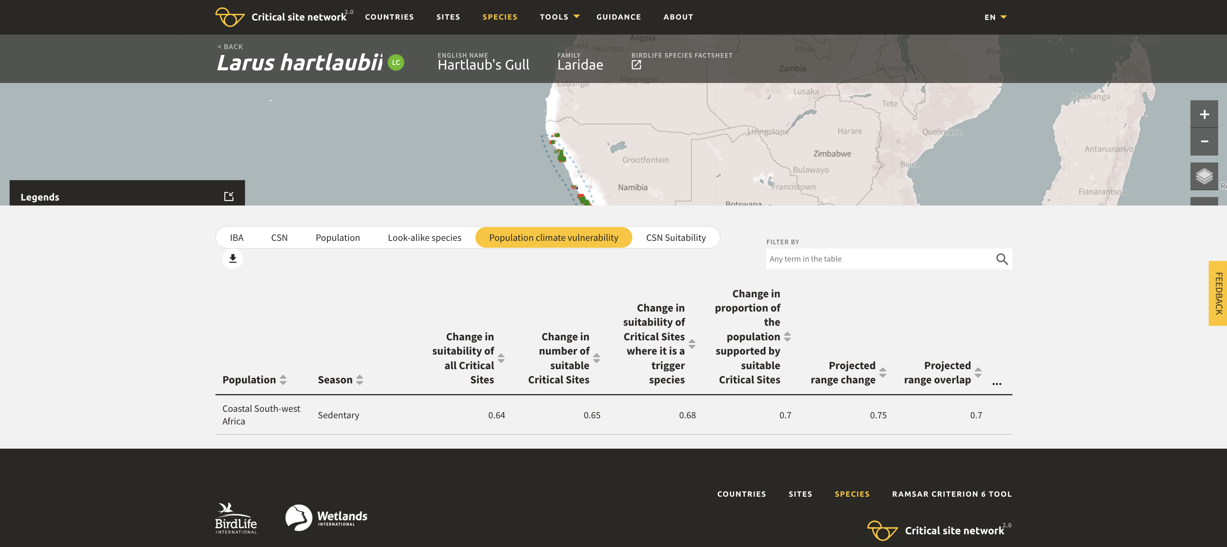
6
Figure 20. Population climate change vulnerability for Hartlaub’s Gull on the Critical Site Network Tool 2.0. The first two columns assess the changes in suitability and number of suitable sites across the entire Critical Sites Network. The next two columns focus on the Critical Sites selected for the population. The last two columns assess the changes at the level of the range. In case of this species, the table suggest a c. 30% contraction of the current range (see last column). It is likely that this will be compensated only to a limited extent (see the penultimate column). C. two-thirds of the Critical Sites selected for the species will remain suitable (see Change in proportion of the population supported by suitable Critical Sites column) and their suitability is projected to decrease (see Change in suitability of Critical Sites where it is a trigger species). Also, based on the Change in suitability of all Critical Sites and the Change in number of suitable Critical Sites columns, the overall suitability and number of Critical Sites across the entire Critical Sites Network will suffer some reduction.
- To see more details about how the suitability of Critical Sites selected for the species is projected to change, click on the CSN Suitability tab (Figure 21).
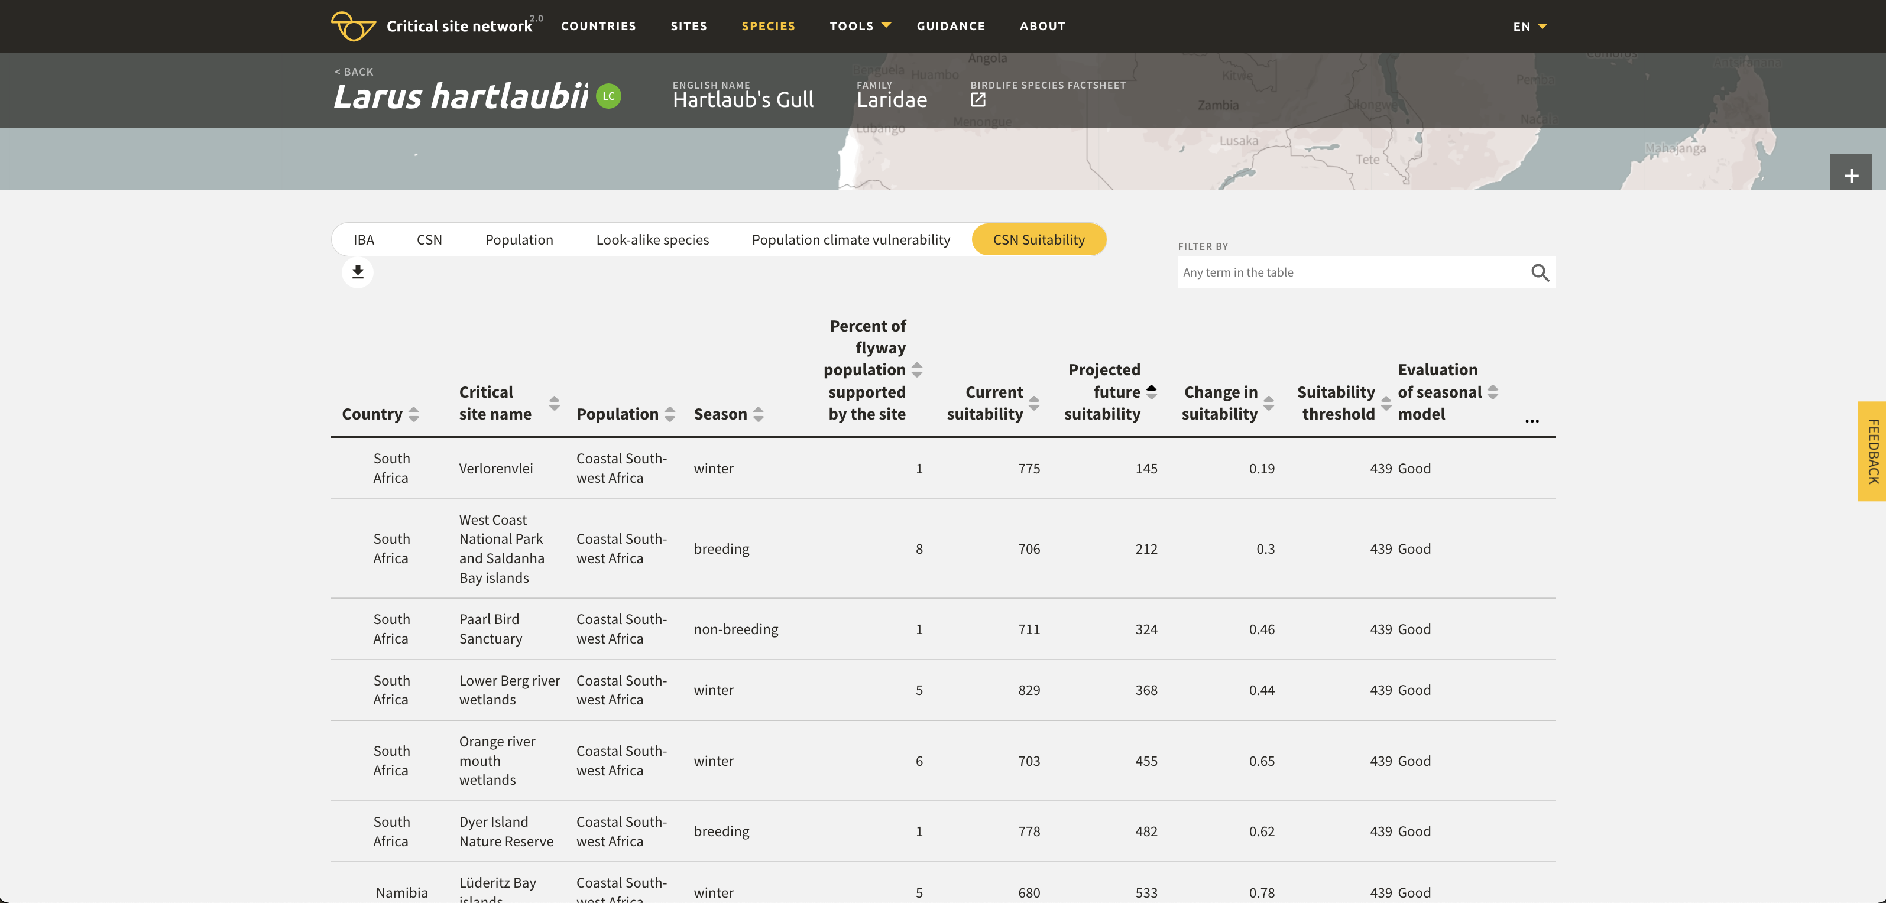
7
Figure 21. Changes in suitability of Critical Sites selected for the Hartlaub’s Gull. The Percent of flyway population supported by the site column gives an indication of the importance of the individual sites and how large proportion of the population is covered by these sites in total. The Change in suitability column gives a quick indication how much the suitability of the site is projected to change, while the comparison of the projected future suitability values with the suitability thresholds indicates that the Verlorenvlei estuary, West Coast National Park and Saldanha Bay islands, Paarl Bird Sanctuary and Lower Berg river wetlands Critical Sites are projected to become unsuitable for the species as a consequence of the climate change.

Caveats
As SDMs depend on climatic and hydrological models, the same caveats mentioned in Appendix II also apply here. Furthermore, correlative SDMs are always somewhat inaccurate and tend to overpredict the species distribution because they ignore important factors of habitat suitability such as local habitat preferences, conditions and configuration, food supply and other factors. They are also strongly influenced by the available training data and can perform poorly in regions with little training data. Therefore, the projected changes are not predictions but only indications that should be read as a statement “if the assumed climatic changes happen and the species distribution is influenced only by the factors included in the model, the projected changes are expected to happen”. When used for practical conservation decision, models should be compared with other available models and their performance should be evaluated critically in the context of conservation decisions.

Identify the key sites or regions for AEWA populations

According to Paragraph 3.1.2 of the AEWA Action Plan (Page 31 in AEWA, 2019), Parties shall identify all sites of international or national importance for populations listed in Table 1 of AEWA. According to Target 3.1 of the AEWA Strategic Plan 2019-2027 (AEWA, 2018) Parties are expected to review and confirm an inventory of these sites. In 2019, the AEWA Technical Committee has provided an interpretation of the terms of “sites of international or national importance” and “internationally accepted criteria of international importance” (AEWA Technical Committee, 2019) and a technical guidance was provided.

Under the UNEP/GEF Wings Over Wetlands project, BirdLife International and Wetlands International have also identified internationally important sites for globally threatened species and sites that meet Criterion 6 of the Ramsar Convention on Wetlands based on data available by 2007 for all waterbird species and seabirds that were listed on Table 1 by that time. The resulting network of Critical Sites are presented on the Critical Site Network Tool 2.0 (BirdLife International & Wetlands International, 2018).

Definitions
Critical sites: Sites that are known or thought to regularly or predictably to hold significant numbers of a population of a globally threatened species (CSN Criterion 1) or >1% a flyway or other distinct population of a waterbird species (CSN Criterion 2). The Critical Sites represent only a subset of the internationally important sites for populations listed on Table 1 of AEWA and reflect the situation in the 1990s and early 2000s.

Steps
- Open the Critical Site Network Tool using the following URL: http://criticalsites.wetlands.org/en
- Click on the Countries menu.
  - Either type in the name of the country in the Search by box or
  - Move the cursor over the country on the map and click on it (Figure 22).
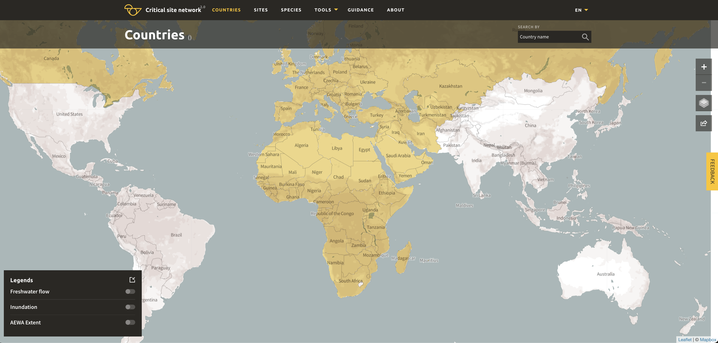
1

2a
2b
Figure 22. Options to access country-level information on the CSN Tool 2.0.
- Once in the country view, you can look up the list of Important Bird and Biodiversity Areas (IBAs), or Critical Sites, species and populations present in the country (Figure 23).

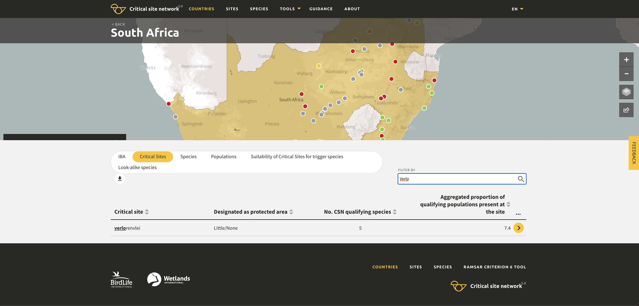
3
4
5
Figure 23. Looking up the Critical Sites for a country.
- Individual sites could be found by either scrolling down the list or by typing in (part of) the name of the site in the Filter by search box.
- By clicking on the yellow circle with a black arrow at the end of the row for each site, it is possible to look up the qualifying species for individual sites.
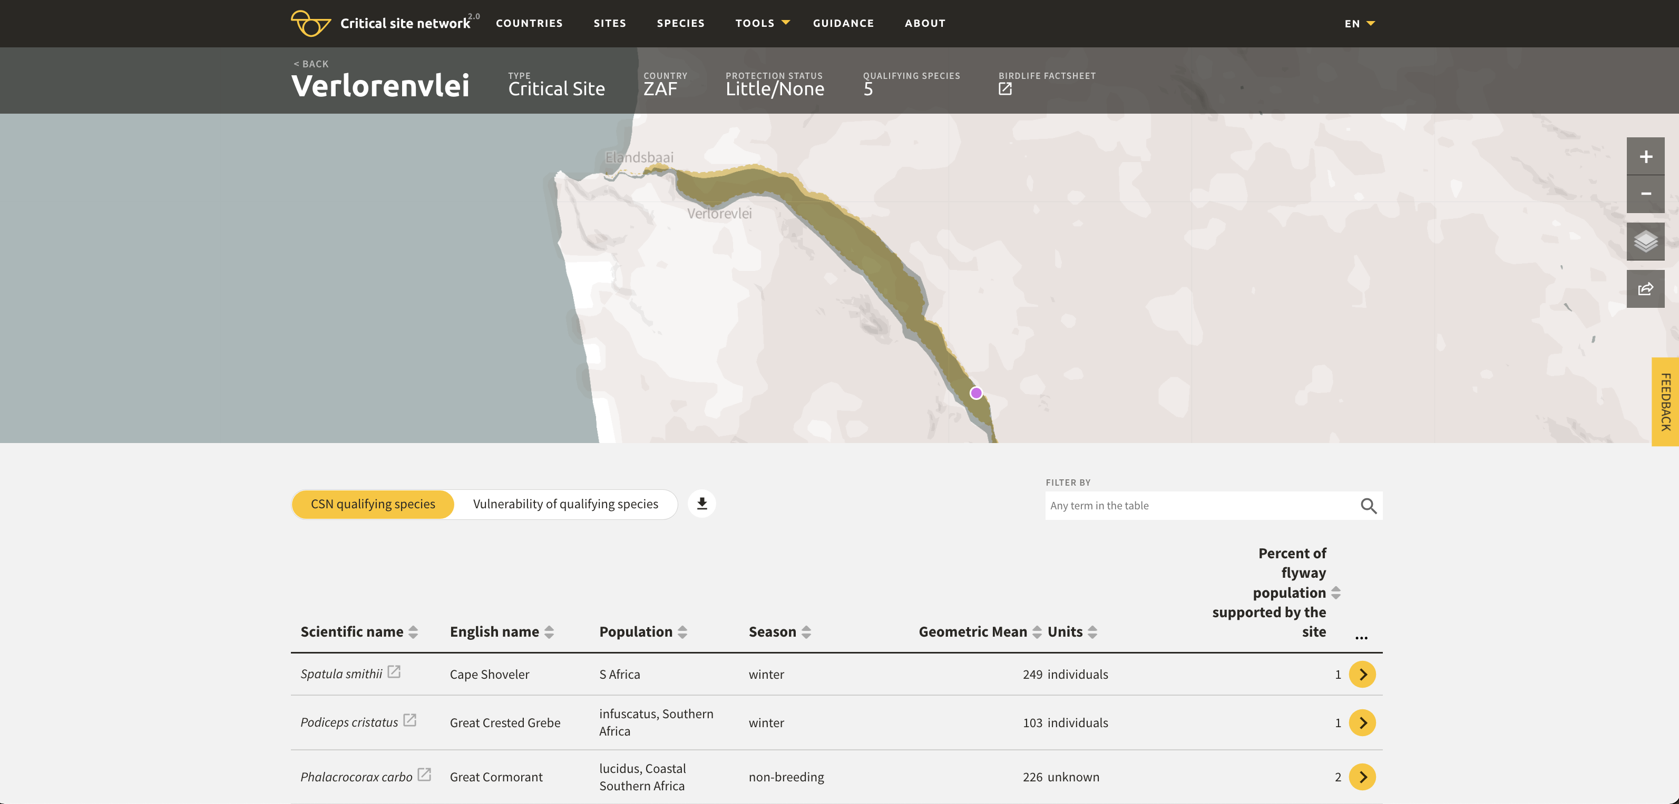
8
7
6
Figure 24. List of qualifying species for a selected Critical Site.
- Data for each site can be downloaded by clicking on the down arrow (Figure 24).
- Further details for the qualifying species (such as minimum and maximum estimates) can be shown by clicking on the three dots (…).
- Flyway-level details can be looked up by clicking on the yellow circle with a black arrow at the end of the row for each qualifying populations.

Caveats
As mentioned above, the Critical Sites information is based on data that has been collected before the mid-2000s and represents the best available knowledge at that time. Some countries might have much better and more up-to-date information available at national level.

Projected changes in the suitability of a Critical Site for its qualifying species

Steps
- Start in the Countries menu in CSN 2.0 (http://criticalsites.wetlands.org; Figure 25).
- Select the Critical Sites tab at the bottom of the page.
- Select the Critical Site of interest and click on the yellow arrow at the end of the row.
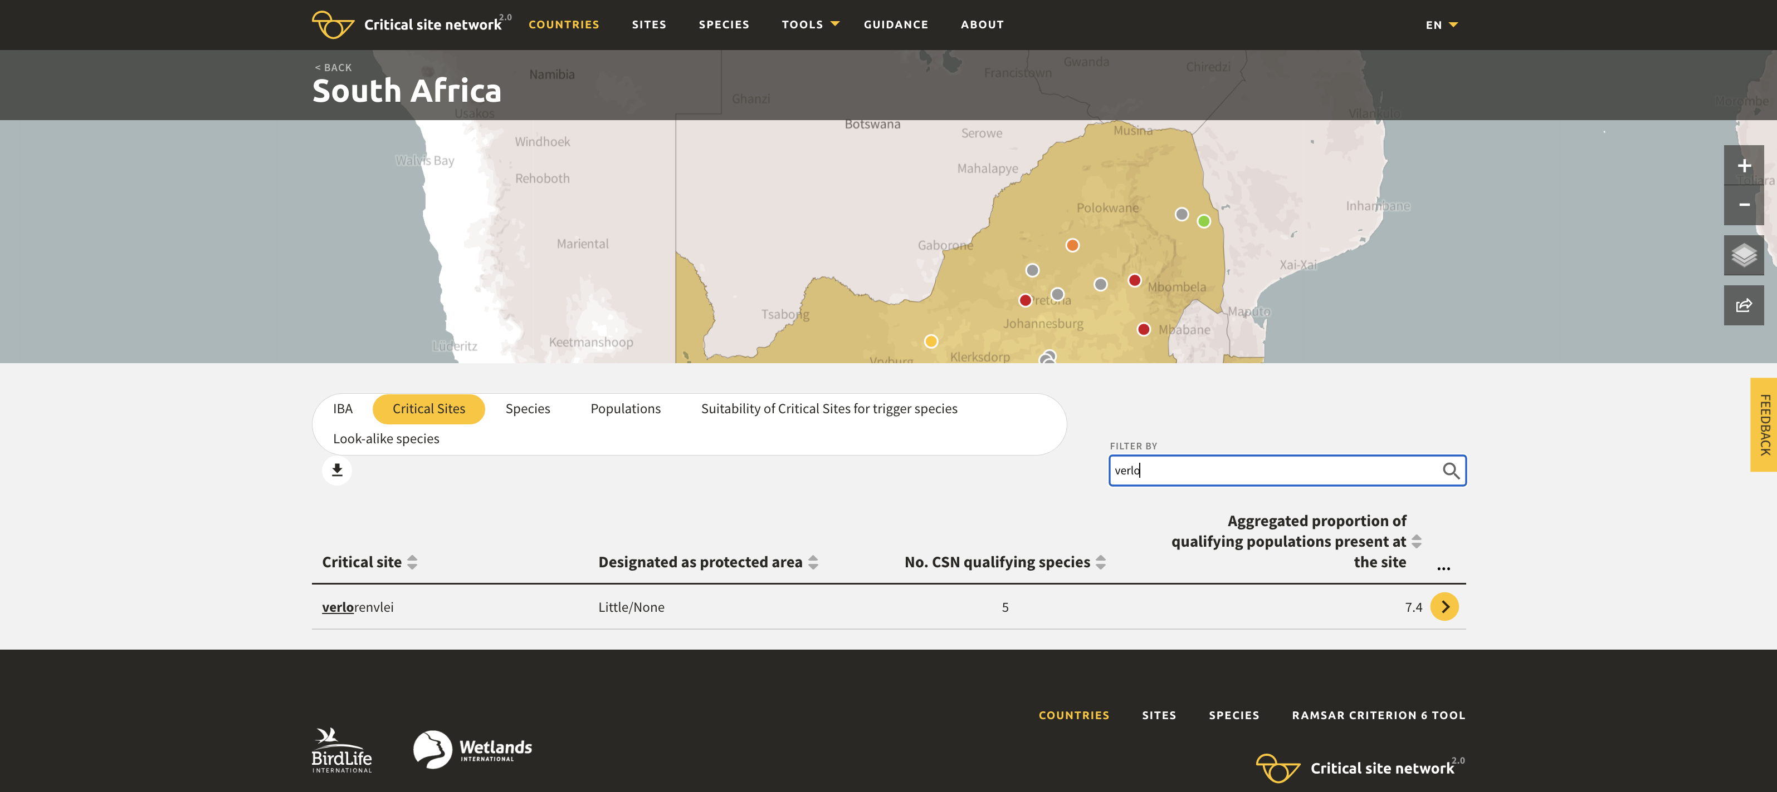
1
3
2
Figure 25. Selection of a site on the CSN Tool 2.0.
- Select the Vulnerability of qualifying species tab (Figure 26).
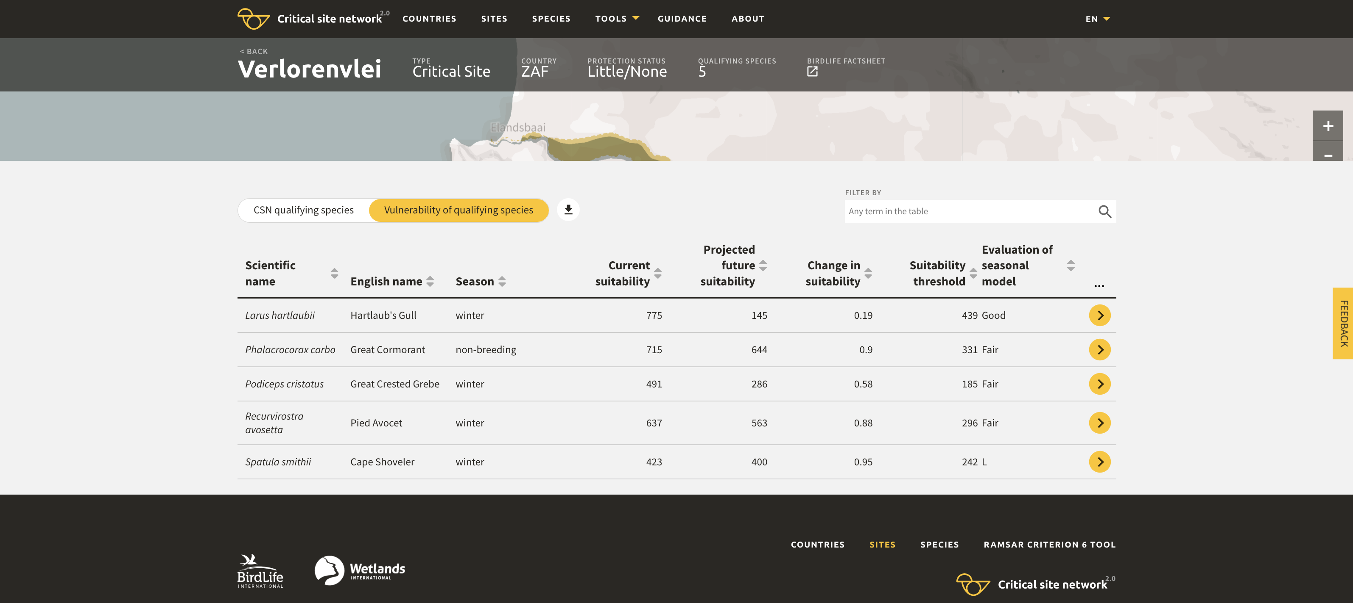
4
Figure 26. Climate change exposure impacts on the qualifying species of the Verlorenvlei Estuary Critical Site. The values in the Change in suitability column show that each qualifying species is expected to suffer some deterioration in condition as a consequences of climate change, but that the conditions are expected to deteriorate for the Hartlaub’s Gull and the Great Crested Grebe, in particular. Comparing the values in the Projected future suitability column with values in the Suitability threshold column indicates that the site is likely to become unsuitable for the Hartlaub’s Gull but expected to remain climatically suitable for the Great Crested Grebe and all other qualifying species.
Caveats
The same caveats as in Appendix III also apply here. The models are even less accurate at the level of individual sites than at the level of the range. Nevertheless, the projected decreasing suitability of the existing Critical Sites should be considered as an indication that caution is needed in the future management of the site. Site managers should consider how the suitability of the site can be maintained by measures at the site or in its catchment.

Impact of climate change on site suitability

For any species whose distribution has been modelled, it is possible to identify which explanatory variables influence the changes in the suitability of the site the most and this can help the planning of climate change adaptation measures.

Such information is available for each Critical Site at this website: https://szabolcsnagy.shinyapps.io/SiteRespCurve_Shiny/.

Steps
- Copy the name of the Critical Site of interest from the Critical Site Network Tool 2.0, e.g. Verlorenvlei.
- Type or insert that name into the Shiny app application under Point 1 (Figure 27).
- Select one of the qualifying species for which the site is predicted to become less suitable in the future (e.g. Hartlaub’s Gull) and type its scientific name in the Shiny app application under point 2 with a dot between the genus and the species names (e.g. Larus.hartlaubii).
- Select the season of interest under point 3. Note that in case of Afrotropical species, only one season (sedentary) was modelled while for most Palearctic migrants the breeding, passage and wintering seasons were modelled separately.

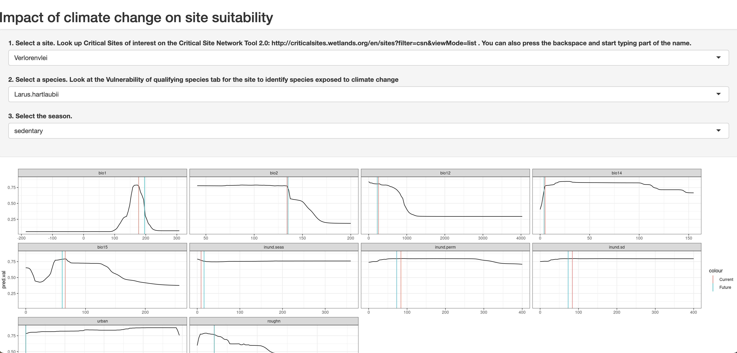
4
3
2
Figure 27. Response curves depicting how the suitability of a site for the Hartlaub’s Gull responds to the changes in the modelled environmental variables. The black lines are the response curves for bio1: Mean Annual Temperature (in °C x 10), bio2: Mean Diurnal Range, bio12: Annual Precipitation, bio15: Precipitation Seasonality, inund.seas: the number of 500 x 500 m pixels in a 10 x 10 km grid cell covered by seasonally inundated wetlands, inund.perm: the number of 500 x 500 m pixels in a 10 x 10 km grid cell covered by permanently inundated wetlands, inund.sd: spatial variability of inundation, urban: the number of 500 x 500 m pixels in a 10 x 10 km grid cell covered by urbanized areas, roughn: terrain roughness index (for more details see Table 1 in Nagy et al., 2021). The more horizontal and flatter the response curve, the less the suitability of a location is influenced by the value of that environmental variable. The red vertical lines represent the current (around 2000) value, the green vertical line represents the future (around 2050) value. The changes in the future suitability of the site are influenced by those predictors where the red and the green lines do not overlap. The bigger the vertical difference between the intersections of the black lines with the red and the green lines, the bigger the effect. E.g. in this case there are several factors where the current values differ from the projected future values. However, there is only one environmental variable (bio1) where the future suitability is smaller than the current one. This means that the increase of the Annual Mean Temperature will reduce the suitability of the site. Probably this will happen because of the increased temperature is likely to lead to increased evaporation. Consequently, the site management should focus on finding ways that can compensate for the future increase of the temperature. E.g. reducing water extraction or drainage can help to preserve water and wetlands.
Caveats
The same caveats as in Appendix III also apply here. Current and future values are available only for the qualifying species at the Critical Sites through the shiny apps because of the huge amount of data to be processed otherwise for all pixels of the map.

Qualitative assessment of the potential impact of climate change and possible responses at the Verlorenvlei Estuary

Table 1 illustrates the assessment of the possible impacts of climate change as set out in Section 6.1 on the example of the Verlorenvlei Estuary as developed by the participants of the AEWA training workshop. The table also considers possible counteracting and compensating measures as suggested in Section 6.3.

Table 1. Assessment of the potential impact of climate change at the Verlorenvlei Estuary.
Cause of change | Consequence | Ecological & human-ecological outcome | Counteracting measures | Compensating measures
Increased temperatures | Reduced water levels and water quality (e.g.: increased salinity and temperature; reduced oxygen levels etc.) via evaporation | Loss of habitat  Loss of foraging, roosting and breeding areas for constituent biota  Compromised breeding success of key species  Survival and population growth of key species reduced  Reduction in tourism (value chain of tourism impacted) and in livelihoods (human impact)  Reduced agricultural outputs resulting in increased poverty and decreased food security  Communities could further extract other natural resources | Address water over abstraction issues, including illegal dam expansion; ground water over extraction  Remove instream barriers e.g.: broken weirs; culverts; jetties etc.  Completion of Ecological Reserve Study for estuary to better understand system’s ecological requirements and to more responsibly allocate water use in catchment  Remove Invasive Alien Plants throughout system  Reduce illegal fishing, including gill netting | Restoration of degraded/ impacted habitat e.g.: salt marsh  Increase formal protection of the site for example, through proclamation as a nature reserve  Investing in alternative livelihood/ business practices e.g.: smart agriculture (water conservation/ sustainable agriculture)
Decreased precipitation | Reduced water levels and water quality (e.g.: increased salinity and temperature; reduced oxygen levels etc.) | Loss of habitat  Loss of foraging, roosting and breeding areas for constituent biota  Compromised breeding success of key species  Survival and population growth of key species reduced  Reduction in tourism (value chain of tourism impacted) and in livelihoods (human impact)  Reduced agricultural outputs resulting in increased poverty and decreased food security  Communities could further extract other natural resources | As above | As above
Reduced freshwater flow and less inundation | Loss of habitat | Increased erosion  Ecosystem services no longer sustained (e.g.: carbon sequestration; air quality; water filtration etc.)  Increased habitat degradation due to vehicular activity | As above | Stabilisation of erosion through habitat restoration/ rehabilitation – linked to increased water retention capacity  Reduce disturbance from vehicular activity in un-inundated areas (i.e.: during dry periods) – causes significant habitat degradation  Reduce impacts of recreational disturbance on waterbirds e.g.: windsurfing etc.
Higher drought risk | As above.  Increased risk of fire | As above.  Changes in plant communities  Increased weed invasion if burnt too frequently  Increased soil erosion, sedimentation and turbidity  Changes to nutrient cycle of estuary, including loss of organic matter and nutrients  Loss of livelihoods linked to fishing  Communities could extract other natural resources | As above | As above  Control of any burning of reeds and sedges  Control of overgrowth of weeds  Development of a fire response team  Investing in alternative livelihood/ business practices e.g.: smart agriculture (water conservation/ sustainable agriculture)
Increased sea level | Increased salt water intrusion  Increased coastal ad soil erosion, leading to increased sedimentation  Increased flooding or inundation of the wetland | Changes in habitat  Changes in populations of key species  Reduced storm protection | Restore habitat to reduce flood risk | Limit development and natural habitat loss/ degradation within the coastal wetland areas  Ensure there is a detailed, updated estuary management plan, including mouth management plan

Application of the landscape approach to climate change adaptation at the Verlorenvlei Critical Site

A central element to the application of the landscape approach is to identify the natural, combined and economic zones in a landscape (Figure 28).

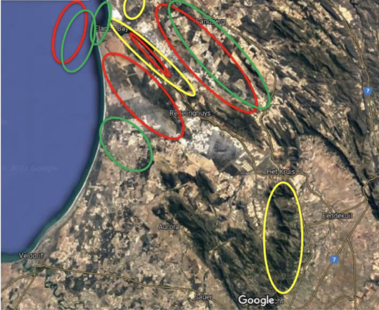
Figure 28. Natural (yellow), combined (red) and economic (green) zones at the Verlorenvlei Critical Site. The natural zone includes the coastal area, the main tributaries of the Verlorenvlei River, the nature reserves and the estuary. The combined zone includes the local fishing communities in the estuary and on the coast, areas used for sustainable agriculture and areas subject of alien clearing programmes. The economic zone includes the commercial fisheries, the town of Elands Bay, mines and areas of commercial agriculture. * Please note: this is not an accurate spatial representation of the different zones – for illustrative purposes only
As landscape scale conservation includes working with all stakeholders in the landscape, the stakeholder analysis forms an important step in the planning process (Table 2).

Table 2. Stakeholders in the different zones of the Verlorenvlei * not exhaustive
 | Natural zone | Combined zone | Economic zone
Stakeholders | - Department of Public Works (DPW)  - Department of Forestry, Fisheries and the Environment (DFFE)  - BirdLife South Africa (BLSA)  - CapeNature (local conservation authority)  - Ramsar Convention | - Moutonshoek Protected Environment Landowners’ Association  - Krom Antonies Water Users Association  - Western Cape District Municipality (including the Expanded Public Works Programme, EPWP)  - Intergovernmental Task Team (headed by Western Cape Department of Environmental Affairs & Development Planning, DEA&DP)  - Department of Water and Sanitation (DWS)  - DFFE  - DEA&DP  - Sandveld Conservancy; Weskus Resource Committee  - Civil society – BLSA, Friends of Verlorenvlei, Verlorenvlei Conservancy  - Homeowners association | - Local businesses  - Privately owned farms  - Private tourism ventures/company  - Department of Mineral Resources (DMR)  - DFFE  - DWS  - DEA&DP  - Department of Tourism (DT)  - Mining companies

As described in Section 6.4, the impact of the landscape approach is measured through four impacts: return on inspiration, on social returns, natural returns and on financial returns and it is important to assess the impacts of the proposed climate change adaptation against these (Error! Reference source not found.).
Table 3. Assessing the impact of the proposed climate change adaptation measures on the four returns (4Rs) at the Verlorenvlei area.

Inspiration | Social | Natural | Financial
Improved fishing conditions (recreational, subsistence, commercial, etc.) | Alternative employment options – micro nurseries for growing mature plants to use in habitat restoration/ erosion control interventions | Reduced erosion through soft engineering, erosion control interventions, including bankside habitat rehabilitation/ restorationNegative impact: no access for users at times | Farm management support and guidelines – smart/ sustainable agriculture, leading to for example, improved soil fertility, with improved yields and water conservation (reducing need for dam infrastructure)
Improved tourism and income generation for the area | Community upliftment through increased training and employment opportunities around IAP clearing and erosion control | Habitat restoration/ rehabilitation, including (as above), revegetation of river banks  Negative impact: no access for users at times and/ or reduced/ controlled access to sensitive habitats | Strengthened local economy through increased training and employment opportunities around IAP clearing and erosion control
Beautification of the area | Opportunities for environmental awareness raising and education of local community around importance of estuary for bird life, other biodiversity and the provision of ecosystem services | Improved native fish populations and restoration of natural cycles through the removal of alien fish  Negative impact on some fishermen | Wetland management guidelines – a sustainably managed wetland will provide ecosystems goods and services  Increased tourism income (local economy) from improved beautification of system, increased recreational potential if water levels are high enough; fish being present in the vlei if water levels/ quality improved
 | Opportunities for integrated and collaborative source to sea management approach | Increased freshwater flow to system through invasive alien plant (IAP) clearing programme, including follow up and natural habitat restoration  Negative impact: may have impact on local communities involved in wood harvesting but can also be positive if managed to support, train and employ members of the local communities. Localised wood harvesting can also form part of IAP Management Unit Clearing Plans.  Negative impact: IAP clearing can disturb tourism activities (localised) and reduce beauty of area for a time. | Reduced illegal fishing and poaching of birds, including birds being caught in gill nets  Negative impact on local communities, but could be compensated by creating alternative livelihoods; awareness-raising etc.
 |  | Increase in stewardship or formal protection can for example, bring additional resources to the management of an area and help prevent/ mitigate external threats  Negative impact: on some development sectors | Development of management plans engage in ESIA – ensures sustainable development (including mining industry) in the right areas (limits costs developments which negatively impact the estuary). Utilizing the correct tools can minimise negative impacts.
 |  | Return of functionality of the ecosystem and its services, including water filtration; improved air quality; increased recreational activities; carbon sequestration etc.  Negative impact for local communities/fishermen, as some areas may be closed to fishing/recreational activities, as well as changes in the fish assemblages through the removal of alien fish. | Increased real-estate prices (improved local economy) through beautification of site
 |  | Increased connectivity of natural areas/source-to-sea functioning, including tributaries, facilitating wildlife movement etc. | Fully functioning system, providing ecosystem services less costly than having to manage impacts/ intervene in non-functioning system

Assessment of the potentials for using nature-based solutions

Opportunities for nature-based solutions at the Verlorenvlei Estuary(Table 3).

Table 3. Opportunities for nature-based solutions and their impacts at the Verlorenvlei.
Threat | Possible nature-based solutions | Impacts
 | For climate change adaptation
Flood risk | Restoration of estuarine functional zone, including floodplain habitat and buffer (terrestrial) areas.  It would also improve water quality and aeration for fish survival/breeding | Flood prevention; water filtration; improved water quality; increased habitat for waterbirds and other biota
Erosion and sedimentation | Use of soft-engineering interventions, including bankside habitat rehabilitation/ restoration to mitigate against erosion and reduce sedimentation. For example, the use of vegetated geo-cells, in landscaped banks.  Establishment of Micro-nurseries to grow mature plants for use in revegetating river/ estuarine banks | Stabilized banks – reduced erosion/ sedimentation and loss of habitat  Reduced turbidity – improved water quality for birds foraging under water by sight  Reduced run off – reduced pollution/ nutrification leading to improved water quality  Decreased sedimentation of fish nursery areas – improved fish survival/ breeding
Sea level rise | Building with nature approach to create coastal dunes | Flood protection
Reduced flow and inundation | Implement smart/sustainable agriculture measures to reduce water abstraction, pesticide use and increase soil health  Troughs/channels to prevent run-off water | Increased and consistent fresh water flow  Increased yields from agricultural activities; improved income; greater food security  Fresh water provision for livestock
Alien plants | Removal of invasive alien plant species | Increased water into system; training and employment opportunities, including local businesses like firewood harvesting; compost; arts and crafts
Alien fish | Removal of alien fish species to support indigenous fish populations and res-establish natural ecosystem functioning | Healthy fish populations → healthy wetland ecosystem
Rising temperatures | Restore peat layers and estuarine functional zone habitats | Healthy wetland ecosystem - improved water quality, reduced fire risk, increased carbon sequestration and cooling effects maintained
Habitat loss and degradation | Estuarine functional zone restoration/ rehabilitation  Seagrass/ Eelgrass and saltmarsh protection and restoration | Carbon sequestration through establishment of a healthy wetland system

However, note that Adaptation in some cases may involve continuing existing measures but doing so with intentionality. So, priority sites may not just be those most at risk but include those projected to increase in importance.
https://www.international-climate-initiative.com/en/details/project/climateresilient-site-network-in-the-africaneurasian-flyway-15_IV_053-437
The Critical Site Network Tool 2.0 (http://criticalsites.wetlands.org/en) The Critical Site Network Tool 2.0 was developed under the framework of the Climate Resilient Site Network in the African-Eurasian Flyway project. This project is supported by the International Climate Initiative on the basis of a decision adopted by the German Bundestag. The original version of the Critical Site Network Tool was developed under the Wings over Wetlands project by BirdLife International, Wetlands International and the UNEP-WCMC to support the implementation of the African-Eurasian Migratory Waterbird Agreement (AEWA) and the Ramsar Convention on Wetlands.
https://en.wikipedia.org/wiki/General_circulation_model
https://en.wikipedia.org/wiki/Representative_Concentration_Pathway
https://en.wikipedia.org/wiki/Shared_Socioeconomic_Pathways
https://cordex.org/
https://www.worldclim.org/data/index.html
https://www.worldclim.org/data/bioclim.html
https://www.ipcc.ch/report/sixth-assessment-report-working-group-i/
https://interactive-atlas.ipcc.ch/
I.e., flooding.
http://criticalsites.wetlands.org/en
https://www.intertidal.app/home
https://sealevel.nasa.gov/ipcc-ar6-sea-level-projection-tool
https://coastal.climatecentral.org
RCP 2.6 represents a very stringent pathway that represents keeping the global temperature rise below 2°C. RCP 4.5 is an intermediate scenario which represents a probable business-as-usual development path, and it is likely to result in a global temperature rise between 2°C and 3°C. The RCP 8.5 represents a worst-case scenario resulting in a global temperature rise around 3.7°C by 2100.
The term „vulnerable” in this guidance follows the terminology applied in the IPCC 4th assessment, which is widely accepted in the conservation community, but differs from the terminology applied in the IPCC 5th assessment. For more details see Foden et al. (2019).
Mainly seabirds were not modelled.
See Chapter 4.1 above.
http://criticalsites.wetlands.org/en/species
LINK TO BE ADDED WHEN AVAILABLE LATER IN 2022
According to target 3.1 of the AEWA Strategic Plan 2018 – 2027, AEWA Flyway Network Sites are to be nominated by the Contracting Parties which obligation stems from Paragraph 3.1.2 of the AEWA Action Plan. Critical Sites are sites that support either an internationally important population of a Globally Threatened waterbird species (CSN 1) or over 1% of a biogeographic population of a waterbird species (CSN 2). These sites were identified by BirdLife International and Wetlands International based on data from the Important Bird Areas and Key Biodiversity Areas inventories and counts from the International Waterbird Census. However, the same principle of key features applies to other sites of national or international importance such as Ramsar Sites, Special Protection Areas under the EU Birds Directive or nationally designated areas.
That are usually also designated as Special Protection Areas under the EU Birds Directive.
https://www.wetlands.org/blog/ziway-shalla-basin-in-balance/
https://www.wetlands.org/publications/will-the-inner-niger-delta-shrivel-up-due-to-climate-change-and-water-use-upstreamae/
https://www.wetlands.org/publications/the-4-returns-framework-for-landscape-restoration/
In case of dispersed species.
https://www.unep-aewa.org/sites/default/files/document/aewa_mop6_res11_energy_en.pdf
https://unfccc.int/
https://www.unccd.int/
https://unfccc.int/process-and-meetings/the-paris-agreement/the-paris-agreement
https://eur-lex.europa.eu/resource.html?uri=cellar:b828d165-1c22-11ea-8c1f-01aa75ed71a1.0002.02/DOC_1&format=PDF
https://ec.europa.eu/info/sites/default/files/communication-annex-eu-biodiversity-strategy-2030_en.pdf
This section was contributed by Emmanuel Kasimbazi.
https://archive.uneca.org/sites/default/files/uploaded-documents/ACPC/2020/africa_climate_change_strategy_-_revised_draft_16.10.2020.pdf
https://archive.uneca.org/sites/default/files/images/ACPC/Sweden/presentation_au_climate_change.pdf
For further details see: https://www.iucn.org/resources/issues-briefs/ecosystem-based-adaptation and key references there.
For further details and resources see https://www.partnersforresilience.nl/en/.
For further details see https://www.eea.europa.eu/themes/biodiversity/green-infrastructure. It is focused on the EU, but the principles might be relevant also elsewhere.
For further details and examples see https://www.wetlands.org/publications/building-with-nature-creating-implementing-and-upscaling-nature-based-solutions/
For a summary see: https://www.eurosite.org/wp-content/uploads/EUROSITE-NCB-leaflet-v04-A4.pdf
https://www.klimaatbuffers.nl/climate-buffers-english
https://unstats.un.org/unsd/envaccounting/seeaRev/meeting2013/EG13-3-TESSA.pdf
http://tessa.tools/
https://maps.birdlife.org/MSBtool/
https://ec.europa.eu/environment/nature/natura2000/management/natura_2000_and_renewable_energy_developments_en.htm
https://ec.europa.eu/environment/nature/natura2000/management/guidance_en.htm
The differences in the short-term are rather small between the different scenarios but increase over time. So, it is recommended to produce similar comparisons for the medium- and long-term periods.
If you select the Country menu, the selected country will remain highlighted in orange, which may make it difficult to see the hydrological information.
Here, the correct terminology should be “climate change exposure”.
Only the sites from the same population and the same season can be meaningfully added up.
Training data is the subset of the available data used to „train” the model. Modellers use another subset of the data to test the predictive power of the model, which is called test data.
https://www.unep-aewa.org/en/waterbird-site-inventory-guidance-video-tutorials
To identify the Critical Sites, the 1% thresholds published in the 4th edition of the Waterbird Population Estimates (Delany & Scott, 2006) were used.

