REPORT ON THE JOINT CMS/AEWA INFORMATION MANAGEMENT, COMMUNICATION AND AWARENESS-RAISING (IMCA) UNIT

Prepared by the Secretariat

Introduction

The following document is a report on the Joint CMS/AEWA Information Management, Communication and Awareness-Raising (IMCA) Unit.

The document includes a summary of both the history and institutional arrangements of the shared Unit and provides an update on the latest management decisions which have been taken to increase the effectiveness of the Joint Unit.

While the report covers for the history a seven-year period since the establishment of the Unit in January 2014, it has a special focus on the years 2019, 2020 and 2021 for which a more detailed analysis is possible. A preliminary outlook for the year 2022 (looking at the months from January – June 2022) will also be provided in the absence of the full annual report for 2022 which will only become available in early 2023.

The document summarises the evolution of the Unit’s staffing per Secretariat (looking at the contributing resources) as well as the main activities carried out by the Unit for each Secretariat in each year (looking how the resources are allocated). Finally, the report will conclude with a summary of the overall balance between the two Secretariats resulting from the staffing contribution as well as the balance of time allocation, i.e. the overall time the Unit has given to each Secretariat to date.

Action Requested from the Meeting of the Parties

The Meeting of the Parties is invited to take note of the Report on the Joint CMS/AEWA Information Management, Communication and Awareness-raising (IMCA) Unit and to take note of its conclusions.

2. – History of the Shared IMCA Unit

2.1. - Establishment of the Shared Unit 2014-2016

In January 2014, a Joint Information Management, Communication and Awareness-raising Unit (IMCA) consisting of staff from both the UNEP/CMS and UNEP/AEWA Secretariats was established as a pilot project in shared services in accordance with the decisions of the 9th Meeting of the AEWA Standing Committee and the 41st Meeting of the CMS Standing Committee.

The new Unit was set up through an inter-office memorandum signed by Bradnee Chambers, the former Executive Secretary of CMS on 27 January 2014, which outlined the new arrangements for the shared Unit. The decision to establish the shared Unit was done in close cooperation with Mr. Bert Lenten, who was the Deputy Executive Secretary of CMS and Acting Executive Secretary of AEWA at the time, after consultation with the respective Standing Committees. In addition to establishing the Unit, the inter-office memorandum also appointed Florian Keil, AEWA’s Information Officer as Coordinator of the newly established team.

Through AEWA Resolution 6.22 on “Synergies Between the UNEP/AEWA and UNEP/CMS”, adopted at the 6th Session of the Meeting of Parties to AEWA in Bonn in November 2015, the AEWA Contracting Parties further agreed to continue and refine the pilot in the area of shared Information Management, Communication and Awareness-raising, by taking into consideration lessons learned by both the UNEP/AEWA and UNEP/CMS Secretariats.

In addition, the Contracting Parties requested the UNEP/AEWA and UNEP/CMS Secretariats to develop a proposal within three months after MOP6 detailing implementation arrangements for the Joint Unit - including staff time and budget sharing ratios, management structure, monitoring and evaluation indicators, amongst others, to be approved by the Standing Committee.

Considering the importance of this issue, the Standing Committee granted the UNEP/AEWA Secretariat additional time to prepare a detailed proposal in consultation with the UNEP/CMS Secretariat. During this period, a method to monitor the staff time allocation within the IMCA Unit was tested and assessed and the draft proposal on the future management modalities was extensively discussed with the UNEP/CMS Secretariat.

The proposal outlining the implementation arrangements for the IMCA Unit, as requested by Resolution 6.22., was circulated on 27 September 2016 and approved by the AEWA Standing Committee via email correspondence on 24 October 2016.

On 8 December 2016, an inter-office memorandum signed by Bradnee Chambers, the former Executive Secretary of CMS and Jacques Trouvilliez, Executive Secretary of AEWA was circulated to all CMS and AEWA staff in which the desire to set up a permanent unit (following the pilot phase) was communicated. The memorandum also confirmed that both Secretariats would accept the management modalities outlined in the AEWA Standing Committee proposal on implementation arrangements of the joint unit.

2.2. - AEWA Standing Committee Review of IMCA

AEWA Resolution 6.22 also requested the Standing Committee to review the progress of the implementation of the IMCA Unit and to prepare a written report to MOP7 on “the results and experiences of the arrangement and to make recommendations on the way forward”. This report was submitted as Annex to the Report from the Chair of the Standing Committee to AEWA MOP7 in Durban, South Africa in December 2018 (Doc AEWA/MOP7.6). The report looked at the institutional, financial and administrative aspects relating to the IMCA Unit and included four recommendations from the Standing Committee for the future management and operation of the Joint Unit to be considered at MOP7. The Secretariat has also prepared regular reports on the implementation of the Joint Unit for each AEWA Standing Committee held since MOP7, with the latest document being AEWA Document StC 16.29.

2.3. - The Cost-Sharing Arrangement: ⅓ AEWA + ⅔ CMS

Since its creation in 2014, the shared Unit has consisted of staff and consultants from both the CMS and AEWA Secretariats. The principle highlighted in the negotiations between the two Agreements by the CMS Executive Secretary was that each Secretariat should receive services in proportion to their contributions to the common unit to ensure that Parties are treated with equity. The human resources allocated in 2014 by each Secretariat represented 1/3 for AEWA and 2/3 for CMS. It was therefore decided that the AEWA Secretariat should receive 1/3 of the total staff time allocated to the Unit. It was also agreed in January 2015 that activities that were considered of “shared activities” such as the organisation of the World Migratory Bird Day campaign, or the management of the unit would be considered as “Joint Activities” and would be calculated along the lines of the ⅓ AEWA and ⅔ CMS formula. This formula was already used in the past for common projects such as the joint CMS Family website and is based on the relative core budget sizes of the two organisations.

The cost-sharing formula was formalised in writing as part of the proposal on implementation arrangements requested through AEWA Resolution 6.22 and approved by the AEWA Standing Committee.

2.4. - Management of the Joint Unit

The IMCA Unit is jointly lead by the CMS Executive Secretary and the AEWA Executive Secretary, while the IMCA Coordinator has the responsibility for the day-to-day management of the team. Over the course of the past years since the establishment of the Unit in January 2014, a lot of progress has been made in terms of building and transforming the Unit into an effective shared team that serves a wide range of communication, information management and outreach needs of both Secretariats. This has been achieved through a re-organization and specialisation process that focused on establishing “core communications and information management capacity” within the team in the areas of 1. Website and Knowledge Management, 2. Screen and Print Design,3. Writing & Editorial Service,4. Press and Media (incl. social media) and 5. Campaigns and Outreach. For a more detailed description of the range of work falling under the remit of the Unit, please see Annex I of this document.

Coordination Function

As already noted above, AEWA’s Information Officer was assigned the task of acting as Coordinator of the IMCA Unit at the time of the establishment of the pilot in January 2014. It should be noted that with this transition, many of the former P-4 CMS Information & Capacity Building Officer’s previous responsibilities in the area of communications and information management, especially with regard to managing the team, shifted to the AEWA Information Officer, a P-2 Officer. Within the United Nations staffing system, a P-2 Officer is usually supposed to support a higher ranked Officer, but not to lead a team. These discrepancies were fully recognised by both CMS and AEWA management early on during the pilot and also confirmed in the independent Job Classification Review conducted for the CMS and AEWA Secretariats in 2016. To reach a better equilibrium between the contributions of the two Secretariat and considering the savings resulting from the establishment of the joint unit on the side of CMS, it was decided between the two Executive Secretaries that any costs for a potential upgrade would need to be covered by CMS, meaning that the upgrade from P-2 to P-3 would need to be cost-neutral to AEWA.

For this reason, the CMS Secretariat requested an upgrade for this core position within the Joint Unit at both CMS COP11 (see Scenario 2 of the CMS Proposed Budget for 2015-2017 (UNEP/CMS/COP11/Doc. 14.3) as well as at COP12 (see Scenario 3 of the CMS Proposed Budget for 2018 –2020 (UNEP/CMS/COP12/Doc.14.2). The proposals were not accepted by CMS Parties due to overall budget constraints.

The issue was also raised in the report from the Chair of the Standing Committee to AEWA MOP7 in December 2018, which recommended that CMS Parties try to financially support the upgrade of the position in the future, so as to resolve the outstanding issue relating to the future coordination of the shared Unit, a proposal which AEWA Parties endorsed.

The CMS Secretariat raised the issue again in the budget proposal for CMS COP13 (see Scenario 3 of the CMS Proposed Budget for 2021 –2023 (UNEP/CMS/COP13/Doc.13.2/Rev.1), proposing to upgrade the current P2 position of Information Officer (IMCA Coordinator) to P3 with the justification that the “responsibilities of the position greatly exceed those usually given to a P2 officer”. The proposal also noted that this upgrade would be “cost-neutral to AEWA and yield significant synergies for the CMS Family.”

Although due to overall budget constraints the proposals were not accepted by CMS Parties at CMS COP13, the situation changed with the CMS Secretariat deciding to move the upgrade of the coordinator position forward with the reclassification of the P2 website and information management position to P3. The recruitment process was initiated in August 2021, ending with the appointment of the new P3 Public Information Officer as the new coordinator of IMCA on 16 February 2022. The previous P2 coordinator retained his staff level at P2 and has continued to work within the unit with new responsibilities, mainly focusing on the World Migratory Bird Day campaign and the production of communications resources such as web stories and statements of the Executive Secretaries.

2.5. - IMCA Management Developments since MOP7

Since MOP7, the IMCA Unit has continued operating under the same set-up and structure outlined in the original inter-office memorandum of January 2014. Throughout this time, the Unit has followed the modalities outlined in the implementation arrangements as well as the recommendations made by the AEWA Standing Committee in its report to MOP7. During the months following the death of the CMS Executive Secretary in January 2019, the Unit was co-managed by Marco Barbieri, Officer in Charge of CMS and Jacques Trouvilliez, Executive Secretary of AEWA.
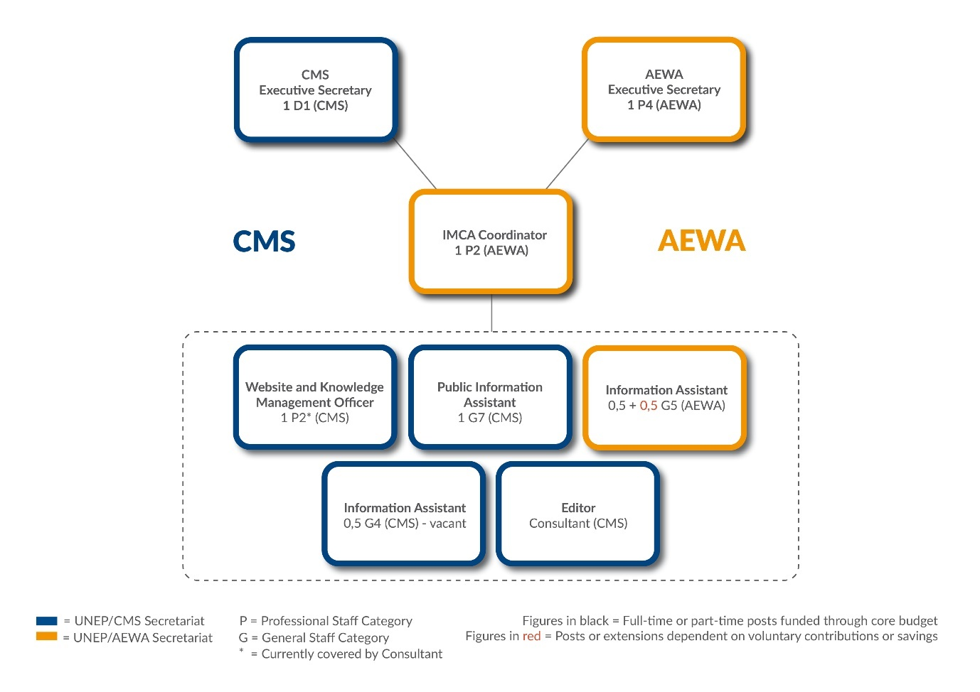
Figure 1: Organigram of the Joint Information Management, Communications and Awareness-raising (IMCA) Unit of the UNEP/CMS and UNEP/AEWA Secretariats (Status in March 2020)

On 13 May 2019, Amy Fraenkel entered on duty as Acting Executive Secretary of CMS and was appointed as CMS Executive Secretary on 11 February 2020, taking on the responsibility of co-managing the shared Unit with the Executive Secretary of AEWA. At this time the IMCA team was involved with preparations for CMS COP13, which took place in Gandhinagar, India from 15-22 February 2020.

Following CMS COP13 at the onset of the covid-19 pandemic, a temporary adjustment was made with regards to the overall management of the Unit on 31 April 2020 through an inter-office memorandum signed by the Executive Secretaries of CMS and AEWA, whereby the CMS Capacity Building Officer (P4) was temporarily made the IMCA Coordinator until the end of December 2020. This was done to better manage the regular IMCA workload for both CMS and AEWA in the area of communications and information management and to also strengthen the Secretariats ability to work on a number of pressing priorities, including on messaging around zoonotic diseases and the World Migratory Bird Day campaign. It was agreed that 80% of the CMS Capacity Building Officer (P4) time would be allocated to managing the shared Unit from May to December 2020.

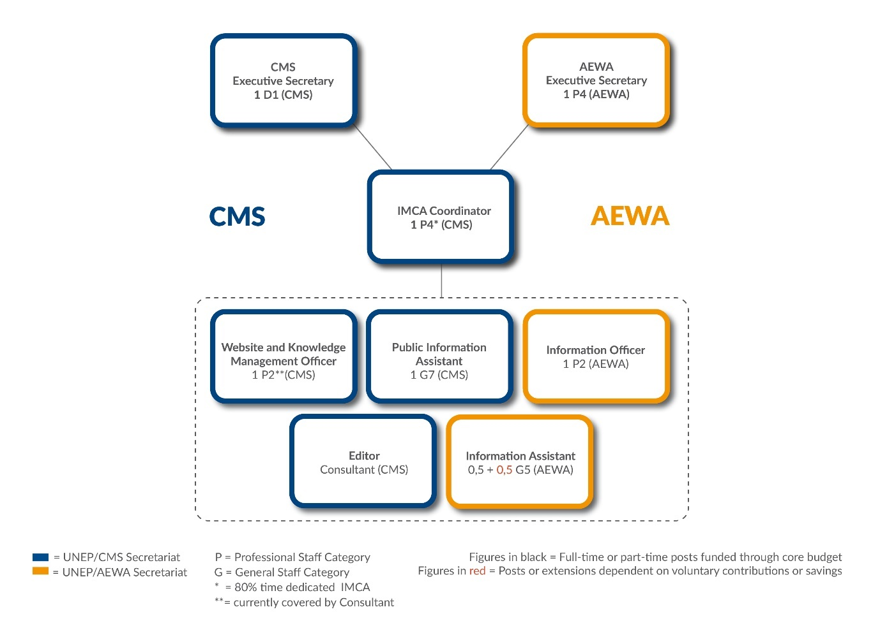

Figure 2: Organigram of the Joint Information Management, Communications and Awareness-raising (IMCA) Unit of the UNEP/CMS and UNEP/AEWA Secretariats (as of 28 April 2020 – 31 December 2020)

On 13 January 2021 Robert A. Vagg, the Consultant Editor and principal writer of the IMCA Unit passed away unexpectedly. His sudden death has been a tragic loss for CMS and the entire CMS Family.

From January – March 2021, the Unit did not have a Coordinator and IMCA team members were being supervised and managed by the respective Executive Secretaries. On 12 March 2021, the IMCA Unit held a team meeting with the CMS and AEWA Executive Secretaries to discuss the future management arrangements for the Unit, noting the existence of vacancies (the P2 Website and knowledge management officer, the 50% G4 and the writer/editor), as well as the continued desire by the CMS and AEWA Executive Secretaries to address the recommendation that the coordinator be at the P3 level. It was decided that for at least the coming year while these matters were addressed, the CMS P4 Legal Officer would continue to serve as the overall supervisor of the team although in reduced capacity in terms of allocated time (1 to 2 days/month).

In August 2021, the CMS Executive Secretary made the decision to reclassify and upgrade the CMS P2 Website and Information Management post to a new P3 position that will encompass the IMCA Coordination role as well as oversee the information management related tasks of the IMCA Unit. The decision to upgrade the position was also described in the budget document submitted to CMS StC52: "The Secretariat is planning to increase the effectiveness of the Information, Communication and Outreach unit by upgrading and advertising the position of the CMS Associate Information Officer from P2 to P3. There will be no costs in 2021, and the cost per annum for 2022 and 2023 is estimated to be $30,000. Most of the costs will be covered through savings achieved by not filling a half-time G4 position. The above decision to upgrade is necessary because the responsibilities of the position greatly exceed those usually given to a P2 officer, including management responsibilities. This is in keeping with the independent consultant report of 2016, Review of Job Classification."

At the result of the recruitment process, the P3 Public Information Officer serves as the Coordinator of the IMCA Unit since 16 February 2022. The following organigram shows the arrangement of the unit as of July 2022.

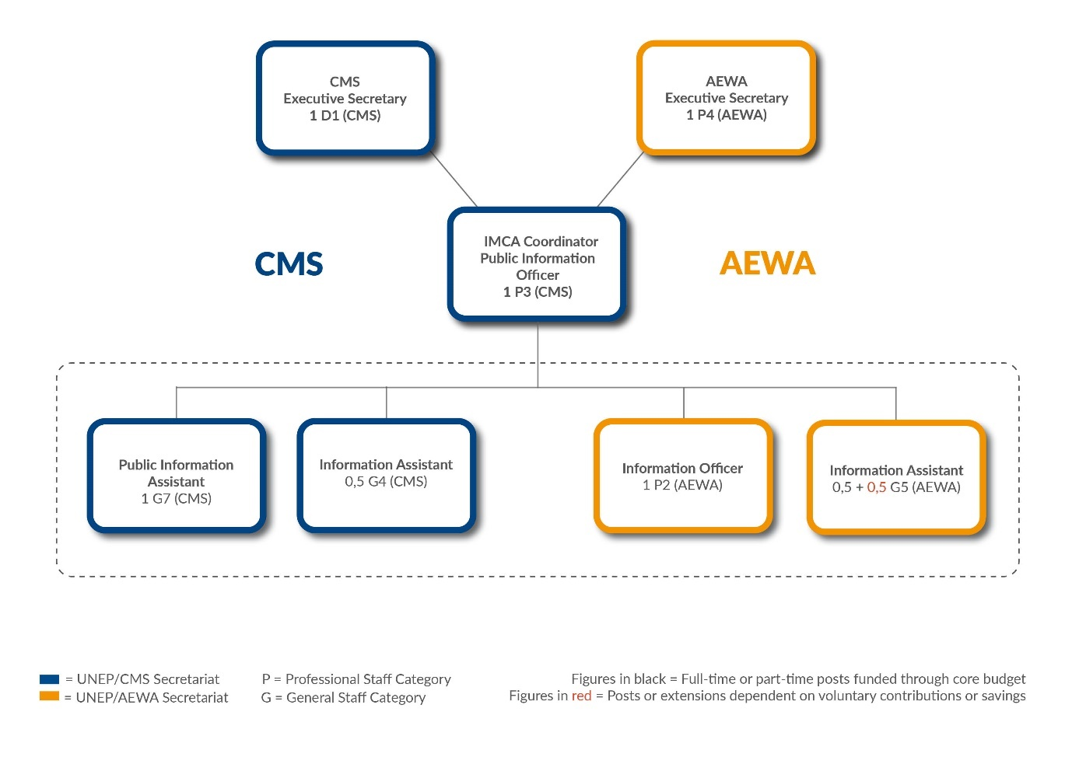
Figure 3: Organigram of the Joint Information Management, Communications and Awareness-raising (IMCA) Unit of the UNEP/CMS and UNEP/AEWA Secretariats (as of 28 July 2022)

3. - Evolution of the Staffing of the IMCA Unit

While AEWA’s contribution to the joint Unit has been stable ever since the creation of the Unit in 2014 (AEWA has consistently contributed its Information Officer (P2) and part-time Information Assistant (G5) to the Unit), the CMS contribution has seen some fluctuations and changes when it comes to the staffing of the Unit over time. While the original inter-office memorandum establishing the shared Unit included a full-time Associate Information Officer (P2), a Senior Public Information Assistant (G7) and a Consultant Editor as the CMS contribution, the actual CMS contribution to the Unit has evolved over time.

For example, the CMS Associate Information Officer position was a Junior Professional Officer (JPO) post that ended in December 2014 and in the absence of a regular full-time position in the budget, CMS hired a Website and Knowledge Management Consultant in April 2015. In June 2015, a CMS G4 (initially 50% but increased to 80% part-time) Secretary Position was added to the Unit until the position became vacant in August 2018. To cover for the gap left by this staff member, CMS management agreed to covering a 20% extension of AEWA’s Information Assistant position as of September 2018, allowing the AEWA staff member to work full time for IMCA since then. In addition, CMS hired temporary consultants to support with the organisation of World Migratory Bird Day in both 2019 and 2020 to compensate for some of the missing capacity in the team. As mentioned above, CMS has also contributed time from the P4 Capacity Building Officer.

The tables below show the overall contribution of both the CMS and AEWA Secretariats to the Unit in 2021, 2020 and 2019.

In 2021, the share of the CMS contribution stood at ca. 60,5 %, while AEWA’s share was at 39,5%. The balanced of the year was leaning towards more AEWA contribution with a calculated monetary difference to the optimum of ca. 25,108 EUR in favour of AEWA (meaning CMS would need to theoretically pay this amount to AEWA in order to reach the optimal balance), using the CMS standard salary costs approved at CMS COP13.

 |  |  | YEAR: 2021
Secretariat | Position | % Time / Months | Cost (€)
CMS | Inter-agency Liaison Officer / Head, Capacity Building (P4) | 30%/9 | 35,876
CMS | Senior Information Assistant (G7) | 100%/12 | 90,604
CMS | Secretary (G4) / Information Assistant (G5) (AEWA Contr.) | 20% / 12 | 14,214
CMS | Associate Information Officer / Web Consultant | 100% / 12 | 86,383
CMS | Website Individual Contractor | 100% / 5 | 17,578
 |  | TOTAL (CMS): | 245,110
Secretariat | Position | % Time / Months | Cost (€)
AEWA | Information Officer (P2) | 100%/12 | 103,362
AEWA | Information Assistant (G5) | 80% / 12 | 56,854
 |  | TOTAL (AEWA): | 160,216
 |  | TOTAL (CMS + AEWA) | 405,326
 |  | CMS Share (%) | 60,5
 |  | AEWA Share (%) | 39,5
 |  | OPTIMAL:
 |  | CMS (2/3) | 270,217
 |  | AEWA (1/3) | 135,108
 |  | Balance
 |  | CMS | -25,108
 |  | AEWA | 25,108

In 2020, the share of the CMS contribution stood at ca. 68 %, while AEWA’s share lay at 32%. This was a “balanced year” in terms of the agreed optimal ⅓ AEWA ⅔ CMS formula for a balanced contribution, with a calculated monetary difference to the optimum of ca. 9,179 EUR in favour of CMS (meaning AEWA would need to theoretically pay this amount to CMS in order to reach the optimal balance), using the CMS standard salary costs.

 |  |  | YEAR: 2020
Secretariat | Position | % Time / Months | Cost (€)
CMS | Inter-agency Liaison Officer / Head, Capacity Building (P4) | 80%/8 | 86,520
CMS | Senior Information Assistant (G7) | 100%/12 | 90,341
CMS | Secretary (G4) / Information Assistant (G5) (AEWA Contr.) | 20% / 12 | 14,171
CMS | Associate Information Officer / Web Consultant | 100% / 12 | 110,950
CMS | Consultant Editor / Writer | 100% / 12 | 50,630
CMS | Consultant (WMBD) | 100% / 3 | 10,197
 |  | TOTAL (CMS): | 362,809
Secretariat | Position | % Time / Months | Cost (€)
AEWA | Information Officer (P2) | 100%/12 | 110,950
AEWA | Information Assistant (G5) | 80% / 12 | 56,686
 | (up 100% as of 1 Sept 2018 CMS covering 20% of G5) | TOTAL (AEWA): | 167,636
 |  | TOTAL (CMS + AEWA) | 530,445
 |  | CMS Share (%) | 68,4
 |  | AEWA Share (%) | 31,6
 |  | OPTIMAL:
 |  | CMS (2/3) | 353630
 |  | AEWA (1/3) | 176815
 |  | Balance
 |  | CMS | -9,179
 |  | AEWA | 9,179

In 2019, the share of the CMS contribution stood at ca. 63 %, while AEWA’s share lay at 37 %, with a calculated monetary difference to the optimum of ca. 16,000 EUR which CMS would theoretically need to pay AEWA in order to reach the equilibrium.
.
 |  |  | YEAR: 2019
Secretariat | Position | % Time / Months | Cost (€)
CMS | Inter-agency Liaison Officer / Head, Capacity Building (P4) | 0% | 0
CMS | Senior Information Assistant (G7) | 100%/12 | 88,569
CMS | Secretary (G4) / Information Assistant (G5) (AEWA Contr.) | 20%/12 | 13,894
CMS | Associate Information Officer / Web Consultant | 100% / 12 | 108,775
CMS | Consultant Editor / Writer | 100% / 12 | 46,993
CMS | Consultant (WMBD) | 100% / 6 | 22,476
 |  | TOTAL (CMS): | 280,707
Secretariat | Position | % Time / Months | Cost (€)
AEWA | Information Officer (P2) | 100%/12 | 108,775
AEWA | Information Assistant (G5) | 80% / 12 | 55,574
 | (up 100% as of 1 Sept 2018 CMS covering 20% of G5) | TOTAL (AEWA): | 164,349
 |  | TOTAL (CMS + AEWA) | 445,056
 |  | CMS Share (%) | 63,1
 |  | AEWA Share (%) | 36,9
 |  | OPTIMAL:
 |  | CMS (2/3) | 296704
 |  | AEWA (1/3) | 148352
 |  | Balance
 |  | CMS | 15,997
 |  | AEWA | -15,997

The tables showing CMS and AEWA contributions to the IMCA Unit from 2014 – 2021 are included as ANNEX II of this document. This comprehensive analysis has shown that the agreed optimal ⅓ AEWA ⅔ CMS balance had never been fully achieved, although it generally improved after 2015.

However, taking the contributions of all the years since the start of IMCA into account (2014 – 2021), a calculated monetary difference to the optimum balance of ca.119,081 EUR exists, meaning that CMS would need to pay this amount to AEWA in order to reach the agreed equilibrium or allocated more CMS staff time to AEWA tasks.

 | CMS | AEWA | TOTAL
2021 | 245,110 | 160,216 | 405,326
Optimal (2/3 CMS + 1/3 AEWA): | 270,217 | 135,108
Difference (+ Overpaid / - Underpaid): | -25,108 | 25,108
2020 | 362,809 | 167,636 | 530,445
Optimal (2/3 CMS + 1/3 AEWA): | 353,630 | 176,815
Difference (+ Overpaid / - Underpaid): | 9,179 | -9,179
2019 | 280,707 | 164,349 | 445,056
Optimal (2/3 CMS + 1/3 AEWA): | 296,704 | 148,352
Difference (+ Overpaid / - Underpaid): | -15,997 | 15,997
2018 | 277,279 | 164,881 | 442,160
Optimal (2/3 CMS + 1/3 AEWA): | 294,773 | 147,387
Difference (+ Overpaid / - Underpaid): | -17,494 | 17,494
2017 | 279,895 | 157,892 | 437,787
Optimal (2/3 CMS + 1/3 AEWA): | 291,858 | 145,929
Difference (+ Overpaid / - Underpaid): | -11,963 | 11,963
2016 | 274,544 | 158,479 | 433,023
Optimal (2/3 CMS + 1/3 AEWA): | 288,682 | 144,341
Difference (+ Overpaid / - Underpaid): | -14,138 | 14,138
2015 | 204,088 | 138,488 | 342,576
Optimal (2/3 CMS + 1/3 AEWA): | 228,384 | 114,192
Difference (+ Overpaid / - Underpaid): | -24,296 | 24,296
2014 | 215,785 | 136,789 | 352,574
Optimal (2/3 CMS + 1/3 AEWA): | 235,049 | 117,525
Difference (+ Overpaid / - Underpaid): | -19,264 | 19,264
TOTAL TO OPTIMUM (2014 - 2021): | -119,081 | 119,081

4. - IMCA Time and Task Tracking Balance per Secretariat

To complement the cost-sharing arrangement, a time and task tracking tool (Toggl) was established at the end of 2016 to be able to monitor and report on the actual work being conducted by the IMCA Unit for each Secretariat. This is an important tool to be able to assess how much time the shared team is giving to each Secretariat. The online time and task tracking tool allows each member of the team to log their work according to pre-defined projects and activities per client (i.e. CMS, AEWA or JOINT). The tool can also produce overview reports that aid the general management of the Unit and help ensure that the ⅓ AEWA – ⅔ CMS arrangement is fulfilled also with regards to the actual “expenses”, i.e. the work the Unit does for each Secretariat.

The time and task tracking tool is also aligned with the annual Programme of Work (PoW) which is developed by the Coordinator and signed off by each Executive Secretary. In addition to providing a good estimate of the time the Unit is actually giving to each Secretariat, the use of this tool is also giving insights into how much time the joint communications team is spending on different activities and projects and what the peak months have been in terms of overall workload for the Unit over the course of the year. Part of the Coordinator’s task in the past years has been to prepare annual summary reports which are reviewed by CMS and AEWA management and which provide insight into how the time of the Unit has been spent.

Before looking at the time and task tracking reports for the year 2019, 2020 and 2021 in more detail, it is important to note here that a legacy imbalance of 48 days exists from the years 2017 and 2018. these 48 days are actually a deficit for AEWA. This imbalance was reviewed and confirmed by both the Acting CMS Executive Secretary and AEWA’s Executive Secretary on 20 March 2019.

4.1. – IMCA Time & Task Report for 2021

Below are the main insights gained from the time and task tracking system for the year 2021 as well as the overall balance per Secretariat. Activities are divided into the three different categories, or clients being CMS, AEWA and JOINT.

Overview of IMCA Activities for CMS

In 2021, the largest amount of time went into supporting the following CMS activities:
The CMS Terrestrial Unit’s time allocation is the highest in 2021 due to the launch of two reports in August and September (Reports on the impacts of plastic pollution and wild meat on migratory species). The September was also the busiest month with the afore-mentioned reports and the CMS Standing Committee.
In June, the IOSEA MOU used resources from IMCA with the celebration of World Sea Turtle Day events. IMCA also dedicated time to the CMS Scientific Council’s 5th Sessional Committee Meeting in the same month.

Overview of IMCA Activities for AEWA

No outstanding event during this period, as MOP8 was postponed, but additional time from the website individual contractor was allocated to the upgrade of the AEWA TC workspace and SSAP websites.

Overview of Joint Activities

Most part of the joint CMS/AEWA activities are dedicated to the organization of the World Migratory Bird Day Campaign. Another notable common project this year in the upgrade of CMS Family websites recorded under “Drupal 9” project.

Overall IMCA Time Balance in 2021

For the period 1 January – 31 December 2021, the overall ratio of time allocation of work carried out by the Joint Communications Unit is balanced with 67 % CMS and 33 % AEWA - with the Joint Activities factored in at a 1/3 AEWA and 2/3 CMS ratio.
The Joint Communications Unit has worked a total of
- 320 days on CMS related tasks
- 163 days on AEWA-related tasks and
- 437 + 49 (30% of P4 Coordinator time in 9 months) = 486 days on Joint CMS/AEWA tasks

From April to December 2021, CMS has also added additional staff capacity to the IMCA team, by allocating 30% of the time of a P-4 Legal Officer Post to help manage and coordinate the team. The time of the P-4 Officer spent towards IMCA was not tracked via the time and task tracking tool (Toggl), but it was agreed by CMS and AEWA management that it should be considered and logged as a “Joint Activity” as the tasks was primarily “Team Management” which falls in the Joint category.
Nine full months equal 164.25 working days, of which 30% are ca. 49 days are therefore added to the total recorded 437 days in Toggl under Joint CMS/AEWA tasks.

IMCA staff have spent a total of 969 man-days (645.62 for CMS (67%) and 323.38 for AEWA (33%)).
The optimal ratio in 2021 for the CMS portion should have been 649.23 and AEWA’s part 319.77, with 4 man-days of deficit from the CMS side.

4.2. - Time & Task Report for 2020

Below are the main insights gained from the time and task tracking system for the year 2020 as well as the overall balance per Secretariat. Activities are divided into the three different categories, or clients being CMS, AEWA and JOINT.

Overview of IMCA Activities for CMS

In 2020, the largest amount of time went into supporting the following CMS activities, which are listed as projects in the time and task tracking system: Support to CMS COP13 (145 days), Social Media Management (35 days), support to the Aquatic Unit/ASCOBANS (32 days),Website Content Management and News Production (28 days), Editorial / Writing Services (18 days) and Internal Meetings (15 days) followed by support to the Terrestrial Unit (14 days). The other projects consuming between 6 - 12 days each include Press and Media Work, Desktop Publishing Work, Audio – Visual (video/photo), Events Coverage, Administration, Personal Development/Training and support to the other CMS Units.

The annual Toggl data also show that the IMCA Unit was working an average of 460 hours (58 days) per month on purely CMS-related tasks in the first three months of the year (January – March 2020), while the average monthly rate dropped to 175 hours (22 days) per month in the remaining months of the year (April – December 2020), a trend that can clearly be attributed to CMS COP13. Alone in the month of February 2020, the team collectively logged a total of 734 hours (92 days) compared to only 85 hours (11 days) in February 2019.

Overview of IMCA Activities for AEWA

In 2020, the largest amount of IMCA time went into supporting the following AEWA activities, which are listed as projects in the time and task tracking system: National Reporting including the Population Status Review (43 days), AEWA’s 25th Anniversary (23 days), Support to the African Initiative (18 days), Website Content Management and News Production (11 days), Social Media Management (10 days).

The other projects consuming between 4 - 8 days each include Support to the SICU EGMP, Desktop Publishing Work, AEWA E-Newsletter, Internal Meetings and Contact Database management. From all the activities carried out for AEWA, the work on the AEWA national report format / population report and the work the team did for AEWA’s 25th Anniversary consumed the largest amount of IMCA staff time over the course of the year.

The annual Toggl data also show that the IMCA Unit was working an average of 105 hours (13 days) per month on purely AEWA-related tasks throughout 2020, whereby the month of June 2020 was the peak month for AEWA activities (34 days), while January and February 2020, with an average of 2 days logged for AEWA confirms the increasing focus on the team on CMS COP13 in those first two months of 2020.

Overview of Joint Activities

In terms of IMCA activities that were logged as shared CMS and AEWA activities by the core team in 2020, the largest amount of time went towards World Migratory Bird Day (WMBD) with 112 days, followed by Office Communication (Email, phone and in-person) with a total of 75 days. Another large chunk of time went towards Internal Meetings (Joint) and Drupal 8 with 42 days logged for each. Other joint activities logging (between 5 – 15 days) on Administration (CMS + AEWA), Team Management and External Meetings as well as Website Enhancement.

In terms of the spread of the annual workload on joint activities, the Toggl data show that the IMCA Unit was working an average of 264 hours (33 days) per month on JOINT activities during 2020. It is interesting to note that the peak months for IMCA on Joint activities were April, May, June and September and October 2020, with the peak month being September 2020 (58 days) and the lowest for shared activities was February 2020, with 4 days only.

Overall IMCA Time Balance in 2020

According to the Toggl time and task tracking figures for the period 1 January – 31 December 2020, the overall ratio of time allocation of work carried out by the Joint Communications Unit is 70 % CMS and 30 % AEWA - with the Joint Activities factored in at a 1/3 AEWA and 2/3 CMS ratio.

However, since 28 April 2020, CMS has also added additional capacity to the IMCA team, by allocating 80% of a P-4 Officer to help manage and coordinate the team (between May – December 2020). The time of the P-4 Officer spent towards IMCA was not tracked via the time and task tracking tool (Toggl), but it was agreed by CMS and AEWA management that it should be considered and logged as a “Joint Activity” as the tasks was primarily “Team Management” which falls in the Joint category. Eight full months equal 146 working days, of which 80% are ca. 117 days. The total amount of “Joint Activity” (so shared as 2/3 CMS and 1/3 AEWA) is therefore 553 man-days.

This total is resulting from the addition of recorded time in Toggl 436 + 117 (80% of P4 Coordinator time in 8 months). This bringing the share between CMS and AEWA from 70%/30% to a range of 69% (381.5 man-days) for CMS and 31% (171.5 man-days) for AEWA.

The optimal ratio in 2020 for the CMS portion should have been 370.5 and AEWA’s part 182.5, with 11 man-days of deficit from the CMS side.

In terms of actual hours, the Joint Communications Unit has worked a total of 3,296 hrs (or 412 days) on purely CMS related tasks and 1,266 hrs (or 158 days) on purely AEWA-related tasks between 1 January and 31 December 2020. Joint CMS and AEWA activities amounted to 3716 hrs (464 days), with World Migratory Bird Day listed as the main item carried out in this category in 2020.

It should be noted that the above figures reflect actual working hours as recorded in Toggl by the team members that have actively been contributing to the work of the Joint Unit in the period January - December 2020.

4.3. - Time & Task Report for 2019

Below are the main insights gained from the time and task tracking system for the year 2019 as well as the overall balance per Secretariat. Activities are divided into the three different categories, or clients being CMS, AEWA and JOINT.

Overview of IMCA Activities for CMS

In 2019, the largest amount of time went into supporting the following CMS activities, which are listed as projects in the time and task tracking system: Support to CMS COP13 (82 days), Social Media Management (42 days), Administration including recruitment and other HR- related tasks (38 days), CMS 40th Anniversary (27 days), Website Content Management and News Production (23 days), Internal Meetings (21 days) and Editorial / Writing Services (18 days). The other projects consuming between 6 - 12 days each include Desktop Publishing Work, Office Communication, External Meetings, Press and Media Work, Personal Development/Training and support to the different CMS Units.

The annual Toggl data also show that the IMCA Unit was working an average of 168 hours (21 days) per month on purely CMS-related tasks in the first half of the year (January – June 2019), while the average increased to 369 hours (46 days) per month in the second half of the year (July – December 2019), a trend that can be attributed to an increasing focus on the team on activities relating to preparations for CMS COP13.

Overview of IMCA Activities for AEWA

In 2019, the largest amount of IMCA time went into supporting the following AEWA activities, which are listed as projects in the time and task tracking system: Support to the EGMP (25 days), Website Content Management and News Production (17 days), National Reporting including the Population Status Review (14 days), Core support to SICU (13 days), Administration (12 days), Social Media Management (11 days) and Personal Development/Training (10 Days). The other projects consuming between 4 - 8 days each include Support to the African Initiative, Desktop Publishing Work, AEWA E-Newsletter, Internal Meetings and Contact Database management. From all the activities carried out for AEWA, the work on the AEWA national report format / population report and the configuration of the EGMP workspace and website consumed the largest amount of IMCA staff time over the course of the year.

The annual Toggl data also show that the IMCA Unit was working an average of 130 hours (16 days) per month on purely AEWA-related tasks in the first half of the year (January – June 2019), while the average declined to 80 hours (10 days) per month in the second half of the year (July – December 2019), a trend that confirms the increasing focus on the team on CMS COP13 in the second half of the year.

Overview of Joint Activities

In terms of IMCA activities that were logged as Joint CMS and AEWA activities in 2019, the largest amount of time went into Office Communication (Email, phone and in-person) with a total of 74 days, followed by activities relating to World Migratory Bird Day (WMBD) with 65 days. Another large chunk of time (between 20 – 40 days) went on Administration (CMS + AEWA), Internal Meetings (Joint), Team Management and External Meetings as well as Website Enhancement and Website Management (administrative).

In terms of the spread of the annual workload on joint activities, the Toggl data show that the IMCA Unit was working an average of 213 hours (27 days) per month on JOINT activities in the first half of the year (January – June 2019), while the average declined to 180 hours (22 days) per month in the second half of the year (July – December 2019).

Overall IMCA Time Balance in 2019

According to the figures for the period 1 January – 31 December 2019, the overall ratio of time allocation of work carried out by the Joint Communications Unit is 71 % CMS and 29 % AEWA - with the Joint Activities factored in at a 1/3 AEWA and 2/3 CMS ratio.

In terms of actual hours, the Joint Communications Unit has worked a total of 3,657 hrs (or 457 days) on purely CMS related tasks and 1,297 hrs (or 162 days) on purely AEWA-related tasks between 1 January and 31 December 2019. Joint CMS and AEWA activities amounted to 2,527 hrs (303 days).

Taking into account the overall IMCA time and task tracking data contained in Toggl (all work carried out by members of the Unit in 2019), there is an imbalance deficit of 44 days in favour of CMS in 2019.

It should be noted that the above figures reflect actual working hours as recorded in Toggl by the team members that have actively been contributing to the work of the Joint Unit in the period January - December 2019. It does not include the missing IMCA team staff capacity that has resulted from a vacant CMS G4 80 % Position (Assistant position to support World Migratory Bird Day).

While some of the missing time has been compensated by CMS through a temporary consultant for World Migratory Bird Day (Jan – July 2019) and by increasing the part-time AEWA G5 Information Assistant Position to 100% full time (whereby 20% was covered by CMS from Jan – Dec 2019), the team has in reality been operating with a reduced capacity in 2019.

4.4. - Overall IMCA Time Balance (2017 – 2021)

As captured in the IMCA Toggl Reports prepared for CMS and AEWA Management, there has been an imbalance of the time the Unit has spent in favour of CMS since the IMCA Unit began with the time and task tracking in 2017.

As presented in the 2019 Toggl Report a total imbalance of 92 days in favour of CMS existed on 31 December 2019, a balance which has accumulated over the years 2017 + 2018 (with 48 days in favour of CMS) and 2019 (with 44 days in favour of CMS). With the added figures of 2020 (4 days in favour of CMS) and 2021 (11 days in favour of CMS) the total imbalance as of 31 December 2021 for the period from 2017 to 2021 amounts to 107 man-days in favour of CMS.

5. - Conclusion

This report summarised the historic developments and institutional arrangements behind the Joint CMS/AEWA Information Management, Communication and Awareness-Raising (IMCA) Unit. It has also described the evolution of the Unit in terms of its staffing and the contributions each Secretariat has made toward IMCA since its establishment in 2014. In addition, it has provided detailed insight into the time and task tracking procedures the team has followed to assess the overall contribution of the Unit in terms of actual staff time allocated to each Secretariat.

From January 2014 onwards, the IMCA Unit has been jointly managed by the CMS Executive Secretary and the AEWA Executive Secretary, while the IMCA Coordinator has been given the responsibility for the day-to-day management of the team. Over the course of the years, a lot of progress has been made in terms of building and transforming the Unit into an effective shared team that serves a wide range of communication, information management as well as outreach needs of both the CMS and AEWA Secretariats.

This has primarily been achieved through a re-organisation and specialisation process that focused on establishing “core communications and information management capacity” within the team in the areas of 1. Website and Knowledge Management, 2. Screen and Print Design,3. Writing & Editorial Service,4. Press and Media (incl. social media) and 5. Campaigns and Outreach.

The benefits for the two Secretariats result in a higher quality of products in the area of design, website management and online reporting through greater specialisation, while for CMS it has also led to some savings.

However, as this report has shown, an imbalance exists in terms of the staff contribution made by each Secretariat to the shared Unit.

In terms of the overall staff resources put into the IMCA Unit from 2014 – 2021, a calculated monetary difference to the optimum balance of ca.119,081 EUR exists in favour of CMS. This figure represents the amount of staff capacity (in terms of monetary value) which CMS did not contribute (over a 7 year period) to IMCA in order to reach the optimum agreed balance. In other words, this “capacity” has been missing and actually represents a deficit on the side of CMS. It is also a clear indication that the IMCA team has been operating with less than the agreed capacity for several years, adding additional strain on an already stretched team servicing two Secretariats.

In terms of the balance of the time given to each Secretariat by the shared Unit, the report has shown that over the period since the time and tasks tracking has been in place (2017 – 2020) a total imbalance of 107 man-days have accumulated in favour of CMS.

As agreed in the institutional arrangements that govern the operation of the Joint Unit, CMS and AEWA Management will work collaboratively to address this imbalance through various means. As requested by the 16th Meeting of the AEWA Standing Committee, a conclusion on how to solve the deficit should have been reached by the end of 2021 after MOP8 and that an updated IMCA report should be provided for the next meeting of the AEWA Standing Committee following AEWA MOP8 showing how the equilibrium between the two Secretariats contributing to the common unit was achieved.

ANNEXES

Annex I – Scope and Remit of the IMCA Unit

Below is an extract from document AEWA/MOP 6.10 Rev. 1 (Report on the CMS/AEWA Common Information Management, Communication and Awareness-raising Team) outlining the remit of the IMCA Unit
“The main areas included under the umbrella “Information Management, Communication and Awareness-raising” considered as main areas of work for the Unit are:
• Information Management – website, online Technical/Scientific Committee Workspaces, Meeting Registration Tool development and technical maintenance etc.;
• Coordination of National Reporting Processes – maintenance and management of the Online Reporting System (ORS) tool; running and coordination of the national reporting processes;
• News and Media Service – Managing the press and media work, which includes media relations, press releases, website stories, placement of op-eds, organisation of press conferences, etc.;
• Special Events and Campaigns – Organisation of special public awareness-raising events and managing both large outreach campaigns such as World Migratory Bird Day (WMBD) and smaller communication campaigns around specific topics, meetings and/or events;
• Digital Design & Publications – Managing print and digital design projects, creation of graphics and designs for both print and digital media, liaising with printers, designers and ensuring high-quality publications and other types of communication products;
• Content Production/Writing – Production of written and visual content for different media, from website articles, to op-eds, statements, presentations and publications, etc.;
• Social Media Management – Managing the social media channels (Facebook and Twitter) of CMS and AEWA on a day-to-day basis, as well as, for campaigns such as World Migratory Bird Day (WMBD) and other special events/days;
• Audio-Visual/Multi-media – Developing audio visual and multi-media products, such as trailers, promotion films, video statements, etc.
• CEPA – Communication, Education and Public Awareness activities, creation of a CEPA Programme.”

Annex II – CMS + AEWA Contributions to the Shared IMCA Unit / Year (2021 – 2014)

 |  |  | YEAR: 2021
Secretariat | Position | % Time / Months | Cost (€)
CMS | Inter-agency Liaison Officer / Head, Capacity Building (P4) | 30%/9 | 35,876
CMS | Senior Information Assistant (G7) | 100%/12 | 90,604
CMS | Secretary (G4) / Information Assistant (G5) (AEWA Contr.) | 20% / 12 | 14,214
CMS | Associate Information Officer / Web Consultant | 100% / 12 | 86,383
CMS | Website Individual Contractor | 100% / 5 | 17,578
 |  | TOTAL (CMS): | 245,110
Secretariat | Position | % Time / Months | Cost (€)
AEWA | Information Officer (P2) | 100%/12 | 103,362
AEWA | Information Assistant (G5) | 80% / 12 | 56,854
 |  | TOTAL (AEWA): | 160,216
 |  | TOTAL (CMS + AEWA) | 405,326
 |  | CMS Share (%) | 60,5
 |  | AEWA Share (%) | 39,5
 |  | OPTIMAL:
 |  | CMS (2/3) | 270,217
 |  | AEWA (1/3) | 135,108
 |  | Balance
 |  | CMS | 25,108
 |  | AEWA | -25,108
 |  |  | YEAR: 2020
Secretariat | Position | % Time / Months | Cost (€)
CMS | Inter-agency Liaison Officer / Head, Capacity Building (P4) | 80%/8 | 86,520
CMS | Senior Information Assistant (G7) | 100%/12 | 90,341
CMS | Secretary (G4) / Information Assistant (G5) (AEWA Contr.) | 20% / 12 | 14,171
CMS | Associate Information Officer / Web Consultant | 100% / 12 | 110,950
CMS | Consultant Editor / Writer | 100% / 12 | 50,630
CMS | Consultant (WMBD) | 100% / 3 | 10,197
 |  | TOTAL (CMS): | 362,809
Secretariat | Position | % Time / Months | Cost (€)
AEWA | Information Officer (P2) | 100%/12 | 110,950
AEWA | Information Assistant (G5) | 80% / 12 | 56,686
 | (up 100% as of 1 Sept 2018 CMS covering 20% of G5) | TOTAL (AEWA): | 167,636
 |  | TOTAL (CMS + AEWA) | 530,445
 |  | CMS Share (%) | 0.684
 |  | AEWA Share (%) | 0.316
 |  | OPTIMAL: | 176815
 |  | CMS (2/3) | 353630
 |  | AEWA (1/3) | 176815
 |  | Balance
 |  | CMS | -9,179
 |  | AEWA | 9,179
 |  |  | YEAR: 2019
Secretariat | Position | % Time / Months | Cost (€)
CMS | Inter-agency Liaison Officer / Head, Capacity Building (P4) | 0% | 0
CMS | Senior Information Assistant (G7) | 100%/12 | 88,569
CMS | Secretary (G4) / Information Assistant (G5) (AEWA Contr.) | 20%/12 | 13,894
CMS | Associate Information Officer / Web Consultant | 100% / 12 | 108,775
CMS | Consultant Editor / Writer | 100% / 12 | 46,993
CMS | Consultant (WMBD) | 100% / 6 | 22,476
 |  | TOTAL (CMS): | 280,707
Secretariat | Position | % Time / Months | Cost (€)
AEWA | Information Officer (P2) | 100%/12 | 108,775
AEWA | Information Assistant (G5) | 80% / 12 | 55,574
 | (up 100% as of 1 Sept 2018 CMS covering 20% of G5) | TOTAL (AEWA): | 164,349
 |  | TOTAL (CMS + AEWA) | 445,056
 |  | CMS Share (%) | 0.631
 |  | AEWA Share (%) | 0.369
 |  | OPTIMAL: | 148352
 |  | CMS (2/3) | 296704
 |  | AEWA (1/3) | 148352
 |  | Balance
 |  | CMS | 15,997
 |  | AEWA | -15,997
 |  |  | YEAR: 2018
Secretariat | Position | % Time / Months | Cost (€)
CMS | Inter-agency Liaison Officer / Head, Capacity Building (P4) | 0% | 0
CMS | Senior Information Assistant (G7) | 100%/12 | 86,833
CMS | Secretary (G4) (until 31 Aug 2018) / Inf. Asst (G5) (AEWA) | 80% G4/8 + 20% G%/4 | 36,652
CMS | Associate Information Officer (P2)/ Web Consultant | 100% / 12 | 106,642
CMS | Consultant Editor / Writer | 100% / 12 | 47,152
CMS | Consultant (WMBD) |  | 0
 |  | TOTAL (CMS): | 277,279
Secretariat | Position | % Time / Months | Cost (€)
AEWA | Information Officer (P2) | 100%/12 | 108,195
AEWA | Information Assistant (G5) | 80% / 12 | 56,686
 | (up 100% as of 1 Sept 2018 CMS covering 20% of G5) | TOTAL (AEWA): | 164,881
 |  | TOTAL (CMS + AEWA) | 442,160
 |  | CMS Share (%) | 0.627
 |  | AEWA Share (%) | 0.373
 |  | OPTIMAL: | 147387
 |  | CMS (2/3) | 294773
 |  | AEWA (1/3) | 147387
 |  | Balance
 |  | CMS | 17,494
 |  | AEWA | -17,494
 |  |  | YEAR: 2017
Secretariat | Position | % Time / Months | Cost (€)
CMS | Inter-agency Liaison Officer / Head, Capacity Building (P4) | 0% | 0
CMS | Senior Information Assistant (G7) | 100%/12 | 86,119
CMS | Secretary (G4) | 80%/12 | 53,526
CMS | Associate Information Officer (P2)/ Web Consultant | 100% / 12 | 93,241
CMS | Consultant Editor / Writer | 100% / 12 | 47,009
CMS | Consultant (WMBD) |  | 0
 |  | TOTAL (CMS): | 279,895
Secretariat | Position | % Time / Months | Cost (€)
AEWA | Information Officer (P2) | 100%/12 | 106,074
AEWA | Information Assistant (G4 until July/ G5 as of August 2017) | 80% / G4/7 + G5/5 | 51,818
 |  | TOTAL (AEWA): | 157,892
 |  | TOTAL (CMS + AEWA) | 437,787
 |  | CMS Share (%) | 0.639
 |  | AEWA Share (%) | 0.361
 |  | OPTIMAL: | 145929
 |  | CMS (2/3) | 291858
 |  | AEWA (1/3) | 145929
 |  | Balance
 |  | CMS | 11,963
 |  | AEWA | -11,963
 |  |  | YEAR: 2016
Secretariat | Position | % Time / Months | Cost (€)
CMS | Inter-agency Liaison Officer / Head, Capacity Building (P4) | 0% | 0
CMS | Senior Information Assistant (G7) | 100%/12 | 84,430
CMS | Secretary (G4) | 80%/12 | 52,477
CMS | Associate Information Officer (P2)/ Web Consultant | 100% / 12 | 92,019
CMS | Consultant Editor / Writer | 100% / 12 | 45,618
CMS | Consultant (WMBD) |  | 0
 |  | TOTAL (CMS): | 274,544
Secretariat | Position | % Time / Months | Cost (€)
AEWA | Information Officer (P2) | 100%/12 | 103,994
AEWA | Information Assistant (G4) | 80% / 12 | 54,485
 |  | TOTAL (AEWA): | 158,479
 |  | TOTAL (CMS + AEWA) | 433,023
 |  | CMS Share (%) | 0.634
 |  | AEWA Share (%) | 0.366
 |  | OPTIMAL: | 144341
 |  | CMS (2/3) | 288682
 |  | AEWA (1/3) | 144341
 |  | DEFICIT Balance
 |  | CMS | 14,138
 |  | AEWA | -14,138
 |  |  | YEAR: 2015
Secretariat | Position | % Time / Months | Cost (€)
CMS | Inter-agency Liaison Officer / Head, Capacity Building (P4) | 0% | 0
CMS | Senior Information Assistant (G7) | 100%/12 | 82,775
CMS | Secretary (G4) (as of 1 June 2015) | 80%/7 | 30,011
CMS | Associate Information Officer (P2)/ Web Consultant | 50% / 8 | 45,102
CMS | Consultant Editor / Writer | 100% / 12 | 46,200
CMS | Consultant (WMBD) |  | 0
 |  | TOTAL (CMS): | 204,088
Secretariat | Position | % Time / Months | Cost (€)
AEWA | Information Officer (P2) | 100%/12 | 87,074
AEWA | Information Assistant (G4) | 80% / 12 | 51,414
 |  | TOTAL (AEWA): | 138,488
 |  | TOTAL (CMS + AEWA) | 342,576
 |  | CMS Share (%) | 0.596
 |  | AEWA Share (%) | 0.404
 |  | OPTIMAL: | 114192
 |  | CMS (2/3) | 228384
 |  | AEWA (1/3) | 114192
 |  | Balance
 |  | CMS | 24,296
 |  | AEWA | -24,296
 |  |  | YEAR: 2014
Secretariat | Position | % Time / Months | Cost (€)
CMS | Inter-agency Liaison Officer / Head, Capacity Building (P4) |  | 0
CMS | Senior Information Assistant (G7) | 100%/12 | 81,151
CMS | Secretary (G4) | 0 | 0
CMS | Associate Information Officer (P2) (until Dec 2014) | 100% / 12 | 88,434
CMS | Consultant Editor / Writer | 100% / 12 | 46,200
CMS | Consultant (WMBD) | 0 | 0
 |  | TOTAL (CMS): | 215,785
Secretariat | Position | % Time / Months | Cost (€)
AEWA | Information Officer (P2) | 100%/12 | 85,367
AEWA | Information Assistant (G4) | 80% / 12 | 51,422
 |  | TOTAL (AEWA): | 136,789
 |  | TOTAL (CMS + AEWA) | 352,574
 |  | CMS Share (%) | 0.612
 |  | AEWA Share (%) | 0.388
 |  | OPTIMAL: | 117525
 |  | CMS (2/3) | 235049
 |  | AEWA (1/3) | 117525
 |  | DEFICIT Balance
 |  | CMS | 19,264
 |  | AEWA | -19,264
 |  |  | YEAR: 2013
Secretariat | Position | % Time / Months | Cost (€)
CMS | Head, Capacity Building (P4) | 50%/12 | 68,850
CMS | Senior Information Assistant (G7) | 100%/12 | 79,560
CMS | Secretary (G4) | 50%/12 | 30,906
CMS | Associate Information Officer (P2) (JPO) | 100% / 12 | 88,434
CMS | Clerk (G4) | 100%/12 | 61,812
CMS | Consultant Editor / Writer | 100% / 12 | 46,200
 |  | TOTAL (CMS): | 375,762
Secretariat | Position | % Time / Months | Cost (€)
AEWA | Information Officer (P2) | 100%/12 | 83,693
AEWA | Information Assistant (G4) | 80% / 12 | 50,414
 |  | TOTAL (AEWA): | 134,107

Annex III – List of Related Documents

Below is a comprehensive overview of all the documents related to the creation and implementation of the IMCA Unit, with direct links to those documents which are publicly available. Copies of non-public documents can be obtained from the Secretariat upon request.
- Resolution 10.9 “Future Structure and Strategies of the CMS and CMS Family” (Doc. UNEP/CMS/Resolution 10.09) / Date of Publication: November 2011
- “CMS Executive Secretary Proposal for Enhancing Cooperation and Coordination between AEWA and CMS” (Doc. AEWA/StC 9.22) / Date of Publication: August 2013
- Inter-Office Memorandum: Establishment of a Common Information Management, Communication and Awareness-raising Team as a Pilot to Demonstrate Shared Services between CMS and AEWA / Date of Publication: January 2014 (Available upon request)
- Executive Secretary Report on the CMS/AEWA Pilot on the Common Communications and Outreach Unit (Annex 2 of Doc. UNEP/CMS/COP11/Doc.16.2/Annex 2) Date of Publication: September 2014
- CMS Resolution 11.3 “Enhancing Synergies and Common Services Among CMS Family Instruments” (Doc. UNEP/CMS/Resolution 11.3) / Date of Publication: November 2014
- Report on the CMS/AEWA Common Information Management, Communication and Awareness-raising Team (Doc. AEWA/MOP6.10 Rev. 1) / Date of Publication: October 2015
- “Independent Analysis on Common Services and Synergies in the CMS Family” (Doc. UNEP/CMS/StC44/15.1) / Date of Publication: October 2015
- Resolution 6.22: “Synergies Between the UNEP/AEWA and UNEP/CMS” / Date of Publication: November 2015
- Review of Job Classification – Final Report by Douglas Winn / Date of Publication: October 2016 (Available upon request)
- Report on the Joint CMS/AEWA Information Management, Communication and Awareness-Raising Unit (Doc. AEWA/StC12.16) / Date of Publication: December 2016
- Inter-Office Memorandum: Future Management Modalities of the Common CMS + AEWA Information Management, Communication and Awareness-raising (IMCA) Unit / Date of Publication: 8 December 2016 (Available upon request)
- Proposal for Implementation Arrangements for the Pilot Joint CMS/AEWA Information Management, Communication and Awareness-raising Unit / Date of Publication: October 2018 (Available upon request)
- Report on the Joint CMS/AEWA Information Management, Communication and Awareness-Raising Unit (Doc. AEWA/StC13.9) / Date of Publication: June 2018
- Report on the Implementation of the AEWA Communication Strategy (Doc. AEWA/MOP7.13) / Date of Publication: 05 October 2018
- Report of the AEWA Standing Committee on the Results and Experiences of the Common CMS and AEWA Information Management, Communication and Awareness-raising (IMCA) Unit and Recommendations on the Way Forward (Doc. AEWA/MOP7.6) /Date of Publication: October 2018
- Report of the 15th Meeting of the AEWA Standing Committee (AEWA StC15 Meeting Report / Paragraphs 41 - 43) / Date of Publication: 24 March 2020
- Inter-Office Memorandum: Changes to IMCA Working Arrangements / Date of Publication: 28 April 2020 (Available upon request)
- IMCA Unit Time & Task Tracking – Toggl Analysis Report for 2019 / Date of Publication: 3 July 2020 (Available upon request)
- IMCA Unit Time & Task Tracking – Toggl Analysis Report for 2020 / Date of Publication: February 2021. (Available upon request)
- Report on the Joint CMS/AEWA Information Management, Communication and Awareness-Raising (IMCA) Unit for the 16th Meeting of the AEWA Standing Committee. (Doc. AEWA/StC16.30) / Date of Publication: April 2021.
- Report of the Joint CMS/AEWA Information Management, Communication and Awareness-raising (IMCA) Unit for the 8th Meeting of the Parties to AEWA. (Doc. AEWA/MOP8.17) / Date of Publication: August 2021.

Bradnee Chambers, Executive Secretary of CMS, passed away on 23 January 2019: Bradnee Chambers 1966 - 2019
According to UN staff rules, every staff member is required to have 5 days of training per year.
For a more detailed description of the range of work falling under the remit of the Unit, please see Annex I of this document.

