REPORT ON THE IMPLEMENTATION OF THE
AEWA COMMUNICATION STRATEGY
Prepared by the Secretariat

Introduction
In accordance with Resolution 6.10, the AEWA Secretariat is providing both a written and oral report on the implementation of the AEWA Communication Strategy to the 8th Meeting of the Parties to AEWA. The written report is being submitted as a MOP8 document, while the oral report will be given as a powerpoint presentation at the meeting. The reports provide a review of the effectiveness of the strategy as well as a summary of the main activities carried out by the Secretariat and its Joint CMS/AEWA Information Management, Communication and Awareness-raising (IMCA) Unit to implement the strategy since MOP7 held in Durban, South Africa in December 2018.
Summary
At the 6th Session of the Meeting of the Parties to AEWA (MOP6) in November 2015, Parties adopted a new Communication Strategy for the Agreement through Resolution 6.10. At the same meeting, Parties also acknowledged the importance of funding to implement the Communication Strategy by adding additional wording to Resolution 6.18 (on Financial and Administrative Matters) which recognised “the need to provide adequate resources to support the implementation of the Communication Strategy”. Similar wording recognising the need to provide resources to the implementation of the AEWA Communication Strategy was included in Resolution 7.12 (on Financial and Administrative Matters) adopted at MOP7 in Durban, South Africa.
The overall aim of the strategy is to guide the communication work of all relevant AEWA stakeholders, from countries (especially Parties) to non-governmental organisations (NGOs) and other partners to the Secretariat, with the primary purpose of supporting the implementation of the Agreement. As such, the strategy is a key document for all stakeholders as well as for the Secretariat as it provides a strategic framework and valuable “communication guidance” for communication activities and implementation efforts.
Since its adoption by MOP6, the AEWA Communication Strategy has proven to be a useful tool and reference document, clearly defining AEWA’s communication objectives, niche and target audiences. In 2018, the AEWA Communication Strategy was also used as a model by CMS for the development of a Communication Strategy for the CMS Memorandum of Understanding on the Conservation of Migratory Sharks (Sharks MOU) and is also being used as a potential model for developing a new Communication Strategy for CMS. At the AEWA Secretariat level, the strategy is primarily being used to give strategic direction to the work of the Secretariat as well as the work being conducted by the Common CMS/AEWA Information Management, Communication and Awareness-Raising (IMCA) Unit for AEWA. The AEWA Communication Strategy is also being used as an important guiding document for MOP8 Communication efforts being carried out by the IMCA Unit on behalf of the Secretariat in the run-up, during, and after the AEWA MOP8 meeting which will be held from 26 – 30 September 2022 in Budapest, Hungary.
The oral presentation on the Implementation of the Communication Strategy to MOP8 will be given by AEWA's Information Officer and will focus on the communication activities carried out by the Secretariat and its shared IMCA Unit for AEWA since MOP7 in 2018. For a detailed summary of efforts by Parties in the area of communication, please see the “Education and Information” section of the “Analysis of AEWA National Reports for Triennium 2018 – 2020” (Document AEWA/MOP 8.13) as well as the relevant sections of the “Analysis of the National Reports on the Implementation of the AEWA Plan of Action for African for the Period 2019-2020” (Document AEWA/MOP 8.15). For a more detailed report on the shared CMS and AEWA Communications Unit, please see the "Report on the Joint CMS/AEWA Information Management, Communication and Awareness-raising (IMCA) Unit" (Document: AEWA/MOP 8.18).

Action Requested from the Meeting of the Parties
The Meeting of the Parties is invited to take note of the report on the Implementation of the AEWA Communication Strategy and to continue to develop and report on activities conducted in support of implementing the AEWA Communication Strategy.
As per Resolutions 6.10 and 6.18, and 7.12 Parties are also encouraged to consider providing voluntary contributions towards the implementation of the AEWA Communication Strategy and to support its implementation with the expertise, networks, skills and resources they have at their disposal.

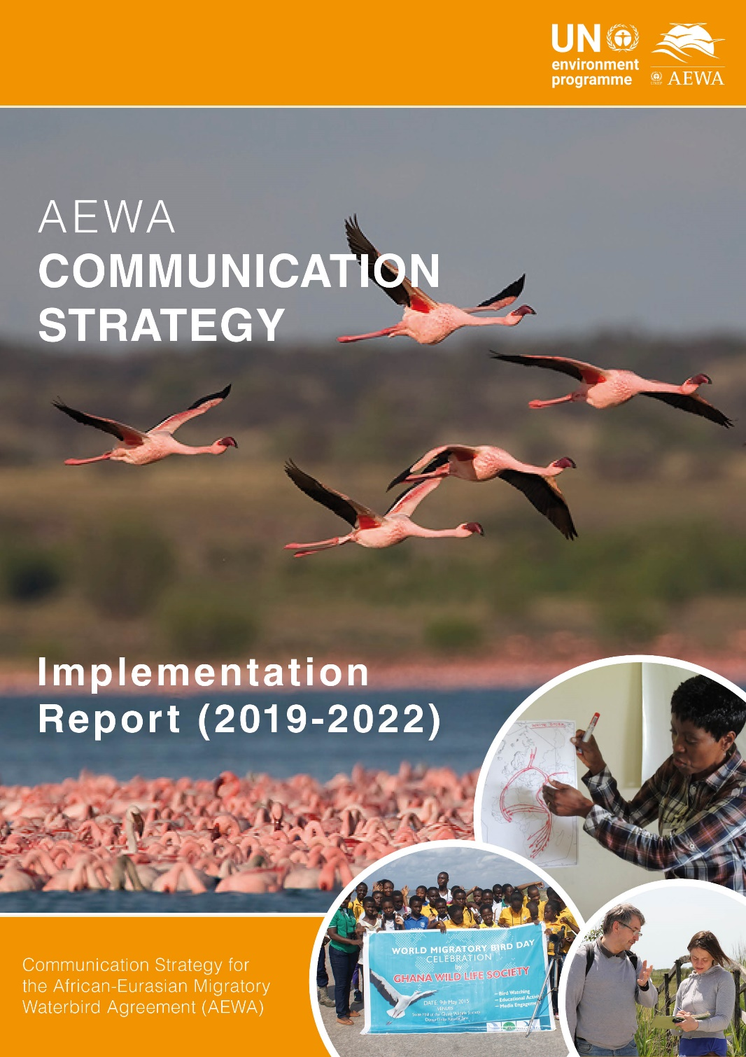
Introduction
This report is being submitted to the 8th Session of the Meeting of the Parties (MOP8) by the Secretariat in accordance with Resolution 6.10, which requests the Secretariat to regularly report on the implementation of the AEWA Communication Strategy at each Meeting of the Parties (MOP). The report reviews the effectiveness of the strategy and presents a summary of activities carried out by the Secretariat to implement the strategy in the period since MOP7 held in December 2018 in Durban, South Africa (2019 – July 2022).

The report also provides some background information on the current arrangements and operation of the Common CMS/AEWA Information Management, Communication and Awareness-raising (IMCA) Unit. For further information on the IMCA Unit please see: “Report on the Joint CMS/AEWA Information Management, Communication and Awareness-raising (IMCA) Unit” (Document AEWA/MOP 8.18).

The AEWA Communication Strategy
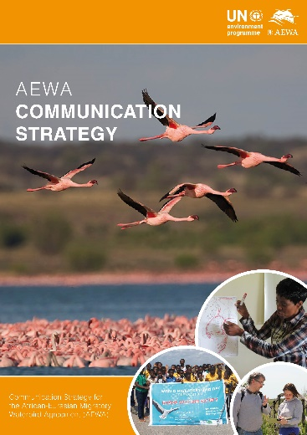
Figure 1: The AEWA Communication Strategy
At the 6th Session of the Meeting of the Parties to AEWA (MOP6) in November 2015, Parties adopted a new Communication Strategy for the Agreement through Resolution 6.10. At the same meeting, Parties also acknowledged the importance of funding to implement the Communication Strategy by adding additional wording to Resolution 6.18 (on Financial and Administrative Matters) which recognised “the need to provide adequate resources to support the implementation of the Communication Strategy”.

The overall aim of the strategy is to guide the communication work of all relevant AEWA stakeholders, from countries (especially Parties) to non-governmental organisations (NGOs) and other partners to the Secretariat, with the primary purpose of supporting the implementation of the Agreement. As such, the strategy is a key document for all stakeholders and particularly for the Secretariat in terms of providing a strategic framework and valuable “communication guidance” for communication activities and implementation efforts. Hence, the current report primarily focuses on the activities carried out by the Secretariat and its shared IMCA Unit.

For a detailed summary of efforts by Parties in this area, please see the “Education and Information” section of the “Analysis of AEWA National Reports for Triennium 2018 – 2020” (Document AEWA/MOP 8.13) as well as the relevant sections of the “Analysis of the National Reports on the Implementation of the AEWA Plan of Action for African for the Period 2019-2020” (Document AEWA/MOP 8.15).

For a detailed report on the shared CMS and AEWA Communications Unit, please see the "Report on the Joint CMS/AEWA Information Management, Communication and Awareness-raising (IMCA) Unit" (Document: AEWA/MOP 8.18).

Since its adoption by MOP6, the AEWA Communication Strategy has proven to be a useful tool and reference document, clearly defining AEWA’s communication objectives, niche and target audiences.

Communication, Education and Public Awareness Raising (CEPA)

AEWA Resolution 6.10, adopted at MOP6 in November 2015, includes a request to both the AEWA CEPA Focal Points and Technical Committee CEPA Expert, to provide active support to the communication work of the Agreement, for example through the identification of priority issues and partners for communication, development of communication plans, communication products and key messages.

As of June 2022, a total of 45 AEWA Parties have nominated National Focal Points for Communication, Education and Public Awareness Raising (CEPA) in accordance with AEWA Resolution 5.5. All Focal Point nominations are communicated to the UNEP/AEWA Secretariat and an up-to-date list of AEWA CEPA Focal Points is published on the AEWA website at the following location: http://www.unep-aewa.org/en/cepa.

Information on the roles and responsibilities of CEPA Focal Points, as well as a designation form can be found on the above-mentioned webpage. Parties are encouraged to continue to nominate AEWA CEPA Focal Points, despite the passing of the deadline mentioned in Resolution 5.5.

Although the number of nominated AEWA CEPA Focal Points has risen since MOP7, the Secretariat would like to highlight that the AEWA CEPA network has been largely underutilised to date. This is in part due to the lack of financial and human resources on the side of the Secretariat, but also due to capacity issue on the national level as well. It would be desirable if the growing AEWA CEPA network can be mobilised more in the future, including through offering dedicated CEPA workshops and the development of a CEPA Resource Hub (the idea of a central web portal for training and education material focused on waterbirds and wetlands for potential use across the flyway). With greater human capacity in this area, the IMCA Unit could seek both cooperation partners and voluntary contributions from countries interested in supporting such work in the framework of AEWA.
Thematic CEPA Expert on the AEWA Technical Committee
In line with AEWA Resolution 5.5, Ms Oleysa Petrovych (Ukraine) has been acting as the Thematic Expert for CEPA on the AEWA Technical Committee (TC) since May 2015. During this time, Ms Petrovych’s acted as Chair of the AEWA Technical Committee Working Group (WG) on Education and Information (WG 6) during several TC meetings and helped to identify CEPA-related activities for inclusion in the TC’s Work Plan for the period 2016 – 2018, 2019 – 2021 and the draft TC work plan for 2022 - 2024. In her capacity as TC Thematic CEPA Expert, Ms Petrovych also contributed to the AEWA Strategic Plan Revision Process Workshop (28 – 30 June 2016 in Bonn, Germany) as well as in the Plan of Action for Africa 2019 – 2027 Development Workshop which took place 10-12 October 2017 in Dakar, Senegal. The Secretariat would like to sincerely thank Ms Petrovych for her dedication and support to the work of the AEWA Technical Committee and the CEPA work of the Agreement. For more information on the work of the Technical Committee, including the work conducted under TC Working Group 6: Education and Information, please see the Report of the Technical Committee to the 8th Session of the Meeting of the Parties (Document AEWA/MOP 8.7)
Figure 2: Ms Oleysa Petrovych (Ukraine), Thematic Expert for CEPA on the AEWA Technical Committee.

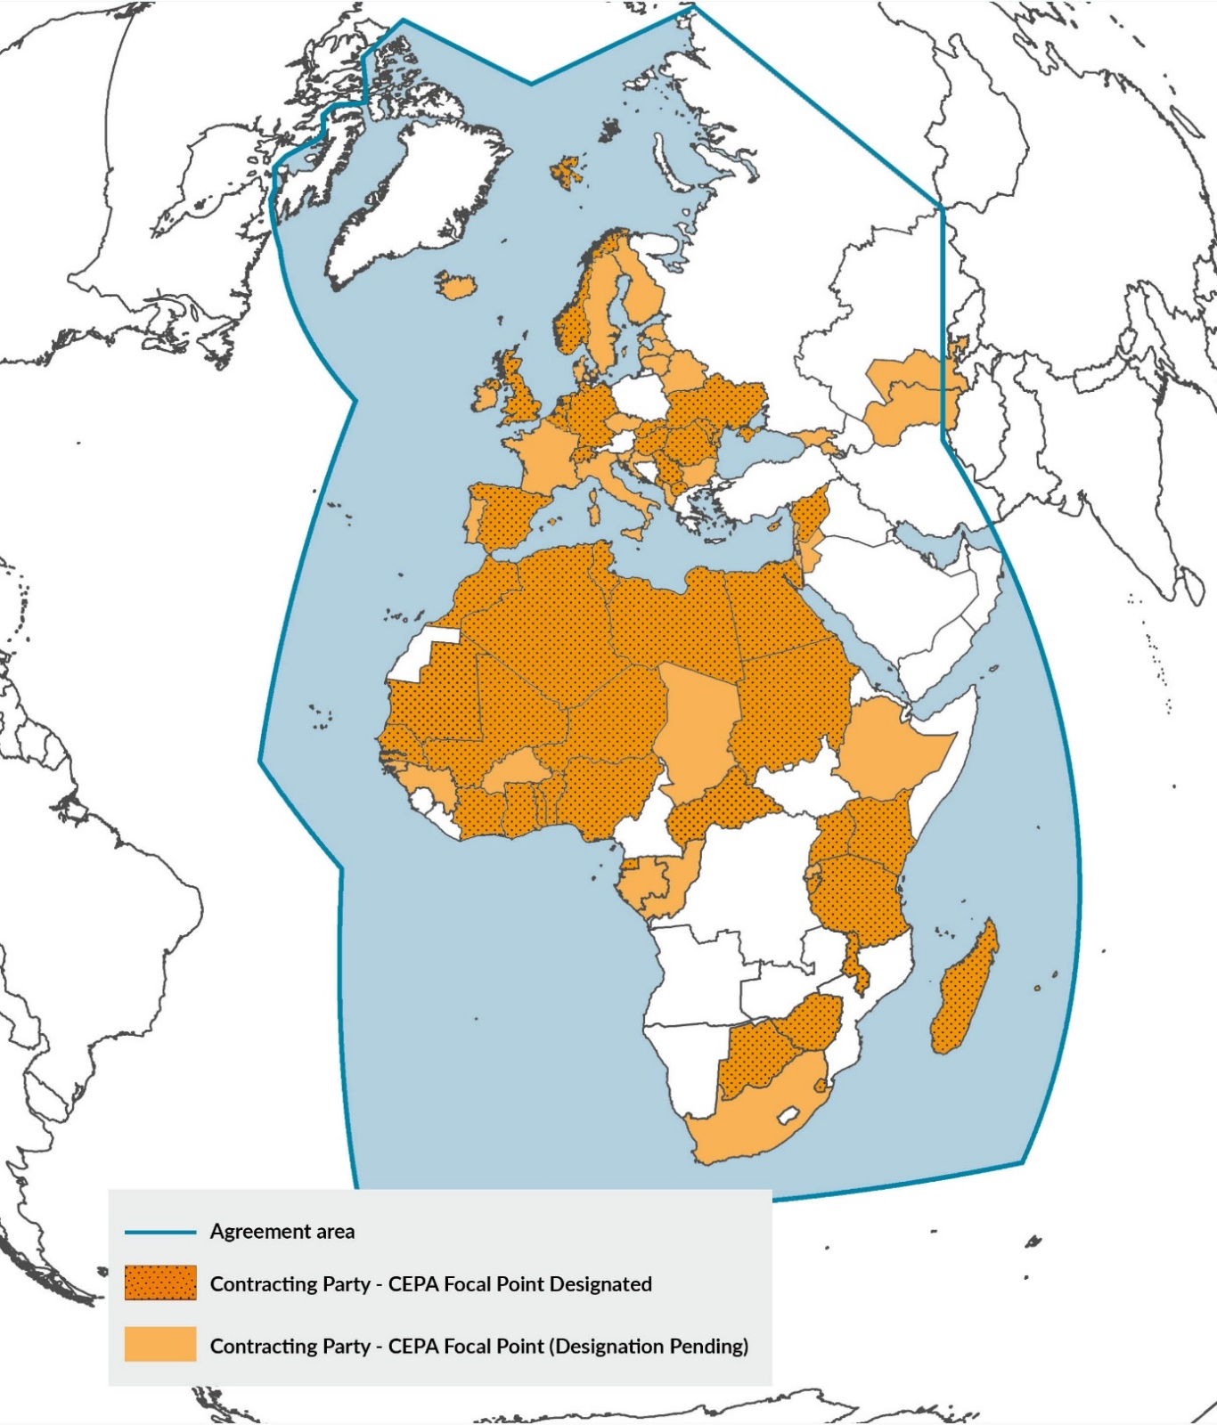
Figure 3: Map of the AEWA Agreement Area showing Contracting Parties that have designated Communication, Education and Awareness-Raising (CEPA) Focal Points (as of June 2022).

AEWA Secretariat Communication and Outreach Efforts

The UNEP/AEWA Secretariat is involved in a number of activities, which both directly and indirectly contribute to the implementation of the AEWA Communication Strategy. For example, the work being conducted under the AEWA African Initiative, the European Goose Management Platform (EGMP), or projects being run to support AEWA Single Species Action Plans (SSAPs) all make significant contributions towards the implementation of the AEWA Communication Strategy.

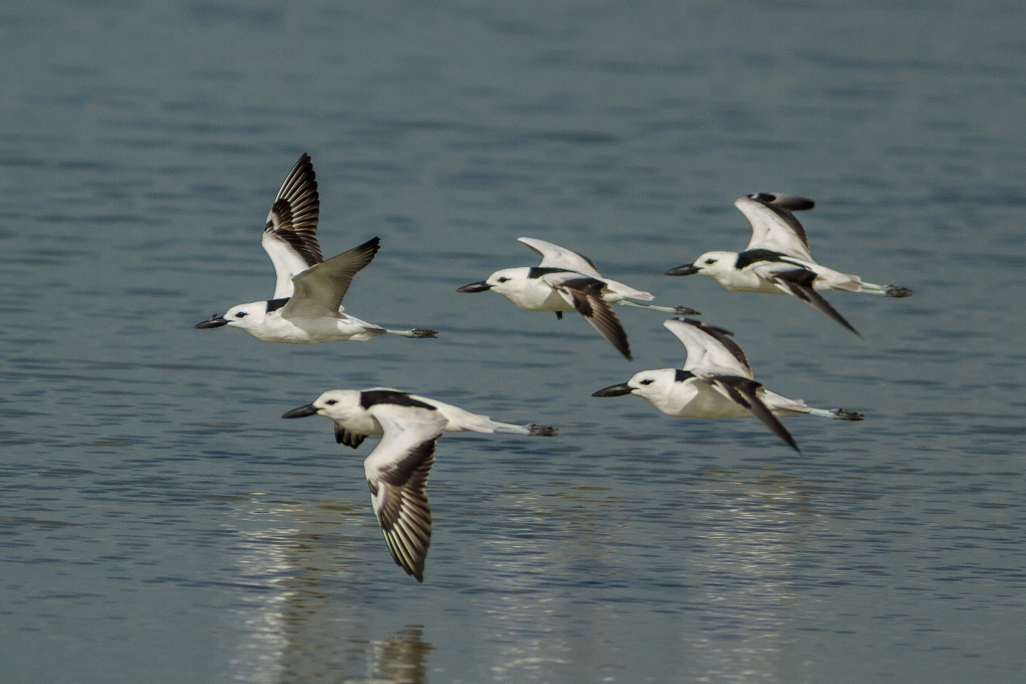
Crab Plovers © Sergey Dereliev, www.dereliev-photography.com

Many of the AEWA Single-Species Action Plans (SSAPs) have their own set of education and awareness-raising components, which are efforts in line with the overall communication objectives outlined in the AEWA Communication Strategy and which also support the implementation of the Agreement per se. The UNEP/AEWA Secretariat is also one of three main partners behind the annual World Migratory Bird Day (WMBD) campaign, which has become one of the primary global communication and awareness-raising campaigns of the CMS Family and has also significantly contributed to raising awareness on migratory birds and the work of AEWA globally over the years.

Communication and awareness-raising is a core function of the Secretariat and is continuously being carried out by all Secretariat staff and by all Units in one way or the other. However, the focus of this report is primarily on activities that fall under the direct remit of the Joint CMS + AEWA Information Management, Communications and Awareness-raising (IMCA) Unit, which continues to carry out a wide spectrum of communication and information management-related activities for the UNEP/AEWA Secretariat.

The Common CMS + AEWA Communications Unit (IMCA)

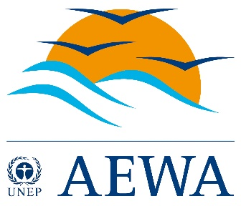
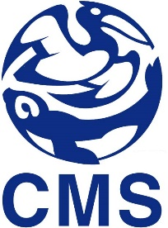
The IMCA Unit was established as a pilot in joint services between the CMS and AEWA Secretariats in 2014. The Unit is jointly managed by both the CMS Executive Secretary and the AEWA Executive Secretary, while the IMCA Coordinator has the responsibility for the day-to-day management of the team. AEWA’s Information Officer (P2) was asked to establish and then manage the Joint Unit from 2014 to April 2020. From April 2020 the role of IMCA Team Coordinator was temporarily given to the CMS Legal Officer (P4) until the CMS Public Information Officer (P3) was recruited in March 2022. Over the course of the past years since the establishment of the Unit in January 2014, much progress has been made in terms of building and transforming the Unit into an effective shared team that serves a wide range of communication, information management and outreach needs of both the UNEP/CMS and UNEP/AEWA Secretariats. This was originally achieved through a re-organisation and specialisation process that focused on establishing “core communications and information management capacity” within the team in the areas of 1. Website and Knowledge Management, 2. Screen and Print Design, 3. Writing & Editorial Service, 4. Press and Media (incl. social media) and 5. Campaigns and Outreach. For a detailed report on the shared CMS and AEWA Communications Unit, please see the "Report on the Joint CMS/AEWA Information Management, Communication and Awareness-raising (IMCA) Unit" (Document: AEWA/MOP 8.18).

Current IMCA Team Composition
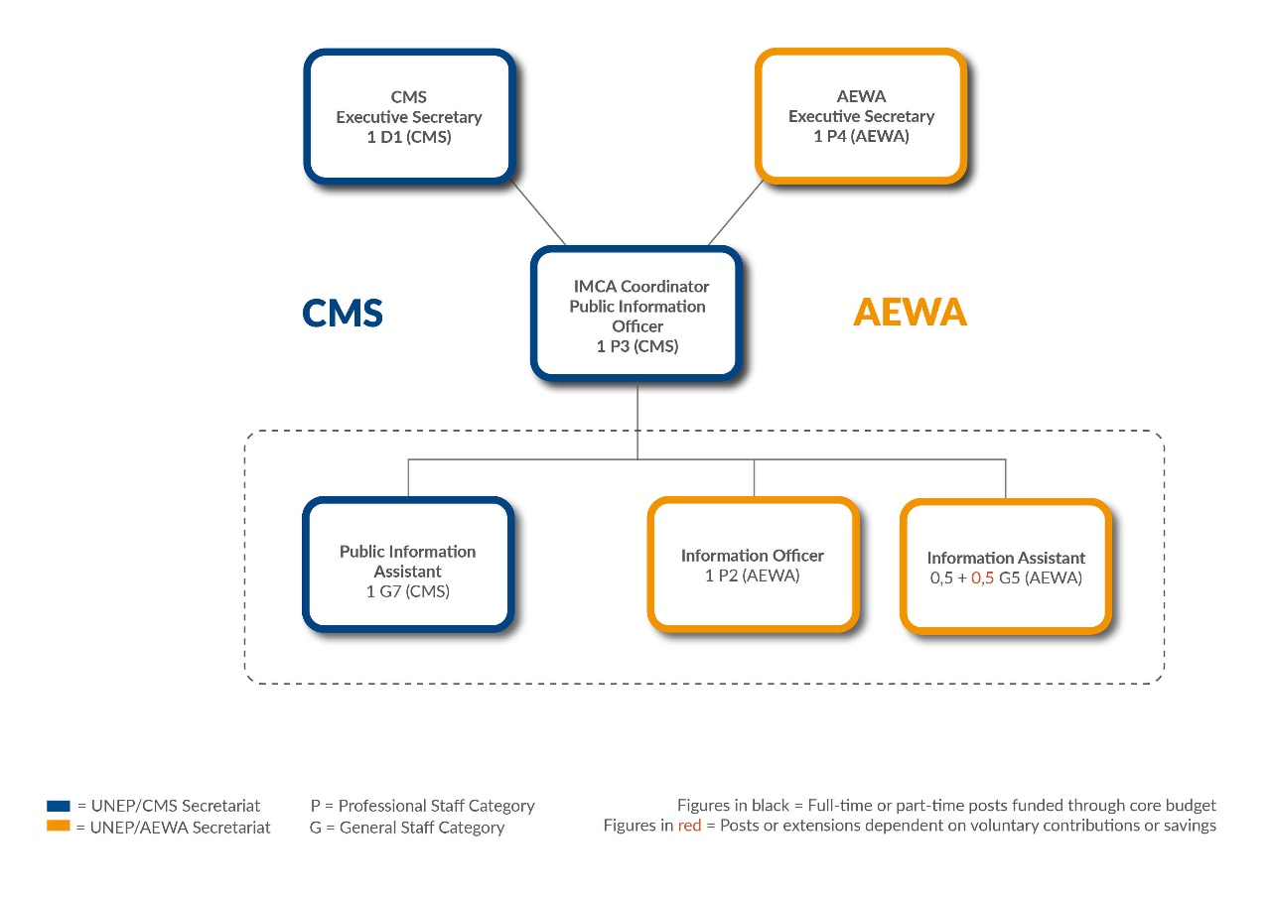
Figure 4: Organigram describing the current composition of the IMCA Unit showing the regular staff positions contributed by the UNEP/CMS and UNEP/AEWA Secretariats to the Joint Unit (as of July 2022).

Team Management

Over the years, the IMCA Coordinator has put in place a number of management tools and procedures, which have significantly improved the operation of the Unit. These include:

- IMCA Unit Programme of Work (PoW) – The work of the IMCA Unit is guided by an agreed annual Programme of Work (PoW) approved by both the CMS and AEWA Executive Secretary on an annual basis.

- A Communications Pipeline – A permanently up-to-date table of upcoming CMS and AEWA events and activities which require communications support from the IMCA Unit. The pipeline has evolved into a useful planning and management tool for the Unit, as it defines the specific communication activities being planned (website news, press releases, social media, videos etc.)

- Regular Editorial Meetings – The IMCA Unit holds weekly editorial meetings to coordinate and plan its work.

- Time and Task Monitoring Tool – A time and task tracking tool is being used to monitor and report on the actual work being conducted by the IMCA Unit for each Secretariat. The online tool allows each member of the team to log their work according to pre-defined projects and activities per client (i.e. CMS, AEWA or JOINT). The tool can also produce overview reports that aid the general management of the Unit. It is used as a basis to record and report on the actual time-allocation of the team to each client.

Summary of IMCA Activities for AEWA

Below is a summary of the work that has been done to support the implementation of the AEWA Communication Strategy. The focus of the report is on major communication activities that have been conducted by the IMCA Unit for AEWA since MOP7 in December 2018.

Website News Production

In total, 93 website news articles have been featured on the AEWA website since the 7th Meeting of the Parties held in Durban, South Africa in December 2018. The published stories report on current AEWA activities such as meetings, major events, and publications and aim to keep the wider AEWA network informed of the activities of the Secretariat and other AEWA stakeholders. The articles are usually drafted by the responsible officers at the Secretariat and then edited and prepared for web publishing by the IMCA Unit. For a full overview of news articles published on the AEWA website to date, please visit the following link: http://www.unep-aewa.org/en/news.

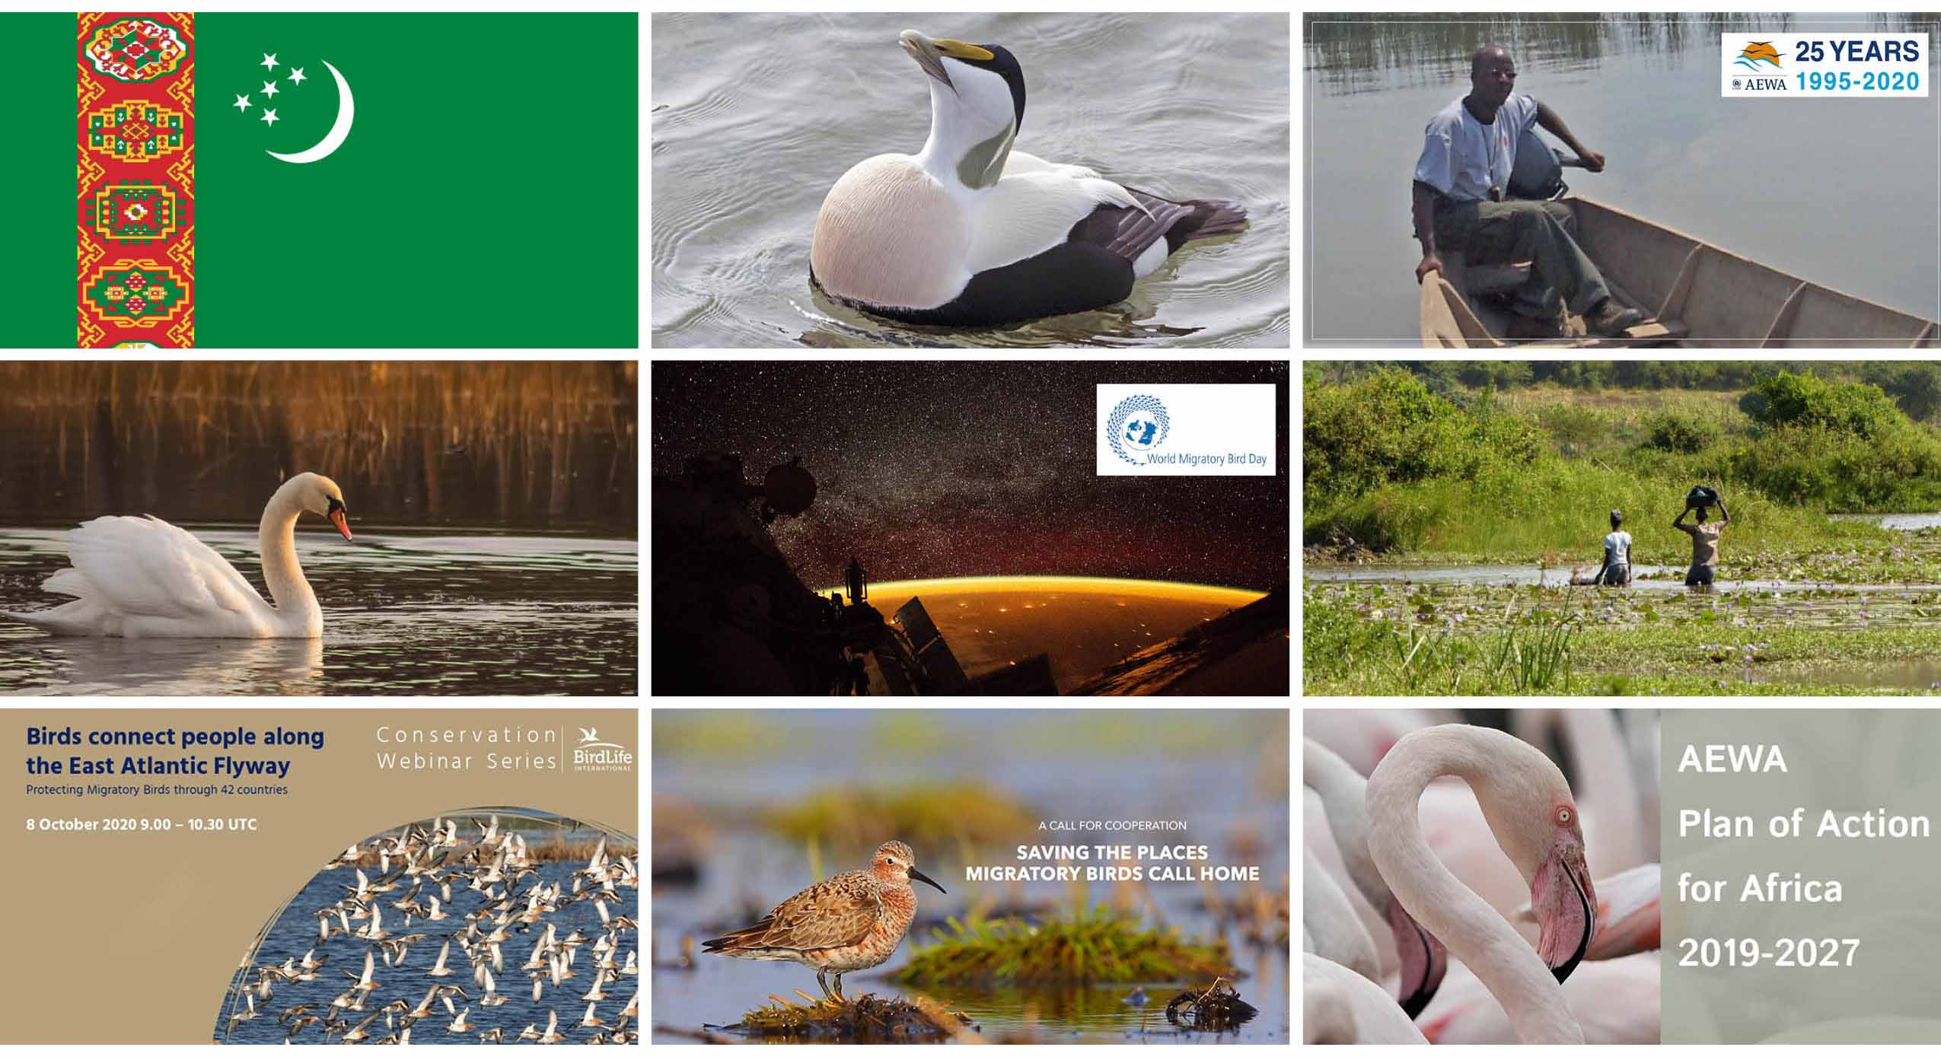
Figure 5: Selection of graphics used in some of the 90+ website news articles posted on the AEWA Website since MOP7 in December 2018.

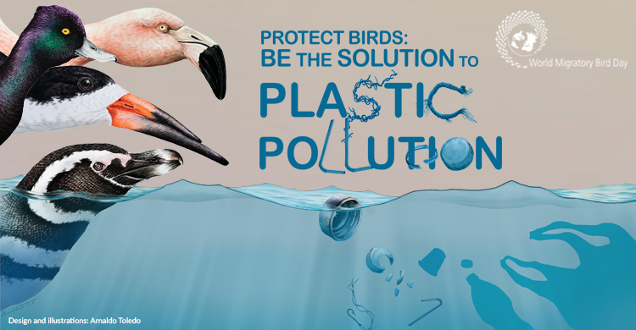
AEWA News Highlights
Figure 6: Graphic used in an AEWA News Story (5 March 2019) announcing the World Migratory Bird Day 2019 Theme on Plastic. The AEWA website statistics confirm the popularity of the topic (see table below).
The AEWA website news story announcing the World Migratory Bird Day 2019 Theme on the topic of plastic pollution had a particularly wide exposure as seen in the number of unique pageviews in the table below. In addition, stories related to the Ban on Lead as well as the Lesser White-fronted Goose have also been viewed and shared widely as well. Other website traffic numbers confirm a consistently strong interest in web stories relating to the White-winged Flufftail and World Migratory Bird Day 2009 on the topic of “barriers to migration” as well as the Flight of the Swans campaign by WWT.
Title | Link | No. of direct Website Hits (Unique Pageviews between 1 Dec 2018 and 25 July 2022)
World Migratory Bird Day 2019 - Protect Birds: Be the Solution to Plastic Pollution | https://www.unep-aewa.org/en/news/world-migratory-bird-day-2019-protect-birds-be-solution-plastic-pollution | 3230
EU Takes Historic Decision to Ban the Use of Lead Shot for Hunting in Wetlands | https://www.unep-aewa.org/en/news/eu-takes-historic-decision-ban-use-lead-shot-hunting-wetlands | 1583
Inger Andersen Appointed as UNEP Executive Director (2019) | https://www.unep-aewa.org/en/news/inger-andersen-appointed-unep-executive-director | 1291
Journée mondiale des oiseaux migrateurs 2019 – Protégez les oiseaux : soyez la solution à la pollution plastique (2019) | https://www.unep-aewa.org/fr/news/journ%C3%A9e-mondiale-des-oiseaux-migrateurs-2019-%E2%80%93-prot%C3%A9gez-les-oiseaux-soyez-la-solution-%C3%A0-la | 894
Sauver l’oie la plus menacée au monde – l’Oie naine (2018) | https://www.unep-aewa.org/fr/news/sauver-l%E2%80%99oie-la-plus-menac%C3%A9e-au-monde-%E2%80%93-l%E2%80%99oie-naine | 686
Millions of birds killed worldwide by man-made barriers each year (2009) | https://www.unep-aewa.org/en/news/millions-birds-killed-worldwide-man-made-barriers-each-year | 499
White-winged Flufftail – Exciting New Discovery in South Africa (2018) | https://www.unep-aewa.org/en/news/white-winged-flufftail-%E2%80%93-exciting-new-discovery-south-africa | 475
Saving One of the World’s Most Threatened Geese – the Lesser White-fronted Goose (2018) | https://www.unep-aewa.org/en/news/saving-one-world%E2%80%99s-most-threatened-geese-%E2%80%93-lesser-white-fronted-goose | 472
Nouvelle campagne sur la voie de migration des cygnes pour sensibiliser sur leur périlleuse situation (2016) | https://www.unep-aewa.org/fr/news/nouvelle-campagne-sur-la-voie-de-migration-des-cygnes-pour-sensibiliser-sur-leur-p%C3%A9rilleuse | 464

Print and Screen Design

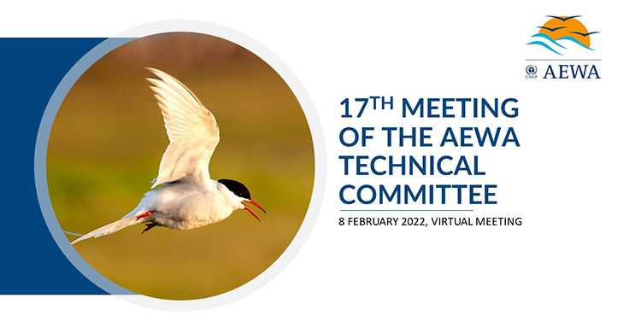
The IMCA Unit has continued to provide considerable in-house design services for the UNEP/AEWA Secretariat with regard to both print and digital products in the period since MOP7. Thanks to the design and desktop publishing skills within the Unit, the UNEP/AEWA Secretariat does not have to go through time-consuming administrative procurement procedures to hire external designers for design work needed for basic layouts and publications.
Figure 7: Example of a "custom graphic" created by the IMCA Unit for an AEWA website news story following the 17th AEWA Technical Committee Meeting held on 8 February 2022.

Design work conducted by the IMCA Unit has resulted in the creation of customised graphics and images used to enhance the presentation of both the AEWA website and social media content. In addition, the in-house desk top publishing service has been used to create a number of AEWA cover designs and smaller publications. Below is a selection of some of the print publications (mainly covers and banners) produced by the IMCA Unit for the AEWA Secretariat over the course of the Triennium. It does not include all the design work that is done for the website, E-Newsletter and for social media.
- MOP7 Proceedings cover in English and French and MOP7 Side Event Brochure;
- Agreement Text cover in English and French;
- Graphics for the 25th AEWA Anniversary;
- Layout of the Plan of Action for Africa in English and French;
- Cover for Conservation Guidelines No. 15;
- AEWA Secretariat Season’s Greetings for 2018-2021 (Mass mail);
- European Goose Management Platform (EGMP) Publications: Different cover pages for EGMP reports, different banners, several maps, Taiga Bean Goose Bird Guide, EGMP Fact Sheet and EGMP Highlights 2018-2021;
- Sticker for the Eurasian Curlew and Lesser White-fronted Goose;
- Lesser White-fronted Goose Report Flyers;
- Species Banners for Eurasian Curlew, Lesser White-fronted Goose, Long-tailed Duck, Shoebill and Velvet Scoter;
- Cover for the AEWA Strategic Plan in English and French;
- ISSAP covers for more than 10 different AEWA species and several other Technical Series;
- Flyer for UNEA and a wide range of Social Media graphics;
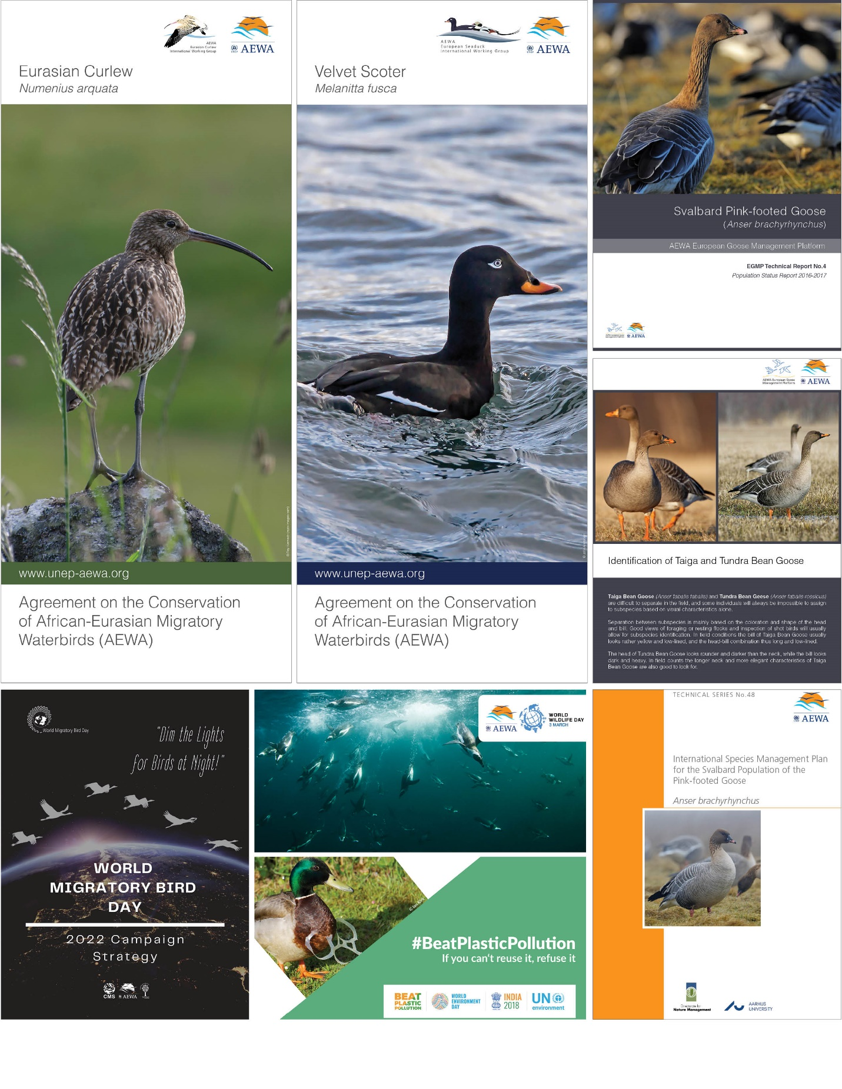
Figure 8: Sample of design products (banners, cover pages and social media cards) developed by the IMCA Unit for AEWA since MOP7.
- Social Media graphics for World Environment Day, World Wetlands Day, World Wildlife Day, World Oceans Day and others;
- Layout of the World Migratory Bird Day 2022 Campaign Strategy;
- Several information materials, Social Media graphics and other publications for World Migratory Bird Day (2019-2022);
- Graphics for AEWA website news articles;
- Layout of Secretariat Reports and Powerpoint Presentations (templates) for AEWA Meetings.

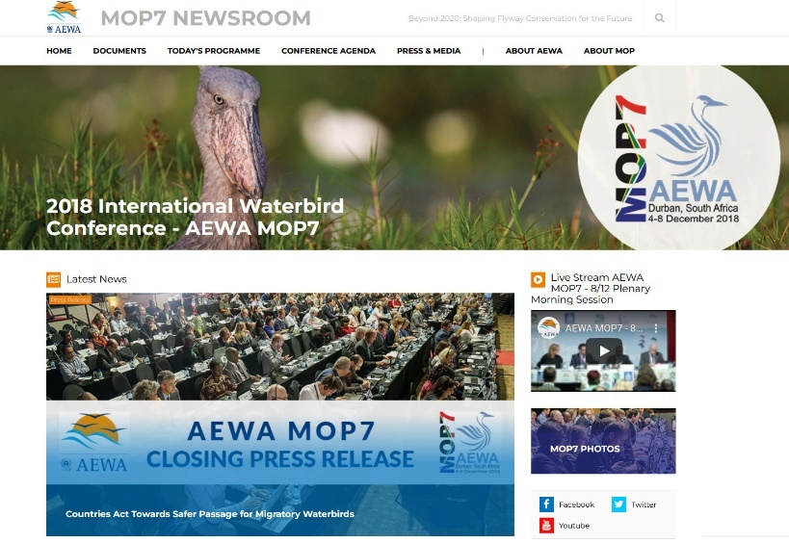
Press and Media
Figure 9: Screenshot of the AEWA MOP7 Newsroom.
The IMCA Unit coordinates the production of press releases, media advisories and occasional op-eds to highlight major AEWA achievements, reports and special events such as MOP and World Migratory Bird Day. On the occasion of MOP7, a special web-based “MOP7 Newsroom” was created by the Unit with news articles, interviews, feature articles, photos and videos to provide a unique multi-media coverage for the MOP. The IMCA team is also planning to create a similar “Media Room” for MOP8, which will include short daily reports, photos and short videos of the main highlights of the conference.
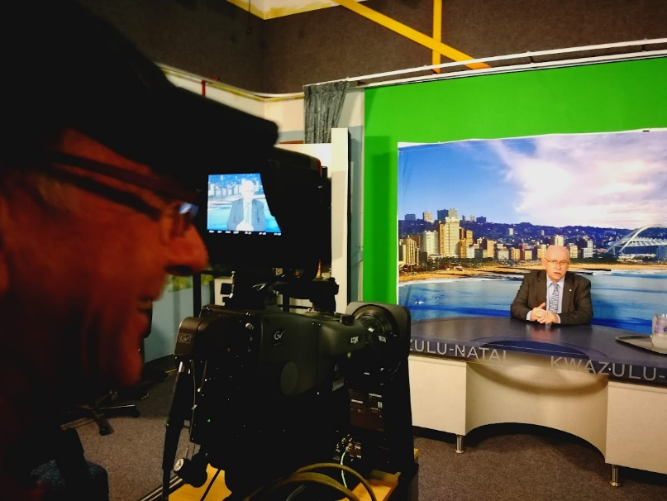
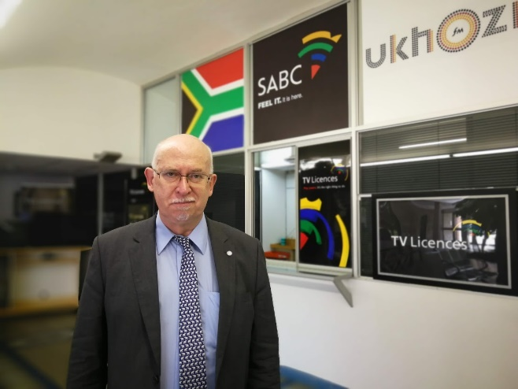
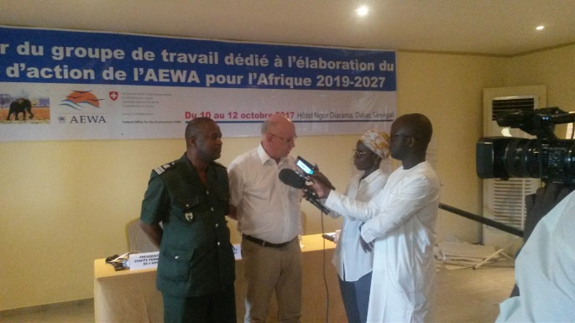
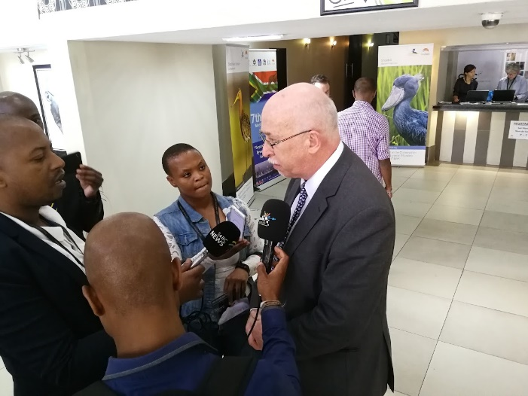
The IMCA team works with the UN Department of Public Information, UNEP DCPI, UNEP Regional Offices and directly with the media to try to enhance press and media coverage for AEWA. In this context, it has facilitated multiple interviews with UN Radio and other broadcasting stations and media outlets in Europe and Africa with the AEWA Executive Secretary, often around the occasion of a major meeting (MOP or COP) or one of the two peak days of World Migratory Bird Day.
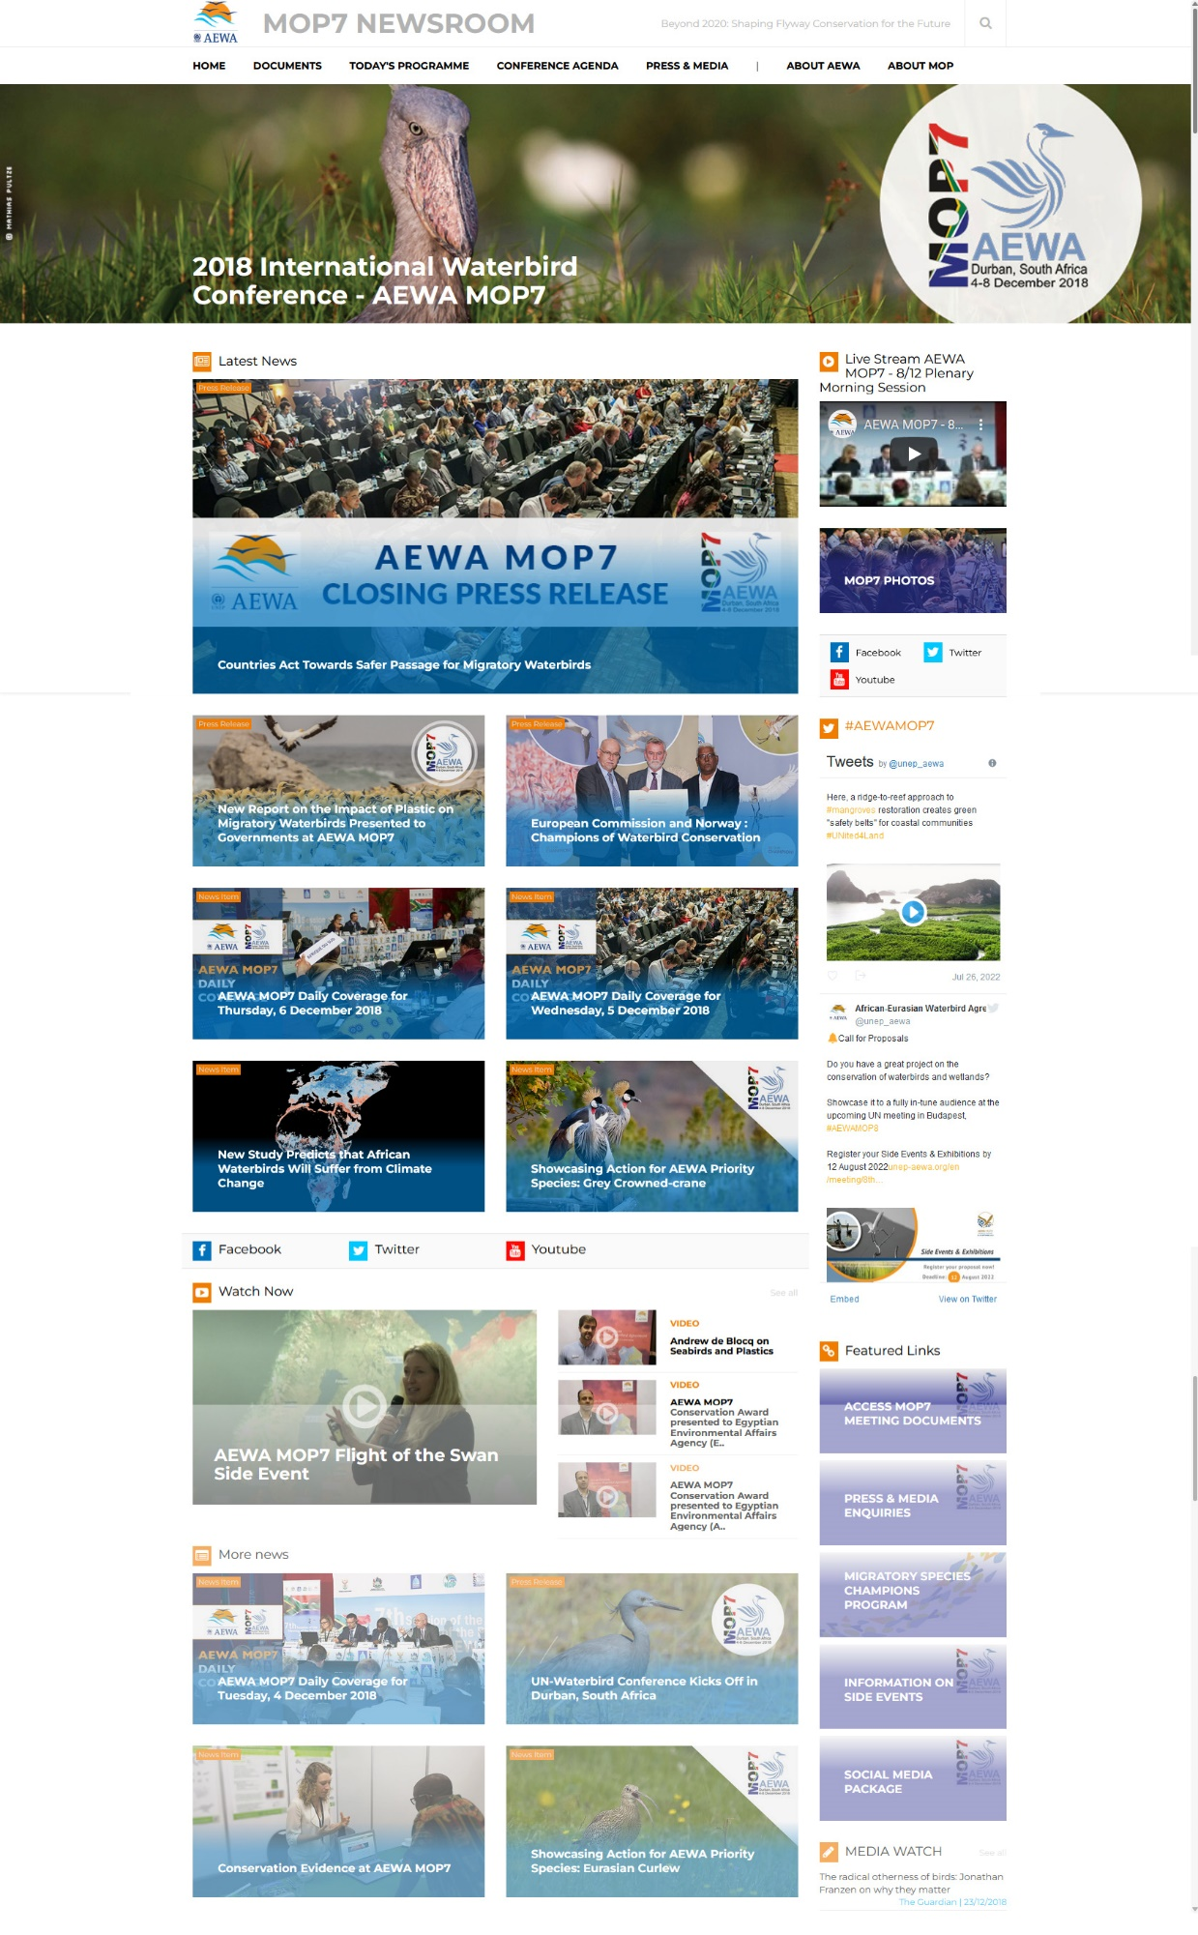
Figure 10 AEWA Executive Secretary giving media interviews at MOP7 in Durban, South Africa and the AEWA Plan of Action for African meeting in Dakar, Senegal.
Figure 11: Full page screenshot of the MOP7 Newsroom - a custom-made multi-media website designed to maximise the coverage of the AEWA MOP7 meeting held in Durban, South Africa in December 2018. The website was created and managed for AEWA entirely in-house by the IMCA Unit and elegantly brought together a variety of creative content.
AEWA Electronic Newsletter

An Electronic Newsletter, the so-called AEWA E-Newsletter, is regularly prepared and disseminated by the IMCA Unit to 3,000+ AEWA contacts via email. The E-Newsletter is a selection of the main AEWA news stories from a period covering several months arranged in an HTML enriched email. The E-Newsletter is produced in-house using a custom E-Newsletter building tool (part of the CMS Family Website Infrastructure) and sent out in both English and French. In the period of this report (January 2018 – July 2022) a total of four AEWA E-Newsletters were prepared and disseminated to the AEWA Network. The newsletter creation and dissemination tool is being upgraded in the context of the CMS Family Drupal Website Upgrade project and will help further professionalise this important communication tool for AEWA.

- AEWA E-Newsletter – Issue # 53 / July 2021 [http://www.unep-aewa.org/en/node/5573]
- AEWA E-Newsletter – Issue # 52 / July 2020 [http://www.unep-aewa.org/en/node/5211]
- AEWA E-Newsletter – Issue # 51 / Dec 2019 [http://www.unep-aewa.org/en/node/5043]
- AEWA E-Newsletter – Issue # 50 / April 2019 [http://www.unep-aewa.org/en/node/4748]
- WMBD Newsletter (Special Edition) / May 2020 [http://www.unep-aewa.org/en/node/5181]
All AEWA E-Newsletters sent to date can be found on the AEWA website at the following location: http://www.unep-aewa.org/en/publications/newsletter

Social Media Highlights

In addition to the official website and other online tools, the IMCA Unit manages the AEWA Twitter and Facebook social media channels. Over the course of the reporting period the number of AEWA Facebook page fans grew to 2,277 in July 2022, while the number of twitter followers grew to a total of 2,463. The channels are being used mainly to promote unique AEWA content published on the AEWA website and/or selected AEWA-relevant content from major partners and active members of the wider AEWA community. It should be noted that the growth of the channels is entirely organic, meaning that no paid advertising is used on any of the AEWA accounts.

The IMCA Unit also manages a very successful global social media strategy in the context of the annual World Migratory Bird Day campaign. For example, in 2022 the primary global hashtags used for the campaign (#WorldMigratoryBirdDay / #WMBD2022 / #DimLightsforBirds) had a combined potential reach of over 200 million people.
The UN website and several UN social media accounts significantly contribute to the large social media reach of World Migratory Bird Day each year. For example, several WMBD-related tweets have been posted by the main United Nation’s Twitter account which currently has fifteen million followers.

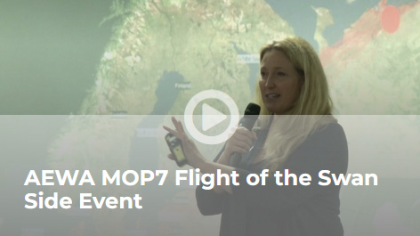
Audiovisual (AV)
Figure 12: Video of the AEWA MOP7 Flight of the Swan Side Event which was one of several videos added to the AEWA MOP7 Newsroom.
A number of video statements and interviews were prepared by the IMCA Unit for the UNEP/AEWA Secretariat between January 2019 and July 2022. For example, during MOP7, videos were recorded on-site with Sacha Dench on Flight of the Swans, Dr. Andrew de Blocq on the topic of Seabirds and Plastic as well as with Aymad Hamada on the the AEWA Conservation Award presented to the Egyptian Environmental Affairs Agency.
In addition, a number of other videos were produced and published on the AEWA YouTube Channel and promoted via the AEWA Website and Social Media Channels since MOP7:
- AEWA MOP7 Video Message by the AEWA Executive Secretary (October 2018)
- Video Message by the AEWA Executive Secretary to mark the 25th Anniversary of AEWA (June 2020)
- Social Media Teaser Video for the 25th Anniversary of AEWA (June 2020)
- “A Call for Cooperation: Saving the Places Migratory Birds Call Home” (June 2020) – Produced by the AEWA Secretariat in close cooperation with the Cornell Lab of Ornithology’s Center for Conservation Media (June 2020)
- World Migratory Bird Day 2020 Statement by the AEWA Executive Secretary (May 2020)
- AEWA Site Network Inventory Video Tutorial (June 2020)
- World Migratory Bird Day 2021 Statement by the AEWA Executive Secretary (May 2021)
- Video Message by the AEWA Executive Secretary to mark the First East Atlantic Flyway Youth Forum (September 2021)
- World Migratory Bird Day 2021 Statement by the AEWA Executive Secretary (May 2021)
- World Migratory Bird Day 2022 Joint Statement by the CMS and AEWA Executive Secretary (May 2022)
- World Migratory Bird Day 2022 Animated Promo Video (May 2022 - All UN Languages)
- AEWA MOP8 Save the Date Video for Social Media (June 2022)
- And upcoming Series of social media videos designed to help promote AEWA MOP8 (August – September 2022)

Website & Knowledge Management
The IMCA Unit technically manages and maintains all external websites and online tools of the UNEP/AEWA Secretariat. This includes the management of the official AEWA website, the AEWA Technical Committee Workspace and a number of AEWA Single Species Action Plan Working Group websites. In addition, the IMCA Unit is in charge of the technical management of the Online National Reporting System (ORS), the Online Meeting Registration System and Contacts Database, all of which are used by the UNEP/AEWA Secretariat and other CMS Family Instruments collectively.
The IMCA Unit is able to tackle many of the technical issues which prior to the establishment of the Unit required the expertise and support of external developers. As such, the team fulfils many important day-to-day functions in the area of knowledge and website management for both the UNEP/AEWA and UNEP/CMS Secretariats (and the wider CMS Family), from bug fixing, to helpdesk and training of staff, establishment of web publishing norms and workflows, to web design, data management and usability improvements.

AEWA Website Upgrade
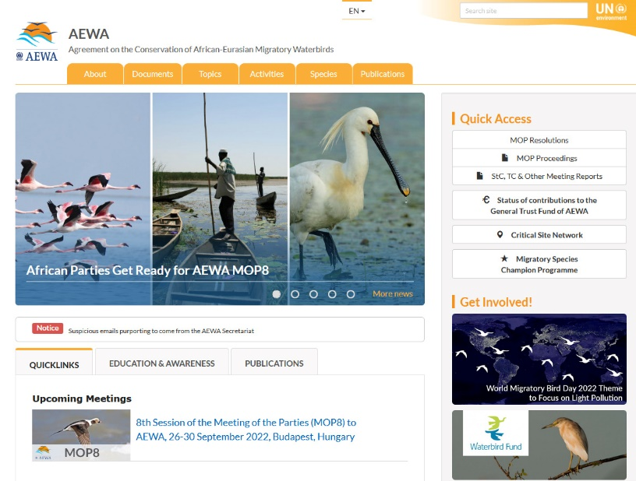
Due to the latest technological changes and current industry norms, the IMCA unit and AEWA Secretariat are currently engaged in the major project of upgrading the AEWA website as well as the AEWA Technical Committee Workspace, both in terms of the content management system, and user interface and design of the template. Two user surveys involving the AEWA Secretariats and AEWA focal points have been conducted in 2021. A prototype has been developed and the information architecture of the new websites is currently being developed. The new website is planned to be launched by the end of 2022.

Thematic Pages for the AEWA Website
Under the guidance of the AEWA Executive Secretary, the IMCA Unit has published a special thematic webpage on the topic of Lead Poisoning as well as a dedicated page on the topic of Avian Influenza. The unit has also prepared draft content for similar thematic pages on the topics of Climate Change and Renewable Energy. The goal of these thematic pages is to bring together all relevant information around selected topics into a single, well-presented, attractive multi-media webpage on the AEWA website.
Figure 13: Screenshot of the AEWA Website (Front Page) on 25 July 2022.

The aim is to create content that will act as both a useful introduction on the topics as they relate to AEWA and as a gateway and hub for all relevant and available information relating to the given topic (resolutions, publications, news, events etc.).

Online National Reporting System (ORS)
The IMCA Unit continues to work closely with the IT and Species Units at UNEP-WCMC to optimise the use of the Online Reporting System (ORS). Thanks to a UNEP DELC / EU ACP funded project, the original ORS which was used for reporting to both AEWA MOP5 and MOP6, has been significantly improved by UNEP-WCMC in close cooperation with the IMCA and AEWA SICU Unit for use during the MOP7 cycle. At this time further improvements were made in terms of its usability and interoperability. The IMCA Unit actively participated in the further development process of the ORS, continuing the pioneering role that the UNEP/AEWA Secretariat originally played in the development of the very first version of a common online reporting system developed by UNEP-WCMC. Meanwhile, the early vision of creating a single, highly sophisticated online national reporting tool for use by multiple Multilateral Environment Agreements (MEAs) has become a reality, with several MEAs, including CMS and AEWA, now using the ORS for their national reporting processes. For more information on the ORS please see: http://www.ors.ngo/
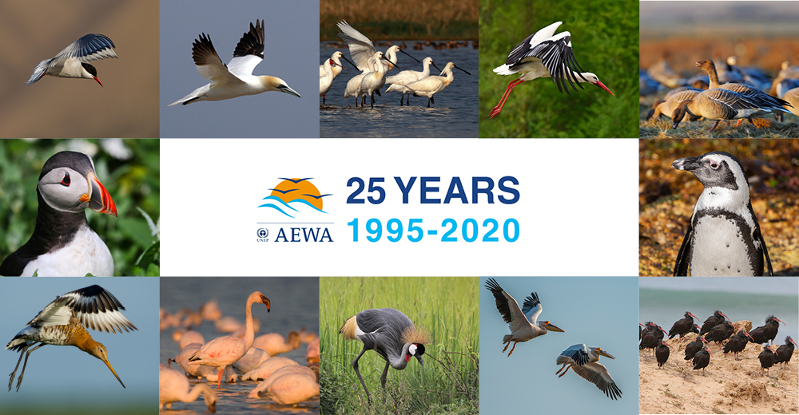
Figure 14: Graphic element used on the special AEWA 25th Anniversary Webpage created by the IMCA Unit for AEWA.

25th Anniversary of AEWA

To mark the 25th Anniversary of AEWA in June 2020, the IMCA Unit created a special webpage dedicated to celebrating AEWA, which brought together some of the history and highlights of the past 25 years of international waterbird conservation under AEWA. The AEWA 25th Anniversary Webpage also featured a collection of anniversary statements received from people who have helped to shape and guide the work of the treaty to date. The anniversary webpage also featured a timeline and short history of the treaty as well as a professionally made new film developed by the AEWA Secretariat with partners called "A Call for Cooperation: Saving the Places Migratory Birds Call Home”. The film was produced by the Cornell Lab of Ornithology’s Center for Conservation Media and showcases the importance and beauty of a number of critical sites for migratory waterbirds found across the African-Eurasian Flyway.
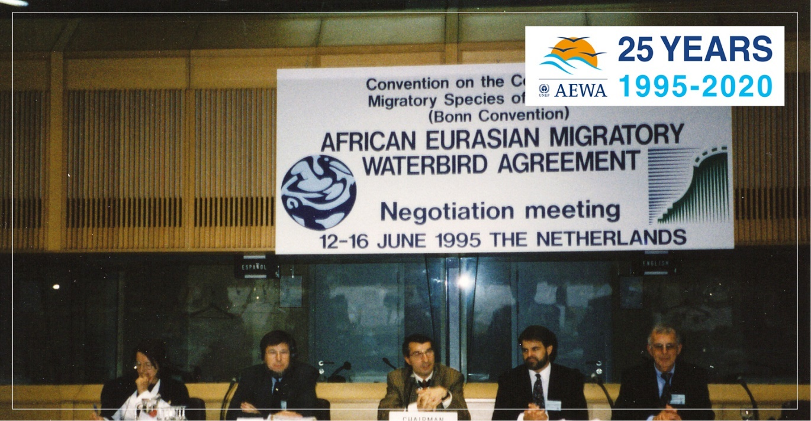
Figure 15: Formal AEWA negotiation meeting, June 1995, Ministry of Foreign Affairs, The Hague, The Netherlands.

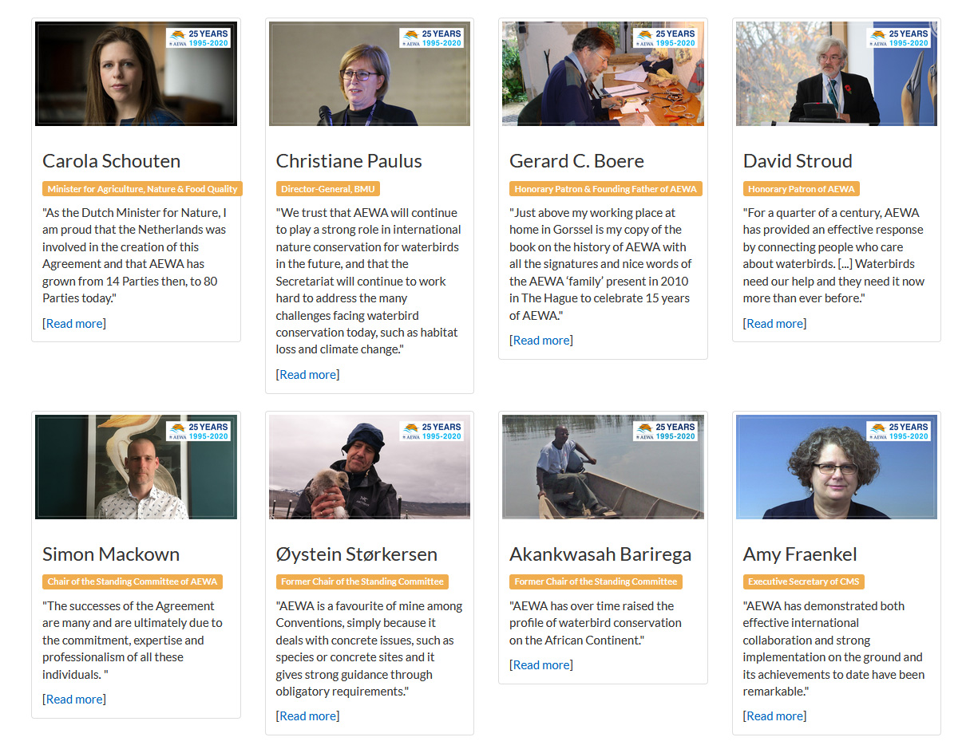
Figure 16: A collection of anniversary statements received from people who have contributed to the work of the treaty featured on the AEWA 25th Anniversary Webpage.

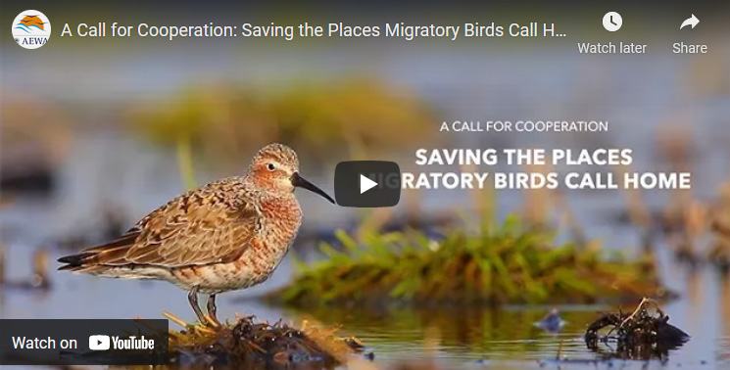
Figure 17: "A Call for Cooperation: Saving the Places Migratory Birds Call Home” – a short film published during the 25th Anniversary of AEWA in June 2020. The film was produced by the Cornell Lab of Ornithology’s Center for Conservation Media in close cooperation with the AEWA Secretariat and partners.

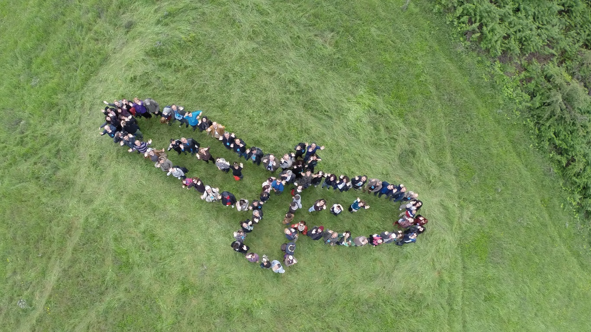
Figure 18: World Migratory Bird Day Event Drone Photo (www.worldmigratorybirdday.org)

World Migratory Bird Day

The IMCA Unit is charged with managing the public outreach and awareness-raising activities of the UNEP/AEWA Secretariat, of which the primary annual outreach campaign continues to be World Migratory Bird Day (WMBD).
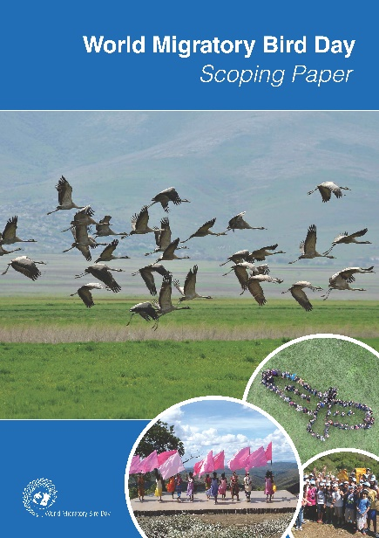
Following requests from both CMS and AEWA Parties, it should be noted that since 2018, the campaign now has two peak days throughout the year, i.e. one on the second Saturday in May and on the second Saturday in October. Since its inception, the campaign has triggered over 5000 events in over 140 countries, with a growing number of registered events each year.

WMBD Scoping Paper

The IMCA Unit worked closely with CMS and AEWA management to prepare a Scoping Paper outlining the future direction and vision for the World Migratory Bird Day Campaign. The paper helped define the goals and vision for the campaign and as well as outlined a number of activities which aim to help the campaign grow in the future.

The Scoping Paper proved to be a good basis for forming a common understanding of a stronger partnership around WMBD and helped stimulate new momentum around the campaign. The WMBD Scoping Paper was presented as a document to the First Meeting of the Americas Flyways Task Force, which took place in Florianopolis, Brazil in July 2018 (Document: UNEP/CMS/AFTF1/Doc.9).

New Transatlantic Cooperation Towards a Unified Campaign

On 26 October 2017, in the margins of the CMS COP12 in Manila, AEWA, CMS and Environment for the Americas (EFTA) signed a Partnership Agreement, which formally united two of the world's largest bird education campaigns, International Migratory Bird Day (IMBD) and World Migratory Bird Day (WMBD), in a bid to strengthen global recognition and appreciation of migratory birds and highlight the urgent need for their conservation.

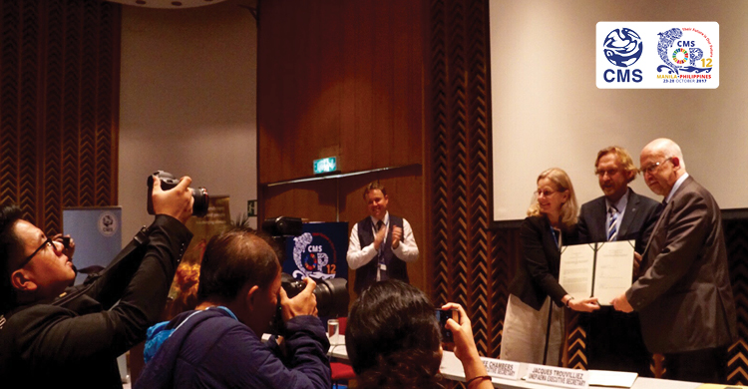
Figure 19: Signing Ceremony for the New Partnership Agreement for World Migratory Bird Day (WMBD) at CMS COP12 on 26 October 2017 in Manila, Philippines. (Photo: EAAFP Secretariat)
The cooperation between CMS, AEWA and EFTA has continued since the signing in Manila in 2017 and has led to the successful organisation of World Migratory Bird Day as a single global campaign in the years 2018, 2019, 2020, 2021 and 2022.

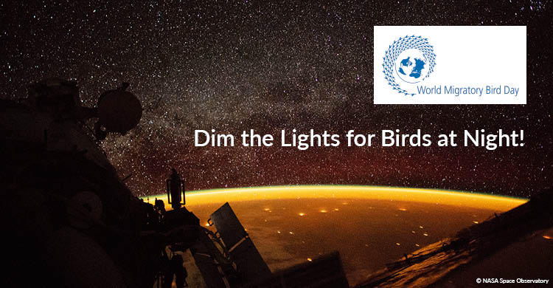

Below is a summary of the themes and highlights of the World Migratory Bird Day campaigns organised by the IMCA Unit for CMS and AEWA since MOP7, i.e. in 2019, 2020, 2021 and 2022.

World Migratory Bird Day 2019: Protect Birds - Be the Solution to Plastic Pollution
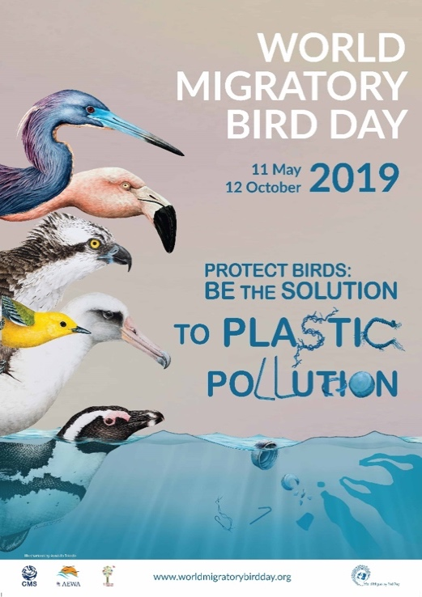
Figure 20: 2019 World Migratory Bird Day Poster.
“Protect Birds: Be the Solution to Plastic Pollution” was the theme for WMBD 2019, marking the fight against the global threat of plastic pollution. With an annual production of more than 300 million tons, plastic is one of the most widely used materials in the world. Whether through ingestion or entanglement, it takes its toll on migratory birds.

For WMBD 2019, clean-ups were organised across the world to remove plastic from important bird areas, while awareness raising campaigns and bird watching events brought people together to combat the threat of plastic pollution. A total of 874 events were registered on the WMBD website throughout the year, with around 100 countries taking part in awareness-raising activities. Key World Migratory Bird Day supporters and partners from around the world provided statements to mark the year’s campaign, with these messages highlighting the importance of unified global effort in tackling the problem of plastic pollution.

World Migratory Bird Day 2020: Birds Connect Our World
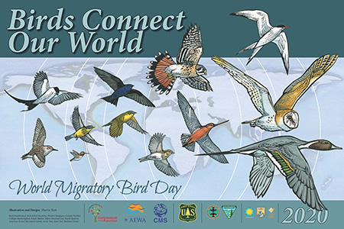
Figure 21: 2020 World Migratory Bird Day Poster.
“Birds Connect Our World” was the theme for WMBD 2020. Connectivity is essential for migratory species, and important for a wide variety of ecological functions. It describes the natural and necessary movement of species and the flow of natural processes that sustain life on Earth. With 1 million species facing the risk of extinction within our generation, connectivity has become a central topic for biodiversity and sustainability. Migratory species move across the globe, running, swimming, flying, connecting countries, people and continents through their migration routes.

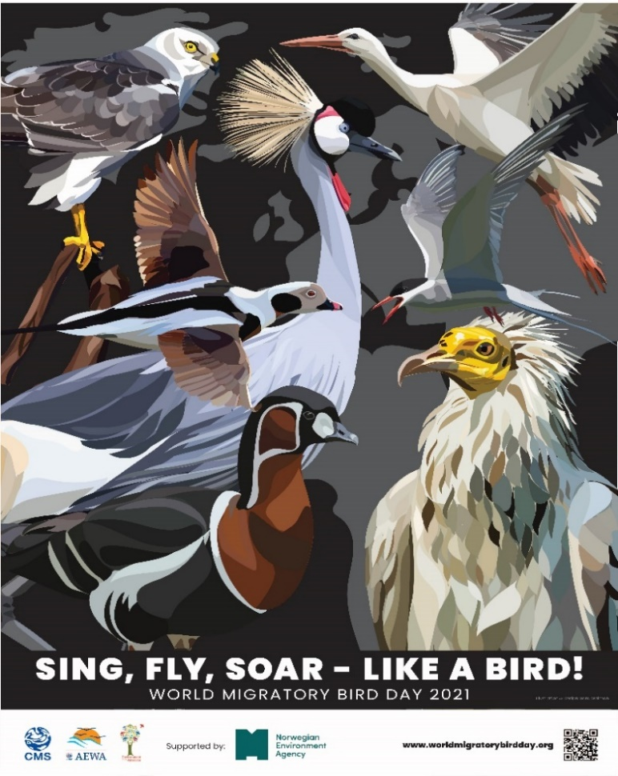
Although the coronavirus pandemic and the strict social distancing restrictions in place caused a significant decrease in events as compared to the previous years’ campaign, global support and participation in the campaign was still observed with 336 events registered on the WMBD website in over 60 countries. Statements to mark the 2020 campaign were also provided by key supporters and partners and displayed on the WMBD website.
Figure 22: World Migratory Bird Day 2021 Poster.

World Migratory Bird Day 2021: Sing, Fly, Soar – Like a Bird!

“Sing, Fly, Soar – Like a Bird!” was the theme for WMBD 2021, focusing on the phenomena of “bird song” and “bird flight”. This was used as a way to inspire and connect people around the world in their shared desire to celebrate migratory birds and to unite around a common, global effort to protect birds and their habitats.

During the pandemic, bird song became a source of comfort and joy for many people around the world, connecting them to each other as well as to nature. Although the pandemic has been an unprecedented challenge for humankind, it has brought a new level of awareness and appreciation of birds and the importance of nature for our well-being. For WMBD 2021, the SING and DANCE #LikeABird challenge was created to invite people to use their creative expression as a way to raise awareness of migratory birds and their conservation.

A total of 244 events in over 71 countries were registered on the WMBD website for the October peak day in 2021. While the coronavirus pandemic still caused a significant decrease in WMBD event numbers as compared to some years prior to the pandemic, the eventual loosening of social distancing restrictions and the switch to virtual programming ensured participation of people in all corners of the world in the campaign.
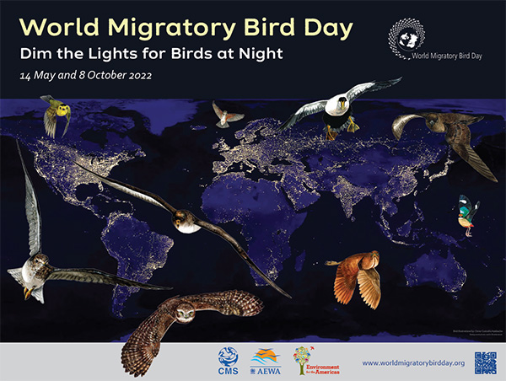
Figure 23: World Migratory Bird Day 2022 Poster.

World Migratory Bird Day 2022: Dim the Lights for Birds at Night

Light pollution and its impact on migratory birds is the focus of World Migratory Bird Day 2022 and activities to mark the day were already held globally on 14 May 2022 under the theme “Dim the Lights for Birds at Night”, with the second peak day coming up on 8 October 2022.

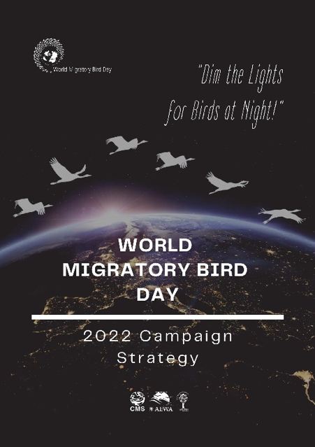
400 + events in over 60 countries were registered on the WMBD website between January and May 2022 for the campaign’s first peak day. This is a marked increase from the lower number of events recorded during the peak of the pandemic. A wide range of activities took place, such as birdwatching events, educational talks, bird festivals, art exhibits, community engagement sessions, and many more. A number of these WMBD events also focused specifically on this year’s theme of light pollution and incorporated this topic into their activities.
Figure 24: Cover Page of the WMBD 2022 Campaign Strategy Document.

The IMCA Unit developed and dissemination a dedicated WMBD 2022 Campaign Strategy document (available in English, French, and Spanish) to all CMS and AEWA National Focal Points as well as main partners in advance of the first peak day. The strategy contains useful background on the theme as well as agreed key messages which have helped to ensure a unified message for the campaign.

A key highlight to note regarding the first peak day celebration of World Migratory Bird Day 2022 is the article published by the UN News Centre in all UN languages running up to the peak day, which shed light on the WMBD 2022 theme and featuring the global WMBD 2022 animation video produced in partnership with the Cornell Lab of Ornithology Center for Conservation Media. The Global WMBD Video Animation on the topic of light pollution was published in all UN languages and was also made available on the various WMBD social media platforms including YouTube.
Figure 25: Screenshot of the World Migratory Bird Day 2022 Global Animation Video produced in all UN Languages with the support of the Cornell Lab of Ornithology Center for Conservation Media.

The Cornell video was repurposed to become the official campaign trailer and shared widely on social media, receiving over 14,000 Twitter impressions, 8,000 Facebook impressions, and 14,000 views through the UNEP Instagram page on the peak day itself. Considerable social media reception was observed during the first peak day, with the primary global hashtags used for the campaign having a combined potential reach of over 200 million people on the first peak day of WMBD on 14 May alone.

Future Campaign Developments

The IMCA Unit is working closely with CMS and AEWA management and the team at EFTA to try to further strengthen the global campaign in the years to come. Work is ongoing to update and expand the partnership agreement and to generally improve and harmonise the global presentation and future branding of World Migratory Bird Day. Work is also ongoing to further enhance the good cooperation amongst the main WMBD partners and to try to further improve the overall impact of the campaign. The partners also wish to mobilise greater support from other dedicated organisations and individuals and to try to establish greater ownership of the campaign amongst national and international actors along the African-Eurasian, the East
Asian-Australasian and Americas Flyways.

A stronger emphasis will also be placed by the team on fundraising to support the campaign on both the global and local levels. For example, resources will be needed to properly re-brand the campaign and to develop a more state-of-the-art website as the main communication hub for the global campaign. The WMBD partners also wish to try to raise funds which will support future World Migratory Bird Day related CEPA activities in least developed countries, developing countries, countries with economies in transition and Small Island Developing States.

The AEWA Communication Strategy is publicly available and can be downloaded from the AEWA Website at: http://www.unep-aewa.org/en/cepa
The AEWA Communication Strategy is publicly available and can be downloaded from the AEWA Website at: http://www.unep-aewa.org/en/cepa
Similar wording recognising the need to provide resources to the implementation of the AEWA Communication Strategy was included in Resolution 7.12 (on Financial and Administrative Matters) adopted at MOP7 in Durban, South Africa.

