**REPORT OF THE SECRETARIAT ON FINANCE AND**

**ADMINISTRATIVE ISSUES IN 2016 - 2018**

*Prepared by the UNEP/AEWA Secretariat*

**Introduction**

At the 6th Session of the Meeting of the Parties to AEWA, the core budget for 2016-2018 was adopted through Resolution 6.18. The Secretariat reported to the Standing Committee at its 12th Meeting (31 January – 01 February 2017, Paris, France) and its 13th Meeting (03–05 July 2018, The Hague, the Netherlands). The present document aims at reporting on staffing issues and on income and expenditure for the period   
01 January 2016 –30 September 2018.

**Action Requested from the Meeting of the Parties**

The Meeting of the Parties is requested to review and approve the information provided in the report.

1. **Staffing (1 January 2016 – 30 September 2018)**

Staff funded by the core budget

There have been no major changes to the team during the period covered by the report.

**African Initiative Unit**

The positions of the African Initiative Coordinator (P-2) and the Programme Management Assistant (G-5) were partly funded (50 %) through the AEWA core budget 2016-2018 since 01 January 2016. The Secretariat was able to maintain the P-2 position at 100 % and the G-5 position at 80 % in 2016 - 2018 thanks to contributions from the Federal Office for the Environment in Switzerland and the European Commission.

For a full report on the Implementation of the African Initiative and the Plan of Action for Africa, please see document AEWA/MOP 7.11.

Staff fully dependent on voluntary contributions

**Associate Programme Officer (P-2) for Single Species Action Plan Support and the coordination of implementation of the Lesser White-fronted Goose International Single Species Action Plan**

The position of the Associate Programme Officer for Single Species Action Plan Support and the coordination of implementation of the Lesser White-fronted Goose International Single Species Action Plan has been secured until February 2020. The Secretariat is grateful to the Norwegian Environment Agency for its continuing support of this important position.

**Associate Programme Officer (P-2) and Programme Management Assistant (G-5) for the AEWA European Goose Management Platform**

Thanks to funding received from the Governments of Norway, Finland, Denmark, the Netherlands and France towards the implementation of the AEWA European Goose Management Platform (EGMP), the Secretariat has been able to recruit staff on two project posts: one full-time P-2 Associate Programme Officer in July 2017 and one full-time G-5 Programme Management Assistant in November 2017. The possibility to maintain these posts is dependent on the annual voluntary contributions by the range states to the EGMP.

Interns

The UNEP/AEWA Secretariat participates in the CMS Family Internship Programme. In the framework of this programme, 15 interns supported the work of the Secretariat in the period under consideration (January 2016 – September 2018), which is an average of six interns per year. All of them have been supporting the work of the IMCA team except one intern working on the analysis of national reports.

Staff reclassification

All the three AEWA G-4 posts were reclassified in 2016, in accordance with AEWA Resolution 6.18 and the three staff members were successfully upgraded to G5 level in 2017.

At the CMS COP11 (Quito, November 2014), CMS Parties requested UNEP and the UNEP/CMS Secretariat through Resolution 11.1 “*to undertake a review of the grading of the Secretariat’s posts, in line with the functions of the Secretariat, […] to enable decisions on the grading of the posts to be taken by Parties at COP12*”. In response to this mandate, the UNEP/CMS Secretariat contracted a Consultant to assess the need for reclassification for all CMS posts.

By correspondence of 29 September 2016, the AEWA Standing Committee provided the Secretariat with the mandate to commission a similar reclassification assessment alongside the one undertaken by the UNEP/CMS Secretariat, which would serve as valid independent assessment of all Secretariat posts. The Consultant reviewed all positions except the three AEWA G-4 posts, which had already been reclassified (*cf. supra*), as well as the post of the Executive Secretary, which had already been classified by UNON at P-5 level in 2012 but maintained at P-4 level by MOP5 due to financial constraints.

The 12th Meeting of the Standing Committee requested the Secretariat to initiate the adjustment of those job titles and job descriptions of the P-staff positions. This is not an upgrade and those positions will retain their current grading, but their titles and job descriptions will, at least, correctly reflect the actual duties and responsibilities undertaken.

Organisation of the Secretariat

The individual staff members and units work closely as a team, interacting with each other on cross-cutting issues on a daily basis. They are divided into four major areas of work (as described in Annex 6 – Organisational Structure and Annex 7 - Staff Composition of the UNEP/AEWA Secretariat).

Each staff member has an annual work plan, which is approved and/or revised annually as well as on a mid-term basis by his/her direct supervisor. All the work plans are examined by the Executive Secretary, in order to ensure synergies between the units and to avoid a duplication of efforts. The Secretariat nonetheless faces a number of challenges in the delivery of its mandate and is rather stretched. This is due to the ever-increasing range of services to be delivered: without the extension of the part-time positions and the availability of additional staff funded through voluntary contributions, and the support of interns, the Secretariat would not have been in a position to deliver all services requested during the course of the period covered by the report.

As at 30 September 2018, the core budget covers 7.25 full-time equivalent positions (FTEs), while voluntary contributions have allowed the addition of 4.15 full-time equivalent positions. The Secretariat currently comprises twelve staff members: seven Professional Staff members (P staff) and five General Staff members (G staff).

**2. Core Budget (AWL) – Overview of income and expenditure**

Income

**Annex 1** summarizes the status of collection of annual assessed contributions from Parties as at 30 September 2018. The assessed contributions 2016-2018 approved by MOP6 amount to EUR 2,768,778. Unpaid pledges amount to a total of EUR 411,310, split up as follows: EUR 306,547 for 2017 and previous years, and EUR 104,763 for 2018. Advanced payments for future years amount to EUR 140,179. The UNEP/AEWA Secretariat regularly reminds Parties of outstanding contributions for the current and previous years and offers assistance to National Focal Points when requested. Some Parties have made progress to set up any arrears or to reduce the arrears in the course of the last two years. The status of collection of contributions is updated on a weekly basis through a [webpage](https://www.unep-aewa.org/en/about/status-contributions-general-trust-fund-aewa) accessible to everyone.

Expenditures (2016 - 2018)

**Annex 2** provides an interim report of 2016-2018 budget implementation as at 30 September 2018. The Annex also shows the authorised withdrawals from the trust fund amounting to EUR 124,518 in total for the small grant fund projects in African countries, the implementation of the Plan of Action for Africa, as well as the classification exercise for the AEWA positions.

The staff salaries under General Management showing overspendings on certain budget lines, partly due to a change in percentages of staff working hours, are compensated by other staff budget lines. Over-expenditures in the operative costs in 2016, e.g. for telephone and fax and office operations are due to the high work peak caused by MOP6 in November 2015. In 2018, the Secretariat was able to acquire more reasonably priced cell phone contracts.

It should be noted that the AEWA budget has benefited from a favourable EUR/ USD exchange rate in the years of 2016 and 2017. Overall, the budget shows a positive end-of-year balance, after Programme Support Costs, of EUR 73,720 in 2016 and EUR 14,423 in 2017, and a balance of EUR 306,919 for the running year 2018 after nine months of implementation, however some expenditures are expected to occur during the last quarter leading to an expected consumption rate of 98% for the triennium.

Trust Fund balance

According to the statement of financial performance, the Trust Fund balance for assessed contributions as at 31 December 2017 amounts to USD 522,472 (which is inclusive of the Operating Reserve of a constant level of at least 15 % of the estimated annual expenditure or EUR 150,000, whichever is higher). This amount could be seen as being high, however it should be kept in mind that it includes advance contributions for future years.

**3. Voluntary Contributions (AVL) - Overview of collections 2016-2018**

In addition to the annual contributions paid by Parties towards the AEWA core budget (AWL), the Secretariat also received voluntary contributions from different governments and organisations that were earmarked for certain activities. These voluntary contributions are managed in the separate Trust Fund (AVL). Annexes 3, 4 and 5 summarize the voluntary contributions to the AVL Trust fund in 2016, 2017 and 2018 respectively.

The pledged voluntary contributions received amounted to **EUR 562,915** in 2016 (Annex 3)[1], **EUR 714,138** in 2017 (Annex 4)[2] and **EUR 698,405** in 2018 (Annex 5)[3].

The voluntary contributions received in 2016-2018 were earmarked for the coordination and implementation of the Lesser White-fronted Goose ISSAP; the European Goose Management Platform; the development of ISSMP for the Barnacle Goose; the development of the ISSMP for the Greylag Goose; the African Initiative; climate change adaption measures for waterbirds; the Strategic Plan 2019-2027 process, the production of the 7th edition of the Conservation Status report, the national report analysis and other MOP7 documents; funded delegates attending MOP7; the organisation of MOP7; the planning workshop for the Velvet Scoter ISSAP; and the 1st Meeting of the Eurasian Curlew International Working Group. The Secretariat would like to thank all governments and organisations that have provided contributions to AEWA.

In addition to the financial contributions, the Secretariat also regularly receives in-kind support mostly from Contracting Parties providing support to a meeting or workshop or projects organized by the Secretariat. The Secretariat would like to point out that it was not possible to reconstitute all support (and equivalent value expressed in EUR) retrospectively for the whole budgetary period 2016-18, as requested by the Standing Committee at its 13th Meeting in The Hague in July 2018. However, the Secretariat is trying to estimate the in-kind contributions with the help of the Parties and will present them at MOP7.

It is suggested that the Secretariat will endeavor to compile a complete list of in-kind support as of   
01 January 2019 for the period 2019-2021 to be presented at MOP8..

**ANNEX 1: GENERAL TRUST FUND FOR ANNUAL CONTRIBUTION TO THE AGREEMENT ON THE CONSERVATION OF AFRICAN - EURASIAN MIGRATORY WATERBIRDS (AWL)**

**Status of Contributions as at 30 September 2018 (in EUR)**









**ANNEX 2: IMPLEMENTATION OF THE APPROVED AEWA BUDGET 2016-2018**

**Report as at 30 September 2018 (in EUR)**





**Withdrawals from the Trust Fund reserve in 2016-2018 authorized by the Standing Committee**



**ANNEX 3: GENERAL TRUST FUND FOR VOLUNTARY CONTRIBUTIONS TO THE AGREEMENT ON THE CONSERVATION OF AFRICAN - EURASIAN MIGRATORY WATERBIRDS (AVL)**



**ANNEX 4: GENERAL TRUST FUND FOR VOLUNTARY CONTRIBUTIONS TO THE AGREEMENT ON THE CONSERVATION OF AFRICAN - EURASIAN MIGRATORY WATERBIRDS (AVL)**

**Status of contributions as at 31 December 2017**



**ANNEX 5: GENERAL TRUST FUND FOR VOLUNTARY CONTRIBUTIONS TO THE AGREEMENT ON THE CONSERVATION OF AFRICAN - EURASIAN MIGRATORY WATERBIRDS (AVL)**

**Status of contributions as at 30 September 2018**



**ANNEX 6 – UNEP/AEWA Secretariat Organisational structure**

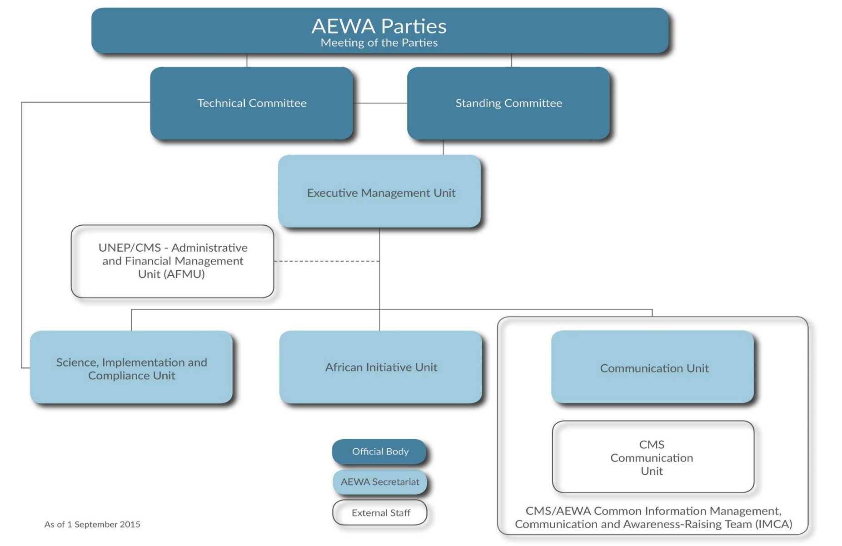

**ANNEX 7 – UNEP/AEWA Secretariat Staff Composition**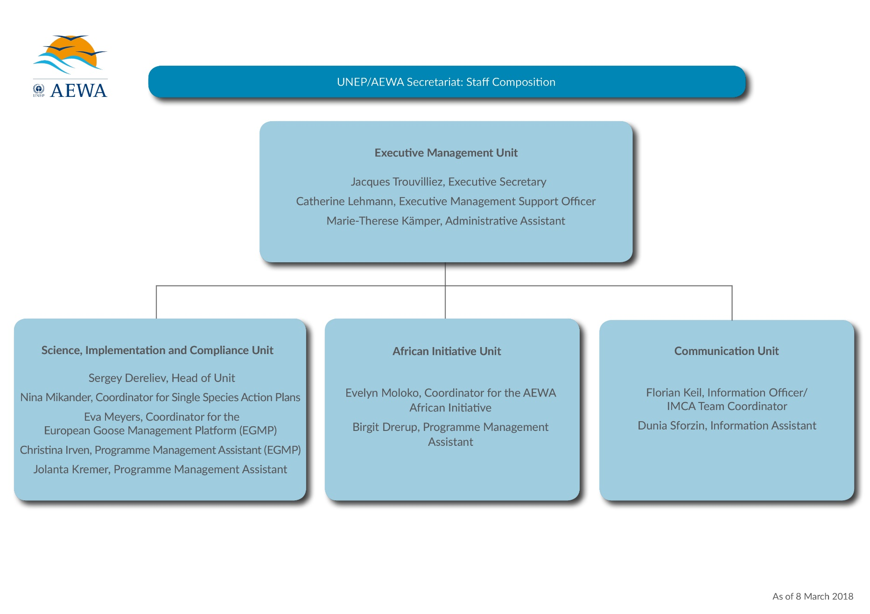

1. **EUR 206,640** + USD 295,804 equivalent to **EUR 267,111** (exchange rate 0,903).
2. **EUR 470,731** + USD 260,435, equivalent to **EUR 232,047** (exchange rate 0,891) + GBP 10,000, amount received USD13,210 equivalent to **EUR 11,360** (exchange rate 0,860).
3. **EUR 471,946** + USD 137,840 equivalent to **EUR 120,610** (exchange rate 0,875) + GBP 6,700 equivalent to **EUR 7,645** + NOK 600,000, amount received USD 73,185, equivalent to **EUR 64,037** (exchange rate 0,875) + Skr 100,000, amount received USD 11,421.41 equivalent to **EUR 9,456** (exchange rate 0,828) + Skr 200,000, amount received USD 28,601.17, equivalent to **EUR 24,711** (exchange rate 0,864).