REPORT ON THE DEVELOPMENT OF WATERBIRD MONITORING
ALONG THE AFRICAN-EURASIAN FLYWAYS

(Compiled by Wetlands International and the UNEP/AEWA Secretariat)

Executive Summary

This paper presents an overview of the progress that has been made by the African-Eurasian Waterbird Monitoring Partnership since MOP6 in response to operative paragraph 5 of Resolution 6.3. The report describes the achievements made in the field of network and capacity development, the technical improvements and outputs from the International Waterbird Census (IWC).

The partnership approach enabled to provide technical and financial support to the development of waterbird monitoring schemes in a large number of the AEWA Range States and to maintain the network and regular data flow. However, funding for waterbird monitoring is still highly uncertain and insufficient while the draft AEWA Strategic Plan 2019-2027 has increased the requirements concerning monitoring.

The revised Conservation Guidelines on Waterbird Monitoring, produced by the Waterbird Monitoring Partnership, provide a blueprint for developing national monitoring schemes that could fulfil these requirements. An increase in the number of populations whose status is assessed based on adequate monitoring is hardly possible without the improvement of the monitoring of breeding bird populations in the African and Asian part of the Agreement Area. Understanding the causes of population changes will require paying more attention to demographic monitoring and monitoring of pressures.

The Waterbird Monitoring Partnership has established the Waterbird Fund as requested by Resolution 6.3 but only one Contracting Party (Switzerland) has contributed to it so far. There are still only a small number of Contracting Parties (France, the Netherlands, Norway, Switzerland, Sweden, the United Kingdom and the European Union) which support waterbird monitoring activities in other countries or at the flyway level. While the increase in external support is needed to provide coordination and capacity building, national governments should also take more responsibility and invest into the running costs of their national monitoring schemes even in low- and medium-income countries.

Background

As described in document AEWA/MOP 5.42 Rev.1 (Strategic Development of the Waterbird Monitoring in the African-Eurasian Flyways), waterbird monitoring is an essential tool for the implementation of the Agreement in many respects, however, the capacity at site, national and international level is insufficient for adequate monitoring of waterbird populations in the Agreement area.
As the 7th edition of the AEWA Conservation Status Report (CSR7) shows, still only about 40% of the status assessment of the AEWA populations is based on monitoring activities.

Recognising that inadequate funding represents a major impediment to the future development of waterbird monitoring activities across the flyway, which are needed for mobilising and curating information needed for the compilation of the AEWA Conservation Status Reports, the Meeting of the Parties adopted Resolution 5.22 on establishing a long-term basic structural funding regime for the international waterbird census in the African-Eurasian region.

Operative paragraph 1 of this resolution "Invites the Technical Committee to work with the Waterbird Monitoring Partnership to make progress towards the monitoring-related targets of the AEWA Strategic Plan 2009-2017 and to report to MOP6 and, if required, to propose this issue to be revisited at MOP6 with the aim to secure a long-term, sustainable solution for international waterbird monitoring".

Operative paragraph 3 of Resolution 6.3 has invited the organisations participating in the Waterbird Monitoring Partnership to jointly establish a Fund to resource waterbird monitoring activities and urged Parties to regularly contribute to it and operative paragraph 5 invited the Waterbird Monitoring Partnership to report to each session of the MOP on the amount raised, the use of resources and remaining gaps as broader reporting on the development of waterbird monitoring.

This report outlines the progress made since the 6th Session of the Meeting of the Parties to AEWA (MOP6) and assesses the long-term adequacy and sustainability of the current arrangements.

Organisational development

The Strategic Working Group of the African-Eurasian Waterbird Monitoring Partnership, established in 2011, continued to meet annually and has slightly expanded its membership. The Strategic Working Group includes organisations with a long-term strategic interest in the development of waterbird monitoring at regional, sub-regional or flyway scale.

It is chaired by Dr Johan Mooij as representative of the Member Delegates of Wetlands International and includes the UNEP/AEWA Secretariat, BirdLife International, the British Trust for Ornithology (BTO), the European Bird Census Council (EBCC), the Federation of Associations for Hunting and Conservation of the European Union (FACE), the French Agency for Wildlife and Hunting management (ONCFS), the Dutch Centre for Field Ornithology (Sovon), Tour du Valat Research Institute (TdV), EuroNatur, the Data Centre for the AEWA European Goose Management Platform based at the Aarhus University, the Wildfowl and Wetlands Trust (representing the WI/IUCN SSC Species Specialist Groups) and Wetlands International.

Regional meetings of the national International Waterbird Census (IWC) coordinators from Africa and the Western Palearctic elected their representatives for the Strategic Working Group in 2016 during the Pan-African Ornithological Congress in Senegal in 2016 and the EBCC conference BirdNumbers 2016 in Germany.

The Waterbird Fund has been established as a separate bank account hosted and managed by Wetlands International in agreement with the Waterbird Monitoring Partnership in October 2016. A website was developed in 2017. An urgent appeal was made in January 2017 to raise funds for the cold weather emergency monitoring in February 2017 and another appeal was made in May 2018 to support the Russian Breeding Bird Atlas project.
A regularly updated website, quarterly newsletters and an active mailing list facilitate the exchange of information amongst the national coordinators and wider group of stakeholders including AEWA and Ramsar National Focal Points.

Major projects that have contributed to strengthening the national waterbird monitoring schemes:

- The Wadden Sea Flyway Initiative, financially supported by the Netherlands and coordinated by Sovon, supported seven coastal countries from Mauritania to Sierra Leone;

- The Mediterranean Waterbird Network Project, coordinated by Tour du Valat and ONCFS, supported the five countries of North Africa;

- The Adriatic Flyway Initiative, led by EuroNatur, has supported Albania and countries of the former Yugoslavia;

- IWC counts in Eastern Africa received support from the Swedish Environmental Protection Agency through the AEWA Plan of Action for Africa and supported counts in seven countries in
2016 and 2017;

- The Technical Support Unit of the AEWA African Initiative (ONCFS/TdV/DPN Senegal), financially supported by the French Ministry in charge of Environment, has been organising IWC data management workshops for Anglophone & Francophone countries of Sub-Saharan Africa since MOP5;

- Wetlands International has organised counts at Barr al Hikman, Oman, with the help of Shell in 2016, 2017 and 2018;

- A coordinated census of marine waterbirds in the Baltic Sea was undertaken in January 2016, organised by members of AEWMP’s Marine Waterbird Working Group and with the support of the region’s governments and HELCOM;

- A three-year project, led by Wetlands International and supported by the MAVA Foundation, has started in Mauritania, Senegal, The Gambia and Guinea-Bissau to strengthen the IWC in those countries;

- The Food and Agriculture Organization of the United Nations (FAO), the ONCFS, and the French Facility for Global Environment (FFEM), as well as other partners have launched the “Strengthening expertise in Sub-Saharan Africa on birds and their rational use for communities and their environment” (RESSOURCE, also co-funded by EU) to promote the sustainable use of waterbirds and their habitats in the Senegal River Valley, the Inner Niger Delta, Lake Chad basin and parts of the Nile basin.

As the result of such support, countries’ participation and willingness to report their observations has been maintained at the improved level achieved earlier (Figures 1 and 2). However, support to counts and national capacity building activities in low- and medium-income countries outside of these projects was not possible. The majority of the support was available to West Africa and the Mediterranean and no support could be provided to Eastern Europe, Central Asia and East Africa. Coordination of national monitoring activities are still negatively affected even in some European Union member states such as Spain, Portugal and Greece, as a consequence of the earlier austerity measures.

Flyway level coordination was supported by voluntary contributions from the Swiss Federal Office for the Environment (2016-2017), the Norwegian Environmental Protection Agency (2016-2017) and the EU LIFE+ NGO Operational Grant (2016-2017). However, at the time of writing, funding for the coordination position was only secured from the EU LIFE+ NGO Operational Grant for 2018.

Ongoing data acquisition and curating was funded by Wetlands International, which ensured timely production of annual count total reports and was fundamental in maintaining the trust of the network of coordinators rebuilt during 2011-2014.

Technical improvements

The IWC Online portal, developed by Sovon for Wetlands International with the support of the MAVA Foundation, is now operational and allows national IWC coordinators to access their data even if they do not have a national database. The time needed for data input has been significantly reduced at Wetlands International thanks to the gradual take up of the tool (37 countries have used the online tool so far) and the more efficient data management system. This allows dedicating more time to curating the historical data and to improve reporting.

In 2017, a new trend analysis process was developed using the R version of TRIM and the MSI-Tool developed by Statistics Netherlands and used by various international monitoring and assessment schemes, such as the Pan-European Common Bird Monitoring Scheme (PECBMS) and the Helsinki Convention on the Conservation of the Baltic Sea (HELCOM). The new methodology is based on producing first national trends and produces feedback for the national schemes that are not able to produce their own national trend analyses. The number of populations for which IWC trend analyses were performed increased by c. 100 compared to the CSR6 and by c. 200 compared to CSR4 and probably has reached the maximum number of populations whose trends can be assessed based on IWC although the trend quality is still poor for many populations in South-west Asia and Africa because of inadequate historical extent and regularity of site coverage. The results of the 2017 IWC trend analysis are now also available on the IWC Online portal.

Support from the Netherlands and Switzerland’s contribution to the flyway level coordination has allowed the production of the revised AEWA Guidelines of Waterbird Monitoring (document AEWA/MOP 7.35) that were first requested by Contracting Parties at MOP5.

Impact

As a result of reorganising the scheme coordination, embracing the partnership approach and the technical improvements, it was possible to keep the time-lag between the last year of the trend period used for trend analysis in the AEWA Conservation Status Report at “only” three years as opposed to the five-year gap in CSR5. The main limitation of further improvement is the ability of the larger schemes in Europe and South Africa to collect and process their data from their observers because smaller schemes now can report within the same year as the counts.

Annual IWC count totals have been produced every year since 2011 and are available on the IWC Online portal.

Population size and trend estimates are produced for the AEWA Conservation Status Reports. In 2018, the 1% thresholds were also updated if they have changed by more than 10% since the last comprehensive update in 2012. The Waterbird Population Estimates are now published in a searchable online database. The online database also allows for consultation with the expert networks. These latest developments contributed to meeting the indicator of Target 3.1 of the AEWA Strategic Plan 2009-2018

Since 2015, nine new data requests were served and 13 scientific articles or reports (see full list in Appendix). These reports addressed issues such as population developments of selected waterbird species of hunting interest in the North-west Mediterranean, status assessment of the Common Pochard, investigating the causes of the decline of the Eurasian Wigeon, the impact of nitrogen load on waterbird populations. The article with the highest impact was published in January 2018 in the Nature magazine and it has highlighted that good governance is the most important factor that determines the status of waterbird populations.

The number of populations whose status could be analysed based on monitoring data has increased by 116% compared to 2008 (the AEWA Strategic Plan 2009-2017 target 3.1. indicator was a 50% increase) and now 40% of the AEWA populations are assessed based on regular monitoring data, although this was not only the result of the improvement in the IWC, but also the data mobilisation for the Art. 12 reporting under the EU Birds Directive and the European Red List of Birds projects, which also played an important role in the improvements.

The IWC trend analyses produced for the Conservation Status Report and the report itself clearly show that further improvement of population size and trend estimates depend on:

- Improving the regularity of waterbird counts in Africa (especially in the Sahel and East Africa) as well as in Central & South-west Asia;
- Promoting adequate breeding bird monitoring schemes and assessment processes in Africa and the Asian part of the Agreement area.

Funding and its sustainability

With the exception of the special counts and the support to counts in low-income countries, the financial targets set out in document AEWA/MOP 5.42 were largely met (Table 1). In total, over 1.1 Million Euro was raised for various components in 2017, which is positive.

However, apart from the funding from Wetlands International to data management, all funding is project-based and short- or maximum medium-term without any guarantee of long-term sustainability. Luckily, the support to the flyway level coordination has been rather stable and predictable over the last triennium thanks to the annual contributions of the European Commission, Switzerland and Norway.

The bulk of the funding was dedicated to capacity building projects in the East Atlantic and the Black Sea-Mediterranean flyway. IWC counts were also boosted in East Africa thanks to the funding received from Sweden. That project has contributed to restart waterbird counts in Tanzania, Burundi and Rwanda. However, no national funding could be mobilised in those countries for 2018 after the project ended.

Long-term funding through the capacity-building projects is also insecure. Key donors such as the MAVA Foundation, Programme for the Rich Wadden Sea, are closing down in the foreseeable future. These projects all contributed to raising capacity, but this capacity can rapidly erode when funding is no longer available and there are little signs that this support can be replaced fully by in-country support. This results in irregular and insufficient coverage of key sites, which leads to highly fluctuating and uncertain population size and trend estimates at flyway level.

Both the experience with capacity building and the incomplete surveys conducted during the last years amongst Contracting Parties and IWC coordinating organisations indicate that the financial estimates in document AEWA/MOP 5.42 significantly underestimated the costs for the IWC not to mention the financial needs of additional monitoring schemes in low- and medium-income countries.

The Waterbird Fund raised over 140,000 EUR by July 2018.

Recommendations

- All Contracting Parties should step up the implementation of Resolution 6.3 including contributions
to the Waterbird Fund;

- Support to low- and medium-income countries should be focused on covering only investment
and capacity-building costs on the condition that the annual running costs are supported by
in-country resources to guarantee sustainability of the monitoring schemes;

- More attention is needed to the monitoring of breeding populations particularly in the African and
Asian parts of the Agreement Area;

- In the light of the draft AEWA Strategic Plan 2019-2027, monitoring schemes should be designed
and implemented in a way that they are more relevant for the adaptive management of populations
and their key sites.

Figure 1. Data availability in March 2018
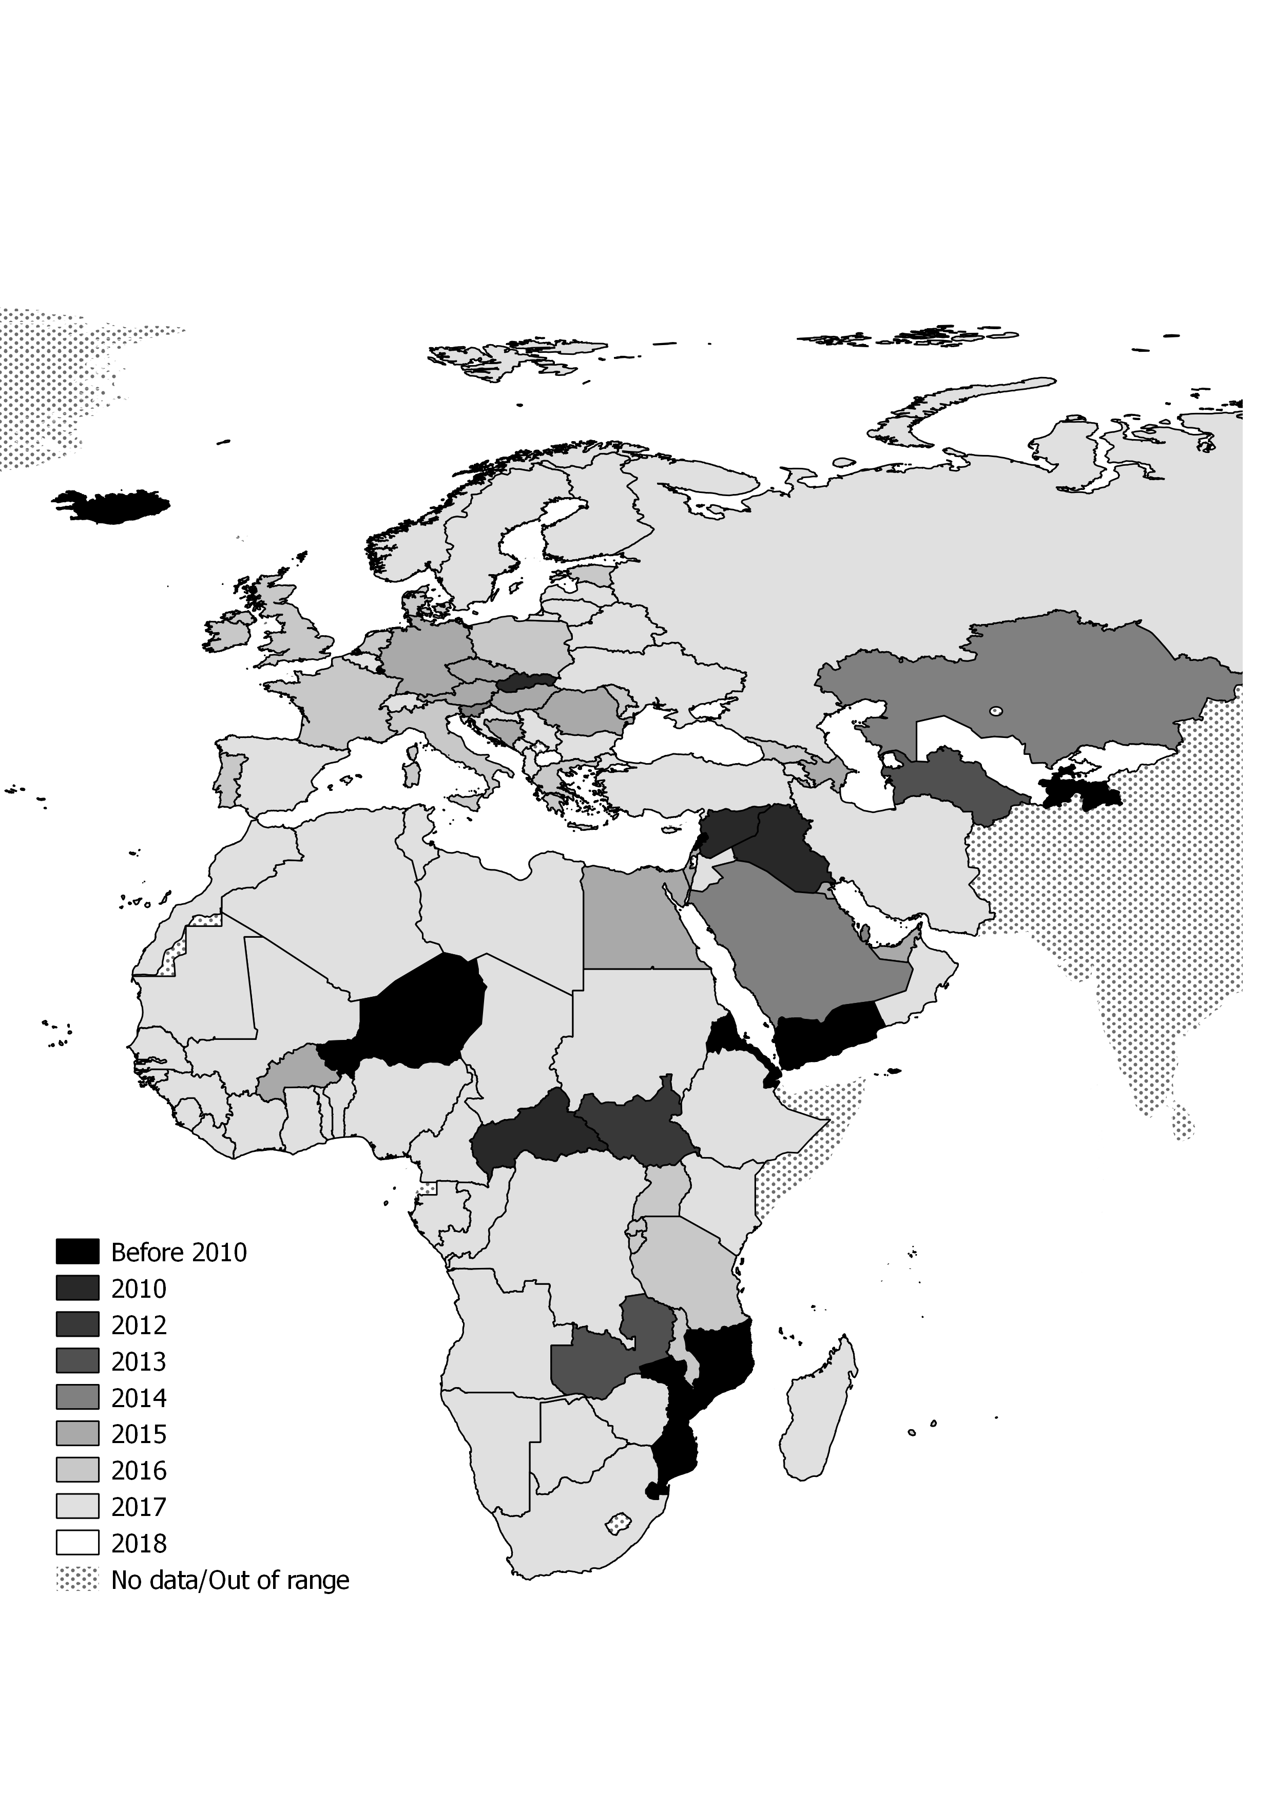

Figure 2. Last data submission in March 2018-03-05
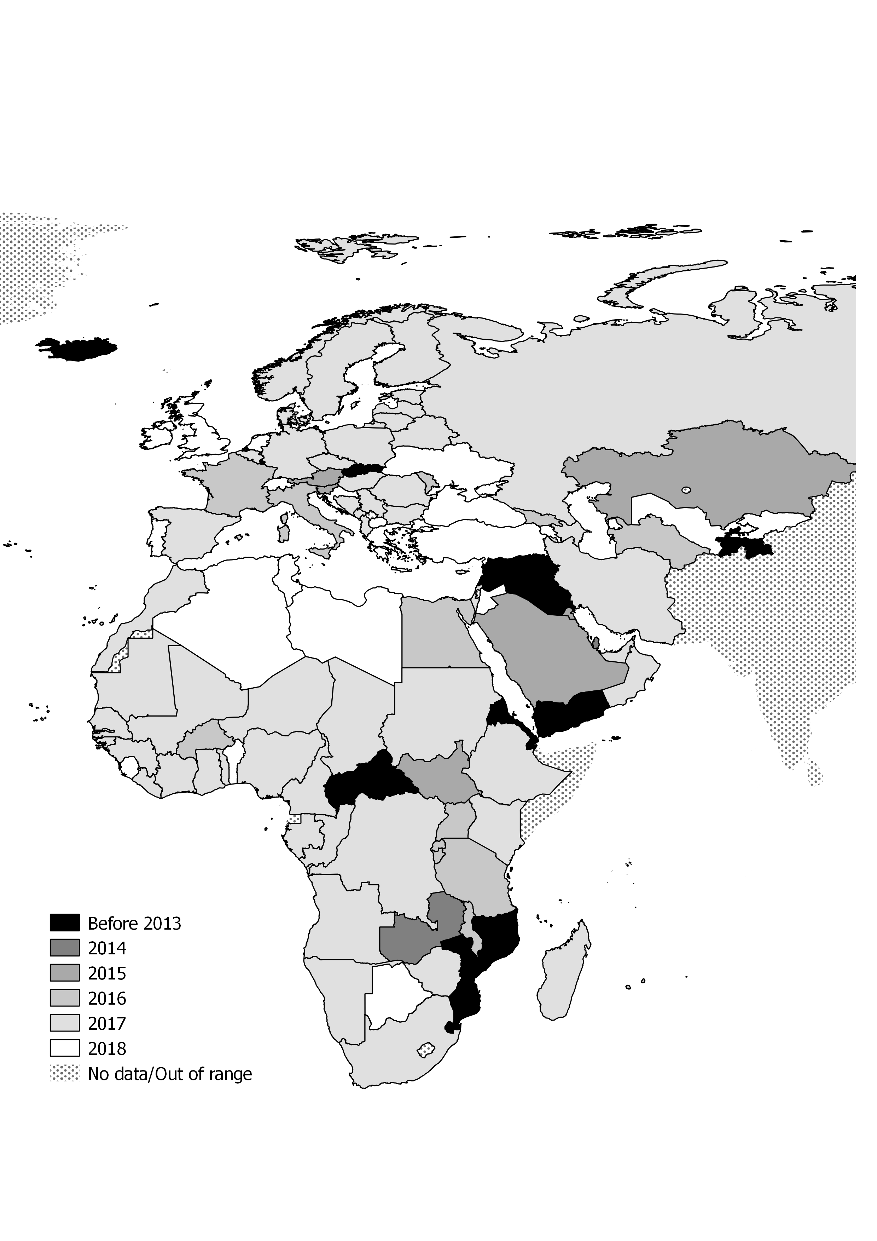

Table 1. Financial overview based on estimates in document AEWA/MOP 5.42

Component | Total estimated  (all costs  x1,000 EUR) | Realised in 2017  (all costs  x1,000 EUR) | Comments
Annually recurring activities
Global coordination and data management | 100 | 100 | Association of the Members of Wetlands International
Basic regional coordination | 65 | 68 | Supported by the EU LIFE+ NGO Operational Grant, voluntary contributions of Switzerland and Norway.
IWC coordinators’ meeting (one meeting per region every three years, ideally three regions: Africa, Europe, Central & South-west Asia) | 30 | n/a | Not applicable in 2017. However, both the Pan-African Ornithological Congress and the BirdNumbers 2016 Conference took place in 2016. Participation at the former was possible by combining meetings and using the EU LIFE+ NGO Grant to support participants, the latter was possible thanks to travel grants provided by the organisers of the conference.
Capacity development in countries with insufficient coverage of key sites | min. 40 | c. 922 | Wadden Sea Flyway Initiative: € 190,000, supported by the Dutch Rich Wadden Sea Programme, the MAVA Foundation through Wetlands International and BirdLife International, WWF Netherlands, the German Wadden Sea National Parks of Lower Saxony and Schleswig-Holstein, Vogelbescherming Netherlands, the UK WeBS programme;  Mediterranean Waterbirds Network: € 130,750, supported by the French Ministry for the Ecological and Inclusive Transition, Tour du Valat, ONCFS, Prince Albert II of Monaco Foundation;  Sahelian wetlands Waterbirds monitoring: in 2017, € 300,000 supported by the four-year FFEM/FAO/EU RESSOURCE project (€ 1,200,000 for the total duration of the project) plus € 60,000 funded by the French Ministry for the Ecological and Inclusive Transition as support for the Technical Support Unit (TSU) (€ 760,000 between 2013 and 2017) plus two engineers from ONCFS part time (ca. 50%, i.e. ca. €100,000 per year);Additional contributions of € 201,050 from the MAVA Foundation for the Adriatic Flyway and over € 100,000 in West Africa.
Small grants for general IWC counts in developing countries | min. 80 | c. 58 | € 27,756 for counts in East Africa (Sudan, Madagascar and Chad and Tanzania) supported by the Swedish Environmental Protection Agency;  € 26,000 for count at Barr al Hikman, Oman, supported by Wetlands International and Shell;  € 4,000 supported by Wetlands International.
Goose and swan counts | min. 22 | 0
Seaduck counts coordination | min. 16 | 0 | The estimated cost of the whole Baltic – North Sea census is estimated over € 1 million.
Total of annual costs | min. 353 | 1,148
Triannual costs
Seaduck counts | 85 | 0
Tidal wetland counts in Africa and the Middle East | 70 | 0 | The CMB/WFI contributed to this in West Africa and the counts organised by Wetlands International in Oman
AEWA Conservation Status Report | 55 | 99 | UNEP/AEWA Secretariat
CSN Tool update | 50 | 50 | Technical development of CSN 2.0
Waterbird Population Estimates | min. 30 | 0
Policy relevant indicators | n/a | 0
Special analyses | n/a | 0
Total periodic costs | 290 | 149

Keys:
min.: indicates a minimum cost estimate, but projects with enhanced content may actually cost more.
n.a.: indicates that the activity responds to needs to be defined bilaterally and it is not possible to estimate the costs here.

Appendix: List of publications that used the IWC data and IWC data requests

2018

1. Zheng Y.X. Huang1, Chi Xu , Frank van Langevelde, Tom Langendoen, Taej Mundkur, Yali S, Huaiyu Tian, Robert H.S. Kraus, Marius Gilbert, Guan-Zhu Han, Xiang Ji, Herbert H.T. Prins, Willem F. de Boer: Contrasting effects of host species and phylogenetic diversity on the occurrence of HPAI H5N1 in European wild birds. Submitted to Proceedings of the Royal Society B Biological Sciences 6/3/2018

2. Clark, Robert, Guillemain, Matthieu, Drever, Mark, Messmer, Dave, Langendoen, Tom: Cross-continental effects of climate cycles on avian population synchrony and dynamics. Currently pending submission.

3. Amano, T., Székely, T., Sandel, B., Nagy, S., Mundkur, T., Langendoen, T., Blanco, D., Soykan, C.U. and Sutherland, W.J. (2018) Successful conservation of global waterbird populations depends on effective governance. Nature 553: 199–202. http://dx.doi.org/10.1038/nature25139

2017
1. Pavón-Jordán, Diego, Fox, Anthony D., Clausen, Preben, Dagys, Mindaugas, Gaudard, Clémence, Devos, Koen, Encarnacao, Vitor, Frost, Teresa, Hornman, Menno, Keller, Verena, Langendoen, Tom, Lorentsen, Svein H., Luigujõe, Leho, Ławicki, Łukasz, Meissner, Włodzimierz, Molina, Blas, Musil, Petr, Musil, Zuzana, Nilsson, Leif, Paquet, Jean-Yves, Stipniece, Antra, Ridzon, Jozef, Lewis, Lesley, Teufelbauer , Norbert, Wahl, Johannes, Zenatello, Marco, Lehikoinen, Aleksi 2015. Short- and long-term changes in the distribution of abundances linked to variation in winter weather conditions in Europe differ between species with different habitat preferences. Submitted to Diversity and Distributions 11/12/2017

2. Lammert Hilarides, Tom Langendoen, Stephan Flink, Merijn van Leeuwen, Bart Steen, Alexander Kondratyev, Andrea Kolzsch, Tomas Aarvak, Helmut Kruckenberg, Didier Vangeluwe, Emil Todorov, Anne Harrison, Eileen Rees, Adriaan Dokter, Bart Nolet, Taej Mundkur: Mapping critical habitat of waterbirds in the Arctic for risk management in respect of IFC PS6. In submission, see https://www.biorxiv.org/content/early/2017/10/20/206763

3. Brides, Kane, Wood, Kevin, Hearn, Richard, Fijen, Thijs: Changes in the sex ratio of the Common Pochard Aythya ferina in Europe and North Africa. Wildfowl (2017) 67: 100–112.

4. Sayoud M.S., Salhi H., Chalabi B., Allali A., Dakki M., Qninba A., El Agbani M.A., Azafzaf H., Feltrup-Azafzaf C., Dlensi H., Hamouda N., Abdel Latif Ibrahim W., Asran H., Abu Elnoor A., Ibrahim H., Etayeb K., Bouras E., Bashaimam W., Defos du Rau P.:The first coordinated trans-North African mid-winter waterbird census: The contribution of the International Waterbird Census to the conservation of waterbirds and wetlands at a biogeographical level. Biological Conservation 206: 11-20. 2017

5. Guillemain, M., & Hearn, R. (2017). Ready for climate change? Geographic trends in the protection status of critical sites for Western Palearctic ducks. Biodiversity and Conservation, 26(10), 2347-2360.

6. Guillemain, M., Calenge, C., Champagnon, J., & Hearn, R. (2017). Determining the boundaries of migratory bird flyways: a Bayesian model for Eurasian teal Anas crecca in western Europe. Journal of Avian Biology, 48(10), 1331-1341.

2016
1. Anthony D. Fox, Lars Dalby, Thomas Kjær Christensen, Szabolcs Nagy,Thorsten J.S. Balsby, Olivia Crowe, Preben Clausen, Bernard Deceuninck,Koen Devos, Chas A. Holt, Menno Hornman, Verena Keller, Tom Langendoen, Aleksi Lehikoinen, Svein-Håkon Lorentsen, Blas Molina,Leif Nilsson, Antra Stipniece, Jens-Christian Svenning & Johannes Wahl: Seeking explanations for recent changes in abundance of wintering EurasianWigeon (Anas penelope) in northwest Europe. Ornis Fennica 93: 12–25. 2016

2015
1. Nagy, Szabolcs, Langendoen, Tom & Flink, Stephan: A Pilot Wintering Waterbird Indicator for the European Union. Wetlands International European Association, Ede.
http://www.wetlands.org/WatchRead/Currentpublications/tabid/56/mod/1570/articleType/ArticleView/articleId/3711/Default.aspx

2. Pavón-Jordán, Diego, Fox, Anthony D., Clausen, Preben, Dagys, Mindaugas, Deceuninck, Bernard, Devos, Koen, Hearn, Richard D., Holt, Chas A., Hornman, Menno, Keller, Verena, Langendoen, Tom, Ławicki, Łukasz, Lorentsen, Svein H., Luigujõe, Leho, Meissner, Włodzimierz, Musil, Petr, Nilsson, Leif, Paquet, Jean-Yves, Stipniece, Antra, Stroud, David A., Wahl, Johannes, Zenatello, Marco, Lehikoinen, Aleksi 2015. Climate-driven changes in winter abundance of a migratory waterbird in relation to EU protected areas. Diversity and Distributions, 1472-4642
http://dx.doi.org/10.1111/ddi.12300

3. Ramo, C., Amat, J. A., Nilsson, L., Schricke, V., Rodríguez-Alonso, M., Gómez-Crespo, E., ... & Boos, M. (2015). Latitudinal-related variation in wintering population trends of greylag geese (Anser Anser) along the atlantic flyway: A response to climate change?. PLoS One, 10(10), e0140181.

2014
1. Kleijn, D., Cherkaoui, I., Goedhart, P. W., Hout, J., & Lammertsma, D. (2014). Waterbirds increase more rapidly in Ramsar-designated wetlands than in unprotected wetlands. Journal of Applied Ecology, 51(2), 289-298.
http://onlinelibrary.wiley.com/doi/10.1111/1365-2664.12193/abstract

2. Nagy, Szabolcs, Flink, Stephan & Langendoen, Tom 2014. Waterbird trends 1988-2012: Results of trend analyses of data from the International Waterbird Census in the African-Eurasian Flyway. Wetlands International, Ede.
http://www.wetlands.org/Portals/0/TRIM%20Report%202014_10_05.pdf

3. van Roomen, M., van Winden, E. & T. Langendoen 2014. The assessment of trends and population sizes of a selection of waterbird species and populations from the coastal East Atlantic Flyway for Conservation Status Report 6 of the African Eurasian Waterbird Agreement. Wadden Sea Flyway Initiative, Wetlands International & Birdlife International, Nijmegen.
http://www.wetlands.org/Portals/0/EAF_selection%20of%20species2014_2.doc.pdf

2013
1. Aunins, A., Nilsson, L., Hario, M., Garthe, S., Dagys, M., Pedersen, K. I., & Skov, H. (2013). Abundance of waterbirds in the wintering season. HELCOM Core Indicator of Biodiversity.
http://www.helcom.fi/Core%20Indicators/HELCOM-CoreIndicator_Abundance_of_waterbirds_in_the_wintering_season.pdf

2. Lehikoinen, Aleksi, Jaatinen, Kim, Vähätalo, Anssi V., Clausen, Preben, Crowe, Olivia, Deceuninck, Bernard, Hearn, Richard, Holt, Chas A., Hornman, Menno, Keller, Verena, Nilsson, Leif, Langendoen, Tom, Tománková, Irena, Wahl, Johannes, Fox, Anthony D. 2013. Rapid climate driven shifts in wintering distributions of three common waterbird species. Global Change Biology 19: 1365-2486
http://dx.doi.org/10.1111/gcb.12200

3. Dalby, Lars; Söderquist, Pär; Christensen, Thomas K.; Clausen, Preben; Einarsson, Árni; Elmberg, Johan; Fox, Anthony D.; Holmqvist, Niklas; Langendoen, Tom; Lehikoinen, Aleksi; Lindström, Åke; Lorentsen, Svein-Håkon; Nilsson, Leif; Pöysä, Hannu; Rintala, Jukka; Sigfússon, Arnór Þ.; Svenning, Jens-Christian. 2013. The status of the Nordic populations of the Mallard (Anas platyrhynchos) in a changing world. Ornis Fennica 90: 2-15
http://pure.au.dk/portal/files/54026900/Dalbyetal2013.pdf

2012
1. Harebottle, Doug M. 2012. Assessing the Conservation Value of Wetlands and Waterbirds with a Focus on the Winter Rainfall Region of South Africa. Ph.D. Thesis. University of Cape Town: South Africa.
http://adu.org.za/pdf/Harebottle_DM_PhD_thesis_UCT_May2012.pdf

2. Dalby, Lars, Fox, Anthony D., Petersen, Ib K., Delany, Simon, Svenning, Jens-Christian. 2012. Temperature does not dictate the wintering distributions of European dabbling duck species. Ibis 155:80-88
http://onlinelibrary.wiley.com/doi/10.1111/j.1474-919X.2012.01257.x/full

3. van Roomen M., Hornman M., Flink S., Langendoen T., van Winden E., Nagy S. & van Turnhout C. 2012. Flyway-trends for waterbird species important in Lakes IJsselmeer and Markermeer. Sovon-rapport 2012/22, Sovon Dutch Centre for Field Ornithology, Nijmegen - the Netherlands.
http://www.wetlands.org/Portals/0/Rap_2012-22_FlywaytrendsTotaalLR.pdf

Data requests:

2018
1. Cambridge University: Understanding global drivers of waterbird population change (PhD project)

2017
1. University of Helsinki: Assessing waterbird distributions in relation to EU protected areas across the entire north-west and the central-Mediterranean populations.
2. Society for the Protection of Prespa. Conservation of pelicans in Greece and SE Europe.
3. Doñana Biological Station-CSIC: Flamingos and drought as drivers of nutrients and microbial dynamics in a saline lake.
4. Université Paris-Sud: Relative importance of climate and nutrients as predictors of the size of waterbird populations.
5. Charles University: Comparison of Czech trends with Western Palearctic
6. ONCFS: Trend of selected waterbird populations in the NW Mediterranean

2016
1. ONCFS: Demographic functioning of hunted populations with the example of Common pochard and Tufted duck in Western Europe (PhD project)
2. NIOO-KNAW: Annual cycle of Bewick’s Swan in search for the cause of its decline.

2015
1. Goose Specialist Group: Update of population estimates for Bean Geese wintering in Europe
http://www.wetlands.org/Portals/0/Rap_2012-22_FlywaytrendsTotaalLR.pdf

2014
1. Society for the Protection of Prespa. Conservation of pelicans in Greece and SE Europe.
2. Cormorant Specialist Group (EU project CorMan): Pan-European roost count Great Cormorant, January 2013.
3. Division of Biology & Conservation Ecology, School of Science & the Environment, Manchester Metropolitan University: The Conservation and Management of Selected Huntable Bird Species in Europe
http://www.wetlands.org/Portals/0/Rap_2012-22_FlywaytrendsTotaalLR.pdf

2013
1. ONCFS. PhD thesis: Influence of post-harvest agricultural practices on rice field use by wintering ducks
Wetlands International Foundation: Iraqi Marshlands World Heritage comparative analysis
http://www.wetlands.org/Portals/0/Rap_2012-22_FlywaytrendsTotaalLR.pdf

2012
1. Ligue pour la Protection des Oiseaux. Trend analysis of non-breeding birds in France.
2. Alterra Wageningen UR. Econet-flyways - analysis on flyway patterns
3. Wildfowl & Wetlands Trust: Understanding trends and distribution changes in wintering Red-breasted Goose
4. Sovon: Naar een effectief en internationaal verantwoord beheer van de in Nederland overwinterende populatie Kolganzen (Anser albifrons)
5. Centre d'Etudes Biologiques de Chizé UPR : Distribution and decline of Common and Brown Scoters in the Western Palaearctic region.
6. ONCFS: Redaction of a monograph on Teal (Anas crecca)

2011
1. NOWAC initiative: Long-term trends in ecosystem effects on food quality and abundance, and the consequences for population trends in migratory waterbirds.
3. IMARES PhD thesis: Trends of wintering Scaup in North-west Europe
4. CNRS: Influence of global changes on wader communities
5. University Lille: Spatio-temporal evolution of the migration of sea ducks in European coasts.
6. Doñana Biological Reserve Station: Long distance dispersal of aquatic organisms by waterbirds
7. Centre for Ecological Research and Forestry Applications (CREAF): Shorebird populations trends

https://europe.wetlands.org/our-network/waterbird-monitoring-partnership/
https://waterbird.fund/
https://europe.wetlands.org/our-approach/healthy-wetland-nature/african-eurasian-waterbird-census/
https://www.cbs.nl/en-gb/society/nature-and-environment/indices-and-trends--trim--
https://www.cbs.nl/en-gb/society/nature-and-environment/indices-and-trends--trim--/msi-tool
http://iwc.wetlands.org/index.php/aewatrends
http://iwc.wetlands.org
http://wpe.wetlands.org
Amano, T., Székely, T., Sandel, B. Nagy, S., Mundkur, T., Langendoen, T., Blanco, D., Soykan, C. & Sutherland, W. (2018) Successful conservation of global waterbird populations depends on effective governance. Nature 553. 199-202 (11 January 2018). DOI:10.1038/nature25139.
The Technical Support Unit (TSU) to the African Initiative of AEWA was established in 2012 at the AEWA MOP5, with the support of the French Ministry of Ecology (MEDDE) and is made up of personnel from the French Hunting and Wildlife Office (ONCFS), Tour du Valat and Senegal's National Parks Directorate (DPN of Senegal).

