**REPORT ON THE CONSERVATION STATUS OF MIGRATORY**

**WATERBIRDS IN THE AGREEMENT AREA**

Seventh Edition

**Introduction**

Article IV of the Agreement introduces the AEWA Action Plan (Annex 3 to the Agreement). Paragraph 7.4 of the AEWA Action Plan requires the Agreement Secretariat, in coordination with the Technical Committee and the Parties, to prepare a series of seven international reviews on the implementation of the Action Plan. These reviews shall be prepared at different frequencies, as per paragraph 7.5, and shall be submitted to the Meeting for the Parties (MOP) for consideration.

Amongst these seven international reviews is the *Report on the Conservation Status of Migratory Waterbirds* *in the Agreement Area* (aka Conservation Status Report - CSR). This review has been produced regularly and submitted to each session of the MOP so far.

In accordance with paragraph 7.5, which determines the frequency of each international review, this report shall be produced for each session of the MOP. The 7th edition of the Report on the Conservation Status of Migratory Waterbirds in the Agreement Area (CSR7), as per item 7.4 (a) of the Agreement’s Action Plan, is to be submitted to the 7th Session of the Meeting of the Parties to AEWA in December 2018.

The Secretariat contracted Wetlands International to produce CSR7 in June 2017. To ensure that the best available knowledge is used, the AEWA Contracting Parties were invited to review the draft status assessments produced (revised population sizes and trends) in November 2017, which, after incorporation of their feedback, formed the basis for producing the first draft of the report.

This draft was reviewed and approved by the Technical Committee at its 14th Meeting in April 2018 and by the Standing Committee at its 13th Meeting in July 2018, for submission MOP7.

**Action Required from the Meeting of the Parties**

The Meeting of the Parties is invited to take note of the 7th edition of the Report on the Conservation Status of Migratory Waterbirds in the Agreement Area (CSR7) and take its conclusions and recommendations into account in the decision-making process.

**Report on the Conservation Status of Migratory Waterbirds in the Agreement Area**

Seventh Edition

2018

**Report prepared by Wetlands International**

*Szabolcs Nagy & Tom Langendoen*

**with contributions from**

*Marc van Roomen, Erik van Winden, Per-Arvid Berglund, Jonas Hentati-Sundberg, Andrea Angel, Ross Wanless, Stuart Butchart, Ian Burfield, Tim Dodman, Rob Sheldon and Tony Fox*

Table of Contents

[Executive Summary 4](#_Toc526256091)

[Acknowledgements 6](#_Toc526256092)

[Introduction 8](#_Toc526256093)

[Part 1. Taxonomic and geographic patterns of migratory waterbird populations included in the Agreement 10](#_Toc526256094)

[Almost 70% of AEWA populations are waders or waterfowl 10](#_Toc526256095)

[70% of AEWA populations breed in the Palearctic 11](#_Toc526256096)

[Part 2. Population sizes 13](#_Toc526256097)

[Two-thirds of population estimates are based on monitoring 13](#_Toc526256098)

[Nine populations with no population size estimates 14](#_Toc526256099)

[The waterbird families with limited knowledge of their size 16](#_Toc526256100)

[Flyway projects helped to fill knowledge gaps 17](#_Toc526256101)

[Population size estimates improved for 83 populations 18](#_Toc526256102)

[More than half of all populations contain less than 100,000 individuals 19](#_Toc526256103)

[AEWA protects nearly half a billion waterbirds and seabirds 20](#_Toc526256104)

[Part 3. Population trends 21](#_Toc526256105)

[We know little about the trends of over half of the AEWA populations 21](#_Toc526256106)

[Quality of trend estimates is best in regions with well-established 22](#_Toc526256107)

[monitoring schemes using citizen science 22](#_Toc526256108)

[The trends of pratincoles, rails, gulls and plovers are poorly known 23](#_Toc526256109)

[Heuglin’s Gull *Larus fuscus heuglini*, NE Europe & W Siberia/SW Asia & NE Africa 26](#_Toc526256110)

[Over a third of all AEWA populations are decreasing 28](#_Toc526256111)

[The status of 143 populations has improved and that of 176 populations has deteriorated 29](#_Toc526256112)

[More than half of the auk and crane populations are declining 31](#_Toc526256113)

[More than half of the populations in Central and Southwest Asia are declining 32](#_Toc526256114)

[More than one quarter of the AEWA populations are in significant long-term decline 33](#_Toc526256115)

[Long-term monitoring is critical to assess long-term trends 41](#_Toc526256116)

[How did AEWA populations change over time? 42](#_Toc526256117)

[Successful conservation of waterbirds depends on effective governance 45](#_Toc526256118)

[Part 4. Threats to waterbird species in the AEWA region 46](#_Toc526256119)

[Part 5. Species of global conservation concern 47](#_Toc526256120)

[Increasing numbers of AEWA populations appear on the Red List 47](#_Toc526256121)

[The highest proportion of populations on the Red List are in Eastern and Southern Africa 48](#_Toc526256122)

[Action plans work, but require long-term commitment 49](#_Toc526256123)

[Part 6. Progress towards the targets set in the AEWA Strategic Plan 50](#_Toc526256124)

[G.1 No AEWA waterbird population has become extinct in the Agreement area 51](#_Toc526256125)

[G.3 At least 75% of the AEWA waterbird populations have a positive trend (growing or stable) 54](#_Toc526256126)

[G.4 Overall status of indicator species has improved, as measured by the Waterbird Indicator 55](#_Toc526256127)

[G.5 Overall extinction risk of waterbirds reduced, as measured by the Red List Index (RLI) 56](#_Toc526256128)

[G.6 20% of threatened and Near Threatened species downlisted to lower categories of threat 57](#_Toc526256129)

[G.7 Fewer populations to be listed in Category 1 in Column A (20% reduction) 58](#_Toc526256130)

[G.8 Fewer populations to be listed in Column A (5% reduction) 59](#_Toc526256131)

[Arctic Loon *Gavia arctica arctica*, Central Siberia/Caspian 61](#_Toc526256132)

[Bean Goose *Anser fabalis johanseni*, West & Central Siberia/Turkmenistan to W China 61](#_Toc526256133)

[Red-breasted Merganser *Mergus serrator*,North-west & Central Europe (win) 61](#_Toc526256134)

[Spotted Redshank *Tringa erythropus*,N Europe/Southern Europe, North & West Africa 61](#_Toc526256135)

[Ruddy Turnstone *Arenaria interpres interpres*, Northern Europe/West Africa 61](#_Toc526256136)

[Common Pochard *Aythya ferina*, North-east Europe/North-west Europe 61](#_Toc526256137)

[Common Pochard *Aythya ferina*, Central & NE Europe/Black Sea & Mediterranean 61](#_Toc526256138)

[Common Eider *Somateria mollissima mollissima*, Norway & Russia 61](#_Toc526256139)

[Long-tailed Duck *Clangula hyemalis*, Iceland & Greenland (bre) 61](#_Toc526256140)

[Long-tailed Duck *Clangula hyemalis*, Western Siberia/North Europe (bre) 61](#_Toc526256141)

[Eurasian Oystercatcher *Haematopus ostralegus ostralegus*, Europe/South & West Europe & NW Africa 61](#_Toc526256142)

[Bar-tailed Godwit *Limosa lapponica taymyrensis*, Central Siberia/South & SW Asia & Eastern Africa 61](#_Toc526256143)

[Eurasian Curlew *Numenius arquata arquata*, Europe/Europe, North & West Africa 61](#_Toc526256144)

[Curlew Sandpiper *Calidris ferruginea*, Western Siberia/West Africa 61](#_Toc526256145)

[Curlew Sandpiper *Calidris ferruginea*, Central Siberia/SW Asia, E & S Africa 61](#_Toc526256146)

[Razorbill *Alca torda islandica*, Iceland, Faeroes, Britain, Ireland, Helgoland, NW France 61](#_Toc526256147)

[Razorbill *Alca torda torda*, E North America, Greenland, E to Baltic & White Seas 61](#_Toc526256148)

[3.1.2 - 50% increase of species/ populations whose international status is being assessed with regular monitoring data 62](#_Toc526256149)

**Annex 1. Population sizes and trends of waterbird species included in the Agreement 65**

**Annex 2. Report on the status and trends of Red Listed AEWA species 116**

**Annex 3. List of contributors to the IWC 133**

# Executive Summary

This is the seventh edition of the AEWA Conservation Status Review allowing an increasingly long-term view of the changing status of the migratory waterbird populations listed on Table 1 of the AEWA Action Plan. AEWA provides a framework to protect almost half a billion (some 338 – 464 million) individuals of water- and seabirds in Africa and Eurasia, and this assessment assesses the status of this important component of global biodiversity.

The key new conclusions from this assessment are:

* The overall status of AEWA waterbird populations has improved during the period of the Strategic Plan 2008-2018 although there are both increasing and declining populations.
* However, an increasing number of mainly marine and farmland species are listed as globally threatened and Near Threatened and in significant long-term decline, which highlights the importance of sustainable management beyond protected areas.
* Good governance is the most important determinant of the trend of waterbird populations
* Species recovery plans positively influence the trend of waterbird populations in the long-term. However, species are becoming globally threatened more rapidly than they can be recovered.
* Achieving AEWA's targets and ensuring its contribution to the Aichi Targets and Sustainable Development Goals require the adoption of proactive strategies that integrate bird conservation into a wide range of other land use policies.

**Status of knowledge**

The status of knowledge has improved substantially both during the last three years and during the duration of the AEWA Strategic Plan 2008-2018. Focused capacity building programmes in the East Atlantic flyway and the Black Sea - Mediterranean (Wadden Sea Flyway Initiative, Mediterranean Waterbirds and Adriatic Flyway Initiative projects) as well as the new status reporting obligations under the EU Birds Directive Article 12 and the related European Red List of Birds publication were crucial in this respect. The number of populations whose international status is being assessed with regular monitoring increased from 102 in CSR4 to 221, i.e. more than doubled. This represents 40% of all AEWA listed populations.

The number of AEWA populations with no recent population trend estimates has declined to 14%, but 38% of the populations still have poor trend estimates. The majority of the populations with no trend estimates are from the Afrotropic biogeographical region and the West Asian-East African Flyway. Most of the population size estimates are based on some sort of monitoring but many are derived using expert opinion rather than statistically representative sampling or full censuses. Knowledge of the status of waterbird populations is especially poor in West Asia and in the Afrotropical region, with the exception of Southern Africa and the Atlantic Coast. In 13 out of 26 waterbird families, trend estimates do not exist for some species.

|  |
| --- |
| Recommended actions:   * To adopt and implement AEWA Guidelines on adequate monitoring schemes for the populations listed on Table 1 of the AEWA Action Plan, in order to assist Range States in gathering compatible data for international status assessments. * To implement reporting of national population size and trend estimates as part of the national reporting process. * To establish national bird atlas schemes similar to the Second Southern African Bird Atlas project across Africa, Central and South-west Asia. * High income Contracting Parties should support low- and medium-income Contracting Parties, either bilaterally or through the Waterbird Fund, to implement adequate waterbird monitoring programmes that submit data to international schemes to produce population-level assessments. |

**Trends**

Of the 445 populations with trend information, 36% are declining. This means that 36% more populations are declining than increasing. Consequently, the overall trend of the waterbird populations listed in Table 1 of the AEWA Action Plans is still slightly negative, but there has been some improvement. Since 1999, the proportion of declining populations has decreased from 42% to 36%. Since CSR4, the status of 143 populations improved and that of 176 has worsened.

The highest proportion of populations decreasing in the last 10 years is in the Central & South-west Asian part of the Western Palearctic, where more than half are declining. However, the highest proportion of populations with significant long-term decline is in the East Atlantic flyway, closely followed by the Central & South-west Asian part of the Western Palearctic, the Eastern & Southern part of the Afrotropic and the Black Sea - Mediterranean Flyway. Populations in significant long-term decline are mainly associated with the marine environment and farmland. Statistical analyses demonstrated that good governance is a key determinant of waterbird trends.

|  |
| --- |
| Recommended actions:   * Develop capacity building programmes similar to the Wadden Sea Flyway Initiative in the Black Sea region, in the West Asian-East African flyway and the Sahel Zone. * Make concerted efforts to expand the membership of the Agreement in the West Asian-East African flyway. * Pay more attention to integrating the conservation of birds and their habitats into other sectorial policies. |

**Indicators of effectiveness:**

Nine AEWA indicators of effectiveness from the AEWA Strategic Plan 2009-2018 were assessed based on the information generated for this report. Only two ('G.4 Overall status of indicator species has improved, as measured by the Waterbird Indicator' and '3.1.2. 50% increase of species/ populations whose international status is being assessed with regular monitoring data'), were achieved. In one case ('At least 75% of the AEWA waterbird populations have a positive trend'), the target was nearly reached. However, for six indicators negative changes were recorded. Negative changes in the indicators of effectiveness are mainly related to an increasing number of globally threatened and Near Threatened species and increasing number of populations with significant long-term decline and lower population size estimates.

|  |
| --- |
| Recommended actions:   * Intensify the implementation of the AEWA Single and Multi-species Action Plans, including adequate protection and management of their key sites and habitat, to assist recovery of globally threatened and Near Threatened Species. * Promote conservation measures in the wider environment to address causes of declines of farmland and marine species. * Apply adaptive harvest management more widely to ensure the sustainability of harvest. * Reduce unnecessary mortality of waterbirds by implementing the relevant AEWA guidelines. |

# Acknowledgements

The 7th edition of the *Report on the Conservation Status of Migratory Waterbirds in the Agreement Area* is the result of a collaborative effort of Wetlands International, BirdLife International, Sovon, the Goose Specialist Group, RDF Conservation and the CAFF CBird Group. Their status assessments are available on the website of Wetlands International[[1]](#footnote-1) and the Red List assessment of AEWA listed species prepared by BirdLife International is attached as Annex 2 to this report.

Updated population estimates were greatly assisted by the population and trend data provided by the EU Member States in the frame of their reporting under Article 12 of the EU Birds Directive and, in the case of European countries outside of the EU, by BirdLife partner organisations in the frame of the European Red List of Birds Project funded by the European Commission. We are grateful to Ian Burfield and Anna Staneva of BirdLife International for making these data available to us. The Pan-European Common Bird Monitoring Scheme (PECMBS[[2]](#footnote-2)) has provided breeding trend data on some abundant waterbird species. In some cases, results of the 2nd Southern African Bird Atlas Project (SABAP2) were used to estimate trends of Southern African waterbird populations. Population size and trend estimates were greatly improved by the enhanced survey efforts supported through the Mediterranean Waterbirds Project[[3]](#footnote-3) in North Africa, the Wadden Sea Flyway Initiative[[4]](#footnote-4) in West Africa and the Adriatic Flyway Project[[5]](#footnote-5) in the north-east Adriatic. Grants from the Swedish Environmental Protection Agency and from the Norwegian Environment Agency have contributed greatly to support counts and mobilize data in Eastern Africa as well as in the Black Sea and Caspian regions respectively. The activities of the Technical Support Unit for the Plan of Action for Africa have also contributed to collecting new data and mobilizing or improving existing data.

The African-Eurasian Waterbird Census, as the flyway level implementation of the International Waterbird Census, is one of the most important monitoring schemes contributing data to this and the above-mentioned assessments. The results of the IWC trend analyses are available through the IWC Online portal[[6]](#footnote-6). Our special gratitude goes to the c. 20,000 observers who collected data from more than 17,000 sites in the AEWA region and the national IWC coordinators (Annex 3). We are also grateful to the members of the Strategic Working Group of the African-Eurasian Waterbird Monitoring Partnership[[7]](#footnote-7) who provided useful strategic guidance on the development of waterbird monitoring in the flyway.

We are grateful for the financial support towards data management provided by the Association of Members of Wetlands International and for the flyway level coordination of the African-Eurasian Waterbird Census by the Swiss Federal Office for the Environment, the Norwegian Environment Agency as well as by the EU LIFE+ NGO Operational Grant. Collection of the data would not have been possible without the funding provided for waterbird monitoring nationally and regionally by a wide range of governmental and non-governmental organisations.

The IWC trend analysis, the production of population size and trend estimates based on this analysis and the collection and review of other sources and the production of CSR7 was possible thanks to the generous support of the Governments of Germany, France, the United Kingdom, the Czech Republic and the AEWA Trust Fund.

The text and the status assessments were greatly improved by comments and other assistance from Pierre Defos du Rau, Kees Koffijberg, Lukasz Lawicki, Aleksi Lehikoinen, Jesper Madsen, Alexander Mischenko, Jean-Yves Mondain-Monval, Johan Mooij, Kerryn Morrison, Mohammed Shobrak, David Stroud, Eileen Rees, David Scallan and Marc van Roomen.

# Introduction

Article IV of the Agreement text introduces the AEWA Action Plan, which is attached as Annex 3 to the Agreement. Paragraph 7.4 of the AEWA Action Plan requires the Agreement Secretariat, in coordination with the Technical Committee and the Parties, to prepare a series of seven international reviews on the implementation of the Action Plan. These reviews shall be prepared at different frequencies, as per paragraph 7.5, and shall be submitted to the Meeting for the Parties (MOP) for consideration.

Amongst these seven international reviews is the Report on the conservation status of migratory waterbirds in the Agreement area (aka Conservation Status Report - CSR). This review has been regularly produced and submitted to each session of MOP so far[[8]](#footnote-8). The last three editions follow an enhanced format with increased analytical content.

Wetlands International was contracted by the UNEP/AEWA Secretariat in June 2017 to produce the 7th edition of the Conservation Status Report. In turn, Wetlands International has subcontracted BirdLife International to assess the Red List status of the AEWA species and Rob Sheldon to assess the status of populations breeding in Central and South-west Asia. This edition used the reports produced by Andrea Angel, on behalf of the Global Seabird Group of BirdLife International, to assess the status of ‘tropical’ seabirds, Per-Arvid Berglund and Jonas Hentati-Sundberg, on behalf of the CAFF CBird Group, to assess the status of ‘northern’ seabirds and the status update produced by Tim Dodman for the CSR6, the report on the Status of coastal waterbird populations in the East Atlantic Flyway, the CAFF global audit of the status and trends of Arctic and Northern Hemisphere Goose populations edited by Tony Fox and J. Leafloor. The Rubicon Foundation led the assessment of the status of other populations.

**Executive summary:** This section includes the key conclusions of the report concerning the available knowledge about the status of waterbird populations, the threats affecting them and the geographic areas that deserve special attention because of the high number or proportion of declining populations. It also contains a summary of the key policy relevant recommendations.

**Part 1:** summarizes the taxonomic and geographic patterns of waterbird populations included into the Agreement.

**Part 2:** summarizes the information concerning population size estimates and their taxonomic and geographic patterns.

**Part 3:** summarizes the information concerning population trends, their patterns by taxonomic groups and geographic areas. No new information is available on habitats. Hence, the [section from CSR5](http://www.unep-aewa.org/sites/default/files/document/mop5_14_csr5_0.pdf) is not repeated in this report, but can be accessed online [here](http://www.unep-aewa.org/sites/default/files/document/mop5_14_csr5_0.pdf).

**Part 4:** No comprehensively updated information is available on threats affecting the species listed on   
Annex 2 of the Agreement, therefore no new analysis of threats has been performed. Part 4 of CSR5 is not repeated in this report, but can be accessed online [here](http://www.unep-aewa.org/sites/default/files/document/mop5_14_csr5_0.pdf).

**Part 5:** summarizes the Red List status information for the species listed on Annex 2 of the Agreement.

**Part 6:** reports the current status of the AEWA Strategic Plan indicators against the 2008 baseline.

**Annex 1:** contains the table documenting the population sizes and trends of waterbird populations included into the agreement. The same information is also available on the [Waterbird Population Estimates Portal](http://wpe.wetlands.org/search?form%5Bspecies%5D=&form%5Bpopulation%5D=&form%5Bpublication%5D=10&form%5Bprotection%5D%5B1%5D=1). Instructions on how to access the data and additional background documents can be found [here](https://www.wetlands.org/publications/1304/).

**Annex 2:** Red List status assessment of AEWA populations produced by BirdLife International in April 2017.

**Annex 3:** List of national IWC Coordinators

*Figure 1. Audit trail of population size and trend data used in CSR7. Assessments are documented in the CSR7 entries of the WPE Portal. Original analyses or further references are available in the data sources.*

|  |  |
| --- | --- |
| 1 | <http://wpe.wetlands.org/search?form%5Bspecies%5D=&form%5Bpopulation%5D=&form%5Bpublication%5D=10&form%5Bprotection%5D%5B1%5D=1> |
| 2 | <http://iwc.wetlands.org/index.php/aewatrends> |
| 3 | <http://datazone.birdlife.org/info/euroredlist> |
| 4 | http://www.waddensea-secretariat.org/sites/default/files/downloads/status\_coastal\_birds\_eaf\_2014\_1.pdf |
| 5 | <https://www.caff.is/assessment-series/all-assessment-documents/458-a-global-audit-of-the-status-and-trends-of-arctic-and-northern-hemisphere-goose> |
| 6 | https://www.wetlands.org/publications/1304/ |

# Part 1. Taxonomic and geographic patterns of migratory waterbird populations included in the Agreement

### Almost 70% of AEWA populations are waders or waterfowl

This report allocated species to families according to the taxonomy used in the checklist of BirdLife International[[9]](#footnote-9).

The Agreement includes 553 populations of 254 species belonging to 26 families (penguins *Spheniscidae*, loons or divers *Gaviidae*, grebes *Podicipedidae*, tropicbirds *Phaethonitidae*, pelicans *Pelicanidae*, gannets and boobies *Sulidae*, cormorants *Phalacrocoracidae*, frigatebirds *Fregatidae*, herons and egrets *Ardeidae*, storks *Ciconiidae*, shoebill *Balaenicipitidae*, ibises and spoonbills *Therskiornithidae*, flamingos *Phoenicopteridae*, ducks, geese and swans *Anatidae*, cranes *Gruidae*, rails, crakes and allies *Rallidae*, crab plover *Dromadidae*, stilts and avocets *Recurvirostridae*, oystercatchers *Haematopodidae*, thick-knees *Burhinidae*, coursers and pratincoles *Glareolidae*, plovers *Charadriidae*, sandpipers and allies *Scolopacidae*, skuas and jaegers *Stercorariidae*, gulls and terns *Laridae* as well as auks *Alcidae*) of 11 orders.

The vast majority of populations belong to the orders of *Charadriiformes* (45% of the AEWA populations) that includes gulls and terns (16%) as well as the sandpipers and allies (13%) and *Anseriformes* (24%) with one family: ducks, geese and swans (Figure 2).

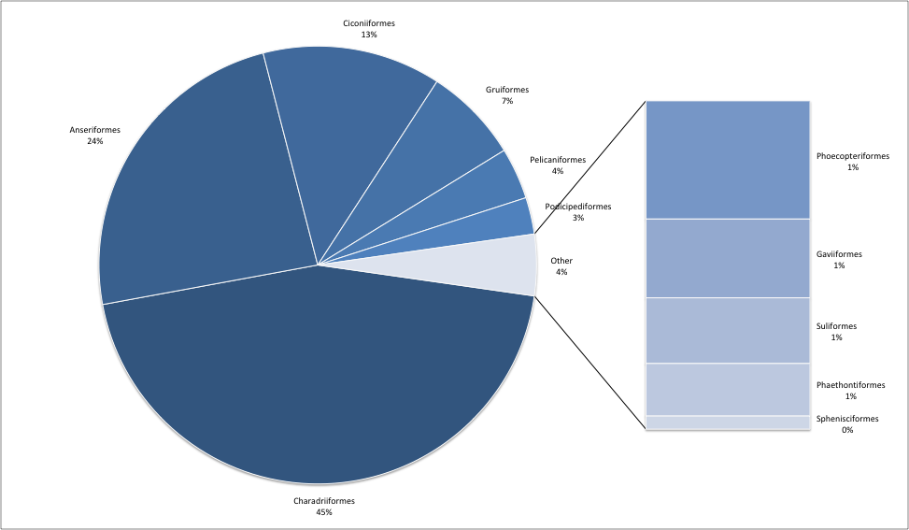

*Figure 2. Taxonomic composition of waterbird populations included into the AEWA*

### 70% of AEWA populations breed in the Palearctic

The earlier editions of the Conservation Status Report have assessed the geographic patterns of waterbird population by the Ramsar regions of Africa, Asia and Europe. To overcome the analytical problem caused by the fact that the majority of waterbird populations belong to multiple Ramsar regions, the CSR5 introduced a new geographic classification which is based on (a) the WWF terrestrial ecoregions[[10]](#footnote-10) for dispersive and short distance migrant populations and (b) on the wader/shorebird flyways for long-distance migrants (Figure 3). In this edition, the WWF terrestrial ecoregions were further subdivided into parts that represent typical populations such as the Atlantic, Black Sea - Mediterranean and Central & South-west Asian part of the Western Palearctic, the Sub-Saharan, the Western & Central, the Eastern, the Southern, the Eastern & Southern parts of the Afrotropic. Populations were allocated only to one biogeographic region or a flyway that best overlaps with their distribution and this allocation was updated during the production of the 5th edition of the Waterbird Population Estimates.

|  |  |
| --- | --- |
| **a) Biogeographic realms**  500px-Ecozones | **b) Flyways**  Shorebird Map (Provided by:   ) |
| **c) Subdivision of the Afrotropic realm** | **d) Subdivision of the Western Palearctic realm** |

*Figure 3. Geographic definitions used in this report. The Sub-Saharan subregion refers to the three subregions in the Afrotropic realm combined. The Eastern & Southern subregion refers to the combination of the Eastern and the South African regions.*

39% of the AEWA populations are migrants restricted to the Palearctic, 31% are Intra-African migrants and 29% are Palearctic migrants that winter in Africa. Most AEWA populations (99, i.e. 18%) belong to the Atlantic or NW European group of the Western Palearctic, followed by the West Asian – East African Flyway (Figure 4).

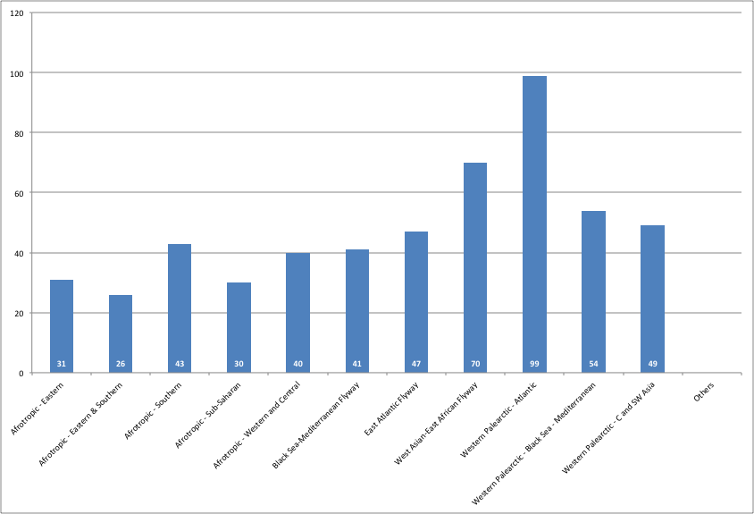

*Figure 4. Distribution of waterbird populations covered by AEWA according to their migration patterns*

# Part 2. Population sizes

### Two-thirds of population estimates are based on monitoring

The quality of population estimates was assessed using four categories. The last two categories are both based on monitoring data. They only differ in the completeness of surveys and the statistical robustness of the analyses. The category of 'best guess' now includes a measure of accuracy and is stricter than it was in the past.

|  |  |  |
| --- | --- | --- |
| 1 | *No estimate* | No population estimate is available; |
| 2 | *Best guess* | Population estimate is only possible in letter-coded ranges (i.e. A: 1-10,000, B: 10,000-25,000 individuals, etc. as applied in the Waterbird Population Estimates books) or the maximum estimate is at least 2.5 times larger than the minimum one; |
| 3 | *Expert opinion* | Population estimate is based on incomplete survey and monitoring data and some expert opinion has been applied to produce an estimate from this data with higher accuracy than the best guess; |
| 4 | *Census based* | Population estimate is based on almost complete census or statistically adequate sampling capable of producing estimates with confidence intervals narrower than best guess. |

The majority of the population estimates are based on counts but extrapolated using expert opinion instead of any formal statistical procedures. Of the population estimates, 15% are based on comprehensive censuses or were derived using statistical procedures. This group consists of either localised goose and swan populations in Northwest Europe or concerns highly localised species subject to intensive conservation efforts (e.g. Northern Bald Ibis). Overall, 66% of the population estimates are based on surveys. Population estimates for 32% of the AEWA populations are only possible in broad ranges such as 1-25,000, 25,000-100,000, etc. (Figure 5).

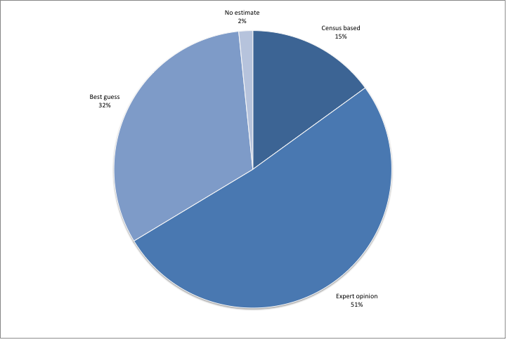

*Figure 5. Quality of population size estimates (number of populations and percentage of all populations)*

### Nine populations with no population size estimates

Population size estimates are now available for 98% of the AEWA populations. Table 1 lists the remaining nine populations with no population estimates.

*Table 1. Populations with no size estimates*

|  |
| --- |
| Buff-spotted Flufftail (*Sarothrura elegans elegans*), NE Eastern & Southern Africa |
| Buff-spotted Flufftail (*Sarothrura elegans reichenovi)*, S West Africa to Central Africa |
| Water Rail (*Rallus aquaticus korejewi*), Western Siberia/South-west Asia |
| African Rail (*Rallus caerulescens)*, Southern & Eastern Africa |
| Eurasian Golden Plover (*Pluvialis apricaria altifrons)*, Northern Siberia/Caspian & Asia Minor |
| Little Ringed Plover (*Charadrius dubius curonicus)*, West & South-west Asia/Eastern Africa |
| Eurasian Woodcock (*Scolopax rusticola*), Western Siberia/South-west Asia (Caspian) |
| Whimbrel (*Numenius phaeopus rogachevae*), C Siberia (bre) |
| Steppe Gull (*Larus fuscus barabensis*), South-west Siberia/South-west Asia |

For these populations knowledge is lacking about their size for one or more of the following reasons:

a) cryptic species, e.g. rails or snipes;

b) difficult to separate from other species or populations in the field, e.g. Steppe Gull (*Larus fuscus barabensis*) from Heuglin’s Gull (*L. f.* heuglini)and other large white-headed gulls),

c) they occur in the West Asia - East Africa flyway or Central & South-west Asian part of the Western Palearctic with low intensity monitoring both at the breeding and wintering grounds.

Since 2008, the number of populations without population size estimates decreased by 23%. First population estimates were produced for Jack Snipe (*Lymnocryptes minimus*), Western Siberia/SW Asia & NE Africa; African Crake (*Crecopsis egregia*), Sub-Saharan Africa; Black-throated Diver (*Gavia arctica suschkini*), Central Siberia/Caspian and Heuglin’s Gull (*Larus heuglini*), NE Europe & W Siberia/SW Asia & NE Africa in CSR6. In the CSR1, only 75% of the populations had any population size estimates.

### The waterbird families with limited knowledge of their size

Families that have a larger proportion of 'best guess' population estimates include (Figure 6):

* Shoebills (*Balaenaciptidae*): fairly cryptic in large ‘inaccessible’ marshes,
* Thick-knees (*Burhinidae*): nocturnal,
* Divers (*Gaviidae*): marine,
* Rails (*Rallidae*): cryptic and often nocturnal,
* Herons (*Ardeidae*): all but one population with ‘best guess’ quality are from C & SW Asia and Africa,
* Pratincoles (*Glareolidae*): highly nomadic, large rivers and drylands mainly of Africa and C & SW Asia,
* Plovers (*Charadriidae*): 18 of the 21 populations are from C & SW Asia and Africa, mainly associated with drylands and coastal mudflats,
* Skuas (*Stercorariidae*): breeding on tundra, pelagic during the non-breeding season,
* Sandpipers and allies (*Scolopacidae*):all but one, the Europe/South & West Europe & North Africa population of Woodcock (*Scolopax rusticola*) breeds in the (Sub-)Arctic zone and winter in South-west Asia, and
* Ibises and spoonbills (*Threskiornithidae*): all breed in E Europe, C & SW Asia or Africa and mix easily with other populations of the same species at the non-breeding grounds*.*

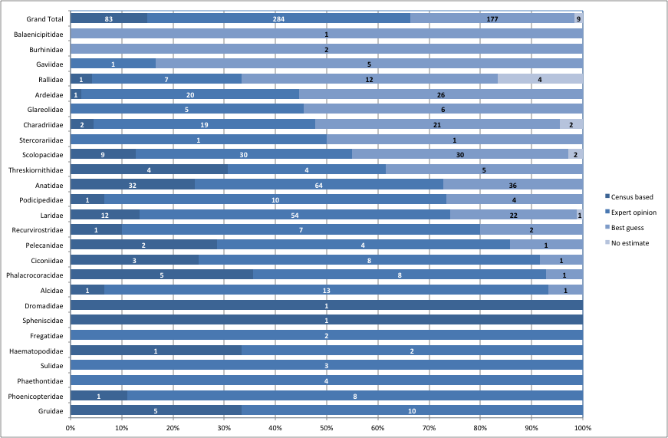In contrast, populations with a higher than average proportion of ‘census-based’ population size estimates tend to be subject of conservation (cranes, spoonbills) or management (e.g. geese, cormorants) actions and are often restricted to a relatively small area at some stage of their annual cycle.

*Figure 6. Quality of population estimates by families. (Numbers are the number of populations within each family).*

### Flyway projects helped to fill knowledge gaps

The quality of the population size estimates is best in the East Atlantic and the Black Sea - Mediterranean Flyways, the Atlantic and Black Sea – Mediterranean regions of the Western Palearctic, as well as in the Eastern and Southern groups of the Afrotropic. It is the worst in the West Asian – East African Flyway, the C & SW Asian part of the Palearctic, in West & Central Africa, in Eastern & Southern Africa and amongst the populations distributed across the whole of Sub-Saharan Africa (Figure 7).

Population estimates in the Western Palearctic have benefited from the reporting requirements under Article 12 of the EU Birds Directive and the European Red List of Birds project of BirdLife International. These reports have also played an important role estimating the size of breeding populations in the East Atlantic and the Black Sea - Mediterranean Flyways. Wintering population estimates have improved as the result of investments into improving monitoring activities along the Western seaboard of Africa by the Wadden Sea Flyway Initiative and in North Africa by the Mediterranean Waterbirds and in the northern part of the Mediterranean by the Adriatic Flyway project.

In Southern and Eastern Africa populations have higher quality estimates to other parts of Africa because their birds are generally better documented and it is easier to produce population estimates for these more restricted

populations than the ones with much larger distribution areas. Waterbird monitoring is rather limited in scope and regularity in the Sahelian part of the Black Sea - Mediterranean flyway except the Senegal River Delta. The RESSOURCE project is contributing to rectify the situation and help establish in-country capacity for regular monitoring in the region. In the West Asian – East African flyway, population size estimates have improved in recent years on the Arabian Peninsula particularly in the United Arab Emirates, Saudi Arabia and Oman as well as in Egypt, Sudan and Tanzania, but Eritrea, Yemen, Somalia and Mozambique remain major gaps.

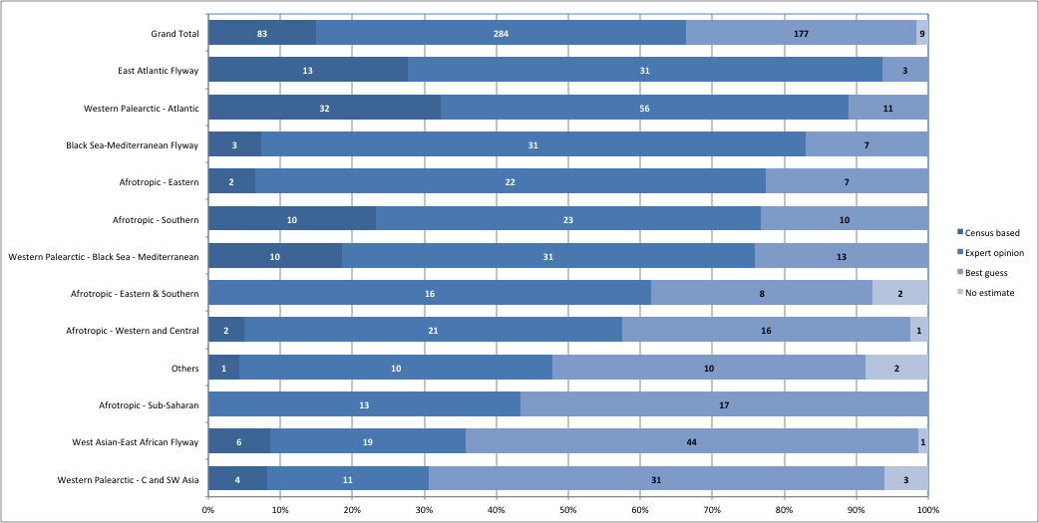

*Figure 7. The quality of population size estimates by flyways. (Numbers are the number of populations within each category).*

### Population size estimates improved for 83 populations

The changes in quality of population estimates between CSR4 (i.e. representing the 2008 baseline) and CSR7 can be compared for 537 populations that have not changed their delineation during this period.

The quality of population size estimates has improved for 83 populations (15%).

The largest numbers of populations with improved population size estimate quality can be found in the Atlantic part of the Western Palearctic as a result of the CAFF seabird assessment and the EU Article 12 reporting, the Eastern part of the Afrotropic as a result of improved estimates for seabirds, in the West Asian – East African, the Black Sea - Mediterranean and in the East Atlantic Flyways as the result of various survey and atlas work in Arabia, the Mediterranean Waterbird Project, as well as the Wadden Sea Flyway Initiative (Figure 8).

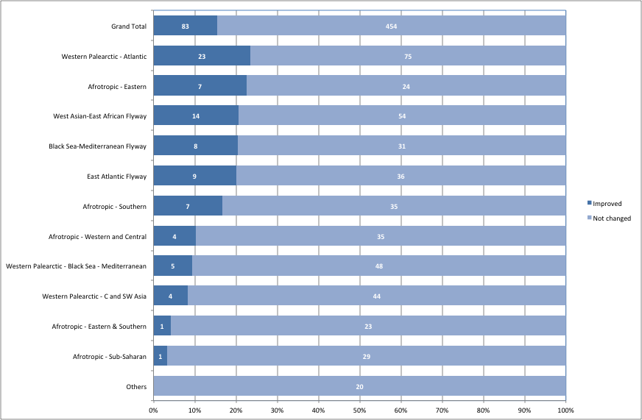

*Figure 8. Proportion and number of populations with improved quality score for population size estimates*

The quality of population size estimates have improved particularly for ducks, geese and swans (*Anatidae -*19 populations), gulls and terns (*Laridae -* 16 populations), sandpipers and allies (*Scolopacidae* - 14 populations)*.*

### More than half of all populations contain less than 100,000 individuals

The same classes are used to summarise sizes of AEWA populations as in previous editions of the Conservation Status Report. These correspond to the criteria listing populations in categories A1c, A2, A3, B1, B2 and C1 except that the population size class over 100,000 has been split into two: one for 100,001 -1,000,000 and another for over 1,000,000.

Only 57 populations (10% of the AEWA populations with size estimates) exceed 1 million individuals. The size of most populations (34%) is between 100,001 and 1,000,000 individuals, whilst 160 (30%) populations have between 25,001 – 100,000. The size of 49 populations is estimated to be between 10,001 and 25,000, i.e. they qualify for Category 2 in Column A, and 91 populations (17%) have less than 10,000 individuals, i.e. would qualify for Category 1c in Column A (Figure 9).

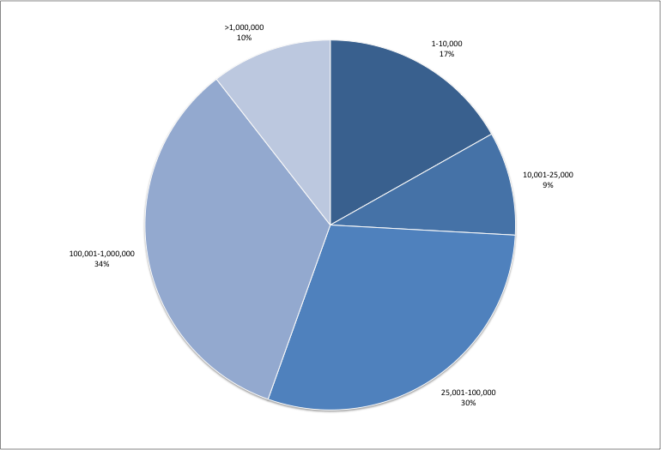

*Figure 9. AEWA populations by population size*

### AEWA protects nearly half a billion waterbirds and seabirds

In total, AEWA provides a framework to protect almost half a billion (some 338 – 464 million) individuals of water- and seabirds in Africa and Eurasia based on the sum of the minimum and maximum population estimates.

Following their addition to Table 1 in 2008, auks (*Alcidae*)is the family with by far the highest number of individuals. The total of the estimated population sizes is around 160 million. They are followed by c. 70 million sandpipers and allies (*Scolopacidae*), nearly 55 million gulls and terns (*Laridae*) and 38 million ducks, geese and swans (*Anatidae*) (Figure 10).

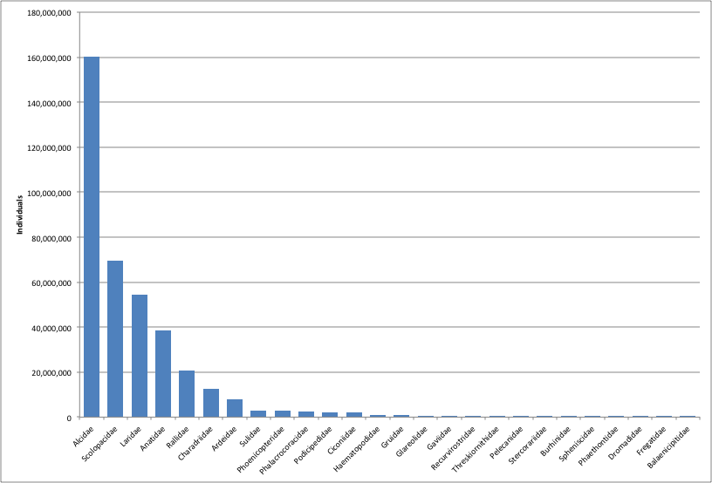

*Figure 10. Aggregated size of populations listed on Table 1 of AEWA by families*

Reflecting the geographic distribution of the families, particularly of the auks, 50% of the individuals of all water- and seabird of the populations listed on Table 1 can be found in the Atlantic region of the Western Palearctic. Even without the auks, this region hosts the largest number of individuals, some 42 million birds. This is largely equivalent to the total number of individuals of all Intra-African migrants. The spectacular annual migration of some 77 million long-distance migrant waterbirds connects Sub-Saharan Africa with the Western Palearctic.

# Part 3. Population trends

Trends were assessed for two time periods: the most recent available 10-year trend period to analyse the current status of the populations and the long-term changes to apply the criteria for significant long-term decline. For the recent trends, information was only taken into account if the end of the trend period fell between 2006 and 2017. In the absence of trend data ending in this period, the recent trend was considered unknown with no idea quality code.

### We know little about the trends of over half of the AEWA populations

The quality of short-term trend estimates was assessed following the scoring system developed by the International Wader Study Group[[11]](#footnote-11). The categories were defined as follows:

|  |  |
| --- | --- |
| *No idea:* | No monitoring at international scale in either breeding or wintering periods. Trends unknown. This category also includes populations where trends are uncertain. |
| *Poor:* | Some international monitoring in either breeding or wintering periods although inadequate in quality or scope. Trends assumed through partial information. |
| *Reasonable:* | International monitoring in either breeding or wintering periods that is adequate in quality or scope to track direction of population changes. |
| *Good:* | International monitoring in either breeding or wintering periods that is adequate in quality or scope to track direction of population changes with defined statistical precision. |

Almost half of the AEWA populations have good (9%) or reasonable (39%) quality trend estimates based on adequate monitoring schemes. However, more than a third of the population trend estimates are poor (38%), i.e. assumed based on partial information or simply non-existent (14%, Figure 11).

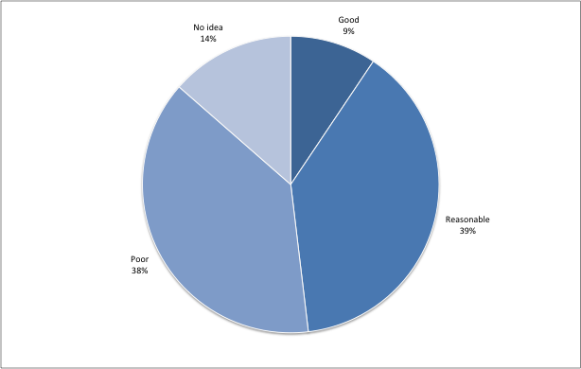

*Figure 11. Quality of trend estimates of the AEWA populations*

### Quality of trend estimates is best in regions with well-established

### monitoring schemes using citizen science

The highest number and proportion of populations with good quality trend estimates can be found in the Atlantic region of the Western Palearctic thanks to well-established monitoring programmes covering both the breeding and the non-breeding season linked to population and site management requirements and reporting obligations under the EU Birds Directive (Figure 12). Here, over 28% of the populations have good and another nearly 50% of the populations have reasonable quality trend estimates. This is closely followed by the Black Sea – Mediterranean part of the Western Palearctic, where half of the populations have reasonable quality trend estimates, though only 15% have good quality estimates. This region also includes Eastern Europe, and the East and Southern Mediterranean where the Birds Directive does not apply.

The quality of trend estimates is similar amongst the long-distance migrants of the East Atlantic and the Black Sea – Mediterranean flyway, partly because some of the trends are estimated based on breeding numbers (i.e. subject of the same monitoring programmes) and partly because of investments into monitoring in these countries. The quality of trend estimates of the Southern African populations is also similar to the European ones. However, 70% of the trend estimates are poor or non-existent for the populations of the rest of the Afrotropic, the Central and South-west Asian and the West Asian – East African populations.

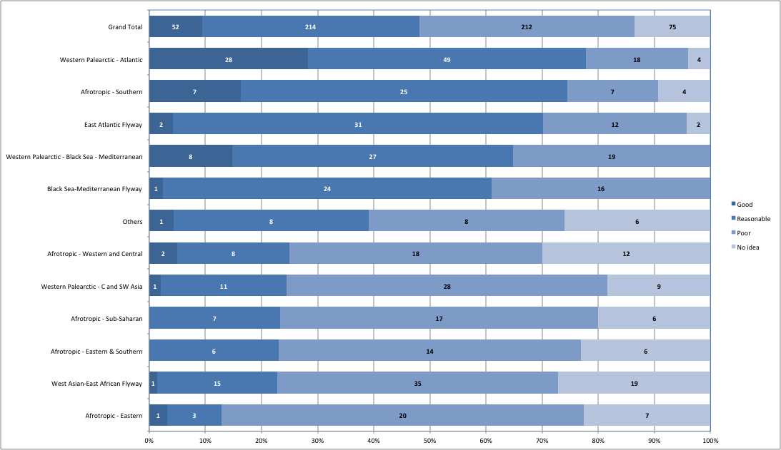

*Figure 12. Quality of population trend estimates by flyways. (Numbers are the number of populations within each category).*

### The trends of pratincoles, rails, gulls and plovers are poorly known

In five out of 26 waterbird families (73%), short-term trend estimates do not exist or are based on only poor data (Figure 13). There are no recent trend estimates for 75 populations (Table 2).

The highest proportion of populations with no idea about their trends belongs to the pratincoles (*Glareolidae* - six out of 11 populations) and rails (*Rallidae -* 11 out of 24 populations). The family with the largest number of populations with unknown trends are the gulls and terns (*Laridae -* 20 out of 89 populations) and plovers (*Charadriidae -*13 out of 44 populations). As with ‘best guess’ population size estimates, these species cannot be easily monitored through multispecies schemes and they mostly occur in parts of Africa and Central and Western Asia with insufficient monitoring.

Families with a high proportion of populations with poor quality trends include the thick-knees (*Burhinidae*), shoebills (*Balaenicipitade*), divers (*Gaviidae*), sandpipers and allies (*Scolopacidae*), herons (*Ardeidae*)as well ascrab plovers (*Dromadidae*) and tropicbirds (*Phaethontidae*)for the same reasons as mentioned above.

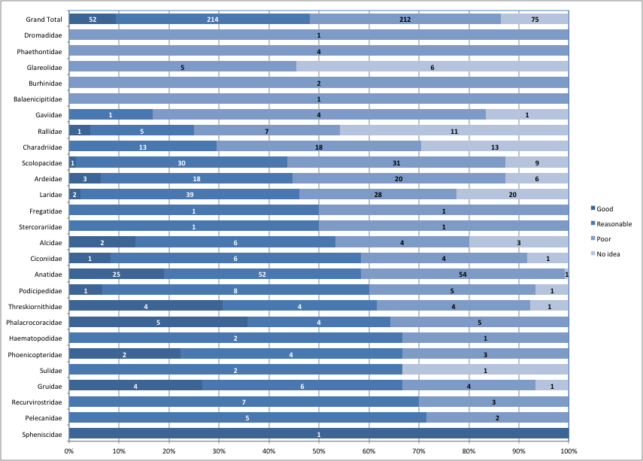

*Figure 13. Quality of trend estimates by family. (Numbers are the number of populations within each category).*

*Table 2. List of populations of which the current trend is unknown*

|  |
| --- |
| **Afrotropic - Eastern** |
| *Charadriiformes* |
| *Glareolidae* |
| Rock Pratincole *Glareola nuchalis nuchalis*, Eastern & Central Africa |
| Egyptian Plover *Pluvianus aegyptius*, Eastern Africa |
| *Laridae* |
| Brown Noddy *Anous stolidus plumbeigularis*, Red Sea & Gulf of Aden |
| Whiskered Tern *Chlidonias hybrida delalandii*, Eastern Africa (Kenya & Tanzania) |
| Roseate Tern *Sterna dougallii dougallii*, East Africa |
| *Gruiformes* |
| *Rallidae* |
| White-winged Flufftail *Sarothrura ayresi*,Ethiopia |
| *Suliformes* |
| *Sulidae* |
| Masked Booby *Sula dactylatra melanops*, W Indian Ocean |
| **Afrotropic - Eastern & Southern** |
| *Charadriiformes* |
| *Laridae* |
| Lesser Noddy *Anous tenuirostris tenuirostris*, Indian OceanIslands to E Africa |
| Sooty Tern *Onychoprion fuscatus nubilosus*, Red Sea, Gulf of Aden, E to Pacific |
| African Skimmer *Rynchops flavirostris*,Eastern & Southern Africa |
| Roseate Tern *Sterna dougallii gracilis*, Seychelles & Mascarenes |
| *Gruiformes* |
| *Rallidae* |
| African Rail *Rallus caerulescens*, Southern & Eastern Africa |
| Buff-spotted Flufftail *Sarothrura elegans elegans*, NE, Eastern & Southern Africa |
| **Afrotropic - Southern** |
| *Anseriformes* |
| *Anatidae* |
| Red-billed Teal *Anas erythrorhyncha*,Madagascar |
| *Charadriiformes* |
| *Laridae* |
| Roseate Tern *Sterna dougallii dougallii*, Southern Africa and Madagascar |
| Antarctic Tern *Sterna vittata tristanensis*, Tristan da Cunha & Gough/South Africa |
| *Gruiformes* |
| *Rallidae* |
| White-winged Flufftail *Sarothrura ayresi*,Southern Africa |
| **Afrotropic - Sub-Saharan** |
| *Charadriiformes* |
| *Charadriidae* |
| Senegal Lapwing *Vanellus lugubris*,Central & Eastern Africa |
| *Ciconiiformes* |
| *Ardeidae* |
| Common Little Bittern *Ixobrychus minutus payesii*, Sub-Saharan Africa |
| Dwarf Bittern *Ixobrychus sturmii*,Sub-Saharan Africa |
| *Gruiformes* |
| *Rallidae* |
| Striped Crake *Amaurornis marginalis*,Sub-Saharan Africa |
| African Crake *Crex egregia*,Sub-Saharan Africa |
| Lesser Moorhen *Gallinula angulata,* Sub-Saharan Africa |
| **Afrotropic - Western and Central** |
| *Charadriiformes* |
| *Charadriidae* |
| Forbes's Plover *Charadrius forbesi*,Western & Central Africa |
| White-headed Lapwing *Vanellus albiceps*,West & Central Africa |
| Crowned Lapwing *Vanellus coronatus coronatus*, Central Africa |
| Senegal Lapwing *Vanellus lugubris*,Southern West Africa |
| Wattled Lapwing *Vanellus senegallus senegallus*, West Africa |
| Brown-chested Lapwing *Vanellus superciliosus,* West & Central Africa |
| *Glareolidae* |
| Grey Pratincole *Glareola cinerea,* SE West Africa & Central Africa |
| Rock Pratincole *Glareola nuchalis liberiae*, West Africa |
| Egyptian Plover *Pluvianus aegyptius,* Lower Congo Basin |
| *Laridae* |
| Little Tern *Sternula albifrons guineae*, West Africa (bre) |
| *Gruiformes* |
| *Rallidae* |
| Streaky-breasted Flufftail *Sarothrura boehmi*,Central Africa |
| Buff-spotted Flufftail *Sarothrura elegans reichenovi*, S West Africa to Central Africa |
| **Antarctic** |
| *Charadriiformes* |
| *Laridae* |
| Antarctic Tern *Sterna vittata vittata*, P.Edward, Marion, Crozet & Kerguelen/South Africa |
| **Central Asian Flyway** |
| *Charadriiformes* |
| *Charadriidae* |
| White-tailed Lapwing *Vanellus leucurus*,C & SW Asia/NE Africa, SW & S Asia |
| *Scolopacidae* |
| Whimbrel *Numenius phaeopus rogachevae*, C Siberia (bre) |
| *Gruiformes* |
| *Gruidae* |
| Common Crane *Grus grus grus*, Western Siberia/South Asia |
| *Rallidae* |
| Western Water Rail *Rallus aquaticus korejewi*, Western Siberia/South-west Asia |
| **East Atlantic Flyway** |
| *Charadriiformes* |
| *Laridae* |
| Sabine's Gull *Xema sabini sabini*, Canada & Greenland/SE Atlantic |
| *Scolopacidae* |
| Whimbrel *Numenius phaeopus islandicus*, Iceland, Faroes & Scotland/West Africa |
| **West Asian-East African Flyway** |
| *Charadriiformes* |
| *Charadriidae* |
| Pacific Golden Plover *Pluvialis fulva*,North-central Siberia/South & SW Asia, NE Africa |
| Sociable Lapwing *Vanellus gregarius*,Central Asia/S, SW Asia, NE Africa |
| *Glareolidae* |
| Collared Pratincole *Glareola pratincola pratincola*, SW Asia/SW Asia & NE Africa |
| *Laridae* |
| Whiskered Tern *Chlidonias hybrida hybrida*, Caspian (bre) |
| Heuglin’s Gull *Larus fuscus heuglini*, NE Europe & W Siberia/SW Asia & NE Africa |
| Pallas's Gull *Larus ichthyaetus*,Black Sea & Caspian/South-west Asia |
| Common Tern *Sterna hirundo hirundo*, Western Asia (bre) |
| Greater Crested Tern *Thalasseus bergii velox*, Red Sea & North-east Africa |
| Sandwich Tern *Thalasseus sandvicensis sandvicensis*, West & Central Asia/South-west & South Asia |
| *Scolopacidae* |
| Common Snipe *Gallinago gallinago gallinago*, Western Siberia/South-west Asia & Africa |
| Pintail Snipe *Gallinago stenura*,Northern Siberia/South Asia & Eastern Africa |
| Eurasian Curlew *Numenius arquata suschkini*, South-east Europe & South-west Asia (bre) |
| Whimbrel *Numenius phaeopus alboaxilliaris*, South-west Asia/Eastern Africa |
| *Ciconiiformes* |
| *Ardeidae* |
| Squacco Heron *Ardeola ralloides ralloides*, West & South-west Asia/Sub-Saharan Africa |
| Eurasian Bittern *Botaurus stellaris stellaris*, South-west Asia (win) |
| Common Little Bittern *Ixobrychus minutus minutus*, West & South-west Asia/Sub-Saharan Africa |
| Black-crowned Night-heron *Nycticorax nycticorax nycticorax*, Western Asia/SW Asia & NE Africa |
| *Ciconiidae* |
| White Stork *Ciconia ciconia ciconia*, Western Asia/South-west Asia |
| *Threskiornithidae* |
| Glossy Ibis *Plegadis falcinellus*,South-west Asia/Eastern Africa |
| **Western Palearctic – Atlantic** |
| *Charadriiformes* |
| *Alcidae* |
| Little Auk *Alle alle alle*, High Arctic, Baffin Is |
| Black Guillemot *Cepphus grylle faeroeensis*, Faeroes |
| Atlantic Puffin *Fratercula arctica*,NE Canada, N Greenland, to Jan Mayen, Svalbard, N Novaya Zemlya |
| *Scolopacidae* |
| Common Snipe *Gallinago gallinago faeroeensis*, Iceland, Faroes & Northern Scotland/Ireland |
| **Western Palearctic - C and SW Asia** |
| *Charadriiformes* |
| *Charadriidae* |
| Greater Sandplover *Charadrius leschenaultii columbinus*, Turkey & SW Asia/E. Mediterranean & Red Sea |
| Eurasian Dotterel *Eudromias morinellus* Asia/Middle East |
| Eurasian Golden Plover *Pluvialis apricaria altifrons*, Northern Siberia/Caspian & Asia Minor |
| *Laridae* |
| Steppe Gull *Larus fuscus barabensis*, South-west Siberia/South-west Asia |
| Little Tern *Sternula albifrons albifrons*, Caspian (bre) |
| *Scolopacidae* |
| Jack Snipe *Lymnocryptes minimus,* Western Siberia/SW Asia & NE Africa |
| Eurasian Woodcock *Scolopax rusticola* Western Siberia/South-west Asia (Caspian) |
| *Gaviiformes* |
| *Gaviidae* |
| Arctic Loon *Gavia arctica arctica*, Central Siberia/Caspian |
| *Podicipediformes* |
| *Podicipedidae* |
| Red-necked Grebe *Podiceps grisegena grisegena*, Caspian (win) |
| **Western Palearctic - Europe & N Africa** |
| *Gruiformes* |
| *Rallidae* |
| Western Water Rail *Rallus aquaticus aquaticus*, Europe & North Africa |

### Over a third of all AEWA populations are decreasing

The number of populations with short-term trend data increased from 376 to 445, i.e. by 18% compared to the previous edition. Of the populations with trend information, 36% are declining, 37% are stable or fluctuating and only 27% are increasing. This means that 36% more populations are declining than increasing or 64% of the AEWA populations are stable or increasing (Figure 14). The proportion of declining populations has decreased from 42% in 1999, i.e. at the time AEWA came into force and from 41% in 2008 over the period of the AEWA Strategic Plan 2009-2018.

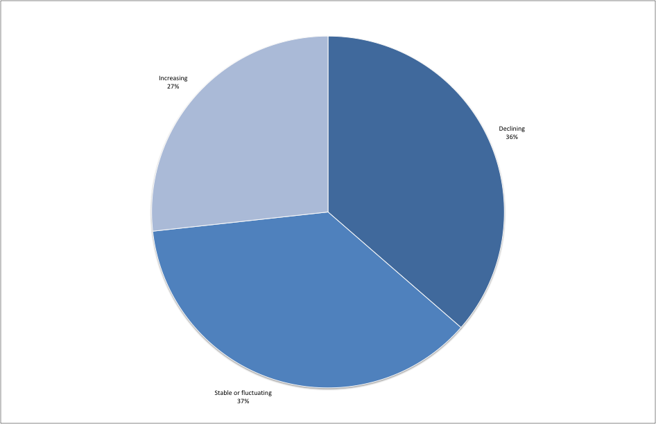

*Figure 14. Distribution of trends amongst populations with trend estimates*

### The status of 143 populations has improved and that of 176 populations has deteriorated

Comparing the current assessments of population trends with trends in CSR4 in 2008, the status of 143 populations have improved and 176 have deteriorated (Figure 15). There has been a significant increase of populations with unknown or uncertain recent trends (from 46 to 103) because of the exclusion of old, already out-dated trend information from the analysis and in order to reflect knowledge gaps.



*Figure 15. Changes in population trends between two assessments*

*Table 3. Populations that were thought to increase in CSR4 and shown as declining in CSR7*

|  |
| --- |
| Greylag Goose *Anser anser rubrirostris*,Western Siberia/Caspian & Iraq |
| Maccoa Duck *Oxyura maccoa*,Southern Africa |
| Common Shelduck *Tadorna tadorna*,Western Asia/Caspian & Middle East |
| Great Cormorant *Phalacrocorax carbo carbo*, North-west Europe |
| Black-necked Grebe *Podiceps nigricollis nigricollis*, Western Asia/South-west & South Asia |
| Grey Heron *Ardea cinerea cinerea*, Central & Eastern Europe |
| Grey Heron *Ardea cinerea cinerea*, Northern & Western Europe |
| Cattle Egret *Bubulcus ibis ibis*, South-west Europe |
| Cattle Egret *Bubulcus ibis ibis*, Southern Africa |
| Little Egret *Egretta garzetta garzetta*, Western Europe, NW Africa |
| Demoiselle Crane *Anthropoides virgo*, Kalmykia/North-east Africa |
| Three-banded Plover *Charadrius tricollaris*, Southern & Eastern Africa |
| Curlew Sandpiper *Calidris ferruginea,* Western Siberia/West Africa |
| Little Gull *Hydrocoloeus minutus*, Central & E Europe/SW Europe & W Mediterranean |
| Kelp Gull *Larus dominicanus vetula*, Coastal Southern Africa |
| Lesser Black-backed Gull *Larus fuscus graellsii*, Western Europe/Mediterranean & West Africa |
| Hartlaub’s Gull *Larus hartlaubii*,Coastal South-west Africa |
| Great Black-backed Gull *Larus marinus*, North & West Europe |

### More than half of the auk and crane populations are declining

Taxonomic groups with a particularly high proportion (over 50%) of declining populations include the shoebills (*Balaenicipitidae -* a mono-specific population), the penguins (*Spheniscidae*)*,* cranes (*Gruidae*) and auks (*Alcidae*). However, the largest numbers of declining populations are amongst ducks, geese and swans (*Anatidae -* 41), sandpipers and allies (*Scolopacidae* - 27), gulls and terns (*Laridae -* 19), as well as herons (*Ardeidae -* 14).

The number of populations increasing is larger than the number of decreasing amongst the pelicans (*Pelecanidae*), cormorants (*Phalacrocoracidae*), avocets and stilts (*Recurvirostridae*), storks (*Ciconiidae*),flamingos (*Phoenicopteridae*)and pratincoles (*Glareolidae*). There are no decreasing populations amongst the oystercatchers (*Haematopodidae*)*.* frigatebirds (*Frigatidae)* and tropicbirds (*Phaethontidae*), but this might reflect only the lack of updated trend information in these difficult to monitor groups (Figure 16).

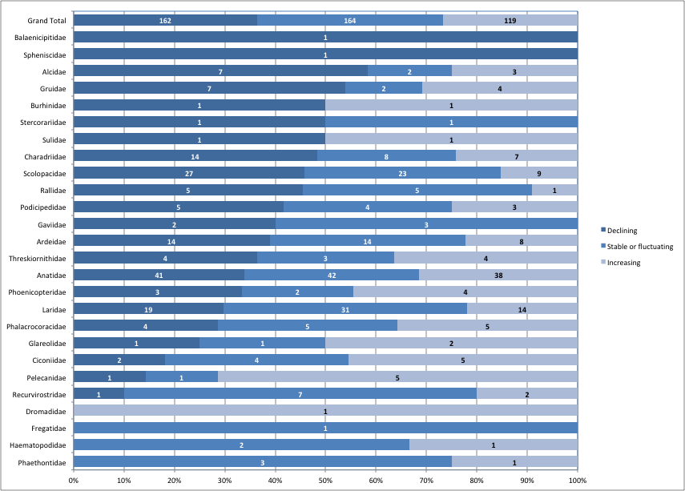

*Figure 16. Population trends by families. (Numbers are the number of populations within each category).*

### More than half of the populations in Central and Southwest Asia are declining

The highest proportions of declining populations occur in the Central & South-west Asian part of the Western Palearctic with more populations decreasing than stable or increasing. The proportion of declining populations is also higher than the average in the Atlantic part of the Western Palearctic, in the East Atlantic, Black Sea – Mediterranean flyways as well as in the Southern, Eastern & Southern and Eastern regions of the Afrotropic and nearly so in the West Asia – East African flyway (Figure 17). In absolute terms, the Atlantic region of the Western Palearctic has the largest number of declining populations (35), but also the highest number of increasing ones (29).

The highest proportion (over 40%) of increasing populations can be found in the Black Sea – Mediterranean region of the Western Palearctic, but the proportion of increasing populations exceeds the average in most parts of the Afrotropic except the Eastern and the Eastern & Southern populations.

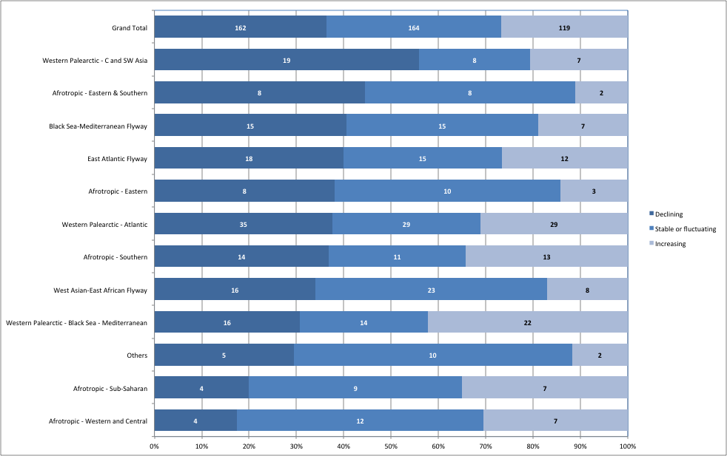

*Figure 17. Population trends by flyways. (Numbers are the number of populations within each category).*

### More than one quarter of the AEWA populations are in significant long-term decline

In total, 152 (27%) of AEWA populations are showing significant long-term decline as defined in AEWA Resolution 5.7. This amounts to seven populations fewer than CSR6.

The proportion of populations in significant long-term decline is higher than the average in the East Atlantic (40%) and Black Sea - Mediterranean (34%) flyways, the Central and South-west Asia part of the Western Palearctic (36%), the Eastern and Southern (34%), Southern (32%) and Eastern (29%) parts of the Afrotropic. The number of populations in significant long-term decline is highest (22) in the Atlantic part of the Western Palearctic.

However, the proportion of populations in significant long-term decline is slightly lower here (22%) than the average and this proportion is similar in the West Asian – East African flyway and in the Western and Central part of the East Atlantic. The proportion of the populations in significant long-term decline is the lowest amongst the ones that are distributed across Sub-Saharan Africa (Figure 18). Table 4, lists the populations in significant long-term decline.

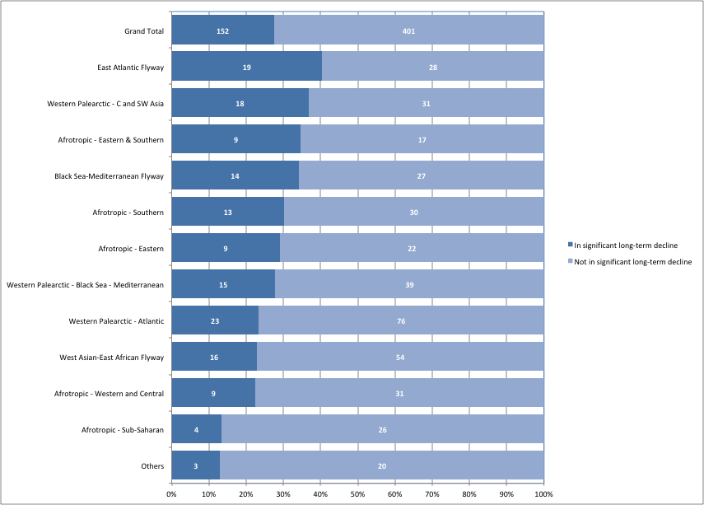

*Figure 18. Proportion of populations that meet the AEWA criteria for significant long-term decline. (Numbers are the number of populations within each category).*

*Table 4. List of populations in significant long-term decline by flyways*

|  |
| --- |
| Afrotropic - Eastern |
| *Anseriformes* |
| *Anatidae* |
| Maccoa Duck *Oxyura maccoa*, Eastern Africa |
| *Charadriiformes* |
| *Burhinidae* |
| Senegal Thick-knee *Burhinus senegalensis*,North-east & Eastern Africa |
| *Gruiformes* |
| *Gruidae* |
| Black Crowned-crane *Balearica pavonina ceciliae*, Eastern Africa (Sudan to Uganda) |
| Grey Crowned-crane *Balearica regulorum gibbericeps*, Eastern Africa (Kenya to Mozambique) |
| *Rallidae* |
| White-winged Flufftail *Sarothrura ayresi*,Ethiopia |
| *Pelicaniformes* |
| *Pelecanidae* |
| Great White Pelican *Pelecanus onocrotalus*,Eastern Africa |
| *Phoecopteriformes* |
| *Phoenicopteridae* |
| Lesser Flamingo *Phoeniconaias minor*,Eastern Africa |
| Greater Flamingo *Phoenicopterus roseus*, Eastern Africa |
| *Suliformes* |
| *Sulidae* |
| Masked Booby *Sula dactylatra melanops*, W Indian Ocean |
| Afrotropic - Eastern & Southern |
| *Anseriformes* |
| *Anatidae* |
| Fulvous Whistling-duck *Dendrocygna bicolor,* Eastern & Southern Africa |
| African Comb Duck *Sarkidiornis melanotos,* Southern & Eastern Africa |
| White-backed Duck Thalassornis *leuconotus leuconotus*, Eastern & Southern Africa |
| *Charadriiformes* |
| *Charadriidae* |
| Crowned Lapwing *Vanellus coronatus coronatus*, Eastern & Southern Africa |
| Wattled Lapwing *Vanellus senegallus lateralis*, Eastern & South-east Africa |
| *Laridae* |
| African Skimmer *Rynchops flavirostris* Eastern & Southern Africa |
| Roseate Tern *Sterna dougallii gracilis*, Seychelles & Mascarenes |
| *Ciconiiformes* |
| *Ardeidae* |
| Madagascar Pond-heron *Ardeola idae*,Madagascar & Aldabra/Central & Eastern Africa |
| *Balaenicipitidae* |
| Shoebill *Balaeniceps rex*,Central Tropical Africa |
| Afrotropic - Southern |
| *Anseriformes* |
| *Anatidae* |
| Red-billed Teal *Anas erythrorhyncha*,Madagascar |
| *Charadriiformes* |
| *Laridae* |
| Damara Tern *Sternula balaenarum*,Namibia & South Africa/Atlantic coast to Ghana |
| *Ciconiiformes* |
| *Ardeidae* |
| Eurasian Bittern *Botaurus stellaris capensis*, Southern Africa |
| Cattle Egret *Bubulcus ibis ibis*, Southern Africa |
| Slaty Egret *Egretta vinaceigula*, Central Southern Africa |
| *Ciconiidae* |
| Black Stork *Ciconia nigra*,Southern Africa |
| *Gruiformes* |
| *Gruidae* |
| Grey Crowned-crane *Balearica regulorum regulorum*, Southern Africa (N to Angola & S Zimbabwe) |
| Wattled Crane *Bugeranus carunculatus*, Central & Southern Africa |
| *Rallidae* |
| White-winged Flufftail *Sarothrura ayresi*,Southern Africa |
| *Pelicaniformes* |
| *Phalacrocoracidae* |
| Cape Cormorant *Phalacrocorax capensis*,Coastal Southern Africa |
| Bank Cormorant *Phalacrocorax neglectus*, Coastal South-west Africa |
| *Sphenisciformes* |
| *Spheniscidae* |
| African Penguin *Spheniscus demersus*,Southern Africa |
| *Suliformes* |
| *Sulidae* |
| Cape Gannet *Morus capensis*,Southern Africa |
| Afrotropic - Sub-Saharan |
| *Anseriformes* |
| *Anatidae* |
| Southern Pochard *Netta erythrophthalma brunnea*, Southern & Eastern Africa |
| *Ciconiiformes* |
| *Ciconiidae* |
| Abdim's Stork *Ciconia abdimii*,Sub-Saharan Africa & SW Arabia |
| *Gruiformes* |
| *Rallidae* |
| Striped Crake *Amaurornis marginalis*,Sub-Saharan Africa |
| Allen's Gallinule *Porphyrio alleni*,Sub-Saharan Africa |
| Afrotropic - Western and Central |
| *Anseriformes* |
| *Anatidae* |
| Cape Teal *Anas capensis*,Lake Chad basin |
| African Pygmy-goose *Nettapus auritus*, West Africa |
| African Comb Duck *Sarkidiornis melanotos*, West Africa |
| Hottentot Teal *Spatula hottentota*, Lake Chad Basin |
| White-backed Duck *Thalassornis leuconotus leuconotus*, West Africa |
| *Charadriiformes* |
| *Laridae* |
| African Skimmer *Rynchops flavirostris*,Coastal West Africa & Central Africa |
| *Ciconiiformes* |
| *Threskiornithidae* |
| Eurasian Spoonbill *Platalea leucorodia balsaci*, Coastal West Africa (Mauritania) |
| *Gruiformes* |
| *Gruidae* |
| Black Crowned-crane *Balearica pavonina pavonina*, West Africa (Senegal to Chad) |
| *Rallidae* |
| Streaky-breasted Flufftail *Sarothrura boehmi,* Central Africa |
| Black Sea-Mediterranean Flyway |
| *Charadriiformes* |
| *Glareolidae* |
| Collared Pratincole *Glareola pratincola pratincola*, Black Sea & E Mediterranean/Eastern Sahel zone |
| *Laridae* |
| Common Gull-billed Tern *Gelochelidon nilotica nilotica*, Black Sea & East Mediterranean/Eastern Africa |
| Caspian Tern *Hydroprogne caspia,* Black Sea (bre) |
| Lesser Black-backed Gull *Larus fuscus fuscus*, NE Europe/Black Sea, SW Asia & Eastern Africa |
| *Scolopacidae* |
| Common Sandpiper *Actitis hypoleucos*,West & Central Europe/West Africa |
| Curlew Sandpiper *Calidris ferruginea*, Western Siberia/West Africa |
| Little Stint *Calidris minuta*, N Europe/S Europe, North & West Africa |
| Ruff *Calidris pugnax,* Northern Europe & Western Siberia/West Africa |
| Common Snipe *Gallinago gallinago gallinago*, Europe/South & West Europe & NW Africa |
| Black-tailed Godwit *Limosa limosa limosa*, Eastern Europe/Central & Eastern Africa |
| Common Redshank *Tringa totanus totanus*, Central & East Europe (breeding) |
| *Ciconiiformes* |
| *Ardeidae* |
| Purple Heron *Ardea purpurea purpurea*, Tropical Africa |
| Squacco Heron *Ardeola ralloides ralloides*, C & E Europe, Black Sea & E Mediterranean (bre) |
| *Gruiformes* |
| *Gruidae* |
| Demoiselle Crane *Anthropoides virgo,* Black Sea (Ukraine)/North-east Africa |
| Central Asian Flyway |
| *Charadriiformes* |
| *Charadriidae* |
| White-tailed Lapwing *Vanellus leucurus*,C & SW Asia/NE Africa, SW & S Asia |
| East Atlantic Flyway |
| *Charadriiformes* |
| *Charadriidae* |
| Kentish Plover *Charadrius alexandrinus alexandrinus*, West Europe & West Mediterranean/West Africa |
| Common Ringed Plover *Charadrius hiaticula psammodromus*, Canada, Greenland & Iceland/W & S Africa |
| *Haematopodidae* |
| Eurasian Oystercatcher *Haematopus ostralegus ostralegus*, Europe/South & West Europe & NW Africa |
| *Laridae* |
| Black Tern *Chlidonias niger niger*, Europe & Western Asia/Atlantic coast of Africa |
| Black-legged Kittiwake *Rissa tridactyla tridactyla*, Arctic from NE Canada to Novaya Zemlya/N Atlantic |
| Roseate Tern *Sterna dougallii dougallii*, Europe (bre) |
| Little Tern *Sternula albifrons albifrons*, West Mediterranean/ W Africa (bre) |
| *Scolopacidae* |
| Ruddy Turnstone *Arenaria interpres interpres*, Northern Europe/West Africa |
| Red Knot *Calidris canutus canutus*, Northern Siberia/West & Southern Africa |
| Purple Sandpiper *Calidris maritima*, NE Canada & N Greenland (breeding) |
| Temminck's Stint *Calidris temminckii*, Fennoscandia/North & West Africa |
| Bar-tailed Godwit *Limosa lapponica taymyrensis*, Western Siberia/West & South-west Africa |
| Black-tailed Godwit *Limosa limosa limosa*, Western Europe/NW & West Africa |
| Eurasian Curlew *Numenius arquata arquata*, Europe/Europe, North & West Africa |
| Red Phalarope *Phalaropus fulicarius*,Canada & Greenland/Atlantic coast of Africa |
| Spotted Redshank *Tringa erythropus*,N Europe/Southern Europe, North & West Africa |
| Common Redshank *Tringa totanus totanus*, Northern Europe (breeding) |
| *Ciconiiformes* |
| *Ardeidae* |
| Common Little Bittern *Ixobrychus minutus minutus*, W Europe, NW Africa/Subsaharan Africa |
| Black-crowned Night-heron *Nycticorax nycticorax nycticorax*, W Europe, NW Africa (bre) |
| West Asian-East African Flyway |
| *Anseriformes* |
| *Anatidae* |
| Northern Pintail *Anas acuta*,Western Siberia/SW Asia & Eastern Africa |
| Tufted Duck *Aythya fuligula*,Western Siberia/SW Asia & NE Africa |
| *Charadriiformes* |
| *Charadriidae* |
| Caspian Plover *Charadrius asiaticus*,SE Europe & West Asia/E & Central Southern Africa |
| Pacific Golden Plover *Pluvialis fulva*,North-central Siberia/South & SW Asia, NE Africa |
| Sociable Lapwing *Vanellus gregarius*,Central Asia/S, SW Asia, NE Africa |
| *Laridae* |
| White-cheeked Tern *Sterna repressa,* W South Asia, Red Sea, Gulf & Eastern Africa |
| *Scolopacidae* |
| Ruddy Turnstone *Arenaria interpres interpres*, West & Central Siberia/SW Asia, E & S Africa |
| Broad-billed Sandpiper *Calidris falcinellus falcinellus*, Northern Europe/SW Asia & Africa |
| Curlew Sandpiper *Calidris ferruginea*,Central Siberia/SW Asia, E & S Africa |
| Great Knot *Calidris tenuirostris*, Eastern Siberia/SW Asia & W Southern Asia |
| Black-tailed Godwit *Limosa limosa limosa*, West-central Asia/SW Asia & Eastern Africa |
| Eurasian Curlew *Numenius arquata suschkini*, South-east Europe & South-west Asia (bre) |
| Whimbrel *Numenius phaeopus alboaxilliaris*, South-west Asia/Eastern Africa |
| Green Sandpiper *Tringa ochropus*,Western Siberia/SW Asia, NE & Eastern Africa |
| *Ciconiiformes* |
| *Ciconiidae* |
| White Stork *Ciconia ciconia ciconia*, Western Asia/South-west Asia |
| *Threskiornithidae* |
| Northern Bald Ibis *Geronticus eremita*,South-west Asia |
| Western Palearctic – Atlantic |
| *Anseriformes* |
| *Anatidae* |
| Bean Goose *Anser fabalis fabalis*, North-east Europe/North-west Europe |
| Common Pochard *Aythya ferina*,North-east Europe/North-west Europe |
| Greater Scaup *Aythya marila marila*, Northern Europe/Western Europe |
| Tundra Swan *Cygnus columbianus bewickii*, Western Siberia & NE Europe/North-west Europe |
| Eurasian Wigeon *Mareca penelope*,Western Siberia & NE Europe/NW Europe |
| Velvet Scoter *Melanitta fusca,* Western Siberia & Northern Europe/NW Europe |
| Red-breasted Merganser *Mergus serrator*,North-west & Central Europe (win) |
| Common Eider *Somateria mollissima borealis*, Svalbard & Franz Joseph (bre) |
| Common Eider *Somateria mollissima mollissima*, Norway & Russia |
| *Charadriiformes* |
| *Alcidae* |
| Razorbill *Alca torda islandica*, Iceland, Faeroes, Britain, Ireland, Helgoland, NW France |
| Black Guillemot *Cepphus grylle grylle*, Baltic Sea |
| Black Guillemot *Cepphus grylle islandicus*, Iceland |
| Atlantic Puffin *Fratercula arctica*,Faeroes, S Norway & Sweden, Britain, Ireland, NW France |
| Common Murre *Uria aalge aalge*, Iceland, Faeroes, Scotland, S Norway, Baltic/NE Atlantic |
| Thick-billed Murre *Uria lomvia lomvia*, E North America, Greenland, E to Severnaya Zemlya |
| *Charadriidae* |
| Common Ringed Plover *Charadrius hiaticula hiaticula*, Northern Europe/Europe & North Africa |
| Eurasian Golden Plover *Pluvialis apricaria apricaria*, Britain, Ireland, Denmark, Germany & Baltic (bre) |
| *Laridae* |
| European Herring Gull *Larus argentatus argentatus*, North & North-west Europe |
| European Herring Gull *Larus argentatus argenteus*, Iceland & Western Europe |
| Black-headed Gull *Larus ridibundus*,W Europe/W Europe, W Mediterranean, West Africa |
| *Scolopacidae* |
| Dunlin *Calidris alpina schinzii*, Baltic/SW Europe & NW Africa |
| Common Redshank *Tringa totanus totanus*, Britain & Ireland/Britain, Ireland, France |
| *Gaviiformes* |
| *Gaviidae* |
| Arctic Loon *Gavia arctica arctica*, Northern Europe & Western Siberia/Europe |
| Western Palearctic - Black Sea - Mediterranean |
| *Anseriformes* |
| *Anatidae* |
| Lesser White-fronted Goose *Anser erythropus*,Fennoscandia |
| Common Pochard *Aythya ferina*,Central & NE Europe/Black Sea & Mediterranean |
| Eurasian Wigeon *Mareca penelope,* W Siberia & NE Europe/Black Sea & Mediterranean |
| Marbled Teal *Marmaronetta angustirostris*,East Mediterranean |
| Velvet Scoter *Melanitta fusca*,Black Sea & Caspian |
| Smew *Mergellus albellus*,North-east Europe/Black Sea & East Mediterranean |
| Red-breasted Merganser *Mergus serrator*,North-east Europe/Black Sea & Mediterranean |
| *Charadriiformes* |
| *Charadriidae* |
| Eurasian Dotterel *Eudromias morinellus*,Europe/North-west Africa |
| *Laridae* |
| Little Gull *Hydrocoloeus minutus*,W Asia/E Mediterranean, Black Sea & Caspian |
| Armenian Gull *Larus armenicus*,Armenia, Eastern Turkey & NW Iran |
| Slender-billed Gull *Larus genei*,Black Sea & Mediterranean (bre) |
| *Scolopacidae* |
| Slender-billed Curlew *Numenius tenuirostris*,Central Siberia/Mediterranean & SW Asia |
| *Ciconiiformes* |
| *Ardeidae* |
| Purple Heron *Ardea purpurea purpurea*, East Europe, Black Sea & Mediteranean/Sub-Saharan Africa |
| *Gruiformes* |
| *Gruidae* |
| Demoiselle Crane *Anthropoides virgo*,Turkey (bre) |
| Common Crane *Grus grus archibaldi*, Turkey & Georgia (bre) |
| Western Palearctic - C and SW Asia |
| *Anseriformes* |
| *Anatidae* |
| Common Teal *Anas crecca crecca*, Western Siberia/SW Asia & NE Africa |
| Greater White-fronted Goose *Anser albifrons albifrons*, Northern Siberia/Caspian & Iraq |
| Greylag Goose *Anser anser rubrirostris*, Western Siberia/Caspian & Iraq |
| Lesser White-fronted Goose *Anser erythropus*, NE Europe & W Siberia/Black Sea & Caspian |
| Bean Goose *Anser fabalis johanseni*, West & Central Siberia/Turkmenistan to W China |
| Common Pochard *Aythya ferina*,Western Siberia/South-west Asia |
| Greater Scaup *Aythya marila marila*, Western Siberia/Black Sea & Caspian |
| Eurasian Wigeon *Mareca penelope*,Western Siberia/SW Asia & NE Africa |
| Gadwall *Mareca strepera strepera*, Western Siberia/SW Asia & NE Africa |
| Marbled Teal *Marmaronetta angustirostris* South-west Asia |
| Red-breasted Merganser *Mergus serrator* Western Siberia/South-west & Central Asia |
| Red-crested Pochard *Netta rufina*,Western & Central Asia/South-west Asia |
| White-headed Duck *Oxyura leucocephala*,East Mediterranean, Turkey & South-west Asia |
| Common Shelduck *Tadorna tadorna*,Western Asia/Caspian & Middle East |
| *Ciconiiformes* |
| *Threskiornithidae* |
| Common Shelduck *Platalea leucorodia archeri, Red Sea & Somalia* |
| *Gruiformes* |
| *Gruidae* |
| Siberian Crane *Leucogeranus leucogeranus*, Iran (win) |
| *Pelicaniformes* |
| *Phalacrocoracidae* |
| Socotra Cormorant *Phalacrocorax nigrogularis*,Arabian Coast |
| *Podicipediformes* |
| *Podicipedidae* |
| Black-necked Grebe *Podiceps nigricollis nigricollis*, Western Asia/South-west & South Asia |
| Western Palearctic - Europe & N Africa |
| *Charadriiformes* |
| *Charadriidae* |
| Northern Lapwing *Vanellus vanellus* Europe, W Asia/Europe, N Africa & SW Asia |
| *Podicipediformes* |
| *Podicipedidae* |
| Horned Grebe *Podiceps auritus auritus*, North-east Europe (small-billed) |

### Long-term monitoring is critical to assess long-term trends

As Figure 19 shows, the proportion of populations with unknown recent trend is four-times higher amongst the populations not in significant long-term decline than amongst those in significant long-term decline.

On the one hand, this indicates that the application of significant long-term decline is based on relatively recent information in over 90% of the cases. However, it also indicates that significant long-term decline might be underestimated for 61 populations currently considered not to be in significant long-term decline, and some populations may not receive adequate protection. Of the populations with unknown long-term trend, 37 % are from the West Asian-East African Flyway (14) and the Central and South-west Asia part of the Western Palearctic (9) and another 25 populations (40%) from the Afrotropic, where Western and Central Africa has the highest numbers (11 populations) mostly the difficult to monitor plovers (*Charadriidae*)and gulls and terns (*Laridae*)*.*

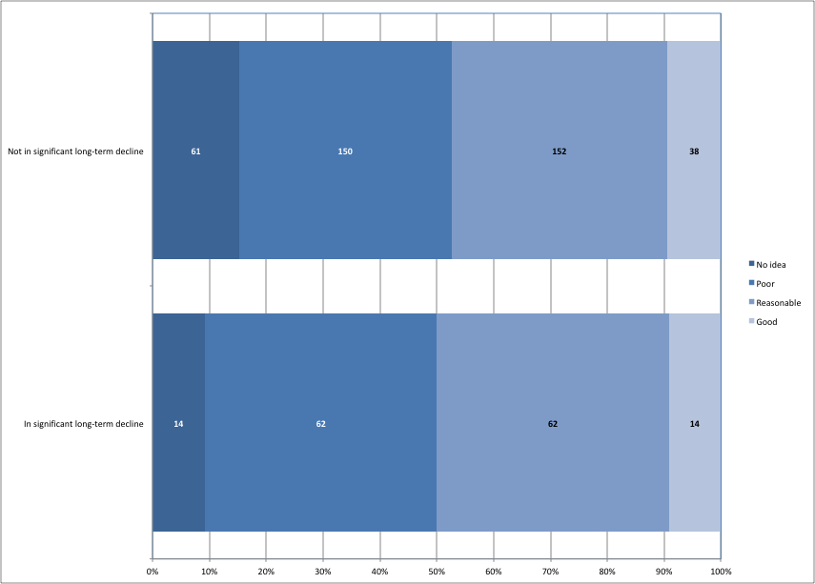

*Figure 19. Quality of population trend estimates for populations classified as whether or not in significant long-term decline. (Numbers are the number of populations within each category).*

### How did AEWA populations change over time?

The availability of annual waterbird censuses across the Agreement Area and the availability of the MSI-tool[[12]](#footnote-12) developed by Statistics Netherlands, now allows for the production of annual multispecies indices for AEWA populations. Currently, IWC trend data can be used for 141 AEWA populations (i.e. 25% of all AEWA populations and 31% of the populations with trend estimates). Figure 20. shows that the overall index has increased slowly in the last 25 years and was stable in the last 10 years, but with strong regional differences as shown on Figure 21.

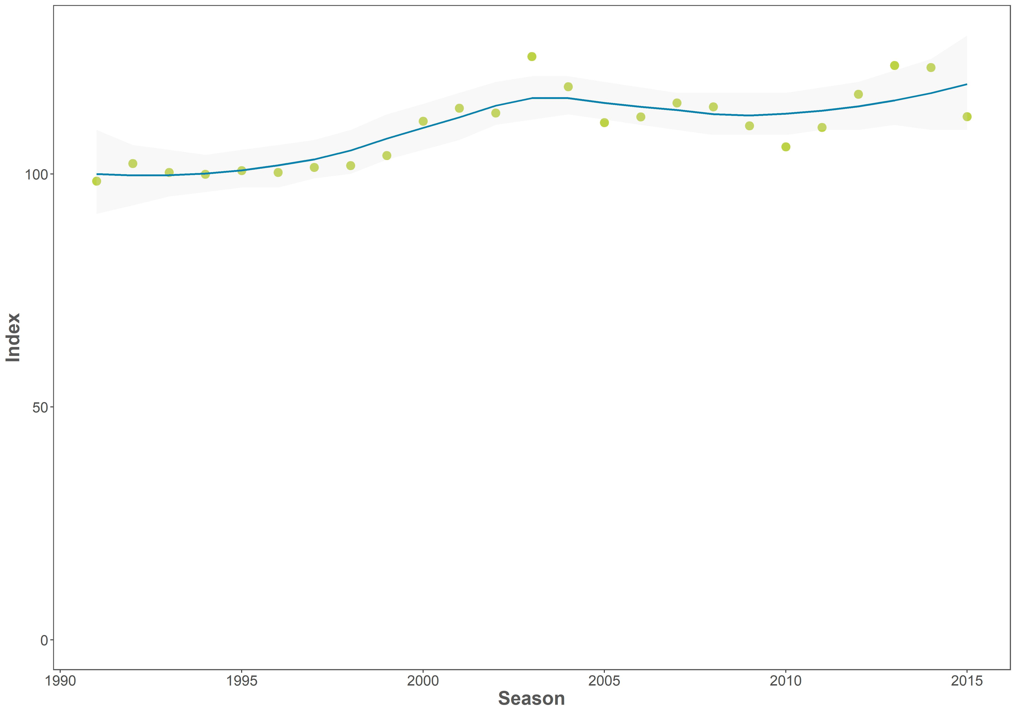

*Figure 20. Multi Species Index of the overall change of AEWA populations (N = 141) during the period of 1991-2015 based on the International Waterbird Census*

|  |  |
| --- | --- |
| *a) Afrotropic - Eastern* | *b) Afrotropic - Eastern & Southern* |
| Macintosh HD:Users:szabika:Dropbox:My files:Work:Wetlands International:Ongoing Projects:1366 CSR7:4 Report:Data analysis:with setting to 0:1_GRAPH.jpg | Macintosh HD:Users:szabika:Dropbox:My files:Work:Wetlands International:Ongoing Projects:1366 CSR7:4 Report:Data analysis:with setting to 0:2_GRAPH.jpg |
| **c***) Afrotropic - Southern* | **d***) Afrotropic - Sub-Saharan* |
| Macintosh HD:Users:szabika:Dropbox:My files:Work:Wetlands International:Ongoing Projects:1366 CSR7:4 Report:Data analysis:with setting to 0:3_GRAPH.jpg | Macintosh HD:Users:szabika:Dropbox:My files:Work:Wetlands International:Ongoing Projects:1366 CSR7:4 Report:Data analysis:with setting to 0:4_GRAPH.jpg |
| *e) Afrotropic - Western and Central* | *f) Black Sea-Mediterranean Flyway (N = 15)* |
| Macintosh HD:Users:szabika:Dropbox:My files:Work:Wetlands International:Ongoing Projects:1366 CSR7:4 Report:Data analysis:with setting to 0:5_GRAPH.jpg | Macintosh HD:Users:szabika:Dropbox:My files:Work:Wetlands International:Ongoing Projects:1366 CSR7:4 Report:Data analysis:with setting to 0:7_GRAPH.jpg |
| *g) East Atlantic Flyway (N = 16)* | *h) West Asian-East African Flyway (N = 31)* |
| Macintosh HD:Users:szabika:Dropbox:My files:Work:Wetlands International:Ongoing Projects:1366 CSR7:4 Report:Data analysis:with setting to 0:9_GRAPH.jpg | Macintosh HD:Users:szabika:Dropbox:My files:Work:Wetlands International:Ongoing Projects:1366 CSR7:4 Report:Data analysis:with setting to 0:12_GRAPH.jpg |

*Figure 21. Multi Species Indices of the overall change of AEWA populations in different multispecies flyways during the period of 1991-2015 based on the International Waterbird Census*

|  |  |
| --- | --- |
| **i***) Western Palearctic - Atlantic (N = 16)* | *j) Western Palearctic - Black Sea - Mediterranean (N = 35)* |
| Macintosh HD:Users:szabika:Dropbox:My files:Work:Wetlands International:Ongoing Projects:1366 CSR7:4 Report:Data analysis:with setting to 0:13_GRAPH.jpg | Macintosh HD:Users:szabika:Dropbox:My files:Work:Wetlands International:Ongoing Projects:1366 CSR7:4 Report:Data analysis:with setting to 0:14_GRAPH.jpg |
| *k) Western Palearctic - C and SW Asia (N = 25)* |  |
| Macintosh HD:Users:szabika:Dropbox:My files:Work:Wetlands International:Ongoing Projects:1366 CSR7:4 Report:Data analysis:with setting to 0:15_GRAPH.jpg |  |

*Figure 21 continued.*

### Successful conservation of waterbirds depends on effective governance

Using a hierarchical Bayesian model Amano et al. (2018) have analysed the changes in species abundances between 1990 and 2013 at a 1 x 1-degree resolution based on data from the Christmas Bird Count for North America and the International Waterbird Census for the rest of the World. This alternative analysis provides us insights into the spatial pattern of population change both at the species level and at the community level at 1 x 1degree resolution.

The study highlights major gaps in the availability of consistent long-term monitoring data across the Agreement Area with major gaps in the Arabian Peninsula and large sections of Africa except Southern Africa, Ethiopia in particular, and a few other countries to a lesser extent. It also confirms the findings of the flyway level analyses that the strongest declines at community level can be found in Central and South-west Asia, Eastern and Southern Africa (Figure 22).

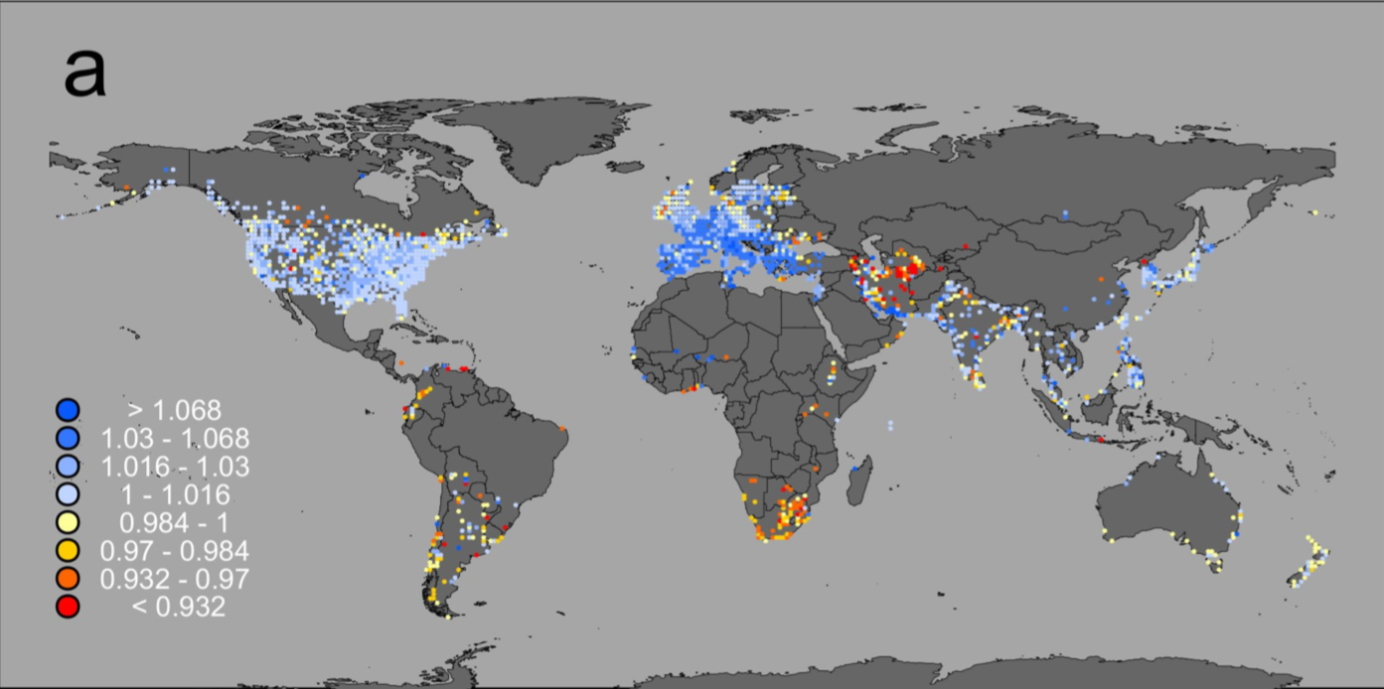

*Figure 22. Overall annual growth rates of waterbirds in 1x1 degree cells from Amano et al. (2018)[[13]](#footnote-13)*

The key finding is that the strongest predictor of change in waterbird abundance globally is the effective governance of the country. This was measured through the World Bank’s Worldwide Governance Indicators that summarises six broad dimensions of governance: Voice and Accountability, Political Stability and Absence of Violance, Government Effectiveness, Regulatory Quality, Rule of Law and Control of Corruption.

Effective governance had a stronger effect than change in surface water, economic and human population growth, agricultural expansion, climate change or biological characteristics of the species (such as range size, migratory status and body size). However, there was a strong positive interaction between effective governance and protected areas. This highlights the importance of AEWA contributing to improving several elements of good governance through its legislative requirements and capacity building programmes.

# Part 4. Threats to waterbird species in the AEWA region

As no comprehensively updated information is available on threats affecting the species listed on Annex 2 of the Agreement, no new analysis of threats has been performed. Part 4 of the 5th edition of the Conservation Status report can be accessed online [here](http://www.unep-aewa.org/sites/default/files/document/mop5_14_csr5_0.pdf).

# Part 5. Species of global conservation concern

A detailed overview of the status of species of global conservation concern was produced by BirdLife International and the full report is presented in Annex 2.

### Increasing numbers of AEWA populations appear on the Red List

The Red List status of the 254 species listed on Annex 2 of AEWA has been reviewed by BirdLife International, the Red List authority for birds, in 2017. The full report is presented in Annex 2. Five species are listed as Critically Endangered, seven as Endangered, 19 as Vulnerable, 21 as Near Threatened and 202 as Least Concern. Hence, 31 (12%) are considered threatened (in the first three of these categories).   
26 species have had their IUCN Red List category revised since the previous report from BirdLife to AEWA in 2014 (Table 2), both for genuine changes[[14]](#footnote-14) and because of improved knowledge or changes in taxonomy.

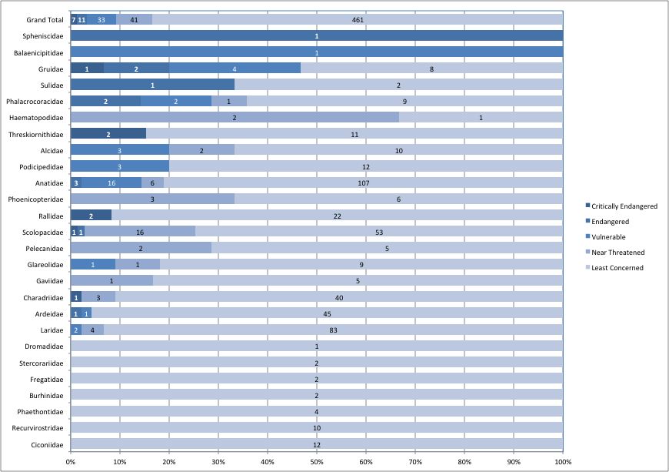A total of 23 AEWA-listed species qualified for higher or lower Red List categories owing to genuine deterioration or improvement in status during 1988-2012. All are listed in Table 3 of Annex 2 to this report, with notes on the basis of each change. Ducks, geese and swans (*Anatidae -* 25), sandpipers and allies (*Scolopacidae -* 18) have the highest number of populations of species of Global Conservation Concern, but the proportion of populations is highest amongst cranes (*Gruidae* - Figure 23).

*Figure 23. Proportion and number of AEWA populations by their Red List status and by families listed according to increasing value of the Red List Index of the family (i.e. most threatened families on the top)*

### The highest proportion of populations on the Red List are in Eastern and Southern Africa

The geographic patterns in the conservation status of AEWA populations were assessed on the basis of their Red List status.

The Atlantic region of the Western Palearctic is the home of the largest number (21) of populations that belong to a species of global conservation concern. This is partly because of the large number (10) populations of Near Threatened species that were added to the Red List after 2014 when the results of the new European Red List of Birds (BirdLife International 2015) became available. Due to the large number of populations involved, this region has the highest Red List Index. However, the Southern and Eastern regions of the Afrotropic have the highest proportion of the populations that belong a species of Global Conservation Concern (Figure 24).

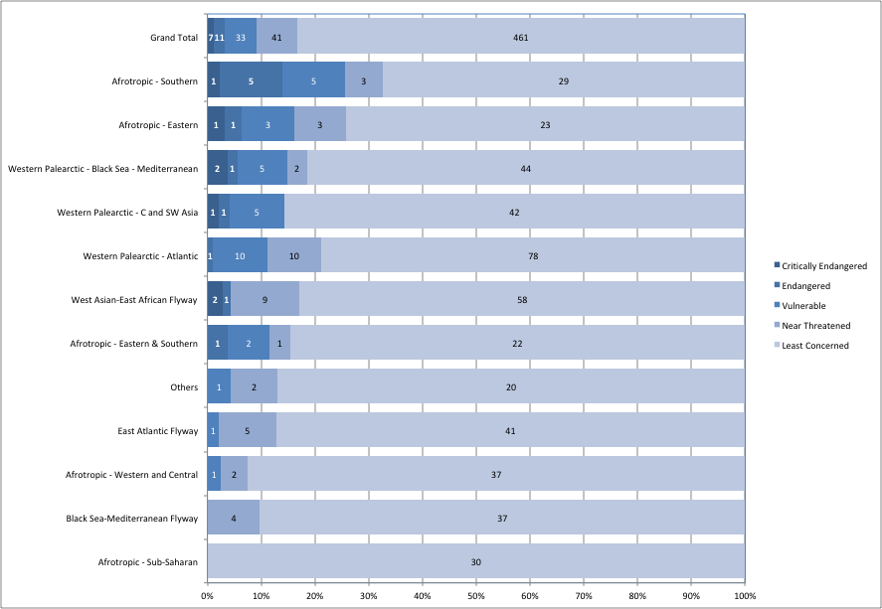

*Figure 24. Proportion and number of populations by their conservation status assessment and by flyways according to increasing value of the Red List Index of the flyway (i.e. most threatened flyways are on the top)*

### Action plans work, but require long-term commitment

The Agreement requires development of Action Plans to coordinate the recovery of populations listed in Category 1 of Column A of Table 1. International Single Species Action Plans require significant investment into their development and implementation.

Figure 25 shows that investment into International Single Species Action Plans usually results in positive population trends. However, the stabilization and eventual recovery of the populations requires time and depends on sustained investment. This explains why there is a discrepancy between the negative tendency suggested by the Red List Index and the positive tendencies suggested in other analyses in this report.

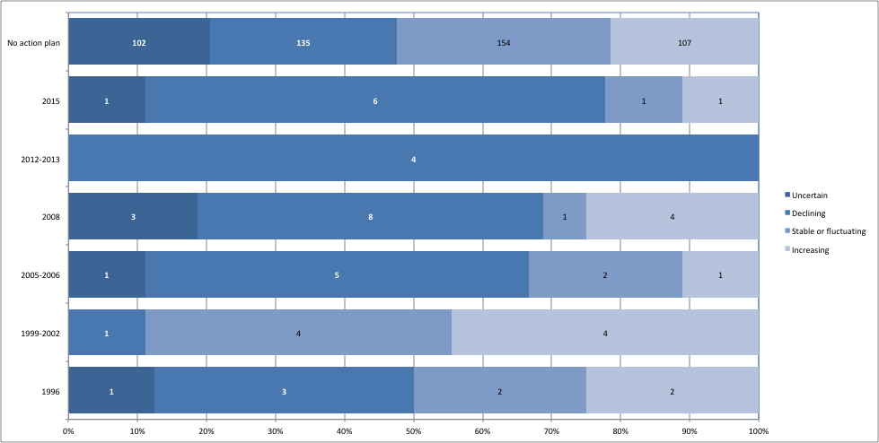

*Figure 25. Trend of populations according to the date of the adoption of their first action plan compared to the trend of populations without an action plan.*

It is important to emphasise that action plans are only tools to facilitate reaching agreement on the recovery strategy of the populations concerned. Their successful implementation requires international and national coordination, sustained commitment of staff and other resources, mobilizing researchers, volunteers and a wide range of other stakeholders including outside of the conservation sector.

# Part 6. Progress towards the targets set in the AEWA Strategic Plan

The logical framework to the AEWA Strategic Plan 2009-2018 has identified a number of indicators in relation to the goal and relevant actions to be reported in the CSR:

Goal: To maintain or to restore migratory waterbird species and their populations at a favourable conservation status throughout their flyways at the Agreement level, within the period of the Strategic Plan 2009-2018 the following indicators were defined:

G.1 No AEWA waterbird population has become extinct in the Agreement area.

G.2 All AEWA waterbird populations currently at favourable conservation status have retained that status.

G.3 At least 75% of the AEWA waterbird populations have a positive trend (growing or stable).

G.4 Overall status of indicator species has improved, as measured by the Waterbird Indicator.

G.5 Overall extinction risk of waterbirds reduced, as measured by the Red List Index.

G.6 20% of threatened and Near Threatened species downlisted to lower categories of threat.

G.7 Fewer populations to be listed in Category 1 in Column A (20% reduction).

G.8 Fewer populations to be listed in Column A (5% reduction).

3.1 Necessary resources are in place to support, on a long-term basis, the international processes for gathering monitoring data for status assessment

3.1.2 50% increase of species/ populations whose international status is being assessed with regular monitoring data

### G.1 No AEWA waterbird population has become extinct in the Agreement area

**This target is not met** because the following population has gone extinct:

* Demoiselle Crane (*Anthropoides virgo*), Turkey (bre)

The following three populations now can be considered quasi extinct:

* Slender billed Curlew (*Numenius tenuirostris)*, Central Siberia/Mediterranean & SW Asia - The last undisputed record with sufficient evidence for incontrovertible identification was on February 1995 in Morocco, despite subsequent intensive searches of the non-breeding range. This one represents not only the extinction of a population but also of the entire species.
* Siberian Crane (*Leucogeranus leucogeranus*), Iran (win) – Only one individual is reported from the wintering site since 2011/2012.
* Northern Bald Ibis (*Geronticus eremita*), South-west Asia - Last breeding observed in Syria in 2012 and possibly extinct now as a breeding species. However, one individual has been reported in Ethiopia in 2016 which likely represents an individual that has migrated from Syria.

**G.2 All AEWA waterbird populations currently at a favourable conservation status have retained that status**

As a proxy to the more complex definition of favourable conservation status in Art. 2 of the Convention on Migratory Species, populations listed in Category 1 of Columns B and C in 2008 were considered to be in a favourable status. Populations that are listed on Appendix 1 of the Convention on Migratory Species (A1a) or which are Globally Threatened (A1b) or which have small and therefore vulnerable populations (A1c and A2) or which are vulnerable because of being concentrated on a small number of sites (A3a or B2a), depending on a certain habitat type (A3b or B2b), undergoing a significant long-term decline (A3c or B2c) or undergoing large fluctuations (A3d or B2d), were considered as not having a favourable conservation status.

From 272 populations listed in categories B1 and C1 in Table 1 following MOP4 and having an equivalent population in CSR7, 60 populations are now in other categories. Thus, **this target was not achieved.** The reason of changing category is significant long-term decline for 44 of these populations (19 more than in CSR6), and lower population estimates for 16 populations (6 more than in CSR5).

The largest number of populations that moved from a favourable conservation status are in the Atlantic region of the Western Palearctic. Other regions with a higher than average proportion include the Eastern & Southern populations of the Afrotropic, the Central & South-west Asia part of the Western Palearctic, as well as the Black Sea Mediterranean and East Atlantic flyways (Figure 26).

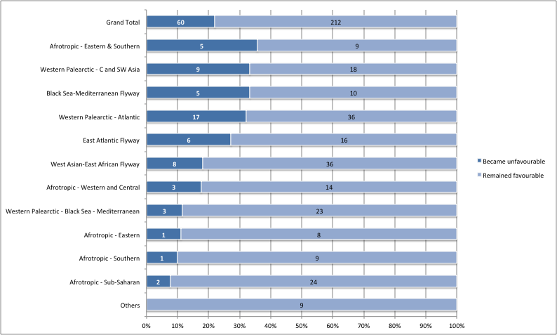

*Figure 26. Proportion of populations that were listed in Categories of 2 and 1 of Column B and C respectively and now moved to other categories and cannot be considered as remaining in favourable conservation status*

However, this indicator gives a rather distorted picture. As shown on Figure 27, approximately 20% of the populations have moved from favourable to unfavourable conservation status or vice versa. The number of populations with a less favourable status (60) is roughly balanced out by number of populations with a more favourable status (57). There are important differences between the various “flyways” and this follows largely the same pattern as on the previous graph.

However, it is also important to note that many of the same regions have also demonstrated an above average proportion of populations with an improved conservation status, e.g. the Eastern & Southern region of the Afrotropic, the Atlantic and the Black Sea Mediterranean parts of the Western Palearctic and the East Atlantic and the Black Sea – Mediterranean flyways.

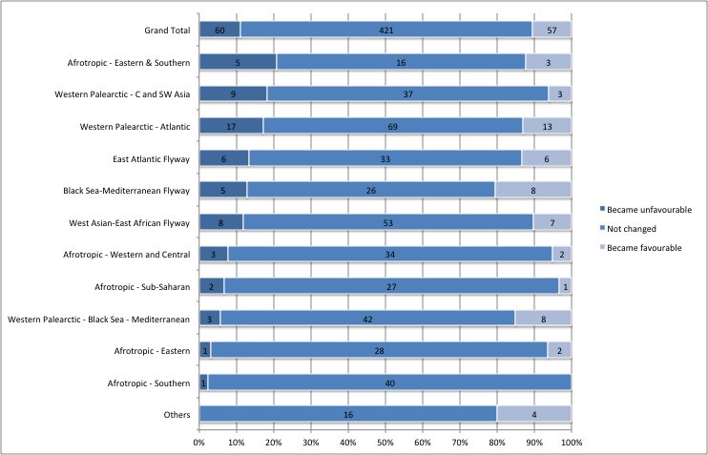

*Figure 27. Number populations whose conservation status became favourable or unfavourable or whose status has not changed since MOP4.*

### G.3 At least 75% of the AEWA waterbird populations have a positive trend (growing or stable)

Of the AEWA populations with known population trends, 73% have a positive trend and the **target was narrowly missed**.

Figure 28 shows that the proportion of populations with a stable or increasing trend has consistently improved during the lifetime of the current AEWA Strategic Plan.

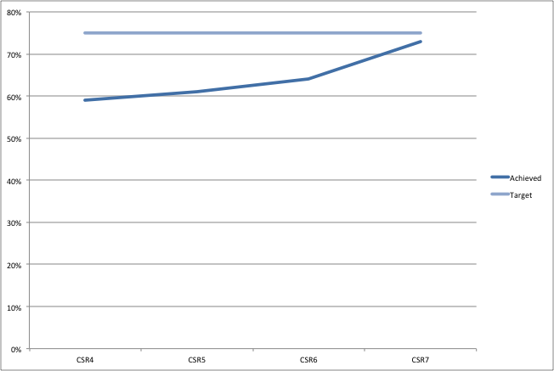

*Figure 28. Proportion of populations with stable or increasing trend in subsequent editions of the AEWA Conservation Status Report during the period of 2008-2017, i.e. that is covered by the AEWA Strategic Plan 2008-2018*

### G.4 Overall status of indicator species has improved, as measured by the Waterbird Indicator

Currently annual indices can only be calculated for 280 populations and many of these are not representative for the population itself. Nevertheless, Figure 29 shows the overall trend of 141 waterbird populations with a reasonable trend. However, there is a substantial bias in the distribution of populations with reasonable quality annual trend indices, with two thirds of them based on data from the Western Palearctic.

Therefore, a composite index similar to the ones generated by the Pan-European Common Bird Monitoring scheme cannot be applied for the entire AEWA region yet. Instead a more qualitative Waterbird Indicator was developed using a similar approach as in the State of the World’s Waterbirds ([Wetlands International 2010](https://www.wetlands.org/publications/state-of-worlds-waterbirds-2010/)) calculating an average of the trend scores assigned to increasing (+1), stable or fluctuating (0)   
or declining (-1) populations for a given period, i.e. in this case for CSR4, CSR5 and CSR6.

The value of the Waterbird Trend Index has increased from -0.1363 (N2008 = 396) to   
-0.0966 (N2017 = 445), which represents some 40% improvement compared to the baseline and shows a continued increase. Thus, **this target is achieved.** Nevertheless, it shows that still more populations are declining than increasing.

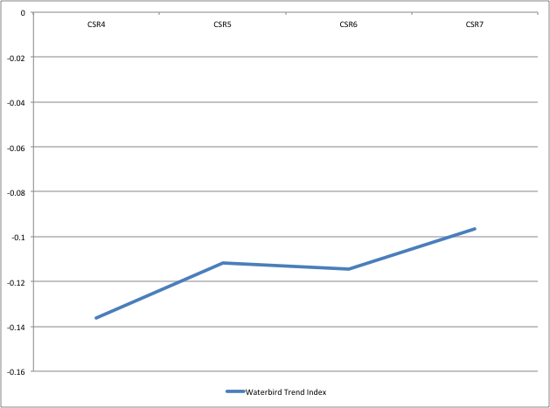

*Figure 29. Changes of the Waterbird Index in subsequent editions of the AEWA Conservation Status Report during the period of 2008-2017, i.e. that is covered by the AEWA Strategic Plan 2008-2018*

### G.5 Overall extinction risk of waterbirds reduced, as measured by the Red List Index (RLI)

Figure 30 shows that while AEWA species are less threatened than other species on average (the RLI values are higher), they have declined in status proportionately faster over the last two decades: the RLI has declined by 2.2% between 1988 and 2016, compared to 0.8% for all bird species. Although these figures are small in magnitude, they represent substantial biodiversity losses and significant increases in the rate that species are slipping towards extinction. **It also means that this target of the AEWA Strategic Plan was not achieved.**

However, it is important to note that the RLI is not very sensitive to positive changes. Populations can be listed in higher threat categories based on rapid short-term declines but moving them to lower threat categories is usually more conservative.

*Figure 30. Change of the Red List Index of all bird species (blue line) and species listed on Annex 2 of AEWA (orange line) between 1988 and 2016*

### G.6 20% of threatened and Near Threatened species downlisted to lower categories of threat

The number of globally threatened and Near Threatened Species listed on Annex 2 of the Agreement has increased from 37 in 2008 to 52 in 2017 (Figure 31). Thus, **this target was not achieved.**

A major increase in the number of globally threatened and Near Threatened species has taken place between the 6th and 7th editions of the AEWA Conservation Status Report, mainly based on the results of the European Red List of Birds (BirdLife International 2014).

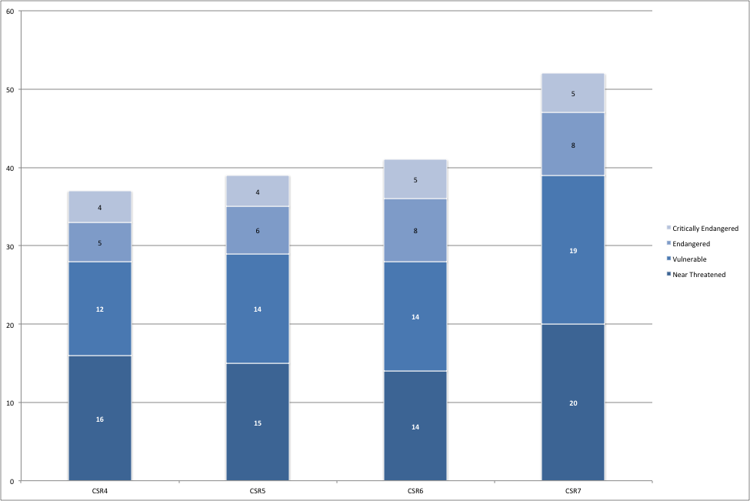

*Figure 31. Change in numbers of globally threatened and Near Threatened Species listed on Annex 2 of AEWA*

During the lifespan of the AEWA Strategic Plan 2009-2018, only two populations were downlisted owing to genuine reasons:

* Dalmatian Pelican (*Pelecanus crispus)*: from Vulnerable to Near Threatened
* Audouin's Gull (*Larus audouinii)*: from Near Threatened to Least Concern

### G.7 Fewer populations to be listed in Category 1 in Column A (20% reduction)

The number of populations listed in Category 1 of Column A has increased from 97 at the start of the AEWA Strategic Plan in 2008 (MOP4) to 122 in 2018 (MOP7), i.e. the end of the period covered (Figure 32). **Thus, the target to reduce the number of populations listed in Category 1 in Column 1 was not achieved.**

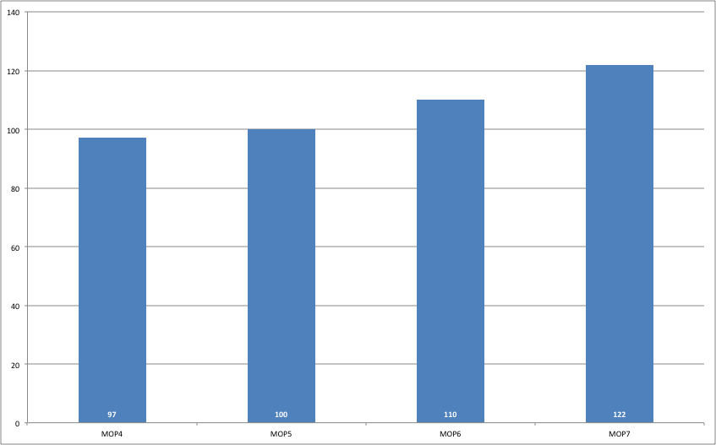

*Figure 32. Number of populations listed in Category 1 of Column A based on the lists relevant MOP resolutions or the proposed changes in case of MOP7 adopting amendments to the Annexes to the Agreement. This table includes all populations.*

Amongst the populations whose definitions have not changed during this period, the number has increased from 94 to 115. Twenty-eight populations were added to Category 1 of Column A and seven were removed.

Seventeen were added to Category 1b because of the species was listed as globally threatened on the IUCN Red List. Eleven populations were added to Category 1c due to lower population size estimates than in the past (Figure 33).

Only two of the seven populations (Corncrake (*Crex*) and Audouin’s Gull (*Larus audouinii*)) were removed from Category 1 because of changes in their global conservation status. The rest of the populations moved to other categories, mostly to Category A2, because of higher population size estimates either as a consequence of population increase, or as a consequence of improved knowledge.

### G.8 Fewer populations to be listed in Column A (5% reduction)

The number of populations listed in Column A has increased from 197 at the start of the AEWA Strategic Plan in 2008 (MOP4) to 234 in 2018 (MOP7), i.e. the end of the period covered (Figure 33). **Thus, the target was not achieved.**

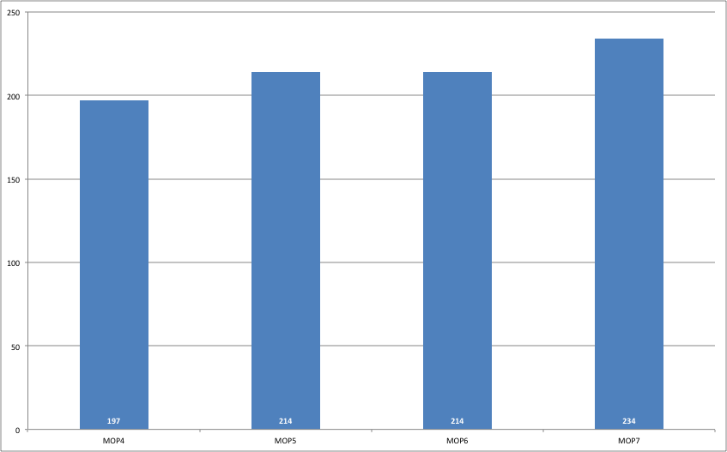

*Figure 33. Number of populations listed in Column A based on the lists in relevant MOP resolutions or the proposed changes in case of MOP7 adopting amendments to the Annexes to the Agreement. This table includes all populations.*

Amongst the populations whose status between CSR4 and CSR7 can be compared, 61 were added to Column A and 28 were removed from Column A.

Twenty-nine populations were added to Column A because they were listed as globally threatened or Near Threatened on the IUCN Red List. In 21 cases, the population is now in significant long-term decline. Ten populations were added to Column A because their latest population size estimates have fallen below the relevant thresholds.

Thirteen populations were removed because they are no longer in significant long-term decline. In 11 cases, the population estimates are higher. In four cases, other conditions for listing in Category 3 have ceased to apply.

Figure 34 summarises the changes in AEWA Table 1 during the period covered by the AEWA Strategic Plan 2009-2018. Although the number of populations in Column C remained relatively stable (164 in 2008 and 165 in 2018), the number of populations in Column B has declined from 186 to 155 while the number of population listed in Column A, requiring strict protection, has increased from 188 to 218 populations. Populations moved from Column C to Column A are listed in Tables 5 and 6. Many (formerly) huntable species are now listed as globally threatened or Near Threatened, triggering restrictions on hunting and impacting hunters and rural communities.

This highlights the importance of focusing on the sustainable management of waterbird populations and their habitats proactively. Even if Species Action Plans can be successful, focusing solely on recovery is an expensive and ineffective strategy. If AEWA Parties and stakeholders are interested in maintaining the ecosystem services provided by waterbird populations, they should invest more into sustainable harvest management and habitat maintenance (including the protection and management of key sites) and restoration.



*Figure 34. Changes of populations between categories and columns on Table 1 of the AEWA Action Plan. This figure only includes populations whose definition has not changed between the 4th and the 7th editions.*

*Table 5. Populations moved from Column C to Column A due to improved population size estimates*

|  |
| --- |
| Arctic Loon *Gavia arctica arctica*, Central Siberia/Caspian |
| Bean Goose *Anser fabalis johanseni*, West & Central Siberia/Turkmenistan to W China |
| Red-breasted Merganser *Mergus serrator*,North-west & Central Europe (win) |
| Spotted Redshank *Tringa erythropus*,N Europe/Southern Europe, North & West Africa |
| Ruddy Turnstone *Arenaria interpres interpres*, Northern Europe/West Africa |

*Table 6. Populations that moved from Column C to Column A because of being listed as globally threatened or Near Threatened on the IUCN Global Red List*

|  |
| --- |
| Common Pochard *Aythya ferina*, North-east Europe/North-west Europe |
| Common Pochard *Aythya ferina*, Central & NE Europe/Black Sea & Mediterranean |
| Common Eider *Somateria mollissima mollissima*, Norway & Russia |
| Long-tailed Duck *Clangula hyemalis*, Iceland & Greenland (bre) |
| Long-tailed Duck *Clangula hyemalis*, Western Siberia/North Europe (bre) |
| Eurasian Oystercatcher *Haematopus ostralegus ostralegus*, Europe/South & West Europe & NW Africa |
| Bar-tailed Godwit *Limosa lapponica taymyrensis*, Central Siberia/South & SW Asia & Eastern Africa |
| Eurasian Curlew *Numenius arquata arquata*, Europe/Europe, North & West Africa |
| Curlew Sandpiper *Calidris ferruginea*, Western Siberia/West Africa |
| Curlew Sandpiper *Calidris ferruginea*, Central Siberia/SW Asia, E & S Africa |
| Razorbill *Alca torda islandica*, Iceland, Faeroes, Britain, Ireland, Helgoland, NW France |
| Razorbill *Alca torda torda*, E North America, Greenland, E to Baltic & White Seas |

### 3.1.2 - 50% increase of species/ populations whose international status is being assessed with regular monitoring data

This indicator measures the Strategic Plan target that "*Necessary resources are in place to support, on a long-term basis, the international processes for gathering monitoring data for status assessment*".

The assessment of this indicator is based on scoring the quality of population size and trend estimates for this and the previous reports. For each time period, the minimum of the score for the quality of population size and trends was taken and the resulting values were converted into yes/no scores considering scores 1 and 2 as ‘no’ and 3 and 4 as ‘yes’.

As Figure 35 shows, the number of populations whose international status was assessed based on regular monitoring data has increased from 102 in CSR4 to 221 in this report, i.e. it has increased by 116%, i.e. more than doubled. Thus, **this target was achieved.**

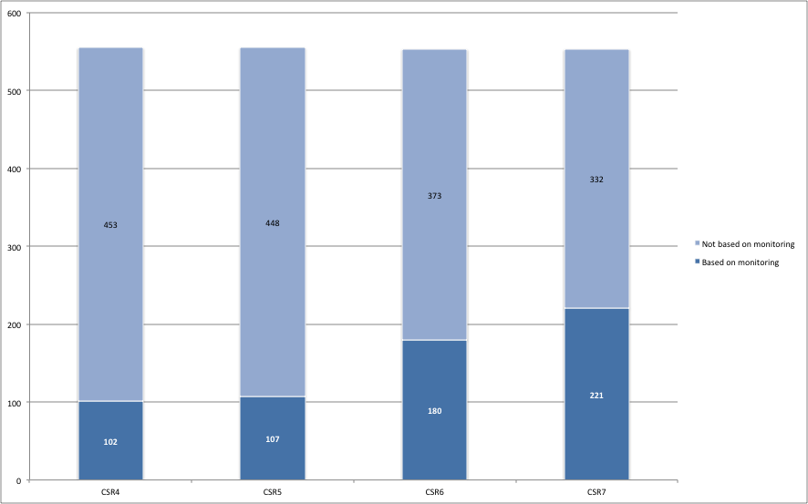

*Figure 35. Number of populations whose international status assessment is based on regular monitoring data*

However, it is important to note that the 221 populations represent only 40% of all AEWA populations. Assessment of 60% of the populations is still not possible based on regular monitoring. As Figure 36 shows, the assessment of the status of waterbird populations is based on regular monitoring for less than 20% of the populations in the Central & South-west Asia and most regions of the Afrotropic except Southern Africa that even exceeds the Black Sea - Mediterranean Flyway.

This highlights the importance of improving the national implementation of the International Waterbird Census and launching adequate monitoring schemes (e.g. colonial breeding bird monitoring, bird atlases) in these sub-regions to generate data for populations whose status cannot be adequately assessed based on the International Waterbird Census.

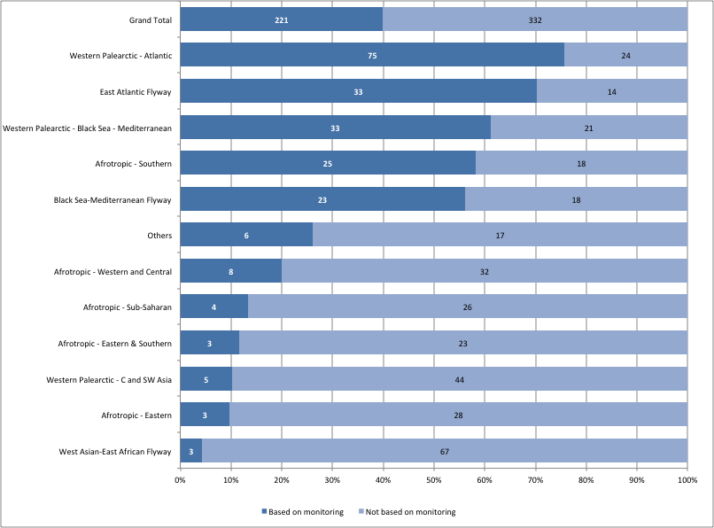

*Figure 36. Number and proportion of populations whose status can be assessed based on regular monitoring in different parts of the Agreement Area*

**Annex 1. Population sizes and trends of waterbird species included in the Agreement**

The most recent population estimate of each population listed in Table 1 of Annex 3 to the AEWA Agreement[[15]](#footnote-15) is presented in the Waterbird Population Estimates Online Database[[16]](#footnote-16) (available also as a separate document).

**Annex 2. Report on the status and trends of Red Listed AEWA species**

Report produced by BirdLife International is attached as a separate document.

**Annex 3. List of contributors to the IWC**

Separate document.

1. https://www.wetlands.org/publications/1304/ [↑](#footnote-ref-1)
2. <http://www.ebcc.info/pecbm.html> [↑](#footnote-ref-2)
3. <http://www.medwaterbirds.net/> [↑](#footnote-ref-3)
4. <http://www.waddensea-secretariat.org/management/projects/wadden-sea-flyway-initiative-wsfi> [↑](#footnote-ref-4)
5. <http://www.euronatur.org/Adriatic-Flyway.937.0.html> [↑](#footnote-ref-5)
6. http://iwc.wetlands.org [↑](#footnote-ref-6)
7. <https://europe.wetlands.org/our-network/waterbird-monitoring-partnership/> [↑](#footnote-ref-7)
8. Its six previous editions are available on the AEWA web site under Meeting of the Parties: <http://www.unep-aewa.org/en/meetings/meetings-of-parties> [↑](#footnote-ref-8)
9. <http://www.birdlife.org/datazone/info/taxonomy> [↑](#footnote-ref-9)
10. Olson, D. M., Dinerstein, E., Wikramanayake, E. D., Burgess, N. D., Powell, G. V. N., Underwood, E. C., D'Amico, J. A., Itoua, I., Strand, H. E., Morrison, J. C., Loucks, C. J., Allnutt, T. F., Ricketts, T. H., Kura, Y., Lamoreux, J. F., Wettengel, W. W., Hedao, P., Kassem, K. R. 2001. Terrestrial ecoregions of the world: a new map of life on Earth. Bioscience 51(11):933-938. URL: <https://academic.oup.com/bioscience/article/51/11/933/227116> [↑](#footnote-ref-10)
11. See International Wader Studies No. 15 (URL: <http://www.waderstudygroup.org/pubs/iws15.php>). [↑](#footnote-ref-11)
12. https://www.cbs.nl/en-gb/society/nature-and-environment/indices-and-trends--trim--/msi-tool [↑](#footnote-ref-12)
13. Amano, T., Székely, T., Sandel, B. Nagy, S., Mundkur, T., Langendoen, T., Blanco, D., Soykan, C. & Sutherland, W. (2018) Successful conservation of global waterbird populations depends on effective governance. Nature 553. 199-202 (11 January 2018). DOI:10.1038/nature25139 [↑](#footnote-ref-13)
14. Genuine changes include only real changes in status and excluding changes due to other reaasons such as revised taxonomy, improved knowledge, changed IUCN Red List criteria. [↑](#footnote-ref-14)
15. http://www.unep-aewa.org/en/documents/agreement-text [↑](#footnote-ref-15)
16. <http://wpe.wetlands.org/search?form%5Bspecies%5D=&form%5Bpopulation%5D=&form%5Bpublication%5D=8&form%5Bprotection%5D%5B1%5D=1> [↑](#footnote-ref-16)