REPORT ON THE IMPLEMENTATION OF THE AEWA AFRICAN INITIATIVE
AND AEWA PLAN OF ACTION FOR AFRICA 2012-2018

Introduction

This report covers the activities of the UNEP/AEWA Secretariat regarding the coordination and implementation of the AEWA African Initiative and related AEWA Plan of Action for Africa (PoAA) 2012-2018 for the period of 01 September 2015 to 30 September 2018.

Daily routine activities of the UNEP/AEWA Secretariat which contribute towards the implementation of the African Initiative, such as internal meetings with CMS, UNEP and/or UN Head of Agencies or carrying out AI-related mailings etc. are not specifically mentioned in this report. Fundraising efforts relating to the African Initiative are described in each relevant section below, rather than in a separate section.

- COORDINATION OF THE AEWA AFRICAN INITIATIVE
During the current reporting period, in accordance with Resolution 5.9 of the 5th Meeting of the Parties (MOP5) to AEWA (La Rochelle, May 2012), the coordination of the AEWA African Initiative and PoAA was maintained at the level of the UNEP/AEWA Secretariat, strengthened by Sub-Regional Focal Point Coordinators (SrFPCs) who are responsible for guiding implementation at the sub-regional level, with support from the Technical Support Unit (TSU), and other partners.

- AEWA African Initiative Unit - Coordination at the UNEP/AEWA Secretariat
Coordination of AEWA activities within the UNEP/AEWA Secretariat has been led by the African Initiative Unit which consists of the Coordinator for the African Initiative supported by a Programme Management Assistant. The AEWA core budget for the period 2016-2018 allocated 50% of the funding required for both positions, while the UNEP/AEWA Secretariat was requested to seek additional voluntary contributions to extend both positions beyond 50% (Resolutions 5.21 and 6.18). The Secretariat secured funding to supplement the position of the Coordinator up to 100% and that of the Programme Assistant up to 80% for the current reporting period, and it expects to be able to maintain these percentages until the end of 2018, thanks to contributions from the Federal Office for the Environment in Switzerland, as well as in the framework of projects funded by the European Commission (EC) Global Public Goods and Challenges (GPGC) Thematic Programme Strategic Cooperation Agreement (SCA) with UN Environment.

- Technical Support Unit
The Technical Support Unit (TSU), offered by the Governments of France and Senegal, consists of a team of multi-disciplinary experts that offer technical support to the African Range States in various areas, including survey and monitoring of waterbirds and their habitats, waterbird data management or promoting sustainable use of waterbirds and wetland resources. The UNEP/AEWA Secretariat, as a member of the TSU Steering Group, participates in its annual meetings which aim to coordinate planning for TSU activities. The AEWA Executive Secretary and African Initiative Coordinator attended the TSU Steering Group meetings in Camargue in January 2016 and in Paris in February 2017. This permitted prioritization and planning for activities to be supported by the TSU or jointly by the TSU and UNEP/AEWA Secretariat.

1.3 AEWA Sub-Regional Focal Point Coordinators for Africa
The UNEP/AEWA Secretariat continued to work closely with the five African Sub-Regional Focal Point Coordinators (SRFPCs) to support them in guiding the implementation of AEWA in their respective sub-regions. They were, for instance, closely involved in planning processes for the organisation of the AEWA Technical training for database managers and the development of the draft AEWA PoAA 2019-2027. The group email addresses for the African region and for each of its five sub-regions were regularly maintained to accommodate updates on Focal Point contact details.

During the current reporting period, the SRFPCs for Southern Africa and Northern Africa changed, following updates in the AEWA National Focal Points for the concerned countries. The UNEP/AEWA Secretariat liaised with the responsible government agencies for the designation of new AEWA National Focal Points (NFPs) and their confirmation as SrFPCs. In December 2017, Mr. Thulani Sihle Methula was designated as new AEWA NFP for Eswatini and confirmed as SRFPC for Southern Africa. In June 2018, Ms Nadjiba Bendjedda was nominated new AEWA National Focal Point for Algeria, and the government of Algeria is currently in the process of confirming her role as SRFPC for the Northern African region.

- IMPLEMENTATION OF THE AEWA AFRICAN INITIATIVE AND PLAN OF ACTION FOR AFRICA

- Development of the draft AEWA Plan of Action for Africa 2019-2027
AEWA Resolution 6.14 extended both the AEWA Strategic Plan and the PoAA until the 7th Session of the Meeting of the Parties (MOP7) in 2018 and instructed the development of a draft Strategic Plan and draft PoAA for the period 2019-2027 for submission to the AEWA MOP7. The Concept Note guiding the development process for the draft PoAA 2019-2027 was approved by the AEWA Standing Committee (StC) in October 2016. In accordance with the PoAA Concept Note, a team of independent consultants was recruited to develop the draft PoAA 2019-2027, with essential input from the Working Group for the development of the AEWA PoAA. The PoAA Working Group was convened in March 2017 and comprises the following members:

- The three African regional representatives of the AEWA StC;
- The four African Regional experts, three thematic experts, one invited CEPA expert and three NGO members of the AEWA Technical Committee (TC);
- Seven African Contracting Party representatives from each of the five sub-regions, nominated by the National Focal Points themselves, under the guidance of their respective SRFPCs.

Observers and partner organisations admitted to the PoAA Working Group comprise:

- The Host Government of the PoAA Working Group workshop;
- Two non-African Contacting Parties;
- Five representatives from international organizations or initiatives
- Three representatives from Intergovernmental Treaties (CMS, Ramsar, UNEP);
- Four representatives of the UNEP/AEWA Secretariat.
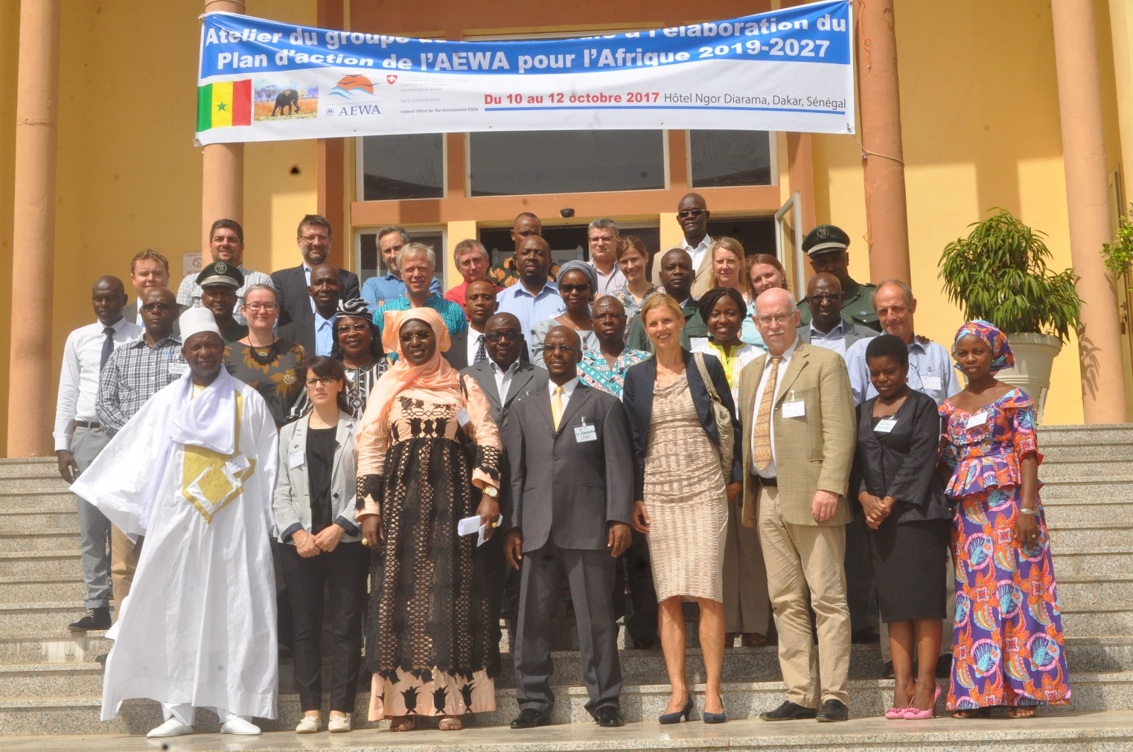
Workshop of the AEWA Plan of Action for African Working Group – Dakar, Senegal, October 2017
(By the Department of National Parks of Senegal)

The PoAA Working Group met in Dakar, Senegal, in October 2017 to establish the basis for the new PoAA, under the facilitation of the PoAA Consultants and the UNEP/AEWA Secretariat. The PoAA development workshop identified key challenges to migratory waterbird conservation in Africa under the five objectives of the draft AEWA Strategic Plan 2019-2027 and opportunities for addressing these challenges. These were then translated into prioritized actions through which the targets of the AEWA Strategic Plan should be addressed in Africa over the next three triennia. The workshop was made possible thanks to the generous financial and other contributions from the Governments of Switzerland, through the Federal Office for the Environment (FOEN), and Senegal. Details on this workshop are available at:
http://www.unep-aewa.org/en/meeting/workshop-working-group-development-aewa-plan-action-africa-2019-2027-10-12-october-2017

The PoAA Consultants, in collaboration with the UNEP/AEWA Secretariat prepared the first draft of the PoAA 2019-2027, which was submitted to the PoAA Working Group for review and commenting on 22 May 2018. The deadline for submission of comments, initially set for 8 June 2018, was extended to 15 July 2018. The first draft document was also submitted to the 13th Meeting of the AEWA Standing Committee (The Hague, July 2018) for consideration. The AEWA StC13 requested for the final draft PoAA, resulting from the final consultation processes, to be submitted to the AEWA MOP7 for consideration.

A second draft document, resulting from the consultation process with the PoAA Working Group, was circulated to the AEWA African Parties and key partners on 31 August 2018 for consultation. The deadline for submission of comments, initially set for 15 September 2018, was later extended to 20 September 2018. The final draft document resulting from the various consultation processes, was submitted for consideration by the AEWA MOP7 by the indicated deadline of 5 October 2018.

- African preparatory meeting for the 7th Meeting of the Parties to AEWA
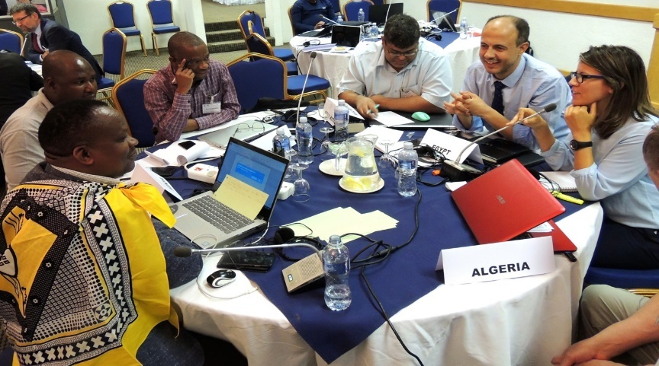
As required under Complementary Targets (CT) 5.1 and 5.2 of the AEWA PoAA, an African preparatory meeting for the AEWA MOP7 (pre-MOP7) was jointly organized by the UNEP/AEWA Secretariat and the Government of the Kingdom of Eswatini, in Ezulwini, in September 2018. It brought together AEWA National Focal Points or their representatives from 22 African Contracting Parties, with the purpose of familiarizing them in advance with key documents and issues to be addressed at MOP7 and permitting them deliberate and agree on regional positions to be defended at the MOP.
AEWA African Pre-MOP7 in Eswatini, September 2018
(By Tim Dodman)

This was achieved through a wide range of illustrative and interactive approaches including presentations, quizzes, discussions, role play exercises and a field excursion. Given the significant 36% turn over in AEWA National Focal Points from African since MOP6, the meeting also offered an excellent opportunity to enhance and refresh knowledge and skills on preparing for AEWA meetings and negotiating at MEAs, using the CMS Family National Focal Point (NFP) Manual as a key training tool. The National Focal Points also had the opportunity to share experience and get to know each other better. More information is available here: https://www.unep-aewa.org/en/news/african-pre-mop-sets-pace-aewa-summit

- Species conservation and monitoring
The UNEP/AEWA Secretariat secured funding from the Government of Sweden, through the Swedish Environmental Protection Agency, to support the International Waterbird Census (IWC) in seven AEWA African Contracting Parties along the West-Asian/East African Flyway (Burundi, Chad, Madagascar, Rwanda, Sudan, Uganda and the United Republic of Tanzania). This project, implemented over the period of 2016-2017, was coordinated by the UNEP/AEWA Secretariat in collaboration with key partners of the African-Eurasian Waterbird Monitoring Partnership. Implementation on the ground was led by National IWC Coordinators and other national partners. The project helped to maintain and/or expand the IWC coverage in these countries and enhance national capacity for waterbird identification and monitoring. A detailed report is available at: http://www.unep-aewa.org/en/news/boost-waterbird-monitoring-seven-aewa-parties-africa

In March 2017, the UNEP/AEWA Secretariat secured funding under the EC GPGC Thematic Programme SCA with UN Environment to support the implementation of the International Single Species Action Plans (ISSAPs) for the Endangered Grey Crowned-crane and the Critically Endangered White-winged Flufftail. Under this project, the organisation of the first meeting of the Grey Crowned-crane International Species Working Group (ISWG) has been initiated in collaboration with the African Crane Conservation Programme – ACCP (as coordinating organisation for the Grey Crowned-crane ISSAP), and the Government of Uganda (as host for the meeting). The meeting is scheduled for the first quarter of 2019 and will bring together governmental representatives and experts from the ten principal range states for the species, namely Burundi, the Democratic Republic of the Congo, Kenya, Mozambique, Rwanda, South Africa, Tanzania, Uganda, Zambia and Zimbabwe, as well as other key partners.

The meeting will help promote and coordinate the implementation of the ISSAP along the flyway. The highest-priority actions identified in the ISSAP for the White-winged Flufftail will be implemented under the EC GPGC project. These include the organisation of a local stakeholder workshop to promote the engagement of local communities in the conservation of the Berga Wetland in Ethiopia which is one of only two confirmed breeding sites for the species, as well as initiating the process for management planning for the Berga Wetland and its eventual designation as a Protected Area. Planning for activities relating to the White-winged Flufftail ISSAP has been initiated with the Ethiopian Wildlife Conservation Authority – EWCA (as AEWA national implementing agency in Ethiopia) and BirdLife South Africa (as lead organization for coordinating the implementation of the ISWG activities). This has permitted establishing the framework, approaches and lead responsible institutions for the identified actions and securing the full engagement of the key partners.

- Operation of the AEWA Small Grants Fund
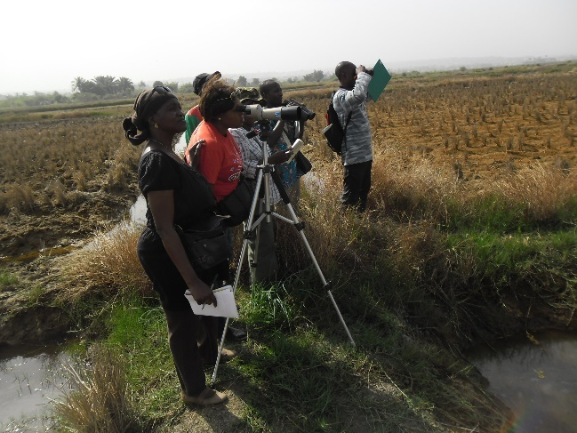
The AEWA Small Grants Fund (SGF) was established by Resolution 1.7 of the AEWA MOP1 (October 1999) and went operational in 2010 thanks to the allocation of seed funding in the AEWA Core Budget for the period of 2009-2012 and voluntary contributions to support its functioning. Given that funding available for the AEWA SGF has so far been earmarked for Africa, support has been provided on the ground for AEWA-relevant activities in Africa, particularly in developing countries and countries with economies in transition. Activities supported range from conservation and monitoring of waterbird species and their sites to training and awareness-raising for different target groups and conservation activities that contribute to enhancing the livelihood of local populations.
Guinea: waterbird monitoring in Sonfonia Plain (By Balla Moussa)

From the 2016-2018 triennium, there were neither funds allocated in the AEWA Core Budget nor voluntary contributions secured for the operation of the AEWA SGF, given that funding priorities for the triennium focused on the development of the AEWA Strategic Plan and PoAA. However, during this triennium, the 2015 SFG project cycle which had been delayed in relation to the organisation of the AEWA MOP6 was implemented, and on-going SGF projects from pas cycles were also monitored.

For the 2015 SGF cycle, a total of 19 project proposals were submitted by the deadline of 27 March 2016, with 11 of these being eligible for evaluation. The UNEP/AEWA Secretariat, in collaboration with the AEWA TC and StC, completed the project evaluation, selection and approval process in April 2017, with the following four conservation projects confirmed for support:

- Zimbabwe: The sum of USD 16,000 was allocated to an 18-month project entitled “Species surveys and habitat assessment for conservation planning to secure the future of two crane Species in Zimbabwe” which is implemented by BirdLife Zimbabwe in collaboration with the African Crane Conservation Programme (ACCP) and other national partners. The project focuses on survey and monitoring of the Grey Crowned-crane and Wattled Crane and their habitats, enhanced capacity for future survey and monitoring, as well as the and development and update of a national Crane action plan;

- Kenya: The sum of USD 9,000 was allocated to a 12-month project entitled “Building capacity preparedness for Rift Valley Lakes conservation” which is implemented by Nature Kenya. The project will primarily support biannual waterbird counts at lakes Bogoria, Elementaita, Nakuru, Magadi and Ol-bolossat and build capacity for local community volunteers, park rangers and scientists on waterbird identification and monitoring;

- Nigeria: Approved for a total of USD 9,000, this 12-month project entitled “Building the capacity of stakeholders to enhance effective monitoring of migratory waterbirds in some coastal and inland wetland areas of Nigeria” is implemented by the Nigerian Conservation Foundation in collaboration with the Nigerian National Parks and Federal Ministry of Environment. It aims to enhance capacity in waterbird monitoring for key stakeholders at the Sokoto Rima River Basin, Manga and Lake Maladumba, conducting waterbird counts at these sites, establishing a waterbird monitoring strategy/guidelines, establishing Sites Support Groups to support waterbird conservation and organise World Migratory Bird Day and World Wetlands Day activities.

- Mauritania: Receiving a total of USD 8,000, this 13-month project entitled “Conservation of the Nesting Sites for Lesser Flamingos (Phoeniconaias minor) at the Island of Aftout Essahili (Chat Boul)” is implemented by the “Association mauritanienne des amis des oiseaux et de la protection des espèces animales menacées d’extinction (AMISO)”. It focuses on enhancing technical and material capacity for waterbird identification and monitoring for staff of Diawling National Park (which is the responsible national authority for Aftout Essahili), as well as for the local communities living around the site.

All four projects are currently underway. For on-going projects from previous SGF cycles, the following were successfully concluded:

- In 2016, three SGF projects which focused on enhancing national capacity for waterbird monitoring and conservation were successfully completed in Gabon, Guinea and Togo;
- In 2017, the SGF project on the conservation of the White-headed Duck in Morocco was successfully completed.

- Expanding membership to AEWA in Africa
The UNEP/AEWA Secretariat continued to promote the accession of new Contracting Parties in Africa, with a focus on the Central and Southern African regions, as well as on Portuguese-speaking African countries, where there are major gaps in AEWA membership in Africa.

Botswana became a Contracting Party to AEWA on 1 November 2017, thanks to the collaborative efforts of governmental and non-governmental partners and the UNEP/AEWA Secretariat.

Through efforts using various methods including accession promotion workshops, bilateral discussions at other MEA meetings and support with documentation and regular correspondence, major progress was also made with advancing the national accession process in a number of African non-Party Range States during this reporting period.

The instrument for accession of the Central African Republic to AEWA was signed in July 2018 and is currently in the process of being transmitted to the AEWA depositary. Thanks to renewed contact and engagement established with the Department of National Parks and Wildlife in Malawi, the formal request for accession was officially submitted to the Ministry of Foreign Affairs and International Cooperation for review and action, marking significant progress in the process.

In 2016, thanks to funding secured from the Swiss Government through the Federal Office for the Environment (FOEN), the AEWA text was translated into Portuguese, in response to a request from the Lusophone African countries. The Portuguese version of the AEWA text, became available in July 2017 and was disseminated to all AEWA Portuguese-speaking Range States. It has been used to facilitate the accession of four (out of five) Lusophone non-Party Range States in Africa (Angola, Cabo Verde, São Tomé and Príncipe and Mozambique).

Also, thanks to a voluntary financial contribution from the Government of Switzerland, the UNEP/AEWA Secretariat, in collaboration with the Cameroon Ministry of Forestry and Wildlife, organised a national multi-stakeholder workshop to promote the accession of Cameroon to AEWA. The workshop took place in Yaoundé, in December 2016, and brought together a wide range of key stakeholders from the National AEWA Committee, including representatives of several Government Ministries and non-governmental organizations, directly or indirectly involved in the process of Cameroon’s accession to AEWA and the eventual implementation of the Agreement in the country. Workshop participants gained a better understanding of the benefits and obligations of being a Party to AEWA, as well as on the national legal processes and instruments in place for accession to AEWA and subsequent implementation. The workshop resulted in a Final Communiqué declaring the engagement of the key stakeholders in taking forward the accession process, accompanied by a road map which outlined the next steps required to complete the national accession process. Significant progress has since been made with the accession process in Cameroon, with the request for accession currently submitted to the Presidency of the country.
AEWA accession workshop – Cameroon, December 2016
(By Dr Jacques Trouvilliez)

Meanwhile, contacts were established, strengthened or renewed with many other non-Party Ranges States in Africa, and regular efforts made to advance accession. These include Angola, Cabo Verde, the Democratic Republic of Congo, Seychelles, Sierra Leone and Zambia.

- Capacity-Building and CEPA in Africa
Enhancing technical and administrative capacity for the implementation of AEWA in Africa cuts across many expected results and associated actions of the AEWA PoAA 2012-2018. The UNEP/AEWA Secretariat therefore dedicated efforts towards capacity-building on various issues in the region.

Enhancing administrative capacity for AEWA implementation
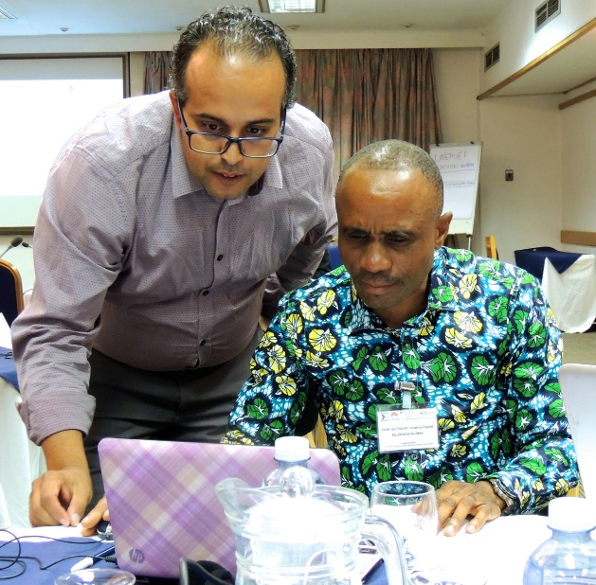
AEWA Pre-MOP7 – Practical session on National Reporting (By Tim Dodman)

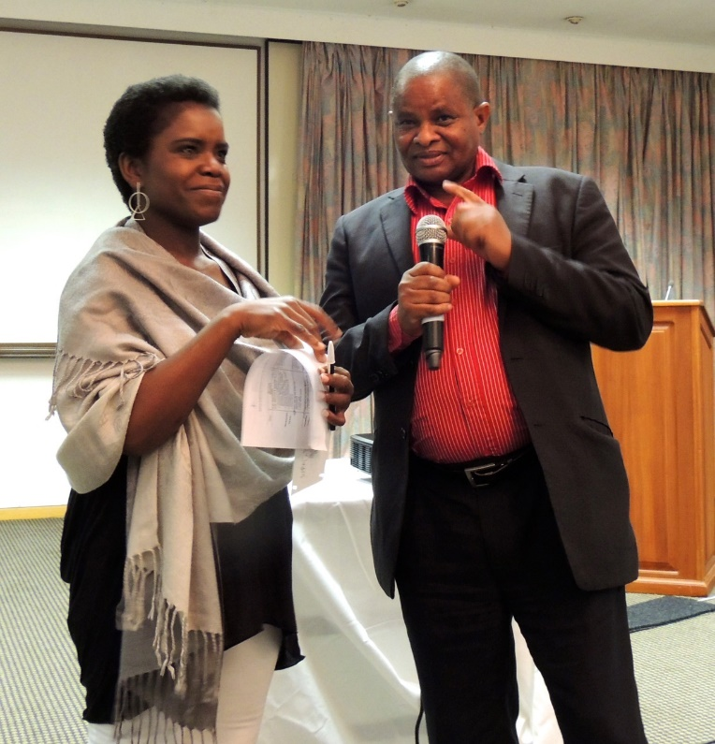
AEWA Pre-MOP7 – exercice on communication
(By Tim Dodman)

In the framework of the African Pre-MOP7 meeting (Eswatini, September 2018) AEWA National Focal Points or their representatives from 22 African Parties were trained in skills and techniques for negotiation at MEAs, as required under CT 5.2 of the PoAA. Their knowledge and skills in preparing for AEWA meetings and performing other duties as Focal Points was also enhanced during this meeting, using the CMS Family NFP Manual. See section 2.2 of this report for further details on the AEWA African Pre-MOP7.

Enhancing capacity for waterbird survey and monitoring and flyway conservation
The African Parties confirmed increasing the quantity and quality of waterbird population data from Africa as one of the highest priority actions prescribed under the PoAA 2012-2018. The UNEP/AEWA Secretariat promoted capacity-building for waterbird identification and monitoring through various activities, including in the framework of the AEWA Small Grants Fund (SGF) where all projects supported during the current reporting period contributed to enhanced capacity for waterbird monitoring (see section 2.4 for details). Some African Contracting Parties also received support to enhance capacity for waterbird monitoring in the framework of the Swedish-funded project to support the IWC at the national level (see section 2.3 for details).

The funding secured in 2017 under the EC GPGC Thematic Programme SCA with UN Environment, included support for the organisation of a training of trainers (ToT) workshop on flyway conservation. The workshop, planned for the first quarter of 2019 in Benin, aims to enhance capacity of technical experts and training institutions from 16 Francophone Western and Central African countries (Benin, Burkina Faso, Cameroon, Central African Republic, Chad, Congo, Côte d'Ivoire, Democratic Republic of the Congo, Equatorial Guinea, Gabon, Guinea, Mali, Niger, Senegal, Togo and Mauritania). The Wings over Wetlands Flyway Training Kit will be used as the main training tool and will be complemented by other tools including the ONCFS toolkit on waterbird identification and monitoring, the BirdLife International IBA monitoring guidelines and the Ramsar GlobWetlands Africa Toolbox. Preparations have been initiated with key partner organisations including the Wadden Sea Flyway Initiative (WSFI) and the Ramsar Convention Secretariat.

Promoting World Migratory Bird Day in Africa
The WMBD celebration continues to receive much attention in the African region thanks to the support and efforts of the Contacting Parties and various partners organisations. Details on the WMBD activities and outcomes will be provided in document AEWA/MOP 7.13 (report on the implementation of the AEWA Communication Strategy).

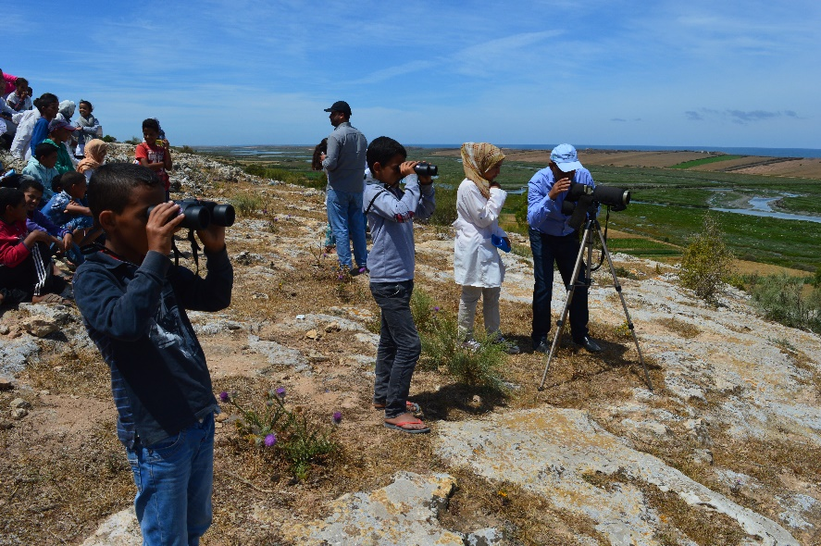
In the African region, Thanks to a voluntary financial contribution from the Government of Germany through the Federal Ministry for the Environment, Nature Conservation, Building and Nuclear Safety (BMUB), seed funding was provided to 14 African Parties to support national or transboundary events in the 2016 WMBD campaign. This included nine national events in Ethiopia, Kenya, Niger, Rwanda, Sudan, Tanzania, Tunisia, Uganda and Zimbabwe as well as two transboundary events in Mauritania (in collaboration with Senegal) and Togo (in collaboration with Benin and Ghana). Through these events, attention was drawn to the issue of illegal use of waterbirds. The countries involved in the transboundary events also undertook engagements for future joint transboundary efforts for waterbird conservation.
Morocco: World Migratory Bird Day 2017 at Walidya

During the current reporting cycle, WMBD events were also organized in the framework of the following AEWA SGF projects:

- The Guinée Écologie NGO, in collaboration with the national AEWA implementing agency in Guinea (Office Guinéen des Parcs et Réserves - OGUIPAR), organised a WMBD event in May 2016 at the General Lansana Conté University of Sonfonia, under an AEWA SGF project: https://www.unep-aewa.org/en/news/aewa-small-grants-fund-project-successfully-concluded-guinea;

- The Research Group for Bird Protection in Morocco (GREPOM) organized three WMBD events in 2017 at the Souss-Massa, Sidi Mousa-Walidia and Kenitra wetlands:
http://www.unep-aewa.org/en/news/focus-white-headed-duck-morocco;

- The Ministry of Water and Forestry of Cote d’Ivoire organized a WMBD event in Adiaké in October 2017;

- Nature Kenya, in collaboration with the Friends of Kinangop Plateau local Site Support Group (SSF) celebrated WMBD in May 2018 at the Nyandarua County:
http://www.worldmigratorybirdday.org/events/2018/marking-world-migratory-bird-day-celebration-nyandarua-county.

  - Promoting partnership for the implementation of AEWA in Africa
As mentioned in the sections above, the UNEP/AEWA Secretariat continued to work closely with key partners (BirdLife International, Wetlands International, Wadden Sea Flyway Initiative, Ramsar Convention Secretariat, etc.) on the organisation and implementation of AEWA activities in Africa, to maximise efforts and resources and avoid duplication of efforts. During the current reporting cycle, the AEWA African Initiative Coordinator participated in the following key meetings to reinforce existing synergies and initiate new ones with relevant partners:

- The three Project Steering Committee (PSC) meetings for the 2nd phase of the BirdLife/MAVA Foundation project on the Conservation of Migratory Birds (CMB) along the coast of West Africa, as Chair of the Committee. The meetings took place in March and October 2016 in Dakar, and in October 2017 in Conakry contributed to further aligning CMB project activities to support AEWA implementation and promote further collaboration with AEWA and other relevant MEAs, including the Ramsar Convention. Thanks to this partnership, the CMB2 project provided seed funding to the three project countries (Guinea-Bissau, Mauritania and Senegal) for organising events to commemorate WMBD 2016 and 2017. The project also provided financial and human resources to support the capacity-building workshop organized under the AEWA SGF project in Mauritania, mentioned under section 2.4;

- The African regional preparatory meeting for the 13th Conference of the Parties to the Ramsar Convention (Senegal, February 2018). This meeting helped to further increase awareness on AEWA issues among government representatives and partners from African and provided an opportunity to network, discuss AEWA relevant issues, promote accession and initiate possible collaboration with new partners, including on the emerging issues of wetlands conservation through remote sensing. The Coordinator for the African Initiative, liaised with the Ramsar Convention Secretariat to secure funding from the Regional Partnership for the conservation of the marine and coastal zones of West Africa (PRCM) to support the participation of the three NGOs of the CMB2 project at the Ramsar Pre-MOP13 and preceding training on the Ramsar/ESA GlobWetland Africa toolbox (i.e. Nature Mauritania, Nature- Communautés-Dévelopment of Senegal and Organização para a Defesa e Desenvolvimento das Zonas Húmidas – ODZH of Guinea-Bissau);

- The GPGC Programme Steering Committee meeting between the EC and UN Environment (Belgium, March 2017). This resulted in a confirmed pledge for funding for AEWA African activities (see sections 2.2 and 2.5 above), for which the funding has now been released for use.

AEWA SrFPCs: http://www.unep-aewa.org/en/activities/african_initiative/poa_for_africa_ai/srfp_coordinators
AEWA SGF 2015 cycle: http://www.unep-aewa.org/en/page/four-new-projects-africa-benefit-aewa-small-grants-fund
AEWA SGF project Gabon: http://www.unep-aewa.org/en/news/capacity-building-gabon-conserve-migratory-waterbirds
AEWA SGF project Guinea: http://www.unep-aewa.org/en/news/aewa-small-grants-fund-project-successfully-concluded-guinea
AEWA SGF project Morocco: http://www.unep-aewa.org/en/news/focus-white-headed-duck-morocco
Accession of Botswana to AEWA: http://www.unep-aewa.org/en/news/botswana-accedes-aewa-party-no-77
AEWA Text in Portuguese: http://www.unep-aewa.org/sites/default/files/basic_page_documents/aewa_agreement_text_2016_2018_Portuguese_FINAL_WITH_COVER.pdf

