ESTABLISHMENT AND OPERATION OF A EUROPEAN GOOSE MANAGEMENT PLATFORM UNDER AEWA (2016-2018)

Introduction

The African-Eurasian Migratory Waterbird Agreement (AEWA) provides for the conservation as well as the sustainable use of the migratory waterbird populations it covers. Addressing the conservation and management of declining as well as growing goose populations in Europe calls for a coordinated flyway approach amongst all range states concerned. To facilitate and implement such an approach, it is suggested to establish a European Goose Management Platform under AEWA as called for by the AEWA Parties through Resolution 6.14.

This document outlines the suggested scope and institutional structure of the Platform as well as timelines for implementation of the various envisaged steps and funding needs. The document will serve as the basis for the discussions between range states at the meeting on the establishment of the Platform on 11-12 May 2016 in Paris, France.

Action Requested from the Range States

Range states are requested to review the document and to consider the suggested institutional and financial arrangements linked to running such an initiative, which are to be agreed at the meeting.

ESTABLISHMENT AND OPERATION OF A EUROPEAN GOOSE MANAGEMENT PLATFORM UNDER AEWA (2016-2018)

Table of Contents

1. Background and Justification 2
2. Goal, Structure and Process Workflow of the European Goose Management Platform (EuroGMP) 3
3. Required Additional Capacity 4
4. Timelines and Milestones for EuroGMP Establishment and Operations Phase-in 5
5. Budget Estimate for the EuroGMP Phase-in 6
6. Annexes 10

1. Background and Justification

The increasing impact caused by migratory and sedentary goose populations to economic activities and natural ecosystems in Europe has been a reason of concern for many governments. Dealing with this challenge at local or national level would bring very limited or no solutions and it is becoming increasingly clear that such flyway-wide issues require major international flyway coordination to deliver effective resolutions on international, and through national to regional and local levels.

As geese have benefitted from the abundance of food provided by intensive agriculture, so growing populations are increasingly reducing some crop yields, impacting on other biodiversity, elevating airport airstrike risk and causing health and nuisance issues in urban areas. However, it is recognised that, at the same time, geese are an integral part of the ecosystems they occur in and, as such, are vital for the provision of ecosystem services. Geese are also of enormous societal value, whether as cultural objects of pleasure and wonder or the basis for hunting ecosystem services. In addition, certain goose populations which remain open for harvest have transgressed into an unfavourable conservation status, which means that some form of regulation of taking and changes to other forms of management may be necessary to re-establish their former abundance and distribution.

In short: the resolution of current societal conflicts created by goose abundance requires structured decision-making, as well as coordinated interventions – in particular as all migratory goose populations move between multiple countries during their annual cycles.

In order to address the goose management challenges in Europe and to address the need of a structured and coordinated decision-making and implementation process, the Contracting Parties to AEWA, through Resolution 6.4 adopted by the 6th Session of the Meeting of the Parties (AEWA MOP6) on 9-14 November 2015, have requested the UNEP/AEWA Secretariat to facilitate the establishment of a European multispecies goose management platform and subsequent process to address the sustainable use of goose populations, targeting as a matter of priority, Barnacle Goose (Branta leucopsis) and Greylag Goose (Anser anser) populations (for which management plans are yet to be developed) as well as the Svalbard population of the Pink-footed Goose (Anser brachyrhynchus) and the Taiga Bean Goose (Anser fabalis fabalis) for which AEWA plans are already in place. The development and implementation of these actions is subject to the availability of financial resources. Interested AEWA Parties, Range States and other stakeholders were invited to engage pro-actively in this initiative, including by providing appropriate resources for the set-up, maintenance and the functioning of the platform.

In this respect, the revised AEWA Guidelines on Sustainable Harvest of Migratory Waterbirds, which were recently adopted by AEWA MOP6 through Resolution 6.5, will provide useful guidance to this new initiative and the process behind it.

2. Goal, Structure and Process Workflow of the European Goose Management Platform (EuroGMP)

The goal of the European Goose Management Platform is to provide the mechanism for a structured, coordinated and inclusive decision-making and implementation process for the sustainable management of goose populations in Europe, with the objective of maintaining them in a favourable conservation status, while taking into account concerns of relevant stakeholders and the pertinent legislative frameworks and regulations.

A possible governance structure for flyway management has been outlined in the revised AEWA Guidelines on Sustainable Harvest of Migratory Waterbirds (see Appendix 1 to the Guidelines). This structure resembles the ‘Flyway Council’ used for the management of migratory waterbirds in North America. Management of geese in Europe would be a first African-Eurasian test case for multispecies management, which, if successful, can be extended in future to cover all migratory waterbird species that require management. The Terms of Reference for such a platform will include the integrated adaptive management and conservation of geese. The structure suggested for the EuroGMP is presented in Figure 1 and includes:

1) AEWA European Goose Management International (inter-governmental) Working Group (corresponding to a Flyway Council) serviced by the AEWA Secretariat;
2) International Data Centre, which can effectively collate information for all European goose populations (coordinated with the African-Eurasian Waterbird Monitoring Partnership) and pan- European goose harvest data (coordinated with FACE and CIC);
3) National Working Groups.

Such an arrangement, albeit at single species level, already exists for the implementation of the AEWA Pink-footed Goose International Management Plan and has been functioning successfully since 2013. It should be noted that the arrangement for the Pink-footed Goose will be integrated into the EuroGMP once the platform has been established and is functional.

It is suggested that the AEWA International Working Group meets annually to decide, at the multispecies level, on adjustments to the management frameworks, prioritisation of plan processes and exchanging of experiences. At the individual population plan level, the Working Group would be expected to follow-up on the progress of actions, agree on the adjustment of actions, and to make recommendations for implementation in the Range States. Thus, the coordination between plans can be guaranteed, and the national authorities in charge of plans as well as stakeholders will only have to attend one annual meeting which combines both the overall policy development and prioritisation as well as the individual plan processes for each individual species (Figure 1).

The International Data Centre will collate and assess population and harvest information based on input from the range states. This work shall be closely coordinated with the African-Eurasian Waterbird Monitoring Partnership and FACE/CIC. Based on updated population estimates and harvest data, the Data Centre will use state-of-the-art modelling tools to predict the annual optimal harvest of huntable populations, to be reported to the International Working Group. It is envisaged to establish an international partnership of scientific institutions to be responsible for the technical work, coordinated by Aarhus University in Denmark.

The National Working Groups will be responsible for the implementation of the actions recommended by the International Working Group, the provisions of the AEWA International Species Management/Action Plans for the respective populations/species, as well as ensuring the effective operation and reporting of national monitoring schemes.

The exact annual iterative process of operations of the EuroGMP will be designed after the Range States have decided on the establishment of the Platform. The Pink-footed Goose annual management cycle will be used as a basis for the process (cf. Annex 1), with additional advice provided by the North American Flyway Councils. The operational process will be regularly reviewed and adjusted, as necessary.

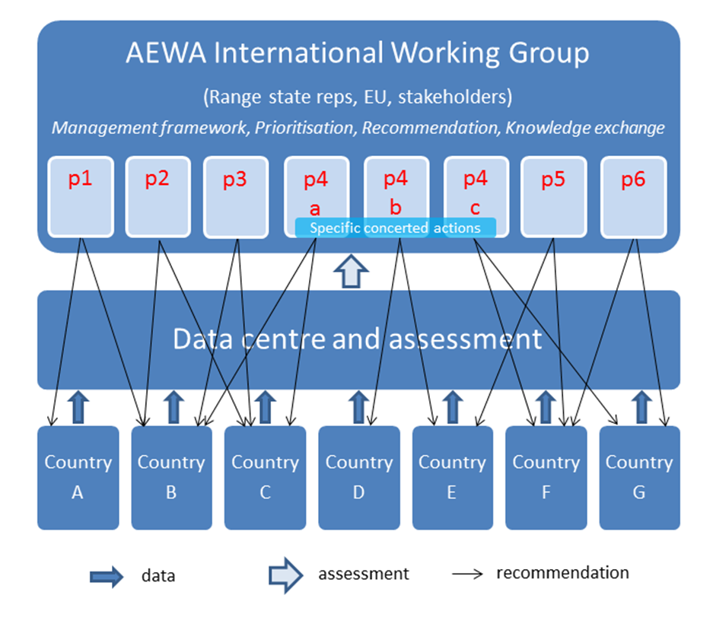

Figure 1. Structure and process workflow of the European Goose Management Platform:

p1…p6 represent individual plan processes; p4 is an example of a species with three populations, for which specific concerted actions can be agreed.

3. Required Additional Capacity

In order to provide effective servicing to and running of the EuroGMP it will be necessary to establish and maintain additional capacity within the bodies assigned with these servicing tasks.

UNEP/AEWA Secretariat
The Secretariat will service and coordinate the overall process of the EuroGMP, including its respective bodies (AEWA European Goose Management International Working Group and International Data Centre) and the participating Range States. The additional capacity required is estimated at two full-time positions, as follows:

- EuroGMP coordinator;
- Administrative assistant.

International Data Centre
The Centre will be established through a Memorandum of Cooperation between the UNEP/AEWA Secretariat and Aarhus University, Denmark. Aarhus University will provide the services required from the Data Centre, while the actual Centre will have a decentralised structure and will also involve expertise from other scientific institutions, as necessary. The needed capacity to be allocated to the Data Centre is estimated at 1.65 positions, as follows:

- Goose monitoring coordinator (population size and harvest);
- Population modelling expert (50%);
- Lead compiler (annual review) (15%).

4. Timelines and Milestones for EuroGMP Establishment and Operations Phase-in

The EuroGMP will be established and its operations will be phased in step-wise over the course of three years starting from 2016 until the end of 2018. At the end of this three-year period the EuroGMP will be fully operational providing a coordinated management approach to an initial six populations of four goose species involving 20 Range States (see Annex 2):

- Pink-footed Goose – 1 population (Svalbard/North-west Europe);
- Taiga Bean Goose – 1 population (North-east Europe/North-west Europe);
- Barnacle Goose – 3 populations (East Greenland/Scotland & Ireland; Svalbard/South-west Scotland; and Russia/North-west Europe);
- Greylag Goose – 1 population (NW Europe/South-west Europe).

After the three-year period of EuroGMP phase-in, the AEWA European Goose Management International Working Group will consider and decide on the possible further taxonomic extension of the Platform to cover other goose populations and species.

Figure 2 below shows the indicative timelines for the different planning and implementation phases of the management plans for the populations of the four goose species listed above. By the end of 2018, it is envisaged that all plans will have entered the active implementation phase - depending on sufficient resources being available as well as reaching consensus amongst range states and other stakeholders).

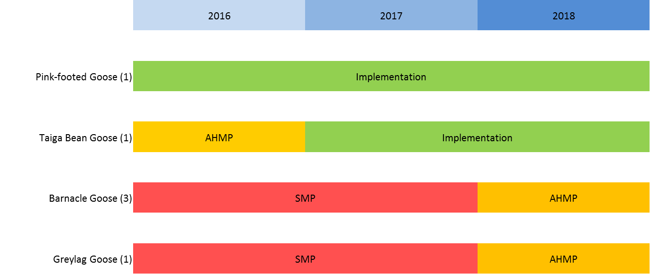

Figure 2. Indicative timelines of planning and implementation phases of the management plans for the initial set of six populations of four goose species in the framework of the EuroGMP. Orange bars indicate development of Adaptive Harvest Management Plan, which is to follow the development of the broader framework of the Species Management Plan (indicated as red bar). The Species Management/Action Plans for the Pink-footed Goose and the Taiga Bean Goose have already been adopted by AEWA MOP5 and MOP6 respectively.

The chronological list below presents the milestones in the three-year phase-in timeline of the EuroGMP; need of funding is indicated and is respectively costed in the budget section of this document (with some exceptions, see the budget section below).

2016
- Initiate recruitment of a coordinator and an assistant at the UNEP/AEWA Secretariat (funding required);
- Initiate development of adaptive harvest management plan for the Taiga Bean Goose (funding required);
- Convene a meeting of the initial 20 Range States to agree on the modalities of the establishment and roll-out of the EuroGMP (funding required);
- Initiate management-planning processes for the Barnacle and the Greylag Geese populations (funding required);
- EuroGMP coordinator and assistant enter on duty at the UNEP/AEWA Secretariat;
- Recruit goose monitoring coordinator at the International Data Centre (funding required);
- Finalise the draft adaptive harvest management plan for the Taiga Bean Goose;
- Convene the first meeting of the AEWA European Goose Management International Working Group with focus on the Pink-footed and Taiga Bean Geese (roll-out of the Taiga Bean Goose plan implementation), which will constitute the launch of the EuroGMP (funding required);

2017
- Recruit remaining personnel at the International Data Centre (funding required);
- Finalise the draft management plans for the Barnacle and the Greylag Geese populations;
- Initiate population models development for the Barnacle and the Greylag Geese populations (funding required);
- Convene the second meeting of the AEWA European Goose Management International Working Group with focus on the Pink-footed and Taiga Bean Geese (funding required).

2018
- Finalise the population models for the Barnacle and the Greylag Geese populations;
- Initiate development of adaptive harvest management plans for the Barnacle and the Greylag Geese populations (funding required);
- Receive approval on a temporary basis from the AEWA Standing Committee of the Species Management Plans for the Barnacle and the Greylag Geese;
- Finalise the draft adaptive harvest management plans for the Barnacle and the Greylag Geese populations;
- Formally adopt the Species Management Plans for the Barnacle and the Greylag Geese at AEWA MOP7;
- Convene the third meeting of the AEWA European Goose Management International Working Group with focus on the full set of six populations of four goose species (roll-out of the Barnacle and Greylag Geese plans implementation), which will constitute completion of the three-year EuroGMP phase-in (funding required).

5. Budget Estimate for the EuroGMP Phase-in

This budget estimate summarises the resources needed at the international level to provide for the services and running of the EuroGMP throughout its phase-in period from 2016 to 2018. The items are presented in the chronological order in which they need to be funded. The only items for which no budget estimates have been indicated are the ones related to the development of the Barnacle and Greylag Geese management plans. These will require a more detailed planning and budgeting to determine more realistic estimates. This budgeting exercise will be undertaken once the Range States have taken a decision on the establishment of the Platform.

It should be noted that additional resources will need to be allocated by each participating Range State at national level to run necessary processes, such as National Working Groups, and implement the recommendations agreed amongst all Range States in the framework of the AEWA European Goose Management International Working Group, as well as the provisions of the AEWA International Species Management/Action Plans for the respective populations/species. These national-level costs are, however, not included in this budget estimate.

In the longer-term, after 2018 when the EuroGMP is fully rolled-out and operational, it is recommended that all participating Range States agree on a cost sharing formula to spread the provision of the annual resources required at international level. In the phase-in period, however, different Range States will be entering the process at different times, therefore, achieving cost sharing from the start will be challenging. It is requested that in the start-up period, at least in 2016/2017, individual Range States champion this initiative and provide the necessary funding in accordance with their financial abilities.

Two possible scenarios for the cost sharing are suggested, either (1) equal or (2) proportionate to the number of populations in each Range State.

Taking the total annual amount of 466,000 EUR, which has been estimated as necessary to facilitate the routine running of the Platform, the two cost sharing scenarios will imply the following annual costs per Range State:

Scenario 1 (equal sharing)

466,000 EUR equally divided amongst 20 Range States would amount to 23,300 EUR per Range State per year.

Scenario 2 (sharing proportionate to the number of populations in each Range States)

A preliminary overview of the goose populations per Range State is presented in Annex 2. As per this overview, sharing proportionate to the number of populations in each Range State would imply the following approximate amounts:

Range State with one population – 11,000 EUR/year
Range State with two populations – 22,000 EUR/year
Range State with three populations – 33,000 EUR/year
Range State with four populations – 44,000 EUR/year

Table 1. Estimated budget for the international coordination and operation of the EuroGMP.

Legend:
[xxx] – amounts in square brackets have been already provided or pledged
* – funding to be provided to the UNEP/AEWA Secretariat; includes 13% UNEP Programme Support Costs
** – funding to be provided directly to Aarhus University
*** – excluding costs for Barnacle and Greylag Geese management plans development# – only eligible range states and invited experts to receive travel support
Green
– shaded in green are one-off costs, which will not occur annually

Items/services | Cost (EUR)
2016
EuroGMP coordinator (UNEP/AEWA Secretariat)* | [142,000]
Administrative assistant (UNEP/AEWA Secretariat)* | [80,000]
Taiga Bean Goose adaptive harvest management plan development** | [10,000]
EuroGMP Range States negotiation meeting*# | [25,000]
Barnacle Goose Species Management Plan development*# | N/A
Greylag Goose Species Management Plan development*# | N/A
Operational budget EuroGMP coordination (UNEP/AEWA Secretariat)* | 35,000
Goose monitoring coordinator (International Data Centre)** | 96,000
Operational budget International Data Centre** | 20,000
1st AEWA European Goose Management IWG meeting*# | 25,000
Total | 433,000 (remaining balance to be provided 176,000)
2017
EuroGMP coordinator (UNEP/AEWA Secretariat)* | 142,000
Administrative assistant UNEP(AEWA Secretariat)* | 80,000
Operational budget EuroGMP coordination (UNEP/AEWA Secretariat)* | 35,000
Goose monitoring coordinator (International Data Centre)** | 96,000
Population modelling expert (International Data Centre)** | 48,000
Lead compiler (annual review) (International Data Centre)** | 20,000
Operational budget International Data Centre** | 20,000
Barnacle Goose population model development** | N/A
Greylag Goose population model development** | N/A
2nd AEWA European Goose Management IWG meeting*# | 25,000
Total | 466,000
2018
EuroGMP coordinator (UNEP/AEWA Secretariat)* | 142,000
Administrative assistant (UNEP/AEWA Secretariat)* | 80,000
Operational budget EuroGMP coordination (UNEP/AEWA Secretariat)* | 35,000
Goose monitoring coordinator (International Data Centre)** | 96,000
Population modelling expert (International Data Centre)** | 48,000
Lead compiler (annual review) (International Data Centre)** | 20,000
Operational budget International Data Centre** | 20,000
Barnacle Goose adaptive harvest management plan development** | N/A
Greylag Goose adaptive harvest management plan development** | N/A
3rd AEWA European Goose Management IWG meeting*# | 25,000
Total | 466,000
Grand total | 1,365,000***

6. Annexes

Annex 1. Annual Routines (indicated in terms of months of action of a given activity) in monitoring and decision-making under the adaptive management framework of the AEWA International Management Plan for the Pink-footed Goose. The plan is coordinated between Norway, Denmark, the Netherlands and Belgium, and an International Working Group, composed of national authorities, stakeholders and experts, oversees the process and provides guidance on national implementation.

In this case, the allowable harvest for the forthcoming hunting season is projected in June/July and communicated for implementation in the range states where the species has an open season (currently Norway and Denmark). Accordingly, the countries decide on national regulations to adjust the level of harvest. Crucial to the process is the close coordination of monitoring of the population size, demographic variables and the harvest in the involved countries as well as an agreement on the decision-making process. See details at http://pinkfootedgoose.aewa.info .

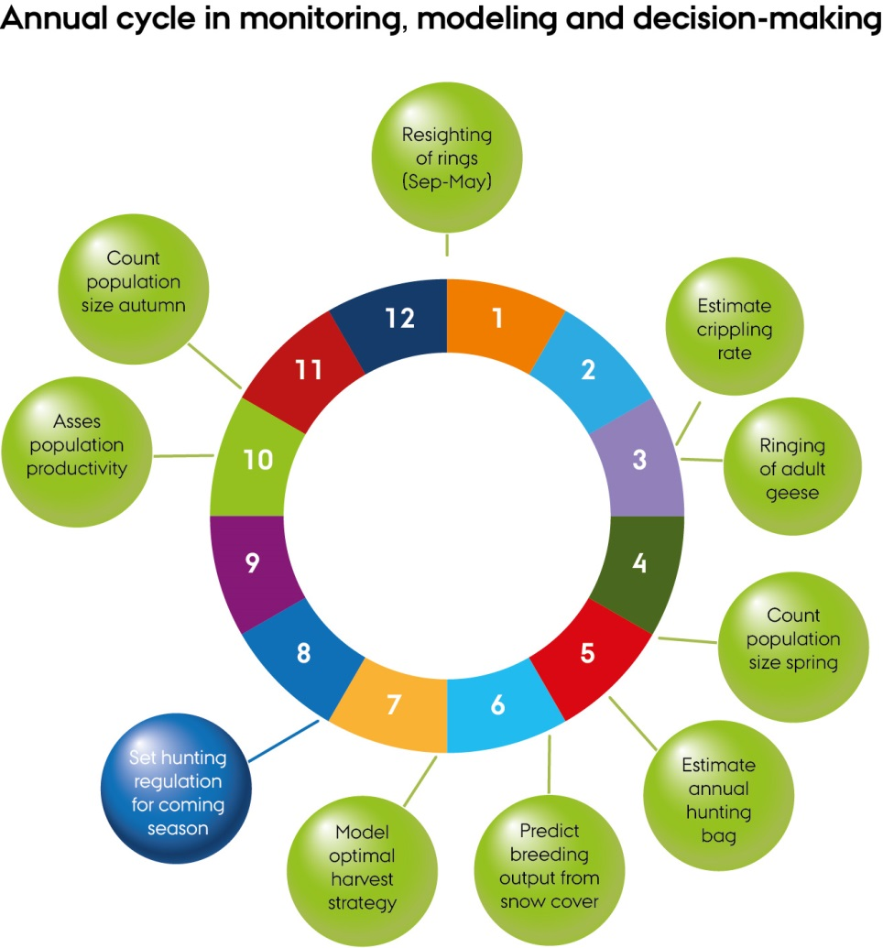

Annex 2. Range States to the initial six populations of four goose species to be covered by the EuroGMP (in red are non-Party Range States to AEWA; the digit indicates the number of populations concerned with the respective Range State)

Belarus – 1 | Latvia – 2
Belgium – 3 | Lithuania – 2
Greenland – 1 | Netherlands – 4
Denmark – 4 | Norway – 4
Estonia – 2 | Poland – 3
Finland – 2 | Russia – 2
France – 1 | Spain – 1
Germany – 3 | Sweden – 3
Iceland – 1 | UK – 2
Ireland – 1 | Ukraine – 1

