ANNOTATED AGENDA

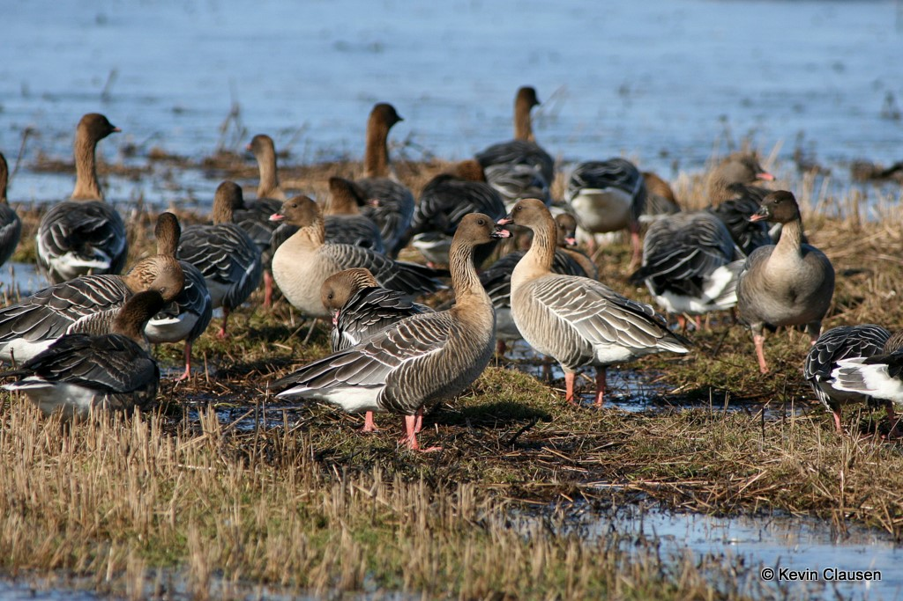

Image courtesy of Kevin Clausen

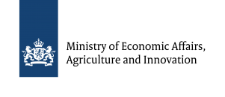 | Hosted by the Dutch Ministry of Economic Affairs,  Agriculture and Innovation.  Organized by Aarhus University, Denmark
-- Annotated Agenda –

Date: Tuesday 14th and Wednesday 15th October 2014
Venue: Van Der Valk Hotel Sneek, Sneek, The Netherlands.
Host: Dutch Ministry of Economic Affairs, Agriculture and Innovation
Chair: Norway (Mr. Øystein Størkersen)

Meeting Documents:
The following working documents will be made available to you for review in advance of the meeting (non-exclusive):
- Annotated agenda (Doc.: SPfG IWG 2.1)
- Svalbard Pink-footed Goose Population Status Report 2013-2014; DCE Technical Report No 39 (Doc.: SPfG IWG 2.2)
- Adaptive Harvest Management for the Svalbard Population of Pink‐Footed Geese 2014 Progress Summary; DCE Technical Report No. 40 (Doc.: SPfG IWG 2.3)
- Agenda item notes: harvest regulations (Doc.: SPfG IWG 2.4)
- Agenda item notes: crop damage assessment (Doc.: SPfG IWG 2.5)

The above documents will be circulated in advance of the meeting.

The following information documents will also be made available to you before the meeting (non-exclusive):
- List of Meeting Documents (Doc.: SPfG IWG Inf. 2.1)
- Meeting Information Sheet (Doc.: SPfG IWG Inf. 2.2)
- List of participants (Doc.: SPfG IWG Inf. 2.3)
- Meeting report of the 1st Meeting of the AEWA Svalbard Pink-footed Goose International Working Group, 23 April 2013, Copenhagen, Denmark. (Doc.: SPfG IWG Inf. 2.4)

Main Objectives:
- Updates on the implementation of the ISMP
- Establish and agree IWG recommendations for the sustainable hunting of pink-footed geese in Norway and Denmark focusing on number key areas of discussion:
  - Emergency closure of the pink-footed goose hunting season
  - Crippling rate target and actions to reduce it
  - Hunting bag share between Norway and Denmark
  - Hunting regulatory options to ensure sustainable hunting of pink-footed geese
- Establish and agree IWG recommendations for the national monitoring and reporting of goose related conflicts
- Elect a new Chair country for the AEWA SPfG IWG

Meeting languages: The meeting will be conducted in English. Meeting documents will be provided in English.

Abbreviations:
- AHM = Adaptive Harvest Management;  - ISMP = International Species Management Plan;  - IWG = International Working Group;  - SPfG = Svalbard Pink-footed Goose  - tbc = to be confirmed  - Doc. = meeting document | - AE = Arild Espelien  - APR = Anja Pel Roest  - BN = Bart Nolet  - EK = Eckhart Kuijken  - FAJ = Fred A. Johnson  - HLS = Henrik Lykke Sørensen  - IT = Ingunn Tombre  - JHW = James H. Williams | - JM = Jesper Madsen  - MV = Michiel Vandegehuchte  - SD = Sergey Dereliev  - ØS = Øystein Størkersen

Monday 13th October
Arrival day
Time | Item | Doc. | Remarks | Lead
 | Arrival |  | Check-in Van Der Valk Hotel Sneek  Burgemeester Rasterhofflaan 1  8606 KZ Sneek, The Netherlands  Tel +31 515 48 18 18
19:00 | Welcome reception |  | Reception to welcome delegates: meet in hotel bar | JM

Tuesday 14th October
08:30 – 18:00
Time | Item | Doc. | Remarks | Lead
08:30 -13:00 | Excursion | -- | Morning excursion to see pink-footed geese in local area | tbc
13:00 - 14:00 | Lunch | --
14:00 – 14:20  (20 mins) | Opening of the meeting, introductions and agenda | SPfG IWG 2.1 | - Tour de table  - Confirmation of observers  - Adoption of the Agenda | Chair  (ØS)
14:20 – 14:45  (25 mins) | Updates from AEWA Secretariat and Coordination Unit | SPfG  IWG 2.2 | Updates on:  - AEWA Secretariat news  - Latest SPfG population status  - Coordination unit ISMP activities and dissemination in 2013-2014 | SD  JM  JHW
14:45 – 15:30  (45 mins) | Range State up-dates:  - Belgium (MV)  - The Netherlands (APR)  - Denmark (HLS)  - Norway (ØS) | -- | Presentations updating on status of national delegations / national working groups, overview of ISMP related activities.
15:30 - 16:00 | Coffee break | --
16:00 – 16.45  (45 mins) | Adaptive Harvest Management (AHM) | SPfG IWG 2.3 | Presentation of AHM 2014 Progress Report | FAJ
16:45 – 17.00  (15 mins) | Q & A session | -- | Brief questions and answers | FAJ
17:00 - 17:45  (45 mins) | Goose-agricultural conflicts and predicting the impact of foraging | -- | Presentation of habitat depletion model for Trøndelag, Norway | BN  IT
17:45 – 18.00  (15 mins) | Q & A session | -- | Brief questions and answers | BN  IT
18:00 – 18:10 | Wrap-up of day | -- |  | Chair  (ØS)  SD  JM
19:00 | Dinner | -- | Dinner kindly hosted by the Dutch Ministry of Economic Affairs,  Agriculture and Innovation | APR

Wednesday 15th October
09:00 – 16:00
Time | Activity | Doc. | Remarks | Lead
09:00 – 09:15  (15 mins) | Arctic tundra degradation | -- | Presentation on arctic tundra monitoring | IT
09:15 - 09:30  (15 mins) | Grassland restoration | -- | Presentation on Belgian grassland restoration in Oostkustpolders | EK
09:30 - 09:40  (10 mins) | Hunting regulations in Norway and Denmark | -- | Presentation on current hunting regulations in Norway and Denmark | AE  HLS
09:40 – 09:50  (10 mins) | Emergency closure of hunting season | -- | Presentation on trigger point and procedure for emergency closure of the hunting season | FAJ  AE  HLS
09:50 – 10:10  (20 mins) | IWG Discussion: emergency closure | SPfG IWG 2.4 | Discussion of emergency closure of hunting season | Chair  (ØS)
10:10 – 10:20  (10 mins) | Crippling rates | -- | Presentation on proposed crippling rate target and management actions to reduce crippling | JM
10:20 – 10:40  (20 mins) | IWG discussion: crippling rates | SPfG IWG 2.4 | Discussion of crippling rate target and management actions to achieve this | Chair  (ØS)
10:40 - 11:00 | Coffee break
11:00 – 11:10  (10 mins) | Annual hunting bag share (DK / NO) | -- | Presentation on proposals to share hunting between Denmark and Norway | AE  HLS
11:10 – 11:30  (20 mins) | IWG discussion: annual hunting bag share | SPfG IWG 2.4 | Discussion on proposals to share hunting between Denmark and Norway | Chair  (ØS)
11:30 – 11:45  (15 mins) | Regulatory options for hunting | SPfG IWG 2.4 | Presentation on potential regulatory options for sustainable hunting in Norway and Denmark | JM
11.45 - 13:00  (75 mins) | IWG Break-out sessions:  - Hunting regulations  - Goose-agricultural conflicts | SPfG IWG 2.4  SPfG IWG 2.5 | - Facilitated workshop on: hunting regulation objectives, alternatives & consequences  - Facilitated workshop on: goose-agricultural conflicts; crop damage assessment and reporting; linking goose populations sizes and crop damages. | Selected chairs
13:00-14:00 | Lunch

14:00 – 14:30  (30 mins) | Summing up of break-out sessions |  | - Feedback on preferred options for hunting regulation  - Feedback on national assessments and reporting of goose related crop damages | Selected chairs
14:30 – 15:30  (60 mins) | Agreement on IWG recommendations |  | Confirmation of, and agreement on IWG recommendations for future management actions:  - Procedure for emergency closure of the pink-footed goose hunting season  - Potential crippling rate target and actions to reduce it  - Recommended hunting bag share between Norway and Denmark  - Recommended regulatory options to ensure sustainable hunting of pink-footed geese  - Recommended reporting practices and formats for goose related conflicts and crop damages | Chair  (ØS)  SD
15:30 – 15:50  (20 mins) | Other business:  - ISMP Work Plan 2015  - Next AEWA SPfG IWG meeting  - Appoint next IWG Chair Country |  | - Outline of planned ISMP activities in 2015  - Discuss and agree possibility, hosting country and timing of 3rd SPfG IWG meeting, foreseen to be held in late 2015  - Appoint new Chair Country for the SPfG IWG. Denmark has offered for 2014-2015 period. | Chair  (ØS)  JM  SD
15:50 - 16:00 | Summary and conclusion of meeting
16:00 | End of meeting

