Agenda point: Discussion about harvest regulations
Note prepared by Jesper Madsen

A) Decisions to be made on emergency closure
At the IWG meeting in Copenhagen, April 2013, it was recommended to implement an emergency closure of the forthcoming hunting season in case the annual optimal harvest models predicted that the population size prior to the hunting season would go below the target of 60,000. However, there are some points which need further clarification and agreement to secure an implementation of the contingency plan.
- What is the predicted population size which triggers a closure: 60,000 (the target level) or 50,000 (which is the lower limit of the previously decided utility function)?
- Has the emergency closure decision been discussed, decided and communicated in the respective countries?
- What management system is required to execute the decision?

The IWG is invited to:
- Discuss and recommend which predicted population size should be used as a trigger for an emergency closure
- Recommend the implementation of a contingency plan for an emergency closure, coordinated between Denmark and Norway

B) Options for sharing the harvest of pink-footed geese between Norway and Denmark

As the population size of pink-footed geese is reduced towards the target level of 60,000 individuals, the harvest will have to be reduced. Hunting organisations in both countries have expressed that it would be necessary and fairest to predefine the share of the harvest of pink-footed geese between Norway and Denmark. Various ways to divide the overall quota have been suggested. To inform the discussion and decision, the proportion of geese shot in Norway out of the total combined bag in Norway and Denmark is presented below. It gives an overview of the relative share based on different retrospective average time intervals of annual hunting bags in Denmark and Norway.

The IWG is invited to:
- Discuss and recommend a share of pink-footed goose harvest between Denmark and Norway in case the overall harvest shall be reduced below current levels

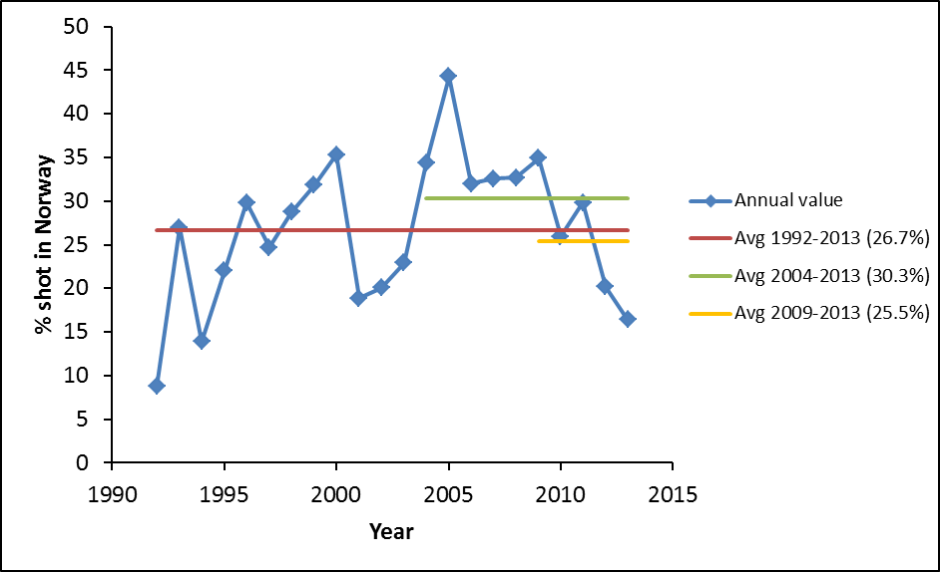
C) Potential options to regulate the harvest of pink-footed geese in Norway and Denmark

As the population size of pink-footed geese is reduced and approaches the target level of 60,000 individuals, it will be necessary to restrict the hunting bag of pink-footed geese. The following options might be considered to be used in Norway and Denmark:

1) Shortening the hunting season length. From an analysis by Sunde and Asferg (2014; Wildlife Biology) it is shown that in general modest regulation of open season length does not have a significant effect on the total harvest; however, we have only few cases where the hunting season has been reduced dramatically, e.g., halved; hence we have little evidence of its effect. To test this out as part of the adaptive harvest management is an interesting option. Two alternative hypotheses: H1) the harvest will decrease proportionately to the reduction in seasonally distributed harvest; H2) the harvest will not decrease proportionately because hunters change behaviour. Regarding H2, we also hypothesise that there is a ‘crowding effect’, i.e., hunters will increasingly affect each other’s opportunities as the season becomes shorter (assuming that hunters will not change the number of hunting days) because geese will be increasingly disturbed. Such an effect can, however, be mitigated by a better local organization of the hunting activity.
Shortening of the season length can be implemented with no need for new regulatory instruments.
Status: In Denmark, the season length on pinkfeet has been extended to include January (from 2014/15 onwards; with the aim to allow more harvest to reduce the current population size). This will give us the first test of the effect of the use of this instrument.

2) Setting an overall quota. If the total harvest quota is divided between the two countries, the hunters in each country will be permitted to shoot a given number (see B above), and the hunting season stops once the quota has been reached. We hypothesise that such a system is likely to affect the hunters’ behaviour, leading to increased harvest (and hunting intensity) early in the season. In turn, if hunting intensity increases, this may affect goose behaviour, reducing shooting opportunities because the geese will leave the areas with hunting.
This instrument requires 1) introduction of a new hunting bag reporting system with mandatory reporting of daily bags to an electronic system and 2) quick communication from the authorities to hunters about closure of the open season once the quota has been reached.

3) Setting a daily bag limit. In Europe, we have no experience with use of this instrument for waterfowl hunting (but there is ample North American experience). We have limited information about daily hunting bags and their variation; hence, we know little about the potential for this instrument to be effective. We hypothesise that setting a daily bag limit can reduce the overall harvest, assuming that the number of hunting days will not increase when the daily bag limit decreases. Hence, we also hypothesise that a system with daily bag limits will change hunter behaviour when there is good hunting opportunity, i.e., hunters will go out more often.
This instrument can be introduced rather easily in the national regulations as an administrative addition to present regulations.

4) Increasing the interval between days when hunting is allowed. We have no experience with the effect of this type of system, apart from experimental data from local studies suggesting that this is a good way to keep waterbirds in the area, increasing the hunting opportunities on the days with hunting. We have two alternative hypotheses about the effect of such a system: H1) the harvest will be reduced because the hunting opportunities will be reduced; H2) the harvest will not be reduced because intermittent shooting will lead to more geese been shot per hunting day.
This instrument will require introduction of new regulation and it will be resource demanding to administer at national level. Local voluntary agreements are an option, but require good self-regulatory control.

A down-regulation of harvest can be achieved by top-down regulatory decisions or by voluntary agreements. The Norwegian authorities have proposed to use regional voluntary agreements as an instrument to make between-year adjustments. Possible agreements may include daily bag limits, number of hunting days, season length, spatial protection of geese. To be efficient this will require 1) good spatial coverage of the goose distribution, 2) agreements between hunters in the entire area (few non-participants can spoil the system), 3) daily reporting of bags to ensure that the quota is not exceeded; daily reporting will be required because there is no knowledge about the efficiency of such a system.

The IWG is invited to:
- Discuss and recommend which possible options (either among the ones proposed above, a combination of them, or alternatives) shall be considered in case the harvest of pink-footed geese needs to be reduced by hunting regulations, noting that Norway and Denmark do not necessarily have to implement the same instruments

D) Actions to maintain a low crippling rate

In the ISMP the following action is stated as essential: ‘Ensure sustainable hunting where practised (at present in Norway and Denmark) and following ‘wise use’ principals, whilst ensuring that crippling rates are kept at a minimum level’. To pursue this action point, it will be necessary to agree on how a minimum level is defined. This is a value-based decision and requires a careful treatment nationally in Denmark and Norway as well as in the IWG.

The background for the focus on crippling in pink-footed geese was a series of X-ray studies carried out by Aarhus University in the 1990s. It was shown that on average 36% of older birds (>1 year old) carried shotgun pellets in their tissue. This finding was regarded as unacceptable by the Danish Minister of Environment and was a primary reason for a national action plan to reduce crippling in wildlife in Denmark, implemented in 1997. Since then, the crippling rate went down (primarily as a result of the action plan), to reach 20% in 2005. However, in 2009 and 2011, it had increased to 22% (against a predicted level of c. 15%). The Danish Nature Agency is currently preparing a new campaign to increase the awareness of maintaining crippling at a low level and has asked Aarhus University to repeat the X-ray monitoring in 2013-2015. Due to difficulties in catching sufficient number of geese, statistically robust results are not yet available.

The reasons for the increase in crippling rate are not totally clear. At least two factors may be involved. First, in Denmark, pink-footed geese have spread over a much wider area where hunters are not used to shooting geese. Second, in Norway, shooting of pink-footed geese has attained more interest, but hunters are generally not experienced. Lack of experience with goose shooting in both parts of Denmark and Norway (e.g. with regard to keeping short shooting range, selecting right ammunition) can thus be a major contributor to increased crippling.

The IWG is invited to:
- Discuss and recommend criteria for a ‘minimum level’ of crippling
- Discuss and recommend which actions should be taken in Denmark and Norway to increase the awareness of keeping crippling at a minimum

