EVALUATION OF AEWA INTERNATIONAL SINGLE
AND MULTI-SPECIES ACTION AND MANAGEMENT PLANS:
RESULTS ACHIEVED AND IMPLEMENTATION PERFORMANCE
Evaluation report template

- Executive summary
[Short section providing an overview of the evaluation process, outcomes and recommendations for next steps, i.e. to retire, extend, update or revise the Plan]

- Glossary and acronyms/initialisms
[For most important terms and the acronyms/initialisms used in the document]

- Introduction
  - Development of the Plan
[Short background about the mandate, development stages etc. of the Plan]
  - Key concepts and processes provided for in the Plan
[If relevant, description of any particular processes, concepts etc. established under the Plan
e.g. harvest strategies, structured decision making, recovery objective vs management objective, Favourable Reference Values, etc.]
- Implementation structures (e.g. Working Group, Task Forces under WG, coordination, etc.)
[Short description of any implementing structures national and international/entities established and their relationship to each other, e.g. Coordination, Working Groups, Task Forces under the WGs, etc.]
- Goal, Purpose and Objectives of the Plan
[Short overview of the goal, purpose and main objectives of the Plan]
- Plan Evaluation
[Description of the evaluation process under AEWA and subsequent steps; standard text to be provided by the Secretariat; case specific text to be added by the evaluation compiler]

- Two-step evaluation
The two-step evaluation follows the decision tree for the retirement, extension, and revision of AEWA Species Action and Management Plans (see document AEWA/MOP8.22)

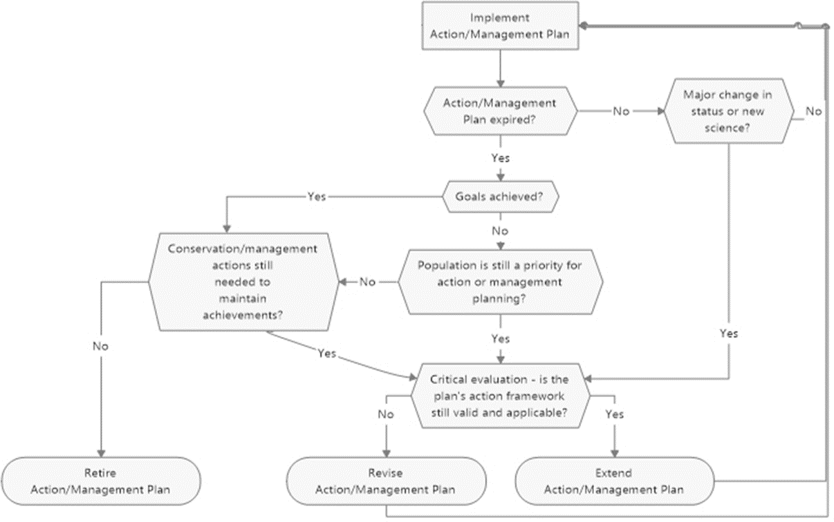

Step 1
- Have the goal and purpose been achieved?
[Evaluate against the goal and purpose of the Plan and use indicators already defined in the Plan]

- Is the population / species still considered by the AEWA Technical Committee (TC) a priority for action or management (with recovery objectives) planning?
[Provide reference to the latest AEWA TC prioritisation of species/populations for action and management planning (undertaken at the first TC meeting after each session of the Meeting of the Parties)]

- This question is relevant only for management plans with the objective of reducing damage to crops and fisheries: Do the Range States participating in the implementation of the management plan consider the necessity of continuing concerted actions to address the issue of damage to crops or fisheries?
[Provide justification]

- Are conservation or management actions still needed to maintain achievements?
[Provide justification]

- Recommendations for the future of the Plan
[Add final recommendation for the need to retire the Plan or continue with its implementation – if a recommendation for retirement is not justified, then proceed to step 2 of the evaluation which will define how to proceed with the Plan implementation. If retirement is justified, this evaluation report will be concluded at step 1 and submitted to the AEWA Technical and Standing Committees for review and forwarding the recommendation for retirement to the Meeting of the Parties.
For learning purposes, even if the Plan has achieved its goal and purpose and/or there is no further necessity of an action/management plan for this species/populations, if capacity and resources allow, step 2.III of the evaluation can be implemented to document the implementation of the Plan and its achievements]

Step 2
Is the Plan’s action framework still valid?
- Are there new insights, biological or other background information, emerging issues or threats?
- If there are new issues, does the action framework of the Plan need to be changed to address these?
- Is the intervention logic of the Plan working?
  - To what extent have actions been implemented?
  - To what extent have results and objectives been achieved?
  - What were the main obstacles hindering implementation and achieving defined results and objectives?
[Evaluate implementation performance and achievement of expected results as defined in the Plan’s action framework using indicators already defined in the Plan; for undertaking step 2.III please refer to the guidance in Annex 1 to this document and attach to the report the resulting analysis]

- Conclusion and recommendations
[Main conclusion and recommendations for the future of the Plan, i.e. whether to extend its lifespan without changes, whether to update the background chapters or to proceed with a full revision including of goal, purpose, objectives and action framework, as necessary. This full evaluation report will be submitted to the AEWA Technical and Standing Committees for review and approval of the recommended continuation option]

- Annexes
[Attach to the report any significant reference material that has been used in the evaluation process, including any resulting analysis from the implementation of step 2.III (see Annex 1 to this document for further guidance on step 2.III)]

ANNEX 1
Guidance on undertaking Step 2.III of the evaluation of implementation of AEWA International Single and Multi-species Action and Management Plans

Purpose
The purpose of this guidance is to assist with undertaking Step 2.III of the evaluation of implementation of AEWA International Single and Multi-species Action and Management Plans as defined in the evaluation report template. By applying this guidance, the evaluator will be able to identify the extent of implementation of the respective plan and the extent to which the anticipated results and objectives have been achieved.

Approach to evaluation
The evaluation of species action and management plans follows the approach used in the Report on the progress of implementation of the AEWA Strategic Plan 2019-2027 (document AEWA/MOP8.11). While this approach is transferable and replicable in the case of species action and management plans, since such plans that have been agreed to date do not include indicators like the Strategic Plan, some adaptation will be necessary. While AEWA species action and management plans do follow an agreed format, this format has been evolving over time and in addition the different levels of the action framework of each plan differ in their formulations from those in other plans. Thus, the evaluation approach will require some degree of customisation to each individual plan.
This evaluation approach employs (1) measuring distance to target and (2) scoring.
Distance to target
For measuring the progress towards achieving the goal and purpose of the plan, when they are defined as quantitative (demographic) targets, it is recommended to use the distance (in percentages) to the aspired target value. If baseline values are available from before the plan was adopted, comparing the current distance to the respective baseline distance will also provide indication of the direction of change. If the goal or purpose is composite and contains more than one quantitative target, the current distances of all targets can be averaged and compared to the mean baseline distance.
See Example 1 below which illustrates the measuring of the distance to target.
Depending on the formulation of the goal or the purpose, it may not be possible to use distance to target, in which case scoring (see next paragraph) can be considered instead (see Examples 1-4).
Scoring
The scoring is applicable for evaluating implementation and can be used for the elements of the action framework, i.e. objectives, results and actions.
The scores are applied according to the following matrix as per document AEWA/MOP8.11 (Table 1 on page 4):

Action score | Not assessed | Not implemented  / not achieved  / no progress  / regress | Limited progress | Good progress | Significant progress | Implemented  / achieved | Mean result / objective score
0 |  |  |  |  |  |  | 0
1 |  |  |  |  |  |  | 0.1 – 1.0
2 |  |  |  |  |  |  | 1.1 – 2.9
3 |  |  |  |  |  |  | 3.0 – 3.9
4 |  |  |  |  |  |  | 4.0 - 4.9
5 |  |  |  |  |  |  | 5

To facilitate scoring of quantitative targets contained in objectives, results or action, the scale below (Table 2 of document AEWA/MOP8.11 on page 5) is used to match the progress towards the aspired target threshold with a specific score:

Progress towards the aspired threshold | Assigned score
0% | 1
1-33% | 2
34-66% | 3
67-99% | 4
100% | 5

Scores shall be first applied to the basic level of the action framework – the actions.
If the formulation of the next level of the action framework – the results – allows direct measurement, then apply a score to the result. If that is not possible, then average the scores of all actions associated with the respective result and apply to it this (arithmetic) mean score.
Apply scores to the objectives in a similar manner as with the results.
Please see Annex 2 of document AEWA/MOP8.11 (page 20) for illustration of the application of scores from actions, through results to objectives.
If at the level of the results or objectives there are demographic targets included, in that case, in addition to scoring, distance to target may also be applied which will present a higher resolution of evaluation and will also demonstrate the direction of change in case baseline values are available.
The scores of all objectives of the plan are in the end averaged to produce an overall mean implementation score for the plan. As an example, see Table 3 of document AEWA/MOP8.11 (page 8).
In case the evaluation of an action, result or objective is based on incomplete data or insufficient quality of data, place the score in brackets to indicate so. When a mean score is based on scores where at least one is bracketed or evaluation is missing for at least one action/result, place the mean score in brackets too.
Based on the mean scores, whenever calculated for results and objectives, the progress towards achieving each result, each objective and all objectives together is placed under the following categories (see last column of the first table above): Not assessed (mean score 0), Not achieved / not reached / no progress (mean score 0.1-1.0), Limited progress (mean score 1.1-2.9), Good progress (mean score 3.0-3.9), Significant progress (mean score 4.0-4.9), Achieved / reached (mean score 5).
An audit trail shall be established for the evaluation of the goal and purpose as well as each objective, result and action of the plan. It is recommended to follow the example in document AEWA/MOP8.11, with necessary adaptation and customisation – compile all the information in a tabular form in an annex to the evaluation report like in Annexes 1 and 2 of document AEWA/MOP8.11 (see pages 17 and 20, respectively).

Example 1
All MUs
Western MU
Central MU
-70
-60
-50
-40
-30
-20
-10
0
10
20
Distance now Distance before
Measuring the progress towards achieving the goal and purpose of the Action Plan: Taiga Bean Goose

The Taiga Bean Goose action plan sets as a goal to reach within 20 years the following population sizes as interim targets towards higher ultimate population targets (long-term goal):
Western Management Unit – 4,000 individuals; Central Management Unit – 60,000 individuals.²
At the time of the action plan compilation, these two management units were assessed to be 1,500 individuals and 35,000 individuals, respectively. The latest complete counts provide the following estimates of population size – 2,186 individuals for the Western MU (January 2022) and 66,166 individuals for the Central MU (March 2023).
At the time when the action plan was compiled the distance of the baseline population size to the interim target was nearly 63% for the Western MU and nearly 42% for the Central MU (Figure 1). The latest population size estimates demonstrate increase in population size and thus a reduction of the distance to just above 45% for the Western MU, while for the Central MU the set interim population target has been surpassed and exceeded by over 10%. For both MUs combined, the distance at the time of action plan compilation was 43% (36,500 individuals versus 64,000 individuals) and now the combined interim population target has been surpassed by nearly 7% (68,352 individuals versus 64,000 individuals).

Figure 1. Distance in percentages of the baseline and the current population sizes to the set target population size for each Management Unit as well as combined for both Management Units. The “0” axis represents the target population size; the shorter the bar to the left, the closer it is to the target; if the target is surpassed, the bar extends to the right.

² For the purposes of this example, Eastern 1 & 2 Management Unit has been excluded due to data and knowledge deficiency which will require further considerations about how to integrate it into the evaluation process.

Using the same approach, the distance to the long-term goal for each MU – 5,000-10,000 individuals for the Western MU and 60,000-80,000 individuals for the Central MU can be calculated. As these long-term population targets are ranges, it is recommended to use arithmetic mean for calculating the distance (i.e. 7,500 individuals for the Western MU and 70,000 individuals for the Central MU).
Based on these calculations, it can be concluded that overall good progress has been made towards achieving the short-term goal of the Taiga Bean Goose Action Plan. However, this progress is primarily due to the Central MU. Some limited progress has been also made in the case of the Western MU, but the short-term goals is yet far out of reach. In the case of both MUs, the long-term goals are not achieved, but approaching very closely for the Central MU.

The purpose of the Taiga Bean Goose action plan is formulated as follows:
“Stabilise the overall population size as well as the numbers in each sub-population at least at their current levels within 5 years, and to enable the sub-populations to start to recover and increase within 10 years.”
Although distance to target can be used as a measurement in this case, it is recommended to use an adapted scoring approach, as follows, considering that the plan is currently in its 11th year of implementation:
Score 5 (achieved) – the management unit / sub-population is currently more numerous than at the time of the action plan approval.
Score 3 (good progress) – the management unit / sub-population is currently maintained at the same population size like at the time of the action plan approval.
Score 1 (no progress / regress) - the management unit / sub-population is currently less numerous than at the time of the action plan approval.
For both MUs, score 5 can be applied since both have larger population sizes compared to when the plan was approved. For the overall Taiga Bean Goose population, the progress towards achieving the purpose of the plan can be also scored as 5 due to the overall increase in the population size since the plan was put in place.

The goal of the White-winged Flufftail action plan is formulated as follows: “To ensure favourable conservation status of the White-winged Flufftail.”
The definition of Favorable Conservation Status (FCS) used by AEWA is the one of the Convention on Migratory Species which is spelled out in the text of the treaty:
"Conservation status" will be taken as ‘favourable’ when:
(1) population dynamics data indicate that the migratory species is maintaining itself on a long-term basis as a viable component of its ecosystems;
Example 2
Measuring the progress towards achieving the goal of the Action Plan: White-winged Flufftail

- the range of the migratory species is neither currently being reduced, nor is likely to be reduced, on a long-term basis;
- there is, and will be in the foreseeable future sufficient habitat to maintain the population of the migratory species on a long-term basis; and
- the distribution and abundance of the migratory species approach historic coverage and levels to the extent that potentially suitable ecosystems exist and to the extent consistent with wise wildlife management;”
To identify what would constitute an FCS for a species, Favourable Reference Values (FRVs) for population, range and habitat need to be defined for each separate population of the respective species. The FRVs will be ideally defined at the time of drafting the action plan. However, to date, this has been done only for a few AEWA species/populations which are subject to management plans rather than action plans.
In the absence of defined FRVs, to measure the progress towards achieving the goal of the action plan, such FRVs will need to be first defined and then the current values of each element compared. Since these are quantitative values, the evaluation can be done by measuring distance to target (See Example 1 above) where the FRVs will be the target values.
In such cases where FRVs were not defined when the plan was compiled and cannot be defined at the time of plan evaluation, an adapted scoring approach can be used instead, as follows:
Score 4 (good progress): the population size, range, extent and quality of habitat has increased;
Score 3 (stable): the population size, range, extent and quality of habitat remained stable (within natural fluctuation);
Score 2 (regress): the population size, range, extent and quality of habitat has declined at a similar rate as before the plan was adopted;
Score 1 (significant regress): the population size, range, extent and quality of habitat has declined faster than before the plan was adopted.
The score to be applied will be the lowest score for either of the three elements: population size, range, extent and quality of habitat. Score 5 cannot be used in this scale as it would be reserved for when the FRVs have been reached or surpassed (which cannot be assessed in the absence of defined FRVs).
To apply the scoring approach, sourcing of baseline (at the time of plan approval) and current values for each of the three elements will be necessary.

The goal of the Lesser Flamingo action plan is formulated as follows: “To improve the conservation status of the Lesser Flamingo from a “Near Threatened” species to a species of “Least Concern” [NB: on the IUCN Red List]…”
When the goal of a plan aims at improving the IUCN Red List status from a Globally Threatened or Near Threatened category, it is recommended to measure the change in the factors that have justified
Example 3
Measuring the progress towards achieving the goal of the Action Plan: Lesser Flamingo

the placing of the species under the respective Red List category at the time when the plan was approved.
As a first step, identify which Red List criteria have been invoked in the listing. For the Lesser Flamingo (category NT) criteria A2c, A3c and A4c have been used. All three criteria refer to a 30% population decline and the common denominator (c) that is pointed as the reason for that population decline is a decline in area of occupancy, extent of occurrence and/or quality of habitat.
Based on the justification for red-listing, in this case it is recommended to measure the change in the extent of occurrence and score progress according to the following scale:
Score 5 - increase >30% in 3 generation or less; Score 4 - increase;
Score 3 - stable (decline stopped); Score 2 - slower decline;
Score 1 - accelerating decline.

The goal of the Maccoa Duck action plan is formulated as follows: “To stabilise or increase natural populations of Maccoa Duck…”
The measure progress towards the action plan goal the evaluation will require calculating the trend of each population of the species. The trend shall be calculated against the baseline population at the time of the plan approval. In the absence of a targeted trend calculation, use the trend estimate provided in the latest edition of the AEWA Conservation Status Report (available on the AEWA website as a standard document at each session of the Meeting of the Parties).
Once the trend has been established, scoring can be applied to evaluate progress towards achieving the goal of the plan by using a scoring scale similar to the one in Example 1 above (purpose of the Taiga Bean Goose action plan).
Example 4
Measuring the progress towards achieving the goal of the Action Plan: Maccoa Duck

Developed by the UNEP/AEWA Secretariat in consultation with the AEWA Technical Committee (TC); final version approved by the AEWA TC by correspondence in 2023. Relevant for task 2.2 of the TC Work Plan 2026-2028.

