PROCESS AND WORKFLOW FOR IMPLEMENTATION OF SELECTED SECRETARIAT TASKS

Compiled by the UNEP/AEWA Secretariat

Introduction

Consolidation of Resolutions

Since the Agreement entered into force in 1995, the Meeting of Parties (MOP) to AEWA, at its nine sessions, adopted a total of 157 Resolutions (at MOP1 in 1999, MOP2 in 2002, MOP3 in 2005, MOP4 in 2008, MOP5 in 2012, MOP6 in 2015, MOP7 in 2018, MOP8 in 2022 and MOP9 in 2025). This has resulted in an accumulation of multiple (often older and redundant) mandates, which need to be streamlined, merged, updated or repealed in order to ensure clarity and efficiency of the implementation work under AEWA.

Pursuant to operative paragraph 10 of Resolution 9.2 adopted by the 9th Session of the Meeting of the Parties (MOP9), the Secretariat has therefore been instructed, under the guidance of the Standing Committee (StC) and with support from the Technical Committee (TC), to consolidate all previously adopted MOP resolutions by subject area, including suggestions for repealing timebound decisions that extend beyond their respective deadlines and other decisions, as necessary and justified, to provide a streamlined basis for the Strategic Plan development process, and to submit the draft consolidated resolutions to MOP10 for consideration and adoption.

This task has been formulated as Activity 3.2.1 of the Programme of Work for the Secretariat for the period 2026-2028 (document AEWA/TC21 Inf.7) and as task 1.6 in the TC Work Plan 2026-2028.

Review and Optimisation of Action Plan

The Action Plan appended as Annex 3 to AEWA specifies actions that Parties shall undertake in relation to priority species and issues and is applicable to the populations of migratory waterbirds listed in Table 1 to this Annex. Article IV.2 of the Agreement text provides that the Action Plan “shall be reviewed at each ordinary session of the Meeting of the Parties, taking into account the Conservation Guidelines”, while Article X specifies the procedure for amending the Agreement’s annexes, including the Action Plan.

Textual amendments to provisions of the Action Plan were adopted by MOP1, MOP4, MOP5, MOP8 and MOP9. Interpretive guidance has also been adopted for some provisions. However, no systematic review of the full Action Plan text has been undertaken to date. Resolution 9.1, operative paragraph 7, therefore requests the Secretariat, in consultation with the Technical and Standing Committees, following MOP9 to “review the Action Plan in Annex 3 to the Agreement in advance of the launch of the development of the Strategic Plan 2029-2037 and suggest possible optimisations to the Action Plan with a view to strengthening its coherence and providing for a more streamlined implementation, which are to be considered in the context of developing the next Strategic Plan, and to arrange for any resulting proposals for amendments to or interpretation of the Action Plan to be submitted to MOP10 for consideration and adoption”. The Resolution further provides that “as part of this process the Secretariat should, inter alia, review the AEWA provisions on sustainable use with the objective of establishing consistency in the use of terminology and potentially additional definitions of terms to ensure coherence of the legal text and in undertaking this task, take into account terminology and definitions used under other relevant frameworks, including the European Union’s Birds Directive”.

This task has been formulated as Activity 3.3.1 of the draft Programme of Work for the Secretariat for the period 2026-2028 (document AEWA/TC21 Inf.7) and as task 1.5 in the TC Work Plan 2026-2028.

In this document, the Secretariat describes the proposed process and workflow for both the consolidation of resolutions and the review and optimisation of the AEWA Action Plan. This proposal was submitted to the 28th meeting of the AEWA Standing Committee (StC28) on 12 March 2026. The only amendments that have been made based on the discussions at StC28 are adjustments of timelines to reflect that the Standing Committee’s next meeting is anticipated to be scheduled for August 2026.

Actions requested from the Technical Committee

The Technical Committee is requested to take note of the anticipated processes and workflows for implementing these two tasks during the period 2026-2028 and is invited to comment and provide guidance on steps 2 and 4 of both processes.

Task 1: Consolidation of MOP Resolutions (Resolution 9.2): Activity 3.2.1 of the draft Secretariat’s PoW 2026-2028

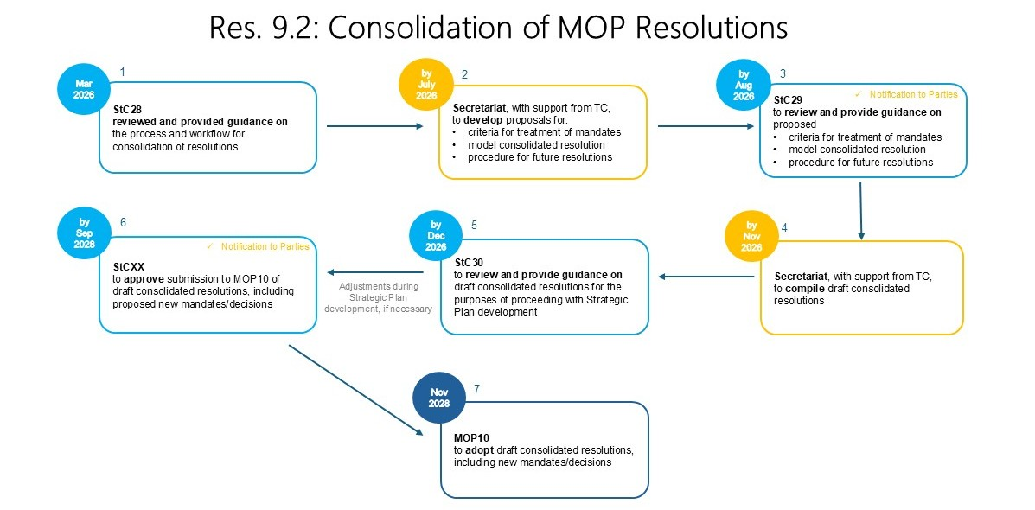

1: The Standing Committee was requested to review and provide guidance on the proposed process and workflow at its 28th Meeting (StC28) on 12 March 2026. The only amendments resulting from this meeting concerned the scheduling of StC29.

2: The Secretariat, with support from the Technical Committee, develops:
- a proposed approach for treatment of mandates deriving from all previously-adopted resolutions (MOP1 - MOP9) - including criteria for retiring and merging mandates;
- a model resolution to serve as an example of how the proposed criteria will be applied and how consolidated resolutions will be structured; and
- a proposed procedure/structure for organising former and new decisions within future resolutions.

3: The Standing Committee, at its 29th meeting (StC29), which is anticipated to be scheduled for August 2026, reviews and provides guidance on the products developed under Step 2. StC29 will also provide an opportunity for other Parties to comment on this document. The notification to Parties regarding StC29 will therefore explicitly draw their attention to this agenda item.

4: The Secretariat, with support from the Technical Committee, compiles draft consolidated resolutions, following the approaches outlined in Step 2 following the consultation at StC29.

5: In December 2026, the Standing Committee reviews and provides guidance on the draft consolidated resolutions at its tentatively scheduled 30th meeting (StC30).

6: At its last meeting before MOP10 the Standing Committee approves the submission of draft consolidated resolutions, including any proposed new mandates/decisions that will have been developed by then, for submission to MOP10. It is anticipated that this meeting will be held by September 2028. Details of the meeting will be communicated to Parties via notification.

7: MOP10 adopts consolidated resolutions, including any new mandates/decisions. It is anticipated that MOP10 will be held in approximately November 2028.

Task 2: Review and Optimisation of the Action Plan in Annex 3 to AEWA (Resolution 9.1): Activity 3.3.1 of the draft Secretariat’s PoW 2026-2028

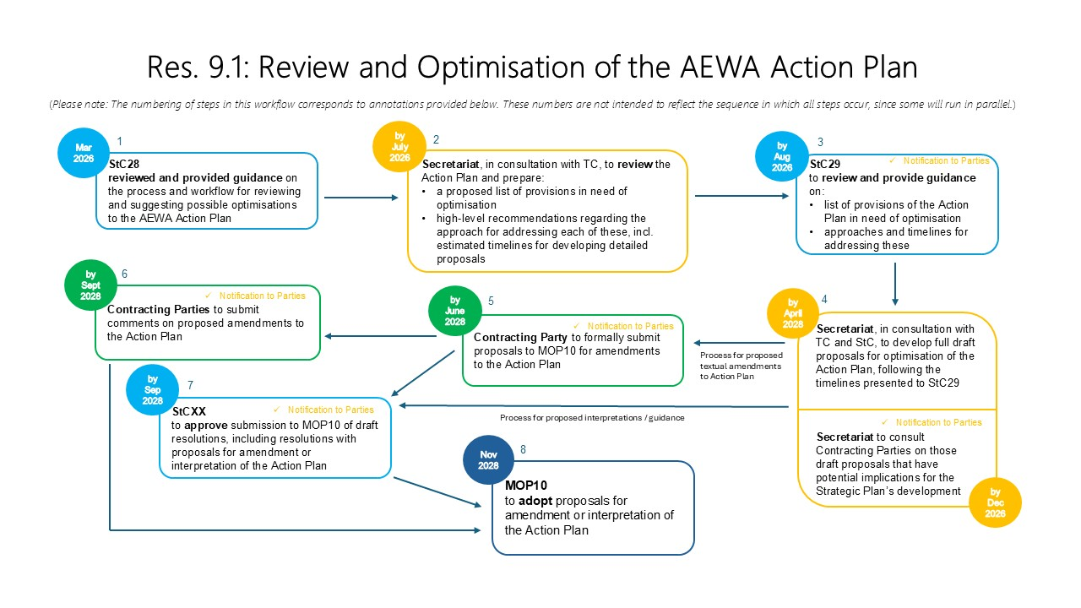

1: The 28th Meeting of the AEWA Standing Committee (StC28) was requested to review and provide guidance on the proposed process and workflow. The only amendments resulting from this meeting concerned the scheduling of StC29.

2: The Secretariat reviews the Action Plan in Annex 3 to AEWA (as amended by MOP9) and identifies provisions for which optimisation is desirable for the purposes of:
- strengthening the Action Plan’s coherence (e.g., by addressing inconsistencies and ambiguities); and
- providing for more streamlined implementation (e.g., by refining priorities and more clearly articulating AEWA’s role in relation to other multilateral environmental agreements).

Per Resolution 9.1, this will include, but not be limited to, a review of AEWA’s provisions on sustainable use.

The review will consider, inter alia, the Action Plan and Agreement text, relevant mandates and guidelines adopted by the AEWA MOP, and the terminology and definitions used under other relevant frameworks. It will result in a proposed list of provisions in need of optimisation, high-level recommendations regarding the appropriate approach for addressing each of these (amendment of the Action Plan text or adoption of interpretive guidance), and estimated timelines for developing detailed proposals for addressing each item on the list. The Technical Committee will be invited to contribute as necessary and appropriate, including by reviewing a draft of this document before StC29.

During this step, the Secretariat will endeavour to identify which optimisations to the Action Plan are likely to impact the framing of the draft AEWA Strategic Plan 2029-2037 and therefore need to be advanced before this Plan’s development.

3: StC29 reviews and provides guidance on the proposed list of provisions, recommendations and timelines. StC29 will also provide an opportunity for other Parties to comment on this document. The notification to Parties regarding StC29 will therefore explicitly draw their attention to this agenda item.

4: The Secretariat, in consultation with the Technical Committee and Standing Committee, develops full draft proposals for optimisation of the Action Plan, following the timelines that were presented to StC29. Depending on the number and complexity of Action Plan provisions in need of optimisation, it might only be possible to develop some of these proposals in 2027-2028. In the first instance, priority will be given to those draft proposals with potential implications for the framing of the draft AEWA Strategic Plan 2029-2037. It is anticipated that these will be prepared in 2026 and consulted with Contracting Parties via a written procedure and online meeting, information on which will be communicated through a notification to the Parties. The purpose of these consultations will not be to formally adopt the draft proposals (such adoption only being possible at MOP10), but to elicit any provisional comments and concerns before proceeding to develop a new draft Strategic Plan.

5: In accordance with Article X.3 of AEWA’s Agreement text, the text of proposed amendments to the Action Plan, and the reasons for these, shall be communicated to the Secretariat by a Contracting Party not less than 150 days before the opening of MOP10 and transmitted by the Secretariat to all Parties. The precise deadline for submission of proposed amendments will be communicated through a notification to the Parties.

6: In accordance with Article X.3, any comments on the proposed amendments shall be communicated by Parties to the Secretariat not less than 60 days before the opening of MOP10. The precise deadline for submission of comments will be communicated through a notification to the Parties. Any comments received will be collated and included in the MOP10 meeting documents.

7: The final StC meeting of the triennium reviews all draft resolutions and approves them for submission to MOP10, including those resolutions with proposals for amendment or interpretation of the Action Plan.
8: MOP10 reviews, amends as necessary, and adopts proposals for amendment or interpretation of the AEWA Action Plan.

