Doc: AEWA/ TC6 Inf. 6.6

Agenda item 26a
04 April 2005
Original: English

AFRICAN-EURASIAN MIGRATORY WATERBIRD AGREEMENT

COORDINATION OF WATERBIRD RINGING SCHEMES IN AFRICA

PRIORITY NO. 20

ANNUAL REPORT: JANUARY – DECEMBER 2004

Compiled by:
Doug Harebottle

Avian Demography Unit
Dept of Statistical Sciences
University of Cape Town
Rondebosch 7701
South Africa

17 December 2004

A. Introduction

This project, no. 20 in the AEWA Implementation Priorities 2004-2007, was initiated in January 2004 and is coordinated by the Avian Demography Unit of the University of Cape Town.

The rationale for this project is based on the paucity of information on waterbird movements in Africa. This limits the implementation of effective conservation strategies and management plans for waterbirds within the African-Eurasian flyway. This project aims to establish and coordinate ringing schemes in Africa through the development of a sustainable infrastructure (AFRING) that will continue building a knowledge-base of waterbird movements and migration into the future.

B. Human resources

The funding granted for Phase 1 of this project has enabled the creation of a full-time African Waterbird Ringing Coordinator (Doug Harebottle) and Species Coordinator (Michael Brooks), based at the Avian Demography Unit. Through the creation of these posts, the implementation of the tasks assigned to the project have, to date, been carried out timeously and this has contributed to the project being managed efficiently.

C. Stakeholder involvement

The success of this project will depend to a large extent on the input and involvement of stakeholders and interested and affected parties (I&APs), particularly existing ringing schemes, government officials and NGOs.

Two stakeholder meetings were held during 2004. These are detailed below.

A. Edinburgh, April 2004

The first stakeholder meeting took place in Edinburgh in April 2004 at the Waterbirds around the World conference organized by Wetlands International. The meeting was coordinated by Doug Harebottle, the African Waterbird Ringing Coordinator, and attended by nine conference delegates, including representatives from Ghana, Nigeria, Tanzania, The Gambia, Kenya, Botswana and South Africa. Representatives from EURING and the Wildfowl and Wetlands Trust were also present at the meeting. Although more African delegates were present at the conference, many could not attend the meeting due to clashes with other side meetings.

The meeting started with a presentation from Doug Harebottle outlining the background, objectives and direction of the project after which it was opened to the floor for comments and discussion. The major outcomes of the discussion included overwhelming support for the concept and development of AFRING, the need to establish additional ringing schemes in Africa and training of African waterbird ringers, and suggestions to focus on conservation priorities for the continent. Dr Charles Malingwa extended an invitation to Doug Harebottle to present the AFRING concept at the next Scientific Forum meeting of the Tanzania Wildlife Research Institute (TAWIRI) to be held in 2005.

Mr Fernando Spina, current president of EURING, extended his support for the establishment of AFRING and mentioned that EURING could assist AFRING with many administrative and political lessons that it had learned from in the past.

Minutes were taken at the meeting and these have been put on file.

B. Djerba, November 2004

The second stakeholder meeting was held at the 11th Pan-African Ornithological Conference in Tunisia during November 2004. A total of 44 delegates attended the meeting representing 16 African countries, four European countries and one North American country. The African countries included (in alphabetical order): Algeria, Burundi, Djibouti, Democratic Republic of the Congo, Ghana, Kenya, Madagascar, Morocco, Nigeria, Rwanda, Senegal, Seychelles, South Africa, Tanzania, Tunisia and Uganda. The European countries were represented by The Netherlands, Spain, United Kingdom and Sweden while North America was represented by the USA.

The meeting took the form of a short presentation by Doug Harebottle outlining the history of waterbird ringing in Africa, explaining the concept and formation of AFRING, followed by an outline and progress of Phase 1 components of priority no. 20. Doug then opened the meeting to the floor for comments, suggestions and discussion. The following points were highlighted:

- All delegates expressed a strong support for AFRING, particularly in developing a centralized repository for African ringing data. Mr Fernando Spina, President of EURING, again endorsed AFRING and said that EURING would support the development of AFRING as much as possible.
- Framework and structure of AFRING is crucial to ensure co-ordination of ringing in Africa.
- Increased awareness of bird ringing needed throughout Africa to aid in retrieval of rings and recovery information. Involvement of local community is important and public relations with these communities should be done in their own languages.
- Key site approach should be considered for monitoring of migration patterns and trends.
- Lack of expertise at local and regional levels. Training is a priority and “training the trainers” concept should be considered. Follow-up training is important as many trainees cannot continue with training after attending formal training courses.
- Delegates from Algeria and Tunisia mentioned that the north African bio-regions need to be considered at both European and sub-Saharan levels as bird movements occur in both directions. Both countries, plus Morocco, expressed a strong willingness to be part of AFRING but with ties to EURING. To date, only Morocco and SAFRING are associate members of EURING.
- The use of standardized ringing and recovery forms throughout the various ringing schemes in Africa. This would streamline data capture and reporting procedures of recoveries.
- Numerous delegates enquired about the incorporation of non-waterbirds into AFRING. Although desirable, the current project is mandated by AEWA to focus on developing an African ringing scheme based on waterbirds, particularly migratory waterbirds, as this is AEWA’s focal avifaunal group. Ultimately, AFRING would like to see all African species included in its scheme but at this stage non-waterbirds would need to be targeted at a different or separate level, preferably under a specific project.
- It was suggested that a steering committee be set up to guide the activities of AFRING to ensure that the correct structures and protocols are adhered to.

Minutes were taken and these have been put on file.

D. Waterbird training courses

Training is a crucial element of this project since ringing in Africa has focused primarily on passerines, particulary migratory songbirds. The limited waterbird ringing that has taken place in Africa has either been done by visiting foreign (mainly European) ringers or by members of established African ringing schemes (e.g. Ghanaian scheme in Accra and East African scheme in Nairobi, Kenya). It is imperative that more people be trained as waterbird ringers in Africa in order to generate increased waterbird movement data that is needed to meet the objectives of this project.

Based on this, the first AFRING waterbird ringing training course took place in Kenya from 19-25 September 2004. Funded by AEWA, with supporting funds from the Highlands Ringing Group, Scotland, UK, a total of eight African delegates attended the course, held near Watamu on the Kenyan coast. For a detailed report of this course see Appendix 1.

An invitation has already been extended to us by the Ghanaian Ringing Scheme to hold a training course in West Africa in 2005. The Centre for African Wetlands has been identified as the possible venue for this course. Acceptance of this invitation is dependent on extension of this project beyond 2004.

A further objective for 2005 should be the extension of the AFRING training concept to include other initiatives that will develop ringing capacity in Africa. To date the following have come to our notice:

(A) The Swedish based AP Leventis Ornithological Research Institute in Nigeria currently runs a MSc programme training young black Africans in Conservation Biology. The programme includes a short course in ornithology and bird ringing. The course is primarily focused on migrant passerines but, in collaboration with AFRING, training in waterbird ringing could be included. This would compliment any training courses that AFRING coordinates therefore building additional capacity.

(B) Barberspan, one of South Africa’s Ramsar sites, was well-known as a waterbird ringing station during the 1960s and 1970s during which hundreds of thousands of birds were ringed. The ringing station closed down in the mid-1980s due to financial and political reasons. A British-trained ringer is keen to resurrect the waterbird ringing station at Barberspan and to train local guides as ringers. Together with the provincial nature conservation authorities AFRING hopes to assist in this initiative.

E. Species-specific projects
The following regional initiatives are planning to be expanded into Africa wide projects which could fall under the AEWA/AFRING umbrella:

Great White Pelican Pelicanus onocrotalus
Currently, two post-graduate researchers are looking at various aspects of the ecology of the Great White Pelican in southern Africa. A large part of their work is focused on the movements and possible interactions between the three breeding populations in the region. With a technique to catch adult pelicans now established, birds can be ringed, colour-banded and/or satellite tagged and their movements monitored. With large populations further north in Africa, it would be good to replicate this study in eastern and western Africa to better establish the connectivity between Great White Pelican populations in Africa. This has recently been demonstrated when a juvenile pelican was colour-banded near Cape Town and was re-sighted at Lake Ngami in central Botswana.

Further information on one of the southern African studies is available at www.uct.ac.za/depts/stats/adu/species/gwp_homepage.htm

From discussions with some of the Kenyan ringers at the training course in September 2004, a lot of interest was generated to establish similar ringing and monitoring programmes for populations of Great White Pelicans in eastern Africa. It is envisaged that project proposals will be written and submitted during phase 2 of the project.

Sacred Ibis Threskiornis aethiopicus / Cattle Egret Bubulcus ibis
These are colonial breeders and post-breeding dispersal is well known in both species. Recoveries of birds ringed in South Africa show long-distance movements into central and east Africa, but little is known of the regularity of these movements. A colour-ringing study of these two species is currently taking place in Cape Town, South Africa with interesting results already. The project, run by Doug Harebottle, is building up expertise, capacity and experience in the safe conduct of this type of ringing project. Further information can be obtained at www.uct.ac.za/depts/stats/adu/colony_colring.htm

Such a project could well be expanded to other parts of Africa to ascertain movements in those breeding populations. Both species are long-legged and lend themselves to a colour-ringing programme.

Ducks
Little is known of the movements and/or migration in African Anatidae, although some (e.g. Comb Duck Sarkidornis melanotis, Red-billed Duck Anas erythroryncha and Southern Pochard Netta erythropthalma) are known to move quite extensively within the continent. In order to assess the true migratory patterns in Africa for this family, the above three species could be used as key species for an Africa-wide project of this nature. It would also assist in stimulating more duck ringing in Africa which has been severely limited in the past.

Doug recently established ties with the Duck Specialist Group based in the UK. Richard Hearn, from the Wildfowl and Wetlands Trust, who is the current coordinator of the DSG, is planning to extend duck ringing into Africa and is interested to work together with AFRING in promoting and training duck ringers in Africa. Richard expressed a keen interest to attend the AFRING waterbird ringing course in Ghana in 2005 where, if funds allow, he could be a co-trainer focusing on trapping and ringing of waterfowl.

Greater Flamingo Phoenicopterus ruber / Lesser Flamingo P. minor
With the current research being carried out on both species in Africa, particularly in East Africa, both species could be adopted under the AEWA/AFRING umbrella as key species. The data generated from ringing or tracking programmes could easily be incorporated into AFRING and should be investigated further with the appropriate researchers.

F. AFRING database development

To accommodate an increased ringing load within Africa, an independent AFRING database will need to be created where waterbird data will be stored and curated. This data can then be used for analyses and publications. Such a database will also cater for historical waterbird ringing data and the inclusion of satellite data.

The design and development of the AFRING database is currently in progress and is being done in close collaboration with SAFRING which uses a custom-written database system to store and curate ringing data from southern Africa. Such a system could be replicated and modified to suit the needs for an AFRING database system.

As part of the development of the new database a numbered African species list has been produced. This was developed and compiled by Dieter Oschadleus and Michael Brooks of SAFRING. This lists all resident and migratory species that occur in Africa and is ideally suited to the needs of AFRING. The advantage of such a list is that it encompasses all species and will ultimately meet the long-term goals of AFRING in the future.

The inclusion of historical waterbird ringing data into the AFRING database has been slow during phase 1 but some progress was made in this regard. Ringing data from Ethiopia from 1969-1978, compiled by Dr John Ash, will be incorporated into the database during 2005. Computerised waterbird ringing and recovery data from Zambia will be submitted by Dr Lizanne Roxburgh, on behalf of Pete Leonard, who has agreed to cede the data to AFRING. She has also agreed to computerize all historical waterbird ringing data for Zambia during the next few years. From contacts made during the 11th Pan-African Ornithological conference, the Moroccans have agreed to submit their waterbird ringing data to AFRING. All southern African waterbird ringing and recovery data currently resides in the beta version of the AFRING database. Negotiations with the east African and Ghanaian schemes will be set up in phase 2 to encourage these schemes to submit their ringing data to Afring.

The beta version of the database is nearing completion. Testing and implementation will take place early in Phase 2 of the project.

G. Financial report

Refer to Appendix 2 for a copy of the financial statement for 2004.

APPENDIX 1

Report on the first AFRING waterbird ringing course, Watamu, Kenya

Doug M. Harebottle¹ & Colin Jackson²
¹Afring, Avian Demography Unit, UCT, Rondebosch, 7701 doug@adu.uct.ac.za
²A Rocha Kenya, PO Box 383, Watamu, Kenya colin.jackson@arocha.org

(This report is to be published in Afring News 33 pp 79-83 due out in early 2005)

The African-Eurasian Migratory Waterbird Agreement (AEWA) is one of the major agreements under the Bonn Convention (Convention on Migratory Species) that aims to conserve migratory waterbirds in the African-Eurasian flyway region. Part of AEWA’s policy is to identify, fund and implement priority projects in order to achieve its objectives. With a lack of information on migration and ecology of waterbirds in Africa, AEWA identified the need to improve coordination between ringing schemes within Africa and provided funding to establish AFRING (African Waterbird Ringing Scheme). Spearheaded by the Avian Demography Unit, the initial focus of the five-year project will be to kick-start waterbird ringing in Africa with the goal to sustain and coordinate waterbird ringing programmes in the long-term. A large component of this includes training waterbird ringers throughout Africa and in September this year the first AFRING waterbird training course was held in East Africa. We report on the results and outcome of this course here.

Eight delegates from four African countries participated in this first training course which was held from 19-26 September 2004 at the A Rocha Bird Observatory and Field Study Centre (“Mwamba”) near Watamu, on the central Kenyan coast. The course focussed on East Africa, as the ringing scheme in the region is relatively well established providing a useful platform from which to launch waterbird ringing initiatives in Africa.
The participants included Titus Imboma, Wamiti Wanyoike and Bernard Amakobe from Kenya, Thade Clamsen and Sigaya Mgassi from Tanzania, Hamlet Mugabe from Uganda, and Samuel Nyame and Alfred Ali from Ghana. The Kenyans form part of the Nairobi Ringing Group which undertakes regular ringing sessions in and around Nairobi and operate under the auspices of the National Museums of Kenya. The two representatives from Tanzania had never been exposed to bird ringing before, while the Ugandan delegate had been involved with some ringing in the past. The Ghanaians are members of the Ghana Ringing Scheme which has been running since 1991 and were invited to compliment the East African component and share ideas and information from their wader ringing experiences in Ghana. Three additional participants, Simon Valle (from Italy), Stefan Adler (from Germany) and Dónall Cross (from Ireland), joined the course during the week, all of them being based at the A Rocha centre where they were volunteering or carrying out post-graduate research projects. Dieter Oschadleus, from the South African Bird Ringing Unit assisted us with the training.

The course involved both theoretical and practical sessions, with emphasis being placed on practical training. Lectures and discussions on the ethics and responsibilities of being a ringer, catching techniques, mapping, data recording and the use of data took up much of the theoretical component. The practical sessions were done mainly in the field and consisted mainly of mistnetting sessions at two wetland sites, Mida Creek and Lake Chem-Chem. Here the trainees were shown how to extract birds from nets and how to ring, measure, age and record moult correctly. Passerine mistnetting was also done around the field study centre to provide delegates with extra opportunities in handling birds and practicing ringing, recording biometrics and moult.

The course focussed on wader ringing due mainly to Mida Creek and Lake Chem-Chem being local wader hotspots near Watamu. No heronry or duck ringing took place as no sites exist locally which support these species in large numbers.
Mida Creek (03°19’S 39°58’E) is a tidal, mangrove-lined inlet just south of Watamu, and regularly supports up to 6,000 Palaearctic waders. It is also an Important Bird Area designated primarily for the diversity and abundance of Palearctic waders that occur annually at the creek (Bennun & Njoroge 2001). As with most wader ringing at coastal wetlands, catching needs to take place at night on a rising tide, and as such we spent three nights catching waders at the creek, using single, double and four panel wader mistnets. Waders have been caught and ringed at the creek since 1998 by the A Rocha research team and over 2,200 birds have been ringed to date, consisting mainly of Little Stint, Curlew Sandpipers, and Greater and Lesser Sandplovers. Their experience in terms of knowing which tide height would yield a good catch certainly paid dividends during the course.
Lake Chem-Chem (03°13’S 40°02’E), situated to the north-west of Watamu is an inland freshwater lake which can dry up for 1-2 months of the year during years of significantly below average rainfall. When full, however, the lake has known to support large numbers of duck species (White-faced Whistling Duck, Garganey, Southern Pochard, Knob-billed Duck) but during the course the water level was low providing large areas of exposed shoreline and mudflats. Both Palaearctic and resident waders were seen at the lake during a reconnaissance trip to the site a few days before the actual ringing session took place. Although both sites afforded good wader catching opportunities they did give the trainees a taste of how catching techniques and planning a ringing session can vary depending on the type of wetland or habitat selected.
The ringing at Mwamba (03°23’S 39°59’E) took place in a small patch of coastal forest/woodland where the A Rocha research team has been carrying out regular mistnetting at designated net sites. A total of 14 mistnets are used during each ringing session. Each net is allocated a number and birds are noted out of which net they were extracted. This helps in seeing how resident birds utilise the site.

A total of 288 birds of 30 species was caught during the week, most (80%) of them being waders, the balance of the birds comprising woodland/forest species. A summary of the species caught at Mwamba, Lake Chem-Chem and Mida Creek is given in Tables 1&2.
Of particular interest was the Broad-billed Sandpiper. This individual represented the first bird to be caught at Mida Creek by A Rocha and only the second one ever, although they have been seen on rare occasions and up to 100+ birds are regularly counted some 30kms to the north at Sabaki River Mouth during waterbird counts conducted as part of the African Waterbird Census programme (see Dodman & Diagana 2003). An immature Crab-plover was also caught at the creek; up to 1,000 birds can spend the non-breeding season at the creek and it is not uncommon to catch these birds during this period. Greater Sandplover and Mongolian (Lesser Sand) Plover are relatively common migrant waders at the creek and are frequently caught during wader ringing sessions (CJ unpubl. data). Other less frequently caught Palaearctic migrants which were netted during the course included Bar-tailed Godwit and Whimbrel. At Lake Chem-Chem, Kittlitz’s Plover was the only resident wader caught, while Wood Sandpiper was only caught at the lake highlighting its preference for freshwater wetlands.

The week ended with a traditional goat barbeque - a local celebration meal in Kenya - and the handing out of attendance certificates to all the delegates. Overall, the course was a great success and we hope that this will be the start of many more AFRING waterbird ringing courses and so fill the gaps that lie within waterbird ringing programmes and activities within Africa. The next course is planned for Ghana in 2005 which will be hosted by the Ghana Ringing Scheme and the Centre for African Wetlands. This will have West African focus, but will include some representation from East Africa.

A photo summary of the course is available at http://www.uct.ac.za/depts/stats/adu/safring/kenya2004.htm
Table 1. Numbers of waders ringed and retrapped (in parentheses) at Lake Chem-Chem and Mida Creek, Kenya. n = the number of ringing sessions conducted at each locality. Species names taken from Checklist of the Birds of East Africa (East Africa Natural History Society).
Species | Lake  Chem-Chem  (n=1) | Mida Creek  (n=3) | Total
Crab Plover Dromas ardeola |  | 1 | 1
Grey Plover Pluvialis squatarola |  | 4 | 4
Common Ringed Plover Charadrius hiaticula | 2 | 7 | 9
Greater Sand Plover C. leschenaultii |  | 40 (1) | 40 (1)
Lesser Sand Plover C. mongolus |  | 25 | 25
Kittlitz's Plover C. pecuarius | 2 |  | 2
Bar-tailed Godwit Limosa lapponica |  | 4 | 4
Whimbrel Numenius phaeopus |  | 2 | 2
Wood Sandpiper Tringa glareola | 1 |  | 1
Common Greenshank T. nebularia |  | 1 | 1
Terek Sandpiper Xenus cinereus |  | 35 | 35
Little Stint Calidris minuta | 20 | 37 (1) | 57 (1)
Curlew Sandpiper C. ferruginea | 5 | 42 (6) | 47 (6)
Sanderling C. alba |  | 2 | 2
Broad-billed Sandpiper Limicola falcinellus |  | 1 | 1
Total | 30 | 201 (8) | 231 (8)

Table 2. Numbers of non-waterbirds ringed and retrapped (in parentheses) at Mwamba and Lake Chem-Chem, Kenya. n = the number of ringing sessions conducted at each locality. Species names taken from Checklist of the Birds of East Africa (East Africa Natural History Society).
Species | Mwamba  (n=2) | Lake  Chem-Chem  (n=1)
Mangrove Kingfisher Halcyon senegaloides | (2)
Red-fronted Tinkerbird Pogoniulus pusillus | 2 (1)
Yellow-rumped Tinkerbird Pogoniulus bilineatus | 1
Lesser Masked Weaver Ploceus intermedius | 20
Scaly Babbler Turdoides squamulatus | 3
Emerald-spotted Wood-Dove Turtur chalcospilos | 2
Tambourine Dove Turtur tympanistria | 1
Red-capped Robin-Chat Cossypha natalensis | (2)
Zanzibar Sombre Greenbul Andropadus importunes | 1 (1)
African Paradise-Flycatcher Terpsiphone viridis | 1 | 1
Eastern Bearded Scrub-Robin Erythropygia quadrivirgata | (1)
Olive Sunbird Nectarinia olivacea | 3 (2)
Dark-capped Bulbul Pycnonotus tricolor | 2
Black-bellied Glossy-Starling Lamprotornis corruscus | 2
Pallid Honeyguide Indicator meliphilus | 1
Total | 39 (9) | 1

Acknowledgements
We would like to thank the African-Eurasian Migratory Waterbird Agreement (AEWA) for identifying AFRING as a priority project and providing the primary funding for the course. The Highlands Ringing Group, based in Inverness, Scotland, also made a small financial contribution towards the course and we are grateful for their support and hope to continue to involve them in any future courses. A Rocha Kenya provided the venue, accommodation facilities, meals and other logistics and we are extremely thankful to them for hosting the course at Mwamba.

References

Bennun LA & Njoroge P, 2001. Kenya. pp.411-464. In: Fishpool, LDC & Evans, MI (eds) 2001. Important Bird Areas in Africa and associated islands: priority sites for conservation. BirdLife Conservation Series No. 11. Newbury and Cambridge, UK: Pisces Publications and BirdLife International.

Dodman, T & Diagana, CH 2003. African Waterbird Census 1999, 2000 & 2001. Wetlands International Global Series No. 16, Wageningen, The Netherlands

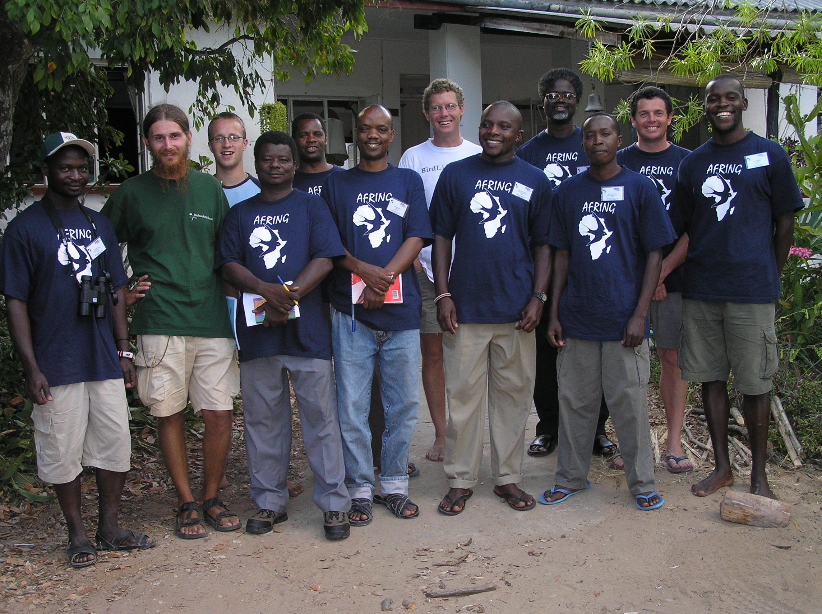

Delegates that participated in the first AFRING waterbird ringing course. From left to right: Titus S. Imboma, Simon Valle, Donall Cross, Alfred N. Ali, Sigawa Mgassi, Thade Clamsen, Colin Jackson, Bernard A. Amakobe, Samuel K. Nyame, Wamiti Wanyoike, Doug Harebottle and Hamlet Mugabe. Photo: Dieter Oschadleus
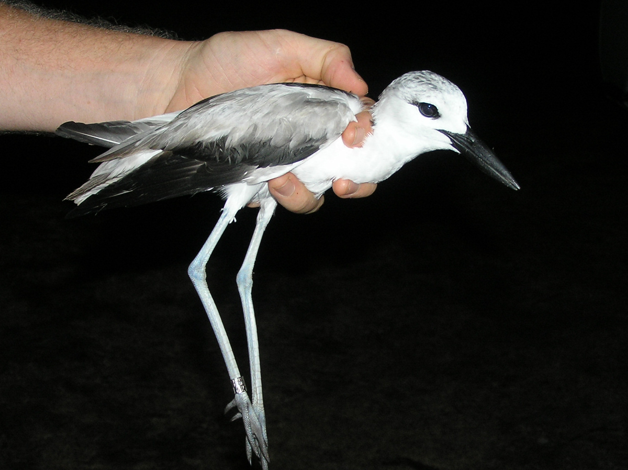
An immature Crab Plover caught at Mida Creek in September 2004. Photo: Doug Harebottle
APPENDIX 2

FINANCIAL STATEMENT

AEWA - AFRING
FINANCIAL STATEMENT: 01 FEB - 10 DEC 2004
EXPENDITURE |  | ZAR
SALARIES |  | 156,316.76
ADU RUNNING COSTS |  | 24,750.00
RESEARCH LEVIES |  | 24,892.61
CONFERENCE FEES |  | 1,581.28
TRAVEL |  | 52,301.31
PHOTOGRAPIC EXPENSES |  | 7,775.55
AFRING T-SHIRTS |  | 720.00
TOTAL EXPENDITURE | R | 268,337.51
INCOME |  | ZAR
AEWA 1ST PAYMENT |  | 254,246.39
TRAVEL REIMBURSEMENT |  | 8,569.72
FINAL PAYMENT (OUTSTANDING) |  | 10,000.00
TOTAL INCOME | R | 272,816.11

