DRAFT INTERNATIONAL SPECIES MANAGEMENT PLAN
FOR THE SVALBARD POPULATION OF
THE PINK-FOOTED GOOSE
Anser brachyrhynchus

Compiled by:
Jesper Madsen & James H. Williams
Aarhus University, Frederiksborgvej 399, postboks 358, DK-4000 Roskilde, Denmark
e-mail: jm@dmu.dk

With contributions from:
Sergey Dereliev, Fred Johnson, Ingunn Tombre, Eckhart Kuijken

With input from:
Boris Barov, Trine Bergholtz, Marco Brodde, Thomas Ceulemans, Preben Clausen, Fred Cottaar, Arild Espelien, Angus Middleton, Szabolcs Nagy, Sarah Roggeman, Niels Henrik Simonsen, Sander Smolders, Øystein Størkersen, Henrik Lykke Sørensen, Christine Verscheure

Milestones in the production of the plan:
Stakeholder workshop: 4-5 November 2010, Dragør, Denmark
First draft: May 2011, presented to experts
Second draft: August 2011, presented to the Range States and the AEWA Technical Committee
Final draft: October 2011, for submission to the 7th AEWA Standing Committee, 26-27 November 2011, Bergen, Norway

Geographical scope
This International Species Management Plan shall be implemented in the following countries: Belgium, Denmark, Netherlands and Norway.

Reviews
This International Species Management Plan should be reviewed and updated every 10 years (first revision in 2022).

Recommended citation: Madsen, J. & Williams, J.H. (Compilers). 2012. International Species Management Plan for the Svalbard population of the Pink-footed Goose Anser brachyrhynchus. AEWA Technical Series No. XX. Bonn, Germany.

Picture on the front cover:
Drawing on the inner cover:

The development of this International Species Management Plan has been sponsored by the
Norwegian Directorate for Nature Management

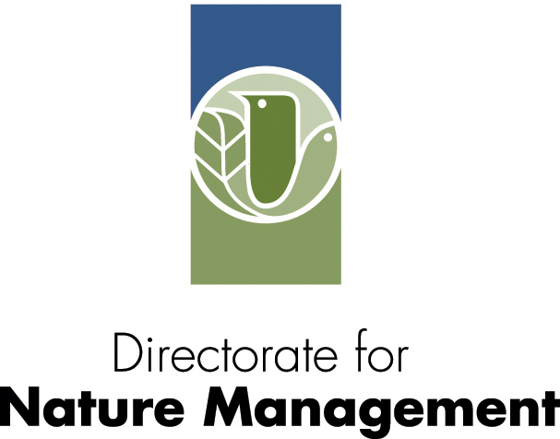
CONTENTS
Executive summary 3
1. Introduction 5
2. Biological assessment 6
2.1 Taxonomy and biogeographic populations 6
2.2 Distribution throughout the annual cycle 8
2.3 Habitat requirements 12
2.4 Population dynamics 13
3. Potential threats 15
4. Management issues 17
4.1 Agricultural conflict 17
4.2 Maintenance of range and connectivity 18
4.3 Overgrazing of Arctic tundra vegetation 18
4.4 Disease transmission/carriers 18
5. Policies and legislation relevant for management 19
5.1 Global Conservation status 19
5.2 International conventions and agreements 19
5.3 National laws, policies and ongoing activities 22
6. Framework for action 24
6.1 Goals and objectives 25
6.2 Management framework 33
6.3 Next steps 36
7. Bibliography and References 37
Appendix 1 - Ongoing monitoring activities 43
Appendix 2 - Adaptive Management: A brief guide and its application in the context of the Svalbard Pink-footed Goose Flyway Plan 44

Executive summary

In its Strategic Plan for 2009-2017, the African-Eurasian Waterbird Agreement (AEWA) is calling for means to manage populations which cause conflicts with certain human economic activities. The Svalbard population of the pink-footed goose Anser brachyrhynchus has been selected as the first test case for such an international species management plan to be developed. The pink-footed goose is classified as having a “Favourable Conservation Status” within Europe and a species of “Least Concern” using IUCN’s global Red List criteria. Numbers of the Svalbard-breeding population of pink-footed goose, although the smaller of the two biogeographical populations, have increased considerably over the past decades, reaching an estimated population size of 69,000 individuals in 2010. The continued growth of the Svalbard population is a conservation success story, yet its increasing population size, along with other goose species, has progressively brought them into conflict with agricultural interests as well as having other environmental and social implications.

A number of key management issues have been identified in relation to the Svalbard population but the most pressing is considered to be the potential for an escalation in agricultural conflicts. Agricultural conflicts have been registered throughout the population’s current flyway (Norway, Denmark, The Netherlands and Belgium), in particular with an increase in conflicts noted in Norway during spring, whilst in the southern range states, the conflicts caused by pink-footed geese are considered more stable. Furthermore, there is concern about degradation of vulnerable tundra vegetation in Svalbard due to increasing goose grazing intensities.

This document outlines the status of the population, the proposed goal, objectives and management framework for such an international species management plan based on the principals of adaptive management. This framework is intended to provide systematic monitoring and evaluation procedures of management actions and their impacts, in order to learn and adapt.

The goal of this international species management plan is primarily focused on the biological dimension of maintaining the Svalbard pink-footed goose in favourable conservation status, whilst taking into account economic and recreational interests. To achieve this goal of the following set of objectives have been established in consultation with national authorities and key stakeholders:

- Maintain a sustainable and stable pink-footed goose population and its range.
- Keep agricultural conflicts to an acceptable level.
- Avoid increase in tundra vegetation degradation in the breeding range.
- Allow for recreational use that does not jeopardize the population.

To attain the objectives the following key actions are regarded as essential:

- Implement an adaptive management framework and modelling concept for the flyway population.
- Maintain a population size of around 60,000 (range 40,000-70,000), with threshold population size to prevent population to collapse or irrupt.
  - Optimise hunting regulations and practises to regulate the population size if needed and in range states where hunting is permitted.
  - Prevent establishment of breeding colonies on mainland Norway.
- Ensure sustainable hunting where practised (at present in Norway and Denmark) and following ‘wise use’ principals, whilst ensuring that crippling rates are kept at a minimum level.
- Maintain and enhance spatial management to ensure that pink-footed geese can fulfil their ecological requirements throughout their annual cycle and allowing for their natural annual migration pattern. Any of the following measures should not jeopardise this:
  - Agri-environmental policies and subsidy schemes which adversely impact the above.
  - Land use and agricultural practices which unduly influence the ecological requirements of the geese.
  - Containment and exclusion tactics (provision of goose feeding areas, scaring, shooting) which unduly influence population distribution and dynamics.
  - Recreational activities and infrastructure development.
- Support the evaluation and optimisation of national and regional compensation/subsidy schemes and alternative non-consumptive methods to minimise agricultural conflicts in the range countries.
- Support ‘conflict mitigation’ through the development of national and regional management plans that promote recreational uses such as tourism and hunting (where permitted or relevant).
- Increase habitat available to pink-footed geese where there is no conflict (e.g. reduce disturbance on stubble fields in autumn or by restoration of grassland complexes which can reduce the feeding on crops or pastures).
- Collect systematic data on the impact and extent of tundra degradation due to goose foraging in Svalbard.

It should be noted that although a key objective is to maintain a target population, initially proposed as 60,000, this is based on current hypotheses and what is considered a desirable management outcome, subject to change based on mutual agreement by the range states, new model evaluations and learning as the adaptive process develops. In addition, as noted in the above key actions, non-consumptive methods of control are equally encouraged to alleviate agricultural conflicts.

Creating the appropriate organisational and management structures is viewed as critical to the success of an adaptive international species management plan for the Svalbard pink-footed goose. It is proposed that a Pink-footed Goose International Species Management Group is established with a clear mandate, comprising of representatives from the relevant national authorities for each range state, international stakeholder groups and international experts. National and local management groups may also be setup, as deemed necessary by each range state. The purpose of this integrated management structure is to facilitate, support and champion the development of an international policy framework, which guides both national and local management strategies based on the principals of adaptive management.

For each of the stated objectives and key actions of the international species management plan a set of management actions and verifiable indicators have been outlined. These will need to be adopted and implemented, over the course of time, once the objectives have been agreed upon. It is foreseen that the Pink-footed Goose International Species Management Group will act as a co-ordinating body that oversees and guides the overall adaptive management process. It will be the responsibility of relevant authorities and organisations within the range states to develop national and/or regional plans and decide how to implement suitable management actions to properly support the achievement of the international species management plan objectives. Furthermore, as management actions are evaluated, findings and learning should be shared and management actions adapted accordingly.
1. Introduction

The majority of goose populations breeding or wintering in Western Europe have increased considerably in numbers during recent decades (Madsen et al. 1999; Fox et al. 2010). This constitutes one of the major successes in European wildlife conservation history, ascribed to a combination of factors such as: a decrease in hunting pressure on the staging and wintering grounds, human persecution on the breeding grounds (e.g. spring hunting, egg collecting, culling of moulting geese), more refuge areas, improved winter feeding conditions and climate change (Kéry et al. 2006; Bauer et al. 2008). Geese are regarded as a highly valued recreational resource, beloved by birdwatchers and the general public and harvested by hunters in some countries. However, due to their concentration and foraging on farmland, the continued increase in numbers has also given rise to an escalation in agricultural conflict in the wintering and staging areas. In addition, in some Arctic regions, the increasing densities may result in an overexploitation of the vegetation causing long-term degradation of wet tundra habitats. Increasingly, it has been realised that successful management of these migratory populations requires international collaboration in order to achieve and maintain viable populations, whilst taking in to account socio-economic interests. Yet in Europe flexible and coordinated conservation-management instruments/plans are not available to cater for this. In North America, adaptive flyway management of waterfowl has been implemented for more than a decade, mainly focussing on harvest management but in some cases, management plans have also included issues related to agricultural conflict mitigation and prevention of tundra degradation.

The African-Eurasian Waterbird Agreement (AEWA) is calling for means to manage populations which cause conflicts with certain human economic activities. Hence, Target 2.5 of the AEWA Strategic Plan for 2009-2017, adopted by the 4th Meeting of the Parties in September 2008, aims at ensuring that in the next decade at least two quarry populations will be managed in accordance with international adaptive harvest management plans. At the same time, paragraph 4.3.4 of the AEWA Action Plan calls upon Parties to cooperate on developing species action plans for populations causing significant damage, especially to crops and fisheries.

To realize the first plan in response to these two legal provisions of AEWA, the Secretariat initiated the development of an international speckies management plan for the Svalbard-breeding population of the Pink-footed Goose (Anser brachyrhynchus). The reason for choosing this population as a subject of the first AEWA international species management plan is that the population is increasing, hunted in some of its range states and is also a cause of conflict with agriculture. The population size is relatively small and is currently estimated at c. 60,000 birds; it has grown from ca. 15,000 in the mid-1960s. The implementation of an international species management plan is also considered realistic, since the population range covers only four countries (Norway, Denmark, The Netherlands and Belgium) sharing common conservation policies and having well-enforced regulations in place, although there are recognised differences in nature and agricultural management practises. Not least, this population is one of the best monitored and studied populations and one which is facing very concrete management issues. The AEWA Technical Committee and the four range states fully supported the choice of the Svalbard Pink-footed Goose population.

The management planning process was launched with a stakeholder workshop co-chaired by Norway and Denmark. It took place on 4-5 November 2010 in Dragør, near Copenhagen and was attended by 21 participants from the four range states and several international organizations. Dr. Fred A. Johnson from the US Geological Survey was specifically invited to present the North American experience in adaptive harvest management and to assist in shaping such an approach for the Pink-footed Goose.

The present draft summarises the biological status of the population, potential threats and management issues, conservation status and, finally, the goal, objectives and framework for action proposed on the basis of the stakeholder workshop in November 2010 and subsequent dialogue with the participants.

2. Biological assessment

The population of Svalbard pink-footed geese is relatively well studied, with monitoring of several variables to support an international species management plan. For an overview of ongoing monitoring activities, see Appendix 1.

2.1 Taxonomy and biogeographic populations

Phylum: Chordata
Class: Aves
Order: Anseriformes
Family: Anatidae
Genus: Anser (Linnaeus 1769)
Species: Anser brachyrhynchus (Baillon 1834)
Biogeographical population: Svalbard

Two biogeographical populations of pink-footed geese (in short called ‘pinkfeet’) are recognised: The Iceland/East Greenland population wintering in the British Isles and the Svalbard population staging in Norway and wintering in Denmark, The Netherlands and Belgium (Fig. 1). On the basis of ring recoveries and resightings of neck-banded individuals, it has been estimated that there is an exchange of individuals between the two populations of 0.1- 0.7% per year (Ebbinge et al. 1984; Madsen et al. 1999). The exchange seems to increase in severe winters such as in 1995/96, 1996/97 and particularly 2009/10 when there was snow cover for an extended period from Denmark to Belgium (J. Madsen unpubl. data). Analyses of mtDNA from individuals from the two populations show that there is significant genetic differentiation between populations which confirms that there is a low rate of gene flow, highest from the Svalbard population towards the Iceland/Greenland population (Ruokonen et al. 2005).

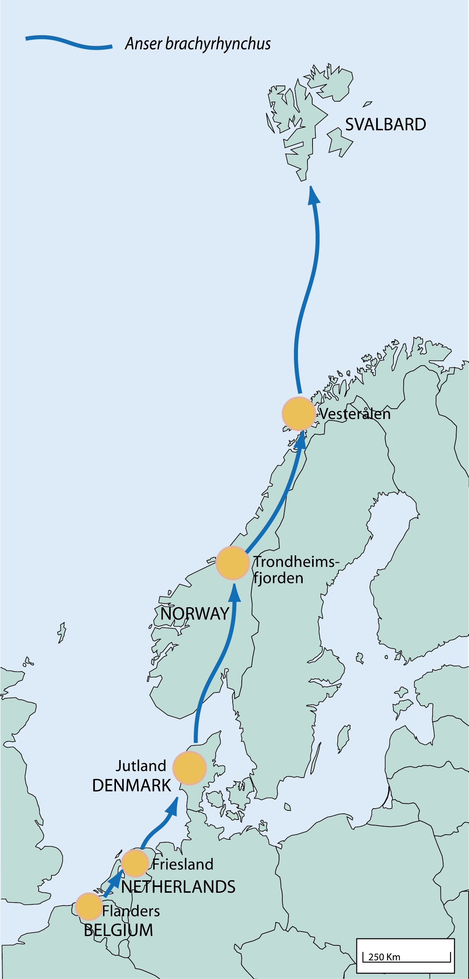

Fig. 1. The Svalbard pink-footed goose flyway and range states (copyright NINA, Norway).
2.2 Distribution throughout the annual cycle

Breeding: According to Løvenskiold (1963), Norderhaug (1971) and Mehlum (1998) most pinkfeet breed in western Svalbard (primarily Spitsbergen); searches for nesting geese in the eastern parts only gave negative results, despite the fact that suitable habitat was available. The lack of pinkfeet in the eastern parts was thought to be due to late snow melt. On the basis of existing data (compiled from literature sources, reports and personal communication with experienced observers), an update of the distribution of geese in Svalbard has recently been made, providing distribution maps of geese during pre-nesting, nesting, brood-rearing, moulting and post-hatching (Tombre et al. 2010). This shows that pinkfeet are primarily distributed in the lowlands on the west side of Spitsbergen and the fjord systems, but they also now breed in the east, mainly on the west side of Edgeøya, as well as dispersed in the north of Svalbard (Fig. 2).

Pinkfeet are now also numerous breeders on Bear Island in the Barents Sea; the exact numbers breeding on the island is uncertain but estimated to be in the hundreds (G. Bangjord pers. comm.). This is probably a recent phenomenon, since it was not previously an observed nesting area despite ornithological activities for several decades. It cannot be ruled out to have been overlooked as a scarce breeding bird in the past.

In 2003, the first record of a nesting pair of pinkfeet was found on Grindøya in Troms, northern Norway (Irgens 2004). Since then, single pairs have also been reported from another site in northern Norway (B. Ganter pers. comm.).

Moulting: Non-breeding pinkfeet moult flight feathers during a four week period from late June to late July. The main moulting grounds appear to be in eastern and north-eastern parts of Svalbard, i.e. outside the main breeding range (Glahder et al. 2007; Tombre et al. 2010).

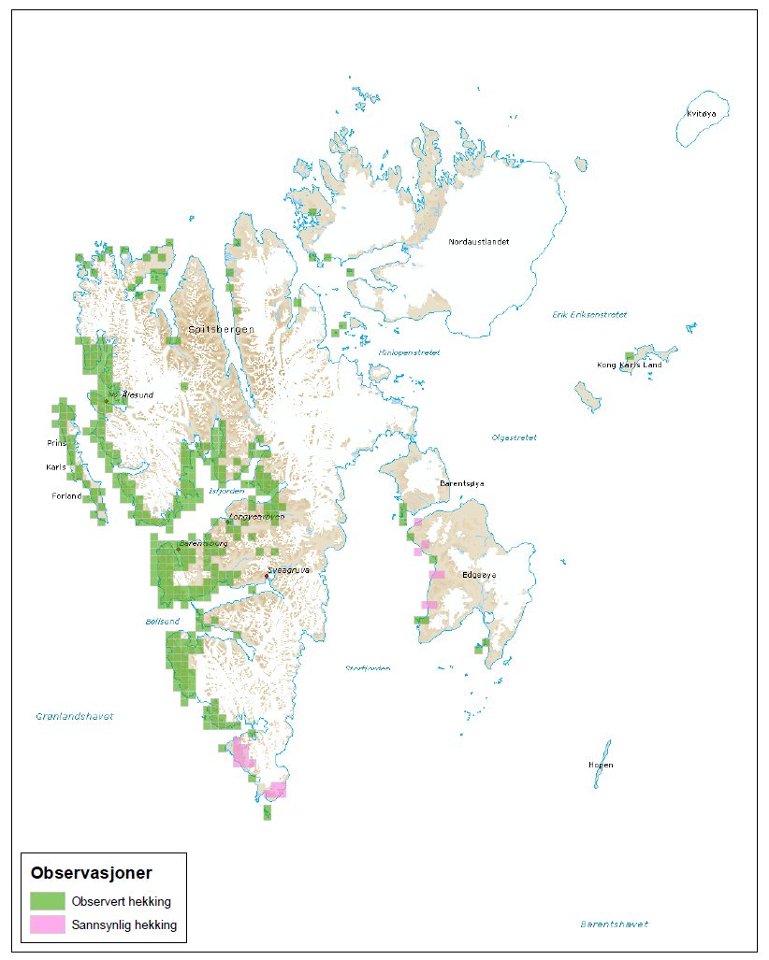
Fig. 2. Known nesting distribution of pink-footed geese in Svalbard, based on geo-referenced information and expert knowledge. Green: observed nesting; pink: probable nesting. From: http://goosemap.nina.no (Tombre et al. 2010).

Autumn migration: Around mid September pinkfeet depart from Svalbard and migrate to autumn staging areas in Trondheimsfjorden in mid Norway. Some flocks fly, more or less, directly to staging areas in west Jutland, Denmark or even Friesland in the Netherlands (Fig. 3). Flocks of pinkfeet have been observed making short stops in Vesterålen in north Norway, Helgeland and in south Norway. In south Sweden pinkfeet were previously scarce, but in recent years up to 750 geese (2008) have been recorded during October (Nilsson & Månsson 2010). The vast majority of pinkfeet migrate along the west coast of Norway, but some flocks have been observed migrating through the Baltic (L. Nilsson & J. Madsen unpubl. data). Flocks can stay in Norway until late November, but depart with the first snow cover.

Wintering: The wintering grounds are divided between Denmark, The Netherlands and Belgium, but the exchange between sites in the wintering areas is highly dynamic, depending on several factors such as weather conditions, levels of disturbance and food availability on the staging grounds (Fig. 3). In Denmark their numbers peak during October, but some flocks (increasingly over recent years) may stay behind and remain throughout the winter, depending on snow cover. In the Netherlands numbers peak during October-November, after which the majority migrate on to the Oostkustpolders, Flanders in Belgium (Kuijken & Meire 1987, 1996; Meire & Kuijken 1991; Meire et al. 1988). Pinkfeet show a high site fidelity for this part of the coastal Polders, with only occasional occurrence in the IJzer valley in some winters. In the Oostkustpolders numbers peak during December-early January, followed by an early and fast northwards migration (Kuijken et al. 2005; Kuijken & Verscheure 2008). In mild winters the majority move northwards to Denmark during January and in February-March the population is concentrated along the west coast of Denmark (Madsen et al. 1999). In harsh winters (e.g. 1996) significant numbers can return from early spring staging in Denmark to Flanders (Kuijken & Verscheure 2007). Pinkfeet occur in small numbers (in tens or hundreds) along the German Wadden Sea coast line (H. Kruckenberg pers. comm.) as well as in Mecklenburg where they mix with flocks of Bean Geese Anser fabalis and White-fronted Geese Anser albifrons (T. Heinecke pers. comm.). Historically pinkfeet wintered in large numbers along the German Wadden Sea coasts and on some islands; however the sites were abandoned during the 1950s-1970s (Prokosch 1984).

Spring migration: Before c. 1990, pinkfeet stayed in Denmark until the first week of May and then migrated non-stop to the spring-staging grounds in Vesterålen and Lofoten in north Norway. However, since then, increasing numbers of geese have discovered and exploited areas in Trondheimsfjorden in mid Norway (Fig. 3). The start of the spring migration from Denmark has advanced by more than a month, which has been enhanced by the advancing spring (Madsen et al. 1999; Tombre et al. 2008). Nowadays, the majority of the population stops in Trondheimsfjorden during a 2-4 week period, with numbers peaking between late April and mid May, before their onward migration to Vesterålen. Vesterålen is used during May, with peak numbers during the second and third week. The majority leave Vesterålen for Svalbard around 15-22 May. In Svalbard pre-nesting stopover areas are found along the southwest coast of Spitsbergen, with Adventdalen being the site with the highest numbers. Geese arrive around mid May and peak numbers are observed around 20-25 May, after which they disperse to the nesting grounds (Glahder et al. 2006). Flocks of pinkfeet are observed migrating northwards through the Baltic, but it remains to be resolved whether this is a regular phenomenon and how many birds are involved.

Generally, as the population has increased in size (see below), pinkfeet have expanded their use of sites on the staging areas as well as on the wintering grounds, although they have remained very faithful to their traditional core areas. There is evidence of increasing inter-species competition between pinkfeet and other goose species resulting in local displacement; in autumn with Greylag Geese Anser anser over spilt grain resources in stubble fields in Norway and, in particular, Denmark (Madsen 1985a, 2001, unpubl. data) during autumn, winter and spring with Barnacle Geese Branta leucopsis competing for grass in pasture fields (Madsen et al. in prep.) and with White-fronted Geese during winter (Kuijken & Verscheure 2008).

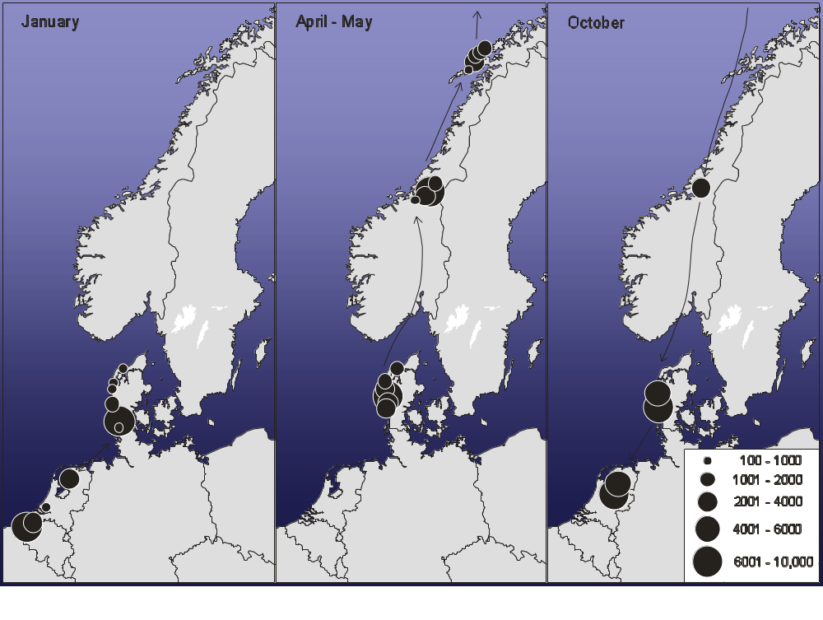

Fig. 3. Distribution of pink-footed geese during the non-breeding period, based on counts of flocks in the range states (data from the late 1990s) (Madsen et al. 1999).

2.3 Habitat requirements

Breeding: In Svalbard pinkfeet nest on islets off the coast and on inland tundra. High nest concentrations are found on cliff sides beneath grassy slopes, especially close to seabird colonies (Nyholm 1965; Norderhaug et al. 1964; Mehlum 1998), but also on south facing slopes which become free from snow early (Madsen et al. 2007; Wisz et al. 2008a). On arrival to Svalbard, pinkfeet primarily feed on rhizomes and roots which they pull out of wet moss carpets (so-called grubbing) (Fox & Bergersen 2005; Fox et al. 2006). During nesting territorial birds primarily feed in moss fens and after hatching families feed on emerging vegetation in flood plains, moss fens and mesic tundra areas (Fox et al. 2007, 2008). During moult (non-breeding geese) flocks congregate along undisturbed coastlines, on large lakes and rivers where they can feed on wetland vegetation in proximity to open water. During moult and post-hatching pinkfeet are extremely wary, avoiding sources of disturbance (people on foot) at a distance of 1-2 km (Madsen et al. 2010).

Non-breeding season: A site used by pinkfeet is characterised by a night roost which is usually a lake, a sheltered bay or tidal mudflats which provide safety against mammalian predators and human disturbance (including hunting) and a surrounding open landscape where they can feed during daytime. However, in the Oostkustpolders, Belgium, pinkfeet almost exclusively roost on the wet grasslands. This is probably due to the lack of red foxes until the mid 1980s; so this traditional behaviour was fixed before red foxes gradually expanded their range from eastern parts of Flanders since the 1990s. Also the low intensity of human disturbance as a result of the national goose shooting ban since 1981/82 is a key factor in the pinkfeet roosting and foraging behaviour, as well as the designation of protected areas (Kuijken 2005; 2010, Kuijken et al. 2005, 2006; Kuijken & Meire 1987; Kuijken & Verscheure 2005, 2007, 2008; Meire & Kuijken 1991). As pinkfeet became less shy due to the absence of hunting, they now can utilise feeding grounds closer to roads and buildings, resulting in increased carrying capacity of the traditional wintering grounds (Kuijken et al. 2001).

The foraging habitat varies with the season (Madsen 1984; Fox et al. 2005). During autumn in Norway and Denmark pinkfeet primarily forage on stubble fields, in The Netherlands on grassland, but recently also on waste maize (Cottaar 2009). In Belgium pinkfeet always preferred permanent grasslands (Kuijken 1969, 1975, 1981) but since the 1990s they gradually increased the use of winter wheat and sown grass (Lolium multiflorum) for silage in early spring. These are quite vulnerable crops, often developed on former grasslands within the traditional goose wintering grounds (Courtens et al 2005). In recent years pinkfeet have adapted to forage on maize stubble and harvested potato fields (or fields where harvest was impossible due to extreme wet or cold weather conditions). Afterwards they return to mainly grassland use (Kuijken & Verscheure 2008 and in prep.). This new behaviour can reduce the intensity of grazing on more vulnerable crops, but the presence of grasslands remains the primary condition.

During winter in Denmark they use a mixture of grasslands and winter cereal fields, the latter especially during cold spells (Therkildsen & Madsen 2000). During spring (in both Denmark and Norway) pinkfeet feed on pastures and, as sowing of spring cereal commences, on newly sown cereal fields where they pick the grain (Madsen 1986; Madsen et al. 2007). In Trondheimsfjorden in Norway pinkfeet also feed on stubble fields (harvested in the previous autumn), as well as un-harvested fields (too wet to be harvested in the previous autumn) which are ploughed during spring.
Pinkfeet prefer to feed within a few kilometres from roost sites, but in extreme cases they can fly long distances, up to 20-30 km between roosts and foraging areas. Because the geese are generally very shy and occur in big flocks, they need to have access to multiple adjacent feeding areas in case of disturbance. During their stay in Vesterålen, in spring, pinkfeet forage on a narrow stretch of lowland pastures and they respond behaviourally; tolerating human activity, probably due to their high energy and nutrient demands prior to breeding (Madsen 1998). However, due to increasing agricultural conflicts (see below) with farmers scaring off geese, pinkfeet have become shyer; hence not able to utilize the small fields efficiently and ultimately unable to build-up energy stores (Madsen 1995; Madsen et al. in prep.).

2.4 Population dynamics

Survival: Based on an analysis of ring recoveries, Ebbinge et al. (1984) calculated that the annual adult survival rate of pink-footed geese increased from 0.71 during 1955-1974 to 0.85 during 1975-1983. The increase in survival was ascribed to protection from hunting in the Belgian and Dutch wintering grounds (gradually implemented during 1968-1976). Based on capture/resightings of neck-banded individuals, Madsen & Noer (1996) estimated annual adult survival rate was 0.84 during 1990-1996. Subsequent capture-resighting analyses has given similar estimates (Madsen et al. 2002; Kéry et al. 2006). Signs of a decrease in annual survival shown in Madsen et al. (2002) was not confirmed in the longer time series, hence there is no suggestion of a recent change in adult survival (Kéry et al. 2006). In years with mild winters the survival rate increases. On a seasonal basis mortality is highest during autumn and summer (Madsen et al. 2002).

Productivity: Age counts (random counts of the number of juveniles compared to older geese in the flocks) and recording of brood sizes in family groups have been carried out almost every autumn in The Netherlands and Denmark since 1980. The proportion of juveniles has varied between 5% and 30% annually (average of 14.3%), with a significant decrease with increasing population size (Trinder & Madsen 2008). Average brood size (recorded during 1980-85 and from 1991 onwards) has also declined significantly with increasing population size, with an average of 1.91 juveniles per family during autumn. Studies on the breeding grounds have shown that snow cover at the start of egg laying (late May) is a critical determinant of the number of geese which nest, their nest success, the number of young produced and ultimately the proportion of juveniles in the population (Madsen et al. 2007; Madsen unpubl. data). In years with early snow melt the number of young produced may thus be tenfold the number produced in a late season.

Population size and trends: The population seems to have increased from approximately 10,000-12,000 individuals in the 1930s-1950s to 15,000-18,000 in the 1960s-mid 1970s, from 15,000-18,000 to 25,000-30,000 individuals in the 1980s, from 25,000-30,000 to 32,000-40,000 in the 1990s, and from around 40,000 to 69,000 in the 2000s (Madsen 1982, Ganter & Madsen 2001, J. Madsen unpubl. data)(Fig. 4). Since the mid 1960’s, the average annual growth rate has been c. 3.1%, with no change over time (Trinder & Madsen 2008). The fact that both proportion of juveniles and brood sizes have decreased with increasing population sizes suggest some sort of density dependent regulation on productivity, but not sufficient to be apparent at the population growth rate which has not changed with increasing population size (Trinder & Madsen 2008).

On the basis of the above findings, two predictive population models were run on the basis of data for the period 1980-2005: a density-independent and density-dependent model. The former predicted a population exceeding 120,000 individuals after 25 years; the latter a stabilising population size at around 60,000 individuals (Trinder & Madsen 2008). Since 2005 the population has continued to grow, until now at a rate exceeding the expectations from the density-independent model.

Hunting: The pink-footed goose is a quarry species in Norway, including Svalbard, and Denmark. In Svalbard a few hundred pinkfeet are shot each year. In mainland Norway around 500 pinkfeet were shot annually in the start of the 2000s. Since then the bag has increased to reach a hitherto peak in 2008 with 2600, of which 84% were shot in Nord-Trøndelag (Statistics Norway http://www.ssb.no/english/). In Denmark the bag has varied between 2000-3000 in the 1990s and 2000s. However, in 2008/09 and 2009/10 the bag increased to c. 5,500 per year (Danish Hunting Bag Statistics, T. K. Christensen, NERI, unpubl. data). This was probably related to the fact that higher numbers of pinkfeet stayed in west Jutland during late autumn than usual (J. Madsen, NERI, unpubl. data), exposing geese to hunting.

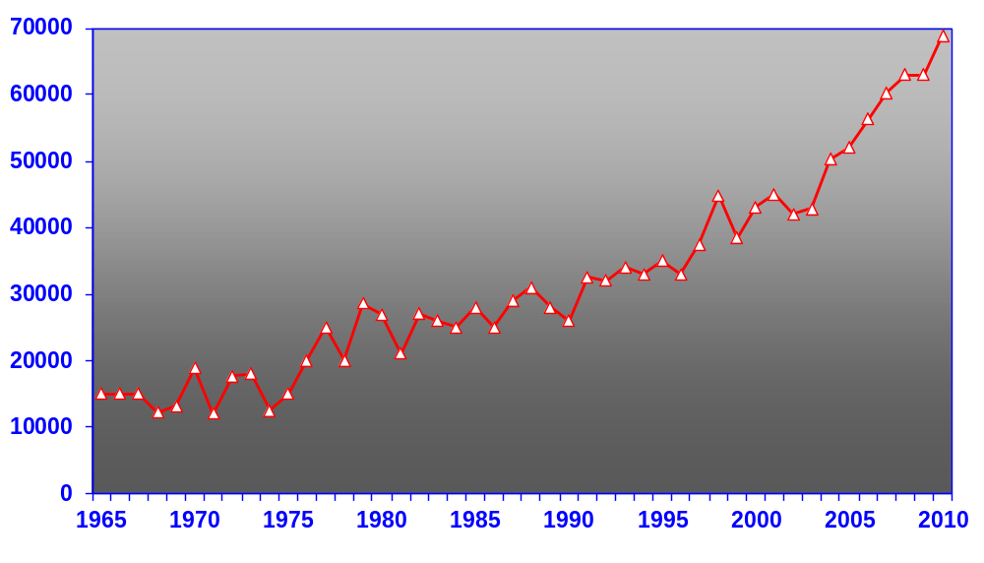

Fig. 4. Development in the size of the Svalbard population of pink-footed geese, 1965-2010 (numbers during autumn/winter).

3. Potential threats

Potential threats to the pink-foot population have been categorised according to sources and perceived root causes (Table 1). Potential consequences have also been listed. However, since the Svalbard population of pinkfeet continues to grow, the overall assessment is that none of these threats are significantly impacting the population level at the moment, although they may become important in the longer-term future.

This section is not intended as a full risk assessment but merely outlines the anticipated actual / potential threats that the management framework may need to cope with. These threats may also vary between range states. Since the status of the population is dynamic the management framework will need to incorporate various forms of risk assessment at the flyway and regional levels. A key part of the risk assessment will require stakeholder input (there are always differing perceptions of risk) as well as monitoring to enable management plans to adapt to these changing threats. In addition some threats may be seen as opportunities in certain circumstances and time scales e.g. climate change could also increase the breeding habitat available due to a decrease of snow and ice cover, whilst increasing red fox numbers may naturally regulate the population.

Table 1. Potential threats to the Svalbard population of pink-footed goose, root causes and possible consequences.

Potential threat | Root causes | Possible consequences
Habitat loss
Arctic habitat succession due to northward moving shrub and taiga | Climate change | Decrease of breeding range  Decrease of population
Mismatch of breeding cycle to resource availability and quality | Climate change | Decrease of breeding output
Sea level rise | Climate change | Loss of winter/spring feeding habitat, connectivity  Increased competition for food  Decrease in fitness
Land use change | Climate change, economic policies, agricultural intensification or abandonment, with regional variances (e.g. change of traditional permanent wet grasslands into fields by drainage and ploughing in Belgium, or overgrowing of grassland habitat in Norway) | Loss of winter/spring feeding habitat, connectivity  Increased competition for food  Decrease in fitness
Physical development | Economic policies  (urban and industrial development in formerly open landscapes causing physical loss and disturbance) | Loss of winter/spring feeding habitat, connectivity  Increased competition for food  Decrease in fitness
Nature restoration | Nature conservation policies, water runoff mitigation (local level projects) | Loss of autumn and spring feeding grounds  Loss of connectivity  Increased competition for food  Decrease in fitness
Inter-species competition | Increase in overlapping population sizes, changing distributions | Loss of feeding habitat  Loss of connectivity  Increased competition for food  Decrease in fitness
Hunting
Harvest pressure | Lack of regulatory control on hunting (adequate monitoring and regulatory feedback) | Uncontrolled population decline
Crippling | Hunting performance | Uncontrolled extra mortality  Long-term health effects
Illegal hunting | Lack of regulatory control on hunting activities | Uncontrolled population decline Crippling
Hunting disturbance | Too high hunting intensity (duration & spatial organisation) | Displacement of geese from resources increased competition  Energetic costs, decrease in fitness, which affect population dynamics
Disturbance
Recreational activities | Numerous types of human activities documented with varying degree of impact (e.g. increasing tourism in the Arctic,  water sports, angling, bird watching, dog walking) | Displacement from feeding or roosting habitat  Energetic costs, decrease in fitness  Nest failure
Intentional scaring | Increasing agricultural conflict | Possible loss of body condition  Loss of feeding habitat and connectivity  Energetic costs, decrease in fitness
Diseases
Avian influenza  Parasites, other diseases | Contact with high densities of wild ducks and poultry  Climate change | Die-off of birds  Population decline, risk to other bird populations
Natural predators
Red fox | Recovery of potential predator populations (e.g. in W. Flanders) | Displacement from inland roost sites and feeding grounds  Egg predation (N)  Energetic costs, decrease in fitness
White-tailed eagle | Recovery of potential predator populations | Adult mortality  Energetic costs, decrease in fitness
Polar bear | Climate change; changed behaviour of bears | Egg predation in nesting colonies  Energetic costs, decrease in fitness

4. Management issues

The following issues were identified as problematic and requiring management measures to be put in place.

4.1 Agricultural conflict

Increasing agricultural conflict has been registered in most of the present range states during recent decades; at present, conflicts are increasing in Norway in particular during spring, whereas in southern range states, the conflicts caused by pinkfeet are considered more stable. In Denmark conflicts have been partly alleviated due to the changed spring migration schedule by the population (Table 2). Nevertheless, agricultural conflicts remain a cause of concern with considerable economic costs. The changing habits of the geese and the continued population expansion make the situation dynamic.

Table 2. Agricultural conflicts caused by pink-footed geese in the four range states and management measures taken to alleviate the conflict.

Country | Crops affected | Relative scale of problem | Management measures by authorities
Norway | Pasture grass (N and Mid N) / new-sown cereal (mid-N);  spring | High/Medium (increasing) | Compensation to farmers to allow geese feeding  Increase hunting pressure to reduce population size
Denmark | New-sown cereal / winter cereal;  spring | Medium (decreasing) | Support with scaring devices; baiting with cereals to keep geese away from crops
Netherlands | Pasture grass;  Autumn/winter | Medium  (stable but small in comparison to other goose populations) | Compensation for damage; accommodation areas for geese
Belgium | Winter cereals;  winter | Medium  (trend uncertain) | Compensation for damage available; awarded on case-by-case basis (change from juridical to administrative procedure)

4.2 Maintenance of range and connectivity

The pink-foot is traditionally extremely faithful to a limited number of sites and regions. Nevertheless, during the last couple of decades the population has undertaken several changes in migratory routes and times and the use of staging grounds. Probable reasons for these changes are: scaring activities due to agricultural conflicts in certain regions such as Vesterålen in Northern Norway, disturbance due to hunting (Denmark in particular) and, more recently, nature restoration of important autumn staging areas which used to be farmland utilized by the pinkfeet, causing geese to leave Denmark and migrate onwards to The Netherlands. Range expansion and changes in migration schedules have probably also been caused by increase in population size, inter-species competition with other species such as greylag geese and barnacle geese as well as climate change. In some cases, the changes have caused a rapid escalation in agricultural conflicts. For example intensified conflict in The Netherlands during the autumn in the 1990s was due to earlier departure from Denmark, and increasing conflict in mid Norway during the last two decades is partly due to climate change induced earlier departure from Denmark in spring.

In a recent spatial prediction of the winter/spring habitat availability of pinkfeet (Wisz et al. 2008a) it was concluded that there is still room of further distributional expansion within the known range. However, this does not take into account fragmentation of original habitat types such as wet grasslands which are turned into less favourable crop types in Flanders, wind turbines in the open landscape or effects of biotic interaction with other species of geese. These factors have to be considered in future evaluations.

4.3 Overgrazing of Arctic tundra vegetation

During the last 10 years increasing signs of the impact of foraging pinkfeet on tundra vegetation in Svalbard has been observed. This is particularly due to the grubbing for roots and rhizomes in the wet moss carpets whereby geese pull out moss and food plants. This may in some areas create holes or craters which appear to regenerate at variable rates depending on wetness, patch size and the plant community (Speed et al. 2010); slowed down by the fact that geese year after year return to the same patches, grubbing on the edges of open patches. In other areas the foraging activity may cause a shift in vegetation composition with a decrease in moss cover and an increase in graminoids (grasses and sedges)(van der Wal et al. 2009). The extent of grubbed areas seems to be increasing with the increment in population size (Speed et al. 2008), although monitoring of this development is currently lacking.

4.4 Disease transmission/carriers

Avian influenza: pinkfeet have very low prevalence of pathogens; however, increasing prevalence during late autumn and winter suggested that pinkfeet are in contact with dabbling ducks which have a higher prevalence (Hoye et al. 2011). There have been no reports of die-offs of pinkfeet which could be related to diseases.

Campylobacter bacteria: A localised outbreak in a local human community in mid Norway was suggested to be caused by pinkfeet using a drink water reservoir as a roost site, with consequent transmission of Campylobacter to the human population. Even though the causal relationship was not demonstrated the local authorities took the initiative to scare away the geese from the site as a precautionary measure.

5. Policies and legislation relevant for management

A summary of international conservation and legal status of the Svalbard population of pink-footed goose is provided in Table 3.

5.1 Global Conservation status

The pink-footed goose has been categorised a species of “Least Concern” using IUCN’s global Red List criteria, although no distinction is made between the Svalbard-breeding population and the much larger Icelandic/Greenlandic population (IUCN 2010).

5.2 International conventions and agreements

5.2.1 Convention on the Conservation of Migratory Species of Wild Animals (CMS)

The pink-footed goose is listed in Appendix II of the CMS. This appendix refers to migratory species which have an unfavourable conservation status or would benefit significantly from international co-operation organised by tailored agreements. Range states are obliged to work towards maintaining populations in a favourable conservation status.

5.2.2 The Agreement on the Conservation of African-Eurasian Migratory Waterbirds (AEWA)

AEWA is a regional agreement negotiated under article IV of CMS and operates with a flyway approach to conservation of populations. Parties to the Agreement shall take co-ordinated measures to maintain migratory waterbird species in a favourable conservation status or to restore them to such a status (AEWA article II, paragraph 1). To this end, they shall apply within the limits of their national jurisdiction the measures prescribed in Agreement, together with the specific actions determined in the Action Plan. Any taking of migratory waterbirds must be conducted on a sustainable basis, taking into account the conservation status of the species concerned over their entire range as well as their biological characteristics.

According to the AEWA Action Plan (Annex 3 to the AEWA Agreement Text), parties shall cooperate with a view to developing single species action plans for populations which cause significant damage, in particular to crops. The Agreement secretariat shall coordinate the development and harmonization of such plans. Furthermore, according to the AEWA Strategic Plan 2009-2017 (Objective 2, Target 2.5), international harvest management plans shall be developed and implemented for two quarry species/populations by 2017. The Svalbard pink-footed goose has been selected as the first case.

Under the AEWA, the Svalbard population of the pink-footed goose is listed with a status in Column B, category 1 (population between 25,000 and 100,000; not being considered at risk).

The range states of the Svalbard population of the pink-footed goose, Belgium, Denmark, Netherlands and Norway (as well as Germany and Sweden), are all parties to AEWA and CMS.

5.2.3 Ramsar Convention on Wetlands (1971)

The Ramsar Convention is an inter-governmental treaty that provides the framework for the conservation and wise use of wetlands and their resources through local, regional and national actions and international cooperation, as a contribution towards achieving sustainable development. The Convention requires that each contracting party designates at least one suitable wetland within its territory for inclusion in the List of Wetlands of International Importance.

The range states of the Svalbard population of the pink-footed goose, Belgium, Denmark, Netherlands and Norway (as well as Germany and Sweden), are all parties to the Ramsar Convention.

For each range state, the number of Ramsar sites for which pink-footed geese are part of the designation criteria has been listed (Table 4).

5.2.4 EU Directive on the conservation of wild birds (EC/2009/147)

The Directive relates to the conservation of all species of naturally occurring birds in the wild state in the European territory of the Member States to which the Treaty applies. It covers the protection, management and control of these species and lays down rules for their exploitation. Member States shall take the requisite measures to maintain the population of species at a level which corresponds in particular to ecological, scientific and cultural requirements, while taking account of economic and recreational requirements, or to adapt the population of these species to that level (Article 2).

The pink-footed goose is listed in Annex II/2: Owing to their population level, geographical distribution and reproductive rate throughout the Community, the species listed in Annex II may be hunted under national legislation. Member States shall ensure that the hunting of these species does not jeopardize conservation efforts in their distribution area. “2” refers to that the species may be hunted only in the Member States in respect of which they are indicated (in case of pinkfeet: Belgium, Denmark, Ireland, UK). Any member state can issue derogations under Article 9 to deviate from the general protection regime, e.g. in cases of agricultural conflict.

For each range state, the number of EU Special Protection Areas for which pink-footed geese were part of the designation criteria has been listed (Table 4).

Table 3. Summary of international conservation and legal status of the Svalbard population of pink-footed goose.

Global IUCN Red List status | European and EU Status | SPEC  category | EU Birds Directive Annex | Bern Convention Annex | Bonn Convention Annex | AEWA | CITES
Least concern | Favourable | N/A | Annex II/2 | Appendix III | Appendix II | Column B, category 1 | Not listed

Table 4. Site and habitat protection measures in each of the four range states according to international regulations (EU Special Protection Areas and Ramsar sites).

Country | Number of sites of international importance for Pink-footed Goose (more than 1% of flyway pop.) and protection status of these sites
Norway | Seven areas of international importance are designated as IBAs with partial coverage of nature protected areas. One site, Nordre Øyeren in south Norway, is a Ramsar site.
Denmark | In total, 16 Special Protection Areas have been designated partly due to occurrence of pink-footed geese. Of these, 15 are also designated as Ramsar sites with pink-footed geese as part of the designation criteria. Generally, sites include roosts and some foraging areas; however, rarely the entire farmland foraging areas have been included. In most of the areas, shooting free areas are found, especially of roost sites.
Netherlands | Natura 2000 area for non-breeding birds: Witte en Zwarte Brekken, Oudegaasterbrekken en Fluessen, Sneekermeer and Frysian IJsselmeer areas
Belgium | The majority of the traditional pink-foot wintering grounds in the Oostkustpolders are situated in two SPAs (and partly in one SAC under Habitat Directive); the recent but temporary use of croplands occurs mostly outside the Natura 2000 sites. Both SPA’s are partly protected as nature reserve. Two Ramsar sites included in SPAs (Zwin area and IJzer valley) are of less importance for pinkfeet. Pinkfeet are considered as ‘ambassadors’ of the Flemish polder landscape  The designation of the coastal polders as Ramsar site (because of international importance for pinkfeet a.o.) has been proposed but was never realised.

5.3 National laws, policies and ongoing activities

5.3.2 National nature conservation policies and hunting status

It is beyond the scope of this framework document to present all national laws, policies and management plans of relevance to pink-footed geese. A summary is provided in Table 5.

A brief overview of on-going management plans and actions is provided in Table 6.

Table 5. National conservation, hunting status and seasons and bag statistics for pink-footed geese in the range states.

Country | Status in national Red Data book | Hunting Status | National open season^{(a)} | Regional open season | Annual bag size | Annual  Statutory Bag  Statistics | Responsible  national authority
Norway - Svalbard | Least concern | Ho | _ | 20.08 – 31.10 | 200 – 500 | Yes | Governor of Svalbard
Norway – mainland | Not assessed | Ho | 10.08 – 23.12 | - | 2,600  (2008) | Yes | Ministry of the Environment
Denmark | National responsibility species | Ho | 01.09 – 31.12 / 31.01 (at sea) | _ | c. 5,500  (2008/09 & 2009/10) | Yes | Ministry of the Environment
Netherlands | not listed | P | Not applicable | _ | _ | _ | Ministry of Economic Affairs, Agriculture & Innovation
Belgium | Protected,  no red list for wintering birds | Hc | Closed | _ | _ | _ | Flemish Government: Ministry of Environment, Nature and Culture

Key:
P = protected & not huntable according to EU Birds directive annex II/2;
Ho = species is huntable and open season declared,
Hc = huntable species but no open season

Notes:
^{(a)} in none of the countries where hunting is allowed do bag limits apply
Table 6. Brief overview of management measures currently underway, which affect pink-footed geese in range states.

Country | Title | Category | Hunting actions | Habitat / species actions | Other actions
Norway - Svalbard | Goose Map: a mapping tool to support management | R | _ | _ | r, s, p
Norway – mainland | Norwegian Agricultural Authority subsidy agreement (Nordland & Nord-Trøndelag) | R | _ | a, d, c | r, s, e
Norway – mainland | Regional management plan for pink-footed geese in Nord-Trøndelag | I | c | d, c | r, p, s
Denmark | West Jutland feed baiting scheme | R | _ | c, d | r, p, s
Denmark | National Crippling Action Plan | R | o | m | r, p, s
Netherlands | Fauna Management Policy Framework – for overwintering geese & widgeon including compensation for crop damages by Faunafonds | I | g | a, d, s, c | s, p
Belgium | Flanders Bird Atlas for location of windfarms | I | g | h, a, d, s, c | r, s, p, e

KEY:
Category:  R = restricted measure,  I = integrated management plan.  Action status:  C = completed,  P = in progress,  F = planned in future. | Hunting actions:  g = general hunting ban,  b = bag limits,  r = regional hunting ban,  s = shortened hunting period,  d = limit to hunting days,  h = limit to hunting hours,  c = coordinated regional hunting management,  o = other
Habitat/species actions:  h = habitat improvement,  a = modifications to agricultural activity,  m = minimisation of adverse effects of harvesting, roads, etc.,  p = predator control,  d = prevention of disturbance,  s = site safeguard,  c = compensation/subsidy schemes and other measures e.g. intentional scaring to reduce agricultural conflicts  o = other. | Other actions:  r = research,  p = public awareness,  e = education campaigns,  s = survey,  census and monitoring,  o = other.

6. Framework for action

As outlined in the scope, this document is a first step in the process of implementing an adaptive international species management plan which, in reference to Appendix 3, requires setting up a management framework. This includes agreement on the following goal, objectives and key actions, captured at the first international stakeholder workshop (November 2010) and subsequently expanded upon. In Table 7 the steps in the process are outlined, and the current position is indicated.

Table 7. Operational steps in the adaptive management process. From Williams et al. (2009). The present draft document covers the first steps in the Set-up phase.
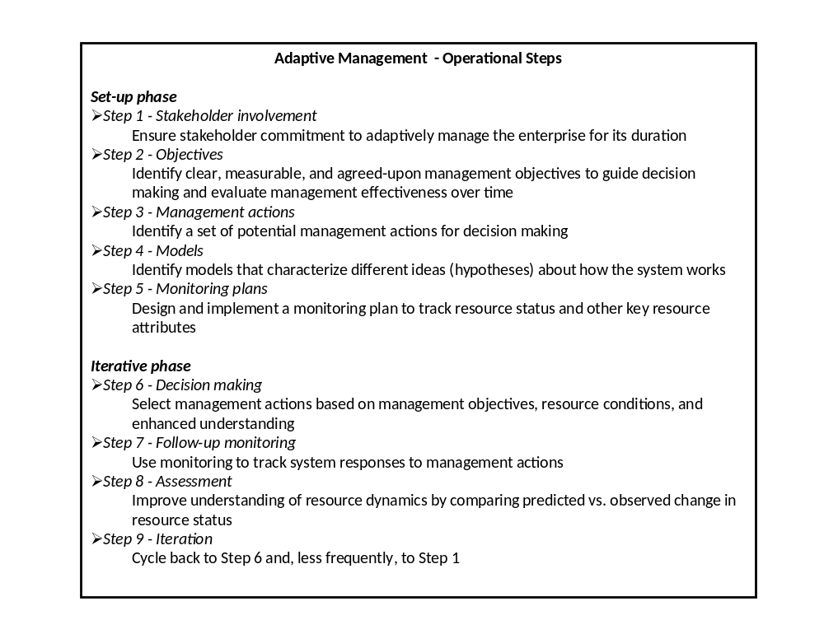

6.1 Goals and objectives

Goal: To maintain the favourable conservation status of the Svalbard pink-footed goose population at flyway level while taking into account economic and recreational interests.

The intent of this international species management plan is primarily focused on the biological dimension of maintaining the Svalbard pink-footed goose in favourable conservation yet it also recognises a social dimension along with the consequences of wildlife-human interaction. The overall goal emphasises that these dimensions need to be addressed. To achieve this goal the following set of objectives have been established in consultation with national authorities and key stakeholders.

Objectives:
- Maintain a sustainable and stable pink-footed goose population and its range.
- Keep agricultural conflicts to an acceptable level
- Avoid increase in tundra vegetation degradation in the breeding range.
- Allow for recreational use that does not jeopardize the population.

To attain the above objectives the following key actions are essential:
- Implement an adaptive management framework and modelling concept for the flyway population.
- Maintain a population size of around 60,000 (range 40,000-70,000), with threshold population size to prevent population to collapse or irrupt.
  - Optimise hunting regulations and practises to regulate the population size if needed and in range states where hunting is permitted.
  - Prevent establishment of breeding colonies on mainland Norway.
- Ensure sustainable hunting where practised (at present in Norway and Denmark) and following ‘wise use’ principals, whilst ensuring that crippling rates are kept at a minimum level.
- Maintain and enhance spatial management to ensure that pink-footed geese can fulfil their ecological requirements throughout their annual cycle and allowing for their natural annual migration pattern. Any of the following measures should not jeopardise this:
  - Agri-environmental policies and subsidy schemes which adversely impact the above.
  - Land use and agricultural practices which unduly influence the ecological requirements of the geese.
  - Containment and exclusion tactics (provision of goose feeding areas, scaring, shooting) which unduly influence population distribution and dynamics.
  - Recreational activities and infrastructure development.
- Support the evaluation and optimisation of national and regional compensation/subsidy schemes and alternative non-consumptive methods to minimise agricultural conflicts in the range countries.
- Support ‘conflict mitigation’ through the development of national and regional management plans that promote recreational uses such as tourism and hunting (where permitted or relevant).
- Increase habitat available to pink-footed geese where there is no conflict (e.g. reduce disturbance on stubble fields in autumn or by restoration of grassland complexes which can reduce the feeding on crops or pastures).
- Collect systematic data on the impact and extent of tundra degradation due to goose foraging in Svalbard.

A target population size of 60,000 individuals has been proposed, because this is the predicted long-term equilibrium population size in a demographic population model including density-dependent reproduction (Trinder & Madsen 2008). The lower range of 40,000 is selected for various biological and societal reasons. It takes into account that society values a minimum number of geese, for reasons of aesthetics, biodiversity, and ecological integrity. The 40,000 was the population size which had been reached when the Norwegian authorities presented their management plan, which included population control as a measure to alleviate the agricultural conflict. Furthermore, the lower level of 40,000 makes biological sense because a preliminary evaluation indicates that below that threshold the population is at an increased risk of serious decline with the current level of harvest or due to abrupt events such as cold weather spells, food shortage or massive scaring (Klaassen et al. 2006; J. Madsen unpubl.). The upper range of 70,000 has preliminarily been defined as the maximum level which is regarded as acceptable by the Norwegian stakeholders. It should be borne in mind, though, that the population objectives are still based on current hypotheses and what are considered as desirable conservation/management outcomes. These are subject to change based on what will be agreed on by the range states, regarding new model evaluations and learning as the adaptive process develops.

The above objectives shall lead to a range of management actions, adopted by the range states. Wherever possible, objectives need to be testable and verifiable. In Table 8 a list of possible resulting actions and verifiable indicators is presented. This is to illustrate some of the possible activities which will follow from the objectives; however, at this stage they are suggestions, subject to modifications according to agreement on the objectives.

Table 8. Results to be achieved on the basis of the objectives (Roman I-IV) and key actions (number 1-8) for the international species management plan framework, including indicators, means of verification and responsible bodies.

Objective | Result | International / national actions | Priority | Timescale | Means of verification | Responsibility
I+II+III + IV / 1 | A framework for adaptive international species management has been agreed | Framework document for PfG International Species Management Plan agreed.  Agree overall PfG International Species Management Plan objectives and key actions. | Essential | Immediate | Written acceptance by all range states and agreement to proceed. Presentation of framework document at AEWA 7th Standing Committee meeting in November 2011.  Publication of framework by AEWA and relevant national authority in range states | Designated range states  AEWA Standing Committee
I+II+III + IV / 1 | Implementation of adaptive international species management plan | Establish management structure and group, along with review and feedback system at the international level. Relevant range state authorities (national or regional) will be responsible for implementation and enforcement within each range state, using existing structures/capacity or new structures (as deemed necessary). | Essential | Short | Publication of management structure and composition.  In consultation with range state authorities, regular action and review meetings planned and scheduled. Frequency and ad-hoc meetings to be confirmed as necessary. | AEWA/Aarhus University in consultation with relevant national authority in range states.
 |  | Predictive modelling tools developed, maintained and results communicated. | Essential | Short | Population target confirmed and communicated to relevant national authority in range states. | PfG International Species Management Group
I+II+III / 2 | A sustainable and stable target population is maintained  If the threshold target is breached in one or other direction, a contingency review is enacted | Population monitoring  If population size is outside the threshold for a number of consecutive years, the PfG International Species Management Group agrees to take the necessary action | Essential | Short | Population monitoring data published and data incorporated in to predictive models  Alert Action Plan published, if required | PfG International Species Management Group
I+II+III / 2 | Harvest management is optimised to maintain sustainable and stable population size | Predictive models to identify harvest impact on the population.  Results communicated to relevant national authority in range states. Ensure international and national hunting regulations are agreed and adjusted accordingly. | Essential | Short | Publication of international / national hunting regulations. | PfG International Species Management Group  Relevant national authority in range states.
 |  | Collection of annual hunting bag statistics within PfG hunting range states.  Feedback information into predictive models. | High | Short | Publication of hunting bag statistics and data incorporated in to predictive models | Relevant national authority in range states.  International. national and local hunting associations  PfG International Species Management Group
I+II+III / 2 | No breeding by pink-footed geese on the mainland of Norway. | Development and implementation of program for eradication in Norway, as necessary. | Medium | Medium | Management plan published. | Relevant national authority in Norway.
IV / 3 | Hunting is conducted in a sustainable manner | Promote ‘wise use’ hunting & ‘best practices’ for the organization of PfG hunting at national and local levels. | High | Short | Publication of guidelines, training programs and local codes of conduct. | International. national & local hunting associations  PfG International Species Management Group
 |  | Ensure that the ‘crippling rate’ is kept at an agreed minimum within all PfG hunting range states.  Maintain monitoring of proportion of population carrying shotgun pellets in tissue | Medium | Short | Monitoring data published and reported to relevant authorities and organizations. | Aarhus University / PfG International Species Management Group
I / 4 | The overall natural migration pattern, behaviour and seasonal distribution by the population is not disturbed by human activities. | Ensure human activities within range states do not adversely impact seasonal distribution pattern in areas of international importance for PfG, e.g. land use, agricultural practises and hunting  Maintain regular monitoring & observations of geese in range states outside the breeding grounds. Evaluation of actions on distribution and PfG population size by monitoring and modelling. | High | Medium | Publication of arrival and departure dates, seasonal numbers at national/regional levels.  Modelling evaluation published. | PfG International Species Management Group  Relevant national authority in range states.
 |  | Ensure status of protected areas are maintained and enhanced where appropriate. | High | Medium | Official documentation of national conservation plans, new information communicated / shared as necessary. | Relevant national authority in range states.
 |  | Periodic review of relevant international / national policy initiatives likely to impact PfG migration pattern.  Results communicated to relevant national authority in range states to support any adaptation action, if required. | High | Medium | Publication of relevant findings.  Modelling evaluation published. | PfG International Species Management Group
II / 4+5 | National agricultural policies and subsidy /compensation schemes and alternative non-consumptive management actions are evaluated and learning is shared. | All range states endeavour to evaluate effects of national policies and subsidy/compensation schemes and alternative non-consumptive management actions to minimise agricultural conflicts at regular intervals.  Monitoring of agricultural conflicts. | Medium | Medium | Publication and communication of relevant schemes and evaluation of level of conflict. | Relevant national authority in range states.  PfG International Species Management Group
II+IV / 6 | National/local management plans are produced including development of recreational activities benefitting local communities | Ranges states endeavour to produce national/local management plans, ensuring recreational activities are established and evaluated at local level (economic and cultural value). | Medium | Medium | National / regional management plans published and shared. | Relevant national authority in range states  PfG International Species Management Group
I+II / 7 | Geese maximise the use of resources in areas where there is no conflict. | All range states support and actively facilitate the use of habitats and areas where there is no conflict and restore favourable habitat where desirable  Evaluation of actions on distribution and PfG population size by monitoring and modelling | Medium | Medium | National / regional management plans published and shared.  Monitoring results and model outputs are published. | Relevant national authority in range states  PfG International Species Management Group
III / 8 | Program to determine impact and extent of tundra degradation. | A rigorous and scientific monitoring program is in place.  Determine and agree on acceptable levels of tundra degradation. | High | Short | Publication of technical guidelines.  Annual reporting and publication of data. | Relevant Norwegian authorities and scientific institutions.  PfG International Species Management Group
 |  | If extent of tundra degradation is outside acceptable levels, the PfG International Species Management Group agrees to take the necessary action | High | Medium | Alert Action Plan published, if required | PfG International Species Management Group in conjunction with relevant Norwegian authorities

Key:

The Priority of each result / action is given, according to an evaluation of what is needed to deliver the fundamental objectives of the PfG International Species Management Plan: Essential; High; Medium; Low.

The Time scales attached to each Activity use the following criteria:
- Immediate: completed within the next year
- Short: completed within the next 1-3 years
- Medium: completed within the next 1 – 5 years.

6.2 Management framework

Creating the appropriate organisational and management structures are viewed as critical to the success of an adaptive international species management plan. Accordingly it is proposed this is an AEWA led organisational and process-planning structure for the management of the Svalbard Pink-footed Goose International Species Management Plan. The purpose of this integrated management framework is to facilitate, support and champion the development of an international policy framework, which guides both national and local management strategies based on the principals of adaptive management. This requires a management structure and policy framework with an agreed overarching goal along with clear objectives, as set out above. There must be sufficient institutional capacity and stability to ensure long-term collaboration in the iterative process of adaptive management. This structure should build on existing international and national institutions, volunteer networks etc. and needs to be action orientated, transparent and accountable.

This is envisaged to be a three layer structure as follows:

Organisational Set-up:
- PfG International Species Management Group
- PfG National Management Groups (where deemed necessary by range states)
- PfG Local Management Groups (where deemed necessary by range states)

6.2.1 PfG International Species Management Group

This is an international co-ordinating body (umbrella organisation) that oversees and guides the overall adaptive management process for the Svalbard Pink-footed Goose International Species Management Plan, working in collaboration with national and local working groups.

The purpose of this working group is the development and maintenance of the international policy framework. Following the adaptive management process, as outlined above, it will foster the acquisition of knowledge and understanding to guide management plans, ensuring progress towards the overall goal and agreed objectives. It will need to periodically review the adaptive management process to take account of ecological, social and economic changes.

This will be a core working group of committed members who understand adaptive management and will promote the integrated, multi-disciplinary and collaborative approach. They should maintain an overview of the policy-planning process and its objectives, calling on specialists and other stakeholders through the iterative cycle. The core group should act as a conduit for knowledge helping to facilitate others understanding and practise of adaptive management.

Role and responsibilities:
- Set and support the development of the overall policy framework and species management plan at an international level, following the principals of adaptive management, to which national and local plans are expected to adhere to; within the context of each range state’s own national policies and plans. The international species management plan is anticipated to be a long term process with bi-annual interim targets depending on management options implemented (e.g. population size, hunting regulations and other management targets as agreed by the range states).
- Guide, review and advise national management plans to ensure these are implemented and applied as part of an integrated process that promotes the international species management plan objectives and helps achieve better management and learning.
- Ensure adequate monitoring in order to effectively assess and evaluate the international species management plan along with national and local plans.
- Develop and maintain adaptive management models that are based on a sound biological understanding and are focused on hypotheses about how the managed system responds to management actions. These must be understandable, actionable and relevant to stakeholders.
- Collate and maintain key data resources provided by national stakeholders. Develop and standardize these where appropriate and necessary e.g. bag statistics, crippling statistics, proportion of habitat designated as ‘no-go’ and ‘go areas’, measures of goose-human conflict, tundra degradation and indicators of alternative recreational usage (eco-tourism) etc.
- Undertake regular assessments and evaluations of national management plans and progress towards meeting the international species management plan objectives. Review monitoring data and make policy and management recommendations where adaptation is needed e.g. international hunting quotas, agri-environmental schemes, spatial and habitat requirements and other recreational policies (eco-tourism).
- Ensure sufficient commitment and funding is obtained from range states and international organisations to maintain a sustainable species management framework and the long-term collaboration required for successful adaptive management.
- Facilitate the sharing of knowledge, learning and the adoption of best practices throughout the flyway range states by:
  - Promoting and sharing the principals and practice of adaptive management.
  - Arranging periodic scientific and stakeholder conferences and review meetings at an international level.
  - Encouraging the active participation of national and local working groups to develop innovative proposals and alternative management actions in accordance with the international species management plan objectives.
  - Creating a documentation/knowledge store of plans and progress of international, national and local actions e.g. publishing of a ‘Pinkfoot’ outlook report or international species management plan review.
  - Create a website for efficient retrieval and exchange of information.

Composition:

Official representatives
- National Representatives from all Range States coming from relevant national environmental/wildlife agencies
Stakeholder representatives
- International conservation organisation
- International hunting organisation
- International farming organisation
Experts
- International/national pink-footed goose experts
AEWA Secretariat

Coordination – to be provided by a Range State in consultation with the AEWA Secretariat

Group size: 13-15 members

Meeting frequency: Meetings to accommodate annual review process (virtual or physical meetings as deemed necessary) dependant on management actions implemented by each range state.

Information structure: Web based capacity for publishing policies, plans, scientific data & models and feedback mechanisms for stakeholders at all levels. This capacity may be restricted in some instances, with certain sections and information limited to operational groups. The overarching principal is to maintain transparency and accountability for the species management plan at international level that is open and available to all stakeholders as well as interested public.

6.2.2 PfG National Management Groups

PfG National Management Groups can be set up to develop, implement, oversee and review national plans that properly support the achievement of the international species management plan objectives and are fully compliant with its terms (policy and principals), as well as other national and international policy directives. Each range state may opt to implement these national groups as they see best to fit within existing management structures and institutional capacity.

This will be a working group of representatives from all the key national stakeholders. It should promote co-operative decision making and long-term collaboration amongst its members.

Role and responsibilities:
- Set-up and support the development of national, and where appropriate local management plans, in accordance with the agreed international species management plan, following the principals of adaptive management. Management plans need to be transparent and accountable to participating stakeholders.
- Ensure sufficient participation and commitment from key national stakeholders. In addition local stakeholders in conflict areas need to have a strong input to the development of local management plans to ensure their widespread acceptance.
- Review, approve and co-ordinate local management plans that are deemed necessary.
- Implement and maintain scientifically-robust monitoring programmes as required by the PfG international species management group. Collate and submit key monitoring and national resource data that is relevant to the assessment and evaluation of the international species management plan.
- Assess and evaluate national and local management plans and their progress towards meeting the international species management plan objectives. Submit findings to the PfG international species management group.
- Facilitate the sharing of knowledge, learning and the adoption of best practices within and between range states by:
  - Active stakeholder engagement throughout the adaptive management process along with appropriate review meetings at national level. Appropriate national representatives should attend international conferences and review meetings.
  - Encouraging the active participation of local working groups to develop innovative proposals and alternative management actions in accordance with the international species management plan objectives.
  - Share national documentation and assessments relevant to the international species management plan

Composition:
- Representative(s) of relevant national environmental/wildlife agency (convener and chair)
- National pink-footed goose experts
- Representatives of national conservation organisations
- Representatives of national farming organisations
- Representatives of national hunting organisations

Group size: To be decided by national representatives.

Meeting frequency: To be decided by national representatives. Guided by the international species management plan and its objectives and actions. Annual communications dependant on management actions in place within each range state.
6.2.3 Local PfG Management Groups

To be decided by range states but should follow the principals and structured decision-making process of the international species management plan.

6.3 Next steps

The next steps (steps 3-5 in Table 7) in the process of setting up a management framework before final implementation are:
- Agreement on goal, objectives and key actions by range states
- Agree upon a management framework
- Identify and agree on potential management actions including actions at national level, wherever possible with testable hypotheses and integrated into a learning system
- Start development of modelling tools for predicting outcomes of actions
- Agree on a monitoring plan to capture the outcome of actions and to follow the trajectory of the population in response to the actions taken.

7. Bibliography and References

Bauer, S., Madsen, J. & Klaassen, M. 2006: Intake rates, stochasticity or onset of spring - what dimension of food availability do Pink-footed Geese follow in their spring migration? - Ardea 94: 555-566.
Bauer, S., van Dinther, M., Høgda, K.-A., Klaassen, M. & Madsen, J. 2008: The consequences of climate-driven stop-over site changes on migration schedules and fitness of Arctic geese. – Journal of Animal Ecology 77: 654-660.
Bauer, S., Gienapp, P. & Madsen, J. 2008: The relevance of local environmental conditions for departure decision changes en route in migrating geese - Ecology 89: 1953-1960.
Bollingmo, D.O. 1981. Spring migration of pink-footed geese. Vår Fuglefauna 4:174-175.
Boyd, H. & Madsen, J. 1997. Impacts of global change on Arctic-breeding bird populations and migration. Pp. 201-217 in Oechel, W.C., Callaghan, T., Gilmanov, T., Holten, J.I., Maxwell, B., Molau, U. & Sveinbjornsson, B. (Eds.) Global change and Arctic terrestrial ecosystems. Springer Verlag, New York.
Cottaar, F. 2009. Pink-footed geese Anser brachyrhynchus exploit maize as a new food resource in the Netherlands. – Limosa 82: 83-85 (Dutch, Engl. summary).
Courtens, W., S. Van Tieghem & E. Kuijken ,2005. De Oostkustpolders, een gedekte tafel voor overwinterende ganzen? Natuur.Oriolus71: 61-70 (with summ.)
Devos, K., E. Kuijken, C. Verscheure, P. Meire, L. Benoy, W. De Smet & J. Gabriëls, 2005. Overwinterende wilde ganzen in Vlaanderen, 1990/91 – 2003/04. Natuur.Oriolus 71: 4-20. (with summ.)
Devos, K. & E. Kuijken 2010. Aantallen en trends van overwinterende ganzen in Vlaanderen. De Levende Natuur 111 (1): 10-13 (with summ.)
Drent, R., Both, C., Green, M., Madsen, J. & Piersma, T. 2003: Pay-offs and penalties of competing migratory schedules. - Oikos 103: 274-292.
Duriez, O., Bauer, S., Destin, A., Madsen, J., Nolet, B.A., Stillmann, R.A. & Klaassen, M. 2009: What decision rules might pink-footed geese use to depart on migration? An individual-based model. - Behavioural Ecology 20: 560-569.
Ebbinge, B.S., Meulen, H. van der & Smit, J.J. 1984. Changes in winter distribution and population size of the pink-footed geese in Svalbard. Norsk Polarinstitutt Skrifter 181:11-17.
Ekker, Å. T. 1981. The pink-footed goose on Spitzbergen. Vår Fuglefauna 4:104-108.
Everaert, J.; Devos, K.; Kuijken, E. (2003). Vogelconcentraties en vliegbewegingen in Vlaanderen : beleidsondersteunende vogelatlas - achtergrondinformatie voor de interpretatie.. Rapport Instituut voor Natuurbehoud, 2003(2). Brussel. 27 pp. (in Dutch)
Frederiksen, M., Fox, A.D., Madsen, J. & Colhoun, K. 2001: Estimating the total number of birds using a staging site. – Journal of Wildlife Management 65: 282-289.
Frengen, O. 1977. Trekkende gjess over centrale deler av Trøndelag i mai. Trøndersk Natur 4:9-13.
Fog, M. 1977. Den kortnæbbede gås ved Vest-Stadil Fjord. Feltornithologen 19:155-158.
Fox, A.D. & Bergersen E. 2005: Lack of competition between barnacle geese (Branta leucopsis) and pink-footed geese (Anser brachyrhynchus) during the pre-breeding period in Svalbard. – J. Avian Biol. 36:173–178.
Fox, A.D., Madsen, J., Boyd, H., Kuijken, E., Norriss, D.W., Tombre, I.M. & Stroud, D.A. 2005: Effects of agricultural change on abundance, fitness components and distribution of two arctic-nesting goose populations. - Global Change Biology 11(6): 881–893.
Fox, A.D., Francis, I.S. & Bergersen, E. 2006: Diet and habitat use of Svalbard Pink-footed Geese Anser brachyrhynchus during arrival and pre-breeding periods in Adventdalen. Ardea 94:691–699.
Fox, A.D., Bergersen, E., Tombre, I.M. & Madsen, J. 2007: Minimal intra-seasonal dietary overlap of barnacle and pink-footed geese on their breeding grounds in Svalbard. - Polar Biology 30(6): 759–776.
Fox, A.D., Eide, N.E., Bergersen, E. & Madsen, J. 2009: Resource partitioning in sympatric arctic-breeding geese: summer habitat use, spatial and dietary overlap of Barnacle and Pink-footed Geese in Svalbard. – Ibis 151: 122-133.
Fox, A.D., Ebbinge, B.S., Mitchell, C., Heinicke, T., Aarvak, T. , Colhoun, K., Clausen, P., Dereliev, S., Farago, S., Koffijberg, K., Kruckenberg, H., Loonen, M., Madsen, J., Moijj, J., Musil, P., Nilsson, L., Pihl, S. & van der Jeugd, H. 2010: Current estimates of goose population sizes in western Europe, a gap analysis and an assessment of trends. – Ornis Svecica 20: 115-127.
Frafjord, K. 1993. Spring foraging and activity patterns of the pink-footed goose Anser brachyrhynchus in Svalbard. Fauna norvegica Series C. Cinclus 16:55-60.
Ganter, B. & Madsen, J. 2001: An examination of methods to estimate population size in wintering geese. - Bird Study 48: 90-101.
Glahder, C.M., Fox, A.D., Hübner, C.E., Madsen, J. & Tombre, I.M. 2006: Pre-nesting site use of satellite transmitter tagged Svalbard Pink-footed Geese Anser brachyrhynchus. - Ardea 94(3): 679-690.
Glahder, C.M., Fox, A.D., O'Connell, M., Jespersen, M. & Madsen, J. 2007: Eastward moult migration of non-breeding pink-footed geese (Anser brachyrhynchus) in Svalbard. - Polar Research 26(1): 31-36.
Hoye, B., Munster, V., Nishiura, H., Fouchier, R., Madsen, J. , Klaassen, M. 2011: Reconstructing an annual cycle of interaction: natural infection and antibody dynamics to avian influenza along a migratory flyway. – Oikos 120: 748-755.
Irgens, M. 2004. Første hekkefunn av kortnebbgås på det norske fastlandet. - Vår Fuglefauna 27: 110-111.
IUCN 2010. IUCN Red List of Threatened Species. Version 2010.3. <www.iucnredlist.org>.
Holgersen, H. 1960. Wanderungen und Winterquartiere der Spitzbergen Kurzschnabelgänse. Proc. XIIth International Ornithological Congress 1958:310-316.
Jensen, R.A., Madsen, J., O'Connell, M., Wisz, M.S. & Mehlum, F. 2008: Prediction of the nesting distribution of pink-footed geese (Anser brachyrhynchus) in Svalbard under a warmer climate scenario. - Global Change Biology 14: 1-10.
Jensen, R.A., Wisz, M.S. & Madsen, J. 2008: Prioritizing refuge sites for migratory geese to alleviate conflicts with agriculture. - Biological Conservation 141: 1806-1818.
Jepsen, P.U. & Madsen, J. 1992. National report from Denmark. Pp. 125-128 in van Roomen, M. & Madsen, J. (Eds.) Farmers and Waterfowl: Conflict or co-existence. Proceedings of International Workshop, Lelystad 1991. Ministry Agriculture & Nature Management, The Netherlands.
Kéry, M., Madsen, J. & Lebreton, J.-D. 2006: Survival of Svalbard pink-footed geese Anser brachyrhynchus in relation to winter climate, density and land use. - Journal of Animal Ecology 75(5): 1172-1181.
Klaassen, M., Bauer, S., Madsen, J. & Tombre, I. 2006: Modelling behavioural and fitness consequences of disturbance for geese along their spring flyway. - Journal of Applied Ecology 43: 92-100.
Klaassen, M., Bauer, S., Madsen, J. & Possingham, H. 2008: Optimal management of a goose flyway: migrant management at minimum cost. - Journal of Applied Ecology 45: 1446-1452.
Kuijken, E. 1969. Grazing of wild geese on grasslands at Damme, Belgium. Wildfowl 20:47-54.
Kuijken, E. 1972. Belgian Wetlands of international importance for Waterfowl. Proc. Int. Conf. on Conserv. of Wetlands and Waterfowl; Ramsar, Iran, 1971 : 179-188.
Kuijken, E. 1975. Oecologie van overwinterende ganzen te Damme (W. Vl.) in Westeuropees verband. Ph.D. Thesis, University of Ghent, 280 pp. (unpublished, in Dutch).
Kuijken, E.1981. Overwinterende ganzen in de kustpolders van NW-Vlaanderen. Wielewaal 47/12 : 467-476 (with summ.)
Kuijken, E. (ed.) 1998. Ramsar Convention on Wetlands, Belgian National Report. 1996-98. Report Instituut voor Natuurbehoud; 20 pp.
Kuijken, E. (ed.) 2002 National Planning Tool for the implementation of the Ramsar Convention on Wetlands. Report Instituut voor Natuurbehoud; 53 p.
Kuijken, E. 2004. The Pink-footed goose: ambassadors of the polders. In: ‘Celebrating the birds directive’ European Commission, Publications office, Luxemb.; p. 4.
Kuijken, E. (ed.) 2005. Ramsar National Report Belgium 2003-2005. Report Instituut voor Natuurbehoud; 106 pp.
Kuijken, E. 2005 Bescherming van wilde ganzenpopulaties in Vlaanderen. verleden, heden en toekomst Natuur.oriolus 71: 170-176 (with summ.)
Kuijken, E. 2010. Bescherming van overwinterende ganzen in België. De Levende Natuur 111 (1): 32-35 (with summ.)
Kuijken E, W. Courtens, W. Theunissen, S. Van Tieghem, C. Verscheure & P. Meire 2001. Aantalsverloop en verspreidingsdynamiek van overwinterende ganzen in Vlaanderen. Rapport VLINA-project 2000/03; Univ. Gent & Univ. Antwerpen m.m.v. Instituut voor Natuurbehoud, i.o.v. AMINAL (Min. Vlaamse Gemeenschap); 280 p. (in Dutch)
Kuijken, E. & Meire, P. 1987. Overwinterende ganzen in België: lessen uit bescherming. De Levende Natuur 88:213-215.
Kuijken, E. & Meire, P. 1996. Some results from long-term monitoring of wintering geese in Oostkustpolders, Flanders, Belgium. Wetlands International Goose Specialist Group Bulletin 8:22-25.
Kuijken, E. & Meire, P., 1997. Ganzentellingen 1990-1996 in de Oostkustpolders. Oriolus 63 (2): 66-67 (with summ.)
Kuijken, E. & C. Verscheure 2005. Kolganzen Anser albifrons en Kleine Rietganzen Anser brachyrhynchus met nekringen. Nieuwe inzichten in de regionale verspreidingsdynamiek. Natuur.Oriolus 71 135-144 (with summ.)
Kuijken, E. & C. Verscheure 2007: Studies on neckringed Pink-footed Geese (Anser brachyrhynchus) in Flanders (Belgium). Aves 44: 167–170.
Kuijken, E. & C. Verscheure 2008. Greater White-fronted Geese Anser albifrons and Pink-footed Geese A. brachyrhynchus wintering in Belgium: observations on interspecific relations. Vogelwelt 129: 185 – 190
Kuijken, E., C. Verscheure & P. Meire, 2005. Ganzen in de Oostkustpolders: 45 jaar evolutie van aantallen en verspreiding. Natuur.Oriolus 71: 21-42. (with summ.)
Kuijken, E., C. Verscheure, W. Courtens & P. Meire 2006: Long term trends in numbers and distribution of wintering geese in the Oostkustpolders, Flanders (Belgium). In: Boere, G. C., C. A. Galbraigth & D. A. Stroud (eds.): Waterbirds around the World: p. 508–511. The Stationery Office, Edinburgh.
Larsen, J.K. & Madsen, J. 2000: Effects of wind turbines and other physical elements on field utilization by pink-footed geese (Anser brachyrhynchus): a landscape perspective. – Landscape Ecology 15: 755-764.
Lorenzen, B. & J. Madsen 1985. Gåsebestandene på Tipperhalvøen. II: Græsningsøkologi i relation til områdets bærekapacitet. Dansk Ornitologisk Forenings Tidsskrift 79:113-132.
Lorenzen, B. & J. Madsen 1986. Feeding by geese on the Filsø farmland, Denmark, and the effect of grazing on yield structure of spring barley. Holarctic Ecology 9:305-311.
Løvenskiold, H.L. 1963. Avifauna Svalbardensis. Norsk Polarinstitutt Skrifter 129:1-460.
Madsen, J. 1980. Occurrence, habitat selection, and roosting of the pink-footed goose at Tipperne, Western Jutland, Denmark, 1972-1978. Dansk Ornitologisk Forenings Tidsskrift 74:45-58.
Madsen, J. 1982. Observations on the Svalbard population of Anser brachyrhynchus in Denmark. Aquila 89:133-140.
Madsen, J. 1984. Numbers, distribution and habitat utilization of pink-footed geese Anser brachyrhynchus in Denmark 1980-1983. Norsk Polarinstitutt Skrifter 181:19-23.
Madsen, J. 1985a. Relations between change in spring habitat selection and daily energetics of pink-footed geese Anser brachyrhynchus. Ornis Scandinavica 16:222-228.
Madsen, J. 1985b. Impact of disturbance on field utilization of pink-footed geese in West Jutland, Denmark. Biological Conservation 33:53-63.
Madsen, J. 1985c. Habitat selection of farmland feeding geese in west Jutland, Denmark: an example of a niche shift. Ornis Scandinavica 16:140-144.
Madsen, J. 1986. Danske rastepladser for gæs. Fredningsstyrelsen, Miljøministeriet. 114 pp.
Madsen, J. 1987. Status and management of goose populations in Europe, with special reference to populations resting and breeding in Denmark. Danish Review of Game Biology 12. 76pp.
Madsen, J. 1994. Impact of disturbance to migratory waterfowl. Ibis 137:S67-S74.
Madsen, J. 1996. Exposure of spring-staging pink-footed geese Anser brachyrhynchus to pesticide-treated seed. Wildlife Biology 2:1-9.
Madsen, J. 1998: Changing trade-offs between predation risk and food intake: gaining access to feeding patches during spring-fattening in pink-footed geese Anser brachyrhynchus. - Norsk Polarinstitutt Skrifter 200: 303-311.
Madsen, J. 2001: Choice of spring migration strategies by pink-footed geese Anser brachyrhynchus and consequences for spring fattening and fecundity. – Ardea 89(special issue): 43-55.
Madsen, J. 2001: Can geese adjust their clocks? Effects of diurnal regulation of goose shooting. - Wildlife Biology 7: 213-222.
Madsen, J. 2008: Fodring af kortnæbbede gæs om foråret i Vestjylland. Biologiske fakta til understøttelse af fremtidig forvaltningsstrategi. - Faglig Rapport fra DMU nr. 676. 20 pp.
Madsen, J. 2010: Age bias in the bag of pink-footed geese Anser brachyrhynchus: influence of flocking behaviour on vulnerability. European Journal of Wildlife Research 56: 577-582.
Madsen, J. & Jepsen, P.U. 1992. Passing the buck: the need for a fly-way management plan for the Svalbard pink-footed goose. Pp. 109-110 in van Roomen, M. & Madsen, J. (Eds.) Farmers and Waterfowl: Conflict or co-existence. Proceedings International Workshop, Lelystad 1991. Ministry Agriculture & Nature Management, The Netherlands.
Madsen, J. & Noer, H. 1996. Decreased survival of pink-footed geese Anser brachyrhynchus carrying shotgun pellets. Wildlife Biology 2:75-82.
Madsen, J., Bregnballe, T. & Hastrup, A. 1992. Impact of the arctic fox Alopex lagopus on nesting success of geese in southeast Svalbard, 1989. Polar Research 11:35-39.
Madsen, J., Asferg, T., Clausager, I. & Noer, H. 1996. Status og jagttider for danske vildtarter Tema-rapport fra DMU 1996/6. National Environmental Research Institute, Rønde, Denmark. 112 pp.
Madsen, J., Hansen, F., Kristensen, J.B. & Boyd, H. 1997. Spring migration strategies and stopover ecology of pink-footed geese. Results of field work in Norway, 1996. National Environmental Research Institute, Denmark. 31 pp. NERI Technical Report no. 204.
Madsen, J., Kuijken, E., Meire, P., Cottaar, F., Haitjema, T., Nicolaisen, P.I., Bønes, T. & Mehlum, F. 1999: Pink-footed Goose Anser brachyrhynchus: Svalbard. Pp. 82-93. in: Madsen, J., Cracknell, G. & Fox, A.D. (eds) Goose Populations of the Western Palearctic. A review of status and distribution. Wetlands International Publication No. 48. Wetlands International, Wageningen, The Netherlands. National Environmental Research Institute, Rønde, Denmark. 344 pp.
Madsen, J., Kuijken, E., Kuijken-Verscheure, C., Hansen, F. & Cottaar F. 2001: Incidents of neckband icing and consequences for body condition and survival of pink-footed geese Anser brachyrhynchus. – Wildlife Biology 7: 49-53.
Madsen, J., Frederiksen, M. & Ganter, B. 2002: Trends in annual and seasonal survival of pink-footed geese Anser brachyrhunchus. – Ibis 144: 218-226.
Madsen, J. & Klaassen, M. 2006: Assessing body condition and energy budget components by scoring abdominal profiles in free-ranging pink-footed geese Anser brachyrhynchus. - Journal of Avian Biology 37(3): 283-287.
Madsen, J. & Riget, F.F. 2007: Do embedded shotgun pellets have a chronic effect on body condition of pink-footed geese? - Journal of Wildlife Management 71(5): 1427–1430.
Madsen, J., Tamstorf, M.P., Klaassen, M., Eide, N., Glahder, C.M., Riget, F.F., Nyegaard, H. & Cottaar, F. 2007: Effects of snow cover on the timing and success of reproduction in high-Arctic pink-footed geese Anser brachyrhynchus. - Polar Biology 30(11): 1363-1372.
Madsen, J. & Boertmann, D. 2008: Animal behavioral adaptation to changing landscapes: Spring-staging geese habituate to wind farms. – Landscape Ecology 23: 1007-1011.
Madsen, J., Tombre, I.M. & Eide, N.E. 2009: Effects of disturbance on geese in Svalbard: implications for management of increasing tourism activities. - Polar Research 28: 376-389. Mehlum, F. 1998: Areas in Svalbard important for geese during the pre-breeding, breeding and post-breeding periods. Norsk Polarinst. Skr. 200:41–55.
Meire, P. & Kuijken, E. 1991. Factors affecting the number and distribution of wintering geese and some implications for their conservation in Flanders, Belgium. Ardea 79:143-158.
Meire P., Kuijken, E. & Devos, K. 1988. Numbers and distribution of White-fronted and Pink-Footed Geese (Anser albifrons and Anser brachyrhynchus) in Flanders (Belgium), 1981-1987, in north west European context. Wildfowl 39:71-81.
Meire, P. M., E. Kuijken, K. Devos, W. De Smet & L. Benoy 1988b. Wilde Ganzen in Vlaanderen gedurende het winterhalfjaar 1985/1986. Oriolus 54: 96-109 (with summ.)
Nicolaisen, P.I. (ed.) 2010: Forvaltningsplan for vår- og høstrastende kortnebbgås i Nord-Trøndelag. Report, Fylkesmannen i Nord-Trøndelag, Miljvernavdelingen, 3-2010.
Nilsson, L. & Månsson, J. 2010: Inventering av sjöfågel, gäss och tranor i Sverige. årsrapport för 2009/2010. Biologiska Institutionen, Lunds Universitet.
Noer, H. & Madsen, J. 1996. Shotgun pellet loads and infliction rates in pink-footed geese Anser brachyrhynchus. Wildlife Biology 2:65-73.
Noer, H., Madsen, J. & Hartmann, P. 2007: Reducing wounding of game by shotgun hunting: effects of a Danish action plan on pink-footed geese. - Journal of Applied Ecology 44: 653-662.
Norderhaug, M. 1971. The present status of the pink-footed goose (Anser fabalis brachyrhynchus) in Svalbard. Norsk Polarinstitutt Årbok 1969:55-69.
Norderhaug, M., Ogilvie, M.A. & Taylor, R.J.F. 1964. Breeding success of geese in West Spitsbergen. Wildfowl Trust Annual Report 16:106-110.
Norwegian Directorate for Nature Management 1996. Handlingsplan for forvaltning af gjess. DN-rapport 1996-2. Trondheim, Norway.
Nyholm, E.S. 1965. Ecological observations on the geese of Spitsbergen. - Ann. Zool. Fenn. 2:197-207.
Prestrud, P. & Børset, A. 1984. Status of the goose populations in the bird sanctuaries in Svalbard. - Norsk Polarinstitutt Skrifter 181:129-133.
Prokosch, P. 1984a. Breeding sites and distribution of geese in the northwest Isfjord area, Svalbard, 1982. - Norsk Polarinstitutt Skrifter 181:135-139.
Prokosch, P. 1984b: The wintering sites of Svalbard Pink-footed Geese Anser brachyrhynchus – present situation. – Norsk Polarinstitutt Skrifter 181: 25-28.
Rikardsen, F. 1982. Migration studies of pink-footed geese Anser brachyrhynchus on Andøya, Nordland. - Vår Fuglefauna 5:163-168.
Ruokonen, M., Aarvak, T. & Madsen, J. 2005: Colonization history of the high-arctic pink-footed goose Anser brachyrhynchus. - Molecular Ecology 14(1): 171-178.
Speed, J.D.M., Woodin, S.J., Tømmervik, H., Tamstorf, M.P. & van der Wal, R. 2009: Predicting Habitat Utilization and Extent of Ecosystem Disturbance by an Increasing Herbivore Population. – Ecosystems 12: 349-359.
Speed, J.D.M., Cooper, E.J., Jonsdottir, I.S., Van der Wal, R. & Woodin, S.J. 2010: Plant community properties predict vegetation resilience to herbivore disturbance in the Arctic. – Journal of Ecology 98: 1002-1013.
Therkildsen, O. & Madsen, J. 1999: Goose grazing selectivity along a depletion gradient - Ecography 22: 516-520.
Therkildsen, O. & Madsen, J. 2000: Energetics of feeding on winter wheat versus pasture grasses: a window of opportunity for winter range expansion in the pink-footed goose Anser brachyrhynchus. - Wildlife Biology 6: 65-74.
Therkildsen, O. & Madsen, J. 2000: Assessment of food intake rates in pink-footed geese Anser brachyrhynchus by examination of oesophagus contents. - Wildlife Biology: 167-172.
Tombre, I.M., Madsen, J., Tømmervik, H., Haugen, K.-P. & Eythórsson, E. 2005: Influence of organised scaring on distribution and habitat choice of geese on pastures in Northern Norway. - Agriculture, Ecosystems and Environment 111(1-4): 311-320.
Tombre, I.M., Tømmervik, H. & Madsen, J. 2005: Land use changes and goose habitats, assessed by remote sensing techniques, and corresponding goose distribution, in Vesterålen, Northern Norway. - Agriculture, Ecosystems & Environment 109(3-4): 284-296.
Tombre, I. M., Høgda, K.A., Madsen, J., Griffin, L.R., Kuijken, E., Shimmings, P., Rees, E. &
Verscheure, C. 2008: The onset of spring and timing of migration in two arctic nesting goose populations: the pink-footed goose Anser brachyrhynchus and the barnacle goose Branta leucopsis. – Journal of Avian Biology 39: 691-703.
Tombre, I.M., Madsen, J., Eythórsson, E., Søreng, S.U., Tømmervik, H. & Kristiansen, A. 2009: Jakt på kortnebbgås i Nord-Trøndelag 2008. En evaluering og forslag til fremtidig forvaltningspraksis. – NINA Rapport 431, 36 pp.
Tombre, I.M., Madsen, J. & Hanssen, F. 2010: GOOSEMAP: Stedfestet informasjon om gjess på Svalbard. http://goosemap.nina.no/
Tombre, I.M., Tømmervik, H., Gullestad, N. & Madsen, J. (2010): Spring staging in the Svalbard-breeding Pink-footed Goose population: site-use changes caused by declining agricultural management? – Wildfowl 60: 3-19.
Trinder, M. N. & Madsen, J. 2008: Predictive modelling of the Svalbard pink-footed goose population: an evaluation of the potential impacts of increased hunting pressure. –Vogelwelt 129: 158–168.
Van der Wal, R., Sjögersten, S., Woodin, S.J., Cooper, E.J., Jonsdottir, I.S., Kuijper, D., Fox, A.D. & Huiskes, A.D. 2007: Spring feeding by pink-footed geese reduces carbon stocks and sink strength in tundra ecosystems. – Global Change Biology 13: 539-545.
Van Vessem J. & E. Kuijken 1986. Overzicht van de voorgestelde speciale beschermingszones in Vlaanderen voor het behoud van de vogelstand (E.G. Richtlijn 79/409/EEG van 2 april 1979), Rapport Instituut voor Natuurbehoud; 94 pp.+bijl. (in Dutch)
Williams, B. K., Szaro, R. C. & Shapiro, C. D. 2009: Adaptive Management: The U.S. Department of the Interior Technical Guide. Adaptive Management Working Group, U.S. Department of the Interior, Washington, DC.
Wisz, M., Dendoncker, N., Madsen, J., Rounsevell, M., Jespersen, M., Kuijken, E., Courtens, W., Verscheure, C. & Cottaar, F. 2008a: Modelling pink-footed goose (Anser brachyrhynchus) wintering distributions for the year 2050: Potential effects of land use change in Europe. - Diversity and Distributions 14: 721-731.
Wisz, M.S., Tamstorf, M.P., Madsen, J. & Jespersen, M. 2008b: Where might the western Svalbard tundra be vulnerable to pink-footed goose (Anser brachyrhynchus) population expansion? Clues from species distribution models. - Diversity and Distributions 14: 26-37.

Appendix 1 - Ongoing monitoring activities

The Svalbard population of the pink-footed geese has been relatively well monitored on the staging and wintering grounds for the last couple of decades, with annual population counts, age ratio and brood size counts, a neckbanding-resighting program and systematic counts in the four range states. Furthermore, studies have been performed on the behavioural and habitat ecology of the geese throughout their staging and wintering range. Until recently, there was little systematic knowledge about breeding distribution and breeding ecology; however, thanks to an EU funded project (FRAGILE 2003-2006), much information has been gained.

Since 1990, a neckbanding-resighting programme has been in place, mainly based on capture of geese during spring when they aggregate in west Jutland, Denmark, however, in 2007 and 2008, supplemented by capture of families on Svalbard.

Variable | Start | Interval - Season | Responsibility
Population size – based on counts | 1965 | Annual - Autumn/winter/(spring) | Aarhus University (AU) and collaborators
Population size – based on Peterson index | 1990 | Annual - Autumn | AU
Age ratio | 1980 | Annual - Autumn | AU/SOVON
Brood size | 1980 | Annual - Autumn | AU/SOVON
Survival – based on capture-resightings | 1990 | Annual | AU
Hunting bag - DK | 1990 | Annual | AU
Hunting bag - N | 2000 | Annual | Norwegian Stat. Office
Crippling rate by X-ray | 1990 | c. 3-y intervals - Spring | AU
Nesting population Sassendalen, Svalbard | 2003 | 2003-2006, 2007, 2010 - Summer | AU
Snow cover Sassendalen | 2000 | Annual - late May | AU
Site use - Norway | 1990 | Annual - Spring /autumn | NINA
Site use - DK | 1980 | Annual - Autumn/winter/spring | AU
Site use - NL | 1980? | Annual - Autumn/winter | SOVON
Site use - B | 1959/60 | Annual - Winter | Ghent University & INBO
Site use - G | 1990 | Annual - Winter | NABU
Site use - S | 1980 | Annual - Autumn/winter | Lund University
Site use - Svalbard | 2000 | Irregular ? - Spring | Longyearbyen OF
Body condition (API) - DK | 1991 | Annual - April | AU
Body condition (API) - N | 1991 | Annual - May | NINA/AU

Appendix 2 -Adaptive Management: A brief guide and its application in the context of the Svalbard Pink-footed Goose International Species Management Plan

Introduction

As a tool for resource and habitat management Adaptive Management is a relatively new concept which is gaining popularity amongst the conservation community.² Yet there are many different interpretations of what it actually means in practice and degrees of success in its application. This document is intended as a brief guide, outlining some of the fundamental concepts and principals of adaptive management and the implications for the international species management plan for the Svalbard Pink-footed Goose.

What is Adaptive Management?

“An approach to managing natural systems that builds on learning—based on common sense, experience, experimenting and monitoring—by adjusting practices based on what was learned.”³

The above quote encompasses many of the fundamental elements of adaptive management. In essence, adaptive management is seen to be ‘learning by doing’ and adapting management actions based on what is learnt.¹ Common sense and experience contribute to sound decisions but what differentiates adaptive management is that it requires the incorporation of scientific method into a management framework. It is not ‘trial and error’ or ‘learn-as-you-go’ management.^{1, 4} An adaptive approach requires regular monitoring of both the system and its response to management strategies, to adapt and improve them by undertaking an iterative cycle of: planning, modelling, implementation, monitoring, reviewing outcomes and adapting plans.^{1, 2, & 5} The process is intended to systematically test assumptions in order to adapt and learn.²

The USDOI Technical Guide to Adaptive Management¹ offers a succinct overview:

“An adaptive approach involves exploring alternative ways to meet management objectives, predicting the outcomes of alternatives based on the current state of knowledge, implementing one or more of these alternatives, monitoring to learn about the impacts of management actions, and then using the results to update knowledge and adjust management actions”

Moreover adaptive management provides a decision framework for making good decisions where there is uncertainty about an ecological system and the impact of management plans. It requires a formal and structured process to reduce these uncertainties, through iterative learning that improves management over time.¹ This function of learning and adapting is enhanced through a participatory approach that necessitates partnerships between scientists, resource/conservation managers and other stakeholders, learning together how to create and maintain a sustainable resource system.¹ Experience in the US has shown that local knowledge of managing habitats and resources is a vital source of learning that can contribute significantly in developing successful management actions and best practices.⁴ Adaptive management necessitates long term collaboration throughout the iterative learning cycle. This promotes cooperative decision making where there is uncertainty, thereby increasing management effectiveness and the achievement of agreed-upon outcomes.^{1, & 2}

Learning from management outcomes is an essential component of adaptive management, which is necessary in the face of uncertainty. Two subtly different forms of adaptive management have been described, differentiated by their emphasis on learning through management actions.^{1, 2, 4 & 6} These are ‘passive’ or ‘active’ adaptive management. Both forms utilize management interventions in a learning
process but they differ slightly depending on their emphasis between explicitly considering different management options to achieve management objectives and learning. Passive adaptive management primarily focuses on the achievement of management objectives with long-term monitoring and learning (if any) informing a gradually evolving management strategy; typically learning is an unplanned by-product of management actions and feedback mechanisms.^{1, 2 & 4} Active adaptive management involves the active pursuit of learning, through experimental management that focuses directly on learning and the achievement of management objectives¹. Active adaptive management has similarly been described as deliberately manipulating management strategies for information outcomes as well as environmental outcomes.⁵ Active adaptive management proactively accelerates learning over time but it does require greater investment. Deliberate experimentation requires suitable replication and controls and is more expensive to implement, monitor and evaluate. ^{1 & 2}

Integral to adaptive management is the use of models. They serve as expressions of ecological understanding, as engines for deductive inference, and as articulations of resource response to management and environmental change.¹ They are intended as contrasting expressions of how a resource system works, comparing alternative courses of action and predicting responses to these actions. They enable management actions to be evaluated and adapted through the comparison of model predictions against monitoring data over time.^{1 & 2} The use of good models is regarded as the foundation for a learning framework that assimilates current knowledge and is able to review and refine it.² Models can capture a shared understanding of an ecological system and bring different perspectives together from scientists, managers and other stakeholders. This collaborative approach places emphasis on the joint assessment of what is known about the system being managed and facilitates an interdisciplinary approach to understanding through monitoring and assessment.^{1 & 7} Furthermore models must be understandable and actionable, often the simplest are the most effective and useful in reality.² Accordingly data collection should be focused on precisely the information expected to be most useful to the management decision, based on a sound biological understanding of the system, and the models focused on hypotheses about how the managed system responds to management actions.⁷

The diagram below is graphical representation of an Adaptive Management Framework as described by the USDOI Technical Guide, which also offer this guidance.

“Adaptive management requires a much more open process of decision making, in which stakeholders are directly engaged and decision making authority is shared among them. It also requires that objectives, assumptions, and the other elements of the decision making process be explicit, and therefore amenable to analysis and debate. Finally, it requires a strong commitment by managers to the necessary monitoring and assessment that underlie adaptive management, not as marginal activities but as essential elements of the process.”¹
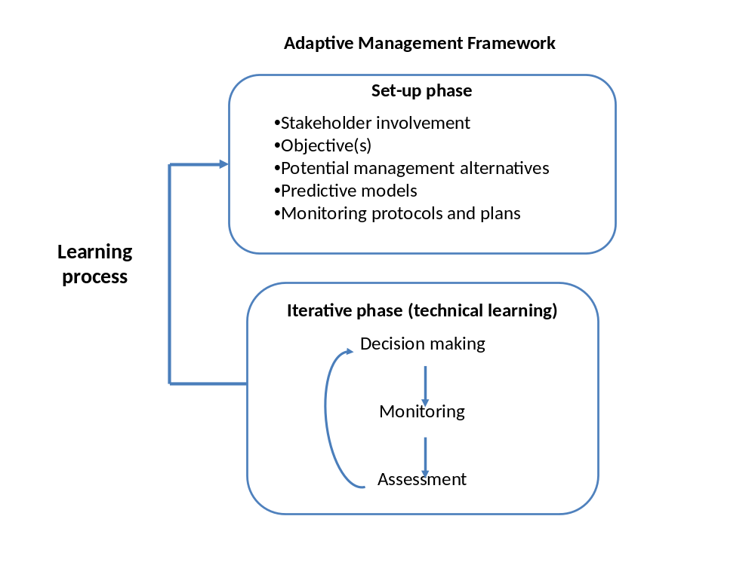
Source: Adapted from USDOI Technical Guide to Adaptive Management¹

The application of Adaptive Management in a European context

It has been commented that an adaptive management approach could not be usefully implemented for waterfowl management in Europe, as is believed that variation between the nations needing to be involved would preclude agreement on a framework for management, along with any proposed objectives and management actions.⁷ One of the most successful and often referred to examples of adaptive management in action is the Adaptive harvest management of North American waterfowl. Increasingly adaptive management is being applied in a wider sociological-ecological context as a means to guide improved systems of natural resource management using a variety of management options. Well known examples are the adaptive management programmes of the Colorado River/Glen Canyon⁸ and the Great Barrier Reef.^{5 & 9} In Europe it is this broader application of adaptive management that is envisaged to create a successful management framework to guide: agricultural conflict resolution, range and habitat conservation and recreational interests, including hunting, across a flyway of range states. The very inclusive nature of adaptive management would seem to lend itself to such a situation. The fact that it is now recognised as a potential approach in the case of Pink-footed geese is a considerable step forward.

The comments above do highlight several points that are worthy of note for the international species management plan for the Svalbard population of the Pink-footed Goose. The success of any management framework is dependent on a mandate to take action; in the face of uncertainty.⁶ This requires an institutional structure and framework with an agreed overarching goal along with clear objectives. There must also be sufficient institutional capacity and stability to ensure long-term collaboration in the iterative process of adaptive management. The implementation of adaptive management can be facilitated by using pre-existing structures and processes and a variety of management actions may be instigated in different regional contexts. Nevertheless, stakeholders and implementing organisations must commit the necessary resources for monitoring and assessing the progress of management actions in achieving agreed objectives, over given time frames.⁴ The institutional structure should champion overall learning and the sharing of this knowledge, which is central to an adaptive management approach.

As noted above adaptive management necessitates a structured approach and it is intended, for the international species management plan for the Svalbard population of the Pink-footed Goose is to follow the ‘9 Step Approach’ as described by the USDOI Technical Guide to Adaptive Management.¹ This is divided into 2 phases, with a set-up phase and an iterative phase as illustrated in the above diagram. Although these phases are considered separate it is recognised that the learning process involves periodic reconsideration of all the adaptive management elements in order to take account of changing circumstances and to maintain stakeholder and political support. This maintains what is often referred to as the ‘double-loop learning’ cycle. ^{1, 7 & 10}

The framework document that this document accompanies initiates this set-up phase as well as setting out a proposed management structure. It is the beginning of a long-term process that is envisaged to deliver an effective adaptive management framework for the Svalbard pink-footed goose population.

In summary successful adaptive management requires the following key elements:¹
- Stakeholder involvement
- Agreed objectives
- Management alternatives
- Predictive models
- Effective monitoring programs
- Which must all be integrated into an iterative learning cycle.

These have been expanded upon slightly in the following pointers which have and is hoped to continue guiding the development of the international species management plan for the Svalbard population of the Pink-footed Goose.

Pointers for Successful Adaptive Management

Stakeholder involvement: Broad stakeholder involvement is needed from the start and throughout the iterative cycle: setting objectives, implementation, monitoring, evaluation and adaptation. This helps build support and learning at all levels of involvement. In addition this contributes to development of a ‘learning organization’ that can capture the collective knowledge and learning of different groups and of individuals, which can be document and used in the future.² As adaptive management is a long-term process commitment, motivation, patience and a desire to learn are also required.

Agreed objectives: A clearly defined goal must be established along with specific, measurable, achievable, results-orientated and time fixed (SMART) objectives. These must be integrated with monitoring and evaluation systems to serve as metrics for assessing management performance. It must be recognised that objectives may change over time, based on changes in social values or in the understanding of system dynamics.

Management alternatives: A set of management options should be considered which can achieve management objectives as well as progress learning. Learning is promoted by a wide range of management alternatives, but hampered by alternatives that differ only marginally. Management actions should also be selected on the basis they can help test and evaluate the systems dynamics that have been identified as important. This facilitates learning in systematic way and can involve treating management actions as experiments. The set of management alternatives may also evolve over time in response to new capabilities or constraint.

Predictive models: These should help facilitate an interdisciplinary approach to understanding the system’s dynamics as well as predicting the outcomes of management actions. They should test the underlying hypothesis of management strategies and have explicit links between management actions and system dynamics, as well as calibrated with the available information monitoring these system dynamics. The most effective models are often those that are simple, understandable and relevant to those who implement management actions.

Effective monitoring programs: Both monitoring and assessment should be designed to ensure that key system parameters are adequately measured and appropriately focused on the relevant performance indicators needed to gauge progress in meeting objectives and guide management decisions. Effective and useful monitoring is required for the hypothesis testing that leads to the reduction of uncertainty that is key to adaptive management. It requires commitment from managers, scientists, and other stakeholders in place to sustain an ongoing monitoring and assessment program.

Iterative Learning: Data collected as part of monitoring programs needs to be analysed and assessed in order to evaluate management actions, improve ecological understanding and adapt management actions in response to what is learnt. This allows managers to determine systematically whether management activities are succeeding or failing to achieve objectives. It is the iterative cycle that over time leads to improved management. This must not be limited to the decision making, monitoring and assessment phase and should involve periodic, but less frequently, recycling through all components of the adaptive management framework to allow for adjustments as stakeholder perspectives, institutional arrangements, and resource conditions evolve. Finally the iterative approach of adaptive management should promote ‘institutional curiosity and innovation’ whereby managers can question the efficiency, effectiveness and appropriateness of actions. Value the learning that comes from trying new interventions and should not be inhibited by failures, recognising them as valuable source of learning on the continuing path to improvement.²

References

1 - Williams, B. K., R. C. Szaro, and C. D. Shapiro. 2009. Adaptive Management: The U.S. Department of the Interior Technical Guide. Adaptive Management Working Group, U.S. Department of the Interior, Washington, DC.

2 – Salafsky, N., R. Margoluis, and K. Redford. 2001. Adaptive management:
A tool for conservation practitioners. Washington, D.C.: Biodiversity Support Program.

3 - Bormann, B. T., J. R. Martin, F. H. Wagner, G. W. Wood, J. Algeria, P. G. Cunningham, M.H. Brookes, P. Friesema, J. Berg, and J. R. Henshaw. 1999. Adaptive management. Pages 505–534 in W.T. Sexton,A. J. Malk, R. C. Szaro, and N. C. Johnson, editors. Ecological Stewardship. A common reference for ecosystem management. Elsevier Science Limited, Oxford, England.

4 – Aldridge, C.L., Boyce, M.S. and R.K. Baydack. 2004. Adaptive management of prairie grouse: how do we get there? Wildlife Society Bulletin 2004, 32(1):92–103

5 - McCook, L.J, T. Ayling, M. Cappo, J. H. Choat, R. D. Evans, D. M. De Freitas, M. Heupel, T. P. Hughes, G. P. Jones, B. Mapstone, H. Marsh, M. Mills, F. J. Molloy, C. R. Pitcher, R. L. Pressey, G. R. Russ, S. Sutton, H. Sweatman, R. Tobin, D. R. Wachenfeld, and David H. Williamson. 2010. Adaptive management of the Great Barrier Reef: A globally significant demonstration of the benefits of networks of marine reserves & supporting information. PNAS October 26, 2010 vol. 107 no. 43 18278-18285

6 – Prato, T. 2006: Adaptive Management of National Park Ecosystems. The George Wright Forum, Volume 23, Number 1 (2006), 72-86.

7 – Nichols J.D., M. C. Runge, F. A. Johnson and Byron K. Williams. 2007. Adaptive harvest management of North American waterfowl populations: a brief history and future prospects. Journal of Ornithology Volume 148, Supplement 2, 343-349.

8 - Glen Canyon Dam Adaptive Management Program. Web link: http://www.gcdamp.gov/

9 – Great Barrier Marine Park. Web link: http://www.gbrmpa.gov.au/

10 - Lee K.N., 1993. Compass and gyroscope: integrating science and politics for the environment. Island Press, Washington

CMS article I, paragraph 1(c): "Conservation status" will be taken as "favourable" when: - population dynamics data indicate that the migratory species is maintaining itself on a long-term basis as a viable component of its ecosystems; - the range of the migratory species is neither currently being reduced, nor is likely to be reduced, on a long-term basis; - there is, and will be in the foreseeable future sufficient habitat to maintain the population of the migratory species on a long-term basis; and - the distribution and abundance of the migratory species approach historic coverage and levels to the extent that potentially suitable ecosystems exist and to the extent consistent with wise wildlife management.
Compensation package available; awarded on case-by-case basis
Guidance document on hunting under Council Directive 79/409/EEC on the conservation of wild birds “The Birds Directive” 2008 (Chapter 2.4).
Annual ecological requirements defined by their need for breeding, moulting, staging and wintering grounds, including a coherent network of roost and foraging areas at international, national and regional levels.
PfG: Pink-footed goose

