
Secretariat provided by the
Agenda item12
Doc. StC 5.18
09 June 2008
Original: English

United Nations Environment Programme
(UNEP)

FIFTH MEETING OF THE STANDING COMMITTEE
24 – 25 June 2008, Bonn, Germany
____________________________________________________________________

Review of Waterbird Re-establishment in the AEWA area

INTRODUCTION

According to Paragraph 7.4 of the AEWA Action Plan the Agreement Secretariat, in coordination with the Technical Committee and the Parties, shall prepare a series of international reviews necessary for the implementation of the Action Plan, including, inter alia, a Review of waterbird re-establishment in the Agreement area.

After a call for tenders the compilation of this review was commissioned to the Wildfowl & Wetlands Trust. Information from Range States on the implementation of re-establishments was collected through questionnaires.

This review was approved by the Technical Committee at its 8th meeting in March 2008. Conclusions and recommendation from the review served as a basis for draft Resolution 4.8.

ACTION REQUESTED FROM THE STANDING COMMITTEE

The Standing Committee is requested to approve the Review of waterbid re-establishments in the AEWA area for submission to the 4th session of the Meeting of the Parties.

Review of Waterbird
Re-establishment in the
AEWA Region

Wildfowl & Wetlands Trust
Slimbridge
Gloucestershire, UK
GL2 7BT

Final draft – April 2008

Authors: Rebecca Lee & Baz Hughes
Wildfowl & Wetlands Trust, Slimbridge, Gloucestershire, GL2 7BT United Kingdom
Email: rebecca.lee@wwt.org.uk or baz.hughes@wwt.org.uk

Acknowledgements

The production of this review would not have been possible without the contributions of a number of ornithological experts and representatives from national governmental agencies. We are grateful to Andy Evans (RSPB; Corn Crake, UK), Jasmina Muzinic (HAZU; Dalmatian Pelican, Croatia), James Lazell (TCA; Caribbean Flamingos, BVI), Wouter Faveyts (Agentschap voor Natuur en Bos), Alessandro Andreotti (INFS; Purple Swamphen, Italy), Jeanne Marie Pittman (Johannesburg Zoo; Wattled Crane, South Africa), Bálint Bajomi (White-headed Duck, Hungary), Antti Haapanen (Lesser White-fronted Goose, Finland), Barbara Amadesi (INFS; White-headed Duck, Italy), Koen Devos (Greylag Goose, Belgium), Wim Van Den Bossche (Natuurpunt; White Stork, Belgium), Nicola Baccetti (INFS), Pritpal Soorae (IUCN/SSC RSG), Chris Bowden (RSPB/IAGNBI), Annemieke Enters (White Stork, the Netherlands) & Wim van Nee (White Stork, the Netherlands).

In addition, we are grateful for the guidance and comments of Ruth Cromie (WWT), Mark Trinder (WWT), Colette Hall (WWT), Sergey Dereliev (AEWA), Bálint Bajomi, Michael Smart, David Stroud (JNCC) and Andrea Pauly (BMU).

Acronyms

AEWA African-Eurasian Waterbird Agreement
BMU Federal Ministry for the Environment, Nature Conservation & Nuclear Safety, Germany
BVI British Virgin Islands
CMS Convention on Migratory Species
EU European Union
HAZU Institute of Ornithology at the Croatian Academy of Sciences and Arts
IAGNBI International Advisory Group on the Northern Bald Ibis
IAP International Action Plan
ICONA National Institute for Nature Conservation in Spain's Ministry of Agriculture
INFS Istituto Nazionale per la Fauna Selvatica
ISSAP International Single Species Action Plan
IUCN International Union for the Conservation of Nature and Natural Resources (World Conservation Union)
JNCC Joint Nature Conservation Committee
RSG Re-introduction Specialist Group
RSPB Royal Society for the Protection of Birds
SSC Species Survival Commission
TCA The Conservation Agency
UKBAP United Kingdom Biodiversity Action Plan
UNCED United Nations Conference on Environment and Development
UNEP United Nations Environment Programme
WCMC World Conservation Monitoring Centre
WWT Wildfowl & Wetlands Trust

Definitions

Re-introduction: an attempt to establish a species in an area which was once part of its historical range, but from which it has been extirpated or become extinct.
Re-establishment: a successful re-introduction.
Re-establishment project: a synonym for re-introduction; a project that attempts to successfully establish a species in an area which was once part of its historical range, but from which it has been extirpated or become extinct.

CONTENTS

Acknowledgements 1
Acronyms 1
Definitions 1
Executive summary 3
1 Introduction 5
2 Species for which re-establishment projects are needed 7
3 Waterbird conservation initiatives requiring re-establishment 23
4 Meta-database for re-establishment projects 31
5 Assessment of waterbird re-establishment projects against IUCN guidelines 34
6 Progress in implementing re-establishment projects 44
7 Improving the effectiveness of re-establishment as a conservation measure 48
8 Recommendations and improvements needed 51
9 Conclusions 54
References 59
Appendix 1. Conservation initiatives reviewed 63
Appendix 2. Completed re-establishment questionnaires 65
Appendix 3. IUCN Guidelines for Re-introductions 95

Executive summary

Re-establishment has received increased attention as a conservation tool over the last two decades resulting in an increase in re-establishment projects worldwide (World Conservation Union and Species Survival Commission Re-introduction Specialist Group (IUCN/SSC RSG) 1995). As re-establishments are sometimes recommendations of action plans and other conservation initiatives it is vital that their occurrence, progress and outcomes are recorded (1) to inform future re-establishment projects for related species and populations, and (2) to allow the implementation of action plans and other conservation initiatives to be monitored.

This report reviews waterbird species re-establishment projects, as per item 7.4 (f) of the African-Eurasian Waterbird Agreement (AEWA) Action Plan.

Seven major objectives were addressed: identifying the species and populations for which re-establishment has been recommended as a conservation measure; identifying the waterbird conservation initiatives with provisions on re-establishment; creating a meta-database containing all relevant data on re-establishments of waterbirds in the AEWA region; assessing existing re-establishment projects against IUCN guidelines; assessing the status of and progress in the implementation of re-establishments by Range States and other stakeholders; and producing recommendations for the future use of re-establishment as a conservation tool.

The review found that re-establishment has been recommended as a conservation measure for six waterbird species in international and national actions plans published since 1995: Lesser White-fronted Goose Anser erythropus, Ferruginous Duck Aythya nyroca, Crested Coot Fulica cristata, White-headed Duck Oxyura leucocephala, Maccoa Duck Oxyura maccoa, and Corn Crake Crex crex. Each of these species except for the Maccoa Duck has been the subject of one or more re-establishment project within the AEWA region. Most projects have failed to result in self-sustaining populations, though varying levels of success have been reported for projects to re-introduce the White-headed Duck in Spain, Ferruginous Duck in Italy, Lesser White-fronted Goose in Sweden, and Corn Crake in the United Kingdom.

Of the 59 conservation initiatives reviewed, 15 had provisions on re-establishment. These initiatives included national and international action plans, international conventions and agreements, and conservation assessment and management plans. The re-establishment recommendations ranged from calling for re-introductions in previously occupied areas according to IUCN guidelines, to calling for particular numbers of birds to be released in particular areas.

A potentially web-accessible meta-database was constructed and populated with data relevant to re-establishments of waterbirds in the AEWA region, incorporating information on species/population, Range States, conservation initiatives, re-establishment projects, references, re-establishment contacts, and data collected as part of a questionnaire survey.

The assessment of existing re-establishment projects found that compliance to IUCN re-introduction guidelines varied from 23% for a White-headed Duck re-introduction in Hungary to 88% for a Corn Crake re-introduction in the United Kingdom. Evaluating success and comparing this with level of compliance indicated that projects showing greater compliance to IUCN guidelines were more likely to be successful.

Re-establishment projects have been implemented for four of the five species for which re-establishment has been recommended in an international single species action plan (ISSAP). The only species where re-establishment has not been implemented despite a recommendation is the Maccoa Duck. Re-establishment projects have been conducted for 33% of the threatened species and 3% of the non-threatened species covered by AEWA.
A number of factors were identified as particularly important to success. These were the completion of a comprehensive feasibility study; pre-release acclimatization of birds to their release area; good quality habitat with the original causes of decline eliminated or reduced; long-term financial and political support; and identification of short and long-term indicators of success.

In order to improve the success of re-establishment as a conservation tool for waterbirds in the AEWA region this report recommends that:
- Re-establishment projects are conducted in strict accordance with the IUCN Guidelines for Re-introductions (IUCN/SSC RSG 1995).
- The IUCN Guidelines for Re-introductions (IUCN/SSC RSG 1995, Appendix 3) are adapted for waterbird species and supplemented with checklists of activities for practitioners to complete.
- The IUCN/SSC Re-introduction Specialist Group (IUCN/SSC RSG) is consulted prior to any re-establishment project.
- Re-establishment projects are conducted by groups of organisations and experts with diverse skills bases.
- Networks or groups of experts with knowledge relevant to the re-establishment of a specific species are assembled to act as advisory groups for re-establishment projects of that species.
- During pre-project activities, particular attention is paid to completing a comprehensive feasibility study and securing long-term financial and political support.
- During re-introduction activities, particular attention is paid to ensuring birds are acclimatized to their release area, a sufficient amount of good quality habitat is available where the original causes of decline have been eliminated or sufficiently reduced, and short and long-term indicators of success are identified.
- AEWA National Focus Points maintain a national register of re-establishment projects occurring or planned to occur wholly or in part within their Ranges States.
- All re-establishment projects are described to the IUCN/SSC RSG.
- The AEWA re-establishment database is maintained.
- A standard set of evaluation criteria for waterbird re-establishment projects is developed.

Introduction

The variety and numbers of waterbirds on their breeding grounds, migration stop-over sites, and wintering grounds has been reduced due to several factors, among others partial or full destruction or alteration of habitats, unsustainable harvesting, pollution, and invasive alien species.

The African-Eurasian Waterbird Agreement (AEWA) entered into force in 1999 and focuses on the conservation of 235 waterbird species in 117 Range States in Africa, Europe, and parts of Canada, Central Asia and the Middle East. AEWA calls on its Parties to engage in a wide range of conservation actions including the use of re-establishment.

Re-establishment has received increased attention as a conservation tool over the last two decades resulting in an increase in re-establishment projects worldwide (World Conservation Union and Species Survival Commission Re-introduction Specialist Group (IUCN/SSC RSG) 1995). As re-establishments are sometimes recommendations of action plans and other conservation initiatives it is vital that their occurrence, progress and outcomes are recorded (1) to inform future re-establishment projects for related species, and (2) to allow the implementation of action plans and other conservation initiatives to be monitored.

IUCN defines ‘re-establishment’ as a successful ‘re-introduction’, a successful ‘attempt to establish a species in an area which was once part of its historical range, but from which it has been extirpated or become extinct’. A re-introduction contrasts with a ‘translocation’, which is the ‘deliberate and mediated movement of wild individuals or populations from one part of their range to another’; a ‘reinforcement/supplementation’, which is the ‘addition of individuals to an existing population of conspecifics’; and a ‘conservation/benign introduction’, which is ‘an attempt to establish a species, for the purpose of conservation, outside its recorded distribution but within an appropriate habitat and ecogeographical area’ (IUCN/SSC RSG 1995).

The IUCN Guidelines for Re-introductions (IUCN/SSC RSG 1995, Appendix 3) provide specific policy guidelines for each stage of a re-introduction (i.e. a re-establishment project) and state that the objectives of a re-introduction may be to enhance the long-term survival of a species; to re-establish a keystone species (in the ecological or cultural sense) in an ecosystem; to maintain and/or restore natural biodiversity; to provide long-term economic benefits to the local and/or national economy; to promote conservation awareness; or a combination of these (IUCN/SSC RSG 1995).

Paragraph 2.4 of AEWA’s Annex 3 (Action Plan) reads “Parties shall exercise the greatest care when re-establishing populations listed in Table 1 into parts of their traditional range where they no longer exist. They shall endeavour to develop and follow a detailed re-establishment plan based on appropriate scientific studies. Re-establishment plans should constitute an integral part of national and, where appropriate, international single species action plans. A re-establishment plan should include assessment of the impact on the environment and shall be made widely available. Parties shall inform the Agreement secretariat, in advance, of all re-establishment programmes for populations listed in Table 1.”

The third Meeting of Parties (MOP3) in paragraph 6 of Resolution 3.11, requested the Technical Committee urgently to implement the international context reviews specified in paragraph 7.4 of the Action Plan - including a review of re-establishment projects - to provide future Meetings of Parties with context on these issues.

This report reviews waterbird species re-establishment projects, as per item 7.4 (f) of the AEWA Agreement's Action Plan, with the following objectives:

- Produce a list of those species for which re-establishments have been identified to be needed, as a priority for the populations listed in Category 1, Column A, Table 1 of the AEWA Action Plan and provide the context against which this has happened.
- Produce a list of waterbird conservation initiatives requesting or promoting the implementation of re-establishment projects, record the relevant text and assess the content of these recommendations.
- Set up a meta-database that contains relevant information on:
- those species/populations for which re-establishment plans have been prepared (and implemented);
- those species/populations for which re-establishment plans are under development; and
- those species/populations for which re-establishment plans remain to be developed.

- Assess re-establishment projects that have occurred for AEWA species in the AEWA region in terms of their compliance to the IUCN Guidelines for Re-introductions (IUCN/SSC RSG 1995).
- Assess the status of and progress in the implementation of re-establishment projects by Range States and other stakeholders.
- Assess the effectiveness of waterbird re-establishment projects in the AEWA region and determine the factors most linked to success in these projects.
- Provide recommendations for the future use of re-establishment as a conservation tool and outline the improvements needed.

Species for which re-establishment projects are needed

Objective

Produce a list of those species for which re-establishments have been identified to be needed, as a priority for the populations listed in Category 1, Column A, Table 1 of the AEWA Action Plan and provide the context against which this has happened.

Method

A total of 38 action plans for waterbird species were reviewed (Table 2-1) to determine for which species or populations re-establishment had been recommended as a conservation measure. The action plans included Council of Europe and European Union action plans; AEWA/CMS action plans; African action plans for globally threatened species; and other national and international action plans. The action plans reviewed represent a sample of the total number available. In particular, it should be noted that only English language action plans were included and of the seven national action plans reviewed, five (71%) were for the United Kingdom. Updates of this review should aim to include non-English action plans and national action plans from a wider range of countries.

Table 2-1. Waterbird action plans reviewed for re-establishment recommendations.
Action Plan | Reference
Action Plan for the Conservation of Bird Species Listed in Annex II of the Protocol Concerning SPAs and Biological Diversity in the Mediterranean | (UNEP MAP RAC/SPA 2003)
Action Plan for the Corn Crake (Crex crex) in Europe | (Crockford et al. 1996)
Action Plan for the Dalmatian Pelican (Pelecanus crispus) in Europe | (Crivelli 1996)
Action Plan for the Pygmy Cormorant (Phalacrocorax pygmeus) in Europe | (Crivelli, Nazirides & Jerrentrup 1996)
Action Plan for the White-headed Duck (Oxyura leucocephala) in Europe | (Green & Hughes 1996)
Conservation action plans for the Black Crowned Crane (Balearica pavonina) and Black Stork (Ciconia nigra) in Africa | (Diagana, Dodman & Sylla 2006)
Cranes - Status Survey and Conservation Action Plan | (Meine & Archibald 1996)
Ducks, Geese, Swans and Screamers: An Action Plan for the Conservation of Anseriformes (Second draft) | (Callaghan, in prep.)
European Species Action Plan Ferruginous Duck (Aythya nyroca) | (Callaghan 1997)
European Species Action Plan Steller's Eider (Polysticta stelleri) | (Pihl 1999)
European Union Species Action Plan Bittern (Botaurus stellaris) | (Newbery, Schaffer & Smith 1997)
Grebes - Status Survey and Conservation Action Plan | (O’Donnel & Fields 1997)
International (East Atlantic) Action Plan Roseate Tern (Sterna dougallii) | (Newbery 1999)
International Action Plan for Audouin's Gull (Larus audouinii) | (Lambertini 1996)
International Action Plan for the Lesser White-fronted Goose (Anser erythropus) | (Madsen 1996)
International Action Plan for the Lesser White-fronted Goose (Anser erythropus) – updated second draft | (Jones 2006)
International Action Plan for the Marbled Teal (Marmaronetta angustirostris) | (Green 1995)
International Action Plan for the Red-breasted Goose (Branta ruficollis) | (Hunter & Black 1996)
International Action Plan for the Slender-billed Curlew (Numenius tenuirostris) | (Gretton 1996)
International Maccoa Duck (Oxyura maccoa) Action Plan | (Berruti et al. 2005)
International Single Species Action Plan for the Conservation of the Lesser Flamingo (Phoenicopterus minor) (second draft) | (Childress, Nagy & Hughes 2007)
International Single Species Action Plan for the Conservation of the Maccoa Duck (Oxyura maccoa) | (Abebe et al. 2007)
International Single Species Action Plan for the Conservation of the Light-bellied Brent Goose - East Canadian High Arctic population (Branta bernicla hrota) | (Robinson & Colhoun 2006)
International Single Species Action Plan for the Conservation of the Northern Bald Ibis (Geronticus eremita) | (Armesto, Boehm & Bowden 2006)
International Single Species Action Plan for the Conservation of the Corn Crake (Crex crex) | (Koffijberg & Schaffer 2006)
International Single Species Action Plan for the Conservation of the White-headed Duck (Oxyura leucocephala) | (Hughes, Robinson & Green 2006)
International Single Species Action Plan for the Conservation of the Ferruginous Duck (Aythya nyroca) | (Robinson & Hughes 2006)
International Single Species Action Plan for the Conservation of the Great Snipe (Gallinago media) | (Kålås 2004)
International Single Species Action Plan for the Conservation of the Black-winged Pratincole (Glareola nordmanni) | (Belik & Lebedeva 2004)
International Single Species Action Plan for the Conservation of the Sociable Lapwing (Vanellus gregarius) | (Tomkovich & Lebedeva 2004)
International Species Action Plan Crested Coot (Fulica cristata) | (Gomez 1999)
National Action Plan for the Lesser White-fronted Goose (Greece) | (Savas & Nazirides 1999)
National Action Plan for the Pygmy Cormorant (Phalacrocorax pygmaeus) (Greece) | (Kazantzidis & Nazirides 1999)
UK Biodiversity Action Plan – Bittern (Botaurus stellaris) | (UKBAP 1995a)
UK Biodiversity Action Plan – Common Scoter (Melanitta nigra) | (UKBAP 1998a)
UK Biodiversity Action Plan – Corn Crake (Crex crex) | (UKBAP 1995b)
UK Biodiversity Action Plan – Red-necked Phalarope (Phalaropus lobatus) | (UKBAP 1998b)
UK Biodiversity Action Plan – Roseate Tern (Sterna dougallii) | (UKBAP 1998c)

After an initial list of species was drawn up, consultations were conducted with AEWA National Focal Points to finalise the list – all National Focal Points were asked if re-establishment had been recommended as a conservation measure for any AEWA species in their Range State. Gaps were filled by consulting relevant ornithological experts, including Wetlands International Specialist Group chairs, BirdLife International contacts and International Waterbird Census coordinators.

The action plans recommending re-establishment were identified and the details noted. For each species or population with a recommendation, background information (distribution, IUCN Red List status and factors causing loss or decline/major threats) was gathered to provide context for the recommendations.

Finally, for each species or population with a recommendation, as much information as possible was gathered on re-establishment projects that have been completed, are being conducted, or are being planned to occur in AEWA Range States. Information was gathered by searching scientific literature, popular literature and websites, and by consulting National Focal Points - all National Focal Points were asked if any re-establishments had been conducted or were planned for any AEWA species in their Range State. Again, gaps were filled by consulting relevant ornithological experts, including Wetlands International Specialist Group chairs, BirdLife International contacts and International Waterbird Census coordinators.

Results

The 38 action plans reviewed covered 43 waterbird species to which AEWA applies: 21 of these species have international single species action plans (ISSAPs), and seven have national single species action plans (of which five also have an ISSAP). The species for which action plans recommend re-establishment activities are listed in Table 2-2 with the number of action plans reviewed, the number recommending re-establishment and the IUCN Red List Status (2007) of each species.

Table 2-2. Species with action plans recommending re-establishment activities.
Species | IUCN Red List Status (2007)* | No. of action plans reviewed | No. of action plans recommending  re-establishment
Corn Crake Crex crex | NT | 3 | 1
Crested Coot Fulica cristata | LC | 1 | 1
Ferruginous Duck Aythya nyroca | NT | 2 | 1
Lesser White-fronted Goose Anser erythropus | VU | 3 | 1
Maccoa Duck Oxyura maccoa | NT | 2 | 1
White-headed Duck Oxyura leucocephala | EN | 2 | 1
* EN = endangered, VU = vulnerable, NT = near threatened, LC = least concern.

Re-establishment was recommended for only six species (Table 2-2): Corn Crake (UKBAP 1995b), Crested Coot (Gomez 1999), Ferruginous Duck (Callaghan 1997), Lesser White-fronted Goose (Madsen 1996), Maccoa Duck (Abebe et al. 2007) and White-headed Duck (Hughes et al. 2006). However, as indicated in Table 2-2, re-establishment was not recommended for five of these six species in at least one other action plan. Of the 10 threatened species covered by the ISSAPs, just two (Lesser White-fronted Goose and White-headed Duck) were recommended for re-establishment, and the latest draft of the Lesser White-fronted Goose ISSAP does not recommend re-establishment (Jones 2006).

Re-establishment was discussed at some length in the 1996 Action Plan for the Dalmatian Pelican Pelecanus crispus in Europe (Crivelli 1996). However, the action plan did not recommend re-establishment, but did recommend that re-introduction techniques were investigated.
The six species for which re-establishment was recommended are discussed in detail in the following sections.
- Corn Crake Crex crex

Re-establishment of this species was recommended in the 1995 UK Biodiversity Action Plan Corn Crake Crex crex (UKBAP 1995b) as a long-term conservation measure to re-establish the Corn Crake in parts of its former range in the United Kingdom. Re-establishment is not recommended in the 1996 Action Plan for the Corn Crake (Crex crex) in Europe (Crockford et al. 1996) or the 2006 International Single Species Action Plan for the Conservation of the Corn Crake (Crex crex) (Koffijberg & Schaffer 2006).

Distribution

Afghanistan (v), Albania (br), Algeria, Angola (v), Armenia (br), Australia (?), Austria (br), Azerbaijan (br), Belarus (br), Belgium (br), Bosnia and Herzegovina (br), Botswana (v), Bulgaria (br), Cameroon (v), Chad (v), China (br), Congo, Côte d'Ivoire (v), Croatia (br), Czech Republic (br), Democratic Republic of the Congo, Denmark (br), Egypt, Eritrea (v), Estonia (br), Ethiopia, Faroe Islands (ex, br), Finland (br), France (br), Gabon (v), Georgia (br), Germany (br), Ghana (v), Greece (br), Guinea (?), Hungary (br), Iceland (v), Iran (Islamic Republic of) (br), Iraq, Ireland (br), Israel, Italy (br), Kazakhstan (br), Kenya, Kuwait, Kyrgyzstan (br), Latvia (br), Lebanon, Lesotho (v), Libyan Arab Jamahiriya (v), Liechtenstein (br), Lithuania (br), Luxembourg (br), Malawi, Mali (v), Mauritania, Moldova, Republic of (br), Mongolia (v), Morocco, Mozambique, Namibia (v), Netherlands (br), Niger (v), Nigeria (v), Norway (br), Oman, Poland (br), Portugal (v), Romania (br), Russian Federation (br), Rwanda (v), Saint Pierre and Miquelon (v), Saudi Arabia, Serbia and Montenegro (br), Seychelles (v), Slovakia (br), Slovenia (br), Somalia (v), South Africa, Spain (br), Sudan, Swaziland, Sweden (br), Switzerland (br), Syrian Arab Republic, Tajikistan (br), The former Yugoslav Republic of Macedonia (br), Tunisia, Turkey (br), Turkmenistan, Uganda (v), Ukraine (br), United Kingdom (br), United Republic of Tanzania, Uzbekistan, Viet Nam (v), Yemen, Zambia, and Zimbabwe.

(br – breeding; ex – extinct; v – vagrant; ? – outstanding query over status)

Status

IUCN Red List: NT (BirdLife International 2006) Trend: 

“Recent surveys in eastern Europe and new population estimates for Asiatic Russia and have shown this species to be considerably more numerous than was thought in the early 1990s. New information suggests that future declines in European Russia are in the region of 10% over the next 10 years because the introduction of intensive agricultural technologies in some areas will be compensated for by the reduction of agricultural production in other areas. In Asiatic Russia, where the bulk of the world population breeds, declines of c. 20% are predicted on the basis of land abandonment, with meadows becoming overgrown by bushy vegetation and trees. For this reason the species is listed as Near Threatened. Nearly qualifies as threatened under criteria A3c” (BirdLife International 2006)

Factors causing loss or decline (United Kingdom)
- Loss of traditional grassland habitat mosaics, especially tall vegetation throughout the breeding season.
- Changes in grass management and cutting techniques (e.g. earlier cutting).
- Predation and disturbance may be contributing to the decline in some localities.

Source of re-establishment recommendation

UK Biodiversity Action Plan - Corn Crake Crex crex. Originally published in: Biodiversity: The UK Steering Group Report - Volume II: Action Plans (December 1995, Tranche 1, Vol. 2, p102).

Completed and ongoing re-establishment projects

- AEWA Range State: UNITED KINGDOM
Region: Cambridge, England
Organisations involved: RSPB, Whipsnade Wild Animal Park (Zoological Society of London), Natural England, and Pensthorpe Conservation Trust
Start year: 2000
End year: Ongoing
Comments: Some 291 birds were released between 2002 and 2006. Released birds have successfully returned from overwinter migration to Africa and have successfully bred in the wild. The long-term goal of the project is the establishment of a stable population of over 30 pairs.

Planned re-establishment projects

None known.

- Crested Coot Fulica cristata

Maintaining a captive breeding population of this species for future re-introductions was considered of medium priority in the 1999 International Species Action Plan Crested Coot Fulica cristata (Gomez 1999). The action plan recommended that a re-introduction programme following IUCN guidelines should be implemented in Spain between the Andalucía and Valencia Regions with a total of 50 pairs re-introduced.

Distribution

Algeria (ex ?, br), Angola (br), Botswana (br), Burundi (v), ? Democratic Republic of the Congo (br), Eritrea (br), Ethiopia (br), France (v), Italy (v), Kenya (br), Lesotho (br), Madagascar (br), Malawi (br), Malta (v), Morocco (br), ? Mozambique (br), Namibia (br), Oman (v), Portugal (v), Rwanda (br), Somalia (v), South Africa (br), Spain (br), Swaziland (br), Tunisia (ex, br), ? Uganda (br), United Arab Emirates (br, v), ? United Republic of Tanzania (br), Zambia (br), and Zimbabwe (br).

(br – breeding; ex – extinct; v – vagrant; ? – outstanding query over status)

Status

IUCN Red List: LC (BirdLife International 2004) Trend: N/A

“This species has a large range, with an estimated global extent of occurrence of 5,400,000 km². It has a large global population estimated to be 110,000–1,000,000 individuals (Wetlands International 2002). Global population trends have not been quantified, but the species is not believed to approach the thresholds for the population decline criterion of the IUCN Red List (i.e., declining more than 30% in 10 years or 3 generations). For these reasons, the species is evaluated as Least Concern” (BirdLife International 2004)

Major threats
- Habitat Loss (importance: critical)
- Habitat Degradation (importance: critical)
- Livestock (importance: high)
- Hunting (importance: medium)
- Fishing (importance: medium)
- Disturbance (importance: low)
- Interaction with Greater Flamingos Phoenicopterus ruber roseus (importance: unknown)
- Introduction of other species (importance: unknown)
- Lead poisoning (importance: unknown)

Source of re-establishment recommendation

Gomez CR (compiler). 1999. International Species Action Plan Crested Coot (Fulica cristata). The European Commission and BirdLife International.

Completed and ongoing re-establishment projects

- AEWA Range State: SPAIN
Region: Andalucía (Reserva Concertada "Cañada de los Pájaros")
Organisations involved: Cañada de los Pájaros
Start year: 1992
End year: 1996 (captive breeding continues for possible future releases)
Comments: The results of releases are unknown - there was no continuous monitoring of this programme.⁹

- AEWA Range State: SPAIN
Region: Valencia (two SPAs)

Planned re-establishment projects

None known.
- Ferruginous Duck Aythya nyroca

Re-establishment of this species was recommended in the 1997 European Species Action Plan Ferruginous Duck Aythya nyroca (Callaghan 1997) as a last measure conservation strategy to re-introduce the species to areas of its former range. Re-establishment was not a recommendation of the 2006 International Single Species Action Plan for the Conservation of the Ferruginous Duck Aythya nyroca (Robinson & Hughes 2006).

Distribution

Afghanistan (br), Albania (br), Algeria (br), Armenia (br), Austria (br), Azerbaijan (br), Bahrain (v), Bangladesh, Belarus (br), Belgium, Bhutan, Bosnia and Herzegovina (br), Bulgaria (br), Burkina Faso (v), Cameroon, Cape Verde (v), Central African Republic, Chad, China (br), Croatia (br), Cyprus, Czech Republic (br), Denmark (v), Egypt, Eritrea, Ethiopia, Finland (v), France (br), Gambia (v), Georgia (br), Germany (br), Ghana (v), Greece (br), Hong Kong, China (v), Hungary (br), India (br), Iran (Islamic Republic of) (br), Iraq, Ireland (v), Israel (br), Italy (br), Japan (v), Jordan, Kazakhstan (br), Kenya, Kuwait (v), Kyrgyzstan, Latvia (br), Lebanon, Libyan Arab Jamahiriya, Liechtenstein (v), Lithuania (br), Luxembourg (v), Maldives (v), Mali, Malta, Mauritania, Moldova (Republic of) (br), Mongolia (br), Morocco (br), Myanmar, Nepal, Netherlands (br?), Niger, Nigeria, Norway (v), Oman, Pakistan, Poland (br), Portugal (br?), Qatar (v), Romania (br), Russian Federation (br), Saudi Arabia (br), Senegal, (br), Seychelles (v), Sierra Leone (v), Slovakia (br), Slovenia (br), Spain (br), Sudan, Sweden (v), Switzerland (br), Syrian Arab Republic (v), Tajikistan (br), Thailand (br), ? Togo (v), Tunisia, Turkey (br), Turkmenistan (br), Uganda (v), Ukraine (br), United Arab Emirates, United Kingdom (v), Uzbekistan (br), Viet Nam, ? Western Sahara, and Yemen.

(br – breeding; v – vagrant; ? – outstanding query over status)

Status

IUCN Red List: NT (BirdLife International 2006) Trend: 

“Given that this species' range may fluctuate considerably from year to year - particularly in Asia - owing to changing water levels, it is very hard to estimate the global population or trends. Owing to significant local declines it is classified as Vulnerable in Europe. However, evidence of declines in the larger Asian populations is sparse, and sometimes contradictory, so it is currently listed as Near Threatened. Evidence of rapid declines in Asia may warrant uplisting to Vulnerable. Nearly qualifies as threatened under criteria A2cd+3cd”
(BirdLife International 2006)

Major threats
- Habitat Loss/Degradation (importance: critical)
- Climate change/drought (importance: critical)
- Over-hunting (importance: high)
- Lead poisoning (importance: medium)
- Drowning in fishing nets (importance: medium)
- Pollution (importance: medium)
- Competition with invasive alien species (importance: medium)
- Human disturbance (importance: medium)
- Competition with native species (importance: unknown)

Source of re-establishment recommendation

Callaghan D (compiler). 1997. European Species Action Plan Ferruginous Duck (Aythya nyroca). The European Commission and BirdLife International.

Completed and ongoing re-establishment projects

- AEWA Range State: FRANCE
Region: Villars des Dombes
Start year: 1970s
Comments: An unsuccessful re-introduction was carried out in the 1970s in Villars des Dombes. ¹³

- AEWA Range State: SPAIN
Region: Acebuche-Huerto-Pajasarea of the Guadalquivir Marshes
Organisations involved: Instituto para la Conservación de la Naturaleza (ICONA)
Start year: 1992
Comments: A re-introduction programme was launched by the Instituto para la Conservación de la Naturaleza (ICONA) in southwest Spain in 1992. In the Acebuche-Huerto-Pajasarea of the Guadalquivir Marshes, 49 individuals were released in 1992 and 1993, from which three pairs bred in 1993. A further 45 were released in southwest Spain during 1994 and 1995, and over 30 in 1996. ¹³

- AEWA Range State: ITALY
Comments: There have been around 20 re-introduction programmes in Italy over the past decade. Although most have been unsuccessful, apparently self-sustaining breeding populations were established at the Eastern Bologna Plain and Alviano Lake.¹³

- AEWA Range State: FRANCE
Region: Le Marais de Ganne
Comments: A re-introduction is being attempted at Le Marais de Ganne (Saint Andre des Eaux), where an open enclosure of pinioned birds is used to breed fully-winged juveniles. In 1996, 10 pinioned birds raised 10 fully-winged individuals.

Planned re-establishment projects

None known.

- Lesser White-fronted Goose Anser erythropus

Re-establishment of the Lesser White-fronted Goose was recommended in the 1996 International Action Plan for the Lesser White-fronted Goose Anser erythropus (Madsen 1996) for areas where the species has disappeared and other conservation measures have failed. However the updated second draft of the 2006 International Action Plan for the Lesser White-fronted Goose Anser erythropus (Jones 2006) did not make such a recommendation and concludes that there is no consensus among Lesser White-fronted Goose stakeholders on the use of captive breeding and re-introduction/restocking as valid conservation tools to be integrated with measures directed at conservation of the surviving wild population.

In November 2005, the Scientific Council of the Convention on Migratory Species (CMS) concluded, as part of its wider recommendation on Lesser White-fronted Geese that:

“For the present, we do not support the introduction of Lesser White-fronts into flyways where they do not occur naturally. We have borne in mind the powerful argument concerning the improved safety of birds in these flyways, as well as practical considerations, such as current proposals that could quickly be put into effect. However, we consider that modifying the natural behaviour of Lesser White-fronts in this respect, as well as unknown ecological effects in the chosen new flyways, and other such considerations, make this technique inappropriate until such time as it may become essential, particularly when major disruption or destruction occurs of key components of the natural flyways. We do not believe that to be the case at present.” ¹³

Distribution

Albania, Armenia, Austria (v), Azerbaijan, Belarus, Belgium (v), Bosnia and Herzegovina, Bulgaria, China, Croatia, Cyprus (v), Czech Republic, Denmark (v), Egypt (v), Estonia, Finland (br), France (v), Georgia, Germany, Greece, Hungary, India, Iran (Islamic Republic of), Iraq, Ireland (v), Israel, Italy, Japan, Jordan (v), Kazakhstan, Korea (Republic of) (v), Kuwait (v), Latvia, Lithuania, Moldova (Republic of), Mongolia, Myanmar (v), Netherlands (v), Norway (br), Oman (v), Pakistan, Poland, Romania, Russian Federation (br), Serbia and Montenegro, Slovakia, Spain, Sweden (br), Switzerland (v), Syrian Arab Republic, Taiwan, Province of China (v), The former Yugoslav Republic of Macedonia, Turkey, Turkmenistan, Ukraine, United Arab Emirates (v), United Kingdom (v), United States (v), and Uzbekistan.

(br – breeding; v – vagrant)

Status

IUCN Red List: VU A2bcd+3bcd (BirdLife International 2006) Trend: 

“This species is listed as Vulnerable because it has suffered a rapid population reduction in its key breeding population in Russia, and equivalent declines are predicted to continue over the next 10 years. The small Fennoscandian population has undergone a severe historical decline.”
(BirdLife International 2006)

Major threats
- Hunting – breeding grounds (importance: medium)
- Hunting – staging/wintering grounds (importance: critical)
- Poisoning – staging/wintering grounds (importance: local)
- Human disturbance – staging/wintering grounds (importance: medium)
- Human disturbance – breeding grounds (importance: local)
- Predation – breeding grounds (importance: local)
- Agricultural intensification – staging/wintering grounds (importance: high)
- Construction of dams and other river regulation infrastructure, wetland drainage – staging/wintering grounds (importance: high)
- Climate change – breeding grounds (importance: unknown)
- Climate change – staging and wintering grounds (importance: unknown)
- Land abandonment – staging and wintering grounds (importance: medium)
- Overgrazing – breeding grounds (importance: local)
- Pollution of wetlands/water bodies – staging and wintering grounds (importance: local)

Source of re-establishment recommendation

Madsen J (compiler). 1996. International Action Plan for the Lesser White-fronted Goose (Anser erythropus). Pp. 67-78 in Heredia, B, Rose, L & Painter, M (eds). Globally threatened birds in Europe: action plans. The European Commission and BirdLife International, Strasbourg.

Completed and ongoing re-establishment projects

- AEWA Range State: SWEDEN
Region: Swedish Lapland
Start year: 1981
End year: 1999
Comments: 348 captive-bred Lesser White-fronted Geese were released in Swedish Lapland. Barnacle Geese Branta leucopsis were used as foster-parents and the re-introduced Lesser White-fronted Geese followed their foster parents to wintering grounds in the Netherlands. A total of 66 young fledged from breeding attempts in the release area up to 1999. The number of fledglings reared between 1999 and 2003 ranged from 13 to 20 annually, with a total for the 5-year period of 83 fledglings from 29 broods.

- AEWA Range State: FINLAND
Region: Finnish Lapland
Start year: 1987
End year: 1997
Comments: Between 1987 and 1997 about 150 captive-bred Lesser White-fronts were released in Finnish Lapland, but high mortality occurred and no breeding attempts were made by the re-introduced birds. This re-introduction programme did not aim to modify goose migration routes (Markkola et al. 1999). Releases were stopped from 1998 (Markkola et al. 1999), though Lesser White-fronted Geese continued to be bred in captivity.¹⁷

Planned re-establishment projects

- AEWA Range States: GERMANY & SWEDEN
Region: Swedish Lapland and the Lower Rhine area of Germany
Organisations involved: Operation Lesser White-fronted Goose/Aktion Zwerggans
Comments: This new international, German-based project aims to breed up to 400 Lesser White-fronted Geese in four years and release them in Lapland. The practitioners intend to use ultra-light aircraft as ‘foster parents’ to guide the birds to wintering grounds in the Lower Rhine area of Germany. Experimental work has been conducted over a six year period.

- Maccoa Duck Oxyura maccoa

The 2007 International Single Species Action Plan for the Conservation of the Maccoa Duck Oxyura maccoa (Abebe 2007) recommended that the Maccoa Duck be re-introduced to suitable sites in southern Tanzania. This measure was considered of medium importance for the conservation of this species.

Distribution

Angola (v), Botswana (br), Burundi (v), Democratic Republic of the Congo (br), Eritrea, Ethiopia (br), Kenya (br), Lesotho, Malawi (v), Namibia (br), Rwanda (br), South Africa (br), Swaziland (v), Uganda (br), United Republic of Tanzania (br), and Zimbabwe (br).

(br – breeding; v – vagrant)

Status

IUCN Red List: NT (BirdLife International 2007) Trend: 

“This species has been uplisted to Near Threatened owing to its small population size and ongoing declines resulting from a variety of threats. Further quantitative estimates of the rate of decline may qualify the species for Vulnerable. Almost qualifies for a threatened category under criterion C1” (BirdLife International 2007)

Major threats
- Drowning in gill nets (importance: high)
- Draining of wetlands (importance: high)
- Pollution (importance: high)
- Alien vegetation (importance: high)
- Variable water levels (importance: high)
- Improved treatment of sewage water (importance: medium)
- Disturbance (importance: medium)
- Nest predation and poaching (importance: medium)
- Sport hunting (importance: low)
- Botulism (importance: low)
- Competition and hybridisation with Oxyura jamaicensis (importance: local)
- Bird trade (importance: local)
- Alien benthic-feeding fish (importance: unknown)

Source of re-establishment recommendation

Abebe YD, Baker N, Berruti A, Buijs D, Colahan BD, Davies C, Eksteen J, Evans SW, Kolberg H, Marchant A, Mpofu Z, Nantongo-Kalundu P, Nnyiti PY, Pienaar K, Shaw K, Tyali T, van Niekerk J & Wheeler MJ (compilers). 2007. International Single Species Action Plan for the Conservation of the Maccoa Duck Oxyura maccoa. AEWA Technical Series No. 14. Bonn, Germany.
Completed and ongoing re-establishment projects

None known.
Planned re-establishment projects

None known.
- White-headed Duck Oxyura leucocephala

Re-establishment of the White-headed Duck was recommended in the 2006 International Single Species Action Plan for the Conservation of the White-headed Duck Oxyura leucocephala (Hughes et al. 2006). The action plan recommends that the species is re-introduced to formerly occupied sites, if IUCN criteria can be met. The 1996 Action Plan for the White-headed Duck Oxyura leucocephala in Europe (Green & Hughes 1996) recommended that re-introductions should be postponed until the problem of the introduced Ruddy Duck Oxyura jamaicensis was resolved.

Distribution

Afghanistan (br), Albania, Algeria (br), Armenia (br), Austria (v), Azerbaijan, Belgium (v), Bosnia and Herzegovina (v), Bulgaria, China, Croatia (v), Cyprus, Czech Republic (v), ? Denmark (v), Egypt, France (v), Georgia (br), Germany (v), Greece, Hungary (ex, br), India, Iran (Islamic Republic of) (br), Iraq, Israel (v), Italy (ex, br), Jordan (v), Kazakhstan (br), Kyrgyzstan (v), Libyan Arab Jamahiriya (v), Malta (v), Mongolia (v), Morocco, Netherlands (v), Pakistan, Poland (v), Portugal (v), Romania (br), Russian Federation (br), Saudi Arabia (v), Serbia and Montenegro (ex, br), Slovakia (v), Slovenia (v), Spain (br), Switzerland (v), Syrian Arab Republic, Tajikistan, (v), Tunisia (br), Turkey (br), Turkmenistan (br), Ukraine (v), and Uzbekistan (br).

(br – breeding; ex – extinct; v – vagrant; ? – outstanding query over status)

Status

IUCN Red List: EN A2bcde (BirdLife International 2006) Trend: 

“Despite uncertainty about the possible large-scale inter-year movement of birds between wintering sites, mid-winter counts indicate that the population of this species has undergone a very rapid decline of over 50% in the last 10 years, which qualifies it as Endangered. Given increases in the Spanish subpopulation, it is projected that the overall rate of decline will be lower in the next 10 years” (BirdLife International 2006)

Major threats
- Hybridisation with invasive alien species (importance: critical)
- Climate change/drought (importance: critical)
- Groundwater extraction and infrastructure development (importance: critical)
- Arable farming (importance: critical)
- Over-hunting (importance: high)
- Inadequate wetland management (importance: high)
- Pollution (importance: medium)
- Drowning in fishing nets (importance: medium)
- Lead poisoning (importance: medium)
- Human disturbance (importance: medium)
- Invasive alien species (directly impacting habitat) (importance: low)
- Competition with invasive alien species (importance: low)
- Livestock farming (importance: local)
- Wildfire (importance: local)
- Predation by Brown Rats (importance: local)

Source of re-establishment recommendation

Hughes B, Robinson J, Green A, Li D & Mundkur T (compilers). 2006. International Single Species Action Plan for the Conservation of the White-headed Duck Oxyura leucocephala. AEWA Technical Series No. 8. Bonn, Germany.

Completed and ongoing re-establishment projects

- AEWA Range State: FRANCE
Region: Lake Biguglia, Corsica
Start year: 2001
Comments: An EU LIFE project, LIFE97 NAT/F/004226, to re-introduce White-headed Ducks was conducted at Lake Biguglia, Corsica. Five birds were released in 2001 but a self-sustaining population was not established. Three of the released birds disappeared rapidly, the fourth a little later and the fifth one year after release. The White-headed Duck was used as a flagship species for the Biguglia nature reserve and an education programme was conducted.

- AEWA Range State: HUNGARY
Start year: 1982
End year: 1992
Comments: Four releases of more than 52 birds occurred between 1982 and 1992 but a self-sustaining population could not be attained - the project was terminated in 1992.^{25,}

- AEWA Range State: ITALY
Region: Gargano National Park, SE Apulia
Start year: 1988
Comments: Ongoing re-establishment project at Gargano National Park, SE Apulia, but self-sustaining population not yet established. ²⁵

- AEWA Range State: SPAIN
Region: Mainland
Comments: A wild population of >1,200 birds was established, but the exact contribution of the re-establishment project to this population is unknown. ²⁵
Region: Majorca
Start year: 1995
Comments: Re-introduction programme conducted in Majorca, but no birds have been re-introduced since 1995 and a self-sustaining population has not been established. ²⁵

Planned re-establishment projects

None known.

Waterbird conservation initiatives requiring re-establishment

Objective

Produce a list of waterbird conservation initiatives requesting or promoting the implementation of re-establishments, record the relevant text and assess the content of the recommendations.

Method

A total of 59 waterbird conservation initiatives were reviewed to determine which had provisions on re-establishment and to record the relevant text relating to re-establishment. The initiatives included international conventions and agreements, the Anseriformes action plan and other legally non-binding conservation initiatives, both national and international. To finalise the list, consultations were conducted with AEWA National Focal Points, and gaps were filled by consulting relevant ornithological experts, including Wetlands International Specialist Group chairs, BirdLife International contacts and International Waterbird Census coordinators.

For a complete list of the initiatives reviewed, see Appendix 1.

To assess the content and specificity of the recommendations in international single species action plans (ISSAPs), the text of each ISSAP was broken-down into components (for example, “re-establishments should be conducted according to IUCN re-introduction guidelines and only in areas where the species previously occurred” would have been broken-down into two components concerning IUCN guidelines and release site) and a master list of components was compiled. The text of each ISSAP was then compared against the master list.

Results

Of the 59 conservation initiatives reviewed, 15 (25%) had provisions on re-establishment (Table 3-1). Some six of these were ISSAPs, two were international action plans for more than one species, one was a national single species action plan, five were international conventions and agreements, and one was a conservation management plan (Table 3-1).

Table 3-3. Numbers of conservation initiatives with provisions on re-establishment.
Type of initiative | Number reviewed | Number with provisions on re-establishment (%)
International single species action plans | 27 | 6 (22%)
Other international action plans | 7 | 2 (29%)
National single species action plans | 7 | 1 (14%)
International conventions and agreements | 7 | 5 (71%)
Other (e.g. conservation management plans, directives and protocols) | 11 | 1 0(9%)
All | 59 | 15 (25%)

Details of the provisions relevant to re-establishment as a conservation measure are presented in the following sections.

- International Action Plan for the Lesser White-fronted Goose Anser erythropus (Madsen 1996)

Re-introduction and re-stocking was recommended for the Lesser White-fronted Goose when other conservation measures had failed:

“Re-introduction and restocking may be accepted as an alternative way to minimise the risk of extinction of the species but should be applied only when other efforts to conserve the wild population appear to fail and the IUCN criteria for re-introductions are met (Kleiman et al. 1994). Re-introduction should only be carried out in areas where the species has disappeared, and measures should be taken to minimise risks to natural populations. As long as captive stocks of Lesser White-fronted Geese exist and can be maintained, there is no urgency for re-introduction and restocking. Therefore, these activities should have lower priority compared to measures focusing on the remaining wild populations. Re-introduction and restocking should be discontinued if a natural recovery of the wild population can be verified.”

Geographical scope of the initiative: Azerbaijan, Bulgaria, Finland, Germany, Greece, Hungary, Kazakhstan, Lithuania, Norway, Romania, Russia, Sweden, Turkey and Ukraine.

Note: The 2006 International Action Plan for the Lesser White-fronted Goose Anser erythropus (Jones 2006) does not recommend re-introduction or re-stocking and concludes that there is no consensus among Lesser White-fronted Goose stakeholders on the use of captive breeding and re-introduction/restocking as valid conservation tools.

- International Species Action Plan Crested Coot Fulica cristata
(Gomez 1999)

Maintaining a captive stock of Crested Coot was recommended as a conservation priority for the Crested Coot:

“Keeping a breeding population of Crested Coot in captivity to ensure a genetic stock of individuals, as well as increasing the productivity of the wild population by the systematic re-introduction of captive individuals into its natural habitats.

To keep a breeding population of Crested Coot in captivity… it is necessary to ensure a genetic stock of individuals, as well as to increase the productivity of the wild population by the regular re-introduction (following IUCN guidelines) of captive individuals into the wild.”

Re-establishment was recommended as a conservation action specifically for Spain with the following instructions:

“Promote a joint captive breeding programme between Andalucía and Valencia Regions, with a total of 50 pairs. This programme should include:
- Control of genetic variability of individuals obtained in captivity
- Sanitary control of individuals in captivity
- Production of individuals for re-introduction”

“Promote a re-introduction programme following IUCN guidelines. A working group of scientists and technical staff interested in the species should be created to co-ordinate the re-introduction in both Andalucía and Valencia Regions, and should consider as a minimum:
- Number of individuals to release
- Choice of appropriate release sites
- Choice of appropriate release season
- Establishment of the release methodology
- Promotion of a monitoring plan with marked individuals”

Geographical scope of the initiative: Spain, Morocco, Algeria and Portugal.

- International Single Species Action Plan for the Conservation of the White-headed Duck Oxyura leucocephala (Hughes et al. 2006)

Re-introduction was recommended to increase the breeding range of the White-headed Duck:

“Re-introduce White-headed Ducks to formerly occupied sites, if IUCN re-introduction criteria can be met.”

Geographical scope of the initiative: Afghanistan, Algeria, Armenia, Azerbaijan, Bulgaria, China, France, Georgia, Greece, Iraq, Islamic Republic of Iran, Israel, Italy, Kazakhstan, Mongolia, Morocco, Pakistan, Romania, Russian Federation, Spain, Syrian Arab Republic, Tunisia, Turkey, Turkmenistan, Ukraine, Uzbekistan.

- International Single Species Action Plan for the Conservation of the Maccoa Duck Oxyura maccoa (Abebe et al. 2007)

Re-introduction was recommended for the Maccoa Duck into suitable sites in southern Tanzania:

“Re-introduction of birds in suitable sites in southern highlands of Tanzania

- Identify suitable sites
- Understand reasons for extirpation
- Ensure previous threats no longer exist
- Identify source of eggs/adults of same genetic stock
- Desktop study of previous programmes/techniques
- Collaboration with suitable partners
- Re-introduction

Time-scale: Jan 06 – Jul 06”

Geographical scope of the initiative: Angola, Botswana, Burundi, Ethiopia, Kenya, Lesotho, Namibia, Rwanda, South Africa, Tanzania, Uganda, and Zimbabwe.

- Penguin conservation assessment and management plan (CAMP): report from the workshop held 8-9 September 1996, Cape Town, South Africa (Ellis et al. 1998)

The penguin CAMP proposed that re-introduction techniques should be investigated as a conservation measure:

“Means of establishing new colonies, or of manipulating colonies to expand in a certain direction (to minimize conflict with man), should be investigated. There is a likelihood that studies of behaviour of captive populations can help in this. The possibility of returning birds bred in captivity to the wild should be investigated. The purpose of this would be to augment populations at colonies that are presently depressed or decreasing, and to establish techniques for re-introductions before the overall population has decreased to a critical level. This is a complex procedure and will require the assistance of specialist groups outside southern Africa. The technique, if established, will have value for other Spheniscus penguins.”

Geographical scope of the initiative: Namibia and South Africa.
- European Species Action Plan Ferruginous Duck Aythya nyroca
(Callaghan 1997)

Re-introduction was recommended for the Ferruginous Duck to areas of its former range:

“Re-introduction ought to be considered a last measure in conservation strategies for this species, and any attempts ought to first fulfil the IUCN guidelines for re-introduction (Kleiman et al. 1994) and the guidelines developed by Black (1991) for bird re-introductions. Any current programmes that do not satisfy these criteria ought to be terminated, and resources spent more effectively.”

Geographical scope of the initiative: Albania, Armenia, Austria, Azerbaijan, Belarus, Bosnia-Herzegovina, Bulgaria, Croatia, Czech Republic, France, Georgia, Germany, Greece, Hungary, Italy (including Sardinia), Lithuania, Moldova, Poland, Romania, Russia (European), Slovakia, Slovenia, Spain, Turkey, Ukraine, former Yugoslav Republic of Macedonia, and Yugoslavia (Serbia-Montenegro).

- Action Plan for the Dalmatian Pelican (Pelecanus crispus) in Europe (Crivelli 1996)

The Action Plan for the Dalmatian Pelican (Pelecanus crispus) in Europe (Crivelli 1996) recommended that:

“Techniques for the establishment of new colonies by re-introduction [are] investigated.”

Geographical scope of the initiative: Morocco, Turkey and Syria.

- Cranes - Status survey and conservation action plan (Meine & Archibald 1996)

At the global level, it was recommended that scientists and conservationists share information about re-introduction techniques, and implement existing recommendations for the sound management and propagation of cranes in captivity and for the coordination of in situ and ex situ conservation strategies:

“To ensure that the populations of captive cranes are managed in a sound fashion, and that these efforts dovetail with re-introduction and habitat protection programmes, the IUCN/SSC Conservation Breeding Specialist Group has sponsored a series of intensive management workshops, the recommendations of which are recorded in the Crane Conservation Assessment and Management Plan (CAMP) and the Global Crane Action Recommendations (GCAR). Specific recommendations are presented on a species-by-species basis under Priority Conservation Measures in the species accounts in Section 2. Several recommendations are presented on a regional basis in the remainder of this section. These recommendations should be fully implemented as part of a comprehensive crane conservation effort, and should be reviewed and updated regularly.”

Captive propagation and re-introduction is recommended for West Africa:

“1. Assess the need for a release programme to re-establish the Black Crowned Crane in areas where it has been extirpated. This assessment should, however, stress the need to ensure protection and sound management of habitat before any releases are undertaken.
2. Expand training opportunities in crane husbandry, propagation, and re-introduction techniques.”

Captive propagation and re-introduction is also recommended for East Africa:

“1. Restrict, if necessary, the reproduction rate among captive Grey Crowned Cranes to allow more space for Black Crowned Cranes.
2. Develop a Global Animal Survival Plan and full PHVA for the Wattled Crane. In situ and ex situ conservation needs of the Ethiopian population should be determined as part of this process.”

- Pan-European Biological and Landscape Diversity Strategy

The Pan-European Biological and Landscape Diversity Strategy is a European response to support implementation of the Convention on Biological Diversity. It was proposed in the Maastricht Declaration Conserving Europe's Natural Heritage (1993), and builds on the Bern Convention, the European Conservation Strategy (1990), the Dobrís and Lucerne Ministerial Conferences (1991, 1993), UNCED (1992), and other existing initiatives and programmes.

Article 9 states that as a measure of ex situ conservation each Contracting Party shall, as far as possible and as appropriate, and predominantly for the purpose of complementing in situ measures:

“Adopt measures for the recovery and rehabilitation of threatened species and for their re-introduction into their natural habitats under appropriate conditions.”

- UK Biodiversity Action Plan – Corn Crake Crex crex (UKBAP 1995b)

Re-establishment is recommended as a long-term conservation objective for the Corn Crake in the United Kingdom:

“In the longer-term, re-establish Corn Crakes in parts of its former range in the UK.”

- Directive 92/43/EEC on the conservation of natural habitats and of wild fauna and flora

The aim of the European Union Habitats Directive is to protect biodiversity in Europe. Member States are required to report on the implementation of the Habitats Directive every six years.

Article 22 states that each Member State shall:

“Study the desirability of re-introducing species in Annex IV that are native to their territory where this might contribute to their conservation, provided that an investigation, also taking into account experience in other Member States or elsewhere, has established that such re-introduction contributes effectively to re-establishing these species at a favourable conservation status and that it takes place only after proper consultation of the public concerned.”

- Convention on the Conservation of European Wildlife and Natural Habitats (Bern Convention)

The aims of the Convention on the Conservation of European Wildlife and Natural Habitats (the Bern Convention) are "to conserve wild flora and fauna and their natural habitats, especially those species and habitats whose conservation requires the co-operation of several States, and to promote such co-operation. Particular emphasis is given to endangered and vulnerable species, including endangered and vulnerable migratory species."

Article 11 of Chapter V states that each contracting party shall:

“Encourage the re-introduction of native species of wild flora and fauna when this would contribute to the conservation of an endangered species, provided that a study is first made in the light of the experience of other Contracting Parties to establish that such re-introduction would be effective and acceptable.”

- Convention on Migratory Species (CMS)

Article V provides guidelines for Agreements that indicate each Agreement should provide for but not be limited to a set of criteria including:

“Where it appears desirable, the provision of new habitats favourable to the migratory species or re-introduction of the migratory species into favourable habitats.”

- Agreement on the Conservation of African-Eurasian Waterbirds (AEWA) and Action Plan (2005-2008)

Paragraph 2.4 of AEWA’s Annex 3 (Action Plan) reads:

“Parties shall exercise the greatest care when re-establishing populations listed in Table 1 into parts of their traditional range where they no longer exist. They shall endeavour to develop and follow a detailed re-establishment plan based on appropriate scientific studies. Re-establishment plans should constitute an integral part of national and, where appropriate, international single species action plans. A re-establishment plan should include assessment of the impact on the environment and shall be made widely available. Parties shall inform the Agreement secretariat, in advance, of all re-establishment programmes for populations listed in Table 1.”

- Central Asian Flyway Action Plan for the Conservation of Migratory Waterbirds and Their Habitats

Paragraph 2.5.1 of the Central Asian Flyway Action Plan requires that Range States exercise great care when executing re-establishment projects, develop detailed plans, include re-establishment in national and international action plans, and report all re-establishment projects to the UNEP/CMS Secretariat.

“Range States shall exercise the greatest care when re-establishing populations listed in Table 2 into parts of their traditional range where they no longer exist. They shall endeavour to develop and follow a detailed re-establishment plan based on appropriate scientific studies. Re-establishment plans should constitute an integral part of national and, where appropriate, international single species action plans. A re-establishment plan should include assessment of the impact on the environment and shall be made widely available. Range States shall inform the Secretariat, in advance, of all re-establishment programmes for populations listed in Table 2.”

Content and specificity of re-establishment recommendations in ISSAPs

Close reading of the ISSAP re-establishment recommendations identified 14 individual components or specific requirements of the recommendations:
- IUCN criteria should be met.
- Birds should only be re-introduced to formerly occupied sites.
- Measures should be taken to protect natural populations.
- Previous threats should be identified and removed.
- A monitoring plan should be designed.
- A release strategy should be developed.
- Collaborations with suitable partners should be sought.
- A review of previous projects should be made.
- Captive populations should be maintained.
- Attention should be paid to the genetic makeup of birds to be re-introduced.
- Sanitary control measures should be applied to captive populations.
- An advisory expert group should be formed.
- Timescale and/or priority should be indicated.
- The area or region most appropriate for re-introduction should be specified.

The ISSAP recommendations differed widely in the number of components included (Table 3-2). The ISSAP for the Crested Coot (Gomez 1999) included the highest number of components (8), while the ISSAPs for the White-headed Duck (Hughes et al. 2006) and Ferruginous Duck (Callaghan 1997) included the lowest (2).

Table 3-4. Requirements or components of the re-establishment recommendations in international single species action plans (ISSAPs).
Individual components of re-establishment recommendations in ISSAPs | (a) Lesser White-fronted Goose | (b) Crested Coot | (c) White-headed Duck | (d) Maccoa Duck | (f) Ferrug. Duck
- IUCN criteria should be met | X | X | X |  | X
- Birds should only be re-introduced to formerly occupied sites | X |  | X
- Measures should be taken to protect natural populations | X
- Previous threats should be identified and removed |  |  |  | X
- A monitoring plan should be designed |  | X
- A release strategy should be developed |  | X
- Collaborations should be sought |  |  |  | X
- A review of previous projects should be made |  |  |  | X
- Captive populations should be maintained | X | X
- Attention should be paid to the genetic makeup of birds to be re-introduced |  | X |  | X
- Sanitary control measures should be applied to captive populations |  | X
- An advisory expert group should be formed |  | X
- Timescale and/or priority is indicated | X |  |  | X | X
- The area or region most appropriate for re-introduction is specified |  | X |  | X
(a) International Action Plan for the Lesser White-fronted Goose Anser erythropus (Madsen 1996).
(b) International Species Action Plan Crested Coot Fulica cristata (Gomez 1999).
(c) International Single Species Action Plan for the Conservation of the White-headed Duck Oxyura leucocephala (Hughes et al. 2006).
(d) International Single Species Action Plan for the Conservation of the Maccoa Duck Oxyura maccoa (Abebe et al. 2007).
(f) European Species Action Plan Ferruginous Duck Aythya nyroca (Callaghan 1997).

Meta-database for re-establishment projects

Objective

Set up a meta-database that contains relevant information on:
- those species/populations for which re-establishment plans have been prepared (and implemented);
- those species/populations for which re-establishments plans are under development; and
- those species/populations for which re-establishment plans remain to be developed.

The past two decades have seen re-establishment receive increased attention as a conservation tool resulting in an increase in re-establishment projects worldwide (IUCN/SSC RSG 1995). As re-establishments are sometimes recommendations of action plans and other conservation initiatives it is vital that their occurrence, progress and outcomes are recorded (1) to inform future re-establishment projects for related species, and (2) to allow for the implementation of action plans and other conservation initiatives to be monitored.

The IUCN/SSC RSG recently began an ambitious project to create a database of all re-establishment projects worldwide. While there will be overlap between the IUCN/SSC RSG database and the AEWA re-establishment database, the AEWA database will focus equally on projects and recommendations, thus will include information not covered in the IUCN/SSC RSG database such as action plan recommendations and the progress of implementation in the relevant AEWA Range States.

Method

A meta-database of re-establishments was created using Microsoft Access. All relevant re-establishment data, gathered at other stages of this review, was added, including information on species, Range States, conservation initiatives, re-establishment projects, references, re-establishment contacts, and the data collected as part of the questionnaire review regarding IUCN re-introduction guidelines (see Section 5). Links to other species information databases, including the IUCN/SSC RSG database, were also included.

The AEWA re-establishment database

The meta-database currently contains the following information:
- Species/population (n=235)
- Common name(s)
- Scientific name
- Family
- IUCN Red List status (2007)
- Link to species information in the AEWA information database
- Link to species information in the UNEP-WCMC species database
- Link to species information in the IUCN Red List database
- Link to species and project information in the IUCN/SSC RSG database
- Conservation initiatives (n=59)
- Name of conservation initiative
- Geographical scope
- Subject (one or more species)
- Year of publishing
- Publisher
- Author(s), editor(s) and/or compiler(s)
- Web link
- Reference
- Type (international action plan, national action plan, international convention or agreement, or other)
- For conservation initiatives with provisions on re-establishment, the relevant text from the initiative was included.
- AEWA Range States (n=120)
- Name of Range State
- Region
- AEWA status
- Name(s) of National Focal Point(s)
- Contact details for National Focal Points
- Re-establishment projects (n=47)
- Subject (common and scientific names)
- Type (re-introduction, re-stocking, feasibility study, etc)
- AEWA Range State
- Region
- Start year
- End year
- Name and role of a contact for the project
- Contact details for above
- Comments (including information about the number of birds released and the perceived success of the project)
- References
- Re-establishment questionnaire returns (n=14)
- Date of return
- AEWA Range State
- Name and contact details of the respondent
- Project ID
- Questionnaire answers and comments
- Re-establishment contacts (n=150)
- Name of contact person or group
- Contact details
- Area of expertise/knowledge
- Project involvement
- Group membership
- Re-establishment references (n=72)
- Title of reference
- Author(s), editor(s) and/or compiler(s)
- Year of publishing
- Publisher
- Journal or book if applicable with volume and page details
- Web link
- Reference
- Description

Figures 4-1 and 4-2 illustrate the format of the AEWA re-establishment database.
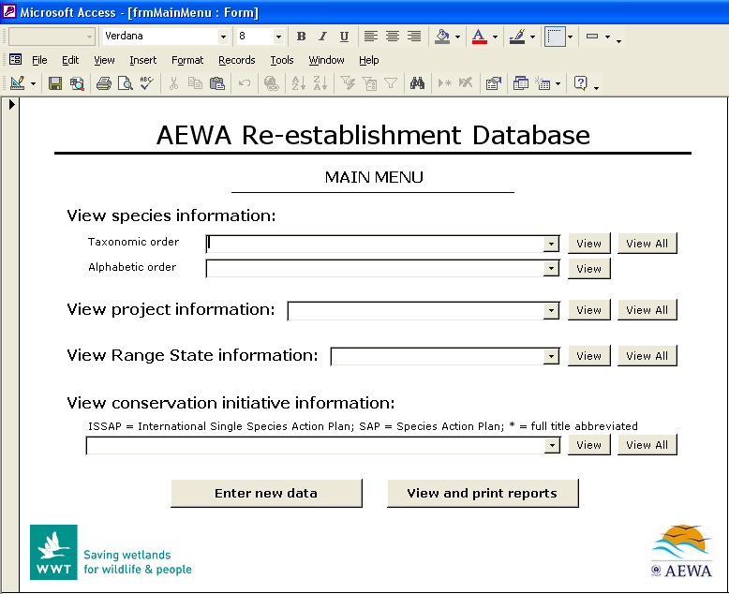
Figure 4-1. Screenshot of the main entry page of the database created for re-establishment information relevant to AEWA.


Figure 4-2. Screenshot of the species information page for White-headed Duck Oxyura leucocephala in the database created for re-establishment information relevant to AEWA.

Assessment of waterbird re-establishment projects against IUCN guidelines

Objective

Assess re-establishment projects that have occurred for AEWA species in the AEWA region in terms of their compliance to IUCN re-introduction guidelines.

Method

To assess how closely waterbird re-establishment projects in the AEWA region have followed IUCN re-introduction guidelines, a questionnaire survey was conducted. Data gathered from the survey were analysed to determine how closely the projects had followed IUCN guidelines, how successful the projects had been and if there was a relationship between compliance and success.

Designing the questionnaire

The questionnaire was designed to address all of the relevant IUCN guidelines. The IUCN/SSC Guidelines for Re-introductions (IUCN/SSC RSG 1995, Appendix 3) were broken-down into a list of 43 separate activities, organised under three project phases: pre-project activities; planning, preparation and release stages; and post-release activities. A question was included in the questionnaire to address each activity (Table 5-1). Thus, the questionnaire had 43 questions addressing IUCN guidelines. Of the 43 activities, 41 were requirements of the IUCN/SSC Guidelines for Re-introductions (IUCN/SSC RSG 1995) while two were simply suggestions.

Table 5-5. IUCN re-introduction guidelines and corresponding questions from the re-establishment questionnaire circulated as part of this review.
IUCN re-introduction guidelines | Corresponding questions in questionnaire
PRE-PROJECT ACTIVITIES
a. BIOLOGICAL
(i) Feasibility study and background research
- Assessment of the taxonomic status of individuals to be re-introduced | 2-5 Was an assessment made of the taxonomic status of individuals to be re-introduced?
- Investigation of historical information about the loss and fate of individuals from the re-introduction area | 2-13 Were the causes of decline identified?
- Determination of critical needs | 2-4 Were the species' critical needs determined?
- Population viability modelling including Population and Habitat Viability Analysis | 2-6 Was a Population and Habitat Viability Analysis conducted?
(ii) Previous re-introductions
- Research into prior re-introductions and contact with relevant experts | 2-7 Was a review of re-introductions for similar species conducted?
(iii) Choice of release site
- Site within historic range of the species  (Core or periphery) | 2-8 Was the release site within the historic range of the species?  2-9 Was the release site in the core or at the periphery of the historic range of the species?)
- Assured, long-term protection | 2-10 Did the release area have assured, long-term protection?
(iv) Evaluation of re-introduction site
- Habitat and landscape requirements of the species are satisfied and sustainable | 2-11 Was the habitat suitability of the release site assessed through scientific investigation?
- Sufficient carrying capacity | 2-12 Was there sufficient habitat at the release site to support a viable (self-sustaining) population in the long-term?
- Identification and elimination, or reduction to a sufficient level, of previous causes of decline | 2-14 Were the causes of decline eliminated or reduced to a sufficient level?
- Habitat restoration programme if necessary | 2-15 Was a habitat restoration programme initiated before re-introduction?
(v) Availability of suitable release stock
- Source animals come from wild populations | 2-17 Was the stock used captive or wild?
- Stock must be guaranteed available on a regular and predictable basis | 2-20 Was stock available on a regular and predictable basis?
- Individuals should only be removed from a wild population after the effects of translocation on the donor population have been assessed, and it is guaranteed that these effects will not be negative | 2-18 If wild stock was used, was the effect on the wild source population assessed?
- If captive or artificially propagated stock is to be used, it must be from a population which has been soundly managed both demographically and genetically | 2-19 If captive or artificially propagated stock was used, was it from a population which had been soundly managed both demographically and genetically, according to the principles of contemporary conservation biology?
- Veterinary screening process | 3-8 Was the health of the release stock monitored before release?
(vi) Release of captive stock
- Individuals should be given the opportunity to acquire the necessary information to enable survival in the wild | 3-21 Were birds acclimatised to local conditions before release?
b. SOCIO-ECONOMIC AND LEGAL REQUIREMENTS
- Long-term financial support | 2-21 Was there long-term financial support for the project?
- Long-term political support | 2-22 Was there long-term political support for the project?
- Socio-economic studies | 2-24 Were socio-economic studies conducted to assess impacts, costs, and benefits of the re-establishment programme to local human populations?
- Assessment of local attitudes | 2-25 Was an assessment made of the attitudes of local people?
- Full understanding, acceptance and support of local communities | 2-26 Were local communities supportive of the re-introduction project?
- Policy of the country where the re-introduction is to take place should be consulted | 2-28 Was the country’s re-introduction policy consulted?
- Permission and involvement of all relevant government agencies and land owners | 2-29 Did the project have permission of the relevant government agencies and land-owners?
PLANNING, PREPARATION AND RELEASE STAGES
- Construction of a multidisciplinary team with access to expert technical advice | 3-2 Was a multidisciplinary team of experts established?
- Identification of short-term success indicators | 3-3 Were short-term success indicators identified?
- Identification of long-term success indicators | 3-4 Were long-term success indicators identified?
- Prediction of programme duration | 2-23 Was the duration of the project predicted?
- Appropriate genetic screening | 3-5 Was the release stock genetically screened?
- Appropriate health screening | 3-6 Was the release stock screened for disease?
- Appropriate veterinary care | 3-9 Was veterinary support available?
- Determination of release strategy | 3-10 Was a release strategy prepared?
- Public relations | 3-11 Was there a public awareness programme associated with the project?
- Involvement of local people | 3-12 Was there local community involvement?
- Interventions when necessary | 3-23 Were there any human interventions, e.g. supplemental feeding?
POST-RELEASE ACTVIVITES
- Post-release monitoring | 4-1 Was there post-release monitoring?
- Collection and investigation of mortalities | 4-4 Was information collected on causes of mortality in released birds?
- Continued habitat protection or restoration where necessary | 4-5 Did habitat protection measures continue after re-introduction?
- Continued public relations | 4-6 Were public relation activities continued after re-introduction?
- Evaluation of cost-effectiveness and success | 4-2 Was there an evaluation of cost-effectiveness and/or re-introduction success?
- Publications in popular literature | 4-7 Were the results published in popular literature?
- Publications in scientific literature | 4-8 Were the results published in scientific literature?

In addition to the 43 questions addressing IUCN guidelines (Table 5-1), the questionnaire had nine questions addressing basic project information (species/population, Range State, etc) and six that could be used to indicate success (Table 5-2). Another 16 questions were included to gather additional information such as the number of releases undertaken and the methods of post-release monitoring (see Appendix 2 for a complete questionnaire).

Table 5-6. Questions, from the re-establishment questionnaire, dealing with basic project information and success indicators.
Information required | Corresponding questions in questionnaire
BASIC PROJECT INFORMATION
- Species name | 1-1 Species (provide common and scientific names)
- Range State | 1-2 Country
- Organisations involved | 1-3 Organisation(s) involved in the project
- Address of project contact | 1-4 Address
- Telephone number of project contact | 1-5 Telephone number (include international code)
- Fax number of project contact | 1-6 Fax number (include international code)
- E-mail address of project contact | 1-7 Email address
- Conservation context of project | 1-8 Was the re-establishment project part of a conservation strategy?  1-9 If yes, please provide details
SUCCESS INDICATORS
- Number of birds released | 3-18 How many birds were released in total?
- Survival of released birds | 3-24 What proportion of birds were known / thought to survive?
- Extent of breeding of the released birds | 3-25 Have re-introduced birds bred successfully in the wild?
- Growth rate of the re-introduced population | 3-24 What proportion of birds were known / thought to survive?  3-25 Have re-introduced birds bred successfully in the wild?  4-1 Was there post-release monitoring?  4-3 Please explain what criteria were used to determine success.
- How successful the practitioners rated their own project (i.e. if short and/or long-term goals were achieved) | 4-2-2 Was the project considered a re-introduction success?
- Whether or not a self-sustaining population of more than 500 individuals was established (Beck et al. 1994) | 3-24 What proportion of birds were known / thought to survive?  3-25 Have re-introduced birds bred successfully in the wild?  4-1 Was there post-release monitoring?  4-3 Please explain what criteria were used to determine success.

The questionnaire was produced in both Microsoft Excel and Microsoft Word formats. The Microsoft Excel version was designed so that it could be automatically analysed and up-loaded into the AEWA re-establishment database.

Distribution of the questionnaire

The questionnaire was distributed to AEWA National Focal Points, re-establishment practitioners and other relevant experts. A total of 157 questionnaires were circulated: 120 to AEWA National Focal Points and 37 to re-establishment practitioners and other relevant experts. For National Focal Points with known e-mail addresses, the questionnaire was sent in Microsoft Excel format with an offer to provide a different format (e.g. Microsoft Word) if required.

Collation and analysis of data

Each questionnaire was reviewed to check the consistency of the answers. The questionnaire was designed to allow for cross-checking. Where answers were inconsistent between related questions or with accompanying comments, minor adjustments were made to improve the consistency, and thus the validity of later analysis. In some questionnaires, answers were left blank that were readily available in literature; these answers were supplemented.

The reviewed questionnaires were then run through a series of procedures in Microsoft Excel to extract the necessary data, calculate each project’s level of compliance to IUCN re-introduction guidelines (‘IUCN compliance score’) and calculate each project’s level of success (‘success rating’).

Calculation of the IUCN compliance scores

Using an automated Microsoft Excel procedure on the questionnaire data, each re-establishment project was scored regarding its level of compliance at each of the three re-introduction phases (pre-project; planning, preparation and release; and post-release) and overall.

Scores were calculated by awarding points for each guideline followed. Each of the 41 required activities from the IUCN Guidelines for Re-introductions (IUCN/SSC RSG 1995) (Table 5-1) was weighted equally. Equal weights were chosen to ensure that the analysis would indicate overall compliance, and not indicate compliance to particular guidelines that are assumed to be more important or have been shown to be more important in past studies.

Each answer to a question that addressed a required activity was scored from 0 to 4: full compliance was awarded 4 points, partial compliance was awarded 1 to 3 points and no compliance was awarded 0 points (Table 5-3).

Two scores were awarded in addition to the required activity scores: one point for releasing birds into the core of a historical range as opposed to at the periphery; and one point for using wild release stock rather than captive (Table 5-3). These two activities were included because, while they are not required activities, they are suggestions of the IUCN Guidelines for Re-introductions.

Table 5-7. Scoring system for compliance to IUCN re-introduction guidelines.
IUCN re-introduction guidelines | Q* | Answers aligned with corresponding scores
IUCN re-introduction guidelines | Q* | 4 | 3 | 2 | 1 | 0
PRE-PROJECT ACTIVITIES
a. BIOLOGICAL
(i) Feasibility study and background research
- Assessment of the taxonomic status of individuals to be re-introduced | 2-5 | Yes |  | Partly |  | No
- Investigation of historical information about the loss and fate of individuals from the re-introduction area | 2-13 | Yes |  | Partly |  | No
- Determination of critical needs | 2-4 | Yes |  | Partly |  | No
- Population and Habitat Viability Analysis | 2-6 | Yes |  | Partly |  | No
(ii) Previous Re-introductions
- Research into prior re-introductions and contact with relevant experts | 2-7 | Yes |  | Partly |  | No
(iii) Choice of release site and type
- Site within historic range of the species | 2-8 | Yes |  | Partly |  | No
- (Core or periphery) | 2-9 |  |  |  | Core | Periphery
- Assured, long-term protection | 2-10 | Yes |  |  |  | No
(iv) Evaluation of re-introduction site
- Habitat and landscape requirements of the species are satisfied and sustainable | 2-11 | Yes |  | Partly |  | No
- Sufficient carrying capacity | 2-12 | Yes |  | Partly |  | No
- Identification and elimination, or reduction to a sufficient level, of previous causes of decline | 2-14 | Eliminated | Reduced sufficiently |  | Reduced somewhat | Not reduced
- Habitat restoration programme if necessary | 2-15 | Yes |  | Partly |  | No
(v) Availability of suitable release stock
- Source animals come from wild populations | 2-17 |  |  |  | Wild | Captive
- Stock must be guaranteed available on a regular and predictable basis | 2-20 | Yes |  | Partly |  | No
- Individuals should only be removed from a wild population after the effects of translocation on the donor population have been assessed, and it is guaranteed that these effects will not be negative | 2-18 | Yes |  | Partly |  | No
- If captive or artificially propagated stock is to be used, it must be from a population which has been soundly managed both demographically and genetically | 2-19 | Yes |  | Partly |  | No
- Veterinary screening process | 3-8 | Yes |  |  |  | No
(vi) Release of captive stock
- Individuals should be given the opportunity to acquire the necessary information to enable survival in the wild | 3-21 | Yes |  | Partly |  | No
b. SOCIO-ECONOMIC AND LEGAL REQUIREMENTS
- Long-term financial support | 2-21 | Yes |  | Partly |  | No
- Long-term political support | 2-22 | Yes |  | Partly |  | No
- Socio-economic studies | 2-24 | Yes |  | Partly |  | No
- Assessment of local attitudes | 2-25 | Yes |  | Partly |  | No
- Full understanding, acceptance and support of local communities | 2-26 | Yes |  | Partly |  | No
- Policy of the country where the re-introduction is to take place should be consulted | 2-28 | Yes |  |  |  | No
- Permission and involvement of all relevant government agencies | 2-29 | Yes |  | Partly |  | No
PLANNING, PREPARATION AND RELEASE STAGES
- Construction of a multidisciplinary team with access to expert technical advice | 3-2 | Yes |  |  |  | No
- Identification of short-term success indicators | 3-3 | Yes |  |  |  | No
- Identification of long-term success indicators | 3-4 | Yes |  |  |  | No
- Prediction of programme duration | 2-23 | Yes |  | Partly |  | No
- Appropriate genetic screening | 3-5 | Yes |  | Partly |  | No
- Appropriate health screening | 3-6 | Yes |  | Partly |  | No
- Appropriate veterinary care | 3-9 | Yes |  | Somewhat |  | No
- Determination of release strategy | 3-10 | Yes |  | Partly |  | No
- Public relations | 3-11 | Yes |  | Partly |  | No
- Involvement of local people | 3-12 | Yes |  | Partly |  | No
POST-RELEASE ACTIVITIES
- Post-release monitoring | 4-1 | Yes |  | Somewhat |  | No
- Collection and investigation of mortalities | 4-4 | Yes |  | Partly |  | No
- Interventions when necessary | 3-23 | Yes |  |  |  | No
- Continued habitat protection or restoration where necessary | 4-5 | Yes |  | Partly |  | No
- Continued public relations | 4-6 | Yes |  | Partly |  | No
- Evaluation of cost-effectiveness and success | 4-2 | Yes |  | Partly |  | No
- Publications in popular literature | 4-7 | Yes |  | Partly |  | No
- Publications in scientific literature | 4-8 | Yes |  | Partly |  | No
* Q = question number in re-establishment questionnaire addressing the relevant guideline.

The maximum possible score was 166: 102 for pre-project activities; 40 for planning, preparation and release stages; and 24 for post-release activities. Unanswered questions were not scored with 0 points but were left out of score calculations. Final scores were converted to percentages for each project phase (pre-project activities; planning, preparation and release stages; and post-release activities) and for the project overall.
Calculating the success ratings

Project success was evaluated using six standard criteria assessed in the questionnaire:

- The number of birds successfully released from captivity or translocated from a wild population.
- The survival rate of released birds.
- The extent of breeding of the re-introduced population.
- The growth rate of the re-introduced population.
- How successful the practitioners rated their own project (i.e. if short and/or long-term goals were achieved).
- Whether or not a self-sustaining population of more than 500 individuals was established (Beck et al. 1994).
The criteria were chosen based on past reviews of re-introduction success (Ostermann et al. 2001, Beck et al. 1994). The first criterion is an indicator of the quality of the captive-breeding techniques and conditions, and/or the methods of translocation from the wild. Criteria 2-4 are indices of the released birds’ ability to contribute to the wild population. The fifth criterion is an indicator of the success of the project in relation to the individual project goals. The sixth criterion is a measure of long-term success.

Each criterion was the subject of one or more questions in the re-establishment questionnaire. Some four of the six criteria required categorical answers that could be scored from 0 to 2 (Table 5-4). The remaining two criteria, growth rate and self-sustaining population of over 500 individuals, were determined by evaluating the answers to four questions (Table 5-4) on survival, breeding, project outcomes and post-release monitoring. Growth rate could be scored from 0 to 2, and self-sustaining population from 0 to 1 (Table 5-4).

The maximum score achievable was 11 and the minimum 0. If a questionnaire was submitted without answers to all of the success criteria questions, missing answers were extrapolated from other answers and additional sources of information.

Table 5-8. Scoring system for re-introduction success.
Success criteria | Question(s) | Answers aligned with corresponding scores
Success criteria | Question(s) | 0 | 1 | 2
- Number of birds released | 3-18 | ≤10 | 11-50 | >50
- Survival of released birds | 3-24 | ≤50% | 51-80% | >80%
- Extent of breeding of the released birds | 3-25 | None | To some extent | To great extent
- Growth rate of the re-introduced population | 3-24, 3-25, 4-1 & 4-3 | No growth | Less than doubled | More than doubled
- How successful the practitioners rated their own project (i.e. if short and/or long-term goals were achieved) | 4-2-2 | No | Partly | Yes
- Whether or not a self-sustaining population of more than 500 individuals was established (Beck et al. 1994) | 3-24, 3-25,  4-1 & 4-3 | No | Yes

Comparison of IUCN compliance scores with success ratings

To assess the relationship between the calculated IUCN compliance scores and success ratings, a regression analysis was performed.

Results

Questionnaire returns

Of the 157 circulated, 11 questionnaires were completed and returned, and an additional three questionnaires were completed by literature review (Table 5-5).

Table 5-9. List of the projects for which questionnaires were completed.
Project code | Species | Location | Questionnaire respondent(s) or literature source
1 WhiDuc HU | White-headed Duck  Oxyura leucocephala | Hungary | Bálint Bajomi
2 GreGoo BE | Greylag Goose  Anser anser | Belgium | Koen Devos via Wouter Faveyts (Agentschap voor Natuur en Bos)
3 WhiSto BE | White Stork  Ciconia ciconia | Belgium | Wim Van Den Bossche (Natuurpunt) via Wouter Faveyts (Agentschap voor Natuur en Bos)
4 FerDuc ES | Ferruginous Duck  Aythya nyroca | Spain | (Perez-Rendon 1999)
5 WhiDuc ES 1 | White-headed Duck  Oxyura leucocephala | Spain (mainland) | (Perez-Rendon 1999)
6 WhiDuc ES 2 | White-headed Duck  Oxyura leucocephala | Spain (Majorca) | (Perez-Rendon 1999)
7 CorCra UK | Corn Crake  Crex crex | United Kingdom | Andy Evans (RSPB)
8 LesWhi FI | Lesser White-fronted Goose  Anser erythropus | Finland | Antti Haapanen
9 WhiDuc IT | White-headed Duck  Oxyura leucocephala | Italy | Barbara Amadesi (INFS)
10 WhiSto NL | White Stork  Ciconia ciconia | The Netherlands | Annemieke Enters & Wim van Nee
11 DalPel CR | Dalmatian Pelican  Pelecanus crispus | Croatia | Jasmina Muzinic (HAZU)
12 CarFla BVI | Caribbean Flamingo  Phoenicopterus ruber | British Virgin Islands | James Lazell (TCA)
13 PurSwa IT | Purple Swamphen  Porphyrio porphyrio | Italy | Alessandro Andreotti (INFS)
14 WatCra ZA | Wattled Crane  Grus carunculatus | South Africa | Jeanne Marie Pittman (Johannesburg Zoo)

Unfortunately, four of the returned questionnaires could not be included in further analysis: the re-introduction of Caribbean Flamingo Phoenicopterus ruber (CarFla BVI) was excluded because it did not occur in an AEWA Range State; a supplementation of Wattled Crane Grus carunculatus (WatCra ZA) was excluded because it did not meet the criteria of a re-establishment project; a re-introduction of Purple Swamphen Porphyrio porphyrio in Italy (PurSwa IT) was excluded because the Purple Swamphen is not an AEWA species; and a project to re-introduce Dalmatian Pelican Pelecanus crispus in Croatia (DalPel CR) was excluded because the project was in planning stages when the questionnaire was completed.

See Appendix 2 for the completed questionnaires.

IUCN compliance scores

The overall IUCN compliance scores ranged from 23% for a re-introduction of the White-headed Duck in Hungary to 88% for a re-introduction of the Corn Crake in the United Kingdom (Table 5-6).

Table 5-10. Scores for compliance to IUCN re-introduction guidelines for 10 re-establishment projects for waterbird species covered by AEWA.
Project | Pre-project activities* | Planning, preparation and release stages* | Post-release activities* | All stages*
1 White-headed Duck – Hungary | 28% | 11% | 30% | 23%
2 Greylag Goose – Belgium | 40% | 33% | 90% | 51%
3 White Stork – Belgium | 60% | 35% | 58% | 50%
4 Ferruginous Duck – Spain | 69% | 10% | 20% | 46%
5 White-headed Duck – Spain (mainland) | 79% | 63% | 60% | 71%
6 White-headed Duck – Spain (Majorca) | 60% | 25% | 80% | 61%
7 Corn Crake – United Kingdom | 88% | 90% | 83% | 88%
8 Lesser White-fronted Goose - Finland | 64% | 80% | 60% | 66%
9 White-headed Duck - Italy | 58% | 72% | 10% | 55%
10 White Stork – The Netherlands | 55% | 56% | 83% | 61%
*See Methods section for explanation of calculations and rationale.

Success ratings

The calculated success ratings ranged from 1 for the re-introduction of White-headed Duck in Italy that did not result in a self-sustaining population to 9 for the re-introduction of White-headed Duck in Spain (mainland) that did result in a self-sustaining population (Table 5-7).

Table 5-11. The success criteria, success ratings and outcomes of 10 re-establishment projects for waterbird species covered by AEWA. | Outcome of project | A self-sustaining population was not attained - ended in 1992. | Unknown. | <65 pairs largely limited to compounds. | Small numbers of breeding birds. | A wild population of >1200 birds – exact contribution of re-introduction unknown. | 68% of birds disappeared within a year. | Progress toward the establishment of a stable population of >30 pairs - birds have returned from overwinter migration and bred in the wild. | Few details given – project said to be in preliminary stages | Poor captive breeding success and high mortality of re-introduced birds. | In 2007, there were more than 600 pairs | * See Methods section for explanation of calculations and rationale.
 | Success rating (/11) * | 2 | 4 | 3 | 5 | 9 | 4 | 7 | 4 | 1 | 8
 | Self-sustaining population of ≥500 | No | No | No | No | Yes | No | No | No | No | No (> 500 pairs but dependent on intervention)
 | Self-rated successful | No | Yes | Not rated | Not rated | Yes | No | Partly | Not rated | Not rated | Yes
 | Population growth | None | Unknown  (pop >700 pairs) | Unknown  (pop. estimated at 65 pairs) | Less than doubled | More than doubled | None | Less than doubled | Unknown  (probably minimal) | None | More than doubled
 | Breeding | None | To great extent | To some extent | To some extent | To some extent | To some extent | To some extent | Unknown | None | To great extent
 | Survival | 0 – 10% | Unknown | 41-50% | Unknown | 61-70% | 31-40% | 81-90% | < 50% | 0 – 10% | 11-20%
 | Number of birds released | Unknown but > 52 | 3 pairs | Unknown but > 150 | 100 | Unknown | 56 | 291 | Not reported but ~150 | 15 | Unknown but >50
 | Project | - White-headed Duck Hungary | - Greylag Goose  Belgium | - White Stork  Belgium | - Ferruginous Duck  Spain | - White-headed Duck  Spain (mainland) | - White-headed Duck  Spain (Majorca) | - Corn Crake  United Kingdom | - Lesser White-fronted Goose  Finland | - White-headed Duck  Italy | - White Stork  The Netherlands

Comparison of IUCN compliance scores with success ratings

Regression analysis showed a positive relationship between the IUCN compliance scores and the success ratings that approached significance (F=5.05, r²=0.387, p=0.055, n=10) (Figure 5-1). The project that received the second lowest success rating (2) showed the least amount of compliance with IUCN guidelines (23%), while the three projects that received the highest success ratings (7, 8 and 9) showed the highest amounts of compliance (88%, 61% and 71%, respectively) with the exception of the Lesser White-fronted Goose project which scored 66% for compliance but achieved a success rating of only 4 (Figure 5-1). If the data for the Caribbean Flamingo and Purple Swamphen projects were included the relationship was significant (F=10.97, r²=0.523, p<0.01, n=12).
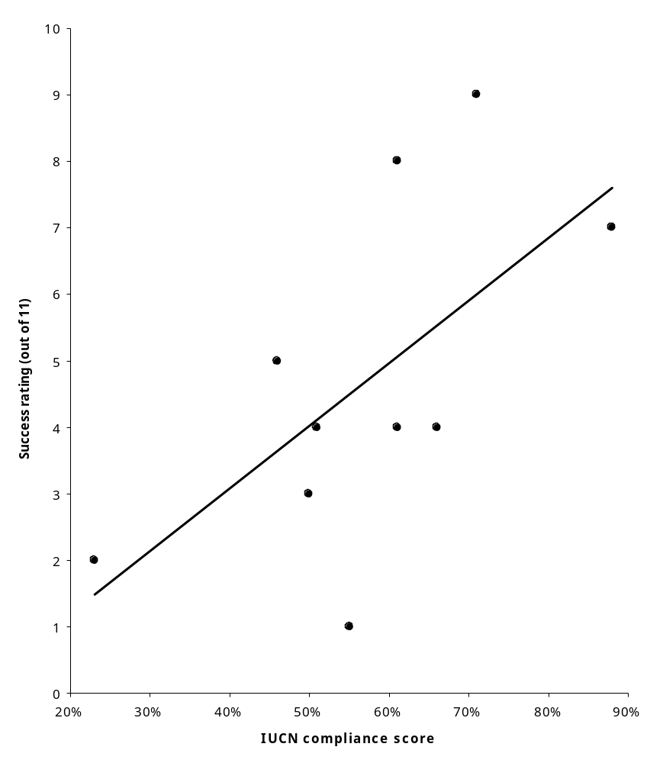
Figure 5-3. Relationship between the compliance to IUCN guidelines scores and the success ratings for 10 re-establishment projects for AEWA waterbird species in AEWA Range States (y=-0.67+9.39x, F=5.05, r²=0.387, p=0.055, n=10).

Progress in implementing re-establishment projects

Objective

Assess the status of and progress in the implementation of re-establishment projects by Range States and other stakeholders.

Method

To assess the status of and progress in the implementation of re-establishment projects, a list of ‘species of interest’ (Table 6-1) was compiled based on 3 criteria: (1) the 2007 IUCN Red List Status of Vulnerable (VU), Endangered (EN), or Critically Endangered (CR) – these species were classed as threatened; (2) an international single species action plan (ISSAP) existing for the species; or (3) the completion or planning of at least one re-establishment project.

As stated, criterion 1 was assessed using the IUCN Red List (2007). The information required to assess criterion 2 was provided in Section 2 of this review, and the information required to assess criterion 3 was gathered by searching scientific literature, popular literature and websites, and by consulting National Focal Points and other relevant ornithological experts.

These criteria ensured that the list included all threatened species, all species with ISSAPs, and all species for which re-establishment projects had been completed or planned.

The ‘species of interest’ were divided into three groups: species with ISSAPs that recommended re-establishment; species with ISSAPs that did not recommend re-establishment; and species without ISSAPs. The proportions of species for which re-establishment projects had been implemented were determined within these groups.

Results

A total of 38 ‘species of interest’ were identified. Of these, 21 were considered threatened, five had had re-establishment recommended in an ISSAP as a conservation measure, and 15 were the subjects of observed (past or current) or expected (planned/future) re-establishment projects (Table 6-1).

Table 6-12. Species of interest based on IUCN Red List Status, existence of an international single species action plan (ISSAP) or existence of a re-establishment project (observed or expected).
AEWA waterbird species | ISSAP | IUCN Red List Status (2007)* | Re-est rec**? | Number of projects (observed*) | Number of projects (expected*)
African Penguin Spheniscus demersus | No | VU | No | 0 | 0
Audouin’s Gull Larus audouinii | Yes | NT | No | 0 | 0
Avocet Recurvirostra avosetta | No | LC | No | 1 | 0
Bald Ibis Geronticus eremita | Yes | CR | No | 5 | 0
Bank Cormorant Phalacrocorax neglectus | No | EN | No | 0 | 0
Bean Goose Anser fabalis | No | LC | No | 1 | 0
Bittern Botaurus stellaris | Yes | LC | No | 0 | 0
Black-winged Pratincole Glareola nordmanni | Yes | NT | No | 0 | 0
Blue Crane Grus paradisea | No | VU | No | 0 | 0
Brent Goose Branta bernicla | Yes | LC | No | 0 | 0
Cape Gannet Morus capensis | No | VU | No | 0 | 0
Common Crane Grus grus | No | LC | No | 0 | 1
Corn Crake Crex crex | Yes | NT | No | 1 | 0
Crested Coot Fulica cristata | Yes | LC | Yes | 2 | 0
Dalmatian Pelican Pelecanus crispus | Yes | VU | No | 0 | 1
Ferruginous Duck Aythya nyroca | Yes | NT | Yes | 23 | 0
Great Snipe Gallinago media | Yes | NT | No | 0 | 0
Greylag Goose Anser anser | No | LC | No | >> | 0
Lesser Flamingo Phoenicopterus minor | Yes | NT | No | 0 | 0
Lesser White-fronted Goose Anser erythropus | Yes | VU | Yes | 2 | 2
Maccoa Duck Oxyura maccoa | Yes | NT | Yes | 0 | 0
Madagascar Pond-heron Ardeola idae | No | EN | No | 0 | 0
Madagascar Pratincole Glareola ocularis | No | VU | No | 0 | 0
Marbled Duck Marmaronetta angustirostris | Yes | VU | No | 1 | 0
Pygmy Cormorant Phalacrocorax pygmeus | Yes | LC | No | 0 | 0
Red-breasted Goose Branta ruficollis | Yes | EN | No | 0 | 0
Roseate Tern Sterna dougallii | Yes | LC | No | 0 | 0
Shoebill Balaeniceps rex | No | VU | No | 0 | 0
Siberian Crane Grus leucogeranus | No | CR | No | 1 | 0
Slaty Egret Egretta vinaceigula | No | VU | No | 0 | 0
Slender-billed Curlew Numenius tenuirostris | Yes | CR | No | 0 | 0
Sociable Lapwing Vanellus gregarius | Yes | CR | No | 0 | 0
Socotra Cormorant Phalacrocorax nigrogularis | No | VU | No | 0 | 0
Steller’s Eider Polysticta stelleri | Yes | VU | No | 0 | 0
Wattled Crane Grus carunculatus | No | VU | No | 1 | 0
White Stork Ciconia ciconia | No | LC | No | 8 | 0
White-headed Duck Oxyura leucocephala | Yes | EN | Yes | 5 | 0
White-winged Crake Sarothrura ayresi | No | EN | No | 0 | 0
* CR = critically endangered, EN = endangered, VU = vulnerable, NT = near threatened, LC = least concern, observed = completed or ongoing, expected = planned for future.
** re-est rec = re-establishment recommended in an ISSAP (i.e. not a national action plan).
>> Multiple re-introductions and introductions (including supplementations for hunting purposes) in at least seven European countries.

Of the 21 species with ISSAPs, five have been recommended for re-establishment. Of these, re-establishment projects have been implemented for both of the two threatened species (Lesser White-fronted Goose and White-headed Duck) and for two out of three of the non-threatened species (Ferruginous Duck and Crested Coot) (Table 6-1). The only species where re-establishment has not been implemented despite a recommendation is the Maccoa Duck.

Of the remaining 214 waterbird species covered by AEWA, re-establishment projects have been conducted for two threatened species and four non-threatened species (Table 6-2). Thus, re-establishments have been conducted for 33% of the threatened species and for 3% of the non-threatened species (Table 6-2).

Table 6-13. Numbers of re-establishment projects observed and expected for groups of waterbird species covered by AEWA - species were grouped according to their status, the existence of an ISSAP and whether or not that ISSAP recommended re-establishment.
Species group | Number of species | Number of species with  re-establishment  projects (%) |  | Number of projects (observed*) | Number of projects (expected*)
Species with an ISSAP recommending re-establishment | 5 | 4 | (80%) | 32 | 2
Threatened | 2 | 2 | (100%) | 7 | 2
Non-threatened | 3 | 2 | (66%) | 25 | 0
Species with an ISSAP not recommending re-establishment | 16 | 3 | (19%) | 7 | 1
Threatened | 7 | 2 | (29%) | 6 | 1
Non-threatened | 9 | 1 | (11%) | 1 | 0
Species without an ISSAP | 214 | 6 | (3%) | >>12 | 1
Threatened | 12 | 2 | (17%) | 2 | 0
Non-threatened | 202 | 4 | (2%) | >>10 | 1
All | 235 | 14 | (6%) | >>50 | 4
Threatened | 21 | 6 | (33%) | 15 | 3
Non-threatened | 214 | 7 | (3%) | >>36 | 1
* observed = completed or ongoing, expected = planned for future.
>> Total number is unknown but significantly higher than stated.

The group with the highest proportion of species with re-establishment projects was the group containing species with ISSAPs recommending re-establishment (80%); second was the group containing species with ISSAPs not recommending re-establishment (19%); and the group with the lowest proportion was the group containing species without ISSAPs (3%) (Table 6-2).

Within each of these groups, the proportion of species with re-establishment projects was ≥15% higher for threatened species compared with non-threatened species (Table 6-2, Figure 6-1).

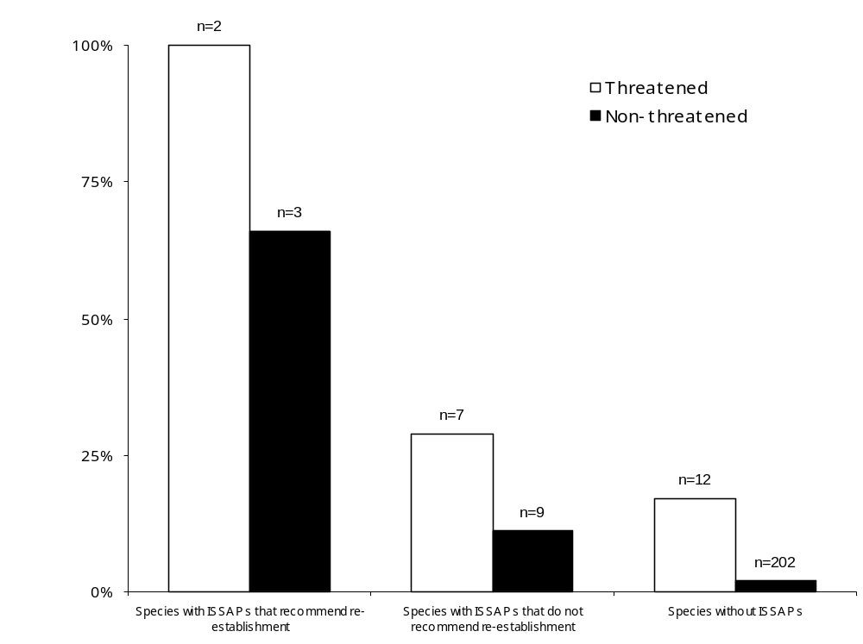
Figure 6-4. Percentage of species for which re-establishment projects have been implemented.

Improving the effectiveness of re-establishment as a conservation measure

Objective

Assess the effectiveness of waterbird re-establishment projects in the AEWA region and determine the factors that are most linked to success in these projects.

Method

Using data gathered during the questionnaire survey (Section 5), an assessment was made of the key factors influencing the success or failure of the projects for which questionnaires were returned.

Projects were defined as ‘successful’ or ‘unsuccessful’ based on the success ratings calculated in Section 5 of this review and whether or not a stable population is thought to have resulted.

The key factors identified by practitioners as influencing success or failure were extracted from the questionnaires, and the answers to a selection of questions were compared to determine which factors were common to the successful projects versus the unsuccessful projects. The findings from these two procedures were combined into a master list of key factors influencing success.

Results

Of the 10 projects reviewed by questionnaire, two achieved stable populations (Table 7-1): the re-introduction of the White-headed Duck in mainland Spain and the re-introduction of White Stork in the Netherlands. These projects also received the highest success ratings, 8 and 9, respectively. Based on these two facts the projects were deemed successful. The re-introduction of Corn Crake in the United Kingdom was also considered successful. While a stable population has not yet been established, the project is on-going, has met its intermediate targets and received the third highest success rating, 7. Thus 30% of the projects reviewed were considered successful. Past reviews of re-establishment have found a much lower success rate. Beck et al. (1994) found evidence that only 16 (11%) of 145 re-introduction projects were successful, with success defined as establishment of a wild population of ≥500 individuals free of human support, or population viability as determined by a formal genetic-demographic analysis.

Table 7-1 presents the key factors that practitioners viewed as influencing success or failure for their own projects. Acclimatization of birds pre-release was mentioned three times as a key factor in success and a lack of acclimatization was mentioned once as a key factor in failure. Quality of habitat (relating to protection, management or regeneration) is mentioned three times as a key factor in success.

Table 7-14. Key factors relating to success or failure in 10 re-establishment projects for waterbird species covered by AEWA.
Project | Key factors relating to success | Key factors relating to failure | Outcome of project
- White-headed Duck  Hungary |  |  | A self-sustaining population could not be attained - the project was stopped in 1992
- Greylag Goose  Belgium | - Birds were initially released into a park with captive waterbirds | - The introduced birds came from Russia and belonged to a subspecies (Anser anser rubirostris) not native to the area | A breeding population of >700 pairs of a non-native subspecies – impact of project on this population unknown.
- White Stork  Belgium |  |  | <65 pairs largely limited to compounds
- Ferruginous Duck  Spain | - Habitat regeneration  - Good acclimatization of birds before release |  | Small numbers of breeding birds
- White-headed Duck  Spain (mainland) | - Released birds were juveniles  - Captive breeding occurring within the release area  - Condition of the released birds (healthy and untamed) |  | A wild population of >1,200 birds
- White-headed Duck  Spain (Majorca) | - Release area is well protected and guarded | - The first release failed because birds were not acclimatised  - The second release failed because too few birds were released | 68% of birds disappeared within a year
- Corn Crake  United Kingdom | - In-depth understanding of the species’ critical needs  - Reserve management sympathetic to needs of the released birds |  | Progress toward the establishment of a stable population of >30 pairs - birds have returned from overwinter migration and bred in the wild.
- Lesser White-fronted Goose |  | - No financial support from official sources  - Poor political support at the national level | Few details given – project said to be in preliminary stages.
- White-headed Duck  Italy |  | - Causes of decline not eliminated  - Problems rearing birds in captivity  - Assessment of reasons for failure pending | Poor captive breeding success and high mortality of re-introduced birds forced a stop to releases.
- White Stork  The Netherlands | - Team were passionate about and dedicated to the project |  | In 1969, the White Stork was considered extinct in the Netherlands; in 2007, there were over 600 pairs.

Table 7-2 compares the characteristics of the projects considered to be successful and those considered to be unsuccessful. Successful projects eliminated or reduced the causes of decline, had long-term financial and political support, identified success indicators, acclimatised birds to their release areas and monitored the birds post-release. Of the three successful projects, two conducted feasibility studies, one released birds at the core of their historical range, and two had support from local communities.

In common with the successful projects, the majority of unsuccessful projects also reduced sufficiently the causes of decline, monitored birds post-release and acclimatised birds to their release areas.

The factors that differ between successful and unsuccessful projects are long-term financial and political support and the identification of success indicators. Of the three successful projects, two reported having both long-term financial and long-term political support while the other reported having partial long-term financial support; in comparison, only one unsuccessful project reported having either. Finally each successful project reported identifying short and long-term success indicators. Again something only one unsuccessful project reported.

Table 7-15. Characteristics of successful and unsuccessful projects for AEWA waterbird species (successful projects are shaded).
Factor | Projects (numbers correspond projects in Table 7-1)
Factor | 1. | 2. | 3. | 4. | 5. | 6. | 7. | 8. | 9. | 10.
Success rating* | 2 | 4 | 3 | 5 | 9 | 4 | 7 | 4 | 1 | 8
Feasibility study |  | No | No |  |  |  | Yes | Partly† | Yes | Partly
Location of release site within the historic range | Periphery |  | Periphery |  |  |  | Core
Elimination or reduction of causes of decline** | No | Reduced suff. | Reduced suff. | Reduced suff. | Reduced suff. | Reduced suff. | Elim. | Reduced some.† | No† | Reduced some.
Long-term financial support |  |  | Partly | No | Yes | No | Yes | No† | Yes | Partly
Long term political support |  |  | Partly | No | Yes | No | Yes | No† | Partly
Identification of success indicators |  |  | No | No | Yes |  | Yes | Yes | Partly | Yes
Acclimatisation | No |  | Yes | Yes | Partly | Partly | Yes | Yes | Yes | Yes
Human interventions | No |  | Yes | No | No | Yes | No | No | No | Yes
Local support |  |  | Yes | No | No | No | Yes | Yes | Partly | Partly
Post-release monitoring |  | Yes | Yes | Yes | Yes | Yes | Yes |  | Partly | Yes
* See Section 5.
** Elim = eliminated; suff = sufficiently; some = somewhat.
† The answers to the questions addressing these factors did not match accompanying comments – comments were given priority.
1 White-headed Duck – Hungary 6 White-headed Duck – Spain (Majorca)
2 Greylag Goose – Belgium 7 Corn Crake – United Kingdom
3 White Stork – Belgium 8 Lesser White-fronted Goose – Finland
4 Ferruginous Duck – Spain 9 White-headed Duck – Italy
5 White-headed Duck – Spain (mainland) 10 White Stork – the Netherlands

Considering the key factors identified by re-introduction practitioners and the factors found common to successful projects and uncommon to unsuccessful projects, the following activities are considered especially crucial to the success of waterbird re-establishment projects:
- Completion of a comprehensive feasibility study.
- Pre-release acclimatization of birds to their release area.
- Good quality habitat with the original causes of decline eliminated or reduced.
- Long-term financial and political support.
- Identification of short and long-term indicators of success.

Recommendations and improvements needed

This report has identified three major areas for improvement regarding re-establishment projects: (1) the success rate of re-establishment projects; (2) the reporting on re-establishment projects; and (3) the evaluation of re-establishment projects.

Evaluating the success of a re-establishment project is a complex process and a variety of factors must be considered. Of the projects assessed as part of this report, only three were considered successful. Past reviews of re-establishment have also found low success rates. Beck et al. (1994) found evidence that only 16 (11%) of 145 re-introduction projects were successful with a wild population of ≥500 individuals established.

In an attempt to improve success, the IUCN Guidelines for Re-introductions (IUCN/SSC RSG 1995) were published in 1995 providing specific policy guidelines for re-establishment projects. Compliance with these guidelines appears to be associated with higher success for waterbird species re-establishment projects. However, the IUCN guidelines were written to encompass the full range of plant and animal taxa and are therefore general. The guidelines are focused on re-establishment projects using captive-bred individuals and toward re-establishment projects of globally threatened species with a limited numbers of founders (IUCN/SSC RSG 1995). For these reasons, guidelines for re-introducing individual species or groups of species should be developed in future.

In addition to guidelines, networks or groups of experts with knowledge relevant to re-establishments of a specific species should be assembled. An example of such a group is the International Advisory Group on the Northern Bald Ibis (IAGNBI). This group was created to ensure international co-ordination and co-operation on Bald Ibis projects. Through regular workshops and newsletters, the group aims to produce release guidelines for the Bald Ibis and review propositions for all Bald Ibis re-introduction projects (Boehm et al. 2003).

In order to improve the success rate of re-establishment projects, this report recommends that:

- Re-establishment projects are conducted in strict accordance with the IUCN Guidelines for Re-introductions (IUCN/SSC RSG 1995).
- The IUCN Guidelines for Re-introductions (IUCN/SSC RSG 1995) are adapted for waterbird species and supplemented with checklists of activities for practitioners to complete.
- The IUCN/SSC Re-introduction Specialist Group (IUCN/SSC RSG) is consulted prior to any re-establishment project to provide best practice guidance, expertise and a list of relevant contacts for the species to be re-established. Consultations should be made before a feasibility study or any planning has been initiated.
- Re-establishment projects are conducted by groups of organisations and experts with diverse skills bases. Collaboration will bring a number of significant advantages: enhanced expertise, transfer of skills, shared responsibility, shared accountability and increased funding opportunities.
- Networks or groups of experts with knowledge relevant to re-establishments of a specific species are assembled to act as advisory groups for re-establishment projects of the relevant species. These should be assembled for those species for which re-establishment has been recommended and for those species for which re-establishment projects are currently occurring or being planned. It may be appropriate for these species-specific groups to be formed within the IUCN/SSC RSG.
As part of this report, IUCN re-introduction guidelines were evaluated to determine which are most associated with success. While this report recommends that all guidelines be followed (see recommendation 1 above), it also recommends that particular attention be paid to those guidelines most associated with success for waterbird re-establishment projects. Thus, this report recommends that:
- During pre-project activities, particular attention is paid to the following:
- Completing a comprehensive feasibility study, comprising an assessment against IUCN re-introduction criteria, a review of historic status, an assessment of the species critical needs, a scientific assessment of habitat suitability of the release site, and a Population and Habitat Viability Analysis to determine the number of birds that need to be released to establish a sustainable population.

- Securing long-term financial and political support.

- During re-introduction activities, particular attention is paid to the following:
- Ensuring birds are acclimatized to their release area prior to release.

- Ensuring a sufficient amount of good quality habitat is available where the original causes of decline have been eliminated or sufficiently reduced.

- Identifying short and long-term indicators of success.

Although the IUCN Guidelines for Re-introductions (IUCN/SSC RSG 1995) suggest an assessment phase, in which the experiences and results of projects are regularly evaluated, published results remain scarce (Ostermann et al. 2001). In 1994, less than half of the projects known to have re-introduced animals had produced assessment information (Beck et al. 1994). As part of this review, information was provided for only 11 waterbird species re-establishment projects despite over 60 known projects having occurred in the AEWA region. This lack of information on re-establishment projects could be in part attributed to the lack of national and international monitoring schemes and a reluctance to report failures. The paucity of information causes difficulties with the evaluation and refinement of re-establishment methods and techniques, thus it is vital that reporting is improved.

In order to inform the triennial up-dates of this review and provide the data necessary to maintain the AEWA re-establishment database, this report recommends that:

- AEWA National Focus Points maintain a national register of re-establishment projects occurring or planned to occur wholly or in part within their corresponding Ranges States. This recommendation is in line with paragraph 2.4 of the AEWA Action Plan requiring Contracting Parties to “inform the Agreement secretariat, in advance, of all re-establishment programmes for populations listed in Table 1.”
In order to improve the amount and quality of data available on re-establishment methodologies, this report recommends that:

- All re-establishment projects are described to the IUCN/SSC RSG. A reporting structure should be developed to encourage practitioners to provide detailed information about each project stage. The IUCN/SSC RSG should make this information widely available and accessible.
In order to monitor the implementation of relevant action plans and other conservation initiatives within the AEWA region, this report recommends that:
- The AEWA re-establishment database is maintained with up to date information, on re-establishment projects and recommendations, supplied by Contracting Parties as per recommendation 8 of this report.
Despite the IUCN Guidelines for Re-introductions (IUCN/SSC RSG 1995) providing detailed guidelines for implementing re-establishment projects, a standard set of evaluation criteria does not exist. Standard criteria specifically for evaluating waterbird re-establishment projects would allow for more informative project assessments and provide guidance for standardised reporting, which would in turn generate recommendations for improving project success (Ostermann et al. 2001; Stanley Price 1991; Beck et al. 1994).

In order to improve the evaluation of re-establishment projects this report recommends that:

- A standard set of evaluation criteria for waterbird re-establishment projects is developed by the AEWA Technical Committee in liaison and consultation with appropriate experts and reported to AEWA Contracting Parties as soon as is possible, as well as being included within the next, triennial update of this review (for the fifth Meeting of Parties in 2011).

Conclusions

Species/populations for which re-establishments are needed

Re-establishment has been recommended as a conservation measure for six waterbird species in international and national actions plans published since 1995: Lesser White-fronted Goose (Madsen 1996), Ferruginous Duck (Callaghan 1997), Crested Coot (Gomez 1999), White-headed Duck (Hughes et al. 2006), Maccoa Duck (Abebe et al. 2007), and Corn Crake (UKBAP 1995b). A variety of projects have been undertaken to fulfil these recommendations.
- Lesser White-fronted Goose Anser erythropus
Re-establishment was recommended in the 1996 International Action Plan for the Lesser White-fronted Goose Anser erythropus (Madsen 1996) for areas where the species had disappeared and other conservation measures had failed. However the second draft of the 2006 International Action Plan for the Lesser White-fronted Goose Anser erythropus (Jones 2006) does not make such a recommendation and concludes that there is no consensus among Lesser White-fronted Goose stakeholders on the use of captive breeding and re-introduction/ restocking as valid conservation tools. In the 1980s, two projects to re-introduce this species were implemented: one in Sweden and the other in Finland. The re-introduced Swedish population is migrating along a route not used by native birds. The Finnish project is reported to have had high-levels of mortality and little breeding success. A new German-based project plans to release 400 captive-bred Lesser White-fronted Geese in Lapland and induce migration to the Lower Rhine area of Germany.
- Ferruginous Duck Aythya nyroca
Re-establishment was recommended in the 1997 European Species Action Plan Ferruginous Duck Aythya nyroca (Callaghan 1997) as a last measure conservation strategy to re-introduce the species to areas of its former range. However, re-establishment was not a recommendation of the 2006 International Single Species Action Plan for the Conservation of the Ferruginous Duck Aythya nyroca (Robinson & Hughes 2006). Over 23 re-introduction projects have been implemented in France, Spain and Italy with little success, apart from two projects in Italy that have reportedly produced self-sustaining populations.
- Crested Coot Fulica cristata
Maintaining a captive breeding population of this species was considered of medium priority in the 1999 International Species Action Plan Crested Coot Fulica cristata (Gomez 1999). The action plan required that a re-introduction programme following IUCN guidelines should be implemented in Spain between the Andalucía and Valencia Regions with a total of 50 pairs re-introduced. Re-introductions of Crested Coot have occurred in both the Andalucía and Valencia regions – the outcomes of these projects are unknown.
- White-headed Duck Oxyura leucocephala
Re-establishment was recommended in the 2006 International Single Species Action Plan for the Conservation of the White-headed Duck Oxyura leucocephala (Hughes et al. 2006). The action plan recommended that the species should be re-introduced to formerly occupied sites, if IUCN criteria can be met. A number of re-introductions of this species have occurred with varying success. Projects in France, Hungary and Italy have failed to achieve self-sustaining populations. Of the two known projects occurring in Spain, one is reported to have established a self-sustaining population, of over 1,200 birds.
- Maccoa Duck Oxyura maccoa
Re-establishment was recommended in the 2007 International Single Species Action Plan for the Conservation of the Maccoa Duck Oxyura maccoa (Abebe et al. 2006) for suitable sites in southern Tanzania. This measure was considered of medium importance for the conservation of this species. No known re-establishment projects have been implemented for the Maccoa Duck.
- Corn Crake Crex crex
Re-establishment was recommended in the 1995 UK Biodiversity Action Plan – Corn Crake Crex crex (UKBAP 1995b) as a long-term conservation measure to re-establish the species in parts of its former range in the United Kingdom. A project to re-introduce Corn Crake in England began in 2000 and is ongoing – 291 birds were released between 2002 and 2006 and breeding has been reported.

Waterbird conservation initiatives requiring re-establishment

Re-establishment can be a recommendation of a variety of conservation initiatives including national and international action plans, international conventions and agreements, and conservation assessment and management plans. Of the 59 initiatives reviewed for this report, 15 had provisions on re-establishment:
- Action Plan for the Dalmatian Pelican (Pelecanus crispus) in Europe (Crivelli 1996).
- Agreement on the Conservation of African-Eurasian Migratory Waterbirds (AEWA) and Action Plan (2005-2008).
- Central Asian Flyway Action Plan for the Conservation of Migratory Waterbirds and their Habitats.
- Convention on Migratory Species (CMS).
- Convention on the Conservation of European Wildlife and Natural Habitats (Bern Convention).
- Cranes - Status survey and conservation action plan (Meine & Archibald 1996).
- Directive 92/43/EEC on the conservation of natural habitats and of wild fauna and flora.
- European Species Action Plan Ferruginous Duck Aythya nyroca (Callaghan 1997).
- International Action Plan for the Lesser White-fronted Goose Anser erythropus (Madsen 1996).
- International Single Species Action Plan for the Conservation of the White-headed Duck Oxyura leucocephala (Hughes et al. 2006).
- International Single Species Action Plan for the Conservation of the Maccoa Duck Oxyura maccoa (Abebe et al. 2007).
- International Species Action Plan Crested Coot Fulica cristata (Gomez 1999).
- Pan-European Biological and Landscape Diversity Strategy.
- Penguin conservation assessment and management plan (CAMP): report from the workshop held 8-9 September 1996, Cape Town, South Africa (Ellis et al. 1998).
- UK Biodiversity Action Plan – Corn Crake Crex crex (UKBAP 1995b).
The recommendations in the ISSAPs included in this list differed widely in the level of detail given about the recommended re-establishments. Some discussed a wide range of requirements, such as the maintenance of genetically variable captive populations and the formation of expert advisory groups, while others said little more than that re-establishments should be attempted in previously occupied areas if IUCN criteria can be met. Standardising re-establishment recommendations in future action plans should be considered.

Meta-database of re-establishment projects

The AEWA re-establishment database is a potentially web-accessible central data repository for information about re-establishments of waterbird species covered by AEWA. The AEWA re-establishment database currently incorporates relevant information on species, Range States, conservation initiatives, re-establishment projects, references, re-establishment contacts, and the data collected as part of the questionnaire review regarding IUCN re-introduction guidelines. The database also includes links to other species information databases.

Assessment of existing waterbird re-establishment projects against IUCN guidelines

The compliance of re-establishment projects to IUCN guidelines was found to vary between 23% for a White-headed Duck re-introduction in Hungary and 88% for a Corn Crake re-introduction in the United Kingdom. Of the 10 projects assessed by questionnaire, three were deemed successful based on a variety of criteria: the re-introduction of Corn Crake in the United Kingdom, the re-introduction of White Stork in the Netherlands, and the re-introduction of White-headed Duck in mainland Spain. These three projects received IUCN compliance scores of 88%, 61% and 71%, respectively. The seven projects deemed unsuccessful all received IUCN compliance scores of 61% or less with the exception of the re-introduction of Lesser White-fronted Geese, which scored 66%. When compliance scores were compared with success ratings, there was a positive relationship between IUCN compliance and success. This relationship did not achieve statistical significance but approached significance, and if additional data were included the relationship was significant. Thus, projects that show greater compliance to IUCN re-introduction guidelines seem to achieve higher levels of success.

Progress in implementing re-establishment projects

Re-establishment projects have been implemented for four of the five species for which re-establishment has been recommended in an ISSAP. The only species where re-establishment has not been implemented despite a recommendation is the Maccoa Duck.

Of the remaining 230 waterbird species covered by AEWA, re-establishment projects have been conducted for four threatened species and five non-threatened species. Thus, re-establishments have been conducted for 33% of the threatened species and for 3% of the non-threatened species covered by AEWA.

Improving the effectiveness of re-establishment as a conservation measure

A number of factors were identified as relating to success. In the questionnaire survey, practitioners most commonly identified pre-release acclimatization of released birds and quality of habitat as key factors influencing success. Further assessment of questionnaire results relating compliance to IUCN guidelines and success, revealed a number of factors common to successful projects but uncommon to unsuccessful projects: long-term financial support, long-term political support and the identification of both short and long-term success indicators.

Considering both the factors identified by re-introduction practitioners and the factors linked to success in the questionnaire assessment, the following activities are considered especially crucial to waterbird re-establishment success:
- Completion of a comprehensive feasibility study.
- Pre-release acclimatization of birds to their release area.
- Good quality habitat with the original causes of decline eliminated or reduced.
- Long-term financial and political support.
- Identification of short and long-term indicators of success.

Recommendations and improvements needed

In order to improve the success of re-establishment as a conservation tool for waterbird species this report recommends that:

- Re-establishment projects are conducted in strict accordance with the IUCN Guidelines for Re-introductions (IUCN/SSC RSG 1995).
- The IUCN Guidelines for Re-introductions (IUCN/SSC RSG 1995) are adapted for waterbird species and supplemented with checklists of activities for practitioners to complete.
- The IUCN/SSC Re-introduction Specialist Group (IUCN/SSC RSG) is consulted prior to any re-establishment project to provide best practice guidance, expertise and a list of relevant contacts for the species to be re-established. Consultations should be made before a feasibility study or any planning has been initiated.
- Re-establishment projects are conducted by groups of organisations and experts with diverse skills bases. Collaboration will bring a number of significant advantages: enhanced expertise, transfer of skills, shared responsibility, shared accountability and increased funding opportunities.
- Networks or groups of experts with knowledge relevant to re-establishments of a specific species are assembled to act as advisory groups for re-establishment projects of the relevant species. These should be assembled for those species for which re-establishment has been recommended and for those species for which re-establishment projects are currently occurring or being planned. It may be appropriate for these species-specific groups to be formed within the IUCN/SSC RSG.
- During pre-project activities, particular attention is paid to the following:
- Completing a comprehensive feasibility study, comprising an assessment against IUCN re-introduction criteria, a review of historic status, an assessment of the species critical needs, a scientific assessment of habitat suitability of the release site, and a Population and Habitat Viability Analysis to determine the number of birds that need to be released to establish a sustainable population.
- Securing long-term financial and political support.
- During re-introduction activities, particular attention is paid to the following:
- Ensuring birds are acclimatized to their release area prior to release.
- Ensuring a sufficient amount of good quality habitat is available where the original causes of decline have been eliminated or sufficiently reduced.
- Identifying short and long-term indicators of success.

- AEWA National Focus Points maintain a national register of re-establishment projects occurring or planned to occur wholly or in part within their Ranges States. This recommendation is in line with paragraph 2.4 of the AEWA Action Plan requiring Contracting Parties to “inform the Agreement secretariat, in advance, of all re-establishment programmes for populations listed in Table 1.”
- All re-establishment projects are described to the IUCN/SSC RSG. A reporting structure should be developed to encourage practitioners to provide detailed information about each project stage. The IUCN/SSC RSG should make this information widely available and accessible.
- The AEWA re-establishment database is maintained with up to date information, on re-establishment projects and recommendations, supplied by Contracting Parties as per recommendation 8 of this report.
- A standard set of evaluation criteria for waterbird re-establishment projects is developed by the AEWA Technical Committee in liaison and consultation with appropriate experts and reported to AEWA Contracting Parties as soon as is possible, as well as being included within the next, triennial update of this review (for the fifth Meeting of Parties in 2011).

References

Abebe YD, Baker N, Berruti A, Buijs D, Colahan BD, Davies C, Eksteen J, Evans SW, Kolberg H, Marchant A, Mpofu Z, Nantongo-Kalundu P, Nnyiti PY, Pienaar K, Shaw K, Tyali T, van Niekerk J & Wheeler MJ (compilers). 2007. International Single Species Action Plan for the Conservation of the Maccoa Duck Oxyura maccoa. AEWA Technical Series No. 14. Bonn, Germany.
Armesto MJJ, Boehm C & Bowden C (compilers). 2006. International Single Species Action Plan for the Conservation of the Northern Bald Ibis Geronticus eremita. AEWA Technical Series No. 10. Bonn, Germany.
Beck BB, Rapaport LG, Stanley Price MR & Wilson AC. 1994. Re-introduction of captive-born animals. In: Olney PJS, Mace GM & Feistner ATC (editors). Creative conservation: interactive management of wild and captive animals. Chapman and Hall, London. Pp. 265-286.
Belik VP & Lebedeva EA (compilers). 2004. International Single Species Action Plan for the Conservation of the Black-winged Pratincole Glareola nordmanni. AEWA Technical Series No. 4. Bonn, Germany.
Berruti A, Baker N, Buijs D, Colahan BD, Davies C, Dellegn Y, Eksteen J, Kolberg H, Marchant AH, Mpofu Z, Nantongo-Kalundu P, Nnyiti P, Pienaar K, Shaw K, Tyali T, van Niekerk J & Wheeler, MJ. 2005. International Maccoa Duck Oxyura maccoa Action Plan. Johannesburg: African Gamebird Research Education and Development Trust.
BirdLife International. 2004. In: IUCN. 2007. 2007 IUCN Red List of Threatened Species. <www.iucnredlist.org>. Downloaded on 28 September 2007.
BirdLife International. 2006. In: IUCN. 2007. 2007 IUCN Red List of Threatened Species. <www.iucnredlist.org>. Downloaded on 28 September 2007.
BirdLife International. 2007. In: IUCN. 2007. 2007 IUCN Red List of Threatened Species. <www.iucnredlist.org>. Downloaded on 28 September 2007.
Black JM. 1991. Re-introduction and restocking: guidelines for bird recovery programmes. Bird Conservation International 1: 329–334.
Boehm C, Bowden CGR & Jordan MJR. 2003. Northern Bald Ibis Conservation and Re-introduction Workshop Proceedings of the International Advisory Group for the Northern Bald Ibis (IAGNBI) meeting Alpenzoo Innsbruck – Tirol, July 2003. RSPB, Sandy, UK.
Callaghan D (compiler). 1997. European Species Action Plan Ferruginous Duck (Aythya nyroca). The European Commission and BirdLife International.
Callaghan D. in prep. Ducks, Geese, Swans and Screamers: An Action Plan for the Conservation of Anseriformes (Second draft). Wetlands International/IUCN SSC Threatened Waterfowl Specialist Group.
Childress B, Nagy S & Hughes B (compilers). 2007. International Single Species Action Plan for the Conservation of the Lesser Flamingo Phoenicopterus minor (Second draft).
Crivelli AJ (compiler). 1996. Action Plan for the Dalmatian Pelican (Pelecanus crispus) in Europe. The European Commission and BirdLife International.
Crivelli AJ, Nazirides T & Jerrentrup H (compilers). 1996. Action Plan for the Pygmy Cormorant (Phalacrocorax pygmeus) in Europe. The European Commission and BirdLife International.
Crockford N, Green R, Rocamora G, Schaffer N, Stowe T & Williams G (compilers). 1996. Action Plan for the Corn Crake (Crex crex) in Europe. The European Commission and BirdLife International.
Diagana CH, Dodman T & Sylla SI. 2006. Conservation action plans for the Black Crowned Crane Balearica pavonina and Black Stork Ciconia nigra in Africa. In: Boere GC, Galbraith CA & Stroud DA (editors). Waterbirds around the world. The Stationery Office, Edinburgh, UK. Pp. 608-612.
Ellis S, Croxall JP & Cooper J. 1998. Penguin conservation assessment and management plan (CAMP): report from the workshop held 8-9 September 1996, Cape Town, South Africa. Apple Valley: IUCN/SSC Conservation, Cape Town South Africa.
Gomez CR (compiler). 1999. International Species Action Plan Crested Coot (Fulica cristata). The European Commission and BirdLife International.
Green A (compiler). 1995. International Action Plan for the Marbled Teal (Marmaronetta angustirostris). The European Commission and BirdLife International.
Green A & Hughes B (compilers). 1996. Action Plan for the White-headed Duck (Oxyura leucocephala) in Europe. The European Commission and BirdLife International.
Gretton A (compiler). 1996. International Action Plan for the Slender-billed Curlew (Numenius tenuirostris). The European Commission and BirdLife International.
Hughes B, Robinson J, Green A, Li D and Mundkur T (compilers). 2006. International Single Species Action Plan for the Conservation of the White-headed Duck Oxyura leucocephala. AEWA Technical Series No. 8. Bonn, Germany.
Hunter J & Black J (compilers). 1996. International Action Plan for the Red-breasted Goose (Branta ruficollis). The European Commission and BirdLife International.
IUCN/Species Survival Commission Re-introduction Specialist Group (IUCN/SSC RSG). 1995. Guidelines for Re-introductions. Gland, Switzerland.
Jones T (compiler). 2006. International Action Plan for the Lesser White-fronted Goose (Anser erythropus) – Updated second draft. The European Commission and AEWA.
Kålås JA (compiler). 2004. International Single Species Action Plan for the Conservation of the Great Snipe Gallinago media. AEWA Technical Series No. 5. Bonn, Germany.
Kazantzidis S & Nazirides T (editors). 1999. National action plan for the Pygmy Cormorant (Phalacrocorax pygmaeus). World Wide Fund for Nature – WWF Greece, Hellenic Ornithological Society, Society for the Protection of Prespa, Thessaloniki.
Kleiman DG, Stanley Price MR & Beck BB. 1994. Criteria for re-introductions. In: Olney PJS, Mace GM & Feistner ATC (editors). Creative conservation: interactive management of wild and captive animals. Chapman and Hall, London. Pp. 287-303.
Koffijberg K & Schaffer N (compilers). 2006. International Single Species Action Plan for the Conservation of the Corn Crake Crex crex. AEWA Technical Series No. 9. Bonn, Germany.
Lambertini M (compiler). 1996. International Action Plan for Audouin's Gull (Larus audouinii). The European Commission and BirdLife International.
Madsen J (compiler). 1996. International Action Plan for the Lesser White-fronted Goose (Anser erythropus). In: Heredia B, Rose L & Painter M (editors). Globally threatened birds in Europe: action plans. The European Commission and BirdLife International, Strasbourg. Pp. 67-78.
Markkola J, Timonen S & Nieminen P. 1999. The Finnish breeding and restocking project of the Lesser White-fronted Goose: results and the current situation in 1998. In: Tolvanen P, Øien, IJ & Ruokolainen K (editors). 1999. Fennoscandian Lesser White-fronted Goose conservation project.
Meine CD & Archibald GW (editors). 1996. The cranes - Status survey and conservation action plan. IUCN, Gland, Switzerland, and Cambridge, U.K.
Newbery P (compiler). 1999. International (East Atlantic) Action Plan Roseate Tern Sterna dougallii. The European Commission and BirdLife International.
Newbery P, Schaffer N & Smith K (compilers). 1997. European Union Species Action Plan Bittern (Botaurus stellaris). The European Commission and BirdLife International.
O’Donnel C & Fields BJ (compilers). 1997. Grebes - Status Survey and Conservation Action Plan. IUCN/SSC Grebe Specialist Group. IUCN, Gland, Switzerland & Cambridge, UK.
Ostermann SD, Deforge JR & Edge WD. 2001. Captive Breeding and Re-introduction Evaluation Criteria: A Case Study of Peninsular Bighorn Sheep. Conservation Biology 15: 749-760.
Perez-Rendon A. 1999. The role of re-introduction of captive-bred birds in the conservation of threatened wildfowl. MSc thesis, University of Kent.
Pihl S (compiler). 1999. European Species Action Plan Steller's Eider (Polysticta stelleri). The European Commission and BirdLife International.
Robinson J & Hughes B (compilers). 2006. International Single Species Action Plan for the Conservation of the Ferruginous Duck Aythya nyroca. AEWA Technical Series No. 7. Bonn, Germany.
Robinson JA & Colhoun K (compilers). 2006. International Single Species Action Plan for the Conservation of the Light-bellied Brent Goose (East Canadian High Arctic population) Branta bernicla hrota. AEWA Technical Series No. 11. Bonn, Germany.
Savas K & Nazirides T (editors). 1999. National Action Plan for the Lesser White-fronted Goose (Greece). Worldwide fund for nature - WWF Greece, Hellenic Ornithological Society, Society for the Protection of Prespa.
Stanley Price M. 1991. A review of mammal re-introductions, and the role of the IUCN/SSC Re-introduction Specialist Group. In: Gipps JHW (editor). Beyond captive breeding: re-introducing endangered mammals to the wild. Symposium of the Zoological Society of London. Oxford University Press, New York. Pp. 9-23.
Tomkovich PS & Lebedeva E. 2004. International Single Species Action Plan for the Conservation of the Sociable Lapwing (Vanellus gregarius). AEWA Technical Series No. 2. Bonn, Germany.
UKBAP. 1995a. UK Biodiversity Action Plan - Bittern (Botaurus stellaris). Originally published in: Biodiversity: The UK Steering Group Report - Volume II: Action Plans (December 1995, Tranche 1, Vol 2, p 98).
UKBAP. 1995b. UK Biodiversity Action Plan - Corn Crake (Crex crex). Originally published in: Biodiversity: The UK Steering Group Report - Volume II: Action Plans (December 1995, Tranche 1, Vol 2, p 102).
UKBAP. 1998a. UK Biodiversity Action Plan - Common Scoter (Melanitta nigra). Originally published in: UK Biodiversity Group Tranche 2 Action Plans - Volume I: Vertebrates and vascular plants (June 1998, Tranche 2, Vol 1, p 81).
UKBAP. 1998b. UK Biodiversity Action Plan - Red-necked Phalarope (Phalaropus lobatus). Originally published in: UK Biodiversity Group Tranche 2 Action Plans - Volume I: Vertebrates and vascular plants (June 1998, Tranche 2, Vol 1, p 97).
UKBAP. 1998c. UK Biodiversity Action Plan - Roseate Tern (Sterna dougallii). Originally published in: UK Biodiversity Group Tranche 2 Action Plans - Volume I: Vertebrates and vascular plants (June 1998, Tranche 2, Vol 1, p 105)
UNEP MAP RAC/SPA. 2003. Action Plan for the Conservation of bird species listed in Annex II of the Protocol concerning Specially Protected Areas (SPAs), and Biological Diversity in the Mediterranean. RAC/SPA, Tunis. Pp 80.
Wetlands International. 2002. Waterbird Population Estimates - Third Edition. Wetlands International Global Series No. 12. Wageningen, The Netherlands.

Appendices

Appendix 1. Conservation initiatives reviewed

Table A1. List of conservation initiatives reviewed for provisions on re-establishment.
No. | Conservation initiative
1 | Action Plan for the Conservation of Bird Species Listed in Annex II of the Protocol Concerning SPAs and Biological Diversity in the Mediterranean
2 | Action Plan for the Corn Crake Crex crex in Europe
3 | Action Plan for the Dalmatian Pelican Pelecanus crispus in Europe
4 | Action Plan for the Pygmy Cormorant Phalacrocorax pygmeus in Europe
5 | Action Plan for the White-headed Duck Oxyura leucocephala in Europe
6 | African Convention on the Conservation of Nature and Natural Resources (1968)
7 | African Convention on the Conservation of Nature and Natural Resources (not yet entered into force)
8 | Agreement on the Conservation of African-Eurasian Migratory Waterbirds (AEWA) and Action Plan (2005-2008)
9 | Central Asian Flyway (CAF) Action Plan
10 | Conservation action plans for the Black Crowned Crane Balearica pavonina and Black Stork Ciconia nigra in Africa
11 | Conservation Assessment and Management Plan for Southern African Seabirds
12 | Convention on Biological Diversity (CBD)
13 | Convention on Migratory Species (CMS)
14 | Convention on the Conservation of European Wildlife and Natural Habitats (Bern Convention)
15 | Cranes - Status survey and conservation action plan
16 | Directive 79/409/EEC on the conservation of wild birds
17 | Directive 85/337/EEC on the assessment of the effects of certain public and private projects on the environment
18 | Directive 92/43/EEC on the conservation of natural habitats and of wild fauna and flora
19 | Ducks, Geese, Swans and Screamers: An Action Plan for the Conservation of Anseriformes (Second draft)
20 | European Species Action Plan Ferruginous Duck Aythya nyroca
21 | European Species Action Plan Steller's Eider Polysticta stelleri
22 | European Union Species Action Plan Bittern Botaurus stellaris
23 | Grebes - Status survey and conservation action plan
24 | Grebes: a global action plan for their conservation
25 | Greenland White-fronted Goose Anser albifrons flavirostris International Conservation Plan
26 | International (East Atlantic) Action Plan Roseate Tern Sterna dougallii
27 | International Action Plan for Audouin's Gull Larus audouinii
28 | International Action Plan for the Lesser White-fronted Goose Anser erythropus
29 | International Action Plan for the Marbled Teal Marmaronetta angustirostris
30 | International Action Plan for the Red-breasted Goose Branta ruficollis
31 | International Action Plan for the Slender-billed Curlew Numenius tenuirostris
32 | International Maccoa Duck Oxyura maccoa Action Plan
33 | International Single Species Action Plan for the Conservation of the Sociable Lapwing Vanellus gregarius
34 | International Single Species Action Plan for the Conservation of the Black-winged Pratincole Glareola nordmanni
35 | International Single Species Action Plan for the Conservation of the Great Snipe Gallinago media
36 | International Single Species Action Plan for the Conservation of the Ferruginous Duck Aythya nyroca
37 | International Single Species Action Plan for the Conservation of the White-headed Duck Oxyura leucocephala
38 | International Single Species Action Plan for the Conservation of the Corn Crake Crex crex
39 | International Single Species Action Plan for the Conservation of the Northern Bald Ibis Geronticus eremita
40 | International Single Species Action Plan for the Conservation of the Light-bellied Brent Goose (East Canadian High Arctic population) Branta bernicla hrota
41 | International Single Species Action Plan for the Conservation of the Maccoa Duck Oxyura maccoa
42 | International Single Species Action Plan for the Conservation of the Lesser Flamingo Phoenicopterus minor (Second draft)
43 | International Single Species Action Plan for Western Palearctic Population of Lesser White-fronted Goose Anser erythropus
44 | International Species Action Plan Crested Coot Fulica cristata
45 | Kyiv Resolution on Biodiversity
46 | Memorandum of Understanding concerning Conservation Measures for the Siberian Crane Grus leucogeranus
47 | National Action Plan for the Lesser White-fronted Goose (Greece)
48 | National Action Plan for the Pygmy Cormorant Phalacrocorax pygmaeus (Greece)
49 | Pan-European Biological and Landscape Diversity Strategy (PEBLDS)
50 | Penguin conservation assessment and management plan (CAMP): report from the workshop held 8-9 September 1996, Cape Town, South Africa
51 | Protocol Concerning Protected Areas and Wild Fauna and Flora in the Eastern African region (PPAWFEA)
52 | Protocol concerning specially protected areas and biological diversity in the Mediterranean
53 | Ramsar Convention on Wetlands (Ramsar)
54 | Species Action Plan for the Mediterranean Shag Phalacrocorax aristotelis desmarestii in Europe
55 | UK Biodiversity Action Plan - Bittern Botaurus stellaris
56 | UK Biodiversity Action Plan - Common Scoter Melanitta nigra
57 | UK Biodiversity Action Plan - Corn Crake Crex crex
58 | UK Biodiversity Action Plan - Red-necked Phalarope Phalaropus lobatus
59 | UK Biodiversity Action Plan - Roseate Tern Sterna dougallii

Appendix 2. Completed re-establishment questionnaires

Figure A2-1. Re-establishment questionnaire for a Corn Crake re-introduction project in the United Kingdom.

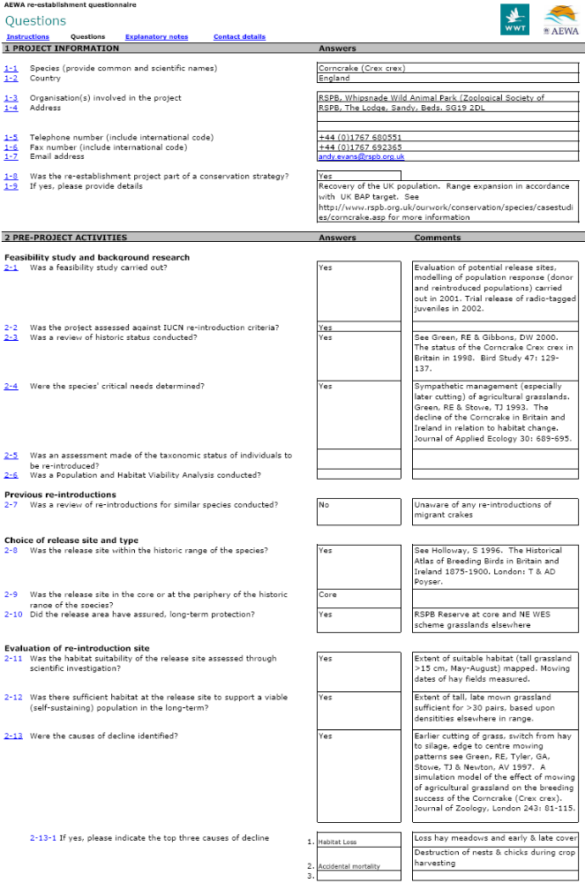
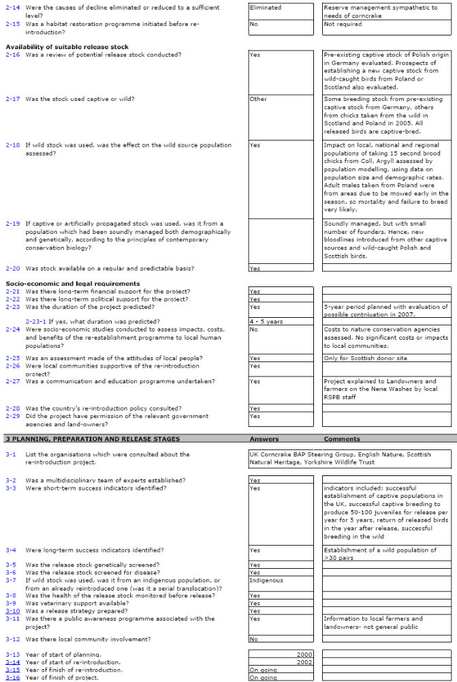

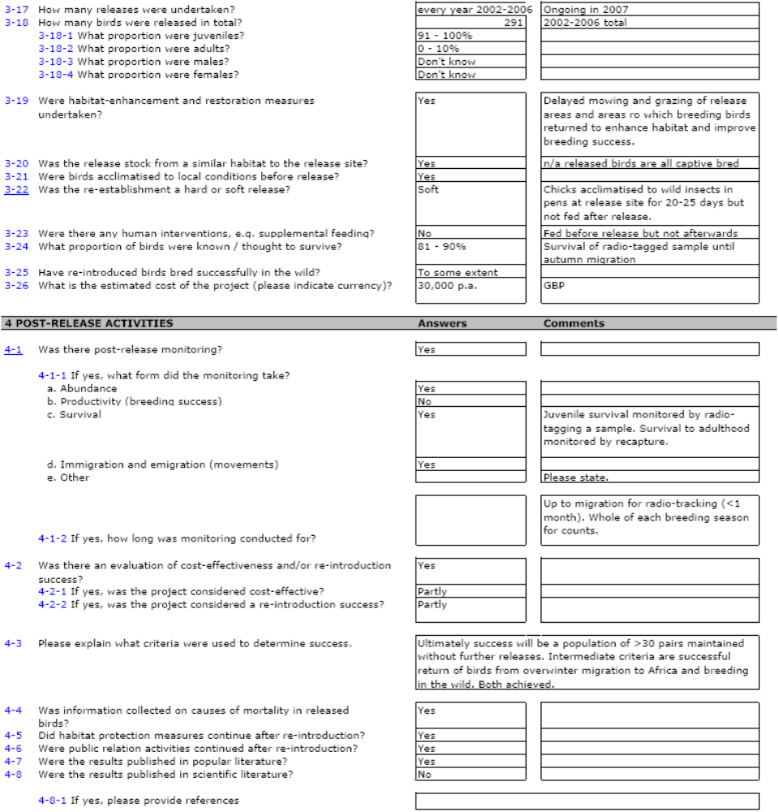
Figure A2-2. Re-establishment questionnaire for a Ferruginous Duck re-introduction project in Spain.

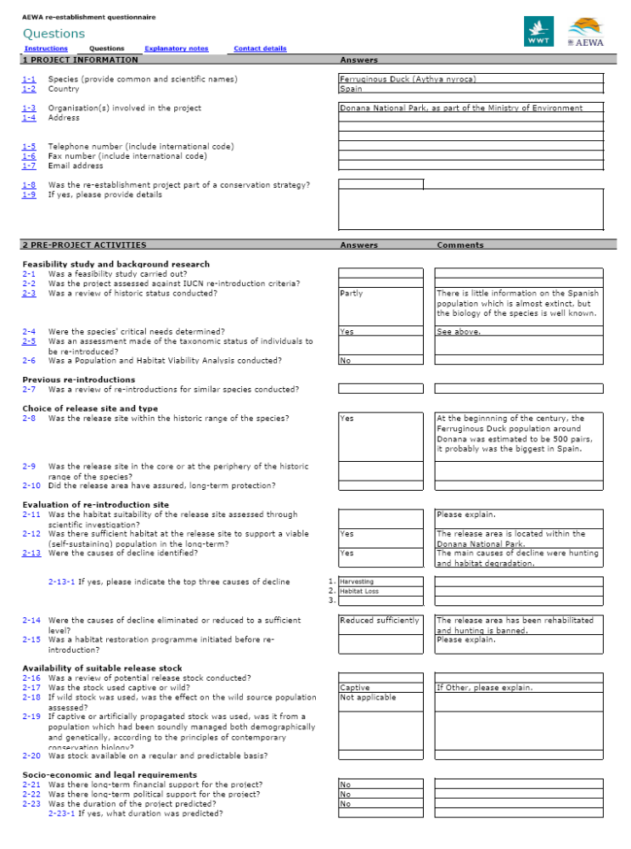
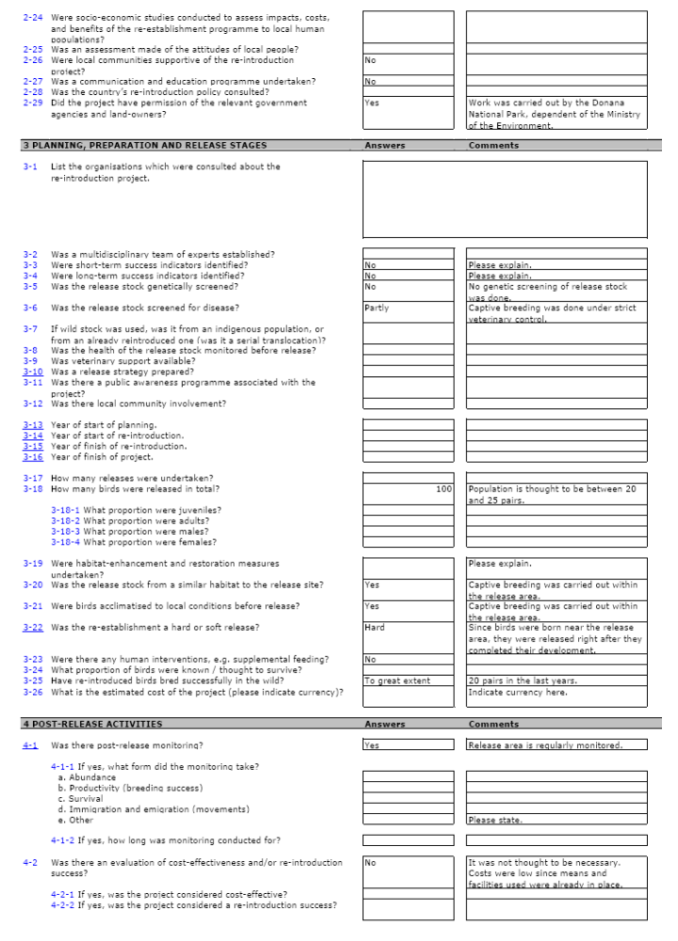

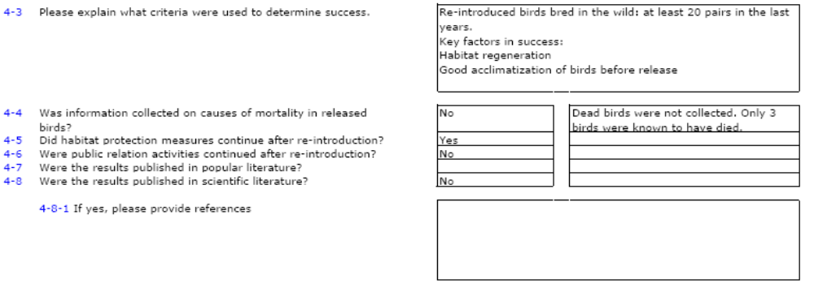
Figure A2-3. Re-establishment questionnaire for a White Stork re-introduction project in the Netherlands.

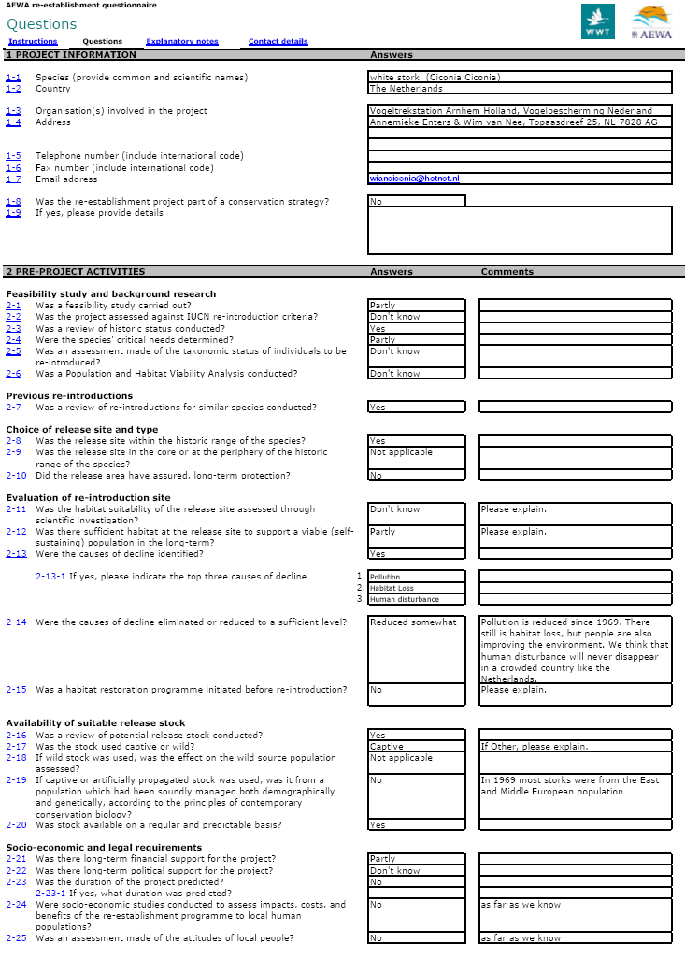

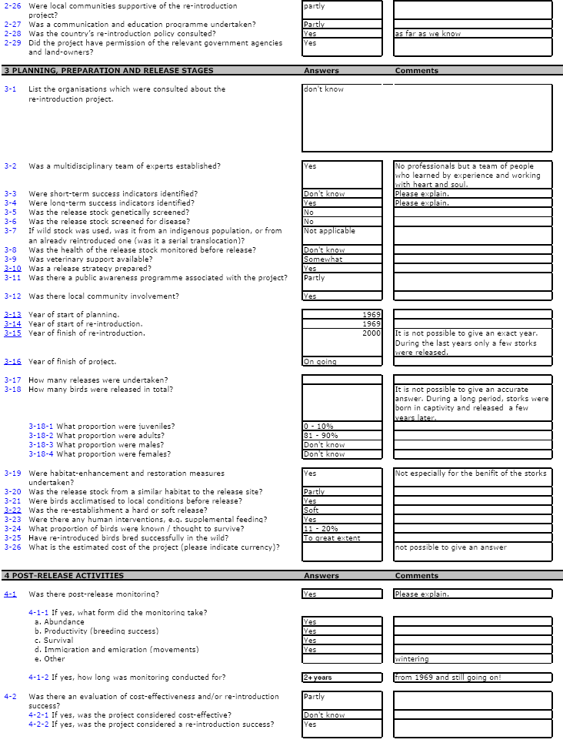

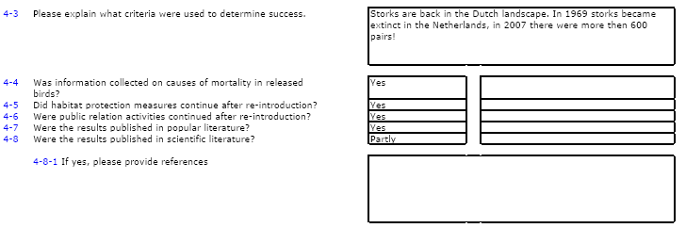
Figure A2-4. Re-establishment questionnaire for a Greylag Goose re-introduction project in Belgium.

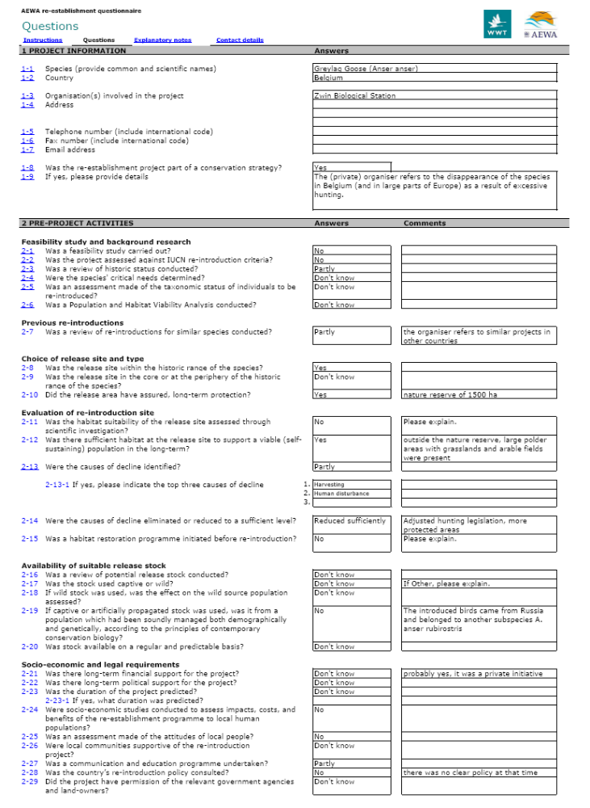

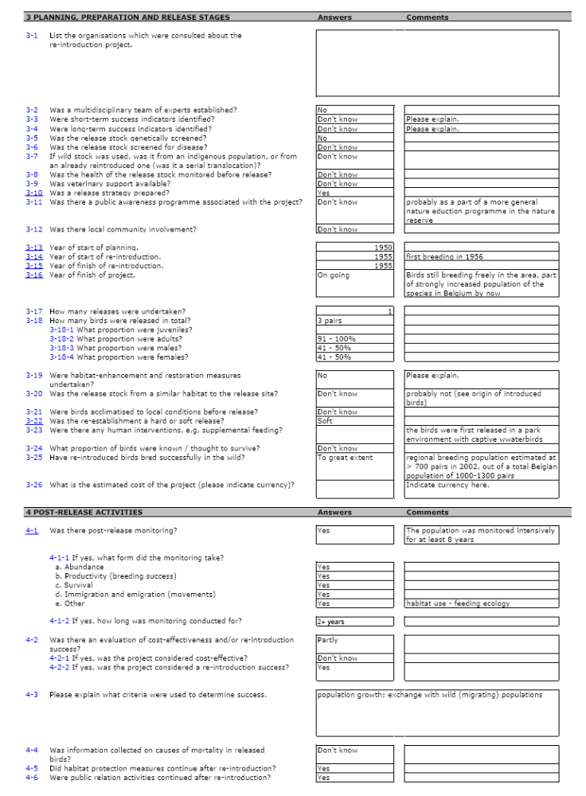

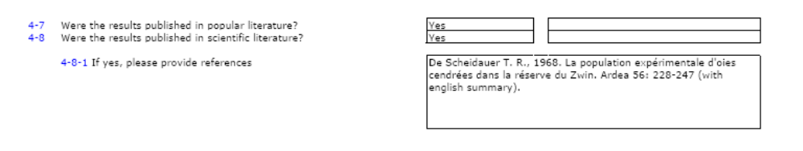
Figure A2-5. Re-establishment questionnaire for a White-headed Duck re-introduction project in Hungary.

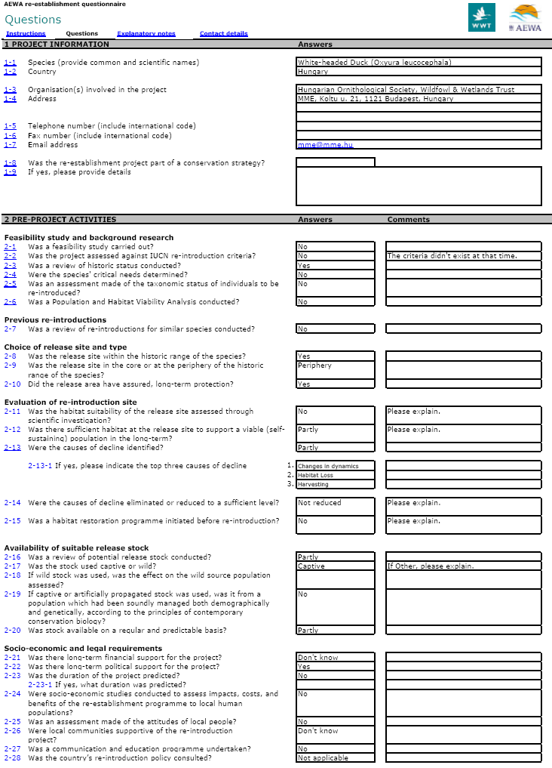

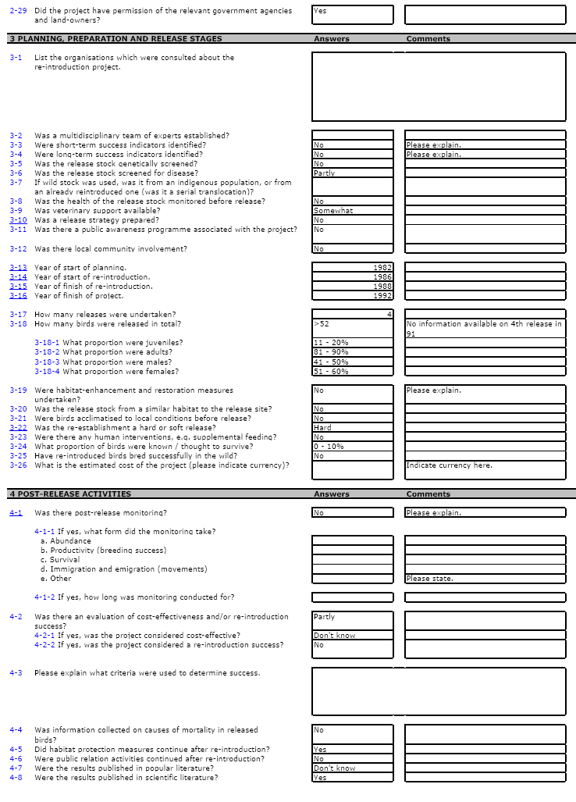

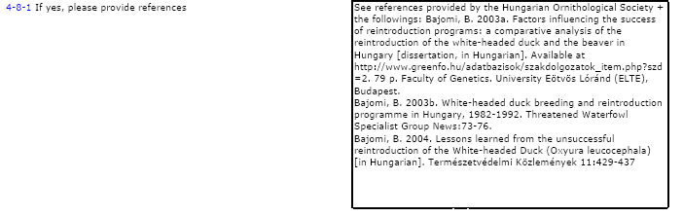

Figure A2-6. Re-establishment questionnaire for a White-headed Duck re-introduction project in Spain (mainland).

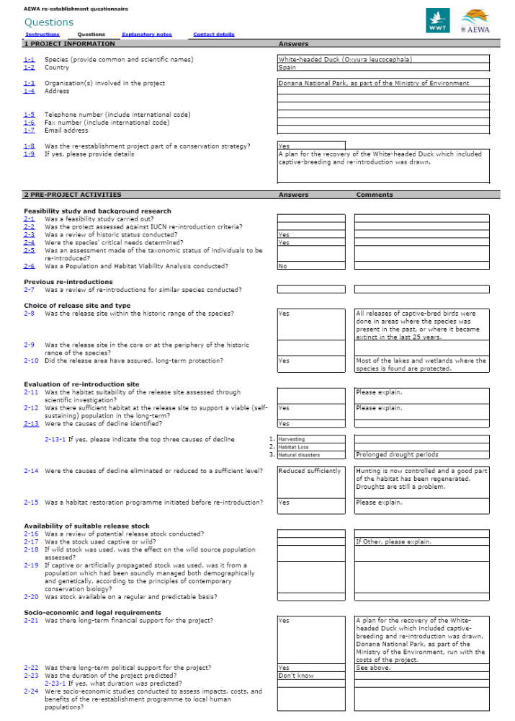
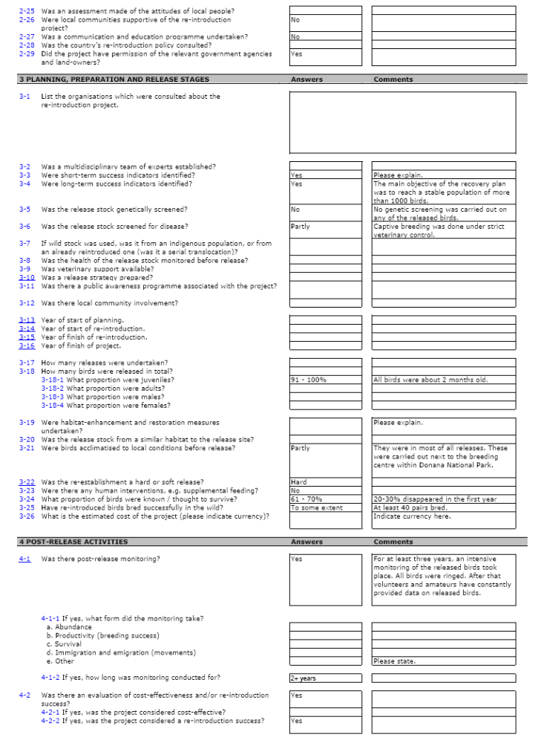
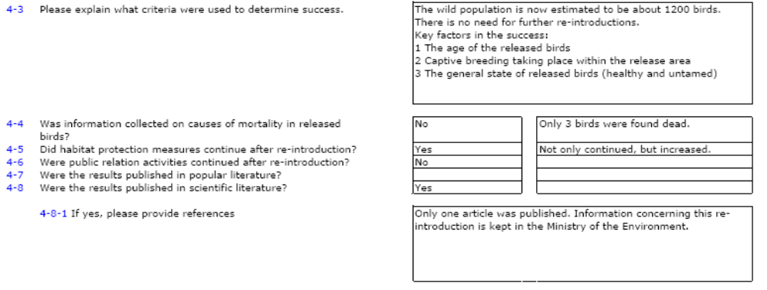
Figure A2-7. Re-establishment questionnaire for a White-headed Duck re-introduction project in Spain (Majorca).

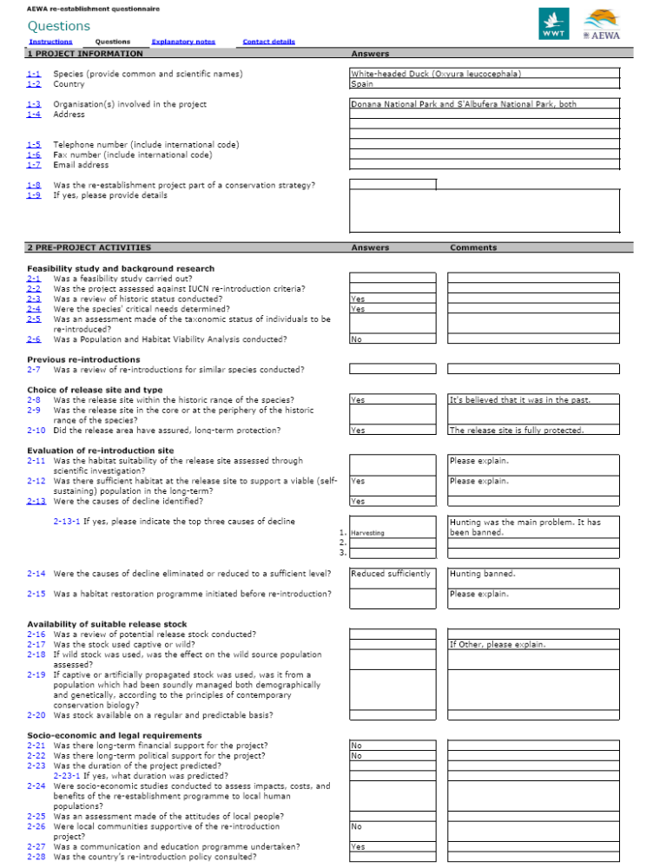

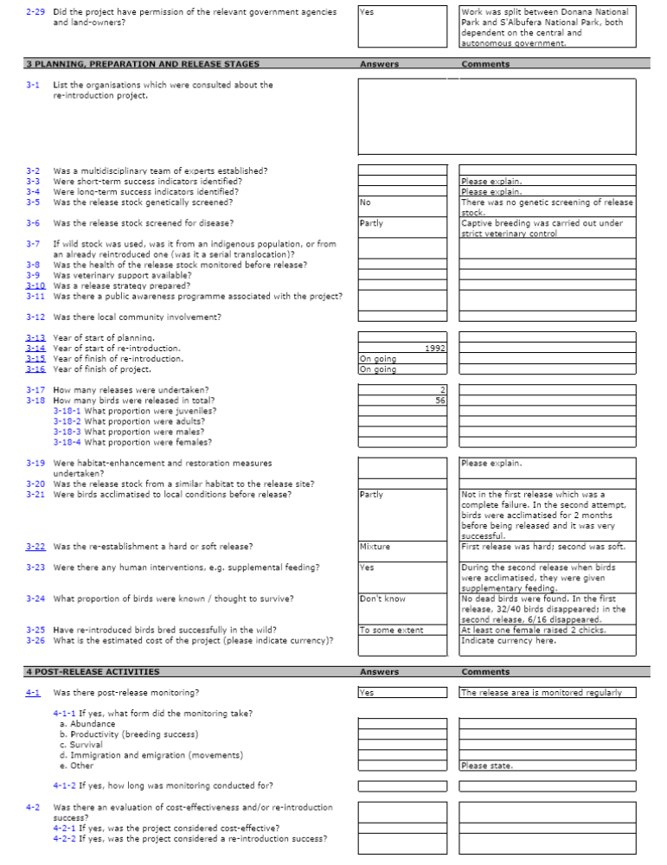

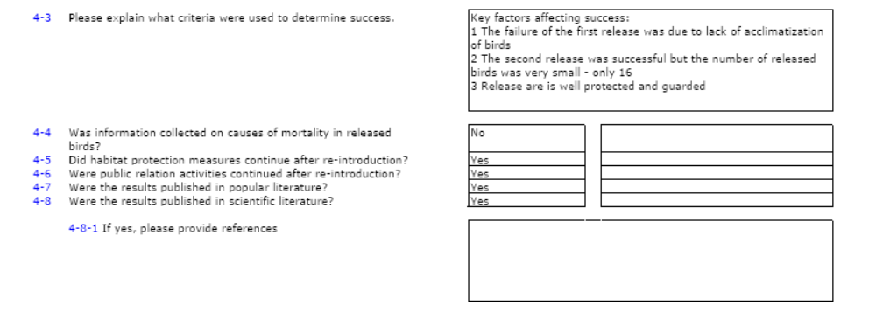
Figure A2-8. Re-establishment questionnaire for a White Stork re-introduction project in Belgium.

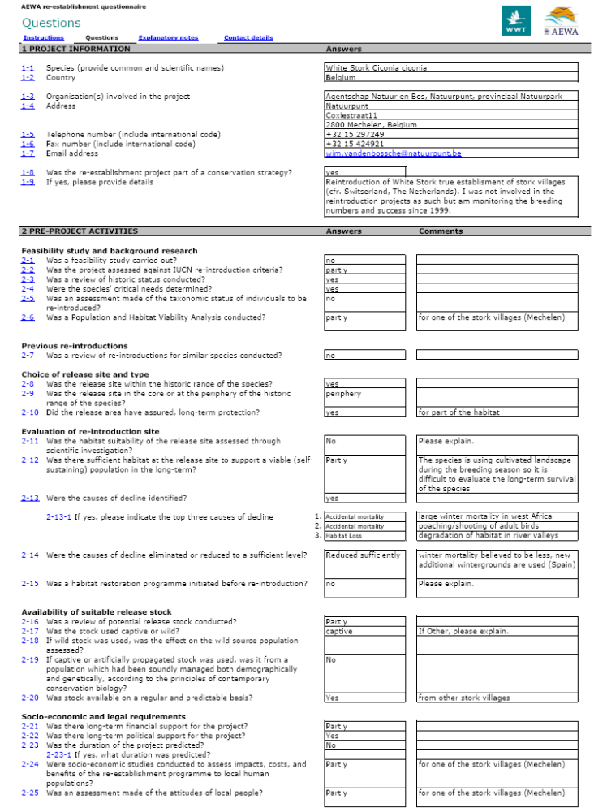

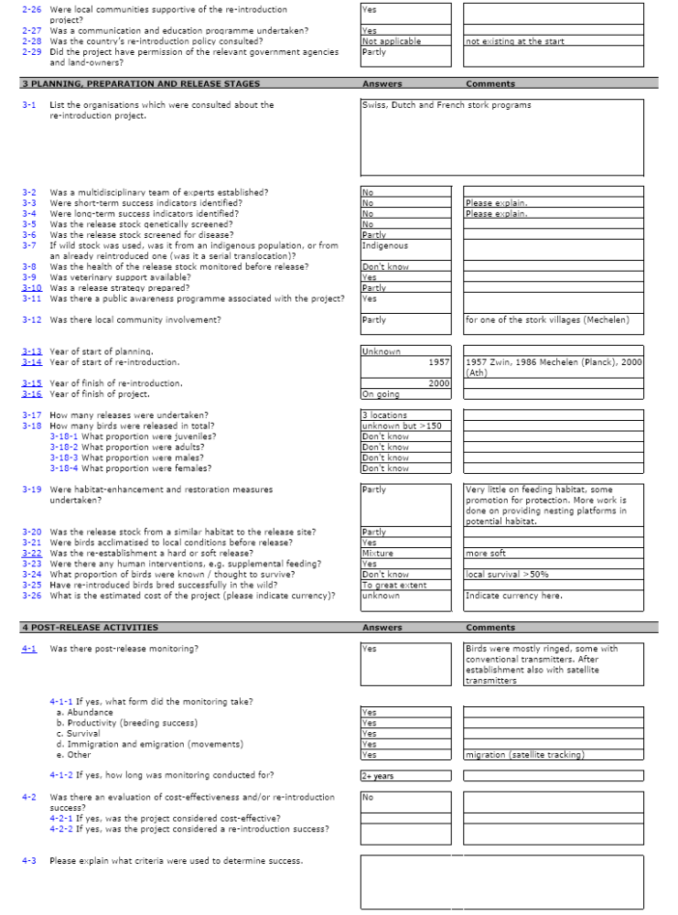
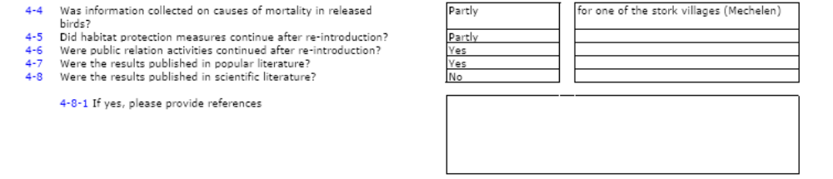

Figure A2-9. Re-establishment questionnaire for a White-headed Duck re-introduction project in Italy.

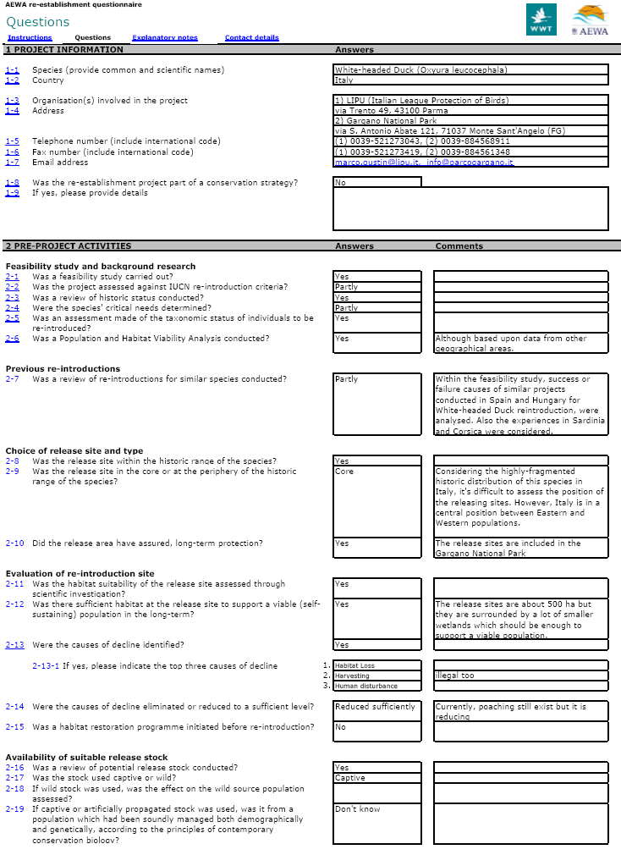

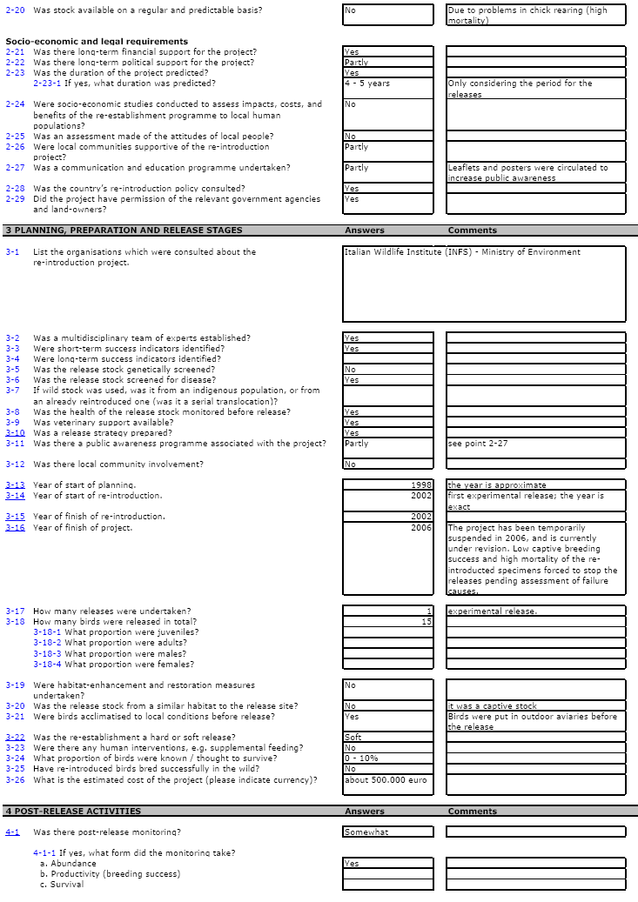

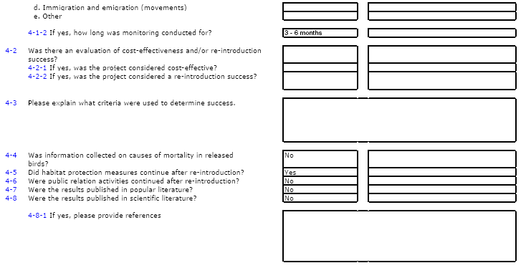

Figure A2-10. Re-establishment questionnaire for a Lesser White-Fronted Goose re-introduction project in Finland.

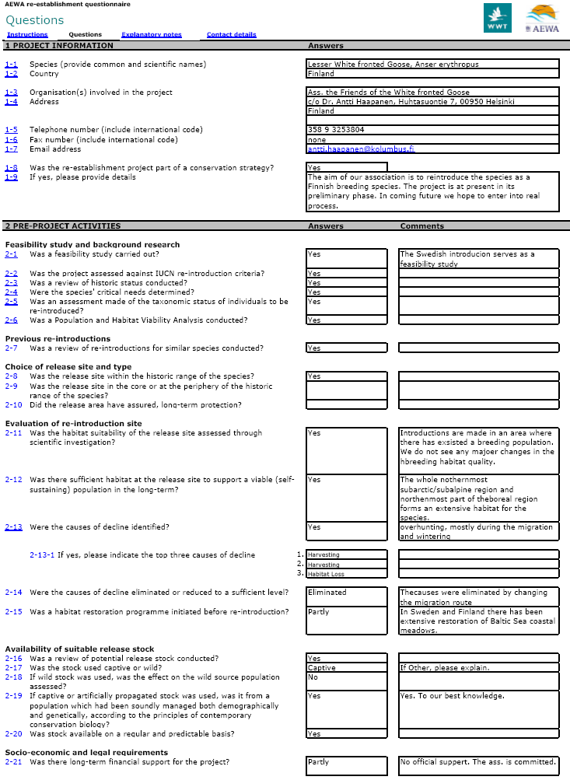

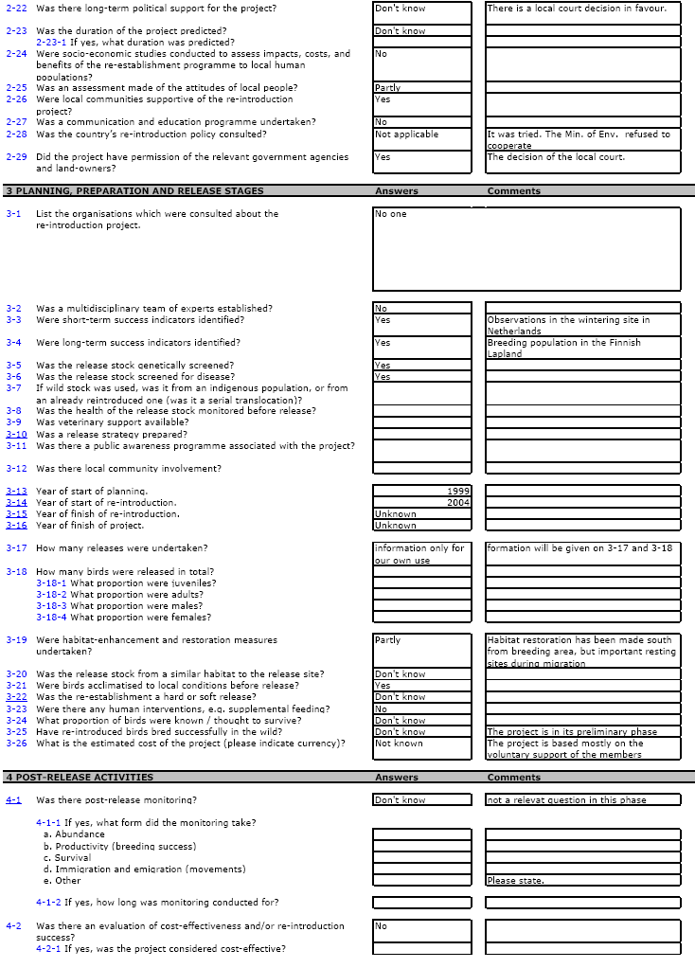

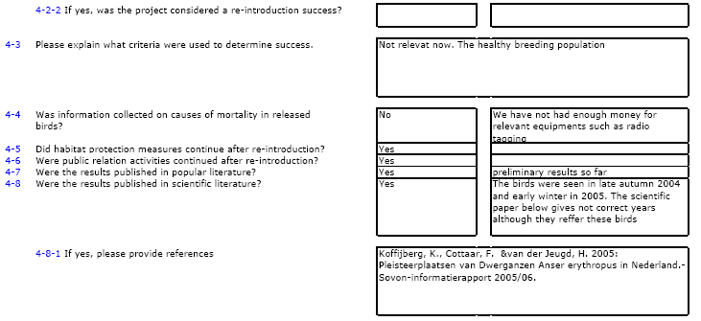

Appendix 3. IUCN Guidelines for Re-introductions

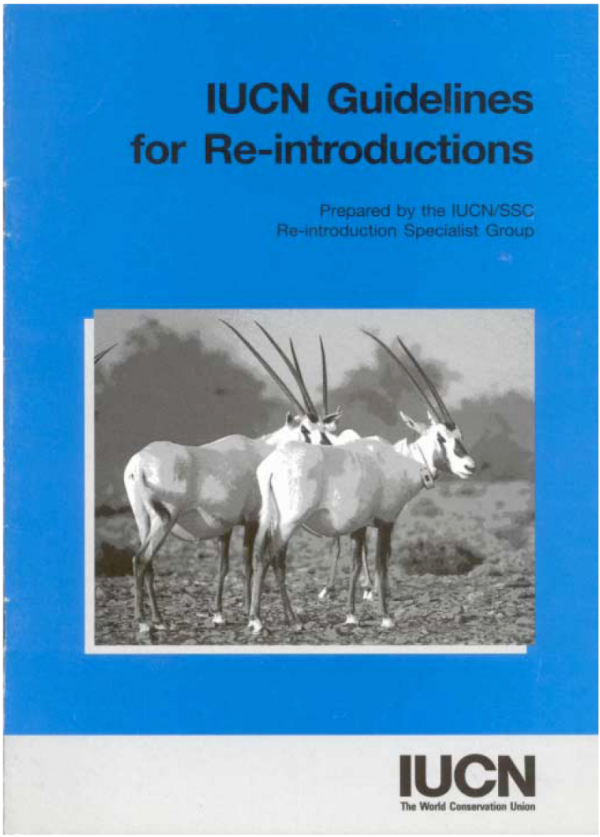
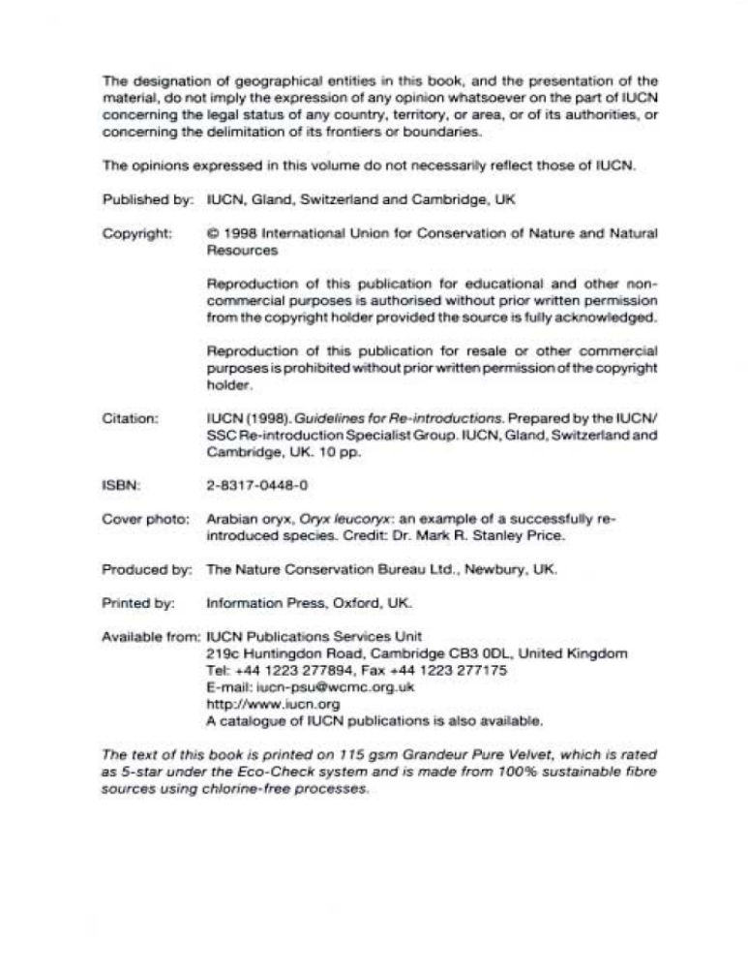
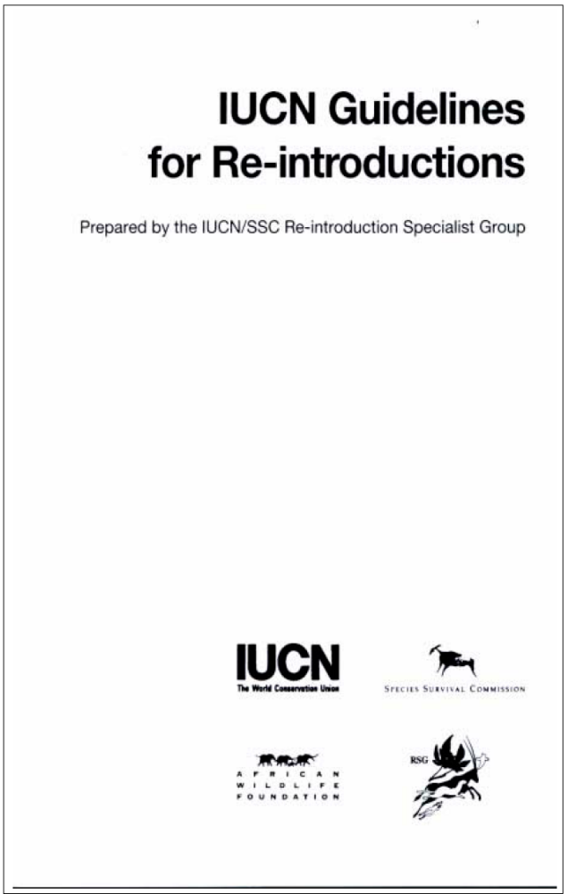
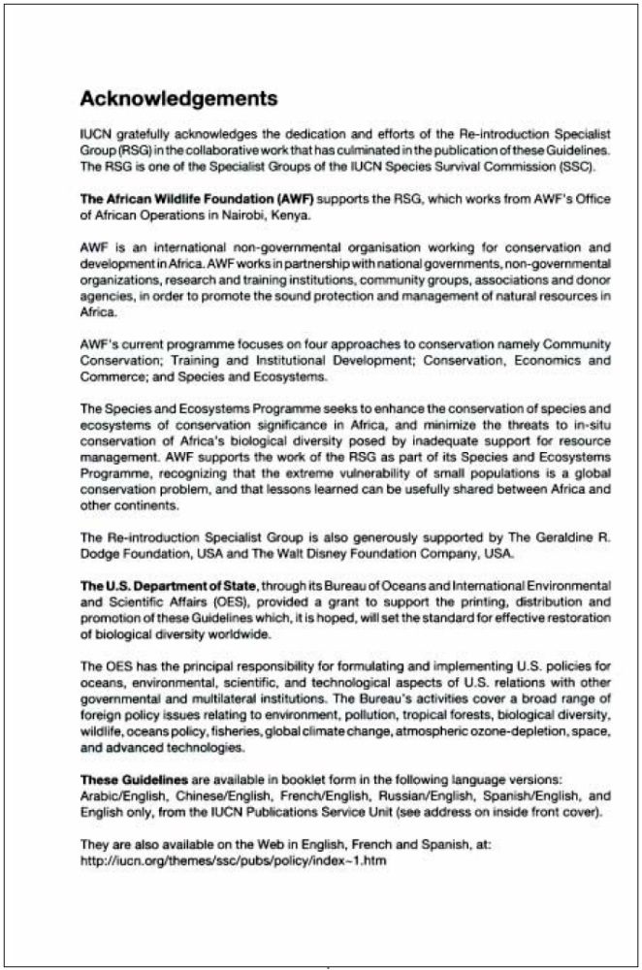
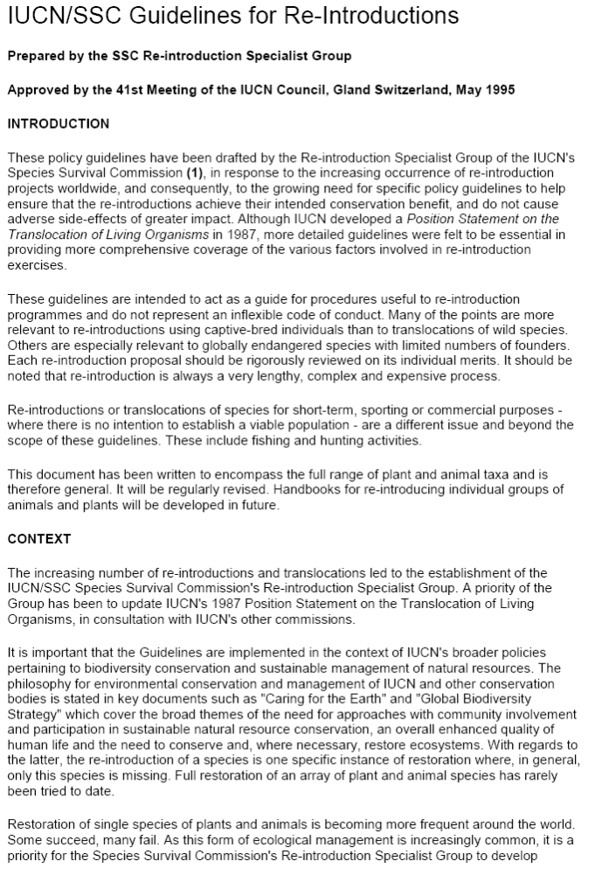
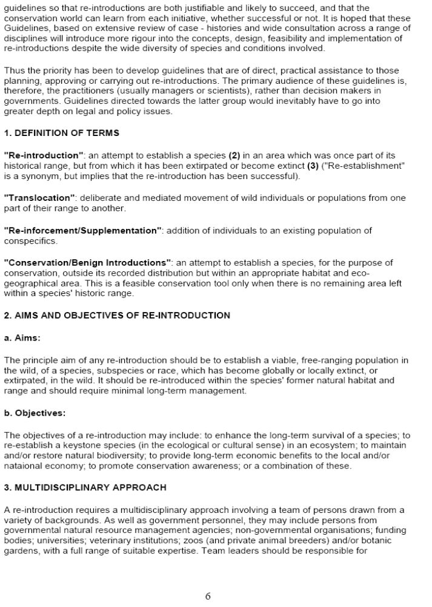
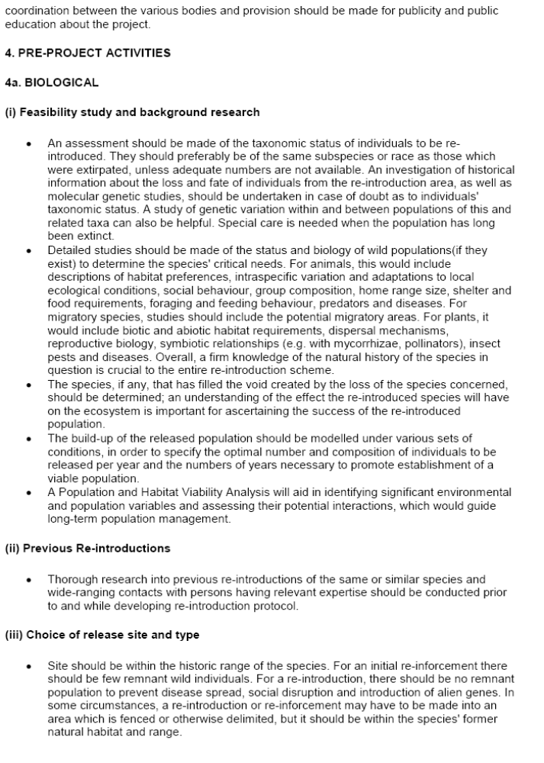
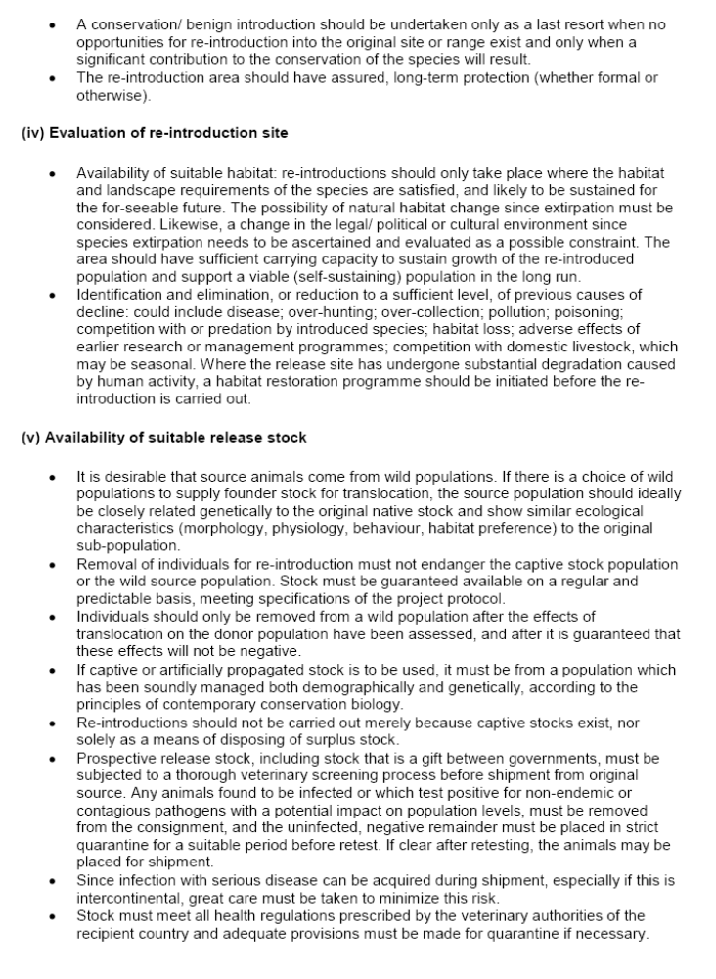
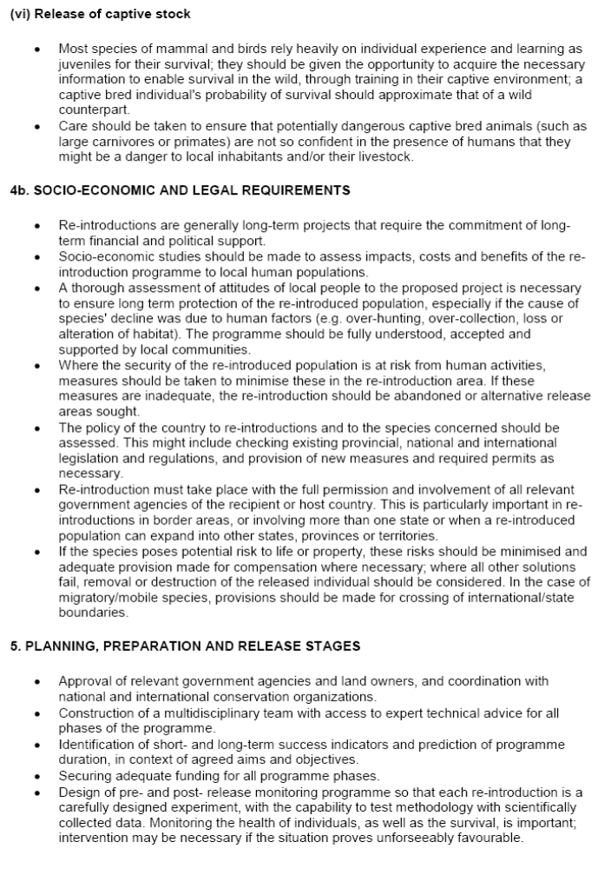
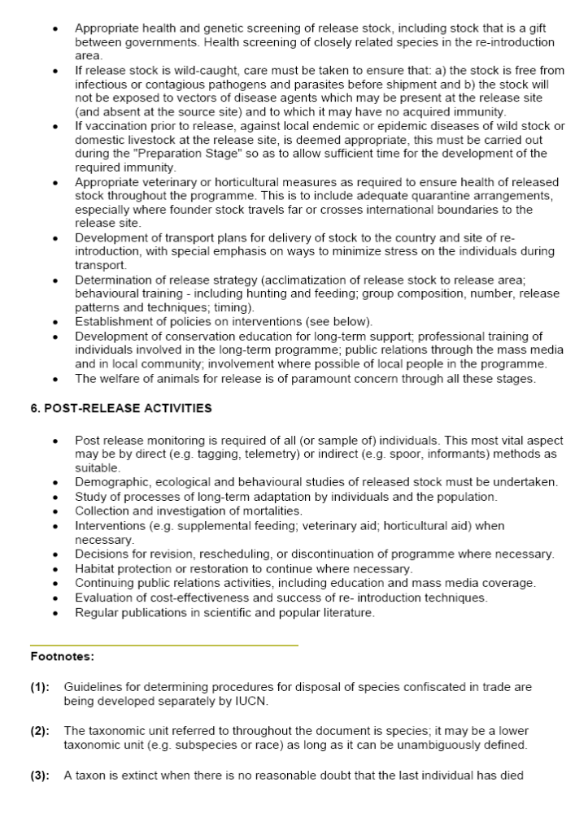
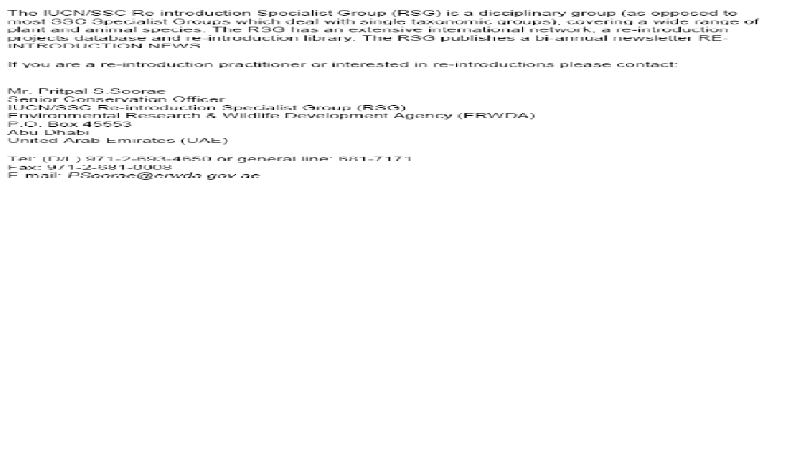

Source: IUCN. 2007. 2007 IUCN Red List of Threatened Species. <www.iucnredlist.org>. Downloaded 28 September 2007.
Source: UNEP-WCMC Species Database. <sea.unep-wcmc.org>.
Source: BirdLife International. 2006. Crex crex. In: IUCN 2007. 2007 IUCN Red List of Threatened Species. <www.iucnredlist.org>. Downloaded 28 September 2007.
UKBAP. 1995b. UK Biodiversity Action Plan - Corn Crake (Crex crex). Originally published in: Biodiversity: The UK Steering Group Report - Volume II: Action Plans (December 1995, Tranche 1, Vol 2, p102).
From a questionnaire completed and returned by Andy Evans (RSPB) (see Appendix 2).
Source: UNEP-WCMC Species Database. <sea.unep-wcmc.org>.
Source: BirdLife International. 2004. Fulica cristata. In: IUCN 7. 2007 IUCN Red List of Threatened Species. <www.iucnredlist.org>. Downloaded on 28 September 2007.
Gomez CR (compiler). 1999. International Species Action Plan Crested Coot (Fulica cristata). The European Commission and BirdLife International.
Gomez CR (compiler). 1999. International Species Action Plan Crested Coot (Fulica cristata). The European Commission and BirdLife International.
Source: UNEP-WCMC Species Database. <sea.unep-wcmc.org>.
Source: BirdLife International. 2006. Aythya nyroca. In: IUCN 2007. 2007 IUCN Red List of Threatened Species. <www.iucnredlist.org>. Downloaded on 28 September 2007.
Robinson J & Hughes B (compilers). 2006. International Single Species Action Plan for the Conservation of the Ferruginous Duck Aythya nyroca. AEWA Technical Series No. 7. Bonn, Germany.
Robinson J & Hughes B (compilers). 2006. International Single Species Action Plan for the Conservation of the Ferruginous Duck Aythya nyroca. AEWA Technical Series No. 7. Bonn, Germany.
Source: UNEP-WCMC Species Database. <sea.unep-wcmc.org>.
Source: BirdLife International. 2006. Anser erythropus. In: IUCN 2007. 2007 IUCN Red List of Threatened Species. <www.iucnredlist.org>. Downloaded on 28 September 2007.
Jones T (compiler). 2006. International Action Plan for the Lesser White-fronted Goose (Anser erythropus) – Updated second draft. The European Commission and AEWA.
Jones T (compiler). 2006. International Action Plan for the Lesser White-fronted Goose (Anser erythropus) – Updated second draft. The European Commission and AEWA.
Jones T (compiler). 2006. International Action Plan for the Lesser White-fronted Goose (Anser erythropus) – Updated second draft. The European Commission and AEWA.
Source: UNEP-WCMC Species Database. <sea.unep-wcmc.org>.
Source: BirdLife International. 2007. Oxyura maccoa. In: IUCN 2007. 2007 IUCN Red List of Threatened Species. <www.iucnredlist.org>. Downloaded 28 September 2007.
Abebe YD, Baker N, Berruti A, Buijs D, Colahan BD, Davies C, Eksteen J, Evans SW, Kolberg H, Marchant A, Mpofu Z, Nantongo-Kalundu P, Nnyiti PY, Pienaar K, Shaw K, Tyali T, van Niekerk J & Wheeler MJ (compilers). 2007. International Single Species Action Plan for the Conservation of the Maccoa Duck Oxyura maccoa. AEWA Technical Series No. 14. Bonn, Germany.
Source: UNEP-WCMC Species Database. <sea.unep-wcmc.org>.
Source: BirdLife International. 2006. Oxyura leucocephala. In: IUCN 2007. 2007 IUCN Red List of Threatened Species. <www.iucnredlist.org>. Downloaded 28 September 2007.
Hughes B, Robinson J, Green A, Li D & Mundkur T (compilers). 2006. International Single Species Action Plan for the Conservation of the White-headed Duck Oxyura leucocephala. AEWA Technical Series No. 8. Bonn, Germany.
Hughes B, Robinson J, Green A, Li D & Mundkur T (compilers). 2006. International Single Species Action Plan for the Conservation of the White-headed Duck Oxyura leucocephala. AEWA Technical Series No. 8. Bonn, Germany.
From a questionnaire completed and returned by Bálint Bajomi (see Appendix 2)
Source: IUCN. 2007. 2007 IUCN Red List of Threatened Species. <www.iucnredlist.org>.

