PoJ: 19
Doc. StC 4.13 rév. 1
17 novembre 2006

Secrétariat assuré par le Programme des Nations Unies
pour l’Environnement (PNUE)

QUATRIÈME RÉUNION DU COMITÉ PERMANENT
20-21 novembre 2006, Bonn, Allemagne

AVANT-PROJET DE PLAN D’ACTION POUR L’ERISMATURE Maccoa Oxyura maccoa

INTRODUCTION
Le Plan d’action pour l’Erismature maccoa, Oxyura maccoa, qui a été introduit par l’AEWA début 2005, couvre l’intégralité de l’aire de répartition de cet oiseau migrant à l’intérieur du continent africain. Le Plan a été sous-traité à l’African Gamebird Research Education and Development Trust (AGRED), en Afrique du Sud. Il a été principalement rédigé par Dr Aldo Berruti ainsi que par plusieurs autres experts des États de l’aire de répartition de l’espèce et d’organisations telles que BirdLife International (Division africaine), BirdLife Afrique du Sud et l’Endangered Wildlife Trust (Afrique du Sud).

La présente version a été transmise aux experts des organisations des États de l’aire de répartition de l’espèce, et tous les amendements y ont été inclus. Les membres du Comité technique l’ont ensuite examinée (février-mars 2006), après quoi leurs observations ont été incluses. À la mi-septembre, les États de l’aire de répartition ont été priés de transmettre leurs commentaires. Le Secrétariat a reçu ceux du gouvernement de la République Sud-Africaine.

Après avoir examiné la dernière version de l’avant-projet lors de sa 7ème Réunion, fin octobre 2006, le Comité technique a suggéré de soumettre cette dernière au Comité permanent pour approbation.

ACTION DEVANT ÊTRE ENTREPRISES PAR LE COMITÉ PERMANENT
Suite à la décision prise par la MOP3 dans sa Résolution 3.12, le Comité permanent est prié d’approuver l’avant-projet de Plan d’action pour l’Erismature maccoa Oxyura maccoa sur base provisoire.

NOTE DU SECRETARIAT

Le Plan d’action pour L’ERISMATURE Maccoa Oxyura maccoa est uniquement disponible en anglais.

Maccoa Duck Oxyura maccoa
International Species Action Planning Workshop

29-31 March 2005
Wakkerstroom, South Africa

First Draft Report
Version 4. 18 October 2005

Sponsored by:

African Eurasian Waterbird Agreement

In collaboration with:

African Gamebird Research Education and Development Trust
BirdLife International Africa Division
BirdLife South Africa
Endangered Wildlife Trust

The Maccoa Duck Oxyura maccoa International Species Action Plan

Edited by

- Berruti, N. Baker, D. Buijs, B.D. Colahan, C. Davies, Y. Dellegn, J. Eksteen,
H. Kolberg, A. Marchant, Z. Mpofu, P. Nantongo-Kalundu, P. Nnyiti, K. Pienaar, K. Shaw, T. Tyali, J. van Niekerk, M.J. Wheeler and S.W. Evans.

Recommended citation:

Berruti, A., Baker, N., Buijs, D., Colahan, B.D., Davies, C., Dellegn, Y., Eksteen, J., Kolberg, Marchant, A., H., Mpofu, Z., Nantongo-Kalundu, P., Nnyiti, P., Pienaar,K., Shaw, K., Tyali, T., van Niekerk, J., Wheeler, M.J. and Evans, S.W. (eds). 2005. International Maccoa Duck Oxyura maccoa Action Plan. African Gamebird Research Education and Development Trust, Johannesburg.

Milestones in the production:

- 1st draft of Action Plan and distributed on 18 April 2005
- Feedback from participants by 30 April 2005
- 2nd draft completed by 18 July 2005
- Distribute to participants
- Review finished by 20 October 2005
- Acceptance by AEWA Technical Committee
- Final product printed and posted following acceptance by AEWA Technical Committee

List of workshop contributors:

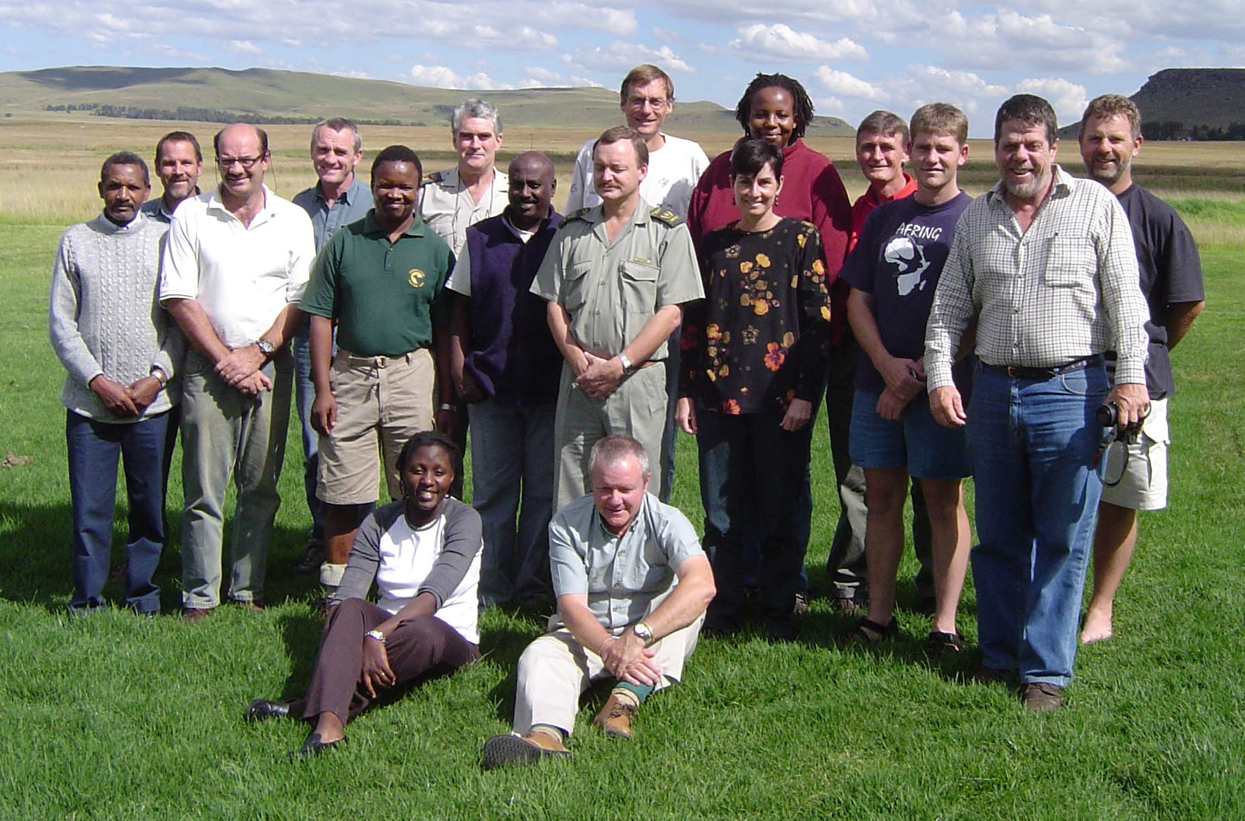

Abebe, Yilma Dellelegn. Ornithopia Ecotour Promotion Agency, ydabebe@yahoo.co.uk, ornithopia@yahoo.co.uk, PO Box 18112, Addis Ababa, Ethiopia.
Baker, Neil. Tanzania Bird Atlas, tzbirdatlas@yahoo.co.uk,PO Box 1605, Iringa, Tanzania.
Berruti, Aldo. African Gamebird, Research, Education & Development Trust, agred@netdial.co.za, PO Box 87070, Houghton, 2041, South Africa.
Buijs, Daan. Dept. of Agriculture, Conservation, Environment & Tourism, Directorate Nature Conservation Services, dbuijs@nwpg.gov.za, PO Box 510, Zeerust, 2865, South Africa.
Colahan, Brian D. Free State Tourism, Environment and Economic Affairs, colahan@dteea.fs.gov.za, Private Bag X20801, Bloemfontein, 9300, South Africa.
Davies, Clare. BirdLife Zimbabwe, birds@zol.co.zw, PO Box RV100, Runiville, Harare, Zimbabwe.
Eksteen, Johan. Mpumalanga Parks Board, johan.eksteen@pboard1.agric.za , Private Bag X11338, Nelspruit, 1200, South Africa.
Evans, Steven W. Poison Working Group, Endangered Wildlife Trust , stevene@ewt.org.za, Private Bag X11, Parkview, 2122, South Africa.
Kolberg, Holger. Directorate Scientific Services, Ministry of Environment & Tourism, holgerk@mweb.com.na, Private Bag 13306, Windhoek, Namibia
Marchant, Athol. Ezemvelo KwaZulu-Natal Wildlife, athol@kznwildlife.com South Africa.
Mpofu, Zenzele. Dept. of Wildlife & National Parks, jbhotdog@yahoo.com, PO Box 11, Maun, Botswana.
Nantongo-Kalundu, Pauline. Nature Uganda, pauline.nantongo@natureuganda.org, PO Box 27034, Kampala, Uganda.
Nnyiti, Paul Y., Wildlife Conservation Society of Tanzania, wcst@africaonline.co.tz, PO Box 70919 Dar-es-Salaam, Tanzania.
Pienaar, Kobus. Limpopo Environmental Affairs tzippor@telkomsa.net, PO Box 3174, Nylstroom, 0510, South Africa.
Shaw, Kevin. Cape Nature, shawka@cncjnk.wcape.gov.za, Private Bag X5019, Stellenbosch, 7299, South Africa.
Tyali, Thembinkosi. tyalit@eetrepc.ecape.gov.za, P Bag X5001, Greenacres, 6057, South Africa.
van Niekerk, Johan. National Gamebird Federation, iso@karanbeef.com, PO Box 1639, Rant en Dal, 1751, South Africa.
Wheeler, Marius J. Avian Demography Unit, mwheeler@adu.uct.ac.za, University of Cape Town, Rondebosch, 7701, South Africa.

Table of contents

Acronyms 4
Executive summary 5
- Biological Assessment 6
- Available key information 11
- Threats 13
- Policies and legislation relevant for management 24
- Framework for Action 26
- Activities by country 31
- Implementation 36
- References and the most relevant literature 38

ANNEX 1. Important Bird Areas (IBAs) of relevance for the Maccoa Duck. 40
ANNEX 2. Signatory Countries for International Conventions relevant for
conservation of the Maccoa Duck. 43

Acronyms

ADU Avian Demographic Unit, University of Cape Town
AEWA African Eurasian Waterbird Agreement
AGRED African Gamebird Research Education and Development Trust
AWC African Waterbird Census
CBD Convention on Biological Diversity
CITES Convention on the International Trade in Endangered Species
CMS Convention on Migratory Species (Bonn Convention)
CWAC Co-ordinated Waterbird Count (South Africa)
IAAPs Interested and Affected Parties
IBA Important Bird Area (of BirdLife International)
EWT Endangered Wildlife Trust
MDAG Maccoa Duck Action Group
NRF National Research Foundation (South Africa)
SSC Species Survival Commission (of the IUCN)
IUCN International Union for the Conservation of Nature
WCST Wildlife and Conservation Society of Tanzania
WFW Working for Water (South Africa)
Executive summary

The Maccoa Duck Oxyura maccoa is a localized, relatively scarce species confined to Africa, with northern (Ethiopia, Kenya, Tanzania and Eritrea) and southern (Angola, Namibia, Botswana, Zimbabwe, South Africa and Lesotho) populations. Previous estimates of its population size, particularly northern populations, were not based on hard data. These reports gave an impression that this species was far more numerous than the actual situation. Similarly, its distribution was described as including several countries for which there were either no records, or very few, giving a false impression of a wider distribution.

Apart from correcting the status of both populations to reflect its true abundance and distribution, information on trends in populations are presented. The northern populations appear to be in rapid decline. The southern population has now stabilised, after a period of increase in range and abundance following colonisation of artificial impoundments. The first national estimate of the population size of Maccoa Ducks in South Africa based on count data is given. At 4500-5500 birds, South Africa has the largest national population of this species, however, there is some evidence that the South African populations may now be in decline. The revised global population estimate is 9000-11750 birds.

Both the estimates of the total population size and rate of declines in at least the northern populations indicate that the status of this species should be elevated to Near-threatened globally, and more precise work on Southern Africa populations may show this species to have a global status of Vulnerable with a global population less than 10 000 birds. Regardless, it is clear that the conservation status of this species is worse than previously understood, and both research and conservation actions are required to quantify the conservation risks.

A primary element of future action is creating awareness amongst conservation organisations at international and national level on the need for concern about this species.

Because of a lack of information and lack of definition of threats, many of the proposed activities will depend on a more accurate assessment of threats and a better understanding of the biology of the Maccoa Duck, particularly its movements between breeding and non-breeding seasons.

The Maccoa Duck feeds mainly on benthic invertebrates, and thus has a higher position in the trophic chain compared to most ducks, which often feed to a larger extent on plant foods. Therefore the Maccoa Duck may be a better indicator than most wetland bird species of pollution resulting from biological concentration of contaminants up the food chain, and may also be a useful indicator of wetland quality.

The northern and southern populations appear to be subjected to different set of threats. Northern populations appear to be subject to factors resulting largely from the subsistence activities of local communities. The perceived threats to the southern populations are the result of the increasing commercialisation of agriculture and intensification of industry (e.g. pollution) and development of urbanisation with demands for leisure activities and disposal of wastes.

The Workshop saw the formation of the Maccoa Duck Action group with AGRED offering a secretariat for co-ordinating communication and action. The possibility that this group may evolve into an International Species Working group under AEWA is discussed.
1. Biological Assessment

General information | The Maccoa Duck is a highly aquatic diving duck restricted to eastern and southern Africa. It has always been comparatively scarce and its biology is not well known. Movements are poorly understood but most movements probably take place over distances of <500 kms. Breeding demographics are not well documented, so that interpretation of its biology in relation to breeding is not simple. This is particularly true for its distribution and movements. Previous estimates of its numbers have been far too high, based on repeated citations of estimates based on guesswork. These high estimates have helped mask the threat posed on northern populations in particular. The most detailed synthesis of the biology of this species is Colahan (2005).
Taxonomy | Class: Aves  Order: Anseriformes  Family: Anatidae  Tribe: Oxyurini  Genus: Oxyura  Species: O. maccoa  Subspecies: none defined  Scott & Rose (1996) defined three separate and isolated populations in the Ethiopian highlands, East Africa and Southern Africa. No subspecies are recognised. They argued for separation of the East African population from the Ethiopian population, on the basis that the Maccoa Duck is an essentially sedentary species of highland areas in Ethiopia and East Africa. They felt that the geographic separation of these populations is a highly probable consequence of the broad band of unsuitable, low-lying country in south-eastern Sudan, southern Ethiopia and northern Kenya separating the two populations.  However, historically, there are records from northern Kenya in this supposed gap region (Neil Baker pers. comm.), and it may be that there continues to be migration along the Rift Valley lakes between Ethiopia and countries further south. However, there is insufficient evidence at this stage to conclude these are a single population e.g. Nasirwa (in litt.) supports the contention of a large gap with little or no suitable habitat in the intervening area.  Thus this Species Action plan accepts that there are two northern populations: the Ethiopian (including any Maccoa Ducks in Eritrea, following the first record of this species from that country) and the Tanzanian/Kenyan population. Clearly, this issue requires better resolution.
Population development | Historically, the Southern African population has increased during the twentieth century due to occupation of artificial impoundments in Namibia, Botswana and some areas of South Africa, presumably occupying Angola, Zimbabwe and Lesotho as a result. However, there are no indications that this spread is continuing and there is cause to believe that declines may have begun. However, it is also clear that the Southern Africa population is smaller than previously estimated, presumably a result of inadequate data.  The populations in East Africa (centred on Kenya, Tanzania, Rwanda, Burundi and Uganda) have declined considerably, perhaps by as much as 50% in the last 10 years. Data for Ethiopia do not allow an accurate estimation of status, but indications from other wetland species suggest a slower decline. However, there is now a single record from Eritrea of five birds (see Table 2a), suggesting that there might be an additional small population there. For the northern populations, the estimated populations are lower than previously estimated by Dodman (in review), and far lower than by Scott and Rose (1996).
Distribution throughout the annual cycle | The northern populations are confined to comparatively small areas in Ethiopia, Tanzania, Kenya and Rwanda (one recent record), centred on lakes within the Rift Valley. The northern populations are now concentrated in high-lying inland areas. In Tanzania, movements recorded between breeding areas in temporary wetlands to concentrations in permanent deeper water when not breeding.  In southern Africa, populations occur from sea-level in the west (South Africa and Namibia) to inland waters at high altitudes (Angola, Namibia, Botswana, Zimbabwe, South Africa and Lesotho). Movements probably take place over distances of less than 500 km, with occasional records of large numbers in non-breeding concentrations on larger wetlands.
Survival and productivity | Nothing recorded on longevity and annual survival. Survival from hatching to fledging is probably <50% (Clark 1964).
Life history: Breeding | The description of the nest and breeding is taken from Tarboton (2001). The Maccoa Duck nests over deep water in emergent vegetation, usually Typha or sedges. The nest is a deep, round bowl constructed from plant stems which are pulled down from a standing position, and woven into a bulky bowl-shaped structure with a deep open cup that stands 100-230 mm above the water. Some nests have a ramp leading from the water to the cup. The nest would be conspicuous, were it not screened by vegetation. Old nests of Red-knobbed Coot Fulica cristata are occasionally used. Nests are anchored to vegetation and therefore prone to flooding when water levels rise.  Nests are surprisingly difficult to detect and females are very inconspicuous during the breeding season.  Males are polgynous and promiscuous. Breeding males defend territories from other males. There may be several females breeding simultaneously within a male’s territory within 20m of each other. Successful territories stretch for up to 80m along emergent vegetation, and unsuccessful males may hold inferior territories without breeding successfully (Siegfried 1976). Males take no part in incubation or chick rearing. Territorial behaviour often indicates breeding activity.  The clutch is usually 5-6 eggs, but up to 12 recorded, with more than eight eggs being deposited by two females. Eggs are often dumped in other ducks’ nests (see also Dean 1970, Milstein 1973, Lees-May 1974). Incubation of 25-27 days by female only and young cared for by female only.  Maclean (1997) notes that in South Africa, it breeds in August –January (peak October-November) in the Western Cape Province, throughout the year in Gauteng, Mpumalanga and Northwest Provinces (Tarboton et al.1987), and throughout the year in Zimbabwe (Irwin 1981), although mainly in northern South Africa. Broadly speaking there is a winter trough and a summer peak in breeding. Timing of breeding appears to be related to rainfall. There is no marked synchronisation of breeding.
Life history: Feeding | Maccoa Ducks feed by diving for extended periods, with dives lasting for 15-22 seconds (Macnae 1959) during foraging spells of 30-60 minutes (Siegfried et al. 1976a). The diet is mainly small invertebrates, including midge larvae, ostracods, gastropods (Siegfried et al. 1976b), Daphnia and plant material (Stark & Sclater 1906), seeds of Persicaria and Polygonum, and roots and seeds of other plants (Brown et al. 1982).
Life history: Outside breeding season | Maccoa Ducks occur in concentrations in the non-breeding season on larger waters, which may be devoid of vegetation, but are presumably rich in invertebrates. The species is subject to local movements which vary from year to year, and which are not well understood.
Habitat requirements:  Breeding | It breeds on inland waters, mainly smaller temporary and permanent freshwater deep nutritious wetlands (IUCN Habitats types 5.5, 5.6, 5.7 and 5.8). Emergent vegetation especially Typha, is critical for breeding (Irwin 1981, Hockey et al. 1989, Maclean 1997). It also breeds on sewage ponds (Maclean 1997). Irwin (1981) described the habitat as pans and dams providing some emergent vegetation with adjacent expanse of open water, nesting in clumps of sedges and rushes.
Habitat requirements:  Feeding | Refer to breeding (above) and non-breeding sections (below).
Habitat requirements: Outside Breeding season | Uses large and small permanent and temporary freshwater wetlands (IUCN Habitats 5.5, 5.6, 5.7 and 5.8) as well as large or small permanent or temporary saline or alkaline wetlands (IUCN Habitats 5.14, 5.15, 5.16 and 5.17). When not breeding, it may use habitats without any emergent vegetation at all (Maclean 1997).

Distribution of the Maccoa Duck

The general distribution of the species is shown below (Fig. 1a), and is much modified from Scott & Rose (1996). Apart from the reduction in general distribution of the northern populations, the following four figures show how localised the distribution is within the broad limits of both the northern (Figs. 1b and 1c) and southern (Figs. 1d and 1d) populations.

The species was listed as occurring in several countries by Brown et al. 1982 and del Hoyo et al. (1992) but these records are not based on valid original information (Baker 2004). There is no information to suggest that the species has ever occurred in Malawi, Mozambique or Sudan or has ever been more than a vagrant in Swaziland and Burundi (Dodman in review, Parker 1994, Neil Baker this workshop.). There are two recent records of single birds in Uganda, both dated 2003 (Pauline Nantongo-Kalundu pers. comm). Thus the lack of more recent records from these countries does not indicate any actual loss in range. There are no records of recent occurrence in the Democratic Republic of the Congo and only one record in 1983 from Rwanda. Its present status in these countries is unknown (Neil Baker pers. comm.). O. Nasirwa (in litt.) notes that the species may still persist in western Kenya in areas, which are seldom visited.

The current distribution is shown below (Fig. 1a), with historical and current distributions in East Africa (Figs. 1b, 1c) and South Africa (Figs. 1d, 1e).
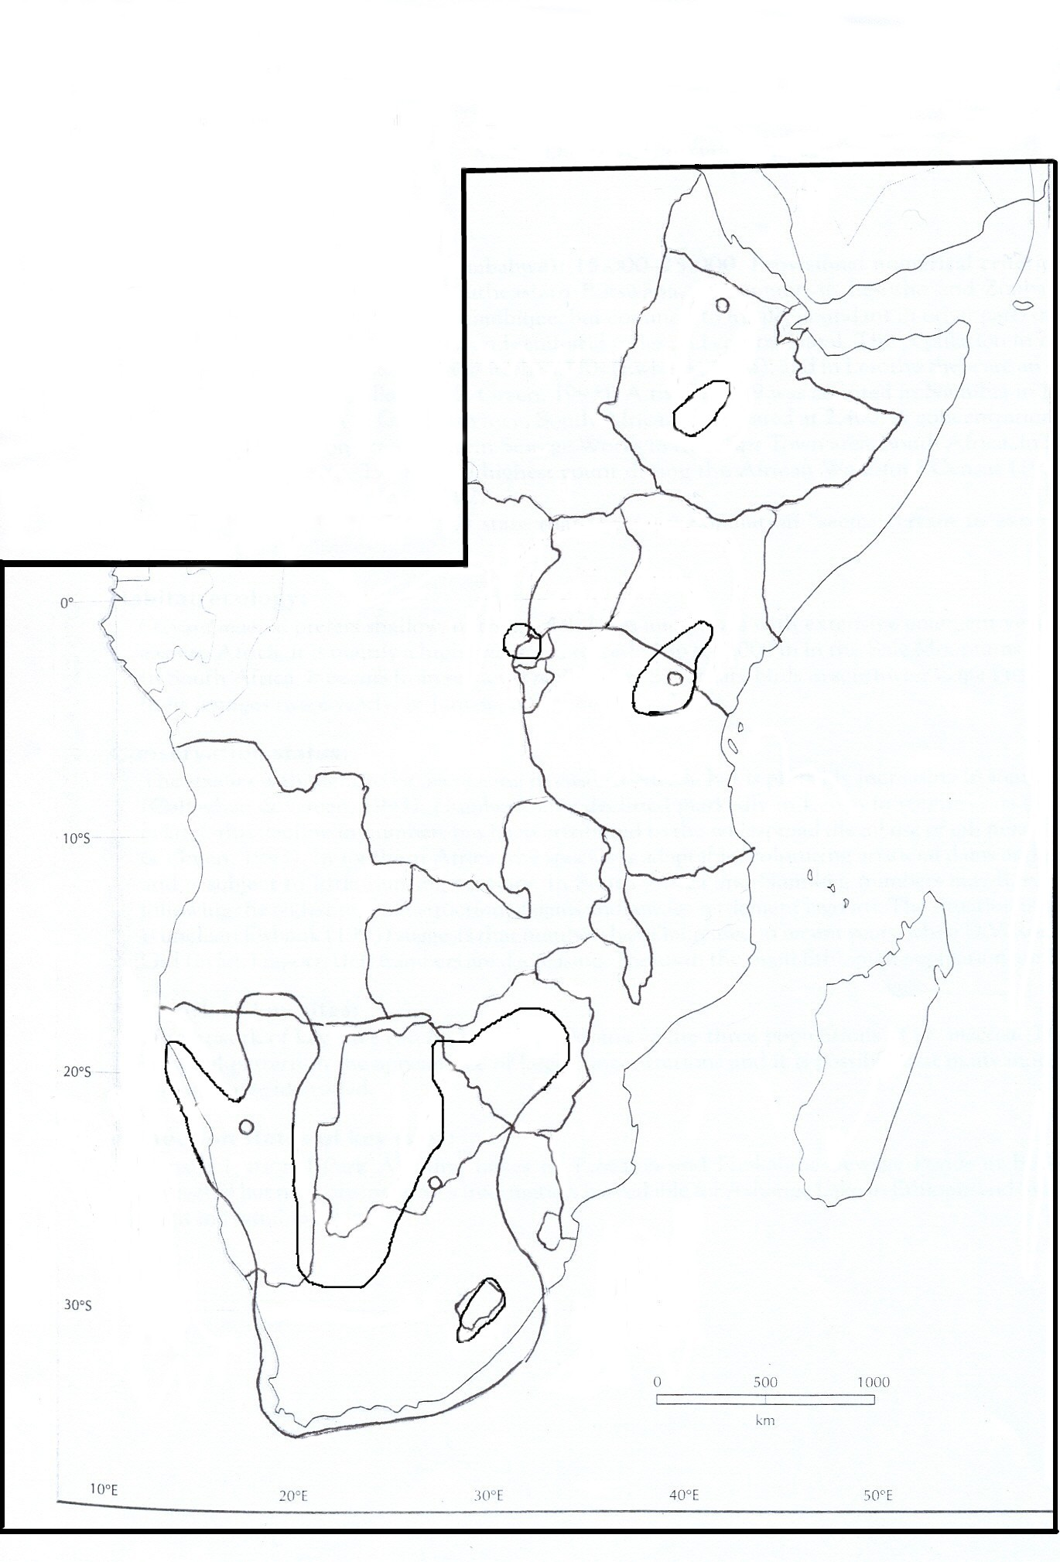

Figure 1a. The current global distribution of the Maccoa Duck based on Scott & Rose (1996) and revised according to Neil Baker (Tanzania Bird Atlas, this workshop, Figs. 1b & 1c), the South African Bird Atlas (Maclean 1997) and CWAC counts (M.J. Wheeler, ADU, this workshop, Figs. 1d & 1e).

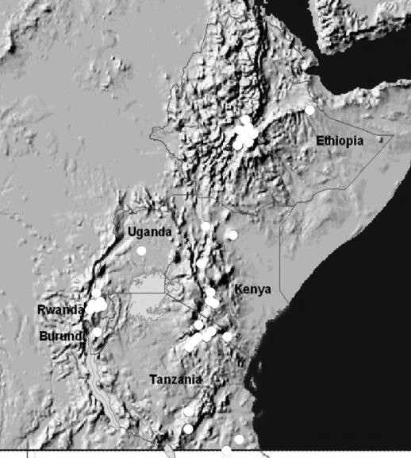

Figure 1b. The historical distribution records of the northern populations of Maccoa Duck (Neil Baker, Tanzania Bird Atlas).

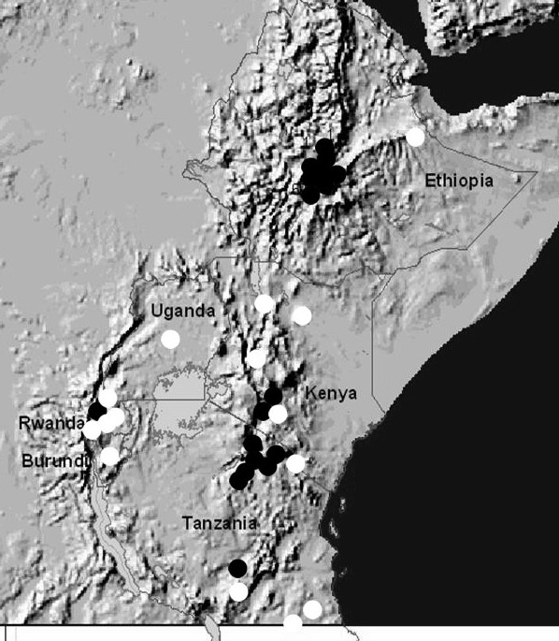

Figure 1c. The current distribution records of the northern populations of Maccoa Duck (Neil Baker, Tanzania Bird Atlas). White circles show sites where the Maccoa Duck no longer occurs and black circles show sites where it still occurs.

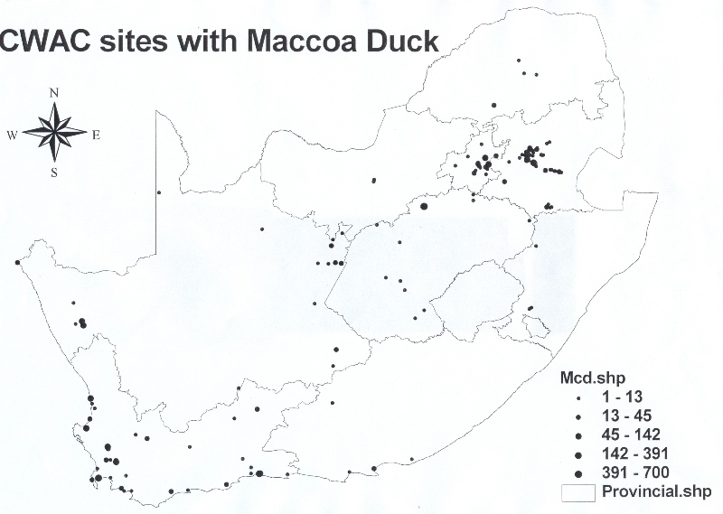

Figure 1d. Current distribution records of Maccoa Duck in South Africa (showing provincial boundaries) and numbers of birds recorded based on CWACs (M.J. Wheeler, ADU).

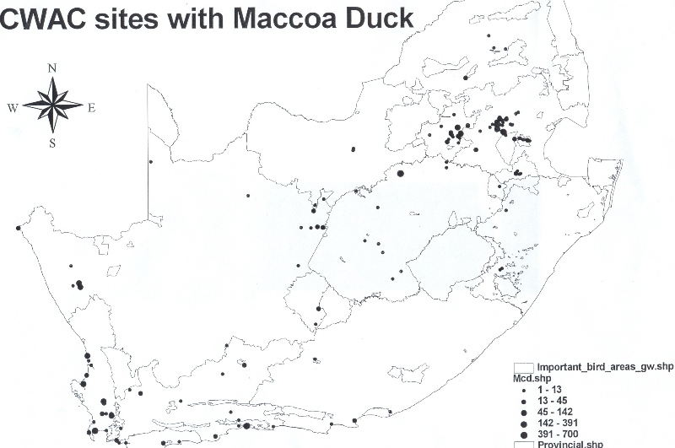

Figure 1e. Current distribution records of Maccoa Duck in relation to IBAs in South Africa from CWACs (M.J. Wheeler, ADU).

2. Available key information

Table 2a. Population estimates for the Maccoa Duck. It is not possible to distinguish between breeding and non-breeding populations for the Maccoa Duck in any country. Data quality, date of estimates and references in all cases do not separate breeding and non-breeding populations. Code for Quality is given as Good (Observed) (Go), Good (estimated) (Ge), Medium (estimated) (Me), Medium (Inferred) (Mi), Poor (Ps) and Unknown (Un), according to the format for AEWA Single Species Action Plan, Sept 2002.

Country | Breeding/ non-breeding no. | Quality | Year(s) of the estimate | Breeding Population trend in the last 10 years (or 3 generations) | Quality | Baseline population | References
Ethiopia | 500-2000 | Me | 2005 | Decline | Ps | 1000-5000  500-3000 | Scott & Rose 1996  Dodman in review
Eritrea | 5 | Go | 2005 | Unknown | Un |  | Ken Harte in litt
Kenya | <1000 | Ge |  | Decline Mi | Ps | No data
Tanzania | 500 | Go | 2005 | Decline 50% Go | Go
Uganda | 0? | Ps |  |  | Un | ?
Rwanda | 0 | Ps |  |  | Un | ? | This workshop
East Africa (excludes Ethiopia) | 1500 | Ge | 2005 | Decline | Me | 15000-25000  1000-1500 | Scott & Rose 1996  Dodman in review
Angola | 50 | Mi | Recent | Unknown - Dean 2000 | Un | Absent?
Namibia | 2000 | Go | 1990s | Unknown - Simmons & Brown in prep | Un | Absent | Stark & Sclater 1906
Botswana | 300 | Ge | 1999-2000 | Unknown - Tyler 2001 | Un | Absent | Smithers 1964
Zimbabwe | 100-300 | Mi | 2005 | Unknown | Un | No data
South Africa | 4500-5500 | Go | 2005 | Unknown | Un | No data
Lesotho | 10-100 | Go | 1990 | Unknown | Un | No data
Southern African region | 7000-8250 | Ge | 2005 | Unknown | Un | >10 000  15000-25000  <10 000 | Callaghan & Green 1993  Scott & Rose 1996  Dodman in review

Table 2b. Maccoa Duck population estimate for South Africa based on provincial population estimates using Coordinated Waterbird Counts (M.J. Wheeler, ADU). These are the sum of the maximum counts multiplied by a factor of 1.5, for wetlands where Maccoa Duck have been recorded.

Province of South Africa | Count
Western Cape | 2148
Northern Cape | 455
Eastern Cape | 30
KwaZulu-Natal | 6
North-west | 14
Free State | 1125
Mpumalanga | 1257
Gauteng | 305
Limpopo | 48
Total | 5388

Table 2c. Revised estimates of national population sizes of Maccoa Duck in Southern and Eastern Africa from this workshop.

Country | Estimate | Reference
Angola | 50 | Based on information in Dean 2000
Botswana | 300 | Tyler 2001
Namibia | 2000 | Simmons and Brown in prep.
South Africa | 4500-5500 | This workshop, Table 2b
Zimbabwe | 100-300 | This workshop
Southern African population | 7000-8250 | This workshop
Ethiopia | 500-2000 | This workshop
Eritrea | 5 | Harte (in litt.)
Kenya | 1000 | This workshop
Tanzania | 500 | This workshop
East African populations | 2000-3500
Global estimate | 9000-11750 | This workshop (rounded estimates)

Table 3a. Knowledge on habitat, diet and occurrence of the Maccoa Duck in Important Bird Areas and Protected Areas in countries in which the population equals or exceeds 50 birds.

Type of Knowledge | Breeding and Non-breeding
 | Ethiopia | Kenya | Tanzania | Angola | Namibia | Botswana | Zimbabwe | South Africa | Lesotho
Habitat and diet
- Habitat use | Partly known | Partly known | Partly known | Partly known | Partly known | Partly known | Partly known | Partly known | Partly known
- Diet | Unknown | Unknown | Unknown | Unknown | Unknown | Unknown | Unknown | Partly known | Unknown
Site Protection
- Number of IBAs where the species breeds or occurs | 4 | 2 | 3 | 1 | 3 | 2 | 2 | 22 | 0
- Proportion of the population in IBAs | ? | 80%? | 80%? | 100%? | 10%? | >50% | 30%? | 30%? | 0
- Proportion of the national population in protected areas | ? | 80%? | 80%? | 100%? | 10%? | >50% | 30%? | 20%? | 0

3. Threats

This section described the identified threats or perceived threats in order of relative importance.
The threat codes given refer to the hierarchical classification of threats as contained on www.iucn.org/themes/ssc/sis/authority.htm.

High
Drowning in gill nets. **** Gill-nets set for fish catch and kill Maccoa Ducks as an incidental by-catch. This was identified as the major threat by Callaghan and Green (1993) for the East African population on larger water bodies. Threat code 4.1.1.2.
Draining of wetlands. **** The draining of wetlands for various reasons, including conversion to farmlands is thought to be an important threat. This applies mainly to smaller water bodies which are used by the Maccoa Duck for breeding. Threat code 1.1.1 & 1.4.
Pollution. **** As Maccoa Duck feed on invertebrates in bottom sediment, there is the possibility that levels of pollutants may have lethal and sub-lethal effects through biological concentration up the food chain. Levels of pesticides were recorded by Tannock et al. (1983) in birds from Zimbabwe. The extent of these threats is not known but not considered important at present. Threat code 6.3.1, 6.3.2 & 6.3.3.
Alien vegetation. *** In South Africa in particular, water bodies are prone to invasion by aquatic alien species whilst the wetland margins may be invaded by alien terrestrial plants. In Kenya, in areas around Naivasha where >60% of birds are thought to occur, water bodies have been invaded by the Louisiana Red Crayfish, Water Hyacinth and Salvinia molesta (O. Nasirwa in litt). Threat code 1.5.

Variable water levels. *** This threat refers to the rapid change in water levels in impoundments notably in Southern Africa, but also increased variability in water levels as a result of e.g. loss of forest cover in catchments in Kenya. Rapid changes can disrupt breeding and feeding conditions for Maccoa Ducks. Variation in water levels of natural wetlands is not included here. Threat code is 1.8.

Medium
Improved treatment of sewage water. ** The numbers of Maccoa Ducks at Strandfontein Sewage Works, Western Cape, South Africa, was recorded as dropping from 500 to less than 50 after a new treatment plant altered feeding conditions (Hockey et al. 1989). New legislation in South Africa has specified standards for high water quality, which will reduce the productivity of aquatic food chains in settling ponds of sewage plants and will probably significantly reduce the food supply of Maccoa Ducks. Threat code 1.1.8.

Disturbance. *** This is incidental disturbance with two very different sources – recreational usage of large water bodies in Southern Africa and incidental disturbance resulting from activities of subsistence living of local communities around wetlands. Threat code 1.4.2. & 10.1
Nest predation and poaching. ** This is the deliberate searching for eggs in nests of Maccoa Ducks in small ephemeral wetlands where they exist. Threat code 3.1.1.

Low
Sport hunting. * Bags are limited and controlled by permit. It is unlikely that this is a significant threat except locally. In South Africa, where the bird is protected, questioning of experienced duck hunters suggest that it is rarely shot and then by accident (A. Berruti, AGRED). When disturbed, birds usually seek to escape to cover by swimming low in the water or by diving and swimming underwater (Macnae 1959, Clark 1964). Because this species does not readily flush (Clancey 1967), it is less likely to be an accidental or deliberate target for sport hunters. Threat code 3.5.1.

Botulism. * Botulism (ingestion of toxins released by the bacterium (Clostridium botulinum) has been recorded on at least one occasion in the Free State Province of South Africa (van Heerden 1974). Thirty-one birds (5.8 % of Maccoa Ducks counted at the site) were affected (presumably this means they died in all cases) over summer of 1972-1973 at Witpan in the Free State, Goldfields, South Africa. From time to time, botulism outbreaks occur in South Africa, and it is likely that Maccoa Ducks are infected and die during such occurrences. However, this is unlikely to be a significant mortality. Hilgarth and Kear (1984) note a death as a result of avian tuberculosis in captivity. Threat code 8.5.

Local
Competition and hybridisation with Oxyura jamaicensis. *. There is a probable record of O. jamaicensis from Eritrea (Dodman & Taylor 1995) from which the Maccoa Duck has now been recorded (Harte in litt). As this species is a major threat to Oxyura lecucocephala (Birdlife International 2005c) and is increasing in its distribution in Eurasia, it does represent a future threat to the integrity of the Ethiopian population of O. maccoa, then possibly southwards to East Africa and finally southern Africa. Another possibility is the escape of captive Oxyura jamaicensis from collections in South Africa. No other hybridisation reported with other species (Milstein 1979). At present a very local threat but it does have the potential to become an important threat. Threat codes 2.1 & 2.3.

Bird trade. * This is regarded as a low priority threat. Threat code 3.5.2.

Unknown
Alien benthic-feeding fish.** Based on the threat posed to the Australian Blue-billed Duck Oxyura australis (BirdLife International 2005a), it is possible that the introduction of alien benthic feeding species, notably carp, is a potential threat by direct competition for benthic invertebrates with the Maccoa Duck. Threat code 2.1.

Table 4.1 The importance of threats resulting in a reduction in breeding success at the national level for Ethiopia, Kenya, Tanzania, Namibia, Botswana, South Africa and Zimbabwe. The threats are ranked relative to each other (-1: a threat believed to have a negligible impact, -2: a threat believed to have a medium impact, -3: a threat believed to have a high impact and -4: a threat believed to have a critical impact and that needs to be addressed immediately). Threats are coded according to the IUCN SSC SiS Threats Authority files.

 |  |  | Countries
Threat code | Threats reducing breeding success | Ethiopia | Kenya | Tanzania | Namibia | Botswana | Zimbabwe | South Africa
High
1.1.1, 1.4. | Draining of wetlands | 1 | 3 | 1 | 1 | 1 | 1 | 2
4.1.1.2 | Drowning in gill-nets | 1 | 2 | 1 | 1 | 1 | 1 | 1
6.3.1., 6.3.2,  6.3.3. | Pollution | 1 | 1 | 1 | 2 | 2 | 1 | 2
1.5. | Invasive alien vegetation on wetlands | 1 | 2 | 1 | 1 | 1 | 1 | 3
1.8 | Variable water levels | 1 | 2/3 | 1 | 3 | 3 | 3 | 3
Medium
1.1.8 | Improved quality of sewage farm water | 1 | 1 | 1 | 1 | 1 | 1 | 2
1.4.2., 10.1. | Disturbance | 2 | 2 | 3 | 1 | 1 | 2 | 2
3.1.1 | Nest predation and poaching | 2 | 2 | 2 | 2 | 1 | 1 | 1
Low
3.5.1. | Sport hunting | 1 | 1 | 1 | 1 | 1 | 1 | 1
8.5. | Botulism | 1 | 1 | 1 | 1 | 1 | 1 | 1
Unknown
2.1.; 2.3. | Competition with O. jamaicensis | 1 | 1 | 1 | 1 | 1 | 1 | 1
2.1 | Competition with alien fish | 1 | 1 | 1 | 1 | 1 | 1 | 2
3.5.2. | Bird trade | 1 | 1 | 1 | 1 | 1 | 1 | 1

Table 4.2 The importance of threats resulting in a reduction in adult survival at the national level for Ethiopia, Kenya, Tanzania, Namibia, Botswana, South Africa and Zimbabwe. Threats are coded according to the IUCN SSC SiS Threats Authority files. (-1: a threat believed to have a negligible impact, -2: a threat believed to have a medium impact, -3: a threat believed to have a high impact and -4: a threat believed to have a critical impact and that needs to be addressed immediately).

 |  |  | Countries
Threat code | Threats reducing breeding success | Ethiopia | Kenya | Tanzania | Namibia | Botswana | Zimbabwe | South Africa
High
1.1.1, 1.4. | Draining of wetlands | 1 | 3 | 1 | 1 | 1 | 1 | 3
4.1.1.2 | Drowning in gill-nets | 2 | 2 | 3 | 1 | 1 | 1 | 1
6.3.1., 6.3.2,  6.3.3. | Pollution | 1 | 1 | 1 | 1 | 1 | 1 | 1
1.5. | Invasive alien vegetation on wetlands | 1 | 2 | 1 | 1 | 1 | 1 | 3
1.8 | Variable water levels | 1 | 2/3 | 1 | 3 | 3 | 3 | 3
Medium
1.1.8 | Improved quality of sewage farm water | 1 | 1 | 1 | 1 | 1 | 1 | 1
1.4.2., 10.1. | Disturbance | 1 | 2 | 1 | 1 | 1 | 1 | 2
3.1.1 | Nest predation and poaching | 1 | 2 | 1 | 1 | 1 | 1 | 1
Low
3.5.1. | Sport hunting | 1 | 1 | 1 | 1 | 1 | 1 | 1
8.5. | Botulism | 1 | 1 | 1 | 1 | 1 | 1 | 1
Unknown
2.1.; 2.3. | Competition with O. jamaicensis | 1 | 1 | 1 | 1 | 1 | 1 | 1
2.1 | Competition with alien fish | 1 | 1 | 1 | 1 | 1 | 1 | 1
3.5.2. | Bird trade | 1 | 1 | 1 | 1 | 1 | 1 | 1

Figure 2. Problem tree of threats and problems relating to Maccoa Duck.

Maccoa Duck

LEGEND:
SA = South Africa
EA = East Africa
AEWA: Column A category 1c
IUCN: Least Concern
CMS: Appendix II
Population(s)
Decrease / Stable / Increase
Rating
X = Low
XX = Medium
XXX = High
XXXX = Very High

Unnatural increase in adult mortality
Unnatural decrease in breeding success

Unnaturally low breeding success

Low level (children)
Nest Predation
XXX (area specific)
Pollution, may result in poor fertility
SA: XXXX, EA: 0
Disturbance: sports & recreation
XXX
Food demands
Lack of awareness
Lack of infrastructure
Agriculture
Negligence
Intensification
Industrial
Domestic
Lack of legislation implementation
Poverty
Lack of control
Absence of legislation
Population growth
Commercial purposes
Increased demand for food
Population increase
Poverty
Ignorance
Recreation
Subsistence living
Increased population

Unnaturally low breeding success continued

Conversion of wetlands to farmlands
XXXX
Improved water quality in sewage works XX
Bird trade (genetics, different populations)
X
Hobby
Financial gain

Drainage of wetlands
XXX
Agriculture
Increased population
Changing markets
Food
Development
Housing, industrial, settlements
Population increase
Increase in wealth
Strict govt regulations
To improve water quality
(ground-water, surface water)

Plenty water
Food
Prod
Increasing population
Fertile soil

Fluctuating water levels

Unpredictable rains

Commercial gain
No “suitable” local species
Unnaturally low breeding success
continued
Brought in accidentally
Brought in as ornamental
Increased population
Commercial & Put Demand
Water abstraction
Lack of funds, personnel, training
War
Insufficient control
Alien Plants
Alter wetland and area surrounding the wetland
XXX
Structural change of nesting habitat
Affects water level (quantity)
Floating vegetation reduces open water
No / Insufficient legislation
No “suitable” local species
Ignorance & snobbery
Brought in for drift-sand reclaim
Brought in for forestry
No suitable local species

Unnaturally high adult mortality

Benthic feeding fish
(Carp) XX
Commercial fishing
Release and escape of captive-bred birds
Hybridization, Ruddy Duck & Maccoa Ducks from different regions X
Disturbance
XX X
Captive breeding
Commercial purposes
Hobby
Accidental & deliberate actions (they already exist in captivity)
Poaching
Not commercial
XX
Recreational (sports)
Subsistence use only, small scale, children
Sport hunting
X
Rural poverty
Ignorance
Tanzania
Localised problem, resident hunting “recreation”?
SA Highly commercialized

Unnaturally high adult mortality continued

Accidental death from gill nets
EA: XXXX
SA: X
Improved sewage treatment
X X
Not in SA
No control
Agricultural leaching into dams
Botulism
X
Lack of control (pre 1998)
Heavy Industry (point source)
Pollution of wetlands
SA: XXXX EA: 0
Village commercial
(only)
Incidental by catch
To improve water quality
(ground-water, surface water)
Strict government regulations
Bad housekeeping,
Farmer, land-owners
Rotting matter in water (hot temps)

4. Policies and legislation relevant for management

Table 5. International conservation and legal status of the species.

World Status | African-Eurasian Migratory Waterbird Agreement | Convention on the International Trade in Endangered Species | Convention on Migratory Species
Least concern | Category A, column 1c | Not listed | Appendix II

National policies, legislation and ongoing activities

Table 6. National conservation and legal status

Country | Status in national Red Data Book | Legal protection from killing | Year of protection status | Penalties for illegal killing or nest destruction | Highest responsible authority
Ethiopia | No RDB | None | N/A | N/A | N/A
Kenya | Endangered | None | N/A | N/A | N/A
Tanzania | Endangered | None | N/A | N/A | N/A
Angola | No RDB |  | N/A | N/A | N/A
Namibia | Near-threatened  Draft RDB |  | N/A | N/A | N/A
Botswana | Listed in RDB  Status? | None | N/A | N/A | N/A
Zimbabwe | No RDB |  | N/A | N/A | N/A
South Africa | Of least concern | Protected by provincial hunting regulations | N/A | N/A | N/A
Lesotho | No RDB | ? | N/A | N/A | N/A

Bennun, L. & Njoroge, P. (eds). 1996. Birds to watch in East Africa: A preliminary Red Data List. National Museums of Kenya, Centre for Biodiversity Research Reports: Ornithology No. 23.

Table 7. Site (and habitat) protection and research.

Country | Percentage of population included in IBAs | Percentage of population included in Ramsar sites | Percentage of population included in national protected areas | Research carried out in the last 5 years
Ethiopia | ? | Nil | ? | Nil
Kenya | 80%? | 70% | 80% | Population monitoring
Tanzania | 80%? | Nil | 80%? | Population monitoring
Angola | 100% | Nil | 100% | Nil
Namibia | 10%? | 2% | 10%? | Population monitoring
Botswana | >50% | Nil | 0% | Nil
Zimbabwe | 30% | Nil | 30% | Nil
South Africa | 30%? | 20%? | 20%? | Population monitoring in selected locations
Lesotho? | Nil | Nil | Nil | Nil

Table 8. Recent conservation action and attitude towards the species.

Country | National protection plan for the species | Is there a national Maccoa Duck working group? | Is there a national survey/monitoring programme? | Is there a monitoring programme in protected areas? | Routines for informing the responsible authorities regarding nesting areas and nest sites | Conservation efforts over the last ten years | General attitude towards the species
Ethiopia | No | No | No | No | No | Not specific | Not a priority
Kenya | No | No | Yes? | No | No | Not specific | Not a priority
Tanzania | No | No | Yes | Yes | Yes? | Not specific | Not a priority
Angola | No | No | No | No | No | Not specific | Not a priority
Namibia | No | No | Yes | Partly | No | Not specific | Not a priority
Botswana | No | No | Yes? | Partly? | No | Not specific | Not a priority
Zimbabwe | No | No | No | No | No | Not specific | Not a priority
South Africa | No | No | Yes | Partly | No | Not specific | Not a priority
Lesotho | No | No | No | No | No | Not specific | Not a priority

5. Framework for Action

Aim

To stabilise or increase natural populations of Maccoa Duck as indicators of sustainable wetland management for the benefit of people in Africa by 2010.

Purpose

To define the threats and take mitigating action based on improved knowledge based on co-operative partnerships.

Objectives

Prevent accidental drawings in gill nets. To reduce the use of gill nets in critical sites through the use of legislation (national and local) and education.
Objectively Verifiable Indicators (OVI): Quarterly report
Means of verification: Provincial conservation reports – law enforcement actions and investigation
reports.
Country: All
Priority: East Africa ****
Southern Africa **
Risks: Government may not wish to amend legislation
Opportunities: Capacity building
Changes in legislation
Wetland management
Reduction in bycatch

To stop wetland loss in key Maccoa Duck areas.
Objectively Verifiable Indicators (OVI): Reports
Means of verification: Remote sensing – (Satellite Application Centre – CSIR)
Country: All
Priority: SA and Kenya***
Risks: No funds
Political will
Opportunities: Updated data and images
Public support

To reduce disturbance at critical Maccoa Duck sites
Objectively Verifiable Indicators (OVI): Quantitative progress report
Means of verification:
Country: All
Priority: Disturbance must first be identified and quantified
Risks: Political will
Practicalities
Increasing poverty
Opportunities: Private ownership/protected areas

Sport hunting
Objectively Verifiable Indicators (OVI): Data from hunting organisations
Reduction of hunted Maccoa ducks
Report accidental deaths
Means of verification: Provincial officials to attend selected hunts (AGRED/NGF could advise)

Country: All
Priority: *
Risks: Non-cooperation by hunting organisations
Integrity of data
Political will
Developing sport hunting industry in east Africa
Opportunities: Well-structured South Africa hunting organisations

To prevent poaching
Objectively Verifiable Indicators (OVI): Political buy-in
Site specific success
Means of verification: No of cases handled by Conservation
Country: All
Priority: *
Risks: Lack of political buy-in
No community support
Opportunities: Capacity building
Govt support for Ramsar sites

Loss of habitat through upgrading sewage works.
Objectively Verifiable Indicators (OVI):
Means of verification:
Country: Southern Africa
Priority: ?
Risks: Political will
Practicalities
Increasing poverty
Opportunities: Private ownership/protected areas

Eliminate alien plants
Objectively Verifiable Indicators (OVI): Reduction in alien plants
Means of verification: Working for Water/Wetlands progress reports in South Africa
Country: All
Priority: ?
Risks: Lack of funding
No political buy-in
Slow progress
Opportunities: Improved co-operation
Awareness
Reduce Botulism
Objectively Verifiable Indicators (OVI): Fewer sites experiencing botulism
Means of verification:
Country: South Africa
Priority: *
Risks: Lack of funding
Lack of practical solution
Opportunities:

Manage water levels for optimal Maccoa Duck
Objectively Verifiable Indicators (OVI): Successful breeding
Length of stay longer than before
Means of verification: Progress in ecological reserve determination and implementation of ecological sound water flow management (appropriate for rivers that feed dams and weirs)
Country: Southern Africa, Kenya
Priority: ?
Risks: Lack of funding
Lack of manpower
Lack of political will
Opportunities: Overall improved aquatic biodiversity/ecological processes

Determine effect of pollution on breeding and abundance of Maccoa Duck
Objectively Verifiable Indicators (OVI): Effects of pollution determined
Mitigation measures in place
Means of verification:
Country: South Africa, Kenya (Naivasha)
Priority: ****
Risks: Lack of funding
No data available
Lack of manpower
Lack of political will
Opportunities: Data gained
Capacity building
Competition with alien benthic-feeding fish
Objectively Verifiable Indicators (OVI): Confirmation of threat
Means of verification:
Country: All
Priority: **
Risks: Data does not exist
Opportunities: Similar studies do exist

Obtain improved population estimates and distribution of Maccoa Duck
Objectively Verifiable Indicators (OVI): Revised estimates of all parameters
Means of verification:
Country: All
Priority: ****
Risks: Buy-in
Opportunities: Outside funding

Re-introduction of birds into suitable sites in southern Tanzania
Objectively Verifiable Indicators (OVI): No. of birds 2 years after release
Means of verification:
Country: Tanzania
Priority: **
Risks: Reasons for extirpation not fully known
No source of birds for breeding
Many risks in actual introduction
No suitable partners
Opportunities: Supportive community in re-introduction area
Much already known
New partners
Bird trade
Objectively Verifiable Indicators (OVI): Known trade is controlled
Means of verification:
Country: All
Priority: *
Risks: Trade not detected
Policy is not accepted
Opportunities: Educate traders
Creating awareness in conservation agencies

Hybridisation
Objectively Verifiable Indicators (OVI): No hybrids known
Means of verification: CWAC/BIRP/wing-shooters observations
Country: All
Priority: **
Risks: Undetected populations of Ruddy Ducks
Identification of hybrids
Opportunities: Educate waterfowl breeders
Uniform policy in South Africa

Upgrade threat status of Maccoa Duck internationally
Objectively Verifiable Indicators (OVI): Species listed as Near-threatened by BirdLife International
Means of verification: Listing on website and RDB
Country: All
Priority: ***
Risks:
Opportunities: Increase international awareness of species at risk
6. Activities by country

Legend:
Cost: * 0 – 5,000 US$, Priority (for results): * low importance
** 50001 – 10,000 US$, ** medium importance
*** 10,001 – 15,000 US$ *** high importance
**** 15,000 US$ **** critically important

Result (Objective) | Activity | Agencies | Timescale | Cost
To reduce the use of gill nets in critical sites through the use of legislation (national and local) and education.
 | - Access existing legislation on gill nets  - Is legislation being implemented?  - Discuss possible amendments with govt.  - Identify strategic sites  - Visit sites to discuss with stakeholders  - Establish & implement site action plans  - Monitor use of gill nets and duck populations | Govt reps, WCST  Maccoa Duck Action Group  NGOs, Govt  NGOs, Govt  NGOs, Govt  NGOs, Govt, community  NGOs, Govt, community | April 05 – Sep 05  Oct 05 – Oct 07  Apr 05 – Apr 08  Apr 05 – Apr 08  Apr 05 -2010  Apr 05 -2010  Apr 05 - 2010 | **  **  ****  ****  ****  ****  ****
Stop wetland loss in key Maccoa Duck areas
 | - Compile a comprehensive list of Maccoa Duck areas by 2006.  - Understand Maccoa Duck movement  - Identify key sites where conversion of wetlands is a problem. Priority ***  - Form partnerships between IAAPs to prevent wetland loss/conversion and rehabilitate degraded wetlands. Priority **.  - Implement/enforce existing relevant legislation including EIAs. Priority ***.  - Monitor wetland loss and rehabilitation. Priority *** | Govt, NGOs, NRF  Govt, NGOs  All  Govt  Govt/NGOs, NRF | Apr 05 – Apr 06  Apr 05 – Apr 06  Apr 05 – Apr 06  Ongoing  Ongoing  Ongoing | ****  ****  ****  **  **  ****
To reduce disturbance at critical Maccoa Duck sites
 | - Assess level and forms of disturbance at critical Maccoa Duck sites. Priority ***  - Formulate proper solution and mitigation measures. Priority*** | Maccoa Duck Action Group, WCST  Maccoa Duck Action Group, WCST | Apr 06 – Apr 07  Apr 06 – Apr 07 | ***  ***
To prevent any negative impacts of sport-hunting on Maccoa Duck
 | - Contact all hunting organizations to request data on mortalities of Maccoa Duck due to hunting. Priority **  - Mitigate through education where necessary. Priority *  - Alert Government to status & threats to Maccoa Duck through hunting. Identify species critical sites not to be hunted. Priority *** | Thirstland Safaris  Thirstland Safaris, govt, media  Neil Baker, WCST | Apr 05 – Sept 05  Apr 05 - 2010 | *  **  *
To minimize the impact of poaching on the Maccoa Duck
 | - Implement village-based, site-specific awareness programmes **  - Monitor the effectiveness of programmes ** | WCST, Govt, NGOs  WCST, Govt, NGOs | Apr 05 - 2010  Apr 05 - 2010 | **  **
To determine the effect of water pollution on the breeding and abundance of Maccoa Ducks and possible mitigation measures
 | - Desktop study of relevant pollution literature and unpublished data sources in SA by 2007. Priority ****.  - Depending on outcome of desktop study. Conduct field work on specific pollution threats of necessary by 2010. Priority ****?.  - Implement pollution mitigation measures where necessary, using national/provincial legislation. Priority ****. | Responsible research scientist (NW Univ, EWT)  Responsible research scientist (NW Univ, EWT)  All relevant govt agencies, private landowners, NGOs | Apr 05 – Dec 06  Jan 07 – Dec 2010  Jan 2011 - ongoing | ****  ***  *
Eliminate alien plants, restore natural vegetation in 10 key Maccoa Duck sites by 2010
 | - Identify key Maccoa Duck sites where alien plants are a problem. Priority ***.  - Form partnerships with key institutions & landowners & IAAPs in order to eliminate alien plants + restore natural vegetation in key MD sites. Priority ****.  - Implement relevant legislation concerning alien plant species where it exists. Priority ***  - Monitor alien plant control and rehabilitation of natural vegetations. Priority **** | Resp. gov. depts., NGOs (WFW)  Resp. gov depts., NGOs, landowners  Resp. govt depts.  Resp. govt depts., universities | Jan 06 – Dec 06  Jan 06 – ongoing  April 05 – ongoing  Apr 05 - ongoing | ****  ****?  *?  ***
Manage water levels for optimum Maccoa Duck habitat in 5 sites by 2010
 | - Identify key Maccoa Duck sites where water level fluctuations are a problem. Priority **.  - Form partnerships with key institutions and IAAPs in order to manage water levels. Priority ***.  - Implement relevant legislation with regard to water. Priority ***.  - Monitor water levels at key Maccoa Duck sites. Priority ***. | Ornithological NGOs  Resp. partners, NGOs, govt  Resp. Govt agencies  Ornithol. govt dept, NGOs, bird clubs | Jan 06- Dec 06  Jan 06 – ongoing  Apr 06 – ongoing  Jan 06 -ongoing | ***?  ***?  *?  ****
To mitigate negative impact on Maccoa Duck habitat due to upgrading of sewage plants
 | - Compile a report on dependence of MD on settling ponds in existing sewage ponds. Priority ***.  - To encourage provision of suitable habitat for Maccoa Ducks in modern sewage works. Priority *.  - EIAs for the upgrading of municipal sewage works must incorporate Maccoa Duck habitats. Priority ***.  - Encourage catchments forums to become aware of Maccoa Duck habitat. Priority **. | Responsible ornithologists & bird clubs.  Provincial and local authorities, EIA consultants, NGOs  National, provincial and local Govt, NGOs, EIA consultants  Resp. ornithologist and NGOs | Jan 06 – Dec 07  Jan 08 – ongoing  Apr 05 – ongoing  Jan 06 - ongoing | ***  *  ***  ***
To minimize occurrence of botulism and therefore impact on Maccoa Duck
 | 1. Get specialist (veterinary?) input on impact and mitigation of botulism in wetlands | Veterinary consultant | Jan 06 – Dec 06 | ***
Re-introduction of birds in suitable sites in southern highlands of Tanzania
 | - Identify suitable sites  - Understand reasons for extirpation  - Ensure previous threats no longer exist  - Identify source of eggs/adults of same genetic stock  - Desktop study of previous programmes/techniques  - Collaboration with suitable partners  - Re-introduction | Tanzania Bird Atlas Project  Tanzania Bird Atlas Project  Tanzania Bird Atlas Project  Tanzania Bird Atlas Project  Tanzania Bird Atlas Project  Tanzania Bird Atlas Project, others  Tanzania Bird Atlas Project, others | Jan 06 - Jul 06  Jan 06 – Jul 06  Jan 06 – Jul 06  Jan 06 – Jul 06  Jan 06 – Jul 06  Jan 06 – Jul 06  Jan 06 – Jul 06 | *  *  *  *  *  *  *
Competition with alien benthic feeding fish
 | - Identify key Maccoa Duck sites where exotic benthic-feeding fish occur  - Conduct desktop study on literature and unpublished data on the impact of alien fish on Maccoa Duck food sources.  - Publish  - Based on Desktop study undertake further appropriate action if necessary. | University  University  University  ? | Jan 7 – Dec 07  Jan 06 – Jul 06  07  ? | *  *  *  ?
Obtain improved population estimates and distribution of Maccoa Duck
 | - Identify all Maccoa Duck breeding and non-breeding sites  - Co-ordinated Maccoa Duck count at non-breeding sites  - Expand CWAC and other counts to include more Maccoa Duck sites  - List all sites where species used to occur and why they no longer occur there  - Determine movement patterns  - Maccoa Duck genetics to determine genetics of captive and wild birds | CWAC, BirdLife partners  CWAC, volunteers, NGOs, conservation agencies  CWAC  Universities/consultants  Universities  Universities | Present – Dec 06  07 – ongoing  07 – ongoing  Jan 07-Dec 09  Jan 07 – Dec 09  Jan -6-Dec 06 | ****  **  **  ***  ***  **
To prevent hybridization of wild populations of Maccoa Duck
 | - Identify captive populations (by end of 2006).  - Alert provincial authorities to ensure compliance (re captive populations) with legislation.  - Alert bird-watchers to report sightings of the Ruddy Duck. | Conservation agencies/NGOs  Maccoa Duck Action Group  AGRED plus Maccoa Duck Action Group | Jan 06 –Jul 06  Jan 06 –Jul 06  Jan 06 –Jul 06 | *  *  *
To control trade of collection of Oxyura ducks and eggs in Africa
 | - Determine extent of Maccoa Duck adult and egg trade by 2006.  - Write a policy document on Oxyura duck importation and collections for national and provincial governments.  - Dispatch policy documents and advocacy for adoption in each range state/province.  - Create awareness of possible dangers of hybridization  - Get other Oxyura species listed as invasive in South Africa and elsewhere | Conservation agencies/NGOs  AGRED/conservation agencies/NGOs  AGRED/conservation agencies/NGOs  AGRED/conservation agencies/ NGOs/ AEWA  AGRED/conservation agencies/NGOs | Jan 06 – Jul 06  Apr 05 – Dec 05  Apr 05 – Dec 05  Jan 06 – ongoing  Apr 05 – Dec 05 | *  *  *  *  *
To upgrade the threat status of the Maccoa Duck internationally
 | - Contact BirdLife International and provide information on Maccoa Duck numbers.  - Provide information as requested by BLI for upgrade | AGRED  AGRED/conservation agencies/NGOs | Sept 05  Oct 05-Dec 05 | *  *

7. Implementation

During the Workshop, AGRED (African Gamebird Research Education and Development Trust) offered to act as the lead organisation for the implementation of the Action Plan, and this offer was accepted by the workshop participants.

This Workshop group comprised representatives of national or provincial government (the latter in the case of South Africa), individual experts and representatives of NGOs. This could form the basis of an International Species Working Group (ISWG), which is envisaged as being comprised of representatives of national Species Working Groups, government representatives, representatives of relevant interest groups including relevant treaties. AGRED would as described above, take on the role as co-ordinator and disseminator of information and act as the driving institution in terms of establishing an International Species Working Group. However, National Species Working Groups will often comprise only one or two individuals, because capacity and expertise is lacking in most, if not all, Range States. In addition, because the Maccoa Duck is not presently rated as highly threatened, it is less likely to achieve significant support from national governments, international and national NGOs and international treaties. Clarification will be sought from the AEWA Technical Committee in terms establishing an ISWG, or a less formal structure (e.g. Maccoa Duck Action group) will develop through a transitional stage of action and achievement towards the status and structure of an ISWG.

It is perceived that initially, the group would firstly focus on obtaining a better understanding of population sizes and trends, secondly on increasing awareness amongst conservationists and executive authorities that this species is at best Near-threatened.

The activities of this group would focus on:

- Guidelines for population censusing and monitoring
- Annual national counts of Maccoa Ducks
- Inclusion in national and international RDB status, and upgrading (i.e. higher levels of threat categorisation) of national and international conservation status as appropriate
- Improved definition of annual cycles and movement
- Improved understanding of habitat usage in relation to breeding activities
- Guidelines for habitat management practices
- Improved definition and evaluation of threats
- Collect country data for and annual reports on the implementation of the Action Plan
- Monitor implementation through submission of an annual report
- Prepare and organise a triennial meeting with range states
- Prepare and submit a triennial review to the triennial range states meeting

8 – References and the most relevant literature

BAKER, N.E. 1997. Tanzania Waterbird count. Wildlife Conservation Society of Tanzania.
BAKER, N.E. & BAKER, E. 2004. Cape Teal. Scopus.
Barnes, K.N. (Ed.) 2000. ESKOM Red Data Book of birds of South Africa, Lesotho and Swaziland.
Johannesburg: BirdLife South Africa. Johannesburg. 169 pp.
BEESLEY, 1972. Birds of the Arusha National Park, Tanzania. J. East Afr. Nat. Hist. Soc. and National
Museum. No 132.
BENNUN, L. & NJOROGE, P. (eds). 1996. Birds to watch in East Africa: A preliminary Red Data List. National Museums of Kenya, Centre for Biodiversity Research Reports: Ornithology No. 23.
BENNUN & NJOROGE. 1999. Cited in Dodman. In review.
BIRDLIFE INTERNATIONAL 2005a. Species Fact Sheet: Oxyura australis. Downloaded from
www.birdlife.org on 7 March 2005.
BIRDLIFE INTERNATIONAL 2005b. Species Fact Sheet: Oxyura leucocephala. Downloaded from
www.birdlife.org on 7 March 2005.
BIRDLIFE INTERNATIONAL 2005c. Species Fact Sheet: Oxyura maccoa. Downloaded from
www.birdlife.org on 7 March 2005.
BISHOP, D.R. 1994. The current status of the Maccoa Duck in Botswana. Babbler 26: 10-12.
BONDE, K. 1993. Birds of Lesotho: A guide to distribution past and present. University of Natal Press,
Pietermaritzburg.
BRITTON, P.L. 1980. Birds of East Africa. Nairobia, East African Natural History Society.
BROWN, L.H., Urban, E.K., & NEWMAN, K. (eds) 1982. The Birds of Africa, Vol. 1. Academic Press,
London.
BURGER, A.E. & BErruti, A. 1977. Dabchicks Podiceps ruficollis feeding in association with Maccoa
Ducks Oxyura maccoa. Ostrich 48: 47.
CALLAGHAN, D.A. & GREEN, A. 1993. Wildfowl at risk, 1993. Wildfowl 44: 149-169.
CLANCEY, P.a. 1967. Gamebirds of Southern Africa. Purnell, Cape Town.
Clark A. 1964. The Maccoa Duck (Oxyura maccoa (Eyton)). Ostrich 35: 264-276.
Clark A. 1974. Plumage changes in the male Maccoa Duck. Ostrich 45: 251-253.
CLARK, A. 1976. strange death of a female Maccoa Duck. Ostrich 47: 141-142.
CLARK, A. 1978. Maccoa Duck displays. Ostrich 49: 86.
COLAHAN, B.D. 1984. The ecology and conservation of waterfowl in Natal. Unpubl. MSc thesis, University of
Natal, Pietermaritzburg.
COLAHAN, B.D. 2005. Maccoa Duck. Pp 89-91. In: Hockey, P.A.R., Dean, W.R.J., Ryan, P.G. & Maree,
S.(eds). Roberts Birds of South Africa, 7th ed. Black Eagle Publishing, Cape Town.
CYRUS, D. & robson, N. 1980. Bird Atlas of natal. Natal University press, Pietermaritzburg.
DEAN, W.R.J. 1970. Anas hottenotta and oxyura maccoa eggs in one nest. Ostrich 41: 216.
DEAN, W.R.J. 2000. The birds of Angola. An annotated Checklist. British Ornithologists’ Union Checklist No.
18. British Ornithologists Union, 2000.
Del Hoyo, J., elliottt, a. & sargatal, j. eds. (1992). Handbook of the Birds of the World. Vol. 1.
Lynx Edicions, Barcelona.
DODMAN, T. in review. Waterbird population estimates in Africa. Unpublished Consultation review.
DODMAN, T., de Vaan, C., Hubert, E. & Nivet, C. 1997. African Waterfowl Census. 1997. Wetlands
International, Wageningen, the Netherlands.
DODMAN, T., TAYLOR. 1995. Cited In Dodman in review.
EARLÉ, R.A. & GROBLER, N. 1987. A First Atlas of Bird Distribution in the Orange Free State. National
Museum, Bloemfontein.
FISHPOOL, L.D.C. & EVANS, M.I. 2001. Important Bird Areas in Africa and associated islands. Priority sites
for conservation. Newbury and Cambridge, UK: Pisces Publications and BirdLife International (BirdLife
International Conservation Series No. 11).
Geldenhuys, J.N. 1976. Relative abundance of waterfowl in the Orange Free State. Ostrich 47: 27-54.
HËYL, C.W. 1994. Clutch sizes of ducks in the south-western Cape. S.Afr.J. Wildlife Res. 24: 6-11.
HILGARTH, N. & KEAR, C.J. 1982. Diseases of stiff-tailed ducks in captivity. Wildfowl 33: 140-144.
HOCKEY, P.A.R., UNDERHILL, L.G. NEATHERWAY, M. & RYAN, P.G. 1989. Atlas of the Birds of the
Southwestern Cape. Cape Bird Club, Cape Town.
JARVIS, A., ROBERTSON, A.J., BROWN, C.J. & SIMMONS, R.E. 2001. Namibian Avifaunal Database.
National Biodiversity programme, Ministry of Environment & Tourism, Windhoek.
JARVIS, M.J.F. 1983. Recommendations for duck management in Zimbabwe. Report written for the
Department of National Parks and Wild Life Management, PO Box CY140, Causeway, Harare. Government Printers, Harare, Zimbabwe.
JOHNSGARD, P.A. 1968. Some observations on Maccoa Duck behaviour. Ostrich 39: 219-222.
LEES-MAY, N. 1974. Eggs of the Maccoa duck in the nest of the Redknobbed Coot. Ostrich 45: 39-40.
LITTLE, R.M., VESTER, K.C. & CROWE, T.M. 1994. Temporal and spatial patterns of breeding activity of 12
duck species (Anatidae) in the Cape Provinces, South Africa, and their implications for hunting season. S. Afr. J. Wildl. Res. 25: 17-22.
IRWIN, M.P.S. 1981. The Birds of Zimbabwe. Quest Publishing, Salisbury.
Maclean, G.L. 1997. Maccoa Duck. Pps. 148-150. In: Harrison JA, Allan DG, Underhill LG, Herremans M,
Tree AJ, Parker V, Brown CJ (eds). The Atlas of Southern African Birds. Vol. 1:120-121. BirdLife South Africa, Johannesburg.
MACNAE 1959. Notes on the biology of the Maccoa Duck. Bokmakierie 11: 49-51.
Milstein, P. le S. 1973. Maccoa Duck Oxyura punctata parasitizing Fulvous Duck Dendrocygna bicolor
nest. Bokmakierie 25(3): 74.
MILSTEIN, P. Le. S. The evolutionary significance of hybridisation in South Africa highveld ducks. Ostrich
Suppl. 13: 1-48.
NASIRWA & BENNUN. 1995. (Cited in Baker (1997).
NASIRWA, O.O. & BENNUN, L.A. 1999. Migratory waterbirds and their conservation in Kenya. In Fleur Ng’weno and Paul Matiku (eds). Kenya and the African Eurasian Waterbird Agreement. Proceedings of a
workshop held at National Museums 29 July 1999. Nature Kenya Nairobi, pp. 14-23.
OSBORNE & TIGAR. 1990. Priorities for Conservation in Lesotho, Southern Africa. Biol. Conserv. 61: 159-
169.
PARKER, V.A. 1994. Swaziland Bird Atlas. Websters, Mbabane, Swaziland.
Parker, v. 2000. O Atlas Das Aves Do Sul Do Save, Mocambique. Avian Demography Unit, Cape Town and
Endangered Wildlife Trust, Johannesburg.
PENRY, E.H. 1982. The status of the Maccoa Duck in Botswana. Honeyguide 11/112: 60-61.
PENRY, H. 1994. Bird Atlas of Botswana. University of Natal Press, Pietermaritzburg.
Scott, D.A. & Rose, P.M. 1996. Atlas of Anatidae populations in Africa and western Eurasia. Wetlands
International (Publ. No. 41), Wageningen, Netherlands.
SIEGFRIED, W.R. 1968. Non-breeding plumage in the adult Maccoa Duck. Ostrich 39: 91-93.
SIEGFRIED, W.R. 1969a. Breeding season of the Maccoa duck in the south-western Cape. Ostrich 40: 213.
SIEGFRIED, W.R. 1969b. The proportion of yolk in the egg of the Maccoa Duck. Wildfowl 20: 78.
SIEGFRIED, W.R. 1970. Double wing-moult in the Maccoa Duck. Wildfowl 21: 122.
SIEGFRIED, W.R. 1976. Social organisation in Ruddy and Maccoa Ducks. Auk 93: 560-570.
SIEGFRIED, W.R. 1985. Socially induced suppression of breeding in the Maccoa Duck. Wildfowl 36: 135-137.
SIEGFRIED, W.R., BURGER, A.E. & CALDWELL, P.J. 1976a. Incubation behaviour of the Ruddy and
Maccoa Ducks. Condor 78: 512-517.
SIEGFRIED, W.R., BURGER, A.E. & FROST, P.G.H. 1976b. Energy requirements for breeding in the
Maccoa Duck. Ardea 64: 171-191.
SIEGFRIED, W.R., BURGER, A.E. & VAN DER MERWE, F.J. 1976c. Activity budgets of male Maccoa
Ducks. Zoologica Africana 11(1): 111-125.
SIEGFRIED, W.R. & VAN DER MERWE, F.J. 1975. A description and inventory of the displays of the Maccoa
Duck Oxyura maccoa. Z. Tierpsychol. 37: 1-23.
SIMMONS, R.E. & BROWN, C.J. in prep. Birds to watch in Namibia: red, rare and endemic species. National
Biodiversity Programme., Windhoek, Namibia.
Smithers, R.H.N. 1964. A checklist of the birds of the Bechuanaland Protectorate and the Caprivi Strip.
Trustees of the National Museums of Southern Rhodesia, Cambridge.
STARK, A.C. & SCLATER, W.L. 1906. The Birds of South Africa. Vol 4. RH Porter, London.
Tannock, J., Howells, W.W., & Phelps, R.J. 1983. Chlorinated hydrocarbon pesticide residues in eggs
of some birds in Zimbabwe. Environ. Bull. 5: 147-155.
TARBOTON, W.R. 2001. Nest and eggs of Southern African birds. Struik, Cape Town.
TARBOTON, W.R., KEMP, M.I. & KEMP, A.C. 1987. Birds of the Transvaal. Transvaal Museum. Pretoria.
Taylor, P.B., Navarro, R.A., Wren-Sargent, M., Harrison, J.A. & Kieswetter, S.L. 1999.
TOTAL CWAC report: Coordinated Waterbird Counts in South Africa, 1992-1997. Cape Town: Avian
Demography Unit, University of Cape Town. 251 pp.
TYLER, S.J. 2001. A review of waterbird counts in Botswana, 1991-2000. Babbler Special Supplement No.1.
BirdLife Botswana, Gaborone.
UNDERHILL, L.G., TREE, A.J., OSCAHDLEUS, H.D. & PARKER, V. 1999. Review of ring recoveries of
waterbirds in Southern Africa. Avian Demography Unit, Cape Town.
VAN HEERDEN, J. 1974. Botulism in the Free State goldfields. Ostrich 45: 182-184.

ANNEX 1. Important Bird Areas (IBAs) of relevance for the Maccoa Duck Oxyura maccoa. Data from Fishpool & Evans (2001), N. Baker (this workshop), M.J. Wheeler (this workshop), Simmons & Brown in prep. and Taylor et al. (1999).

Country | International name | Area (ha) | Location |  | Population |  | Year | Season | Accur-acy | Protection status | Protected area name | Type of protected area
 |  |  | Lat | Long | Min | Max
Ethiopia | Sululta plains ET024 | ? | 09 12 | 38 43 | N/A | N/A | N/A | N/A | N/A | Unprotected
 | Bishoftu ET032 | 93 | 08 48 | 39 00 | N/A | N/A | N/A | N/A | N/A | Unprotected
 | Chelekleka lake & swamp ET033 | ? | 08 51 | 38 58 | N/A | N/A | N/A | N/A | N/A | Unprotected
 | Abijatta-Shalla Lakes National Park ET048 | 88 700 | 07 30 | 38 30 | N/A | N/A | N/A | N/A | N/A | Proposed national park | Abijatta-Shalla Lakes | National Park
Kenya | Lake Naivasha KE048 | 23 600 | 00 46 | 36 21 | N/A | N/A | N/A | N/A | N/A | Ramsar
 | Lake Nakuru National Park | 18 800 | 00 22 | 36 05 | N/A | N/A | N/A | N/A | N/A | National park  Ramsar | Lake Nakuru | National Park
Tanzania | Arusha National Park TZ001 | 13 700 | 03 15 | 37 00 | N/A | N/A | N/A | N/A | N/A | National Park  Forest reserves | Arusha | National park Forest reserves
 | Eluanata TZ022 | 1100 | 03 23 | 36 18 | N/A | N/A | N/A | N/A | N/A | Unprotected
 | Singida Lakes TZ034 | 1100 | 04 18 | 34 42 | N/A | N/A | N/A | N/A | N/A | Unprotected
Angola | Bicuari National Park AO 001 | 790 000 | 15 08 | 14 56 | N/A | N/A | N/A | N/A | N/A | National Park | Bicuari | National Park
Zimbabwe | Robert Macilwaine Recreation Park ZW 013 | 6 180 | 17 52 | 30 46 | N/A | N/A | N/A | N/A | N/A | Recreational park | Robert Macilwaine  Recreation Park | Recreation-al park
 | Hwange National Park ZW009 | 1 460 000 | 19 00 | 26 30 | N/A | N/A | N/A | N/A | N/A | National Park | Hwange | National Park
Botswana | Bokaa Dam? BW009 | 620 | 24 28 | 25 55 | N/A | N/A | N/A | N/A | N/A | Unprotected
 | Phakalane Sewage lagoons BW010 | 100 | 24 34 | 25 58 | N/A | N/A | N/A | N/A | N/A | Unprotected
Namibia | Etosha National Park NA004 | 2 291 200 | 18 59 | 14 45 | N/A | N/A | N/A | N/A | N/A | National Park  Ramsar | Etosha | National Park  Ramsar
 | Bushman Pan System NA 007 | 120 000 | 19 37 | 20 37 | N/A | N/A | N/A | N/A | N/A | Unprotected
 | Sandwich harbour NA014 | 8 500 | 23 20 | 14 30 | N/A | N/A | N/A | N/A | N/A | Park  Ramsar | Namib Naukluft | National Park
South Africa | Nyl River Floodplain SA008 | 50 270 | 28.41 | 24.93 | N/A | N/A | N/A | N/A | N/A | Partially Protected | Nylsvley Nature Reserve | Provincial reserve, Ramsar
 | Steenkamsberg SA016 | 4431 | 30.02 | 25.37 | N/A | N/A | N/A | N/A | N/A | Partially Protected | Lakenvlei Reserve? | Provincial Reserve?
 | Amersfoort-Bethal-Carolina District SA018 | 347 381 | 26 32 | 29 50 | N/A | N/A | N/A | N/A | N/A | Unprotected
 | Chrissie Pans SA019 | 98 122 | 26 19 | 30 15 | N/A | N/A | N/A | N/A | N/A | Unprotected
 | SA020 Grassland Biosphere Reserve | 1 053 740 | 27 15 | 30 01 | N/A | N/A | N/A | N/A | N/A | Partly reserves, Ramsar | Wakker-stroom, Seekoeivlei | Provincial reserves
 | Nyl River Floodplain SA008 | 50 270 | 28.41 | 24.93 | N/A | N/A | N/A | N/A | N/A | Partially Protected | Nylsvley Nature Reserve | Provincial reserve, Ramsar
 | Blesbokspruit SA021 | 1932 | 28.30 | 26.16 | N/A | N/A | N/A | N/A | N/A | Partially Protected | Marievale Bird Sanctuary | Provincial reserve, Ramsar
 | Spitzkop Dam SA028 | 13 131 | 24.33 | 28.04 | N/A | N/A | N/A | N/A | N/A | Unprotected | Unprotected
 | Orange River Mouth Wetlands SA030 | 2311 | 28 36 | 16 28 | N/A | N/A | N/A | N/A | N/A | Unprotected  Ramsar |  | Ramsar
 | Kamfers Dam SA032 | 1176 | 24.46 | 28.40 | N/A | N/A | N/A | N/A | N/A | Partially Protected | ? | ?
 | Platberg-Karoo Conservancy SA037 | 1 248 164 | 24.18 | 30.38 | N/A | N/A | N/A | N/A | N/A | Unprotected
 | Sandveld & Bloemhof Nature Reserve SA039 | 49 310 | 25.40 | 27.41 | N/A | N/A | N/A | N/A | N/A | Fully Protected | Sandveld & Bloemhof Nature Reserve | Provincial Reserve
 | Karoo Nature Reserve SA090 | 16 865 | 24.32 | 32.13 | N/A | N/A | N/A | N/A | N/A | Partially Protected | Karoo Nature Reserve? | Provincial Reserve?
 | Swartkops Estuary & Chatty Saltpans SA096 | 2878 | 25.36 | 33.52 | N/A | N/A | N/A | N/A | N/A | Partially Protected | ? | ?
 | Verlorenvlei SA103 | 1448 | 18.25 | 32.20 | N/A | N/A | N/A | N/A | N/A | Unprotected |  | Ramsar
 | Lower Berg River Wetlands SA104 | 23 949 | 32 47 | 18 16 | N/A | N/A | N/A | N/A | N/A | Unprotected
 | Overberg Wheatbelt SA115 | 904 760 | 20.00 | 34.24 | N/A | N/A | N/A | N/A | N/A | Unprotected
 | Rietvlei Wetland Reserve SA111 | 619 | 18.30 | 33.50 | N/A | N/A | N/A | N/A | N/A | Fully Protected | Rietvlei Wetland Reserve | Provincial Reserve
 | Wilderness-Sedgefield Lakes Complex SA114 | 19 854 | 34 00 | 22 44 | N/A | N/A | N/A | N/A | N/A | Partially Protected  National Park, Nature reserve | Wilderness National Park, Goukamma reserve | National park, provincial reserve  Ramsar
 | False Bay Park (Proposed) SA116 | 893 | 34 05 | 8 31 | N/A | N/A | N/A | N/A | N/A | Unprotected
 | Botriviervlei & Kleinmond Estuary SA118 | 26 642 | 19.06 | 34.21 | N/A | N/A | N/A | N/A | N/A | Unprotected
 | De Hoop Nature Reserve SA119 | 18 256 | 20.23 | 34.26 | N/A | N/A | N/A | N/A | N/A | Fully Protected  Ramsar | De Hoop Nature Reserve | Provincial Reserve  Ramsar
Lesotho | None |  |  |  | N/A | N/A | N/A | N/A | N/A

ANNEX 2. Signatory Countries for International Conventions relevant for conservation of the Maccoa Duck.

Country | Presence of Maccoa Duck | Ramsar | CMS | AEWA | CBD | CITES
Angola | Breeding? |  |  |  | X
Botswana | Breeding | X |  |  | X
Burundi | Historical | X |  |  | X | X
Ethiopia | Breeding |  |  |  | X | X
Kenya | Breeding | X | X | X
Lesotho | Breeding?
Namibia | Breeding | X |  |  | X | X
Rwanda | Absent? |  |  |  | X | X
South Africa | Breeding | X | X | X | X | X
Uganda | Absent? | X | X | X | X | X
Tanzania | Breeding | X | X | X | X | X
Zimbabwe | Breeding |  |  |  | X | X

