DRAFT INTERNATIONAL MULTI-SPECIES ACTION PLAN FOR THE CONSERVATION OF BENGUELA CURRENT UPWELLING SYSTEM
COASTAL SEABIRDS

Introduction

This draft International Multi-species Action Plan (MSAP) for the Conservation of the Benguela Current System Coastal Seabirds was developed for nine priority species, as identified by AEWA Table 1 (version revised at MOP5) and verified by the AEWA Technical Committee. It was commissioned to BirdLife South Africa and compiled by Christina Hagen and Ross Wanless. An action-planning workshop was held in Namibia in September 2014, kindly supported by the Federal Ministry for the Environment, Nature Conservation, Building and Nuclear Safety of Germany and the Federal Office for the Environment (FOEN) of Switzerland and hosted by the Ministry of Environment and Tourism of the Republic of Namibia.

Drafts of the plan went through rigorous consultations with experts followed by official consultation with government officials in the range states. The draft plan was approved for submission to MOP6 by the Technical Committee and the Standing Committee by correspondence in September 2015.

Being the first MSAP under AEWA, this Action Plan follows an adapted version of the revised format for Single Species Action Plans approved by the 4th Session of the Meeting of the Parties to AEWA in September 2008.

Action requested from the Meeting of the Parties

The Meeting of the Parties is invited to review this draft MSAP and to adopt it for further implementation.

Agreement on the Conservation of African-Eurasian
Migratory Waterbirds (AEWA)

Draft International Multi-species Action Plan for the Conservation of Benguela Current Upwelling System Coastal Seabirds

AEWA Technical Series No. […]
November 2015

Prepared by BirdLife South Africa

With support from
the Federal Office for the Environment of Switzerland
and
the Federal Ministry for the Environment, Nature Conservation, Building and Nuclear Safety of Germany

Compilers: Christina Hagen¹ and Ross Wanless²
Seabird Conservation Programme, BirdLife South Africa
PO Box 7119, Roggebaai, Cape Town, 8012
¹christina.hagen@birdlife.org.za
²ross.wanless@bidlife.org.za

Contributors:
Mark Boorman (Namibia); Rodney Braby, DEA/Nacoma/Ministry of Environment and Tourism (Namibia); Robert Crawford, Branch Oceans and Coasts, Department of Environmental Affairs (South Africa); Sergey Dereliev, UNEP/AEWA Secretariat (Germany); Hashali Hamukuaya, Benguela Current Commission (Namibia); Johannes Holtzhausen, Ministry of Fisheries and Marine Resources (Namibia); Mafumo Humbulani, Department of Environmental Affairs (South Africa); Jessica Kemper, African Penguin Conservation Project (Namibia); Holger Kolberg, Directorate of Scientific Services, Ministry of Environment and Tourism (Namibia); Melissa Lewis, Tilburg University (the Netherlands); Maria Lopes, National Museum of Natural History, Scientific Research (Angola); Tendani Mashamba, Department of Environmental Affairs (South Africa); Adri Meyer, BirdLife South Africa; Angus Middleton, Namibia Nature Foundation (Namibia); Szabolcs Nagy, Rubicon Foundation (Netherlands); Antonio Nascimento, Ministry of Environment (Angola); Ashili Paulus, Resource Management, Ministry of Fisheries and Marine Resource (Namibia); Jean-Paul Roux, Ministry of Fisheries and Marine Resources, Ecosystem Section, Lüderitz Marine Research (Namibia); José da Silva, National Institute of Fish Research, Ministry of Fisheries (Angola); David Stroud, Joint Nature Conservation
Committee (United Kingdom); Barend van Zyl, South East Atlantic Fisheries Organisation (SEAFO) (Namibia); Lauren Waller, Western Cape Nature Conservation Board (CapeNature) (South Africa); Philip Whittington, East London Museum (South Africa)

Milestones in the production of the plan:
9-12 September 2014: Action Planning Workshop, Swakopmund, Namibia
4 May 2015: 1st consultation draft submitted to the action planning workshop participants
23 July 2015: 2nd draft submitted to the Range States and to the AEWA Technical Committee for
consultation
8 September 2015: 3rd draft submitted to the AEWA Standing Committee for approval to be submitted to the AEWA MOP
9-14 November 2015: Final draft submitted for approval to the 6th Session of the Meeting of the Parties to AEWA (9-14 November 2015, Bonn, Germany)

Geographical Scope: This MSAP shall be implemented in the following countries – Angola, Namibia and South Africa, including their Exclusive Economic Zones (EEZs; 200 nautical miles).

Species Scope: This Multi-species Action Plan covers the following nine species – African Penguin (Spheniscus demersus), Bank Cormorant (Phalacrocorax neglectus), Cape Cormorant (Phalacrocorax capensis), Cape Gannet (Morus capensis), African Oystercatcher (Haematopus moquini), Crowned Cormorant (Microcarbo coronatus), Damara Tern (Sternula balaenarum), Caspian Tern (Sterna caspia) and Greater Crested Tern (Thalasseus bergii bergii)

Reviews: This plan should be reviewed and updated every ten years (next review in 2026). An emergency review will be undertaken if there is a significant change to the species’ status before the next scheduled review.

Recommended Citation: Hagen, C. & Wanless, R. 2015. Multi-species Action Plan for the Conservation of Benguela Upwelling System Coastal Seabirds. UNEP/AEWA Secretariat. Bonn, Germany.

Picture on the cover: tbd

The taxonomic order and names of species follow The Handbook of the Birds of the World/BirdLife International Illustrated Checklist of the Birds of the World, Volume 1: Non-passerines, by Josep del Hoyo, Nigel J. Collar, David A. Christie, Andrew Elliot and Lincoln D.C. Fishpool (2014).

Table of Contents
List of acronyms and abbreviations 7
Executive Summary 8
1. Scope 10
1.1. Geographic scope 10
1.2. Taxonomic scope 10
2. Biological assessment 12
2.1. African Penguin Spheniscus demersus 12
2.2. Bank Cormorant Phalacrocorax neglectus 14
2.3. Cape Cormorant Phalacrocorax capensis 15
2.4. Cape Gannet Morus capensis 17
2.5. African Oystercatcher Haematopus moquini 18
2.6. Crowned Cormorant Microcarbo coronatus 19
2.7. Damara Tern Sternula balaenarum 21
2.8. Caspian Tern Hydroprogne caspia caspia 22
2.9. Greater Crested Tern Thalasseus bergii bergii 23
3. Threats 25
3.1. Lack of food and low quality prey 25
3.2. Oil spills and oiling 26
3.3. Predation 27
3.4. Human disturbance 29
3.5. Lack of breeding habitat 29
3.6. Direct impact of fisheries 30
3.7. Disease 30
3.8. Environmental change 30
3.9. Mining and oil and gas exploitation 30
4. Policies and legislation relevant for management 34
International Level 34
Angola 38
Namibia 39
South Africa 42
Monitoring and research 45
Angola 45
Namibia 45
South Africa 46
5. Framework for action 47
5.1. Goal 47
5.2. Purpose 47
5.3. Objectives 47
5.4. Results and Actions 49
6. International Coordination of Action Plan Implementation 58
7. References 58
Annexes 62
Annex 1: Threats 62
1. Lack of food and low quality prey 62
2. Oil spills and oiling 64
3. Predation 65
4. Human disturbance and harvesting 67
5. Lack of breeding habitat 67
6. Fisheries impact 68
7. Disease 69
8. Environmental change 70
9. Mining and oil and gas exploitation 70
4.1 References 71

Annex 2: Conservation, research and recommendations 78
5.1 African Penguin Spheniscus demersus 78
6.1 Bank Cormorant Phalacrocorax neglectus 79
7.1 Cape Cormorant Phalacrocorax capensis 81
8.1 Cape Gannet Morus capensis 82
9.1 African Oystercatcher Haematopus moquini 83
10.1 Crowned Cormorant Phalacrocorax coronatus 83
11.1 Damara Tern Sterna balaenarum 84
12.1 Caspian Tern Sterna caspia caspia 85
13.1 Swift Tern Sterna bergii bergi 85
14.1 References 85

List of acronyms and abbreviations
ABNJ | Areas Beyond National Jurisdiction
ACAP | Agreement on the Conservation of Albatrosses and Petrels
AGO | Angola
APCP | African Penguin Conservation Project
ATF | Albatross Task Force
AEWA | African-Eurasian Waterbird Agreement
ATLAFCO | Ministerial Conference on Fisheries Cooperation among African States Bordering the Atlantic Ocean
BCC | Benguela Current Commission
BCLME | Benguela Current Large Marine Ecosystem
CBD | Convention on Biological Diversity
CMS | Convention on Migratory Species
CITES | Convention on the International Trade in Endangered Species
DAFF | Department of Agriculture, Forestry and Fisheries (South Africa)
DEA O&C | Department of Environmental Affairs: Branch Oceans and Coasts (South Africa)
EAF | Ecosystem Approach to Fisheries management
EIA | Environmental Impact Assessment
eKZN Wildlife | Ezemvelo KwaZulu-Natal Wildlife (South Africa)
IBA | Important Bird and Biodiversity Area
INIP | Instituto Nacional de Investigação Pesqueira (Angola)
IUCN | International Union for the Conservation of Nature
MaRe | Marine Research Institute (South Africa)
MARPOL | International Convention for the Prevention of Pollution from Ships
MFMR | Marine Fisheries and Marine Resources (Namibia)
MET | Ministry of Environment and Tourism (Namibia)
NAM | Namibia
NACOMA | Namibian Coast Conservation and Management Project
NIMPA | Namibian Islands Marine Protected Area
NGO | Non-Governmental Organisation
OPRC | International Convention on Oil Pollution Preparedness, Response and Cooperation
RFMO | Regional Fisheries Management Organisation
SADC | Southern African Development Community
SAMSA | South African Maritime Safety Association
SANCCOB | Southern African Foundation for the Conservation of Coastal Birds
SANParks | South African National Parks
SEAFO | South East Atlantic Fisheries Organisation
UNCLOS | UN Convention on the Law of the Sea
ZAF | South Africa

Executive Summary
The Benguela Current Large Marine Ecosystem (BCLME) is recognised as a discrete biogeographical entity within the territorial waters of Angola, Namibia and South Africa. It has a diverse seabird assemblage, with several breeding endemic species. This Multi-species Action Plan covers nine species in the BCLME and parts of their non-breeding range that extend beyond the BCLME area. The species listed below are included because of their priority conservation status on the IUCN Red List 2014 and categorisation under the African-Eurasian Waterbird Agreement (AEWA):
- African Penguin (Spheniscus demersus): Endangered
- Bank Cormorant (Phalacrocorax neglectus): Endangered
- Cape Cormorant (Phalacrocorax capensis): Endangered
- Cape Gannet (Morus capensis): Vulnerable
- African Oystercatcher (Haematopus moquini): Near Threatened
- Crowned Cormorant (Microcarbo coronatus): Near Threatened
- Damara Tern (Sternula balaenarum): Near Threatened
- Caspian Tern (Hydroprogne caspia caspia): Least Concern
- Greater Crested Tern Thalasseus bergii (ssp. bergii): Least Concern

Many of these species rely on the same rocky, offshore island habitats for breeding, although the Damara and Caspian terns tend to breed on the mainland coast. Most species forage in nearshore waters, with only the Cape Gannet foraging further than 100 km from the coast. Five of these species rely on commercially exploited prey species. The African Penguin, Cape Cormorant, Cape Gannet and Greater Crested Tern forage predominantly on sardine (Sardinops sagax) and anchovy (Engraulis encrasicolus). Although in Namibia where these species are not available they feed on bearded goby Sufflogobius bibarbatus, especially in southern Namibia. The Bank Cormorant feeds on west coast rock lobster (Jasus lalandii) in South Africa and on bearded goby and west coast rock lobster in Namibia. The other species feed on a variety of fish and invertebrates.
A lack of readily available and good quality prey affects the five species which feed on commercially exploited prey species. They have been impacted both by a shift in prey stocks (sardine and anchovy as well as west coast rock lobster) in South Africa, localised fishing effects in South Africa and overfishing in Namibia. Other significant threats include oil spills (which affect the African Penguin most strongly, but affect all species to some extent), displacement by seals (all but the Greater Crested Tern), and predation by terrestrial mammalian predators, Kelp Gulls (Larus dominicanus) and Cape fur seals (Arctocephalus pusillus pusillus; all species to varying degrees). Human disturbance, especially coastal construction and off-road driving, affects the species which breed on the mainland such as Damara Tern and African Oystercatcher. There are substantial gaps in knowledge of the impacts of marine mining, particularly bulk sediment mining, levels of seabird bycatch in gillnet fisheries and the impacts of climate change. Direct mortality as bycatch in longline and trawl fishing operations only affects one species significantly - the Cape Gannet - and these threats are currently dealt with through other processes and are therefore not elaborated on here.

The vision of this plan is for “Abundant seabirds in a bountiful Benguela” and the goal is to restore Benguela seabird species to a favourable conservation status by 2040. Objectives to achieve that goal include:
- to manage fish stocks for their recovery and maintenance at agreed levels,
- to reduce the number of seabird deaths due to pollution,
- to minimise displacement and predation at colonies, and
- to fill key knowledge gaps on the impacts of threats, especially those relating to mining impacts and gillnet mortalities.
High priority actions proposed to reach these objectives include:
- Fish stock recovery actions such as identifying further ecologically meaningful biomass thresholds for forage fish stocks as they relate to seabird foraging requirements, ensuring sufficient availability of prey around key seabird breeding localities and establishing transboundary collaboration for coherent Marine Protected Area networks to be established in the region. Increasing scientific capacity in the region is also a key part of addressing this action.
- Preventing seal recolonisation at sensitive seabird breeding sites.
- Developing and implementing protocols for the mitigation of seals and Kelp Gulls predation on seabirds as well as removing existing introduced predators at key existing seabird breeding sites and excluding terrestrial mammalian predators from proposed new colonies.
- Strengthening environmental management legislation and its implementation as it relates to coastal development.
- A suite of oil spill prevention actions from strengthening legislative frameworks for vessel oil spill responses to developing national and regional oil spill contingency plans.
- Research into the effects of seabed mining (both extraction and subsequent beneficiation), and seismic activities from oil and gas exploration on seabirds.

Scope

Geographic scope
This action plan covers the countries of Angola, Namibia and South Africa (Figure 1), including their Exclusive Economic Zones (EEZs; 200 nautical miles). It is intended to cover the entire Benguela Current Upwelling system but also includes those parts of the ranges of Benguela-endemic species that extend beyond the Benguela Current.

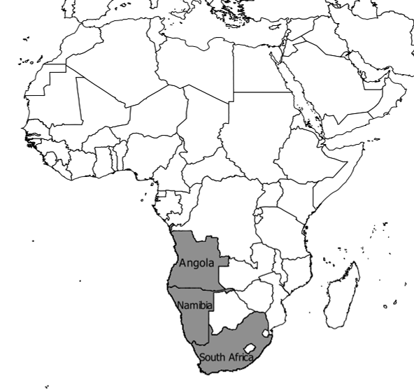
Figure 1: The three countries covered in this plan.

Taxonomic scope
Nine species from within the region are included in this plan (Table 1) because of their priority conservation status and categorisation under the African-Eurasian Waterbirds Agreement (AEWA) in Column A of Table 1 of the Agreement’s Action Plan. In most cases these species face similar threats, which can be addressed by similar actions.

Table 1: The International Union for the Conservation of Nature (IUCN) Red List status, global population trends and AEWA Table 1 categorisation of the nine species considered in this plan.
Common name | Species name | Current IUCN Red List category | Global population trend | AEWA Table 1
African Penguin | Spheniscus demersus | Endangered | Decreasing | A: 1b  B: 2a, 2c
Bank Cormorant | Phalacrocorax neglectus | Endangered | Decreasing | A: 1b 2
Cape Cormorant | Phalacrocorax capensis | Endangered | Decreasing | A: 4
Cape Gannet | Morus capensis | Vulnerable | Decreasing | A: 1b  B: 2a, 2c
African Oystercatcher | Haematopus moquini | Near Threatened | Increasing | A: 1c
Crowned Cormorant | Microcarbo coronatus | Near Threatened | Stable | A: 1c
Damara Tern | Sternula balaenarum | Near Threatened | Stable | A: 2
Caspian Tern | Sterna caspia | Least Concern | Increasing | A: 1c
Greater Crested Tern | Sterna bergii (ssp. bergii) | Least Concern | Stable | A: 2

Biological assessment

African Penguin Spheniscus demersus
HISTORICAL DISTRIBUTION: Breeding in South Africa and Namibia. Vagrant birds have been found as far north as Gabon on the African west coast and east to Mozambique on the east coast.
CURRENT DISTRIBUTION: unchanged, although two South African colonies (Lamberts Bay (Bird Island) in 2006 and Geyser Island in 1996) and two Namibian colonies (North Reef and Pomona) have gone extinct.
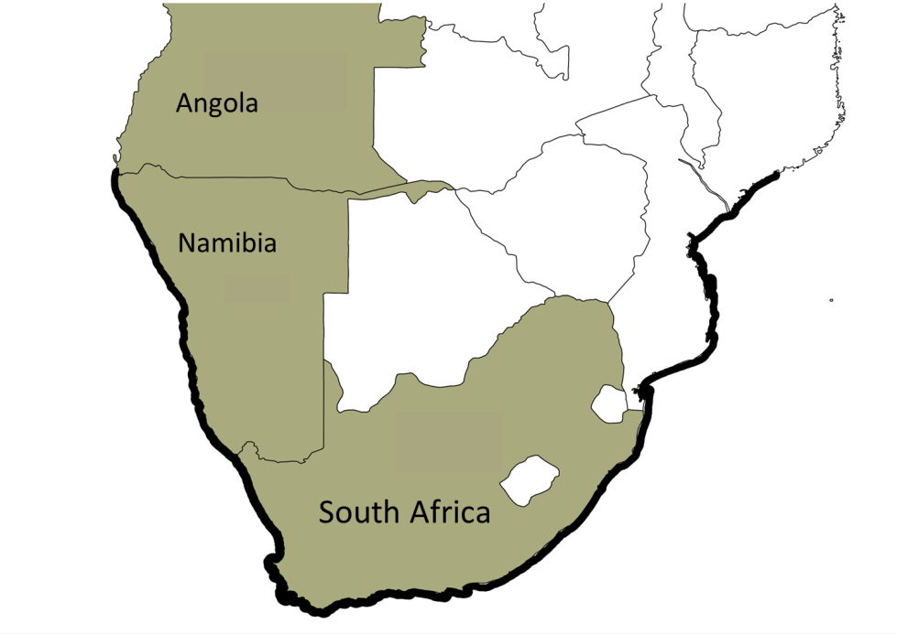
Figure 2: Non-breeding distribution of the African Penguin.
MIGRATION: No concentrated sites used during migration - juveniles tend to disperse west and north along the coastline, but usually return to recruit at their natal colony. Adults also disperse in the non-breeding period but generally not as far. When breeding, African penguins may contract or expand their feeding range depending on food availability.
POPULATION SIZE AND TREND (all breeding localities):
Breeding location | Pairs | Year | Trend
Overall¹ | 23 000 | 2013 | Decreasing
Namibia² | 5 500 | 2013 | Decreasing
HollamsBird Island | 1 | 1988 | Unknown
Sylvia Hill | 11 | 2004 | No data
Oyster Cliffs | 45 | 2002 | No data
Mercury Island | 3 171 | 2011 | Stable
Neglectus Islet | 5 | 2008 | No data
Ichaboe Island | 661 | 2011 | Decreasing
Penguin Island | 3 | 2010 | Unknown
Halifax Island | 851 | 2011 | Increasing
Possession Island | 594 | 2011 | Stable
Plumpudding Island | 86 | 2008 | Stable
Sinclair Island | 68 | 2008 | Stable
South Africa³ | 18 640 | 2013 | Decreasing
Bird Is., Lambert’s Bay | 10 | 2005 | Extinct
Marcus Island | 23 | 2013 | Decreasing
Vondeling Island | 175 | 2012 | Decreasing
Malgas Island | 40 | 2012 | Decreasing
Jutten Island | 253 | 2013 | Decreasing
Dassen Island | 2 633 | 2013 | Decreasing
Robben Island | 1 364 | 2013 | Decreasing
Boulders | 553 | 2013 | Decreasing
Seal Is., False Bay | 31 | 2013 | Decreasing
Stony Point | 2 033 | 2013 | Increasing
Dyer Island | 1 250 | 2013 | Decreasing
Geyser Island | 0 | 2013 | Extinct
Jahleel Island | 164 | 2013 | Decreasing
St Croix Island | 7 657 | 2013 | Decreasing
Stag Island | 11 | 2012 | Decreasing
Brenton Rock | 17 | 2013 | Decreasing
Seal Is., Algoa Bay | 174 | 2013 | Decreasing
Bird Is., Algoa Bay | 2 486 | 2013 | Decreasing
¹BirdLife International 2013; ²Kemper 2015; ³Department of Environmental Affairs 2014 unpublished data.

BREEDING SEASON: Breeds throughout the year. South Africa: peak breeding season February to September; Namibia: peak breeding season October to February and a secondary peak between June and October.
HABITAT: This species is marine and usually found in seas within 40 km of the shore, coming ashore on inshore islands or isolated areas of the mainland coast to breed, moult and rest. Breeding habitats range from flat, sandy islands with sparse or abundant vegetation, to steep rocky islands with practically no vegetation.
KEY PREY SPECIES: Pelagic shoaling fish, primarily anchovy (Engraulis encrasicolus) and sardine (Sardinops sagax). With the lack of sardine and anchovy in southern Namibian waters, the diet there largely consists of bearded goby (Sufflogobius bibarbatus).

Bank Cormorant Phalacrocorax neglectus
HISTORICAL DISTRIBUTION: Bred at 52 localities from Hollamsbird Island, Namibia, to Quoin Rock, South Africa.
CURRENT DISTRIBUTION: unchanged.
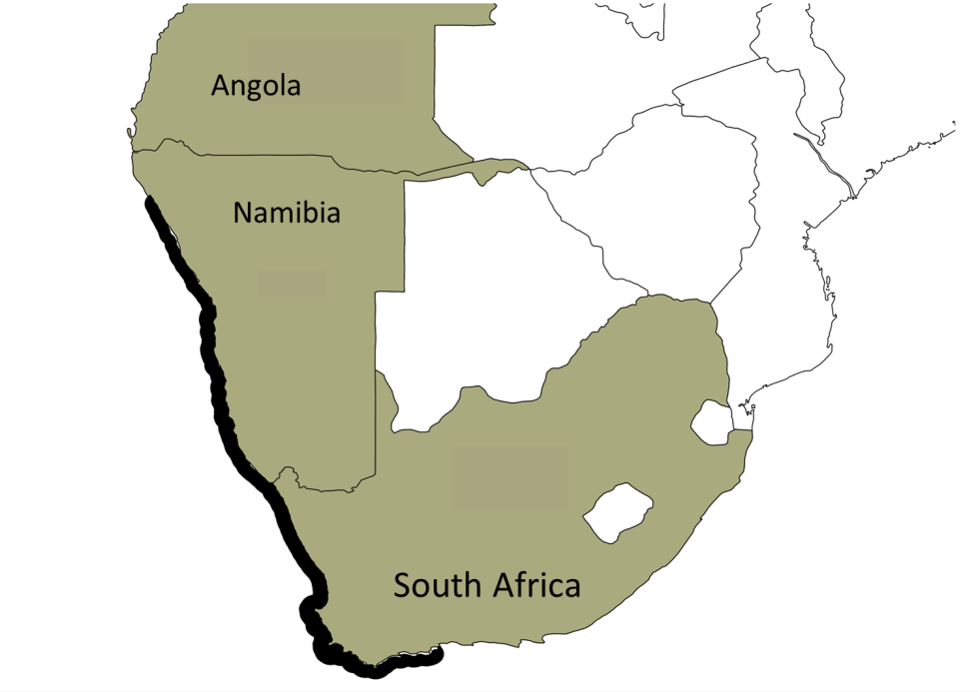
Figure 3: The breeding distribution of the Bank Cormorant.
MIGRATION: Adults are mostly sedentary and remain close to breeding colonies while juveniles may disperse up to 500 km from their breeding colonies.
POPULATION SIZE AND TREND (some important breeding localities):
Breeding location | Pairs | Year | Trend
Overall | 3 400 to 3 900 | 2013 | Decreasing
Namibia¹ | 2 600 to 3 100 | 2010 | Decreasing
Mercury Island | 2 505 | 2010 | Increasing
Ichaboe Island | 217 | 2010 | Decreasing
Penguin Island | 70 | 2010 | Decreasing
Seal Island | 18 | 2010 | Decreasing
North reef | 14 | 2010 | Decreasing
Albatross Rock | 25 | 2008 | Decreasing
Pomona Island | 6 | 2008 | Extinct
South Africa² | 800 | 2013 | Decreasing
Boegoeberg stack | 48 | 2011-2013 | Decreasing
Bird Island, Lambert’s Bay | 0 | 2011-2013 | Extinct
Groot Paternoster rocks | 58 | 2011-2013 | Decreasing
Cape Colombine rocks | 99 | 2011-2013 | Increasing
Marcus Island | 35 | 2011-2013 | Decreasing
Malgas Island | 12 | 2011-2013 | Decreasing
Jutten Island | 24 | 2011-2013 | Decreasing
Vondeling Island | 3 | 2011-2013 | Decreasing
Dassen Island | 81 | 2011-2013 | Decreasing
Robben Island | 147 | 2011-2013 | Decreasing
Dyer Island | 13 | 2011-2013 | Decreasing
Stony Point | 46 | 2011-2013 | Increasing
¹Kemper 2006, Kemper et al. 2007, Roux & Kemper 2015; ²Crawford et al. 2015
BREEDING SEASON: South Africa: May to October; Namibia: November to April
HABITAT: Rarely found more than 10 km offshore. Does not use estuaries or inland waters. Breeds on cliffs, rocks and surfaces of offshore islands, as well as man-made platforms close to the sea.
KEY PREY SPECIES: Namibia: bearded goby, West coast rock lobster (Jasus lalandii). South Africa: West coast rock lobster, Cape rock crab (Plagusia chabrus), several Klipfish spp (Clinus spp).

Cape Cormorant Phalacrocorax capensis
HISTORICAL DISTRIBUTION: From Cape Cross, Namibia, to Hole in the Wall, Eastern Cape, South Africa.
CURRENT DISTRIBUTION: Expanded in the north to include Ilha dos Tigres, southern Angola and retracted in the east to Seal Island, Eastern Cape, South Africa. Non-breeding range north to Lobito, Angola (vagrant to Gabon) and southern Mozambique. New breeding colonies were established at Robben Island, Knysna Heads and Stony Point in 2004, 2008 and 2010 respectively (Crawford et al. 2015).
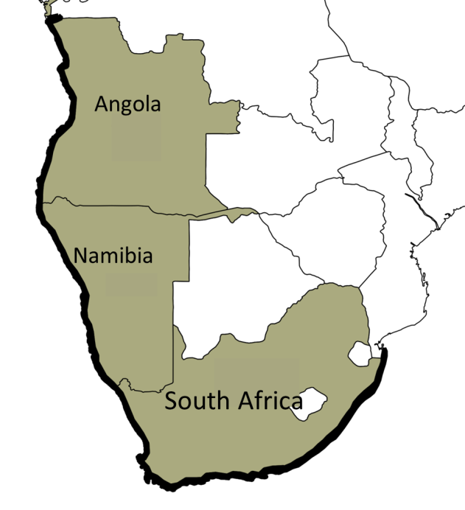
Figure 4: The non-breeding range of the Cape Cormorant.
MIGRATION: Mainly sedentary but may disperse extensively post breeding. Regular visitor to KwaZulu-Natal during winter “sardine run”.
POPULATION SIZE AND TREND (some important breeding localities):
Breeding location | Pairs | Year | Trend
Overall¹ | 92 000 | 2005/06 | Decreasing
Namibia² | 57 400 | 2005 | Decreasing
Cape Cross North | 1 234 | 2006 | Decreasing
Cape Cross Central | 250 | 2006 | Decreasing
Swakopmund | 30 311 | 2005 | Decreasing
Bird Rock | 1 167 | 2005 | Decreasing
Mercury Island | 1 590 | 2005 | Decreasing
Ichaboe Island | 16 366 | 2005 | Decreasing
Seal Island³ | 803 | 2009 | Fluctuating
Penguin Island³ | 3 224 | 2011 | Fluctuating
South Africa⁴ | 65 800 | 2013 | Decreasing
Mathew Island | 629 | 2009-2013 | Increasing
Bird Island, Lambert’s Bay | 115 | 2009-2013 | Decreasing
Groot Paternoster | 421 | 2009-2013 | Increasing
Malgas Island | 1 914 | 2009-2013 | Decreasing
Jutten Island | 7 329 | 2009-2013 | Decreasing
Schaapen Island | 2 108 | 2009-2013 | Increasing
Meeuw Island | 493 | 2009-2013 | Increasing
Vondeling Island | 5 017 | 2009-2013 | Decreasing
Dassen Island | 5 647 | 2009-2013 | Decreasing
Robben Island | 2 166 | 2009-2013 | Decreasing
Dyer Island | 36 283 | 2009-2013 | Decreasing
¹Crawford et al. 2007; ²Kemper 2006, Kemper et al. 2007, Kemper & Simmons 2015; ³MFMRunpublished data; ⁴Crawford et al. 2015

BREEDING SEASON: Namibia and Western Cape peak breeding occurs September to February, in Algoa Bay peak breeding occurs August to December.
HABITAT: Mainly marine, found along the cold waters of the Benguela Current, often less than 10 km off shore. Also occurs in brackish waters of lagoons, estuaries and harbours. It usually nests on flat surfaces of islands and guano platforms but also uses cliff ledges and artificial structures such as unused boats.
KEY PREY SPECIES: sardine, anchovy, horse mackerel (Trachurus capensis) and bearded goby.

Cape Gannet Morus capensis
HISTORICAL DISTRIBUTION: Breeding at five localities in South Africa before 1978 (Crawford et al. 2015), and five localities in Namibia. Non-breeding north to Gabon and Mozambique.
CURRENT DISTRIBUTION: Breeding shift occurred after the 1960s (Crawford et al. 2015) and birds currently breed at three localities in South Africa, and three localities in Namibia.
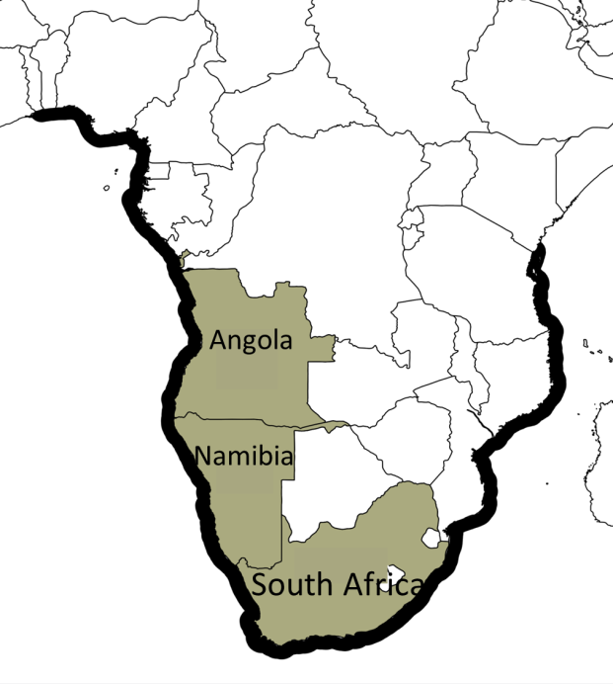
Figure 5: Non-breeding distribution of the Cape Gannet.
MIGRATION: No concentrated migration sites, non-breeding adults and juveniles disperse. Juveniles tend to breed at natal colony. Regularly follows the eastward migration of sardines as far as southern KwaZulu-Natal.
POPULATION SIZE AND TREND (all breeding localities):
Breeding location | Pairs | Year | Trend
Overall | 135 500 |  | Decreasing
Namibia¹ | 13 080 | 2010/11 | Decreasing
Mercury Island | 2 200 | 2010/11 | Decreasing
Ichaboe Island | 10 500 | 2010/11 | Decreasing
Possession Island | 380 | 2010/11 | Decreasing
South Africa² | 122 400 | 2012/13 | Increasing
Bird Island, Lambert’s Bay | 8 907 | 2012/13 | Decreasing
Malgas Island | 20 252 | 2012/13 | Decreasing
Bird Island, Algoa Bay | 93 224 | 2012/13 | Increasing
¹Kemper 2006, Kemper et al. 2007, Kemper 2015; ²Department of Environmental Affairs 2014 unpublished data
BREEDING SEASON: Mostly mid-September to April.
HABITAT: Strictly marine. Nests on flat ground on offshore islands, but has been known to use island cliffs and man-made structures (e.g. guano platforms). It may forage up to 120 km offshore.
KEY PREY SPECIES: Pelagic shoaling fish, primarily anchovy and sardine. When these species aren’t available, Cape hake (Merluccius capensis and M. paradoxus) are scavenged from behind trawlers.

African Oystercatcher Haematopus moquini
HISTORICAL DISTRIBUTION: Distribution stretches along coasts and offshore islands of south and south-western Africa, from Lüderitz in Namibia to the Eastern Cape in South Africa. Vagrants have been recorded in Angola and Mozambique.
CURRENT DISTRIBUTION: Birds are regularly recorded during wetland counts at Walvis Bay and Mile 4 Saltworks in Namibia so are spreading northwards, probably due to spread of the Mediterranean mussel (Mytilus galloprovincialis).
MIGRATION: Juveniles tend to disperse at independence and can migrate up to 2 000 km to other nursery areas along the coast, and only return to their natal area after 2-3 years.
POPULATION SIZE AND TREND (all breeding localities):
Breeding location | Individuals | Year | Trend
Overall | 6 670 | 1997-2003 | Increasing
Namibia^{1,2} | 1 297 | 2003 | Increasing
Mercury Island | 6 | post-1997 | Increasing
Ichaboe Island | 23 | post-1997 | Increasing
Flamingo Island | 142 | post-1997 | Increasing
Seal Island | 6 | post-1997 | Decreasing
Penguin Island | 34 | post-1997 | Decreasing
Shark Island | 10 | post-1997 | Increasing
Halifax Island | 77 | post-1997 | Increasing
Possession Island | 386 | post-1997 | Increasing
Pomona Island | 60 | post-1997 | Increasing
Kunene River-Orange River | 379 | post-1997 | Decreasing
South Africa¹ | 5 373 |  | Increasing
Malgas Island | 129 | post-1997 | Increasing
Marcus Island | 65 | post-1997 | Decreasing
Jutten Island | 234 | post-1997 | Increasing
Schaapen Island | 25 | post-1997 | Increasing
Meeuw Island | 8 | post-1997 | Decreasing
Vondeling Island | 117 | post-1997 | Increasing
Dassen Island | 339 | post-1997 | Increasing
Robben Island | 166 | post-1997 | Increasing
Seal Island (Mossel Bay) | 9 | post-1997 | Increasing
St. Croix Island | 20 | post-1997 | Increasing
Bird Island Group | 14 | post-1997 | Stable
Orange River-Olifants River | 79 | post-1997 | Decreasing
Olifants River-Cape Point | 1 264 | post-1997 | Increasing
Cape Point-Mossel Bay | 677 | post-1997 | Increasing
Mossel Bay-Port Elizabeth | 726 | post-1997 | Increasing
Port Elizabeth-Kei River | 637 | post-1997 | Increasing
Kei-River-Ramsgate | 43 | post-1997 | Increasing
¹Underhill, 2014; ²Leseberg 2015, MFMR unpublished data

BREEDING SEASON: October-March.
HABITAT: Exclusively coastal. Occurs on rocky, sandy and mixed (rocky and sandy) shores. It also occurs along estuaries, lagoons, coastal pans and coastal islands.
KEY PREY SPECIES: Limpets (Scutellastra spp.), Mediterranean mussel and various invertebrates.

Crowned Cormorant Microcarbo coronatus
HISTORICAL DISTRIBUTION: Möwe Bay, Namibia to Cape Agulhas, Western Cape, South Africa.
CURRENT DISTRIBUTION: Breeding at Bird Rock platform, Walvis Bay, Namibia extended the breeding range in Namibia 415 km northward and breeding in Tsitsikamma National Park, Eastern Cape extended the South African range 500 km eastward, although recent information suggests the latter site may have been opportunistic (R. Randall pers. comm.).
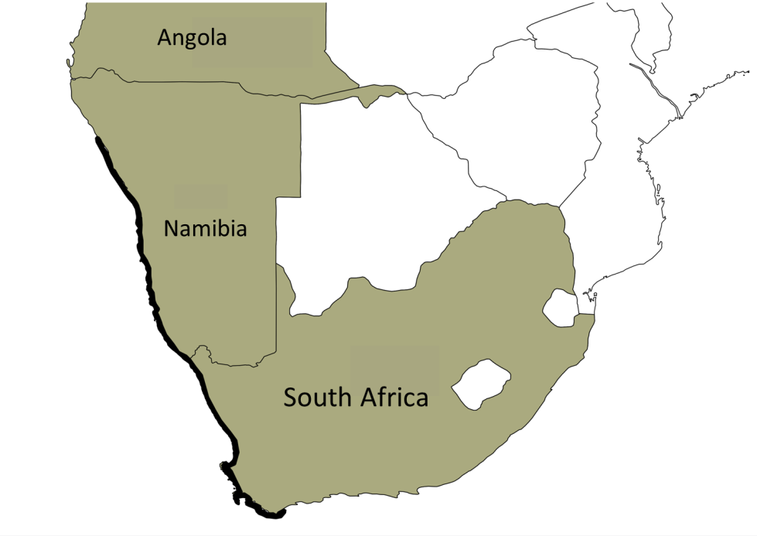
Figure 6: Breeding distribution of the Crowned Cormorant.
MIGRATION: Adults are mostly sedentary and remain close to breeding colonies while juveniles may disperse up to 500 km from their natal colonies.
POPULATION SIZE AND TREND (some important breeding localities):
Breeding location | Pairs | Year | Trend
Overall | 3 080 |  | Stable
Namibia¹ | 1 180 | 2005/06 | Stable
Bird rock platform | 98 | 1999/00 | Increasing
Mercury Island | 70 | 2010/11 | Stable
Ichaboe Island | 335 | 2010/11 | Increasing
Wolf Bay | 135 | 1999/00 | No data
Halifax Island | 56 | 2010/11 | Stable
Seal Island | 158 | 2010/11 | No data
Possession Island | 106 | 2007/08 | Fluctuating
South Africa^{2,3} | 1 900 | 2012 | Stable
Bird Island, Lambert’s Bay | 87 | 2013 | Increasing
Malgas Island | 100 | 2013 | Decreasing
Marcus Island | 0 | 2013 | Fluctuating
Jutten Island | 14 | 2013 | Fluctuating
Schaapen Island | 187 | 2013 | Fluctuating
Vondeling Island | 24 | 2013 | Fluctuating
Meeuw Island | 53 | 2013 | Fluctuating
Dassen Island | 247 | 2013 | Decreasing
Robben Island | 106 | 2013 | Decreasing
Dyer Island | 102 | 2013 | Decreasing
¹Kemper et al. 2007, Kemper 2015; ² Department of Environmental Affairs 2014 unpublished data; ³Crawford et al. 2012b.

BREEDING SEASON: Breeding occurs throughout the year peaking from December to March in South Africa and from October to March in Namibia.
HABITAT: Occurs along coastal cliffs and offshore islands breeding in the Benguela Current, mostly between central Namibia and Cape Agulhas. It forages in coastal waters, estuaries and kelp beds.
KEY PREY SPECIES: slow-moving benthic fish, such as Clinidae especially clipfish (Clinus superciliosus) and Gobiidae, as well as crustaceans, molluscs and polychaete worms.

Damara Tern Sternula balaenarum
HISTORICAL DISTRIBUTION: Southern Angola, Namibia to Algoa Bay in South Africa; non-breeding Benin, Cameroon, Congo, Equatorial Guinea, Gabon, Ghana, Liberia, Nigeria and Togo.
CURRENT DISTRIBUTION: Largely unchanged but four breeding colonies have disappeared in the last century (north of Swakopmund and Dolphin Beach, Namibia, and Port Nolloth and Kommetjie, South Africa) in several places due to coastal development.
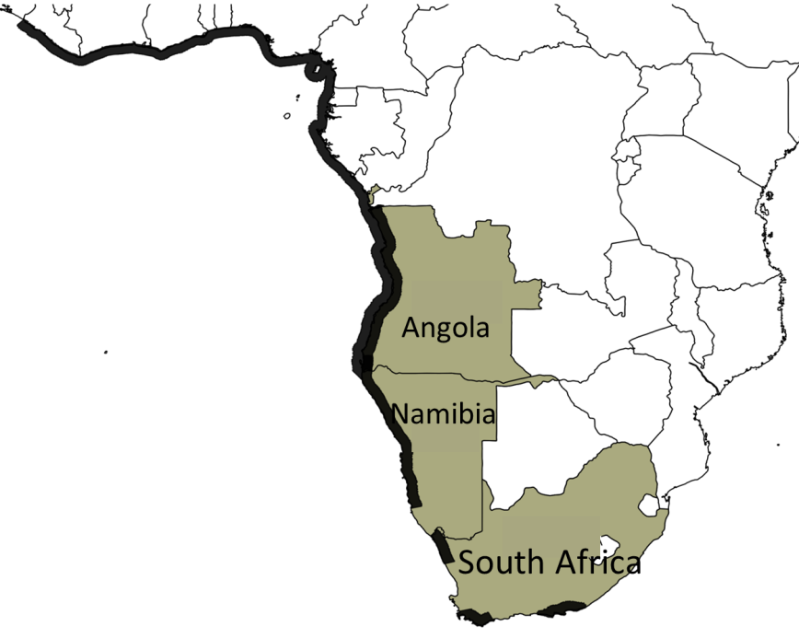
Figure 7: Non-breeding distribution of the Damara Tern.
MIGRATION: During the non-breeding season (July to October) they disperse north to West Africa. Most breeders have left breeding colonies by April and return in September/October.
POPULATION SIZE AND TREND (known breeding localities):
Breeding location | Pairs | Year | Trend
Overall | Unknown |  | Unknown
Angola¹ | <100 | 2010 | Unknown
Bahia dos Tigres² | 12 | 2009 | No data
Namibia³ | 1 000 - 2 685 | 2011 | Stable
Möwe Bay to Swakopmund | 248 | 2006/07 | Stable
Swakopmund to Walvis Bay¹ | 160 | 2010 | Stable
Walvis Bay to Lüderitz | 87 | 2004/05 | Stable
Lüderitz to Orange river | 76 | 2005/06 | Stable
South Africa⁴ | 36 | 2011 | Decreasing
Brandfontein | 2 | 1995/96 | No data
De Mond and vicinity | 15 | 2011/12 | Stable
Port Nolloth | 0 | 2011/12 | No data
Eastern Cape⁵ | 25-29 pairs | 2009/10 | Stable
¹Braby 2010; ²Simmons 2010 (although 573 adults and fledglings were also recorded); ³Braby 2011, Simmons et al. 2015; ⁴Crawford et al. 2012a; ⁵Whittington et al. 2015
BREEDING SEASON: September to April
HABITAT: Coastal, breeds on gravel and stony plains, salt pans and in dune slacks. Can also breed on rock ledges, favouring sites that provide good visibility. Very few records of breeding on islands. During the non-breeding season, the species is found along high-energy coasts and salt-pans in the surf zone.
KEY PREY SPECIES: Small fish including mullet (Mugilidae), needle fish (Tylosaurus species), larval blennies (Blennidae), Cape silverside (Atherina breviceps) and anchovy. The latter is the only commercially important prey species.

Caspian Tern Hydroprogne caspia caspia
HISTORICAL DISTRIBUTION: Large lakes and ocean coasts in North America, locally in Europe, Asia, Africa and Australasia. In southern Africa the species was found at coastal and inland localities and has bred at 28 mainly coastal sites between Swakopmund, Namibia and Lake St Lucia, South Africa, although breeding has also been recorded at Ilha dos Tigres in Angola.
CURRENT DISTRIBUTION: Number of breeding sites fluctuates and terns have been recorded breeding at 16 of 28 sites since 1980.

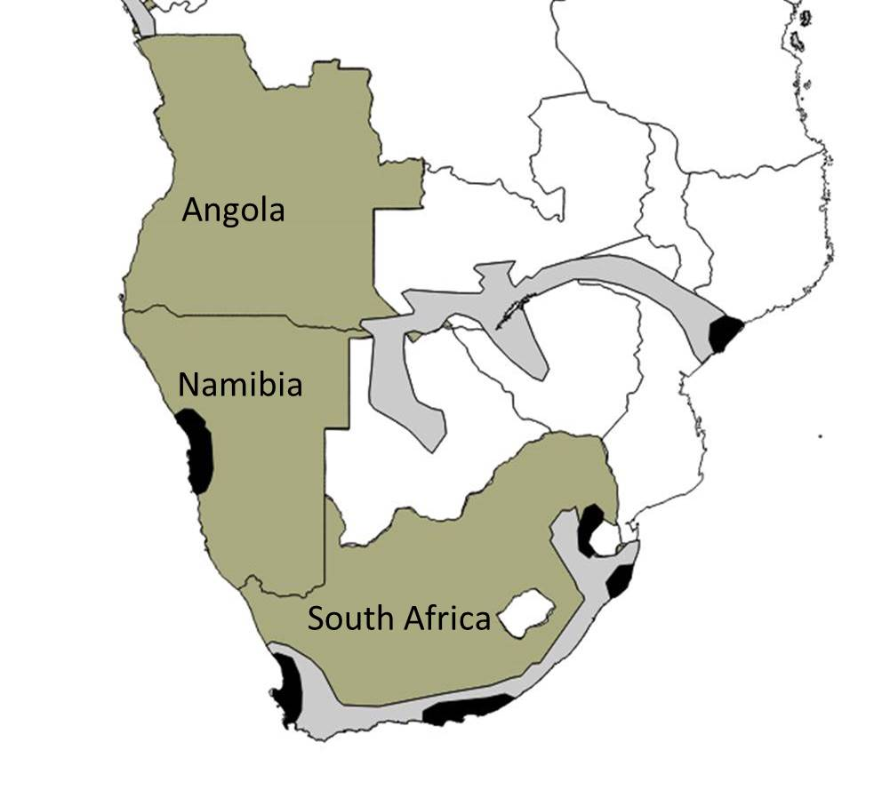
Figure 8: Non-breeding distribution of the Caspian Tern in southern Africa. Black shading indicates breeding distribution and grey indicates non-breeding.
MIGRATION: The African population breeds in South Africa and Namibia, and winters in southern Angola and Zambia, northern Zambia and Botswana and central Mozambique.

POPULATION SIZE AND TREND (list of known breeding localities):
Breeding location | Pairs | Year | Trend
Overall¹ | 500 | 2011 | Stable
Angola² | 88 | 2005 | Unknown
Ilha dos Tigres | 88 | 2005 | Unknown
Namibia²* | 20 | 1977 | Unknown
Swakopmund² | 18 | 1975 | Unknown
Walvis Bay² | 2 | 2014 | Unknown
Sandwich Harbour² | 1 | 1977 | Unknown
South Africa³ | >500 | 2011 | Decreasing
Heuningnes River Estuary⁴ | 35 | 2002/03 | Unknown
Veldrif | 69 | 2011 | Unknown
Jutten Island | 1 | 2011 | Unknown
Meeuw Island | 1 | 2011 | Unknown
Schaapen Island | 1 | 2011 | Unknown
Robben Island | 1 | 2011 | Unknown
Keurbooms estuary | 3 | 2006 | Unknown
Redhouse Saltpans⁵ | 18 | 2008 | Fluctuating
Lake St Lucia⁶ | 300 | 2015 | Unknown
Port Elizabeth | 13 | 2007 | Unknown
¹Cooper et al. 1992; ²Kemper et al. 2007; ³Crawford et al. 2012a; ⁴Williams et al. 2004; ⁵Crawford et al. 2009; ⁶iSimangaliso Wetland Park 2015
*Average of 160 individuals seen at multiple wetland counts from 1977-2012, Simmons 2015.

BREEDING SEASON: Seasonal variations between localities (Namibia: December-March, Western Cape: October-January, Eastern Cape: February-June, KwaZulu-Natal: March-September.
HABITAT: Sheltered coastal embankments, preferably with sandy or muddy margins. They also occur on near-coastal and inland wetlands, especially lakes, waterholes, reservoirs, salt pans, rivers and creeks. The species is rarely seen beyond reefs in offshore locations. Along the coast occurs at sand-dunes, coastal lakes, offshore islands and salt pans.
KEY PREY SPECIES: Fish (5-25 cm) include riverbream (Acanthopagrus berda), small kob (Johnius belengerii), sharptooth catfish (Clarias gariepinus), spotted grunter (Pomadasys commersonnii), Mozambique tilapia (Oreochromis mossambicus), orangemouth glassnose (Thryssa vitrirostris), southern mullet (Liza richardsonii) as well as soles and breams. They also feed on various marine and aquatic invertebrates and are known to prey on eggs and young birds.

Greater Crested Tern Thalasseus bergii bergii
HISTORICAL DISTRIBUTION: Occurred along coasts of west-central Pacific, south-east Atlantic, and Indian Oceans. In southern Africa these birds are found around the coast, from Swakopmund in Namibia to the coast of Mozambique.
CURRENT DISTRIBUTION: Same as historical distribution, although new breeding sites have become available at salt and sewage works.
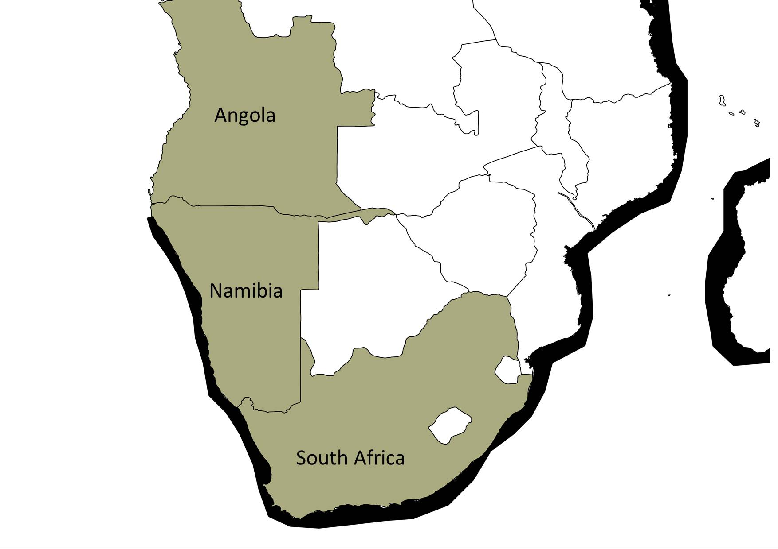
Figure 9: Non-breeding distribution of the Greater Crested Tern in southern Africa.
MIGRATION: After breeding, it migrates away from colonies. Many fledglings move to nursery areas on the south east coast of South Africa (Plettenberg Bay to KwaZulu-Natal), although some disperse northwards. Older birds remain in the vicinity of breeding areas 30 - 100 km. Birds are often nomadic between breeding localities.
POPULATION SIZE AND TREND (list of some breeding localities):
Breeding location | Pairs | Year | Trend
Overall¹ | 11 400 | 2013 | Increasing
Namibia¹* | 1 300 | 2007 | Unknown
Ichaboe Island | 200 | 2007 | Unknown
Halifax Island² | 800 | 2014 | Unknown
Possession Island | 55 | 2007 | Unknown
South Africa³ | 10 100 | 2013 | Stable
Western Cape Islands⁴ | 13 747 | 2011 | Stable
Eastern Cape⁴ | 565 | 2010 | Unknown
¹Kemper et al.2007; ²J. Kemper pers. comm.; ³Crawford et al. 2015; ⁴ Crawford et al. 2012a
*Breeding also occurs occasionally at Seal and Penguin islands (J. Kemper pers. comm.)

BREEDING SEASON: January - September (peak: February - March).
HABITAT: Inhabits tropical, subtropical and temperate coastlines and forages in shallow and coastal waters, estuaries, coral reefs, bays, harbours and inlets. They nest along sandy or rocky coastlines, showing a preference for offshore islands.
KEY PREY SPECIES: Pelagic fish (sardine, anchovy and bearded goby).

Threats
Threats were ranked based on the scope (proportion of population affected), severity (the speed of the decrease) and irreversibility of the threat (Conservation Measures Partnership 2013) – see overview in Table 2. The overall rank of the threat was determined considering its effect across the suite of species concerned. A summary of the threats is presented below but more details can be found in Annex 1.
Nine main threats affect the AEWA-listed seabird species in the Benguela Current Large Marine Ecosystem (BCLME). The most severe threat, which impacts most species, is poor food availability. This is driven by a combination of historical overfishing, the risk of current overfishing at small spatio-temporal scales, and large-scale shifts in the abundance and distributions of prey species. As seabird populations shrink, smaller impacts, such as predation by seals, gulls and pelicans, can become more significant at particular colonies.
Climate change is a concern, but its impacts other than that of sea-level rise and increased storms flooding low-lying breeding localities, are difficult to predict and even more difficult to mitigate. Environmental change is likely influencing changes in the distributions of several prey species, which for some seabirds has led to mismatches in the locations of their breeding localities and prey and consequent population decreases (e.g. Crawford et al. 2015). The potential environmental impacts of seabed mining, in particular phosphate mining, have caused deep consternation across fisheries and environmental sectors in South Africa and Namibia, and there is currently a moratorium on this activity in Namibia. Bulk sediment mining’s impacts on seabirds are unknown.

Lack of food and low quality prey
Rank: very high
Lack of preferred prey species, and consequent reliance by some species/populations on lower-quality prey, is one of the main factors causing low breeding success of the African Penguin, Cape Gannet and Cape and Bank cormorants (Lewis et al. 2006; Roy et al. 2007; Coetzee et al. 2008; Grémillet et al. 2008; Crawford et al. 2011, 2014, 2015). With the exception of the Bank Cormorant, whose main prey species is bearded goby in Namibia and West Coast rock lobster in South Africa (Crawford et al. 1985, 2008, Ludynia et al. 2010), the other three species forage mainly for sardine and anchovy. In the Benguela system, relatively discrete stocks of both sardine and anchovy are found to the north and south of an area of intense upwelling near Lüderitz, Namibia (Crawford, 1998). These fish tend to be out of reach of birds breeding on the Namibian islands which are all near Lüderitz.
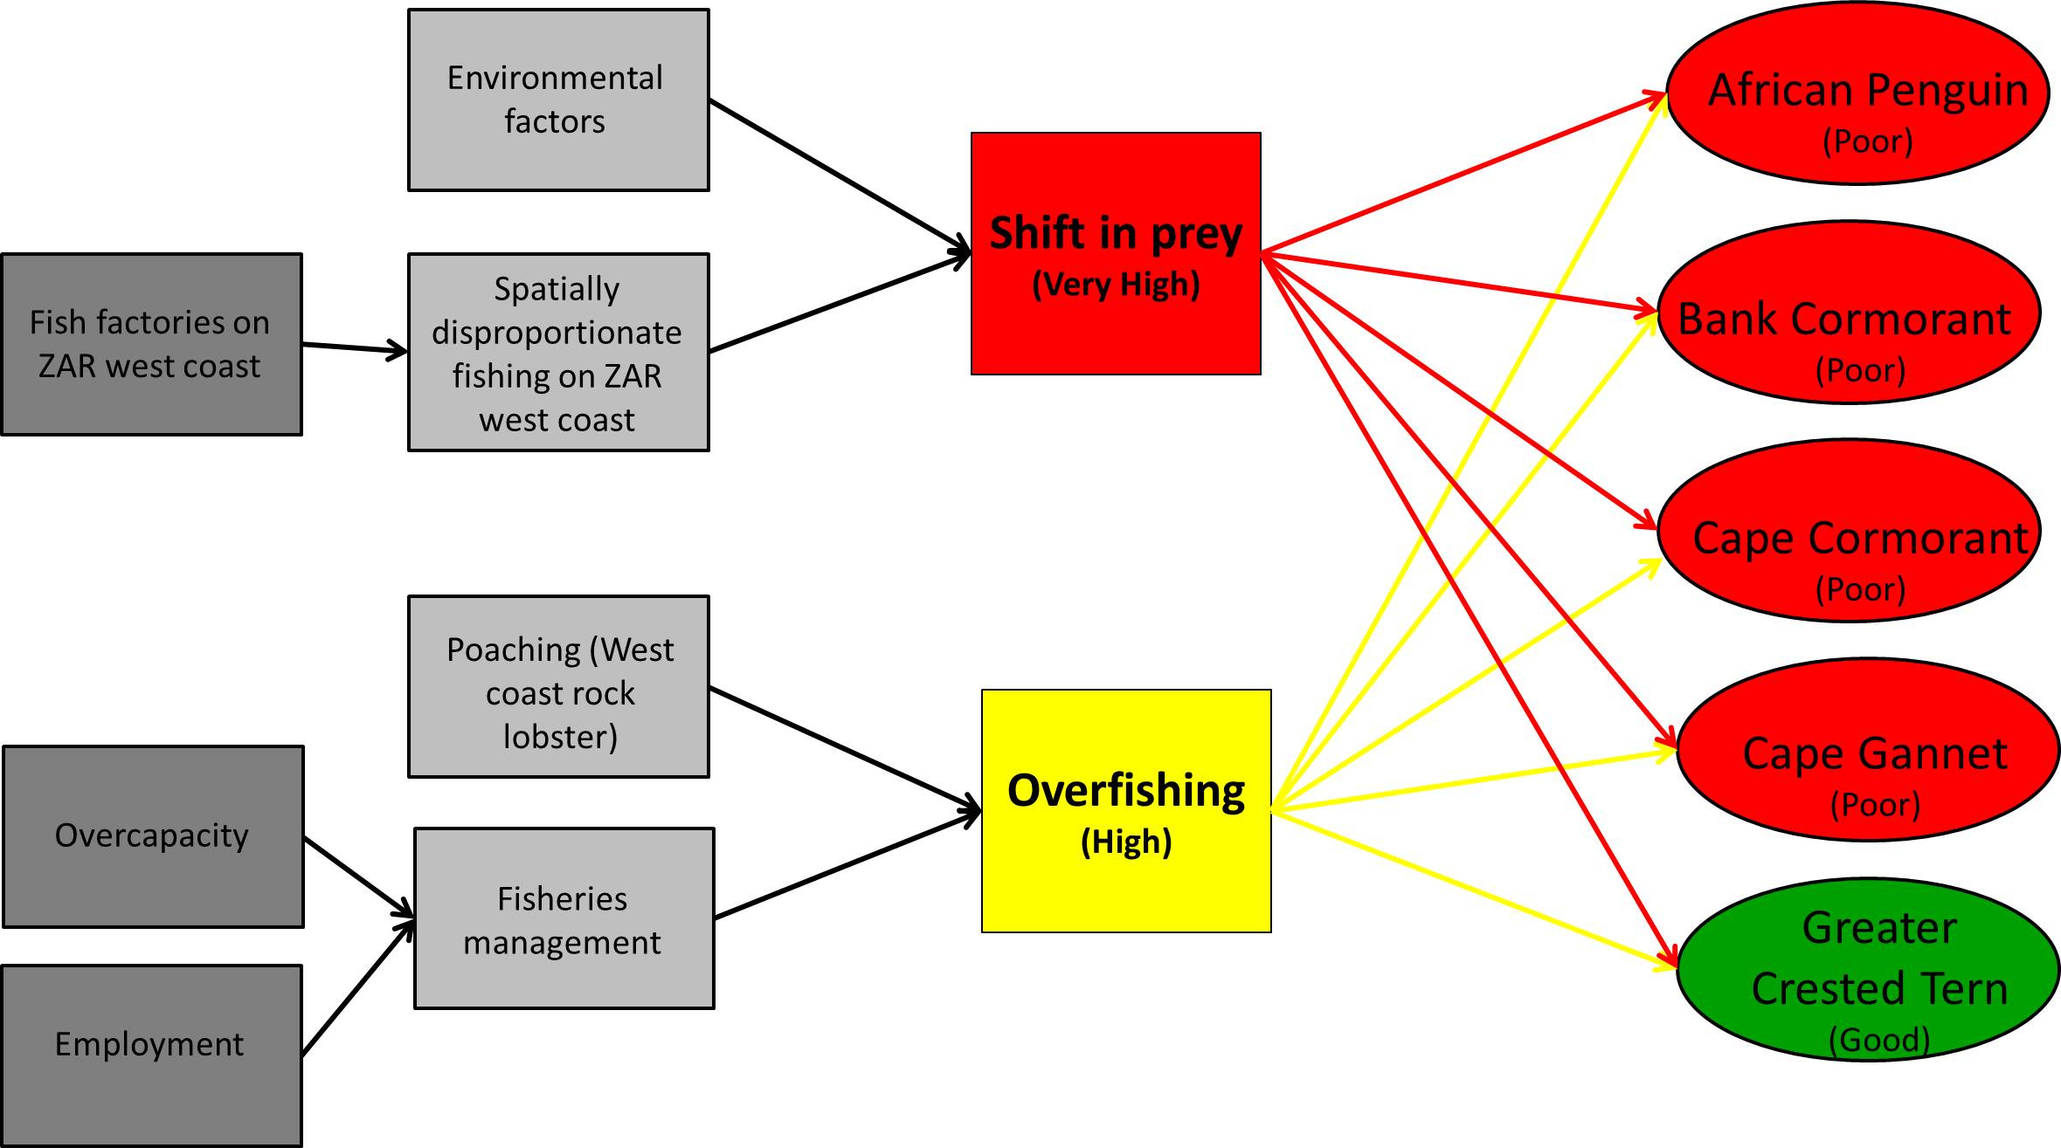
Figure 10: The factors contributing to the threats (grey) relating to availability of food (and threat rank) and the species that are affected (and population status).

Oil spills and oiling
Rank: high
All species are at risk from oiling and South Africa is a global hotspot for oil pollution (Wolfaardt et al. 2009). Oil pollution causes feathers to clump, leading to a breakdown in their insulating properties. As a result birds become hypothermic and are forced to leave the sea. Birds then dehydrate, mobilize stored energy reserves and may lose up to 13% of their body mass within a week and unless rescued will starve to death (Underhill et al. 1999; Wolfaardt et al. 2009).
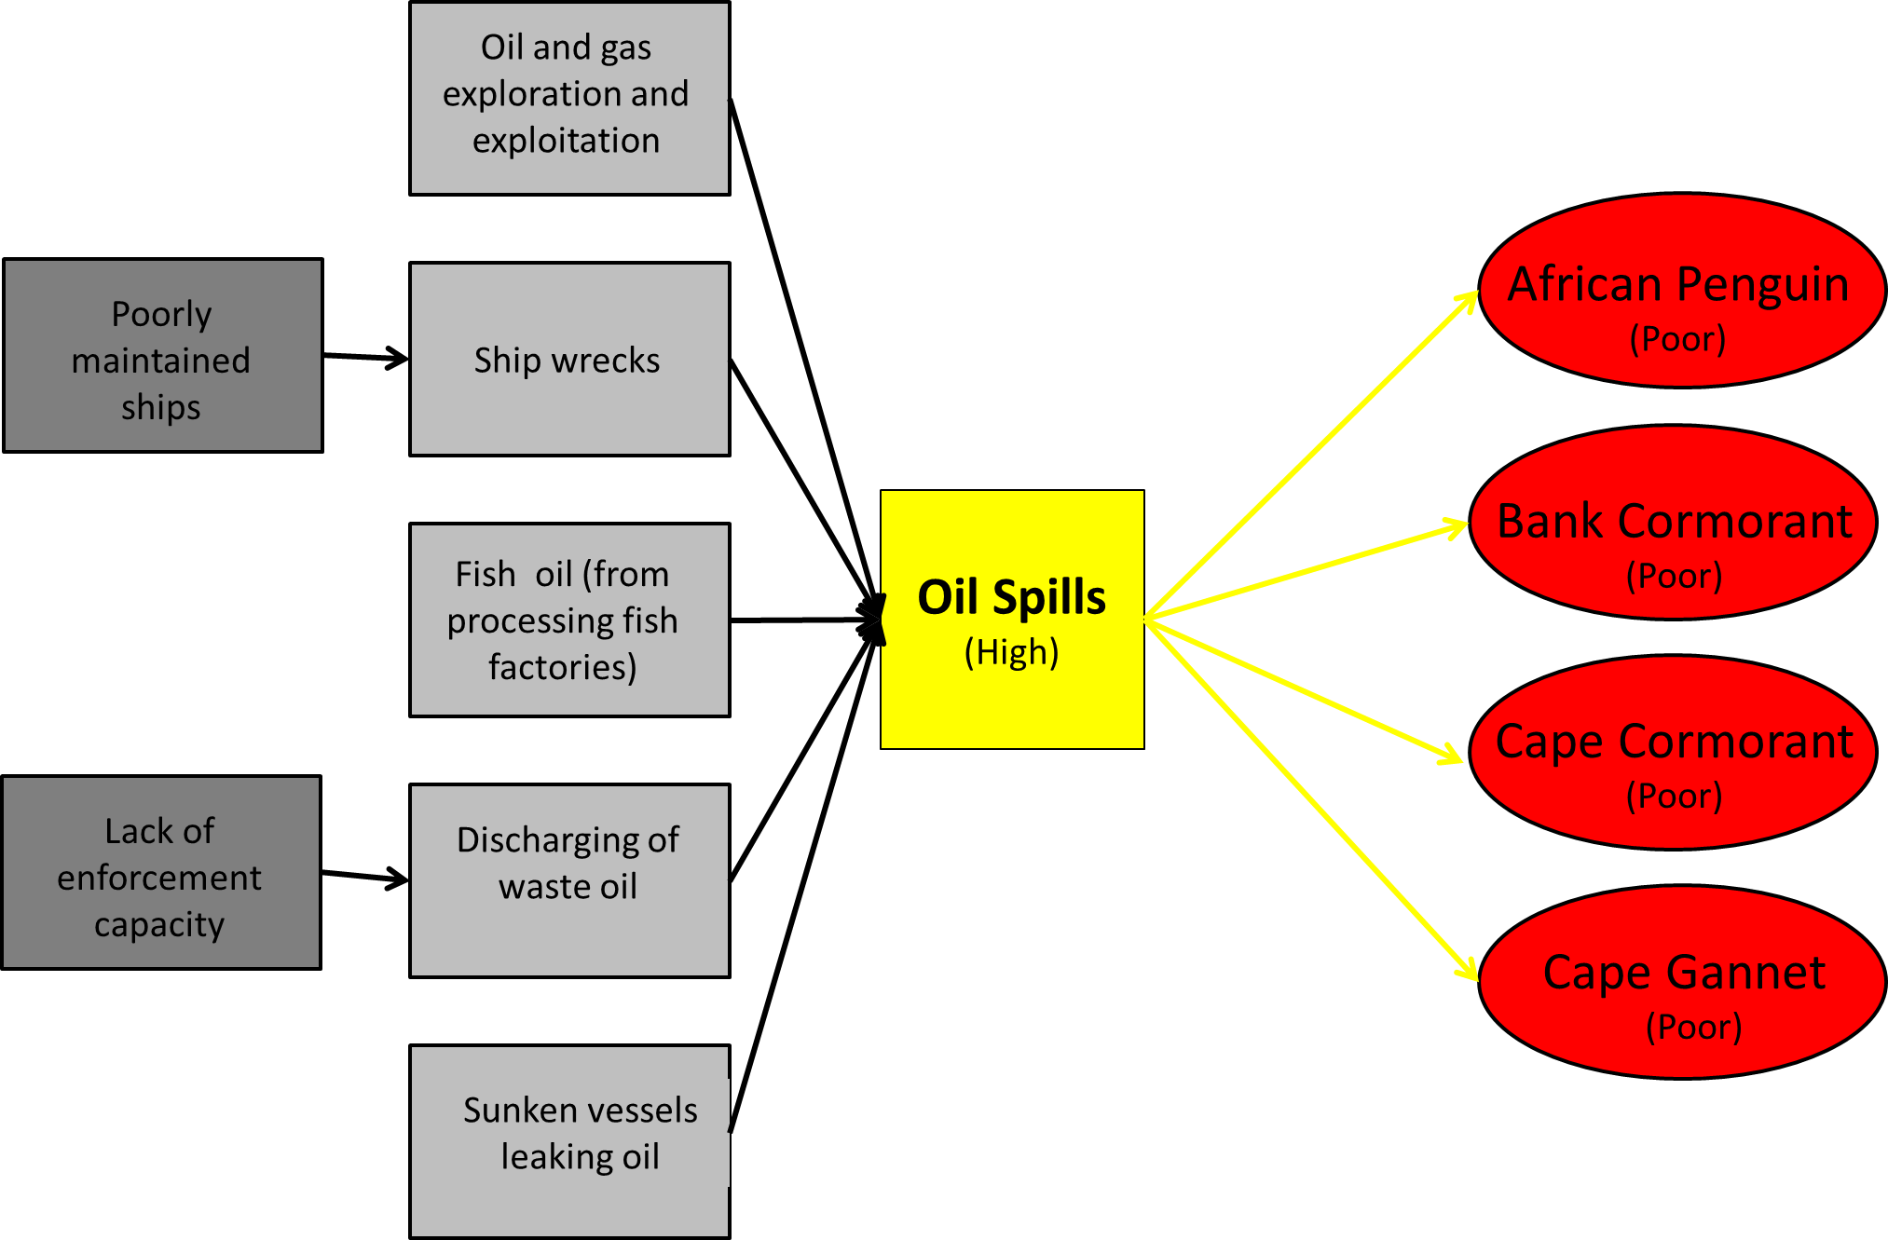

Figure 11: The factors contributing to the threats (grey) relating to oil spills (and threat rank) and the species that are affected (and population status). While all species are potentially susceptible to oiling, the above species are the most regularly oiled.

Predation
Rank: high to low (predators ranked separately in Table 2)
Most of the seabird species covered by this Action Plan are at risk from Kelp Gull (Larus dominicanus) predation of their eggs and small chicks, particularly when adults are disturbed and force to leave their nests. African Penguins, Cape Gannets and the three cormorant species are also at risk from predation at sea by the Cape fur seal (Arctocephalus pusillus pusillus) and on land from the Great White Pelican Pelecanus onocrotalus which prey on chicks. It is worth noting that Kelp Gull predation in parts of the south-western Cape is mitigated by the heavy predation of their chicks by Great White Pelicans (Whittington et al. in press) The Damara Tern is vulnerable to predation by terrestrial mammalian predators (generally Black-backed Jackals Canis mesomelas) and other aerial predators (most frequently Pied Crow Corvus albus and Kelp Gull).

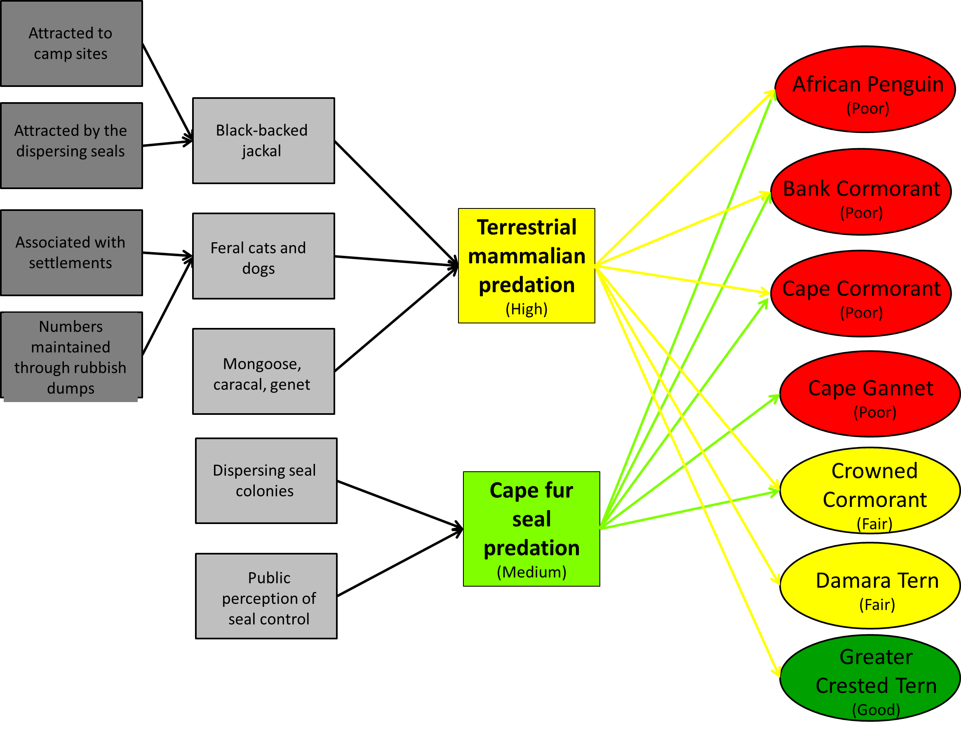
Figure 12: The factors contributing to the threats (grey) relating to mammalian predation (and threat rank) and the species that are affected (and population status).
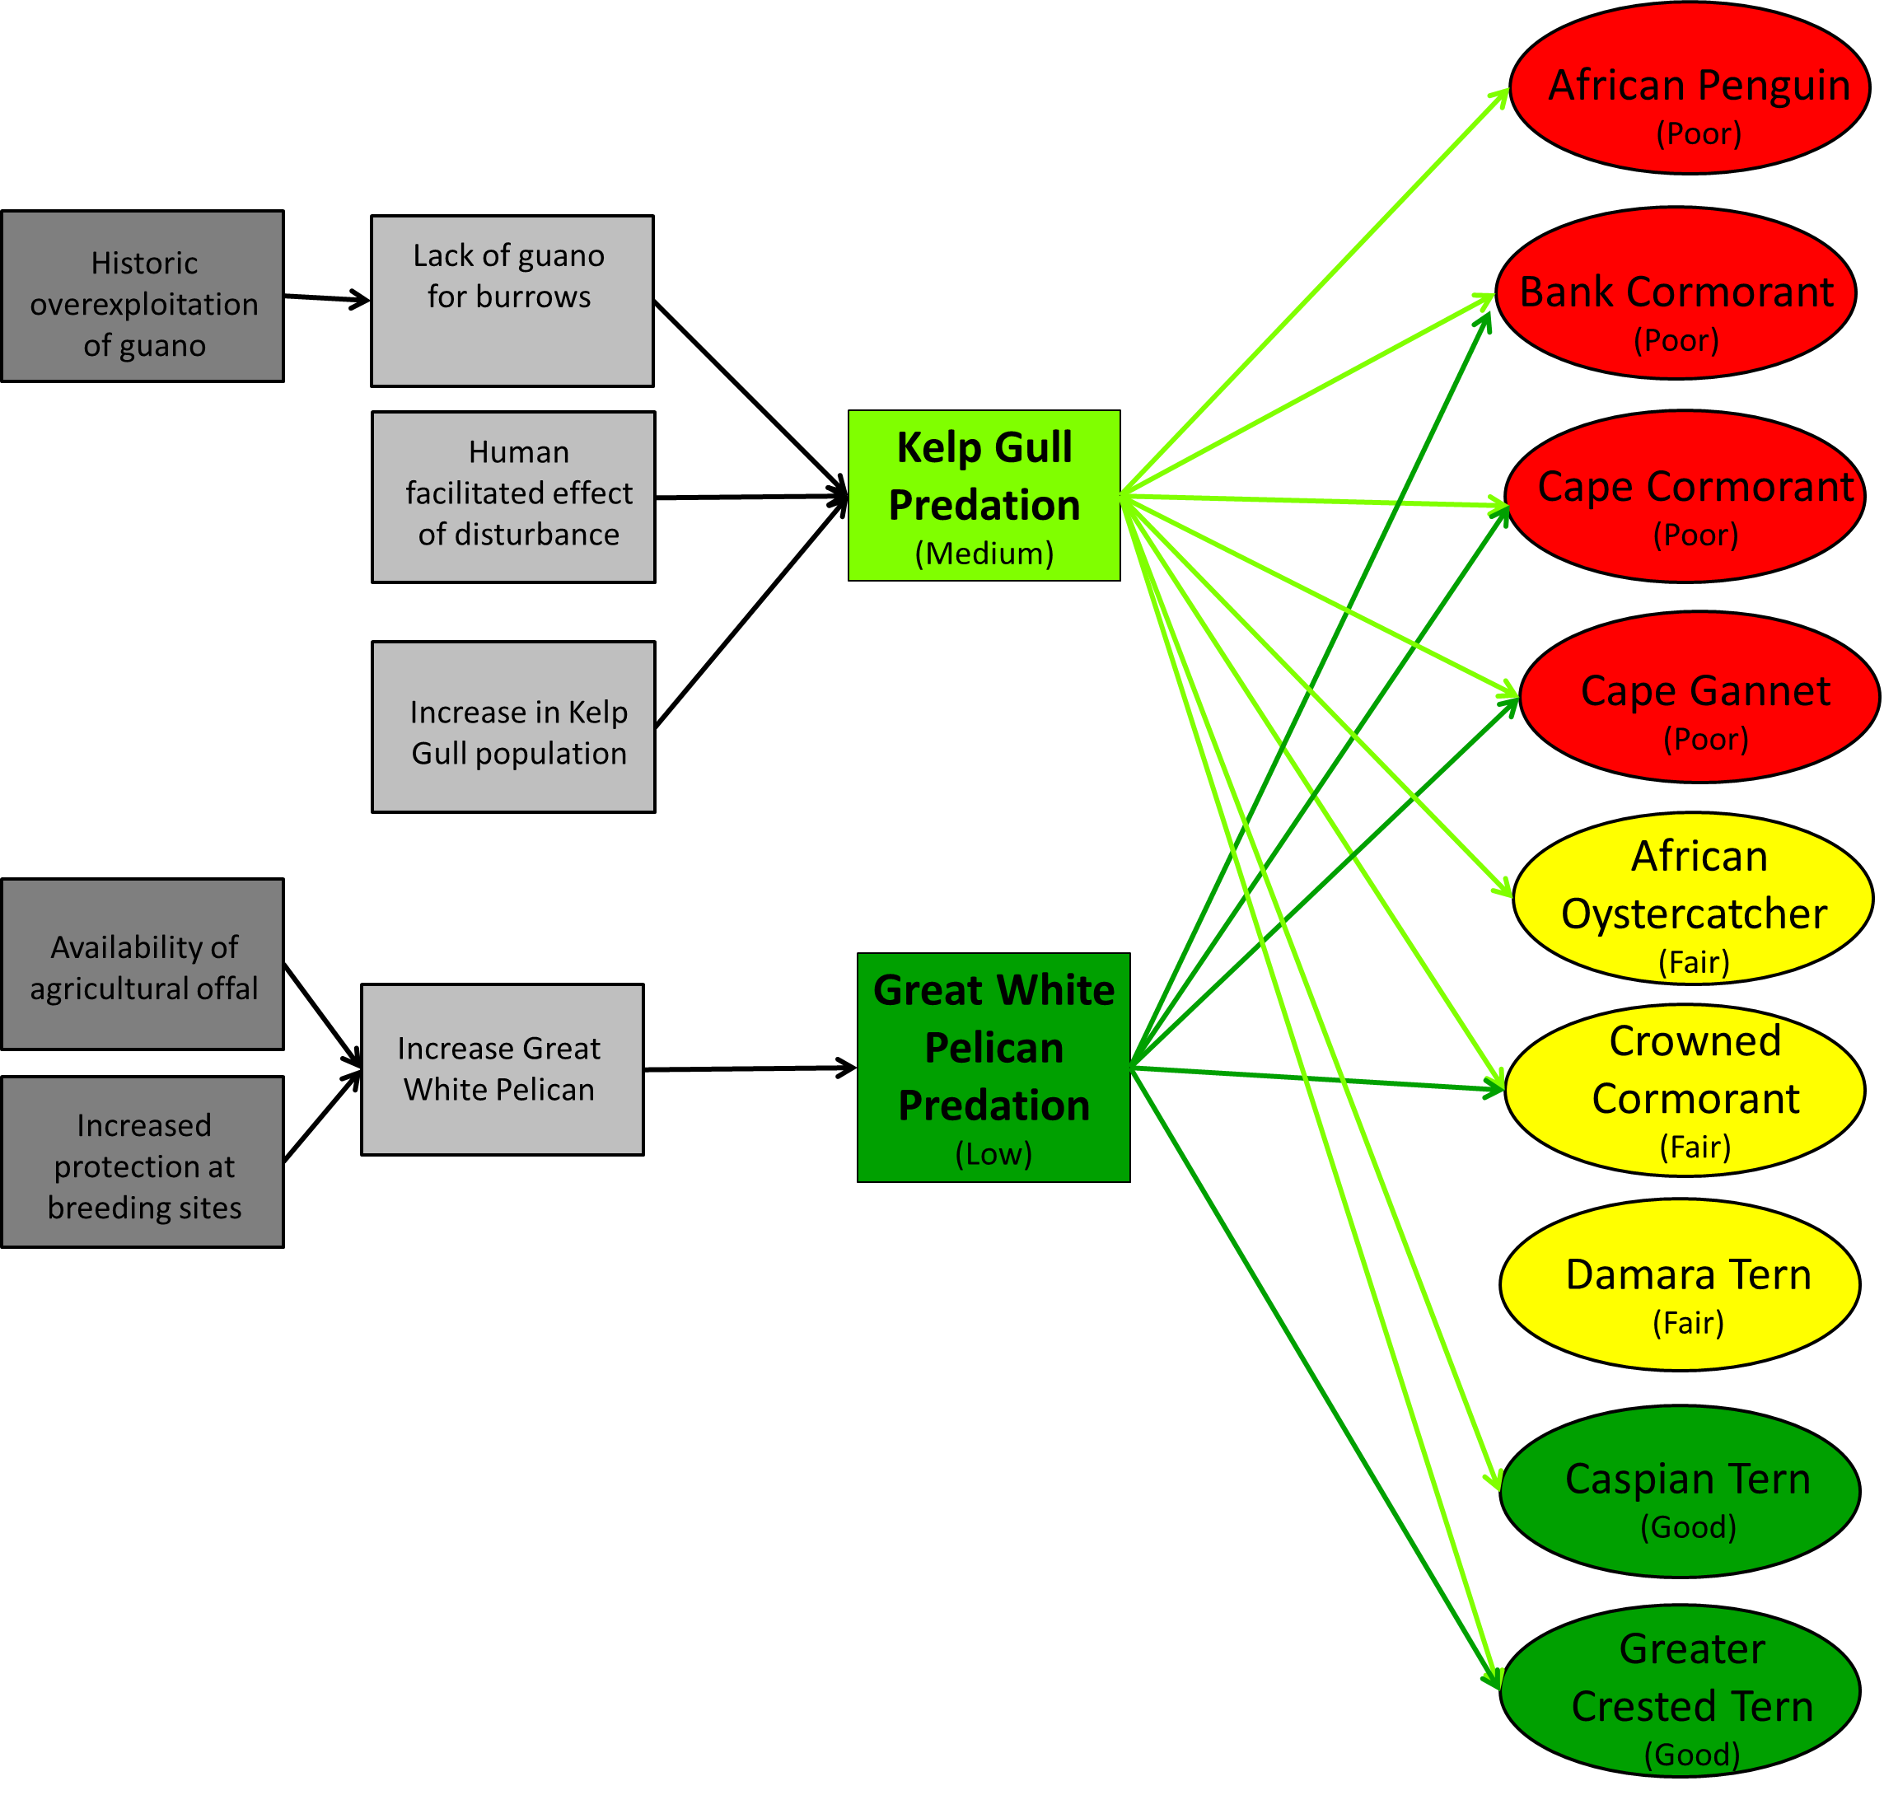
Figure 13: The factors contributing to the threats (grey) relating to seabird predation (and threat rank) and the species that are affected (and population status).

Human disturbance
Rank: medium
All seabirds are vulnerable to human disturbance, especially during breeding but Bank, Cape and Crowned cormorants as well as the Damara Tern are particularly sensitive. Human visitors during breeding can cause abandonment of nests resulting in egg and chick loss to predators or mortality during these stages from heat or cold stress. Disturbance by the researchers is also evident. Coastal development projects affect these species in a more lasting manner due to the loss of habitat.
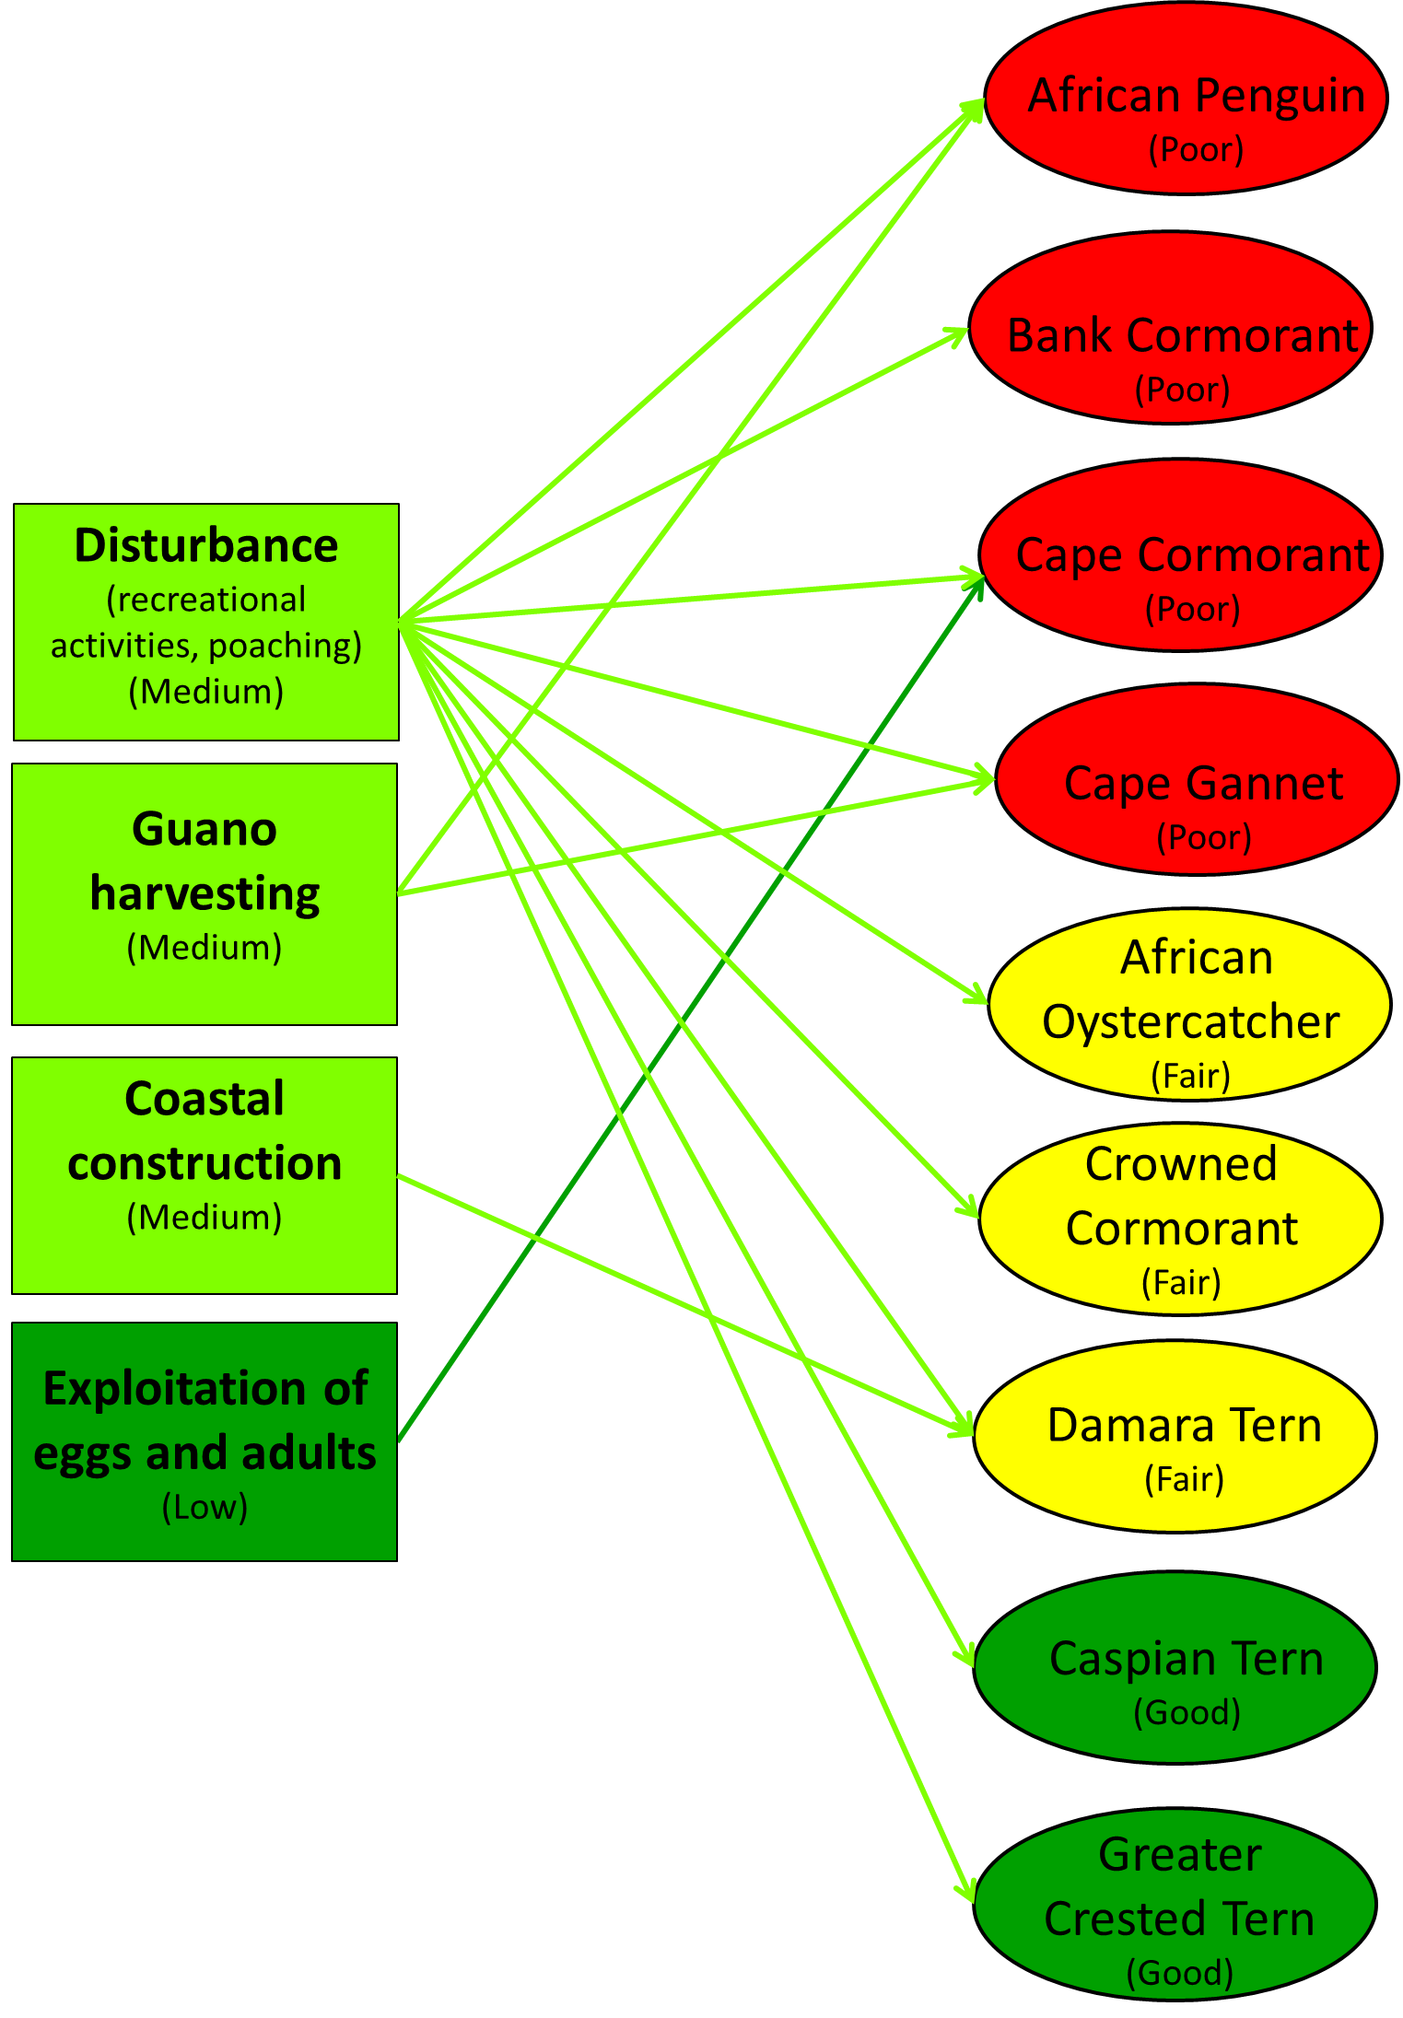
Figure 14: The threat of human disturbance (and threat rank) and the species that are most severely affected (and population status).

Lack of breeding habitat
Rank: medium
Lack of preferred breeding habitat affects the African Penguin, the Damara Tern and the three cormorant species. Lack of breeding habitat can be due to human interference, such as construction, displacement by seals or other seabird species or lack of suitable nest building material (e.g. guano).

Direct impact of fisheries
Rank: low
Fisheries can cause direct impacts on seabirds through bycatch and entanglement in fishing gear. The Cape Gannet is the only species covered by this plan that is directly affected by the trawl (entanglement in the nets or warp cable strikes) and longline fisheries (accidental hooking). Surface diving species (the cormorants and African Penguin) are presumed to be at risk from drowning in gillnets and other floating debris.

Disease
Rank: low
Of the species covered by this Action Plan, the Cape Cormorant is most sensitive to disease, with several outbreaks of various diseases, including coccidiosis, pneumonia and avian cholera Pasteurella multocida, having occurred in the last 50 years (for more details see Annex 1).

Environmental change
Rank: high to low (aspects of environmental change were ranked separately, Table 2)
The Benguela Current Large Marine Ecosystem (BCLME) is a highly variable system but sustained environmental changes such as Benguela Niños, Agulhas intrusions and changes in winds have the potential to impact the ecosystem in unpredictable ways (Timmerman et al. 1999; Shannon & Toole 2003). The effects of global climate change are also likely to be felt through unpredictable changes to weather and sea conditions. Sea level rise was identified as a threat which will affect those seabirds that breed on low-lying islands (African Penguin, Cape Gannet, African Oystercatcher, Greater Crested Tern and the three cormorant species).

Mining and oil and gas exploitation
Rank: unknown
Both onshore and offshore mining have the potential to threaten seabirds in the region. The Damara Tern and possibly the African Oystercatcher are most at risk from shore-based mining activities. Offshore phosphate mining, and oil and gas drilling are not yet established in the region so the threats are unknown but these activities could potentially have significant impacts on the entire ecosystem.

Table 2: Threats to each species were ranked based on the scope, severity and irreversibility of the threat. Blank cells indicate that particular threat did not affect that species

Threats | African Penguin | Bank Cormorant | Cape Cormorant | Cape Gannet | African Oystercatcher | Crowned Cormorant | Damara Tern | Caspian Tern | Greater Crested Tern | Summary Threat Rating
Lack of food and low quality prey
Shift of prey stocks | Very High | High | High | Very High |  |  |  |  | Medium | Very High
Overfishing | High | High | High | High |  |  |  |  | Low | High
Overexploitation of mussels |  |  |  |  | Low |  |  |  |  | Low
Oil spills and oiling
Oil spills | High | Very High | Medium | Medium | Low | Low | Low | Low | Low | High
Lack of breeding habitat
Displacement by seals | Low | Very High | Low | Low | Low | Low | Low | Low |  | High
Direct impact of fisheries
Entanglement | Low | Low | Low | Low |  | Low |  |  |  | Low
Longline and trawl fishing |  |  |  | Medium |  |  |  |  |  | Low
Predation
Terrestrial mammalian predators | Low | Low | Low |  |  | Low | Very High |  | Low | High
Cape fur seal | Medium | High | Medium | Medium |  | Low |  |  |  | Medium
Kelp Gull | Medium | Low | Low | Low | Low | Low | Low | Medium | Low | Medium
Great White Pelican |  | Low | Low | Low |  | Low |  |  | Low | Low
Human disturbance
Human disturbance | Low | Low | Low | Low | Medium | Low | High | Low | Low | Medium
Guano harvesting | High |  |  | Low |  |  |  |  |  | Medium
Coastal construction |  |  |  |  |  |  | High |  |  | Medium
Exploitation of eggs and adults |  |  | Low |  |  |  |  |  |  | Low
Diseases
Diseases | Low | Low | Medium |  |  | Low |  |  |  | Low
Environmental Change
Sea-level rise | Medium | Medium | Medium | Very High | Medium | Medium | Low | Low | Low | High
Sand swamping |  |  |  |  | Low |  | Low |  |  | Low
Flooding (storms) | Low | Low | Low | Low | Low | Low | Low | Low | Low | Low
Extreme heat and cold | Low | Low | Low | Low | Low | Low | Low | Low | Low | Low
Harmful algal blooms | Low | Low | Low |  |  |  |  |  |  | Low
Mining, and oil and gas exploration
Phosphate extraction from seabed | Unknown | Unknown | Unknown | Unknown | Unknown | Unknown | Unknown | Unknown | Unknown | Unknown
Renewable energy development | Unknown | Unknown | Unknown | Unknown | Unknown | Unknown | Unknown | Unknown | Unknown | Unknown

Policies and legislation relevant for management

International Level
Of the three countries covered by this Action Plan, South Africa is the only Contracting Party to AEWA at the time of writing. Parties to AEWA are obliged to ‘take co-ordinated measures to maintain migratory waterbird species in a favourable conservation status or to restore them to such a status’, and to this end must implement the measures prescribed by Article III of the Agreement and the Agreement Action Plan. Paragraphs 4.3.7 - 4.3.10 of the Action Plan are especially relevant for seabirds, and call for actions to minimise the impact of fisheries on migratory waterbirds (including by addressing incidental killing and bycatch, as well as unsustainable fishing which causes depletion of food resources); to control marine pollution; and to eliminate or otherwise to mitigate the threat from non-native terrestrial predators to breeding migratory waterbirds on islands and islets.
The AEWA provision on marine pollution requires Parties to ‘establish and effectively enforce adequate statutory pollution controls in accordance with international norms and legal agreements, particularly as related to oil spills, discharge and dumping of solid wastes’. There are several international agreements which address these issues: for instance, the International Convention on Oil Pollution Preparedness, Response and Cooperation (OPRC), International Convention for the Prevention of Pollution from Ships (MARPOL) and the Protocol to the London Dumping Convention ( Table 3). All three of the countries under consideration are Parties to the OPRC and MARPOL and are thus subject to these Conventions’ obligations, regardless of whether or not they are Parties to AEWA. Angola and South Africa are Parties to the Protocol to the London Dumping Convention.
All three countries are Parties to the Convention on Biological Diversity (CBD; Table 3), which inter alia formalises the need to establish protected areas (including developing guidelines for their management) and to develop or maintain necessary legislation for the protection of threatened species. Internationally, three species are listed as Endangered on the IUCN Red List, one is Vulnerable, three are Near Threatened and two are of Least Concern (Table 1). While threatened status on the Red List does not directly confer legal protection, it provides an incentive for species protection. In addition, threatened and Near Threatened species on the IUCN Red List are included in Column A of AEWA’s Table 1, resulting in legal obligations to ensure that the taking of these species is prohibited or occurs within the framework of an international species action plan (depending on the species’ categorization within Column A).
CITES (to which all three countries are also Parties) regulates the international trade in wild animals and plants to ensure that this practice does not threaten their survival. The African Penguin is the only species under consideration that is listed by CITES (Appendix II). This means that all Parties to the Convention have an obligation to regulate the international trade of this species to avoid over-utilisation which might threaten its survival.
Of the other international agreements pertaining to biodiversity conservation, Angola and South Africa are Parties to the Convention on Migratory Species (CMS). CMS provides a framework for international cooperation for conservation measures across the range of a migratory species. However, all the species under consideration that are covered by CMS are listed on Appendix II, in respect of which the Convention imposes no direct conservation obligations, but simply requires that Parties endeavour to conclude ancillary agreements (of which AEWA is an example). Four of the species are listed on CMS Appendix II: African Penguin, and Damara (listed as Sternula balaenarum), Caspian (listed as Hydropogene caspia, Western Eurasian and African population) and Greater Crested Terns. Namibia and South Africa are contracting Parties to the Ramsar Convention on Wetlands, which seeks to promote the conservation and wise use of wetlands, which include marine features such as estuaries, deltas and tidal flats. These features will have relevance to the tern species.
All three countries are Parties to the United Nations Convention on the Law of the Sea (UNCLOS), and Namibia and South Africa are Parties to the related UN Fish Stocks Agreement. These instruments are relevant to the sustainable management of fish stocks. However, the latter agreement applies only to Areas Beyond National Jurisdiction (ABNJ), except for its provisions on the promotion of the use of the precautionary principle and the compatibility of conservation and management measures. The precautionary principle advocates caution in situations when information is uncertain or unreliable and does not allow the lack of information to be used as a reason to postpone conservation actions.
The Benguela Current Commission (BCC) is a multi-sectoral, inter-governmental initiative of Angola, Namibia and South Africa. The Commission aims to promote regional cooperation to ensure the conservation and sustainable use of the natural resources of the Benguela Current Large Marine Ecosystem. In 2013, the three governments signed the Benguela Current Convention, which commits these countries to inter alia preventing and eliminating pollution, reversing (where possible) and preventing habitat destruction, protecting vulnerable species and improving human capacity and infrastructure. The BCC therefore has an important coordinating role to play in implementing this plan, and in addressing threats to species that cross national boundaries.
In South Africa and Namibia, bycatch of seabirds (mostly albatrosses and petrels, but also Cape Gannets) is being addressed by the Albatross Task Force (ATF), which works with the longline and trawl fisheries to implement seabird bycatch mitigation measures (BirdLife International, 2012). Although the Agreement on the Conservation of Albatrosses and Petrels (ACAP) deals only with albatross and petrel species, their bycatch mitigation factsheets are of relevance to the prevention of bycatch of the Cape Gannet, the only species in this plan to be accidentally caught or killed in trawl and longline fisheries.
Several Regional Fisheries Management Organisations (RFMOs) operate in the region, although only two are of relevance to this plan. The South East Atlantic Fisheries Organisation (SEAFO) promotes the management of sedentary and straddling fish stocks in the region. The Cape horse mackerel (Trachurus capensis) is the only fish managed by this organisation that is also a prey source for one of the seabirds in this plan. Importantly for sustainable fisheries management, SEAFO advocates an Ecosystem Approach to Fisheries (EAF) and the use of the precautionary principle. The Convention through which the Ministerial Conference on Fisheries Cooperation among African States Bordering the Atlantic Ocean (ATLAFCO) was established obliges Contracting Parties to cooperate in the management and conservation of shared stocks, protect and preserve the marine environment, share data, and where possible, harmonise fisheries policies. All three of the countries under consideration participate in SEAFO, while Angola and Namibia are Member States of ATLAFCO.
All three countries are Parties to the Southern African Development Community (SADC) Protocol on Fisheries, which provides for the harmonisation of the legislation of Contracting Parties in order to better manage shared fish resources, including information sharing and law enforcement.
South Africa is a Party to the Abidjan Convention (Convention for Cooperation in the Protection, Management and Development of the Marine and Coastal Environment of the Atlantic Coast of the West, Central and Southern Africa Region), and is thus obliged to take action to prevent and control pollution of the Convention area and to implement sound environmental management of natural resources.
Table 3: The relevant international agreements to which each of the countries under consideration is party.
Instrument | Description | Angola | Namibia | South Africa
Convention on Biological Diversity (CBD) | Obligations inter alia regarding the creation of protected areas and maintaining legislation to protect threatened species | X | X | X
International Union for the Conservation of Nature (IUCN) | Focuses on valuing and conserving nature, ensuring effective and equitable governance of its use, and deploying nature-based solutions to global challenges in climate, food and development. | X  (Ministério do Ambiente) | X  (Ministry of Environment and Tourism) | X  (Department of Environmental Affairs)
Convention on the International Trade of Endangered Species of Wild Fauna and Flora (CITES) | Regulates the international trade in wild animals and plants. | X | X | X
Convention on Migratory Species (CMS) | Provides a framework for international cooperation for conservation measures across the range of a migratory species. | X | - | X
Ramsar Convention on Wetlands | Promotes the wise use of wetlands. | - | X | X
UN Convention on the Law of the Sea (UNCLOS) | Obligations regarding, inter alia, the conservation and management of marine living resources (including consideration of effects on species dependent upon harvested species), and protection of the marine environment. | X | X | X
Agreement for the Implementation of UNCLOS relating to the Conservation and Management of Straddling Fish Stocks and Highly Migratory Fish Stocks (UN Fish Stocks Agreement) | Obligations regarding the conservation and sustainable use of straddling and highly migratory fish stocks (including assessment of impacts on, and adoption of conservation and management measures for, species dependent on target stocks). | - | X | X
International Convention on Oil Pollution Preparedness, Response and Cooperation (OPRC) | Obligations for addressing oil pollution incidents. | X | X | X
International Convention for the Prevention of Pollution from Ships (MARPOL) | Obligations regarding the prevention of pollution by ships from operational or accidental causes. | X | X | X
1996 Protocol to the Convention on the Prevention of Marine Pollution by Dumping of Wastes and Other Matter | Obligations regarding the prohibition and regulation of dumping at sea. | X | - | X
Benguela Current Commission (BCC) | Promotes a science-based approach to the conservation and sustainable use of natural resources in the Benguela Current Large Marine Ecosystem through regional cooperation. Participating countries are Parties to the Benguela Current Convention. | X | X | X
Convention for Cooperation in the Protection, Management and Development of the Marine and Coastal Environment of the Atlantic Coast of the West, Central and Southern Africa Region (Abidjan Convention) | Obligations regarding the prevention and control of pollution of the Convention area and the sound environmental management of natural resources. | - | - | X
Southern African Development Community (SADC) Protocol on Fisheries | Promotes responsible and sustainable use of living aquatic resources. Obligations regarding shared resources and the harmonisation of legislation. | X | X | X
South East Atlantic Fisheries Organisation (SEAFO) | Created through the Convention on the Conservation and Management of Fishery Resources in the South East Atlantic Ocean; promotes the sustainable use of sedentary and straddling fish stocks | X | X | X
Ministerial Conference on Fisheries Cooperation among African States Bordering the Atlantic Ocean (ATLAFCO) | Created through the Convention on Fisheries Cooperation among African States Bordering the Atlantic Ocean. Promotes effective and active co-operation between Member States for conservation and sustainable development of fisheries in the region. | X | X | -

Angola
The Angolan Constitution (published in the Official Gazette Iª Series No. 23 of February 5, 2010 Article 39) provides for the protection of the environment through the following:
- Everyone has the right to live in a healthy and unpolluted environment and the duty to defend and preserve;
- The state shall take the necessary measures to protect the environment and species of flora and fauna throughout the national territory, to maintain ecological balance, exploitation and rational use of all natural resources within the framework of sustainable development and respect for rights of future generations and the preservation of the different species:
- The law punishes acts that endanger or tarnish preserving the environment.
The National Policy of Forests, Wildlife and Conservation Areas (Resolution No. 1/10 of 14 January 2010) aims to create and strengthen legal framework to promote the following principles:
- Conservation and sustainable use: Forest resources, wildlife and existing conservation areas in the country should be kept and used in a sustainable way without compromising the rights of future generations of Angolans
- Sustainable development: forest resources, wildlife and conservation areas should serve to meet the needs of present and future generations;
The Environment Framework Act (No. 5 of 1998), which provides the foundation for environmental protection in Angola, contains broad provisions on, inter alia, the protection of biodiversity; establishment of protected areas; performance of environmental impact assessments (these being further addressed in the Decree on Environmental Impact Assessment (No. 51/04 of 23 Jul. 2004)); and environmental licences for activities which may have significant environmental impacts (these being further addressed in the Decree on Environmental Licensing (No. 59/07 of 13 Jul. 2007)) .
The Decree on Environmental Protection for the Petroleum Industry (No. 39/00 of 10 Oct. 2000) provides for the protection of the environment in the course of both onshore and offshore ‘petroleum activities’ – which include activities related to, inter alia, the prospecting, exploration, production and transportation of oil and its by-products. The Decree includes provisions on both preventing and responding to oil spills.

Namibia
The Marine Resources Act (No. 27 of 2000) provides for the conservation of the marine ecosystem and the responsible use of marine resources. The Act defines ‘marine resources’ to include all marine organisms, as well as guano and anything naturally derived from or produced by such organisms. It is thus applicable to both seabirds themselves and prey species. Regulations published under this Act (the 2001 Regulations Relating to the Exploitation of Marine Resources) include specific protections for seabirds (including, inter alia, penguins, cormorants, gannets, terns, and oystercatchers) and the eggs thereof; as well as provisions on the regulation of fisheries and protection of the marine environment. The Parks and Wildlife Management Bill is in preparation and will regulate protected areas and all indigenous flora and fauna in Namibia. This Bill will replace the outdated Nature Conservation Ordinance (no. 4 of 1975).
The Water Resources Management Act (No. 11 of 2013) is also relevant for the management and protection of estuaries (these being included in the Act’s definition of ‘watercourse’), while the Prevention and Combatting of Pollution at Sea by Oil Act (No. 6 of 1981) provides Namibia’s legislative framework for preventing and responding to oil pollution. Other statutes which are relevant insofar as they regulate activities which present threats to seabirds include the Minerals Prospecting and Mining Act (No. 33 of 1992), Petroleum (Exploration and Production) Act (No. 2 of 1991), and Environmental Management Act (No. 7 of 2007) (under which activities are listed which require environmental impact assessments).
Several seabird breeding sites have been declared Important Bird and Biodiversity Areas (IBAs; Table 4). While IBAs do not necessarily provide any legal protection, their identification helps with prioritisation for designation of protected areas and other conservation initiatives.
Table 4: The policies and legislation applicable to the species covered by this Action Plan in Namibia as well as the protection status of their breeding sites.
Common name | Marine Resources Act (2000) | Parks and Wildlife Management Bill (draft) | Namibian Red Data Book (2015) | Protected area status¹ | Global IBAs¹
African Penguin | Protected | Protected | Endangered | All islands protected in Namibian Islands Marine Protected Area (NIMPA) | Mercury, Ichaboe, Lüderitz Bay islands, Possession islands
Bank Cormorant | Protected | Protected | Endangered | All islands protected in NIMPA | Mercury, Ichaboe, Seal and Penguin islands
Cape Cormorant | Protected | Protected | Endangered | Most breeding sites fall into the NIMPA, Skeleton Coast, Dorob, Cape Cross,Namib-Naukluft, or Tsau//Khaeb National Parks | Cape Cross lagoon, Ichaboe Island, Mile 4 saltworks, Possession Island, Sandwich Harbour, Sperrgebiet, Lüderitz Bay islands
Cape Gannet | Protected | Protected | Critically Endangered | All islands protected in NIMPA; all sites global IBAs | Mercury, Ichaboe, Possession islands
African Oystercatcher | Protected | Protected | Near Threatened | All breeding sites fall within the Namib-Naukluft and Tsau//Khaeb NP as well as NIMPA | Lüderitz Bay islands, Mercury Island, Mile 4 saltworks, Namib-Naukluft Park, Possession Island, Sandwich Harbour, Sperrgebiet, Walvis Bay
Crowned Cormorant | Protected | Not listed | Near Threatened | All sites except Bird Rock included in the NIMPA, the Namib-Naukluft NP or the Tsau//Khaeb NP | Ichaboe Island, Lüderitz Bay islands, Mercury Island, Namib-Naukluft Park, Possession Island, Sperrgebiet
Damara Tern | Protected | Protected | Near Threatened | All breeding sites are in National Parks; Ramsar Site: Sandwich Harbour | Mile 4, Namib-Naukluft, Walvis Bay to Swakopmund Beach, Sandwich Harbour, Sperrgebiet, Possession Island
Caspian Tern | Protected | Protected | Vulnerable | Potential breeding sites fall into the Skeleton Coast, Dorob Namib-Naukluft and Tsau//Khaeb National Parks, the NIMPA and the Hardap Recreation Resort; | Mile 4, Walvis Bay, Sandwich Harbour, Possession Island and Sperrgebiet IBAs
Greater Crested Tern | Protected | Protected | Least Concern | Potential breeding sites fall into the Skeleton Coast-, Dorob- Namib-Naukluft- and Tsau//Khaeb National Parks, the NIMPA | Cape Cross lagoon, Lüderitz Bay islands, Sandwich Harbour, Sperrgebiet, Walvis Bay
¹ Note that the Sperrgebiet NP is now Tsau//Khaeb NP, however the IBA name is still Sperrgebiet.

South Africa
All seabirds occurring in South Africa are protected by the Sea Birds and Seals Protection Act (No. 46 of 1973). The act provides for the control of certain islands and rocks as well as the protection of seabirds from capture, killing, and use of their eggs, feathers and guano. The National Environment Management: Protected Areas Act (No. 57 of 2003) protects many seabird breeding colonies while the National Environment Management: Biodiversity Act (No. 10 of 2004) makes provision for the compilation of biodiversity management plans (including for migratory species in order to give effect to South Africa’s international obligations). Only one such management plan, for the African Penguin (which is listed as a protected species under the Act), has been undertaken in South Africa for species under consideration in this plan (Table 5). The African Penguin is also covered by the National Environmental Management: Biodiversity Act (No. 10 of 2004): Convention on International Trade in Endangered Species (CITES) Regulations. All island breeding sites, except Robben Island, are protected as nature reserves and managed by national or provincial conservation bodies. South Africa is currently revising the Threatened or Protected Species (TOPS) regulations but all species in this plan are listed by the regulations as protected. The TOPS regulations set out permit requirements for restricted activities (e.g. the hunting, capturing, killing, importing, exporting etc. of any listed species) and the regulation of facilities that may transport, hold or keep captive any of the listed species (e.g. captive breeding facilities, rehabilitation centres, etc.)
A range of other South African legislation is relevant for addressing the threats faced by seabirds. Fisheries management is governed by the Marine Living Resources Act (No. 18 of 1998), which recognizes the needs to, inter alia, apply precautionary approaches, protect the ecosystem as a whole (including species which are not targeted for exploitation), and preserve marine biodiversity as principles which decision-makers must consider in implementing this statute. Several statutes seek to protect the marine environment from pollution by oil and other harmful substances, and thereby implement South Africa’s international commitments concerning marine pollution. These include the Marine Pollution (Control and Civil Liability) Act (No. 6 of 1981), the Marine Pollution (Prevention of Pollution from Ships) Act (No. 2 of 1986), and the Marine Pollution (Intervention) Act (No. 64 of 1987). The National Environmental Management: Integrated Coastal Management Act (No. 24 of 2008) is also relevant insofar as it contains provisions on dumping at sea. The statute further provides the overarching framework for coastal management in South Africa and is thus an important tool through which to control development and other activities in the coastal environment, as is the environmental authorisation process established by the National Environmental Management Act (No. 107 of 1998). The use of estuaries specifically is additionally governed by the National Water Act (No. 36 of 1998); while a regulatory framework for mining and oil and gas exploitation is provided by the Mineral and Petroleum Resources Development Act (No. 28 of 2002).
Table 5: The policies and legislation applicable to the species covered in this Action Plan in South Africa as well as the protection status of their breeding sites.
Common name | Management Plans | Status in Red Data Book of South Africa, Lesotho and Swaziland | Protected Area status | Global IBAs
African Penguin | Species Biodiversity Management Plan | Endangered (2015) | All breeding sites are under management of nature conservation authorities, except Robben Island, managed by Robben Island Museum | Algoa Bay Islands Nature Reserve, Bird Island (Lambert’s Bay), Boulders Beach, Dassen Island, Dyer Island Nature Reserve, Overstrand, Robben Island National Historical Monument, West Coast National Park and Saldanha Bay islands
Bank Cormorant | None | Endangered (2015) | Most important breeding sites¹ are under management of nature conservation authorities | Dassen Island, Dyer Island Nature Reserve, Overstrand, Robben Island National Historical Monument, West Coast National Park and Saldanha Bay islands
Cape Cormorant | None | Endangered (2015) | Most important breeding sites¹ are under management of nature conservation authorities | Dassen Island, Dyer Island Nature Reserve, False Bay Nature Reserve, Orange River Mouth Wetlands, Robben Island National Historical Monument, West Coast National Park and Saldanha Bay islands
Cape Gannet | National Plan of Action for Reducing the Incidental Catch of Seabirds in Longline Fisheries | Vulnerable (2015) | All breeding sites are under management of nature conservation authorities | Algoa Bay Island Nature Reserve, Bird Island, West Coast National Park and Saldanha Bay islands
African Oystercatcher | None | Near Threatened (2000) | Most important breeding sites¹ are under management of nature conservation authorities | Alexandria coastal belt, Algoa Bay Island Nature Reserve, Dassen Island, De Hoop Nature Reserve, Dwesa and Cwebe Nature Reserves, Dyer Island Nature Reserve, Maitland - Gamtoos coast, Rietvlei Wetland Reserve, Robben Island National Historical Monument, Swartkops Estuary - Redhouse and Chatty Saltpans, West Coast National Park and Saldanha Bay islands
Crowned Cormorant | None | Near Threatened (2015) | Most important breeding sites¹ are under management of nature conservation authorities | Dassen Island, Dyer Island Nature Reserve, Overstrand, Robben Island National Historical Monument, West Coast National Park and Saldanha Bay islands
Damara Tern | None | Critically Endangered (2015) | Most breeding sites in the Eastern Cape protected by Greater Addo Elephant National Park but other sites in the province are not protected | Alexandria coastal belt, Heuningnes river and estuary system, Orange River Mouth Wetlands
Caspian Tern | None | Near Threatened (2015) | Breeding sites on islands largely protected, while mainland sites are not | Lake St Lucia and Mkuze Swamps, Lower Berg river wetlands, Saldanha Bay islands, West Coast National Park
Greater Crested Tern | None | Not assessed | Breeding sites on islands largely protected, while mainland sites are not | Dassen Island, Dyer Island Nature Reserve, False Bay Nature Reserve, Lower Berg river wetlands, Robben Island National Historical Monument, West Coast National Park, Saldanha Bay islands, Algoa Bay islands
¹Those listed for each species under Section 2: Biological Assessment.

Monitoring and research
There are differing levels of monitoring taking place in each of the three countries due to differences in capacity and resources. Research projects underway on each species are listed in Annex 2.

Angola
There is little regular monitoring of seabirds in Angola. In 2003, the BCLME, Instituto Nacional de Investigação Pesqueira (INIP) and University Agostinho Neto conducted the first at-sea census of seabirds in Angolan waters. Additional censuses were conducted in 2005 (winter) and 2014 (summer and winter). Ten species were frequently encountered, of which only two are considered in this plan (Cape Gannet and Cape Cormorant).

Namibia
Three seabird breeding islands are permanently staffed (Mercury, Ichaboe, Possession islands) and together with Halifax Island, which is situated close to Lüderitz, these sites have regular counts (Table 6) while other sites are counted on an ad hoc basis. Monitoring programmes for the Namibian Islands Marine Protected Area (NIMPA) are being developed and a draft management plan for these islands is also nearing completion. All the birds on this list will also be counted during the wetland bird counts if they should be present at the count sites.
Table 6: The monitoring frequency and organisations responsible for this at Namibian seabird breeding sites.
Common name | Monitoring action | Organisation responsible
African Penguin | Four main islands (~96%) counted bi-monthly (moult) and monthly (nests)  Additional sites censused once a year at most | Ministry of Fisheries and Marine Resources (MFMR), African Penguin Conservation Project (APCP)
Bank Cormorant | Monthly counts at staffed islands with ad hoc counts at other sites. Other monitoring work (mostly at Mercury Island) includes ringing, breeding success and diet studies | MFMR
Cape Cormorant | No annual census although aerial surveys at large colonies may take place during seal census, but are not necessarily at breeding peak. Ground censuses may be done at smaller colonies, including those at Mercury, Ichaboe, and Possession. | Aerial censuses organised and conducted by MFMR, DEA South Africa, Namibian Coast Conservation and Management Project (NACOMA)
Cape Gannet | Annual Cape Gannet census (last done 2010) at all three (permanently staffed) breeding sites. Other monitoring is being done there (ringing, breeding success and some diet studies) | MFMR, DEA South Africa, NACOMA
African Oystercatcher | Counted monthly at staffed islands and Halifax Island. Counted incidentally during bi-annual wetland counts, counted opportunistically at other times | Ministry of Environment and Tourism (MET) and volunteers; MFMR
Crowned Cormorant | Counted monthly at Mercury, Ichaboe, Halifax, Possession islands; ad hoc counts at other islands | MFMR
Damara Tern | Horses Graves and Caution Reef surveyed annually, other sites less often | NACOMA, R Braby, J Braby
Caspian Tern | Counted incidentally during bi-annual wetland counts, counted opportunistically at other times | Ministry of Environment and Tourism (MET) and volunteers; MFMR
Greater Crested Tern | Counted incidentally during bi-annual wetland counts, counted opportunistically at other times | Ministry of Environment and Tourism (MET) and volunteers; MFMR

South Africa

South African authorities conduct annual censuses of 12 seabirds, including African Penguin, Cape Gannet, Greater Crested Tern, and Cape, Crowned and Bank cormorants. Opportunistic information on the Damara and Caspian terns is collected. All major seabird breeding sites (15) are surveyed annually, with some sites being visited monthly. These surveys are organized by Department of Environmental Affairs, CapeNature, South African National Parks and eKZN Wildlife. Many of the breeding sites have management plans in place.

Framework for action

Goal
Restore Benguela seabird species to favourable conservation status by 2040.

Purpose
The purpose of this plan is to stop further declines and maintain current population size and breeding distribution area of species covered by this Action Plan by 2025.

Table 7: The current status of the populations of the nine species is shown as well as the population size required for these species to be in a “Good” state.
Species | Current Status¹ | Current population size | Unit | Good
African Penguin | Poor | 23 000 | Breeding pairs | 90 000
Bank Cormorant | Poor | 3 250 | Breeding pairs | 10 000
Cape Cormorant | Poor | 94 808 | Breeding pairs | 250 000
Cape Gannet | Poor | 135 463 | Breeding pairs | 250 000
African Oystercatcher | Fair | 6 670 | Individuals | 9 000
Crowned Cormorant | Fair | 3 080 | Breeding pairs | 5 000
Damara Tern | Fair | 2 685 | Breeding pairs | 5 000
Caspian Tern | Good | >500 | Breeding pairs
Greater Crested Tern | Good | 11 400 | Breeding pairs
¹Poor: restoration increasingly difficult, may result in extirpation
Fair: outside acceptable range of variation, requires human intervention
Good: indicator within acceptable range of variation, some human intervention may be needed to maintain this status
Very good: indicator within acceptable range of variation, no human intervention needed

Objectives
- To manage anchovy and sardine stocks so that they recover to and do not fall below one third of maximum historical levels
Indicator: Estimated sardine and anchovy stocks reach agreed levels by 2025
Means of Verification: Official stock estimates from each country
- To reduce fisheries bycatch of Cape Gannets to levels that do not impact population demographics
Indicator: By 2025, no measurable impact of bycatch on adult survival rates
Means of Verification: Adult survival rates
- To minimise displacement and predation at colonies
Indicator: Displacement by seals does not disrupt breeding seabirds and breeding failure rate due to predation by gulls and seals does not exceed 10% at high-risk colonies by 2020
Means of Verification: Colony monitoring
- To minimise disturbance to colonies by construction and recreational activities
Indicator: No colonies are destroyed or deserted as a result of construction or recreational activities after 2018
Means of Verification: Colony monitoring
- To reduce the number of seabird deaths due to pollution (i.e. oil and other hazardous and noxious substances)
Indicator: By 2020, all three countries have adequate measures in place to reduce the likelihood of spills occurring and adequate capacity to respond quickly, which are resulting in effective prevention of incidents of spills and their impacts on seabirds
Means of Verification: National reports to the Working Group detailing progress on implementing the measures agreed in this action plan
- To minimise impact of sea-level rise on the population size
Indicator: By 2025, risk assessments of priority sites completed and mitigation measures investigated and implemented
Means of Verification: Risk assessments, mitigation measures in place

- To fill key knowledge gaps on the impacts of threats, especially those relating to mining impacts and gillnet mortalities
Indicator: By 2025, monitoring and research plans are in place
Means of Verification: Reports and scientific publications

Results and Actions

Table 8: Results, actions, time scales and responsibilities
Result | Action |  | Priority¹ | Timescale² | Organisations responsible
Objective 1. To manage anchovy and sardine stocks so that they recover to and do not fall below one third of maximum levels
1.1. Forage fish stocks* have recovered to agreed levels | 1.1.1. Identify further ecologically meaningful biomass thresholds for forage fish stocks as they relate to seabird foraging requirements. |  | High | Short | Bengula Current Commission (BCC) to coordinate  AGO: Ministries of Fisheries and Environment, INIP  NAM: MFMR, APCP  ZAF: DEA O&C, DAFF, Marine Research Institute (MaRe)
 | 1.1.2. Support Angola to manage fish stocks and pressures on fish stocks (human fishing pressure and other impacts such as seals). This requires dedicated research to understand fisheries and predator-prey interactions. |  | Medium | Short | BCC  AGO Ministries of Fisheries and Environment
 | 1.1.3. Identify when fishing pressure impacts stocks most critically, taking into account natural variability of stocks and manage fisheries accordingly (e.g. reduced quotas, closed seasons/areas as appropriate, including through a fisheries management plan). |  | Medium | Short | AGO: Ministries of Fisheries and Environment, INIP  NAM: MFMR  ZAF: DEA O&C, DAFF, Marine Research Institute (MaRe)  Stock assessment teams
 | 1.1.4. Undertake fisheries management strategy evaluation by externals on a regular basis.** |  | Medium | Every 5 years | As above
1.2. Spatial management implemented | 1.2.1. Establishment of a bilateral Angola-Namibia stock assessment and management working group to coordinate the development and implementation of spatial management plans for shared fish stocks. |  | Medium | Short | BCC  AGO: Ministry of Fisheries NAM:MFMR
 | 1.2.2. Establish transboundary collaboration for coherent MPA networks to be established in the region, including pelagic/offshore MPAs for fishery management and seabird conservation purposes. Ensure that these contribute to national CBD Aichi Biodiversity Targets for protected areas (target 11) |  | Medium | Short | BCC, national departments responsible for marine protected areas
 | 1.2.3. South Africa to implement revised quota system taking into account the presence of two sardine stocks to reduce risk of localised depletion. |  | High | Immediate | DAFF
1.3. Science and ecosystem considerations are integrated into fisheries management, quota setting and recovery planning | 1.3.1. Increase scientific capacity (e.g. fill posts with appropriately qualified and experienced personnel and create new posts as required). |  | High | Ongoing | AGO: Ministry of Fisheries  NAM:MFMR  ZAF: DAFF
 | 1.3.2. Integrate research programmes into building management capacity and vice versa; build stronger links between academic marine research initiatives to management. Promote collaborative research between national and international bodies. |  | Medium | Ongoing | AGO: Ministry of Fisheries  NAM:MFMR  ZAF: DAFF
 | 1.3.3. Promote the influence of scientific advice in fisheries management through inclusion of ecosystem approaches in decision-making processes. |  | Medium | Medium | AGO: Ministry of Fisheries  NAM:MFMR  ZAF: DAFF, DEA
1.4. Controlled fishing zones are established around key breeding islands where appropriate, to avoid local depletion | 1.4.1. Investigations and reports or scientific papers published describing core foraging areas during different stages for each species, in collaboration with other range states especially those on Damara Tern migration routes |  | High | Ongoing, completed within 5 years | AGO: Ministries of Environment and Fisheries, INIP  NAM: MET, with MFMR  ZAF: DEA O&C  Universities and NGOs
 | 1.4.2. Relate core foraging areas back to fishing zones/activities/catch and effort levels to design MPAs. |  | Medium | Ongoing and within 2 years of completion of 1.4.1 | AGO: Ministries of Environment and Fisheries, INIP  NAM: MET, with MFMR  ZAF: DEA O&C
Objective 2. To reduce fisheries bycatch of Cape Gannets to levels that do not impact population demographics
2.1. Cape Gannet mortalities in longline and trawl fisheries are minimised | 2.1.1. Ensure that the use of proven mitigation measures is in permit conditions of relevant fisheries and that this is complied with. |  | Essential | Ongoing | AGO: Ministry of Fisheries  NAM: MFMR  ZAF: DAFF  NGOs (Albatross Task Force)
Objective 3. To minimise displacement and predation at colonies
3.1. Displacement of seabirds by seals is minimised | 3.1.1. Prevent seals from settling at sensitive sites. |  | High | Ongoing | Management authorities at seabird colonies in NAM and ZAF
 | 3.1.2. Mitigate effects of existing displacements of seabirds by seals, e.g. by placing pipes for penguins to nest in and maintaining sea walls. |  | High | As appropriate | Management authorities at seabird colonies in NAM and ZAF
3.2. Predation of seabirds by seals, gulls, pelicans and terrestrial mammals is minimised | 3.2.1. Develop and implement protocols for the control of seals and Kelp Gulls involved in predation on seabirds. |  | High | Ongoing | Seabird colony management authorities  AGO: Ministry of Environment  NAM: MFMR  ZAF: DEA
 | 3.2.2. Remove/relocate existing predators at key existing seabird breeding sites and exclude terrestrial mammalian predators from proposed new sites |  | Essential | Medium | Seabird colony management authorities, NGOs
 | 3.2.3. Improve management of rubbish dumps and removal of seal carcasses to prevent Kelp Gulls and terrestrial mammalian predators approaching/colonising important breeding colonies of seabirds, especially Damara Terns. |  | Medium | Ongoing | NAM: MET, municipal authorities  ZAF: DEA, municipal authorities
 | 3.2.4. Deter Great White Pelicans involved in predation on seabirds from key colonies. |  | Medium | Ongoing | CapeNature, SANParks
Objective 4. To minimise disturbance to colonies by construction and recreational activities
4.1. Adequate legal frameworks and administrative capacity in place to manage coastal development without jeopardising seabird breeding habitat | 4.1.1. Strengthen environmental management legislation, especially fast tracking environmental legislation in Namibia. |  | High | Immediate | AGO: Ministry of Environment  NAM: MET, MFMR  ZAF: DEA, CapeNature, SANParks
 | 4.1.2. Strengthen implementation of the environmental legislation. |  | High | On-going | AGO: Ministry of Environment, others?  NAM: MET, MFMR  ZAF: DEA
4.2. Human disturbance of coastal seabirds is reduced and controlled | 4.2.1. Improve awareness, crime prevention and law enforcement. |  | High | On-going | AGO: Ministry of Environment, Ministry of Fisheries  NAM: MET, MFMR  ZAF: DEA, Cape Nature, SANParks
 | 4.2.2. Improvement of maintenance of access management structures (e.g. fences). |  | High | On-going | AGO: Ministry of Environment, Ministry of Fisheries  NAM: MET, MFMR  ZAF: DEA, Cape Nature, SANParks
Objective 5. To reduce the number of seabird deaths due to pollution (i.e. oil and other hazardous and noxious substances)
5.1. The number of oil spills is reduced | 5.1.1. All countries to ensure that there is a legislative framework to ensure that vessels are sea worthy, have oil/effluent (or emergency/disaster) spill response plans and that they take responsibility to comply with relevant international laws and treaties governing sea going vessels. Mechanisms should also be in place to prevent decision making deadlocks and delays in implementation of legislation. |  | Essential | Immediate | International Maritime Organisation  Governments  NAM: Ministry of Works and Transport  ZAF: SAMSA, DEA: Oil Pollution
 | 5.1.2. Formulate a MOU between Angola, Namibia and South Africa with regard to oil and pollution response in order to assist with capacity and resources in oil/pollution response. |  | High | Immediate | Central Governments under the framework of the BCC, include CITES if movement of animals is involved
 | 5.1.3. Investigate means to develop a fund that shipping/oil companies contribute to, which would be used to support rehabilitation efforts, especially important in incidents when the responsible party cannot be identified. |  | High | Immediate | International maritime Organisation
 | 5.1.4. Ensure all Oil, Mining and other industries involved in resource extraction have oil/effluent (or emergency/disaster) spill response plans and capacity to carry them out; Reconsider legislation regarding EIAs for prospecting activities, ensuing that EIAs are required for all prospecting activities. |  | Essential | Immediate | Relevant industries in all countries.  AGO: Ministry of Environment, Ministry of Energy  NAM: Ministry of Works and Transport, Ministry of Mines and Energy, MET  ZAF: DEA and Department of Transport, Department of Mineral and Energy Resources
 | 5.1.5. Implement environmental surveillance to identify oil spills and subsequently identify and track vessels at sea which may release pollutants. |  | Medium | Immediate | AGO: Ministries of Agriculture, Energy and Fishing  NAM: Directorate of Maritime Affairs within Ministry of Works and Transport  ZAF: SAMSA, DEA: O&C and Department of Transport
 | 5.1.6. Explore designating sites as sensitive marine areas under International Maritime Organisation and consequent rerouting of shipping. |  | Essential | Immediate | Relevant industries in all countries. AGO: Ministry of Environment  NAM: Ministry of Works and Transport, Ministry of Mines and Energy, MET  ZAF: DEA and Department of Transport
5.2. Countries are adequately prepared for oil spills | 5.2.1. Develop and maintain national, and where relevant, regional Oil (and other Hazardous and Noxious Substances) Spill Contingency Plans. *** |  | Essential | Immediate with annual updates | AGO: Ministry of Environment , Ministry of Energy  NAM: Ministry of Works and Transport  ZAF: DEA, SAMSA and Department of Transport
 | 5.2.2. Develop and regularly update individual seabird colony oil spill contingency plans (in line with the relevant National and Regional Oil Spill Contingency Plan). These plans are to include shoreline clean up strategies for the islands. |  | Essential | Immediate with annual updates | AGO: Ministry of Fisheries, Ministry of Environment  NAM: MFMR  ZAF: Relevant island management authorities (South African National Parks (SANParks), CapeNature, Robben Island Museum)
 | 5.2.3. Conduct training in order to familiarise stakeholders with updated oil spill contingency plans and mitigation and response techniques. |  | Essential | Ongoing | AGO: relevant NGOs and oil and mining companies  NAM: Relevant NGOs and oil and mining companies  ZAF: SAMSA and NGOs and oil and mining companies
5.3. Responses to oil spills are adequate and appropriate | 5.3.1. Effective monitoring for oil pollution through aerial flights. |  | High | When appropriate | AGO: Ministry of Environment  NAM: MET, MFMR and NGOs  ZAF: DEA: Oil Pollution and NGOs
 | 5.3.2. Implement response as per contingency plans. |  | Essential | When appropriate | All affected stakeholders identified in the contingency plans
 | 5.3.3. Each country to ensure that there is a means to effectively rehabilitate seabirds. |  | High | Immediate | AGO: Ministry of Environment  NAM: MFMR  ZAF: DEA  Veterinary authorities, NGOs
 | 5.3.4. Develop techniques for rescue and rehabilitation of cormorants. |  | High | Immediate | Relevant authorities responsible for wildlife management, veterinary issues, rehab experts
5.4. Effects of oiling are monitored | 5.4.1. Determine the number of birds impacted in oiling events and the success of implemented response measures. |  | Essential | Ongoing | AGO: Ministry of Environment  NAM: MFMR  ZAF: DEA  NGOs
Objective 6. To minimise impact of sea-level rise on population sizes
6.1. Effects of sea level rise are mitigated at the most important and vulnerable seabird colonies | 6.1.1. Create a sea level rise working group with representatives from each country to conduct a risk assessment that will prioritise vulnerable colonies and investigate different technical solutions/mitigation measures (e.g. sea wall, platforms, artificial islands, coastal barriers). |  | High | Short (establishment of working group)  Long (activities of group) | AGO: Ministry of Environment  NAM: Ministry of Fisheries and Marine Resources, MET  ZAF: DEA  Managing authorities at each colony with the support of local academic institutions
 | 6.1.2. Implement appropriate mitigation measures at priority sites. |  | High | Long | Managing authorities at each colony
 | 6.1.3. Restore/improve breeding habitat on islands/sites where higher level space is available but habitat unsuitable (e.g. provision of nest boxes). |  | Medium | Long | Managing authorities at each colony
Objective 7. To fill key knowledge gaps on the impacts of threats, especially those relating to mining impacts and gillnet mortalities
7.1 The impacts of mining (especially phosphate mining) and oil and gas exploration on seabirds in the region are identified | 7.1.1. Research and monitoring programmes underway. |  | High | Medium | AGO:  NAM: MFMR, MET  ZAF: DEA, DAFF  Research institutions, NGOs
 | 7.1.2. Seabirds are considered in all EIAs that cover these activities. |  | High | Immediate and ongoing | AGO:  NAM: MFMR, MET  ZAF: DEA, DAFF, Department of Mineral and Energy Resources
7.2. Levels of directed take of Cape Gannets are quantified | 7.2.1. Determine the degree of directed take of Cape Gannets in AGO by artisanal fishers. |  | Medium | Short | NGOs and universities/research institutions  AGO: Ministry of Fisheries
7.3. Cormorant mortalities in gillnets, lobster pots and other fishing gear are quantified | 7.3.1. Investigate the scale of the problem in AGO, NAM and ZAF. |  | Medium | Medium | NGOs and universities/research institutions  AGO: Ministry of Fisheries  NAM: MFMR  ZAF: DAFF
¹Essential : Very effective (Both impact and feasibility are very high)  High: Effective (Both impact and feasibility are at least high)  Medium: Less effective (Both impact and feasibility are at least medium)  Low: Not effective (At least one of impact and feasibility is low) |  | ² Immediate: completed within the next year.  Short: completed within the next 3 years.  Medium: completed within the next 5 years.  Long: completed within the next 10 years.  Ongoing: currently being implemented and should continue.  Completed: completed during preparation of the action plan.
Supporting notes on actions:
*1.1: The stocks in question are Sardines (and some anchovy) in Namibia, Sardine and Anchovy in South Africa and Sardine, horse mackerel and Sardinella in Angola.
**1.1.4: The BirdLife International marine Important Bird and Biodiversity Areas programme provides a useful, standardised tool for establishing the geographical scope and thresholds for what constitutes ‘core’
***2.2.1: This would include
- Conducting Risk Assessments for spills of Oil and Hazardous and Noxious Substances to inform strategies within the National Oil Spill Contingency Plan.
- Identify areas (all colonies and areas used by both foraging breeders and non-breeders) that are particularly vulnerable to pollution.
- Identify wrecks along the coastline that have the potential to cause chronic pollution.
- Determine, document and implement actions to prevent oil from escaping from the wrecks identified in point
- Clearly identify roles, responsibilities and mandates of the various government departments (at all levels) involved in preparedness, planning and response to oil (including hazardous and noxious substances) spills

International Coordination of Action Plan Implementation
Appropriate organizational and management structures are vital to the successful and coordinated implementation of the Action Plan. To this end, an AEWA International Working Group (IWG) for the Benguela Current Upwelling System Coastal Seabirds consisting of designated government representatives and national experts from all range states as well as experts from the international conservation community will be convened by the AEWA Secretariat following the adoption of the plan. The IWG will coordinate and guide the implementation and further development of the activities foreseen in the Action Plan. Under the framework of the Action Plan and the International Working Group, range states are encouraged to establish National Working Groups and to develop and adopt National Multi-species Action Plans for the Benguela Current Upwelling System Coastal Seabirds.

References
BirdLife International. 2012. BirdLife's Albatross Task Force is bridging the gap between conservationists and fishermen. Presented as part of the BirdLife State of the world's birds website. Available from: http://www.birdlife.org/datazone/sowb/casestudy/264. Accessed: 05/07/2015
BirdLife International. 2015. Species factsheet: Spheniscus demersus. Downloaded from http://www.birdlife.org on 05/07/2015.
Braby, J. 2010. Damara Tern: What we know and what we don’t. Prepared for NACOMA. Downloaded from http://www.nacoma.org.na/Downloading/Damara_Tern_Status_Update_April2010.pdf on 05/07/2015.
Braby, J. 2011. The Biology and Conservation of the Damara Tern in Namibia. PhD thesis, University of Cape Town.
Coetzee, J.C., van der Lingen, C.D., Hutchings, L., Fairweather, T.P. 2008. Has the fishery contributed to a major shift in the distribution of South African sardine? ICES Journal of Marine Science 65: 1676-1688.
Conservation Measures Partnership. 2013. Open Standards for the Practice of Conservation. Version 3.0. URL: http://cmp-openstandards.org/wp-content/uploads/2014/03/CMP-OS-V3-0-Final.pdf.
Cooper J., Brooke, R.K., Cyrus, D.P., Martin, A.P., Taylor, R.H., Williams, A.J. 1992. Distribution, population size and conservation of the Caspian Tern Sterna caspia in southern Africa. Ostrich 8: 61-67.
Crawford, R.J.M. 1998. Responses of African Penguins to regime changes of sardine and anchovy in the Benguela System. South African Journal of Marine Science 19: 355-364.
Crawford, R.J.M., Altwegg, R., Barham, B.J., Durant, J.M., Dyer, B.M., Geldenhuys, D., Makhado, A.B., Pichegru, L., Ryan, P.G., Underhill, L.G., Upfold, L., Visagie, J., Waller, L.J., Whittington, P.A. 2011. Collapse of South Africa's penguins in the early 21st century. African Journal of Marine Science 33(1): 139-156.
Crawford, R.J.M., Cockcroft, A.C. Dyer, B.M., Upfold, L. 2008. Divergent trends in Bank Cormorant Phalacrocorax neglectus breeding in South Africa’s Western Cape consistent with a distributional shift of Rock Lobsters Jasus lalandii. African Journal of Marine Science 30: 161-166.
Crawford , R.J.M., Cruickshank, R.A., Shelton, P.A., Kruger, I. 1985. Partitioning of a goby resource amongst four avian predators and evidence for altered trophic flow in the pelagic community of an intense, perennial upwelling system. South African Journal of Marine Science 3: 215-228.
Crawford, R.J.M., Dyer, B.M., Geldenhuys, D., Makhado, A.B., Randall, R.M., Upfold, L., Visagie, J., Waller, L. 2012b. Trends in numbers of crowned cormorants in South Africa, with information on diet. African Journal of Marine Science 34(3):411-424.
Crawford, R.J.M., Dyer, B.M., Kotze, P.G.H., McCue, S., Meӱer, M.A., Upfold, L., Makhado, A.B. 2012a. Status of seabirds breeding in South Africa in 2011. Technical report, Department of Environmental Affairs, Ocean and Coasts, Cape Town.
Crawford, R.J.M., Makhado, A.B., Waller, L.J., Whittington, P.A. 2014. Winners and losers – responses to recent environmental change by South African seabirds that compete with purse-seine fisheries for food Ostrich 85: 111-117.
Crawford, R.J.M., Makhado, A.B., Whittington, P.A., Randall, R.M., Oosthuizen, W.H., Waller, L.J. 2015. A changing distribution of seabirds in South Africa- the possible impact of climate and its consequences. Frontiers in Ecology and Evolution 3: 10, 1-10.
Crawford, R.J.M., Whittington, P.A., Martin, A.P., Tree, A.J., Makhado, A.B. 2009. Population trends of seabirds breeding in South Africa’s Eastern Cape and the possible influence of anthropogenic and environmental change. Marine Ornithology 37: 159-174.
Grémillet, D., Pichegru, L., Kuntz, G., Woakes, A.G., Wilkinson, S., Crawford, R.J.M., Ryan, P.G. 2008. A junk-food hypothesis for gannets feeding on fishery waste. Proceedings of the Royal Society B 275: 1149-1156.
iSimangaliso Wetland Park. 2015. iSimangaliso and drought. iSimangaliso News Flash July 2015. http://isimangaliso.com/newsflash/isimangaliso-and-drought/. Accessed: 05/07/2015.
Kemper, J. 2015. African Penguin. In: Simmons RE, Brown CJ, Kemper J. Birds to watch in Namibia - red, rare and endemic species. Ministry of Environment and Tourism and Namibia Nature Foundation, Windhoek, Namibia: 183-185.
Kemper, J. 2015. Crowned Cormorant. In: Simmons RE, Brown CJ, Kemper J. Birds to watch in Namibia - red, rare and endemic species. Ministry of Environment and Tourism and Namibia Nature Foundation, Windhoek, Namibia: 152-154.
Kemper, J. 2006. Heading towards extinction? Demography of the African Penguin in Namibia. PhD thesis. University of Cape Town.
Kemper, J. & Simmons, R.E. 2015. Cape Cormorant. In: Simmons RE, Brown CJ, Kemper J. Birds to watch in Namibia - red, rare and endemic species. Ministry of Environment and Tourism and Namibia Nature Foundation, Windhoek, Namibia: 158-160.
Kemper, J., Underhill, L.G., Crawford, R.J.M., Kirkman, S.P. 2007. Revision of the conservation status of seabirds and seals breeding in the Benguela ecosystem. In: Kirkman, S.P. (Ed.), Final Report of the BCLME (Benguela Current Large Marine Ecosystem) Project on Top Predators as Biological Indicators of Ecosystem Change in the BCLME. Avian Demography Unit, Cape Town, pp. 697-704.
Leseberg, A. 2015. African Oystercatcher. In: Simmons RE, Brown CJ, Kemper J. Birds to watch in Namibia - red, rare and endemic species. Ministry of Environment and Tourism and Namibia Nature Foundation, Windhoek, Namibia: 73-76.
Lewis, S., Grémilet, D., Daunt, F., Ryan, P.G., Crawford, R.J.M., Wanless, S. 2006. Using behavioural and state variables to identify proximate causes of population change in a seabird. Oecologia 147: 606-614.
Meyer, C. 2014. The endangered bank cormorant Phalacrocorax neglectus: the heat is on. MSc thesis. University of Cape Town.
Roux, J-P, & Kemper, J. 2015. Bank Cormorant. In: Simmons RE, Brown CJ, Kemper J. Birds to watch in Namibia - red, rare and endemic species. Ministry of Environment and Tourism and Namibia Nature Foundation, Windhoek, Namibia: 155-157.
Roy, C., van der Lingen, C.D., Coetzee, J., Lutjeharms, J., 2007. Abrupt environmental shift associated with changes in the distribution of Cape anchovy Engraulis encrasicolus spawners in the southern Benguela. African Journal of Marine Science 29: 309-319.
Shannon, L.V., O’Toole, M.J. 2003. Sustainability of the Benguela: ex Africa semper aliquid novi. In: Hempel, G., Sherman, K. (Eds.), Large Marine Ecosystems of the World: Trends in Exploitation, Protection and Research, p.p. 227-253.
Simmons, R.E. 2010. First breeding records for Damara Terns and density of other shorebirds along Angola's Namib Desert coast. Ostrich 81(1): 19-23.
Simmons, R.E., Braby, R.J., Braby, S.J. 2015. Damara Tern. In: Simmons, R.E., Brown, C.J. and Kemper, J. Birds to watch in Namibia - red, rare and endemic species. Ministry of Environment and Tourism and Namibia Nature Foundation, Windhoek, Namibia: 91-95.
Simmons, R.E. 2015. Caspian Tern. In: Simmons, R.E., Brown, C.J. and Kemper, J. Birds to watch in Namibia: red, rare and endemic species. Pp. 55-67. Ministry of Environment and Tourism and Namibia Nature Foundation, Windhoek.
Timmermann, A., Oberhuber, J., Bacher, A., Esch, M., Latif, M., Roeckner, E. 1999. Increased El Niño frequency in a climate model forced by future greenhouse warming. Nature 398(6729), 694-697.
Underhill, L.G., Bartlett, P.A., Baumann, l., Crawford, R. J.M., Dyer, B.M., Gildenhuys, A., Nel, D.C., Oatley, T.B., Thornton, M., Upfold, L., Williams, A.J., Whittington, P.A., Wolfaardt, A.C. 1999. Mortality and survival of African Penguins Spheniscus demersus involved in the Apollo Sea oil spill: an evaluation of rehabilitation efforts. Ibis 141(1): 29-37.
Underhill, L.G. 2014. Assessment of the conservation status of African Black Oystercatcher Haematopus moquini. International Wader Studies 20: 97–108.
UNDP (United Nations Development Programme). 2013. Implementation of the Benguela Current LME Strategic Action Programme for Restoring Depleted Fisheries and Reducing Coastal Resources Degradation. UNDP Project Document, Available at: http://iwlearn.net/iw-projects/3305/project_doc/benguela-sap-implementation-project-document-without-annexes
Whittington, P.A., Tree, A.J., Connan, M., Watkins, E.G. 2015. The status of the Damara Tern in the Eastern Cape, South Africa. Ostrich 86(1-2): 65-73.
Whittington, P.A., Crawford, R.J.M., Martin, A.P., Randall, R.M., Brown, M., Ryan, P.G., Dyer, B.M., Harrison, K.H.B., Huisamen, J., Makhado, A.B., Upfold, L., Waller, L.J., Witteveen, M. In press. Recent trends of the Kelp Gull Larus dominicanus in South Africa. Waterbirds.
Williams, A.J., Ward, V.L., Underhill, L.G. 2004. Waders respond quickly and positively to the banning of off-road vehicles from beaches in South Africa. Wader Study Group Bulletin 104: 79-81.
Wolfaardt, A.C., Williams, A.J., Underhill, L.G., Crawford, R.J.M., Whittington, P.A. 2009. Review of the rescue, rehabilitation and restoration of oiled seabirds in South Africa, especially African penguins Spheniscus demersus and Cape gannets Morus capensis, 1983-2005. African Journal of Marine Science 31(1): 31-54.

Annexes

Annex 1: Threats

Lack of food and low quality prey
Lack of preferred prey species, and consequent reliance by some species/populations on lower-quality prey, is one of the main factors behind low breeding success of the African Penguin, Cape Gannet and Cape and Bank Cormorants (Lewis et al. 2006; Roy et al., 2007; Coetzee et al., 2008; Gremillet et al., 2008; Crawford et al., 2006, 2011). Excluding the Bank Cormorant whose main prey species is pelagic goby in Namibia and West Coast rock lobster in South Africa (Crawford et al., 1985, 2008), the remaining bird species forage mainly for sardine and anchovy. In the Benguela system, relatively discrete stocks of both sardine and anchovy are found to the north and south of an area of intense upwelling near Lüderitz, Namibia (Crawford, 1998).
During the breeding season, which places high energy demands on adults, breeders are restricted to a smaller foraging range and require access to their preferred prey, and lack thereof is a main reason behind poor breeding success recorded in recent decades (Pichegru et al., 2007; Crawford et al., 2008). The lack of prey species is related to two main factors: overfishing and large-scale periodic environmental changes in the ecosystem, such as El Nino.
In the 1950s and 1960s sardine stocks were abundant, and between Namibia and South Africa some 13.5 million tons were harvested by the purse-seine fishery. Large-scale commercial fishing started in Namibia in 1947, when 1 000 tons of sardine were caught (Hampton 2003). As this industry grew, with some 1.4 million tons being landed in 1968, the sardine stocks, however, declined dramatically. Some of these declines and fluctuations were partly attributable to known inter-annual variability and decadal-scale environmental conditions which affect the upwelling system of the Benguela Current (Jarre et al., 2013). The sardine biomass in Namibia dwindled to a few thousand tons in 1995/96 following the 1995 El Niño event. Prior to this (mid-1960s) the fishing industry had switched to harvesting anchovy, but this fishery also soon collapsed when stocks became severely depleted; after 1996, catches were negligible and the resource has remained low (Crawford, 1998; Boyer & Hampton 2001; Kemper, 2006). The sardine stocks recovered slightly off Namibia during the 1990s but remained low, contracting to the north of Namibia (Crawford, 1998).
In South Africa the sardine fishery collapsed in the mid-1960s, before the collapse in Namibia, with the lowest South African sardine catch recorded in 1974 of just 16,000 tons (Crawford, 1998). In the 1960s, South Africa like Namibia began the harvesting of anchovy; 300 tons were landed in 1963. However, as with sardines, the stock was rapidly overexploited and the catch in 1984 was <17,000 tons (Crawford, 1998). Both stocks have since recovered in South Africa and in the 1990s both sardine and anchovy were caught in substantial quantities on the west coast of South Africa and usually provided sufficient resources for seabirds (Adams et al., 1991). However, beginning in the late 1990s there was a progressive, large-scale, eastward displacement of sardine, and to some degree of anchovy. By 2005 the ‘centre of gravity’ of sardine catches had been displaced some 400 km to the south-east and it was located between African Penguin breeding localities in the Western Cape and Eastern Cape (Crawford et al., 2008). This shift in prey distribution had enormous implications for the breeding success of the African Penguins, which are constrained to forage within 40 km of their colonies (Crawford, 2007; Crawford et al., 2008).
This shift was also been proposed as the explanation behind the decreases in Cape Gannet numbers at the five west coast colonies (Okes et al., 2009). Indeed, the one thriving population is on the east coast, closer to where the bulk of pelagic fish are now caught by the fishery (Fairweather et al., 2006; Pichegru et al., 2007).
The Cape Cormorant has also been affected in a similar manner by overfishing and eastward shift of the sardine stocks which brought on declines in the colonies off the Namibian coastline, although with a delayed effect (Boyer & Hampton 2001; Crawford et al., 2007). The Cape Cormorant populations may have benefitted from erection of guano platforms off northern/central Namibia which facilitated access to the shrinking range of sardine in Namibia, the decrease in Cape Gannet populations that reduced competition for breeding space and by feeding on the pelagic goby which partially replaced the sardine off central Namibia (Mercury and Ichaboe island colonies). However, in Namibia numbers of Cape Cormorants fell substantially after the 1970s (Crawford, 2007). Off South Africa’s Western Cape, the numbers of Cape Cormorant remained fairly stable between the 1950s and the 1970s because, in spite of the decreasing abundance of sardine, that of anchovy increased (Crawford et al., 1987; Crawford et al. 2007). The sardine stocks recovered in the 1990s and the Cape Cormorant population remained stable, exploiting both sardine and anchovy, but as the stocks of both prey species shifted eastward the Cape Cormorant populations decreased (Crawford et al., 2007, 2015).
The Bank Cormorant’s principal prey in South Africa is the West Coast rock lobster and in both South Africa and Namibia there is a strong correlation between the numbers of breeding pairs and local estimates of available West Coast rock lobster (e.g. Crawford et al. 2008). However the exact relationships between prey quality or availability and Bank Cormorant population trends are not well understood in all cases (Kemper et al., 2007; Crawford et al. 2008; Ludynia et al. 2010). During the breeding season Bank Cormorants forage up to 9 km from their colony during daylight and to depths of about 30 m, thus scarcity of prey in that range will affect their breeding success (Cooper 1985; Wilson and Wilson 1988). The West Coast rock lobster is a commercial species and the fishery operates at shallow depths overlapping with Bank Cormorant foraging ranges and depths (Crawford et al., 2008). The abundance of lobsters was severely affected by mass “walkouts” in the 1990s which coincided with a decrease in the harvested numbers of lobsters and a decrease of Bank Cormorant populations (Crawford et al., 2008). Commercial exploitation rates recovered subsequently, but this was sustained from stocks in deeper waters (likely beyond Bank Cormorant dive range) and also from a reduced minimum size limit, which over the following years would have reduced the availability of rock lobsters to Bank Cormorants (Crawford et al., 2008). In the southern part of their range, a slowing in Cape rock lobster growth rates lead to a smaller stock size that is thought to have negatively impacted the species on the west coast (Cruywagen et al. 1997). East of Cape Point, Bank Cormorant numbers have increased in recent years, reflecting an observed eastward shift in the rock lobster population, thought to be linked to environmental change (Cockcroft et al., 2008; Crawford et al., 2015).
As a result of the lack of availability of preferred prey species within the seabirds’ foraging ranges, seabirds have the choice of starving, of hunting lower-quality prey, not participating in breeding or moving their breeding location. In Namibia, the pelagic goby became the main prey species in the diet of African Penguins following the collapse of the sardine stock in the 1970s. It remained the main prey of penguins at Mercury Island and presumably in the entire northern Benguela upwelling system for over 30 years (Crawford et al. 1985, Kemper et al. 2007; Ludynia et al., 2010). The energetic content of the pelagic goby is about 40% lower than that of sardine or anchovy, and it is therefore unlikely that it would be the preferred prey of the African Penguin, but rather the more available and abundant prey (Ludynia et al., 2010). Low-energy food, however abundant or easy to obtain, has been postulated to negatively affect chick growth and breeding success: it is known as the “Junk-food hypothesis” (Gremillet et al., 2008). The Cape Gannet is another example of a species that facing a scarcity of its preferred prey, has increased its foraging effort five-fold and also turned to scavenging behind trawlers, taking prey of lower energy content, such as hakes Merluccius spp. which has half the calorific value of sardine (Pichegru et al., 2007; Gremillet et al., 2008). As a result, fledgling body condition and cognitive abilities at colonies on the west coast of South Africa have decreased, resulting in higher mortality rates (Batchelor & Ross 1984; Pichegru et al., 2007; Okes et al., 2009).
Similarly in Namibia the collapse of the sardine and anchovy fisheries, and no alternative prey, led to a collapse of the Namibian gannet population, which registered a 40% decrease of the global population (Crawford et al., 2007). The eastward shift of the sardine stocks did contribute to a large increase in the number of gannets breeding at South Africa’s easternmost colony, at Bird Island, Algoa Bay, currently the only colony showing an increase in numbers (Crawford et al., 2012a). Food scarcity caused high mortality of chicks from starvation in 1956 at Ichaboe Island and in 1970, following the collapse of the Namibian sardine stock, at Mercury, Ichaboe and Possession Islands. At Malgas Island, alternative food of inferior quality has led to reduced breeding output and population declines, in 1986/88; at least 75% of deaths of chicks were attributed to starvation (Pichegru et al. 2007; Crawford et al., 2007).
In conclusion the combined effects of overfishing and the eastward shift in sardine and anchovy stocks has contributed to the lack of food availability and large population decreases for three of the seabird species discussed. Furthermore, although some seabird species have switched to other more abundant and readily available prey, the suggestion that alternate prey is keeping the ecosystem productive and sustains predators (Pennisi 2010), must be balanced against the fact that replacing preferred prey species with lower quality prey will and has resulted in a drastic decline in the energy content in seabirds’ diets (Ludynia et al. 2010) and in turn resulted in slower chick growth and lowered recruitment rates to the breeding population. Only a recovery of preferred prey stocks will allow a substantial increase of current population numbers of species such as the African Penguin and Cape Gannet.

Oil spills and oiling
All species under review are at risk from oiling and South Africa is a global hotspot for oil pollution (Wolfaardt et al., 2009). Oil pollution causes feathers to clump, leading to a breakdown in their insulative properties. As a result birds become hypothermic and are forced to leave the sea. Birds then dehydrate, mobilize stored energy reserves and may lose up to 13% of their body mass within a week and unless rescued will starve to death (Underhill et al., 1999; Wolfaardt et al., 2009). There are also toxic effects associated with the ingestion of oil (Birrel, 1995).
The regional oiled seabird cleaning centre, the Southern African Foundation for the Conservation of Coastal Birds (SANCCOB), handled over 50 000 oiled birds from its inception in 1968 until 2005. Most were African Penguins and Cape Gannets (Wolfaardt et al., 2009). Although no major oil spill has yet occurred along Namibia’s coast, persistent chronic oiling, from ships discharging waste oil and sunken boats leaking oil, remains a problem. Should a catastrophic oil spill occur between Mercury and Ichaboe islands it would immediately threaten 70% of the Namibian penguin population (Kemper, African Penguin in press). As a flightless bird, the African Penguin is particularly vulnerable to marine pollution such as oil spills, which can cause significant mortality of both oiled birds and abandoned chicks and eggs (Adams, 1994; Crawford, et al., 2000). Cape Gannets are also susceptible to oiling by fish oil from factories and fishing vessels processing fish aboard and, to a lesser extent, from fuel oil discharged by ships (du Toit & Bartlett 2001, Crawford et al., 2000).
In South Africa there have been several oiling incidents due to oil spills from tankers, such as with the sinking of the Esso Essen off Cape Point, South Africa in 1968 when at least 500 gannets got oiled and died as result. In 1979, fish oil resulted in the deaths of at least 709 gannets at Lambert’s Bay; however improvements in the fish-offloading technique have reduced this risk. Two other major oiling events were the wreck of the bulk ore carriers Apollo Sea in 1994 and the Treasure in 2000, which oiled 10 000 and 20 000 African Penguins respectively (Wolfaardt et al. 2001).
There are also long-term effects of oiling on penguins and gannets. De-oiled gannets survive slightly less well than un-oiled birds and approximately 27% of rehabilitated African penguins are unable to breed following their release (Wolfaardt et al., 2009). Cape Cormorants also respond poorly to rehabilitation efforts (Crawford et al. 2000, J Kemper pers. obs.). As shoreline feeders the Crowned and Bank cormorants are highly vulnerable to oil pollution (du Toit et al. 2003), although incidents of oiled cormorants in Namibia have been rare to date (Kemper, in press). In South Africa the potential for catastrophic, large-scale oil spills is likely to increase, given further developments planned along the coast (e.g. the planned expansion of the Coega harbour in Port Elizabeth). Chronic oiling from leaking wrecks, washing of ship’s tanks at sea and other sources of oil are a threat to adult and immature seabirds (Wolfaardt et al., 2009). The beach-nesting Damara Tern is at relatively low risk from oil spills – any risk is most likely to come from disturbance from people cleaning oil from the coastline.

Predation
This is another major threat to most of the seabird species discussed. Predators include the Cape fur Seal, Kelp Gull, Great White Pelican and Black-backed jackal.
The Cape fur seal is a conspicuous seabird predator which has been recorded hunting and feeding on Cape Gannet (du Toit et al., 2004; David et al., 2003; Makhado et al. 2006), Cape Cormorant (Marks et al., 1997), Crowned and Bank Cormorants (du Toit et al., 2004) and the African Penguin (Shaughnessy 1978; Crawford et al., 2001; du Toit et al., 2004). Machado et al. (2006) calculated that 29% of Cape Gannets fledging at Malgas Island, South Africa, were killed by Cape fur seals during the 2000/01 breeding season; this increased to 83% during the 2003/04 breeding season. Up to 7.1% of the fledging Cape Cormorants at Dyer Island may fall victim to seals annually (Marks et al., 1997). In 2005, bull seals came ashore at Bird Island, Lambert’s Bay, and killed 200 adult Cape Gannets and caused abandonment of the entire colony there, some 11 000 pairs (Wolfaardt and Williams 2006). In Namibia individual seals prey on gannets at sea, particularly on fledglings (du Toit 2001, du Toit et al. 2004, MFMR unpubl. data). At Ichaboe Island, Namibia, seal predation accounted for an estimated 0.9% of the African Penguin population (du Toit et al., 2004). While there is no question that seal–seabird interactions can have a negative impact on locally breeding seabirds, this predation seems to form an extension of play behaviour, predominantly in sub-adult males and does not seem to be a common behaviour in seals (du Toit et al., 2004). Selective culling of individual predatory seals is being carried out at Lambert’s Bay, Malgas, Dyer (South Africa) and Ichaboe (Namibia) islands (K. Ludynia pers. comm).
The Kelp Gull and the Great White Pelican are two other important predators, although of less significance than the seal. Kelp Gulls are known predators of the eggs and small chicks of the African Penguin (van Heezik & Seddon, 1990; du Toit et al., 2003), Bank Cormorant (du Toit et al., 2003), Cape Cormorant (Voorbergen et al., 2012) and Crowned Cormorant (du Toit et al., 2003). In Namibia and at some South African colonies the African Penguin formerly bred in burrows excavated into guano; however, due overexploitation of guano deposits at virtually all islands off southern Africa, unless there is sandy habitat available (e.g. at Dassen Island) penguins now breed on the surface where they are exposed to predation by Kelp Gulls (Hockey & Hallinan 1981, van Heezik & Seddon 1990). At Dyer Island, Kelp Gull predation occurred on an estimated 3.8% of the total number of Cape Cormorant eggs and 2.0% of the chicks on the island, or the equivalent of 5% of fledglings, compared to the 24% predation by seals (Voorbergen et al., 2012). Human disturbance has been shown to facilitate Kelp Gull predation on eggs and chicks and increase the mobbing of cormorant fledglings (Voorbergen et al., 2012). The threat of Kelp Gull predation is exacerbated by population increases at some mainland breeding sites (e.g. Western Cape, South Africa) in recent years and may be related to increased availability of food at rubbish tips and reduced persecution (Steele & Hockey, 1990).
The Great White Pelican targets chicks of the three cormorant species reviewed here, as well as chicks of the Cape Gannet (de Ponte Machado, 2007). Over the past two decades, pelicans have been observed to prey extensively on nest-bound chicks of other seabird species, although so far this behaviour is exclusive to coastal seabird populations in southwestern Africa (de Ponte Machado, 2007). The Western Cape pelican population increased from 185 pairs in 1985 to 370 pairs in 2006, driven by increased protection at the breeding sites, and subsequent availability of agricultural offal (Crawford et al. 1995). Predatory interactions were recorded on four offshore islands off the west coast of South Africa: Dassen, Malgas, Jutten and Schaapen between 2004 and 2007 (de Ponte Machado, 2007). In 2006 predation by pelicans caused almost complete breeding failure of Bank, Cape and Crowned Cormorants at Dassen Island (Mwema, 2010). Pelicans have since been managed by a chasing programme at Malgas Island resulting in fewer records of pelican predation events, although the disturbance caused by rangers chasing pelicans has led to an increase in gull predation (B Dyer pers comm. to RMW). On Malgas Island Crowned Cormorants have been observed building their nests on elevated structures and constructing nest ‘towers’ on tops of rocks within the Cape Gannet colony, a strategy believed to be directed at avoiding predation by pelicans (Crawford et al., 2012b).
Other less important or under reported predators are Orcas (Williams et al. 1990), the Great White Shark (Randall et al., 1988), Sacred Ibis and Grey Heron (Williams & Ward, 2006), and feral cats (Crawford et al., 2012a). Orcas occasionally specialize on cormorants around breeding islands (Williams et al. 1990). At St. Croix Island, South Africa, sharks were responsible for the highest number of identifiable natural causes of death from recovered African Penguin carcasses, although the level of impact on the penguin population has yet to be assessed (Randall et al., 1988). On Dyer Island, South Africa, a similar study on shark-penguin interactions was conducted, but sharks were not found to be responsible for a single attack. This was attributed to the presence of a very large seal colony, with high predation rates by sharks on seals (Johnson et al., 2006). Sacred Ibis and Grey Heron have been recorded preying on chicks and eggs of Cape and Crowned Cormorants on Malgas and Lambert’s Bay (Penguin) islands, South Africa (Williams & Ward, 2006; T. Cook pers. obs.) and on Swift Tern chicks (Sacred Ibis) at Robben Island (PAW pers. obs.). On Bird Island, Lambert’s Bay their combined impact on breeding was estimated to be greater than the impact of gull predation and may merit attention (Williams and Ward, 2006). At Robben Island, feral cats remain a threat to breeding Crowned Cormorants and Swift Terns, although cat numbers are currently much reduced (Crawford et al., 2012b). Crowned Cormorant chicks at Shark Island, Lüderitz are also targeted by feral cats (J Kemper pers. obs.). The Damara Tern is vulnerable to predation from black-backed jackals (Braby et al., 2009).

Human disturbance and harvesting
All species under review are vulnerable to human disturbance; the Bank, Cape and Crowned cormorants, and Damara Tern are particularly sensitive however. The African Oystercatcher is also heavily disturbed during the peak of its breeding season, which coincides with the main holiday period when large numbers of people flock to coastal areas. These species are easily startled, the Cape Cormorant may even cause a mass panic (Jarvis & Cram 1971), and will abandon their nests leading to loss of eggs or chicks to predators (Berry, 1974; Cooper, 1987; de Villiers & Cooper, 2002; du Toit et al., 2003). Development projects such as harbour extensions or housing developments caused the Bank Cormorant to abandon breeding at four localities and a reduction in numbers at six other sites in South Africa. A colony of Crowned Cormorants at Shark Island, Lüderitz, became extinct by 2005 following the disturbance caused by the extension of the harbour and a new housing development nearby (J Kemper pers. obs.).
The Damara Tern is impacted by land reclamation, dredging and hotel construction on breeding areas, in addition to increased urban development associated with the main coastal settlements, which is already putting pressure on the coastal Walvis-Swakopmund Important Bird Area (IBA) and Walvis Bay IBA, also a Ramsar site. Further, breeding Damara Terns are particularly vulnerable to recreational activities in colonies (such as off-road vehicles, quad-bikes, horse-riding and hiking) during the peak breeding season (Braby et al. 2001). Disturbance by recreational and artisanal fishers and SCUBA divers may disturb Cape and Bank Cormorants breeding or roosting and roosting Swift Terns on small inshore rocks and islets. Illegal collection of rock lobsters by both commercial and recreational fishers may also be an issue, with poachers causing disturbance by landing on breeding islands at night. Cape Gannets and Bank Cormorants are sensitive to disturbance, including guano scraping, and may abandon their nests and disrupt chick feeding (de Villiers & Cooper 2002, du Toit et al., 2003; MFMR unpubl. data).

Lack of breeding habitat
Lack of suitable or optimal breeding habitat affects the African Penguin and the three cormorant species. Lack of breeding habitat can be due to human interference, such as construction, displacement by other seabird species, increasing seal numbers or lack of suitable nest building material, e.g. guano. Penguins prefer to nest in excavated burrows in guano or sand, but in the absence of these they will nest under bushes or boulders, in buildings or on bare ground. In South Africa the collection of guano is prohibited. In Namibia guano was last harvested commercially at Ichaboe Island in 2010; however a new license was issued in 2012, despite recommendations that no more guano should be harvested within the Namibian Islands’ Marine Protected Area (Kemper, African Penguin in press). As a result, the lack of guano has reduced the availability of quality burrowing habitat for the penguin (Kemper, 2006). Guano harvesting also affects the Cape Gannet by decreasing its breeding success and causing delayed onset of breeding (Crawford & Cochrane 1990). Disturbance created by guano harvesting may disturb breeding adults and can disrupt chick feeding (du Toit et al. 2003).
By nesting on the surface, eggs and chicks are exposed to temperature extremes impacting breeding success and they become easy targets for Kelp Gulls (du Toit et al., 2003; Pichegru, 2012). At some penguin colonies artificial structures have been introduced to assist breeding, such as at Halifax Island (Kemper 2007a), at Boulders in Cape Town and at Dyer Island (Underhill 2006) also at Bird Island, Algoa Bay (Pichegru 2012). A few artificial pipes were introduced on Seal Island in False Bay in 1991 which have been beneficial to the small penguin colony situated among a dense seal colony (Crawford et al. 1995).
Displacement by Cape fur seals also plays an important role in limiting available breeding habitat for the African Penguin, Cape Gannet and the three cormorant species (Crawford et al., 1989, du Toit et al., 2003). Breeding at Hollamsbird Island ceased after gannets were displaced by Cape fur seals (Shaughnessy 1984). Gannets at Mercury Island were threatened with displacement by Cape fur seals from the early 1980s, until seals were cleared from the island during the early 1990s (Crawford et al. 1989).
Management of seals at Mercury Island enabled the Bank Cormorant population to increase after they had been displaced by seals during the 1980s (Crawford et al. 1989). Four sets of artificial platforms near Swakopmund and Walvis Bay were built to provide additional breeding habitat and promote breeding of Cape Cormorants, as well as subsequent guano collection (Berry 1976).
Crowned Cormorants are also limited by the availability of nesting habitat. Lack of suitable breeding locations is evidenced by Crowned Cormorant behaviour; at both Lambert’s Bay and Malgas Island, pairs nested on roofs of buildings and when a new lighthouse was erected in 2004 at Marcus Island, immediately 26 pairs built nests on it (Crawford et al., 2012b). Nesting attempts on some artificial structures (e.g. stacked lobster traps), and the inclusion of human debris in nests, have caused entanglement and subsequent death of adults and chicks (Kemper, Crowned Cormorant in press). Crowned and Bank cormorants are sometimes displaced by White-breasted Cormorants Phalacrocorax carbo (du Toit et al. 2003; MFMR unpubl. data).

Fisheries impact
Aside from indirect impacts of fishing on seabirds – as described above where fisheries compete with seabirds and/or have caused massive depletion in prey stocks, bycatch and entanglement in fishing gear can cause significant conservation problems for seabirds. Fisheries impacts on seabirds can be both positive and negative – for example the Cape Gannet has likely been negatively impacted by competition with the purse seine fishery, but is sustained by discards from the hake trawl fishery. Lack of food has been considered in detail above. However, other than impacting the food resource, seabirds are vulnerable to some fisheries-associated impacts such as bycatch on longline and trawl fisheries (Petersen et al. 2007, Watkins et al. 2008), ingestion of hooks or drowning after getting hooked (Petersen et al. 2007; 2008), and entanglement in gillnets, lobster traps and in discarded fishing tackle (Cooper, 1985).
The Cape Gannet is the only species under review which is vulnerable to direct mortality from longline and trawl fishing operations. Low numbers of Cape Gannets are killed as incidental bycatch of longline and trawl fisheries (Albatross Task Force, unpublished data); however the scale of the impact is poorly known at present. Entanglement in plastic debris, discarded fishing tackle, gillnets, or potential drowning in rock lobster traps while foraging, affects the African Penguin, and all three cormorant species (Cooper 1985; Roux & Kemper, Bank Cormorant in press). Crowned Cormorants do not overlap with commercial fisheries activities, but are presumed to be at risk from drowning in fixed gillnets, although there is no gillnet effort in Namibia and it is limited in extent in South Africa (S Lamberth and K Hutchings, pers. comm. to RMW). The scale of negative, direct impacts of fisheries is unknown but unlikely to be significant for any species other than the Cape Gannet.
At Ilha dos Tigres in Angola, disturbance by artisanal fishers (and their dogs) including collection of Cape Gannets for human consumption is suspected (Dyer, 2007; Simmons et al., 2006). Furthermore, non-breeding gannets, including recently fledged birds, are at risk in Angolan waters, and possibly farther north, by fishermen deliberately targeting them by setting baited hooks on float lines (Roux et al. 2007). The extent and impacts are difficult to assess and merit further investigation (Crawford et al. 1983, Roux et al. 2007). In Angola, there are anecdotal reports of local people trapping and killing seabirds, including (mostly migrating) Damara Terns, including within the Iona National Park (T. de Wit pers. comm. in J. Braby, 2011). The scale of the problem is, however, unknown.

Disease
Cape Cormorants are sensitive to disease with thousands dying in the early 1950s along the Cape coast and KwaZulu-Natal as a result of coccidiosis associated with lice (La Cock, 1985), and again in 1977 thousands to tens of thousands of emaciated Cape Cormorants, mainly adults, died off KwaZulu-Natal and the Eastern Cape (Crawford et al., 1980). In the 1950s many died from pneumonia at Walker Bay. In 1979, conjunctivitis killed c. 5000 chicks at Ichaboe Island. Resistance of young birds to bacterial infection may be reduced by hunger stress. In 1991, more than 14 000 Cape Cormorants died from avian cholera Pasteurella multocida, possibly precipitated by poor feeding over the preceding two years (Crawford et al. 1992; Williams and Ward 2002; Ward and Williams 2004; Waller and Underhill 2007). In the early 2000s avian cholera again caused substantial mortality on Dyer Island as well as at Dassen Island and Lambert’s Bay (Waller and Underhill, 2007). In Namibia, no definite diagnosis has been made for avian cholera; however dead or dying birds at Sandwich Harbour in the years 2000 to 2004 (R Braby unpubl. data) may have died of cholera given that Kelp Gulls were also found dead and were assumed to be the natural vector (Williams & Parson 2004). Cape Cormorants and African Penguins appear to be susceptible to incidents of paralytic shellfish poisoning following toxic plankton blooms, through the ingestion of contaminated prey (J Kemper unpubl. data).

Environmental change
The Benguela Current Large Marine Ecosystem (BCLME) displays a high degree of variability over a broad spectrum of time and space scales, such as variability over short seasonal time scales, inter-annual and inter-decadal (Shannon & Toole, 2003). However, sustained environmental events such as Benguela Niños, Agulhas intrusions and changes in winds, will impact the system as a whole in unpredictable ways, which could affect primary productivity and availability of prey species to all seabirds (Timmerman et al. 1999; Shannon & Toole, 2003). The level of this threat is, however, hard to gauge. Coastal and island breeding seabird species are all vulnerable to these changes. For instance sand-swamping of eggs is the major cause of mortality for Damara Terns breeding in the Struis Bay colony (A.J. Williams unpubl. data). During rough seas and during rain storms the Cape Gannet, Crowned Cormorant and African Penguin are vulnerable to flooding of nests, particularly of ground nests and those constructed among washed-up seaweed (Crawford et al. 1986; Kemper, 2006; MFMR unpubl. data). Burrows are also prone to flooding. Significant sea-level rise will cause major loss of nesting habitats as the sea inundates areas currently used by seabirds. In Namibia, the African Penguin is also vulnerable to hot easterly winds during winter which may cause heat stress, due to lack of adequate burrowing habitat. This may force adult birds to desert their nests, leaving eggs and chicks exposed to heat and predators (Kemper, 2006). The Cape Cormorant is particularly sensitive to fluctuating environmental conditions and resulting periodic food scarcity can cause mass abandonment of nests or mass mortality of chicks or post-fledglings (Crawford et al., 1980; Duffy et al. 1984; Crawford et al., 1992; du Toit et al. 2003). Climate change scenarios predicting increases in the frequency or intensity of extreme environmental conditions (Roux 2003) may exacerbate all these threats. Potential sea level rise will affect seabirds that nest on low-lying islands, and is one of the more easily identifiable threats associated with climate change.

Mining and oil and gas exploitation
Mining development near breeding areas may threaten the population of Damara Terns known to breed along the c. 1 000 km Diamond Coast between Swakopmund and Oranjemund. Futhermore, the central Namib Desert in Namibia is experiencing a “uranium rush” which could mean a significant increase in mining development in the region, increasing the pressure for residential and infrastructural development along the coast. The massive expansion of prospecting licenses for offshore resources, particularly hydrocarbons, is cause for significant concern. In South Africa, virtually the entire coast has been divided into exploration blocks and is currently subject to active seismic surveying. The infrastructure development that will follow the discovery of exploitable resources could pose significant risks if in proximity to seabird breeding locations. However of more concern is the risk from accidental spills from drilling operations and spills from transporting oil from wells/platforms.
Another deeply concerning threat is the proposal to mine phosphates from the seabed. This involves ‘crawler’ excavators that remove up to 2 m of substrate across vast areas of continental shelf. The short-term impacts of disturbance and sedimentation/clouding of the water column are likely to be extreme. However it is the long-term impacts of removing phosphates from the marine system, and the potential loss of this organic fertilizer, that could cause irrevocable and highly significant impacts on the entire marine ecosystem. The Namibian government has placed a moratorium on marine phosphate mining.

References
Adams, N.J. 1994. Patterns and impacts of oiling of African Penguins Spheniscus demersus: 1981–1991. Biological Conservation 68: 35–41.
Adams, N.J., Abrams, R.W., Siegfried, W.R., Nagy, K.A., Kaplan, I.R. 1991. Energy expenditure and food consumption by breeding Cape gannets Morus capensis. Marine ecology progress series. 70: 1-9.
Batchelor, A.L., Ross, G.J.B. 1984. The diet and implications of dietary change of Cape gannets on Bird Island, Nelson Mandela Bay. Ostrich 55:45–63.
Berry, H.H. Mass mortality of Cape Cormorants, caused by fish oil, in the Walvis Bay region of South West Africa. Madoqua, 9: 57–62
Berry, H.H. 1974. The crowned race of the reed cormorant Phalacrocorx africanus coronatus breeding underneath Walvis Bay guano platform. South West Africa. Madoqva. Scr. 1, No. 8: 59-62.
Birrel, J. 1995. General principles of disease control. In: Barrett, J., Erasmus, Z., Williams, A.J. (Eds.), Coastal Oil Spills: Effect on Penguin Communities and Rehabilitation Procedures. Cape Nature Conservation, Cape Town, pp. 34–37.
Boyer, D.C. ,Hampton, I. 2001. An overview of the living marine resources of Namibia. South African Journal of Marine Science 23: 5-35.
Braby J., Braby R.J., Braby N., Simmons R.E. 2009. Protecting Damara Terns Sterna balaenarum from recreational disturbance in the Namib Desert increases breeding density and overall success. Ostrich 80:71–75.
Braby, J. 2011. The Biology and Conservation of the Damara Tern in Namibia. PhD thesis, University of Cape Town.
Braby, R.J., Shapira, A., Simmons, R.E. 2001. Successful conservation measures and new breeding records for Damara Terns Sterna balaenarum in Namibia. Marine Ornithology 28: 81–84.
Cockcroft, A.C., van Zyl, D., Hutchings, L. 2008. Large-scale changes in the spatial distribution of South African West Coast rock lobsters: an overview. African Journal of Marine Science 30: 149–159
Coetzee, J.C., van der Lingen, C.D., Hutchings, L., Fairweather, T.P. 2008. Has the fishery contributed to a major shift in the distribution of South African sardine? ICES Journal of Marine Science 65, 1676–1688.
Cooper, J. 1985. Biology of the bank cormorant, part 3: foraging behaviour. Ostrich 56: 86–95
Cooper, J. 1987. Biology of the Bank Cormorant, Part 5: Clutch Size, Eggs and Incubation. Ostrich 58: 1-8.
Crawford , R.J.M., Cruickshank, R.A., Shelton, P.A., Kruger, I. 1985. Partitioning of a goby resource amongst four avian predators and evidence for altered trophic flow in the pelagic community of an intense, perennial upwelling system. South African Journal of Marine Science 3: 215-228.
Crawford, R.J.M., Barham, P.J., Underhill, L.G., Shannon, L.J., Coetzee, J.C., Dyer, B.M., Leshoro, T.M., Upfold, L. 2006. The influence of food availability on breeding success of African Penguins Spheniscus demersus at Robben Island, South Africa. Biological Conservation 132: 119–125.
Crawford, R.J.M., Dundee, B.L., Dyer, B.M., Klages, N.T.W., Meÿer, M.A., Upfold, L. 2007. Trends in numbers of Cape gannets (Morus capensis) 1956/57-2005/06, with a consideration of the influence of food and other factors. ICES Journal of Marine Science 64:169–177
Crawford, R.J.M., Cochrane, K.L. 1990. Onset of Breeding by Cape Gannets Morus capensis Influenced by availability of nesting material. Ostrich 61: 147-149
Crawford, R.J.M., Shelton, P.A., Cooper, J., Brooke, R.K. 1983. Distribution, population size and conservation of the Cape gannet Morus capensis. South African Journal of Marine Science, 1: 153-174.
Crawford, R.J.M., Altwegg, R., Barham, B.J., Durant, J.M., Dyer, B.M., Geldenhuys, D., Makhado, A.B., Pichegru, L., Ryan, P.G., Underhill, L.G., Upfold, L., Visagie, J., Waller, L.J., Whittington, P.W. 2011. Collapse of South Africa's penguins in the early 21st century. African Journal of Marine Science 33(1): 139-156.Crawford, R.J.M. 1998. Responses of African Penguins to regime changes of sardine and anchovy in the Benguela System. South African Journal of Marine Science 19: 355-364
Crawford, R.J.M. 2007. Food, fishing and seabirds in the Benguela Upwelling System. Journal of Ornithology 148 Supplement No. 2: S253-S260.
Crawford, R.J.M., Cockcroft, A.C. Dyer, B.M.,Upfold, L. 2008. Divergent trends in Bank Cormorant Phalacrocorax neglectus breeding in South Africa’s Western Cape consistent with a distributional shift of Rock Lobsters Jasus lalandii. African Journal of Marine Science 30: 161-166.
Crawford, R.J.M., Cooper, J., Dyer, B.M. 1995. Conservation of an increasing population of Great White Pelicans Pelecanus onocrotalus in South Africa’s Western Cape. South African Journal of Marine Science 15: 33–42.
Crawford, R.J.M., David, J.H.M., Shannon, L.J., Kemper, J., Klages, N.T.W., Roux, J-P., Underhill, L.G., Ward. V.L., Williams, A.J. & Wolfaardt, A.C. 2001. African penguins as predators and prey – coping (or not) with change. South African Journal of Marine Science 23: 435–447.
Crawford, R.J.M., David, J.H.M., Williams, A.J., Dyer, B.M. 1989. Competition for space: recolonizing seals displace endangered, endemic seabirds off Namibia. Biological Conservation 48: 59–72.
Crawford, R.J.M., Davis, S.A., Harding, R.T., Jackson, L.F., Leshoro, T.M., Meÿer, M.A., Randall, R.M., Underhill, L.G., Upfold, L., van Dalsen, A.P., van der Merwe, E., Whittington, P.A., Williams, A.J., Wolfaardt, A.C. 2000. Initial impact of the Treasure oil spill on seabirds off western South Africa. South African Journal of Marine Science 22: 157-176.
Crawford, R.J.M., Dyer, B.M., Geldenhuys, D., Makhado, A.B., Randall, R.M., Upfold, L., Visagie, J., Waller, L. 2012b. Trends in numbers of crowned cormorants in South Africa, with information on diet. African Journal of Marine Science 34(3):411-424.
Crawford, R.J.M., Dyer, B.M., Kotze, P.G.H., McCue, S., Meӱer, M.A., Upfold, L., Makhado, A.B. 2012a. Status of seabirds breeding in South Africa in 2011. Technical report, Department of Environmental Affairs, Ocean and Coasts, Cape Town
Crawford, R.J.M., Makhado, A.B., Whittington, P.A., Randall, R.M., Oosthuizen, W.H., Waller, L.J. 2015. A changing distribution of seabirds in South Africa- the possible impact of climate and its consequences. Frontiers in Ecology and Evolution 3: 10, 1-10.
Crawford, R.J.M., Shelton, P.A., Batchelor, A.L. Clinning, C.F. 1980. Observations on mortality of juvenile Cape Cormorants Phalacrocorax capensis during 1975 and 1979. Fisheries Bulletin South Africa 13:69-75
Crawford, R.J.M., Williams, A.J. & Crawford, P.B. 1986. A note on mortality of seabirds off western southern Africa, October 1985–February 1986. South African Journal of Marine Science 4: 119–123.
Crawford, R.J.M., Allwright, D.M., Heyl, C.W. 1992. High mortality of Cape cormorants (Phalacrocorax capensis) off western South Africa in 1991 caused by Pasteurella multocida. Colonial Waterbirds 15: 236–238.
Crawford, R.J.M.,Shannon, L.V., Pollock, D.E. 1987.The Benguela ecosystem. Part IV. The major fish and invertebrate resources. Oceanography and Marine Biology Annual Review 25: 353–505.
Cruywagen, G.C. 1997. The use of generalized linear modelling to determine inter-annual and inter-area variation of growth rates: the Cape rock lobster as example. Fisheries Research 29: 119–131
David, J.H.M., Cury, P., Crawford, R.J.M., Randall, R.M., Underhill, L.G., Meyer, M.A. 2003. Assessing conservation priorities in the Benguela ecosystem, South Africa: analysing predation by seals on threatened seabirds. Biological Conservation 114: 289–292
de Ponte Machado, M. 2007. Is predation on seabirds a new foraging behaviour for great white pelicans? History, foraging strategies and prey defensive responses. Final report of the BCLME (Benguela Current Large Marine Ecosystem) project on top predators as biological indicators of ecosystem change in the BCLME, 131-142.
du Toit, M., Boere, G.C., Cooper, J., de Villiers, M.S., Kemper, J., Lenten, B., Petersen, S.L., Simmons, R.E., Underhill, L.G., Whittington, P.A., Byers, O.P. (eds) 2003. Conservation Assessment and Management Plan for Southern African Coastal Seabirds. Avian Demography Unit, Cape Town, and Conservation Breeding Specialist Group, Apple Valley, Minnesota, p 28
du Toit, M., Bartlett, P.A. 2001. ‘Soaked’ Cape Gannets at Ichaboe Island, Namibia. Bird Numbers 10: 8.
du Toit, M. 2001. Predatory interactions between Cape Fur Seals and seabirds at Ichaboe Island, Namibia. M.Sc. thesis, University of Pretoria.
du Toit, M., Bartlett, P.A., Bester, M.N., Roux, J.P. 2004. Seabird predation by individual seals at Ichaboe Island, Namibia. South African Journal of Wildlife Research, 34: 45.
Dyer, B. 2006. Report on top-predator survey of southern Angola including Ilha dos Tigres, 20–29 November 2005. Top predators of the Benguela system. Cape Town: Avian Demography Unit, University of Cape Town, 303-306.
Fairweather, T.P., van der Lingen, C.D., Booth, A.J., Drapeau, L., van der Westhuizen, J.J. 2006. Indicators of sustainable fishing for South African sardine Sardinops sagax and anchovy Engraulis encrasicolus. African Journal of Marine Science 28: 661–680.
Grémillet, D., Pichegru, L., Kuntz, G., Woakes, A.G., Wilkinson, S., Crawford, R.J.M., Ryan, P.G. 2008. A junk-food hypothesis for gannets feeding on fishery waste. Proceedings of the Royal Society B 275: 1149-1156.
Hampton, I. 2003. Harvesting the sea. In: Molloy, F. & Reinikainen, T. (eds), Namibia’s marine environment. Directorate of Environmental Affairs of the Ministry of Environment and Tourism, Windhoek, Namibia. pp. 31-69
Hockey, P.A.R., Hallinan, J. 1981. Effect of Human Disturbance on the Breeding Behaviour of Jackass Penguins Spheniscus demersus. South African Journal of Wildlife Research, 11(2): 59-62.
Jarre, A., Ragaller, S. M., Hutchings, L. 2013. Long-term, ecosystem-scale changes in the southern Benguela marine pelagic social-ecological system–interaction of natural and human drivers. Ecology and Society, 18(4): 55.
Jarvis, M.J.F., Cram, D.L. 1971. Bird Island, Lambert's Bay, South Africa: an attempt at conservation. Biological Conservation. 4: 269-272.
Johnson, R.L., Venter, A., Bester, M.N., Oosthuizen, W.H. 2006. Seabird predation by white shark, Carcharodon carcharias, and Cape fur seal, Arctocephalus pusillus pusillus, at Dyer Island. African Journal of Marine Science 29: 105–111
Kemper, J. in press. African Penguin. In: Simmons RE, Brown CJ, Kemper J. Birds to watch in Namibia - red, rare and endemic species. Namibia Nature Foundation, Windhoek, Namibia.
Kemper, J. in press. Crowned Cormorant. In: Simmons RE, Brown CJ, Kemper J. Birds to watch in Namibia - red, rare and endemic species. Namibia Nature Foundation, Windhoek, Namibia.
Kemper, J. 2006. Heading towards extinction? Demography of the African Penguin in Namibia. PhD thesis. University of Cape Town.
Kemper, J. 2007. Annex 3. Monitoring seabirds in the BCLME: data collection manual. In Kirkman, S.P., ed. Final Report of the BCLME (Benguela Current Large Marine Ecosystem) Project on Top Predators as Biological Indicators of Ecosystem Change in the BCLME. Cape Town, Avian Demography Unit, 26 pp. URL: http://adu.org.za/bclme_report.php
Kemper, J., Underhill, L.G., Crawford, R.J.M., Kirkman, S.P. 2007. Revision of the conservation status of seabirds and seals breeding in the Benguela ecosystem. In: Kirkman, S.P. (Ed.), Final Report of the BCLME (Benguela Current Large Marine Ecosystem) Project on Top Predators as Biological Indicators of Ecosystem Change in the BCLME. Avian Demography Unit, Cape Town, pp. 697-704.
Lewis, S., Grémilet, D., Daunt, F., Ryan, P.G., Crawford, R.J.M., Wanless, S. 2006. Using behavioural and state variables to identify proximate causes of population change in a seabird. Oecologia 147: 606–614
Ludynia, K., Jones, R., Kemper, J., Garthe, S., Underhill, L.G. 2010. Foraging behaviour of bank cormorants in Namibia: implications for conservation. Endangered Species Research 12:31–40
Makhado, A.B., Crawford, R.J.M., Underhill, L.G. 2006. Impact of predation by Cape fur seals Arctocephalus pusillus pusillus on Cape gannets Morus capensis at Malgas Island, Western Cape, South Africa. African Journal of Marine Science 28: 681–687.
Marks, M.A., Brooke, R.K., Gildenhuys, A.M. 1997. Cape fur seal Arcto cephalus pusillus predation on Cape cormorants Phalacrocorax capensis and other birds at Dyer Island, South Africa. Marine Ornithology 25: 9–12
Mwema, M.M. 2010. The effect of Great White Pelican predation on breeding seabirds at Dassen Island, South Africa. MSc thesis, University of Cape Town.
Okes, N. C., Hockey, P. A., Pichegru, L., Lingen, C. D., Crawford, R. J., & Grémillet, D. (2009). Competition for shifting resources in the southern Benguela upwelling: seabirds versus purse-seine fisheries. Biological Conservation, 142(10), 2361-2368.
Pennisi, E. 2010. How a little fish keeps overfished ecosystem productive. Science 329: 268.
Petersen, S.L., Honig, M.B., Nel, D.C. 2007. The impact of longline fisheries on seabirds in the Benguela Current Large Marine Ecosystem.Towards an Ecosystem Approach to Longline Fisheries in the Benguela: An assessment of impacts on seabirds, 9, 9.
Petersen, S., Nel, D., Underhill, L. (Eds.). (2008). Understanding and mitigating vulnerable bycatch in southern African trawl and longline fisheries. WWF Responsible Fisheries Programme.
Pichegru, L. 2012. Increasing breeding success of an Endangered penguin: artificial nests or culling predatory gulls? Bird Conservation International 23: 296-308.
Pichegru, L., Ryan, P.G., van der Lingen, C.D., Coetzee, J., Ropert-Coudert, Y., Grémillet, D. 2007. Foraging behaviour and energetics of Cape Gannets Morus capensis feeding on live prey and fishery discards in the Benguela upwelling system. Marine Ecology Progress Series 350, 127–136
Randall, B.M., Randall, R.M., Compagno, L. J.V. 1988. Injuries to jackass penguins (Spheniscus demersus): evidence for shark involvement. Journal of Zoology, 214(4): 589-599.
Roux, J.-P. 2003. Risks. In: Namibia's marine environment. Molloy, F. J. & Reinikainen, T. (eds). pp. 137-152. Directorate of Environmental Affairs of the Ministry of Environment and Tourism, Windhoek, Namibia.
Roux, J-P & Kemper, J. in press. Bank Cormorant. In: Simmons RE, Brown CJ, Kemper J. Birds to watch in Namibia - red, rare and endemic species. Namibia Nature Foundation, Windhoek, Namibia.
Roy, C., van der Lingen, C., Coetzee, J., Lutjeharms, J., 2007. Abrupt environmental shift associated with changes in the distribution of Cape anchovy Engraulis encrasicolus spawners in the southern Benguela. African J. Mar. Sci. 29, 309–319.
Shannon, L. V., O’Toole, M. J. 2003. Sustainability of the Benguela: ex Africa semper aliquid novi.
Shaughnessy, P.D. 1978. Cape fur seals preying on seabirds. Cormorant 5: 31
Shaughnessy, P.D., 1984. Historical population levels of seals and seabirds on islands off southern Africa, with special reference to Seal Island, False Bay. Investigational Report Sea Fisheries Research Institute, South Africa 127: 1–26.
Steele, W.K., Hockey, P.A.R. 1990. Population size, distribution and dispersal of Kelp Gulls in the southwestern Cape, South Africa. Ostrich, 61(3-4), 97-106.
Timmermann, A., Oberhuber, J., Bacher, A., Esch, M., Latif, M., Roeckner, E. 1999. Increased El Niño frequency in a climate model forced by future greenhouse warming. Nature 398(6729), 694-697.
Underhill, L.G., Bartlett, P.A., Baumann, l., Crawford, R. J., Dyer, B. M., Gildenhuys, A., Wolfaardt, A.C. 1999. Mortality and survival of African Penguins Spheniscus demersus involved in the Apollo Sea oil spill: an evaluation of rehabilitation efforts. Ibis 141(1): 29-37.
van Heezik, Y.M., Seddon, P.J. 1990. Effect of human disturbance on beach groups of Jackass penguins. South African Journal of Wildlife Research 20: 89–93
Voorbergen, A., de Boer, W.F., Underhill, L.G. 2012. Natural and human-induced predation on Cape cormorants at Dyer Island. Bird Conservation International 22: 82–93.
Waller, L.J., Underhill, L.G. 2007. Management of avian cholera Pasteurella multocida outbreaks on Dyer Island, South Africa, 2002–2005. African Journal of Marine Science 29: 105–111.
Ward, V.L., Williams, A.J. 2004. Coastal killers: causes of seabird mortality. Bird Numbers 13: 14– 17
Watkins, B.P., Petersen, S.L. & Ryan, P.G. 2008. Interaction between seabirds and deep-water hake trawl gear: an assessment of impacts in South African waters. Animal Conservation 11: 247–254.
Williams, A.J., Parsons, N. 2004. Cholera catastrophes: are kelp gulls culprits? Bird Numbers 13: 8–10
Williams, A. J., Ward, V. L. 2002. Catastrophic cholera: cover- age, causes, context, conservation and concern. Bird Numbers 11(2): 2–6.
Williams, A.J., Steele, W.K., Cooper, J. Crawford, R.J.M. 1990. Distribution, population size and conservation of Hartlaub's Gull Larus hartlaubii. Ostrich 61: 66-76.
Williams, A.J., Ward, V.L. 2006. Sacred Ibis and Gray Heron Predation of Cape Cormorant Eggs and Chicks; and a Review of Ciconiiform Birds as Seabird Predators Waterbirds 29: 321-327
Wilson, R.P., Wilson, M-P.T. 1988. Foraging behaviour in four sympatric cormorants. Journal of Animal Ecology 57: 943–955
Wolfaardt, A., Williams, A.J. 2006. Sealed off: predation threatens seabirds and tourism. Africa— Birds & Birding 11(2): 61–67
Wolfaardt, A.C., Underhill, L.G., Crawford, R.J.M., Klages, N.T.W. 2001. Results of the 2001 census of African penguins Spheniscus demersus in South Africa: first measures of the impact of the Treasure oil spill on the breeding population. Transactions of the Royal Society of South Africa, 56:1, 45-49
Wolfaardt, A.C., Williams, A.J., Underhill, L.G., Crawford, R.J.M., Whittington, P.A. 2009. Review of the rescue, rehabilitation and restoration of oiled seabirds in South Africa, especially African penguins Spheniscus demersus and Cape gannets Morus capensis, 1983-2005. African Journal of Marine Science 31(1): 31-54.

Annex 2: Conservation, research and recommendations

African Penguin Spheniscus demersus
Conservation measures:
- A Biodiversity Management Plan for the African Penguin was gazetted in 2013 by Cape Nature and the Department of Environmental Affairs (DEA). It outlines the major threats and specifies what actions need to be taken to mitigate these (Department of Environmental Affairs 2013).
- Oiled penguins are successfully rehabilitated by various rehabilitation centres (Southern African Foundation for the Conservation of Coastal Birds (SANCCOB), and SA Marine Rehabilitation and Education Centre (SAMREC)) and released successfully. There is little difference in the survival rates of oiled birds that have been rehabilitated and those of unoiled birds (Underhill, et al., 1999, Whittington 1999), although long-term breeding success may be diminished (Wolfaardt et al., 2008).
- Fibreglass nest boxes have been provided at some colonies affected by the lack of guano, and were thought to improve breeding success (Kemper et al., 2007b). However, these boxes can overheat and reduce hatching success by at least one third compared to natural burrows. Alternative materials such as wooden frames or concrete pipes can increase breeding success compared to open nests (Pichegru et al. 2012).
- Feral cats have been eliminated from Dassen Island and nearly so from Robben Island (B Dyer pers comm to RMW) but can breed rapidly.
- Kelp Gull numbers are controlled and kept at a minimum by SANParks at Bird Island, and this is successful in increasing penguin breeding success there.
- At Dyer Island measures have been put in place by CapeNature to deal with Kelp Gull numbers and where Cape fur seals are implicated in penguin predation they are controlled. This is not however the case on other islands where seals are a problem, such as Dassen and Robben islands.
- SANCCOB does background disease monitoring.

Research:
- Birdlife South Africa is carrying out several projects under the banner of: “African Penguin Spheniscus demersus conservation: priority interventions for a BirdLife Species Champion” including working towards driving changes in the management and policies relating to the African Penguin and the small pelagic fishery, establishing a new colony and tracking adult penguins outside of the breeding season.
- Island closure project (2008 – 2014). This is a project looking into the effects of experimental exclusions of purse-seine fishing around penguin colonies. Fishing within a 20 km radius of St. Croix and Bird islands was stopped for three consecutive years while the area around neighbouring colonies (<50 km away) remained open. Foraging behaviour and breeding output were compared in relation to fish catches and small pelagic fish distribution. Although, results varied between colonies, at St Croix Island, where the largest penguin colony is located, chick growth and breeding success were negatively affected by fish catches in the vicinity, but were positively affected by closures with foraging efforts decreasing by 30%. As a result a permanent purse-seine fishing exclusion zone has been recommended. This work is carried out by the Department of Agriculture, Forestry and Fisheries (DAFF), Department of Environmental Affairs (DEA), PFIAO, BLSA, ADU and others.
- Tracking juvenile African Penguins (Richard Sherley, Animal Demography Unit)
- Models are being developed of the influence of various driving forces on penguin colonies by MARE with the aim to understand the main drivers at colonies and advise on means to mitigate decreases (e.g. Weller et al. 2014).

Recommendations:
- Enforcement of Namibian regulations pertaining to the Marine Resources Act (Act 27 of 2000) and to the Namibian Islands’ Marine Protected Area is crucial to ensure sound conservation management of the species.
- In Namibia detailed management plans are required for each island to ensure that conservation management strategies are implemented.
- Island-specific oil contingency plans need to be drawn up for all breeding colonies. The Namibian National Oil Spill Contingency Plan requires revision. Effective, realistic measures must be put in place in the event of an oil spill.
- In Namibia the legislation on oil pollution should be reviewed for vessels illegally discharging oil at sea and must be strictly enforced.
- Guano harvesting on all seabird breeding islands should cease (Currie et al. 2009).
- Research and monitoring programmes on all breeding colonies
- Monitoring of seal populations at and near the islands should also be continued and individual predators that target seabirds should be removed.
- There are currently no detailed published data available on the diet composition of African penguins off South Africa since the eastward shift of prey there. In particular, more information is needed to assess whether the continuous decline in numbers of African penguins in South Africa is related to a switch in diet composition or possibly to reduced quality of sardine and anchovy around the breeding sites (e.g. Ludynia et al., 2010).
- In order to mitigate the present mismatch in the distributions of breeding localities and food off South Africa, further attention needs to be given to a) establishing zones around breeding colonies in which fishing of prey is excluded; and b) establishing one or more colonies closer to the present distribution of food (this includes the potential use of captive-reared penguins in colony formation).
- Other endeavours to increase production and decrease mortality should be implemented, as specified in South Africa’s Biodiversity Management Plan.
- Consideration should be given to identifying and protecting important non-breeding feeding areas of penguins throughout the Benguela system.
- Ecosystem approaches to management of fisheries need to be implemented, e.g. ascertaining and implementing thresholds that ensure sufficient prey for dependent predators (e.g. Cury et al. 2011).

Bank Cormorant Phalacrocorax neglectus
Conservation measures:
- Current conservation actions include full protection of breeding colonies of Bank Cormorants at localities, mainly islands in South Africa and Namibia.
- Monitoring of population size is conducted at several South African breeding colonies annually.
- The capacity to hand-rear Bank Cormorants from eggs is being developed by SANCCOB, in case the wild population needs to be bolstered in future.

Research:
- Research is under way at PFIAO and the ADU, under the supervision of Richard Sherley, Timothee Cook, Les Underhill and Peter Ryan:
- Involving the testing of the food-shortage and heat-stress hypotheses for the decline of Bank Cormorant numbers (completed by 2015).
- Research into the drivers behind decreases in the abundance of West Coast rock lobster in South Africa, an important component of Bank Cormorant diet, which is suspected to drive part of the population dynamics in South Africa. This hypothesis will be tested using a modelling approach (with bird counts on the one hand and biomass estimates of rock lobster on the other - provided by Ocean and Coasts, DEA and DAFF).
- Future research should focus on using a modelling approach that will test a suite of environmental variables (air temperature, sea-surface temperature, rainfall, wind, etc.), as well as biological variables, like seal abundance (a potential competitor) or abundance of other benthic organisms (plant or animal). Gaining further information on basic demographic parameters, particularly adult and juvenile survival, and how these respond to environmental variability should also be given priority.
- Bank Cormorants are also the focus of ongoing research into regime shifts in the inshore environment being conducted by the Marine Research Institute at UCT (Blamey, Howard, Agenbag and Jarre, 2012).

Recommendations:
- In the eventuality that rock lobster is shown to be a potential primary driver of population dynamics, full protection of rock lobsters should be considered around every island or mainland colony where Bank Cormorants breed.
- Efforts should be made to census the entire South African and Namibian population annually so that trends can be assessed more accurately.
- Increased public awareness of the conservation problems facing this species is needed, particularly in terms of the species’ sensitivity to human disturbance and reliance on rock lobster.
- Efforts to reduce illegal cleaning of oil tanks at sea and to ensure complete salvage of oil from ships wrecked around breeding colonies would benefit this species.
- The species can breed successfully on man-made structures . Additional, protected breeding habitat should be provided in the region of relatively good rock lobster abundance between Robben Island and Cape Hangklip as well as at localities such as Vondeling Island, where Bank Cormorants compete with seals for space.
- The enforcement of regulations relating to the Marine Resources Act (Act 27 of 2000) and the Namibian Islands’ Marine Protected Area are crucial. Management plans need to be developed for each Bank Cormorant breeding locality to ensure that conservation management strategies are implemented.
- A Namibian island-specific oil contingency plan is needed. The National Oil Spill Contingency Plan needs to be revised and effective, realistic measures must be put in place to be prepared in the event of a catastrophic spill. Oil pollution legislation should be reviewed for vessels illegally discharging oil at sea and existing legislation should be strictly enforced.
- Guano harvesting on Namibian islands where Bank Cormorants breed should be prohibited (Currie et al. 2009).
- Key demographic parameters, such as adult survival, juvenile recruitment, post-fledging movements and aspects of Bank Cormorant foraging ecology, particularly at Ichaboe Island, need to be investigated.
- Monitoring of seal populations at and near breeding localities should be continued and individual seals specialising on seabirds should be removed.
- Means to catch oiled Bank Cormorants before they are certain to die need to be developed.

Cape Cormorant Phalacrocorax capensis
Conservation measures:
- Current conservation actions involve full protection of breeding colonies of Cape Cormorants at islands that fall under the jurisdiction of South African National Parks, CapeNature, and Robben Island Nature Reserve as well as the Namibian Islands Marine Protected Area.

Research:
- Present research focuses on understanding how Cape Cormorants explore their environment in search of food. Specifically, GPS and Temperature-Depth Recorders are deployed on birds to describe their foraging behaviour. This will enable characterisation of their geographical foraging niche and help establish, through time-budget data, their energetic needs. Research results can be used in an ecosystem approach to fisheries to integrate the needs of Cape Cormorants in the management of small pelagic fish stocks in the Benguela.
- Opportunistic information on diet is obtained from regurgitations and pellets and banding of chicks is undertaken to estimate movements and survival.
- Information is needed on foraging distributions of Cape Cormorants in southern Africa both during breeding and outside the breeding period.
- It is planned to investigate how colony size of Cape Cormorants is influenced by the overall population size and whether the contribution of smaller colonies to the overall population size is changing.
- Other research proposals include specifically addressing the food shortage hypothesis. Although fishing is suspected to be partly responsible for the decline of Cape Cormorant numbers, this remains difficult to demonstrate.

Recommendations:
- An assessment of the overall population of Cape Cormorants that updates the previous assessment (2006/07, Crawford et al. 2007) should be conducted as soon as possible.
- Future research should concentrate on exploring how different indexes of fish abundance, including catch biomass, at different geographical and temporal scales influence population dynamics at different colonies.
- An important conservation action is to secure food in the vicinity of important colonies, especially at Dyer Island, and that spread of disease continues to be restricted.
- In Namibia, the species requires concerted monitoring action across its breeding range, including annual aerial surveys of the guano platforms and main breeding islands during the peak breeding season, which may differ between localities.
- The commitment to implement an Ecosystem Approach to Fisheries (EAF) by the Namibian Ministry of Fisheries and Marine Resources requires incorporation of the foraging needs of Cape Cormorants into fishery management plans. These should include quota limitations, as well as seasonal and spatial catch restrictions.
- In Namibia, management plans need to be developed for all breeding localities, particularly to ensure minimal disturbance at these and to manage potential disease outbreaks
- A proposal by the Ministry of Fisheries and Marine Resources to grant tourism concessions at Namibia’s Penguin Island and/or Seal Island (Currie et al. 2009) need to enforce access restrictions during the Cape Cormorant breeding season.

Cape Gannet Morus capensis
Conservation measures:
- SANCCOB successfully rehabilitates oiled birds.
- Monitoring of the breeding population size is conducted at all three South African colonies and of breeding success, survival and diet at two colonies annually by the Department of Environmental Affairs.
- BirdLife South Africa through the Albatross Task Force Programme is addressing the bycatch issue in South Africa’s trawl fishery though the use of bird scaring lines.
- Progress is also being achieved in the longline fisheries, through the use of bird scaring lines and other mitigating measures, such as avoiding offal dumping during longline setting, night setting and line weighting.
- The Albatross Task force in Namibia is addressing the issue in their longline and trawl fisheries using similar strategies.

Research:
- Research into the foraging patterns of Cape Gannets is being undertaken by the Percy FitzPatrick Institute of African Ornithology at the University of Cape Town in collaboration with the Department of Environmental Affairs and Agriculture, Forestry and Fisheries. This research will help to identify marine Important Bird Areas in the region.
- DEA O&C monitor diet of birds at Malgas Island and Bird Island, Algoa Bay.
- Students at the Nelson Mandela Metropolitan University are working on various aspects of gannet foraging, ecology and breeding at Bird Island (Algoa Bay) over the last few years.

Recommendations:
- The Namibian regulations pertaining to the Marine Resources Act (Act 27 of 2000) and the Namibian Islands’ Marine Protected Area need to be strictly enforced.
- The prevention of oil pollution by increasing controls over the cleaning of ship's tanks and the maintenance of seabird rehabilitation centres are essential. In Namibia, management and oil contingency plans need to be drafted for each island.
- Fisheries management needs to implement additional measures to promote the growth of sardine stocks, such as reduced quotas, no-take areas or closed seasons, and to take the forage needs of threatened top predators such as the Cape Gannet, into account.
- The Namibia National Plan of Action for Seabirds, which stipulates mitigation measures to reduce seabird bycatch needs to be ratified by the Namibian government, implemented and enforced.
- The impacts of the longline and trawl fisheries on the Namibian gannet population need to be further quantified.
- Monitoring programmes should continue on the breeding islands, with aerial surveys conducted during the peak breeding season at least every second year.
- Research on the distribution and foraging ecology of non-breeding Cape Gannets should be prioritized to improve conservation management strategies.
- In Namibia, guano scraping should cease at all breeding islands, until populations have recovered to at least their mid-1950 levels.

African Oystercatcher Haematopus moquini
Conservation measures:
- South Africa has banned the use of vehicles on beaches.
- Monitoring of numbers present is conducted at several South African islands annually.

Research proposed:
- There are small scale projects in various places measuring breeding success, e.g. in the East London area, probably one or two in the Overberg region.

Recommendations:
- Continue to monitor numbers and breeding success in selected areas/main range.

Crowned Cormorant Phalacrocorax coronatus
Conservation measures:
- Colonies at Mercury, Ichaboe, Lüderitz Bay and Possession Islands are partially protected, while Sperrgebiet is fully protected being a national Park (Barnes 1998). The colonies at Bird Island, Lamberts Bay, (but some breeding takes place on roofs of the adjacent town), Dassen, Dyer and Vondeling islands are Provincial Nature Reserves. Robben Island is a World heritage site. Malgas, Marcus, Jutten, Schaapen, Meeuw and Caspian islands are all part of the National Park system and are listed as Ramsar sites.
- Monitoring of population size is conducted at several South African breeding colonies annually.
- Management practices at breeding islands currently minimise disturbance:
- Selective culling of Cape fur seals observed killing seabirds has occurred since 1993 at Malgas Island. This has an immediate but short-term effect on seabird mortality rates (David et al. 2003).
- Selective culling of seals is also carried out on Mercury Island, Namibia (David et al., 2003) and at Lambert’s Bay and Dyer Island, South Africa.

Research:
- The Percy FitzPatrick Institute and the Animal Demography Unit (Department of Zoology, University of Cape Town), under the supervision of Timothee Cook and Peter Ryan are studying the foraging strategies of Crowned Cormorants. Specifically, Temperature-Depth Recorders and accelerometers are deployed on birds and will enable the characterisation of their foraging niche. Future research should also try to deploy GPSs on this species.

Recommendations:
- Because Crowned Cormorants are highly dependent on the inshore benthic zone for foraging, full protection of the inshore marine environment within a radius of 5 km around breeding colonies should ensure adequate food.
- Crowned Cormorants have very specific nesting habitats and management should ensure that sufficient appropriate nesting sites are available, especially in areas where breeding habitat is scarce. This has been done successfully at Ichaboe Island, where stacks of old lobster traps (with netting removed) were erected (P Bartlett pers. comm.).
- Limit and manage human access to colonies to avoid unnecessary disturbance, through the development of island-specific management plans.
- Plans by the Ministry of Fisheries and Marine Resources to award tourism concessions at the Namibia’s Penguin and/or Seal Island (Currie et al. 2009) need to take the needs of Crowned Cormorants into account and should implement and enforce access restrictions during the breeding season.
- The Namibian National Oil Spill Contingency Plan needs to be revised and updated and legislation on marine pollution (including fishing tackle) needs to be more strictly enforced.

Damara Tern Sterna balaenarum
Conservation measures:
- Most breeding localities in Namibia fall within national parks although some near Swakopmund are not legally protected (although fenced off to reduce human disturbance, especially from off-road vehicles) and are at risk to coastal development. The main breeding area in the Eastern Cape, South Africa, falls within the Greater Addo Elephant National Park.
- The banning of off-road vehicles on South African beaches in 2001 reduced disturbance along breeding beaches and increased breeding success (Williams et al., 2004). Similar results were obtained In Namibia, by restricting vehicle access over the course of two breeding seasons (Braby et al., 2009).
- Monitoring of population size is conducted at the De Mond breeding colony in South African annually.

Research proposed:
- Reasons for abandonment of breeding sites by Damara Terns in South Africa should be researched. Examples include the colony at Dreyer’s Pan near Kleinzee and the well-monitored colony at Struis Bay.
- Studies on diet composition and linkages with relevant fish populations in South African waters need to be undertaken.
- Tern population fluctuations in relation to oceanic upwelling and El Nino Southern Oscillation events need to be assessed.
- Information is needed on demographic parameters of Damara Terns, such as survival and age at breeding.

Recommendations:
- The numbers of Damara Terns breeding at different colonies need to be accurately assessed, and an updated assessment of the South African population, including at the Alexandria dune fields, is needed.
- Colonies within tourist areas need to be protected.
- The species shows very low dispersal abilities, a trait that is consistent with seabirds adapted to stable environments; thus protection of their current breeding sites is crucial for their survival (Braby et al., 2012). Given that off-road disturbance and mining are probably the biggest sources of mortality and colony abandonment, vigilance in keeping colonies undisturbed, and protecting them formally, are priorities for the few colonies remaining in South Africa, and elsewhere.

Caspian Tern Sterna caspia caspia
Conservation measures:
- Monitoring of population size is conducted at several South African breeding colonies annually.

Research proposed:
- Information is needed on demographic parameters of Caspian Terns in southern Africa, such as survival and age at breeding.

Recommendations:
- A dedicated survey to assess the South African population (perhaps over 3 years) should be initiated.

Swift Tern Sterna bergii bergi
Conservation measures:
- Island breeding colonies are protected with nature reserve status. Some occur within working salt pans and while not protected and disturbed by workmen, are off limits to public disturbance.
- Removal of cats from Robben Island should improve breeding success.
- Monitoring of population size is conducted at all South African breeding colonies annually.
Research proposed:
- Students at PFIAO are currently studying movements of fledged young using colour rings.
- Information is needed on demographic parameters of Swift Terns in southern Africa, such as survival and age at breeding.
- Information is needed on foraging distributions of Swift Terns in southern Africa both during breeding and outside the breeding period.

Recommendations:
- Limit pelican predation on this species (if a problem) on west coast islands.

References
Barnes, K.N. (Ed.). 1998. The Important Bird Areas of southern Africa. Johannesburg: BirdLife South Africa.
Blamey, L.K., Howard, J.A., Agenbag, J., Jarre, A. 2012. Regime-shifts in the southern Benguela shelf and inshore region. Progress in Oceanography 106: 80-95.
Braby, J., Braby, R.J., Braby, N., Simmons, R.E. 2009. Protecting Damara Terns Sterna balaenarum from recreational disturbance in the Namib Desert increases breeding density and overall success. Ostrich, 80(2): 71-75.
Braby, J., Braby, S.J., Braby, R.J., Altwegg, R. 2012. Annual survival and breeding dispersal of a seabird adapted to a stable environment: implications for conservation. Journal of Ornithology 153(3): 809-816.
Currie, H., Grobler, K., Kemper, J. (eds). 2009. Namibian Islands’ Marine Protected Area. Ministry of Fisheries and Marine Resources, Namibia. http://www.nacoma.org.na/key_Activities/Marine_Protected_Areas.htm.
Cury, P.M., Boyd, I.L., Bonhommeau, S., Anker-Nilssen, T., Crawford, R.J.M., Furness, R.W., Mills, J.A., Murphy, E.J., Österblom, H., Paleczny, M., Piatt, J.F., Roux, J-P., Shannon, L.[J]., Sydeman, W.J. 2011. Global seabird response to forage fish depletion – one-third for the birds. Science 334: 1703–1706.
David, J.H. ., Cury, P., Crawford, R.J.M., Randall, R.M., Underhill, L.G., Meyer, M.A. 2003. Assessing conservation priorities in the Benguela ecosystem: analysing predation by seals on threatened seabirds. Biological Conservation, 114: 289–292
Department of Environmental Affairs. 2013.Biodiversity Management Plan for the African penguin Spheniscus demersus. South African Government Gazette. 580: 1–64.
Kemper, J., Underhill, L.G., Roux, J., 2007. Artificial burrows for African penguins on Halifax Island , Namibia : do they improve breeding success?, in: Final Report of the BCLME (Benguela Current Large Marine Ecosystem) Project on Top Predators as Biological Indicators of Ecosystem Change in the BCLME. Avian Demography Unit, Cape Town, pp. 101–106.
Ludynia, K., Roux, J.-P., Jones, R., Kemper, J., Underhill, L.G. 2010. Surviving off junk: low-energy prey dominates the diet of African penguins Spheniscus demersus at Mercury Island, Namibia, between 1996 and 2009. African J. Mar. Sci. 32, 563–572.
Pichegru, L. 2012. Increasing breeding success of an Endangered penguin: artificial nests or culling predatory gulls? Bird Conservation International 23: 296-308
Underhill, L.G., Crawford, R.J.M. 1999. Season of moult of African Penguins at Robben Island, South Africa, and its variation, 1988-1998. South African Journal of Marine Science 21: 437-441.
Weller, F., Cecchini, L-A., Shannon, L.J., Sherley, R.B., Crawford, R.J.M., Altwegg, R., Scott, L., Stewart, T., Jarre, A. 2014. A system dynamics approach to modelling multiple drivers of the African Penguin population on Robben Island, South Africa. Ecological Modelling 277: 38–56.
Whittington, P.A. 1999. The contribution made by cleaning oiled African Penguins Spheniscus demersus to population dynamics and conservation of the species. Marine Ornithology 27: 177–180.
Williams, A. J., Ward, V. L., Underhill, L. G. 2004. Waders respond quickly and positively to the banning of off-road vehicles from beaches in South Africa. Bulletin-Wader Study Group 104, 79-81.
Wolfaardt, A. C., Underhill, L. G., Altwegg, R., Visagie, J. 2008. Impact of the Treasure oil spill on African penguins Spheniscus demersus at Dassen Island: case study of a rescue operation. African Journal of Marine Science 30(2): 405-41

Categories to be updated upon adoption of amendments to Table 1 by MOP6 Column A Category 1: - Species, which are included in Appendix I to the Convention on the Conservation of Migratory species of Wild Animals; - Species, which are listed as threatened on the IUCN Red list of Threatened Species, as reported in the most recent summary by BirdLife International; or - Populations, which number less than around 10,000 individuals. Category 2: Populations numbering between around 10,000 and around 25,000 individuals. Category 3: Populations numbering between around 25,000 and around 100,000 individuals and considered to be at risk as a result of: - Concentration onto a small number of sites at any stage of their annual cycle; - Dependence on a habitat type, which is under severe threat; - Showing significant long-term decline; or - Showing large fluctuations in population size or trend. Category 4: Species, which are listed as Near Threatened on the IUCN Red List of Threatened species, as reported in the most recent summary by BirdLife International, but do not fulfil the conditions in respect of Category 1, 2 or 3, as described above, and which are pertinent for international action. Column B Category 1: Populations numbering between around 25,000 and around 100,000 individuals and which do not fulfil the conditions in respect of Column A, as described above. Category 2: Populations numbering more than around 100,000 individuals and considered to be in need of special attention as a result of: - Concentration onto a small number of sites at any stage of their annual cycle; - Dependence on a habitat type, which is under severe threat; - Showing significant long-term decline; or - Showing large fluctuations in population size or trend.
Following the methodology of the Open Standards for the Practice of Conservation (Conservation Measures Partnership, 2013)
The southern boundary of the Benguela system is dynamic, and about 10% of the tropical warm water from the Agulhas Current “leaks” into the South Atlantic in the form of eddies which are shed from the Agulhas Current as it retroflects (UNDP 2013).
NIMPA is made up of 11 natural islands and islets stretching 400 km from Hollamsbird Island to Sinclair Island, extending 30 km out from the coast.
Target population sizes identified for each species in Table 7

